**建筑碳排放报告书**

公共建筑

|  |  |
| --- | --- |
| 工程名称 | 绿峰枢纽 |
| 工程地点 | 广东-惠州 |
| 设计编号 |  |
| 建设单位 |  |
| 设计单位 |  |
| 设 计 人 |  |
| 审 核 人 |  |
| 审 定 人 |  |
| 设计日期 | 2024年12月26日 |



|  |  |
| --- | --- |
| 采用软件 | 建筑碳排放CEEB2024 |
| 软件版本 | 20240430(SP1) |
| 研发单位 | 北京绿建软件股份有限公司 |
| 正版授权码 | T15118925359 |

**目 录**

1 建筑概况 3

2 标准依据 3

3 软件介绍 3

4 气象数据 4

4.1 逐日干球温度表 4

4.2 逐月辐照量表 4

4.3 峰值工况 4

5 建筑大样 5

6 围护结构 8

6.1 工程材料 8

6.2 围护结构作法简要说明 9

7 围护结构概况 9

8 房间类型 10

8.1 房间参数表 10

8.2 作息时间表 10

9 采暖空调 10

10 照明 11

11 光伏发电 11

12 计算结果 12

12.1 建材生产运输碳排放 12

12.1.1 建材生产阶段 12

12.1.2 建材运输阶段 13

12.2 建筑建造拆除碳排放 13

12.2.1 建筑建造 13

12.2.2 建筑拆除 14

12.3 碳汇 14

12.4 建筑运行碳排放 14

12.5 全生命周期 15

12.5.1 单位面积指标 15

12.5.2 总碳排放量 15

13 附录 18

13.1 工作日/节假日人员逐时在室率(%) 18

13.2 工作日/节假日照明开关时间表(%) 20

13.3 工作日/节假日设备逐时使用率(%) 23

# 建筑概况

|  |  |  |
| --- | --- | --- |
| 工程名称 | 绿峰枢纽 | |
| 工程地点 | 广东-惠州 | |
| 地理位置 | 北纬：23.09° | 东经：114.40° |
| 建筑寿命(年) | 50 | |
| 建筑面积(m2) | 地上5879 地下0 | |
| 建筑层数 | 地上3 地下0 | |
| 建筑高度（m） | 地上13.5 地下0.0 | |
| 建筑体积(m3) | 20037.24 | |
| 建筑外表面积(m2) | 4492.89 | |
| 北向角度 | 90 | |
| 结构类型 | 砖混结构 | |
| 外墙太阳辐射吸收系数 | 0.75 | |
| 屋顶太阳辐射吸收系数 | 0.75 | |
| 控温期 | 供冷期:6.1-10.1 | |

# 标准依据

1. 《建筑节能与可再生能源利用通用规范》GB 55015-2021

2. 《建筑碳排放计算标准》GB/T 51366-2019

3. 《绿色建筑评价标准》GB/T50378-2019

4. 《民用建筑绿色性能计算标准》JGJ/T 449-2018

# 软件介绍

本报告内容由建筑碳排放CEEB2024计算并输出，建筑碳排放CEEB以CAD为平台，可与建筑节能模型无缝对接，以国家标准《建筑碳排放计算标准》为主要依据，完整支持建筑全生命周期的碳排放计算，包括建材生产运输、建造拆除、建筑运行和碳汇的计算，以及详细的结果数据分析。

# 气象数据

## 逐日干球温度表

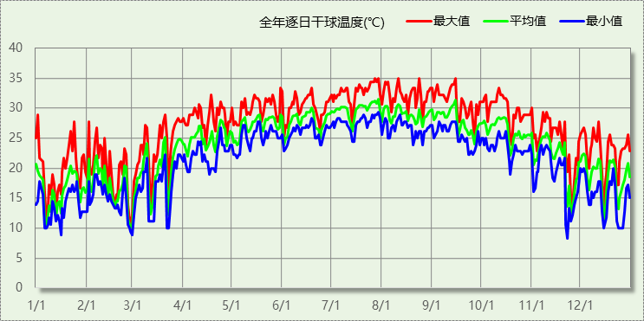

## 逐月辐照量表

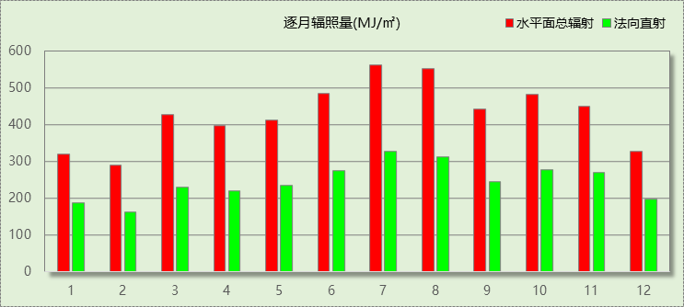

## 峰值工况

|  |  |  |  |  |  |
| --- | --- | --- | --- | --- | --- |
| 气象数据 | 时刻 | 干球温度(℃) | 湿球温度(℃) | 含湿量(g/kg) | 焓值(kj/kg) |
| 最热 | 07月27日14时 | 35.0 | 27.2 | 20.6 | 88.0 |
| 最冷 | 11月22日04时 | 8.3 | 5.6 | 4.3 | 19.2 |

# 建筑大样

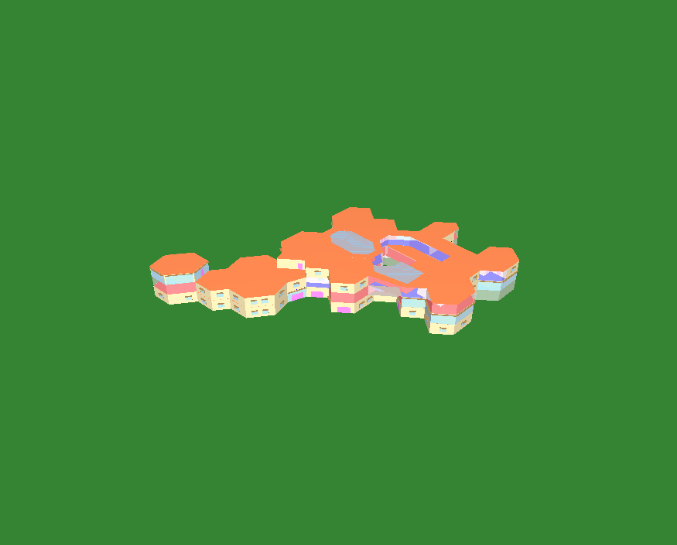

西南轴侧图

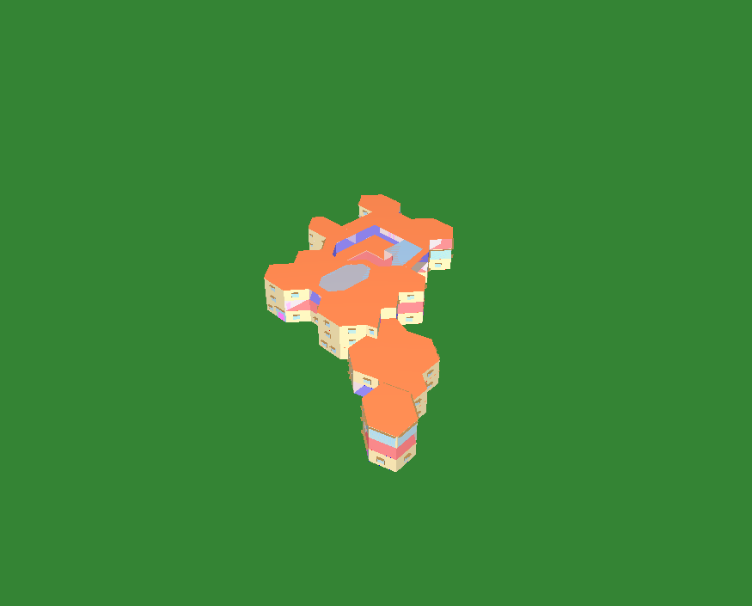

东南轴侧图

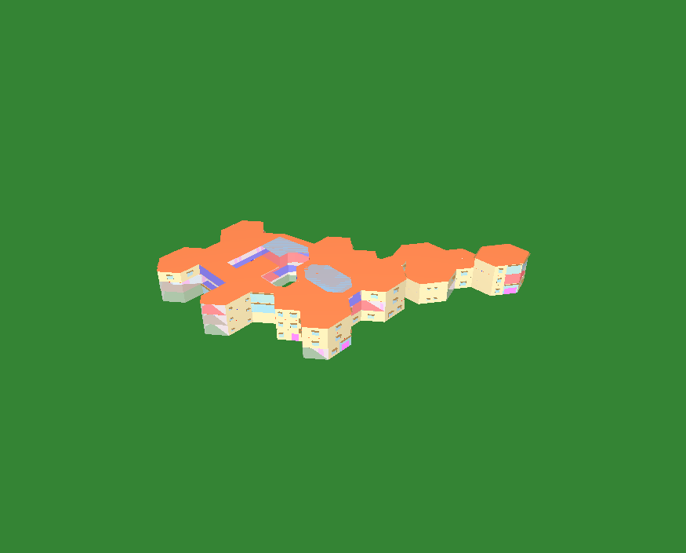

西北轴侧图



东北轴侧图

# 围护结构

## 工程材料

|  |  |  |  |  |  |  |
| --- | --- | --- | --- | --- | --- | --- |
| 材料名称 | 导热系数λ | 蓄热系数S | 密度ρ | 比热容Cp | 蒸汽渗透 系数u | 数据来源 |
| W/(m.K) | W/(㎡.K) | kg/m3 | J/(kg.K) | g/(m.h.kPa) |
| 水泥砂浆 | 0.930 | 11.370 | 1800.0 | 1050.0 | 0.0210 |  |
| 聚苯乙烯泡沫塑料（灰板） | 0.033 | 0.280 | 20.0 | 1380.0 | 0.0162 |  |
| 石灰砂浆 | 0.810 | 10.070 | 1600.0 | 1050.0 | 0.0443 |  |
| 钢筋混凝土 | 1.740 | 17.200 | 2500.0 | 920.0 | 0.0158 |  |
| 挤塑聚苯板(ρ=25-32) | 0.030 | 0.320 | 28.5 | 1647.0 | 0.0162 |  |
| 加气混凝土、泡沫混凝土(ρ=700) | 0.180 | 3.100 | 700.0 | 1050.0 | 0.0998 |  |
| 混凝土多孔砖(190六孔砖） | 0.750 | 7.490 | 1450.0 | 709.4 | 0.0010 |  |
| 岩棉板(ρ=60-160) | 0.041 | 0.615 | 110.0 | 1220.0 | 0.4880 |  |
| c20细石混凝土(ρ=2300) | 1.510 | 15.243 | 2300.0 | 920.0 | 0.0173 |  |
| 轻骨料混凝土(找坡层) | 0.300 | 5.000 | 1050.0 | 1091.3 | 0.0140 |  |
| 石墨聚苯板 | 0.033 | 0.280 | 20.0 | 1633.5 | 0.0162 |  |

## 围护结构作法简要说明

**1. 屋顶：**屋顶构造一 (K=0.264,D=3.856)：（由上到下）

加气混凝土、泡沫混凝土(ρ=700) 20mm＋c20细石混凝土(ρ=2300) 40mm＋挤塑聚苯板(ρ=25-32) 110mm＋轻骨料混凝土(找坡层) 30mm＋钢筋混凝土 120mm＋石灰砂浆 20mm

**2. 外墙（填充墙）：**外墙构造一 (K=0.445,D=3.064)：（由外到内）

水泥砂浆 20mm＋石墨聚苯板 70mm＋钢筋混凝土 200mm＋石灰砂浆 20mm

**3. 热桥梁：**热桥梁构造一 (K=0.445,D=3.064)：（由外到内）

水泥砂浆 20mm＋石墨聚苯板 70mm＋钢筋混凝土 200mm＋石灰砂浆 20mm

**4. 幕墙：**60系列内平开下悬铝合金窗[5涂膜+12A+5Low-E] (K=2.300)：

传热系数2.300W/㎡.K，窗太阳得热系数0.231

**5. 天窗：**60系列内平开下悬玻璃钢窗[5涂膜+12A+5Low-E] (K=2.200)：

传热系数2.200W/㎡.K，窗太阳得热系数0.222

**6. 外窗：**70系列断桥铝窗5Low-E+0.3V+5 (K=0.970)：

传热系数0.970W/㎡.K，窗太阳得热系数0.479

# 围护结构概况

|  |  |  |  |  |  |
| --- | --- | --- | --- | --- | --- |
|  | | | 设计建筑 | | |
| 体形系数S | | | 0.22 | | |
| 屋顶传热系数K  和热惰性指标 D | | | 0.26  3.86 | | |
| 外墙传热系数K  和热惰性指标 D | | | 0.45  3.06 | | |
| 挑空(或架空)楼板传热系数K  和热惰性指标 D | | | 0.42  2.43 | | |
| 天窗传热系数K  和太阳得热系数 SHGC | | | 2.20  0.22 | | |
| 外窗（包括透明幕墙） | 朝向 | 立面 | 窗墙比 | 传热  系数 | 太阳得热系数 |
| 南向 | 南-默认立面 | 0.24 | 1.74 | 0.27 |
| 北向 | 北-默认立面 | 0.21 | 2.30 | 0.21 |
| 东向 | 东-默认立面 | 0.26 | 1.91 | 0.25 |
| 西向 | 西-默认立面 | 0.21 | 1.67 | 0.27 |

# 房间类型

## 房间参数表

|  |  |  |  |  |  |  |  |
| --- | --- | --- | --- | --- | --- | --- | --- |
| 房间类型 | 空调 温度℃ | 供暖 温度℃ | 新风量 | 渗透风 换气次数 | 人员密度 | 照明功率 密度 | 电器设备 功率 |
| 健身活动室 | 24 | 19 | 40(m3/h.人) | 0(次/h) | 4(㎡/人) | 2(W/㎡) | 2(W/㎡) |
| 卫生间 | 28 | 16 | 0(m3/h.人) | 0(次/h) | 0(人) | 2(W/㎡) | 2(W/㎡) |
| 多媒体教室 | 26 | 18 | 20(m3/h.人) | 0(次/h) | 4(㎡/人) | 2(W/㎡) | 2(W/㎡) |
| 大厅 | 26 | 20 | 30(m3/h.人) | 0(次/h) | 20(㎡/人) | 2(W/㎡) | 2(W/㎡) |
| 实验教室 | 26 | 18 | 20(m3/h.人) | 0(次/h) | 4(㎡/人) | 2(W/㎡) | 2(W/㎡) |
| 密集办公室 | 26 | 20 | 30(m3/h.人) | 0(次/h) | 4(㎡/人) | 2(W/㎡) | 2(W/㎡) |
| 报告厅 | 26 | 18 | 14(m3/h.人) | 0(次/h) | 2.5(㎡/人) | 2(W/㎡) | 2(W/㎡) |
| 普通办公室 | 26 | 20 | 30(m3/h.人) | 0(次/h) | 6(㎡/人) | 2(W/㎡) | 2(W/㎡) |
| 普通办公室 | 26 | 20 | 30(m3/h.人) | 0(次/h) | 8(㎡/人) | 8(W/㎡) | 15(W/㎡) |
| 楼梯间 | － | － | 0(m3/h.人) | 0(次/h) | 0(人) | 2(W/㎡) | 2(W/㎡) |
| 空房间 | － | － | 0(m3/h.人) | 0(次/h) | 0(人) | 2(W/㎡) | 2(W/㎡) |
| 美术教室 | 26 | 18 | 20(m3/h.人) | 0(次/h) | 4(㎡/人) | 2(W/㎡) | 2(W/㎡) |
| 舞蹈教室 | 26 | 20 | 30(m3/h.人) | 0(次/h) | 4(㎡/人) | 2(W/㎡) | 2(W/㎡) |
| 计算机房 | 26 | 18 | 24(m3/h.人) | 0(次/h) | 1.39(㎡/人) | 2(W/㎡) | 2(W/㎡) |
| 设备间 | － | － | 0(次/h) | 0(次/h) | 0(人) | 2(W/㎡) | 2(W/㎡) |
| 走廊 | － | － | 0(m3/h.人) | 0(次/h) | 0(人) | 2(W/㎡) | 2(W/㎡) |
| 阅览室 | 26 | 20 | 20(m3/h.人) | 0(次/h) | 1.9(㎡/人) | 2(W/㎡) | 2(W/㎡) |
| 阶梯教室 | 26 | 18 | 24(m3/h.人) | 0(次/h) | 1.39(㎡/人) | 2(W/㎡) | 2(W/㎡) |
| 音乐教室 | 26 | 18 | 20(m3/h.人) | 0(次/h) | 4(㎡/人) | 2(W/㎡) | 2(W/㎡) |
| 风雨操场 | 28 | 15 | 19(m3/h.人) | 0(次/h) | 6(㎡/人) | 2(W/㎡) | 2(W/㎡) |
| 餐厅 | 26 | 18 | 25(m3/h.人) | 0(次/h) | 2(㎡/人) | 2(W/㎡) | 2(W/㎡) |

## 作息时间表

详见附录

# 采暖空调

|  |  |  |  |  |  |
| --- | --- | --- | --- | --- | --- |
| 类别 | 负荷 (kWh/a) | 系统综合 性能系数 | 耗电 (kWh/a) | 碳排放因子 (kgCO2/kWh) | 碳排放量 (tCO2/a) |
| 供冷 | 290143 | 3.5 | 82898 | 0.5271 | 43.696 |

|  |  |  |  |  |  |
| --- | --- | --- | --- | --- | --- |
| 类别 | 负荷 (kWh/a) | 系统综合 性能系数 | 耗电 (kWh/a) | 碳排放因子 (kgCO2/kWh) | 碳排放量 (tCO2/a) |
| 供暖 | 0 | 2.6 | 0 | 0.5271 | 0.000 |

# 照明

|  |  |  |  |  |  |  |
| --- | --- | --- | --- | --- | --- | --- |
| 房间类型 | 单位面积电耗 (kWh/㎡.a) | 房间个数 | 房间合计面积 (㎡) | 合计电耗 (kWh/a) | 碳排放因子(kgCO2/kWh) | 碳排放量(tCO2/a) |
| 健身活动室 | 4.14 | 1 | 240 | 993 | 0.5271 | 0.523 |
| 卫生间 | 4.14 | 50 | 199 | 825 | 0.435 |
| 多媒体教室 | 4.14 | 1 | 120 | 497 | 0.262 |
| 大厅 | 4.14 | 8 | 1340 | 5544 | 2.922 |
| 实验教室 | 4.14 | 1 | 120 | 497 | 0.262 |
| 密集办公室 | 4.14 | 1 | 200 | 827 | 0.436 |
| 报告厅 | 4.14 | 1 | 120 | 497 | 0.262 |
| 普通办公室 | 4.14 | 21 | 1139 | 4716 | 2.486 |
| 楼梯间 | 4.14 | 11 | 238 | 985 | 0.519 |
| 空房间 | 4.82 | 12 | 251 | 1211 | 0.638 |
| 美术教室 | 4.14 | 1 | 46 | 192 | 0.101 |
| 舞蹈教室 | 4.14 | 1 | 70 | 290 | 0.153 |
| 计算机房 | 4.14 | 1 | 51 | 211 | 0.111 |
| 设备间 | 10.51 | 1 | 23 | 237 | 0.125 |
| 走廊 | 4.14 | 6 | 790 | 3270 | 1.724 |
| 阅览室 | 4.14 | 1 | 420 | 1738 | 0.916 |
| 阶梯教室 | 4.14 | 2 | 185 | 766 | 0.404 |
| 音乐教室 | 4.14 | 1 | 100 | 414 | 0.218 |
| 风雨操场 | 4.14 | 1 | 77 | 319 | 0.168 |
| 餐厅 | 4.14 | 3 | 73 | 303 | 0.160 |
| 总计 | | | | | | 12.826 |

# 光伏发电

|  |  |  |  |
| --- | --- | --- | --- |
| 月 | 发电量(kWh/a) | 碳排放因子(kgCO2/kWh) | 可减少碳排放量(tCO2/a) |
| 1 | 17500 | 0.5271 | 9.22425 |
| 2 | 17500 | 9.22425 |
| 3 | 16000 | 8.4336 |
| 4 | 18000 | 9.4878 |
| 5 | 25000 | 13.1775 |
| 6 | 22500 | 11.8598 |
| 7 | 27000 | 14.2317 |
| 8 | 22500 | 11.8598 |
| 9 | 24500 | 12.914 |
| 10 | 26500 | 13.9681 |
| 11 | 20000 | 10.542 |
| 12 | 18000 | 9.4878 |
| 总计 | | | 134.411 |

# 计算结果

## 建材生产运输碳排放

### 建材生产阶段

|  |  |  |  |  |  |  |
| --- | --- | --- | --- | --- | --- | --- |
| 材料 | 单位 | 用量 | 拆除后回收比例 | 寿命(年) | 碳排放因子 (kgCO2e/单位) | 碳排放量 (tCO2e) |
| 混凝土 | m3 | 623.14 | 0 | 全生命周期 | 340 | 211.868 |
| 钢筋 | t | 452.66 | 0 | 全生命周期 | 2340 | 1059.224 |
| 型钢 | t | 52.91 | 0 | 全生命周期 | 2365 | 125.132 |
| 水泥 | t | 199.88 | 0 | 全生命周期 | 735 | 146.912 |
| 钢混预制楼板 | m3 | 123.45 | 0 | 全生命周期 | 688 | 84.934 |
| 钢混预制墙板 | m3 | 117.57 | 0 | 全生命周期 | 488 | 57.374 |
| 预拌砂浆 | t | 1369.74 | 0 | 全生命周期 | 370 | 506.804 |
| 砂 | m3 | 123.45 | 0 | 全生命周期 | 3 | 0.370 |
| 挤塑聚苯板(ρ=25-32) | m3 | 255.44 | 0 | 全生命周期 | 534 | 136.405 |
| 石墨聚苯板 | m3 | 117.11 | 0 | 全生命周期 | 534 | 62.537 |
| 岩棉板(ρ=60-160) | m3 | 57.18 | 0 | 全生命周期 | 534 | 30.534 |
| 砖 | m3 | 881.80 | 0 | 全生命周期 | 336 | 296.285 |
| 70系列断桥铝窗5Low-E+0.3V+5 | m2 | 185.40 | 0 | 全生命周期 | 129.5 | 24.009 |
| 60系列内平开下悬铝合金窗[5涂膜+12A+5Low-E] | m2 | 339.57 | 0 | 全生命周期 | 129.5 | 43.974 |
| 60系列内平开下悬玻璃钢窗[5涂膜+12A+5Low-E] | m2 | 188.97 | 0 | 全生命周期 | 129.5 | 24.472 |
| 70系列内平开下悬铝合金窗[5Low-E+12A+5+12A+5] | m2 | 57.36 | 0 | 全生命周期 | 129.5 | 7.428 |
| 保温门（多功能门） | m2 | 111.24 | 0 | 全生命周期 | 48.3 | 5.373 |
| 内门 | m2 | 210.75 | 0 | 全生命周期 | 48.3 | 10.179 |
| 陶瓷 | m2 | 199.88 | 0 | 全生命周期 | 19.5 | 3.898 |
| 涂料 | t | 29.39 | 0 | 全生命周期 | 6550 | 192.505 |
| 电缆 | kg | 1069.92 | 0 | 全生命周期 | 94.1 | 100.679 |
| 管材 | kg | 8818.04 | 0 | 全生命周期 | 3.6 | 31.745 |
| 合计 | | | | | | 3162.641 |

### 建材运输阶段

|  |  |  |  |  |  |
| --- | --- | --- | --- | --- | --- |
| 材料 | 重量(t) | 运输距离 (km) | 寿命(年) | 碳排放因子 (kgCO2e/t·km) | 碳排放量 (tCO2e) |
| 混凝土 | 1470.61 | 50 | 全生命周期 | 0.115 | 8.456 |
| 钢筋 | 452.66 | 50 | 全生命周期 | 0.115 | 2.603 |
| 型钢 | 52.91 | 50 | 全生命周期 | 0.115 | 0.304 |
| 水泥 | 199.88 | 50 | 全生命周期 | 0.115 | 1.149 |
| 钢混预制楼板 | 308.63 | 50 | 全生命周期 | 0.115 | 1.775 |
| 钢混预制墙板 | 293.94 | 50 | 全生命周期 | 0.115 | 1.690 |
| 预拌砂浆 | 1369.74 | 50 | 全生命周期 | 0.115 | 7.876 |
| 砂 | 197.52 | 50 | 全生命周期 | 0.115 | 1.136 |
| 挤塑聚苯板(ρ=25-32) | 7.28 | 50 | 全生命周期 | 0.115 | 0.042 |
| 石墨聚苯板 | 2.34 | 50 | 全生命周期 | 0.115 | 0.013 |
| 岩棉板(ρ=60-160) | 6.29 | 50 | 全生命周期 | 0.115 | 0.036 |
| 砖 | 1278.62 | 50 | 全生命周期 | 0.115 | 7.352 |
| 70系列断桥铝窗5Low-E+0.3V+5 | 3.71 | 50 | 全生命周期 | 0.115 | 0.021 |
| 60系列内平开下悬铝合金窗[5涂膜+12A+5Low-E] | 6.79 | 50 | 全生命周期 | 0.115 | 0.039 |
| 60系列内平开下悬玻璃钢窗[5涂膜+12A+5Low-E] | 3.78 | 50 | 全生命周期 | 0.115 | 0.022 |
| 70系列内平开下悬铝合金窗[5Low-E+12A+5+12A+5] | 1.15 | 50 | 全生命周期 | 0.115 | 0.007 |
| 保温门（多功能门） | 3.34 | 50 | 全生命周期 | 0.115 | 0.019 |
| 内门 | 6.32 | 50 | 全生命周期 | 0.115 | 0.036 |
| 陶瓷 | 6.00 | 50 | 全生命周期 | 0.115 | 0.035 |
| 涂料 | 29.39 | 50 | 全生命周期 | 0.115 | 0.169 |
| 电缆 | 1.07 | 50 | 全生命周期 | 0.115 | 0.006 |
| 管材 | 8.82 | 50 | 全生命周期 | 0.115 | 0.051 |
| 总计 | | | | | 32.837 |

## 建筑建造拆除碳排放

### 建筑建造

根据广东省《建筑碳排放计算导则（试行）》，采用经验公式法进行估算，公式如下：

Y = X + 1.99

其中X 为地上层数，Y 为单位面积的碳排放量，单位为：kgCO2/㎡,

则建造阶段碳排放估算值 Cjz=Y×A, 其中A——建筑总面积，㎡。

|  |  |  |  |
| --- | --- | --- | --- |
| 建筑面积(㎡) | 地上层数 | 单位面积碳排放量(kgCO2/㎡) | 建造碳排放量(tCO2) |
| 5878.70 | 3 | 4.99 | 29.335 |

### 建筑拆除

根据广东省《建筑碳排放计算导则（试行）》，建议粗略估算拆除阶段的碳排放，计算方法与建造阶段公式一致即可，公式如下：

Y = X + 1.99

其中X 为地上层数，Y 为单位面积的碳排放量，单位为：kgCO2/㎡,

则拆除阶段碳排放估算值 Ccc=Y×A, 其中A——建筑总面积，㎡。

|  |  |  |  |
| --- | --- | --- | --- |
| 建筑面积(㎡) | 地上层数 | 单位面积碳排放量(kgCO2/㎡) | 拆除碳排放量(tCO2) |
| 5878.70 | 3 | 4.99 | 29.335 |

## 碳汇

|  |  |  |  |  |  |
| --- | --- | --- | --- | --- | --- |
| 绿植 | 生长期 修正因子 | CO2固定量 (kg/㎡·a) | 面积(㎡) | 年数 | 碳固定量 (tCO2) |
| 休闲绿地 | 1 | 2.9628 | 509.52 | 50 | 75.480 |
| 合计 | | | | | 75.480 |

## 建筑运行碳排放

|  |  |  |  |  |
| --- | --- | --- | --- | --- |
| 电力 | 类别 | 耗电  (kWh/㎡) | 碳排放因子  (kgCO2/kWh) | 碳排放量(tCO2) |
| 供冷(Ec) | | 705.07 | 0.5271 | 2184.779 |
| 供暖(Eh) | | 0.00 | 0.5271 | 0.000 |
| 照明 | | 206.96 | 0.5271 | 641.283 |
| 插座设备 | | - | 0.5271 | - |
| 其他(Eo) | 电梯 | 0.00 | 0.5271 | 0.000 |
|  | 排风机 | 0.00 |  |  |
|  | 生活热水(扣减了太阳能) | 0.00 |  |  |
|  | 其他设备 | 0.00 |  |  |
|  | 合计 | 0.00 |  |  |
| 化石燃料 | 所属类别 | 耗热量(kWh/㎡) | 碳排放因子(tCO2/TJ) | 碳排放量(tCO2) |
|  | 供暖系统 | 0.000 |  | 0.000 |
| 无 | 生活热水(扣减了太阳能) | 0.00 | 0 | 0.000 |
| 燃气 | 炊事 | -(m³/㎡) | 55.54 | - |
| 汽油 | 其他设备 | 0 (kg/㎡) | 67.91 | 0.000 |
| 柴油 | 其他设备 | 0 (kg/㎡) | 72.59 | 0.000 |
| 煤炭 | 其他设备 | 0 (kg/㎡) | 2.66(kgCO2/kg) | 0.000 |
| 燃气 | 其他设备 | 0 (kg/㎡) | 55.54 | 0.000 |
| 可再生 | 类别 | 供电(kWh/㎡) | 碳排放因子(kgCO2/kWh) | 碳减排量(tCO2) |
| 可再生能源(Er) | 光伏(Ep) | 0.00 | 0.5271 | 0.000 |
|  | 风力(Ew) | 0.00 |  | 0.000 |
| 建筑运行碳排放合计 | | | | 2826.061 |

## 全生命周期

### 单位面积指标

|  |  |  |
| --- | --- | --- |
| 类别 | 年碳排放量(kgCO2/㎡·a) | 碳排放量(kgCO2/㎡) |
| 建筑材料生产 | 10.76 | 537.98 |
| 建筑材料运输 | 0.11 | 5.59 |
| 建筑建造 | 0.10 | 4.99 |
| 建筑拆除 | 0.10 | 4.99 |
| 建筑运行 | 9.61 | 480.73 |
| 碳汇 | -0.26 | -12.84 |
| 合计 | 20.42 | 1021.44 |

### 总碳排放量

|  |  |  |
| --- | --- | --- |
| 类别 | 年碳排放量(tCO2/a) | 碳排放量(tCO2) |
| 建筑材料生产 | 63.253 | 3162.641 |
| 建筑材料运输 | 0.657 | 32.837 |
| 建筑建造 | 0.587 | 29.335 |
| 建筑拆除 | 0.587 | 29.335 |
| 建筑运行 | 56.521 | 2826.061 |
| 碳汇 | -1.510 | -75.480 |
| 合计 | 120.095 | 6004.729 |

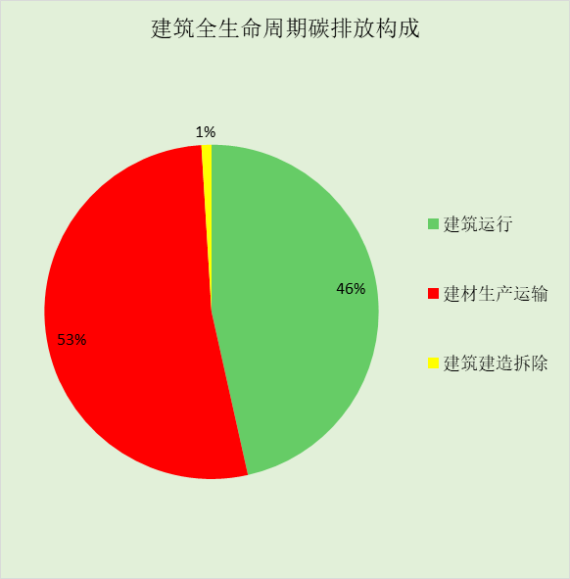

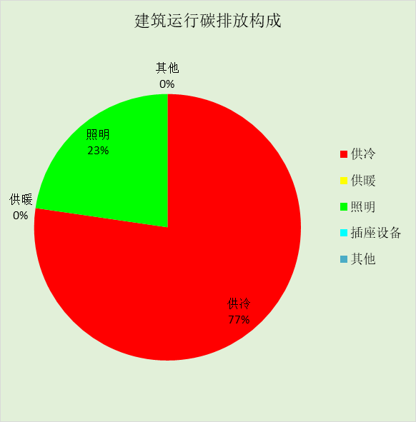

# 附录

暑假:7.15~8.25; 寒假：1.15~3.1

## 工作日/节假日人员逐时在室率(%)

|  |  |  |  |  |  |  |  |  |  |  |  |  |  |  |  |  |  |  |  |  |  |  |  |  |
| --- | --- | --- | --- | --- | --- | --- | --- | --- | --- | --- | --- | --- | --- | --- | --- | --- | --- | --- | --- | --- | --- | --- | --- | --- |
| 房间类型 | 1 | 2 | 3 | 4 | 5 | 6 | 7 | 8 | 9 | 10 | 11 | 12 | 13 | 14 | 15 | 16 | 17 | 18 | 19 | 20 | 21 | 22 | 23 | 24 |
| 健身活动室 | 0 | 0 | 0 | 0 | 0 | 0 | 10 | 50 | 95 | 95 | 95 | 80 | 80 | 95 | 95 | 95 | 95 | 30 | 30 | 0 | 0 | 0 | 0 | 0 |
| 0 | 0 | 0 | 0 | 0 | 0 | 0 | 0 | 0 | 0 | 0 | 0 | 0 | 0 | 0 | 0 | 0 | 0 | 0 | 0 | 0 | 0 | 0 | 0 |
| 0 | 0 | 0 | 0 | 0 | 0 | 0 | 0 | 0 | 0 | 0 | 0 | 0 | 0 | 0 | 0 | 0 | 0 | 0 | 0 | 0 | 0 | 0 | 0 |
| 0 | 0 | 0 | 0 | 0 | 0 | 0 | 0 | 0 | 0 | 0 | 0 | 0 | 0 | 0 | 0 | 0 | 0 | 0 | 0 | 0 | 0 | 0 | 0 |
| 卫生间 | 0 | 0 | 0 | 0 | 0 | 0 | 10 | 50 | 95 | 95 | 95 | 80 | 80 | 95 | 95 | 95 | 95 | 30 | 30 | 0 | 0 | 0 | 0 | 0 |
| 0 | 0 | 0 | 0 | 0 | 0 | 0 | 0 | 0 | 0 | 0 | 0 | 0 | 0 | 0 | 0 | 0 | 0 | 0 | 0 | 0 | 0 | 0 | 0 |
| 0 | 0 | 0 | 0 | 0 | 0 | 0 | 0 | 0 | 0 | 0 | 0 | 0 | 0 | 0 | 0 | 0 | 0 | 0 | 0 | 0 | 0 | 0 | 0 |
| 0 | 0 | 0 | 0 | 0 | 0 | 0 | 0 | 0 | 0 | 0 | 0 | 0 | 0 | 0 | 0 | 0 | 0 | 0 | 0 | 0 | 0 | 0 | 0 |
| 多媒体教室 | 0 | 0 | 0 | 0 | 0 | 0 | 10 | 50 | 95 | 95 | 95 | 80 | 80 | 95 | 95 | 95 | 95 | 30 | 30 | 0 | 0 | 0 | 0 | 0 |
| 0 | 0 | 0 | 0 | 0 | 0 | 0 | 0 | 0 | 0 | 0 | 0 | 0 | 0 | 0 | 0 | 0 | 0 | 0 | 0 | 0 | 0 | 0 | 0 |
| 0 | 0 | 0 | 0 | 0 | 0 | 0 | 0 | 0 | 0 | 0 | 0 | 0 | 0 | 0 | 0 | 0 | 0 | 0 | 0 | 0 | 0 | 0 | 0 |
| 0 | 0 | 0 | 0 | 0 | 0 | 0 | 0 | 0 | 0 | 0 | 0 | 0 | 0 | 0 | 0 | 0 | 0 | 0 | 0 | 0 | 0 | 0 | 0 |
| 大厅 | 0 | 0 | 0 | 0 | 0 | 0 | 10 | 50 | 95 | 95 | 95 | 80 | 80 | 95 | 95 | 95 | 95 | 30 | 30 | 0 | 0 | 0 | 0 | 0 |
| 0 | 0 | 0 | 0 | 0 | 0 | 0 | 0 | 0 | 0 | 0 | 0 | 0 | 0 | 0 | 0 | 0 | 0 | 0 | 0 | 0 | 0 | 0 | 0 |
| 0 | 0 | 0 | 0 | 0 | 0 | 0 | 0 | 0 | 0 | 0 | 0 | 0 | 0 | 0 | 0 | 0 | 0 | 0 | 0 | 0 | 0 | 0 | 0 |
| 0 | 0 | 0 | 0 | 0 | 0 | 0 | 0 | 0 | 0 | 0 | 0 | 0 | 0 | 0 | 0 | 0 | 0 | 0 | 0 | 0 | 0 | 0 | 0 |
| 实验教室 | 0 | 0 | 0 | 0 | 0 | 0 | 10 | 50 | 95 | 95 | 95 | 80 | 80 | 95 | 95 | 95 | 95 | 30 | 30 | 0 | 0 | 0 | 0 | 0 |
| 0 | 0 | 0 | 0 | 0 | 0 | 0 | 0 | 0 | 0 | 0 | 0 | 0 | 0 | 0 | 0 | 0 | 0 | 0 | 0 | 0 | 0 | 0 | 0 |
| 0 | 0 | 0 | 0 | 0 | 0 | 0 | 0 | 0 | 0 | 0 | 0 | 0 | 0 | 0 | 0 | 0 | 0 | 0 | 0 | 0 | 0 | 0 | 0 |
| 0 | 0 | 0 | 0 | 0 | 0 | 0 | 0 | 0 | 0 | 0 | 0 | 0 | 0 | 0 | 0 | 0 | 0 | 0 | 0 | 0 | 0 | 0 | 0 |
| 密集办公室 | 0 | 0 | 0 | 0 | 0 | 0 | 10 | 50 | 95 | 95 | 95 | 80 | 80 | 95 | 95 | 95 | 95 | 30 | 30 | 0 | 0 | 0 | 0 | 0 |
| 0 | 0 | 0 | 0 | 0 | 0 | 0 | 0 | 0 | 0 | 0 | 0 | 0 | 0 | 0 | 0 | 0 | 0 | 0 | 0 | 0 | 0 | 0 | 0 |
| 0 | 0 | 0 | 0 | 0 | 0 | 0 | 0 | 0 | 0 | 0 | 0 | 0 | 0 | 0 | 0 | 0 | 0 | 0 | 0 | 0 | 0 | 0 | 0 |
| 0 | 0 | 0 | 0 | 0 | 0 | 0 | 0 | 0 | 0 | 0 | 0 | 0 | 0 | 0 | 0 | 0 | 0 | 0 | 0 | 0 | 0 | 0 | 0 |
| 报告厅 | 0 | 0 | 0 | 0 | 0 | 0 | 10 | 50 | 95 | 95 | 95 | 80 | 80 | 95 | 95 | 95 | 95 | 30 | 30 | 0 | 0 | 0 | 0 | 0 |
| 0 | 0 | 0 | 0 | 0 | 0 | 0 | 0 | 0 | 0 | 0 | 0 | 0 | 0 | 0 | 0 | 0 | 0 | 0 | 0 | 0 | 0 | 0 | 0 |
| 0 | 0 | 0 | 0 | 0 | 0 | 0 | 0 | 0 | 0 | 0 | 0 | 0 | 0 | 0 | 0 | 0 | 0 | 0 | 0 | 0 | 0 | 0 | 0 |
| 0 | 0 | 0 | 0 | 0 | 0 | 0 | 0 | 0 | 0 | 0 | 0 | 0 | 0 | 0 | 0 | 0 | 0 | 0 | 0 | 0 | 0 | 0 | 0 |
| 普通办公室 | 0 | 0 | 0 | 0 | 0 | 0 | 10 | 50 | 95 | 95 | 95 | 80 | 80 | 95 | 95 | 95 | 95 | 30 | 30 | 0 | 0 | 0 | 0 | 0 |
| 0 | 0 | 0 | 0 | 0 | 0 | 0 | 0 | 0 | 0 | 0 | 0 | 0 | 0 | 0 | 0 | 0 | 0 | 0 | 0 | 0 | 0 | 0 | 0 |
| 0 | 0 | 0 | 0 | 0 | 0 | 0 | 0 | 0 | 0 | 0 | 0 | 0 | 0 | 0 | 0 | 0 | 0 | 0 | 0 | 0 | 0 | 0 | 0 |
| 0 | 0 | 0 | 0 | 0 | 0 | 0 | 0 | 0 | 0 | 0 | 0 | 0 | 0 | 0 | 0 | 0 | 0 | 0 | 0 | 0 | 0 | 0 | 0 |
| 普通办公室 | 0 | 0 | 0 | 0 | 0 | 0 | 10 | 50 | 100 | 100 | 100 | 30 | 100 | 100 | 100 | 100 | 50 | 20 | 10 | 0 | 0 | 0 | 0 | 0 |
| 0 | 0 | 0 | 0 | 0 | 0 | 0 | 20 | 45 | 0 | 0 | 0 | 0 | 0 | 0 | 0 | 0 | 0 | 0 | 0 | 0 | 0 | 0 | 0 |
| 0 | 0 | 0 | 0 | 0 | 0 | 0 | 20 | 45 | 0 | 0 | 0 | 0 | 0 | 0 | 0 | 0 | 0 | 0 | 0 | 0 | 0 | 0 | 0 |
| 0 | 0 | 0 | 0 | 0 | 0 | 0 | 20 | 45 | 0 | 0 | 0 | 0 | 0 | 0 | 0 | 0 | 0 | 0 | 0 | 0 | 0 | 0 | 0 |
| 楼梯间 | 0 | 0 | 0 | 0 | 0 | 0 | 10 | 50 | 95 | 95 | 95 | 80 | 80 | 95 | 95 | 95 | 95 | 30 | 30 | 0 | 0 | 0 | 0 | 0 |
| 0 | 0 | 0 | 0 | 0 | 0 | 0 | 0 | 0 | 0 | 0 | 0 | 0 | 0 | 0 | 0 | 0 | 0 | 0 | 0 | 0 | 0 | 0 | 0 |
| 0 | 0 | 0 | 0 | 0 | 0 | 0 | 0 | 0 | 0 | 0 | 0 | 0 | 0 | 0 | 0 | 0 | 0 | 0 | 0 | 0 | 0 | 0 | 0 |
| 0 | 0 | 0 | 0 | 0 | 0 | 0 | 0 | 0 | 0 | 0 | 0 | 0 | 0 | 0 | 0 | 0 | 0 | 0 | 0 | 0 | 0 | 0 | 0 |
| 空房间 | 0 | 0 | 0 | 0 | 0 | 0 | 0 | 20 | 50 | 80 | 80 | 80 | 80 | 80 | 80 | 80 | 80 | 80 | 80 | 70 | 50 | 0 | 0 | 0 |
| 0 | 0 | 0 | 0 | 0 | 0 | 0 | 0 | 0 | 0 | 0 | 0 | 0 | 0 | 0 | 0 | 0 | 0 | 0 | 0 | 0 | 0 | 0 | 0 |
| 0 | 0 | 0 | 0 | 0 | 0 | 0 | 0 | 0 | 0 | 0 | 0 | 0 | 0 | 0 | 0 | 0 | 0 | 0 | 0 | 0 | 0 | 0 | 0 |
| 0 | 0 | 0 | 0 | 0 | 0 | 0 | 0 | 0 | 0 | 0 | 0 | 0 | 0 | 0 | 0 | 0 | 0 | 0 | 0 | 0 | 0 | 0 | 0 |
| 美术教室 | 0 | 0 | 0 | 0 | 0 | 0 | 10 | 50 | 95 | 95 | 95 | 80 | 80 | 95 | 95 | 95 | 95 | 30 | 30 | 0 | 0 | 0 | 0 | 0 |
| 0 | 0 | 0 | 0 | 0 | 0 | 0 | 0 | 0 | 0 | 0 | 0 | 0 | 0 | 0 | 0 | 0 | 0 | 0 | 0 | 0 | 0 | 0 | 0 |
| 0 | 0 | 0 | 0 | 0 | 0 | 0 | 0 | 0 | 0 | 0 | 0 | 0 | 0 | 0 | 0 | 0 | 0 | 0 | 0 | 0 | 0 | 0 | 0 |
| 0 | 0 | 0 | 0 | 0 | 0 | 0 | 0 | 0 | 0 | 0 | 0 | 0 | 0 | 0 | 0 | 0 | 0 | 0 | 0 | 0 | 0 | 0 | 0 |
| 舞蹈教室 | 0 | 0 | 0 | 0 | 0 | 0 | 10 | 50 | 95 | 95 | 95 | 80 | 80 | 95 | 95 | 95 | 95 | 30 | 30 | 0 | 0 | 0 | 0 | 0 |
| 0 | 0 | 0 | 0 | 0 | 0 | 0 | 0 | 0 | 0 | 0 | 0 | 0 | 0 | 0 | 0 | 0 | 0 | 0 | 0 | 0 | 0 | 0 | 0 |
| 0 | 0 | 0 | 0 | 0 | 0 | 0 | 0 | 0 | 0 | 0 | 0 | 0 | 0 | 0 | 0 | 0 | 0 | 0 | 0 | 0 | 0 | 0 | 0 |
| 0 | 0 | 0 | 0 | 0 | 0 | 0 | 0 | 0 | 0 | 0 | 0 | 0 | 0 | 0 | 0 | 0 | 0 | 0 | 0 | 0 | 0 | 0 | 0 |
| 计算机房 | 0 | 0 | 0 | 0 | 0 | 0 | 10 | 50 | 95 | 95 | 95 | 80 | 80 | 95 | 95 | 95 | 95 | 30 | 30 | 0 | 0 | 0 | 0 | 0 |
| 0 | 0 | 0 | 0 | 0 | 0 | 0 | 0 | 0 | 0 | 0 | 0 | 0 | 0 | 0 | 0 | 0 | 0 | 0 | 0 | 0 | 0 | 0 | 0 |
| 0 | 0 | 0 | 0 | 0 | 0 | 0 | 0 | 0 | 0 | 0 | 0 | 0 | 0 | 0 | 0 | 0 | 0 | 0 | 0 | 0 | 0 | 0 | 0 |
| 0 | 0 | 0 | 0 | 0 | 0 | 0 | 0 | 0 | 0 | 0 | 0 | 0 | 0 | 0 | 0 | 0 | 0 | 0 | 0 | 0 | 0 | 0 | 0 |
| 设备间 | 0 | 0 | 0 | 0 | 0 | 0 | 0 | 0 | 0 | 0 | 0 | 0 | 0 | 0 | 0 | 0 | 0 | 0 | 0 | 0 | 0 | 0 | 0 | 0 |
| 0 | 0 | 0 | 0 | 0 | 0 | 0 | 0 | 0 | 0 | 0 | 0 | 0 | 0 | 0 | 0 | 0 | 0 | 0 | 0 | 0 | 0 | 0 | 0 |
| 0 | 0 | 0 | 0 | 0 | 0 | 0 | 0 | 0 | 0 | 0 | 0 | 0 | 0 | 0 | 0 | 0 | 0 | 0 | 0 | 0 | 0 | 0 | 0 |
| 0 | 0 | 0 | 0 | 0 | 0 | 0 | 0 | 0 | 0 | 0 | 0 | 0 | 0 | 0 | 0 | 0 | 0 | 0 | 0 | 0 | 0 | 0 | 0 |
| 走廊 | 0 | 0 | 0 | 0 | 0 | 0 | 10 | 50 | 95 | 95 | 95 | 80 | 80 | 95 | 95 | 95 | 95 | 30 | 30 | 0 | 0 | 0 | 0 | 0 |
| 0 | 0 | 0 | 0 | 0 | 0 | 0 | 0 | 0 | 0 | 0 | 0 | 0 | 0 | 0 | 0 | 0 | 0 | 0 | 0 | 0 | 0 | 0 | 0 |
| 0 | 0 | 0 | 0 | 0 | 0 | 0 | 0 | 0 | 0 | 0 | 0 | 0 | 0 | 0 | 0 | 0 | 0 | 0 | 0 | 0 | 0 | 0 | 0 |
| 0 | 0 | 0 | 0 | 0 | 0 | 0 | 0 | 0 | 0 | 0 | 0 | 0 | 0 | 0 | 0 | 0 | 0 | 0 | 0 | 0 | 0 | 0 | 0 |
| 阅览室 | 0 | 0 | 0 | 0 | 0 | 0 | 10 | 50 | 95 | 95 | 95 | 80 | 80 | 95 | 95 | 95 | 95 | 30 | 30 | 0 | 0 | 0 | 0 | 0 |
| 0 | 0 | 0 | 0 | 0 | 0 | 0 | 0 | 0 | 0 | 0 | 0 | 0 | 0 | 0 | 0 | 0 | 0 | 0 | 0 | 0 | 0 | 0 | 0 |
| 0 | 0 | 0 | 0 | 0 | 0 | 0 | 0 | 0 | 0 | 0 | 0 | 0 | 0 | 0 | 0 | 0 | 0 | 0 | 0 | 0 | 0 | 0 | 0 |
| 0 | 0 | 0 | 0 | 0 | 0 | 0 | 0 | 0 | 0 | 0 | 0 | 0 | 0 | 0 | 0 | 0 | 0 | 0 | 0 | 0 | 0 | 0 | 0 |
| 阶梯教室 | 0 | 0 | 0 | 0 | 0 | 0 | 10 | 50 | 95 | 95 | 95 | 80 | 80 | 95 | 95 | 95 | 95 | 30 | 30 | 0 | 0 | 0 | 0 | 0 |
| 0 | 0 | 0 | 0 | 0 | 0 | 0 | 0 | 0 | 0 | 0 | 0 | 0 | 0 | 0 | 0 | 0 | 0 | 0 | 0 | 0 | 0 | 0 | 0 |
| 0 | 0 | 0 | 0 | 0 | 0 | 0 | 0 | 0 | 0 | 0 | 0 | 0 | 0 | 0 | 0 | 0 | 0 | 0 | 0 | 0 | 0 | 0 | 0 |
| 0 | 0 | 0 | 0 | 0 | 0 | 0 | 0 | 0 | 0 | 0 | 0 | 0 | 0 | 0 | 0 | 0 | 0 | 0 | 0 | 0 | 0 | 0 | 0 |
| 音乐教室 | 0 | 0 | 0 | 0 | 0 | 0 | 10 | 50 | 95 | 95 | 95 | 80 | 80 | 95 | 95 | 95 | 95 | 30 | 30 | 0 | 0 | 0 | 0 | 0 |
| 0 | 0 | 0 | 0 | 0 | 0 | 0 | 0 | 0 | 0 | 0 | 0 | 0 | 0 | 0 | 0 | 0 | 0 | 0 | 0 | 0 | 0 | 0 | 0 |
| 0 | 0 | 0 | 0 | 0 | 0 | 0 | 0 | 0 | 0 | 0 | 0 | 0 | 0 | 0 | 0 | 0 | 0 | 0 | 0 | 0 | 0 | 0 | 0 |
| 0 | 0 | 0 | 0 | 0 | 0 | 0 | 0 | 0 | 0 | 0 | 0 | 0 | 0 | 0 | 0 | 0 | 0 | 0 | 0 | 0 | 0 | 0 | 0 |
| 风雨操场 | 0 | 0 | 0 | 0 | 0 | 0 | 10 | 50 | 95 | 95 | 95 | 80 | 80 | 95 | 95 | 95 | 95 | 30 | 30 | 0 | 0 | 0 | 0 | 0 |
| 0 | 0 | 0 | 0 | 0 | 0 | 0 | 0 | 0 | 0 | 0 | 0 | 0 | 0 | 0 | 0 | 0 | 0 | 0 | 0 | 0 | 0 | 0 | 0 |
| 0 | 0 | 0 | 0 | 0 | 0 | 0 | 0 | 0 | 0 | 0 | 0 | 0 | 0 | 0 | 0 | 0 | 0 | 0 | 0 | 0 | 0 | 0 | 0 |
| 0 | 0 | 0 | 0 | 0 | 0 | 0 | 0 | 0 | 0 | 0 | 0 | 0 | 0 | 0 | 0 | 0 | 0 | 0 | 0 | 0 | 0 | 0 | 0 |
| 餐厅 | 0 | 0 | 0 | 0 | 0 | 0 | 10 | 50 | 95 | 95 | 95 | 80 | 80 | 95 | 95 | 95 | 95 | 30 | 30 | 0 | 0 | 0 | 0 | 0 |
| 0 | 0 | 0 | 0 | 0 | 0 | 0 | 0 | 0 | 0 | 0 | 0 | 0 | 0 | 0 | 0 | 0 | 0 | 0 | 0 | 0 | 0 | 0 | 0 |
| 0 | 0 | 0 | 0 | 0 | 0 | 0 | 0 | 0 | 0 | 0 | 0 | 0 | 0 | 0 | 0 | 0 | 0 | 0 | 0 | 0 | 0 | 0 | 0 |
| 0 | 0 | 0 | 0 | 0 | 0 | 0 | 0 | 0 | 0 | 0 | 0 | 0 | 0 | 0 | 0 | 0 | 0 | 0 | 0 | 0 | 0 | 0 | 0 |

注：第一行：工作日；第二行：节假日；第三行：寒假；第四行：暑假

## 工作日/节假日照明开关时间表(%)

|  |  |  |  |  |  |  |  |  |  |  |  |  |  |  |  |  |  |  |  |  |  |  |  |  |
| --- | --- | --- | --- | --- | --- | --- | --- | --- | --- | --- | --- | --- | --- | --- | --- | --- | --- | --- | --- | --- | --- | --- | --- | --- |
| 房间类型 | 1 | 2 | 3 | 4 | 5 | 6 | 7 | 8 | 9 | 10 | 11 | 12 | 13 | 14 | 15 | 16 | 17 | 18 | 19 | 20 | 21 | 22 | 23 | 24 |
| 健身活动室 | 0 | 0 | 0 | 0 | 0 | 0 | 10 | 50 | 95 | 95 | 95 | 80 | 80 | 95 | 95 | 95 | 95 | 30 | 30 | 0 | 0 | 0 | 0 | 0 |
| 0 | 0 | 0 | 0 | 0 | 0 | 0 | 0 | 0 | 0 | 0 | 0 | 0 | 0 | 0 | 0 | 0 | 0 | 0 | 0 | 0 | 0 | 0 | 0 |
| 0 | 0 | 0 | 0 | 0 | 0 | 0 | 0 | 0 | 0 | 0 | 0 | 0 | 0 | 0 | 0 | 0 | 0 | 0 | 0 | 0 | 0 | 0 | 0 |
| 0 | 0 | 0 | 0 | 0 | 0 | 0 | 0 | 0 | 0 | 0 | 0 | 0 | 0 | 0 | 0 | 0 | 0 | 0 | 0 | 0 | 0 | 0 | 0 |
| 卫生间 | 0 | 0 | 0 | 0 | 0 | 0 | 10 | 50 | 95 | 95 | 95 | 80 | 80 | 95 | 95 | 95 | 95 | 30 | 30 | 0 | 0 | 0 | 0 | 0 |
| 0 | 0 | 0 | 0 | 0 | 0 | 0 | 0 | 0 | 0 | 0 | 0 | 0 | 0 | 0 | 0 | 0 | 0 | 0 | 0 | 0 | 0 | 0 | 0 |
| 0 | 0 | 0 | 0 | 0 | 0 | 0 | 0 | 0 | 0 | 0 | 0 | 0 | 0 | 0 | 0 | 0 | 0 | 0 | 0 | 0 | 0 | 0 | 0 |
| 0 | 0 | 0 | 0 | 0 | 0 | 0 | 0 | 0 | 0 | 0 | 0 | 0 | 0 | 0 | 0 | 0 | 0 | 0 | 0 | 0 | 0 | 0 | 0 |
| 多媒体教室 | 0 | 0 | 0 | 0 | 0 | 0 | 10 | 50 | 95 | 95 | 95 | 80 | 80 | 95 | 95 | 95 | 95 | 30 | 30 | 0 | 0 | 0 | 0 | 0 |
| 0 | 0 | 0 | 0 | 0 | 0 | 0 | 0 | 0 | 0 | 0 | 0 | 0 | 0 | 0 | 0 | 0 | 0 | 0 | 0 | 0 | 0 | 0 | 0 |
| 0 | 0 | 0 | 0 | 0 | 0 | 0 | 0 | 0 | 0 | 0 | 0 | 0 | 0 | 0 | 0 | 0 | 0 | 0 | 0 | 0 | 0 | 0 | 0 |
| 0 | 0 | 0 | 0 | 0 | 0 | 0 | 0 | 0 | 0 | 0 | 0 | 0 | 0 | 0 | 0 | 0 | 0 | 0 | 0 | 0 | 0 | 0 | 0 |
| 大厅 | 0 | 0 | 0 | 0 | 0 | 0 | 10 | 50 | 95 | 95 | 95 | 80 | 80 | 95 | 95 | 95 | 95 | 30 | 30 | 0 | 0 | 0 | 0 | 0 |
| 0 | 0 | 0 | 0 | 0 | 0 | 0 | 0 | 0 | 0 | 0 | 0 | 0 | 0 | 0 | 0 | 0 | 0 | 0 | 0 | 0 | 0 | 0 | 0 |
| 0 | 0 | 0 | 0 | 0 | 0 | 0 | 0 | 0 | 0 | 0 | 0 | 0 | 0 | 0 | 0 | 0 | 0 | 0 | 0 | 0 | 0 | 0 | 0 |
| 0 | 0 | 0 | 0 | 0 | 0 | 0 | 0 | 0 | 0 | 0 | 0 | 0 | 0 | 0 | 0 | 0 | 0 | 0 | 0 | 0 | 0 | 0 | 0 |
| 实验教室 | 0 | 0 | 0 | 0 | 0 | 0 | 10 | 50 | 95 | 95 | 95 | 80 | 80 | 95 | 95 | 95 | 95 | 30 | 30 | 0 | 0 | 0 | 0 | 0 |
| 0 | 0 | 0 | 0 | 0 | 0 | 0 | 0 | 0 | 0 | 0 | 0 | 0 | 0 | 0 | 0 | 0 | 0 | 0 | 0 | 0 | 0 | 0 | 0 |
| 0 | 0 | 0 | 0 | 0 | 0 | 0 | 0 | 0 | 0 | 0 | 0 | 0 | 0 | 0 | 0 | 0 | 0 | 0 | 0 | 0 | 0 | 0 | 0 |
| 0 | 0 | 0 | 0 | 0 | 0 | 0 | 0 | 0 | 0 | 0 | 0 | 0 | 0 | 0 | 0 | 0 | 0 | 0 | 0 | 0 | 0 | 0 | 0 |
| 密集办公室 | 0 | 0 | 0 | 0 | 0 | 0 | 10 | 50 | 95 | 95 | 95 | 80 | 80 | 95 | 95 | 95 | 95 | 30 | 30 | 0 | 0 | 0 | 0 | 0 |
| 0 | 0 | 0 | 0 | 0 | 0 | 0 | 0 | 0 | 0 | 0 | 0 | 0 | 0 | 0 | 0 | 0 | 0 | 0 | 0 | 0 | 0 | 0 | 0 |
| 0 | 0 | 0 | 0 | 0 | 0 | 0 | 0 | 0 | 0 | 0 | 0 | 0 | 0 | 0 | 0 | 0 | 0 | 0 | 0 | 0 | 0 | 0 | 0 |
| 0 | 0 | 0 | 0 | 0 | 0 | 0 | 0 | 0 | 0 | 0 | 0 | 0 | 0 | 0 | 0 | 0 | 0 | 0 | 0 | 0 | 0 | 0 | 0 |
| 报告厅 | 0 | 0 | 0 | 0 | 0 | 0 | 10 | 50 | 95 | 95 | 95 | 80 | 80 | 95 | 95 | 95 | 95 | 30 | 30 | 0 | 0 | 0 | 0 | 0 |
| 0 | 0 | 0 | 0 | 0 | 0 | 0 | 0 | 0 | 0 | 0 | 0 | 0 | 0 | 0 | 0 | 0 | 0 | 0 | 0 | 0 | 0 | 0 | 0 |
| 0 | 0 | 0 | 0 | 0 | 0 | 0 | 0 | 0 | 0 | 0 | 0 | 0 | 0 | 0 | 0 | 0 | 0 | 0 | 0 | 0 | 0 | 0 | 0 |
| 0 | 0 | 0 | 0 | 0 | 0 | 0 | 0 | 0 | 0 | 0 | 0 | 0 | 0 | 0 | 0 | 0 | 0 | 0 | 0 | 0 | 0 | 0 | 0 |
| 普通办公室 | 0 | 0 | 0 | 0 | 0 | 0 | 10 | 50 | 95 | 95 | 95 | 80 | 80 | 95 | 95 | 95 | 95 | 30 | 30 | 0 | 0 | 0 | 0 | 0 |
| 0 | 0 | 0 | 0 | 0 | 0 | 0 | 0 | 0 | 0 | 0 | 0 | 0 | 0 | 0 | 0 | 0 | 0 | 0 | 0 | 0 | 0 | 0 | 0 |
| 0 | 0 | 0 | 0 | 0 | 0 | 0 | 0 | 0 | 0 | 0 | 0 | 0 | 0 | 0 | 0 | 0 | 0 | 0 | 0 | 0 | 0 | 0 | 0 |
| 0 | 0 | 0 | 0 | 0 | 0 | 0 | 0 | 0 | 0 | 0 | 0 | 0 | 0 | 0 | 0 | 0 | 0 | 0 | 0 | 0 | 0 | 0 | 0 |
| 普通办公室 | 10 | 10 | 10 | 10 | 10 | 10 | 10 | 36 | 62 | 56 | 54 | 43 | 53 | 55 | 58 | 67 | 40 | 18 | 10 | 10 | 10 | 10 | 10 | 10 |
| 0 | 0 | 0 | 0 | 0 | 0 | 0 | 0 | 0 | 0 | 0 | 0 | 0 | 0 | 0 | 0 | 0 | 0 | 0 | 0 | 0 | 0 | 0 | 0 |
| 0 | 0 | 0 | 0 | 0 | 0 | 0 | 0 | 0 | 0 | 0 | 0 | 0 | 0 | 0 | 0 | 0 | 0 | 0 | 0 | 0 | 0 | 0 | 0 |
| 0 | 0 | 0 | 0 | 0 | 0 | 0 | 0 | 0 | 0 | 0 | 0 | 0 | 0 | 0 | 0 | 0 | 0 | 0 | 0 | 0 | 0 | 0 | 0 |
| 楼梯间 | 0 | 0 | 0 | 0 | 0 | 0 | 10 | 50 | 95 | 95 | 95 | 80 | 80 | 95 | 95 | 95 | 95 | 30 | 30 | 0 | 0 | 0 | 0 | 0 |
| 0 | 0 | 0 | 0 | 0 | 0 | 0 | 0 | 0 | 0 | 0 | 0 | 0 | 0 | 0 | 0 | 0 | 0 | 0 | 0 | 0 | 0 | 0 | 0 |
| 0 | 0 | 0 | 0 | 0 | 0 | 0 | 0 | 0 | 0 | 0 | 0 | 0 | 0 | 0 | 0 | 0 | 0 | 0 | 0 | 0 | 0 | 0 | 0 |
| 0 | 0 | 0 | 0 | 0 | 0 | 0 | 0 | 0 | 0 | 0 | 0 | 0 | 0 | 0 | 0 | 0 | 0 | 0 | 0 | 0 | 0 | 0 | 0 |
| 空房间 | 10 | 10 | 10 | 10 | 10 | 10 | 10 | 50 | 60 | 60 | 60 | 60 | 60 | 60 | 60 | 60 | 80 | 90 | 100 | 100 | 100 | 10 | 10 | 10 |
| 0 | 0 | 0 | 0 | 0 | 0 | 0 | 0 | 0 | 0 | 0 | 0 | 0 | 0 | 0 | 0 | 0 | 0 | 0 | 0 | 0 | 0 | 0 | 0 |
| 0 | 0 | 0 | 0 | 0 | 0 | 0 | 0 | 0 | 0 | 0 | 0 | 0 | 0 | 0 | 0 | 0 | 0 | 0 | 0 | 0 | 0 | 0 | 0 |
| 0 | 0 | 0 | 0 | 0 | 0 | 0 | 0 | 0 | 0 | 0 | 0 | 0 | 0 | 0 | 0 | 0 | 0 | 0 | 0 | 0 | 0 | 0 | 0 |
| 美术教室 | 0 | 0 | 0 | 0 | 0 | 0 | 10 | 50 | 95 | 95 | 95 | 80 | 80 | 95 | 95 | 95 | 95 | 30 | 30 | 0 | 0 | 0 | 0 | 0 |
| 0 | 0 | 0 | 0 | 0 | 0 | 0 | 0 | 0 | 0 | 0 | 0 | 0 | 0 | 0 | 0 | 0 | 0 | 0 | 0 | 0 | 0 | 0 | 0 |
| 0 | 0 | 0 | 0 | 0 | 0 | 0 | 0 | 0 | 0 | 0 | 0 | 0 | 0 | 0 | 0 | 0 | 0 | 0 | 0 | 0 | 0 | 0 | 0 |
| 0 | 0 | 0 | 0 | 0 | 0 | 0 | 0 | 0 | 0 | 0 | 0 | 0 | 0 | 0 | 0 | 0 | 0 | 0 | 0 | 0 | 0 | 0 | 0 |
| 舞蹈教室 | 0 | 0 | 0 | 0 | 0 | 0 | 10 | 50 | 95 | 95 | 95 | 80 | 80 | 95 | 95 | 95 | 95 | 30 | 30 | 0 | 0 | 0 | 0 | 0 |
| 0 | 0 | 0 | 0 | 0 | 0 | 0 | 0 | 0 | 0 | 0 | 0 | 0 | 0 | 0 | 0 | 0 | 0 | 0 | 0 | 0 | 0 | 0 | 0 |
| 0 | 0 | 0 | 0 | 0 | 0 | 0 | 0 | 0 | 0 | 0 | 0 | 0 | 0 | 0 | 0 | 0 | 0 | 0 | 0 | 0 | 0 | 0 | 0 |
| 0 | 0 | 0 | 0 | 0 | 0 | 0 | 0 | 0 | 0 | 0 | 0 | 0 | 0 | 0 | 0 | 0 | 0 | 0 | 0 | 0 | 0 | 0 | 0 |
| 计算机房 | 0 | 0 | 0 | 0 | 0 | 0 | 10 | 50 | 95 | 95 | 95 | 80 | 80 | 95 | 95 | 95 | 95 | 30 | 30 | 0 | 0 | 0 | 0 | 0 |
| 0 | 0 | 0 | 0 | 0 | 0 | 0 | 0 | 0 | 0 | 0 | 0 | 0 | 0 | 0 | 0 | 0 | 0 | 0 | 0 | 0 | 0 | 0 | 0 |
| 0 | 0 | 0 | 0 | 0 | 0 | 0 | 0 | 0 | 0 | 0 | 0 | 0 | 0 | 0 | 0 | 0 | 0 | 0 | 0 | 0 | 0 | 0 | 0 |
| 0 | 0 | 0 | 0 | 0 | 0 | 0 | 0 | 0 | 0 | 0 | 0 | 0 | 0 | 0 | 0 | 0 | 0 | 0 | 0 | 0 | 0 | 0 | 0 |
| 设备间 | 100 | 100 | 100 | 100 | 100 | 100 | 100 | 100 | 100 | 100 | 100 | 100 | 100 | 100 | 100 | 100 | 100 | 100 | 100 | 100 | 100 | 100 | 100 | 100 |
| 0 | 0 | 0 | 0 | 0 | 0 | 0 | 0 | 0 | 0 | 0 | 0 | 0 | 0 | 0 | 0 | 0 | 0 | 0 | 0 | 0 | 0 | 0 | 0 |
| 0 | 0 | 0 | 0 | 0 | 0 | 0 | 0 | 0 | 0 | 0 | 0 | 0 | 0 | 0 | 0 | 0 | 0 | 0 | 0 | 0 | 0 | 0 | 0 |
| 0 | 0 | 0 | 0 | 0 | 0 | 0 | 0 | 0 | 0 | 0 | 0 | 0 | 0 | 0 | 0 | 0 | 0 | 0 | 0 | 0 | 0 | 0 | 0 |
| 走廊 | 0 | 0 | 0 | 0 | 0 | 0 | 10 | 50 | 95 | 95 | 95 | 80 | 80 | 95 | 95 | 95 | 95 | 30 | 30 | 0 | 0 | 0 | 0 | 0 |
| 0 | 0 | 0 | 0 | 0 | 0 | 0 | 0 | 0 | 0 | 0 | 0 | 0 | 0 | 0 | 0 | 0 | 0 | 0 | 0 | 0 | 0 | 0 | 0 |
| 0 | 0 | 0 | 0 | 0 | 0 | 0 | 0 | 0 | 0 | 0 | 0 | 0 | 0 | 0 | 0 | 0 | 0 | 0 | 0 | 0 | 0 | 0 | 0 |
| 0 | 0 | 0 | 0 | 0 | 0 | 0 | 0 | 0 | 0 | 0 | 0 | 0 | 0 | 0 | 0 | 0 | 0 | 0 | 0 | 0 | 0 | 0 | 0 |
| 阅览室 | 0 | 0 | 0 | 0 | 0 | 0 | 10 | 50 | 95 | 95 | 95 | 80 | 80 | 95 | 95 | 95 | 95 | 30 | 30 | 0 | 0 | 0 | 0 | 0 |
| 0 | 0 | 0 | 0 | 0 | 0 | 0 | 0 | 0 | 0 | 0 | 0 | 0 | 0 | 0 | 0 | 0 | 0 | 0 | 0 | 0 | 0 | 0 | 0 |
| 0 | 0 | 0 | 0 | 0 | 0 | 0 | 0 | 0 | 0 | 0 | 0 | 0 | 0 | 0 | 0 | 0 | 0 | 0 | 0 | 0 | 0 | 0 | 0 |
| 0 | 0 | 0 | 0 | 0 | 0 | 0 | 0 | 0 | 0 | 0 | 0 | 0 | 0 | 0 | 0 | 0 | 0 | 0 | 0 | 0 | 0 | 0 | 0 |
| 阶梯教室 | 0 | 0 | 0 | 0 | 0 | 0 | 10 | 50 | 95 | 95 | 95 | 80 | 80 | 95 | 95 | 95 | 95 | 30 | 30 | 0 | 0 | 0 | 0 | 0 |
| 0 | 0 | 0 | 0 | 0 | 0 | 0 | 0 | 0 | 0 | 0 | 0 | 0 | 0 | 0 | 0 | 0 | 0 | 0 | 0 | 0 | 0 | 0 | 0 |
| 0 | 0 | 0 | 0 | 0 | 0 | 0 | 0 | 0 | 0 | 0 | 0 | 0 | 0 | 0 | 0 | 0 | 0 | 0 | 0 | 0 | 0 | 0 | 0 |
| 0 | 0 | 0 | 0 | 0 | 0 | 0 | 0 | 0 | 0 | 0 | 0 | 0 | 0 | 0 | 0 | 0 | 0 | 0 | 0 | 0 | 0 | 0 | 0 |
| 音乐教室 | 0 | 0 | 0 | 0 | 0 | 0 | 10 | 50 | 95 | 95 | 95 | 80 | 80 | 95 | 95 | 95 | 95 | 30 | 30 | 0 | 0 | 0 | 0 | 0 |
| 0 | 0 | 0 | 0 | 0 | 0 | 0 | 0 | 0 | 0 | 0 | 0 | 0 | 0 | 0 | 0 | 0 | 0 | 0 | 0 | 0 | 0 | 0 | 0 |
| 0 | 0 | 0 | 0 | 0 | 0 | 0 | 0 | 0 | 0 | 0 | 0 | 0 | 0 | 0 | 0 | 0 | 0 | 0 | 0 | 0 | 0 | 0 | 0 |
| 0 | 0 | 0 | 0 | 0 | 0 | 0 | 0 | 0 | 0 | 0 | 0 | 0 | 0 | 0 | 0 | 0 | 0 | 0 | 0 | 0 | 0 | 0 | 0 |
| 风雨操场 | 0 | 0 | 0 | 0 | 0 | 0 | 10 | 50 | 95 | 95 | 95 | 80 | 80 | 95 | 95 | 95 | 95 | 30 | 30 | 0 | 0 | 0 | 0 | 0 |
| 0 | 0 | 0 | 0 | 0 | 0 | 0 | 0 | 0 | 0 | 0 | 0 | 0 | 0 | 0 | 0 | 0 | 0 | 0 | 0 | 0 | 0 | 0 | 0 |
| 0 | 0 | 0 | 0 | 0 | 0 | 0 | 0 | 0 | 0 | 0 | 0 | 0 | 0 | 0 | 0 | 0 | 0 | 0 | 0 | 0 | 0 | 0 | 0 |
| 0 | 0 | 0 | 0 | 0 | 0 | 0 | 0 | 0 | 0 | 0 | 0 | 0 | 0 | 0 | 0 | 0 | 0 | 0 | 0 | 0 | 0 | 0 | 0 |
| 餐厅 | 0 | 0 | 0 | 0 | 0 | 0 | 10 | 50 | 95 | 95 | 95 | 80 | 80 | 95 | 95 | 95 | 95 | 30 | 30 | 0 | 0 | 0 | 0 | 0 |
| 0 | 0 | 0 | 0 | 0 | 0 | 0 | 0 | 0 | 0 | 0 | 0 | 0 | 0 | 0 | 0 | 0 | 0 | 0 | 0 | 0 | 0 | 0 | 0 |
| 0 | 0 | 0 | 0 | 0 | 0 | 0 | 0 | 0 | 0 | 0 | 0 | 0 | 0 | 0 | 0 | 0 | 0 | 0 | 0 | 0 | 0 | 0 | 0 |
| 0 | 0 | 0 | 0 | 0 | 0 | 0 | 0 | 0 | 0 | 0 | 0 | 0 | 0 | 0 | 0 | 0 | 0 | 0 | 0 | 0 | 0 | 0 | 0 |

注：第一行：工作日；第二行：节假日；第三行：寒假；第四行：暑假

## 工作日/节假日设备逐时使用率(%)

|  |  |  |  |  |  |  |  |  |  |  |  |  |  |  |  |  |  |  |  |  |  |  |  |  |
| --- | --- | --- | --- | --- | --- | --- | --- | --- | --- | --- | --- | --- | --- | --- | --- | --- | --- | --- | --- | --- | --- | --- | --- | --- |
| 房间类型 | 1 | 2 | 3 | 4 | 5 | 6 | 7 | 8 | 9 | 10 | 11 | 12 | 13 | 14 | 15 | 16 | 17 | 18 | 19 | 20 | 21 | 22 | 23 | 24 |
| 健身活动室 | 0 | 0 | 0 | 0 | 0 | 0 | 10 | 50 | 95 | 95 | 95 | 50 | 50 | 95 | 95 | 95 | 95 | 30 | 30 | 0 | 0 | 0 | 0 | 0 |
| 0 | 0 | 0 | 0 | 0 | 0 | 0 | 0 | 0 | 0 | 0 | 0 | 0 | 0 | 0 | 0 | 0 | 0 | 0 | 0 | 0 | 0 | 0 | 0 |
| 0 | 0 | 0 | 0 | 0 | 0 | 0 | 0 | 0 | 0 | 0 | 0 | 0 | 0 | 0 | 0 | 0 | 0 | 0 | 0 | 0 | 0 | 0 | 0 |
| 0 | 0 | 0 | 0 | 0 | 0 | 0 | 0 | 0 | 0 | 0 | 0 | 0 | 0 | 0 | 0 | 0 | 0 | 0 | 0 | 0 | 0 | 0 | 0 |
| 卫生间 | 0 | 0 | 0 | 0 | 0 | 0 | 10 | 50 | 95 | 95 | 95 | 50 | 50 | 95 | 95 | 95 | 95 | 30 | 30 | 0 | 0 | 0 | 0 | 0 |
| 0 | 0 | 0 | 0 | 0 | 0 | 0 | 0 | 0 | 0 | 0 | 0 | 0 | 0 | 0 | 0 | 0 | 0 | 0 | 0 | 0 | 0 | 0 | 0 |
| 0 | 0 | 0 | 0 | 0 | 0 | 0 | 0 | 0 | 0 | 0 | 0 | 0 | 0 | 0 | 0 | 0 | 0 | 0 | 0 | 0 | 0 | 0 | 0 |
| 0 | 0 | 0 | 0 | 0 | 0 | 0 | 0 | 0 | 0 | 0 | 0 | 0 | 0 | 0 | 0 | 0 | 0 | 0 | 0 | 0 | 0 | 0 | 0 |
| 多媒体教室 | 0 | 0 | 0 | 0 | 0 | 0 | 10 | 50 | 95 | 95 | 95 | 50 | 50 | 95 | 95 | 95 | 95 | 30 | 30 | 0 | 0 | 0 | 0 | 0 |
| 0 | 0 | 0 | 0 | 0 | 0 | 0 | 0 | 0 | 0 | 0 | 0 | 0 | 0 | 0 | 0 | 0 | 0 | 0 | 0 | 0 | 0 | 0 | 0 |
| 0 | 0 | 0 | 0 | 0 | 0 | 0 | 0 | 0 | 0 | 0 | 0 | 0 | 0 | 0 | 0 | 0 | 0 | 0 | 0 | 0 | 0 | 0 | 0 |
| 0 | 0 | 0 | 0 | 0 | 0 | 0 | 0 | 0 | 0 | 0 | 0 | 0 | 0 | 0 | 0 | 0 | 0 | 0 | 0 | 0 | 0 | 0 | 0 |
| 大厅 | 0 | 0 | 0 | 0 | 0 | 0 | 10 | 50 | 95 | 95 | 95 | 50 | 50 | 95 | 95 | 95 | 95 | 30 | 30 | 0 | 0 | 0 | 0 | 0 |
| 0 | 0 | 0 | 0 | 0 | 0 | 0 | 0 | 0 | 0 | 0 | 0 | 0 | 0 | 0 | 0 | 0 | 0 | 0 | 0 | 0 | 0 | 0 | 0 |
| 0 | 0 | 0 | 0 | 0 | 0 | 0 | 0 | 0 | 0 | 0 | 0 | 0 | 0 | 0 | 0 | 0 | 0 | 0 | 0 | 0 | 0 | 0 | 0 |
| 0 | 0 | 0 | 0 | 0 | 0 | 0 | 0 | 0 | 0 | 0 | 0 | 0 | 0 | 0 | 0 | 0 | 0 | 0 | 0 | 0 | 0 | 0 | 0 |
| 实验教室 | 0 | 0 | 0 | 0 | 0 | 0 | 10 | 50 | 95 | 95 | 95 | 50 | 50 | 95 | 95 | 95 | 95 | 30 | 30 | 0 | 0 | 0 | 0 | 0 |
| 0 | 0 | 0 | 0 | 0 | 0 | 0 | 0 | 0 | 0 | 0 | 0 | 0 | 0 | 0 | 0 | 0 | 0 | 0 | 0 | 0 | 0 | 0 | 0 |
| 0 | 0 | 0 | 0 | 0 | 0 | 0 | 0 | 0 | 0 | 0 | 0 | 0 | 0 | 0 | 0 | 0 | 0 | 0 | 0 | 0 | 0 | 0 | 0 |
| 0 | 0 | 0 | 0 | 0 | 0 | 0 | 0 | 0 | 0 | 0 | 0 | 0 | 0 | 0 | 0 | 0 | 0 | 0 | 0 | 0 | 0 | 0 | 0 |
| 密集办公室 | 0 | 0 | 0 | 0 | 0 | 0 | 10 | 50 | 95 | 95 | 95 | 50 | 50 | 95 | 95 | 95 | 95 | 30 | 30 | 0 | 0 | 0 | 0 | 0 |
| 0 | 0 | 0 | 0 | 0 | 0 | 0 | 0 | 0 | 0 | 0 | 0 | 0 | 0 | 0 | 0 | 0 | 0 | 0 | 0 | 0 | 0 | 0 | 0 |
| 0 | 0 | 0 | 0 | 0 | 0 | 0 | 0 | 0 | 0 | 0 | 0 | 0 | 0 | 0 | 0 | 0 | 0 | 0 | 0 | 0 | 0 | 0 | 0 |
| 0 | 0 | 0 | 0 | 0 | 0 | 0 | 0 | 0 | 0 | 0 | 0 | 0 | 0 | 0 | 0 | 0 | 0 | 0 | 0 | 0 | 0 | 0 | 0 |
| 报告厅 | 0 | 0 | 0 | 0 | 0 | 0 | 10 | 50 | 95 | 95 | 95 | 50 | 50 | 95 | 95 | 95 | 95 | 30 | 30 | 0 | 0 | 0 | 0 | 0 |
| 0 | 0 | 0 | 0 | 0 | 0 | 0 | 0 | 0 | 0 | 0 | 0 | 0 | 0 | 0 | 0 | 0 | 0 | 0 | 0 | 0 | 0 | 0 | 0 |
| 0 | 0 | 0 | 0 | 0 | 0 | 0 | 0 | 0 | 0 | 0 | 0 | 0 | 0 | 0 | 0 | 0 | 0 | 0 | 0 | 0 | 0 | 0 | 0 |
| 0 | 0 | 0 | 0 | 0 | 0 | 0 | 0 | 0 | 0 | 0 | 0 | 0 | 0 | 0 | 0 | 0 | 0 | 0 | 0 | 0 | 0 | 0 | 0 |
| 普通办公室 | 0 | 0 | 0 | 0 | 0 | 0 | 10 | 50 | 95 | 95 | 95 | 50 | 50 | 95 | 95 | 95 | 95 | 30 | 30 | 0 | 0 | 0 | 0 | 0 |
| 0 | 0 | 0 | 0 | 0 | 0 | 0 | 0 | 0 | 0 | 0 | 0 | 0 | 0 | 0 | 0 | 0 | 0 | 0 | 0 | 0 | 0 | 0 | 0 |
| 0 | 0 | 0 | 0 | 0 | 0 | 0 | 0 | 0 | 0 | 0 | 0 | 0 | 0 | 0 | 0 | 0 | 0 | 0 | 0 | 0 | 0 | 0 | 0 |
| 0 | 0 | 0 | 0 | 0 | 0 | 0 | 0 | 0 | 0 | 0 | 0 | 0 | 0 | 0 | 0 | 0 | 0 | 0 | 0 | 0 | 0 | 0 | 0 |
| 普通办公室 | 0 | 0 | 0 | 0 | 0 | 0 | 10 | 50 | 100 | 100 | 100 | 100 | 100 | 100 | 100 | 100 | 50 | 20 | 10 | 0 | 0 | 0 | 0 | 0 |
| 0 | 0 | 0 | 0 | 0 | 0 | 0 | 0 | 0 | 0 | 0 | 0 | 0 | 0 | 0 | 0 | 0 | 0 | 0 | 0 | 0 | 0 | 0 | 0 |
| 0 | 0 | 0 | 0 | 0 | 0 | 0 | 0 | 0 | 0 | 0 | 0 | 0 | 0 | 0 | 0 | 0 | 0 | 0 | 0 | 0 | 0 | 0 | 0 |
| 0 | 0 | 0 | 0 | 0 | 0 | 0 | 0 | 0 | 0 | 0 | 0 | 0 | 0 | 0 | 0 | 0 | 0 | 0 | 0 | 0 | 0 | 0 | 0 |
| 楼梯间 | 0 | 0 | 0 | 0 | 0 | 0 | 10 | 50 | 95 | 95 | 95 | 50 | 50 | 95 | 95 | 95 | 95 | 30 | 30 | 0 | 0 | 0 | 0 | 0 |
| 0 | 0 | 0 | 0 | 0 | 0 | 0 | 0 | 0 | 0 | 0 | 0 | 0 | 0 | 0 | 0 | 0 | 0 | 0 | 0 | 0 | 0 | 0 | 0 |
| 0 | 0 | 0 | 0 | 0 | 0 | 0 | 0 | 0 | 0 | 0 | 0 | 0 | 0 | 0 | 0 | 0 | 0 | 0 | 0 | 0 | 0 | 0 | 0 |
| 0 | 0 | 0 | 0 | 0 | 0 | 0 | 0 | 0 | 0 | 0 | 0 | 0 | 0 | 0 | 0 | 0 | 0 | 0 | 0 | 0 | 0 | 0 | 0 |
| 空房间 | 0 | 0 | 0 | 0 | 0 | 0 | 0 | 30 | 50 | 80 | 80 | 80 | 80 | 80 | 80 | 80 | 80 | 80 | 80 | 70 | 50 | 0 | 0 | 0 |
| 0 | 0 | 0 | 0 | 0 | 0 | 0 | 0 | 0 | 0 | 0 | 0 | 0 | 0 | 0 | 0 | 0 | 0 | 0 | 0 | 0 | 0 | 0 | 0 |
| 0 | 0 | 0 | 0 | 0 | 0 | 0 | 0 | 0 | 0 | 0 | 0 | 0 | 0 | 0 | 0 | 0 | 0 | 0 | 0 | 0 | 0 | 0 | 0 |
| 0 | 0 | 0 | 0 | 0 | 0 | 0 | 0 | 0 | 0 | 0 | 0 | 0 | 0 | 0 | 0 | 0 | 0 | 0 | 0 | 0 | 0 | 0 | 0 |
| 美术教室 | 0 | 0 | 0 | 0 | 0 | 0 | 10 | 50 | 95 | 95 | 95 | 50 | 50 | 95 | 95 | 95 | 95 | 30 | 30 | 0 | 0 | 0 | 0 | 0 |
| 0 | 0 | 0 | 0 | 0 | 0 | 0 | 0 | 0 | 0 | 0 | 0 | 0 | 0 | 0 | 0 | 0 | 0 | 0 | 0 | 0 | 0 | 0 | 0 |
| 0 | 0 | 0 | 0 | 0 | 0 | 0 | 0 | 0 | 0 | 0 | 0 | 0 | 0 | 0 | 0 | 0 | 0 | 0 | 0 | 0 | 0 | 0 | 0 |
| 0 | 0 | 0 | 0 | 0 | 0 | 0 | 0 | 0 | 0 | 0 | 0 | 0 | 0 | 0 | 0 | 0 | 0 | 0 | 0 | 0 | 0 | 0 | 0 |
| 舞蹈教室 | 0 | 0 | 0 | 0 | 0 | 0 | 10 | 50 | 95 | 95 | 95 | 50 | 50 | 95 | 95 | 95 | 95 | 30 | 30 | 0 | 0 | 0 | 0 | 0 |
| 0 | 0 | 0 | 0 | 0 | 0 | 0 | 0 | 0 | 0 | 0 | 0 | 0 | 0 | 0 | 0 | 0 | 0 | 0 | 0 | 0 | 0 | 0 | 0 |
| 0 | 0 | 0 | 0 | 0 | 0 | 0 | 0 | 0 | 0 | 0 | 0 | 0 | 0 | 0 | 0 | 0 | 0 | 0 | 0 | 0 | 0 | 0 | 0 |
| 0 | 0 | 0 | 0 | 0 | 0 | 0 | 0 | 0 | 0 | 0 | 0 | 0 | 0 | 0 | 0 | 0 | 0 | 0 | 0 | 0 | 0 | 0 | 0 |
| 计算机房 | 0 | 0 | 0 | 0 | 0 | 0 | 10 | 50 | 95 | 95 | 95 | 50 | 50 | 95 | 95 | 95 | 95 | 30 | 30 | 0 | 0 | 0 | 0 | 0 |
| 0 | 0 | 0 | 0 | 0 | 0 | 0 | 0 | 0 | 0 | 0 | 0 | 0 | 0 | 0 | 0 | 0 | 0 | 0 | 0 | 0 | 0 | 0 | 0 |
| 0 | 0 | 0 | 0 | 0 | 0 | 0 | 0 | 0 | 0 | 0 | 0 | 0 | 0 | 0 | 0 | 0 | 0 | 0 | 0 | 0 | 0 | 0 | 0 |
| 0 | 0 | 0 | 0 | 0 | 0 | 0 | 0 | 0 | 0 | 0 | 0 | 0 | 0 | 0 | 0 | 0 | 0 | 0 | 0 | 0 | 0 | 0 | 0 |
| 设备间 | 100 | 100 | 100 | 100 | 100 | 100 | 100 | 100 | 100 | 100 | 100 | 100 | 100 | 100 | 100 | 100 | 100 | 100 | 100 | 100 | 100 | 100 | 100 | 100 |
| 0 | 0 | 0 | 0 | 0 | 0 | 0 | 0 | 0 | 0 | 0 | 0 | 0 | 0 | 0 | 0 | 0 | 0 | 0 | 0 | 0 | 0 | 0 | 0 |
| 0 | 0 | 0 | 0 | 0 | 0 | 0 | 0 | 0 | 0 | 0 | 0 | 0 | 0 | 0 | 0 | 0 | 0 | 0 | 0 | 0 | 0 | 0 | 0 |
| 0 | 0 | 0 | 0 | 0 | 0 | 0 | 0 | 0 | 0 | 0 | 0 | 0 | 0 | 0 | 0 | 0 | 0 | 0 | 0 | 0 | 0 | 0 | 0 |
| 走廊 | 0 | 0 | 0 | 0 | 0 | 0 | 10 | 50 | 95 | 95 | 95 | 50 | 50 | 95 | 95 | 95 | 95 | 30 | 30 | 0 | 0 | 0 | 0 | 0 |
| 0 | 0 | 0 | 0 | 0 | 0 | 0 | 0 | 0 | 0 | 0 | 0 | 0 | 0 | 0 | 0 | 0 | 0 | 0 | 0 | 0 | 0 | 0 | 0 |
| 0 | 0 | 0 | 0 | 0 | 0 | 0 | 0 | 0 | 0 | 0 | 0 | 0 | 0 | 0 | 0 | 0 | 0 | 0 | 0 | 0 | 0 | 0 | 0 |
| 0 | 0 | 0 | 0 | 0 | 0 | 0 | 0 | 0 | 0 | 0 | 0 | 0 | 0 | 0 | 0 | 0 | 0 | 0 | 0 | 0 | 0 | 0 | 0 |
| 阅览室 | 0 | 0 | 0 | 0 | 0 | 0 | 10 | 50 | 95 | 95 | 95 | 50 | 50 | 95 | 95 | 95 | 95 | 30 | 30 | 0 | 0 | 0 | 0 | 0 |
| 0 | 0 | 0 | 0 | 0 | 0 | 0 | 0 | 0 | 0 | 0 | 0 | 0 | 0 | 0 | 0 | 0 | 0 | 0 | 0 | 0 | 0 | 0 | 0 |
| 0 | 0 | 0 | 0 | 0 | 0 | 0 | 0 | 0 | 0 | 0 | 0 | 0 | 0 | 0 | 0 | 0 | 0 | 0 | 0 | 0 | 0 | 0 | 0 |
| 0 | 0 | 0 | 0 | 0 | 0 | 0 | 0 | 0 | 0 | 0 | 0 | 0 | 0 | 0 | 0 | 0 | 0 | 0 | 0 | 0 | 0 | 0 | 0 |
| 阶梯教室 | 0 | 0 | 0 | 0 | 0 | 0 | 10 | 50 | 95 | 95 | 95 | 50 | 50 | 95 | 95 | 95 | 95 | 30 | 30 | 0 | 0 | 0 | 0 | 0 |
| 0 | 0 | 0 | 0 | 0 | 0 | 0 | 0 | 0 | 0 | 0 | 0 | 0 | 0 | 0 | 0 | 0 | 0 | 0 | 0 | 0 | 0 | 0 | 0 |
| 0 | 0 | 0 | 0 | 0 | 0 | 0 | 0 | 0 | 0 | 0 | 0 | 0 | 0 | 0 | 0 | 0 | 0 | 0 | 0 | 0 | 0 | 0 | 0 |
| 0 | 0 | 0 | 0 | 0 | 0 | 0 | 0 | 0 | 0 | 0 | 0 | 0 | 0 | 0 | 0 | 0 | 0 | 0 | 0 | 0 | 0 | 0 | 0 |
| 音乐教室 | 0 | 0 | 0 | 0 | 0 | 0 | 10 | 50 | 95 | 95 | 95 | 50 | 50 | 95 | 95 | 95 | 95 | 30 | 30 | 0 | 0 | 0 | 0 | 0 |
| 0 | 0 | 0 | 0 | 0 | 0 | 0 | 0 | 0 | 0 | 0 | 0 | 0 | 0 | 0 | 0 | 0 | 0 | 0 | 0 | 0 | 0 | 0 | 0 |
| 0 | 0 | 0 | 0 | 0 | 0 | 0 | 0 | 0 | 0 | 0 | 0 | 0 | 0 | 0 | 0 | 0 | 0 | 0 | 0 | 0 | 0 | 0 | 0 |
| 0 | 0 | 0 | 0 | 0 | 0 | 0 | 0 | 0 | 0 | 0 | 0 | 0 | 0 | 0 | 0 | 0 | 0 | 0 | 0 | 0 | 0 | 0 | 0 |
| 风雨操场 | 0 | 0 | 0 | 0 | 0 | 0 | 10 | 50 | 95 | 95 | 95 | 50 | 50 | 95 | 95 | 95 | 95 | 30 | 30 | 0 | 0 | 0 | 0 | 0 |
| 0 | 0 | 0 | 0 | 0 | 0 | 0 | 0 | 0 | 0 | 0 | 0 | 0 | 0 | 0 | 0 | 0 | 0 | 0 | 0 | 0 | 0 | 0 | 0 |
| 0 | 0 | 0 | 0 | 0 | 0 | 0 | 0 | 0 | 0 | 0 | 0 | 0 | 0 | 0 | 0 | 0 | 0 | 0 | 0 | 0 | 0 | 0 | 0 |
| 0 | 0 | 0 | 0 | 0 | 0 | 0 | 0 | 0 | 0 | 0 | 0 | 0 | 0 | 0 | 0 | 0 | 0 | 0 | 0 | 0 | 0 | 0 | 0 |
| 餐厅 | 0 | 0 | 0 | 0 | 0 | 0 | 10 | 50 | 95 | 95 | 95 | 50 | 50 | 95 | 95 | 95 | 95 | 30 | 30 | 0 | 0 | 0 | 0 | 0 |
| 0 | 0 | 0 | 0 | 0 | 0 | 0 | 0 | 0 | 0 | 0 | 0 | 0 | 0 | 0 | 0 | 0 | 0 | 0 | 0 | 0 | 0 | 0 | 0 |
| 0 | 0 | 0 | 0 | 0 | 0 | 0 | 0 | 0 | 0 | 0 | 0 | 0 | 0 | 0 | 0 | 0 | 0 | 0 | 0 | 0 | 0 | 0 | 0 |
| 0 | 0 | 0 | 0 | 0 | 0 | 0 | 0 | 0 | 0 | 0 | 0 | 0 | 0 | 0 | 0 | 0 | 0 | 0 | 0 | 0 | 0 | 0 | 0 |

注：第一行：工作日；第二行：节假日；第三行：寒假；第四行：暑假