**超低能耗**

**建筑能效报告书**

公共建筑

|  |  |
| --- | --- |
| 工程名称 | 绿峰枢纽 |
| 工程地点 | 广东-惠州 |
| 设计编号 |  |
| 建设单位 |  |
| 设计单位 |  |
| 设 计 人 |  |
| 审 核 人 |  |
| 审 定 人 |  |
| 设计日期 | 2024年12月28日 |



|  |  |
| --- | --- |
| 采用软件 | 超低能耗PHES2024 |
| 软件版本 | 20240430(SP1) |
| 研发单位 | 北京绿建软件股份有限公司 |
| 正版授权码 | T15879507622 |

**目 录**

1 建筑概况 4

2 评估依据 4

3 气象数据 4

3.1 气象地点 4

3.2 逐日干球温度表 5

3.3 逐月辐照量表 5

3.4 峰值工况 5

4 建筑大样 6

5 围护结构 9

5.1 工程材料 9

5.2 屋顶 10

5.2.1 屋顶构造一 10

5.3 天窗类型 10

5.4 外墙 10

5.4.1 外墙相关构造 10

5.4.2 外墙平均热工特性 11

5.5 外窗热工 12

5.5.1 外窗 12

5.5.2 外遮阳类型 13

5.5.3 总体热工性能 13

5.6 外窗气密性 14

5.7 外门气密性 14

5.8 户门气密性 14

5.9 规定项检查 14

6 围护结构概况 14

7 设计建筑 15

7.1 房间类型 15

7.1.1 房间参数表 15

7.1.2 作息时间表 16

7.2 系统类型 16

7.2.1 系统分区 16

7.2.2 热回收参数 16

7.3 制冷系统 16

7.3.1 默认冷源 16

7.4 照明 17

7.5 光伏发电 18

7.6 负荷分项统计 18

7.7 逐月负荷表 19

8 基准建筑 20

8.1 房间类型 20

8.1.1 房间参数表 20

8.1.2 作息时间表 21

8.2 系统类型 21

8.3 制冷系统 21

8.3.1 默认冷源 21

8.4 照明 22

8.5 负荷分项统计 23

8.6 逐月负荷表 24

9 能效结果 25

9.1 建筑能耗 25

9.2 结论 28

10 附录 29

10.1 工作日/节假日人员逐时在室率(%) 29

10.2 工作日/节假日照明开关时间表(%) 31

10.3 工作日/节假日设备逐时使用率(%) 34

10.4 工作日/节假日空调系统运行时间表(1:开,0:关) 37

10.5 工作日/节假日新风运行时间表(%) 37

# 建筑概况

|  |  |  |
| --- | --- | --- |
| 工程名称 | 绿峰枢纽 | |
| 工程地点 | 广东-惠州 | |
| 地理位置 | 北纬：23.09° | 东经：114.40° |
| 建筑面积(m2) | 地上5879 地下0 | |
| 建筑层数 | 地上3 地下0 | |
| 建筑高度（m） | 地上13.5 地下0.0 | |
| 建筑体积(m3) | 20037.24 | |
| 建筑外表面积(m2) | 4492.89 | |
| 建筑气密性（换气次数N50） | 0.60 | |
| 建筑类型细化 | 办公建筑 | |
| 北向角度 | 90 | |
| 结构类型 | 砖混结构 | |
| 外墙太阳辐射吸收系数 | 0.75 | |
| 屋顶太阳辐射吸收系数 | 0.75 | |
| 控温期 | 供冷期:6.1-10.1 | |

# 评估依据

1. 《近零能耗建筑技术标准》(GB/T51350-2019)

2. 《公共建筑节能设计标准》(GB50189-2015)

3. 《民用建筑热工设计规范》(GB50176-2016-2016)

4. 《建筑幕墙、门窗通用技术条件》(GB/T31433-2015)

# 气象数据

## 气象地点

广东-深圳 (当前地点无气象数据，选用较近可用的气象地点), 《建筑节能气象参数标准》

## 逐日干球温度表

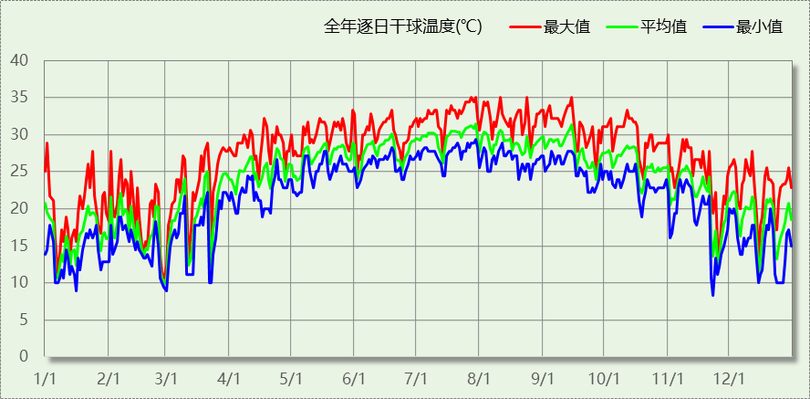

## 逐月辐照量表

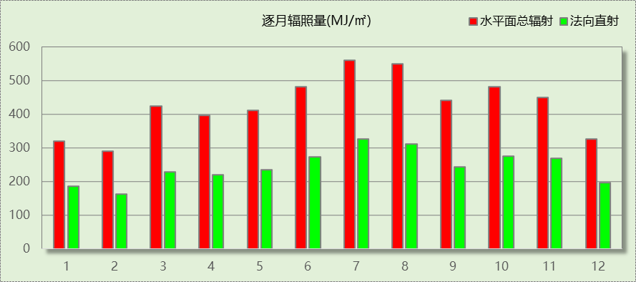

## 峰值工况

|  |  |  |  |  |  |
| --- | --- | --- | --- | --- | --- |
| 气象数据 | 时刻 | 干球温度(℃) | 湿球温度(℃) | 含湿量(g/kg) | 焓值(kj/kg) |
| 最热 | 07月27日14时 | 35.0 | 27.2 | 20.6 | 88.0 |
| 最冷 | 11月22日04时 | 8.3 | 5.6 | 4.3 | 19.2 |

# 建筑大样

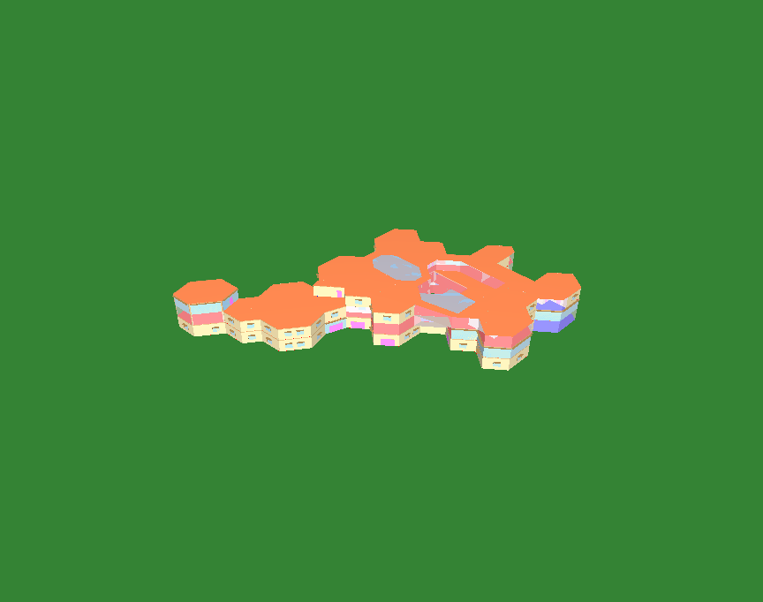

西南轴侧图

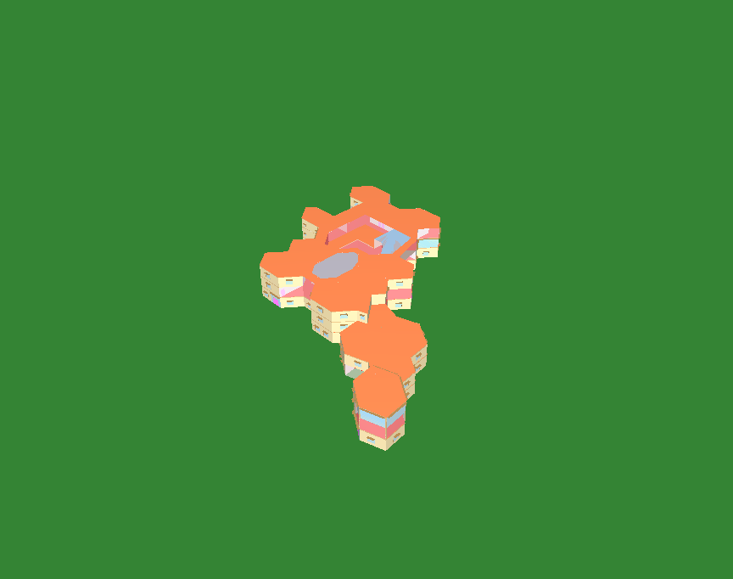

东南轴侧图

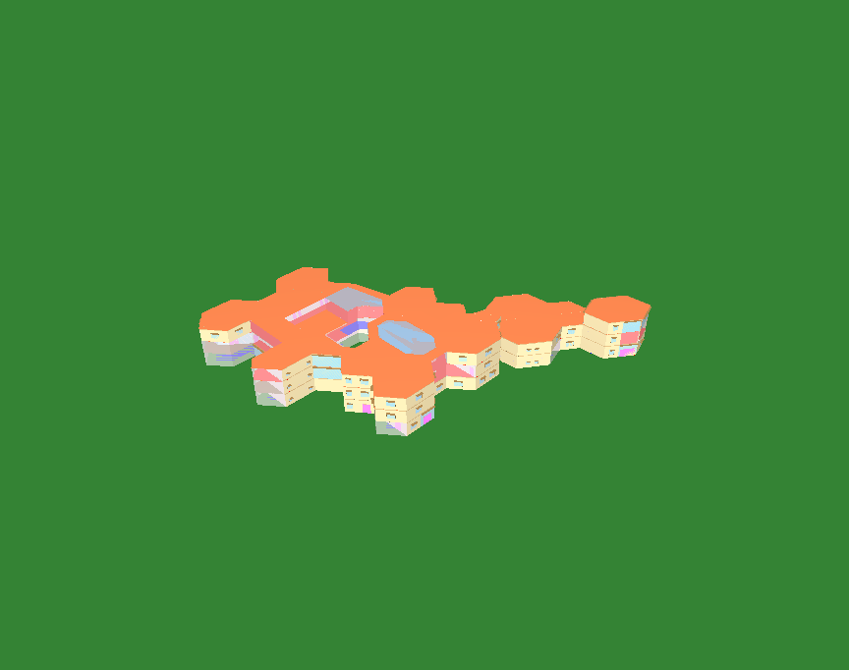

西北轴侧图

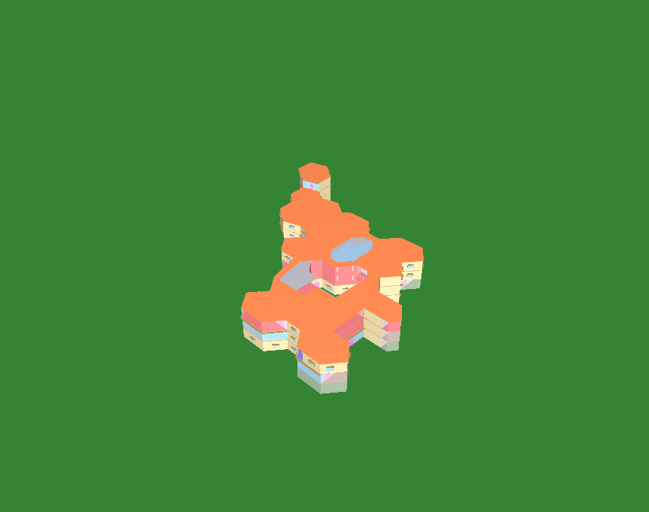

东北轴侧图

# 围护结构

## 工程材料

|  |  |  |  |  |  |  |
| --- | --- | --- | --- | --- | --- | --- |
| 材料名称 | 导热系数λ | 蓄热系数S | 密度ρ | 比热容Cp | 蒸汽渗透 系数u | 数据来源 |
| W/(m.K) | W/(㎡.K) | kg/m3 | J/(kg.K) | g/(m.h.kPa) |
| 水泥砂浆 | 0.930 | 11.370 | 1800.0 | 1050.0 | 0.0210 |  |
| 聚苯乙烯泡沫塑料（灰板） | 0.033 | 0.280 | 20.0 | 1380.0 | 0.0162 |  |
| 石灰砂浆 | 0.810 | 10.070 | 1600.0 | 1050.0 | 0.0443 |  |
| 钢筋混凝土 | 1.740 | 17.200 | 2500.0 | 920.0 | 0.0158 |  |
| 挤塑聚苯板(ρ=25-32) | 0.030 | 0.320 | 28.5 | 1647.0 | 0.0162 |  |
| 加气混凝土、泡沫混凝土(ρ=700) | 0.180 | 3.100 | 700.0 | 1050.0 | 0.0998 |  |
| 混凝土多孔砖(190六孔砖） | 0.750 | 7.490 | 1450.0 | 709.4 | 0.0010 |  |
| 岩棉板(ρ=60-160) | 0.041 | 0.615 | 110.0 | 1220.0 | 0.4880 |  |
| c20细石混凝土(ρ=2300) | 1.510 | 15.243 | 2300.0 | 920.0 | 0.0173 |  |
| 轻骨料混凝土(找坡层) | 0.300 | 5.000 | 1050.0 | 1091.3 | 0.0140 |  |
| 石墨聚苯板 | 0.033 | 0.280 | 20.0 | 1633.5 | 0.0162 |  |

## 屋顶

### 屋顶构造一

|  |  |  |  |  |  |  |
| --- | --- | --- | --- | --- | --- | --- |
| 材料名称 （由上到下） | 厚度δ | 导热系数λ | 蓄热系数S | 修正 系数 | 热阻R | 热惰性 指标 |
| (mm) | W/(m.K) | W/(㎡.K) | α | (㎡K)/W | D=R*S |
| 加气混凝土、泡沫混凝土(ρ=700) | 20 | 0.180 | 3.100 | 1.00 | 0.111 | 0.344 |
| c20细石混凝土(ρ=2300) | 40 | 1.510 | 15.243 | 1.00 | 0.026 | 0.404 |
| 挤塑聚苯板(ρ=25-32) | 110 | 0.030 | 0.320 | 1.10 | 3.333 | 1.173 |
| 轻骨料混凝土(找坡层) | 30 | 0.300 | 5.000 | 1.50 | 0.067 | 0.500 |
| 钢筋混凝土 | 120 | 1.740 | 17.200 | 1.00 | 0.069 | 1.186 |
| 石灰砂浆 | 20 | 0.810 | 10.070 | 1.00 | 0.025 | 0.249 |
| 各层之和∑ | 340 | － | － | － | 3.631 | 3.856 |
| 外表面太阳辐射吸收系数 | 0.75[默认] | | | | | |
| 传热系数K=1/(0.15+∑R) | 0.26 | | | | | |

## 天窗类型

|  |  |  |  |  |  |  |
| --- | --- | --- | --- | --- | --- | --- |
| 序号 | 构造名称 | 构造编号 | 传热系数 | 夏季综合 太阳得热系数 | 冬季综合 太阳得热系数 | 备注 |
| 1 | 60系列内平开下悬玻璃钢窗[5涂膜+12A+5Low-E] | 107 | 2.20 | 0.22 | 0.22 |  |
| 平均 | |  | 2.20 | 0.22 | 0.22 |  |

## 外墙

### 外墙相关构造

#### 外墙构造一

|  |  |  |  |  |  |  |
| --- | --- | --- | --- | --- | --- | --- |
| 材料名称 （由外到内） | 厚度δ | 导热系数λ | 蓄热系数S | 修正 系数 | 热阻R | 热惰性 指标 |
| (mm) | W/(m.K) | W/(㎡.K) | α | (㎡K)/W | D=R*S |
| 水泥砂浆 | 20 | 0.930 | 11.370 | 1.00 | 0.022 | 0.245 |
| 石墨聚苯板 | 70 | 0.033 | 0.280 | 1.10 | 1.928 | 0.594 |
| 钢筋混凝土 | 200 | 1.740 | 17.200 | 1.00 | 0.115 | 1.977 |
| 石灰砂浆 | 20 | 0.810 | 10.070 | 1.00 | 0.025 | 0.249 |
| 各层之和∑ | 310 | － | － | － | 2.090 | 3.064 |
| 外表面太阳辐射吸收系数 | 0.75[默认] | | | | | |
| 传热系数K=1/(0.15+∑R) | 0.45 | | | | | |

#### 热桥梁构造一

|  |  |  |  |  |  |  |
| --- | --- | --- | --- | --- | --- | --- |
| 材料名称 （由外到内） | 厚度δ | 导热系数λ | 蓄热系数S | 修正 系数 | 热阻R | 热惰性 指标 |
| (mm) | W/(m.K) | W/(㎡.K) | α | (㎡K)/W | D=R*S |
| 水泥砂浆 | 20 | 0.930 | 11.370 | 1.00 | 0.022 | 0.245 |
| 石墨聚苯板 | 70 | 0.033 | 0.280 | 1.10 | 1.928 | 0.594 |
| 钢筋混凝土 | 200 | 1.740 | 17.200 | 1.00 | 0.115 | 1.977 |
| 石灰砂浆 | 20 | 0.810 | 10.070 | 1.00 | 0.025 | 0.249 |
| 各层之和∑ | 310 | － | － | － | 2.090 | 3.064 |
| 外表面太阳辐射吸收系数 | 0.75[默认] | | | | | |
| 传热系数K=1/(0.15+∑R) | 0.45 | | | | | |

#### 热桥柱构造一

|  |  |  |  |  |  |  |
| --- | --- | --- | --- | --- | --- | --- |
| 材料名称 （由外到内） | 厚度δ | 导热系数λ | 蓄热系数S | 修正 系数 | 热阻R | 热惰性 指标 |
| (mm) | W/(m.K) | W/(㎡.K) | α | (㎡K)/W | D=R*S |
| 水泥砂浆 | 20 | 0.930 | 11.370 | 1.00 | 0.022 | 0.245 |
| 石墨聚苯板 | 70 | 0.033 | 0.280 | 1.10 | 1.928 | 0.594 |
| 钢筋混凝土 | 200 | 1.740 | 17.200 | 1.00 | 0.115 | 1.977 |
| 石灰砂浆 | 20 | 0.810 | 10.070 | 1.00 | 0.025 | 0.249 |
| 各层之和∑ | 310 | － | － | － | 2.090 | 3.064 |
| 外表面太阳辐射吸收系数 | 0.75[默认] | | | | | |
| 传热系数K=1/(0.15+∑R) | 0.45 | | | | | |

### 外墙平均热工特性

1.　南向

|  |  |  |  |  |  |  |
| --- | --- | --- | --- | --- | --- | --- |
| 构造名称 | 构件 类型 | 面积(㎡) | 面积所占比例 | 传热系数K W / (㎡K) | 热惰性 指标D | 太阳辐射 吸收系数 |
| 外墙构造一 | 主墙体 | 408.43 | 0.915 | 0.45 | 3.06 | 0.75 |
| 热桥梁构造一 | 热桥梁 | 35.63 | 0.080 | 0.45 | 3.06 | 0.75 |
| 热桥柱构造一 | 热桥柱 | 1.77 | 0.004 | 0.45 | 3.06 | 0.75 |
| 热桥梁构造一 | 窗过梁 | 0.59 | 0.001 | 0.45 | 3.06 | 0.75 |
| 合计 |  | 446.41 | 1.000 | 0.45 | 3.06 | 0.75 |

2.　北向

|  |  |  |  |  |  |  |
| --- | --- | --- | --- | --- | --- | --- |
| 构造名称 | 构件 类型 | 面积(㎡) | 面积所占比例 | 传热系数K W / (㎡K) | 热惰性 指标D | 太阳辐射 吸收系数 |
| 外墙构造一 | 主墙体 | 418.20 | 0.922 | 0.45 | 3.06 | 0.75 |
| 热桥梁构造一 | 热桥梁 | 35.16 | 0.077 | 0.45 | 3.06 | 0.75 |
| 热桥梁构造一 | 窗过梁 | 0.42 | 0.001 | 0.45 | 3.06 | 0.75 |
| 合计 |  | 453.78 | 1.000 | 0.45 | 3.06 | 0.75 |

3.　东向

|  |  |  |  |  |  |  |
| --- | --- | --- | --- | --- | --- | --- |
| 构造名称 | 构件 类型 | 面积(㎡) | 面积所占比例 | 传热系数K W / (㎡K) | 热惰性 指标D | 太阳辐射 吸收系数 |
| 外墙构造一 | 主墙体 | 334.07 | 0.909 | 0.45 | 3.06 | 0.75 |
| 热桥梁构造一 | 热桥梁 | 30.98 | 0.084 | 0.45 | 3.06 | 0.75 |
| 热桥柱构造一 | 热桥柱 | 2.27 | 0.006 | 0.45 | 3.06 | 0.75 |
| 热桥梁构造一 | 窗过梁 | 0.26 | 0.001 | 0.45 | 3.06 | 0.75 |
| 合计 |  | 367.58 | 1.000 | 0.45 | 3.06 | 0.75 |

4.　西向

|  |  |  |  |  |  |  |
| --- | --- | --- | --- | --- | --- | --- |
| 构造名称 | 构件 类型 | 面积(㎡) | 面积所占比例 | 传热系数K W / (㎡K) | 热惰性 指标D | 太阳辐射 吸收系数 |
| 外墙构造一 | 主墙体 | 373.49 | 0.920 | 0.45 | 3.06 | 0.75 |
| 热桥梁构造一 | 热桥梁 | 30.13 | 0.074 | 0.45 | 3.06 | 0.75 |
| 热桥柱构造一 | 热桥柱 | 2.16 | 0.005 | 0.45 | 3.06 | 0.75 |
| 热桥梁构造一 | 窗过梁 | 0.33 | 0.001 | 0.45 | 3.06 | 0.75 |
| 合计 |  | 406.11 | 1.000 | 0.45 | 3.06 | 0.75 |

5.　总体

|  |  |  |  |  |  |  |
| --- | --- | --- | --- | --- | --- | --- |
| 构造名称 | 构件 类型 | 面积(㎡) | 面积所占比例 | 传热系数K W / (㎡K) | 热惰性 指标D | 太阳辐射 吸收系数 |
| 外墙构造一 | 主墙体 | 1534.19 | 0.917 | 0.45 | 3.06 | 0.75 |
| 热桥梁构造一 | 热桥梁 | 131.90 | 0.079 | 0.45 | 3.06 | 0.75 |
| 热桥柱构造一 | 热桥柱 | 6.20 | 0.004 | 0.45 | 3.06 | 0.75 |
| 热桥梁构造一 | 窗过梁 | 1.59 | 0.001 | 0.45 | 3.06 | 0.75 |
| 合计 |  | 1673.88 | 1.000 | 0.45 | 3.06 | 0.75 |

## 外窗热工

### 外窗

|  |  |  |  |  |  |  |
| --- | --- | --- | --- | --- | --- | --- |
| 序号 | 构造名称 | 构造 编号 | 传热 系数 | 窗遮阳 系数 | 可见光 透射比 | 数据来源 |
| 1 | 60系列内平开下悬铝合金窗[5涂膜+12A+5Low-E] | 108 | 2.30 | 0.27 | 0.620 | 建筑节能门窗 16J607 |
| 窗编号 | | | | |
| 幕墙 | | | | |
| 2 | 70系列断桥铝窗5Low-E+0.3V+5 | 18 | 0.97 | 0.55 | 0.710 |  |
| 窗编号 | | | | |
| C1815，C0909，C1215 | | | | |

### 外遮阳类型

#### 平板遮阳

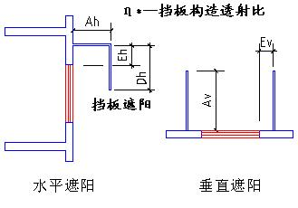

|  |  |  |  |  |  |  |  |
| --- | --- | --- | --- | --- | --- | --- | --- |
| 序号 | 编号 | 水平挑出Ah (m) | 距离上沿Eh (m) | 垂直挑出Av (m) | 距离边沿Ev (m) | 挡板高Dh (m) | 挡板透射η* |
| 1 | 平板遮阳0 | 0.600 | 0.000 | 0.100 | 0.000 | 0.000 | 0.000 |
| 2 | 平板遮阳0 | 0.500 | 0.000 | 0.000 | 0.000 | 0.000 | 0.000 |

### 总体热工性能

|  |  |  |  |  |  |  |  |
| --- | --- | --- | --- | --- | --- | --- | --- |
| 朝向 | 面积 | 传热系数 | 夏季综合 太阳得热系数 | 冬季综合 太阳得热系数 | 窗墙比 | 标准要求 | 结论 |
| 南向 | 143.69 | 1.88 | 0.24 | 0.24 | 0.23 | K≤2.80, SHGCSum≤0.15, SHGCWin(不要求) | 不需要 |
| 北向 | 129.77 | 1.91 | 0.25 | 0.25 | 0.22 | K≤2.80, SHGCSum≤0.15, SHGCWin(不要求) | 不需要 |
| 东向 | 153.39 | 1.86 | 0.25 | 0.25 | 0.29 | K≤2.80, SHGCSum≤0.15, SHGCWin(不要求) | 不需要 |
| 西向 | 98.11 | 1.62 | 0.27 | 0.27 | 0.19 | K≤2.80, SHGCSum≤0.15, SHGCWin(不要求) | 不需要 |
| 综合平均 | 524.97 | 1.83 | 0.25 | 0.25 | 0.23 |  |  |
| 标准依据 | 《近零能耗建筑技术标准》(GB/T51350-2019)第6.1.5条 | | | | | | |
| 标准要求 | K和SHGC值可按表6.1.5-2选取 | | | | | | |
| 结论 | 不需要 | | | | | | |

注：本表所统计的外窗包含凸窗。

## 外窗气密性

|  |  |
| --- | --- |
| 最不利气密性等级 | 6级（窗编号：C0909） |
| 外窗气密性措施 |  |
| 标准依据 | 《近零能耗建筑技术标准》第6.1.4条，分级与检测方法《建筑幕墙、门窗通用技术条件》(GB/T31433-2015) |
| 标准要求 | 外窗及外门户门气密性不宜低于《建筑幕墙、门窗通用技术条件》(GB/T31433-2015)的8级 |
| 结论 | 不适宜 |

## 外门气密性

|  |  |
| --- | --- |
| 最不利气密性等级 | 4级（窗编号：FJM1824） |
| 外门气密性措施 |  |
| 标准依据 | 《近零能耗建筑技术标准》第6.1.4条，分级与检测方法《建筑幕墙、门窗通用技术条件》(GB/T31433-2015) |
| 标准要求 | 外窗及外门户门气密性不宜低于《建筑幕墙、门窗通用技术条件》(GB/T31433-2015)的6级 |
| 结论 | 不适宜 |

## 户门气密性

|  |  |
| --- | --- |
| 最不利气密性等级 | － |
| 户门气密性措施 |  |
| 标准依据 | 《近零能耗建筑技术标准》第6.1.4条，分级与检测方法《建筑幕墙、门窗通用技术条件》(GB/T31433-2015) |
| 标准要求 | 外窗及外门户门气密性不宜低于《建筑幕墙、门窗通用技术条件》(GB/T31433-2015)的6级 |
| 结论 | － |

## 规定项检查

|  |  |  |
| --- | --- | --- |
| 序号 | 检查项 | 结论 |
| 1 | 屋顶 | 不需要 |
| 2 | 天窗类型 | 不需要 |
| 3 | 外墙 | 不需要 |
| 4 | 外窗热工 | 不需要 |
| 5 | 外窗气密性 | 不适宜 |
| 6 | 外门气密性 | 不适宜 |
| 7 | 户门气密性 | 适宜 |

# 围护结构概况

|  |  |  |  |  |  |  |  |
| --- | --- | --- | --- | --- | --- | --- | --- |
|  | | 设计建筑 | | | 基准建筑 | | |
| 屋顶传热系数K  和热惰性指标 D | | 0.26  3.86 | | | 0.80  2.97 | | |
| 外墙传热系数K  和热惰性指标 D | | 0.45  3.06 | | | 1.50  2.58 | | |
| 挑空(或架空)楼板传热系数K  和热惰性指标 D | | 0.42  2.43 | | | 1.50  1.82 | | |
| 天窗传热系数K  和太阳得热系数 SHGC | | 2.20  0.22 | | | 3.00  0.30 | | |
| 外窗（包括透明幕墙） | 朝向 | 窗墙比 | 传热  系数 | 太阳得热系数 | 窗墙比 | 传热  系数 | 太阳得热系数 |
| 南向 | 0.23 | 1.88 | 0.24 | 0.23 | 4.00 | 0.44 |
| 北向 | 0.22 | 1.91 | 0.25 | 0.22 | 4.00 | 0.52 |
| 东向 | 0.29 | 1.86 | 0.25 | 0.29 | 4.00 | 0.44 |
| 西向 | 0.19 | 1.62 | 0.27 | 0.19 | 5.20 | 0.52 |

备注：

1. 传热系数的单位W/(m2.k)，其他参数无量纲.

2. 屋顶和外墙的传热系数K和热情性指标D指平均值.

# 设计建筑

## 房间类型

### 房间参数表

|  |  |  |  |  |  |  |  |
| --- | --- | --- | --- | --- | --- | --- | --- |
| 房间类型 | 空调 温度℃ | 供暖 温度℃ | 新风量 | 渗透风 换气次数 | 人员密度 | 照明功率 密度 | 电器设备 功率 |
| 健身活动室 | 26 | 20 | 30(m3/h.人) | 0(次/h) | 8(㎡/人) | 2(W/㎡) | 2(W/㎡) |
| 办公-普通办公室 | 26 | 20 | 30(m3/h.人) | 0(次/h) | 10(㎡/人) | 8(W/㎡) | 13(W/㎡) |
| 卫生间 | 26 | 20 | 30(m3/h.人) | 0(次/h) | 10(㎡/人) | 2(W/㎡) | 2(W/㎡) |
| 多媒体教室 | 26 | 20 | 30(m3/h.人) | 0(次/h) | 1.12(㎡/人) | 2(W/㎡) | 2(W/㎡) |
| 大厅 | 26 | 20 | 30(m3/h.人) | 0(次/h) | 20(㎡/人) | 2(W/㎡) | 2(W/㎡) |
| 实验教室 | 26 | 20 | 30(m3/h.人) | 0(次/h) | 1.12(㎡/人) | 2(W/㎡) | 2(W/㎡) |
| 密集办公室 | 26 | 20 | 30(m3/h.人) | 0(次/h) | 4(㎡/人) | 2(W/㎡) | 2(W/㎡) |
| 报告厅 | 26 | 20 | 30(m3/h.人) | 0(次/h) | 4(㎡/人) | 2(W/㎡) | 2(W/㎡) |
| 普通办公室 | 26 | 20 | 30(m3/h.人) | 0(次/h) | 10(㎡/人) | 2(W/㎡) | 2(W/㎡) |
| 楼梯间 | － | － | 20(m3/h.人) | 0(次/h) | 50(㎡/人) | 2(W/㎡) | 2(W/㎡) |
| 空房间 | － | － | 20(m3/h.人) | 0(次/h) | 50(㎡/人) | 2(W/㎡) | 2(W/㎡) |
| 美术教室 | 26 | 20 | 30(m3/h.人) | 0(次/h) | 1.12(㎡/人) | 2(W/㎡) | 2(W/㎡) |
| 舞蹈教室 | 26 | 20 | 30(m3/h.人) | 0(次/h) | 1.12(㎡/人) | 2(W/㎡) | 2(W/㎡) |
| 计算机房 | 26 | 20 | 30(m3/h.人) | 0(次/h) | 10(㎡/人) | 2(W/㎡) | 2(W/㎡) |
| 设备间 | － | － | 0(m3/h.人) | 0(次/h) | 0(人) | 2(W/㎡) | 2(W/㎡) |
| 走廊 | 26 | 20 | 30(m3/h.人) | 0(次/h) | 20(㎡/人) | 2(W/㎡) | 2(W/㎡) |
| 阅览室 | 26 | 20 | 30(m3/h.人) | 0(次/h) | 2.5(㎡/人) | 2(W/㎡) | 2(W/㎡) |
| 阶梯教室 | 26 | 20 | 30(m3/h.人) | 0(次/h) | 1.12(㎡/人) | 2(W/㎡) | 2(W/㎡) |
| 音乐教室 | 26 | 20 | 30(m3/h.人) | 0(次/h) | 1.12(㎡/人) | 2(W/㎡) | 2(W/㎡) |
| 风雨操场 | 26 | 20 | 30(m3/h.人) | 0(次/h) | 8(㎡/人) | 2(W/㎡) | 2(W/㎡) |
| 餐厅 | 26 | 20 | 30(m3/h.人) | 0(次/h) | 4(㎡/人) | 2(W/㎡) | 2(W/㎡) |

### 作息时间表

详见附录

## 系统类型

### 系统分区

|  |  |  |  |  |  |
| --- | --- | --- | --- | --- | --- |
| 系统编号 | 系统类型 | 制冷 SEER | 制热 HSPF | 面积(㎡) | 包含的房间 |
| 默认 | 双管制风机盘管 | － | － | 5091.82 | 所有房间 |

### 热回收参数

|  |  |  |  |  |  |
| --- | --- | --- | --- | --- | --- |
| 系统编号 | 热回收 | 供冷 | | 供暖 | |
| 回收效率 | 启动温(焓)差 | 回收效率 | 启动温(焓)差 |
| 默认 | 无 | － | － | － | － |

## 制冷系统

### 默认冷源

#### 供应的系统

|  |  |
| --- | --- |
| 系统编号 | 默认 |

#### 冷水机组

根据《民用建筑绿色性能计算标准》表5.3.4-2的要求，区域冷源按电动离心/螺杆式冷水机组计算。

软件按电动离心式冷水机组计算。

|  |  |  |  |  |  |  |  |  |
| --- | --- | --- | --- | --- | --- | --- | --- | --- |
| 名称 | 类型 | 额定 耗电量(kW) | 额定 制冷量(kW) | 额定性 能系数 (COP) | 台数 | 全年 供冷量(kWh) | 综合部分 负荷性能系数(IPLV) | 电耗 (kWh) |
| 机组1 | 水冷-离心式冷水机组 | 133.90 | 777 | 5.80 | 1 | 262237 | 5.90 | 44447 |

#### 冷却水泵

|  |  |  |  |  |  |  |
| --- | --- | --- | --- | --- | --- | --- |
| 机组名称 | 冷水机组 制冷量(kW) | 机组性能 系数(COP) | 冷凝负荷(kW) | 输送能效比 | 运行时长 (h) | 水泵电耗 (kWh) |
| 机组1 | 776.63 | 5.80 | 911 | 0.0214 | 620 | 12081 |

#### 冷冻水泵

|  |  |  |  |  |
| --- | --- | --- | --- | --- |
| 机组名称 | 机组制冷量(kW) | 输送能效比 | 运行时长(h) | 水泵电耗(kWh) |
| 机组1 | 776.63 | 0.0241 | 620 | 11604 |

#### 冷却塔

|  |  |  |  |  |  |
| --- | --- | --- | --- | --- | --- |
| 类型 | 机组制冷量(kW) | 冷却塔风机单位 电耗制冷量(kW/kW) | 冷却塔风机 功率(kW) | 运行时长(h) | 冷却塔电耗 (kWh) |
| 冷却塔 | 776.63 | 170 | 4.568 | 620 | 2832 |

## 照明

|  |  |  |  |  |
| --- | --- | --- | --- | --- |
| 房间类型 | 单位面积电耗 (kWh/㎡) | 房间个数 | 房间合计面积 (㎡) | 合计电耗 (kWh) |
| 健身活动室 | 3.07 | 1 | 240 | 735 |
| 卫生间 | 5.69 | 50 | 199 | 1135 |
| 多媒体教室 | 3.95 | 1 | 120 | 474 |
| 大厅 | 0.57 | 8 | 1340 | 763 |
| 实验教室 | 3.95 | 1 | 120 | 474 |
| 密集办公室 | 5.69 | 1 | 200 | 1138 |
| 报告厅 | 5.69 | 1 | 120 | 683 |
| 普通办公室 | 5.69 | 21 | 1139 | 6487 |
| 楼梯间 | 4.82 | 11 | 238 | 1146 |
| 空房间 | 4.82 | 12 | 251 | 1211 |
| 美术教室 | 3.95 | 1 | 46 | 183 |
| 舞蹈教室 | 3.95 | 1 | 70 | 277 |
| 计算机房 | 5.69 | 1 | 51 | 290 |
| 设备间 | 0.00 | 1 | 23 | 0 |
| 走廊 | 0.57 | 6 | 790 | 450 |
| 阅览室 | 3.95 | 1 | 420 | 1659 |
| 阶梯教室 | 3.95 | 2 | 185 | 731 |
| 音乐教室 | 3.95 | 1 | 100 | 395 |
| 风雨操场 | 3.07 | 1 | 77 | 236 |
| 餐厅 | 4.42 | 3 | 73 | 323 |
| 总计 | | | | 18794 |

## 光伏发电

|  |  |
| --- | --- |
| 月 | 发电量(kWh) |
| 1 | 17500 |
| 2 | 17500 |
| 3 | 16000 |
| 4 | 18000 |
| 5 | 25000 |
| 6 | 22500 |
| 7 | 27000 |
| 8 | 22500 |
| 9 | 24500 |
| 10 | 26500 |
| 11 | 20000 |
| 12 | 18000 |
| 总计 | 255000 |

## 负荷分项统计

|  |  |  |  |  |  |  |
| --- | --- | --- | --- | --- | --- | --- |
| 分类 | 围护传热 | 室内得热 | 窗日射 | 新风/渗透 | 热回收 | 合计 |
| 供暖(kWh/㎡) | 0.00 | 0.00 | 0.00 | 0.00 | 0.00 | 0.00 |
| 供冷(kWh/㎡) | 6.00 | 4.59 | 1.86 | 32.15 | 0.00 | 44.61 |

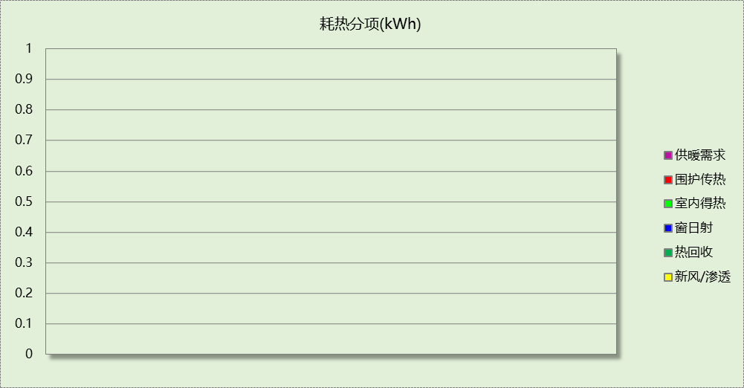

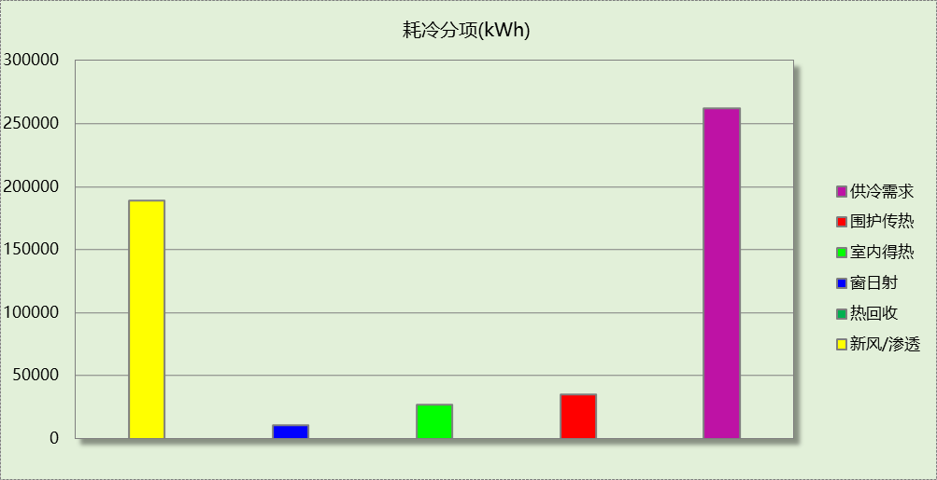

## 逐月负荷表

|  |  |  |  |  |  |  |
| --- | --- | --- | --- | --- | --- | --- |
| 月份 | 供暖(kWh) | 供冷(kWh) | 热负荷 峰值(kW) | 热负荷 峰值时刻 | 冷负荷 峰值(kW) | 冷负荷 峰值时刻 |
| 1月 | 0 | 0 | 0.000 | -- | 0.000 | -- |
| 2月 | 0 | 0 | 0.000 | -- | 0.000 | -- |
| 3月 | 0 | 0 | 0.000 | -- | 0.000 | -- |
| 4月 | 0 | 0 | 0.000 | -- | 0.000 | -- |
| 5月 | 0 | 0 | 0.000 | -- | 0.000 | -- |
| 6月 | 0 | 84620 | 0.000 | -- | 499.691 | 6月17日8时 |
| 7月 | 0 | 52101 | 0.000 | -- | 540.818 | 7月8日8时 |
| 8月 | 0 | 31336 | 0.000 | -- | 776.629 | 8月26日8时 |
| 9月 | 0 | 94179 | 0.000 | -- | 649.267 | 9月12日14时 |
| 10月 | 0 | 0 | 0.000 | -- | 0.000 | -- |
| 11月 | 0 | 0 | 0.000 | -- | 0.000 | -- |
| 12月 | 0 | 0 | 0.000 | -- | 0.000 | -- |

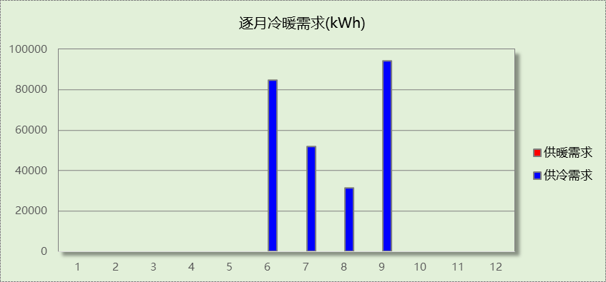

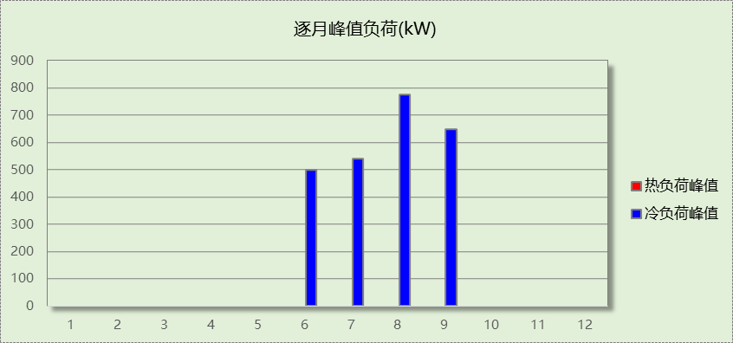

# 基准建筑

## 房间类型

### 房间参数表

|  |  |  |  |  |  |  |  |
| --- | --- | --- | --- | --- | --- | --- | --- |
| 房间类型 | 空调 温度℃ | 供暖 温度℃ | 新风量 | 渗透风 换气次数 | 人员密度 | 照明功率 密度 | 电器设备 功率 |
| 健身活动室 | 26 | 20 | 30(m3/h.人) | 0(次/h) | 8(㎡/人) | 11(W/㎡) | 0(W/㎡) |
| 办公-普通办公室 | 26 | 20 | 30(m3/h.人) | 0(次/h) | 10(㎡/人) | 9(W/㎡) | 13(W/㎡) |
| 卫生间 | 26 | 20 | 30(m3/h.人) | 0(次/h) | 10(㎡/人) | 8(W/㎡) | 13(W/㎡) |
| 多媒体教室 | 26 | 20 | 30(m3/h.人) | 0(次/h) | 1.12(㎡/人) | 9(W/㎡) | 5(W/㎡) |
| 大厅 | 26 | 20 | 30(m3/h.人) | 0(次/h) | 20(㎡/人) | 10(W/㎡) | 0(W/㎡) |
| 实验教室 | 26 | 20 | 30(m3/h.人) | 0(次/h) | 1.12(㎡/人) | 9(W/㎡) | 5(W/㎡) |
| 密集办公室 | 26 | 20 | 30(m3/h.人) | 0(次/h) | 4(㎡/人) | 13.5(W/㎡) | 20(W/㎡) |
| 报告厅 | 26 | 20 | 30(m3/h.人) | 0(次/h) | 4(㎡/人) | 13.5(W/㎡) | 20(W/㎡) |
| 普通办公室 | 26 | 20 | 30(m3/h.人) | 0(次/h) | 10(㎡/人) | 8(W/㎡) | 13(W/㎡) |
| 楼梯间 | － | － | 20(m3/h.人) | 0(次/h) | 50(㎡/人) | 0(W/㎡) | 0(W/㎡) |
| 空房间 | － | － | 20(m3/h.人) | 0(次/h) | 50(㎡/人) | 0(W/㎡) | 0(W/㎡) |
| 美术教室 | 26 | 20 | 30(m3/h.人) | 0(次/h) | 1.12(㎡/人) | 9(W/㎡) | 5(W/㎡) |
| 舞蹈教室 | 26 | 20 | 30(m3/h.人) | 0(次/h) | 1.12(㎡/人) | 9(W/㎡) | 5(W/㎡) |
| 计算机房 | 26 | 20 | 30(m3/h.人) | 0(次/h) | 10(㎡/人) | 8(W/㎡) | 13(W/㎡) |
| 设备间 | － | － | 0(m3/h.人) | 0(次/h) | 0(人) | 5(W/㎡) | 0(W/㎡) |
| 走廊 | 26 | 20 | 30(m3/h.人) | 0(次/h) | 20(㎡/人) | 10(W/㎡) | 0(W/㎡) |
| 阅览室 | 26 | 20 | 30(m3/h.人) | 0(次/h) | 2.5(㎡/人) | 10(W/㎡) | 5(W/㎡) |
| 阶梯教室 | 26 | 20 | 30(m3/h.人) | 0(次/h) | 1.12(㎡/人) | 9(W/㎡) | 5(W/㎡) |
| 音乐教室 | 26 | 20 | 30(m3/h.人) | 0(次/h) | 1.12(㎡/人) | 9(W/㎡) | 5(W/㎡) |
| 风雨操场 | 26 | 20 | 30(m3/h.人) | 0(次/h) | 8(㎡/人) | 11(W/㎡) | 0(W/㎡) |
| 餐厅 | 26 | 20 | 30(m3/h.人) | 0(次/h) | 4(㎡/人) | 9(W/㎡) | 0(W/㎡) |

### 作息时间表

同设计建筑

## 系统类型

|  |  |  |  |  |  |
| --- | --- | --- | --- | --- | --- |
| 系统编号 | 系统类型 | 制冷 SEER | 制热 HSPF | 面积(㎡) | 包含的房间 |
| 默认 | 双管制风机盘管 | － | － | 同设计建筑 | 同设计建筑 |

## 制冷系统

### 默认冷源

#### 供应的系统

|  |  |
| --- | --- |
| 系统编号 | 默认 |

#### 冷水机组

|  |  |  |  |  |  |  |  |  |
| --- | --- | --- | --- | --- | --- | --- | --- | --- |
| 名称 | 类型 | 额定 耗电量(kW) | 额定 制冷量(kW) | 额定性 能系数 (COP) | 台数 | 全年 供冷量(kWh) | 综合部分 负荷性能系数(IPLV) | 电耗 (kWh) |
| 机组1 | 水冷-螺杆式冷水机组 | 176.63 | 936.15 | 5.30 | 1 | 325835 | 6.00 | 54306 |
| 合计 | | | | | | | | 54306 |

#### 冷却水泵

|  |  |  |  |  |  |  |
| --- | --- | --- | --- | --- | --- | --- |
| 机组名称 | 冷水机组 制冷量(kW) | 机组性能 系数(COP) | 冷凝负荷(kW) | 输送能效比 | 运行时长 (h) | 水泵电耗 (kWh) |
| 机组1 | 936 | 5.30 | 1113 | 0.0214 | 648 | 15431 |
| 合计 | 936 |  | 1113 |  |  | 15431 |

#### 冷冻水泵

|  |  |  |  |  |
| --- | --- | --- | --- | --- |
| 机组名称 | 机组制冷量(kW) | 输送能效比 | 运行时长(h) | 水泵电耗(kWh) |
| 机组1 | 936 | 0.0241 | 648 | 14620 |
| 合计 | 936 |  |  | 14620 |

#### 冷却塔

|  |  |  |  |  |  |
| --- | --- | --- | --- | --- | --- |
| 类型 | 机组制冷量(kW) | 冷却塔风机单位 电耗制冷量(kW/kW) | 冷却塔风机 功率(kW) | 运行时长(h) | 冷却塔电耗 (kWh) |
| 冷却塔 | 936 | 170 | 5.51 | 648 | 3568 |

## 照明

|  |  |  |  |  |
| --- | --- | --- | --- | --- |
| 房间类型 | 单位面积电耗 (kWh/㎡) | 房间个数 | 房间合计面积 (㎡) | 合计电耗 (kWh) |
| 健身活动室 | 16.86 | 1 | 240 | 4045 |
| 卫生间 | 22.78 | 50 | 199 | 4542 |
| 多媒体教室 | 17.78 | 1 | 120 | 2135 |
| 大厅 | 2.85 | 8 | 1340 | 3814 |
| 实验教室 | 17.78 | 1 | 120 | 2133 |
| 密集办公室 | 38.43 | 1 | 200 | 7683 |
| 报告厅 | 38.43 | 1 | 120 | 4612 |
| 普通办公室 | 22.78 | 21 | 1139 | 25950 |
| 楼梯间 | 0.00 | 11 | 238 | 0 |
| 空房间 | 0.00 | 12 | 251 | 0 |
| 美术教室 | 17.78 | 1 | 46 | 824 |
| 舞蹈教室 | 17.78 | 1 | 70 | 1244 |
| 计算机房 | 22.78 | 1 | 51 | 1162 |
| 设备间 | 0.00 | 1 | 23 | 0 |
| 走廊 | 2.85 | 6 | 790 | 2250 |
| 阅览室 | 19.75 | 1 | 420 | 8293 |
| 阶梯教室 | 17.78 | 2 | 185 | 3292 |
| 音乐教室 | 17.78 | 1 | 100 | 1778 |
| 风雨操场 | 16.86 | 1 | 77 | 1300 |
| 餐厅 | 19.87 | 3 | 73 | 1456 |
| 总计 | | | | 76512 |

## 负荷分项统计

|  |  |  |  |  |  |  |
| --- | --- | --- | --- | --- | --- | --- |
| 分类 | 围护传热 | 室内得热 | 窗日射 | 新风/渗透 | 热回收 | 合计 |
| 供暖(kWh/㎡) | 0.00 | 0.00 | 0.00 | 0.00 | 0.00 | 0.00 |
| 供冷(kWh/㎡) | 11.06 | 7.56 | 3.23 | 33.58 | 0.00 | 55.43 |



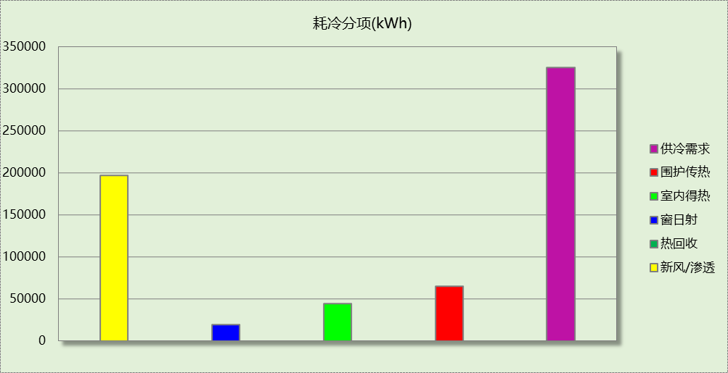

## 逐月负荷表

|  |  |  |  |  |  |  |
| --- | --- | --- | --- | --- | --- | --- |
| 月份 | 供暖(kWh) | 供冷(kWh) | 热负荷 峰值(kW) | 热负荷 峰值时刻 | 冷负荷 峰值(kW) | 冷负荷 峰值时刻 |
| 1月 | 0 | 0 | 0.000 | -- | 0.000 | -- |
| 2月 | 0 | 0 | 0.000 | -- | 0.000 | -- |
| 3月 | 0 | 0 | 0.000 | -- | 0.000 | -- |
| 4月 | 0 | 0 | 0.000 | -- | 0.000 | -- |
| 5月 | 0 | 0 | 0.000 | -- | 0.000 | -- |
| 6月 | 0 | 105620 | 0.000 | -- | 627.721 | 6月17日8时 |
| 7月 | 0 | 64514 | 0.000 | -- | 683.844 | 7月8日8时 |
| 8月 | 0 | 35333 | 0.000 | -- | 861.829 | 8月26日8时 |
| 9月 | 0 | 120368 | 0.000 | -- | 747.678 | 9月2日13时 |
| 10月 | 0 | 0 | 0.000 | -- | 0.000 | -- |
| 11月 | 0 | 0 | 0.000 | -- | 0.000 | -- |
| 12月 | 0 | 0 | 0.000 | -- | 0.000 | -- |

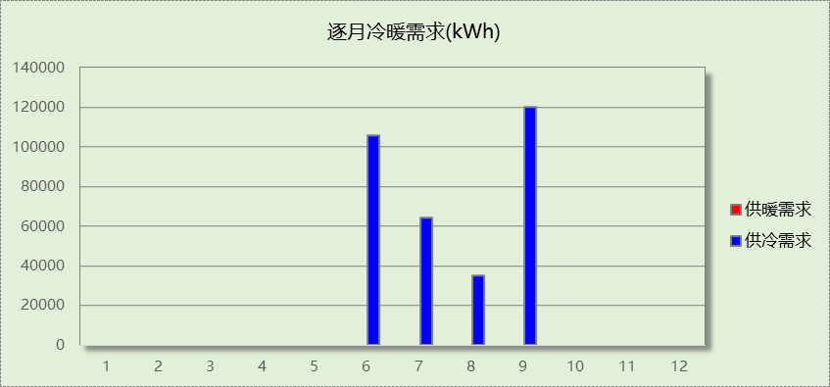

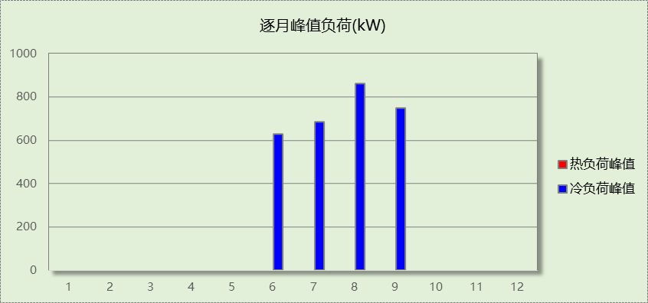

# 能效结果

## 建筑能耗

|  |  |  |  |  |
| --- | --- | --- | --- | --- |
| **设计建筑** | | | | |
| 用能分类 | | | 能耗值 | 一次能源(kWh/㎡) |
| 电力(kWh/㎡) | 供  冷 | 中央冷源 | 7.56 | 19.66 |
| 冷却水泵 | 2.06 | 5.36 |
| 冷冻水泵 | 1.97 | 5.12 |
| 冷却塔 | 0.48 | 1.25 |
| 多联机/单元式空调 | 0.00 | 0.00 |
| 供  暖 | 中央热源 | 0.00 | 0.00 |
| 供暖水泵 | 0.00 | 0.00 |
| 多联机/单元式热泵 | 0.00 | 0.00 |
| 热源侧水泵 | 0.00 | 0.00 |
| 照明 | | 3.20 | 8.32 |
| 生活热水 | | 0.00 | 0.00 |
| 电梯 | | 0.00 | 0.00 |
| 标准煤(kgce/㎡) | 供暖锅炉 | | 0.00 | 0.00 |
| 天然气(m³/㎡) | 供暖锅炉 | | 0.00 | 0.00 |
| 生活热水 | | 0.00 | 0.00 |
| 市政热力(kWh/㎡) | 市政热力 | | 0.00 | 0.00 |
| 可再生发电  (kWh/㎡) | 光伏发电 | | 43.38 | 112.79 |
| 风力发电 | | 0.00 | 0.00 |
| 建筑本体能耗(一次能源) (kWh/㎡) | | | 39.70 | |
| 建筑综合能耗(一次能源) (kWh/㎡) | | | 0.00 | |

|  |  |  |  |  |
| --- | --- | --- | --- | --- |
| **基准建筑** | | | | |
| 用能分类 | | | 能耗值 | 一次能源(kWh/㎡) |
| 电力(kWh/㎡) | 供  冷 | 中央冷源 | 9.24 | 24.02 |
| 冷却水泵 | 2.62 | 6.81 |
| 冷冻水泵 | 2.49 | 6.47 |
| 冷却塔 | 0.61 | 1.59 |
| 多联机/单元式空调 | 0.00 | 0.00 |
| 供  暖 | 中央热源 | 0.00 | 0.00 |
| 供暖水泵 | 0.00 | 0.00 |
| 多联机/单元式热泵 | 0.00 | 0.00 |
| 照明 | | 13.02 | 33.85 |
| 生活热水 | | 0.00 | 0.00 |
| 电梯 | | 0.00 | 0.00 |
| 标准煤(kgce/㎡) | 供暖锅炉 | | 0.00 | 0.00 |
| 天然气(m³/㎡) | 供暖锅炉 | | 0.00 | 0.00 |
| 生活热水 | | 0.00 | 0.00 |
| 市政热力(kWh/㎡) | 市政热力 | | 0.00 | 0.00 |
| 建筑本体能耗(一次能源) (kWh/㎡) | | | 72.73 | |
| 建筑综合能耗(一次能源) (kWh/㎡) | | | 72.73 | |

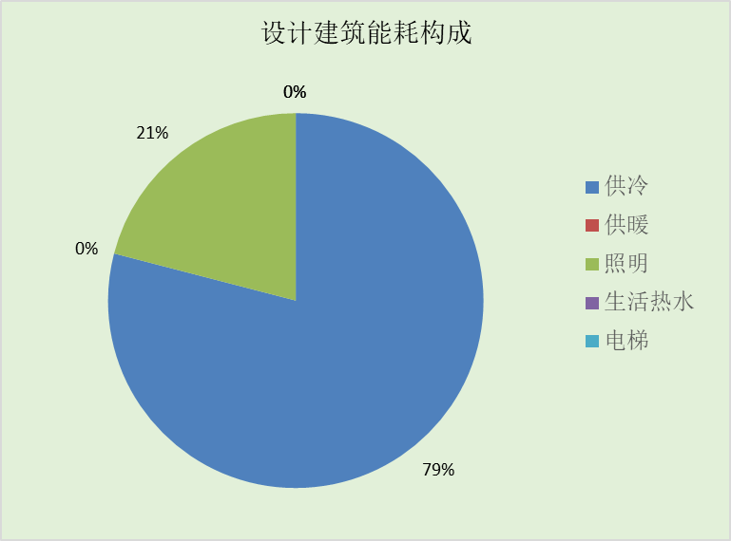

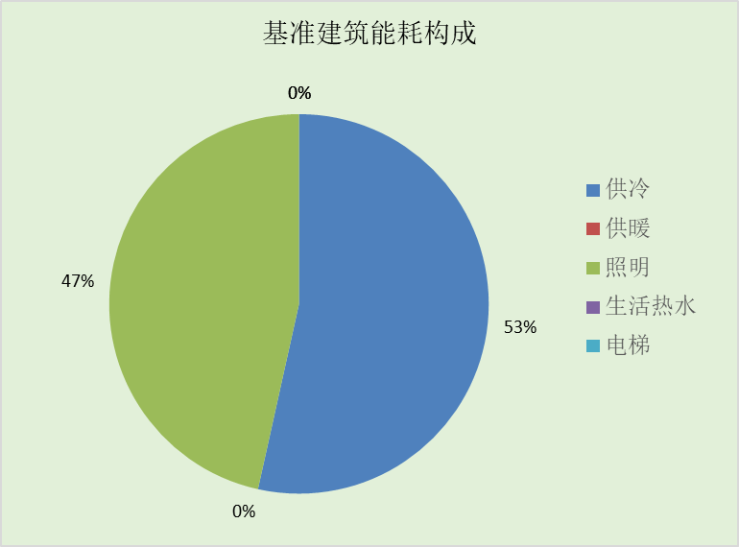

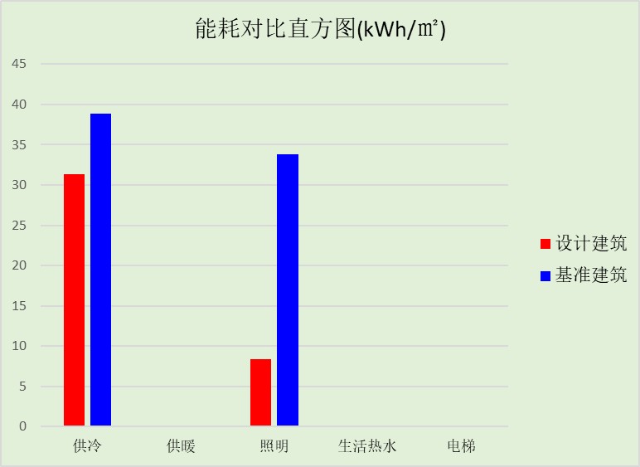

## 结论

|  |  |  |
| --- | --- | --- |
|  | 设计建筑 | 基准建筑 |
| 建筑本体能耗(一次能源) (kWh/㎡) | 39.70 | 72.73 |
| 建筑综合能耗(一次能源) (kWh/㎡) | 0.00 | 72.73 |
|  | 值 | 限值 |
| 建筑本体能耗节能率(%) | 45.41 | 20.00 |
| 建筑综合能耗节能率(%) | 100.00 | 50.00 |
| 标准依据 | 《近零能耗建筑技术标准》(GB/T51350-2019)表5.0.4 | |
| 标准要求 | 建筑综合节能率应≥50%; 建筑本体节能率应符合表5.0.4的要求 | |
| 结论 | 满足 | |

# 附录

暑假:7.15~8.25; 寒假：1.15~3.1

## 工作日/节假日人员逐时在室率(%)

|  |  |  |  |  |  |  |  |  |  |  |  |  |  |  |  |  |  |  |  |  |  |  |  |  |
| --- | --- | --- | --- | --- | --- | --- | --- | --- | --- | --- | --- | --- | --- | --- | --- | --- | --- | --- | --- | --- | --- | --- | --- | --- |
| 房间类型 | 1 | 2 | 3 | 4 | 5 | 6 | 7 | 8 | 9 | 10 | 11 | 12 | 13 | 14 | 15 | 16 | 17 | 18 | 19 | 20 | 21 | 22 | 23 | 24 |
| 健身活动室 | 0 | 0 | 0 | 0 | 0 | 0 | 0 | 45 | 45 | 45 | 45 | 45 | 45 | 45 | 45 | 45 | 45 | 45 | 45 | 45 | 45 | 0 | 0 | 0 |
| 0 | 0 | 0 | 0 | 0 | 0 | 0 | 0 | 0 | 0 | 0 | 0 | 0 | 0 | 0 | 0 | 0 | 0 | 0 | 0 | 0 | 0 | 0 | 0 |
| 0 | 0 | 0 | 0 | 0 | 0 | 0 | 0 | 0 | 0 | 0 | 0 | 0 | 0 | 0 | 0 | 0 | 0 | 0 | 0 | 0 | 0 | 0 | 0 |
| 0 | 0 | 0 | 0 | 0 | 0 | 0 | 0 | 0 | 0 | 0 | 0 | 0 | 0 | 0 | 0 | 0 | 0 | 0 | 0 | 0 | 0 | 0 | 0 |
| 办公-普通办公室 | 0 | 0 | 0 | 0 | 0 | 0 | 0 | 33 | 33 | 33 | 33 | 33 | 33 | 33 | 33 | 33 | 33 | 33 | 0 | 0 | 0 | 0 | 0 | 0 |
| 0 | 0 | 0 | 0 | 0 | 0 | 0 | 0 | 0 | 0 | 0 | 0 | 0 | 0 | 0 | 0 | 0 | 0 | 0 | 0 | 0 | 0 | 0 | 0 |
| 0 | 0 | 0 | 0 | 0 | 0 | 0 | 0 | 0 | 0 | 0 | 0 | 0 | 0 | 0 | 0 | 0 | 0 | 0 | 0 | 0 | 0 | 0 | 0 |
| 0 | 0 | 0 | 0 | 0 | 0 | 0 | 0 | 0 | 0 | 0 | 0 | 0 | 0 | 0 | 0 | 0 | 0 | 0 | 0 | 0 | 0 | 0 | 0 |
| 卫生间 | 0 | 0 | 0 | 0 | 0 | 0 | 0 | 33 | 33 | 33 | 33 | 33 | 33 | 33 | 33 | 33 | 33 | 33 | 0 | 0 | 0 | 0 | 0 | 0 |
| 0 | 0 | 0 | 0 | 0 | 0 | 0 | 0 | 0 | 0 | 0 | 0 | 0 | 0 | 0 | 0 | 0 | 0 | 0 | 0 | 0 | 0 | 0 | 0 |
| 0 | 0 | 0 | 0 | 0 | 0 | 0 | 0 | 0 | 0 | 0 | 0 | 0 | 0 | 0 | 0 | 0 | 0 | 0 | 0 | 0 | 0 | 0 | 0 |
| 0 | 0 | 0 | 0 | 0 | 0 | 0 | 0 | 0 | 0 | 0 | 0 | 0 | 0 | 0 | 0 | 0 | 0 | 0 | 0 | 0 | 0 | 0 | 0 |
| 多媒体教室 | 0 | 0 | 0 | 0 | 0 | 0 | 0 | 27 | 27 | 27 | 27 | 27 | 27 | 27 | 27 | 27 | 27 | 27 | 0 | 0 | 0 | 0 | 0 | 0 |
| 0 | 0 | 0 | 0 | 0 | 0 | 0 | 0 | 0 | 0 | 0 | 0 | 0 | 0 | 0 | 0 | 0 | 0 | 0 | 0 | 0 | 0 | 0 | 0 |
| 0 | 0 | 0 | 0 | 0 | 0 | 0 | 0 | 0 | 0 | 0 | 0 | 0 | 0 | 0 | 0 | 0 | 0 | 0 | 0 | 0 | 0 | 0 | 0 |
| 0 | 0 | 0 | 0 | 0 | 0 | 0 | 0 | 0 | 0 | 0 | 0 | 0 | 0 | 0 | 0 | 0 | 0 | 0 | 0 | 0 | 0 | 0 | 0 |
| 大厅 | 0 | 0 | 0 | 0 | 0 | 0 | 0 | 55 | 55 | 55 | 55 | 55 | 55 | 55 | 55 | 55 | 55 | 55 | 0 | 0 | 0 | 0 | 0 | 0 |
| 0 | 0 | 0 | 0 | 0 | 0 | 0 | 0 | 0 | 0 | 0 | 0 | 0 | 0 | 0 | 0 | 0 | 0 | 0 | 0 | 0 | 0 | 0 | 0 |
| 0 | 0 | 0 | 0 | 0 | 0 | 0 | 0 | 0 | 0 | 0 | 0 | 0 | 0 | 0 | 0 | 0 | 0 | 0 | 0 | 0 | 0 | 0 | 0 |
| 0 | 0 | 0 | 0 | 0 | 0 | 0 | 0 | 0 | 0 | 0 | 0 | 0 | 0 | 0 | 0 | 0 | 0 | 0 | 0 | 0 | 0 | 0 | 0 |
| 实验教室 | 0 | 0 | 0 | 0 | 0 | 0 | 0 | 27 | 27 | 27 | 27 | 27 | 27 | 27 | 27 | 27 | 27 | 27 | 0 | 0 | 0 | 0 | 0 | 0 |
| 0 | 0 | 0 | 0 | 0 | 0 | 0 | 0 | 0 | 0 | 0 | 0 | 0 | 0 | 0 | 0 | 0 | 0 | 0 | 0 | 0 | 0 | 0 | 0 |
| 0 | 0 | 0 | 0 | 0 | 0 | 0 | 0 | 0 | 0 | 0 | 0 | 0 | 0 | 0 | 0 | 0 | 0 | 0 | 0 | 0 | 0 | 0 | 0 |
| 0 | 0 | 0 | 0 | 0 | 0 | 0 | 0 | 0 | 0 | 0 | 0 | 0 | 0 | 0 | 0 | 0 | 0 | 0 | 0 | 0 | 0 | 0 | 0 |
| 密集办公室 | 0 | 0 | 0 | 0 | 0 | 0 | 0 | 33 | 33 | 33 | 33 | 33 | 33 | 33 | 33 | 33 | 33 | 33 | 0 | 0 | 0 | 0 | 0 | 0 |
| 0 | 0 | 0 | 0 | 0 | 0 | 0 | 0 | 0 | 0 | 0 | 0 | 0 | 0 | 0 | 0 | 0 | 0 | 0 | 0 | 0 | 0 | 0 | 0 |
| 0 | 0 | 0 | 0 | 0 | 0 | 0 | 0 | 0 | 0 | 0 | 0 | 0 | 0 | 0 | 0 | 0 | 0 | 0 | 0 | 0 | 0 | 0 | 0 |
| 0 | 0 | 0 | 0 | 0 | 0 | 0 | 0 | 0 | 0 | 0 | 0 | 0 | 0 | 0 | 0 | 0 | 0 | 0 | 0 | 0 | 0 | 0 | 0 |
| 报告厅 | 0 | 0 | 0 | 0 | 0 | 0 | 0 | 33 | 33 | 33 | 33 | 33 | 33 | 33 | 33 | 33 | 33 | 33 | 0 | 0 | 0 | 0 | 0 | 0 |
| 0 | 0 | 0 | 0 | 0 | 0 | 0 | 0 | 0 | 0 | 0 | 0 | 0 | 0 | 0 | 0 | 0 | 0 | 0 | 0 | 0 | 0 | 0 | 0 |
| 0 | 0 | 0 | 0 | 0 | 0 | 0 | 0 | 0 | 0 | 0 | 0 | 0 | 0 | 0 | 0 | 0 | 0 | 0 | 0 | 0 | 0 | 0 | 0 |
| 0 | 0 | 0 | 0 | 0 | 0 | 0 | 0 | 0 | 0 | 0 | 0 | 0 | 0 | 0 | 0 | 0 | 0 | 0 | 0 | 0 | 0 | 0 | 0 |
| 普通办公室 | 0 | 0 | 0 | 0 | 0 | 0 | 0 | 33 | 33 | 33 | 33 | 33 | 33 | 33 | 33 | 33 | 33 | 33 | 0 | 0 | 0 | 0 | 0 | 0 |
| 0 | 0 | 0 | 0 | 0 | 0 | 0 | 0 | 0 | 0 | 0 | 0 | 0 | 0 | 0 | 0 | 0 | 0 | 0 | 0 | 0 | 0 | 0 | 0 |
| 0 | 0 | 0 | 0 | 0 | 0 | 0 | 0 | 0 | 0 | 0 | 0 | 0 | 0 | 0 | 0 | 0 | 0 | 0 | 0 | 0 | 0 | 0 | 0 |
| 0 | 0 | 0 | 0 | 0 | 0 | 0 | 0 | 0 | 0 | 0 | 0 | 0 | 0 | 0 | 0 | 0 | 0 | 0 | 0 | 0 | 0 | 0 | 0 |
| 楼梯间 | 0 | 0 | 0 | 0 | 0 | 0 | 0 | 20 | 50 | 80 | 80 | 80 | 80 | 80 | 80 | 80 | 80 | 80 | 80 | 70 | 50 | 0 | 0 | 0 |
| 0 | 0 | 0 | 0 | 0 | 0 | 0 | 0 | 0 | 0 | 0 | 0 | 0 | 0 | 0 | 0 | 0 | 0 | 0 | 0 | 0 | 0 | 0 | 0 |
| 0 | 0 | 0 | 0 | 0 | 0 | 0 | 0 | 0 | 0 | 0 | 0 | 0 | 0 | 0 | 0 | 0 | 0 | 0 | 0 | 0 | 0 | 0 | 0 |
| 0 | 0 | 0 | 0 | 0 | 0 | 0 | 0 | 0 | 0 | 0 | 0 | 0 | 0 | 0 | 0 | 0 | 0 | 0 | 0 | 0 | 0 | 0 | 0 |
| 空房间 | 0 | 0 | 0 | 0 | 0 | 0 | 0 | 20 | 50 | 80 | 80 | 80 | 80 | 80 | 80 | 80 | 80 | 80 | 80 | 70 | 50 | 0 | 0 | 0 |
| 0 | 0 | 0 | 0 | 0 | 0 | 0 | 0 | 0 | 0 | 0 | 0 | 0 | 0 | 0 | 0 | 0 | 0 | 0 | 0 | 0 | 0 | 0 | 0 |
| 0 | 0 | 0 | 0 | 0 | 0 | 0 | 0 | 0 | 0 | 0 | 0 | 0 | 0 | 0 | 0 | 0 | 0 | 0 | 0 | 0 | 0 | 0 | 0 |
| 0 | 0 | 0 | 0 | 0 | 0 | 0 | 0 | 0 | 0 | 0 | 0 | 0 | 0 | 0 | 0 | 0 | 0 | 0 | 0 | 0 | 0 | 0 | 0 |
| 美术教室 | 0 | 0 | 0 | 0 | 0 | 0 | 0 | 27 | 27 | 27 | 27 | 27 | 27 | 27 | 27 | 27 | 27 | 27 | 0 | 0 | 0 | 0 | 0 | 0 |
| 0 | 0 | 0 | 0 | 0 | 0 | 0 | 0 | 0 | 0 | 0 | 0 | 0 | 0 | 0 | 0 | 0 | 0 | 0 | 0 | 0 | 0 | 0 | 0 |
| 0 | 0 | 0 | 0 | 0 | 0 | 0 | 0 | 0 | 0 | 0 | 0 | 0 | 0 | 0 | 0 | 0 | 0 | 0 | 0 | 0 | 0 | 0 | 0 |
| 0 | 0 | 0 | 0 | 0 | 0 | 0 | 0 | 0 | 0 | 0 | 0 | 0 | 0 | 0 | 0 | 0 | 0 | 0 | 0 | 0 | 0 | 0 | 0 |
| 舞蹈教室 | 0 | 0 | 0 | 0 | 0 | 0 | 0 | 27 | 27 | 27 | 27 | 27 | 27 | 27 | 27 | 27 | 27 | 27 | 0 | 0 | 0 | 0 | 0 | 0 |
| 0 | 0 | 0 | 0 | 0 | 0 | 0 | 0 | 0 | 0 | 0 | 0 | 0 | 0 | 0 | 0 | 0 | 0 | 0 | 0 | 0 | 0 | 0 | 0 |
| 0 | 0 | 0 | 0 | 0 | 0 | 0 | 0 | 0 | 0 | 0 | 0 | 0 | 0 | 0 | 0 | 0 | 0 | 0 | 0 | 0 | 0 | 0 | 0 |
| 0 | 0 | 0 | 0 | 0 | 0 | 0 | 0 | 0 | 0 | 0 | 0 | 0 | 0 | 0 | 0 | 0 | 0 | 0 | 0 | 0 | 0 | 0 | 0 |
| 计算机房 | 0 | 0 | 0 | 0 | 0 | 0 | 0 | 33 | 33 | 33 | 33 | 33 | 33 | 33 | 33 | 33 | 33 | 33 | 0 | 0 | 0 | 0 | 0 | 0 |
| 0 | 0 | 0 | 0 | 0 | 0 | 0 | 0 | 0 | 0 | 0 | 0 | 0 | 0 | 0 | 0 | 0 | 0 | 0 | 0 | 0 | 0 | 0 | 0 |
| 0 | 0 | 0 | 0 | 0 | 0 | 0 | 0 | 0 | 0 | 0 | 0 | 0 | 0 | 0 | 0 | 0 | 0 | 0 | 0 | 0 | 0 | 0 | 0 |
| 0 | 0 | 0 | 0 | 0 | 0 | 0 | 0 | 0 | 0 | 0 | 0 | 0 | 0 | 0 | 0 | 0 | 0 | 0 | 0 | 0 | 0 | 0 | 0 |
| 设备间 | 0 | 0 | 0 | 0 | 0 | 0 | 0 | 0 | 0 | 0 | 0 | 0 | 0 | 0 | 0 | 0 | 0 | 0 | 0 | 0 | 0 | 0 | 0 | 0 |
| 0 | 0 | 0 | 0 | 0 | 0 | 0 | 0 | 0 | 0 | 0 | 0 | 0 | 0 | 0 | 0 | 0 | 0 | 0 | 0 | 0 | 0 | 0 | 0 |
| 0 | 0 | 0 | 0 | 0 | 0 | 0 | 0 | 0 | 0 | 0 | 0 | 0 | 0 | 0 | 0 | 0 | 0 | 0 | 0 | 0 | 0 | 0 | 0 |
| 0 | 0 | 0 | 0 | 0 | 0 | 0 | 0 | 0 | 0 | 0 | 0 | 0 | 0 | 0 | 0 | 0 | 0 | 0 | 0 | 0 | 0 | 0 | 0 |
| 走廊 | 0 | 0 | 0 | 0 | 0 | 0 | 0 | 55 | 55 | 55 | 55 | 55 | 55 | 55 | 55 | 55 | 55 | 55 | 0 | 0 | 0 | 0 | 0 | 0 |
| 0 | 0 | 0 | 0 | 0 | 0 | 0 | 0 | 0 | 0 | 0 | 0 | 0 | 0 | 0 | 0 | 0 | 0 | 0 | 0 | 0 | 0 | 0 | 0 |
| 0 | 0 | 0 | 0 | 0 | 0 | 0 | 0 | 0 | 0 | 0 | 0 | 0 | 0 | 0 | 0 | 0 | 0 | 0 | 0 | 0 | 0 | 0 | 0 |
| 0 | 0 | 0 | 0 | 0 | 0 | 0 | 0 | 0 | 0 | 0 | 0 | 0 | 0 | 0 | 0 | 0 | 0 | 0 | 0 | 0 | 0 | 0 | 0 |
| 阅览室 | 0 | 0 | 0 | 0 | 0 | 0 | 0 | 27 | 27 | 27 | 27 | 27 | 27 | 27 | 27 | 27 | 27 | 27 | 0 | 0 | 0 | 0 | 0 | 0 |
| 0 | 0 | 0 | 0 | 0 | 0 | 0 | 0 | 0 | 0 | 0 | 0 | 0 | 0 | 0 | 0 | 0 | 0 | 0 | 0 | 0 | 0 | 0 | 0 |
| 0 | 0 | 0 | 0 | 0 | 0 | 0 | 0 | 0 | 0 | 0 | 0 | 0 | 0 | 0 | 0 | 0 | 0 | 0 | 0 | 0 | 0 | 0 | 0 |
| 0 | 0 | 0 | 0 | 0 | 0 | 0 | 0 | 0 | 0 | 0 | 0 | 0 | 0 | 0 | 0 | 0 | 0 | 0 | 0 | 0 | 0 | 0 | 0 |
| 阶梯教室 | 0 | 0 | 0 | 0 | 0 | 0 | 0 | 27 | 27 | 27 | 27 | 27 | 27 | 27 | 27 | 27 | 27 | 27 | 0 | 0 | 0 | 0 | 0 | 0 |
| 0 | 0 | 0 | 0 | 0 | 0 | 0 | 0 | 0 | 0 | 0 | 0 | 0 | 0 | 0 | 0 | 0 | 0 | 0 | 0 | 0 | 0 | 0 | 0 |
| 0 | 0 | 0 | 0 | 0 | 0 | 0 | 0 | 0 | 0 | 0 | 0 | 0 | 0 | 0 | 0 | 0 | 0 | 0 | 0 | 0 | 0 | 0 | 0 |
| 0 | 0 | 0 | 0 | 0 | 0 | 0 | 0 | 0 | 0 | 0 | 0 | 0 | 0 | 0 | 0 | 0 | 0 | 0 | 0 | 0 | 0 | 0 | 0 |
| 音乐教室 | 0 | 0 | 0 | 0 | 0 | 0 | 0 | 27 | 27 | 27 | 27 | 27 | 27 | 27 | 27 | 27 | 27 | 27 | 0 | 0 | 0 | 0 | 0 | 0 |
| 0 | 0 | 0 | 0 | 0 | 0 | 0 | 0 | 0 | 0 | 0 | 0 | 0 | 0 | 0 | 0 | 0 | 0 | 0 | 0 | 0 | 0 | 0 | 0 |
| 0 | 0 | 0 | 0 | 0 | 0 | 0 | 0 | 0 | 0 | 0 | 0 | 0 | 0 | 0 | 0 | 0 | 0 | 0 | 0 | 0 | 0 | 0 | 0 |
| 0 | 0 | 0 | 0 | 0 | 0 | 0 | 0 | 0 | 0 | 0 | 0 | 0 | 0 | 0 | 0 | 0 | 0 | 0 | 0 | 0 | 0 | 0 | 0 |
| 风雨操场 | 0 | 0 | 0 | 0 | 0 | 0 | 0 | 45 | 45 | 45 | 45 | 45 | 45 | 45 | 45 | 45 | 45 | 45 | 45 | 45 | 45 | 0 | 0 | 0 |
| 0 | 0 | 0 | 0 | 0 | 0 | 0 | 0 | 0 | 0 | 0 | 0 | 0 | 0 | 0 | 0 | 0 | 0 | 0 | 0 | 0 | 0 | 0 | 0 |
| 0 | 0 | 0 | 0 | 0 | 0 | 0 | 0 | 0 | 0 | 0 | 0 | 0 | 0 | 0 | 0 | 0 | 0 | 0 | 0 | 0 | 0 | 0 | 0 |
| 0 | 0 | 0 | 0 | 0 | 0 | 0 | 0 | 0 | 0 | 0 | 0 | 0 | 0 | 0 | 0 | 0 | 0 | 0 | 0 | 0 | 0 | 0 | 0 |
| 餐厅 | 0 | 0 | 0 | 0 | 0 | 0 | 29 | 29 | 29 | 29 | 29 | 29 | 29 | 29 | 29 | 29 | 29 | 29 | 29 | 29 | 0 | 0 | 0 | 0 |
| 0 | 0 | 0 | 0 | 0 | 0 | 0 | 0 | 0 | 0 | 0 | 0 | 0 | 0 | 0 | 0 | 0 | 0 | 0 | 0 | 0 | 0 | 0 | 0 |
| 0 | 0 | 0 | 0 | 0 | 0 | 0 | 0 | 0 | 0 | 0 | 0 | 0 | 0 | 0 | 0 | 0 | 0 | 0 | 0 | 0 | 0 | 0 | 0 |
| 0 | 0 | 0 | 0 | 0 | 0 | 0 | 0 | 0 | 0 | 0 | 0 | 0 | 0 | 0 | 0 | 0 | 0 | 0 | 0 | 0 | 0 | 0 | 0 |

注：第一行：工作日；第二行：节假日；第三行：寒假；第四行：暑假

## 工作日/节假日照明开关时间表(%)

|  |  |  |  |  |  |  |  |  |  |  |  |  |  |  |  |  |  |  |  |  |  |  |  |  |
| --- | --- | --- | --- | --- | --- | --- | --- | --- | --- | --- | --- | --- | --- | --- | --- | --- | --- | --- | --- | --- | --- | --- | --- | --- |
| 房间类型 | 1 | 2 | 3 | 4 | 5 | 6 | 7 | 8 | 9 | 10 | 11 | 12 | 13 | 14 | 15 | 16 | 17 | 18 | 19 | 20 | 21 | 22 | 23 | 24 |
| 健身活动室 | 0 | 0 | 0 | 0 | 0 | 0 | 0 | 50 | 50 | 50 | 50 | 50 | 50 | 50 | 50 | 50 | 50 | 50 | 50 | 50 | 50 | 0 | 0 | 0 |
| 0 | 0 | 0 | 0 | 0 | 0 | 0 | 0 | 0 | 0 | 0 | 0 | 0 | 0 | 0 | 0 | 0 | 0 | 0 | 0 | 0 | 0 | 0 | 0 |
| 0 | 0 | 0 | 0 | 0 | 0 | 0 | 0 | 0 | 0 | 0 | 0 | 0 | 0 | 0 | 0 | 0 | 0 | 0 | 0 | 0 | 0 | 0 | 0 |
| 0 | 0 | 0 | 0 | 0 | 0 | 0 | 0 | 0 | 0 | 0 | 0 | 0 | 0 | 0 | 0 | 0 | 0 | 0 | 0 | 0 | 0 | 0 | 0 |
| 办公-普通办公室 | 0 | 0 | 0 | 0 | 0 | 0 | 0 | 100 | 100 | 100 | 100 | 100 | 100 | 100 | 100 | 100 | 100 | 100 | 100 | 0 | 0 | 0 | 0 | 0 |
| 0 | 0 | 0 | 0 | 0 | 0 | 0 | 0 | 0 | 0 | 0 | 0 | 0 | 0 | 0 | 0 | 0 | 0 | 0 | 0 | 0 | 0 | 0 | 0 |
| 0 | 0 | 0 | 0 | 0 | 0 | 0 | 0 | 0 | 0 | 0 | 0 | 0 | 0 | 0 | 0 | 0 | 0 | 0 | 0 | 0 | 0 | 0 | 0 |
| 0 | 0 | 0 | 0 | 0 | 0 | 0 | 0 | 0 | 0 | 0 | 0 | 0 | 0 | 0 | 0 | 0 | 0 | 0 | 0 | 0 | 0 | 0 | 0 |
| 卫生间 | 0 | 0 | 0 | 0 | 0 | 0 | 100 | 100 | 100 | 100 | 100 | 100 | 100 | 100 | 100 | 100 | 100 | 100 | 100 | 0 | 0 | 0 | 0 | 0 |
| 0 | 0 | 0 | 0 | 0 | 0 | 0 | 0 | 0 | 0 | 0 | 0 | 0 | 0 | 0 | 0 | 0 | 0 | 0 | 0 | 0 | 0 | 0 | 0 |
| 0 | 0 | 0 | 0 | 0 | 0 | 0 | 0 | 0 | 0 | 0 | 0 | 0 | 0 | 0 | 0 | 0 | 0 | 0 | 0 | 0 | 0 | 0 | 0 |
| 0 | 0 | 0 | 0 | 0 | 0 | 0 | 0 | 0 | 0 | 0 | 0 | 0 | 0 | 0 | 0 | 0 | 0 | 0 | 0 | 0 | 0 | 0 | 0 |
| 多媒体教室 | 0 | 0 | 0 | 0 | 0 | 0 | 0 | 82 | 82 | 82 | 82 | 82 | 82 | 82 | 82 | 82 | 82 | 82 | 0 | 0 | 0 | 0 | 0 | 0 |
| 0 | 0 | 0 | 0 | 0 | 0 | 0 | 0 | 0 | 0 | 0 | 0 | 0 | 0 | 0 | 0 | 0 | 0 | 0 | 0 | 0 | 0 | 0 | 0 |
| 0 | 0 | 0 | 0 | 0 | 0 | 0 | 0 | 0 | 0 | 0 | 0 | 0 | 0 | 0 | 0 | 0 | 0 | 0 | 0 | 0 | 0 | 0 | 0 |
| 0 | 0 | 0 | 0 | 0 | 0 | 0 | 0 | 0 | 0 | 0 | 0 | 0 | 0 | 0 | 0 | 0 | 0 | 0 | 0 | 0 | 0 | 0 | 0 |
| 大厅 | 0 | 0 | 0 | 0 | 0 | 0 | 10 | 10 | 10 | 10 | 10 | 10 | 10 | 10 | 10 | 10 | 10 | 10 | 10 | 0 | 0 | 0 | 0 | 0 |
| 0 | 0 | 0 | 0 | 0 | 0 | 0 | 0 | 0 | 0 | 0 | 0 | 0 | 0 | 0 | 0 | 0 | 0 | 0 | 0 | 0 | 0 | 0 | 0 |
| 0 | 0 | 0 | 0 | 0 | 0 | 0 | 0 | 0 | 0 | 0 | 0 | 0 | 0 | 0 | 0 | 0 | 0 | 0 | 0 | 0 | 0 | 0 | 0 |
| 0 | 0 | 0 | 0 | 0 | 0 | 0 | 0 | 0 | 0 | 0 | 0 | 0 | 0 | 0 | 0 | 0 | 0 | 0 | 0 | 0 | 0 | 0 | 0 |
| 实验教室 | 0 | 0 | 0 | 0 | 0 | 0 | 0 | 82 | 82 | 82 | 82 | 82 | 82 | 82 | 82 | 82 | 82 | 82 | 0 | 0 | 0 | 0 | 0 | 0 |
| 0 | 0 | 0 | 0 | 0 | 0 | 0 | 0 | 0 | 0 | 0 | 0 | 0 | 0 | 0 | 0 | 0 | 0 | 0 | 0 | 0 | 0 | 0 | 0 |
| 0 | 0 | 0 | 0 | 0 | 0 | 0 | 0 | 0 | 0 | 0 | 0 | 0 | 0 | 0 | 0 | 0 | 0 | 0 | 0 | 0 | 0 | 0 | 0 |
| 0 | 0 | 0 | 0 | 0 | 0 | 0 | 0 | 0 | 0 | 0 | 0 | 0 | 0 | 0 | 0 | 0 | 0 | 0 | 0 | 0 | 0 | 0 | 0 |
| 密集办公室 | 0 | 0 | 0 | 0 | 0 | 0 | 100 | 100 | 100 | 100 | 100 | 100 | 100 | 100 | 100 | 100 | 100 | 100 | 100 | 0 | 0 | 0 | 0 | 0 |
| 0 | 0 | 0 | 0 | 0 | 0 | 0 | 0 | 0 | 0 | 0 | 0 | 0 | 0 | 0 | 0 | 0 | 0 | 0 | 0 | 0 | 0 | 0 | 0 |
| 0 | 0 | 0 | 0 | 0 | 0 | 0 | 0 | 0 | 0 | 0 | 0 | 0 | 0 | 0 | 0 | 0 | 0 | 0 | 0 | 0 | 0 | 0 | 0 |
| 0 | 0 | 0 | 0 | 0 | 0 | 0 | 0 | 0 | 0 | 0 | 0 | 0 | 0 | 0 | 0 | 0 | 0 | 0 | 0 | 0 | 0 | 0 | 0 |
| 报告厅 | 0 | 0 | 0 | 0 | 0 | 0 | 100 | 100 | 100 | 100 | 100 | 100 | 100 | 100 | 100 | 100 | 100 | 100 | 100 | 0 | 0 | 0 | 0 | 0 |
| 0 | 0 | 0 | 0 | 0 | 0 | 0 | 0 | 0 | 0 | 0 | 0 | 0 | 0 | 0 | 0 | 0 | 0 | 0 | 0 | 0 | 0 | 0 | 0 |
| 0 | 0 | 0 | 0 | 0 | 0 | 0 | 0 | 0 | 0 | 0 | 0 | 0 | 0 | 0 | 0 | 0 | 0 | 0 | 0 | 0 | 0 | 0 | 0 |
| 0 | 0 | 0 | 0 | 0 | 0 | 0 | 0 | 0 | 0 | 0 | 0 | 0 | 0 | 0 | 0 | 0 | 0 | 0 | 0 | 0 | 0 | 0 | 0 |
| 普通办公室 | 0 | 0 | 0 | 0 | 0 | 0 | 100 | 100 | 100 | 100 | 100 | 100 | 100 | 100 | 100 | 100 | 100 | 100 | 100 | 0 | 0 | 0 | 0 | 0 |
| 0 | 0 | 0 | 0 | 0 | 0 | 0 | 0 | 0 | 0 | 0 | 0 | 0 | 0 | 0 | 0 | 0 | 0 | 0 | 0 | 0 | 0 | 0 | 0 |
| 0 | 0 | 0 | 0 | 0 | 0 | 0 | 0 | 0 | 0 | 0 | 0 | 0 | 0 | 0 | 0 | 0 | 0 | 0 | 0 | 0 | 0 | 0 | 0 |
| 0 | 0 | 0 | 0 | 0 | 0 | 0 | 0 | 0 | 0 | 0 | 0 | 0 | 0 | 0 | 0 | 0 | 0 | 0 | 0 | 0 | 0 | 0 | 0 |
| 楼梯间 | 10 | 10 | 10 | 10 | 10 | 10 | 10 | 50 | 60 | 60 | 60 | 60 | 60 | 60 | 60 | 60 | 80 | 90 | 100 | 100 | 100 | 10 | 10 | 10 |
| 0 | 0 | 0 | 0 | 0 | 0 | 0 | 0 | 0 | 0 | 0 | 0 | 0 | 0 | 0 | 0 | 0 | 0 | 0 | 0 | 0 | 0 | 0 | 0 |
| 0 | 0 | 0 | 0 | 0 | 0 | 0 | 0 | 0 | 0 | 0 | 0 | 0 | 0 | 0 | 0 | 0 | 0 | 0 | 0 | 0 | 0 | 0 | 0 |
| 0 | 0 | 0 | 0 | 0 | 0 | 0 | 0 | 0 | 0 | 0 | 0 | 0 | 0 | 0 | 0 | 0 | 0 | 0 | 0 | 0 | 0 | 0 | 0 |
| 空房间 | 10 | 10 | 10 | 10 | 10 | 10 | 10 | 50 | 60 | 60 | 60 | 60 | 60 | 60 | 60 | 60 | 80 | 90 | 100 | 100 | 100 | 10 | 10 | 10 |
| 0 | 0 | 0 | 0 | 0 | 0 | 0 | 0 | 0 | 0 | 0 | 0 | 0 | 0 | 0 | 0 | 0 | 0 | 0 | 0 | 0 | 0 | 0 | 0 |
| 0 | 0 | 0 | 0 | 0 | 0 | 0 | 0 | 0 | 0 | 0 | 0 | 0 | 0 | 0 | 0 | 0 | 0 | 0 | 0 | 0 | 0 | 0 | 0 |
| 0 | 0 | 0 | 0 | 0 | 0 | 0 | 0 | 0 | 0 | 0 | 0 | 0 | 0 | 0 | 0 | 0 | 0 | 0 | 0 | 0 | 0 | 0 | 0 |
| 美术教室 | 0 | 0 | 0 | 0 | 0 | 0 | 0 | 82 | 82 | 82 | 82 | 82 | 82 | 82 | 82 | 82 | 82 | 82 | 0 | 0 | 0 | 0 | 0 | 0 |
| 0 | 0 | 0 | 0 | 0 | 0 | 0 | 0 | 0 | 0 | 0 | 0 | 0 | 0 | 0 | 0 | 0 | 0 | 0 | 0 | 0 | 0 | 0 | 0 |
| 0 | 0 | 0 | 0 | 0 | 0 | 0 | 0 | 0 | 0 | 0 | 0 | 0 | 0 | 0 | 0 | 0 | 0 | 0 | 0 | 0 | 0 | 0 | 0 |
| 0 | 0 | 0 | 0 | 0 | 0 | 0 | 0 | 0 | 0 | 0 | 0 | 0 | 0 | 0 | 0 | 0 | 0 | 0 | 0 | 0 | 0 | 0 | 0 |
| 舞蹈教室 | 0 | 0 | 0 | 0 | 0 | 0 | 0 | 82 | 82 | 82 | 82 | 82 | 82 | 82 | 82 | 82 | 82 | 82 | 0 | 0 | 0 | 0 | 0 | 0 |
| 0 | 0 | 0 | 0 | 0 | 0 | 0 | 0 | 0 | 0 | 0 | 0 | 0 | 0 | 0 | 0 | 0 | 0 | 0 | 0 | 0 | 0 | 0 | 0 |
| 0 | 0 | 0 | 0 | 0 | 0 | 0 | 0 | 0 | 0 | 0 | 0 | 0 | 0 | 0 | 0 | 0 | 0 | 0 | 0 | 0 | 0 | 0 | 0 |
| 0 | 0 | 0 | 0 | 0 | 0 | 0 | 0 | 0 | 0 | 0 | 0 | 0 | 0 | 0 | 0 | 0 | 0 | 0 | 0 | 0 | 0 | 0 | 0 |
| 计算机房 | 0 | 0 | 0 | 0 | 0 | 0 | 100 | 100 | 100 | 100 | 100 | 100 | 100 | 100 | 100 | 100 | 100 | 100 | 100 | 0 | 0 | 0 | 0 | 0 |
| 0 | 0 | 0 | 0 | 0 | 0 | 0 | 0 | 0 | 0 | 0 | 0 | 0 | 0 | 0 | 0 | 0 | 0 | 0 | 0 | 0 | 0 | 0 | 0 |
| 0 | 0 | 0 | 0 | 0 | 0 | 0 | 0 | 0 | 0 | 0 | 0 | 0 | 0 | 0 | 0 | 0 | 0 | 0 | 0 | 0 | 0 | 0 | 0 |
| 0 | 0 | 0 | 0 | 0 | 0 | 0 | 0 | 0 | 0 | 0 | 0 | 0 | 0 | 0 | 0 | 0 | 0 | 0 | 0 | 0 | 0 | 0 | 0 |
| 设备间 | 0 | 0 | 0 | 0 | 0 | 0 | 0 | 0 | 0 | 0 | 0 | 0 | 0 | 0 | 0 | 0 | 0 | 0 | 0 | 0 | 0 | 0 | 0 | 0 |
| 0 | 0 | 0 | 0 | 0 | 0 | 0 | 0 | 0 | 0 | 0 | 0 | 0 | 0 | 0 | 0 | 0 | 0 | 0 | 0 | 0 | 0 | 0 | 0 |
| 0 | 0 | 0 | 0 | 0 | 0 | 0 | 0 | 0 | 0 | 0 | 0 | 0 | 0 | 0 | 0 | 0 | 0 | 0 | 0 | 0 | 0 | 0 | 0 |
| 0 | 0 | 0 | 0 | 0 | 0 | 0 | 0 | 0 | 0 | 0 | 0 | 0 | 0 | 0 | 0 | 0 | 0 | 0 | 0 | 0 | 0 | 0 | 0 |
| 走廊 | 0 | 0 | 0 | 0 | 0 | 0 | 10 | 10 | 10 | 10 | 10 | 10 | 10 | 10 | 10 | 10 | 10 | 10 | 10 | 0 | 0 | 0 | 0 | 0 |
| 0 | 0 | 0 | 0 | 0 | 0 | 0 | 0 | 0 | 0 | 0 | 0 | 0 | 0 | 0 | 0 | 0 | 0 | 0 | 0 | 0 | 0 | 0 | 0 |
| 0 | 0 | 0 | 0 | 0 | 0 | 0 | 0 | 0 | 0 | 0 | 0 | 0 | 0 | 0 | 0 | 0 | 0 | 0 | 0 | 0 | 0 | 0 | 0 |
| 0 | 0 | 0 | 0 | 0 | 0 | 0 | 0 | 0 | 0 | 0 | 0 | 0 | 0 | 0 | 0 | 0 | 0 | 0 | 0 | 0 | 0 | 0 | 0 |
| 阅览室 | 0 | 0 | 0 | 0 | 0 | 0 | 0 | 82 | 82 | 82 | 82 | 82 | 82 | 82 | 82 | 82 | 82 | 82 | 0 | 0 | 0 | 0 | 0 | 0 |
| 0 | 0 | 0 | 0 | 0 | 0 | 0 | 0 | 0 | 0 | 0 | 0 | 0 | 0 | 0 | 0 | 0 | 0 | 0 | 0 | 0 | 0 | 0 | 0 |
| 0 | 0 | 0 | 0 | 0 | 0 | 0 | 0 | 0 | 0 | 0 | 0 | 0 | 0 | 0 | 0 | 0 | 0 | 0 | 0 | 0 | 0 | 0 | 0 |
| 0 | 0 | 0 | 0 | 0 | 0 | 0 | 0 | 0 | 0 | 0 | 0 | 0 | 0 | 0 | 0 | 0 | 0 | 0 | 0 | 0 | 0 | 0 | 0 |
| 阶梯教室 | 0 | 0 | 0 | 0 | 0 | 0 | 0 | 82 | 82 | 82 | 82 | 82 | 82 | 82 | 82 | 82 | 82 | 82 | 0 | 0 | 0 | 0 | 0 | 0 |
| 0 | 0 | 0 | 0 | 0 | 0 | 0 | 0 | 0 | 0 | 0 | 0 | 0 | 0 | 0 | 0 | 0 | 0 | 0 | 0 | 0 | 0 | 0 | 0 |
| 0 | 0 | 0 | 0 | 0 | 0 | 0 | 0 | 0 | 0 | 0 | 0 | 0 | 0 | 0 | 0 | 0 | 0 | 0 | 0 | 0 | 0 | 0 | 0 |
| 0 | 0 | 0 | 0 | 0 | 0 | 0 | 0 | 0 | 0 | 0 | 0 | 0 | 0 | 0 | 0 | 0 | 0 | 0 | 0 | 0 | 0 | 0 | 0 |
| 音乐教室 | 0 | 0 | 0 | 0 | 0 | 0 | 0 | 82 | 82 | 82 | 82 | 82 | 82 | 82 | 82 | 82 | 82 | 82 | 0 | 0 | 0 | 0 | 0 | 0 |
| 0 | 0 | 0 | 0 | 0 | 0 | 0 | 0 | 0 | 0 | 0 | 0 | 0 | 0 | 0 | 0 | 0 | 0 | 0 | 0 | 0 | 0 | 0 | 0 |
| 0 | 0 | 0 | 0 | 0 | 0 | 0 | 0 | 0 | 0 | 0 | 0 | 0 | 0 | 0 | 0 | 0 | 0 | 0 | 0 | 0 | 0 | 0 | 0 |
| 0 | 0 | 0 | 0 | 0 | 0 | 0 | 0 | 0 | 0 | 0 | 0 | 0 | 0 | 0 | 0 | 0 | 0 | 0 | 0 | 0 | 0 | 0 | 0 |
| 风雨操场 | 0 | 0 | 0 | 0 | 0 | 0 | 0 | 50 | 50 | 50 | 50 | 50 | 50 | 50 | 50 | 50 | 50 | 50 | 50 | 50 | 50 | 0 | 0 | 0 |
| 0 | 0 | 0 | 0 | 0 | 0 | 0 | 0 | 0 | 0 | 0 | 0 | 0 | 0 | 0 | 0 | 0 | 0 | 0 | 0 | 0 | 0 | 0 | 0 |
| 0 | 0 | 0 | 0 | 0 | 0 | 0 | 0 | 0 | 0 | 0 | 0 | 0 | 0 | 0 | 0 | 0 | 0 | 0 | 0 | 0 | 0 | 0 | 0 |
| 0 | 0 | 0 | 0 | 0 | 0 | 0 | 0 | 0 | 0 | 0 | 0 | 0 | 0 | 0 | 0 | 0 | 0 | 0 | 0 | 0 | 0 | 0 | 0 |
| 餐厅 | 0 | 0 | 0 | 0 | 0 | 0 | 72 | 72 | 72 | 72 | 72 | 72 | 72 | 72 | 72 | 72 | 72 | 72 | 72 | 72 | 0 | 0 | 0 | 0 |
| 0 | 0 | 0 | 0 | 0 | 0 | 0 | 0 | 0 | 0 | 0 | 0 | 0 | 0 | 0 | 0 | 0 | 0 | 0 | 0 | 0 | 0 | 0 | 0 |
| 0 | 0 | 0 | 0 | 0 | 0 | 0 | 0 | 0 | 0 | 0 | 0 | 0 | 0 | 0 | 0 | 0 | 0 | 0 | 0 | 0 | 0 | 0 | 0 |
| 0 | 0 | 0 | 0 | 0 | 0 | 0 | 0 | 0 | 0 | 0 | 0 | 0 | 0 | 0 | 0 | 0 | 0 | 0 | 0 | 0 | 0 | 0 | 0 |

注：第一行：工作日；第二行：节假日；第三行：寒假；第四行：暑假

## 工作日/节假日设备逐时使用率(%)

|  |  |  |  |  |  |  |  |  |  |  |  |  |  |  |  |  |  |  |  |  |  |  |  |  |
| --- | --- | --- | --- | --- | --- | --- | --- | --- | --- | --- | --- | --- | --- | --- | --- | --- | --- | --- | --- | --- | --- | --- | --- | --- |
| 房间类型 | 1 | 2 | 3 | 4 | 5 | 6 | 7 | 8 | 9 | 10 | 11 | 12 | 13 | 14 | 15 | 16 | 17 | 18 | 19 | 20 | 21 | 22 | 23 | 24 |
| 健身活动室 | 0 | 0 | 0 | 0 | 0 | 0 | 0 | 0 | 0 | 0 | 0 | 0 | 0 | 0 | 0 | 0 | 0 | 0 | 0 | 0 | 0 | 0 | 0 | 0 |
| 0 | 0 | 0 | 0 | 0 | 0 | 0 | 0 | 0 | 0 | 0 | 0 | 0 | 0 | 0 | 0 | 0 | 0 | 0 | 0 | 0 | 0 | 0 | 0 |
| 0 | 0 | 0 | 0 | 0 | 0 | 0 | 0 | 0 | 0 | 0 | 0 | 0 | 0 | 0 | 0 | 0 | 0 | 0 | 0 | 0 | 0 | 0 | 0 |
| 0 | 0 | 0 | 0 | 0 | 0 | 0 | 0 | 0 | 0 | 0 | 0 | 0 | 0 | 0 | 0 | 0 | 0 | 0 | 0 | 0 | 0 | 0 | 0 |
| 办公-普通办公室 | 0 | 0 | 0 | 0 | 0 | 0 | 0 | 33 | 33 | 33 | 33 | 33 | 33 | 33 | 33 | 33 | 33 | 33 | 0 | 0 | 0 | 0 | 0 | 0 |
| 0 | 0 | 0 | 0 | 0 | 0 | 0 | 0 | 0 | 0 | 0 | 0 | 0 | 0 | 0 | 0 | 0 | 0 | 0 | 0 | 0 | 0 | 0 | 0 |
| 0 | 0 | 0 | 0 | 0 | 0 | 0 | 0 | 0 | 0 | 0 | 0 | 0 | 0 | 0 | 0 | 0 | 0 | 0 | 0 | 0 | 0 | 0 | 0 |
| 0 | 0 | 0 | 0 | 0 | 0 | 0 | 0 | 0 | 0 | 0 | 0 | 0 | 0 | 0 | 0 | 0 | 0 | 0 | 0 | 0 | 0 | 0 | 0 |
| 卫生间 | 0 | 0 | 0 | 0 | 0 | 0 | 0 | 33 | 33 | 33 | 33 | 33 | 33 | 33 | 33 | 33 | 33 | 33 | 0 | 0 | 0 | 0 | 0 | 0 |
| 0 | 0 | 0 | 0 | 0 | 0 | 0 | 0 | 0 | 0 | 0 | 0 | 0 | 0 | 0 | 0 | 0 | 0 | 0 | 0 | 0 | 0 | 0 | 0 |
| 0 | 0 | 0 | 0 | 0 | 0 | 0 | 0 | 0 | 0 | 0 | 0 | 0 | 0 | 0 | 0 | 0 | 0 | 0 | 0 | 0 | 0 | 0 | 0 |
| 0 | 0 | 0 | 0 | 0 | 0 | 0 | 0 | 0 | 0 | 0 | 0 | 0 | 0 | 0 | 0 | 0 | 0 | 0 | 0 | 0 | 0 | 0 | 0 |
| 多媒体教室 | 0 | 0 | 0 | 0 | 0 | 0 | 0 | 15 | 15 | 15 | 15 | 15 | 15 | 15 | 15 | 15 | 15 | 15 | 0 | 0 | 0 | 0 | 0 | 0 |
| 0 | 0 | 0 | 0 | 0 | 0 | 0 | 0 | 0 | 0 | 0 | 0 | 0 | 0 | 0 | 0 | 0 | 0 | 0 | 0 | 0 | 0 | 0 | 0 |
| 0 | 0 | 0 | 0 | 0 | 0 | 0 | 0 | 0 | 0 | 0 | 0 | 0 | 0 | 0 | 0 | 0 | 0 | 0 | 0 | 0 | 0 | 0 | 0 |
| 0 | 0 | 0 | 0 | 0 | 0 | 0 | 0 | 0 | 0 | 0 | 0 | 0 | 0 | 0 | 0 | 0 | 0 | 0 | 0 | 0 | 0 | 0 | 0 |
| 大厅 | 0 | 0 | 0 | 0 | 0 | 0 | 0 | 0 | 0 | 0 | 0 | 0 | 0 | 0 | 0 | 0 | 0 | 0 | 0 | 0 | 0 | 0 | 0 | 0 |
| 0 | 0 | 0 | 0 | 0 | 0 | 0 | 0 | 0 | 0 | 0 | 0 | 0 | 0 | 0 | 0 | 0 | 0 | 0 | 0 | 0 | 0 | 0 | 0 |
| 0 | 0 | 0 | 0 | 0 | 0 | 0 | 0 | 0 | 0 | 0 | 0 | 0 | 0 | 0 | 0 | 0 | 0 | 0 | 0 | 0 | 0 | 0 | 0 |
| 0 | 0 | 0 | 0 | 0 | 0 | 0 | 0 | 0 | 0 | 0 | 0 | 0 | 0 | 0 | 0 | 0 | 0 | 0 | 0 | 0 | 0 | 0 | 0 |
| 实验教室 | 0 | 0 | 0 | 0 | 0 | 0 | 0 | 15 | 15 | 15 | 15 | 15 | 15 | 15 | 15 | 15 | 15 | 15 | 0 | 0 | 0 | 0 | 0 | 0 |
| 0 | 0 | 0 | 0 | 0 | 0 | 0 | 0 | 0 | 0 | 0 | 0 | 0 | 0 | 0 | 0 | 0 | 0 | 0 | 0 | 0 | 0 | 0 | 0 |
| 0 | 0 | 0 | 0 | 0 | 0 | 0 | 0 | 0 | 0 | 0 | 0 | 0 | 0 | 0 | 0 | 0 | 0 | 0 | 0 | 0 | 0 | 0 | 0 |
| 0 | 0 | 0 | 0 | 0 | 0 | 0 | 0 | 0 | 0 | 0 | 0 | 0 | 0 | 0 | 0 | 0 | 0 | 0 | 0 | 0 | 0 | 0 | 0 |
| 密集办公室 | 0 | 0 | 0 | 0 | 0 | 0 | 0 | 33 | 33 | 33 | 33 | 33 | 33 | 33 | 33 | 33 | 33 | 33 | 0 | 0 | 0 | 0 | 0 | 0 |
| 0 | 0 | 0 | 0 | 0 | 0 | 0 | 0 | 0 | 0 | 0 | 0 | 0 | 0 | 0 | 0 | 0 | 0 | 0 | 0 | 0 | 0 | 0 | 0 |
| 0 | 0 | 0 | 0 | 0 | 0 | 0 | 0 | 0 | 0 | 0 | 0 | 0 | 0 | 0 | 0 | 0 | 0 | 0 | 0 | 0 | 0 | 0 | 0 |
| 0 | 0 | 0 | 0 | 0 | 0 | 0 | 0 | 0 | 0 | 0 | 0 | 0 | 0 | 0 | 0 | 0 | 0 | 0 | 0 | 0 | 0 | 0 | 0 |
| 报告厅 | 0 | 0 | 0 | 0 | 0 | 0 | 0 | 33 | 33 | 33 | 33 | 33 | 33 | 33 | 33 | 33 | 33 | 33 | 0 | 0 | 0 | 0 | 0 | 0 |
| 0 | 0 | 0 | 0 | 0 | 0 | 0 | 0 | 0 | 0 | 0 | 0 | 0 | 0 | 0 | 0 | 0 | 0 | 0 | 0 | 0 | 0 | 0 | 0 |
| 0 | 0 | 0 | 0 | 0 | 0 | 0 | 0 | 0 | 0 | 0 | 0 | 0 | 0 | 0 | 0 | 0 | 0 | 0 | 0 | 0 | 0 | 0 | 0 |
| 0 | 0 | 0 | 0 | 0 | 0 | 0 | 0 | 0 | 0 | 0 | 0 | 0 | 0 | 0 | 0 | 0 | 0 | 0 | 0 | 0 | 0 | 0 | 0 |
| 普通办公室 | 0 | 0 | 0 | 0 | 0 | 0 | 0 | 33 | 33 | 33 | 33 | 33 | 33 | 33 | 33 | 33 | 33 | 33 | 0 | 0 | 0 | 0 | 0 | 0 |
| 0 | 0 | 0 | 0 | 0 | 0 | 0 | 0 | 0 | 0 | 0 | 0 | 0 | 0 | 0 | 0 | 0 | 0 | 0 | 0 | 0 | 0 | 0 | 0 |
| 0 | 0 | 0 | 0 | 0 | 0 | 0 | 0 | 0 | 0 | 0 | 0 | 0 | 0 | 0 | 0 | 0 | 0 | 0 | 0 | 0 | 0 | 0 | 0 |
| 0 | 0 | 0 | 0 | 0 | 0 | 0 | 0 | 0 | 0 | 0 | 0 | 0 | 0 | 0 | 0 | 0 | 0 | 0 | 0 | 0 | 0 | 0 | 0 |
| 楼梯间 | 0 | 0 | 0 | 0 | 0 | 0 | 0 | 30 | 50 | 80 | 80 | 80 | 80 | 80 | 80 | 80 | 80 | 80 | 80 | 70 | 50 | 0 | 0 | 0 |
| 0 | 0 | 0 | 0 | 0 | 0 | 0 | 0 | 0 | 0 | 0 | 0 | 0 | 0 | 0 | 0 | 0 | 0 | 0 | 0 | 0 | 0 | 0 | 0 |
| 0 | 0 | 0 | 0 | 0 | 0 | 0 | 0 | 0 | 0 | 0 | 0 | 0 | 0 | 0 | 0 | 0 | 0 | 0 | 0 | 0 | 0 | 0 | 0 |
| 0 | 0 | 0 | 0 | 0 | 0 | 0 | 0 | 0 | 0 | 0 | 0 | 0 | 0 | 0 | 0 | 0 | 0 | 0 | 0 | 0 | 0 | 0 | 0 |
| 空房间 | 0 | 0 | 0 | 0 | 0 | 0 | 0 | 30 | 50 | 80 | 80 | 80 | 80 | 80 | 80 | 80 | 80 | 80 | 80 | 70 | 50 | 0 | 0 | 0 |
| 0 | 0 | 0 | 0 | 0 | 0 | 0 | 0 | 0 | 0 | 0 | 0 | 0 | 0 | 0 | 0 | 0 | 0 | 0 | 0 | 0 | 0 | 0 | 0 |
| 0 | 0 | 0 | 0 | 0 | 0 | 0 | 0 | 0 | 0 | 0 | 0 | 0 | 0 | 0 | 0 | 0 | 0 | 0 | 0 | 0 | 0 | 0 | 0 |
| 0 | 0 | 0 | 0 | 0 | 0 | 0 | 0 | 0 | 0 | 0 | 0 | 0 | 0 | 0 | 0 | 0 | 0 | 0 | 0 | 0 | 0 | 0 | 0 |
| 美术教室 | 0 | 0 | 0 | 0 | 0 | 0 | 0 | 15 | 15 | 15 | 15 | 15 | 15 | 15 | 15 | 15 | 15 | 15 | 0 | 0 | 0 | 0 | 0 | 0 |
| 0 | 0 | 0 | 0 | 0 | 0 | 0 | 0 | 0 | 0 | 0 | 0 | 0 | 0 | 0 | 0 | 0 | 0 | 0 | 0 | 0 | 0 | 0 | 0 |
| 0 | 0 | 0 | 0 | 0 | 0 | 0 | 0 | 0 | 0 | 0 | 0 | 0 | 0 | 0 | 0 | 0 | 0 | 0 | 0 | 0 | 0 | 0 | 0 |
| 0 | 0 | 0 | 0 | 0 | 0 | 0 | 0 | 0 | 0 | 0 | 0 | 0 | 0 | 0 | 0 | 0 | 0 | 0 | 0 | 0 | 0 | 0 | 0 |
| 舞蹈教室 | 0 | 0 | 0 | 0 | 0 | 0 | 0 | 15 | 15 | 15 | 15 | 15 | 15 | 15 | 15 | 15 | 15 | 15 | 0 | 0 | 0 | 0 | 0 | 0 |
| 0 | 0 | 0 | 0 | 0 | 0 | 0 | 0 | 0 | 0 | 0 | 0 | 0 | 0 | 0 | 0 | 0 | 0 | 0 | 0 | 0 | 0 | 0 | 0 |
| 0 | 0 | 0 | 0 | 0 | 0 | 0 | 0 | 0 | 0 | 0 | 0 | 0 | 0 | 0 | 0 | 0 | 0 | 0 | 0 | 0 | 0 | 0 | 0 |
| 0 | 0 | 0 | 0 | 0 | 0 | 0 | 0 | 0 | 0 | 0 | 0 | 0 | 0 | 0 | 0 | 0 | 0 | 0 | 0 | 0 | 0 | 0 | 0 |
| 计算机房 | 0 | 0 | 0 | 0 | 0 | 0 | 0 | 33 | 33 | 33 | 33 | 33 | 33 | 33 | 33 | 33 | 33 | 33 | 0 | 0 | 0 | 0 | 0 | 0 |
| 0 | 0 | 0 | 0 | 0 | 0 | 0 | 0 | 0 | 0 | 0 | 0 | 0 | 0 | 0 | 0 | 0 | 0 | 0 | 0 | 0 | 0 | 0 | 0 |
| 0 | 0 | 0 | 0 | 0 | 0 | 0 | 0 | 0 | 0 | 0 | 0 | 0 | 0 | 0 | 0 | 0 | 0 | 0 | 0 | 0 | 0 | 0 | 0 |
| 0 | 0 | 0 | 0 | 0 | 0 | 0 | 0 | 0 | 0 | 0 | 0 | 0 | 0 | 0 | 0 | 0 | 0 | 0 | 0 | 0 | 0 | 0 | 0 |
| 设备间 | 0 | 0 | 0 | 0 | 0 | 0 | 0 | 0 | 0 | 0 | 0 | 0 | 0 | 0 | 0 | 0 | 0 | 0 | 0 | 0 | 0 | 0 | 0 | 0 |
| 0 | 0 | 0 | 0 | 0 | 0 | 0 | 0 | 0 | 0 | 0 | 0 | 0 | 0 | 0 | 0 | 0 | 0 | 0 | 0 | 0 | 0 | 0 | 0 |
| 0 | 0 | 0 | 0 | 0 | 0 | 0 | 0 | 0 | 0 | 0 | 0 | 0 | 0 | 0 | 0 | 0 | 0 | 0 | 0 | 0 | 0 | 0 | 0 |
| 0 | 0 | 0 | 0 | 0 | 0 | 0 | 0 | 0 | 0 | 0 | 0 | 0 | 0 | 0 | 0 | 0 | 0 | 0 | 0 | 0 | 0 | 0 | 0 |
| 走廊 | 0 | 0 | 0 | 0 | 0 | 0 | 0 | 0 | 0 | 0 | 0 | 0 | 0 | 0 | 0 | 0 | 0 | 0 | 0 | 0 | 0 | 0 | 0 | 0 |
| 0 | 0 | 0 | 0 | 0 | 0 | 0 | 0 | 0 | 0 | 0 | 0 | 0 | 0 | 0 | 0 | 0 | 0 | 0 | 0 | 0 | 0 | 0 | 0 |
| 0 | 0 | 0 | 0 | 0 | 0 | 0 | 0 | 0 | 0 | 0 | 0 | 0 | 0 | 0 | 0 | 0 | 0 | 0 | 0 | 0 | 0 | 0 | 0 |
| 0 | 0 | 0 | 0 | 0 | 0 | 0 | 0 | 0 | 0 | 0 | 0 | 0 | 0 | 0 | 0 | 0 | 0 | 0 | 0 | 0 | 0 | 0 | 0 |
| 阅览室 | 0 | 0 | 0 | 0 | 0 | 0 | 0 | 15 | 15 | 15 | 15 | 15 | 15 | 15 | 15 | 15 | 15 | 15 | 0 | 0 | 0 | 0 | 0 | 0 |
| 0 | 0 | 0 | 0 | 0 | 0 | 0 | 0 | 0 | 0 | 0 | 0 | 0 | 0 | 0 | 0 | 0 | 0 | 0 | 0 | 0 | 0 | 0 | 0 |
| 0 | 0 | 0 | 0 | 0 | 0 | 0 | 0 | 0 | 0 | 0 | 0 | 0 | 0 | 0 | 0 | 0 | 0 | 0 | 0 | 0 | 0 | 0 | 0 |
| 0 | 0 | 0 | 0 | 0 | 0 | 0 | 0 | 0 | 0 | 0 | 0 | 0 | 0 | 0 | 0 | 0 | 0 | 0 | 0 | 0 | 0 | 0 | 0 |
| 阶梯教室 | 0 | 0 | 0 | 0 | 0 | 0 | 0 | 15 | 15 | 15 | 15 | 15 | 15 | 15 | 15 | 15 | 15 | 15 | 0 | 0 | 0 | 0 | 0 | 0 |
| 0 | 0 | 0 | 0 | 0 | 0 | 0 | 0 | 0 | 0 | 0 | 0 | 0 | 0 | 0 | 0 | 0 | 0 | 0 | 0 | 0 | 0 | 0 | 0 |
| 0 | 0 | 0 | 0 | 0 | 0 | 0 | 0 | 0 | 0 | 0 | 0 | 0 | 0 | 0 | 0 | 0 | 0 | 0 | 0 | 0 | 0 | 0 | 0 |
| 0 | 0 | 0 | 0 | 0 | 0 | 0 | 0 | 0 | 0 | 0 | 0 | 0 | 0 | 0 | 0 | 0 | 0 | 0 | 0 | 0 | 0 | 0 | 0 |
| 音乐教室 | 0 | 0 | 0 | 0 | 0 | 0 | 0 | 15 | 15 | 15 | 15 | 15 | 15 | 15 | 15 | 15 | 15 | 15 | 0 | 0 | 0 | 0 | 0 | 0 |
| 0 | 0 | 0 | 0 | 0 | 0 | 0 | 0 | 0 | 0 | 0 | 0 | 0 | 0 | 0 | 0 | 0 | 0 | 0 | 0 | 0 | 0 | 0 | 0 |
| 0 | 0 | 0 | 0 | 0 | 0 | 0 | 0 | 0 | 0 | 0 | 0 | 0 | 0 | 0 | 0 | 0 | 0 | 0 | 0 | 0 | 0 | 0 | 0 |
| 0 | 0 | 0 | 0 | 0 | 0 | 0 | 0 | 0 | 0 | 0 | 0 | 0 | 0 | 0 | 0 | 0 | 0 | 0 | 0 | 0 | 0 | 0 | 0 |
| 风雨操场 | 0 | 0 | 0 | 0 | 0 | 0 | 0 | 0 | 0 | 0 | 0 | 0 | 0 | 0 | 0 | 0 | 0 | 0 | 0 | 0 | 0 | 0 | 0 | 0 |
| 0 | 0 | 0 | 0 | 0 | 0 | 0 | 0 | 0 | 0 | 0 | 0 | 0 | 0 | 0 | 0 | 0 | 0 | 0 | 0 | 0 | 0 | 0 | 0 |
| 0 | 0 | 0 | 0 | 0 | 0 | 0 | 0 | 0 | 0 | 0 | 0 | 0 | 0 | 0 | 0 | 0 | 0 | 0 | 0 | 0 | 0 | 0 | 0 |
| 0 | 0 | 0 | 0 | 0 | 0 | 0 | 0 | 0 | 0 | 0 | 0 | 0 | 0 | 0 | 0 | 0 | 0 | 0 | 0 | 0 | 0 | 0 | 0 |
| 餐厅 | 0 | 0 | 0 | 0 | 0 | 0 | 0 | 0 | 0 | 0 | 0 | 0 | 0 | 0 | 0 | 0 | 0 | 0 | 0 | 0 | 0 | 0 | 0 | 0 |
| 0 | 0 | 0 | 0 | 0 | 0 | 0 | 0 | 0 | 0 | 0 | 0 | 0 | 0 | 0 | 0 | 0 | 0 | 0 | 0 | 0 | 0 | 0 | 0 |
| 0 | 0 | 0 | 0 | 0 | 0 | 0 | 0 | 0 | 0 | 0 | 0 | 0 | 0 | 0 | 0 | 0 | 0 | 0 | 0 | 0 | 0 | 0 | 0 |
| 0 | 0 | 0 | 0 | 0 | 0 | 0 | 0 | 0 | 0 | 0 | 0 | 0 | 0 | 0 | 0 | 0 | 0 | 0 | 0 | 0 | 0 | 0 | 0 |

注：第一行：工作日；第二行：节假日；第三行：寒假；第四行：暑假

## 工作日/节假日空调系统运行时间表(1:开,0:关)

采暖期：

|  |  |  |  |  |  |  |  |  |  |  |  |  |  |  |  |  |  |  |  |  |  |  |  |  |
| --- | --- | --- | --- | --- | --- | --- | --- | --- | --- | --- | --- | --- | --- | --- | --- | --- | --- | --- | --- | --- | --- | --- | --- | --- |
| 系统编号 | 1 | 2 | 3 | 4 | 5 | 6 | 7 | 8 | 9 | 10 | 11 | 12 | 13 | 14 | 15 | 16 | 17 | 18 | 19 | 20 | 21 | 22 | 23 | 24 |
| 默认 | 0 | 0 | 0 | 0 | 0 | 0 | 0 | 0 | 0 | 0 | 0 | 0 | 0 | 0 | 0 | 0 | 0 | 0 | 0 | 0 | 0 | 0 | 0 | 0 |
| 0 | 0 | 0 | 0 | 0 | 0 | 0 | 0 | 0 | 0 | 0 | 0 | 0 | 0 | 0 | 0 | 0 | 0 | 0 | 0 | 0 | 0 | 0 | 0 |
| 0 | 0 | 0 | 0 | 0 | 0 | 0 | 0 | 0 | 0 | 0 | 0 | 0 | 0 | 0 | 0 | 0 | 0 | 0 | 0 | 0 | 0 | 0 | 0 |
| 0 | 0 | 0 | 0 | 0 | 0 | 0 | 0 | 0 | 0 | 0 | 0 | 0 | 0 | 0 | 0 | 0 | 0 | 0 | 0 | 0 | 0 | 0 | 0 |

供冷期：

|  |  |  |  |  |  |  |  |  |  |  |  |  |  |  |  |  |  |  |  |  |  |  |  |  |
| --- | --- | --- | --- | --- | --- | --- | --- | --- | --- | --- | --- | --- | --- | --- | --- | --- | --- | --- | --- | --- | --- | --- | --- | --- |
| 系统编号 | 1 | 2 | 3 | 4 | 5 | 6 | 7 | 8 | 9 | 10 | 11 | 12 | 13 | 14 | 15 | 16 | 17 | 18 | 19 | 20 | 21 | 22 | 23 | 24 |
| 默认 | 0 | 0 | 0 | 0 | 0 | 0 | 1 | 1 | 1 | 1 | 1 | 1 | 1 | 1 | 1 | 1 | 1 | 1 | 0 | 0 | 0 | 0 | 0 | 0 |
| 0 | 0 | 0 | 0 | 0 | 0 | 0 | 0 | 0 | 0 | 0 | 0 | 0 | 0 | 0 | 0 | 0 | 0 | 0 | 0 | 0 | 0 | 0 | 0 |
| 0 | 0 | 0 | 0 | 0 | 0 | 0 | 0 | 0 | 0 | 0 | 0 | 0 | 0 | 0 | 0 | 0 | 0 | 0 | 0 | 0 | 0 | 0 | 0 |
| 0 | 0 | 0 | 0 | 0 | 0 | 0 | 0 | 0 | 0 | 0 | 0 | 0 | 0 | 0 | 0 | 0 | 0 | 0 | 0 | 0 | 0 | 0 | 0 |

注：第一行：工作日；第二行：节假日；第三行：寒假；第四行：暑假

## 工作日/节假日新风运行时间表(%)

采暖期：

|  |  |  |  |  |  |  |  |  |  |  |  |  |  |  |  |  |  |  |  |  |  |  |  |  |
| --- | --- | --- | --- | --- | --- | --- | --- | --- | --- | --- | --- | --- | --- | --- | --- | --- | --- | --- | --- | --- | --- | --- | --- | --- |
| 系统编号 | 1 | 2 | 3 | 4 | 5 | 6 | 7 | 8 | 9 | 10 | 11 | 12 | 13 | 14 | 15 | 16 | 17 | 18 | 19 | 20 | 21 | 22 | 23 | 24 |
| 默认 | 0 | 0 | 0 | 0 | 0 | 0 | 0 | 0 | 0 | 0 | 0 | 0 | 0 | 0 | 0 | 0 | 0 | 0 | 0 | 0 | 0 | 0 | 0 | 0 |
| 0 | 0 | 0 | 0 | 0 | 0 | 0 | 0 | 0 | 0 | 0 | 0 | 0 | 0 | 0 | 0 | 0 | 0 | 0 | 0 | 0 | 0 | 0 | 0 |
| 0 | 0 | 0 | 0 | 0 | 0 | 0 | 0 | 0 | 0 | 0 | 0 | 0 | 0 | 0 | 0 | 0 | 0 | 0 | 0 | 0 | 0 | 0 | 0 |
| 0 | 0 | 0 | 0 | 0 | 0 | 0 | 0 | 0 | 0 | 0 | 0 | 0 | 0 | 0 | 0 | 0 | 0 | 0 | 0 | 0 | 0 | 0 | 0 |

供冷期：

|  |  |  |  |  |  |  |  |  |  |  |  |  |  |  |  |  |  |  |  |  |  |  |  |  |
| --- | --- | --- | --- | --- | --- | --- | --- | --- | --- | --- | --- | --- | --- | --- | --- | --- | --- | --- | --- | --- | --- | --- | --- | --- |
| 系统编号 | 1 | 2 | 3 | 4 | 5 | 6 | 7 | 8 | 9 | 10 | 11 | 12 | 13 | 14 | 15 | 16 | 17 | 18 | 19 | 20 | 21 | 22 | 23 | 24 |
| 默认 | 0 | 0 | 0 | 0 | 0 | 0 | 100 | 100 | 100 | 100 | 100 | 100 | 100 | 100 | 100 | 100 | 100 | 100 | 0 | 0 | 0 | 0 | 0 | 0 |
| 0 | 0 | 0 | 0 | 0 | 0 | 0 | 0 | 0 | 0 | 0 | 0 | 0 | 0 | 0 | 0 | 0 | 0 | 0 | 0 | 0 | 0 | 0 | 0 |
| 0 | 0 | 0 | 0 | 0 | 0 | 0 | 0 | 0 | 0 | 0 | 0 | 0 | 0 | 0 | 0 | 0 | 0 | 0 | 0 | 0 | 0 | 0 | 0 |
| 0 | 0 | 0 | 0 | 0 | 0 | 0 | 0 | 0 | 0 | 0 | 0 | 0 | 0 | 0 | 0 | 0 | 0 | 0 | 0 | 0 | 0 | 0 | 0 |

注：第一行：工作日；第二行：节假日；第三行：寒假；第四行：暑假