**综合能耗节能率计算书**

公共建筑

|  |  |
| --- | --- |
| 工程名称 | 绿峰枢纽 |
| 工程地点 | 广东-惠州 |
| 设计编号 |  |
| 建设单位 |  |
| 设计单位 |  |
| 设 计 人 |  |
| 审 核 人 |  |
| 审 定 人 |  |
| 设计日期 | 2024年12月28日 |



|  |  |
| --- | --- |
| 采用软件 | 能耗计算BESI2024 |
| 软件版本 | 20240430(SP1) |
| 研发单位 | 北京绿建软件股份有限公司 |
| 正版授权码 | T15879507622 |

**目 录**

1 建筑概况 4

2 计算依据 4

3 计算要求 4

3.1 计算目标 4

3.2 计算方法 5

4 软件介绍 5

5 气象数据 5

5.1 气象地点 5

5.2 逐日干球温度表 6

5.3 逐月辐照量表 6

5.4 峰值工况 6

6 建筑大样 7

7 围护结构 10

7.1 工程材料 10

7.2 围护结构作法简要说明 11

7.3 体形系数 11

7.3.1 体形系数 11

7.3.2 楼层信息表 11

7.4 窗墙比 11

7.4.1 窗墙比 11

7.4.2 外窗表 11

7.5 天窗 13

7.5.1 天窗屋顶比 13

7.5.2 天窗类型 13

7.6 屋顶 13

7.6.1 屋顶构造一 13

7.7 外墙 13

7.7.1 外墙构造一 13

7.7.2 外墙主断面传热系数的修正系数ψ 14

7.8 外窗热工 14

7.8.1 外窗 14

7.8.2 建筑遮阳措施 14

7.8.3 外遮阳类型 15

7.8.4 平均传热系数 15

7.8.5 综合太阳得热系数 17

7.8.6 总体热工性能 19

7.9 可开启窗扇 19

8 围护结构概况 19

9 设计建筑 20

9.1 房间类型 20

9.1.1 房间参数表 20

9.1.2 作息时间表 20

9.2 系统类型 20

9.2.1 系统分区 20

9.2.2 热回收参数 20

9.3 制冷系统 21

9.3.1 默认冷源 21

9.4 空调风机 21

9.4.1 独立新排风 21

9.4.2 风机盘管 22

9.5 照明 22

9.6 负荷分项统计 22

9.7 逐月负荷表 23

9.8 逐月电耗 24

10 参照建筑 25

10.1 房间类型 25

10.1.1 房间参数表 25

10.1.2 作息时间表 25

10.2 系统类型 25

10.3 制冷系统 26

10.3.1 默认冷源 26

10.4 空调风机 26

10.4.1 独立新排风 26

10.4.2 风机盘管 27

10.5 照明 27

10.6 负荷分项统计 27

10.7 逐月负荷表 28

10.8 逐月电耗 29

11 计算结果 30

12 绿色建筑性能评估得分 30

13 附录 34

13.1 工作日/节假日人员逐时在室率(%) 34

13.2 工作日/节假日照明开关时间表(%) 36

13.3 工作日/节假日设备逐时使用率(%) 38

13.4 工作日/节假日空调系统运行时间表(1:开,0:关) 41

13.5 工作日/节假日新风运行时间表(%) 41

# 建筑概况

|  |  |  |
| --- | --- | --- |
| 工程名称 | 绿峰枢纽 | |
| 工程地点 | 广东-惠州 | |
| 地理位置 | 北纬：23.09° | 东经：114.40° |
| 建筑面积(m2) | 地上5879 地下0 | |
| 建筑层数 | 地上3 地下0 | |
| 建筑高度（m） | 地上13.5 地下0.0 | |
| 建筑体积(m3) | 20037.24 | |
| 建筑外表面积(m2) | 4492.89 | |
| 北向角度 | 90 | |
| 结构类型 |  | |
| 外墙太阳辐射吸收系数 | 0.75 | |
| 屋顶太阳辐射吸收系数 | 0.75 | |
| 控温期 | 供冷期:6.1-10.1 | |

# 计算依据

1. 《绿色建筑评价标准》(GB/T50378-2019)

2. 《民用建筑绿色性能计算标准》(JGJ/T 449-2018)

3. 《建筑能效标识技术标准》(JGJ/T 288-2012)

4. 《建筑节能与可再生能源利用通用规范》GB55015-2021

5. 《公共建筑节能设计标准》GB50189-2015

6. 《民用建筑热工设计规范》GB50176-2016

7. 《建筑幕墙、门窗通用技术条件》GB/T31433-2015

# 计算要求

## 计算目标

《绿色建筑评价标准》(GB/T50378-2019) 第7.2.8条：采取措施降低建筑能耗，评价总分值10分。建筑能耗相比国家现行有关建筑节能标准降低10%，得5分；降低20%，得10分。

《绿色建筑评价标准》(GB/T50378-2019) 第9.2.1条：采取措施进一步降低建筑供暖空调系统的能耗，评价总分值30分。建筑供暖空调系统能耗相比国家现行有关建筑节能标准降低40%，得10分；每再降低10%，再得5分；最高得30分。

## 计算方法

建立参照建筑，参照建筑的热工参数、采暖空调照明形式及设备满足现行国家节能标准要求。

根据现行行业标准《民用建筑绿色性能计算标准》JGJ/T449的相关规定，分别计算设计建筑及参照建筑的供暖空调和照明系统能耗，计算其节能率并进行得分判定。

即：建筑综合节能率 （7.2.8条）＝ （参照建筑全年采暖空调照明耗电量 － 设计建筑全年采暖空调照明耗电量） / 参照建筑全年采暖空调照明耗电量 × 100%

建筑采暖空调节能率 （9.2.1条）＝ （参照建筑全年采暖空调耗电量 － 设计建筑全年采暖空调耗电量） / 参照建筑全年采暖空调耗电量 × 100%

# 软件介绍

本报告内容由能耗计算BESI2024计算并输出，能耗计算BESI以CAD为平台，内置DOE2内核，可与建筑节能模型无缝对接，精准快速得到动态理想负荷，完美支持从《建筑能效标识技术标准》到《绿色建筑评价标准》要求的节能率，以及建筑全能耗的计算；软件充分考虑工程实际需求，从冷热源、输配水泵到末端风机，覆盖了常见暖通设备的能耗计算；并支持灵活的采暖供冷期、系统划分、运行策略设置等功能以及强大的结果数据分析。

# 气象数据

## 气象地点

广东-深圳, 《建筑节能气象参数标准》

## 逐日干球温度表

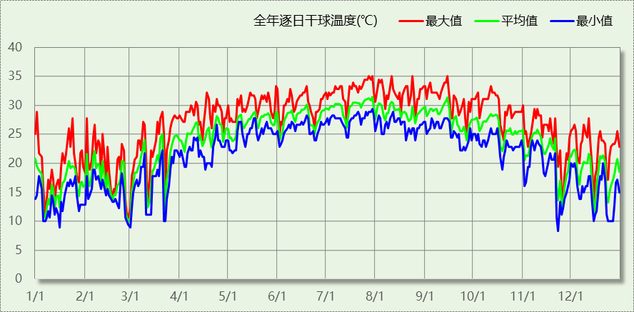

## 逐月辐照量表

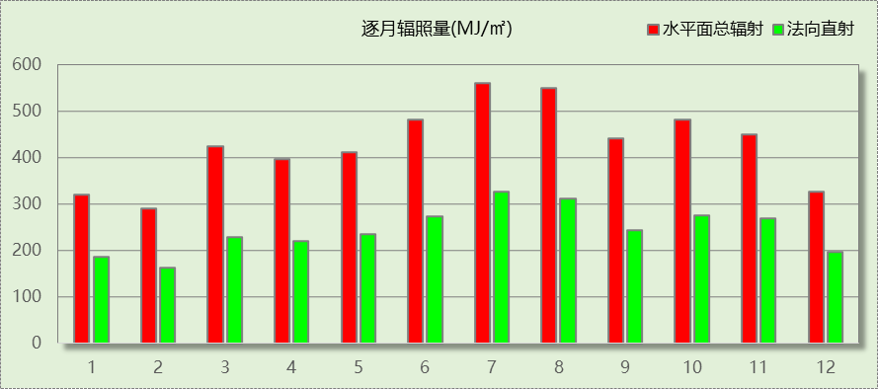

## 峰值工况

|  |  |  |  |  |  |
| --- | --- | --- | --- | --- | --- |
| 气象数据 | 时刻 | 干球温度(℃) | 湿球温度(℃) | 含湿量(g/kg) | 焓值(kj/kg) |
| 最热 | 07月27日14时 | 35.0 | 27.2 | 20.6 | 88.0 |
| 最冷 | 11月22日04时 | 8.3 | 5.6 | 4.3 | 19.2 |

# 建筑大样

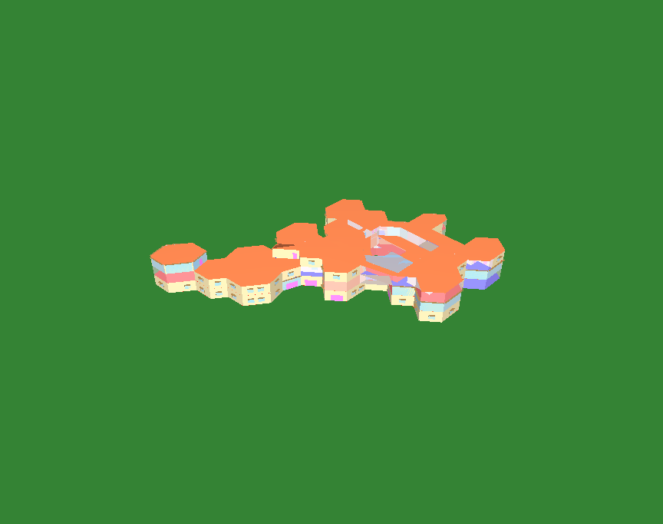

西南轴侧图



东南轴侧图

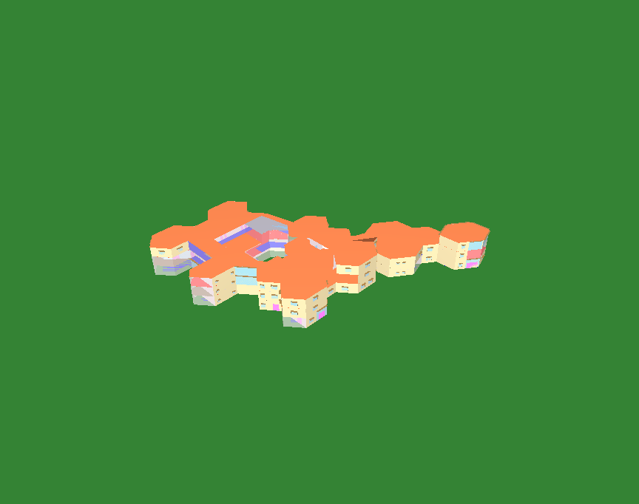

西北轴侧图



东北轴侧图

# 围护结构

## 工程材料

|  |  |  |  |  |  |  |
| --- | --- | --- | --- | --- | --- | --- |
| 材料名称 | 导热系数λ | 蓄热系数S | 密度ρ | 比热容Cp | 蒸汽渗透 系数u | 数据来源 |
| W/(m.K) | W/(㎡.K) | kg/m3 | J/(kg.K) | g/(m.h.kPa) |
| 水泥砂浆 | 0.930 | 11.370 | 1800.0 | 1050.0 | 0.0210 |  |
| 聚苯乙烯泡沫塑料（灰板） | 0.033 | 0.280 | 20.0 | 1380.0 | 0.0162 |  |
| 石灰砂浆 | 0.810 | 10.070 | 1600.0 | 1050.0 | 0.0443 |  |
| 钢筋混凝土 | 1.740 | 17.200 | 2500.0 | 920.0 | 0.0158 |  |
| 挤塑聚苯板(ρ=25-32) | 0.030 | 0.320 | 28.5 | 1647.0 | 0.0162 |  |
| 加气混凝土、泡沫混凝土(ρ=700) | 0.180 | 3.100 | 700.0 | 1050.0 | 0.0998 |  |
| 混凝土多孔砖(190六孔砖） | 0.750 | 7.490 | 1450.0 | 709.4 | 0.0010 |  |
| 岩棉板(ρ=60-160) | 0.041 | 0.615 | 110.0 | 1220.0 | 0.4880 |  |
| c20细石混凝土(ρ=2300) | 1.510 | 15.243 | 2300.0 | 920.0 | 0.0173 |  |
| 轻骨料混凝土(找坡层) | 0.300 | 5.000 | 1050.0 | 1091.3 | 0.0140 |  |
| 石墨聚苯板 | 0.033 | 0.280 | 20.0 | 1633.5 | 0.0162 |  |

## 围护结构作法简要说明

**1. 屋顶：**屋顶构造一 (K=0.264,D=3.856)：（由上到下）

加气混凝土、泡沫混凝土(ρ=700) 20mm＋c20细石混凝土(ρ=2300) 40mm＋挤塑聚苯板(ρ=25-32) 110mm＋轻骨料混凝土(找坡层) 30mm＋钢筋混凝土 120mm＋石灰砂浆 20mm

**2. 外墙：**外墙构造一 (K=0.445,D=3.064)：（由外到内）

水泥砂浆 20mm＋石墨聚苯板 70mm＋钢筋混凝土 200mm＋石灰砂浆 20mm

**3. 幕墙：**60系列内平开下悬铝合金窗[5涂膜+12A+5Low-E] (K=2.300)：

传热系数2.300W/㎡.K，窗太阳得热系数0.231

**4. 外窗：**70系列断桥铝窗5Low-E+0.3V+5 (K=0.970)：

传热系数0.970W/㎡.K，窗太阳得热系数0.479

**5. 天窗：**60系列内平开下悬玻璃钢窗[5涂膜+12A+5Low-E] (K=2.200)：

传热系数2.200W/㎡.K，窗太阳得热系数0.222

## 体形系数

### 体形系数

|  |  |
| --- | --- |
| 外表面积 | 4492.89 |
| 建筑体积 | 20037.24 |
| 体形系数 | 0.22 |

### 楼层信息表

|  |  |  |  |  |
| --- | --- | --- | --- | --- |
| 楼层 | 层高(m) | 建筑面积(㎡) | 外表面积(㎡) | 计算体积(m3) |
| 1 | 3.600 | 2125.14 | 978.43 | 7650.50 |
| 2 | 3.300 | 2132.33 | 682.69 | 7036.67 |
| 3 | 3.300 | 1621.23 | 1210.55 | 5350.06 |
| 4 | 3.300 | 0.00 | 1621.22 | 0.00 |
| 合计 | 13.50 | 5878.70 | 4492.89 | 20037.24 |

## 窗墙比

### 窗墙比

|  |  |  |  |  |
| --- | --- | --- | --- | --- |
| 朝向 | 立面 | 窗面积(㎡) | 墙面积(㎡) | 窗墙比 |
| 南向 | 南-默认立面 | 33.17 | 132.54 | 0.25 |
| 北向 | 北-默认立面 | 34.92 | 154.49 | 0.23 |
| 东向 | 东-默认立面 | 269.28 | 985.77 | 0.27 |
| 西向 | 西-默认立面 | 211.11 | 987.48 | 0.21 |

### 外窗表

|  |  |  |  |  |  |  |  |  |
| --- | --- | --- | --- | --- | --- | --- | --- | --- |
| 朝向 | 立面 | 编号 | 尺寸 | 楼层 | 数量 | 单个面积 （㎡） | 合计面积 （㎡） | 总面积 （㎡） |
| 南向 | 南-默认立面 | (玻璃幕墙) |  | 3 |  |  | 19.67 | 33.17 |
| C1815 | 1.80×1.50 | 1~2 | 5 | 2.70 | 13.50 |
| 北向 | 北-默认立面 | (玻璃幕墙) |  | 1 |  |  | 27.72 | 34.92 |
| (玻璃幕墙) |  | 1 |  |  | 7.20 |
| 东向 | 东-默认立面 | (玻璃幕墙) |  | 1 |  |  | 8.43 | 269.28 |
| (玻璃幕墙) |  | 1 |  |  | 5.40 |
| (玻璃幕墙) |  | 2~3 |  |  | 69.28 |
| (玻璃幕墙) |  | 2 |  |  | 21.13 |
| (玻璃幕墙) |  | 2~3 |  |  | 88.00 |
| (玻璃幕墙) |  | 3 |  |  | 1.44 |
| C1815 | 1.80×1.50 | 1~3 | 11 | 2.70 | 29.70 |
| C1815 | 1.80×1.50 | 1~3 | 12 | 2.70 | 32.40 |
| C1815 | 1.80×1.50 | 1~3 | 5 | 2.70 | 13.50 |
| 西向 | 西-默认立面 | (玻璃幕墙) |  | 1 |  |  | 3.11 | 211.11 |
| (玻璃幕墙) |  | 1 |  |  | 5.40 |
| (玻璃幕墙) |  | 1~2 |  |  | 26.86 |
| (玻璃幕墙) |  | 1 |  |  | 3.60 |
| (玻璃幕墙) |  | 2~3 |  |  | 56.22 |
| (玻璃幕墙) |  | 3 |  |  | 19.61 |
| C0909 | 0.90×0.90 | 1~3 | 6 | 0.81 | 4.86 |
| C0909 | 0.90×0.90 | 1~2 | 4 | 0.81 | 3.24 |
| C1215 | 1.20×1.50 | 1~3 | 6 | 1.80 | 10.80 |
| C1215 | 1.20×1.50 | 3 | 1 | 1.80 | 1.80 |
| C1815 | 1.80×1.50 | 1~3 | 11 | 2.70 | 29.70 |
| C1815 | 1.80×1.50 | 1~3 | 9 | 2.70 | 24.30 |
| C1815 | 1.80×1.50 | 1~3 | 8 | 2.70 | 21.60 |

## 天窗

### 天窗屋顶比

|  |  |  |  |  |
| --- | --- | --- | --- | --- |
| 房间 | 天窗编号 | 天窗面积（㎡） | 屋顶面积（㎡） | 面积比 |
| 3086 |  | 77.12 | 77.12 | 1.00 |
| 整栋建筑 | | 77.12 | 2275.28 | 0.03 |

### 天窗类型

|  |  |  |  |  |  |
| --- | --- | --- | --- | --- | --- |
| 序号 | 构造名称 | 构造编号 | 传热系数 | 综合太阳 得热系数 | 备注 |
| 1 | 60系列内平开下悬玻璃钢窗[5涂膜+12A+5Low-E] | 107 | 2.20 | 0.22 |  |
| 平均 | |  | 2.20 | 0.22 |  |

## 屋顶

### 屋顶构造一

|  |  |  |  |  |  |  |
| --- | --- | --- | --- | --- | --- | --- |
| 材料名称 （由上到下） | 厚度δ | 导热系数λ | 蓄热系数S | 修正 系数 | 热阻R | 热惰性 指标 |
| (mm) | W/(m.K) | W/(㎡.K) | α | (㎡K)/W | D=R*S |
| 加气混凝土、泡沫混凝土(ρ=700) | 20 | 0.180 | 3.100 | 1.00 | 0.111 | 0.344 |
| c20细石混凝土(ρ=2300) | 40 | 1.510 | 15.243 | 1.00 | 0.026 | 0.404 |
| 挤塑聚苯板(ρ=25-32) | 110 | 0.030 | 0.320 | 1.10 | 3.333 | 1.173 |
| 轻骨料混凝土(找坡层) | 30 | 0.300 | 5.000 | 1.50 | 0.067 | 0.500 |
| 钢筋混凝土 | 120 | 1.740 | 17.200 | 1.00 | 0.069 | 1.186 |
| 石灰砂浆 | 20 | 0.810 | 10.070 | 1.00 | 0.025 | 0.249 |
| 各层之和∑ | 340 | － | － | － | 3.631 | 3.856 |
| 外表面太阳辐射吸收系数 | 0.75[默认] | | | | | |
| 传热系数K=1/(0.16+∑R) | 0.26 | | | | | |

## 外墙

### 外墙构造一

|  |  |  |  |  |  |  |
| --- | --- | --- | --- | --- | --- | --- |
| 材料名称 （由外到内） | 厚度δ | 导热系数λ | 蓄热系数S | 修正 系数 | 热阻R | 热惰性 指标 |
| (mm) | W/(m.K) | W/(㎡.K) | α | (㎡K)/W | D=R*S |
| 水泥砂浆 | 20 | 0.930 | 11.370 | 1.00 | 0.022 | 0.245 |
| 石墨聚苯板 | 70 | 0.033 | 0.280 | 1.10 | 1.928 | 0.594 |
| 钢筋混凝土 | 200 | 1.740 | 17.200 | 1.00 | 0.115 | 1.977 |
| 石灰砂浆 | 20 | 0.810 | 10.070 | 1.00 | 0.025 | 0.249 |
| 各层之和∑ | 310 | － | － | － | 2.090 | 3.064 |
| 外表面太阳辐射吸收系数 | 0.75[默认] | | | | | |
| 传热系数K=1/(0.16+∑R) | 0.45 | | | | | |

### 外墙主断面传热系数的修正系数ψ

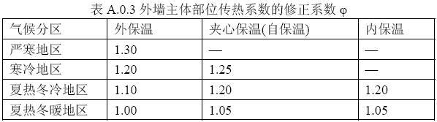

## 外窗热工

### 外窗

|  |  |  |  |  |  |  |
| --- | --- | --- | --- | --- | --- | --- |
| 序号 | 构造名称 | 构造 编号 | 传热 系数 | 窗太阳 得热系数 | 可见光 透射比 | 数据来源 |
| 1 | 60系列内平开下悬铝合金窗[5涂膜+12A+5Low-E] | 108 | 2.30 | 0.23 | 0.620 | 建筑节能门窗 16J607 |
| 窗编号 | | | | |
| 幕墙 | | | | |
| 2 | 70系列断桥铝窗5Low-E+0.3V+5 | 18 | 0.97 | 0.48 | 0.710 |  |
| 窗编号 | | | | |
| C1815，C0909，C1215 | | | | |

### 建筑遮阳措施

|  |  |  |  |
| --- | --- | --- | --- |
| 朝向 | 立面编号 | 遮阳措施 | 标准要求 |
| 南向 | 南-默认立面 | 平板遮阳 | 应采取遮阳措施 |
| 东向 | 东-默认立面 | 平板遮阳 | 应采取遮阳措施 |
| 西向 | 西-默认立面 | 平板遮阳 | 应采取遮阳措施 |

### 外遮阳类型

#### 平板遮阳

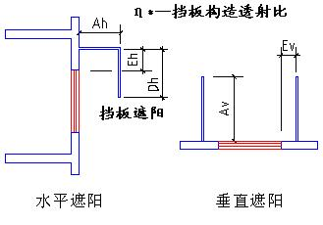

|  |  |  |  |  |  |  |  |
| --- | --- | --- | --- | --- | --- | --- | --- |
| 序号 | 编号 | 水平挑出Ah (m) | 距离上沿Eh (m) | 垂直挑出Av (m) | 距离边沿Ev (m) | 挡板高Dh (m) | 挡板透射η* |
| 1 | 平板遮阳0 | 0.600 | 0.000 | 0.100 | 0.000 | 0.000 | 0.000 |
| 2 | 平板遮阳0 | 0.500 | 0.000 | 0.000 | 0.000 | 0.000 | 0.000 |

### 平均传热系数

1. 南向：

南-默认立面

|  |  |  |  |  |  |  |  |
| --- | --- | --- | --- | --- | --- | --- | --- |
| 序号 | 门窗 编号 | 楼层 | 数量 | 单个面积（㎡） | 总面积（㎡） | 构造 编号 | 传热系数 |
| 1 | (玻璃幕墙) | 3 |  |  | 19.666 | 108 | 2.300 |
| 2 | C1815 | 1~2 | 5 | 2.700 | 13.500 | 18 | 0.970 |
| 立面总面积(㎡) | | | 33.166 | 立面平均传热系数 | | | 1.759 |

2. 北向：

北-默认立面

|  |  |  |  |  |  |  |  |
| --- | --- | --- | --- | --- | --- | --- | --- |
| 序号 | 门窗 编号 | 楼层 | 数量 | 单个面积（㎡） | 总面积（㎡） | 构造 编号 | 传热系数 |
| 1 | (玻璃幕墙) | 1 |  |  | 27.720 | 108 | 2.300 |
| 2 | (玻璃幕墙) | 1 |  |  | 7.200 | 108 | 2.300 |
| 立面总面积(㎡) | | | 34.920 | 立面平均传热系数 | | | 2.300 |

3. 东向：

东-默认立面

|  |  |  |  |  |  |  |  |
| --- | --- | --- | --- | --- | --- | --- | --- |
| 序号 | 门窗 编号 | 楼层 | 数量 | 单个面积（㎡） | 总面积（㎡） | 构造 编号 | 传热系数 |
| 1 | (玻璃幕墙) | 1 |  |  | 8.428 | 108 | 2.300 |
| 2 | (玻璃幕墙) | 1 |  |  | 5.400 | 108 | 2.300 |
| 3 | (玻璃幕墙) | 2~3 |  |  | 69.280 | 108 | 2.300 |
| 4 | (玻璃幕墙) | 2 |  |  | 21.130 | 108 | 2.300 |
| 5 | (玻璃幕墙) | 2~3 |  |  | 88.002 | 108 | 2.300 |
| 6 | (玻璃幕墙) | 3 |  |  | 1.440 | 108 | 2.300 |
| 7 | C1815 | 1~3 | 11 | 2.700 | 29.700 | 18 | 0.970 |
| 8 | C1815 | 1~3 | 12 | 2.700 | 32.400 | 18 | 0.970 |
| 9 | C1815 | 1~3 | 5 | 2.700 | 13.500 | 18 | 0.970 |
| 立面总面积(㎡) | | | 269.281 | 立面平均传热系数 | | | 1.927 |

4. 西向：

西-默认立面

|  |  |  |  |  |  |  |  |
| --- | --- | --- | --- | --- | --- | --- | --- |
| 序号 | 门窗 编号 | 楼层 | 数量 | 单个面积（㎡） | 总面积（㎡） | 构造 编号 | 传热系数 |
| 1 | (玻璃幕墙) | 1 |  |  | 3.114 | 108 | 2.300 |
| 2 | (玻璃幕墙) | 1 |  |  | 5.400 | 108 | 2.300 |
| 3 | (玻璃幕墙) | 1~2 |  |  | 26.862 | 108 | 2.300 |
| 4 | (玻璃幕墙) | 1 |  |  | 3.600 | 108 | 2.300 |
| 5 | (玻璃幕墙) | 2~3 |  |  | 56.218 | 108 | 2.300 |
| 6 | (玻璃幕墙) | 3 |  |  | 19.611 | 108 | 2.300 |
| 7 | C0909 | 1~3 | 6 | 0.810 | 4.860 | 18 | 0.970 |
| 8 | C0909 | 1~2 | 4 | 0.810 | 3.240 | 18 | 0.970 |
| 9 | C1215 | 1~3 | 6 | 1.800 | 10.800 | 18 | 0.970 |
| 10 | C1215 | 3 | 1 | 1.800 | 1.800 | 18 | 0.970 |
| 11 | C1815 | 1~3 | 11 | 2.700 | 29.700 | 18 | 0.970 |
| 12 | C1815 | 1~3 | 9 | 2.700 | 24.300 | 18 | 0.970 |
| 13 | C1815 | 1~3 | 8 | 2.700 | 21.600 | 18 | 0.970 |
| 立面总面积(㎡) | | | 211.105 | 立面平均传热系数 | | | 1.693 |

### 综合太阳得热系数

1. 南向：

南-默认立面

|  |  |  |  |  |  |  |  |  |  |  |
| --- | --- | --- | --- | --- | --- | --- | --- | --- | --- | --- |
| 序号 | 门窗 编号 | 楼层 | 数量 | 单个面积（㎡） | 总面积（㎡） | 构造 编号 | 窗太阳 得热系数 | 外遮阳 编号 | 外遮阳 系数 | 综合太阳 得热系数 |
| 1 | (玻璃幕墙) | 3 |  |  | 19.666 | 108 | 0.231 | 平板遮阳0 | 0.900 | 0.208 |
| 2 | C1815 | 1~2 | 5 | 2.700 | 13.500 | 18 | 0.479 | 平板遮阳0 | 0.747 | 0.358 |
| 立面总面积(㎡) | | | | | 33.166 | 综合太阳得热系数 | | | | 0.269 |

2. 北向：

北-默认立面

|  |  |  |  |  |  |  |  |  |  |  |
| --- | --- | --- | --- | --- | --- | --- | --- | --- | --- | --- |
| 序号 | 门窗 编号 | 楼层 | 数量 | 单个面积（㎡） | 总面积（㎡） | 构造 编号 | 窗太阳 得热系数 | 外遮阳 编号 | 外遮阳 系数 | 综合太阳 得热系数 |
| 1 | (玻璃幕墙) | 1 |  |  | 27.720 | 108 | 0.231 | 平板遮阳0 | 0.921 | 0.212 |
| 2 | (玻璃幕墙) | 1 |  |  | 7.200 | 108 | 0.231 | 平板遮阳0 | 0.832 | 0.192 |
| 立面总面积(㎡) | | | | | 34.920 | 综合太阳得热系数 | | | | 0.208 |

3. 东向：

东-默认立面

|  |  |  |  |  |  |  |  |  |  |  |
| --- | --- | --- | --- | --- | --- | --- | --- | --- | --- | --- |
| 序号 | 门窗 编号 | 楼层 | 数量 | 单个面积（㎡） | 总面积（㎡） | 构造 编号 | 窗太阳 得热系数 | 外遮阳 编号 | 外遮阳 系数 | 综合太阳 得热系数 |
| 1 | (玻璃幕墙) | 1 |  |  | 8.428 | 108 | 0.231 | 平板遮阳0 | 0.905 | 0.209 |
| 2 | (玻璃幕墙) | 1 |  |  | 5.400 | 108 | 0.231 | 平板遮阳0 | 0.796 | 0.183 |
| 3 | (玻璃幕墙) | 2~3 |  |  | 69.280 | 108 | 0.231 | 平板遮阳0 | 0.897 | 0.207 |
| 4 | (玻璃幕墙) | 2 |  |  | 21.130 | 108 | 0.231 | 平板遮阳0 | 0.892 | 0.206 |
| 5 | (玻璃幕墙) | 2~3 |  |  | 88.002 | 108 | 0.231 | 平板遮阳0 | 0.896 | 0.207 |
| 6 | (玻璃幕墙) | 3 |  |  | 1.440 | 108 | 0.231 | 平板遮阳0 | 0.757 | 0.174 |
| 7 | C1815 | 1~3 | 11 | 2.700 | 29.700 | 18 | 0.479 | 平板遮阳0 | 0.734 | 0.351 |
| 8 | C1815 | 1~3 | 12 | 2.700 | 32.400 | 18 | 0.479 | 平板遮阳0 | 0.736 | 0.352 |
| 9 | C1815 | 1~3 | 5 | 2.700 | 13.500 | 18 | 0.479 | 平板遮阳0 | 0.723 | 0.346 |
| 立面总面积(㎡) | | | | | 269.281 | 综合太阳得热系数 | | | | 0.246 |

4. 西向：

西-默认立面

|  |  |  |  |  |  |  |  |  |  |  |
| --- | --- | --- | --- | --- | --- | --- | --- | --- | --- | --- |
| 序号 | 门窗 编号 | 楼层 | 数量 | 单个面积（㎡） | 总面积（㎡） | 构造 编号 | 窗太阳 得热系数 | 外遮阳 编号 | 外遮阳 系数 | 综合太阳 得热系数 |
| 1 | (玻璃幕墙) | 1 |  |  | 3.114 | 108 | 0.231 | 平板遮阳0 | 0.911 | 0.210 |
| 2 | (玻璃幕墙) | 1 |  |  | 5.400 | 108 | 0.231 | 平板遮阳0 | 0.810 | 0.187 |
| 3 | (玻璃幕墙) | 1~2 |  |  | 26.862 | 108 | 0.231 | 平板遮阳0 | 0.907~0.907 | 0.209~0.209 |
| 4 | (玻璃幕墙) | 1 |  |  | 3.600 | 108 | 0.231 | 平板遮阳0 | 0.800 | 0.184 |
| 5 | (玻璃幕墙) | 2~3 |  |  | 56.218 | 108 | 0.231 | 平板遮阳0 | 0.904 | 0.208 |
| 6 | (玻璃幕墙) | 3 |  |  | 19.611 | 108 | 0.231 | 平板遮阳0 | 0.899 | 0.207 |
| 7 | C0909 | 1~3 | 6 | 0.810 | 4.860 | 18 | 0.479 | 平板遮阳0 | 0.629 | 0.301 |
| 8 | C0909 | 1~2 | 4 | 0.810 | 3.240 | 18 | 0.479 | 平板遮阳0 | 0.640 | 0.306 |
| 9 | C1215 | 1~3 | 6 | 1.800 | 10.800 | 18 | 0.479 | 平板遮阳0 | 0.731 | 0.350 |
| 10 | C1215 | 3 | 1 | 1.800 | 1.800 | 18 | 0.479 | 平板遮阳0 | 0.725 | 0.347 |
| 11 | C1815 | 1~3 | 11 | 2.700 | 29.700 | 18 | 0.479 | 平板遮阳0 | 0.740 | 0.354 |
| 12 | C1815 | 1~3 | 9 | 2.700 | 24.300 | 18 | 0.479 | 平板遮阳0 | 0.747 | 0.358 |
| 13 | C1815 | 1~3 | 8 | 2.700 | 21.600 | 18 | 0.479 | 平板遮阳0 | 0.755 | 0.361 |
| 立面总面积(㎡) | | | | | 211.105 | 综合太阳得热系数 | | | | 0.273 |

### 总体热工性能

|  |  |  |  |  |  |
| --- | --- | --- | --- | --- | --- |
| 朝向 | 立面 | 面积 | 传热系数 | 综合太阳得热系数 | 窗墙比 |
| 南向 | 南-默认立面 | 33.17 | 1.76 | 0.27 | 0.25 |
| 北向 | 北-默认立面 | 34.92 | 2.30 | 0.21 | 0.23 |
| 东向 | 东-默认立面 | 269.28 | 1.93 | 0.25 | 0.27 |
| 西向 | 西-默认立面 | 211.11 | 1.69 | 0.27 | 0.21 |
| 综合平均 |  | 548.47 | 1.85 | 0.26 | 0.24 |

注：本表所统计的外窗包含凸窗。

## 可开启窗扇

# 围护结构概况

|  |  |  |  |  |  |  |  |  |
| --- | --- | --- | --- | --- | --- | --- | --- | --- |
|  | | | 设计建筑 | | | 参照建筑 | | |
| 天窗屋顶比 | | | 0.03 | | | 0.03 | | |
| 屋顶传热系数K  和热惰性指标 D | | | K=0.26  D=3.86 | | | K=0.40  D=3.40 | | |
| 外墙传热系数K  和热惰性指标 D | | | K=0.45  D=3.06 | | | K=1.50  D=2.67 | | |
| 挑空楼板传热系数K  和热惰性指标 D | | | K=0.42  D=2.43 | | | K=0.42  D=2.43 | | |
| 天窗传热系数K  和太阳得热系数 SHGC | | | K=2.20  SHGC=0.22 | | | K=2.50  SHGC=0.25 | | |
| 外窗（包括透明幕墙） | 朝向 | 立面 | 窗墙比 | 传热  系数 | 太阳得热系数 | 窗墙比 | 传热  系数 | 太阳得热系数 |
| 南向 | 南-默认立面 | 0.25 | 1.76 | 0.27 | 0.25 | 3.00 | 0.35 |
| 北向 | 北-默认立面 | 0.23 | 2.30 | 0.21 | 0.23 | 3.00 | 0.40 |
| 东向 | 东-默认立面 | 0.27 | 1.93 | 0.25 | 0.27 | 3.00 | 0.35 |
| 西向 | 西-默认立面 | 0.21 | 1.69 | 0.27 | 0.21 | 3.00 | 0.35 |
| 室内参数和气象条件设置 | | | 按《公共建筑节能设计标准》附录B设置 | | | | | |

备注：

1. 传热系数的单位W/(m2.k)，其他参数无量纲.

2. 屋顶和外墙的传热系数K和热情性指标D指平均值.

# 设计建筑

## 房间类型

### 房间参数表

|  |  |  |  |  |  |  |  |
| --- | --- | --- | --- | --- | --- | --- | --- |
| 房间类型 | 空调 温度℃ | 供暖 温度℃ | 新风量 | 渗透风 换气次数 | 人员密度 | 照明功率 密度 | 电器设备 功率 |
| 健身活动室 | 24 | 19 | 40(m3/h.人) | 0(次/h) | 4(㎡/人) | 2(W/㎡) | 5(W/㎡) |
| 办公-普通办公室 | 26 | 20 | 30(m3/h.人) | 0(次/h) | 8(㎡/人) | 8(W/㎡) | 15(W/㎡) |
| 卫生间 | 28 | 16 | 0(m3/h.人) | 0(次/h) | 0(人) | 1.8(W/㎡) | 5(W/㎡) |
| 多媒体教室 | 26 | 18 | 20(m3/h.人) | 0(次/h) | 4(㎡/人) | 2(W/㎡) | 5(W/㎡) |
| 大厅 | 26 | 20 | 30(m3/h.人) | 0(次/h) | 20(㎡/人) | 1.5(W/㎡) | 0(W/㎡) |
| 实验教室 | 26 | 18 | 20(m3/h.人) | 0(次/h) | 4(㎡/人) | 2(W/㎡) | 5(W/㎡) |
| 密集办公室 | 26 | 20 | 30(m3/h.人) | 0(次/h) | 4(㎡/人) | 2(W/㎡) | 20(W/㎡) |
| 报告厅 | 26 | 18 | 14(m3/h.人) | 0(次/h) | 2.5(㎡/人) | 2(W/㎡) | 5(W/㎡) |
| 普通办公室 | 26 | 20 | 30(m3/h.人) | 0(次/h) | 6(㎡/人) | 2(W/㎡) | 5(W/㎡) |
| 楼梯间 | － | － | 0(m3/h.人) | 0(次/h) | 0(人) | 1.4(W/㎡) | 5(W/㎡) |
| 空房间 | － | － | 0(m3/h.人) | 0(次/h) | 0(人) | 0(W/㎡) | 0(W/㎡) |
| 舞蹈教室 | 26 | 20 | 30(m3/h.人) | 0(次/h) | 4(㎡/人) | 2(W/㎡) | 5(W/㎡) |
| 计算机房 | 26 | 18 | 24(m3/h.人) | 0(次/h) | 1.39(㎡/人) | 2(W/㎡) | 5(W/㎡) |
| 设备间 | － | － | 0(次/h) | 0(次/h) | 0(人) | 1.8(W/㎡) | 15(W/㎡) |
| 走廊 | － | － | 0(m3/h.人) | 0(次/h) | 0(人) | 1.4(W/㎡) | 5(W/㎡) |
| 阅览室 | 26 | 20 | 20(m3/h.人) | 0(次/h) | 1.9(㎡/人) | 2(W/㎡) | 5(W/㎡) |
| 风雨操场 | 28 | 15 | 19(m3/h.人) | 0(次/h) | 6(㎡/人) | 1.5(W/㎡) | 5(W/㎡) |
| 餐厅 | 26 | 18 | 25(m3/h.人) | 0(次/h) | 2(㎡/人) | 2(W/㎡) | 5(W/㎡) |

### 作息时间表

详见附录

## 系统类型

### 系统分区

|  |  |  |  |  |  |
| --- | --- | --- | --- | --- | --- |
| 系统编号 | 系统类型 | 制冷 SEER | 制热 HSPF | 面积(㎡) | 包含的房间 |
| Sys1 | 双管制风机盘管 | － | － | 3006.09 | 所有房间 |

### 热回收参数

|  |  |  |  |  |  |
| --- | --- | --- | --- | --- | --- |
| 系统编号 | 热回收 | 供冷 | | 供暖 | |
| 回收效率 | 启动温(焓)差 | 回收效率 | 启动温(焓)差 |
| Sys1 | 全热回收 | 0.50 | 5℃ | 0.00 | 5(℃) |

## 制冷系统

### 默认冷源

#### 供应的系统

|  |  |
| --- | --- |
| 系统编号 | Sys1 |

#### 冷水机组

根据《民用建筑绿色性能计算标准》表5.3.4-2的要求，区域冷源按电动离心/螺杆式冷水机组计算。

软件按电动离心式冷水机组计算。

|  |  |  |  |  |  |  |  |  |
| --- | --- | --- | --- | --- | --- | --- | --- | --- |
| 名称 | 类型 | 额定 耗电量(kW) | 额定 制冷量(kW) | 额定性 能系数 (COP) | 台数 | 全年 供冷量(kWh) | 综合部分 负荷性能系数(IPLV) | 电耗 (kWh) |
| 机组1 | 水冷-离心式冷水机组 | 97.77 | 567 | 5.80 | 1 | 181672 | 5.90 | 30792 |

#### 冷却水泵

|  |  |  |  |  |  |  |
| --- | --- | --- | --- | --- | --- | --- |
| 机组名称 | 冷水机组 制冷量(kW) | 机组性能 系数(COP) | 冷凝负荷(kW) | 输送能效比 | 运行时长 (h) | 水泵电耗 (kWh) |
| 机组1 | 567.04 | 5.80 | 665 | 0.0214 | 594 | 8451 |

#### 冷冻水泵

|  |  |  |  |  |
| --- | --- | --- | --- | --- |
| 机组名称 | 机组制冷量(kW) | 输送能效比 | 运行时长(h) | 水泵电耗(kWh) |
| 机组1 | 567.04 | 0.0241 | 594 | 8117 |

#### 冷却塔

|  |  |  |  |  |  |
| --- | --- | --- | --- | --- | --- |
| 类型 | 机组制冷量(kW) | 冷却塔风机单位 电耗制冷量(kW/kW) | 冷却塔风机 功率(kW) | 运行时长(h) | 冷却塔电耗 (kWh) |
| 冷却塔 | 567.04 | 170 | 3.336 | 594 | 1981 |

## 空调风机

### 独立新排风

|  |  |  |  |  |  |
| --- | --- | --- | --- | --- | --- |
| 系统编号 | 新风量 (m3/h) | 单位风量耗功率 W/(m3/h) | 风机功率(W) | 运行时长(h) | 新风电耗(kWh) |
| Sys1 | 16763 | 0.24 | 4023 | 924 | 3717 |
| 合计 | | | | | 3717 |

|  |  |  |  |  |  |  |
| --- | --- | --- | --- | --- | --- | --- |
| 系统编号 | 排风量 (m3/h) | 排风比 | 单位风量耗功率W/(m3/h) | 风机功率(W) | 运行时长(h) | 排风电耗 (kWh) |
| Sys1 | 16763 | 1 | 0.24 | 4023 | 924 | 3717 |
| 合计 | | | | | | 3717 |

### 风机盘管

|  |  |  |  |  |
| --- | --- | --- | --- | --- |
| 系统编号 | 总功率(W) | 同时使用系数 | 运行时长(h) | 风机盘管电耗(kWh) |
| Sys1 | 400 | 1 | 594 | 238 |
| 合计 | | | | 238 |

## 照明

|  |  |  |  |  |
| --- | --- | --- | --- | --- |
| 房间类型 | 单位面积电耗 (kWh/㎡) | 房间个数 | 房间合计面积 (㎡) | 合计电耗 (kWh) |
| 健身活动室 | 4.14 | 1 | 240 | 993 |
| 卫生间 | 3.73 | 50 | 199 | 743 |
| 多媒体教室 | 4.14 | 1 | 120 | 497 |
| 大厅 | 3.10 | 4 | 843 | 2617 |
| 实验教室 | 4.14 | 1 | 120 | 497 |
| 密集办公室 | 4.14 | 1 | 200 | 827 |
| 报告厅 | 4.14 | 1 | 120 | 497 |
| 普通办公室 | 4.14 | 15 | 602 | 2491 |
| 楼梯间 | 2.90 | 11 | 238 | 689 |
| 空房间 | 0.00 | 12 | 251 | 0 |
| 舞蹈教室 | 4.14 | 1 | 70 | 290 |
| 计算机房 | 4.14 | 1 | 51 | 211 |
| 设备间 | 9.46 | 1 | 23 | 213 |
| 走廊 | 2.90 | 4 | 606 | 1756 |
| 阅览室 | 4.14 | 1 | 420 | 1738 |
| 风雨操场 | 3.10 | 1 | 77 | 239 |
| 餐厅 | 4.14 | 3 | 73 | 303 |
| 总计 | | | | 14601 |

## 负荷分项统计

|  |  |  |  |  |  |  |
| --- | --- | --- | --- | --- | --- | --- |
| 分类 | 围护传热 | 室内得热 | 窗日射 | 新风/渗透 | 热回收 | 合计 |
| 供暖(kWh/㎡) | 0.00 | 0.00 | 0.00 | 0.00 | 0.00 | 0.00 |
| 供冷(kWh/㎡) | 6.00 | 11.25 | 1.28 | 15.52 | -3.15 | 30.90 |

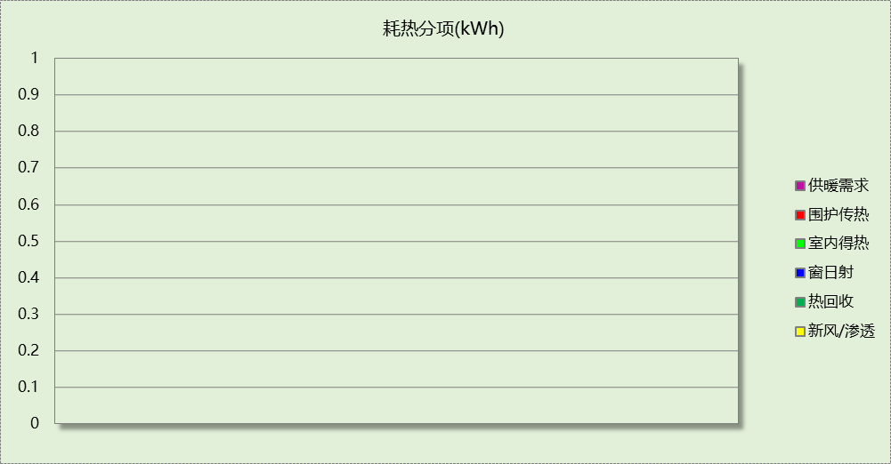

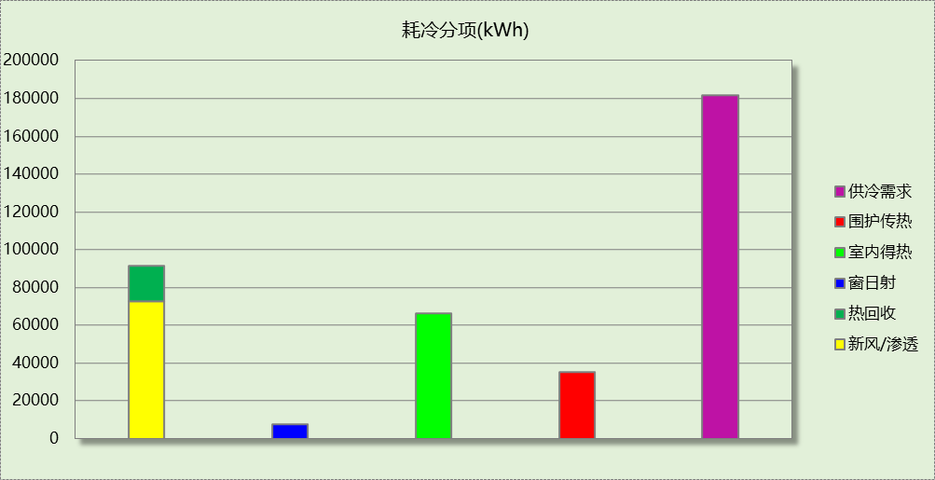

## 逐月负荷表

|  |  |  |  |  |  |  |
| --- | --- | --- | --- | --- | --- | --- |
| 月份 | 供暖(kWh) | 供冷(kWh) | 热负荷 峰值(kW) | 热负荷 峰值时刻 | 冷负荷 峰值(kW) | 冷负荷 峰值时刻 |
| 1月 | 0 | 0 | 0.000 | -- | 0.000 | -- |
| 2月 | 0 | 0 | 0.000 | -- | 0.000 | -- |
| 3月 | 0 | 0 | 0.000 | -- | 0.000 | -- |
| 4月 | 0 | 0 | 0.000 | -- | 0.000 | -- |
| 5月 | 0 | 0 | 0.000 | -- | 0.000 | -- |
| 6月 | 0 | 61929 | 0.000 | -- | 390.015 | 6月19日9时 |
| 7月 | 0 | 33124 | 0.000 | -- | 417.896 | 7月8日9时 |
| 8月 | 0 | 19435 | 0.000 | -- | 567.042 | 8月26日9时 |
| 9月 | 0 | 67184 | 0.000 | -- | 462.013 | 9月2日10时 |
| 10月 | 0 | 0 | 0.000 | -- | 0.000 | -- |
| 11月 | 0 | 0 | 0.000 | -- | 0.000 | -- |
| 12月 | 0 | 0 | 0.000 | -- | 0.000 | -- |

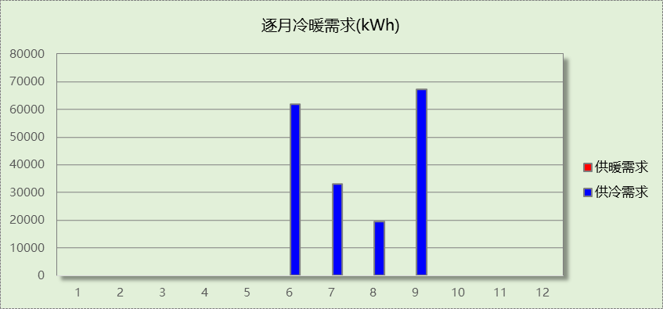

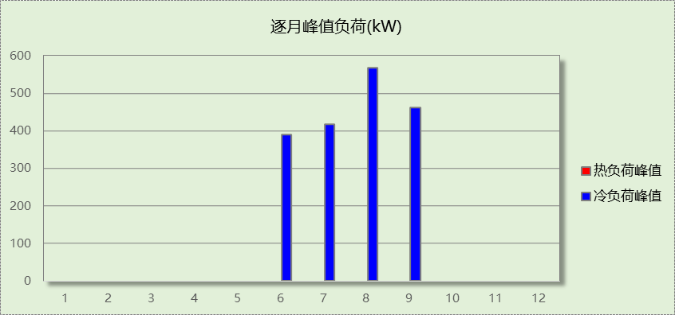

## 逐月电耗

注:供冷供暖为冷热源及输配水泵电耗，热水为扣减太阳能后电耗，所有数据单位kWh/㎡。

|  |  |  |  |  |  |  |  |  |
| --- | --- | --- | --- | --- | --- | --- | --- | --- |
| 月 | 供冷 | 供暖 | 空调风机 | 照明 | 插座设备 | 排风机 | 电梯 | 热水 |
| 1 | 0.00 | 0.00 | 0.00 | 0.10 | － | － | － | － |
| 2 | 0.00 | 0.00 | 0.00 | 0.00 | － |
| 3 | 0.00 | 0.00 | 0.00 | 0.23 | － |
| 4 | 0.00 | 0.00 | 0.00 | 0.24 | － |
| 5 | 0.00 | 0.00 | 0.00 | 0.25 | － |
| 6 | 2.90 | 0.00 | 0.30 | 0.22 | － |
| 7 | 1.54 | 0.00 | 0.35 | 0.26 | － |
| 8 | 0.85 | 0.00 | 0.33 | 0.25 | － |
| 9 | 3.11 | 0.00 | 0.32 | 0.23 | － |
| 10 | 0.00 | 0.00 | 0.00 | 0.23 | － |
| 11 | 0.00 | 0.00 | 0.00 | 0.24 | － |
| 12 | 0.00 | 0.00 | 0.00 | 0.25 | － |
| 合计 | 8.39 | 0.00 | 1.31 | 2.48 | － | － | － | － |

# 参照建筑

## 房间类型

### 房间参数表

|  |  |  |  |  |  |  |  |
| --- | --- | --- | --- | --- | --- | --- | --- |
| 房间类型 | 空调 温度℃ | 供暖 温度℃ | 新风量 | 渗透风 换气次数 | 人员密度 | 照明功率 密度 | 电器设备 功率 |
| 健身活动室 | 24 | 19 | 40(m3/h.人) | 0(次/h) | 4(㎡/人) | 9(W/㎡) | 5(W/㎡) |
| 办公-普通办公室 | 26 | 20 | 30(m3/h.人) | 0(次/h) | 8(㎡/人) | 9(W/㎡) | 15(W/㎡) |
| 卫生间 | 28 | 16 | 0(m3/h.人) | 0(次/h) | 0(人) | 6(W/㎡) | 5(W/㎡) |
| 多媒体教室 | 26 | 18 | 20(m3/h.人) | 0(次/h) | 4(㎡/人) | 9(W/㎡) | 5(W/㎡) |
| 大厅 | 26 | 20 | 30(m3/h.人) | 0(次/h) | 20(㎡/人) | 10(W/㎡) | 0(W/㎡) |
| 实验教室 | 26 | 18 | 20(m3/h.人) | 0(次/h) | 4(㎡/人) | 9(W/㎡) | 5(W/㎡) |
| 密集办公室 | 26 | 20 | 30(m3/h.人) | 0(次/h) | 4(㎡/人) | 13.5(W/㎡) | 20(W/㎡) |
| 报告厅 | 26 | 18 | 14(m3/h.人) | 0(次/h) | 2.5(㎡/人) | 12(W/㎡) | 5(W/㎡) |
| 普通办公室 | 26 | 20 | 30(m3/h.人) | 0(次/h) | 6(㎡/人) | 9(W/㎡) | 5(W/㎡) |
| 楼梯间 | － | － | 0(m3/h.人) | 0(次/h) | 0(人) | 5(W/㎡) | 5(W/㎡) |
| 空房间 | － | － | 0(m3/h.人) | 0(次/h) | 0(人) | 0(W/㎡) | 0(W/㎡) |
| 舞蹈教室 | 26 | 20 | 30(m3/h.人) | 0(次/h) | 4(㎡/人) | 9(W/㎡) | 5(W/㎡) |
| 计算机房 | 26 | 18 | 24(m3/h.人) | 0(次/h) | 1.39(㎡/人) | 9(W/㎡) | 5(W/㎡) |
| 设备间 | － | － | 0(次/h) | 0(次/h) | 0(人) | 6(W/㎡) | 15(W/㎡) |
| 走廊 | － | － | 0(m3/h.人) | 0(次/h) | 0(人) | 5(W/㎡) | 5(W/㎡) |
| 阅览室 | 26 | 20 | 20(m3/h.人) | 0(次/h) | 1.9(㎡/人) | 9(W/㎡) | 5(W/㎡) |
| 风雨操场 | 28 | 15 | 19(m3/h.人) | 0(次/h) | 6(㎡/人) | 9(W/㎡) | 5(W/㎡) |
| 餐厅 | 26 | 18 | 25(m3/h.人) | 0(次/h) | 2(㎡/人) | 9(W/㎡) | 5(W/㎡) |

### 作息时间表

同设计建筑

## 系统类型

|  |  |  |  |  |  |
| --- | --- | --- | --- | --- | --- |
| 系统编号 | 系统类型 | 制冷 SEER | 制热 HSPF | 面积(㎡) | 包含的房间 |
| Sys1 | 双管制风机盘管 | － | － | 同设计建筑 | 同设计建筑 |

## 制冷系统

### 默认冷源

#### 供应的系统

|  |  |
| --- | --- |
| 系统编号 | Sys1 |

#### 冷水机组

|  |  |  |  |  |  |  |  |  |
| --- | --- | --- | --- | --- | --- | --- | --- | --- |
| 名称 | 类型 | 额定 耗电量(kW) | 额定 制冷量(kW) | 额定性 能系数 (COP) | 台数 | 全年 供冷量(kWh) | 综合部分 负荷性能系数(IPLV) | 电耗 (kWh) |
| 机组1 | 水冷-离心式冷水机组 | 102 | 592 | 5.80 | 1 | 226291 | 5.90 | 38354 |
| 合计 | | | | | | | | 38354 |

#### 冷却水泵

|  |  |  |  |  |  |  |
| --- | --- | --- | --- | --- | --- | --- |
| 机组名称 | 冷水机组 制冷量(kW) | 机组性能 系数(COP) | 冷凝负荷(kW) | 输送能效比 | 运行时长 (h) | 水泵电耗 (kWh) |
| 机组1 | 592 | 5.80 | 694 | 0.0214 | 594 | 8824 |
| 合计 | 592 |  | 694 |  |  | 8824 |

#### 冷冻水泵

|  |  |  |  |  |
| --- | --- | --- | --- | --- |
| 机组名称 | 机组制冷量(kW) | 输送能效比 | 运行时长(h) | 水泵电耗(kWh) |
| 机组1 | 592 | 0.0241 | 594 | 8475 |
| 合计 | 592 |  |  | 8475 |

#### 冷却塔

|  |  |  |  |  |  |
| --- | --- | --- | --- | --- | --- |
| 类型 | 机组制冷量(kW) | 冷却塔风机单位 电耗制冷量(kW/kW) | 冷却塔风机 功率(kW) | 运行时长(h) | 冷却塔电耗 (kWh) |
| 冷却塔 | 592 | 170 | 3.48 | 594 | 2069 |

## 空调风机

### 独立新排风

|  |  |  |  |  |  |
| --- | --- | --- | --- | --- | --- |
| 系统编号 | 新风量 (m3/h) | 单位风量耗功率 W/(m3/h) | 风机功率(W) | 运行时长(h) | 新风电耗(kWh) |
| Sys1 | 16763 | 0.24 | 4023 | 924 | 3717 |
| 合计 | | | | | 3717 |

|  |  |  |  |  |  |  |
| --- | --- | --- | --- | --- | --- | --- |
| 系统编号 | 排风量 (m3/h) | 排风比 | 单位风量耗功率W/(m3/h) | 风机功率(W) | 运行时长(h) | 排风电耗 (kWh) |
| Sys1 | 16763 | 1 | 0.24 | 4023 | 924 | 3717 |
| 合计 | | | | | | 3717 |

### 风机盘管

|  |  |  |  |  |
| --- | --- | --- | --- | --- |
| 系统编号 | 总功率(W) | 同时使用系数 | 运行时长(h) | 风机盘管电耗(kWh) |
| Sys1 | 400 | 1 | 620 | 248 |
| 合计 | | | | 248 |

## 照明

|  |  |  |  |  |
| --- | --- | --- | --- | --- |
| 房间类型 | 单位面积电耗 (kWh/㎡) | 房间个数 | 房间合计面积 (㎡) | 合计电耗 (kWh) |
| 健身活动室 | 18.63 | 1 | 240 | 4468 |
| 卫生间 | 12.42 | 50 | 199 | 2476 |
| 多媒体教室 | 18.63 | 1 | 120 | 2237 |
| 大厅 | 20.70 | 4 | 843 | 17446 |
| 实验教室 | 18.63 | 1 | 120 | 2235 |
| 密集办公室 | 27.94 | 1 | 200 | 5585 |
| 报告厅 | 24.83 | 1 | 120 | 2980 |
| 普通办公室 | 18.63 | 15 | 602 | 11208 |
| 楼梯间 | 10.35 | 11 | 238 | 2462 |
| 空房间 | 0.00 | 12 | 251 | 0 |
| 舞蹈教室 | 18.63 | 1 | 70 | 1304 |
| 计算机房 | 18.63 | 1 | 51 | 950 |
| 设备间 | 31.54 | 1 | 23 | 710 |
| 走廊 | 10.35 | 4 | 606 | 6273 |
| 阅览室 | 18.63 | 1 | 420 | 7820 |
| 风雨操场 | 18.63 | 1 | 77 | 1436 |
| 餐厅 | 18.63 | 3 | 73 | 1365 |
| 总计 | | | | 70954 |

## 负荷分项统计

|  |  |  |  |  |  |  |
| --- | --- | --- | --- | --- | --- | --- |
| 分类 | 围护传热 | 室内得热 | 窗日射 | 新风/渗透 | 热回收 | 合计 |
| 供暖(kWh/㎡) | 0.00 | 0.00 | 0.00 | 0.00 | 0.00 | 0.00 |
| 供冷(kWh/㎡) | 7.84 | 13.17 | 1.79 | 15.69 | 0.00 | 38.49 |



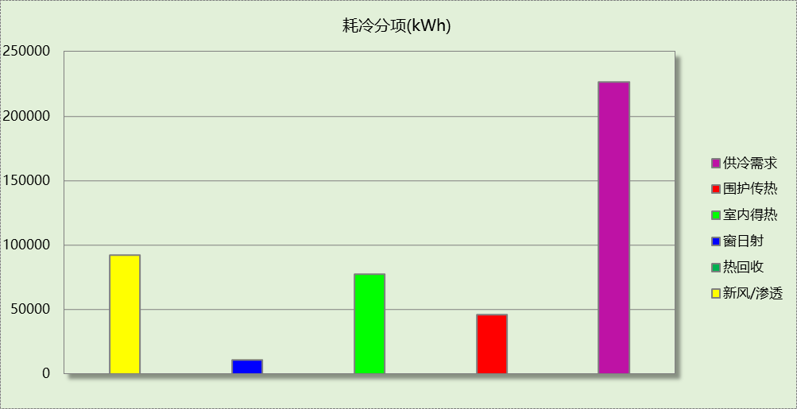

## 逐月负荷表

|  |  |  |  |  |  |  |
| --- | --- | --- | --- | --- | --- | --- |
| 月份 | 供暖(kWh) | 供冷(kWh) | 热负荷 峰值(kW) | 热负荷 峰值时刻 | 冷负荷 峰值(kW) | 冷负荷 峰值时刻 |
| 1月 | 0 | 0 | 0.000 | -- | 0.000 | -- |
| 2月 | 0 | 0 | 0.000 | -- | 0.000 | -- |
| 3月 | 0 | 0 | 0.000 | -- | 0.000 | -- |
| 4月 | 0 | 0 | 0.000 | -- | 0.000 | -- |
| 5月 | 0 | 0 | 0.000 | -- | 0.000 | -- |
| 6月 | 0 | 74595 | 0.000 | -- | 459.948 | 6月17日9时 |
| 7月 | 0 | 43859 | 0.000 | -- | 495.988 | 7月8日9时 |
| 8月 | 0 | 23609 | 0.000 | -- | 592.053 | 8月26日9时 |
| 9月 | 0 | 84228 | 0.000 | -- | 536.956 | 9月2日10时 |
| 10月 | 0 | 0 | 0.000 | -- | 0.000 | -- |
| 11月 | 0 | 0 | 0.000 | -- | 0.000 | -- |
| 12月 | 0 | 0 | 0.000 | -- | 0.000 | -- |

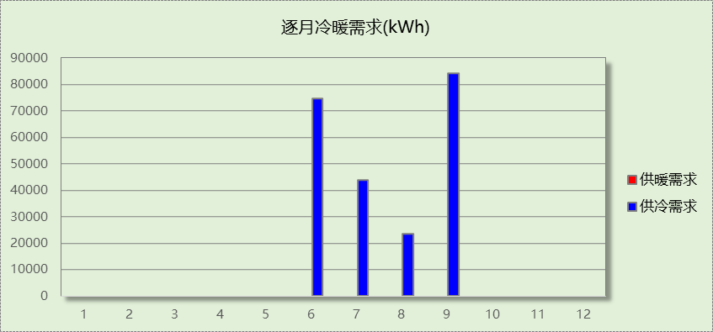

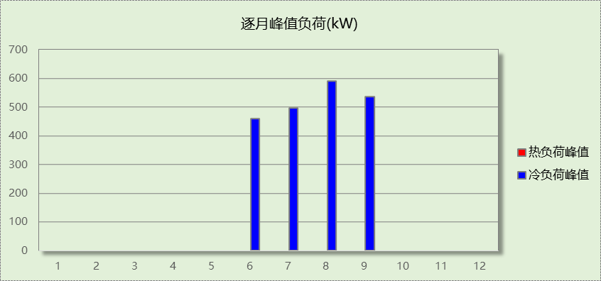

## 逐月电耗

注:供冷供暖为冷热源及输配水泵电耗，热水为扣减太阳能后电耗，所有数据单位kWh/㎡。

|  |  |  |  |  |  |  |  |  |
| --- | --- | --- | --- | --- | --- | --- | --- | --- |
| 月 | 供冷 | 供暖 | 空调风机 | 照明 | 插座设备 | 排风机 | 电梯 | 热水 |
| 1 | 0.00 | 0.00 | 0.00 | 0.50 | － | － | － | － |
| 2 | 0.00 | 0.00 | 0.00 | 0.00 | － |
| 3 | 0.00 | 0.00 | 0.00 | 1.10 | － |
| 4 | 0.00 | 0.00 | 0.00 | 1.16 | － |
| 5 | 0.00 | 0.00 | 0.00 | 1.21 | － |
| 6 | 3.31 | 0.00 | 0.01 | 1.05 | － |
| 7 | 1.87 | 0.00 | 0.01 | 1.27 | － |
| 8 | 0.99 | 0.00 | 0.00 | 1.21 | － |
| 9 | 3.65 | 0.00 | 0.02 | 1.10 | － |
| 10 | 0.00 | 0.00 | 0.00 | 1.10 | － |
| 11 | 0.00 | 0.00 | 0.00 | 1.16 | － |
| 12 | 0.00 | 0.00 | 0.00 | 1.21 | － |
| 合计 | 9.82 | 0.00 | 0.04 | 12.07 | － | － | － | － |

# 计算结果

|  |  |  |  |  |
| --- | --- | --- | --- | --- |
| 能耗分类 | 能耗子类 | 设计建筑  (kWh/㎡) | 参照建筑  (kWh/㎡) | 节能率  （%） |
| 建筑负荷 | 耗冷量 | 30.90 | 38.49 | 19.72% |
| 耗热量 | 0.00 | 0.00 | － |
| 冷热合计 | 30.90 | 38.49 | 19.72% |
| 热回收负荷 | 供冷 | 3.15 | － |  |
| 供暖 | 0.00 | － |  |
| 冷热合计 | 3.15 | － |  |
| 供冷电耗 | 中央冷源 | 5.24 | 6.52 | 14.52% |
| 冷却水泵 | 1.44 | 1.50 |
| 冷冻水泵 | 1.38 | 1.44 |
| 冷却塔 | 0.34 | 0.35 |
| 多联机/单元式空调 | 0.00 | 0.00 |
| 供冷合计 | 8.39 | 9.82 |
| 供暖电耗 | 中央热源 | 0.00 | 0.00 | - |
| 热源侧水泵 | 0.00 | － |
| 供暖水泵 | 0.00 | 0.00 |
| 多联机/单元式热泵 | 0.00 | 0.00 |
| 供暖合计 | 0.00 | 0.00 |
| 空调风机电耗 | 独立新排风 | 1.26 | 1.26 | 0.00% |
| 风机盘管 | 0.04 | 0.04 |
| 全空气系统 | 0.00 | 0.00 |
| 风机合计 | 1.31 | 1.31 |
| 采暖空调电耗 | | 9.70 | 11.13 | 12.81% |
| 照明电耗 | | 2.48 | 12.07 | 79.42% |
| 建筑综合电耗 | | 12.19 | 23.20 | 47.47% |

# 绿色建筑性能评估得分

|  |  |  |  |
| --- | --- | --- | --- |
| 标准条文 | 得分评价 | 节能率 | 得分 |
| 7.2.8 采取措施降低建筑能耗 | 建筑能耗相比国家现行有关建筑节能标准降低10%, 得5 分；降低20%,得10 分。 | 47.47% | 10 |
| 标准依据 | 《绿色建筑评价标准》GB-T 50378-2019 | | |

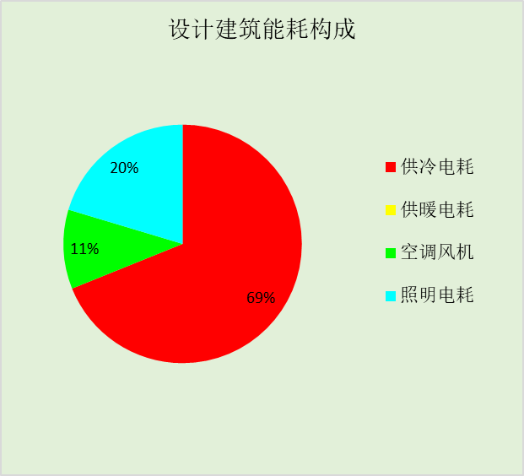

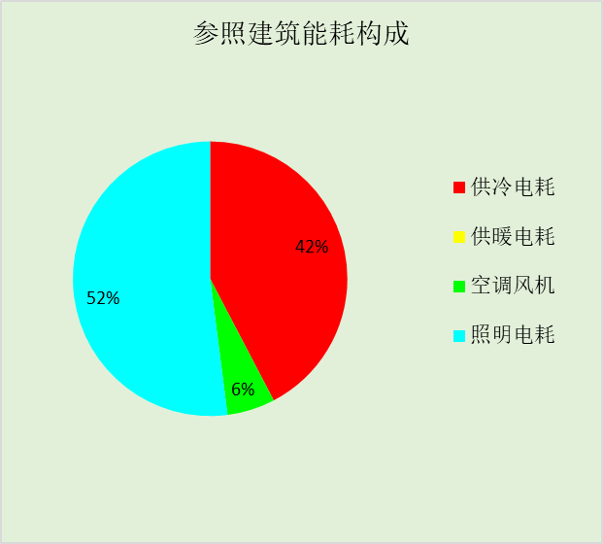

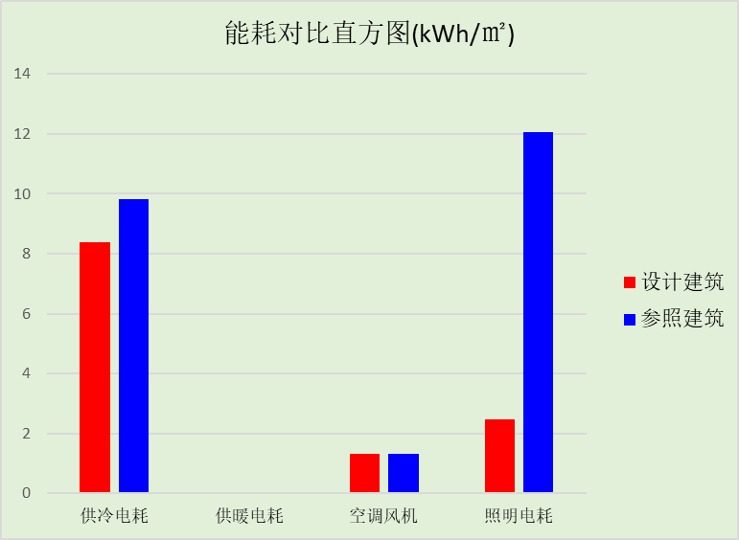

# 附录

暑假:7.15~8.25; 寒假：1.15~3.1

## 工作日/节假日人员逐时在室率(%)

|  |  |  |  |  |  |  |  |  |  |  |  |  |  |  |  |  |  |  |  |  |  |  |  |  |
| --- | --- | --- | --- | --- | --- | --- | --- | --- | --- | --- | --- | --- | --- | --- | --- | --- | --- | --- | --- | --- | --- | --- | --- | --- |
| 房间类型 | 1 | 2 | 3 | 4 | 5 | 6 | 7 | 8 | 9 | 10 | 11 | 12 | 13 | 14 | 15 | 16 | 17 | 18 | 19 | 20 | 21 | 22 | 23 | 24 |
| 健身活动室 | 0 | 0 | 0 | 0 | 0 | 0 | 10 | 50 | 95 | 95 | 95 | 80 | 80 | 95 | 95 | 95 | 95 | 30 | 30 | 0 | 0 | 0 | 0 | 0 |
| 0 | 0 | 0 | 0 | 0 | 0 | 0 | 0 | 0 | 0 | 0 | 0 | 0 | 0 | 0 | 0 | 0 | 0 | 0 | 0 | 0 | 0 | 0 | 0 |
| 0 | 0 | 0 | 0 | 0 | 0 | 0 | 0 | 0 | 0 | 0 | 0 | 0 | 0 | 0 | 0 | 0 | 0 | 0 | 0 | 0 | 0 | 0 | 0 |
| 0 | 0 | 0 | 0 | 0 | 0 | 0 | 0 | 0 | 0 | 0 | 0 | 0 | 0 | 0 | 0 | 0 | 0 | 0 | 0 | 0 | 0 | 0 | 0 |
| 办公-普通办公室 | 0 | 0 | 0 | 0 | 0 | 0 | 10 | 50 | 100 | 100 | 100 | 30 | 100 | 100 | 100 | 100 | 50 | 20 | 10 | 0 | 0 | 0 | 0 | 0 |
| 0 | 0 | 0 | 0 | 0 | 0 | 0 | 20 | 45 | 0 | 0 | 0 | 0 | 0 | 0 | 0 | 0 | 0 | 0 | 0 | 0 | 0 | 0 | 0 |
| 0 | 0 | 0 | 0 | 0 | 0 | 0 | 20 | 45 | 0 | 0 | 0 | 0 | 0 | 0 | 0 | 0 | 0 | 0 | 0 | 0 | 0 | 0 | 0 |
| 0 | 0 | 0 | 0 | 0 | 0 | 0 | 20 | 45 | 0 | 0 | 0 | 0 | 0 | 0 | 0 | 0 | 0 | 0 | 0 | 0 | 0 | 0 | 0 |
| 卫生间 | 0 | 0 | 0 | 0 | 0 | 0 | 10 | 50 | 95 | 95 | 95 | 80 | 80 | 95 | 95 | 95 | 95 | 30 | 30 | 0 | 0 | 0 | 0 | 0 |
| 0 | 0 | 0 | 0 | 0 | 0 | 0 | 0 | 0 | 0 | 0 | 0 | 0 | 0 | 0 | 0 | 0 | 0 | 0 | 0 | 0 | 0 | 0 | 0 |
| 0 | 0 | 0 | 0 | 0 | 0 | 0 | 0 | 0 | 0 | 0 | 0 | 0 | 0 | 0 | 0 | 0 | 0 | 0 | 0 | 0 | 0 | 0 | 0 |
| 0 | 0 | 0 | 0 | 0 | 0 | 0 | 0 | 0 | 0 | 0 | 0 | 0 | 0 | 0 | 0 | 0 | 0 | 0 | 0 | 0 | 0 | 0 | 0 |
| 多媒体教室 | 0 | 0 | 0 | 0 | 0 | 0 | 10 | 50 | 95 | 95 | 95 | 80 | 80 | 95 | 95 | 95 | 95 | 30 | 30 | 0 | 0 | 0 | 0 | 0 |
| 0 | 0 | 0 | 0 | 0 | 0 | 0 | 0 | 0 | 0 | 0 | 0 | 0 | 0 | 0 | 0 | 0 | 0 | 0 | 0 | 0 | 0 | 0 | 0 |
| 0 | 0 | 0 | 0 | 0 | 0 | 0 | 0 | 0 | 0 | 0 | 0 | 0 | 0 | 0 | 0 | 0 | 0 | 0 | 0 | 0 | 0 | 0 | 0 |
| 0 | 0 | 0 | 0 | 0 | 0 | 0 | 0 | 0 | 0 | 0 | 0 | 0 | 0 | 0 | 0 | 0 | 0 | 0 | 0 | 0 | 0 | 0 | 0 |
| 大厅 | 0 | 0 | 0 | 0 | 0 | 0 | 10 | 50 | 95 | 95 | 95 | 80 | 80 | 95 | 95 | 95 | 95 | 30 | 30 | 0 | 0 | 0 | 0 | 0 |
| 0 | 0 | 0 | 0 | 0 | 0 | 0 | 0 | 0 | 0 | 0 | 0 | 0 | 0 | 0 | 0 | 0 | 0 | 0 | 0 | 0 | 0 | 0 | 0 |
| 0 | 0 | 0 | 0 | 0 | 0 | 0 | 0 | 0 | 0 | 0 | 0 | 0 | 0 | 0 | 0 | 0 | 0 | 0 | 0 | 0 | 0 | 0 | 0 |
| 0 | 0 | 0 | 0 | 0 | 0 | 0 | 0 | 0 | 0 | 0 | 0 | 0 | 0 | 0 | 0 | 0 | 0 | 0 | 0 | 0 | 0 | 0 | 0 |
| 实验教室 | 0 | 0 | 0 | 0 | 0 | 0 | 10 | 50 | 95 | 95 | 95 | 80 | 80 | 95 | 95 | 95 | 95 | 30 | 30 | 0 | 0 | 0 | 0 | 0 |
| 0 | 0 | 0 | 0 | 0 | 0 | 0 | 0 | 0 | 0 | 0 | 0 | 0 | 0 | 0 | 0 | 0 | 0 | 0 | 0 | 0 | 0 | 0 | 0 |
| 0 | 0 | 0 | 0 | 0 | 0 | 0 | 0 | 0 | 0 | 0 | 0 | 0 | 0 | 0 | 0 | 0 | 0 | 0 | 0 | 0 | 0 | 0 | 0 |
| 0 | 0 | 0 | 0 | 0 | 0 | 0 | 0 | 0 | 0 | 0 | 0 | 0 | 0 | 0 | 0 | 0 | 0 | 0 | 0 | 0 | 0 | 0 | 0 |
| 密集办公室 | 0 | 0 | 0 | 0 | 0 | 0 | 10 | 50 | 95 | 95 | 95 | 80 | 80 | 95 | 95 | 95 | 95 | 30 | 30 | 0 | 0 | 0 | 0 | 0 |
| 0 | 0 | 0 | 0 | 0 | 0 | 0 | 0 | 0 | 0 | 0 | 0 | 0 | 0 | 0 | 0 | 0 | 0 | 0 | 0 | 0 | 0 | 0 | 0 |
| 0 | 0 | 0 | 0 | 0 | 0 | 0 | 0 | 0 | 0 | 0 | 0 | 0 | 0 | 0 | 0 | 0 | 0 | 0 | 0 | 0 | 0 | 0 | 0 |
| 0 | 0 | 0 | 0 | 0 | 0 | 0 | 0 | 0 | 0 | 0 | 0 | 0 | 0 | 0 | 0 | 0 | 0 | 0 | 0 | 0 | 0 | 0 | 0 |
| 报告厅 | 0 | 0 | 0 | 0 | 0 | 0 | 10 | 50 | 95 | 95 | 95 | 80 | 80 | 95 | 95 | 95 | 95 | 30 | 30 | 0 | 0 | 0 | 0 | 0 |
| 0 | 0 | 0 | 0 | 0 | 0 | 0 | 0 | 0 | 0 | 0 | 0 | 0 | 0 | 0 | 0 | 0 | 0 | 0 | 0 | 0 | 0 | 0 | 0 |
| 0 | 0 | 0 | 0 | 0 | 0 | 0 | 0 | 0 | 0 | 0 | 0 | 0 | 0 | 0 | 0 | 0 | 0 | 0 | 0 | 0 | 0 | 0 | 0 |
| 0 | 0 | 0 | 0 | 0 | 0 | 0 | 0 | 0 | 0 | 0 | 0 | 0 | 0 | 0 | 0 | 0 | 0 | 0 | 0 | 0 | 0 | 0 | 0 |
| 普通办公室 | 0 | 0 | 0 | 0 | 0 | 0 | 10 | 50 | 95 | 95 | 95 | 80 | 80 | 95 | 95 | 95 | 95 | 30 | 30 | 0 | 0 | 0 | 0 | 0 |
| 0 | 0 | 0 | 0 | 0 | 0 | 0 | 0 | 0 | 0 | 0 | 0 | 0 | 0 | 0 | 0 | 0 | 0 | 0 | 0 | 0 | 0 | 0 | 0 |
| 0 | 0 | 0 | 0 | 0 | 0 | 0 | 0 | 0 | 0 | 0 | 0 | 0 | 0 | 0 | 0 | 0 | 0 | 0 | 0 | 0 | 0 | 0 | 0 |
| 0 | 0 | 0 | 0 | 0 | 0 | 0 | 0 | 0 | 0 | 0 | 0 | 0 | 0 | 0 | 0 | 0 | 0 | 0 | 0 | 0 | 0 | 0 | 0 |
| 楼梯间 | 0 | 0 | 0 | 0 | 0 | 0 | 10 | 50 | 95 | 95 | 95 | 80 | 80 | 95 | 95 | 95 | 95 | 30 | 30 | 0 | 0 | 0 | 0 | 0 |
| 0 | 0 | 0 | 0 | 0 | 0 | 0 | 0 | 0 | 0 | 0 | 0 | 0 | 0 | 0 | 0 | 0 | 0 | 0 | 0 | 0 | 0 | 0 | 0 |
| 0 | 0 | 0 | 0 | 0 | 0 | 0 | 0 | 0 | 0 | 0 | 0 | 0 | 0 | 0 | 0 | 0 | 0 | 0 | 0 | 0 | 0 | 0 | 0 |
| 0 | 0 | 0 | 0 | 0 | 0 | 0 | 0 | 0 | 0 | 0 | 0 | 0 | 0 | 0 | 0 | 0 | 0 | 0 | 0 | 0 | 0 | 0 | 0 |
| 空房间 | 0 | 0 | 0 | 0 | 0 | 0 | 0 | 20 | 50 | 80 | 80 | 80 | 80 | 80 | 80 | 80 | 80 | 80 | 80 | 70 | 50 | 0 | 0 | 0 |
| 0 | 0 | 0 | 0 | 0 | 0 | 0 | 0 | 0 | 0 | 0 | 0 | 0 | 0 | 0 | 0 | 0 | 0 | 0 | 0 | 0 | 0 | 0 | 0 |
| 0 | 0 | 0 | 0 | 0 | 0 | 0 | 0 | 0 | 0 | 0 | 0 | 0 | 0 | 0 | 0 | 0 | 0 | 0 | 0 | 0 | 0 | 0 | 0 |
| 0 | 0 | 0 | 0 | 0 | 0 | 0 | 0 | 0 | 0 | 0 | 0 | 0 | 0 | 0 | 0 | 0 | 0 | 0 | 0 | 0 | 0 | 0 | 0 |
| 舞蹈教室 | 0 | 0 | 0 | 0 | 0 | 0 | 10 | 50 | 95 | 95 | 95 | 80 | 80 | 95 | 95 | 95 | 95 | 30 | 30 | 0 | 0 | 0 | 0 | 0 |
| 0 | 0 | 0 | 0 | 0 | 0 | 0 | 0 | 0 | 0 | 0 | 0 | 0 | 0 | 0 | 0 | 0 | 0 | 0 | 0 | 0 | 0 | 0 | 0 |
| 0 | 0 | 0 | 0 | 0 | 0 | 0 | 0 | 0 | 0 | 0 | 0 | 0 | 0 | 0 | 0 | 0 | 0 | 0 | 0 | 0 | 0 | 0 | 0 |
| 0 | 0 | 0 | 0 | 0 | 0 | 0 | 0 | 0 | 0 | 0 | 0 | 0 | 0 | 0 | 0 | 0 | 0 | 0 | 0 | 0 | 0 | 0 | 0 |
| 计算机房 | 0 | 0 | 0 | 0 | 0 | 0 | 10 | 50 | 95 | 95 | 95 | 80 | 80 | 95 | 95 | 95 | 95 | 30 | 30 | 0 | 0 | 0 | 0 | 0 |
| 0 | 0 | 0 | 0 | 0 | 0 | 0 | 0 | 0 | 0 | 0 | 0 | 0 | 0 | 0 | 0 | 0 | 0 | 0 | 0 | 0 | 0 | 0 | 0 |
| 0 | 0 | 0 | 0 | 0 | 0 | 0 | 0 | 0 | 0 | 0 | 0 | 0 | 0 | 0 | 0 | 0 | 0 | 0 | 0 | 0 | 0 | 0 | 0 |
| 0 | 0 | 0 | 0 | 0 | 0 | 0 | 0 | 0 | 0 | 0 | 0 | 0 | 0 | 0 | 0 | 0 | 0 | 0 | 0 | 0 | 0 | 0 | 0 |
| 设备间 | 0 | 0 | 0 | 0 | 0 | 0 | 0 | 0 | 0 | 0 | 0 | 0 | 0 | 0 | 0 | 0 | 0 | 0 | 0 | 0 | 0 | 0 | 0 | 0 |
| 0 | 0 | 0 | 0 | 0 | 0 | 0 | 0 | 0 | 0 | 0 | 0 | 0 | 0 | 0 | 0 | 0 | 0 | 0 | 0 | 0 | 0 | 0 | 0 |
| 0 | 0 | 0 | 0 | 0 | 0 | 0 | 0 | 0 | 0 | 0 | 0 | 0 | 0 | 0 | 0 | 0 | 0 | 0 | 0 | 0 | 0 | 0 | 0 |
| 0 | 0 | 0 | 0 | 0 | 0 | 0 | 0 | 0 | 0 | 0 | 0 | 0 | 0 | 0 | 0 | 0 | 0 | 0 | 0 | 0 | 0 | 0 | 0 |
| 走廊 | 0 | 0 | 0 | 0 | 0 | 0 | 10 | 50 | 95 | 95 | 95 | 80 | 80 | 95 | 95 | 95 | 95 | 30 | 30 | 0 | 0 | 0 | 0 | 0 |
| 0 | 0 | 0 | 0 | 0 | 0 | 0 | 0 | 0 | 0 | 0 | 0 | 0 | 0 | 0 | 0 | 0 | 0 | 0 | 0 | 0 | 0 | 0 | 0 |
| 0 | 0 | 0 | 0 | 0 | 0 | 0 | 0 | 0 | 0 | 0 | 0 | 0 | 0 | 0 | 0 | 0 | 0 | 0 | 0 | 0 | 0 | 0 | 0 |
| 0 | 0 | 0 | 0 | 0 | 0 | 0 | 0 | 0 | 0 | 0 | 0 | 0 | 0 | 0 | 0 | 0 | 0 | 0 | 0 | 0 | 0 | 0 | 0 |
| 阅览室 | 0 | 0 | 0 | 0 | 0 | 0 | 10 | 50 | 95 | 95 | 95 | 80 | 80 | 95 | 95 | 95 | 95 | 30 | 30 | 0 | 0 | 0 | 0 | 0 |
| 0 | 0 | 0 | 0 | 0 | 0 | 0 | 0 | 0 | 0 | 0 | 0 | 0 | 0 | 0 | 0 | 0 | 0 | 0 | 0 | 0 | 0 | 0 | 0 |
| 0 | 0 | 0 | 0 | 0 | 0 | 0 | 0 | 0 | 0 | 0 | 0 | 0 | 0 | 0 | 0 | 0 | 0 | 0 | 0 | 0 | 0 | 0 | 0 |
| 0 | 0 | 0 | 0 | 0 | 0 | 0 | 0 | 0 | 0 | 0 | 0 | 0 | 0 | 0 | 0 | 0 | 0 | 0 | 0 | 0 | 0 | 0 | 0 |
| 风雨操场 | 0 | 0 | 0 | 0 | 0 | 0 | 10 | 50 | 95 | 95 | 95 | 80 | 80 | 95 | 95 | 95 | 95 | 30 | 30 | 0 | 0 | 0 | 0 | 0 |
| 0 | 0 | 0 | 0 | 0 | 0 | 0 | 0 | 0 | 0 | 0 | 0 | 0 | 0 | 0 | 0 | 0 | 0 | 0 | 0 | 0 | 0 | 0 | 0 |
| 0 | 0 | 0 | 0 | 0 | 0 | 0 | 0 | 0 | 0 | 0 | 0 | 0 | 0 | 0 | 0 | 0 | 0 | 0 | 0 | 0 | 0 | 0 | 0 |
| 0 | 0 | 0 | 0 | 0 | 0 | 0 | 0 | 0 | 0 | 0 | 0 | 0 | 0 | 0 | 0 | 0 | 0 | 0 | 0 | 0 | 0 | 0 | 0 |
| 餐厅 | 0 | 0 | 0 | 0 | 0 | 0 | 10 | 50 | 95 | 95 | 95 | 80 | 80 | 95 | 95 | 95 | 95 | 30 | 30 | 0 | 0 | 0 | 0 | 0 |
| 0 | 0 | 0 | 0 | 0 | 0 | 0 | 0 | 0 | 0 | 0 | 0 | 0 | 0 | 0 | 0 | 0 | 0 | 0 | 0 | 0 | 0 | 0 | 0 |
| 0 | 0 | 0 | 0 | 0 | 0 | 0 | 0 | 0 | 0 | 0 | 0 | 0 | 0 | 0 | 0 | 0 | 0 | 0 | 0 | 0 | 0 | 0 | 0 |
| 0 | 0 | 0 | 0 | 0 | 0 | 0 | 0 | 0 | 0 | 0 | 0 | 0 | 0 | 0 | 0 | 0 | 0 | 0 | 0 | 0 | 0 | 0 | 0 |

注：第一行：工作日；第二行：节假日；第三行：寒假；第四行：暑假

## 工作日/节假日照明开关时间表(%)

|  |  |  |  |  |  |  |  |  |  |  |  |  |  |  |  |  |  |  |  |  |  |  |  |  |
| --- | --- | --- | --- | --- | --- | --- | --- | --- | --- | --- | --- | --- | --- | --- | --- | --- | --- | --- | --- | --- | --- | --- | --- | --- |
| 房间类型 | 1 | 2 | 3 | 4 | 5 | 6 | 7 | 8 | 9 | 10 | 11 | 12 | 13 | 14 | 15 | 16 | 17 | 18 | 19 | 20 | 21 | 22 | 23 | 24 |
| 健身活动室 | 0 | 0 | 0 | 0 | 0 | 0 | 10 | 50 | 95 | 95 | 95 | 80 | 80 | 95 | 95 | 95 | 95 | 30 | 30 | 0 | 0 | 0 | 0 | 0 |
| 0 | 0 | 0 | 0 | 0 | 0 | 0 | 0 | 0 | 0 | 0 | 0 | 0 | 0 | 0 | 0 | 0 | 0 | 0 | 0 | 0 | 0 | 0 | 0 |
| 0 | 0 | 0 | 0 | 0 | 0 | 0 | 0 | 0 | 0 | 0 | 0 | 0 | 0 | 0 | 0 | 0 | 0 | 0 | 0 | 0 | 0 | 0 | 0 |
| 0 | 0 | 0 | 0 | 0 | 0 | 0 | 0 | 0 | 0 | 0 | 0 | 0 | 0 | 0 | 0 | 0 | 0 | 0 | 0 | 0 | 0 | 0 | 0 |
| 办公-普通办公室 | 10 | 10 | 10 | 10 | 10 | 10 | 10 | 36 | 62 | 56 | 54 | 43 | 53 | 55 | 58 | 67 | 40 | 18 | 10 | 10 | 10 | 10 | 10 | 10 |
| 0 | 0 | 0 | 0 | 0 | 0 | 0 | 0 | 0 | 0 | 0 | 0 | 0 | 0 | 0 | 0 | 0 | 0 | 0 | 0 | 0 | 0 | 0 | 0 |
| 0 | 0 | 0 | 0 | 0 | 0 | 0 | 0 | 0 | 0 | 0 | 0 | 0 | 0 | 0 | 0 | 0 | 0 | 0 | 0 | 0 | 0 | 0 | 0 |
| 0 | 0 | 0 | 0 | 0 | 0 | 0 | 0 | 0 | 0 | 0 | 0 | 0 | 0 | 0 | 0 | 0 | 0 | 0 | 0 | 0 | 0 | 0 | 0 |
| 卫生间 | 0 | 0 | 0 | 0 | 0 | 0 | 10 | 50 | 95 | 95 | 95 | 80 | 80 | 95 | 95 | 95 | 95 | 30 | 30 | 0 | 0 | 0 | 0 | 0 |
| 0 | 0 | 0 | 0 | 0 | 0 | 0 | 0 | 0 | 0 | 0 | 0 | 0 | 0 | 0 | 0 | 0 | 0 | 0 | 0 | 0 | 0 | 0 | 0 |
| 0 | 0 | 0 | 0 | 0 | 0 | 0 | 0 | 0 | 0 | 0 | 0 | 0 | 0 | 0 | 0 | 0 | 0 | 0 | 0 | 0 | 0 | 0 | 0 |
| 0 | 0 | 0 | 0 | 0 | 0 | 0 | 0 | 0 | 0 | 0 | 0 | 0 | 0 | 0 | 0 | 0 | 0 | 0 | 0 | 0 | 0 | 0 | 0 |
| 多媒体教室 | 0 | 0 | 0 | 0 | 0 | 0 | 10 | 50 | 95 | 95 | 95 | 80 | 80 | 95 | 95 | 95 | 95 | 30 | 30 | 0 | 0 | 0 | 0 | 0 |
| 0 | 0 | 0 | 0 | 0 | 0 | 0 | 0 | 0 | 0 | 0 | 0 | 0 | 0 | 0 | 0 | 0 | 0 | 0 | 0 | 0 | 0 | 0 | 0 |
| 0 | 0 | 0 | 0 | 0 | 0 | 0 | 0 | 0 | 0 | 0 | 0 | 0 | 0 | 0 | 0 | 0 | 0 | 0 | 0 | 0 | 0 | 0 | 0 |
| 0 | 0 | 0 | 0 | 0 | 0 | 0 | 0 | 0 | 0 | 0 | 0 | 0 | 0 | 0 | 0 | 0 | 0 | 0 | 0 | 0 | 0 | 0 | 0 |
| 大厅 | 0 | 0 | 0 | 0 | 0 | 0 | 10 | 50 | 95 | 95 | 95 | 80 | 80 | 95 | 95 | 95 | 95 | 30 | 30 | 0 | 0 | 0 | 0 | 0 |
| 0 | 0 | 0 | 0 | 0 | 0 | 0 | 0 | 0 | 0 | 0 | 0 | 0 | 0 | 0 | 0 | 0 | 0 | 0 | 0 | 0 | 0 | 0 | 0 |
| 0 | 0 | 0 | 0 | 0 | 0 | 0 | 0 | 0 | 0 | 0 | 0 | 0 | 0 | 0 | 0 | 0 | 0 | 0 | 0 | 0 | 0 | 0 | 0 |
| 0 | 0 | 0 | 0 | 0 | 0 | 0 | 0 | 0 | 0 | 0 | 0 | 0 | 0 | 0 | 0 | 0 | 0 | 0 | 0 | 0 | 0 | 0 | 0 |
| 实验教室 | 0 | 0 | 0 | 0 | 0 | 0 | 10 | 50 | 95 | 95 | 95 | 80 | 80 | 95 | 95 | 95 | 95 | 30 | 30 | 0 | 0 | 0 | 0 | 0 |
| 0 | 0 | 0 | 0 | 0 | 0 | 0 | 0 | 0 | 0 | 0 | 0 | 0 | 0 | 0 | 0 | 0 | 0 | 0 | 0 | 0 | 0 | 0 | 0 |
| 0 | 0 | 0 | 0 | 0 | 0 | 0 | 0 | 0 | 0 | 0 | 0 | 0 | 0 | 0 | 0 | 0 | 0 | 0 | 0 | 0 | 0 | 0 | 0 |
| 0 | 0 | 0 | 0 | 0 | 0 | 0 | 0 | 0 | 0 | 0 | 0 | 0 | 0 | 0 | 0 | 0 | 0 | 0 | 0 | 0 | 0 | 0 | 0 |
| 密集办公室 | 0 | 0 | 0 | 0 | 0 | 0 | 10 | 50 | 95 | 95 | 95 | 80 | 80 | 95 | 95 | 95 | 95 | 30 | 30 | 0 | 0 | 0 | 0 | 0 |
| 0 | 0 | 0 | 0 | 0 | 0 | 0 | 0 | 0 | 0 | 0 | 0 | 0 | 0 | 0 | 0 | 0 | 0 | 0 | 0 | 0 | 0 | 0 | 0 |
| 0 | 0 | 0 | 0 | 0 | 0 | 0 | 0 | 0 | 0 | 0 | 0 | 0 | 0 | 0 | 0 | 0 | 0 | 0 | 0 | 0 | 0 | 0 | 0 |
| 0 | 0 | 0 | 0 | 0 | 0 | 0 | 0 | 0 | 0 | 0 | 0 | 0 | 0 | 0 | 0 | 0 | 0 | 0 | 0 | 0 | 0 | 0 | 0 |
| 报告厅 | 0 | 0 | 0 | 0 | 0 | 0 | 10 | 50 | 95 | 95 | 95 | 80 | 80 | 95 | 95 | 95 | 95 | 30 | 30 | 0 | 0 | 0 | 0 | 0 |
| 0 | 0 | 0 | 0 | 0 | 0 | 0 | 0 | 0 | 0 | 0 | 0 | 0 | 0 | 0 | 0 | 0 | 0 | 0 | 0 | 0 | 0 | 0 | 0 |
| 0 | 0 | 0 | 0 | 0 | 0 | 0 | 0 | 0 | 0 | 0 | 0 | 0 | 0 | 0 | 0 | 0 | 0 | 0 | 0 | 0 | 0 | 0 | 0 |
| 0 | 0 | 0 | 0 | 0 | 0 | 0 | 0 | 0 | 0 | 0 | 0 | 0 | 0 | 0 | 0 | 0 | 0 | 0 | 0 | 0 | 0 | 0 | 0 |
| 普通办公室 | 0 | 0 | 0 | 0 | 0 | 0 | 10 | 50 | 95 | 95 | 95 | 80 | 80 | 95 | 95 | 95 | 95 | 30 | 30 | 0 | 0 | 0 | 0 | 0 |
| 0 | 0 | 0 | 0 | 0 | 0 | 0 | 0 | 0 | 0 | 0 | 0 | 0 | 0 | 0 | 0 | 0 | 0 | 0 | 0 | 0 | 0 | 0 | 0 |
| 0 | 0 | 0 | 0 | 0 | 0 | 0 | 0 | 0 | 0 | 0 | 0 | 0 | 0 | 0 | 0 | 0 | 0 | 0 | 0 | 0 | 0 | 0 | 0 |
| 0 | 0 | 0 | 0 | 0 | 0 | 0 | 0 | 0 | 0 | 0 | 0 | 0 | 0 | 0 | 0 | 0 | 0 | 0 | 0 | 0 | 0 | 0 | 0 |
| 楼梯间 | 0 | 0 | 0 | 0 | 0 | 0 | 10 | 50 | 95 | 95 | 95 | 80 | 80 | 95 | 95 | 95 | 95 | 30 | 30 | 0 | 0 | 0 | 0 | 0 |
| 0 | 0 | 0 | 0 | 0 | 0 | 0 | 0 | 0 | 0 | 0 | 0 | 0 | 0 | 0 | 0 | 0 | 0 | 0 | 0 | 0 | 0 | 0 | 0 |
| 0 | 0 | 0 | 0 | 0 | 0 | 0 | 0 | 0 | 0 | 0 | 0 | 0 | 0 | 0 | 0 | 0 | 0 | 0 | 0 | 0 | 0 | 0 | 0 |
| 0 | 0 | 0 | 0 | 0 | 0 | 0 | 0 | 0 | 0 | 0 | 0 | 0 | 0 | 0 | 0 | 0 | 0 | 0 | 0 | 0 | 0 | 0 | 0 |
| 空房间 | 10 | 10 | 10 | 10 | 10 | 10 | 10 | 50 | 60 | 60 | 60 | 60 | 60 | 60 | 60 | 60 | 80 | 90 | 100 | 100 | 100 | 10 | 10 | 10 |
| 0 | 0 | 0 | 0 | 0 | 0 | 0 | 0 | 0 | 0 | 0 | 0 | 0 | 0 | 0 | 0 | 0 | 0 | 0 | 0 | 0 | 0 | 0 | 0 |
| 0 | 0 | 0 | 0 | 0 | 0 | 0 | 0 | 0 | 0 | 0 | 0 | 0 | 0 | 0 | 0 | 0 | 0 | 0 | 0 | 0 | 0 | 0 | 0 |
| 0 | 0 | 0 | 0 | 0 | 0 | 0 | 0 | 0 | 0 | 0 | 0 | 0 | 0 | 0 | 0 | 0 | 0 | 0 | 0 | 0 | 0 | 0 | 0 |
| 舞蹈教室 | 0 | 0 | 0 | 0 | 0 | 0 | 10 | 50 | 95 | 95 | 95 | 80 | 80 | 95 | 95 | 95 | 95 | 30 | 30 | 0 | 0 | 0 | 0 | 0 |
| 0 | 0 | 0 | 0 | 0 | 0 | 0 | 0 | 0 | 0 | 0 | 0 | 0 | 0 | 0 | 0 | 0 | 0 | 0 | 0 | 0 | 0 | 0 | 0 |
| 0 | 0 | 0 | 0 | 0 | 0 | 0 | 0 | 0 | 0 | 0 | 0 | 0 | 0 | 0 | 0 | 0 | 0 | 0 | 0 | 0 | 0 | 0 | 0 |
| 0 | 0 | 0 | 0 | 0 | 0 | 0 | 0 | 0 | 0 | 0 | 0 | 0 | 0 | 0 | 0 | 0 | 0 | 0 | 0 | 0 | 0 | 0 | 0 |
| 计算机房 | 0 | 0 | 0 | 0 | 0 | 0 | 10 | 50 | 95 | 95 | 95 | 80 | 80 | 95 | 95 | 95 | 95 | 30 | 30 | 0 | 0 | 0 | 0 | 0 |
| 0 | 0 | 0 | 0 | 0 | 0 | 0 | 0 | 0 | 0 | 0 | 0 | 0 | 0 | 0 | 0 | 0 | 0 | 0 | 0 | 0 | 0 | 0 | 0 |
| 0 | 0 | 0 | 0 | 0 | 0 | 0 | 0 | 0 | 0 | 0 | 0 | 0 | 0 | 0 | 0 | 0 | 0 | 0 | 0 | 0 | 0 | 0 | 0 |
| 0 | 0 | 0 | 0 | 0 | 0 | 0 | 0 | 0 | 0 | 0 | 0 | 0 | 0 | 0 | 0 | 0 | 0 | 0 | 0 | 0 | 0 | 0 | 0 |
| 设备间 | 100 | 100 | 100 | 100 | 100 | 100 | 100 | 100 | 100 | 100 | 100 | 100 | 100 | 100 | 100 | 100 | 100 | 100 | 100 | 100 | 100 | 100 | 100 | 100 |
| 0 | 0 | 0 | 0 | 0 | 0 | 0 | 0 | 0 | 0 | 0 | 0 | 0 | 0 | 0 | 0 | 0 | 0 | 0 | 0 | 0 | 0 | 0 | 0 |
| 0 | 0 | 0 | 0 | 0 | 0 | 0 | 0 | 0 | 0 | 0 | 0 | 0 | 0 | 0 | 0 | 0 | 0 | 0 | 0 | 0 | 0 | 0 | 0 |
| 0 | 0 | 0 | 0 | 0 | 0 | 0 | 0 | 0 | 0 | 0 | 0 | 0 | 0 | 0 | 0 | 0 | 0 | 0 | 0 | 0 | 0 | 0 | 0 |
| 走廊 | 0 | 0 | 0 | 0 | 0 | 0 | 10 | 50 | 95 | 95 | 95 | 80 | 80 | 95 | 95 | 95 | 95 | 30 | 30 | 0 | 0 | 0 | 0 | 0 |
| 0 | 0 | 0 | 0 | 0 | 0 | 0 | 0 | 0 | 0 | 0 | 0 | 0 | 0 | 0 | 0 | 0 | 0 | 0 | 0 | 0 | 0 | 0 | 0 |
| 0 | 0 | 0 | 0 | 0 | 0 | 0 | 0 | 0 | 0 | 0 | 0 | 0 | 0 | 0 | 0 | 0 | 0 | 0 | 0 | 0 | 0 | 0 | 0 |
| 0 | 0 | 0 | 0 | 0 | 0 | 0 | 0 | 0 | 0 | 0 | 0 | 0 | 0 | 0 | 0 | 0 | 0 | 0 | 0 | 0 | 0 | 0 | 0 |
| 阅览室 | 0 | 0 | 0 | 0 | 0 | 0 | 10 | 50 | 95 | 95 | 95 | 80 | 80 | 95 | 95 | 95 | 95 | 30 | 30 | 0 | 0 | 0 | 0 | 0 |
| 0 | 0 | 0 | 0 | 0 | 0 | 0 | 0 | 0 | 0 | 0 | 0 | 0 | 0 | 0 | 0 | 0 | 0 | 0 | 0 | 0 | 0 | 0 | 0 |
| 0 | 0 | 0 | 0 | 0 | 0 | 0 | 0 | 0 | 0 | 0 | 0 | 0 | 0 | 0 | 0 | 0 | 0 | 0 | 0 | 0 | 0 | 0 | 0 |
| 0 | 0 | 0 | 0 | 0 | 0 | 0 | 0 | 0 | 0 | 0 | 0 | 0 | 0 | 0 | 0 | 0 | 0 | 0 | 0 | 0 | 0 | 0 | 0 |
| 风雨操场 | 0 | 0 | 0 | 0 | 0 | 0 | 10 | 50 | 95 | 95 | 95 | 80 | 80 | 95 | 95 | 95 | 95 | 30 | 30 | 0 | 0 | 0 | 0 | 0 |
| 0 | 0 | 0 | 0 | 0 | 0 | 0 | 0 | 0 | 0 | 0 | 0 | 0 | 0 | 0 | 0 | 0 | 0 | 0 | 0 | 0 | 0 | 0 | 0 |
| 0 | 0 | 0 | 0 | 0 | 0 | 0 | 0 | 0 | 0 | 0 | 0 | 0 | 0 | 0 | 0 | 0 | 0 | 0 | 0 | 0 | 0 | 0 | 0 |
| 0 | 0 | 0 | 0 | 0 | 0 | 0 | 0 | 0 | 0 | 0 | 0 | 0 | 0 | 0 | 0 | 0 | 0 | 0 | 0 | 0 | 0 | 0 | 0 |
| 餐厅 | 0 | 0 | 0 | 0 | 0 | 0 | 10 | 50 | 95 | 95 | 95 | 80 | 80 | 95 | 95 | 95 | 95 | 30 | 30 | 0 | 0 | 0 | 0 | 0 |
| 0 | 0 | 0 | 0 | 0 | 0 | 0 | 0 | 0 | 0 | 0 | 0 | 0 | 0 | 0 | 0 | 0 | 0 | 0 | 0 | 0 | 0 | 0 | 0 |
| 0 | 0 | 0 | 0 | 0 | 0 | 0 | 0 | 0 | 0 | 0 | 0 | 0 | 0 | 0 | 0 | 0 | 0 | 0 | 0 | 0 | 0 | 0 | 0 |
| 0 | 0 | 0 | 0 | 0 | 0 | 0 | 0 | 0 | 0 | 0 | 0 | 0 | 0 | 0 | 0 | 0 | 0 | 0 | 0 | 0 | 0 | 0 | 0 |

注：第一行：工作日；第二行：节假日；第三行：寒假；第四行：暑假

## 工作日/节假日设备逐时使用率(%)

|  |  |  |  |  |  |  |  |  |  |  |  |  |  |  |  |  |  |  |  |  |  |  |  |  |
| --- | --- | --- | --- | --- | --- | --- | --- | --- | --- | --- | --- | --- | --- | --- | --- | --- | --- | --- | --- | --- | --- | --- | --- | --- |
| 房间类型 | 1 | 2 | 3 | 4 | 5 | 6 | 7 | 8 | 9 | 10 | 11 | 12 | 13 | 14 | 15 | 16 | 17 | 18 | 19 | 20 | 21 | 22 | 23 | 24 |
| 健身活动室 | 0 | 0 | 0 | 0 | 0 | 0 | 10 | 50 | 95 | 95 | 95 | 50 | 50 | 95 | 95 | 95 | 95 | 30 | 30 | 0 | 0 | 0 | 0 | 0 |
| 0 | 0 | 0 | 0 | 0 | 0 | 0 | 0 | 0 | 0 | 0 | 0 | 0 | 0 | 0 | 0 | 0 | 0 | 0 | 0 | 0 | 0 | 0 | 0 |
| 0 | 0 | 0 | 0 | 0 | 0 | 0 | 0 | 0 | 0 | 0 | 0 | 0 | 0 | 0 | 0 | 0 | 0 | 0 | 0 | 0 | 0 | 0 | 0 |
| 0 | 0 | 0 | 0 | 0 | 0 | 0 | 0 | 0 | 0 | 0 | 0 | 0 | 0 | 0 | 0 | 0 | 0 | 0 | 0 | 0 | 0 | 0 | 0 |
| 办公-普通办公室 | 0 | 0 | 0 | 0 | 0 | 0 | 10 | 50 | 100 | 100 | 100 | 100 | 100 | 100 | 100 | 100 | 50 | 20 | 10 | 0 | 0 | 0 | 0 | 0 |
| 0 | 0 | 0 | 0 | 0 | 0 | 0 | 0 | 0 | 0 | 0 | 0 | 0 | 0 | 0 | 0 | 0 | 0 | 0 | 0 | 0 | 0 | 0 | 0 |
| 0 | 0 | 0 | 0 | 0 | 0 | 0 | 0 | 0 | 0 | 0 | 0 | 0 | 0 | 0 | 0 | 0 | 0 | 0 | 0 | 0 | 0 | 0 | 0 |
| 0 | 0 | 0 | 0 | 0 | 0 | 0 | 0 | 0 | 0 | 0 | 0 | 0 | 0 | 0 | 0 | 0 | 0 | 0 | 0 | 0 | 0 | 0 | 0 |
| 卫生间 | 0 | 0 | 0 | 0 | 0 | 0 | 10 | 50 | 95 | 95 | 95 | 50 | 50 | 95 | 95 | 95 | 95 | 30 | 30 | 0 | 0 | 0 | 0 | 0 |
| 0 | 0 | 0 | 0 | 0 | 0 | 0 | 0 | 0 | 0 | 0 | 0 | 0 | 0 | 0 | 0 | 0 | 0 | 0 | 0 | 0 | 0 | 0 | 0 |
| 0 | 0 | 0 | 0 | 0 | 0 | 0 | 0 | 0 | 0 | 0 | 0 | 0 | 0 | 0 | 0 | 0 | 0 | 0 | 0 | 0 | 0 | 0 | 0 |
| 0 | 0 | 0 | 0 | 0 | 0 | 0 | 0 | 0 | 0 | 0 | 0 | 0 | 0 | 0 | 0 | 0 | 0 | 0 | 0 | 0 | 0 | 0 | 0 |
| 多媒体教室 | 0 | 0 | 0 | 0 | 0 | 0 | 10 | 50 | 95 | 95 | 95 | 50 | 50 | 95 | 95 | 95 | 95 | 30 | 30 | 0 | 0 | 0 | 0 | 0 |
| 0 | 0 | 0 | 0 | 0 | 0 | 0 | 0 | 0 | 0 | 0 | 0 | 0 | 0 | 0 | 0 | 0 | 0 | 0 | 0 | 0 | 0 | 0 | 0 |
| 0 | 0 | 0 | 0 | 0 | 0 | 0 | 0 | 0 | 0 | 0 | 0 | 0 | 0 | 0 | 0 | 0 | 0 | 0 | 0 | 0 | 0 | 0 | 0 |
| 0 | 0 | 0 | 0 | 0 | 0 | 0 | 0 | 0 | 0 | 0 | 0 | 0 | 0 | 0 | 0 | 0 | 0 | 0 | 0 | 0 | 0 | 0 | 0 |
| 大厅 | 0 | 0 | 0 | 0 | 0 | 0 | 10 | 50 | 95 | 95 | 95 | 50 | 50 | 95 | 95 | 95 | 95 | 30 | 30 | 0 | 0 | 0 | 0 | 0 |
| 0 | 0 | 0 | 0 | 0 | 0 | 0 | 0 | 0 | 0 | 0 | 0 | 0 | 0 | 0 | 0 | 0 | 0 | 0 | 0 | 0 | 0 | 0 | 0 |
| 0 | 0 | 0 | 0 | 0 | 0 | 0 | 0 | 0 | 0 | 0 | 0 | 0 | 0 | 0 | 0 | 0 | 0 | 0 | 0 | 0 | 0 | 0 | 0 |
| 0 | 0 | 0 | 0 | 0 | 0 | 0 | 0 | 0 | 0 | 0 | 0 | 0 | 0 | 0 | 0 | 0 | 0 | 0 | 0 | 0 | 0 | 0 | 0 |
| 实验教室 | 0 | 0 | 0 | 0 | 0 | 0 | 10 | 50 | 95 | 95 | 95 | 50 | 50 | 95 | 95 | 95 | 95 | 30 | 30 | 0 | 0 | 0 | 0 | 0 |
| 0 | 0 | 0 | 0 | 0 | 0 | 0 | 0 | 0 | 0 | 0 | 0 | 0 | 0 | 0 | 0 | 0 | 0 | 0 | 0 | 0 | 0 | 0 | 0 |
| 0 | 0 | 0 | 0 | 0 | 0 | 0 | 0 | 0 | 0 | 0 | 0 | 0 | 0 | 0 | 0 | 0 | 0 | 0 | 0 | 0 | 0 | 0 | 0 |
| 0 | 0 | 0 | 0 | 0 | 0 | 0 | 0 | 0 | 0 | 0 | 0 | 0 | 0 | 0 | 0 | 0 | 0 | 0 | 0 | 0 | 0 | 0 | 0 |
| 密集办公室 | 0 | 0 | 0 | 0 | 0 | 0 | 10 | 50 | 95 | 95 | 95 | 50 | 50 | 95 | 95 | 95 | 95 | 30 | 30 | 0 | 0 | 0 | 0 | 0 |
| 0 | 0 | 0 | 0 | 0 | 0 | 0 | 0 | 0 | 0 | 0 | 0 | 0 | 0 | 0 | 0 | 0 | 0 | 0 | 0 | 0 | 0 | 0 | 0 |
| 0 | 0 | 0 | 0 | 0 | 0 | 0 | 0 | 0 | 0 | 0 | 0 | 0 | 0 | 0 | 0 | 0 | 0 | 0 | 0 | 0 | 0 | 0 | 0 |
| 0 | 0 | 0 | 0 | 0 | 0 | 0 | 0 | 0 | 0 | 0 | 0 | 0 | 0 | 0 | 0 | 0 | 0 | 0 | 0 | 0 | 0 | 0 | 0 |
| 报告厅 | 0 | 0 | 0 | 0 | 0 | 0 | 10 | 50 | 95 | 95 | 95 | 50 | 50 | 95 | 95 | 95 | 95 | 30 | 30 | 0 | 0 | 0 | 0 | 0 |
| 0 | 0 | 0 | 0 | 0 | 0 | 0 | 0 | 0 | 0 | 0 | 0 | 0 | 0 | 0 | 0 | 0 | 0 | 0 | 0 | 0 | 0 | 0 | 0 |
| 0 | 0 | 0 | 0 | 0 | 0 | 0 | 0 | 0 | 0 | 0 | 0 | 0 | 0 | 0 | 0 | 0 | 0 | 0 | 0 | 0 | 0 | 0 | 0 |
| 0 | 0 | 0 | 0 | 0 | 0 | 0 | 0 | 0 | 0 | 0 | 0 | 0 | 0 | 0 | 0 | 0 | 0 | 0 | 0 | 0 | 0 | 0 | 0 |
| 普通办公室 | 0 | 0 | 0 | 0 | 0 | 0 | 10 | 50 | 95 | 95 | 95 | 50 | 50 | 95 | 95 | 95 | 95 | 30 | 30 | 0 | 0 | 0 | 0 | 0 |
| 0 | 0 | 0 | 0 | 0 | 0 | 0 | 0 | 0 | 0 | 0 | 0 | 0 | 0 | 0 | 0 | 0 | 0 | 0 | 0 | 0 | 0 | 0 | 0 |
| 0 | 0 | 0 | 0 | 0 | 0 | 0 | 0 | 0 | 0 | 0 | 0 | 0 | 0 | 0 | 0 | 0 | 0 | 0 | 0 | 0 | 0 | 0 | 0 |
| 0 | 0 | 0 | 0 | 0 | 0 | 0 | 0 | 0 | 0 | 0 | 0 | 0 | 0 | 0 | 0 | 0 | 0 | 0 | 0 | 0 | 0 | 0 | 0 |
| 楼梯间 | 0 | 0 | 0 | 0 | 0 | 0 | 10 | 50 | 95 | 95 | 95 | 50 | 50 | 95 | 95 | 95 | 95 | 30 | 30 | 0 | 0 | 0 | 0 | 0 |
| 0 | 0 | 0 | 0 | 0 | 0 | 0 | 0 | 0 | 0 | 0 | 0 | 0 | 0 | 0 | 0 | 0 | 0 | 0 | 0 | 0 | 0 | 0 | 0 |
| 0 | 0 | 0 | 0 | 0 | 0 | 0 | 0 | 0 | 0 | 0 | 0 | 0 | 0 | 0 | 0 | 0 | 0 | 0 | 0 | 0 | 0 | 0 | 0 |
| 0 | 0 | 0 | 0 | 0 | 0 | 0 | 0 | 0 | 0 | 0 | 0 | 0 | 0 | 0 | 0 | 0 | 0 | 0 | 0 | 0 | 0 | 0 | 0 |
| 空房间 | 0 | 0 | 0 | 0 | 0 | 0 | 0 | 30 | 50 | 80 | 80 | 80 | 80 | 80 | 80 | 80 | 80 | 80 | 80 | 70 | 50 | 0 | 0 | 0 |
| 0 | 0 | 0 | 0 | 0 | 0 | 0 | 0 | 0 | 0 | 0 | 0 | 0 | 0 | 0 | 0 | 0 | 0 | 0 | 0 | 0 | 0 | 0 | 0 |
| 0 | 0 | 0 | 0 | 0 | 0 | 0 | 0 | 0 | 0 | 0 | 0 | 0 | 0 | 0 | 0 | 0 | 0 | 0 | 0 | 0 | 0 | 0 | 0 |
| 0 | 0 | 0 | 0 | 0 | 0 | 0 | 0 | 0 | 0 | 0 | 0 | 0 | 0 | 0 | 0 | 0 | 0 | 0 | 0 | 0 | 0 | 0 | 0 |
| 舞蹈教室 | 0 | 0 | 0 | 0 | 0 | 0 | 10 | 50 | 95 | 95 | 95 | 50 | 50 | 95 | 95 | 95 | 95 | 30 | 30 | 0 | 0 | 0 | 0 | 0 |
| 0 | 0 | 0 | 0 | 0 | 0 | 0 | 0 | 0 | 0 | 0 | 0 | 0 | 0 | 0 | 0 | 0 | 0 | 0 | 0 | 0 | 0 | 0 | 0 |
| 0 | 0 | 0 | 0 | 0 | 0 | 0 | 0 | 0 | 0 | 0 | 0 | 0 | 0 | 0 | 0 | 0 | 0 | 0 | 0 | 0 | 0 | 0 | 0 |
| 0 | 0 | 0 | 0 | 0 | 0 | 0 | 0 | 0 | 0 | 0 | 0 | 0 | 0 | 0 | 0 | 0 | 0 | 0 | 0 | 0 | 0 | 0 | 0 |
| 计算机房 | 0 | 0 | 0 | 0 | 0 | 0 | 10 | 50 | 95 | 95 | 95 | 50 | 50 | 95 | 95 | 95 | 95 | 30 | 30 | 0 | 0 | 0 | 0 | 0 |
| 0 | 0 | 0 | 0 | 0 | 0 | 0 | 0 | 0 | 0 | 0 | 0 | 0 | 0 | 0 | 0 | 0 | 0 | 0 | 0 | 0 | 0 | 0 | 0 |
| 0 | 0 | 0 | 0 | 0 | 0 | 0 | 0 | 0 | 0 | 0 | 0 | 0 | 0 | 0 | 0 | 0 | 0 | 0 | 0 | 0 | 0 | 0 | 0 |
| 0 | 0 | 0 | 0 | 0 | 0 | 0 | 0 | 0 | 0 | 0 | 0 | 0 | 0 | 0 | 0 | 0 | 0 | 0 | 0 | 0 | 0 | 0 | 0 |
| 设备间 | 100 | 100 | 100 | 100 | 100 | 100 | 100 | 100 | 100 | 100 | 100 | 100 | 100 | 100 | 100 | 100 | 100 | 100 | 100 | 100 | 100 | 100 | 100 | 100 |
| 0 | 0 | 0 | 0 | 0 | 0 | 0 | 0 | 0 | 0 | 0 | 0 | 0 | 0 | 0 | 0 | 0 | 0 | 0 | 0 | 0 | 0 | 0 | 0 |
| 0 | 0 | 0 | 0 | 0 | 0 | 0 | 0 | 0 | 0 | 0 | 0 | 0 | 0 | 0 | 0 | 0 | 0 | 0 | 0 | 0 | 0 | 0 | 0 |
| 0 | 0 | 0 | 0 | 0 | 0 | 0 | 0 | 0 | 0 | 0 | 0 | 0 | 0 | 0 | 0 | 0 | 0 | 0 | 0 | 0 | 0 | 0 | 0 |
| 走廊 | 0 | 0 | 0 | 0 | 0 | 0 | 10 | 50 | 95 | 95 | 95 | 50 | 50 | 95 | 95 | 95 | 95 | 30 | 30 | 0 | 0 | 0 | 0 | 0 |
| 0 | 0 | 0 | 0 | 0 | 0 | 0 | 0 | 0 | 0 | 0 | 0 | 0 | 0 | 0 | 0 | 0 | 0 | 0 | 0 | 0 | 0 | 0 | 0 |
| 0 | 0 | 0 | 0 | 0 | 0 | 0 | 0 | 0 | 0 | 0 | 0 | 0 | 0 | 0 | 0 | 0 | 0 | 0 | 0 | 0 | 0 | 0 | 0 |
| 0 | 0 | 0 | 0 | 0 | 0 | 0 | 0 | 0 | 0 | 0 | 0 | 0 | 0 | 0 | 0 | 0 | 0 | 0 | 0 | 0 | 0 | 0 | 0 |
| 阅览室 | 0 | 0 | 0 | 0 | 0 | 0 | 10 | 50 | 95 | 95 | 95 | 50 | 50 | 95 | 95 | 95 | 95 | 30 | 30 | 0 | 0 | 0 | 0 | 0 |
| 0 | 0 | 0 | 0 | 0 | 0 | 0 | 0 | 0 | 0 | 0 | 0 | 0 | 0 | 0 | 0 | 0 | 0 | 0 | 0 | 0 | 0 | 0 | 0 |
| 0 | 0 | 0 | 0 | 0 | 0 | 0 | 0 | 0 | 0 | 0 | 0 | 0 | 0 | 0 | 0 | 0 | 0 | 0 | 0 | 0 | 0 | 0 | 0 |
| 0 | 0 | 0 | 0 | 0 | 0 | 0 | 0 | 0 | 0 | 0 | 0 | 0 | 0 | 0 | 0 | 0 | 0 | 0 | 0 | 0 | 0 | 0 | 0 |
| 风雨操场 | 0 | 0 | 0 | 0 | 0 | 0 | 10 | 50 | 95 | 95 | 95 | 50 | 50 | 95 | 95 | 95 | 95 | 30 | 30 | 0 | 0 | 0 | 0 | 0 |
| 0 | 0 | 0 | 0 | 0 | 0 | 0 | 0 | 0 | 0 | 0 | 0 | 0 | 0 | 0 | 0 | 0 | 0 | 0 | 0 | 0 | 0 | 0 | 0 |
| 0 | 0 | 0 | 0 | 0 | 0 | 0 | 0 | 0 | 0 | 0 | 0 | 0 | 0 | 0 | 0 | 0 | 0 | 0 | 0 | 0 | 0 | 0 | 0 |
| 0 | 0 | 0 | 0 | 0 | 0 | 0 | 0 | 0 | 0 | 0 | 0 | 0 | 0 | 0 | 0 | 0 | 0 | 0 | 0 | 0 | 0 | 0 | 0 |
| 餐厅 | 0 | 0 | 0 | 0 | 0 | 0 | 10 | 50 | 95 | 95 | 95 | 50 | 50 | 95 | 95 | 95 | 95 | 30 | 30 | 0 | 0 | 0 | 0 | 0 |
| 0 | 0 | 0 | 0 | 0 | 0 | 0 | 0 | 0 | 0 | 0 | 0 | 0 | 0 | 0 | 0 | 0 | 0 | 0 | 0 | 0 | 0 | 0 | 0 |
| 0 | 0 | 0 | 0 | 0 | 0 | 0 | 0 | 0 | 0 | 0 | 0 | 0 | 0 | 0 | 0 | 0 | 0 | 0 | 0 | 0 | 0 | 0 | 0 |
| 0 | 0 | 0 | 0 | 0 | 0 | 0 | 0 | 0 | 0 | 0 | 0 | 0 | 0 | 0 | 0 | 0 | 0 | 0 | 0 | 0 | 0 | 0 | 0 |

注：第一行：工作日；第二行：节假日；第三行：寒假；第四行：暑假

## 工作日/节假日空调系统运行时间表(1:开,0:关)

采暖期：

|  |  |  |  |  |  |  |  |  |  |  |  |  |  |  |  |  |  |  |  |  |  |  |  |  |
| --- | --- | --- | --- | --- | --- | --- | --- | --- | --- | --- | --- | --- | --- | --- | --- | --- | --- | --- | --- | --- | --- | --- | --- | --- |
| 系统编号 | 1 | 2 | 3 | 4 | 5 | 6 | 7 | 8 | 9 | 10 | 11 | 12 | 13 | 14 | 15 | 16 | 17 | 18 | 19 | 20 | 21 | 22 | 23 | 24 |
| Sys1 | 0 | 0 | 0 | 0 | 0 | 0 | 0 | 1 | 1 | 1 | 1 | 1 | 1 | 1 | 1 | 1 | 1 | 1 | 0 | 0 | 0 | 0 | 0 | 0 |
| 0 | 0 | 0 | 0 | 0 | 0 | 0 | 0 | 0 | 0 | 0 | 0 | 0 | 0 | 0 | 0 | 0 | 0 | 0 | 0 | 0 | 0 | 0 | 0 |
| 0 | 0 | 0 | 0 | 0 | 0 | 0 | 0 | 0 | 0 | 0 | 0 | 0 | 0 | 0 | 0 | 0 | 0 | 0 | 0 | 0 | 0 | 0 | 0 |
| 0 | 0 | 0 | 0 | 0 | 0 | 0 | 0 | 0 | 0 | 0 | 0 | 0 | 0 | 0 | 0 | 0 | 0 | 0 | 0 | 0 | 0 | 0 | 0 |

供冷期：

|  |  |  |  |  |  |  |  |  |  |  |  |  |  |  |  |  |  |  |  |  |  |  |  |  |
| --- | --- | --- | --- | --- | --- | --- | --- | --- | --- | --- | --- | --- | --- | --- | --- | --- | --- | --- | --- | --- | --- | --- | --- | --- |
| 系统编号 | 1 | 2 | 3 | 4 | 5 | 6 | 7 | 8 | 9 | 10 | 11 | 12 | 13 | 14 | 15 | 16 | 17 | 18 | 19 | 20 | 21 | 22 | 23 | 24 |
| Sys1 | 0 | 0 | 0 | 0 | 0 | 0 | 0 | 1 | 1 | 1 | 1 | 1 | 1 | 1 | 1 | 1 | 1 | 1 | 0 | 0 | 0 | 0 | 0 | 0 |
| 0 | 0 | 0 | 0 | 0 | 0 | 0 | 0 | 0 | 0 | 0 | 0 | 0 | 0 | 0 | 0 | 0 | 0 | 0 | 0 | 0 | 0 | 0 | 0 |
| 0 | 0 | 0 | 0 | 0 | 0 | 0 | 0 | 0 | 0 | 0 | 0 | 0 | 0 | 0 | 0 | 0 | 0 | 0 | 0 | 0 | 0 | 0 | 0 |
| 0 | 0 | 0 | 0 | 0 | 0 | 0 | 0 | 0 | 0 | 0 | 0 | 0 | 0 | 0 | 0 | 0 | 0 | 0 | 0 | 0 | 0 | 0 | 0 |

注：第一行：工作日；第二行：节假日；第三行：寒假；第四行：暑假

## 工作日/节假日新风运行时间表(%)

采暖期：

|  |  |  |  |  |  |  |  |  |  |  |  |  |  |  |  |  |  |  |  |  |  |  |  |  |
| --- | --- | --- | --- | --- | --- | --- | --- | --- | --- | --- | --- | --- | --- | --- | --- | --- | --- | --- | --- | --- | --- | --- | --- | --- |
| 系统编号 | 1 | 2 | 3 | 4 | 5 | 6 | 7 | 8 | 9 | 10 | 11 | 12 | 13 | 14 | 15 | 16 | 17 | 18 | 19 | 20 | 21 | 22 | 23 | 24 |
| Sys1 | 0 | 0 | 0 | 0 | 0 | 0 | 0 | 100 | 100 | 100 | 100 | 100 | 100 | 100 | 100 | 100 | 100 | 100 | 0 | 0 | 0 | 0 | 0 | 0 |
| 0 | 0 | 0 | 0 | 0 | 0 | 0 | 0 | 0 | 0 | 0 | 0 | 0 | 0 | 0 | 0 | 0 | 0 | 0 | 0 | 0 | 0 | 0 | 0 |
| 0 | 0 | 0 | 0 | 0 | 0 | 0 | 0 | 0 | 0 | 0 | 0 | 0 | 0 | 0 | 0 | 0 | 0 | 0 | 0 | 0 | 0 | 0 | 0 |
| 0 | 0 | 0 | 0 | 0 | 0 | 0 | 0 | 0 | 0 | 0 | 0 | 0 | 0 | 0 | 0 | 0 | 0 | 0 | 0 | 0 | 0 | 0 | 0 |

供冷期：

|  |  |  |  |  |  |  |  |  |  |  |  |  |  |  |  |  |  |  |  |  |  |  |  |  |
| --- | --- | --- | --- | --- | --- | --- | --- | --- | --- | --- | --- | --- | --- | --- | --- | --- | --- | --- | --- | --- | --- | --- | --- | --- |
| 系统编号 | 1 | 2 | 3 | 4 | 5 | 6 | 7 | 8 | 9 | 10 | 11 | 12 | 13 | 14 | 15 | 16 | 17 | 18 | 19 | 20 | 21 | 22 | 23 | 24 |
| Sys1 | 0 | 0 | 0 | 0 | 0 | 0 | 0 | 100 | 100 | 100 | 100 | 100 | 100 | 100 | 100 | 100 | 100 | 100 | 0 | 0 | 0 | 0 | 0 | 0 |
| 0 | 0 | 0 | 0 | 0 | 0 | 0 | 0 | 0 | 0 | 0 | 0 | 0 | 0 | 0 | 0 | 0 | 0 | 0 | 0 | 0 | 0 | 0 | 0 |
| 0 | 0 | 0 | 0 | 0 | 0 | 0 | 0 | 0 | 0 | 0 | 0 | 0 | 0 | 0 | 0 | 0 | 0 | 0 | 0 | 0 | 0 | 0 | 0 |
| 0 | 0 | 0 | 0 | 0 | 0 | 0 | 0 | 0 | 0 | 0 | 0 | 0 | 0 | 0 | 0 | 0 | 0 | 0 | 0 | 0 | 0 | 0 | 0 |

注：第一行：工作日；第二行：节假日；第三行：寒假；第四行：暑假