**建筑全能耗报告书**

公共建筑

|  |  |
| --- | --- |
| 工程名称 | 莱柏巷 |
| 工程地点 | 上海-上海 |
| 设计编号 |  |
| 建设单位 |  |
| 设计单位 |  |
| 设 计 人 |  |
| 审 核 人 |  |
| 审 定 人 |  |
| 设计日期 | 2024年12月20日 |



|  |  |
| --- | --- |
| 采用软件 | 建筑碳排放CEEB2024 |
| 软件版本 | 20240430(SP1) |
| 研发单位 | 北京绿建软件股份有限公司 |
| 正版授权码 | T15890145948 |

**目 录**

1 建筑概况 4

2 计算依据 4

3 软件介绍 4

4 气象数据 5

4.1 逐日干球温度表 5

4.2 逐月辐照量表 5

4.3 峰值工况 5

5 建筑大样 6

6 围护结构 9

6.1 工程材料 9

6.2 围护结构作法简要说明 10

7 围护结构概况 10

8 房间类型 11

8.1 房间参数表 11

8.2 作息时间表 11

9 暖通空调系统 12

9.1 系统类型 12

9.1.1 系统分区 12

9.1.2 热回收参数 12

9.2 制冷系统 12

9.2.1 默认冷源 12

9.2.2 多联机/单元式空调能耗 13

9.3 供暖系统 13

9.3.1 默认热源 13

9.3.2 多联机/单元式热泵能耗 14

9.4 空调风机 14

9.4.1 独立新排风 14

9.4.2 风机盘管 14

10 照明 14

11 排风机 15

12 生活热水 15

12.1 热水需求 15

12.2 太阳能集热 15

12.3 热水设备 15

13 电梯 16

13.1 直梯 16

14 光伏发电 16

15 计算结果 16

15.1 负荷分项统计 16

15.2 逐月负荷表 17

15.3 逐月电耗 18

15.4 全年能耗 19

16 附录 21

16.1 工作日/节假日人员逐时在室率(%) 21

16.2 工作日/节假日照明开关时间表(%) 22

16.3 工作日/节假日设备逐时使用率(%) 22

16.4 工作日/节假日空调系统运行时间表(1:开,0:关) 23

16.5 工作日/节假日新风运行时间表(%) 24

# 建筑概况

|  |  |  |
| --- | --- | --- |
| 工程名称 | 莱柏巷 | |
| 工程地点 | 上海-上海 | |
| 地理位置 | 北纬：31.20° | 东经：121.43° |
| 建筑面积(m2) | 地上6152 地下0 | |
| 建筑层数 | 地上6 地下1 | |
| 建筑高度（m） | 地上21.0 地下3.0 | |
| 建筑体积(m3) | 26042.24 | |
| 建筑外表面积(m2) | 6222.63 | |
| 北向角度 | 90 | |
| 结构类型 | 框架结构 | |
| 外墙太阳辐射吸收系数 | 0.75 | |
| 屋顶太阳辐射吸收系数 | 0.75 | |
| 控温期 | 供冷期:6.14-8.31,供暖期:11.30-2.28 | |

# 计算依据

1. 《建筑节能与可再生能源利用通用规范》GB55010-2021

2. 《民用建筑绿色性能计算标准》JGJ/T 449-2018

# 软件介绍

本报告内容由建筑碳排放CEEB2024计算并输出，CEEB以CAD为平台，内置DOE2内核，可与建筑节能模型无缝对接，精准快速得到动态理想负荷，软件充分考虑工程实际需求，从冷热源、输配水泵到末端风机，覆盖了常见暖通设备的能耗计算；并支持照明、生活热水、电梯动力、插座设备等能耗计算，最终得到包含详细数据的建筑运行能耗报告。

# 气象数据

## 逐日干球温度表

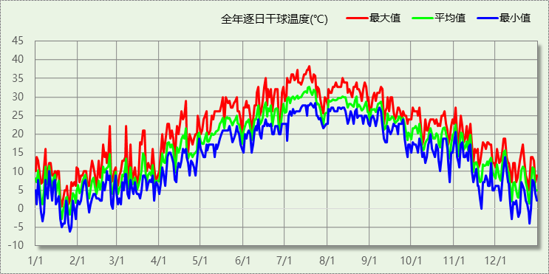

## 逐月辐照量表

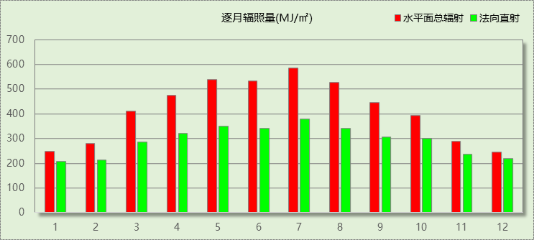

## 峰值工况

|  |  |  |  |  |  |
| --- | --- | --- | --- | --- | --- |
| 气象数据 | 时刻 | 干球温度(℃) | 湿球温度(℃) | 含湿量(g/kg) | 焓值(kj/kg) |
| 最热 | 07月18日17时 | 38.3 | 27.2 | 18.0 | 84.8 |
| 最冷 | 01月25日04时 | -6.1 | -6.7 | 1.9 | -1.4 |

# 建筑大样



西南轴侧图

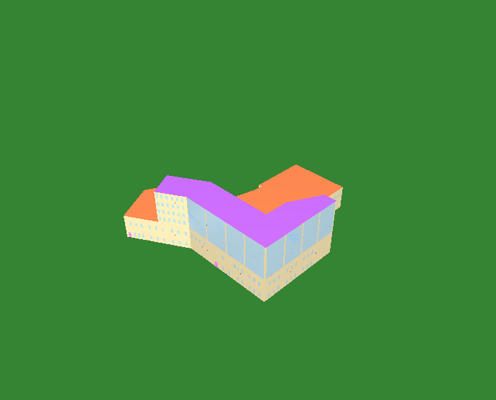

东南轴侧图

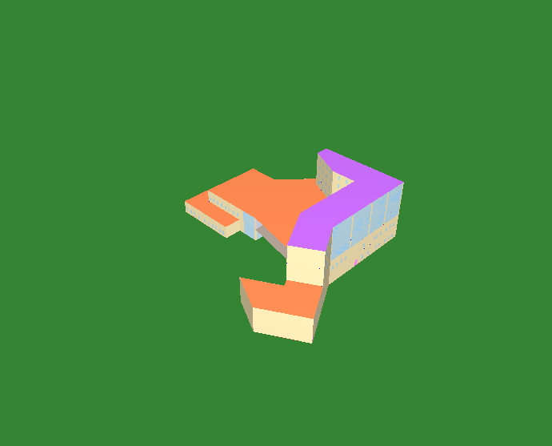

西北轴侧图

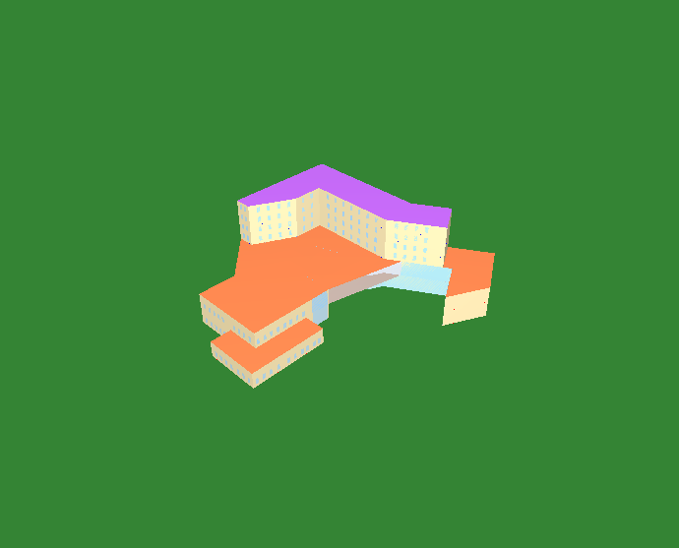

东北轴侧图

# 围护结构

## 工程材料

|  |  |  |  |  |  |  |
| --- | --- | --- | --- | --- | --- | --- |
| 材料名称 | 导热系数λ | 蓄热系数S | 密度ρ | 比热容Cp | 蒸汽渗透 系数u | 数据来源 |
| W/(m.K) | W/(㎡.K) | kg/m3 | J/(kg.K) | g/(m.h.kPa) |
| 水泥砂浆 | 0.930 | 11.370 | 1800.0 | 1050.0 | 0.0210 | 民用建筑热工设计规范 GB50176-2016 |
| 聚苯乙烯泡沫塑料（灰板） | 0.033 | 0.280 | 20.0 | 1380.0 | 0.0162 | 民用建筑热工设计规范 GB50176-2016 |
| 混合砂浆 | 0.870 | 10.750 | 1700.0 | 1074.4 | 0.0975 | 民用建筑热工设计规范 GB50176-2016 |
| 钢筋混凝土 | 1.740 | 17.200 | 2500.0 | 920.0 | 0.0158 | 民用建筑热工设计规范 GB50176-2016 |
| 挤塑聚苯板(ρ=25-32) | 0.030 | 0.320 | 28.5 | 1647.0 | 0.0162 | 民用建筑热工设计规范 GB50176-2016 |
| 加气混凝土、泡沫混凝土(ρ=700) | 0.180 | 3.100 | 700.0 | 1050.0 | 0.0998 | 民用建筑热工设计规范 GB50176-2016 |
| 混凝土多孔砖(190六孔砖） | 0.750 | 7.490 | 1450.0 | 709.4 | 0.0010 | 民用建筑热工设计规范 GB50176-2016 |
| 岩棉板(ρ=60-160) | 0.041 | 0.615 | 110.0 | 1220.0 | 0.4880 | 民用建筑热工设计规范 GB50176-2016 |
| c20细石混凝土(ρ=2300) | 1.510 | 15.243 | 2300.0 | 920.0 | 0.0173 | 民用建筑热工设计规范 GB50176-2016 |
| 轻骨料混凝土(找坡层) | 0.300 | 5.000 | 1050.0 | 1091.3 | 0.0140 | 民用建筑热工设计规范 GB50176-2016 |
| 石墨聚苯板 | 0.033 | 0.280 | 20.0 | 1633.5 | 0.0162 | 内蒙古12系列建筑标准设计图集 DBJ03-22-2014 |

## 围护结构作法简要说明

**1. 屋顶：**屋顶构造一 (K=0.270,D=3.755)：（由上到下）

水泥砂浆 20mm＋c20细石混凝土(ρ=2300) 40mm＋挤塑聚苯板(ρ=25-32) 110mm＋轻骨料混凝土(找坡层) 30mm＋钢筋混凝土 120mm＋混合砂浆 20mm

**2. 外墙：**填充墙构造一 (K=0.331,D=4.530)：（由外到内）

水泥砂浆 20mm＋石墨聚苯板 70mm＋加气混凝土、泡沫混凝土(ρ=700) 200mm＋混合砂浆 20mm

**3. 挑空楼板：**挑空楼板构造一 (K=0.418,D=2.425)：（由上到下）

水泥砂浆 20mm＋挤塑聚苯板(ρ=25-32) 70mm＋钢筋混凝土 120mm＋混合砂浆 20mm

**4. 幕墙：**70系列内平开隔热铝合金窗(5+12Ar+5Low-E+12Ar+5Low-E) (K=1.600)：

传热系数1.600W/㎡.K，窗太阳得热系数0.275

**5. 外窗：**70系列内平开隔热铝合金窗(5+12Ar+5Low-E+12Ar+5Low-E) (K=1.600)：

传热系数1.600W/㎡.K，窗太阳得热系数0.275

# 围护结构概况

|  |  |  |  |  |  |
| --- | --- | --- | --- | --- | --- |
|  | | | 设计建筑 | | |
| 体形系数S | | | 0.24 | | |
| 屋顶传热系数K  和热惰性指标 D | | | 0.27  3.76 | | |
| 外墙传热系数K  和热惰性指标 D | | | 0.36  4.53 | | |
| 挑空(或架空)楼板传热系数K  和热惰性指标 D | | | 0.42  2.43 | | |
| 天窗传热系数K  和太阳得热系数 SHGC | | | －  － | | |
| 外窗（包括透明幕墙） | 朝向 | 立面 | 窗墙比 | 传热  系数 | 太阳得热系数 |
| 南向 | 南-默认立面 | 0.52 | 1.60 | 0.27 |
| 北向 | 北-默认立面 | 0.25 | 1.60 | 0.27 |
| 东向 | 东-默认立面 | 0.31 | 1.60 | 0.27 |
| 西向 | 西-默认立面 | 0.34 | 1.60 | 0.27 |

# 房间类型

## 房间参数表

|  |  |  |  |  |  |  |  |
| --- | --- | --- | --- | --- | --- | --- | --- |
| 房间类型 | 空调 温度℃ | 供暖 温度℃ | 新风量 | 渗透风 换气次数 | 人员密度 | 照明功率 密度 | 电器设备 功率 |
| 3星以下客房 | 25 | 22 | 30(m3/h.人) | 0(次/h) | 14.3(㎡/人) | 6(W/㎡) | 13(W/㎡) |
| 休息室 | 26 | 18 | 10(m3/h.人) | 0(次/h) | 10(㎡/人) | 8(W/㎡) | 15(W/㎡) |
| 会议室 | 26 | 18 | 14(m3/h.人) | 0(次/h) | 2.5(㎡/人) | 8(W/㎡) | 15(W/㎡) |
| 厨房 | 27 | 18 | 28(次/h) | 0(次/h) | 5(㎡/人) | 8(W/㎡) | 15(W/㎡) |
| 展示区 | 26 | 20 | 30(m3/h.人) | 0(次/h) | 2.5(㎡/人) | 8(W/㎡) | 15(W/㎡) |
| 报告厅 | 26 | 18 | 14(m3/h.人) | 0(次/h) | 2.5(㎡/人) | 8(W/㎡) | 15(W/㎡) |
| 接待室 | 26 | 20 | 30(m3/h.人) | 0(次/h) | 8(㎡/人) | 8(W/㎡) | 15(W/㎡) |
| 普通办公室 | 26 | 20 | 30(m3/h.人) | 0(次/h) | 8(㎡/人) | 8(W/㎡) | 15(W/㎡) |
| 档案室 | 26 | 18 | 30(m3/h.人) | 0(次/h) | 8(㎡/人) | 6(W/㎡) | 15(W/㎡) |
| 楼梯间 | － | － | 0(m3/h.人) | 0(次/h) | 0(人) | 3.5(W/㎡) | 15(W/㎡) |
| 空房间 | － | － | 0(m3/h.人) | 0(次/h) | 0(人) | 0(W/㎡) | 0(W/㎡) |
| 走廊 | 26 | 16 | 20(m3/h.人) | 0(次/h) | 50(㎡/人) | 3.5(W/㎡) | 15(W/㎡) |
| 阅览室 | 26 | 18 | 30(m3/h.人) | 0(次/h) | 8(㎡/人) | 8(W/㎡) | 15(W/㎡) |

## 作息时间表

详见附录

# 暖通空调系统

## 系统类型

### 系统分区

|  |  |  |  |  |  |
| --- | --- | --- | --- | --- | --- |
| 系统编号 | 系统类型 | 制冷 SEER | 制热 HSPF | 面积(㎡) | 包含的房间 |
| 默认 | 双管制风机盘管 | － | － | 903.09 | 1003(1),1002(1),X126(1),2002(2),X010(2),X008(2),X067(3),X066(3) |
| Sys0 | 多联式空调(热泵)机组 | 4.00[全年能源消耗效率(APF)] | | 1975.17 | X022(1),X016(1),X013(1),X011(1),X009(1),X128(2),X032(3),X017(3),X015(3),X012(3),X069(4),X068(4),X033(4),X021(4),X019(4),X018(4),X014(4),X071(5),X070(5),X063(5),X062(5),X046(5),X042(5),X041(5),X039(5),X035(5),X029(5),X073(6),X072(6),X064(6),X061(6),X047(6),X044(6),X043(6),X040(6),X034(6),X028(6) |

### 热回收参数

|  |  |  |  |  |  |
| --- | --- | --- | --- | --- | --- |
| 系统编号 | 热回收 | 供冷 | | 供暖 | |
| 回收效率 | 启动温(焓)差 | 回收效率 | 启动温(焓)差 |
| 默认 | 无 | － | － | － | － |
| Sys0 | 无 | － | － | － | － |

## 制冷系统

### 默认冷源

#### 供应的系统

|  |  |
| --- | --- |
| 系统编号 | 默认 |

#### 冷水机组

|  |  |  |  |  |  |
| --- | --- | --- | --- | --- | --- |
| 名称 | 类型 | 额定耗电量 (kW) | 额定制冷量 (kW) | 额定性能系数 (COP) | 台数 |
| 机组1 | 水冷-螺杆式冷水机组 | 100 | 500 | 5.00 | 1 |

#### 水泵系统

|  |  |  |  |  |  |  |  |
| --- | --- | --- | --- | --- | --- | --- | --- |
| 类型 | 调节 | 流量 (m3/h) | 扬程 (m) | 设计工作效率(%) | 输入功率 (kW) | 冷却塔耗电比 (kWh/m3) | 台数 |
| 冷却水泵 | 单速 | 320 | 25 | 80 | 31.3 | 0.03 | 1 |
| 冷冻水泵 | 单速 | 320 | 30 | 80 | 37.6 | － | 1 |

#### 运行工况

|  |  |  |  |  |  |  |
| --- | --- | --- | --- | --- | --- | --- |
| 负载率 (%) | 机组制冷量 (kW) | 机组功率 (kW) | 性能系数 (COP) | 冷却水泵功率 (kW) | 冷冻水泵功率 (kW) | 冷却塔功率 (kW) |
| 20 | 100 | 25 | 4.00 | 31.3 | 37.6 | 10 |
| 40 | 200 | 48 | 4.17 | 31.3 | 37.6 | 10 |
| 60 | 300 | 68 | 4.41 | 31.3 | 37.6 | 10 |
| 80 | 400 | 80 | 5.00 | 31.3 | 37.6 | 10 |
| 100 | 500 | 100 | 5.00 | 31.3 | 37.6 | 10 |

#### 制冷能耗

|  |  |  |  |  |  |  |  |
| --- | --- | --- | --- | --- | --- | --- | --- |
| 负荷区间 (%) | 区间负荷 (kWh) | 运行时长(h) | 制冷机组 (kWh) | 平均性能系数(COP) | 冷却水泵 (kWh) | 冷冻水泵 (kWh) | 冷却塔 (kWh) |
| 0~20 | 1699 | 26 | 425 | 4.00 | 814 | 978 | 260 |
| 20~40 | 12026 | 74 | 2926 | 4.11 | 2316 | 2782 | 740 |
| 40~60 | 11697 | 48 | 2735 | 4.28 | 1502 | 1805 | 480 |
| 60~80 | 16206 | 44 | 3362 | 4.82 | 1377 | 1654 | 440 |
| 80~100 | 90558 | 198 | 18112 | 5.00 | 6197 | 7445 | 1980 |
| >100 | 157553 | 282 | 28200 | － | 8827 | 10603 | 2820 |
| 合计 | 289739 | 672 | 55760 |  | 21034 | 25267 | 6720 |

### 多联机/单元式空调能耗

|  |  |  |  |
| --- | --- | --- | --- |
| 系统编号 | 制冷SEER | 耗冷量(kWh) | 耗电量(kWh) |
| Sys0 | 4.00[全年能源消耗效率(APF)] | 214427 | 53607 |

## 供暖系统

### 默认热源

#### 供应的系统

|  |  |
| --- | --- |
| 系统编号 | 默认 |

#### 热水锅炉系统

##### 热水锅炉

|  |  |  |  |  |  |  |  |
| --- | --- | --- | --- | --- | --- | --- | --- |
| 燃料类型 | 容量 (MW) | 台数 | 累计热负荷 (kWh) | 锅炉 热效率 | 外网热 输送效率 | 热/电系数 (kWh/kWh) | 折合电耗 (kWh) |
| 烟煤II | 1.00 | 1 | 76413 | 0.78 | 0.92 | 2.93 | 36338 |

##### 热水循环泵

|  |  |  |  |  |  |
| --- | --- | --- | --- | --- | --- |
| 类型 | 流量(m3/h) | 扬程(m) | 设计工作效率(%) | 输入功率(kW) | 台数 |
| 单速 | 320 | 30 | 80 | 37.6 | 1 |

##### 热水循环水泵能耗

|  |  |  |  |  |  |  |
| --- | --- | --- | --- | --- | --- | --- |
| 负荷 率 (%) | 锅炉 负荷 (kW) | 供暖水 泵功率 (kW) | 热水输送 能效比 EHR | 区间 负荷 (kWh) | 区间 时长 (h) | 供暖水 泵电耗 (kWh) |
| 20 | 200 | 37.6 | 0.1880 | 68609 | 698 | 26245 |
| 40 | 400 | 37.6 | 0.0940 | 7804 | 34 | 1278 |
| 60 | 600 | 37.6 | 0.0627 | 0 | 0 | 0 |
| 80 | 800 | 37.6 | 0.0470 | 0 | 0 | 0 |
| 100 | 1000 | 37.6 | 0.0376 | 0 | 0 | 0 |
| 综合 | | | | 76413 | 732 | 27523 |

### 多联机/单元式热泵能耗

|  |  |  |  |
| --- | --- | --- | --- |
| 系统编号 | 制热HSPF | 耗热量(kWh) | 耗电量(kWh) |
| Sys0 | 4.00[全年能源消耗效率(APF)] | 143246 | 35812 |

## 空调风机

### 独立新排风

|  |  |  |  |  |  |
| --- | --- | --- | --- | --- | --- |
| 系统编号 | 新风量 (m3/h) | 单位风量耗功率 W/(m3/h) | 风机功率(W) | 运行时长(h) | 新风电耗(kWh) |
| 默认 | 5018 | 0.24 | 1204 | 1404 | 1691 |
| Sys0 | 32905 | 0.24 | 7897 | 4080 | 32221 |
| 合计 | | | | | 33911 |

|  |  |  |  |  |  |  |
| --- | --- | --- | --- | --- | --- | --- |
| 系统编号 | 排风量 (m3/h) | 排风比 | 单位风量耗功率W/(m3/h) | 风机功率(W) | 运行时长(h) | 排风电耗 (kWh) |
| 默认 | 4014 | 0.8 | 0.24 | 963 | 1404 | 1353 |
| Sys0 | 26324 | 0.8 | 0.24 | 6318 | 4080 | 25776 |
| 合计 | | | | | | 27129 |

### 风机盘管

|  |  |  |  |  |
| --- | --- | --- | --- | --- |
| 系统编号 | 总功率(W) | 同时使用系数 | 运行时长(h) | 风机盘管电耗(kWh) |
| 默认 | 400 | 1 | 1379 | 552 |
| 合计 | | | | 552 |

# 照明

|  |  |  |  |  |
| --- | --- | --- | --- | --- |
| 房间类型 | 单位面积电耗 (kWh/㎡) | 房间个数 | 房间合计面积 (㎡) | 合计电耗 (kWh) |
| 3星以下客房 | 20.15 | 18 | 477 | 9608 |
| 休息室 | 26.86 | 2 | 190 | 5091 |
| 会议室 | 13.44 | 5 | 327 | 4399 |
| 厨房 | 13.44 | 1 | 164 | 2210 |
| 展示区 | 13.44 | 4 | 696 | 9360 |
| 报告厅 | 13.44 | 1 | 133 | 1784 |
| 接待室 | 13.44 | 1 | 81 | 1090 |
| 普通办公室 | 13.44 | 9 | 320 | 4295 |
| 档案室 | 10.08 | 1 | 44 | 445 |
| 楼梯间 | 9.63 | 3 | 79 | 758 |
| 空房间 | 0.00 | 79 | 2899 | 0 |
| 走廊 | 8.27 | 1 | 347 | 2865 |
| 阅览室 | 13.44 | 2 | 271 | 3637 |
| 总计 | | | | 45540 |

# 排风机

|  |  |  |  |  |  |
| --- | --- | --- | --- | --- | --- |
| 额定功率 (kW) | 台数 | 使用系数 | 运行时间 (h/天) | 年运行天数 | 全年电耗 (kWh) |
| 5 | 2 | 0.8 | 5 | 365 | 14600 |
| 总计 | | | | | 14600 |

注：此类风机指非空调区域排风机

# 生活热水

## 热水需求

|  |  |  |  |  |  |
| --- | --- | --- | --- | --- | --- |
| 分区 | 用水定额 (L/人·d) | 热水温差(℃) | 用水人数 | 年使用天数 | 所需热量 (kWh/a) |
| 办公 | 30 | 45 | 50 | 365 | 28168 |
| 总计 | | | | | 28168 |

## 太阳能集热

|  |  |  |  |  |  |  |
| --- | --- | --- | --- | --- | --- | --- |
| 太阳能板 分组名称 | 集热器面积(㎡) | 日均辐照量(kj/(㎡·d) | 年利用天数 | 年均集 热效率 | 热量 损失率 | 太阳能供热(kWh/a) |
| 1 | 0 | 16340 | 256 | 0.4 | 0.25 | 0 |
| 总计 | | | | | | 0 |

## 热水设备

|  |  |  |  |  |  |
| --- | --- | --- | --- | --- | --- |
| 热水设备 | 供热比例 | 供热量(kWh/a) | 能源 | 效率 | 耗电量(kWh/a) |
| 电加热 | 1 | 28168 | 电 | 0.9 | 31297.4 |
| 备注 | 热水设备承担的供热量=(总需求热量－太阳能供热量)×设备供热比例。 耗电量=供热量÷效率。 | | | | |

# 电梯

## 直梯

|  |  |  |  |  |  |  |  |  |
| --- | --- | --- | --- | --- | --- | --- | --- | --- |
| 名称 | 特定能量消耗(mWh/kgm) | 额定载重量(kg) | 速度(m/s) | 待机功率(W) | 运行时长(h/天) | 年运行天数 | 数量 | 全年电耗 (kWh) |
| 直梯1 | 1.26 | 1350 | 1.75 | 200 | 1.5 | 365 | 2 | 15019 |
| 总计 | | | | | | | | 15019 |

# 光伏发电

日照辐照量(kJ/㎡.天)：16340，年运行天数：365

|  |  |  |  |  |
| --- | --- | --- | --- | --- |
| 光伏板面积 (㎡) | 光电转换 效率(%) | 光伏系统效率 | 光伏电池性能衰减修正系数 | 全年供电 (kWh) |
| 300 | 15 | 0.75 | 0.85 | 47526 |
| 总计 | | | | 47526 |

# 计算结果

## 负荷分项统计

|  |  |  |  |  |  |  |
| --- | --- | --- | --- | --- | --- | --- |
| 分类 | 围护传热 | 室内得热 | 窗日射 | 新风/渗透 | 热回收 | 合计 |
| 供暖(kWh/㎡) | -4.75 | 4.93 | 2.11 | -27.85 | 0.00 | -25.56 |
| 供冷(kWh/㎡) | 5.51 | 9.71 | 3.35 | 42.32 | 0.00 | 60.89 |

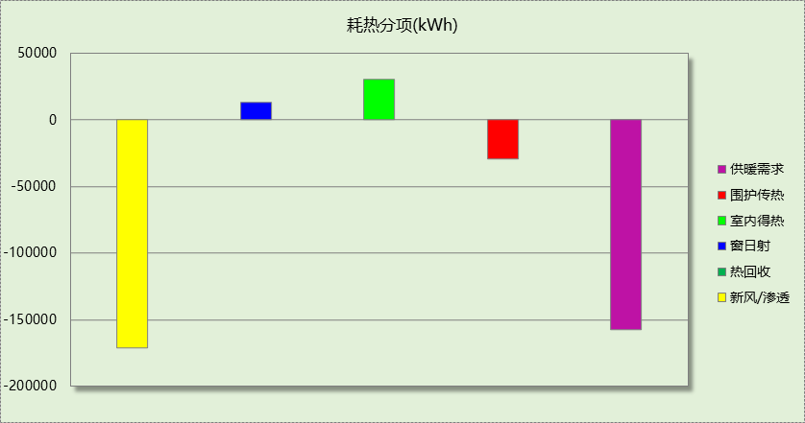

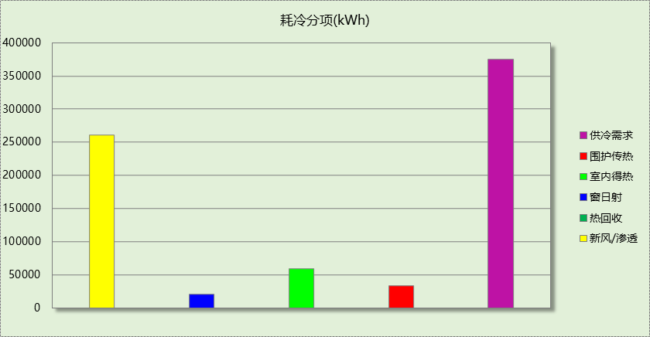

## 逐月负荷表

|  |  |  |  |  |  |  |
| --- | --- | --- | --- | --- | --- | --- |
| 月份 | 供暖(kWh) | 供冷(kWh) | 热负荷 峰值(kW) | 热负荷 峰值时刻 | 冷负荷 峰值(kW) | 冷负荷 峰值时刻 |
| 1月 | 70028 | 0 | 453.821 | 1月21日8时 | 0.000 | -- |
| 2月 | 41943 | 0 | 371.526 | 2月14日8时 | 0.000 | -- |
| 3月 | 0 | 0 | 0.000 | -- | 0.000 | -- |
| 4月 | 0 | 0 | 0.000 | -- | 0.000 | -- |
| 5月 | 0 | 0 | 0.000 | -- | 0.000 | -- |
| 6月 | 0 | 59368 | 0.000 | -- | 580.707 | 6月25日16时 |
| 7月 | 0 | 160351 | 0.000 | -- | 740.993 | 7月15日14时 |
| 8月 | 0 | 154878 | 0.000 | -- | 731.132 | 8月21日15时 |
| 9月 | 0 | 0 | 0.000 | -- | 0.000 | -- |
| 10月 | 0 | 0 | 0.000 | -- | 0.000 | -- |
| 11月 | 258 | 0 | 26.621 | 11月30日24时 | 0.000 | -- |
| 12月 | 45025 | 0 | 352.616 | 12月16日8时 | 0.000 | -- |

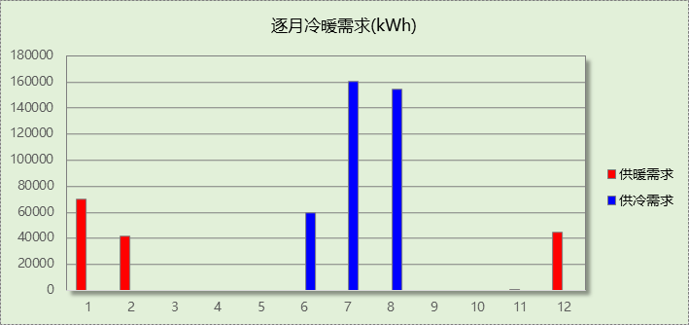

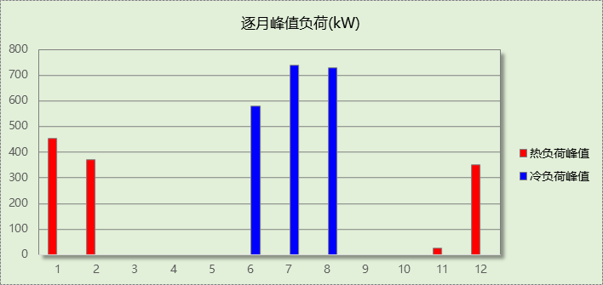

## 逐月电耗

注:供冷供暖为冷热源及输配水泵电耗，热水为扣减太阳能后电耗，所有数据单位kWh/㎡。

|  |  |  |  |  |  |  |  |  |
| --- | --- | --- | --- | --- | --- | --- | --- | --- |
| 月 | 供冷 | 供暖 | 空调风机 | 照明 | 插座设备 | 排风机 | 电梯 | 热水 |
| 1 | 0.00 | 2.58 | 1.83 | 0.64 | － | 2.37 | 2.44 | 5.09 |
| 2 | 0.00 | 1.55 | 1.64 | 0.52 | － |
| 3 | 0.00 | 0.00 | 0.00 | 0.62 | － |
| 4 | 0.00 | 0.00 | 0.00 | 0.62 | － |
| 5 | 0.00 | 0.00 | 0.00 | 0.64 | － |
| 6 | 1.36 | 0.00 | 1.00 | 0.58 | － |
| 7 | 3.76 | 0.00 | 1.83 | 0.66 | － |
| 8 | 3.60 | 0.00 | 1.83 | 0.64 | － |
| 9 | 0.00 | 0.00 | 0.00 | 0.60 | － |
| 10 | 0.00 | 0.00 | 0.00 | 0.60 | － |
| 11 | 0.00 | 0.01 | 0.06 | 0.62 | － |
| 12 | 0.00 | 1.68 | 1.83 | 0.64 | － |
| 合计 | 8.71 | 5.82 | 10.01 | 7.40 | － | 2.37 | 2.44 | 5.09 |

## 全年能耗

|  |  |  |  |
| --- | --- | --- | --- |
| 能耗分类 | 能耗子类 | 设计建筑  (kWh/㎡) | 备注 |
| 建筑负荷 | 耗冷量 | 60.89 |  |
| 耗热量 | 25.56 |  |
| 冷热合计 | 86.45 |  |
| 热回收 | 供冷 | 0.00 |  |
| 供暖 | 0.00 |  |
| 冷热合计 | 0.00 |  |
| 供冷电耗  (Ec) | 中央冷源 | 0.00 |  |
| 冷却水泵 | 0.00 |  |
| 冷冻水泵 | 0.00 |  |
| 冷却塔 | 0.00 |  |
| 多联机/单元式空调 | 8.71 |  |
| 供冷合计 | 0.00 |  |
| 供暖电耗  (Eh) | 中央热源 | 0.00 |  |
| 供暖水泵 | 0.00 |  |
| 热源侧水泵 | 0.00 |  |
| 多联机/单元式热泵 | 5.82 |  |
| 供暖合计 | 0.00 |  |
| 空调风机电耗  (Ef) | 新排风 | 9.92 |  |
| 风机盘管 | 0.09 |  |
| 全空气系统 | 0.00 |  |
| 风机合计 | 10.01 |  |
| 照明电耗 | | 7.40 |  |
| 插座设备电耗 | | - |  |
| 其他电耗(Eo) | 电梯 | 2.44 |  |
| 独立排风机 | 2.37 |  |
| 生活热水 | 5.09 | 扣减了太阳能热水 |
| 其他设备 | 0.00 |  |
| 合计 | 9.90 |  |
| 可再生能源  (Er) | 光伏发电(Ep) | 7.73 |  |
| 风力发电(Ew) | 0.00 |  |
| 建筑总能耗(E1)：电耗(kWh/㎡) | | 19.59 | E1=Ec+Eh+Ef+Eo-Er |

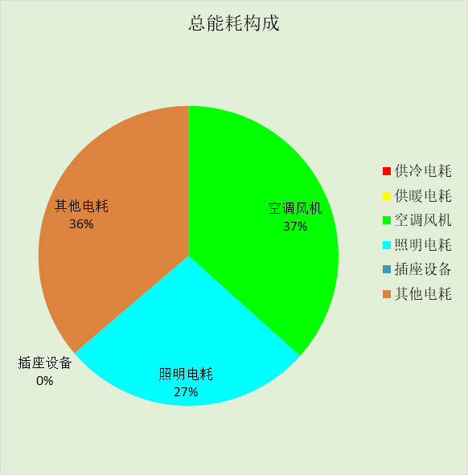

# 附录

## 工作日/节假日人员逐时在室率(%)

|  |  |  |  |  |  |  |  |  |  |  |  |  |  |  |  |  |  |  |  |  |  |  |  |  |
| --- | --- | --- | --- | --- | --- | --- | --- | --- | --- | --- | --- | --- | --- | --- | --- | --- | --- | --- | --- | --- | --- | --- | --- | --- |
| 房间类型 | 1 | 2 | 3 | 4 | 5 | 6 | 7 | 8 | 9 | 10 | 11 | 12 | 13 | 14 | 15 | 16 | 17 | 18 | 19 | 20 | 21 | 22 | 23 | 24 |
| 3星以下客房 | 70 | 70 | 70 | 70 | 70 | 70 | 70 | 70 | 50 | 50 | 50 | 50 | 50 | 50 | 50 | 50 | 50 | 50 | 70 | 70 | 70 | 70 | 70 | 70 |
| 70 | 70 | 70 | 70 | 70 | 70 | 70 | 70 | 50 | 50 | 50 | 50 | 50 | 50 | 50 | 50 | 50 | 50 | 70 | 70 | 70 | 70 | 70 | 70 |
| 休息室 | 70 | 70 | 70 | 70 | 70 | 70 | 70 | 70 | 50 | 50 | 50 | 50 | 50 | 50 | 50 | 50 | 50 | 50 | 70 | 70 | 70 | 70 | 70 | 70 |
| 70 | 70 | 70 | 70 | 70 | 70 | 70 | 70 | 50 | 50 | 50 | 50 | 50 | 50 | 50 | 50 | 50 | 50 | 70 | 70 | 70 | 70 | 70 | 70 |
| 会议室 | 0 | 0 | 0 | 0 | 0 | 0 | 10 | 50 | 100 | 100 | 100 | 30 | 100 | 100 | 100 | 100 | 50 | 20 | 10 | 0 | 0 | 0 | 0 | 0 |
| 0 | 0 | 0 | 0 | 0 | 0 | 0 | 20 | 45 | 0 | 0 | 0 | 0 | 0 | 0 | 0 | 0 | 0 | 0 | 0 | 0 | 0 | 0 | 0 |
| 厨房 | 0 | 0 | 0 | 0 | 0 | 0 | 10 | 50 | 100 | 100 | 100 | 30 | 100 | 100 | 100 | 100 | 50 | 20 | 10 | 0 | 0 | 0 | 0 | 0 |
| 0 | 0 | 0 | 0 | 0 | 0 | 0 | 20 | 45 | 0 | 0 | 0 | 0 | 0 | 0 | 0 | 0 | 0 | 0 | 0 | 0 | 0 | 0 | 0 |
| 展示区 | 0 | 0 | 0 | 0 | 0 | 0 | 10 | 50 | 100 | 100 | 100 | 30 | 100 | 100 | 100 | 100 | 50 | 20 | 10 | 0 | 0 | 0 | 0 | 0 |
| 0 | 0 | 0 | 0 | 0 | 0 | 0 | 20 | 45 | 0 | 0 | 0 | 0 | 0 | 0 | 0 | 0 | 0 | 0 | 0 | 0 | 0 | 0 | 0 |
| 报告厅 | 0 | 0 | 0 | 0 | 0 | 0 | 10 | 50 | 100 | 100 | 100 | 30 | 100 | 100 | 100 | 100 | 50 | 20 | 10 | 0 | 0 | 0 | 0 | 0 |
| 0 | 0 | 0 | 0 | 0 | 0 | 0 | 20 | 45 | 0 | 0 | 0 | 0 | 0 | 0 | 0 | 0 | 0 | 0 | 0 | 0 | 0 | 0 | 0 |
| 接待室 | 0 | 0 | 0 | 0 | 0 | 0 | 10 | 50 | 100 | 100 | 100 | 30 | 100 | 100 | 100 | 100 | 50 | 20 | 10 | 0 | 0 | 0 | 0 | 0 |
| 0 | 0 | 0 | 0 | 0 | 0 | 0 | 20 | 45 | 0 | 0 | 0 | 0 | 0 | 0 | 0 | 0 | 0 | 0 | 0 | 0 | 0 | 0 | 0 |
| 普通办公室 | 0 | 0 | 0 | 0 | 0 | 0 | 10 | 50 | 100 | 100 | 100 | 30 | 100 | 100 | 100 | 100 | 50 | 20 | 10 | 0 | 0 | 0 | 0 | 0 |
| 0 | 0 | 0 | 0 | 0 | 0 | 0 | 20 | 45 | 0 | 0 | 0 | 0 | 0 | 0 | 0 | 0 | 0 | 0 | 0 | 0 | 0 | 0 | 0 |
| 档案室 | 0 | 0 | 0 | 0 | 0 | 0 | 10 | 50 | 100 | 100 | 100 | 30 | 100 | 100 | 100 | 100 | 50 | 20 | 10 | 0 | 0 | 0 | 0 | 0 |
| 0 | 0 | 0 | 0 | 0 | 0 | 0 | 20 | 45 | 0 | 0 | 0 | 0 | 0 | 0 | 0 | 0 | 0 | 0 | 0 | 0 | 0 | 0 | 0 |
| 楼梯间 | 0 | 0 | 0 | 0 | 0 | 0 | 0 | 20 | 50 | 80 | 80 | 80 | 80 | 80 | 80 | 80 | 80 | 80 | 80 | 70 | 50 | 0 | 0 | 0 |
| 0 | 0 | 0 | 0 | 0 | 0 | 0 | 0 | 0 | 0 | 0 | 0 | 0 | 0 | 0 | 0 | 0 | 0 | 0 | 0 | 0 | 0 | 0 | 0 |
| 空房间 | 0 | 0 | 0 | 0 | 0 | 0 | 0 | 20 | 50 | 80 | 80 | 80 | 80 | 80 | 80 | 80 | 80 | 80 | 80 | 70 | 50 | 0 | 0 | 0 |
| 0 | 0 | 0 | 0 | 0 | 0 | 0 | 0 | 0 | 0 | 0 | 0 | 0 | 0 | 0 | 0 | 0 | 0 | 0 | 0 | 0 | 0 | 0 | 0 |
| 走廊 | 0 | 0 | 0 | 0 | 0 | 0 | 10 | 50 | 95 | 95 | 95 | 80 | 80 | 95 | 95 | 95 | 95 | 30 | 30 | 0 | 0 | 0 | 0 | 0 |
| 0 | 0 | 0 | 0 | 0 | 0 | 0 | 0 | 0 | 0 | 0 | 0 | 0 | 0 | 0 | 0 | 0 | 0 | 0 | 0 | 0 | 0 | 0 | 0 |
| 阅览室 | 0 | 0 | 0 | 0 | 0 | 0 | 10 | 50 | 100 | 100 | 100 | 30 | 100 | 100 | 100 | 100 | 50 | 20 | 10 | 0 | 0 | 0 | 0 | 0 |
| 0 | 0 | 0 | 0 | 0 | 0 | 0 | 20 | 45 | 0 | 0 | 0 | 0 | 0 | 0 | 0 | 0 | 0 | 0 | 0 | 0 | 0 | 0 | 0 |

注：上行：工作日；下行：节假日

## 工作日/节假日照明开关时间表(%)

|  |  |  |  |  |  |  |  |  |  |  |  |  |  |  |  |  |  |  |  |  |  |  |  |  |
| --- | --- | --- | --- | --- | --- | --- | --- | --- | --- | --- | --- | --- | --- | --- | --- | --- | --- | --- | --- | --- | --- | --- | --- | --- |
| 房间类型 | 1 | 2 | 3 | 4 | 5 | 6 | 7 | 8 | 9 | 10 | 11 | 12 | 13 | 14 | 15 | 16 | 17 | 18 | 19 | 20 | 21 | 22 | 23 | 24 |
| 3星以下客房 | 10 | 10 | 10 | 10 | 10 | 10 | 30 | 30 | 30 | 30 | 30 | 30 | 30 | 30 | 50 | 50 | 60 | 90 | 90 | 90 | 90 | 80 | 10 | 10 |
| 10 | 10 | 10 | 10 | 10 | 10 | 30 | 30 | 30 | 30 | 30 | 30 | 30 | 30 | 50 | 50 | 60 | 90 | 90 | 90 | 90 | 80 | 10 | 10 |
| 休息室 | 10 | 10 | 10 | 10 | 10 | 10 | 30 | 30 | 30 | 30 | 30 | 30 | 30 | 30 | 50 | 50 | 60 | 90 | 90 | 90 | 90 | 80 | 10 | 10 |
| 10 | 10 | 10 | 10 | 10 | 10 | 30 | 30 | 30 | 30 | 30 | 30 | 30 | 30 | 50 | 50 | 60 | 90 | 90 | 90 | 90 | 80 | 10 | 10 |
| 会议室 | 10 | 10 | 10 | 10 | 10 | 10 | 10 | 36 | 62 | 56 | 54 | 43 | 53 | 55 | 58 | 67 | 40 | 18 | 10 | 10 | 10 | 10 | 10 | 10 |
| 0 | 0 | 0 | 0 | 0 | 0 | 0 | 0 | 0 | 0 | 0 | 0 | 0 | 0 | 0 | 0 | 0 | 0 | 0 | 0 | 0 | 0 | 0 | 0 |
| 厨房 | 10 | 10 | 10 | 10 | 10 | 10 | 10 | 36 | 62 | 56 | 54 | 43 | 53 | 55 | 58 | 67 | 40 | 18 | 10 | 10 | 10 | 10 | 10 | 10 |
| 0 | 0 | 0 | 0 | 0 | 0 | 0 | 0 | 0 | 0 | 0 | 0 | 0 | 0 | 0 | 0 | 0 | 0 | 0 | 0 | 0 | 0 | 0 | 0 |
| 展示区 | 10 | 10 | 10 | 10 | 10 | 10 | 10 | 36 | 62 | 56 | 54 | 43 | 53 | 55 | 58 | 67 | 40 | 18 | 10 | 10 | 10 | 10 | 10 | 10 |
| 0 | 0 | 0 | 0 | 0 | 0 | 0 | 0 | 0 | 0 | 0 | 0 | 0 | 0 | 0 | 0 | 0 | 0 | 0 | 0 | 0 | 0 | 0 | 0 |
| 报告厅 | 10 | 10 | 10 | 10 | 10 | 10 | 10 | 36 | 62 | 56 | 54 | 43 | 53 | 55 | 58 | 67 | 40 | 18 | 10 | 10 | 10 | 10 | 10 | 10 |
| 0 | 0 | 0 | 0 | 0 | 0 | 0 | 0 | 0 | 0 | 0 | 0 | 0 | 0 | 0 | 0 | 0 | 0 | 0 | 0 | 0 | 0 | 0 | 0 |
| 接待室 | 10 | 10 | 10 | 10 | 10 | 10 | 10 | 36 | 62 | 56 | 54 | 43 | 53 | 55 | 58 | 67 | 40 | 18 | 10 | 10 | 10 | 10 | 10 | 10 |
| 0 | 0 | 0 | 0 | 0 | 0 | 0 | 0 | 0 | 0 | 0 | 0 | 0 | 0 | 0 | 0 | 0 | 0 | 0 | 0 | 0 | 0 | 0 | 0 |
| 普通办公室 | 10 | 10 | 10 | 10 | 10 | 10 | 10 | 36 | 62 | 56 | 54 | 43 | 53 | 55 | 58 | 67 | 40 | 18 | 10 | 10 | 10 | 10 | 10 | 10 |
| 0 | 0 | 0 | 0 | 0 | 0 | 0 | 0 | 0 | 0 | 0 | 0 | 0 | 0 | 0 | 0 | 0 | 0 | 0 | 0 | 0 | 0 | 0 | 0 |
| 档案室 | 10 | 10 | 10 | 10 | 10 | 10 | 10 | 36 | 62 | 56 | 54 | 43 | 53 | 55 | 58 | 67 | 40 | 18 | 10 | 10 | 10 | 10 | 10 | 10 |
| 0 | 0 | 0 | 0 | 0 | 0 | 0 | 0 | 0 | 0 | 0 | 0 | 0 | 0 | 0 | 0 | 0 | 0 | 0 | 0 | 0 | 0 | 0 | 0 |
| 楼梯间 | 10 | 10 | 10 | 10 | 10 | 10 | 10 | 50 | 60 | 60 | 60 | 60 | 60 | 60 | 60 | 60 | 80 | 90 | 100 | 100 | 100 | 10 | 10 | 10 |
| 0 | 0 | 0 | 0 | 0 | 0 | 0 | 0 | 0 | 0 | 0 | 0 | 0 | 0 | 0 | 0 | 0 | 0 | 0 | 0 | 0 | 0 | 0 | 0 |
| 空房间 | 10 | 10 | 10 | 10 | 10 | 10 | 10 | 50 | 60 | 60 | 60 | 60 | 60 | 60 | 60 | 60 | 80 | 90 | 100 | 100 | 100 | 10 | 10 | 10 |
| 0 | 0 | 0 | 0 | 0 | 0 | 0 | 0 | 0 | 0 | 0 | 0 | 0 | 0 | 0 | 0 | 0 | 0 | 0 | 0 | 0 | 0 | 0 | 0 |
| 走廊 | 0 | 0 | 0 | 0 | 0 | 0 | 10 | 50 | 95 | 95 | 95 | 80 | 80 | 95 | 95 | 95 | 95 | 30 | 30 | 0 | 0 | 0 | 0 | 0 |
| 0 | 0 | 0 | 0 | 0 | 0 | 0 | 0 | 0 | 0 | 0 | 0 | 0 | 0 | 0 | 0 | 0 | 0 | 0 | 0 | 0 | 0 | 0 | 0 |
| 阅览室 | 10 | 10 | 10 | 10 | 10 | 10 | 10 | 36 | 62 | 56 | 54 | 43 | 53 | 55 | 58 | 67 | 40 | 18 | 10 | 10 | 10 | 10 | 10 | 10 |
| 0 | 0 | 0 | 0 | 0 | 0 | 0 | 0 | 0 | 0 | 0 | 0 | 0 | 0 | 0 | 0 | 0 | 0 | 0 | 0 | 0 | 0 | 0 | 0 |

注：上行：工作日；下行：节假日

## 工作日/节假日设备逐时使用率(%)

|  |  |  |  |  |  |  |  |  |  |  |  |  |  |  |  |  |  |  |  |  |  |  |  |  |
| --- | --- | --- | --- | --- | --- | --- | --- | --- | --- | --- | --- | --- | --- | --- | --- | --- | --- | --- | --- | --- | --- | --- | --- | --- |
| 房间类型 | 1 | 2 | 3 | 4 | 5 | 6 | 7 | 8 | 9 | 10 | 11 | 12 | 13 | 14 | 15 | 16 | 17 | 18 | 19 | 20 | 21 | 22 | 23 | 24 |
| 3星以下客房 | 0 | 0 | 0 | 0 | 0 | 0 | 0 | 0 | 0 | 0 | 0 | 0 | 0 | 0 | 0 | 0 | 0 | 80 | 80 | 80 | 80 | 80 | 0 | 0 |
| 0 | 0 | 0 | 0 | 0 | 0 | 0 | 0 | 0 | 0 | 0 | 0 | 0 | 0 | 0 | 0 | 0 | 80 | 80 | 80 | 80 | 80 | 0 | 0 |
| 休息室 | 0 | 0 | 0 | 0 | 0 | 0 | 0 | 0 | 0 | 0 | 0 | 0 | 0 | 0 | 0 | 0 | 0 | 80 | 80 | 80 | 80 | 80 | 0 | 0 |
| 0 | 0 | 0 | 0 | 0 | 0 | 0 | 0 | 0 | 0 | 0 | 0 | 0 | 0 | 0 | 0 | 0 | 80 | 80 | 80 | 80 | 80 | 0 | 0 |
| 会议室 | 0 | 0 | 0 | 0 | 0 | 0 | 10 | 50 | 100 | 100 | 100 | 100 | 100 | 100 | 100 | 100 | 50 | 20 | 10 | 0 | 0 | 0 | 0 | 0 |
| 0 | 0 | 0 | 0 | 0 | 0 | 0 | 0 | 0 | 0 | 0 | 0 | 0 | 0 | 0 | 0 | 0 | 0 | 0 | 0 | 0 | 0 | 0 | 0 |
| 厨房 | 0 | 0 | 0 | 0 | 0 | 0 | 10 | 50 | 100 | 100 | 100 | 100 | 100 | 100 | 100 | 100 | 50 | 20 | 10 | 0 | 0 | 0 | 0 | 0 |
| 0 | 0 | 0 | 0 | 0 | 0 | 0 | 0 | 0 | 0 | 0 | 0 | 0 | 0 | 0 | 0 | 0 | 0 | 0 | 0 | 0 | 0 | 0 | 0 |
| 展示区 | 0 | 0 | 0 | 0 | 0 | 0 | 10 | 50 | 100 | 100 | 100 | 100 | 100 | 100 | 100 | 100 | 50 | 20 | 10 | 0 | 0 | 0 | 0 | 0 |
| 0 | 0 | 0 | 0 | 0 | 0 | 0 | 0 | 0 | 0 | 0 | 0 | 0 | 0 | 0 | 0 | 0 | 0 | 0 | 0 | 0 | 0 | 0 | 0 |
| 报告厅 | 0 | 0 | 0 | 0 | 0 | 0 | 10 | 50 | 100 | 100 | 100 | 100 | 100 | 100 | 100 | 100 | 50 | 20 | 10 | 0 | 0 | 0 | 0 | 0 |
| 0 | 0 | 0 | 0 | 0 | 0 | 0 | 0 | 0 | 0 | 0 | 0 | 0 | 0 | 0 | 0 | 0 | 0 | 0 | 0 | 0 | 0 | 0 | 0 |
| 接待室 | 0 | 0 | 0 | 0 | 0 | 0 | 10 | 50 | 100 | 100 | 100 | 100 | 100 | 100 | 100 | 100 | 50 | 20 | 10 | 0 | 0 | 0 | 0 | 0 |
| 0 | 0 | 0 | 0 | 0 | 0 | 0 | 0 | 0 | 0 | 0 | 0 | 0 | 0 | 0 | 0 | 0 | 0 | 0 | 0 | 0 | 0 | 0 | 0 |
| 普通办公室 | 0 | 0 | 0 | 0 | 0 | 0 | 10 | 50 | 100 | 100 | 100 | 100 | 100 | 100 | 100 | 100 | 50 | 20 | 10 | 0 | 0 | 0 | 0 | 0 |
| 0 | 0 | 0 | 0 | 0 | 0 | 0 | 0 | 0 | 0 | 0 | 0 | 0 | 0 | 0 | 0 | 0 | 0 | 0 | 0 | 0 | 0 | 0 | 0 |
| 档案室 | 0 | 0 | 0 | 0 | 0 | 0 | 10 | 50 | 100 | 100 | 100 | 100 | 100 | 100 | 100 | 100 | 50 | 20 | 10 | 0 | 0 | 0 | 0 | 0 |
| 0 | 0 | 0 | 0 | 0 | 0 | 0 | 0 | 0 | 0 | 0 | 0 | 0 | 0 | 0 | 0 | 0 | 0 | 0 | 0 | 0 | 0 | 0 | 0 |
| 楼梯间 | 0 | 0 | 0 | 0 | 0 | 0 | 0 | 30 | 50 | 80 | 80 | 80 | 80 | 80 | 80 | 80 | 80 | 80 | 80 | 70 | 50 | 0 | 0 | 0 |
| 0 | 0 | 0 | 0 | 0 | 0 | 0 | 0 | 0 | 0 | 0 | 0 | 0 | 0 | 0 | 0 | 0 | 0 | 0 | 0 | 0 | 0 | 0 | 0 |
| 空房间 | 0 | 0 | 0 | 0 | 0 | 0 | 0 | 30 | 50 | 80 | 80 | 80 | 80 | 80 | 80 | 80 | 80 | 80 | 80 | 70 | 50 | 0 | 0 | 0 |
| 0 | 0 | 0 | 0 | 0 | 0 | 0 | 0 | 0 | 0 | 0 | 0 | 0 | 0 | 0 | 0 | 0 | 0 | 0 | 0 | 0 | 0 | 0 | 0 |
| 走廊 | 0 | 0 | 0 | 0 | 0 | 0 | 10 | 50 | 95 | 95 | 95 | 50 | 50 | 95 | 95 | 95 | 95 | 30 | 30 | 0 | 0 | 0 | 0 | 0 |
| 0 | 0 | 0 | 0 | 0 | 0 | 0 | 0 | 0 | 0 | 0 | 0 | 0 | 0 | 0 | 0 | 0 | 0 | 0 | 0 | 0 | 0 | 0 | 0 |
| 阅览室 | 0 | 0 | 0 | 0 | 0 | 0 | 10 | 50 | 100 | 100 | 100 | 100 | 100 | 100 | 100 | 100 | 50 | 20 | 10 | 0 | 0 | 0 | 0 | 0 |
| 0 | 0 | 0 | 0 | 0 | 0 | 0 | 0 | 0 | 0 | 0 | 0 | 0 | 0 | 0 | 0 | 0 | 0 | 0 | 0 | 0 | 0 | 0 | 0 |

注：上行：工作日；下行：节假日

## 工作日/节假日空调系统运行时间表(1:开,0:关)

采暖期：

|  |  |  |  |  |  |  |  |  |  |  |  |  |  |  |  |  |  |  |  |  |  |  |  |  |
| --- | --- | --- | --- | --- | --- | --- | --- | --- | --- | --- | --- | --- | --- | --- | --- | --- | --- | --- | --- | --- | --- | --- | --- | --- |
| 系统编号 | 1 | 2 | 3 | 4 | 5 | 6 | 7 | 8 | 9 | 10 | 11 | 12 | 13 | 14 | 15 | 16 | 17 | 18 | 19 | 20 | 21 | 22 | 23 | 24 |
| 默认 | 0 | 0 | 0 | 0 | 0 | 0 | 1 | 1 | 1 | 1 | 1 | 1 | 1 | 1 | 1 | 1 | 1 | 1 | 0 | 0 | 0 | 0 | 0 | 0 |
| 0 | 0 | 0 | 0 | 0 | 0 | 0 | 0 | 0 | 0 | 0 | 0 | 0 | 0 | 0 | 0 | 0 | 0 | 0 | 0 | 0 | 0 | 0 | 0 |
| Sys0 | 1 | 1 | 1 | 1 | 1 | 1 | 1 | 1 | 1 | 1 | 1 | 1 | 1 | 1 | 1 | 1 | 1 | 1 | 1 | 1 | 1 | 1 | 1 | 1 |
| 1 | 1 | 1 | 1 | 1 | 1 | 1 | 1 | 1 | 1 | 1 | 1 | 1 | 1 | 1 | 1 | 1 | 1 | 1 | 1 | 1 | 1 | 1 | 1 |

供冷期：

|  |  |  |  |  |  |  |  |  |  |  |  |  |  |  |  |  |  |  |  |  |  |  |  |  |
| --- | --- | --- | --- | --- | --- | --- | --- | --- | --- | --- | --- | --- | --- | --- | --- | --- | --- | --- | --- | --- | --- | --- | --- | --- |
| 系统编号 | 1 | 2 | 3 | 4 | 5 | 6 | 7 | 8 | 9 | 10 | 11 | 12 | 13 | 14 | 15 | 16 | 17 | 18 | 19 | 20 | 21 | 22 | 23 | 24 |
| 默认 | 0 | 0 | 0 | 0 | 0 | 0 | 1 | 1 | 1 | 1 | 1 | 1 | 1 | 1 | 1 | 1 | 1 | 1 | 0 | 0 | 0 | 0 | 0 | 0 |
| 0 | 0 | 0 | 0 | 0 | 0 | 0 | 0 | 0 | 0 | 0 | 0 | 0 | 0 | 0 | 0 | 0 | 0 | 0 | 0 | 0 | 0 | 0 | 0 |
| Sys0 | 1 | 1 | 1 | 1 | 1 | 1 | 1 | 1 | 1 | 1 | 1 | 1 | 1 | 1 | 1 | 1 | 1 | 1 | 1 | 1 | 1 | 1 | 1 | 1 |
| 1 | 1 | 1 | 1 | 1 | 1 | 1 | 1 | 1 | 1 | 1 | 1 | 1 | 1 | 1 | 1 | 1 | 1 | 1 | 1 | 1 | 1 | 1 | 1 |

注：上行：工作日；下行：节假日

## 工作日/节假日新风运行时间表(%)

采暖期：

|  |  |  |  |  |  |  |  |  |  |  |  |  |  |  |  |  |  |  |  |  |  |  |  |  |
| --- | --- | --- | --- | --- | --- | --- | --- | --- | --- | --- | --- | --- | --- | --- | --- | --- | --- | --- | --- | --- | --- | --- | --- | --- |
| 系统编号 | 1 | 2 | 3 | 4 | 5 | 6 | 7 | 8 | 9 | 10 | 11 | 12 | 13 | 14 | 15 | 16 | 17 | 18 | 19 | 20 | 21 | 22 | 23 | 24 |
| 默认 | 0 | 0 | 0 | 0 | 0 | 0 | 100 | 100 | 100 | 100 | 100 | 100 | 100 | 100 | 100 | 100 | 100 | 100 | 0 | 0 | 0 | 0 | 0 | 0 |
| 0 | 0 | 0 | 0 | 0 | 0 | 0 | 0 | 0 | 0 | 0 | 0 | 0 | 0 | 0 | 0 | 0 | 0 | 0 | 0 | 0 | 0 | 0 | 0 |
| Sys0 | 100 | 100 | 100 | 100 | 100 | 100 | 100 | 100 | 100 | 100 | 100 | 100 | 100 | 100 | 100 | 100 | 100 | 100 | 100 | 100 | 100 | 100 | 100 | 100 |
| 100 | 100 | 100 | 100 | 100 | 100 | 100 | 100 | 100 | 100 | 100 | 100 | 100 | 100 | 100 | 100 | 100 | 100 | 100 | 100 | 100 | 100 | 100 | 100 |

供冷期：

|  |  |  |  |  |  |  |  |  |  |  |  |  |  |  |  |  |  |  |  |  |  |  |  |  |
| --- | --- | --- | --- | --- | --- | --- | --- | --- | --- | --- | --- | --- | --- | --- | --- | --- | --- | --- | --- | --- | --- | --- | --- | --- |
| 系统编号 | 1 | 2 | 3 | 4 | 5 | 6 | 7 | 8 | 9 | 10 | 11 | 12 | 13 | 14 | 15 | 16 | 17 | 18 | 19 | 20 | 21 | 22 | 23 | 24 |
| 默认 | 0 | 0 | 0 | 0 | 0 | 0 | 100 | 100 | 100 | 100 | 100 | 100 | 100 | 100 | 100 | 100 | 100 | 100 | 0 | 0 | 0 | 0 | 0 | 0 |
| 0 | 0 | 0 | 0 | 0 | 0 | 0 | 0 | 0 | 0 | 0 | 0 | 0 | 0 | 0 | 0 | 0 | 0 | 0 | 0 | 0 | 0 | 0 | 0 |
| Sys0 | 100 | 100 | 100 | 100 | 100 | 100 | 100 | 100 | 100 | 100 | 100 | 100 | 100 | 100 | 100 | 100 | 100 | 100 | 100 | 100 | 100 | 100 | 100 | 100 |
| 100 | 100 | 100 | 100 | 100 | 100 | 100 | 100 | 100 | 100 | 100 | 100 | 100 | 100 | 100 | 100 | 100 | 100 | 100 | 100 | 100 | 100 | 100 | 100 |

注：上行：工作日；下行：节假日