**建筑全能耗报告书**

公共建筑

|  |  |
| --- | --- |
| 工程名称 | 崇技北楼建筑通风 |
| 工程地点 | 河北-石家庄 |
| 设计编号 |  |
| 建设单位 |  |
| 设计单位 |  |
| 设 计 人 |  |
| 审 核 人 |  |
| 审 定 人 |  |
| 设计日期 | 2024年12月11日 |



|  |  |
| --- | --- |
| 采用软件 | 能耗计算BESI2024 |
| 软件版本 | 20240430(SP1) |
| 研发单位 | 北京绿建软件股份有限公司 |
| 正版授权码 | T17325531839 |

**目 录**

1 建筑概况 3

2 计算依据 3

3 软件介绍 3

4 气象数据 4

4.1 气象地点 4

4.2 逐日干球温度表 4

4.3 逐月辐照量表 4

4.4 峰值工况 5

5 围护结构 5

5.1 工程材料 5

5.2 围护结构作法简要说明 5

6 围护结构概况 6

7 房间类型 6

7.1 房间参数表 6

7.2 作息时间表 7

8 暖通空调系统 7

8.1 系统类型 7

8.1.1 系统分区 7

8.1.2 热回收参数 7

8.2 制冷系统 7

8.2.1 默认冷源 7

8.3 供暖系统 8

8.3.1 默认热源 8

8.4 空调风机 9

8.4.1 独立新排风 9

8.4.2 风机盘管 9

9 照明 9

10 插座设备 10

11 计算结果 10

11.1 负荷分项统计 10

11.2 逐月负荷表 11

11.3 逐月电耗 12

11.4 全年能耗 13

12 附录 15

12.1 工作日/节假日人员逐时在室率(%) 15

12.2 工作日/节假日照明开关时间表(%) 16

12.3 工作日/节假日设备逐时使用率(%) 17

12.4 工作日/节假日空调系统运行时间表(1:开,0:关) 18

12.5 工作日/节假日新风运行时间表(%) 18

# 建筑概况

|  |  |  |
| --- | --- | --- |
| 工程名称 | 崇技北楼建筑通风 | |
| 工程地点 | 河北-石家庄 | |
| 地理位置 | 北纬：38.00° | 东经：114.41° |
| 建筑面积(m2) | 地上8869 地下0 | |
| 建筑层数 | 地上3 地下0 | |
| 建筑高度（m） | 地上18.6 地下0.0 | |
| 建筑体积(m3) | 40789.82 | |
| 建筑外表面积(m2) | 3963.62 | |
| 北向角度 | 90 | |
| 结构类型 |  | |
| 外墙太阳辐射吸收系数 | 0.75 | |
| 屋顶太阳辐射吸收系数 | 0.75 | |
| 控温期 | 全年控温 | |

# 计算依据

1. 《绿色建筑评价标准》(GB/T50378-2019)

2. 《民用建筑绿色性能计算标准》(JGJ/T 449-2018)

3. 《建筑能效标识技术标准》(JGJ/T 288-2012)

4. 《建筑节能与可再生能源利用通用规范》GB55015-2021

5. 《公共建筑节能设计标准》GB50189-2015

6. 《民用建筑热工设计规范》GB50176-2016

7. 《建筑幕墙、门窗通用技术条件》GB/T31433-2015

# 软件介绍

本报告内容由能耗计算BESI2024计算并输出，能耗计算BESI以CAD为平台，内置DOE2内核，可与建筑节能模型无缝对接，精准快速得到动态理想负荷，完美支持从《建筑能效标识技术标准》到《绿色建筑评价标准》要求的节能率，以及建筑全能耗的计算；软件充分考虑工程实际需求，从冷热源、输配水泵到末端风机，覆盖了常见暖通设备的能耗计算；并支持灵活的采暖供冷期、系统划分、运行策略设置等功能以及强大的结果数据分析。

# 气象数据

## 气象地点

河北-石家庄, 《建筑节能气象参数标准》

## 逐日干球温度表

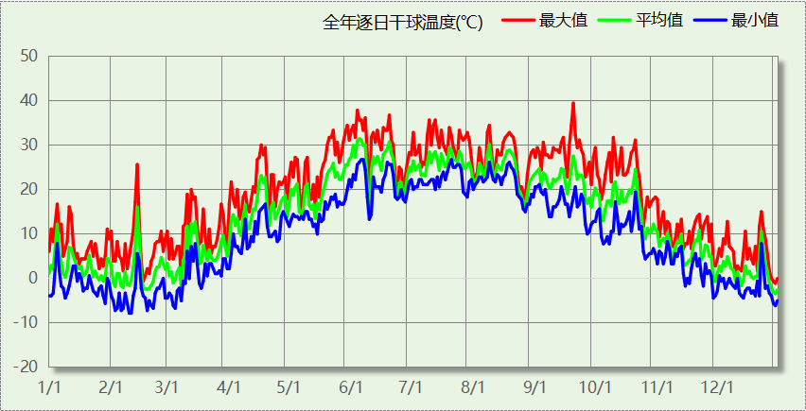

## 逐月辐照量表

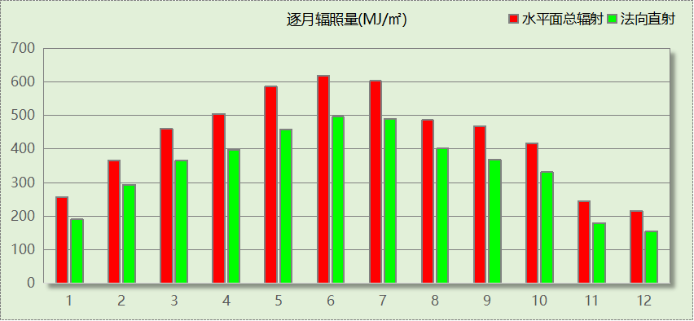

## 峰值工况

|  |  |  |  |  |  |
| --- | --- | --- | --- | --- | --- |
| 气象数据 | 时刻 | 干球温度(℃) | 湿球温度(℃) | 含湿量(g/kg) | 焓值(kj/kg) |
| 最热 | 09月19日14时 | 39.4 | 20.0 | 6.8 | 57.1 |
| 最冷 | 02月09日06时 | -7.8 | -10.0 | 0.8 | -5.8 |

# 围护结构

## 工程材料

|  |  |  |  |  |  |  |
| --- | --- | --- | --- | --- | --- | --- |
| 材料名称 | 导热系数λ | 蓄热系数S | 密度ρ | 比热容Cp | 蒸汽渗透 系数u | 数据来源 |
| W/(m.K) | W/(㎡.K) | kg/m3 | J/(kg.K) | g/(m.h.kPa) |
| 水泥砂浆 | 0.930 | 11.370 | 1800.0 | 1050.0 | 0.0210 |  |
| 石灰砂浆 | 0.810 | 10.070 | 1600.0 | 1050.0 | 0.0443 |  |
| 钢筋混凝土 | 1.740 | 17.200 | 2500.0 | 920.0 | 0.0158 |  |
| 碎石、卵石混凝土(ρ=2300) | 1.510 | 15.360 | 2300.0 | 920.0 | 0.0173 |  |
| 挤塑聚苯乙烯泡沫塑料（带表皮） | 0.030 | 0.340 | 35.0 | 1380.0 | 0.0000 |  |
| 加气混凝土、泡沫混凝土(ρ=700) | 0.180 | 3.100 | 700.0 | 1050.0 | 0.0998 |  |
| 混凝土多孔砖(190六孔砖） | 0.750 | 7.490 | 1450.0 | 709.4 | 0.0000 |  |

## 围护结构作法简要说明

**1. 屋顶：**屋顶构造一 (K=0.774,D=3.691)：（由上到下）

碎石、卵石混凝土(ρ=2300) 40mm＋挤塑聚苯乙烯泡沫塑料（带表皮） 20mm＋水泥砂浆 20mm＋加气混凝土、泡沫混凝土(ρ=700) 80mm＋钢筋混凝土 120mm＋石灰砂浆 20mm

**2. 外墙：**外墙构造一 (K=1.126,D=2.941)：（由外到内）

水泥砂浆 20mm＋挤塑聚苯乙烯泡沫塑料（带表皮） 20mm＋水泥砂浆 20mm＋钢筋混凝土 200mm＋石灰砂浆 20mm

**3. 挑空楼板：**挑空楼板构造一 (K=1.192,D=2.146)：（由上到下）

水泥砂浆 20mm＋钢筋混凝土 120mm＋水泥砂浆 20mm＋挤塑聚苯乙烯泡沫塑料（带表皮） 20mm＋水泥砂浆 20mm

**4. 控温与非控温隔墙：**控温与非控温空间隔墙构造一 (K=1.925,D=2.391)：

水泥砂浆 20mm＋混凝土多孔砖(190六孔砖） 190mm＋石灰砂浆 20mm

**5. 控温房间隔墙：**内墙构造一 (K=1.925,D=2.391)：

水泥砂浆 20mm＋混凝土多孔砖(190六孔砖） 190mm＋石灰砂浆 20mm

**6. 幕墙：**12A钢铝单框双玻窗（平均） (K=3.900)：

传热系数3.900W/㎡.K，窗太阳得热系数0.653

**7. 外窗：**12A钢铝单框双玻窗（平均） (K=3.900)：

传热系数3.900W/㎡.K，窗太阳得热系数0.653

**8. 周边地面：**周边地面构造一 (K=4.988,D=1.431)：

水泥砂浆 20mm＋钢筋混凝土 120mm

# 围护结构概况

|  |  |  |  |  |  |
| --- | --- | --- | --- | --- | --- |
|  | | | 设计建筑 | | |
| 屋顶传热系数K  和热情性指标 D | | | 0.77  3.69 | | |
| 外墙传热系数K  和热情性指标 D | | | 1.36  2.94 | | |
| 挑空(或架空)楼板传热系数K  和热惰性指标 D | | | 1.19  2.15 | | |
| 天窗传热系数K  和太阳得热系数 SHGC | | | －  － | | |
| 外窗（包括透明幕墙） | 朝向 | 立面 | 窗墙比 | 传热  系数 | 太阳得热系数 |
| 南向 | 南-默认立面 | 0.48 | 3.90 | 0.64 |
| 北向 | 北-默认立面 | 0.44 | 3.90 | 0.65 |
| 东向 | 东-默认立面 | 0.44 | 3.90 | 0.64 |
| 西向 | 西-默认立面 | 0.23 | 3.90 | 0.65 |

# 房间类型

## 房间参数表

|  |  |  |  |  |  |  |  |
| --- | --- | --- | --- | --- | --- | --- | --- |
| 房间类型 | 空调 温度℃ | 供暖 温度℃ | 新风量 | 渗透风 换气次数 | 人员密度 | 照明功率 密度 | 电器设备 功率 |
| 休息室 | 26 | 18 | 24(m3/h.人) | 0(次/h) | 1.39(㎡/人) | 8(W/㎡) | 5(W/㎡) |
| 办公-普通办公室 | 26 | 20 | 30(m3/h.人) | 0(次/h) | 8(㎡/人) | 8(W/㎡) | 15(W/㎡) |
| 卫生间 | 28 | 18 | 20(m3/h.人) | 0(次/h) | 20(㎡/人) | 5(W/㎡) | 15(W/㎡) |
| 卫生间 | 28 | 16 | 0(m3/h.人) | 0(次/h) | 0(人) | 5(W/㎡) | 5(W/㎡) |
| 实验教室 | 26 | 18 | 20(m3/h.人) | 0(次/h) | 4(㎡/人) | 8(W/㎡) | 5(W/㎡) |
| 展示区 | 26 | 20 | 30(m3/h.人) | 0(次/h) | 2.5(㎡/人) | 8(W/㎡) | 15(W/㎡) |
| 普通办公室 | 26 | 20 | 30(m3/h.人) | 0(次/h) | 8(㎡/人) | 8(W/㎡) | 15(W/㎡) |
| 普通教室 | 26 | 18 | 24(m3/h.人) | 0(次/h) | 1.39(㎡/人) | 8(W/㎡) | 5(W/㎡) |
| 楼梯间 | － | － | 0(m3/h.人) | 0(次/h) | 0(人) | 5(W/㎡) | 5(W/㎡) |
| 空房间 | － | － | 0(m3/h.人) | 0(次/h) | 0(人) | 0(W/㎡) | 0(W/㎡) |
| 空房间 | － | － | 0(m3/h.人) | 0(次/h) | 0(人) | 0(W/㎡) | 0(W/㎡) |
| 设备间 | － | － | 0(次/h) | 0(次/h) | 0(人) | 6(W/㎡) | 15(W/㎡) |
| 设备间 | － | － | 0(次/h) | 0(次/h) | 0(人) | 6(W/㎡) | 15(W/㎡) |
| 走廊 | － | － | 0(m3/h.人) | 0(次/h) | 0(人) | 5(W/㎡) | 5(W/㎡) |
| 阅览室 | 26 | 20 | 20(m3/h.人) | 0(次/h) | 1.9(㎡/人) | 8(W/㎡) | 5(W/㎡) |

## 作息时间表

详见附录

# 暖通空调系统

## 系统类型

### 系统分区

|  |  |  |  |  |  |
| --- | --- | --- | --- | --- | --- |
| 系统编号 | 系统类型 | 制冷 SEER | 制热 HSPF | 面积(㎡) | 包含的房间 |
| 默认 | 双管制风机盘管 | － | － | 7312.20 | 所有房间 |

### 热回收参数

|  |  |  |  |  |  |
| --- | --- | --- | --- | --- | --- |
| 系统编号 | 热回收 | 供冷 | | 供暖 | |
| 回收效率 | 启动温(焓)差 | 回收效率 | 启动温(焓)差 |
| 默认 | 无 | － | － | － | － |

## 制冷系统

### 默认冷源

#### 供应的系统

|  |  |
| --- | --- |
| 系统编号 | 默认 |

#### 冷水机组

|  |  |  |  |  |  |
| --- | --- | --- | --- | --- | --- |
| 名称 | 类型 | 额定耗电量 (kW) | 额定制冷量 (kW) | 额定性能系数 (COP) | 台数 |
| 机组1 | 水冷-螺杆式冷水机组 | 100 | 500 | 5.00 | 1 |

#### 水泵系统

|  |  |  |  |  |  |  |  |
| --- | --- | --- | --- | --- | --- | --- | --- |
| 类型 | 调节 | 流量 (m3/h) | 扬程 (m) | 设计工作效率(%) | 输入功率 (kW) | 冷却塔耗电比 (kWh/m3) | 台数 |
| 冷却水泵 | 单速 | 320 | 25 | 80 | 31.3 | 0.03 | 1 |
| 冷冻水泵 | 单速 | 320 | 30 | 80 | 37.6 | － | 1 |

#### 运行工况

|  |  |  |  |  |  |  |
| --- | --- | --- | --- | --- | --- | --- |
| 负载率 (%) | 机组制冷量 (kW) | 机组功率 (kW) | 性能系数 (COP) | 冷却水泵功率 (kW) | 冷冻水泵功率 (kW) | 冷却塔功率 (kW) |
| 20 | 100 | 25 | 4.00 | 31.3 | 37.6 | 10 |
| 40 | 200 | 48 | 4.17 | 31.3 | 37.6 | 10 |
| 60 | 300 | 68 | 4.41 | 31.3 | 37.6 | 10 |
| 80 | 400 | 80 | 5.00 | 31.3 | 37.6 | 10 |
| 100 | 500 | 100 | 5.00 | 31.3 | 37.6 | 10 |

#### 制冷能耗

|  |  |  |  |  |  |  |  |
| --- | --- | --- | --- | --- | --- | --- | --- |
| 负荷区间 (%) | 区间负荷 (kWh) | 运行时长(h) | 制冷机组 (kWh) | 平均性能系数(COP) | 冷却水泵 (kWh) | 冷冻水泵 (kWh) | 冷却塔 (kWh) |
| 0~20 | 5796 | 198 | 1449 | 4.00 | 6197 | 7445 | 1980 |
| 20~40 | 13368 | 90 | 3268 | 4.09 | 2817 | 3384 | 900 |
| 40~60 | 19920 | 79 | 4630 | 4.30 | 2473 | 2970 | 790 |
| 60~80 | 26727 | 75 | 5624 | 4.75 | 2348 | 2820 | 750 |
| 80~100 | 33817 | 75 | 6763 | 5.00 | 2348 | 2820 | 750 |
| >100 | 998920 | 924 | 92400 | － | 28921 | 34742 | 9240 |
| 合计 | 1098548 | 1441 | 114134 |  | 45103 | 54182 | 14410 |

## 供暖系统

### 默认热源

#### 供应的系统

|  |  |
| --- | --- |
| 系统编号 | 默认 |

#### 热水锅炉系统

##### 热水锅炉

|  |  |  |  |  |  |  |  |
| --- | --- | --- | --- | --- | --- | --- | --- |
| 燃料类型 | 容量 (MW) | 台数 | 累计热负荷 (kWh) | 锅炉 热效率 | 外网热 输送效率 | 热/电系数 (kWh/kWh) | 折合电耗 (kWh) |
| 烟煤II | 1.00 | 1 | 399348 | 0.78 | 0.92 | 2.93 | 189908 |

##### 热水循环泵

|  |  |  |  |  |  |
| --- | --- | --- | --- | --- | --- |
| 类型 | 流量(m3/h) | 扬程(m) | 设计工作效率(%) | 输入功率(kW) | 台数 |
| 单速 | 320 | 30 | 80 | 37.6 | 1 |

##### 热水循环水泵能耗

|  |  |  |  |  |  |  |
| --- | --- | --- | --- | --- | --- | --- |
| 负荷 率 (%) | 锅炉 负荷 (kW) | 供暖水 泵功率 (kW) | 热水输送 能效比 EHR | 区间 负荷 (kWh) | 区间 时长 (h) | 供暖水 泵电耗 (kWh) |
| 20 | 200 | 37.6 | 0.1880 | 43901 | 629 | 23650 |
| 40 | 400 | 37.6 | 0.0940 | 112479 | 377 | 14175 |
| 60 | 600 | 37.6 | 0.0627 | 125772 | 256 | 9626 |
| 80 | 800 | 37.6 | 0.0470 | 69263 | 101 | 3798 |
| 100 | 1000 | 37.6 | 0.0376 | 47933 | 51 | 1918 |
| 综合 | | | | 399348 | 1414 | 53166 |

## 空调风机

### 独立新排风

|  |  |  |  |  |  |
| --- | --- | --- | --- | --- | --- |
| 系统编号 | 新风量 (m3/h) | 单位风量耗功率 W/(m3/h) | 风机功率(W) | 运行时长(h) | 新风电耗(kWh) |
| 默认 | 95280 | 0.24 | 22867 | 2750 | 62885 |
| 合计 | | | | | 62885 |

|  |  |  |  |  |  |  |
| --- | --- | --- | --- | --- | --- | --- |
| 系统编号 | 排风量 (m3/h) | 排风比 | 单位风量耗功率W/(m3/h) | 风机功率(W) | 运行时长(h) | 排风电耗 (kWh) |
| 默认 | 76224 | 0.8 | 0.24 | 18294 | 2750 | 50308 |
| 合计 | | | | | | 50308 |

### 风机盘管

|  |  |  |  |  |
| --- | --- | --- | --- | --- |
| 系统编号 | 总功率(W) | 同时使用系数 | 运行时长(h) | 风机盘管电耗(kWh) |
| 默认 | 400 | 1 | 2855 | 1142 |
| 合计 | | | | 1142 |

# 照明

|  |  |  |  |  |
| --- | --- | --- | --- | --- |
| 房间类型 | 单位面积电耗 (kWh/㎡) | 房间个数 | 房间合计面积 (㎡) | 合计电耗 (kWh) |
| 休息室 | 18.90 | 1 | 38 | 724 |
| 卫生间 | 8.40 | 8 | 267 | 2246 |
| 实验教室 | 18.90 | 2 | 299 | 5658 |
| 展示区 | 13.44 | 1 | 1700 | 22854 |
| 普通办公室 | 13.44 | 6 | 389 | 5234 |
| 普通教室 | 18.90 | 17 | 3066 | 57947 |
| 楼梯间 | 11.81 | 3 | 221 | 2612 |
| 空房间 | 0.00 | 18 | 43 | 0 |
| 设备间 | 36.00 | 5 | 197 | 7075 |
| 走廊 | 11.81 | 2 | 577 | 6810 |
| 阅览室 | 18.90 | 1 | 1740 | 32880 |
| 总计 | | | | 144040 |

# 插座设备

|  |  |  |  |  |
| --- | --- | --- | --- | --- |
| 房间类型 | 单位面积电耗 (kWh/㎡) | 房间个数 | 房间合计面积 (㎡) | 合计电耗 (kWh) |
| 休息室 | 11.06 | 1 | 38 | 424 |
| 卫生间 | 35.25 | 8 | 267 | 9426 |
| 实验教室 | 11.06 | 2 | 299 | 3312 |
| 展示区 | 35.25 | 1 | 1700 | 59939 |
| 普通办公室 | 35.25 | 6 | 389 | 13726 |
| 普通教室 | 11.06 | 17 | 3066 | 33918 |
| 楼梯间 | 11.06 | 3 | 221 | 2446 |
| 空房间 | 0.00 | 18 | 43 | 0 |
| 设备间 | 90.00 | 5 | 197 | 17687 |
| 走廊 | 11.06 | 2 | 577 | 6378 |
| 阅览室 | 11.06 | 1 | 1740 | 19245 |
| 总计 | | | | 166501 |

# 计算结果

## 负荷分项统计

|  |  |  |  |  |  |  |
| --- | --- | --- | --- | --- | --- | --- |
| 分类 | 围护传热 | 室内得热 | 窗日射 | 新风/渗透 | 热回收 | 合计 |
| 供暖(kWh/㎡) | -24.34 | 27.60 | 9.12 | -57.41 | 0.00 | -45.03 |
| 供冷(kWh/㎡) | 13.87 | 61.17 | 15.33 | 33.49 | 0.00 | 123.87 |

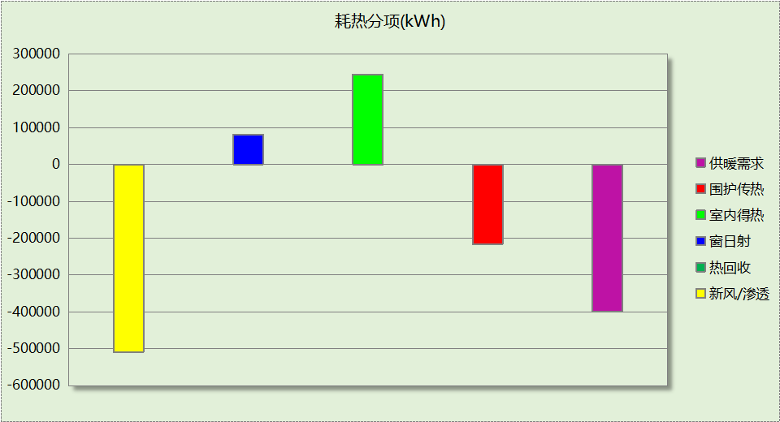

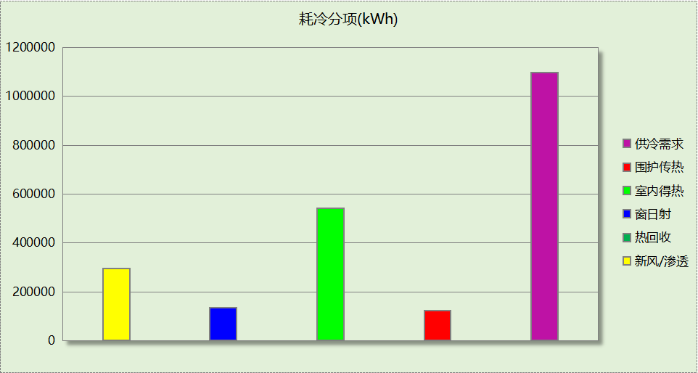

## 逐月负荷表

|  |  |  |  |  |  |  |
| --- | --- | --- | --- | --- | --- | --- |
| 月份 | 供暖(kWh) | 供冷(kWh) | 热负荷 峰值(kW) | 热负荷 峰值时刻 | 冷负荷 峰值(kW) | 冷负荷 峰值时刻 |
| 1月 | 96023 | 0 | 1269.107 | 1月2日9时 | 0.000 | -- |
| 2月 | 86562 | 0 | 1243.815 | 2月18日9时 | 0.000 | -- |
| 3月 | 60437 | 55 | 1132.242 | 3月4日9时 | 16.838 | 3月14日16时 |
| 4月 | 4891 | 20306 | 369.126 | 4月1日9时 | 852.464 | 4月18日16时 |
| 5月 | 472 | 83710 | 50.705 | 5月14日8时 | 1223.930 | 5月30日15时 |
| 6月 | 0 | 192945 | 0.000 | -- | 1733.841 | 6月18日16时 |
| 7月 | 0 | 312805 | 0.000 | -- | 1893.452 | 7月24日14时 |
| 8月 | 0 | 282950 | 0.000 | -- | 2074.177 | 8月8日16时 |
| 9月 | 0 | 163784 | 0.000 | -- | 1406.123 | 9月2日14时 |
| 10月 | 86 | 41993 | 29.663 | 10月31日8时 | 649.809 | 10月9日16时 |
| 11月 | 37866 | 0 | 797.763 | 11月28日9时 | 0.000 | -- |
| 12月 | 113010 | 0 | 1271.557 | 12月30日9时 | 0.000 | -- |

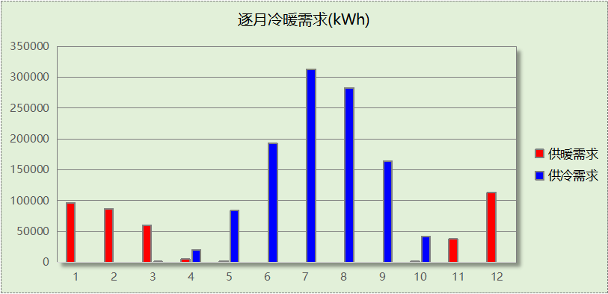

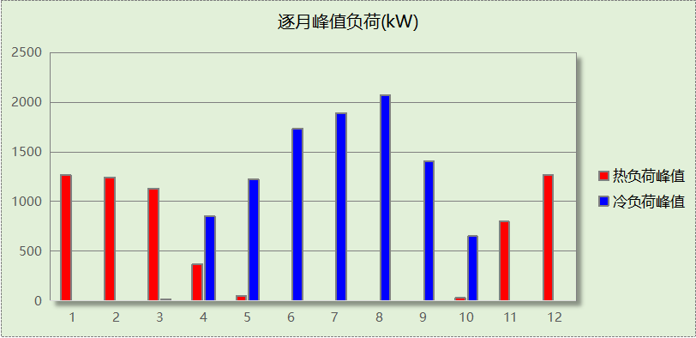

## 逐月电耗

注:供冷供暖为冷热源及输配水泵电耗，热水为扣减太阳能后电耗，所有数据单位kWh/㎡。

|  |  |  |  |  |  |  |  |  |
| --- | --- | --- | --- | --- | --- | --- | --- | --- |
| 月 | 供冷 | 供暖 | 空调风机 | 照明 | 插座设备 | 排风机 | 电梯 | 热水 |
| 1 | 0.00 | 6.27 | 1.14 | 1.43 | 1.65 | 0.00 | 0.00 | 0.00 |
| 2 | 0.00 | 5.51 | 0.88 | 1.10 | 1.28 |
| 3 | 0.04 | 4.29 | 1.08 | 1.36 | 1.58 |
| 4 | 1.40 | 0.83 | 1.08 | 1.36 | 1.58 |
| 5 | 3.28 | 0.21 | 1.13 | 1.43 | 1.65 |
| 6 | 4.12 | 0.00 | 0.98 | 1.23 | 1.43 |
| 7 | 5.07 | 0.00 | 1.19 | 1.49 | 1.73 |
| 8 | 4.79 | 0.00 | 1.13 | 1.43 | 1.65 |
| 9 | 4.20 | 0.00 | 1.03 | 1.30 | 1.50 |
| 10 | 2.80 | 0.07 | 1.03 | 1.30 | 1.50 |
| 11 | 0.00 | 3.05 | 1.08 | 1.36 | 1.58 |
| 12 | 0.00 | 7.18 | 1.14 | 1.43 | 1.65 |
| 合计 | 25.69 | 27.41 | 12.89 | 16.24 | 18.77 | 0.00 | 0.00 | 0.00 |

## 全年能耗

|  |  |  |  |
| --- | --- | --- | --- |
| 能耗分类 | 能耗子类 | 设计建筑  (kWh/㎡) | 备注 |
| 建筑负荷 | 耗冷量 | 123.87 |  |
| 耗热量 | 45.03 |  |
| 冷热合计 | 168.90 |  |
| 热回收 | 供冷 | 0.00 |  |
| 供暖 | 0.00 |  |
| 冷热合计 | 0.00 |  |
| 供冷电耗  (Ec) | 中央冷源 | 12.87 |  |
| 冷却水泵 | 5.09 |  |
| 冷冻水泵 | 6.11 |  |
| 冷却塔 | 1.62 |  |
| 多联机/单元式空调 | 0.00 |  |
| 供冷合计 | 25.69 |  |
| 供暖电耗  (Eh) | 中央热源 | 21.41 |  |
| 供暖水泵 | 5.99 |  |
| 热源侧水泵 | 0.00 |  |
| 多联机/单元式热泵 | 0.00 |  |
| 供暖合计 | 27.41 |  |
| 空调风机电耗  (Ef) | 新排风 | 12.76 |  |
| 风机盘管 | 0.13 |  |
| 全空气系统 | 0.00 |  |
| 风机合计 | 12.89 |  |
| 照明电耗(El) | | 16.24 |  |
| 插座设备电耗(Ej) | | 18.77 |  |
| 其他电耗(Eo) | 电梯 | 0.00 |  |
| 独立排风机 | 0.00 |  |
| 生活热水 | 0.00 | 扣减了太阳能热水 |
| 其他设备 | 0.00 |  |
| 其他合计 | 0.00 |  |
| 可再生发电  (Er) | 光伏发电(Ep) | 0.00 |  |
| 风力发电(Ew) | 0.00 |  |
| 合计 | 0.00 |  |
| 建筑总能耗(E1)：电耗(kWh/㎡) | | 101.00 | E1=Ec+Eh+Ef+El +Ej +Eo-Er |

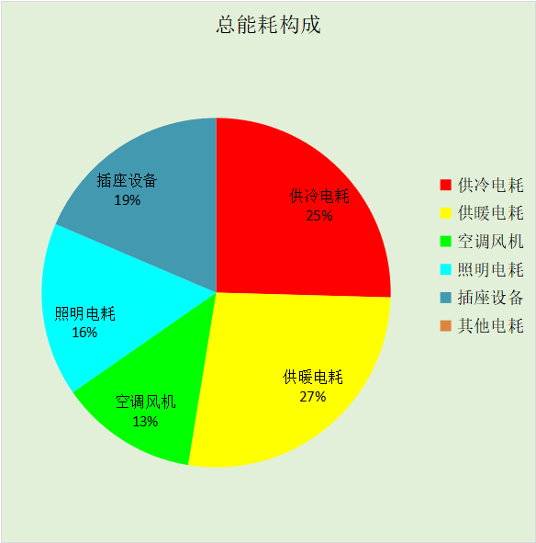

# 附录

## 工作日/节假日人员逐时在室率(%)

|  |  |  |  |  |  |  |  |  |  |  |  |  |  |  |  |  |  |  |  |  |  |  |  |  |
| --- | --- | --- | --- | --- | --- | --- | --- | --- | --- | --- | --- | --- | --- | --- | --- | --- | --- | --- | --- | --- | --- | --- | --- | --- |
| 房间类型 | 1 | 2 | 3 | 4 | 5 | 6 | 7 | 8 | 9 | 10 | 11 | 12 | 13 | 14 | 15 | 16 | 17 | 18 | 19 | 20 | 21 | 22 | 23 | 24 |
| 休息室 | 0 | 0 | 0 | 0 | 0 | 0 | 10 | 50 | 95 | 95 | 95 | 80 | 80 | 95 | 95 | 95 | 95 | 30 | 30 | 0 | 0 | 0 | 0 | 0 |
| 0 | 0 | 0 | 0 | 0 | 0 | 0 | 0 | 0 | 0 | 0 | 0 | 0 | 0 | 0 | 0 | 0 | 0 | 0 | 0 | 0 | 0 | 0 | 0 |
| 办公-普通办公室 | 0 | 0 | 0 | 0 | 0 | 0 | 10 | 50 | 100 | 100 | 100 | 30 | 100 | 100 | 100 | 100 | 50 | 20 | 10 | 0 | 0 | 0 | 0 | 0 |
| 0 | 0 | 0 | 0 | 0 | 0 | 0 | 20 | 45 | 0 | 0 | 0 | 0 | 0 | 0 | 0 | 0 | 0 | 0 | 0 | 0 | 0 | 0 | 0 |
| 卫生间 | 0 | 0 | 0 | 0 | 0 | 0 | 10 | 50 | 100 | 100 | 100 | 30 | 100 | 100 | 100 | 100 | 50 | 20 | 10 | 0 | 0 | 0 | 0 | 0 |
| 0 | 0 | 0 | 0 | 0 | 0 | 0 | 20 | 45 | 0 | 0 | 0 | 0 | 0 | 0 | 0 | 0 | 0 | 0 | 0 | 0 | 0 | 0 | 0 |
| 卫生间 | 0 | 0 | 0 | 0 | 0 | 0 | 10 | 50 | 95 | 95 | 95 | 80 | 80 | 95 | 95 | 95 | 95 | 30 | 30 | 0 | 0 | 0 | 0 | 0 |
| 0 | 0 | 0 | 0 | 0 | 0 | 0 | 0 | 0 | 0 | 0 | 0 | 0 | 0 | 0 | 0 | 0 | 0 | 0 | 0 | 0 | 0 | 0 | 0 |
| 实验教室 | 0 | 0 | 0 | 0 | 0 | 0 | 10 | 50 | 95 | 95 | 95 | 80 | 80 | 95 | 95 | 95 | 95 | 30 | 30 | 0 | 0 | 0 | 0 | 0 |
| 0 | 0 | 0 | 0 | 0 | 0 | 0 | 0 | 0 | 0 | 0 | 0 | 0 | 0 | 0 | 0 | 0 | 0 | 0 | 0 | 0 | 0 | 0 | 0 |
| 展示区 | 0 | 0 | 0 | 0 | 0 | 0 | 10 | 50 | 100 | 100 | 100 | 30 | 100 | 100 | 100 | 100 | 50 | 20 | 10 | 0 | 0 | 0 | 0 | 0 |
| 0 | 0 | 0 | 0 | 0 | 0 | 0 | 20 | 45 | 0 | 0 | 0 | 0 | 0 | 0 | 0 | 0 | 0 | 0 | 0 | 0 | 0 | 0 | 0 |
| 普通办公室 | 0 | 0 | 0 | 0 | 0 | 0 | 10 | 50 | 100 | 100 | 100 | 30 | 100 | 100 | 100 | 100 | 50 | 20 | 10 | 0 | 0 | 0 | 0 | 0 |
| 0 | 0 | 0 | 0 | 0 | 0 | 0 | 20 | 45 | 0 | 0 | 0 | 0 | 0 | 0 | 0 | 0 | 0 | 0 | 0 | 0 | 0 | 0 | 0 |
| 普通教室 | 0 | 0 | 0 | 0 | 0 | 0 | 10 | 50 | 95 | 95 | 95 | 80 | 80 | 95 | 95 | 95 | 95 | 30 | 30 | 0 | 0 | 0 | 0 | 0 |
| 0 | 0 | 0 | 0 | 0 | 0 | 0 | 0 | 0 | 0 | 0 | 0 | 0 | 0 | 0 | 0 | 0 | 0 | 0 | 0 | 0 | 0 | 0 | 0 |
| 楼梯间 | 0 | 0 | 0 | 0 | 0 | 0 | 10 | 50 | 95 | 95 | 95 | 80 | 80 | 95 | 95 | 95 | 95 | 30 | 30 | 0 | 0 | 0 | 0 | 0 |
| 0 | 0 | 0 | 0 | 0 | 0 | 0 | 0 | 0 | 0 | 0 | 0 | 0 | 0 | 0 | 0 | 0 | 0 | 0 | 0 | 0 | 0 | 0 | 0 |
| 空房间 | 0 | 0 | 0 | 0 | 0 | 0 | 0 | 20 | 50 | 80 | 80 | 80 | 80 | 80 | 80 | 80 | 80 | 80 | 80 | 70 | 50 | 0 | 0 | 0 |
| 0 | 0 | 0 | 0 | 0 | 0 | 0 | 0 | 0 | 0 | 0 | 0 | 0 | 0 | 0 | 0 | 0 | 0 | 0 | 0 | 0 | 0 | 0 | 0 |
| 空房间 | 0 | 0 | 0 | 0 | 0 | 0 | 0 | 20 | 50 | 80 | 80 | 80 | 80 | 80 | 80 | 80 | 80 | 80 | 80 | 70 | 50 | 0 | 0 | 0 |
| 0 | 0 | 0 | 0 | 0 | 0 | 0 | 0 | 0 | 0 | 0 | 0 | 0 | 0 | 0 | 0 | 0 | 0 | 0 | 0 | 0 | 0 | 0 | 0 |
| 设备间 | 0 | 0 | 0 | 0 | 0 | 0 | 0 | 0 | 0 | 0 | 0 | 0 | 0 | 0 | 0 | 0 | 0 | 0 | 0 | 0 | 0 | 0 | 0 | 0 |
| 0 | 0 | 0 | 0 | 0 | 0 | 0 | 0 | 0 | 0 | 0 | 0 | 0 | 0 | 0 | 0 | 0 | 0 | 0 | 0 | 0 | 0 | 0 | 0 |
| 设备间 | 0 | 0 | 0 | 0 | 0 | 0 | 0 | 0 | 0 | 0 | 0 | 0 | 0 | 0 | 0 | 0 | 0 | 0 | 0 | 0 | 0 | 0 | 0 | 0 |
| 0 | 0 | 0 | 0 | 0 | 0 | 0 | 0 | 0 | 0 | 0 | 0 | 0 | 0 | 0 | 0 | 0 | 0 | 0 | 0 | 0 | 0 | 0 | 0 |
| 走廊 | 0 | 0 | 0 | 0 | 0 | 0 | 10 | 50 | 95 | 95 | 95 | 80 | 80 | 95 | 95 | 95 | 95 | 30 | 30 | 0 | 0 | 0 | 0 | 0 |
| 0 | 0 | 0 | 0 | 0 | 0 | 0 | 0 | 0 | 0 | 0 | 0 | 0 | 0 | 0 | 0 | 0 | 0 | 0 | 0 | 0 | 0 | 0 | 0 |
| 阅览室 | 0 | 0 | 0 | 0 | 0 | 0 | 10 | 50 | 95 | 95 | 95 | 80 | 80 | 95 | 95 | 95 | 95 | 30 | 30 | 0 | 0 | 0 | 0 | 0 |
| 0 | 0 | 0 | 0 | 0 | 0 | 0 | 0 | 0 | 0 | 0 | 0 | 0 | 0 | 0 | 0 | 0 | 0 | 0 | 0 | 0 | 0 | 0 | 0 |

注：上行：工作日；下行：节假日

## 工作日/节假日照明开关时间表(%)

|  |  |  |  |  |  |  |  |  |  |  |  |  |  |  |  |  |  |  |  |  |  |  |  |  |
| --- | --- | --- | --- | --- | --- | --- | --- | --- | --- | --- | --- | --- | --- | --- | --- | --- | --- | --- | --- | --- | --- | --- | --- | --- |
| 房间类型 | 1 | 2 | 3 | 4 | 5 | 6 | 7 | 8 | 9 | 10 | 11 | 12 | 13 | 14 | 15 | 16 | 17 | 18 | 19 | 20 | 21 | 22 | 23 | 24 |
| 休息室 | 0 | 0 | 0 | 0 | 0 | 0 | 10 | 50 | 95 | 95 | 95 | 80 | 80 | 95 | 95 | 95 | 95 | 30 | 30 | 0 | 0 | 0 | 0 | 0 |
| 0 | 0 | 0 | 0 | 0 | 0 | 0 | 0 | 0 | 0 | 0 | 0 | 0 | 0 | 0 | 0 | 0 | 0 | 0 | 0 | 0 | 0 | 0 | 0 |
| 办公-普通办公室 | 10 | 10 | 10 | 10 | 10 | 10 | 10 | 36 | 62 | 56 | 54 | 43 | 53 | 55 | 58 | 67 | 40 | 18 | 10 | 10 | 10 | 10 | 10 | 10 |
| 0 | 0 | 0 | 0 | 0 | 0 | 0 | 0 | 0 | 0 | 0 | 0 | 0 | 0 | 0 | 0 | 0 | 0 | 0 | 0 | 0 | 0 | 0 | 0 |
| 卫生间 | 10 | 10 | 10 | 10 | 10 | 10 | 10 | 36 | 62 | 56 | 54 | 43 | 53 | 55 | 58 | 67 | 40 | 18 | 10 | 10 | 10 | 10 | 10 | 10 |
| 0 | 0 | 0 | 0 | 0 | 0 | 0 | 0 | 0 | 0 | 0 | 0 | 0 | 0 | 0 | 0 | 0 | 0 | 0 | 0 | 0 | 0 | 0 | 0 |
| 卫生间 | 0 | 0 | 0 | 0 | 0 | 0 | 10 | 50 | 95 | 95 | 95 | 80 | 80 | 95 | 95 | 95 | 95 | 30 | 30 | 0 | 0 | 0 | 0 | 0 |
| 0 | 0 | 0 | 0 | 0 | 0 | 0 | 0 | 0 | 0 | 0 | 0 | 0 | 0 | 0 | 0 | 0 | 0 | 0 | 0 | 0 | 0 | 0 | 0 |
| 实验教室 | 0 | 0 | 0 | 0 | 0 | 0 | 10 | 50 | 95 | 95 | 95 | 80 | 80 | 95 | 95 | 95 | 95 | 30 | 30 | 0 | 0 | 0 | 0 | 0 |
| 0 | 0 | 0 | 0 | 0 | 0 | 0 | 0 | 0 | 0 | 0 | 0 | 0 | 0 | 0 | 0 | 0 | 0 | 0 | 0 | 0 | 0 | 0 | 0 |
| 展示区 | 10 | 10 | 10 | 10 | 10 | 10 | 10 | 36 | 62 | 56 | 54 | 43 | 53 | 55 | 58 | 67 | 40 | 18 | 10 | 10 | 10 | 10 | 10 | 10 |
| 0 | 0 | 0 | 0 | 0 | 0 | 0 | 0 | 0 | 0 | 0 | 0 | 0 | 0 | 0 | 0 | 0 | 0 | 0 | 0 | 0 | 0 | 0 | 0 |
| 普通办公室 | 10 | 10 | 10 | 10 | 10 | 10 | 10 | 36 | 62 | 56 | 54 | 43 | 53 | 55 | 58 | 67 | 40 | 18 | 10 | 10 | 10 | 10 | 10 | 10 |
| 0 | 0 | 0 | 0 | 0 | 0 | 0 | 0 | 0 | 0 | 0 | 0 | 0 | 0 | 0 | 0 | 0 | 0 | 0 | 0 | 0 | 0 | 0 | 0 |
| 普通教室 | 0 | 0 | 0 | 0 | 0 | 0 | 10 | 50 | 95 | 95 | 95 | 80 | 80 | 95 | 95 | 95 | 95 | 30 | 30 | 0 | 0 | 0 | 0 | 0 |
| 0 | 0 | 0 | 0 | 0 | 0 | 0 | 0 | 0 | 0 | 0 | 0 | 0 | 0 | 0 | 0 | 0 | 0 | 0 | 0 | 0 | 0 | 0 | 0 |
| 楼梯间 | 0 | 0 | 0 | 0 | 0 | 0 | 10 | 50 | 95 | 95 | 95 | 80 | 80 | 95 | 95 | 95 | 95 | 30 | 30 | 0 | 0 | 0 | 0 | 0 |
| 0 | 0 | 0 | 0 | 0 | 0 | 0 | 0 | 0 | 0 | 0 | 0 | 0 | 0 | 0 | 0 | 0 | 0 | 0 | 0 | 0 | 0 | 0 | 0 |
| 空房间 | 10 | 10 | 10 | 10 | 10 | 10 | 10 | 50 | 60 | 60 | 60 | 60 | 60 | 60 | 60 | 60 | 80 | 90 | 100 | 100 | 100 | 10 | 10 | 10 |
| 0 | 0 | 0 | 0 | 0 | 0 | 0 | 0 | 0 | 0 | 0 | 0 | 0 | 0 | 0 | 0 | 0 | 0 | 0 | 0 | 0 | 0 | 0 | 0 |
| 空房间 | 10 | 10 | 10 | 10 | 10 | 10 | 10 | 50 | 60 | 60 | 60 | 60 | 60 | 60 | 60 | 60 | 80 | 90 | 100 | 100 | 100 | 10 | 10 | 10 |
| 0 | 0 | 0 | 0 | 0 | 0 | 0 | 0 | 0 | 0 | 0 | 0 | 0 | 0 | 0 | 0 | 0 | 0 | 0 | 0 | 0 | 0 | 0 | 0 |
| 设备间 | 100 | 100 | 100 | 100 | 100 | 100 | 100 | 100 | 100 | 100 | 100 | 100 | 100 | 100 | 100 | 100 | 100 | 100 | 100 | 100 | 100 | 100 | 100 | 100 |
| 0 | 0 | 0 | 0 | 0 | 0 | 0 | 0 | 0 | 0 | 0 | 0 | 0 | 0 | 0 | 0 | 0 | 0 | 0 | 0 | 0 | 0 | 0 | 0 |
| 设备间 | 100 | 100 | 100 | 100 | 100 | 100 | 100 | 100 | 100 | 100 | 100 | 100 | 100 | 100 | 100 | 100 | 100 | 100 | 100 | 100 | 100 | 100 | 100 | 100 |
| 0 | 0 | 0 | 0 | 0 | 0 | 0 | 0 | 0 | 0 | 0 | 0 | 0 | 0 | 0 | 0 | 0 | 0 | 0 | 0 | 0 | 0 | 0 | 0 |
| 走廊 | 0 | 0 | 0 | 0 | 0 | 0 | 10 | 50 | 95 | 95 | 95 | 80 | 80 | 95 | 95 | 95 | 95 | 30 | 30 | 0 | 0 | 0 | 0 | 0 |
| 0 | 0 | 0 | 0 | 0 | 0 | 0 | 0 | 0 | 0 | 0 | 0 | 0 | 0 | 0 | 0 | 0 | 0 | 0 | 0 | 0 | 0 | 0 | 0 |
| 阅览室 | 0 | 0 | 0 | 0 | 0 | 0 | 10 | 50 | 95 | 95 | 95 | 80 | 80 | 95 | 95 | 95 | 95 | 30 | 30 | 0 | 0 | 0 | 0 | 0 |
| 0 | 0 | 0 | 0 | 0 | 0 | 0 | 0 | 0 | 0 | 0 | 0 | 0 | 0 | 0 | 0 | 0 | 0 | 0 | 0 | 0 | 0 | 0 | 0 |

注：上行：工作日；下行：节假日

## 工作日/节假日设备逐时使用率(%)

|  |  |  |  |  |  |  |  |  |  |  |  |  |  |  |  |  |  |  |  |  |  |  |  |  |
| --- | --- | --- | --- | --- | --- | --- | --- | --- | --- | --- | --- | --- | --- | --- | --- | --- | --- | --- | --- | --- | --- | --- | --- | --- |
| 房间类型 | 1 | 2 | 3 | 4 | 5 | 6 | 7 | 8 | 9 | 10 | 11 | 12 | 13 | 14 | 15 | 16 | 17 | 18 | 19 | 20 | 21 | 22 | 23 | 24 |
| 休息室 | 0 | 0 | 0 | 0 | 0 | 0 | 10 | 50 | 95 | 95 | 95 | 50 | 50 | 95 | 95 | 95 | 95 | 30 | 30 | 0 | 0 | 0 | 0 | 0 |
| 0 | 0 | 0 | 0 | 0 | 0 | 0 | 0 | 0 | 0 | 0 | 0 | 0 | 0 | 0 | 0 | 0 | 0 | 0 | 0 | 0 | 0 | 0 | 0 |
| 办公-普通办公室 | 0 | 0 | 0 | 0 | 0 | 0 | 10 | 50 | 100 | 100 | 100 | 100 | 100 | 100 | 100 | 100 | 50 | 20 | 10 | 0 | 0 | 0 | 0 | 0 |
| 0 | 0 | 0 | 0 | 0 | 0 | 0 | 0 | 0 | 0 | 0 | 0 | 0 | 0 | 0 | 0 | 0 | 0 | 0 | 0 | 0 | 0 | 0 | 0 |
| 卫生间 | 0 | 0 | 0 | 0 | 0 | 0 | 10 | 50 | 100 | 100 | 100 | 100 | 100 | 100 | 100 | 100 | 50 | 20 | 10 | 0 | 0 | 0 | 0 | 0 |
| 0 | 0 | 0 | 0 | 0 | 0 | 0 | 0 | 0 | 0 | 0 | 0 | 0 | 0 | 0 | 0 | 0 | 0 | 0 | 0 | 0 | 0 | 0 | 0 |
| 卫生间 | 0 | 0 | 0 | 0 | 0 | 0 | 10 | 50 | 95 | 95 | 95 | 50 | 50 | 95 | 95 | 95 | 95 | 30 | 30 | 0 | 0 | 0 | 0 | 0 |
| 0 | 0 | 0 | 0 | 0 | 0 | 0 | 0 | 0 | 0 | 0 | 0 | 0 | 0 | 0 | 0 | 0 | 0 | 0 | 0 | 0 | 0 | 0 | 0 |
| 实验教室 | 0 | 0 | 0 | 0 | 0 | 0 | 10 | 50 | 95 | 95 | 95 | 50 | 50 | 95 | 95 | 95 | 95 | 30 | 30 | 0 | 0 | 0 | 0 | 0 |
| 0 | 0 | 0 | 0 | 0 | 0 | 0 | 0 | 0 | 0 | 0 | 0 | 0 | 0 | 0 | 0 | 0 | 0 | 0 | 0 | 0 | 0 | 0 | 0 |
| 展示区 | 0 | 0 | 0 | 0 | 0 | 0 | 10 | 50 | 100 | 100 | 100 | 100 | 100 | 100 | 100 | 100 | 50 | 20 | 10 | 0 | 0 | 0 | 0 | 0 |
| 0 | 0 | 0 | 0 | 0 | 0 | 0 | 0 | 0 | 0 | 0 | 0 | 0 | 0 | 0 | 0 | 0 | 0 | 0 | 0 | 0 | 0 | 0 | 0 |
| 普通办公室 | 0 | 0 | 0 | 0 | 0 | 0 | 10 | 50 | 100 | 100 | 100 | 100 | 100 | 100 | 100 | 100 | 50 | 20 | 10 | 0 | 0 | 0 | 0 | 0 |
| 0 | 0 | 0 | 0 | 0 | 0 | 0 | 0 | 0 | 0 | 0 | 0 | 0 | 0 | 0 | 0 | 0 | 0 | 0 | 0 | 0 | 0 | 0 | 0 |
| 普通教室 | 0 | 0 | 0 | 0 | 0 | 0 | 10 | 50 | 95 | 95 | 95 | 50 | 50 | 95 | 95 | 95 | 95 | 30 | 30 | 0 | 0 | 0 | 0 | 0 |
| 0 | 0 | 0 | 0 | 0 | 0 | 0 | 0 | 0 | 0 | 0 | 0 | 0 | 0 | 0 | 0 | 0 | 0 | 0 | 0 | 0 | 0 | 0 | 0 |
| 楼梯间 | 0 | 0 | 0 | 0 | 0 | 0 | 10 | 50 | 95 | 95 | 95 | 50 | 50 | 95 | 95 | 95 | 95 | 30 | 30 | 0 | 0 | 0 | 0 | 0 |
| 0 | 0 | 0 | 0 | 0 | 0 | 0 | 0 | 0 | 0 | 0 | 0 | 0 | 0 | 0 | 0 | 0 | 0 | 0 | 0 | 0 | 0 | 0 | 0 |
| 空房间 | 0 | 0 | 0 | 0 | 0 | 0 | 0 | 30 | 50 | 80 | 80 | 80 | 80 | 80 | 80 | 80 | 80 | 80 | 80 | 70 | 50 | 0 | 0 | 0 |
| 0 | 0 | 0 | 0 | 0 | 0 | 0 | 0 | 0 | 0 | 0 | 0 | 0 | 0 | 0 | 0 | 0 | 0 | 0 | 0 | 0 | 0 | 0 | 0 |
| 空房间 | 0 | 0 | 0 | 0 | 0 | 0 | 0 | 30 | 50 | 80 | 80 | 80 | 80 | 80 | 80 | 80 | 80 | 80 | 80 | 70 | 50 | 0 | 0 | 0 |
| 0 | 0 | 0 | 0 | 0 | 0 | 0 | 0 | 0 | 0 | 0 | 0 | 0 | 0 | 0 | 0 | 0 | 0 | 0 | 0 | 0 | 0 | 0 | 0 |
| 设备间 | 100 | 100 | 100 | 100 | 100 | 100 | 100 | 100 | 100 | 100 | 100 | 100 | 100 | 100 | 100 | 100 | 100 | 100 | 100 | 100 | 100 | 100 | 100 | 100 |
| 0 | 0 | 0 | 0 | 0 | 0 | 0 | 0 | 0 | 0 | 0 | 0 | 0 | 0 | 0 | 0 | 0 | 0 | 0 | 0 | 0 | 0 | 0 | 0 |
| 设备间 | 100 | 100 | 100 | 100 | 100 | 100 | 100 | 100 | 100 | 100 | 100 | 100 | 100 | 100 | 100 | 100 | 100 | 100 | 100 | 100 | 100 | 100 | 100 | 100 |
| 0 | 0 | 0 | 0 | 0 | 0 | 0 | 0 | 0 | 0 | 0 | 0 | 0 | 0 | 0 | 0 | 0 | 0 | 0 | 0 | 0 | 0 | 0 | 0 |
| 走廊 | 0 | 0 | 0 | 0 | 0 | 0 | 10 | 50 | 95 | 95 | 95 | 50 | 50 | 95 | 95 | 95 | 95 | 30 | 30 | 0 | 0 | 0 | 0 | 0 |
| 0 | 0 | 0 | 0 | 0 | 0 | 0 | 0 | 0 | 0 | 0 | 0 | 0 | 0 | 0 | 0 | 0 | 0 | 0 | 0 | 0 | 0 | 0 | 0 |
| 阅览室 | 0 | 0 | 0 | 0 | 0 | 0 | 10 | 50 | 95 | 95 | 95 | 50 | 50 | 95 | 95 | 95 | 95 | 30 | 30 | 0 | 0 | 0 | 0 | 0 |
| 0 | 0 | 0 | 0 | 0 | 0 | 0 | 0 | 0 | 0 | 0 | 0 | 0 | 0 | 0 | 0 | 0 | 0 | 0 | 0 | 0 | 0 | 0 | 0 |

注：上行：工作日；下行：节假日

## 工作日/节假日空调系统运行时间表(1:开,0:关)

|  |  |  |  |  |  |  |  |  |  |  |  |  |  |  |  |  |  |  |  |  |  |  |  |  |
| --- | --- | --- | --- | --- | --- | --- | --- | --- | --- | --- | --- | --- | --- | --- | --- | --- | --- | --- | --- | --- | --- | --- | --- | --- |
| 系统编号 | 1 | 2 | 3 | 4 | 5 | 6 | 7 | 8 | 9 | 10 | 11 | 12 | 13 | 14 | 15 | 16 | 17 | 18 | 19 | 20 | 21 | 22 | 23 | 24 |
| 默认 | 0 | 0 | 0 | 0 | 0 | 0 | 1 | 1 | 1 | 1 | 1 | 1 | 1 | 1 | 1 | 1 | 1 | 1 | 0 | 0 | 0 | 0 | 0 | 0 |
| 0 | 0 | 0 | 0 | 0 | 0 | 0 | 0 | 0 | 0 | 0 | 0 | 0 | 0 | 0 | 0 | 0 | 0 | 0 | 0 | 0 | 0 | 0 | 0 |

注：上行：工作日；下行：节假日

## 工作日/节假日新风运行时间表(%)

|  |  |  |  |  |  |  |  |  |  |  |  |  |  |  |  |  |  |  |  |  |  |  |  |  |
| --- | --- | --- | --- | --- | --- | --- | --- | --- | --- | --- | --- | --- | --- | --- | --- | --- | --- | --- | --- | --- | --- | --- | --- | --- |
| 系统编号 | 1 | 2 | 3 | 4 | 5 | 6 | 7 | 8 | 9 | 10 | 11 | 12 | 13 | 14 | 15 | 16 | 17 | 18 | 19 | 20 | 21 | 22 | 23 | 24 |
| 默认 | 0 | 0 | 0 | 0 | 0 | 0 | 100 | 100 | 100 | 100 | 100 | 100 | 100 | 100 | 100 | 100 | 100 | 100 | 0 | 0 | 0 | 0 | 0 | 0 |
| 0 | 0 | 0 | 0 | 0 | 0 | 0 | 0 | 0 | 0 | 0 | 0 | 0 | 0 | 0 | 0 | 0 | 0 | 0 | 0 | 0 | 0 | 0 | 0 |

注：上行：工作日；下行：节假日