**综合能耗节能率计算书**

公共建筑

|  |  |
| --- | --- |
| 工程名称 | 办公楼 |
| 工程地点 | 云南-大理 |
| 设计编号 | 2024.12.3 |
| 建设单位 | xxx工程建设有限公司 |
| 设计单位 | zzz建筑设计研究院有限公司 |
| 设 计 人 |  |
| 审 核 人 |  |
| 审 定 人 |  |
| 设计日期 | 2024年12月4日 |



|  |  |
| --- | --- |
| 采用软件 | 能耗计算BESI2024 |
| 软件版本 | 20240430(SP1) |
| 研发单位 | 北京绿建软件股份有限公司 |
| 正版授权码 | T18687104283 |

**目 录**

1 建筑概况 4

2 计算依据 4

3 计算要求 4

3.1 计算目标 4

3.2 计算方法 5

4 软件介绍 5

5 气象数据 5

5.1 气象地点 5

5.2 逐日干球温度表 6

5.3 逐月辐照量表 6

5.4 峰值工况 6

6 围护结构 7

6.1 工程材料 7

6.1.1 普通材料 7

6.1.2 其他材料 7

6.2 围护结构作法简要说明 8

7 围护结构概况 8

8 设计建筑 9

8.1 房间类型 9

8.1.1 房间参数表 9

8.1.2 作息时间表 9

8.2 系统类型 9

8.2.1 系统分区 9

8.2.2 热回收参数 9

8.3 制冷系统 10

8.3.1 多联机/单元式空调能耗 10

8.4 供暖系统 10

8.4.1 默认热源 10

8.5 空调风机 11

8.5.1 独立新排风 11

8.6 照明 11

8.7 负荷分项统计 11

8.8 逐月负荷表 12

8.9 逐月电耗 13

9 参照建筑 14

9.1 房间类型 14

9.1.1 房间参数表 14

9.1.2 作息时间表 14

9.2 系统类型 14

9.3 制冷系统 15

9.3.1 多联机/单元式空调能耗 15

9.4 供暖系统 15

9.4.1 默认热源 15

9.5 空调风机 16

9.5.1 独立新排风 16

9.6 照明 16

9.7 负荷分项统计 16

9.8 逐月负荷表 17

9.9 逐月电耗 18

10 计算结果 19

11 绿色建筑性能评估得分 19

12 附录 23

12.1 工作日/节假日人员逐时在室率(%) 23

12.2 工作日/节假日照明开关时间表(%) 24

12.3 工作日/节假日设备逐时使用率(%) 26

12.4 工作日/节假日空调系统运行时间表(1:开,0:关) 27

12.5 工作日/节假日新风运行时间表(%) 27

# 建筑概况

|  |  |  |
| --- | --- | --- |
| 工程名称 | 办公楼 | |
| 工程地点 | 云南-大理 | |
| 地理位置 | 北纬：25.69° | 东经：100.19° |
| 建筑面积(m2) | 地上5709 地下0 | |
| 建筑层数 | 地上5 地下0 | |
| 建筑高度（m） | 地上21.0 地下0.0 | |
| 建筑体积(m3) | 23977.64 | |
| 建筑外表面积(m2) | 4607.58 | |
| 北向角度 | 333.3 | |
| 结构类型 |  | |
| 外墙太阳辐射吸收系数 | 0.75 | |
| 屋顶太阳辐射吸收系数 | 0.75 | |
| 控温期 | 全年控温 | |

# 计算依据

1. 《绿色建筑评价标准》(GB/T50378-2019)

2. 《民用建筑绿色性能计算标准》(JGJ/T 449-2018)

3. 《建筑能效标识技术标准》(JGJ/T 288-2012)

4. 《公共建筑节能设计标准》(GB50189-2015)

5. 《民用建筑热工设计规范》(GB50176)

# 计算要求

## 计算目标

《绿色建筑评价标准》(GB/T50378-2019) 第7.2.8条：采取措施降低建筑能耗，评价总分值10分。建筑能耗相比国家现行有关建筑节能标准降低10%，得5分；降低20%，得10分。

《绿色建筑评价标准》(GB/T50378-2019) 第9.2.1条：采取措施进一步降低建筑供暖空调系统的能耗，评价总分值30分。建筑供暖空调系统能耗相比国家现行有关建筑节能标准降低40%，得10分；每再降低10%，再得5分；最高得30分。

## 计算方法

建立参照建筑，参照建筑的热工参数、采暖空调照明形式及设备满足现行国家节能标准要求。

根据现行行业标准《民用建筑绿色性能计算标准》JGJ/T449的相关规定，分别计算设计建筑及参照建筑的供暖空调和照明系统能耗，计算其节能率并进行得分判定。

即：建筑综合节能率 （7.2.8条）＝ （参照建筑全年采暖空调照明耗电量 － 设计建筑全年采暖空调照明耗电量） / 参照建筑全年采暖空调照明耗电量 × 100%

建筑采暖空调节能率 （9.2.1条）＝ （参照建筑全年采暖空调耗电量 － 设计建筑全年采暖空调耗电量） / 参照建筑全年采暖空调耗电量 × 100%

# 软件介绍

本报告内容由能耗计算BESI2024计算并输出，能耗计算BESI以CAD为平台，内置DOE2内核，可与建筑节能模型无缝对接，精准快速得到动态理想负荷，完美支持从《建筑能效标识技术标准》到《绿色建筑评价标准》要求的节能率，以及建筑全能耗的计算；软件充分考虑工程实际需求，从冷热源、输配水泵到末端风机，覆盖了常见暖通设备的能耗计算；并支持灵活的采暖供冷期、系统划分、运行策略设置等功能以及强大的结果数据分析。

# 气象数据

## 气象地点

云南-大理, 《建筑节能气象参数标准》

## 逐日干球温度表

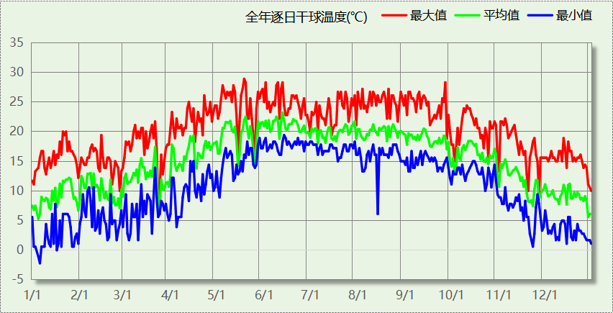

## 逐月辐照量表

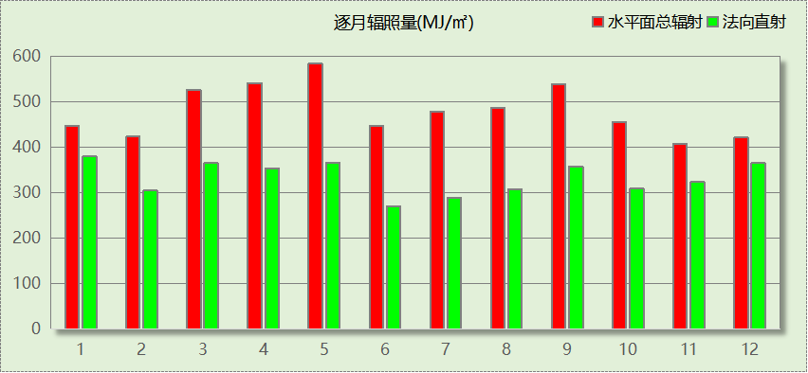

## 峰值工况

|  |  |  |  |  |  |
| --- | --- | --- | --- | --- | --- |
| 气象数据 | 时刻 | 干球温度(℃) | 湿球温度(℃) | 含湿量(g/kg) | 焓值(kj/kg) |
| 最热 | 05月18日16时 | 28.9 | 16.7 | 9.6 | 53.5 |
| 最冷 | 01月05日07时 | -2.2 | -2.8 | 3.8 | 7.3 |

# 围护结构

## 工程材料

### 普通材料

|  |  |  |  |  |  |  |
| --- | --- | --- | --- | --- | --- | --- |
| 材料名称 | 导热系数λ | 蓄热系数S | 密度ρ | 比热容Cp | 蒸汽渗透 系数u | 数据来源 |
| W/(m.K) | W/(㎡.K) | kg/m3 | J/(kg.K) | g/(m.h.kPa) |
| 水泥砂浆 | 0.930 | 11.370 | 1800.0 | 1050.0 | 0.0210 | 民用建筑热工设计规范 GB50176-2016 |
| 钢筋混凝土 | 1.740 | 17.200 | 2500.0 | 920.0 | 0.0158 | 民用建筑热工设计规范 GB50176-2016 |
| 石灰水泥砂浆 | 0.870 | 10.750 | 1700.0 | 1074.4 | 0.0000 | 民用建筑热工设计规范 GB50176-2016 |
| 耐碱玻纤网布抗裂砂浆 | 0.930 | 11.306 | 1800.0 | 1050.0 | 0.0000 | DB34-T753-2007 |
| c20细石混凝土(ρ=2300) | 1.510 | 15.243 | 2300.0 | 920.0 | 0.0158 | 安徽公共建筑节能设计标准 DB34 T753-2007 |
| 挤塑聚苯板 | 0.030 | 0.340 | 35.0 | 1380.0 | 0.0140 | 民用建筑热工设计规范 GB50176-2016 |
| 蒸压加气混凝土砌块（525-625） | 0.160 | 2.750 | 600.0 | 1050.0 | 0.0000 | 云南省民用建筑节能设计标准 DBJ 53/T-39-2020 |
| 轻骨料混凝土(找坡层) | 0.300 | 5.000 | 1050.0 | 1091.3 | 0.0040 | 安徽省居住建筑节能设计标准 DB34/1466-2019 |
| 玻化微珠保温隔热砂浆 | 0.070 | 1.500 | 300.0 | 1473.3 | 0.0210 | JC/T 2164-2013 |
| SBS改性沥青防水卷材 | 0.230 | 9.370 | 900.0 | 5832.3 | 0.0014 | DB34-T753-2007 |
| C20细石混凝土 | 1.510 | 15.243 | 2300.0 | 920.0 | 0.0158 | DB34-T753-2007 |

### 其他材料

|  |  |  |  |  |
| --- | --- | --- | --- | --- |
| 材料名称 | 厚度 | 热阻R | 太阳辐射吸收系数 | 备注 |
| mm | (㎡K)/W |
| 界面砂浆 | － | － | － |  |
| 胶粘剂 | － | － | － |  |
| 合成高分子防水涂料 | － | － | － |  |

## 围护结构作法简要说明

**1. 屋顶：**上人屋面 (K=0.758,D=2.844)：（由上到下）

C20细石混凝土 40mm＋SBS改性沥青防水卷材 3mm＋合成高分子防水涂料 1.5mm＋水泥砂浆 20mm＋挤塑聚苯板 30mm＋水泥砂浆 20mm＋轻骨料混凝土(找坡层) 30mm＋钢筋混凝土 100mm

**2. 外墙：**外墙（填充墙）构造一 (K=0.701,D=4.174)：（由外到内）

耐碱玻纤网布抗裂砂浆 5mm＋玻化微珠保温隔热砂浆 20mm＋界面砂浆 0mm＋蒸压加气混凝土砌块（525-625） 200mm＋石灰水泥砂浆 20mm

**3. 挑空楼板：**挑空楼板类型 (K=1.137,D=1.520)：（由上到下）

水泥砂浆 20mm＋钢筋混凝土 100mm＋胶粘剂 0mm＋挤塑聚苯板 20mm＋耐碱玻纤网布抗裂砂浆 5mm

**4. 外窗：**6中透光Low-E+12空气+6透明-铝合金窗框[Kf=6.21W/(㎡·K),框面积20%] (K=2.700)：

传热系数2.700W/㎡.K，窗太阳得热系数0.374

# 围护结构概况

|  |  |  |  |  |  |  |  |  |
| --- | --- | --- | --- | --- | --- | --- | --- | --- |
|  | | | 设计建筑 | | | 参照建筑 | | |
| 天窗屋顶比 | | | － | | | － | | |
| 屋顶传热系数K  和热惰性指标 D | | | K=0.76  D=2.84 | | | K=0.80  D=－－ | | |
| 外墙传热系数K  和热惰性指标 D | | | K=0.70  D=4.17 | | | K=1.50  D=－－ | | |
| 挑空楼板传热系数K  和热惰性指标 D | | | K=1.14  D=1.52 | | | K=1.14  D=1.52 | | |
| 天窗传热系数K  和太阳得热系数 SHGC | | | K=－  SHGC=－ | | | K=－  SHGC=－ | | |
| 外窗（包括透明幕墙） | 朝向 | 立面 | 窗墙比 | 传热  系数 | 太阳得热系数 | 窗墙比 | 传热  系数 | 太阳得热系数 |
| 南向 | 南-默认立面 | 0.03 | 2.70 | 0.36 | 0.03 | 5.20 | －－ |
| 北向 | 北-默认立面 | 0.03 | 2.70 | 0.36 | 0.03 | 5.20 | －－ |
| 东向 | 东-默认立面 | 0.22 | 2.70 | 0.37 | 0.22 | 4.00 | 0.44 |
| 西向 | 西-默认立面 | 0.23 | 2.70 | 0.37 | 0.23 | 4.00 | 0.44 |
| 室内参数和气象条件设置 | | | 按《公共建筑节能设计标准》附录B设置 | | | | | |

备注：

1. 传热系数的单位W/(m2.k)，其他参数无量纲.

2. 屋顶和外墙的传热系数K和热情性指标D指平均值.

3. 设计建筑：“—”代表本工程无对应项.

4. 参照建筑：“— —”代表参照建筑不要求，取值同设计建筑.

# 设计建筑

## 房间类型

### 房间参数表

|  |  |  |  |  |  |  |  |
| --- | --- | --- | --- | --- | --- | --- | --- |
| 房间类型 | 空调 温度℃ | 供暖 温度℃ | 新风量 | 渗透风 换气次数 | 人员密度 | 照明功率 密度 | 电器设备 功率 |
| 书库 | 28 | 10 | 0(m3/h.人) | 0(次/h) | 0(人) | 6(W/㎡) | 5(W/㎡) |
| 办公-普通办公室 | 26 | 20 | 30(m3/h.人) | 0(次/h) | 8(㎡/人) | 8(W/㎡) | 15(W/㎡) |
| 卫生间 | 28 | 16 | 0(m3/h.人) | 0(次/h) | 0(人) | 5(W/㎡) | 5(W/㎡) |
| 大厅 | 26 | 20 | 30(m3/h.人) | 0(次/h) | 20(㎡/人) | 10(W/㎡) | 0(W/㎡) |
| 实验教室 | 26 | 18 | 20(m3/h.人) | 0(次/h) | 4(㎡/人) | 8(W/㎡) | 5(W/㎡) |
| 普通办公室 | 26 | 20 | 30(m3/h.人) | 0(次/h) | 6(㎡/人) | 8(W/㎡) | 5(W/㎡) |
| 普通教室 | 26 | 18 | 24(m3/h.人) | 0(次/h) | 1.39(㎡/人) | 8(W/㎡) | 5(W/㎡) |
| 计算机房 | 26 | 18 | 24(m3/h.人) | 0(次/h) | 1.39(㎡/人) | 8(W/㎡) | 5(W/㎡) |
| 设备间 | － | － | 0(次/h) | 0(次/h) | 0(人) | 6(W/㎡) | 15(W/㎡) |
| 走廊 | － | － | 0(m3/h.人) | 0(次/h) | 0(人) | 5(W/㎡) | 5(W/㎡) |
| 阅览室 | 26 | 20 | 20(m3/h.人) | 0(次/h) | 1.9(㎡/人) | 8(W/㎡) | 5(W/㎡) |

### 作息时间表

详见附录

## 系统类型

### 系统分区

|  |  |  |  |  |  |
| --- | --- | --- | --- | --- | --- |
| 系统编号 | 系统类型 | 制冷 SEER | 制热 HSPF | 面积(㎡) | 包含的房间 |
| 默认 | 地暖/辐射板采暖/散热器采暖+多联机供冷 | 4.30 | － | 4657.78 | 所有房间 |

### 热回收参数

|  |  |  |  |  |  |
| --- | --- | --- | --- | --- | --- |
| 系统编号 | 热回收 | 供冷 | | 供暖 | |
| 回收效率 | 启动温(焓)差 | 回收效率 | 启动温(焓)差 |
| 默认 | 全热回收 | 0.50 | 5℃ | 0.55 | 5(℃) |

## 制冷系统

### 多联机/单元式空调能耗

|  |  |  |  |
| --- | --- | --- | --- |
| 系统编号 | 制冷SEER | 耗冷量(kWh) | 耗电量(kWh) |
| 默认 | 4.30 | 116464 | 27085 |

## 供暖系统

### 默认热源

#### 供应的系统

|  |  |
| --- | --- |
| 系统编号 | 默认 |

#### 热泵系统

##### 热泵机组

|  |  |  |  |  |  |
| --- | --- | --- | --- | --- | --- |
| 名称 | 类型 | 额定耗电量(kW) | 额定制热量(kW) | 额定性能系数 COP | 台数 |
| 热泵机组 | 空气源热泵 | 125 | 500 | 4.00 | 1 |

##### 热水循环泵

|  |  |  |  |  |  |
| --- | --- | --- | --- | --- | --- |
| 类型 | 流量(m3/h) | 扬程(m) | 设计工作效率(%) | 输入功率(kW) | 台数 |
| 单速 | 320 | 30 | 80 | 37.6 | 1 |

##### 运行工况

|  |  |  |  |  |
| --- | --- | --- | --- | --- |
| 负载率(%) | 机组制热量(kW) | 机组功率(kW) | 性能系数(COP) | 供暖水泵功率(kW) |
| 20 | 100 | 25 | 4.00 | 37.6 |
| 40 | 200 | 50 | 4.00 | 37.6 |
| 60 | 300 | 75 | 4.00 | 37.6 |
| 80 | 400 | 100 | 4.00 | 37.6 |
| 100 | 500 | 125 | 4.00 | 37.6 |

##### 制热能耗

|  |  |  |  |  |  |
| --- | --- | --- | --- | --- | --- |
| 负荷区间 (%) | 区间负荷 (kWh) | 运行时长 (h) | 平均性能系数 (COP) | 热泵机组 (kWh) | 供暖水泵 (kWh) |
| 0~20 | 4366 | 1033 | 4.00 | 1091 | 38841 |
| 20~40 | 419 | 3 | 4.00 | 105 | 113 |
| 40~60 | 209 | 1 | 4.00 | 52 | 38 |
| 60~80 | 0 | 0 | 0.00 | 0 | 0 |
| 80~100 | 0 | 0 | 0.00 | 0 | 0 |
| >100 | 0 | 0 | － | 0 | 0 |
| 合计 | 4993 | 1037 |  | 1248 | 38991 |

## 空调风机

### 独立新排风

|  |  |  |  |  |  |
| --- | --- | --- | --- | --- | --- |
| 系统编号 | 新风量 (m3/h) | 单位风量耗功率 W/(m3/h) | 风机功率(W) | 运行时长(h) | 新风电耗(kWh) |
| 默认 | 39363 | 0.24 | 9447 | 3285 | 27827 |
| 合计 | | | | | 27827 |

|  |  |  |  |  |  |  |
| --- | --- | --- | --- | --- | --- | --- |
| 系统编号 | 排风量 (m3/h) | 排风比 | 单位风量耗功率W/(m3/h) | 风机功率(W) | 运行时长(h) | 排风电耗 (kWh) |
| 默认 | 31491 | 0.8 | 0.24 | 7558 | 3285 | 22262 |
| 合计 | | | | | | 22262 |

## 照明

|  |  |  |  |  |
| --- | --- | --- | --- | --- |
| 房间类型 | 单位面积电耗 (kWh/㎡) | 房间个数 | 房间合计面积 (㎡) | 合计电耗 (kWh) |
| 书库 | 12.42 | 1 | 240 | 2985 |
| 卫生间 | 10.35 | 10 | 186 | 1920 |
| 大厅 | 20.70 | 1 | 409 | 8454 |
| 实验教室 | 16.56 | 12 | 892 | 14771 |
| 普通办公室 | 11.77 | 29 | 1508 | 17759 |
| 普通教室 | 16.56 | 8 | 959 | 15871 |
| 计算机房 | 16.56 | 6 | 549 | 9097 |
| 设备间 | 31.54 | 22 | 284 | 8948 |
| 走廊 | 10.35 | 2 | 365 | 3778 |
| 阅览室 | 16.56 | 2 | 221 | 3653 |
| 总计 | | | | 87237 |

## 负荷分项统计

|  |  |  |  |  |  |  |
| --- | --- | --- | --- | --- | --- | --- |
| 分类 | 围护传热 | 室内得热 | 窗日射 | 新风/渗透 | 热回收 | 合计 |
| 供暖(kWh/㎡) | -1.69 | 2.65 | 0.29 | -3.24 | 1.12 | -0.87 |
| 供冷(kWh/㎡) | 1.87 | 14.72 | 1.07 | 2.74 | 0.00 | 20.40 |

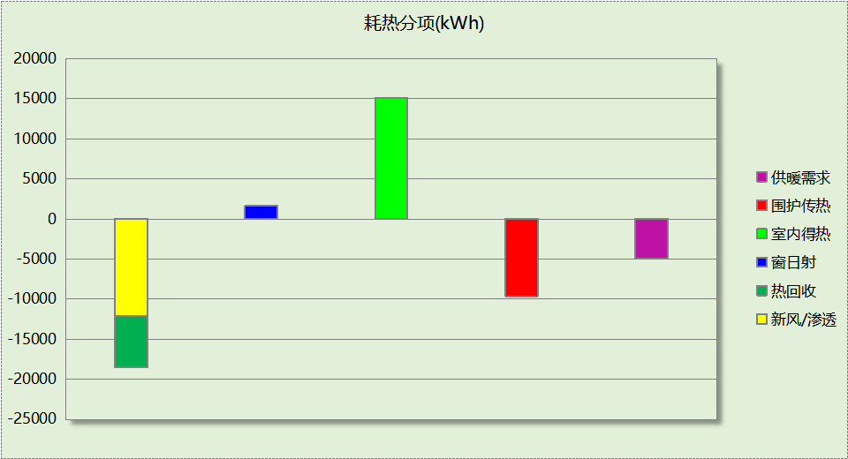

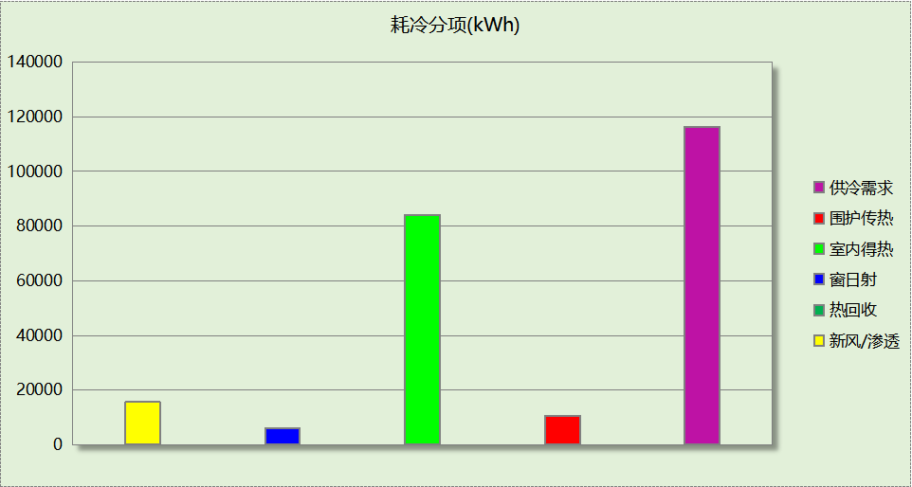

## 逐月负荷表

|  |  |  |  |  |  |  |
| --- | --- | --- | --- | --- | --- | --- |
| 月份 | 供暖(kWh) | 供冷(kWh) | 热负荷 峰值(kW) | 热负荷 峰值时刻 | 冷负荷 峰值(kW) | 冷负荷 峰值时刻 |
| 1月 | 2008 | 16 | 193.784 | 1月2日9时 | 4.561 | 1月11日11时 |
| 2月 | 0 | 0 | 0.000 | -- | 0.000 | -- |
| 3月 | 2244 | 480 | 208.597 | 3月4日9时 | 72.895 | 3月22日15时 |
| 4月 | 275 | 888 | 18.464 | 4月1日9时 | 78.743 | 4月16日14时 |
| 5月 | 19 | 10990 | 0.370 | 5月2日8时 | 362.163 | 5月31日9时 |
| 6月 | 1 | 28155 | 0.085 | 6月17日8时 | 437.316 | 6月26日15时 |
| 7月 | 0 | 30025 | 0.016 | 7月1日8时 | 452.514 | 7月3日16时 |
| 8月 | 0 | 7487 | 0.000 | -- | 390.701 | 8月26日16时 |
| 9月 | 0 | 29369 | 0.000 | -- | 529.425 | 9月26日18时 |
| 10月 | 0 | 8312 | 0.070 | 10月31日8时 | 361.535 | 10月25日17时 |
| 11月 | 46 | 635 | 3.165 | 11月21日8时 | 18.508 | 11月8日11时 |
| 12月 | 400 | 106 | 32.520 | 12月30日8时 | 8.365 | 12月13日11时 |

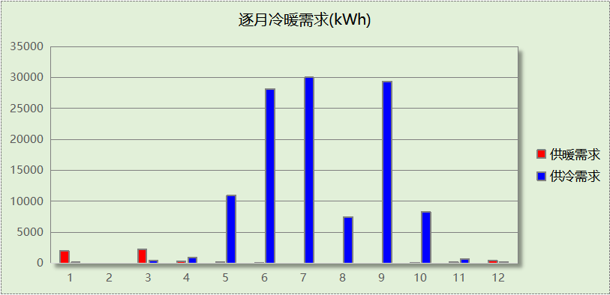

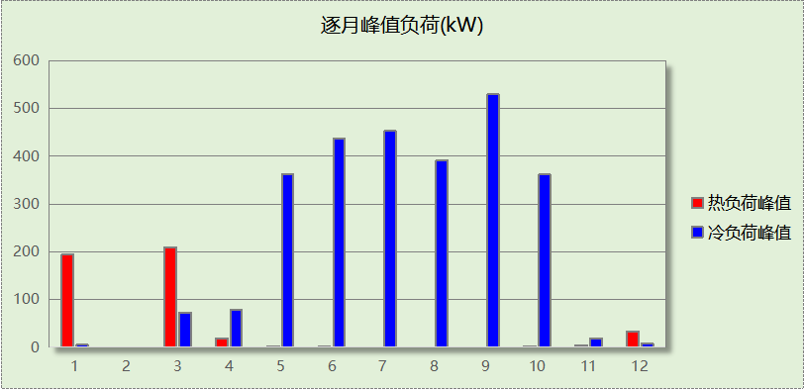

## 逐月电耗

注:供冷供暖为冷热源及输配水泵电耗，热水为扣减太阳能后电耗，所有数据单位kWh/㎡。

|  |  |  |  |  |  |  |  |  |
| --- | --- | --- | --- | --- | --- | --- | --- | --- |
| 月 | 供冷 | 供暖 | 空调风机 | 照明 | 插座设备 | 排风机 | 电梯 | 热水 |
| 1 | 0.00 | 0.65 | 0.36 | 0.63 | － | － | － | － |
| 2 | 0.00 | 0.00 | 0.00 | 0.00 | － |
| 3 | 0.02 | 1.53 | 0.80 | 1.40 | － |
| 4 | 0.04 | 1.46 | 0.84 | 1.47 | － |
| 5 | 0.45 | 1.35 | 0.88 | 1.54 | － |
| 6 | 1.15 | 0.14 | 0.76 | 1.33 | － |
| 7 | 1.22 | 0.01 | 0.92 | 1.60 | － |
| 8 | 0.30 | 0.00 | 0.88 | 1.54 | － |
| 9 | 1.20 | 0.00 | 0.80 | 1.40 | － |
| 10 | 0.34 | 0.07 | 0.80 | 1.40 | － |
| 11 | 0.03 | 0.79 | 0.84 | 1.47 | － |
| 12 | 0.00 | 1.05 | 0.88 | 1.54 | － |
| 合计 | 4.74 | 7.05 | 8.77 | 15.28 | － | － | － | － |

# 参照建筑

## 房间类型

### 房间参数表

|  |  |  |  |  |  |  |  |
| --- | --- | --- | --- | --- | --- | --- | --- |
| 房间类型 | 空调 温度℃ | 供暖 温度℃ | 新风量 | 渗透风 换气次数 | 人员密度 | 照明功率 密度 | 电器设备 功率 |
| 书库 | 28 | 10 | 0(m3/h.人) | 0(次/h) | 0(人) | 7(W/㎡) | 5(W/㎡) |
| 办公-普通办公室 | 26 | 20 | 30(m3/h.人) | 0(次/h) | 8(㎡/人) | 9(W/㎡) | 15(W/㎡) |
| 卫生间 | 28 | 16 | 0(m3/h.人) | 0(次/h) | 0(人) | 6(W/㎡) | 5(W/㎡) |
| 大厅 | 26 | 20 | 30(m3/h.人) | 0(次/h) | 20(㎡/人) | 10(W/㎡) | 0(W/㎡) |
| 实验教室 | 26 | 18 | 20(m3/h.人) | 0(次/h) | 4(㎡/人) | 9(W/㎡) | 5(W/㎡) |
| 普通办公室 | 26 | 20 | 30(m3/h.人) | 0(次/h) | 6(㎡/人) | 9(W/㎡) | 5(W/㎡) |
| 普通教室 | 26 | 18 | 24(m3/h.人) | 0(次/h) | 1.39(㎡/人) | 9(W/㎡) | 5(W/㎡) |
| 计算机房 | 26 | 18 | 24(m3/h.人) | 0(次/h) | 1.39(㎡/人) | 9(W/㎡) | 5(W/㎡) |
| 设备间 | － | － | 0(次/h) | 0(次/h) | 0(人) | 6(W/㎡) | 15(W/㎡) |
| 走廊 | － | － | 0(m3/h.人) | 0(次/h) | 0(人) | 5(W/㎡) | 5(W/㎡) |
| 阅览室 | 26 | 20 | 20(m3/h.人) | 0(次/h) | 1.9(㎡/人) | 9(W/㎡) | 5(W/㎡) |

### 作息时间表

同设计建筑

## 系统类型

|  |  |  |  |  |  |
| --- | --- | --- | --- | --- | --- |
| 系统编号 | 系统类型 | 制冷 SEER | 制热 HSPF | 面积(㎡) | 包含的房间 |
| 默认 | 地暖/辐射板采暖/散热器采暖+多联机供冷 | 2.70 | － | 同设计建筑 | 同设计建筑 |

## 制冷系统

### 多联机/单元式空调能耗

|  |  |  |  |
| --- | --- | --- | --- |
| 系统编号 | 制冷SEER | 耗冷量(kWh) | 耗电量(kWh) |
| 默认 | 2.70 | 267826 | 99195 |

## 供暖系统

### 默认热源

#### 供应的系统

|  |  |
| --- | --- |
| 系统编号 | 默认 |

#### 热泵机组能耗

下表是空气源热泵不同负荷率下能效比，根据逐时负荷率插值计算能效比，进而计算耗电量。

|  |
| --- |
| 空气源热泵机组COP曲线 |
|  |

|  |  |  |  |
| --- | --- | --- | --- |
| 系统类型 | 能效比 | 耗热量(kWh) | 耗电量(kWh) |
| 空气源热泵 | 2.88 | 24811 | 27364 |

#### 热水循环水泵能耗

|  |  |  |  |
| --- | --- | --- | --- |
| 热泵容量(kW) | 输送能效比 | 运行时长(h) | 供暖水泵电耗(kWh) |
| 401 | 0.00865 | 1228 | 4259 |

## 空调风机

### 独立新排风

|  |  |  |  |  |  |
| --- | --- | --- | --- | --- | --- |
| 系统编号 | 新风量 (m3/h) | 单位风量耗功率 W/(m3/h) | 风机功率(W) | 运行时长(h) | 新风电耗(kWh) |
| 默认 | 39363 | 0.24 | 9447 | 3285 | 31034 |
| 合计 | | | | | 31034 |

|  |  |  |  |  |  |  |
| --- | --- | --- | --- | --- | --- | --- |
| 系统编号 | 排风量 (m3/h) | 排风比 | 单位风量耗功率W/(m3/h) | 风机功率(W) | 运行时长(h) | 排风电耗 (kWh) |
| 默认 | 31491 | 0.8 | 0.24 | 7558 | 3285 | 24827 |
| 合计 | | | | | | 24827 |

## 照明

|  |  |  |  |  |
| --- | --- | --- | --- | --- |
| 房间类型 | 单位面积电耗 (kWh/㎡) | 房间个数 | 房间合计面积 (㎡) | 合计电耗 (kWh) |
| 书库 | 14.49 | 1 | 240 | 3483 |
| 卫生间 | 12.42 | 10 | 186 | 2304 |
| 大厅 | 20.70 | 1 | 409 | 8454 |
| 实验教室 | 18.63 | 12 | 892 | 16617 |
| 普通办公室 | 13.25 | 29 | 1508 | 19979 |
| 普通教室 | 18.63 | 8 | 959 | 17855 |
| 计算机房 | 18.63 | 6 | 549 | 10235 |
| 设备间 | 31.54 | 22 | 284 | 8948 |
| 走廊 | 10.35 | 2 | 365 | 3778 |
| 阅览室 | 18.63 | 2 | 221 | 4110 |
| 总计 | | | | 95762 |

## 负荷分项统计

|  |  |  |  |  |  |  |
| --- | --- | --- | --- | --- | --- | --- |
| 分类 | 围护传热 | 室内得热 | 窗日射 | 新风/渗透 | 热回收 | 合计 |
| 供暖(kWh/㎡) | -4.49 | 4.66 | 0.59 | -5.11 | 0.00 | -4.35 |
| 供冷(kWh/㎡) | -1.13 | 37.57 | 3.78 | 6.70 | 0.00 | 46.91 |

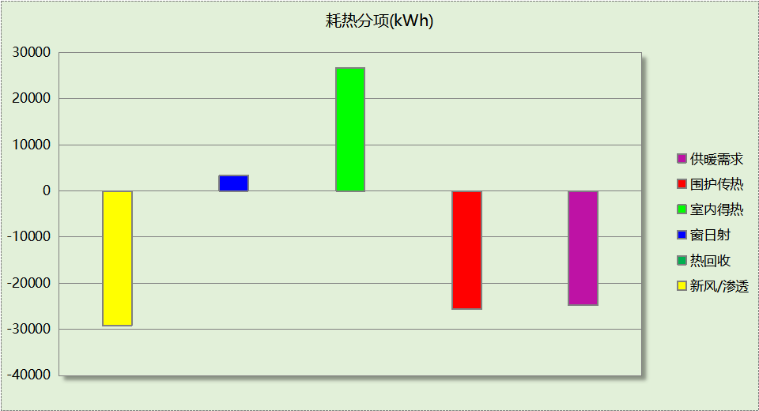

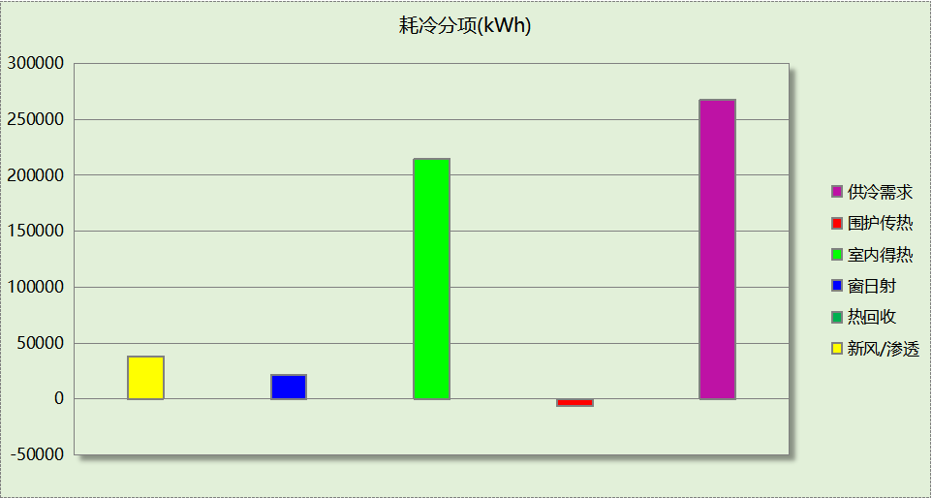

## 逐月负荷表

|  |  |  |  |  |  |  |
| --- | --- | --- | --- | --- | --- | --- |
| 月份 | 供暖(kWh) | 供冷(kWh) | 热负荷 峰值(kW) | 热负荷 峰值时刻 | 冷负荷 峰值(kW) | 冷负荷 峰值时刻 |
| 1月 | 9059 | 49 | 453.754 | 1月2日9时 | 7.040 | 1月11日17时 |
| 2月 | 0 | 0 | 0.000 | -- | 0.000 | -- |
| 3月 | 4702 | 1754 | 377.954 | 3月4日9时 | 68.986 | 3月21日17时 |
| 4月 | 634 | 10213 | 32.850 | 4月1日9时 | 186.062 | 4月30日16时 |
| 5月 | 17 | 50086 | 2.053 | 5月2日9时 | 431.316 | 5月31日16时 |
| 6月 | 0 | 64955 | 0.016 | 6月17日8时 | 448.028 | 6月26日16时 |
| 7月 | 0 | 35346 | 0.000 | -- | 462.914 | 7月4日16时 |
| 8月 | 0 | 15626 | 0.000 | -- | 410.362 | 8月28日17时 |
| 9月 | 0 | 64445 | 0.085 | 9月30日8时 | 556.547 | 9月26日17时 |
| 10月 | 7 | 22814 | 0.574 | 10月31日12时 | 323.811 | 10月25日17时 |
| 11月 | 1997 | 2100 | 92.881 | 11月21日9时 | 77.093 | 11月4日17时 |
| 12月 | 8396 | 438 | 232.202 | 12月30日9时 | 10.150 | 12月12日17时 |

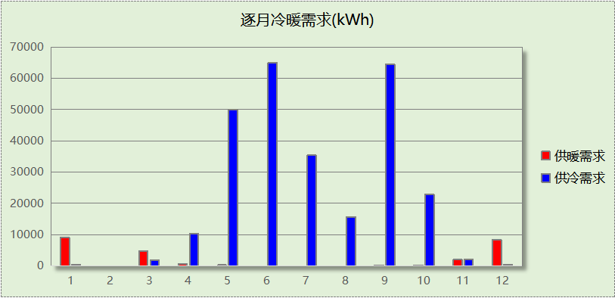

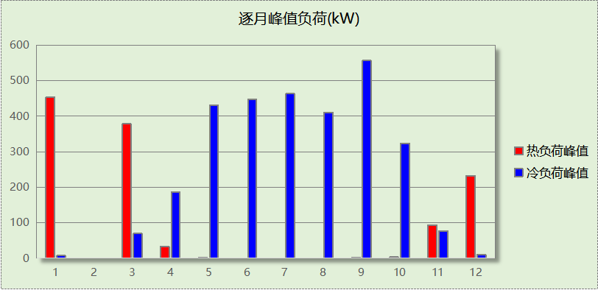

## 逐月电耗

注:供冷供暖为冷热源及输配水泵电耗，热水为扣减太阳能后电耗，所有数据单位kWh/㎡。

|  |  |  |  |  |  |  |  |  |
| --- | --- | --- | --- | --- | --- | --- | --- | --- |
| 月 | 供冷 | 供暖 | 空调风机 | 照明 | 插座设备 | 排风机 | 电梯 | 热水 |
| 1 | 0.00 | 0.81 | 0.00 | 0.69 | － | － | － | － |
| 2 | 0.00 | 0.00 | 0.00 | 0.00 | － |
| 3 | 0.11 | 1.25 | 0.00 | 1.53 | － |
| 4 | 0.66 | 0.84 | 0.00 | 1.61 | － |
| 5 | 3.25 | 0.11 | 0.00 | 1.69 | － |
| 6 | 4.21 | 0.00 | 0.00 | 1.46 | － |
| 7 | 2.29 | 0.00 | 0.00 | 1.76 | － |
| 8 | 1.01 | 0.00 | 0.00 | 1.69 | － |
| 9 | 4.18 | 0.00 | 0.00 | 1.53 | － |
| 10 | 1.48 | 0.08 | 0.00 | 1.53 | － |
| 11 | 0.14 | 1.00 | 0.00 | 1.61 | － |
| 12 | 0.03 | 1.45 | 0.00 | 1.69 | － |
| 合计 | 17.38 | 5.54 | 0.00 | 16.77 | － | － | － | － |

# 计算结果

|  |  |  |  |  |
| --- | --- | --- | --- | --- |
| 能耗分类 | 能耗子类 | 设计建筑  (kWh/㎡) | 参照建筑  (kWh/㎡) | 节能率  （%） |
| 建筑负荷 | 耗冷量 | 20.40 | 46.91 | 56.52% |
| 耗热量 | 0.87 | 4.35 | 79.88% |
| 冷热合计 | 21.27 | 51.26 | 58.50% |
| 热回收负荷 | 供冷 | 0.00 | － |  |
| 供暖 | 1.12 | － |  |
| 冷热合计 | 1.12 | － |  |
| 供冷电耗 | 中央冷源 | 0.00 | 0.00 | 72.70% |
| 冷却水泵 | 0.00 | 0.00 |
| 冷冻水泵 | 0.00 | 0.00 |
| 冷却塔 | 0.00 | 0.00 |
| 多联机/单元式空调 | 4.74 | 17.38 |
| 供冷合计 | 4.74 | 17.38 |
| 供暖电耗 | 中央热源 | 0.22 | 4.79 | -27.25% |
| 热源侧水泵 | 0.00 | － |
| 供暖水泵 | 6.83 | 0.75 |
| 多联机/单元式热泵 | 0.00 | 0.00 |
| 供暖合计 | 7.05 | 5.54 |
| 空调风机电耗 | 独立新排风 | 8.77 | 9.78 | 10.33% |
| 风机盘管 | 0.00 | 0.00 |
| 全空气系统 | 0.00 | 0.00 |
| 风机合计 | 8.77 | 9.78 |
| 采暖空调电耗 | | 20.56 | 32.69 | 37.11% |
| 照明电耗 | | 15.28 | 16.77 | 8.90% |
| 建筑综合电耗 | | 35.84 | 49.47 | 27.54% |

# 绿色建筑性能评估得分

|  |  |  |  |
| --- | --- | --- | --- |
| 标准条文 | 得分评价 | 节能率 | 得分 |
| 7.2.8 采取措施降低建筑能耗 | 建筑能耗相比国家现行有关建筑节能标准降低10%, 得5 分；降低20%,得10 分。 | 27.54% | 10 |
| 标准依据 | 《绿色建筑评价标准》GB-T 50378-2019 | | |

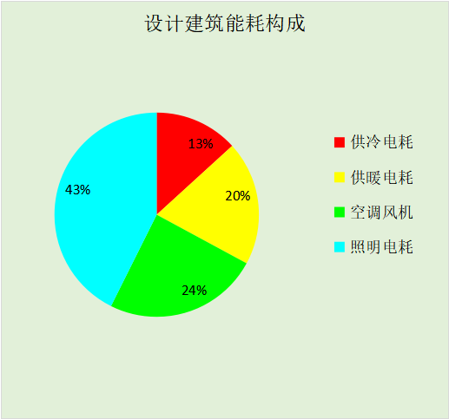

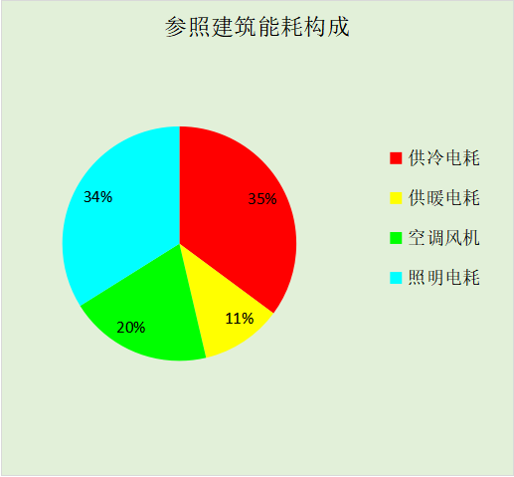

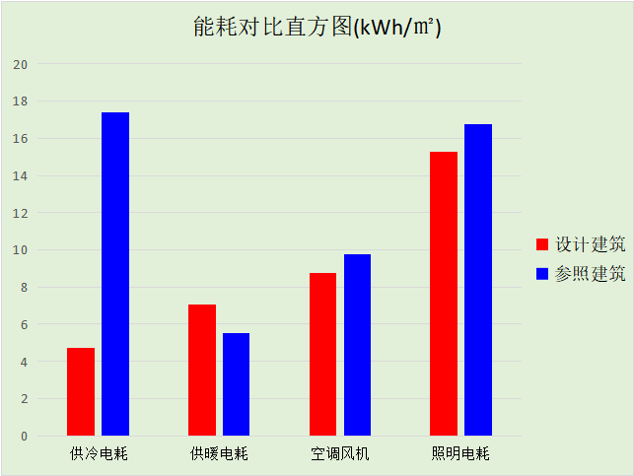

# 附录

暑假:7.15~8.25; 寒假：1.15~3.1

## 工作日/节假日人员逐时在室率(%)

|  |  |  |  |  |  |  |  |  |  |  |  |  |  |  |  |  |  |  |  |  |  |  |  |  |
| --- | --- | --- | --- | --- | --- | --- | --- | --- | --- | --- | --- | --- | --- | --- | --- | --- | --- | --- | --- | --- | --- | --- | --- | --- |
| 房间类型 | 1 | 2 | 3 | 4 | 5 | 6 | 7 | 8 | 9 | 10 | 11 | 12 | 13 | 14 | 15 | 16 | 17 | 18 | 19 | 20 | 21 | 22 | 23 | 24 |
| 书库 | 0 | 0 | 0 | 0 | 0 | 0 | 10 | 50 | 95 | 95 | 95 | 80 | 80 | 95 | 95 | 95 | 95 | 30 | 30 | 0 | 0 | 0 | 0 | 0 |
| 0 | 0 | 0 | 0 | 0 | 0 | 0 | 0 | 0 | 0 | 0 | 0 | 0 | 0 | 0 | 0 | 0 | 0 | 0 | 0 | 0 | 0 | 0 | 0 |
| 0 | 0 | 0 | 0 | 0 | 0 | 0 | 0 | 0 | 0 | 0 | 0 | 0 | 0 | 0 | 0 | 0 | 0 | 0 | 0 | 0 | 0 | 0 | 0 |
| 0 | 0 | 0 | 0 | 0 | 0 | 0 | 0 | 0 | 0 | 0 | 0 | 0 | 0 | 0 | 0 | 0 | 0 | 0 | 0 | 0 | 0 | 0 | 0 |
| 办公-普通办公室 | 0 | 0 | 0 | 0 | 0 | 0 | 10 | 50 | 100 | 100 | 100 | 30 | 100 | 100 | 100 | 100 | 50 | 20 | 10 | 0 | 0 | 0 | 0 | 0 |
| 0 | 0 | 0 | 0 | 0 | 0 | 0 | 20 | 45 | 0 | 0 | 0 | 0 | 0 | 0 | 0 | 0 | 0 | 0 | 0 | 0 | 0 | 0 | 0 |
| 0 | 0 | 0 | 0 | 0 | 0 | 0 | 20 | 45 | 0 | 0 | 0 | 0 | 0 | 0 | 0 | 0 | 0 | 0 | 0 | 0 | 0 | 0 | 0 |
| 0 | 0 | 0 | 0 | 0 | 0 | 0 | 20 | 45 | 0 | 0 | 0 | 0 | 0 | 0 | 0 | 0 | 0 | 0 | 0 | 0 | 0 | 0 | 0 |
| 卫生间 | 0 | 0 | 0 | 0 | 0 | 0 | 10 | 50 | 95 | 95 | 95 | 80 | 80 | 95 | 95 | 95 | 95 | 30 | 30 | 0 | 0 | 0 | 0 | 0 |
| 0 | 0 | 0 | 0 | 0 | 0 | 0 | 0 | 0 | 0 | 0 | 0 | 0 | 0 | 0 | 0 | 0 | 0 | 0 | 0 | 0 | 0 | 0 | 0 |
| 0 | 0 | 0 | 0 | 0 | 0 | 0 | 0 | 0 | 0 | 0 | 0 | 0 | 0 | 0 | 0 | 0 | 0 | 0 | 0 | 0 | 0 | 0 | 0 |
| 0 | 0 | 0 | 0 | 0 | 0 | 0 | 0 | 0 | 0 | 0 | 0 | 0 | 0 | 0 | 0 | 0 | 0 | 0 | 0 | 0 | 0 | 0 | 0 |
| 大厅 | 0 | 0 | 0 | 0 | 0 | 0 | 10 | 50 | 95 | 95 | 95 | 80 | 80 | 95 | 95 | 95 | 95 | 30 | 30 | 0 | 0 | 0 | 0 | 0 |
| 0 | 0 | 0 | 0 | 0 | 0 | 0 | 0 | 0 | 0 | 0 | 0 | 0 | 0 | 0 | 0 | 0 | 0 | 0 | 0 | 0 | 0 | 0 | 0 |
| 0 | 0 | 0 | 0 | 0 | 0 | 0 | 0 | 0 | 0 | 0 | 0 | 0 | 0 | 0 | 0 | 0 | 0 | 0 | 0 | 0 | 0 | 0 | 0 |
| 0 | 0 | 0 | 0 | 0 | 0 | 0 | 0 | 0 | 0 | 0 | 0 | 0 | 0 | 0 | 0 | 0 | 0 | 0 | 0 | 0 | 0 | 0 | 0 |
| 实验教室 | 0 | 0 | 0 | 0 | 0 | 0 | 10 | 50 | 95 | 95 | 95 | 80 | 80 | 95 | 95 | 95 | 95 | 30 | 30 | 0 | 0 | 0 | 0 | 0 |
| 0 | 0 | 0 | 0 | 0 | 0 | 0 | 0 | 0 | 0 | 0 | 0 | 0 | 0 | 0 | 0 | 0 | 0 | 0 | 0 | 0 | 0 | 0 | 0 |
| 0 | 0 | 0 | 0 | 0 | 0 | 0 | 0 | 0 | 0 | 0 | 0 | 0 | 0 | 0 | 0 | 0 | 0 | 0 | 0 | 0 | 0 | 0 | 0 |
| 0 | 0 | 0 | 0 | 0 | 0 | 0 | 0 | 0 | 0 | 0 | 0 | 0 | 0 | 0 | 0 | 0 | 0 | 0 | 0 | 0 | 0 | 0 | 0 |
| 普通办公室 | 0 | 0 | 0 | 0 | 0 | 0 | 10 | 50 | 95 | 95 | 95 | 80 | 80 | 95 | 95 | 95 | 95 | 30 | 30 | 0 | 0 | 0 | 0 | 0 |
| 0 | 0 | 0 | 0 | 0 | 0 | 0 | 0 | 0 | 0 | 0 | 0 | 0 | 0 | 0 | 0 | 0 | 0 | 0 | 0 | 0 | 0 | 0 | 0 |
| 0 | 0 | 0 | 0 | 0 | 0 | 0 | 0 | 0 | 0 | 0 | 0 | 0 | 0 | 0 | 0 | 0 | 0 | 0 | 0 | 0 | 0 | 0 | 0 |
| 0 | 0 | 0 | 0 | 0 | 0 | 0 | 0 | 0 | 0 | 0 | 0 | 0 | 0 | 0 | 0 | 0 | 0 | 0 | 0 | 0 | 0 | 0 | 0 |
| 普通教室 | 0 | 0 | 0 | 0 | 0 | 0 | 10 | 50 | 95 | 95 | 95 | 80 | 80 | 95 | 95 | 95 | 95 | 30 | 30 | 0 | 0 | 0 | 0 | 0 |
| 0 | 0 | 0 | 0 | 0 | 0 | 0 | 0 | 0 | 0 | 0 | 0 | 0 | 0 | 0 | 0 | 0 | 0 | 0 | 0 | 0 | 0 | 0 | 0 |
| 0 | 0 | 0 | 0 | 0 | 0 | 0 | 0 | 0 | 0 | 0 | 0 | 0 | 0 | 0 | 0 | 0 | 0 | 0 | 0 | 0 | 0 | 0 | 0 |
| 0 | 0 | 0 | 0 | 0 | 0 | 0 | 0 | 0 | 0 | 0 | 0 | 0 | 0 | 0 | 0 | 0 | 0 | 0 | 0 | 0 | 0 | 0 | 0 |
| 计算机房 | 0 | 0 | 0 | 0 | 0 | 0 | 10 | 50 | 95 | 95 | 95 | 80 | 80 | 95 | 95 | 95 | 95 | 30 | 30 | 0 | 0 | 0 | 0 | 0 |
| 0 | 0 | 0 | 0 | 0 | 0 | 0 | 0 | 0 | 0 | 0 | 0 | 0 | 0 | 0 | 0 | 0 | 0 | 0 | 0 | 0 | 0 | 0 | 0 |
| 0 | 0 | 0 | 0 | 0 | 0 | 0 | 0 | 0 | 0 | 0 | 0 | 0 | 0 | 0 | 0 | 0 | 0 | 0 | 0 | 0 | 0 | 0 | 0 |
| 0 | 0 | 0 | 0 | 0 | 0 | 0 | 0 | 0 | 0 | 0 | 0 | 0 | 0 | 0 | 0 | 0 | 0 | 0 | 0 | 0 | 0 | 0 | 0 |
| 设备间 | 0 | 0 | 0 | 0 | 0 | 0 | 0 | 0 | 0 | 0 | 0 | 0 | 0 | 0 | 0 | 0 | 0 | 0 | 0 | 0 | 0 | 0 | 0 | 0 |
| 0 | 0 | 0 | 0 | 0 | 0 | 0 | 0 | 0 | 0 | 0 | 0 | 0 | 0 | 0 | 0 | 0 | 0 | 0 | 0 | 0 | 0 | 0 | 0 |
| 0 | 0 | 0 | 0 | 0 | 0 | 0 | 0 | 0 | 0 | 0 | 0 | 0 | 0 | 0 | 0 | 0 | 0 | 0 | 0 | 0 | 0 | 0 | 0 |
| 0 | 0 | 0 | 0 | 0 | 0 | 0 | 0 | 0 | 0 | 0 | 0 | 0 | 0 | 0 | 0 | 0 | 0 | 0 | 0 | 0 | 0 | 0 | 0 |
| 走廊 | 0 | 0 | 0 | 0 | 0 | 0 | 10 | 50 | 95 | 95 | 95 | 80 | 80 | 95 | 95 | 95 | 95 | 30 | 30 | 0 | 0 | 0 | 0 | 0 |
| 0 | 0 | 0 | 0 | 0 | 0 | 0 | 0 | 0 | 0 | 0 | 0 | 0 | 0 | 0 | 0 | 0 | 0 | 0 | 0 | 0 | 0 | 0 | 0 |
| 0 | 0 | 0 | 0 | 0 | 0 | 0 | 0 | 0 | 0 | 0 | 0 | 0 | 0 | 0 | 0 | 0 | 0 | 0 | 0 | 0 | 0 | 0 | 0 |
| 0 | 0 | 0 | 0 | 0 | 0 | 0 | 0 | 0 | 0 | 0 | 0 | 0 | 0 | 0 | 0 | 0 | 0 | 0 | 0 | 0 | 0 | 0 | 0 |
| 阅览室 | 0 | 0 | 0 | 0 | 0 | 0 | 10 | 50 | 95 | 95 | 95 | 80 | 80 | 95 | 95 | 95 | 95 | 30 | 30 | 0 | 0 | 0 | 0 | 0 |
| 0 | 0 | 0 | 0 | 0 | 0 | 0 | 0 | 0 | 0 | 0 | 0 | 0 | 0 | 0 | 0 | 0 | 0 | 0 | 0 | 0 | 0 | 0 | 0 |
| 0 | 0 | 0 | 0 | 0 | 0 | 0 | 0 | 0 | 0 | 0 | 0 | 0 | 0 | 0 | 0 | 0 | 0 | 0 | 0 | 0 | 0 | 0 | 0 |
| 0 | 0 | 0 | 0 | 0 | 0 | 0 | 0 | 0 | 0 | 0 | 0 | 0 | 0 | 0 | 0 | 0 | 0 | 0 | 0 | 0 | 0 | 0 | 0 |

注：第一行：工作日；第二行：节假日；第三行：寒假；第四行：暑假

## 工作日/节假日照明开关时间表(%)

|  |  |  |  |  |  |  |  |  |  |  |  |  |  |  |  |  |  |  |  |  |  |  |  |  |
| --- | --- | --- | --- | --- | --- | --- | --- | --- | --- | --- | --- | --- | --- | --- | --- | --- | --- | --- | --- | --- | --- | --- | --- | --- |
| 房间类型 | 1 | 2 | 3 | 4 | 5 | 6 | 7 | 8 | 9 | 10 | 11 | 12 | 13 | 14 | 15 | 16 | 17 | 18 | 19 | 20 | 21 | 22 | 23 | 24 |
| 书库 | 0 | 0 | 0 | 0 | 0 | 0 | 10 | 50 | 95 | 95 | 95 | 80 | 80 | 95 | 95 | 95 | 95 | 30 | 30 | 0 | 0 | 0 | 0 | 0 |
| 0 | 0 | 0 | 0 | 0 | 0 | 0 | 0 | 0 | 0 | 0 | 0 | 0 | 0 | 0 | 0 | 0 | 0 | 0 | 0 | 0 | 0 | 0 | 0 |
| 0 | 0 | 0 | 0 | 0 | 0 | 0 | 0 | 0 | 0 | 0 | 0 | 0 | 0 | 0 | 0 | 0 | 0 | 0 | 0 | 0 | 0 | 0 | 0 |
| 0 | 0 | 0 | 0 | 0 | 0 | 0 | 0 | 0 | 0 | 0 | 0 | 0 | 0 | 0 | 0 | 0 | 0 | 0 | 0 | 0 | 0 | 0 | 0 |
| 办公-普通办公室 | 10 | 10 | 10 | 10 | 10 | 10 | 10 | 36 | 62 | 56 | 54 | 43 | 53 | 55 | 58 | 67 | 40 | 18 | 10 | 10 | 10 | 10 | 10 | 10 |
| 0 | 0 | 0 | 0 | 0 | 0 | 0 | 0 | 0 | 0 | 0 | 0 | 0 | 0 | 0 | 0 | 0 | 0 | 0 | 0 | 0 | 0 | 0 | 0 |
| 0 | 0 | 0 | 0 | 0 | 0 | 0 | 0 | 0 | 0 | 0 | 0 | 0 | 0 | 0 | 0 | 0 | 0 | 0 | 0 | 0 | 0 | 0 | 0 |
| 0 | 0 | 0 | 0 | 0 | 0 | 0 | 0 | 0 | 0 | 0 | 0 | 0 | 0 | 0 | 0 | 0 | 0 | 0 | 0 | 0 | 0 | 0 | 0 |
| 卫生间 | 0 | 0 | 0 | 0 | 0 | 0 | 10 | 50 | 95 | 95 | 95 | 80 | 80 | 95 | 95 | 95 | 95 | 30 | 30 | 0 | 0 | 0 | 0 | 0 |
| 0 | 0 | 0 | 0 | 0 | 0 | 0 | 0 | 0 | 0 | 0 | 0 | 0 | 0 | 0 | 0 | 0 | 0 | 0 | 0 | 0 | 0 | 0 | 0 |
| 0 | 0 | 0 | 0 | 0 | 0 | 0 | 0 | 0 | 0 | 0 | 0 | 0 | 0 | 0 | 0 | 0 | 0 | 0 | 0 | 0 | 0 | 0 | 0 |
| 0 | 0 | 0 | 0 | 0 | 0 | 0 | 0 | 0 | 0 | 0 | 0 | 0 | 0 | 0 | 0 | 0 | 0 | 0 | 0 | 0 | 0 | 0 | 0 |
| 大厅 | 0 | 0 | 0 | 0 | 0 | 0 | 10 | 50 | 95 | 95 | 95 | 80 | 80 | 95 | 95 | 95 | 95 | 30 | 30 | 0 | 0 | 0 | 0 | 0 |
| 0 | 0 | 0 | 0 | 0 | 0 | 0 | 0 | 0 | 0 | 0 | 0 | 0 | 0 | 0 | 0 | 0 | 0 | 0 | 0 | 0 | 0 | 0 | 0 |
| 0 | 0 | 0 | 0 | 0 | 0 | 0 | 0 | 0 | 0 | 0 | 0 | 0 | 0 | 0 | 0 | 0 | 0 | 0 | 0 | 0 | 0 | 0 | 0 |
| 0 | 0 | 0 | 0 | 0 | 0 | 0 | 0 | 0 | 0 | 0 | 0 | 0 | 0 | 0 | 0 | 0 | 0 | 0 | 0 | 0 | 0 | 0 | 0 |
| 实验教室 | 0 | 0 | 0 | 0 | 0 | 0 | 10 | 50 | 95 | 95 | 95 | 80 | 80 | 95 | 95 | 95 | 95 | 30 | 30 | 0 | 0 | 0 | 0 | 0 |
| 0 | 0 | 0 | 0 | 0 | 0 | 0 | 0 | 0 | 0 | 0 | 0 | 0 | 0 | 0 | 0 | 0 | 0 | 0 | 0 | 0 | 0 | 0 | 0 |
| 0 | 0 | 0 | 0 | 0 | 0 | 0 | 0 | 0 | 0 | 0 | 0 | 0 | 0 | 0 | 0 | 0 | 0 | 0 | 0 | 0 | 0 | 0 | 0 |
| 0 | 0 | 0 | 0 | 0 | 0 | 0 | 0 | 0 | 0 | 0 | 0 | 0 | 0 | 0 | 0 | 0 | 0 | 0 | 0 | 0 | 0 | 0 | 0 |
| 普通办公室 | 0 | 0 | 0 | 0 | 0 | 0 | 10 | 50 | 95 | 95 | 95 | 80 | 80 | 95 | 95 | 95 | 95 | 30 | 30 | 0 | 0 | 0 | 0 | 0 |
| 0 | 0 | 0 | 0 | 0 | 0 | 0 | 0 | 0 | 0 | 0 | 0 | 0 | 0 | 0 | 0 | 0 | 0 | 0 | 0 | 0 | 0 | 0 | 0 |
| 0 | 0 | 0 | 0 | 0 | 0 | 0 | 0 | 0 | 0 | 0 | 0 | 0 | 0 | 0 | 0 | 0 | 0 | 0 | 0 | 0 | 0 | 0 | 0 |
| 0 | 0 | 0 | 0 | 0 | 0 | 0 | 0 | 0 | 0 | 0 | 0 | 0 | 0 | 0 | 0 | 0 | 0 | 0 | 0 | 0 | 0 | 0 | 0 |
| 普通教室 | 0 | 0 | 0 | 0 | 0 | 0 | 10 | 50 | 95 | 95 | 95 | 80 | 80 | 95 | 95 | 95 | 95 | 30 | 30 | 0 | 0 | 0 | 0 | 0 |
| 0 | 0 | 0 | 0 | 0 | 0 | 0 | 0 | 0 | 0 | 0 | 0 | 0 | 0 | 0 | 0 | 0 | 0 | 0 | 0 | 0 | 0 | 0 | 0 |
| 0 | 0 | 0 | 0 | 0 | 0 | 0 | 0 | 0 | 0 | 0 | 0 | 0 | 0 | 0 | 0 | 0 | 0 | 0 | 0 | 0 | 0 | 0 | 0 |
| 0 | 0 | 0 | 0 | 0 | 0 | 0 | 0 | 0 | 0 | 0 | 0 | 0 | 0 | 0 | 0 | 0 | 0 | 0 | 0 | 0 | 0 | 0 | 0 |
| 计算机房 | 0 | 0 | 0 | 0 | 0 | 0 | 10 | 50 | 95 | 95 | 95 | 80 | 80 | 95 | 95 | 95 | 95 | 30 | 30 | 0 | 0 | 0 | 0 | 0 |
| 0 | 0 | 0 | 0 | 0 | 0 | 0 | 0 | 0 | 0 | 0 | 0 | 0 | 0 | 0 | 0 | 0 | 0 | 0 | 0 | 0 | 0 | 0 | 0 |
| 0 | 0 | 0 | 0 | 0 | 0 | 0 | 0 | 0 | 0 | 0 | 0 | 0 | 0 | 0 | 0 | 0 | 0 | 0 | 0 | 0 | 0 | 0 | 0 |
| 0 | 0 | 0 | 0 | 0 | 0 | 0 | 0 | 0 | 0 | 0 | 0 | 0 | 0 | 0 | 0 | 0 | 0 | 0 | 0 | 0 | 0 | 0 | 0 |
| 设备间 | 100 | 100 | 100 | 100 | 100 | 100 | 100 | 100 | 100 | 100 | 100 | 100 | 100 | 100 | 100 | 100 | 100 | 100 | 100 | 100 | 100 | 100 | 100 | 100 |
| 0 | 0 | 0 | 0 | 0 | 0 | 0 | 0 | 0 | 0 | 0 | 0 | 0 | 0 | 0 | 0 | 0 | 0 | 0 | 0 | 0 | 0 | 0 | 0 |
| 0 | 0 | 0 | 0 | 0 | 0 | 0 | 0 | 0 | 0 | 0 | 0 | 0 | 0 | 0 | 0 | 0 | 0 | 0 | 0 | 0 | 0 | 0 | 0 |
| 0 | 0 | 0 | 0 | 0 | 0 | 0 | 0 | 0 | 0 | 0 | 0 | 0 | 0 | 0 | 0 | 0 | 0 | 0 | 0 | 0 | 0 | 0 | 0 |
| 走廊 | 0 | 0 | 0 | 0 | 0 | 0 | 10 | 50 | 95 | 95 | 95 | 80 | 80 | 95 | 95 | 95 | 95 | 30 | 30 | 0 | 0 | 0 | 0 | 0 |
| 0 | 0 | 0 | 0 | 0 | 0 | 0 | 0 | 0 | 0 | 0 | 0 | 0 | 0 | 0 | 0 | 0 | 0 | 0 | 0 | 0 | 0 | 0 | 0 |
| 0 | 0 | 0 | 0 | 0 | 0 | 0 | 0 | 0 | 0 | 0 | 0 | 0 | 0 | 0 | 0 | 0 | 0 | 0 | 0 | 0 | 0 | 0 | 0 |
| 0 | 0 | 0 | 0 | 0 | 0 | 0 | 0 | 0 | 0 | 0 | 0 | 0 | 0 | 0 | 0 | 0 | 0 | 0 | 0 | 0 | 0 | 0 | 0 |
| 阅览室 | 0 | 0 | 0 | 0 | 0 | 0 | 10 | 50 | 95 | 95 | 95 | 80 | 80 | 95 | 95 | 95 | 95 | 30 | 30 | 0 | 0 | 0 | 0 | 0 |
| 0 | 0 | 0 | 0 | 0 | 0 | 0 | 0 | 0 | 0 | 0 | 0 | 0 | 0 | 0 | 0 | 0 | 0 | 0 | 0 | 0 | 0 | 0 | 0 |
| 0 | 0 | 0 | 0 | 0 | 0 | 0 | 0 | 0 | 0 | 0 | 0 | 0 | 0 | 0 | 0 | 0 | 0 | 0 | 0 | 0 | 0 | 0 | 0 |
| 0 | 0 | 0 | 0 | 0 | 0 | 0 | 0 | 0 | 0 | 0 | 0 | 0 | 0 | 0 | 0 | 0 | 0 | 0 | 0 | 0 | 0 | 0 | 0 |

注：第一行：工作日；第二行：节假日；第三行：寒假；第四行：暑假

## 工作日/节假日设备逐时使用率(%)

|  |  |  |  |  |  |  |  |  |  |  |  |  |  |  |  |  |  |  |  |  |  |  |  |  |
| --- | --- | --- | --- | --- | --- | --- | --- | --- | --- | --- | --- | --- | --- | --- | --- | --- | --- | --- | --- | --- | --- | --- | --- | --- |
| 房间类型 | 1 | 2 | 3 | 4 | 5 | 6 | 7 | 8 | 9 | 10 | 11 | 12 | 13 | 14 | 15 | 16 | 17 | 18 | 19 | 20 | 21 | 22 | 23 | 24 |
| 书库 | 0 | 0 | 0 | 0 | 0 | 0 | 10 | 50 | 95 | 95 | 95 | 50 | 50 | 95 | 95 | 95 | 95 | 30 | 30 | 0 | 0 | 0 | 0 | 0 |
| 0 | 0 | 0 | 0 | 0 | 0 | 0 | 0 | 0 | 0 | 0 | 0 | 0 | 0 | 0 | 0 | 0 | 0 | 0 | 0 | 0 | 0 | 0 | 0 |
| 0 | 0 | 0 | 0 | 0 | 0 | 0 | 0 | 0 | 0 | 0 | 0 | 0 | 0 | 0 | 0 | 0 | 0 | 0 | 0 | 0 | 0 | 0 | 0 |
| 0 | 0 | 0 | 0 | 0 | 0 | 0 | 0 | 0 | 0 | 0 | 0 | 0 | 0 | 0 | 0 | 0 | 0 | 0 | 0 | 0 | 0 | 0 | 0 |
| 办公-普通办公室 | 0 | 0 | 0 | 0 | 0 | 0 | 10 | 50 | 100 | 100 | 100 | 100 | 100 | 100 | 100 | 100 | 50 | 20 | 10 | 0 | 0 | 0 | 0 | 0 |
| 0 | 0 | 0 | 0 | 0 | 0 | 0 | 0 | 0 | 0 | 0 | 0 | 0 | 0 | 0 | 0 | 0 | 0 | 0 | 0 | 0 | 0 | 0 | 0 |
| 0 | 0 | 0 | 0 | 0 | 0 | 0 | 0 | 0 | 0 | 0 | 0 | 0 | 0 | 0 | 0 | 0 | 0 | 0 | 0 | 0 | 0 | 0 | 0 |
| 0 | 0 | 0 | 0 | 0 | 0 | 0 | 0 | 0 | 0 | 0 | 0 | 0 | 0 | 0 | 0 | 0 | 0 | 0 | 0 | 0 | 0 | 0 | 0 |
| 卫生间 | 0 | 0 | 0 | 0 | 0 | 0 | 10 | 50 | 95 | 95 | 95 | 50 | 50 | 95 | 95 | 95 | 95 | 30 | 30 | 0 | 0 | 0 | 0 | 0 |
| 0 | 0 | 0 | 0 | 0 | 0 | 0 | 0 | 0 | 0 | 0 | 0 | 0 | 0 | 0 | 0 | 0 | 0 | 0 | 0 | 0 | 0 | 0 | 0 |
| 0 | 0 | 0 | 0 | 0 | 0 | 0 | 0 | 0 | 0 | 0 | 0 | 0 | 0 | 0 | 0 | 0 | 0 | 0 | 0 | 0 | 0 | 0 | 0 |
| 0 | 0 | 0 | 0 | 0 | 0 | 0 | 0 | 0 | 0 | 0 | 0 | 0 | 0 | 0 | 0 | 0 | 0 | 0 | 0 | 0 | 0 | 0 | 0 |
| 大厅 | 0 | 0 | 0 | 0 | 0 | 0 | 10 | 50 | 95 | 95 | 95 | 50 | 50 | 95 | 95 | 95 | 95 | 30 | 30 | 0 | 0 | 0 | 0 | 0 |
| 0 | 0 | 0 | 0 | 0 | 0 | 0 | 0 | 0 | 0 | 0 | 0 | 0 | 0 | 0 | 0 | 0 | 0 | 0 | 0 | 0 | 0 | 0 | 0 |
| 0 | 0 | 0 | 0 | 0 | 0 | 0 | 0 | 0 | 0 | 0 | 0 | 0 | 0 | 0 | 0 | 0 | 0 | 0 | 0 | 0 | 0 | 0 | 0 |
| 0 | 0 | 0 | 0 | 0 | 0 | 0 | 0 | 0 | 0 | 0 | 0 | 0 | 0 | 0 | 0 | 0 | 0 | 0 | 0 | 0 | 0 | 0 | 0 |
| 实验教室 | 0 | 0 | 0 | 0 | 0 | 0 | 10 | 50 | 95 | 95 | 95 | 50 | 50 | 95 | 95 | 95 | 95 | 30 | 30 | 0 | 0 | 0 | 0 | 0 |
| 0 | 0 | 0 | 0 | 0 | 0 | 0 | 0 | 0 | 0 | 0 | 0 | 0 | 0 | 0 | 0 | 0 | 0 | 0 | 0 | 0 | 0 | 0 | 0 |
| 0 | 0 | 0 | 0 | 0 | 0 | 0 | 0 | 0 | 0 | 0 | 0 | 0 | 0 | 0 | 0 | 0 | 0 | 0 | 0 | 0 | 0 | 0 | 0 |
| 0 | 0 | 0 | 0 | 0 | 0 | 0 | 0 | 0 | 0 | 0 | 0 | 0 | 0 | 0 | 0 | 0 | 0 | 0 | 0 | 0 | 0 | 0 | 0 |
| 普通办公室 | 0 | 0 | 0 | 0 | 0 | 0 | 10 | 50 | 95 | 95 | 95 | 50 | 50 | 95 | 95 | 95 | 95 | 30 | 30 | 0 | 0 | 0 | 0 | 0 |
| 0 | 0 | 0 | 0 | 0 | 0 | 0 | 0 | 0 | 0 | 0 | 0 | 0 | 0 | 0 | 0 | 0 | 0 | 0 | 0 | 0 | 0 | 0 | 0 |
| 0 | 0 | 0 | 0 | 0 | 0 | 0 | 0 | 0 | 0 | 0 | 0 | 0 | 0 | 0 | 0 | 0 | 0 | 0 | 0 | 0 | 0 | 0 | 0 |
| 0 | 0 | 0 | 0 | 0 | 0 | 0 | 0 | 0 | 0 | 0 | 0 | 0 | 0 | 0 | 0 | 0 | 0 | 0 | 0 | 0 | 0 | 0 | 0 |
| 普通教室 | 0 | 0 | 0 | 0 | 0 | 0 | 10 | 50 | 95 | 95 | 95 | 50 | 50 | 95 | 95 | 95 | 95 | 30 | 30 | 0 | 0 | 0 | 0 | 0 |
| 0 | 0 | 0 | 0 | 0 | 0 | 0 | 0 | 0 | 0 | 0 | 0 | 0 | 0 | 0 | 0 | 0 | 0 | 0 | 0 | 0 | 0 | 0 | 0 |
| 0 | 0 | 0 | 0 | 0 | 0 | 0 | 0 | 0 | 0 | 0 | 0 | 0 | 0 | 0 | 0 | 0 | 0 | 0 | 0 | 0 | 0 | 0 | 0 |
| 0 | 0 | 0 | 0 | 0 | 0 | 0 | 0 | 0 | 0 | 0 | 0 | 0 | 0 | 0 | 0 | 0 | 0 | 0 | 0 | 0 | 0 | 0 | 0 |
| 计算机房 | 0 | 0 | 0 | 0 | 0 | 0 | 10 | 50 | 95 | 95 | 95 | 50 | 50 | 95 | 95 | 95 | 95 | 30 | 30 | 0 | 0 | 0 | 0 | 0 |
| 0 | 0 | 0 | 0 | 0 | 0 | 0 | 0 | 0 | 0 | 0 | 0 | 0 | 0 | 0 | 0 | 0 | 0 | 0 | 0 | 0 | 0 | 0 | 0 |
| 0 | 0 | 0 | 0 | 0 | 0 | 0 | 0 | 0 | 0 | 0 | 0 | 0 | 0 | 0 | 0 | 0 | 0 | 0 | 0 | 0 | 0 | 0 | 0 |
| 0 | 0 | 0 | 0 | 0 | 0 | 0 | 0 | 0 | 0 | 0 | 0 | 0 | 0 | 0 | 0 | 0 | 0 | 0 | 0 | 0 | 0 | 0 | 0 |
| 设备间 | 100 | 100 | 100 | 100 | 100 | 100 | 100 | 100 | 100 | 100 | 100 | 100 | 100 | 100 | 100 | 100 | 100 | 100 | 100 | 100 | 100 | 100 | 100 | 100 |
| 0 | 0 | 0 | 0 | 0 | 0 | 0 | 0 | 0 | 0 | 0 | 0 | 0 | 0 | 0 | 0 | 0 | 0 | 0 | 0 | 0 | 0 | 0 | 0 |
| 0 | 0 | 0 | 0 | 0 | 0 | 0 | 0 | 0 | 0 | 0 | 0 | 0 | 0 | 0 | 0 | 0 | 0 | 0 | 0 | 0 | 0 | 0 | 0 |
| 0 | 0 | 0 | 0 | 0 | 0 | 0 | 0 | 0 | 0 | 0 | 0 | 0 | 0 | 0 | 0 | 0 | 0 | 0 | 0 | 0 | 0 | 0 | 0 |
| 走廊 | 0 | 0 | 0 | 0 | 0 | 0 | 10 | 50 | 95 | 95 | 95 | 50 | 50 | 95 | 95 | 95 | 95 | 30 | 30 | 0 | 0 | 0 | 0 | 0 |
| 0 | 0 | 0 | 0 | 0 | 0 | 0 | 0 | 0 | 0 | 0 | 0 | 0 | 0 | 0 | 0 | 0 | 0 | 0 | 0 | 0 | 0 | 0 | 0 |
| 0 | 0 | 0 | 0 | 0 | 0 | 0 | 0 | 0 | 0 | 0 | 0 | 0 | 0 | 0 | 0 | 0 | 0 | 0 | 0 | 0 | 0 | 0 | 0 |
| 0 | 0 | 0 | 0 | 0 | 0 | 0 | 0 | 0 | 0 | 0 | 0 | 0 | 0 | 0 | 0 | 0 | 0 | 0 | 0 | 0 | 0 | 0 | 0 |
| 阅览室 | 0 | 0 | 0 | 0 | 0 | 0 | 10 | 50 | 95 | 95 | 95 | 50 | 50 | 95 | 95 | 95 | 95 | 30 | 30 | 0 | 0 | 0 | 0 | 0 |
| 0 | 0 | 0 | 0 | 0 | 0 | 0 | 0 | 0 | 0 | 0 | 0 | 0 | 0 | 0 | 0 | 0 | 0 | 0 | 0 | 0 | 0 | 0 | 0 |
| 0 | 0 | 0 | 0 | 0 | 0 | 0 | 0 | 0 | 0 | 0 | 0 | 0 | 0 | 0 | 0 | 0 | 0 | 0 | 0 | 0 | 0 | 0 | 0 |
| 0 | 0 | 0 | 0 | 0 | 0 | 0 | 0 | 0 | 0 | 0 | 0 | 0 | 0 | 0 | 0 | 0 | 0 | 0 | 0 | 0 | 0 | 0 | 0 |

注：第一行：工作日；第二行：节假日；第三行：寒假；第四行：暑假

## 工作日/节假日空调系统运行时间表(1:开,0:关)

|  |  |  |  |  |  |  |  |  |  |  |  |  |  |  |  |  |  |  |  |  |  |  |  |  |
| --- | --- | --- | --- | --- | --- | --- | --- | --- | --- | --- | --- | --- | --- | --- | --- | --- | --- | --- | --- | --- | --- | --- | --- | --- |
| 系统编号 | 1 | 2 | 3 | 4 | 5 | 6 | 7 | 8 | 9 | 10 | 11 | 12 | 13 | 14 | 15 | 16 | 17 | 18 | 19 | 20 | 21 | 22 | 23 | 24 |
| 默认 | 0 | 0 | 0 | 0 | 0 | 0 | 0 | 1 | 1 | 1 | 1 | 1 | 1 | 1 | 1 | 1 | 1 | 1 | 0 | 0 | 0 | 0 | 0 | 0 |
| 0 | 0 | 0 | 0 | 0 | 0 | 0 | 0 | 0 | 0 | 0 | 0 | 0 | 0 | 0 | 0 | 0 | 0 | 0 | 0 | 0 | 0 | 0 | 0 |
| 0 | 0 | 0 | 0 | 0 | 0 | 0 | 0 | 0 | 0 | 0 | 0 | 0 | 0 | 0 | 0 | 0 | 0 | 0 | 0 | 0 | 0 | 0 | 0 |
| 0 | 0 | 0 | 0 | 0 | 0 | 0 | 0 | 0 | 0 | 0 | 0 | 0 | 0 | 0 | 0 | 0 | 0 | 0 | 0 | 0 | 0 | 0 | 0 |

注：第一行：工作日；第二行：节假日；第三行：寒假；第四行：暑假

## 工作日/节假日新风运行时间表(%)

|  |  |  |  |  |  |  |  |  |  |  |  |  |  |  |  |  |  |  |  |  |  |  |  |  |
| --- | --- | --- | --- | --- | --- | --- | --- | --- | --- | --- | --- | --- | --- | --- | --- | --- | --- | --- | --- | --- | --- | --- | --- | --- |
| 房间类型 | 1 | 2 | 3 | 4 | 5 | 6 | 7 | 8 | 9 | 10 | 11 | 12 | 13 | 14 | 15 | 16 | 17 | 18 | 19 | 20 | 21 | 22 | 23 | 24 |
| 书库 | 0 | 0 | 0 | 0 | 0 | 0 | 0 | 100 | 100 | 100 | 100 | 100 | 100 | 100 | 100 | 100 | 100 | 100 | 100 | 100 | 100 | 0 | 0 | 0 |
| 0 | 0 | 0 | 0 | 0 | 0 | 0 | 0 | 0 | 0 | 0 | 0 | 0 | 0 | 0 | 0 | 0 | 0 | 0 | 0 | 0 | 0 | 0 | 0 |
| 0 | 0 | 0 | 0 | 0 | 0 | 0 | 0 | 0 | 0 | 0 | 0 | 0 | 0 | 0 | 0 | 0 | 0 | 0 | 0 | 0 | 0 | 0 | 0 |
| 0 | 0 | 0 | 0 | 0 | 0 | 0 | 0 | 0 | 0 | 0 | 0 | 0 | 0 | 0 | 0 | 0 | 0 | 0 | 0 | 0 | 0 | 0 | 0 |
| 办公-普通办公室 | 0 | 0 | 0 | 0 | 0 | 0 | 100 | 100 | 100 | 100 | 100 | 100 | 100 | 100 | 100 | 100 | 100 | 100 | 0 | 0 | 0 | 0 | 0 | 0 |
| 0 | 0 | 0 | 0 | 0 | 0 | 0 | 0 | 0 | 0 | 0 | 0 | 0 | 0 | 0 | 0 | 0 | 0 | 0 | 0 | 0 | 0 | 0 | 0 |
| 0 | 0 | 0 | 0 | 0 | 0 | 0 | 0 | 0 | 0 | 0 | 0 | 0 | 0 | 0 | 0 | 0 | 0 | 0 | 0 | 0 | 0 | 0 | 0 |
| 0 | 0 | 0 | 0 | 0 | 0 | 0 | 0 | 0 | 0 | 0 | 0 | 0 | 0 | 0 | 0 | 0 | 0 | 0 | 0 | 0 | 0 | 0 | 0 |
| 卫生间 | 0 | 0 | 0 | 0 | 0 | 0 | 0 | 100 | 100 | 100 | 100 | 100 | 100 | 100 | 100 | 100 | 100 | 100 | 100 | 100 | 100 | 0 | 0 | 0 |
| 0 | 0 | 0 | 0 | 0 | 0 | 0 | 0 | 0 | 0 | 0 | 0 | 0 | 0 | 0 | 0 | 0 | 0 | 0 | 0 | 0 | 0 | 0 | 0 |
| 0 | 0 | 0 | 0 | 0 | 0 | 0 | 0 | 0 | 0 | 0 | 0 | 0 | 0 | 0 | 0 | 0 | 0 | 0 | 0 | 0 | 0 | 0 | 0 |
| 0 | 0 | 0 | 0 | 0 | 0 | 0 | 0 | 0 | 0 | 0 | 0 | 0 | 0 | 0 | 0 | 0 | 0 | 0 | 0 | 0 | 0 | 0 | 0 |
| 大厅 | 0 | 0 | 0 | 0 | 0 | 0 | 0 | 100 | 100 | 100 | 100 | 100 | 100 | 100 | 100 | 100 | 100 | 100 | 100 | 100 | 100 | 0 | 0 | 0 |
| 0 | 0 | 0 | 0 | 0 | 0 | 0 | 0 | 0 | 0 | 0 | 0 | 0 | 0 | 0 | 0 | 0 | 0 | 0 | 0 | 0 | 0 | 0 | 0 |
| 0 | 0 | 0 | 0 | 0 | 0 | 0 | 0 | 0 | 0 | 0 | 0 | 0 | 0 | 0 | 0 | 0 | 0 | 0 | 0 | 0 | 0 | 0 | 0 |
| 0 | 0 | 0 | 0 | 0 | 0 | 0 | 0 | 0 | 0 | 0 | 0 | 0 | 0 | 0 | 0 | 0 | 0 | 0 | 0 | 0 | 0 | 0 | 0 |
| 实验教室 | 0 | 0 | 0 | 0 | 0 | 0 | 0 | 100 | 100 | 100 | 100 | 100 | 100 | 100 | 100 | 100 | 100 | 100 | 100 | 100 | 100 | 0 | 0 | 0 |
| 0 | 0 | 0 | 0 | 0 | 0 | 0 | 0 | 0 | 0 | 0 | 0 | 0 | 0 | 0 | 0 | 0 | 0 | 0 | 0 | 0 | 0 | 0 | 0 |
| 0 | 0 | 0 | 0 | 0 | 0 | 0 | 0 | 0 | 0 | 0 | 0 | 0 | 0 | 0 | 0 | 0 | 0 | 0 | 0 | 0 | 0 | 0 | 0 |
| 0 | 0 | 0 | 0 | 0 | 0 | 0 | 0 | 0 | 0 | 0 | 0 | 0 | 0 | 0 | 0 | 0 | 0 | 0 | 0 | 0 | 0 | 0 | 0 |
| 普通办公室 | 0 | 0 | 0 | 0 | 0 | 0 | 0 | 100 | 100 | 100 | 100 | 100 | 100 | 100 | 100 | 100 | 100 | 100 | 100 | 100 | 100 | 0 | 0 | 0 |
| 0 | 0 | 0 | 0 | 0 | 0 | 0 | 0 | 0 | 0 | 0 | 0 | 0 | 0 | 0 | 0 | 0 | 0 | 0 | 0 | 0 | 0 | 0 | 0 |
| 0 | 0 | 0 | 0 | 0 | 0 | 0 | 0 | 0 | 0 | 0 | 0 | 0 | 0 | 0 | 0 | 0 | 0 | 0 | 0 | 0 | 0 | 0 | 0 |
| 0 | 0 | 0 | 0 | 0 | 0 | 0 | 0 | 0 | 0 | 0 | 0 | 0 | 0 | 0 | 0 | 0 | 0 | 0 | 0 | 0 | 0 | 0 | 0 |
| 普通教室 | 0 | 0 | 0 | 0 | 0 | 0 | 0 | 100 | 100 | 100 | 100 | 100 | 100 | 100 | 100 | 100 | 100 | 100 | 100 | 100 | 100 | 0 | 0 | 0 |
| 0 | 0 | 0 | 0 | 0 | 0 | 0 | 0 | 0 | 0 | 0 | 0 | 0 | 0 | 0 | 0 | 0 | 0 | 0 | 0 | 0 | 0 | 0 | 0 |
| 0 | 0 | 0 | 0 | 0 | 0 | 0 | 0 | 0 | 0 | 0 | 0 | 0 | 0 | 0 | 0 | 0 | 0 | 0 | 0 | 0 | 0 | 0 | 0 |
| 0 | 0 | 0 | 0 | 0 | 0 | 0 | 0 | 0 | 0 | 0 | 0 | 0 | 0 | 0 | 0 | 0 | 0 | 0 | 0 | 0 | 0 | 0 | 0 |
| 计算机房 | 0 | 0 | 0 | 0 | 0 | 0 | 0 | 100 | 100 | 100 | 100 | 100 | 100 | 100 | 100 | 100 | 100 | 100 | 100 | 100 | 100 | 0 | 0 | 0 |
| 0 | 0 | 0 | 0 | 0 | 0 | 0 | 0 | 0 | 0 | 0 | 0 | 0 | 0 | 0 | 0 | 0 | 0 | 0 | 0 | 0 | 0 | 0 | 0 |
| 0 | 0 | 0 | 0 | 0 | 0 | 0 | 0 | 0 | 0 | 0 | 0 | 0 | 0 | 0 | 0 | 0 | 0 | 0 | 0 | 0 | 0 | 0 | 0 |
| 0 | 0 | 0 | 0 | 0 | 0 | 0 | 0 | 0 | 0 | 0 | 0 | 0 | 0 | 0 | 0 | 0 | 0 | 0 | 0 | 0 | 0 | 0 | 0 |
| 设备间 | 100 | 100 | 100 | 100 | 100 | 100 | 100 | 100 | 100 | 100 | 100 | 100 | 100 | 100 | 100 | 100 | 100 | 100 | 100 | 100 | 100 | 100 | 100 | 100 |
| 0 | 0 | 0 | 0 | 0 | 0 | 0 | 0 | 0 | 0 | 0 | 0 | 0 | 0 | 0 | 0 | 0 | 0 | 0 | 0 | 0 | 0 | 0 | 0 |
| 0 | 0 | 0 | 0 | 0 | 0 | 0 | 0 | 0 | 0 | 0 | 0 | 0 | 0 | 0 | 0 | 0 | 0 | 0 | 0 | 0 | 0 | 0 | 0 |
| 0 | 0 | 0 | 0 | 0 | 0 | 0 | 0 | 0 | 0 | 0 | 0 | 0 | 0 | 0 | 0 | 0 | 0 | 0 | 0 | 0 | 0 | 0 | 0 |
| 走廊 | 0 | 0 | 0 | 0 | 0 | 0 | 0 | 100 | 100 | 100 | 100 | 100 | 100 | 100 | 100 | 100 | 100 | 100 | 100 | 100 | 100 | 0 | 0 | 0 |
| 0 | 0 | 0 | 0 | 0 | 0 | 0 | 0 | 0 | 0 | 0 | 0 | 0 | 0 | 0 | 0 | 0 | 0 | 0 | 0 | 0 | 0 | 0 | 0 |
| 0 | 0 | 0 | 0 | 0 | 0 | 0 | 0 | 0 | 0 | 0 | 0 | 0 | 0 | 0 | 0 | 0 | 0 | 0 | 0 | 0 | 0 | 0 | 0 |
| 0 | 0 | 0 | 0 | 0 | 0 | 0 | 0 | 0 | 0 | 0 | 0 | 0 | 0 | 0 | 0 | 0 | 0 | 0 | 0 | 0 | 0 | 0 | 0 |
| 阅览室 | 0 | 0 | 0 | 0 | 0 | 0 | 0 | 100 | 100 | 100 | 100 | 100 | 100 | 100 | 100 | 100 | 100 | 100 | 100 | 100 | 100 | 0 | 0 | 0 |
| 0 | 0 | 0 | 0 | 0 | 0 | 0 | 0 | 0 | 0 | 0 | 0 | 0 | 0 | 0 | 0 | 0 | 0 | 0 | 0 | 0 | 0 | 0 | 0 |
| 0 | 0 | 0 | 0 | 0 | 0 | 0 | 0 | 0 | 0 | 0 | 0 | 0 | 0 | 0 | 0 | 0 | 0 | 0 | 0 | 0 | 0 | 0 | 0 |
| 0 | 0 | 0 | 0 | 0 | 0 | 0 | 0 | 0 | 0 | 0 | 0 | 0 | 0 | 0 | 0 | 0 | 0 | 0 | 0 | 0 | 0 | 0 | 0 |

注：第一行：工作日；第二行：节假日；第三行：寒假；第四行：暑假