**敬老院二号楼**

全年负荷计算书

|  |  |
| --- | --- |
| 工程名称 | 二号楼 |
| 设计编号 |  |
| 建设单位 |  |
| 设计单位 |  |
| 计 算 人 |  |
| 校 对 人 |  |
| 审 核 人 |  |
| 计算日期 |  |



|  |  |
| --- | --- |
| 采用软件 | 斯维尔暖通负荷BECH2020 |
| 软件版本 | 20190909 |
| 研发单位 | 北京绿建软件有限公司 |
| 正版授权码 | T18861303443 |

**目 录**

1 建筑概况 1

2 气象数据 1

2.1 气象地点 1

2.2 逐日干球温度表 1

2.3 逐月辐照量表 2

2.4 峰值工况 2

3 软件介绍 2

4 围护结构 2

4.1 屋顶构造 2

4.1.1 屋顶构造一 2

4.2 外墙构造 3

4.2.1 外墙构造一 3

4.3 周边地面构造 3

4.3.1 周边地面构造一 3

4.4 非周边地面构造 4

4.4.1 非周边地面构造一 4

4.5 门构造 4

4.6 窗构造 4

5 房间类型 4

5.1 房间表 4

5.2 作息时间表 5

6 系统设置 5

6.1 系统划分 5

6.2 运行时间表 5

7 计算结果 5

7.1 模拟周期 5

7.2 全年冷暖需求 5

7.3 能耗分项统计 6

7.4 逐月负荷表 7

8 附录 9

# 建筑概况

|  |  |  |
| --- | --- | --- |
| 地理位置 | 河南-郑州 | |
| 气候分区 | 寒冷 | |
| 北纬 | 35.00 | |
| 东经 | 113.65 | |
| 建筑名称 | 北向 | |
| 建筑类型 | 公共建筑 |  |
| 建筑面积 | 地上 743.22 ㎡ | 地下 0.00 ㎡ |
| 建筑高度 | 地上 6.60 m | 地下0.00 |
| 建筑层数 | 地上 1 | 地下 0 |
| 北向角度 | 90° | |

# 气象数据

## 气象地点

河南-郑州, 《中国建筑热环境分析专用气象数据集》

## 逐日干球温度表

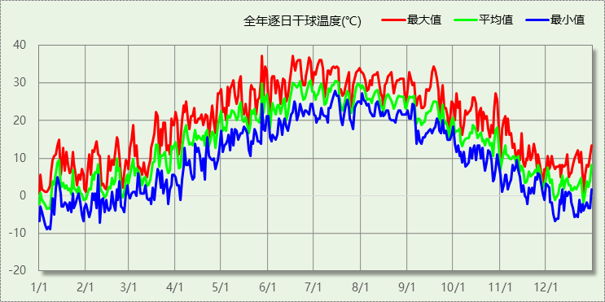

## 逐月辐照量表

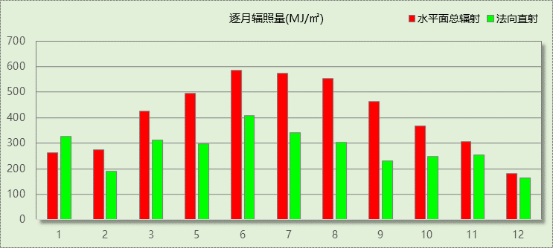

## 峰值工况

|  |  |  |  |  |  |
| --- | --- | --- | --- | --- | --- |
| 气象数据 | 时刻 | 干球温度(℃) | 湿球温度(℃) | 含湿量(g/kg) | 焓值(kj/kg) |
| 最大值 | 05月27日16时 | 37.2 | 18.3 | 5.5 | 51.5 |
| 最小值 | 01月05日07时 | -8.9 | -10.0 | 1.2 | -6.0 |

# 软件介绍

本报告采用的软件为绿建斯维尔暖通负荷BECH2020，该软件紧密结合暖通和节能设计规范、可根据项目实际情况建立建筑热工模型，并可对围护结构材料、房间内扰发热、作息时间表、热回收方式等参数进行设置。

软件包含全国各地典型气象年数据，内置DOE2.1E内核，对于建筑的逐时负荷进行动态模拟，既可以模拟8760小时理想负荷，也可以根据设定好的采暖期/空调期进行逐时模拟。

软件还支持分析全年建筑能耗的来源构成，依据日射得热、新风负荷、围护传热和内扰得热进行归类分项，生成设计建筑全年负荷计算报告书，提供详实的数据和多样的图表，为设计师在设备选型、制定运行策略等方面提供参考和帮助。

# 围护结构

## 屋顶构造

### 屋顶构造一

|  |  |  |  |  |  |  |
| --- | --- | --- | --- | --- | --- | --- |
| 材料名称 （由上到下） | 厚度δ | 导热系数λ | 蓄热系数S | 修正系数 | 热阻R | 热惰性指标 |
| (mm) | W/(m.K) | W/(㎡.K) | α | (㎡K)/W | D=R*S |
| 混凝土瓦(挂瓦条) | 20 | 0.930 | 11.306 | 1.00 | 0.022 | 0.243 |
| （冬季）垂直空气间层（δ=5） | 40 | 0.050 | 0.066 | 1.00 | 0.800 | 0.053 |
| 细石混凝土（双向配筋） | 40 | 1.740 | 17.060 | 1.00 | 0.023 | 0.392 |
| 挤塑聚苯板(ρ=25-32) | 50 | 0.030 | 0.320 | 1.00 | 1.667 | 0.533 |
| SBS改性沥青防水卷材 | 10 | 0.230 | 9.370 | 1.00 | 0.043 | 0.407 |
| 水泥砂浆 | 20 | 0.930 | 11.370 | 1.00 | 0.022 | 0.245 |
| 钢筋混凝土 | 100 | 1.740 | 17.200 | 1.00 | 0.057 | 0.989 |
| 石灰水泥砂浆（混合砂浆） | 20 | 0.870 | 10.750 | 1.00 | 0.023 | 0.247 |
| 各层之和∑ | 300 | － | － | － | 2.657 | 3.109 |
| 外表面太阳辐射吸收系数 | 0.69 | | | | | |
| 传热系数K=1/(0.15+∑R) | 0.36 | | | | | |

## 外墙构造

### 外墙构造一

|  |  |  |  |  |  |  |
| --- | --- | --- | --- | --- | --- | --- |
| 材料名称 （由外到内） | 厚度δ | 导热系数λ | 蓄热系数S | 修正系数 | 热阻R | 热惰性指标 |
| (mm) | W/(m.K) | W/(㎡.K) | α | (㎡K)/W | D=R*S |
| 水泥砂浆 | 20 | 0.930 | 11.370 | 1.00 | 0.022 | 0.245 |
| 挤塑聚苯板(ρ=25-32) | 80 | 0.030 | 0.320 | 1.00 | 2.667 | 0.853 |
| 水泥砂浆 | 20 | 0.930 | 11.370 | 1.00 | 0.022 | 0.245 |
| 砼多孔砖 | 160 | 0.730 | 7.330 | 1.00 | 0.219 | 1.607 |
| 聚合物保温砂浆 | 20 | 0.110 | 3.500 | 1.00 | 0.182 | 0.636 |
| 各层之和∑ | 300 | － | － | － | 3.111 | 3.585 |
| 外表面太阳辐射吸收系数 | 0.48 | | | | | |
| 传热系数K=1/(0.15+∑R) | 0.31 | | | | | |
| 数据来源 | 河南公建2006标准第60页 | | | | | |

## 周边地面构造

### 周边地面构造一

|  |  |  |  |  |  |  |
| --- | --- | --- | --- | --- | --- | --- |
| 材料名称 | 厚度δ | 导热系数λ | 蓄热系数S | 修正系数 | 热阻R | 热惰性指标 |
| (mm) | W/(m.K) | W/(㎡.K) | α | (㎡K)/W | D=R*S |
| 水泥砂浆 | 60 | 0.930 | 11.370 | 1.00 | 0.065 | 0.734 |
| 钢筋混凝土 | 100 | 1.740 | 17.200 | 1.00 | 0.057 | 0.989 |
| 聚苯板(EPS板) | 40 | 0.041 | 0.287 | 1.00 | 0.976 | 0.280 |
| 夯实粘土(ρ=2000) | 100 | 1.160 | 13.054 | 1.00 | 0.086 | 1.125 |
| 各层之和∑ | 300 | － | － | － | 1.184 | 3.127 |
| 传热系数K=1/(0.11+∑R) | 0.34 | | | | | |
|  |  |  |  |  |  |  |

## 非周边地面构造

### 非周边地面构造一

|  |  |  |  |  |  |  |
| --- | --- | --- | --- | --- | --- | --- |
| 材料名称 | 厚度δ | 导热系数λ | 蓄热系数S | 修正系数 | 热阻R | 热惰性指标 |
| (mm) | W/(m.K) | W/(㎡.K) | α | (㎡K)/W | D=R*S |
| 水泥砂浆 | 20 | 0.930 | 11.370 | 1.00 | 0.022 | 0.245 |
| 石灰砂浆 | 120 | 0.810 | 10.070 | 1.00 | 0.148 | 1.492 |
| 各层之和∑ | 140 | － | － | － | 0.170 | 1.736 |
| 传热系数K=1/(0.11+∑R) | 0.30 | | | | | |
|  |  |  |  |  |  |  |

## 门构造

|  |  |  |  |
| --- | --- | --- | --- |
| 序号 | 构造名称 | 传热系数 | 备注 |
| 1 | 木（塑料）—单层实体门 | 3.500 |  |

## 窗构造

|  |  |  |  |  |  |
| --- | --- | --- | --- | --- | --- |
| 序号 | 构造名称 | 传热系数 | 遮阳系数 | 可见光透射比 | 备注 |
| 1 | 下限-60系列平开铝合金断热窗4+0.12V+4+6A+5LowE | 1.500 | 0.270 | 0.800 |  |
| 2 | 下限-60系列平开铝合金断热窗4+0.12V+4+6A+5LowE | 1.500 | 0.270 | 1.000 |  |
| 3 | 下限-60系列平开铝合金断热窗4+0.12V+4+6A+5LowE | 1.500 | 0.270 | 1.000 |  |

# 房间类型

## 房间表

|  |  |  |  |  |  |  |
| --- | --- | --- | --- | --- | --- | --- |
| 房间类型 | 空调温度 ℃ | 供暖温度 ℃ | 新风量 | 人员密度 | 照明功率 密度 | 电器设备 功率 |
| 卧室 | 26 | 20 | 25(m^3/h.人) | 2(人) | 16(W/m^2) | 13(W/m^2) |
| 卫生间 | 26 | 20 | 12(m^3/h.人) | 2(m^2/人) | 16(W/m^2) | 13(W/m^2) |
| 宾馆-2星级多功能厅 | 25 | 22 | 15(m^3/h.人) | 6(m^2/人) | 18(W/m^2) | 5(W/m^2) |
| 宾馆-走廊 | 26 | 18 | 0(m^3/h.人) | 20(m^2/人) | 5(W/m^2) | 15(W/m^2) |
| 杂物室 | 26 | 20 | 22(m^3/h.人) | 2(人) | 16(W/m^2) | 13(W/m^2) |
| 污物室 | 26 | 20 | 18(m^3/h.人) | 2(人) | 16(W/m^2) | 13(W/m^2) |
| 洗衣房 | 26 | 20 | 18(m^3/h.人) | 2(人) | 16(W/m^2) | 13(W/m^2) |

## 作息时间表

详见附录

# 系统设置

## 系统划分

|  |  |  |  |  |  |  |
| --- | --- | --- | --- | --- | --- | --- |
| 系统编号 | 热回收 类型 | 启动 条件 | 回收 效率 | 排风 比例 | 面积(m2) | 包含的房间 |
| Sys1 | 无 | -- | -- | -- | 206.48 | 1017,1016,1015,1014,1013,1012,1011,1010,1009,1008,1007,1006,1005,1004 |
| Sys2 | 无 | -- | -- | -- | 74.86 | 1038,1037,1036,1035,1034,1033,1032,1031,1030,1029,1028,1027,1026,1025,1024,1023,1022 |
| Sys3 | 无 | -- | -- | -- | 300.72 | 1021,1019,1018,1001 |
| Sys4 | 无 | -- | -- | -- | 47.99 | 1020,1003,1002 |

## 运行时间表

详见附录

# 计算结果

## 模拟周期

供冷季(6.1-9.30) 供暖季(11.15-3.1)

## 全年冷暖需求

|  |  |  |  |  |
| --- | --- | --- | --- | --- |
| 系统名称\负荷 | 供暖需求 (kWh) | 供暖指标 (kWh/㎡·a) | 供冷需求 (kWh) | 供冷指标 (kWh/㎡·a) |
| Sys2 | 4765 | 64 | 14503 | 194 |
| Sys3 | 7324 | 24 | 19893 | 66 |
| Sys4 | 9439 | 197 | 7869 | 164 |
| Sys1 | 7878 | 38 | 20158 | 98 |
| 总计 | 29405 | 47 | 62424 | 99 |

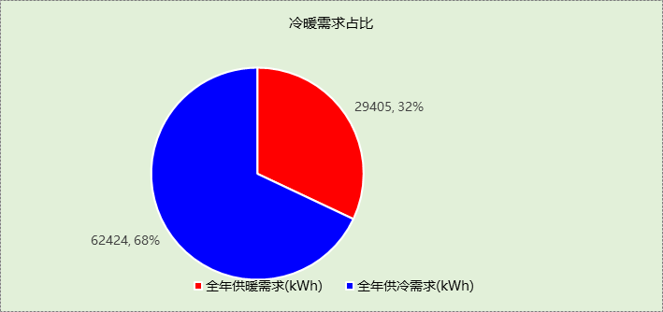

## 能耗分项统计

|  |  |  |  |  |  |  |
| --- | --- | --- | --- | --- | --- | --- |
| 分类 | 围护传热 | 室内得热 | 窗日射 | 新风/渗透 | 热回收 | 合计 |
| 供暖需求(kWh) | -40804 | 16339 | 10332 | -15272 | 0 | -29405 |
| 供冷需求(kWh) | 6307 | 26683 | 15383 | 14050 | 0 | 62424 |

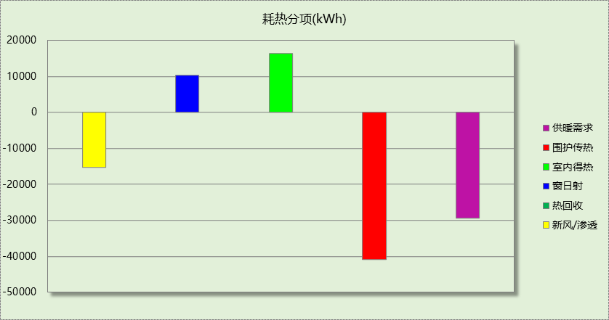

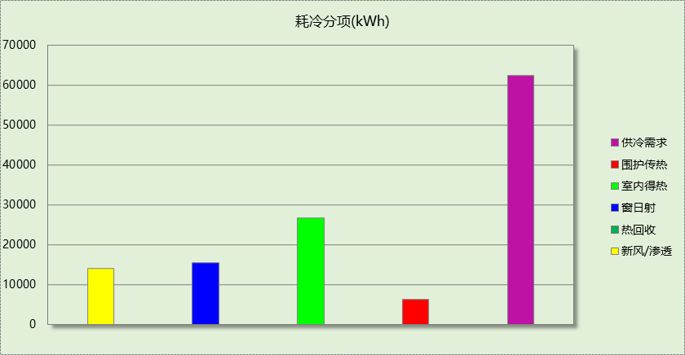

## 逐月负荷表

|  |  |  |  |  |  |  |
| --- | --- | --- | --- | --- | --- | --- |
| 月份 | 供暖需求 (kWh) | 供冷需求 (kWh) | 热负荷 峰值(kW) | 热负荷 峰值时刻 | 冷负荷 峰值(kW) | 冷负荷 峰值时刻 |
| 1月 | 9560 | 0 | 56.435 | 01月01日08时 | 0.000 | -- |
| 2月 | 7762 | 0 | 52.047 | 02月15日08时 | 0.000 | -- |
| 3月 | 179 | 0 | 35.618 | 03月01日08时 | 0.000 | -- |
| 4月 | 0 | 0 | 0.000 | -- | 0.000 | -- |
| 5月 | 0 | 0 | 0.000 | -- | 0.000 | -- |
| 6月 | 0 | 15691 | 0.000 | -- | 59.126 | 06月28日17时 |
| 7月 | 0 | 19312 | 0.000 | -- | 64.753 | 07月29日17时 |
| 8月 | 0 | 17704 | 0.000 | -- | 62.258 | 08月01日17时 |
| 9月 | 0 | 9717 | 0.000 | -- | 49.537 | 09月02日17时 |
| 10月 | 0 | 0 | 0.000 | -- | 0.000 | -- |
| 11月 | 3761 | 0 | 45.064 | 11月29日08时 | 0.000 | -- |
| 12月 | 8143 | 0 | 47.406 | 12月12日08时 | 0.000 | -- |

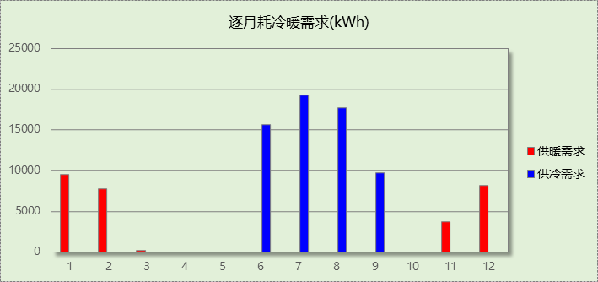

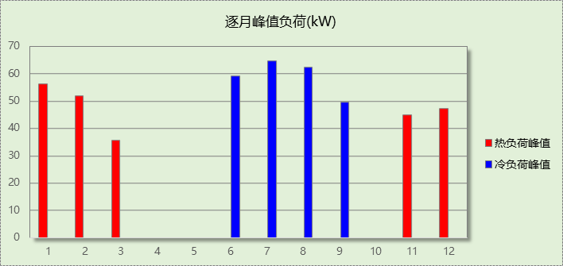

# 附录

**工作日/节假日人员逐时在室率(%)**

|  |  |  |  |  |  |  |  |  |  |  |  |  |  |  |  |  |  |  |  |  |  |  |  |  |
| --- | --- | --- | --- | --- | --- | --- | --- | --- | --- | --- | --- | --- | --- | --- | --- | --- | --- | --- | --- | --- | --- | --- | --- | --- |
| 房间类型 | 1 | 2 | 3 | 4 | 5 | 6 | 7 | 8 | 9 | 10 | 11 | 12 | 13 | 14 | 15 | 16 | 17 | 18 | 19 | 20 | 21 | 22 | 23 | 24 |
| 卧室 | 0 | 0 | 0 | 0 | 0 | 0 | 0 | 20 | 50 | 80 | 80 | 80 | 80 | 80 | 80 | 80 | 80 | 80 | 80 | 70 | 50 | 0 | 0 | 0 |
| 0 | 0 | 0 | 0 | 0 | 0 | 0 | 20 | 50 | 80 | 80 | 80 | 80 | 80 | 80 | 80 | 80 | 80 | 80 | 70 | 50 | 0 | 0 | 0 |
| 卫生间 | 0 | 0 | 0 | 0 | 0 | 0 | 0 | 20 | 50 | 80 | 80 | 80 | 80 | 80 | 80 | 80 | 80 | 80 | 80 | 70 | 50 | 0 | 0 | 0 |
| 0 | 0 | 0 | 0 | 0 | 0 | 0 | 20 | 50 | 80 | 80 | 80 | 80 | 80 | 80 | 80 | 80 | 80 | 80 | 70 | 50 | 0 | 0 | 0 |
| 宾馆-2星级多功能厅 | 70 | 70 | 70 | 70 | 70 | 70 | 70 | 70 | 50 | 50 | 50 | 50 | 50 | 50 | 50 | 50 | 50 | 50 | 70 | 70 | 70 | 70 | 70 | 70 |
| 70 | 70 | 70 | 70 | 70 | 70 | 70 | 70 | 50 | 50 | 50 | 50 | 50 | 50 | 50 | 50 | 50 | 50 | 70 | 70 | 70 | 70 | 70 | 70 |
| 宾馆-走廊 | 70 | 70 | 70 | 70 | 70 | 70 | 70 | 70 | 50 | 50 | 50 | 50 | 50 | 50 | 50 | 50 | 50 | 50 | 70 | 70 | 70 | 70 | 70 | 70 |
| 70 | 70 | 70 | 70 | 70 | 70 | 70 | 70 | 50 | 50 | 50 | 50 | 50 | 50 | 50 | 50 | 50 | 50 | 70 | 70 | 70 | 70 | 70 | 70 |
| 杂物室 | 0 | 0 | 0 | 0 | 0 | 0 | 0 | 20 | 50 | 80 | 80 | 80 | 80 | 80 | 80 | 80 | 80 | 80 | 80 | 70 | 50 | 0 | 0 | 0 |
| 0 | 0 | 0 | 0 | 0 | 0 | 0 | 20 | 50 | 80 | 80 | 80 | 80 | 80 | 80 | 80 | 80 | 80 | 80 | 70 | 50 | 0 | 0 | 0 |
| 污物室 | 0 | 0 | 0 | 0 | 0 | 0 | 0 | 20 | 50 | 80 | 80 | 80 | 80 | 80 | 80 | 80 | 80 | 80 | 80 | 70 | 50 | 0 | 0 | 0 |
| 0 | 0 | 0 | 0 | 0 | 0 | 0 | 20 | 50 | 80 | 80 | 80 | 80 | 80 | 80 | 80 | 80 | 80 | 80 | 70 | 50 | 0 | 0 | 0 |
| 洗衣房 | 0 | 0 | 0 | 0 | 0 | 0 | 0 | 20 | 50 | 80 | 80 | 80 | 80 | 80 | 80 | 80 | 80 | 80 | 80 | 70 | 50 | 0 | 0 | 0 |
| 0 | 0 | 0 | 0 | 0 | 0 | 0 | 20 | 50 | 80 | 80 | 80 | 80 | 80 | 80 | 80 | 80 | 80 | 80 | 70 | 50 | 0 | 0 | 0 |

注：上行：工作日；下行：节假日

**工作日/节假日照明开关时间表(%)**

|  |  |  |  |  |  |  |  |  |  |  |  |  |  |  |  |  |  |  |  |  |  |  |  |  |
| --- | --- | --- | --- | --- | --- | --- | --- | --- | --- | --- | --- | --- | --- | --- | --- | --- | --- | --- | --- | --- | --- | --- | --- | --- |
| 房间类型 | 1 | 2 | 3 | 4 | 5 | 6 | 7 | 8 | 9 | 10 | 11 | 12 | 13 | 14 | 15 | 16 | 17 | 18 | 19 | 20 | 21 | 22 | 23 | 24 |
| 卧室 | 10 | 10 | 10 | 10 | 10 | 10 | 10 | 50 | 60 | 60 | 60 | 60 | 60 | 60 | 60 | 60 | 80 | 90 | 100 | 100 | 100 | 10 | 10 | 10 |
| 10 | 10 | 10 | 10 | 10 | 10 | 10 | 50 | 60 | 60 | 60 | 60 | 60 | 60 | 60 | 60 | 80 | 90 | 100 | 100 | 100 | 10 | 10 | 10 |
| 卫生间 | 10 | 10 | 10 | 10 | 10 | 10 | 10 | 50 | 60 | 60 | 60 | 60 | 60 | 60 | 60 | 60 | 80 | 90 | 100 | 100 | 100 | 10 | 10 | 10 |
| 10 | 10 | 10 | 10 | 10 | 10 | 10 | 50 | 60 | 60 | 60 | 60 | 60 | 60 | 60 | 60 | 80 | 90 | 100 | 100 | 100 | 10 | 10 | 10 |
| 宾馆-2星级多功能厅 | 10 | 10 | 10 | 10 | 10 | 10 | 30 | 30 | 30 | 30 | 30 | 30 | 30 | 30 | 50 | 50 | 60 | 90 | 90 | 90 | 90 | 80 | 10 | 10 |
| 10 | 10 | 10 | 10 | 10 | 10 | 30 | 30 | 30 | 30 | 30 | 30 | 30 | 30 | 50 | 50 | 60 | 90 | 90 | 90 | 90 | 80 | 10 | 10 |
| 宾馆-走廊 | 10 | 10 | 10 | 10 | 10 | 10 | 30 | 30 | 30 | 30 | 30 | 30 | 30 | 30 | 50 | 50 | 60 | 90 | 90 | 90 | 90 | 80 | 10 | 10 |
| 10 | 10 | 10 | 10 | 10 | 10 | 30 | 30 | 30 | 30 | 30 | 30 | 30 | 30 | 50 | 50 | 60 | 90 | 90 | 90 | 90 | 80 | 10 | 10 |
| 杂物室 | 10 | 10 | 10 | 10 | 10 | 10 | 10 | 50 | 60 | 60 | 60 | 60 | 60 | 60 | 60 | 60 | 80 | 90 | 100 | 100 | 100 | 10 | 10 | 10 |
| 10 | 10 | 10 | 10 | 10 | 10 | 10 | 50 | 60 | 60 | 60 | 60 | 60 | 60 | 60 | 60 | 80 | 90 | 100 | 100 | 100 | 10 | 10 | 10 |
| 污物室 | 10 | 10 | 10 | 10 | 10 | 10 | 10 | 50 | 60 | 60 | 60 | 60 | 60 | 60 | 60 | 60 | 80 | 90 | 100 | 100 | 100 | 10 | 10 | 10 |
| 10 | 10 | 10 | 10 | 10 | 10 | 10 | 50 | 60 | 60 | 60 | 60 | 60 | 60 | 60 | 60 | 80 | 90 | 100 | 100 | 100 | 10 | 10 | 10 |
| 洗衣房 | 10 | 10 | 10 | 10 | 10 | 10 | 10 | 50 | 60 | 60 | 60 | 60 | 60 | 60 | 60 | 60 | 80 | 90 | 100 | 100 | 100 | 10 | 10 | 10 |
| 10 | 10 | 10 | 10 | 10 | 10 | 10 | 50 | 60 | 60 | 60 | 60 | 60 | 60 | 60 | 60 | 80 | 90 | 100 | 100 | 100 | 10 | 10 | 10 |

注：上行：工作日；下行：节假日

**工作日/节假日设备逐时使用率(%)**

|  |  |  |  |  |  |  |  |  |  |  |  |  |  |  |  |  |  |  |  |  |  |  |  |  |
| --- | --- | --- | --- | --- | --- | --- | --- | --- | --- | --- | --- | --- | --- | --- | --- | --- | --- | --- | --- | --- | --- | --- | --- | --- |
| 房间类型 | 1 | 2 | 3 | 4 | 5 | 6 | 7 | 8 | 9 | 10 | 11 | 12 | 13 | 14 | 15 | 16 | 17 | 18 | 19 | 20 | 21 | 22 | 23 | 24 |
| 卧室 | 0 | 0 | 0 | 0 | 0 | 0 | 0 | 30 | 50 | 80 | 80 | 80 | 80 | 80 | 80 | 80 | 80 | 80 | 80 | 70 | 50 | 0 | 0 | 0 |
| 0 | 0 | 0 | 0 | 0 | 0 | 0 | 30 | 50 | 80 | 80 | 80 | 80 | 80 | 80 | 80 | 80 | 80 | 80 | 70 | 50 | 0 | 0 | 0 |
| 卫生间 | 0 | 0 | 0 | 0 | 0 | 0 | 0 | 30 | 50 | 80 | 80 | 80 | 80 | 80 | 80 | 80 | 80 | 80 | 80 | 70 | 50 | 0 | 0 | 0 |
| 0 | 0 | 0 | 0 | 0 | 0 | 0 | 30 | 50 | 80 | 80 | 80 | 80 | 80 | 80 | 80 | 80 | 80 | 80 | 70 | 50 | 0 | 0 | 0 |
| 宾馆-2星级多功能厅 | 0 | 0 | 0 | 0 | 0 | 0 | 0 | 0 | 0 | 0 | 0 | 0 | 0 | 0 | 0 | 0 | 0 | 80 | 80 | 80 | 80 | 80 | 0 | 0 |
| 0 | 0 | 0 | 0 | 0 | 0 | 0 | 0 | 0 | 0 | 0 | 0 | 0 | 0 | 0 | 0 | 0 | 80 | 80 | 80 | 80 | 80 | 0 | 0 |
| 宾馆-走廊 | 0 | 0 | 0 | 0 | 0 | 0 | 0 | 0 | 0 | 0 | 0 | 0 | 0 | 0 | 0 | 0 | 0 | 80 | 80 | 80 | 80 | 80 | 0 | 0 |
| 0 | 0 | 0 | 0 | 0 | 0 | 0 | 0 | 0 | 0 | 0 | 0 | 0 | 0 | 0 | 0 | 0 | 80 | 80 | 80 | 80 | 80 | 0 | 0 |
| 杂物室 | 0 | 0 | 0 | 0 | 0 | 0 | 0 | 30 | 50 | 80 | 80 | 80 | 80 | 80 | 80 | 80 | 80 | 80 | 80 | 70 | 50 | 0 | 0 | 0 |
| 0 | 0 | 0 | 0 | 0 | 0 | 0 | 30 | 50 | 80 | 80 | 80 | 80 | 80 | 80 | 80 | 80 | 80 | 80 | 70 | 50 | 0 | 0 | 0 |
| 污物室 | 0 | 0 | 0 | 0 | 0 | 0 | 0 | 30 | 50 | 80 | 80 | 80 | 80 | 80 | 80 | 80 | 80 | 80 | 80 | 70 | 50 | 0 | 0 | 0 |
| 0 | 0 | 0 | 0 | 0 | 0 | 0 | 30 | 50 | 80 | 80 | 80 | 80 | 80 | 80 | 80 | 80 | 80 | 80 | 70 | 50 | 0 | 0 | 0 |
| 洗衣房 | 0 | 0 | 0 | 0 | 0 | 0 | 0 | 30 | 50 | 80 | 80 | 80 | 80 | 80 | 80 | 80 | 80 | 80 | 80 | 70 | 50 | 0 | 0 | 0 |
| 0 | 0 | 0 | 0 | 0 | 0 | 0 | 30 | 50 | 80 | 80 | 80 | 80 | 80 | 80 | 80 | 80 | 80 | 80 | 70 | 50 | 0 | 0 | 0 |

注：上行：工作日；下行：节假日

**工作日/节假日空调系统开关时间表**

采暖期：

|  |  |  |  |  |  |  |  |  |  |  |  |  |  |  |  |  |  |  |  |  |  |  |  |  |
| --- | --- | --- | --- | --- | --- | --- | --- | --- | --- | --- | --- | --- | --- | --- | --- | --- | --- | --- | --- | --- | --- | --- | --- | --- |
| 系统编号 | 1 | 2 | 3 | 4 | 5 | 6 | 7 | 8 | 9 | 10 | 11 | 12 | 13 | 14 | 15 | 16 | 17 | 18 | 19 | 20 | 21 | 22 | 23 | 24 |
| Sys1 | 1 | 1 | 1 | 1 | 1 | 1 | 1 | 1 | 1 | 1 | 1 | 1 | 1 | 1 | 1 | 1 | 1 | 1 | 1 | 1 | 1 | 1 | 1 | 1 |
| 1 | 1 | 1 | 1 | 1 | 1 | 1 | 1 | 1 | 1 | 1 | 1 | 1 | 1 | 1 | 1 | 1 | 1 | 1 | 1 | 1 | 1 | 1 | 1 |
| Sys2 | 0 | 0 | 0 | 0 | 0 | 0 | 0 | 1 | 1 | 1 | 1 | 1 | 1 | 1 | 1 | 1 | 1 | 1 | 1 | 1 | 1 | 0 | 0 | 0 |
| 0 | 0 | 0 | 0 | 0 | 0 | 0 | 1 | 1 | 1 | 1 | 1 | 1 | 1 | 1 | 1 | 1 | 1 | 1 | 1 | 1 | 0 | 0 | 0 |
| Sys3 | 1 | 1 | 1 | 1 | 1 | 1 | 1 | 1 | 1 | 1 | 1 | 1 | 1 | 1 | 1 | 1 | 1 | 1 | 1 | 1 | 1 | 1 | 1 | 1 |
| 1 | 1 | 1 | 1 | 1 | 1 | 1 | 1 | 1 | 1 | 1 | 1 | 1 | 1 | 1 | 1 | 1 | 1 | 1 | 1 | 1 | 1 | 1 | 1 |
| Sys4 | 1 | 1 | 1 | 1 | 1 | 1 | 1 | 1 | 1 | 1 | 1 | 1 | 1 | 1 | 1 | 1 | 1 | 1 | 1 | 1 | 1 | 1 | 1 | 1 |
| 1 | 1 | 1 | 1 | 1 | 1 | 1 | 1 | 1 | 1 | 1 | 1 | 1 | 1 | 1 | 1 | 1 | 1 | 1 | 1 | 1 | 1 | 1 | 1 |

供冷期：

|  |  |  |  |  |  |  |  |  |  |  |  |  |  |  |  |  |  |  |  |  |  |  |  |  |
| --- | --- | --- | --- | --- | --- | --- | --- | --- | --- | --- | --- | --- | --- | --- | --- | --- | --- | --- | --- | --- | --- | --- | --- | --- |
| 系统编号 | 1 | 2 | 3 | 4 | 5 | 6 | 7 | 8 | 9 | 10 | 11 | 12 | 13 | 14 | 15 | 16 | 17 | 18 | 19 | 20 | 21 | 22 | 23 | 24 |
| Sys1 | 1 | 1 | 1 | 1 | 1 | 1 | 1 | 1 | 1 | 1 | 1 | 1 | 1 | 1 | 1 | 1 | 1 | 1 | 1 | 1 | 1 | 1 | 1 | 1 |
| 1 | 1 | 1 | 1 | 1 | 1 | 1 | 1 | 1 | 1 | 1 | 1 | 1 | 1 | 1 | 1 | 1 | 1 | 1 | 1 | 1 | 1 | 1 | 1 |
| Sys2 | 0 | 0 | 0 | 0 | 0 | 0 | 0 | 1 | 1 | 1 | 1 | 1 | 1 | 1 | 1 | 1 | 1 | 1 | 1 | 1 | 1 | 0 | 0 | 0 |
| 0 | 0 | 0 | 0 | 0 | 0 | 0 | 1 | 1 | 1 | 1 | 1 | 1 | 1 | 1 | 1 | 1 | 1 | 1 | 1 | 1 | 0 | 0 | 0 |
| Sys3 | 1 | 1 | 1 | 1 | 1 | 1 | 1 | 1 | 1 | 1 | 1 | 1 | 1 | 1 | 1 | 1 | 1 | 1 | 1 | 1 | 1 | 1 | 1 | 1 |
| 1 | 1 | 1 | 1 | 1 | 1 | 1 | 1 | 1 | 1 | 1 | 1 | 1 | 1 | 1 | 1 | 1 | 1 | 1 | 1 | 1 | 1 | 1 | 1 |
| Sys4 | 1 | 1 | 1 | 1 | 1 | 1 | 1 | 1 | 1 | 1 | 1 | 1 | 1 | 1 | 1 | 1 | 1 | 1 | 1 | 1 | 1 | 1 | 1 | 1 |
| 1 | 1 | 1 | 1 | 1 | 1 | 1 | 1 | 1 | 1 | 1 | 1 | 1 | 1 | 1 | 1 | 1 | 1 | 1 | 1 | 1 | 1 | 1 | 1 |

注：上行：工作日；下行：节假日