**新建项目**

全年负荷计算书

|  |  |
| --- | --- |
| 工程名称 | 四川大学华西校区第二食堂 |
| 设计编号 |  |
| 建设单位 |  |
| 设计单位 |  |
| 计 算 人 |  |
| 校 对 人 |  |
| 审 核 人 |  |
| 计算日期 |  |



|  |  |
| --- | --- |
| 采用软件 | 斯维尔暖通负荷BECH2020 |
| 软件版本 | 20190909 |
| 研发单位 | 北京绿建软件有限公司 |
| 正版授权码 | T15835442401 |

**目 录**

1 建筑概况 1

2 气象数据 1

2.1 气象地点 1

2.2 逐日干球温度表 1

2.3 逐月辐照量表 2

2.4 峰值工况 2

3 软件介绍 2

4 围护结构 2

4.1 屋顶构造 2

4.1.1 屋顶构造一 2

4.2 外墙构造 3

4.2.1 外墙构造一 3

4.3 挑空楼板构造 3

4.3.1 挑空楼板构造一 3

4.4 楼板构造 3

4.4.1 控温房间楼板构造一 3

4.5 周边地面构造 4

4.5.1 周边地面构造一 4

4.6 非周边地面构造 4

4.6.1 非周边地面构造一 4

4.7 门构造 4

4.8 窗构造 4

5 房间类型 5

5.1 房间表 5

5.2 作息时间表 5

6 系统设置 5

6.1 系统划分 5

6.2 运行时间表 6

7 计算结果 6

7.1 模拟周期 6

7.2 全年冷暖需求 6

7.3 能耗分项统计 6

7.4 逐月负荷表 7

8 附录 9

# 建筑概况

|  |  |  |
| --- | --- | --- |
| 地理位置 | 四川-成都 | |
| 气候分区 | 夏热冬冷 | |
| 北纬 | 30.67 | |
| 东经 | 104.02 | |
| 建筑名称 | 新建项目 | |
| 建筑类型 | 公共建筑 |  |
| 建筑面积 | 地上 18313.16 ㎡ | 地下 0.00 ㎡ |
| 建筑高度 | 地上 22.40 m | 地下0.00 |
| 建筑层数 | 地上 7 | 地下 0 |
| 北向角度 | 180° | |

# 气象数据

## 气象地点

四川-成都, 《中国建筑热环境分析专用气象数据集》

## 逐日干球温度表

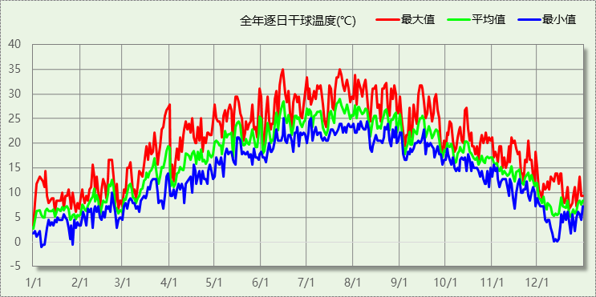

## 逐月辐照量表

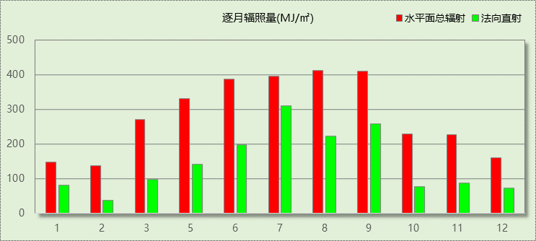

## 峰值工况

|  |  |  |  |  |  |
| --- | --- | --- | --- | --- | --- |
| 气象数据 | 时刻 | 干球温度(℃) | 湿球温度(℃) | 含湿量(g/kg) | 焓值(kj/kg) |
| 最大值 | 06月14日14时 | 35.0 | 25.0 | 17.2 | 79.3 |
| 最小值 | 01月05日06时 | -1.1 | -1.1 | 3.4 | 7.4 |

# 软件介绍

本报告采用的软件为绿建斯维尔暖通负荷BECH2020，该软件紧密结合暖通和节能设计规范、可根据项目实际情况建立建筑热工模型，并可对围护结构材料、房间内扰发热、作息时间表、热回收方式等参数进行设置。

软件包含全国各地典型气象年数据，内置DOE2.1E内核，对于建筑的逐时负荷进行动态模拟，既可以模拟8760小时理想负荷，也可以根据设定好的采暖期/空调期进行逐时模拟。

软件还支持分析全年建筑能耗的来源构成，依据日射得热、新风负荷、围护传热和内扰得热进行归类分项，生成设计建筑全年负荷计算报告书，提供详实的数据和多样的图表，为设计师在设备选型、制定运行策略等方面提供参考和帮助。

# 围护结构

## 屋顶构造

### 屋顶构造一

|  |  |  |  |  |  |  |
| --- | --- | --- | --- | --- | --- | --- |
| 材料名称 （由上到下） | 厚度δ | 导热系数λ | 蓄热系数S | 修正系数 | 热阻R | 热惰性指标 |
| (mm) | W/(m.K) | W/(㎡.K) | α | (㎡K)/W | D=R*S |
| 碎石、卵石混凝土(ρ=2300) | 40 | 1.510 | 15.360 | 1.00 | 0.026 | 0.407 |
| 水泥砂浆 | 20 | 0.930 | 11.370 | 1.00 | 0.022 | 0.245 |
| 粉煤灰陶粒混凝土(ρ=1100) | 50 | 0.440 | 6.300 | 1.00 | 0.114 | 0.716 |
| 岩棉板（ρ：60~160） | 110 | 0.041 | 0.615 | 1.00 | 2.683 | 1.650 |
| 水泥砂浆 | 20 | 0.930 | 11.370 | 1.00 | 0.022 | 0.245 |
| 钢筋混凝土 | 120 | 1.740 | 17.200 | 1.00 | 0.069 | 1.186 |
| 各层之和∑ | 360 | － | － | － | 2.935 | 4.448 |
| 外表面太阳辐射吸收系数 | 0.75[默认] | | | | | |
| 传热系数K=1/(0.15+∑R) | 0.32 | | | | | |

## 外墙构造

### 外墙构造一

|  |  |  |  |  |  |  |
| --- | --- | --- | --- | --- | --- | --- |
| 材料名称 （由外到内） | 厚度δ | 导热系数λ | 蓄热系数S | 修正系数 | 热阻R | 热惰性指标 |
| (mm) | W/(m.K) | W/(㎡.K) | α | (㎡K)/W | D=R*S |
| 无机轻集料保温砂浆（ρ≤450） | 8 | 0.085 | 1.610 | 1.00 | 0.094 | 0.152 |
| 聚苯乙烯泡沫塑料 | 25 | 0.042 | 0.360 | 1.00 | 0.595 | 0.214 |
| 蒸压加气混凝土(ρ=500) | 200 | 0.140 | 2.310 | 1.00 | 1.429 | 3.300 |
| 水泥砂浆 | 20 | 0.930 | 11.370 | 1.00 | 0.022 | 0.245 |
| 各层之和∑ | 253 | － | － | － | 2.139 | 3.910 |
| 外表面太阳辐射吸收系数 | 0.75[默认] | | | | | |
| 传热系数K=1/(0.15+∑R) | 0.44 | | | | | |

## 挑空楼板构造

### 挑空楼板构造一

|  |  |  |  |  |  |  |
| --- | --- | --- | --- | --- | --- | --- |
| 材料名称 （由上到下） | 厚度δ | 导热系数λ | 蓄热系数S | 修正系数 | 热阻R | 热惰性指标 |
| (mm) | W/(m.K) | W/(㎡.K) | α | (㎡K)/W | D=R*S |
| C20细石混凝土(ρ=2300) | 30 | 1.510 | 15.243 | 1.00 | 0.020 | 0.303 |
| 钢筋混凝土 | 120 | 1.740 | 17.200 | 1.00 | 0.069 | 1.186 |
| 岩棉板（ρ：60~160） | 50 | 0.041 | 0.615 | 1.00 | 1.220 | 0.750 |
| 胶粉聚苯颗粒浆料 | 10 | 0.060 | 1.020 | 1.00 | 0.167 | 0.170 |
| 水泥砂浆 | 10 | 0.930 | 11.370 | 1.00 | 0.011 | 0.122 |
| 各层之和∑ | 220 | － | － | － | 1.486 | 2.531 |
| 传热系数K=1/(0.15+∑R) | 0.61 | | | | | |

## 楼板构造

### 控温房间楼板构造一

|  |  |  |  |  |  |  |
| --- | --- | --- | --- | --- | --- | --- |
| 材料名称 | 厚度δ | 导热系数λ | 蓄热系数S | 修正系数 | 热阻R | 热惰性指标 |
| (mm) | W/(m.K) | W/(㎡.K) | α | (㎡K)/W | D=R*S |
| 水泥砂浆 | 20 | 0.930 | 11.370 | 1.00 | 0.022 | 0.245 |
| 钢筋混凝土 | 120 | 1.740 | 17.200 | 1.00 | 0.069 | 1.186 |
| 石灰砂浆 | 20 | 0.810 | 10.070 | 1.00 | 0.025 | 0.249 |
| 各层之和∑ | 160 | － | － | － | 0.115 | 1.679 |
| 传热系数K=1/(0.22+∑R) | 2.98 | | | | | |

## 周边地面构造

### 周边地面构造一

|  |  |  |  |  |  |  |
| --- | --- | --- | --- | --- | --- | --- |
| 材料名称 | 厚度δ | 导热系数λ | 蓄热系数S | 修正系数 | 热阻R | 热惰性指标 |
| (mm) | W/(m.K) | W/(㎡.K) | α | (㎡K)/W | D=R*S |
| 水泥砂浆 | 20 | 0.930 | 11.370 | 1.00 | 0.022 | 0.245 |
| 钢筋混凝土 | 120 | 1.740 | 17.200 | 1.00 | 0.069 | 1.186 |
| 各层之和∑ | 140 | － | － | － | 0.090 | 1.431 |
| 传热系数K=1/(0.11+∑R) | 0.52 | | | | | |
|  |  |  |  |  |  |  |

## 非周边地面构造

### 非周边地面构造一

|  |  |  |  |  |  |  |
| --- | --- | --- | --- | --- | --- | --- |
| 材料名称 | 厚度δ | 导热系数λ | 蓄热系数S | 修正系数 | 热阻R | 热惰性指标 |
| (mm) | W/(m.K) | W/(㎡.K) | α | (㎡K)/W | D=R*S |
| 水泥砂浆 | 20 | 0.930 | 11.370 | 1.00 | 0.022 | 0.245 |
| 钢筋混凝土 | 120 | 1.740 | 17.200 | 1.00 | 0.069 | 1.186 |
| 各层之和∑ | 140 | － | － | － | 0.090 | 1.431 |
| 传热系数K=1/(0.11+∑R) | 0.30 | | | | | |
|  |  |  |  |  |  |  |

## 门构造

|  |  |  |  |
| --- | --- | --- | --- |
| 序号 | 构造名称 | 传热系数 | 备注 |
| 1 | 商场玻璃外门 | 0.839 |  |

## 窗构造

|  |  |  |  |  |  |
| --- | --- | --- | --- | --- | --- |
| 序号 | 构造名称 | 传热系数 | 遮阳系数 | 可见光透射比 | 备注 |
| 1 | 6较低透光Low-E+12A+6透明-多腔塑料窗框 | 1.900 | 0.285 | 0.480 | 可见光透射比=0.480 |
| 2 | 6较低透光Low-E+12A+6透明-多腔塑料窗框 | 1.900 | 0.285 | 0.480 | 可见光透射比=0.480 |
| 3 | 6较低透光Low-E+12A+6透明-多腔塑料窗框 | 1.900 | 0.285 | 0.480 | 可见光透射比=0.480 |

# 房间类型

## 房间表

|  |  |  |  |  |  |  |
| --- | --- | --- | --- | --- | --- | --- |
| 房间类型 | 空调温度 ℃ | 供暖温度 ℃ | 新风量 | 人员密度 | 照明功率 密度 | 电器设备 功率 |
| 其他-休憩区 | 25 | 20 | 20(m^3/h.人) | 3.3(m^2/人) | 20(W/m^2) | 0(W/m^2) |
| 办公-普通办公室 | 26 | 20 | 30(m^3/h.人) | 8(m^2/人) | 9(W/m^2) | 15(W/m^2) |
| 办公-走廊 | 26 | 20 | 30(m^3/h.人) | 10(m^2/人) | 9(W/m^2) | 15(W/m^2) |
| 商场-后勤区 | 26 | 20 | 20(m^3/h.人) | 10(m^2/人) | 9(W/m^2) | 13(W/m^2) |
| 教育-健身活动室 | 24 | 19 | 40(m^3/h.人) | 4(m^2/人) | 9(W/m^2) | 5(W/m^2) |
| 教育-卫生间 | 28 | 16 | 0(m^3/h.人) | 0(m^2/人) | 6(W/m^2) | 5(W/m^2) |
| 教育-厨房 | 27 | 18 | 28(次/h) | 5(m^2/人) | 9(W/m^2) | 5(W/m^2) |
| 教育-报告厅 | 26 | 18 | 14(m^3/h.人) | 2.5(m^2/人) | 9(W/m^2) | 5(W/m^2) |
| 教育-非空调房间 | － | － | 0(m^3/h.人) | 0(m^2/人) | 5(W/m^2) | 5(W/m^2) |
| 教育-餐厅 | 26 | 18 | 25(m^3/h.人) | 1(m^2/人) | 9(W/m^2) | 5(W/m^2) |
| 教育-高级办公室 | 26 | 20 | 30(m^3/h.人) | 8(m^2/人) | 15(W/m^2) | 5(W/m^2) |

## 作息时间表

详见附录

# 系统设置

## 系统划分

|  |  |  |  |  |  |  |
| --- | --- | --- | --- | --- | --- | --- |
| 系统编号 | 热回收 类型 | 启动 条件 | 回收 效率 | 排风 比例 | 面积(m2) | 包含的房间 |
| 默认 | 无 | -- | -- | -- | 4588.82 | 1005,1016,1020,1009,1017,1001,2005,2020,2009,3003,3012,3015,3013,4019,4017,4016,5001,6005,6013,6016,6008,6014,7004,7009,7012,7010,8006,8009,8007 |
| Sys1 | 无 | -- | -- | -- | 9821.85 | 1021,1022,1013,1010,1018,1011,1019,1014,1012,1007,1002,2021,2022,3009,3001,3016,3017,3014,4015,4012,6009,6001,6017,6018,6015,7005,7011,7002,7001,7013,7014,8004,8010,8011,8008,8001 |
| Sys2 | 无 | -- | -- | -- | 2514.87 | 1015,1003,1008,1006,1004,2008,2006,4014,4011,4005,4003,6007,6006,6010,6002,6004 |

## 运行时间表

详见附录

# 计算结果

## 模拟周期

全年8760小时模拟

## 全年冷暖需求

|  |  |  |  |  |
| --- | --- | --- | --- | --- |
| 系统名称\负荷 | 供暖需求 (kWh) | 供暖指标 (kWh/㎡·a) | 供冷需求 (kWh) | 供冷指标 (kWh/㎡·a) |
| Sys1 | 0 | 0 | 684048 | 70 |
| Sys2 | 0 | 0 | 350723 | 139 |
| 默认系统 | 231899 | 51 | 395854 | 86 |
| 总计 | 231899 | 14 | 1430625 | 85 |

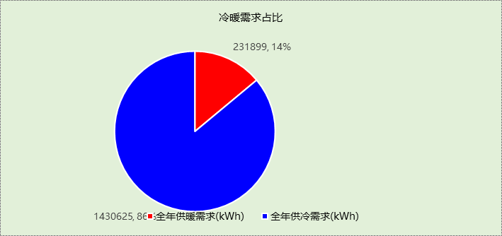

## 能耗分项统计

|  |  |  |  |  |  |  |
| --- | --- | --- | --- | --- | --- | --- |
| 分类 | 围护传热 | 室内得热 | 窗日射 | 新风/渗透 | 热回收 | 合计 |
| 供暖需求(kWh) | -202288 | 31744 | 2583 | -63938 | 0 | -231899 |
| 供冷需求(kWh) | 180233 | 420274 | 14332 | 815787 | 0 | 1430625 |

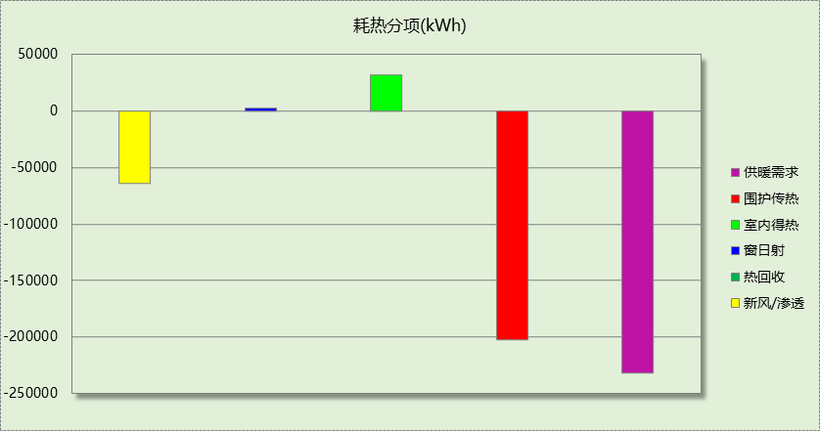

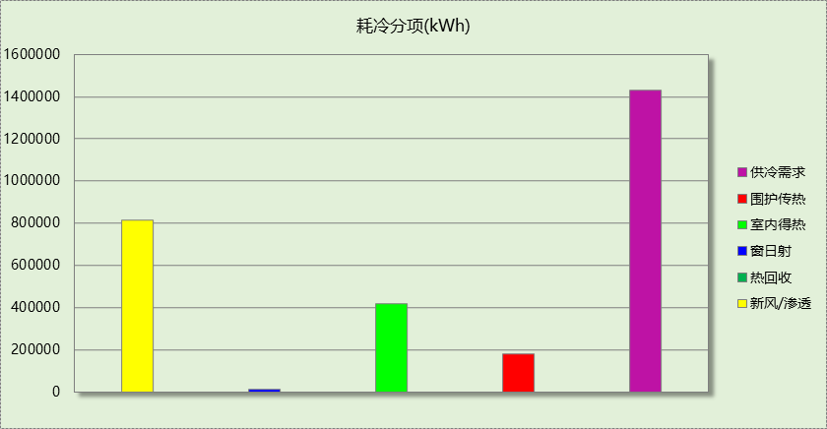

## 逐月负荷表

|  |  |  |  |  |  |  |
| --- | --- | --- | --- | --- | --- | --- |
| 月份 | 供暖需求 (kWh) | 供冷需求 (kWh) | 热负荷 峰值(kW) | 热负荷 峰值时刻 | 冷负荷 峰值(kW) | 冷负荷 峰值时刻 |
| 1月 | 80055 | 0 | 556.394 | 01月02日07时 | 0.000 | -- |
| 2月 | 63440 | 0 | 554.673 | 02月14日07时 | 0.000 | -- |
| 3月 | 23866 | 1078 | 483.654 | 03月04日07时 | 276.232 | 03月29日15时 |
| 4月 | 5527 | 2450 | 267.122 | 04月05日07时 | 466.477 | 04月30日16时 |
| 5月 | 33 | 117170 | 12.462 | 05月06日07时 | 2586.835 | 05月31日15时 |
| 6月 | 1 | 358046 | 1.056 | 06月03日07时 | 4959.858 | 06月14日14时 |
| 7月 | 0 | 457060 | 0.000 | -- | 6471.688 | 07月02日15时 |
| 8月 | 0 | 285235 | 0.000 | -- | 5167.214 | 08月28日16时 |
| 9月 | 3 | 203202 | 1.657 | 09月30日07时 | 3907.166 | 09月13日14时 |
| 10月 | 753 | 6385 | 95.412 | 10月07日07时 | 512.389 | 10月14日15时 |
| 11月 | 12238 | 0 | 297.538 | 11月25日07时 | 0.000 | -- |
| 12月 | 45983 | 0 | 531.594 | 12月23日07时 | 0.000 | -- |

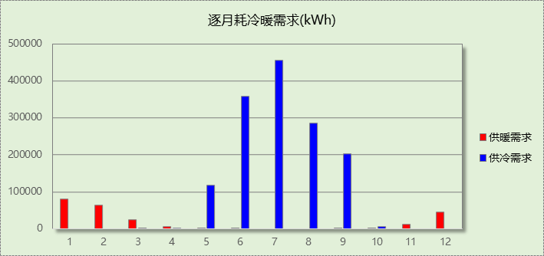

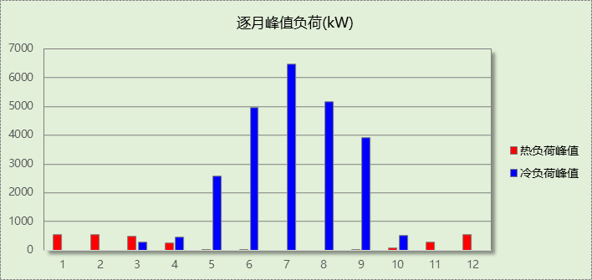

# 附录

**工作日/节假日人员逐时在室率(%)**

|  |  |  |  |  |  |  |  |  |  |  |  |  |  |  |  |  |  |  |  |  |  |  |  |  |
| --- | --- | --- | --- | --- | --- | --- | --- | --- | --- | --- | --- | --- | --- | --- | --- | --- | --- | --- | --- | --- | --- | --- | --- | --- |
| 房间类型 | 1 | 2 | 3 | 4 | 5 | 6 | 7 | 8 | 9 | 10 | 11 | 12 | 13 | 14 | 15 | 16 | 17 | 18 | 19 | 20 | 21 | 22 | 23 | 24 |
| 其他-休憩区 | 0 | 0 | 0 | 0 | 0 | 0 | 10 | 50 | 95 | 95 | 95 | 80 | 80 | 95 | 95 | 95 | 95 | 30 | 30 | 0 | 0 | 0 | 0 | 0 |
| 0 | 0 | 0 | 0 | 0 | 0 | 0 | 0 | 0 | 0 | 0 | 0 | 0 | 0 | 0 | 0 | 0 | 0 | 0 | 0 | 0 | 0 | 0 | 0 |
| 办公-普通办公室 | 0 | 0 | 0 | 0 | 0 | 0 | 10 | 50 | 100 | 100 | 100 | 30 | 100 | 100 | 100 | 100 | 50 | 20 | 10 | 0 | 0 | 0 | 0 | 0 |
| 0 | 0 | 0 | 0 | 0 | 0 | 0 | 20 | 45 | 0 | 0 | 0 | 0 | 0 | 0 | 0 | 0 | 0 | 0 | 0 | 0 | 0 | 0 | 0 |
| 办公-走廊 | 0 | 0 | 0 | 0 | 0 | 0 | 10 | 50 | 95 | 95 | 95 | 80 | 80 | 95 | 95 | 95 | 95 | 30 | 30 | 0 | 0 | 0 | 0 | 0 |
| 0 | 0 | 0 | 0 | 0 | 0 | 0 | 0 | 0 | 0 | 0 | 0 | 0 | 0 | 0 | 0 | 0 | 0 | 0 | 0 | 0 | 0 | 0 | 0 |
| 商场-后勤区 | 0 | 0 | 0 | 0 | 0 | 0 | 0 | 20 | 50 | 80 | 80 | 80 | 80 | 80 | 80 | 80 | 80 | 80 | 80 | 70 | 50 | 0 | 0 | 0 |
| 0 | 0 | 0 | 0 | 0 | 0 | 0 | 20 | 50 | 80 | 80 | 80 | 80 | 80 | 80 | 80 | 80 | 80 | 80 | 70 | 50 | 0 | 0 | 0 |
| 教育-健身活动室 | 0 | 0 | 0 | 0 | 0 | 0 | 10 | 50 | 95 | 95 | 95 | 80 | 80 | 95 | 95 | 95 | 95 | 30 | 30 | 0 | 0 | 0 | 0 | 0 |
| 0 | 0 | 0 | 0 | 0 | 0 | 10 | 50 | 95 | 95 | 95 | 80 | 80 | 95 | 95 | 95 | 95 | 30 | 30 | 0 | 0 | 0 | 0 | 0 |
| 教育-卫生间 | 0 | 0 | 0 | 0 | 0 | 0 | 10 | 50 | 95 | 95 | 95 | 80 | 80 | 95 | 95 | 95 | 95 | 30 | 30 | 0 | 0 | 0 | 0 | 0 |
| 0 | 0 | 0 | 0 | 0 | 0 | 0 | 0 | 0 | 0 | 0 | 0 | 0 | 0 | 0 | 0 | 0 | 0 | 0 | 0 | 0 | 0 | 0 | 0 |
| 教育-厨房 | 0 | 0 | 0 | 0 | 0 | 0 | 10 | 50 | 95 | 95 | 95 | 80 | 80 | 95 | 95 | 95 | 95 | 30 | 30 | 0 | 0 | 0 | 0 | 0 |
| 0 | 0 | 0 | 0 | 0 | 0 | 0 | 0 | 0 | 0 | 0 | 0 | 0 | 0 | 0 | 0 | 0 | 0 | 0 | 0 | 0 | 0 | 0 | 0 |
| 教育-报告厅 | 0 | 0 | 0 | 0 | 0 | 0 | 10 | 50 | 95 | 95 | 95 | 80 | 80 | 95 | 95 | 95 | 95 | 30 | 30 | 0 | 0 | 0 | 0 | 0 |
| 0 | 0 | 0 | 0 | 0 | 0 | 0 | 0 | 0 | 0 | 0 | 0 | 0 | 0 | 0 | 0 | 0 | 0 | 0 | 0 | 0 | 0 | 0 | 0 |
| 教育-非空调房间 | 0 | 0 | 0 | 0 | 0 | 0 | 10 | 50 | 95 | 95 | 95 | 80 | 80 | 95 | 95 | 95 | 95 | 30 | 30 | 0 | 0 | 0 | 0 | 0 |
| 0 | 0 | 0 | 0 | 0 | 0 | 10 | 50 | 95 | 95 | 95 | 80 | 80 | 95 | 95 | 95 | 95 | 30 | 30 | 0 | 0 | 0 | 0 | 0 |
| 教育-餐厅 | 0 | 0 | 0 | 0 | 0 | 0 | 10 | 50 | 95 | 95 | 95 | 80 | 80 | 95 | 95 | 95 | 95 | 30 | 30 | 0 | 0 | 0 | 0 | 0 |
| 0 | 0 | 0 | 0 | 0 | 0 | 0 | 0 | 0 | 0 | 0 | 0 | 0 | 0 | 0 | 0 | 0 | 0 | 0 | 0 | 0 | 0 | 0 | 0 |
| 教育-高级办公室 | 0 | 0 | 0 | 0 | 0 | 0 | 10 | 50 | 95 | 95 | 95 | 80 | 80 | 95 | 95 | 95 | 95 | 30 | 30 | 0 | 0 | 0 | 0 | 0 |
| 0 | 0 | 0 | 0 | 0 | 0 | 0 | 0 | 0 | 0 | 0 | 0 | 0 | 0 | 0 | 0 | 0 | 0 | 0 | 0 | 0 | 0 | 0 | 0 |

注：上行：工作日；下行：节假日

**工作日/节假日照明开关时间表(%)**

|  |  |  |  |  |  |  |  |  |  |  |  |  |  |  |  |  |  |  |  |  |  |  |  |  |
| --- | --- | --- | --- | --- | --- | --- | --- | --- | --- | --- | --- | --- | --- | --- | --- | --- | --- | --- | --- | --- | --- | --- | --- | --- |
| 房间类型 | 1 | 2 | 3 | 4 | 5 | 6 | 7 | 8 | 9 | 10 | 11 | 12 | 13 | 14 | 15 | 16 | 17 | 18 | 19 | 20 | 21 | 22 | 23 | 24 |
| 其他-休憩区 | 0 | 0 | 0 | 0 | 0 | 0 | 10 | 50 | 95 | 95 | 95 | 80 | 80 | 95 | 95 | 95 | 95 | 30 | 30 | 0 | 0 | 0 | 0 | 0 |
| 0 | 0 | 0 | 0 | 0 | 0 | 0 | 0 | 0 | 0 | 0 | 0 | 0 | 0 | 0 | 0 | 0 | 0 | 0 | 0 | 0 | 0 | 0 | 0 |
| 办公-普通办公室 | 10 | 10 | 10 | 10 | 10 | 10 | 10 | 36 | 62 | 56 | 54 | 43 | 53 | 55 | 58 | 67 | 40 | 18 | 10 | 10 | 10 | 10 | 10 | 10 |
| 0 | 0 | 0 | 0 | 0 | 0 | 0 | 0 | 0 | 0 | 0 | 0 | 0 | 0 | 0 | 0 | 0 | 0 | 0 | 0 | 0 | 0 | 0 | 0 |
| 办公-走廊 | 0 | 0 | 0 | 0 | 0 | 0 | 10 | 50 | 95 | 95 | 95 | 80 | 80 | 95 | 95 | 95 | 95 | 30 | 30 | 0 | 0 | 0 | 0 | 0 |
| 0 | 0 | 0 | 0 | 0 | 0 | 0 | 0 | 0 | 0 | 0 | 0 | 0 | 0 | 0 | 0 | 0 | 0 | 0 | 0 | 0 | 0 | 0 | 0 |
| 商场-后勤区 | 10 | 10 | 10 | 10 | 10 | 10 | 10 | 50 | 60 | 60 | 60 | 60 | 60 | 60 | 60 | 60 | 80 | 90 | 100 | 100 | 100 | 10 | 10 | 10 |
| 10 | 10 | 10 | 10 | 10 | 10 | 10 | 50 | 60 | 60 | 60 | 60 | 60 | 60 | 60 | 60 | 80 | 90 | 100 | 100 | 100 | 10 | 10 | 10 |
| 教育-健身活动室 | 0 | 0 | 0 | 0 | 0 | 0 | 10 | 50 | 95 | 95 | 95 | 80 | 80 | 95 | 95 | 95 | 95 | 30 | 30 | 0 | 0 | 0 | 0 | 0 |
| 0 | 0 | 0 | 0 | 0 | 0 | 10 | 50 | 95 | 95 | 95 | 80 | 80 | 95 | 95 | 95 | 95 | 30 | 30 | 0 | 0 | 0 | 0 | 0 |
| 教育-卫生间 | 0 | 0 | 0 | 0 | 0 | 0 | 10 | 50 | 95 | 95 | 95 | 80 | 80 | 95 | 95 | 95 | 95 | 30 | 30 | 0 | 0 | 0 | 0 | 0 |
| 0 | 0 | 0 | 0 | 0 | 0 | 0 | 0 | 0 | 0 | 0 | 0 | 0 | 0 | 0 | 0 | 0 | 0 | 0 | 0 | 0 | 0 | 0 | 0 |
| 教育-厨房 | 0 | 0 | 0 | 0 | 0 | 0 | 10 | 50 | 95 | 95 | 95 | 80 | 80 | 95 | 95 | 95 | 95 | 30 | 30 | 0 | 0 | 0 | 0 | 0 |
| 0 | 0 | 0 | 0 | 0 | 0 | 0 | 0 | 0 | 0 | 0 | 0 | 0 | 0 | 0 | 0 | 0 | 0 | 0 | 0 | 0 | 0 | 0 | 0 |
| 教育-报告厅 | 0 | 0 | 0 | 0 | 0 | 0 | 10 | 50 | 95 | 95 | 95 | 80 | 80 | 95 | 95 | 95 | 95 | 30 | 30 | 0 | 0 | 0 | 0 | 0 |
| 0 | 0 | 0 | 0 | 0 | 0 | 0 | 0 | 0 | 0 | 0 | 0 | 0 | 0 | 0 | 0 | 0 | 0 | 0 | 0 | 0 | 0 | 0 | 0 |
| 教育-非空调房间 | 0 | 0 | 0 | 0 | 0 | 0 | 10 | 50 | 95 | 95 | 95 | 80 | 80 | 95 | 95 | 95 | 95 | 30 | 30 | 0 | 0 | 0 | 0 | 0 |
| 0 | 0 | 0 | 0 | 0 | 0 | 10 | 50 | 95 | 95 | 95 | 80 | 80 | 95 | 95 | 95 | 95 | 30 | 30 | 0 | 0 | 0 | 0 | 0 |
| 教育-餐厅 | 0 | 0 | 0 | 0 | 0 | 0 | 10 | 50 | 95 | 95 | 95 | 80 | 80 | 95 | 95 | 95 | 95 | 30 | 30 | 0 | 0 | 0 | 0 | 0 |
| 0 | 0 | 0 | 0 | 0 | 0 | 0 | 0 | 0 | 0 | 0 | 0 | 0 | 0 | 0 | 0 | 0 | 0 | 0 | 0 | 0 | 0 | 0 | 0 |
| 教育-高级办公室 | 0 | 0 | 0 | 0 | 0 | 0 | 10 | 50 | 95 | 95 | 95 | 80 | 80 | 95 | 95 | 95 | 95 | 30 | 30 | 0 | 0 | 0 | 0 | 0 |
| 0 | 0 | 0 | 0 | 0 | 0 | 0 | 0 | 0 | 0 | 0 | 0 | 0 | 0 | 0 | 0 | 0 | 0 | 0 | 0 | 0 | 0 | 0 | 0 |

注：上行：工作日；下行：节假日

**工作日/节假日设备逐时使用率(%)**

|  |  |  |  |  |  |  |  |  |  |  |  |  |  |  |  |  |  |  |  |  |  |  |  |  |
| --- | --- | --- | --- | --- | --- | --- | --- | --- | --- | --- | --- | --- | --- | --- | --- | --- | --- | --- | --- | --- | --- | --- | --- | --- |
| 房间类型 | 1 | 2 | 3 | 4 | 5 | 6 | 7 | 8 | 9 | 10 | 11 | 12 | 13 | 14 | 15 | 16 | 17 | 18 | 19 | 20 | 21 | 22 | 23 | 24 |
| 其他-休憩区 | 0 | 0 | 0 | 0 | 0 | 0 | 10 | 50 | 95 | 95 | 95 | 50 | 50 | 95 | 95 | 95 | 95 | 30 | 30 | 0 | 0 | 0 | 0 | 0 |
| 0 | 0 | 0 | 0 | 0 | 0 | 0 | 0 | 0 | 0 | 0 | 0 | 0 | 0 | 0 | 0 | 0 | 0 | 0 | 0 | 0 | 0 | 0 | 0 |
| 办公-普通办公室 | 0 | 0 | 0 | 0 | 0 | 0 | 10 | 50 | 100 | 100 | 100 | 100 | 100 | 100 | 100 | 100 | 50 | 20 | 10 | 0 | 0 | 0 | 0 | 0 |
| 0 | 0 | 0 | 0 | 0 | 0 | 0 | 0 | 0 | 0 | 0 | 0 | 0 | 0 | 0 | 0 | 0 | 0 | 0 | 0 | 0 | 0 | 0 | 0 |
| 办公-走廊 | 0 | 0 | 0 | 0 | 0 | 0 | 10 | 50 | 95 | 95 | 95 | 50 | 50 | 95 | 95 | 95 | 95 | 30 | 30 | 0 | 0 | 0 | 0 | 0 |
| 0 | 0 | 0 | 0 | 0 | 0 | 0 | 0 | 0 | 0 | 0 | 0 | 0 | 0 | 0 | 0 | 0 | 0 | 0 | 0 | 0 | 0 | 0 | 0 |
| 商场-后勤区 | 0 | 0 | 0 | 0 | 0 | 0 | 0 | 30 | 50 | 80 | 80 | 80 | 80 | 80 | 80 | 80 | 80 | 80 | 80 | 70 | 50 | 0 | 0 | 0 |
| 0 | 0 | 0 | 0 | 0 | 0 | 0 | 30 | 50 | 80 | 80 | 80 | 80 | 80 | 80 | 80 | 80 | 80 | 80 | 70 | 50 | 0 | 0 | 0 |
| 教育-健身活动室 | 0 | 0 | 0 | 0 | 0 | 0 | 10 | 50 | 95 | 95 | 95 | 50 | 50 | 95 | 95 | 95 | 95 | 30 | 30 | 0 | 0 | 0 | 0 | 0 |
| 0 | 0 | 0 | 0 | 0 | 0 | 10 | 50 | 95 | 95 | 95 | 50 | 50 | 95 | 95 | 95 | 95 | 30 | 30 | 0 | 0 | 0 | 0 | 0 |
| 教育-卫生间 | 0 | 0 | 0 | 0 | 0 | 0 | 10 | 50 | 95 | 95 | 95 | 50 | 50 | 95 | 95 | 95 | 95 | 30 | 30 | 0 | 0 | 0 | 0 | 0 |
| 0 | 0 | 0 | 0 | 0 | 0 | 0 | 0 | 0 | 0 | 0 | 0 | 0 | 0 | 0 | 0 | 0 | 0 | 0 | 0 | 0 | 0 | 0 | 0 |
| 教育-厨房 | 0 | 0 | 0 | 0 | 0 | 0 | 10 | 50 | 95 | 95 | 95 | 50 | 50 | 95 | 95 | 95 | 95 | 30 | 30 | 0 | 0 | 0 | 0 | 0 |
| 0 | 0 | 0 | 0 | 0 | 0 | 0 | 0 | 0 | 0 | 0 | 0 | 0 | 0 | 0 | 0 | 0 | 0 | 0 | 0 | 0 | 0 | 0 | 0 |
| 教育-报告厅 | 0 | 0 | 0 | 0 | 0 | 0 | 10 | 50 | 95 | 95 | 95 | 50 | 50 | 95 | 95 | 95 | 95 | 30 | 30 | 0 | 0 | 0 | 0 | 0 |
| 0 | 0 | 0 | 0 | 0 | 0 | 0 | 0 | 0 | 0 | 0 | 0 | 0 | 0 | 0 | 0 | 0 | 0 | 0 | 0 | 0 | 0 | 0 | 0 |
| 教育-非空调房间 | 0 | 0 | 0 | 0 | 0 | 0 | 10 | 50 | 95 | 95 | 95 | 50 | 50 | 95 | 95 | 95 | 95 | 30 | 30 | 0 | 0 | 0 | 0 | 0 |
| 0 | 0 | 0 | 0 | 0 | 0 | 10 | 50 | 95 | 95 | 95 | 50 | 50 | 95 | 95 | 95 | 95 | 30 | 30 | 0 | 0 | 0 | 0 | 0 |
| 教育-餐厅 | 0 | 0 | 0 | 0 | 0 | 0 | 10 | 50 | 95 | 95 | 95 | 50 | 50 | 95 | 95 | 95 | 95 | 30 | 30 | 0 | 0 | 0 | 0 | 0 |
| 0 | 0 | 0 | 0 | 0 | 0 | 0 | 0 | 0 | 0 | 0 | 0 | 0 | 0 | 0 | 0 | 0 | 0 | 0 | 0 | 0 | 0 | 0 | 0 |
| 教育-高级办公室 | 0 | 0 | 0 | 0 | 0 | 0 | 10 | 50 | 95 | 95 | 95 | 50 | 50 | 95 | 95 | 95 | 95 | 30 | 30 | 0 | 0 | 0 | 0 | 0 |
| 0 | 0 | 0 | 0 | 0 | 0 | 0 | 0 | 0 | 0 | 0 | 0 | 0 | 0 | 0 | 0 | 0 | 0 | 0 | 0 | 0 | 0 | 0 | 0 |

注：上行：工作日；下行：节假日

**工作日/节假日空调系统开关时间表**

|  |  |  |  |  |  |  |  |  |  |  |  |  |  |  |  |  |  |  |  |  |  |  |  |  |
| --- | --- | --- | --- | --- | --- | --- | --- | --- | --- | --- | --- | --- | --- | --- | --- | --- | --- | --- | --- | --- | --- | --- | --- | --- |
| 系统编号 | 1 | 2 | 3 | 4 | 5 | 6 | 7 | 8 | 9 | 10 | 11 | 12 | 13 | 14 | 15 | 16 | 17 | 18 | 19 | 20 | 21 | 22 | 23 | 24 |
| 默认 | 0 | 0 | 0 | 0 | 0 | 0 | 1 | 1 | 1 | 1 | 1 | 1 | 1 | 1 | 1 | 1 | 1 | 1 | 0 | 0 | 0 | 0 | 0 | 0 |
| 0 | 0 | 0 | 0 | 0 | 0 | 0 | 0 | 0 | 0 | 0 | 0 | 0 | 0 | 0 | 0 | 0 | 0 | 0 | 0 | 0 | 0 | 0 | 0 |
| Sys1 | 0 | 0 | 0 | 0 | 0 | 0 | 1 | 1 | 1 | 1 | 1 | 1 | 1 | 1 | 1 | 1 | 1 | 1 | 1 | 1 | 1 | 0 | 0 | 0 |
| 0 | 0 | 0 | 0 | 0 | 0 | 0 | 0 | 0 | 0 | 0 | 0 | 0 | 0 | 0 | 0 | 0 | 0 | 0 | 0 | 0 | 0 | 0 | 0 |
| Sys2 | 0 | 0 | 0 | 0 | 0 | 0 | 1 | 1 | 1 | 1 | 1 | 1 | 1 | 1 | 1 | 1 | 1 | 1 | 1 | 1 | 1 | 1 | 1 | 0 |
| 0 | 0 | 0 | 0 | 0 | 0 | 0 | 0 | 0 | 0 | 0 | 0 | 0 | 0 | 0 | 0 | 0 | 0 | 0 | 0 | 0 | 0 | 0 | 0 |

注：上行：工作日；下行：节假日