**室内PMV与PPD、风速分析**

图书馆2层实测数据：

|  |  |  |  |  |  |  |  |  |  |  |
| --- | --- | --- | --- | --- | --- | --- | --- | --- | --- | --- |
| **Statistics** | **Tw (  C )** | **Tg (  C )** | **Ta (  C )** | **RH ( % )** | **Va ( m/s )** | **Tr (  C )** | **WBGT-i (  C )** | **WBGT-o (  C )** | **PMV** | **PPD ( % )** |
| Maximum Value | 10.7 | 17.7 | 18 | 41.1 | 0.31 | 17.6 | 12.8 | 12.8 | 0.72 | 15.77 |
| Minimum Value | 8.8 | 15.9 | 16.1 | 34.9 | 0 | 15.7 | 10.9 | 11 | 0.39 | 8.14 |
| Average Value | 10.01 | 17.12 | 17.28 | 37.39 | 0.08 | 16.99 | 12.14 | 12.15 | 0.62 | 13.18 |
| Standard Deviation | 0.6255 | 0.5333 | 0.5944 | 1.5828 | 0.0563 | 0.4955 | 0.5938 | 0.5969 | 0.0787 | 1.9476 |

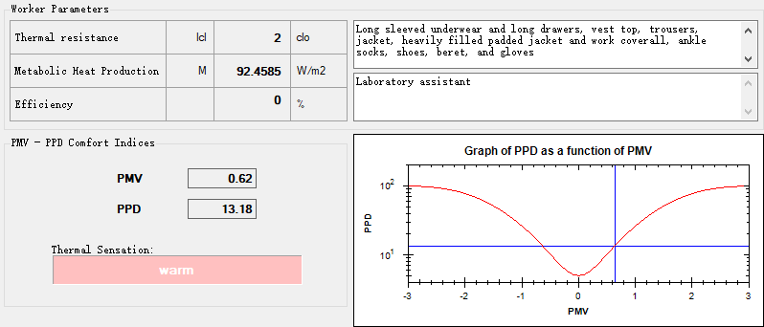

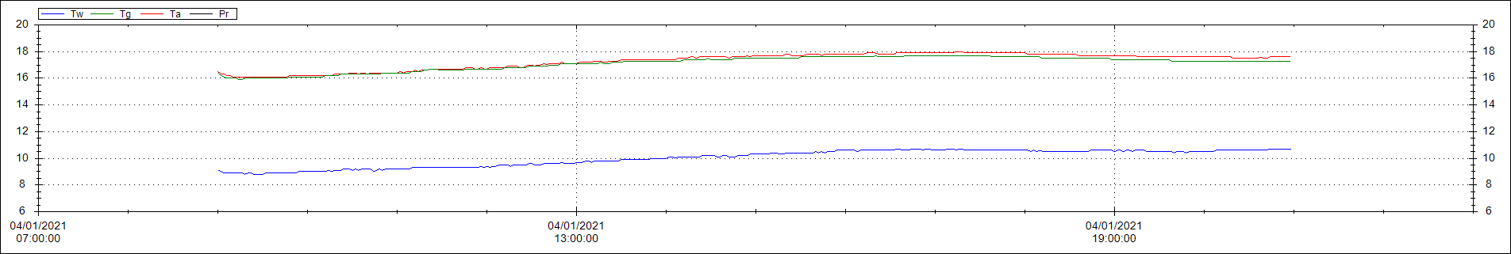

图书馆4层实测数据：

|  |  |  |  |  |  |  |  |  |  |  |
| --- | --- | --- | --- | --- | --- | --- | --- | --- | --- | --- |
| **Statistics** | **Tw (  C )** | **Tg (  C )** | **Ta (  C )** | **RH ( % )** | **Va ( m/s )** | **Tr (  C )** | **WBGT-i (  C )** | **WBGT-o (  C )** | **PMV** | **PPD ( % )** |
| Maximum Value | 11.1 | 17.9 | 18.4 | 40 | 1.07 | 17.7 | 13.1 | 13.2 | 0.74 | 16.65 |
| Average Value | 10.33 | 17.34 | 17.78 | 36.91 | 0.01 | 17.11 | 12.42 | 12.48 | 0.67 | 14.56 |
| Minimum Value | 9.3 | 16.4 | 16.8 | 33.1 | 0 | 15.6 | 11.4 | 11.5 | 0.39 | 8.2 |
| Standard Deviation | 0.6107 | 0.485 | 0.5162 | 1.7398 | 0.0595 | 0.4867 | 0.581 | 0.565 | 0.0615 | 1.7005 |

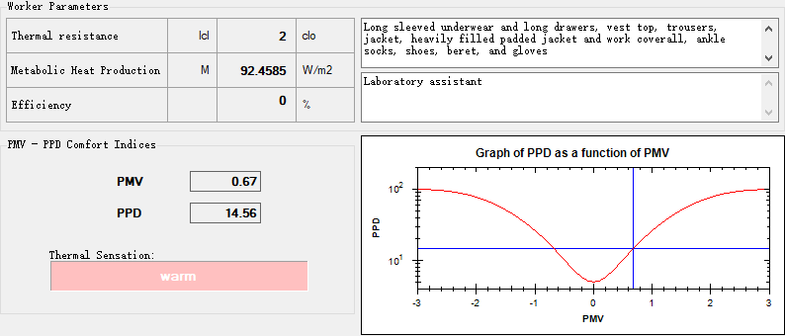

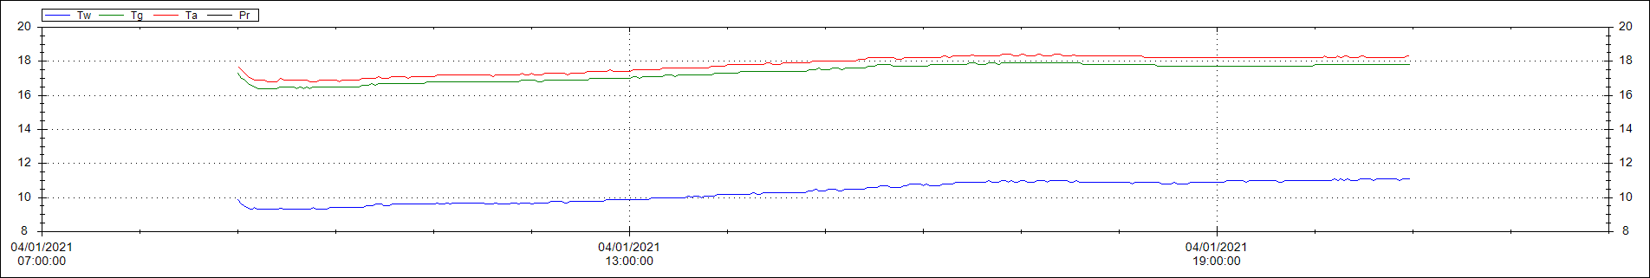

图书馆5层实测数据：

|  |  |  |  |  |  |  |  |  |  |  |
| --- | --- | --- | --- | --- | --- | --- | --- | --- | --- | --- |
| **Statistics** | **Tw (  C )** | **Tg (  C )** | **Ta (  C )** | **RH ( % )** | **Va ( m/s )** | **Tr (  C )** | **WBGT-i (  C )** | **WBGT-o (  C )** | **PMV** | **PPD ( % )** |
| Maximum Value | 11.9 | 19.7 | 20.1 | 38.2 | 1.29 | 19.6 | 14.2 | 14.3 | 0.92 | 22.98 |
| Minimum Value | 9.7 | 17.3 | 17.6 | 29.6 | 0 | 16.5 | 12 | 12 | 0.48 | 9.88 |
| Average Value | 11.01 | 18.75 | 19.11 | 34.59 | 0.02 | 18.57 | 13.34 | 13.37 | 0.81 | 18.99 |
| Standard Deviation | 0.676 | 0.6878 | 0.6914 | 1.4533 | 0.0745 | 0.6994 | 0.6728 | 0.6857 | 0.0812 | 2.7015 |

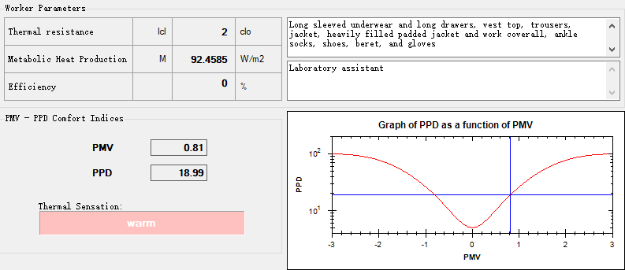

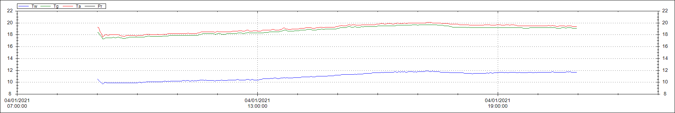

图书馆7层实测数据：

|  |  |  |  |  |  |  |  |  |  |  |
| --- | --- | --- | --- | --- | --- | --- | --- | --- | --- | --- |
| **Statistics** | **Tw (  C )** | **Tg (  C )** | **Ta (  C )** | **RH ( % )** | **Va ( m/s )** | **Tr (  C )** | **WBGT-i (  C )** | **WBGT-o (  C )** | **PMV** | **PPD ( % )** |
| Maximum Value | 11.9 | 19.7 | 20.1 | 40.5 | 0.25 | 19.6 | 14.2 | 14.3 | 0.92 | 23.01 |
| Minimum Value | 9.9 | 17.3 | 17.6 | 34 | 0 | 16.7 | 12.1 | 12.2 | 0.6 | 12.63 |
| Average Value | 11.11 | 18.69 | 18.93 | 36.26 | 0.04 | 18.55 | 13.39 | 13.41 | 0.8 | 18.66 |
| Standard Deviation | 0.64 | 0.6761 | 0.7079 | 1.5285 | 0.0467 | 0.6788 | 0.6474 | 0.6427 | 0.0818 | 2.7006 |

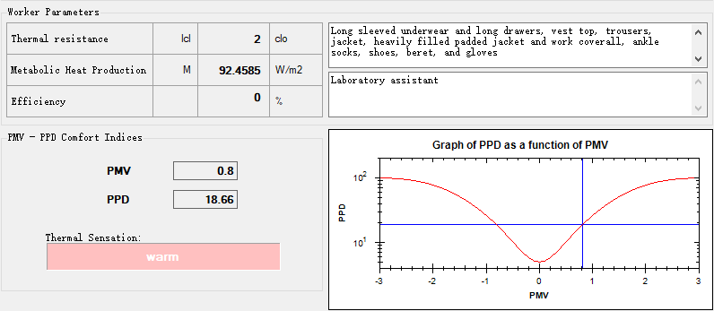

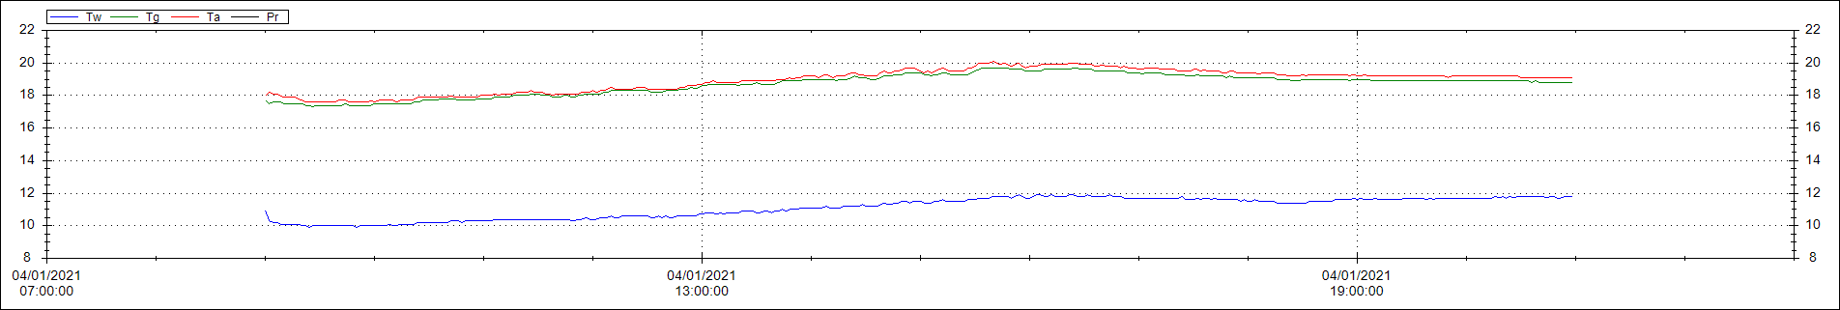

《民用建筑室内热湿环境评价标准》GB/T 50785-2012中给出如下评价标准。

|  |  |  |
| --- | --- | --- |
| 等级 | 整体评价指标 | |
| Ⅰ级 | PPD≤10％ | －0.5≤PMV≤＋0.5 |
| Ⅱ级 | 10％＜PPD≤25％ | －1≤PMV＜－0.5或＋0.5＜PMV≤＋1 |
| Ⅲ级 | PPD＞25％ | PMV＜－1或PMV＞＋1 |

该建筑主要功能房间热湿环境评价指标PMV和PPD达到整体评价II级的面积比例为86%，根据绿标5.2.9，应得6分。