**筑·巢—绿色共享生态圈**

全年负荷计算书

|  |  |
| --- | --- |
| 工程名称 | 筑·巢—绿色共享生态圈 |
| 设计编号 | GX30039 |
| 建设单位 | 华南理工大学广州广州学院 |
| 设计单位 | 华南理工大学广州广州学院建筑学院 |
| 计 算 人 |  |
| 校 对 人 |  |
| 审 核 人 |  |
| 计算日期 | 2021年1月1日 |



|  |  |
| --- | --- |
| 采用软件 | 斯维尔暖通负荷BECH2020 |
| 软件版本 | 20200606(SP1) |
| 研发单位 | 北京绿建软件股份有限公司 |
| 正版授权码 | T13580456287 |

**目 录**

1 建筑概况 1

2 气象数据 1

2.1 气象地点 1

2.2 逐日干球温度表 1

2.3 逐月辐照量表 2

2.4 峰值工况 2

3 软件介绍 2

4 围护结构 2

4.1 屋顶构造 2

4.1.1 挤塑聚苯板20+加气砼80＋钢筋砼120 2

4.2 外墙构造 3

4.2.1 外-挤塑聚苯板20+钢筋砼200 3

4.3 挑空楼板构造 3

4.3.1 挤塑聚苯板20+钢筋砼120 3

4.4 门构造 3

4.5 窗构造 4

5 房间类型 4

5.1 房间表 4

5.2 作息时间表 4

6 系统设置 4

6.1 系统划分 4

6.2 运行时间表 5

7 计算结果 5

7.1 模拟周期 5

7.2 全年冷暖需求 5

7.3 能耗分项统计 5

7.4 逐月负荷表 6

8 附录 8

# 建筑概况

|  |  |  |
| --- | --- | --- |
| 地理位置 | 广东-广州 | |
| 气候分区 | 夏热冬暖南区 | |
| 北纬 | 23.17 | |
| 东经 | 113.33 | |
| 建筑名称 | 筑·巢—绿色共享生态圈 | |
| 建筑类型 | 公共建筑 |  |
| 建筑面积 | 地上 12175.65 ㎡ | 地下 0.00 ㎡ |
| 建筑高度 | 地上 15.80 m | 地下0.00 |
| 建筑层数 | 地上 4 | 地下 0 |
| 北向角度 | 196° | |

# 气象数据

## 气象地点

广东-广州, 《中国建筑热环境分析专用气象数据集》

## 逐日干球温度表

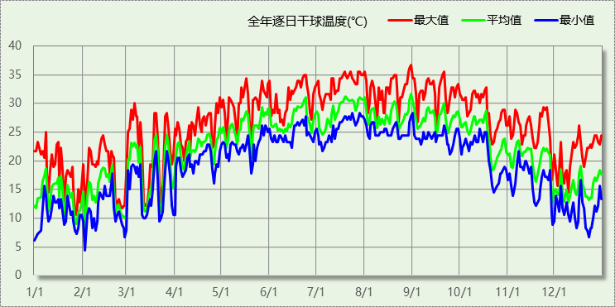

## 逐月辐照量表

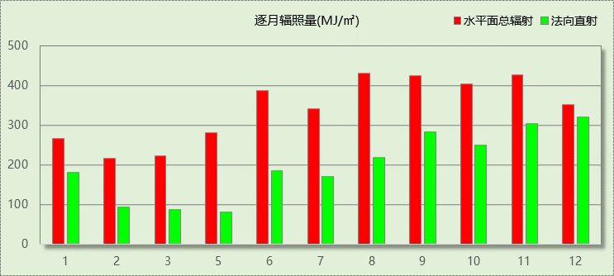

## 峰值工况

|  |  |  |  |  |  |
| --- | --- | --- | --- | --- | --- |
| 气象数据 | 时刻 | 干球温度(℃) | 湿球温度(℃) | 含湿量(g/kg) | 焓值(kj/kg) |
| 最大值 | 08月30日14时 | 36.7 | 28.3 | 21.5 | 92.1 |
| 最小值 | 02月01日03时 | 4.4 | 4.4 | 5.0 | 17.0 |

# 软件介绍

本报告采用的软件为绿建斯维尔暖通负荷BECH2020，该软件紧密结合暖通和节能设计规范、可根据项目实际情况建立建筑热工模型，并可对围护结构材料、房间内扰发热、作息时间表、热回收方式等参数进行设置。

软件包含全国各地典型气象年数据，内置DOE2.1E内核，对于建筑的逐时负荷进行动态模拟，既可以模拟8760小时理想负荷，也可以根据设定好的采暖期/空调期进行逐时模拟。

软件还支持分析全年建筑能耗的来源构成，依据日射得热、新风负荷、围护传热和内扰得热进行归类分项，生成设计建筑全年负荷计算报告书，提供详实的数据和多样的图表，为设计师在设备选型、制定运行策略等方面提供参考和帮助。

# 围护结构

## 屋顶构造

### 挤塑聚苯板20+加气砼80＋钢筋砼120

|  |  |  |  |  |  |  |
| --- | --- | --- | --- | --- | --- | --- |
| 材料名称 （由上到下） | 厚度δ | 导热系数λ | 蓄热系数S | 修正系数 | 热阻R | 热惰性指标 |
| (mm) | W/(m.K) | W/(㎡.K) | α | (㎡K)/W | D=R*S |
| 碎石、卵石混凝土(ρ=2300) | 40 | 1.510 | 15.360 | 1.00 | 0.026 | 0.407 |
| 挤塑聚苯板(ρ=25-32) | 20 | 0.030 | 0.320 | 1.20 | 0.556 | 0.213 |
| 水泥砂浆 | 20 | 0.930 | 11.370 | 1.00 | 0.022 | 0.245 |
| 加气混凝土、泡沫混凝土(ρ=700) | 80 | 0.220 | 3.590 | 1.00 | 0.364 | 1.305 |
| 钢筋混凝土 | 120 | 1.740 | 17.200 | 1.00 | 0.069 | 1.186 |
| 石灰砂浆 | 20 | 0.810 | 10.070 | 1.00 | 0.025 | 0.249 |
| 各层之和∑ | 300 | － | － | － | 1.061 | 3.605 |
| 外表面太阳辐射吸收系数 | 0.75[默认] | | | | | |
| 传热系数K=1/(0.15+∑R) | 0.83 | | | | | |

## 外墙构造

### 外-挤塑聚苯板20+钢筋砼200

|  |  |  |  |  |  |  |
| --- | --- | --- | --- | --- | --- | --- |
| 材料名称 （由外到内） | 厚度δ | 导热系数λ | 蓄热系数S | 修正系数 | 热阻R | 热惰性指标 |
| (mm) | W/(m.K) | W/(㎡.K) | α | (㎡K)/W | D=R*S |
| 水泥砂浆 | 20 | 0.930 | 11.370 | 1.00 | 0.022 | 0.245 |
| 挤塑聚苯板(ρ=25-32) | 20 | 0.030 | 0.320 | 1.20 | 0.556 | 0.213 |
| 水泥砂浆 | 20 | 0.930 | 11.370 | 1.00 | 0.022 | 0.245 |
| 钢筋混凝土 | 200 | 1.740 | 17.200 | 1.00 | 0.115 | 1.977 |
| 石灰砂浆 | 20 | 0.810 | 10.070 | 1.00 | 0.025 | 0.249 |
| 各层之和∑ | 280 | － | － | － | 0.738 | 2.928 |
| 外表面太阳辐射吸收系数 | 0.75[默认] | | | | | |
| 传热系数K=1/(0.15+∑R) | 1.13 | | | | | |

## 挑空楼板构造

### 挤塑聚苯板20+钢筋砼120

|  |  |  |  |  |  |  |
| --- | --- | --- | --- | --- | --- | --- |
| 材料名称 （由上到下） | 厚度δ | 导热系数λ | 蓄热系数S | 修正系数 | 热阻R | 热惰性指标 |
| (mm) | W/(m.K) | W/(㎡.K) | α | (㎡K)/W | D=R*S |
| 水泥砂浆 | 20 | 0.930 | 11.370 | 1.00 | 0.022 | 0.245 |
| 钢筋混凝土 | 120 | 1.740 | 17.200 | 1.00 | 0.069 | 1.186 |
| 水泥砂浆 | 20 | 0.930 | 11.370 | 1.00 | 0.022 | 0.245 |
| 挤塑聚苯板(ρ=25-32) | 20 | 0.030 | 0.320 | 1.20 | 0.556 | 0.213 |
| 水泥砂浆 | 20 | 0.930 | 11.370 | 1.00 | 0.022 | 0.245 |
| 各层之和∑ | 200 | － | － | － | 0.689 | 2.133 |
| 传热系数K=1/(0.15+∑R) | 1.19 | | | | | |

## 门构造

|  |  |  |  |
| --- | --- | --- | --- |
| 序号 | 构造名称 | 传热系数 | 备注 |
| 1 | 保温门（多功能门） | 1.972 |  |

## 窗构造

|  |  |  |  |  |  |
| --- | --- | --- | --- | --- | --- |
| 序号 | 构造名称 | 传热系数 | 遮阳系数 | 可见光透射比 | 备注 |
| 1 | 12A钢铝单框双玻窗（平均） | 3.900 | 0.750 | 1.000 | 来源《民用建筑热工设计规范》 |
| 2 | 12A钢铝单框双玻窗（平均） | 3.900 | 0.750 | 1.000 | 来源《民用建筑热工设计规范》 |

# 房间类型

## 房间表

|  |  |  |  |  |  |  |
| --- | --- | --- | --- | --- | --- | --- |
| 房间类型 | 空调温度 ℃ | 供暖温度 ℃ | 新风量 | 人员密度 | 照明功率 密度 | 电器设备 功率 |
| 宾馆-2星级多功能厅 | 25 | 22 | 15(m^3/h.人) | 2.5(m^2/人) | 18(W/m^2) | 5(W/m^2) |
| 宾馆-3星级客房 | 25 | 22 | 30(m^3/h.人) | 15(m^2/人) | 15(W/m^2) | 20(W/m^2) |
| 宾馆-4～5星级大堂 | 25 | 22 | 10(m^3/h.人) | 20(m^2/人) | 15(W/m^2) | 5(W/m^2) |
| 宾馆-走廊 | － | － | 0(m^3/h.人) | 50(m^2/人) | 5(W/m^2) | 15(W/m^2) |
| 空房间 | － | － | 20(m^3/h.人) | 50(m^2/人) | 0(W/m^2) | 0(W/m^2) |

## 作息时间表

详见附录

# 系统设置

## 系统划分

|  |  |  |  |  |  |  |
| --- | --- | --- | --- | --- | --- | --- |
| 系统编号 | 热回收 类型 | 启动 条件 | 回收 效率 | 排风 比例 | 面积(m2) | 包含的房间 |
| 默认 | 无 | -- | -- | -- | 183.46 | 2001,3054,3042 |
| 2层 | 无 | -- | -- | -- | 1054.41 | 2065,2062,2050,2048,2047,2044,2041,2039,2038,2035,2033,2031,2028,2023,2020,2018,2017,2002,2014 |
| 3层 | 无 | -- | -- | -- | 943.34 | 3067,3066,3064,3063,3052,3049,3046,3045,3043,3040,3037,3036,3034,3032,3029,3022,3021,3019,3008,3007 |
| 4层 | 无 | -- | -- | -- | 681.12 | 4069,4055,4053,4050,4049,4045,4044,4040,4038,4035,4032,4031,4028,4027,4020,4018,4017,4013,4009,4004,4003 |

## 运行时间表

详见附录

# 计算结果

## 模拟周期

供冷季(6.14-8.31) 供暖季(12.31-1.1)

## 全年冷暖需求

|  |  |  |  |  |
| --- | --- | --- | --- | --- |
| 系统名称\负荷 | 供暖需求 (kWh) | 供暖指标 (kWh/㎡·a) | 供冷需求 (kWh) | 供冷指标 (kWh/㎡·a) |
| 3层 | 0 | 0 | 98724 | 105 |
| 4层 | 0 | 0 | 72306 | 106 |
| 默认系统 | 0 | 0 | 24276 | 132 |
| 总计 | 0 | 0 | 195306 | 108 |

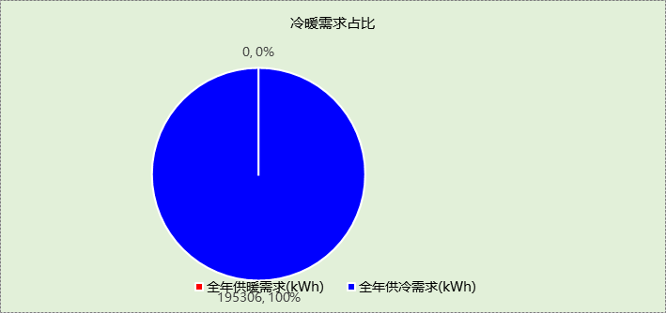

## 能耗分项统计

|  |  |  |  |  |  |  |
| --- | --- | --- | --- | --- | --- | --- |
| 分类 | 围护传热 | 室内得热 | 窗日射 | 新风/渗透 | 热回收 | 合计 |
| 供暖需求(kWh) | 0 | 0 | 0 | 0 | 0 | 0 |
| 供冷需求(kWh) | 46902 | 60693 | 2475 | 85235 | 0 | 195306 |

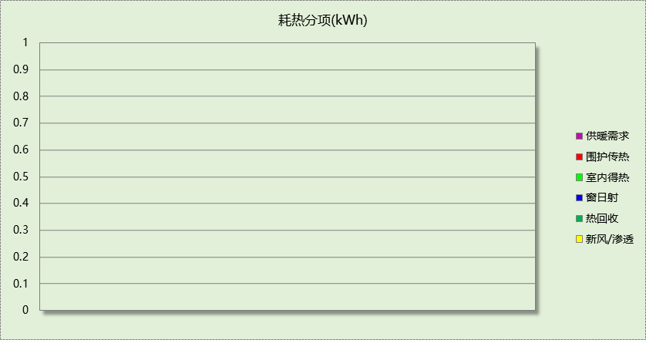

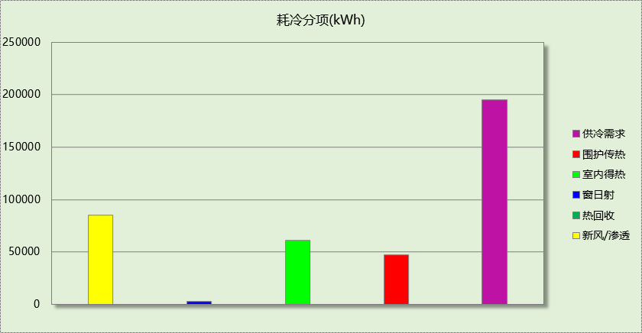

## 逐月负荷表

|  |  |  |  |  |  |  |
| --- | --- | --- | --- | --- | --- | --- |
| 月份 | 供暖需求 (kWh) | 供冷需求 (kWh) | 热负荷 峰值(kW) | 热负荷 峰值时刻 | 冷负荷 峰值(kW) | 冷负荷 峰值时刻 |
| 1月 | 0 | 0 | 0.000 | -- | 0.000 | -- |
| 2月 | 0 | 0 | 0.000 | -- | 0.000 | -- |
| 3月 | 0 | 0 | 0.000 | -- | 0.000 | -- |
| 4月 | 0 | 0 | 0.000 | -- | 0.000 | -- |
| 5月 | 0 | 0 | 0.000 | -- | 0.000 | -- |
| 6月 | 0 | 44102 | 0.000 | -- | 361.225 | 06月14日00时 |
| 7月 | 0 | 76957 | 0.000 | -- | 148.435 | 07月28日18时 |
| 8月 | 0 | 74247 | 0.000 | -- | 149.741 | 08月31日18时 |
| 9月 | 0 | 0 | 0.000 | -- | 0.000 | -- |
| 10月 | 0 | 0 | 0.000 | -- | 0.000 | -- |
| 11月 | 0 | 0 | 0.000 | -- | 0.000 | -- |
| 12月 | 0 | 0 | 0.000 | -- | 0.000 | -- |

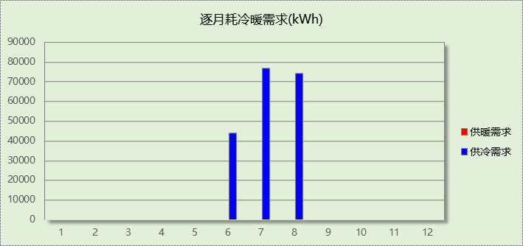

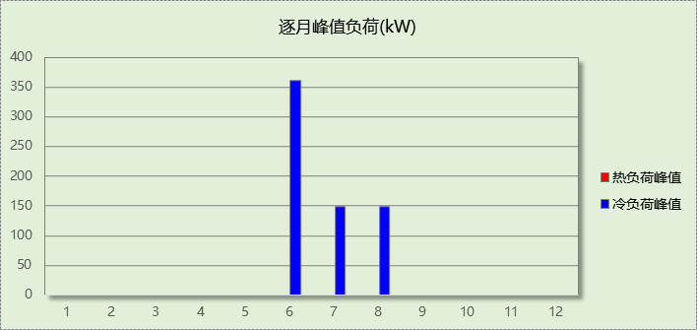

# 附录

**工作日/节假日人员逐时在室率(%)**

|  |  |  |  |  |  |  |  |  |  |  |  |  |  |  |  |  |  |  |  |  |  |  |  |  |
| --- | --- | --- | --- | --- | --- | --- | --- | --- | --- | --- | --- | --- | --- | --- | --- | --- | --- | --- | --- | --- | --- | --- | --- | --- |
| 房间类型 | 1 | 2 | 3 | 4 | 5 | 6 | 7 | 8 | 9 | 10 | 11 | 12 | 13 | 14 | 15 | 16 | 17 | 18 | 19 | 20 | 21 | 22 | 23 | 24 |
| 宾馆-2星级多功能厅 | 70 | 70 | 70 | 70 | 70 | 70 | 70 | 70 | 50 | 50 | 50 | 50 | 50 | 50 | 50 | 50 | 50 | 50 | 70 | 70 | 70 | 70 | 70 | 70 |
| 70 | 70 | 70 | 70 | 70 | 70 | 70 | 70 | 50 | 50 | 50 | 50 | 50 | 50 | 50 | 50 | 50 | 50 | 70 | 70 | 70 | 70 | 70 | 70 |
| 宾馆-3星级客房 | 70 | 70 | 70 | 70 | 70 | 70 | 70 | 70 | 50 | 50 | 50 | 50 | 50 | 50 | 50 | 50 | 50 | 50 | 70 | 70 | 70 | 70 | 70 | 70 |
| 70 | 70 | 70 | 70 | 70 | 70 | 70 | 70 | 50 | 50 | 50 | 50 | 50 | 50 | 50 | 50 | 50 | 50 | 70 | 70 | 70 | 70 | 70 | 70 |
| 宾馆-4～5星级大堂 | 70 | 70 | 70 | 70 | 70 | 70 | 70 | 70 | 50 | 50 | 50 | 50 | 50 | 50 | 50 | 50 | 50 | 50 | 70 | 70 | 70 | 70 | 70 | 70 |
| 70 | 70 | 70 | 70 | 70 | 70 | 70 | 70 | 50 | 50 | 50 | 50 | 50 | 50 | 50 | 50 | 50 | 50 | 70 | 70 | 70 | 70 | 70 | 70 |
| 宾馆-走廊 | 70 | 70 | 70 | 70 | 70 | 70 | 70 | 70 | 50 | 50 | 50 | 50 | 50 | 50 | 50 | 50 | 50 | 50 | 70 | 70 | 70 | 70 | 70 | 70 |
| 70 | 70 | 70 | 70 | 70 | 70 | 70 | 70 | 50 | 50 | 50 | 50 | 50 | 50 | 50 | 50 | 50 | 50 | 70 | 70 | 70 | 70 | 70 | 70 |
| 空房间 | 0 | 0 | 0 | 0 | 0 | 0 | 0 | 20 | 50 | 80 | 80 | 80 | 80 | 80 | 80 | 80 | 80 | 80 | 80 | 70 | 50 | 0 | 0 | 0 |
| 0 | 0 | 0 | 0 | 0 | 0 | 0 | 20 | 50 | 80 | 80 | 80 | 80 | 80 | 80 | 80 | 80 | 80 | 80 | 70 | 50 | 0 | 0 | 0 |

注：上行：工作日；下行：节假日

**工作日/节假日照明开关时间表(%)**

|  |  |  |  |  |  |  |  |  |  |  |  |  |  |  |  |  |  |  |  |  |  |  |  |  |
| --- | --- | --- | --- | --- | --- | --- | --- | --- | --- | --- | --- | --- | --- | --- | --- | --- | --- | --- | --- | --- | --- | --- | --- | --- |
| 房间类型 | 1 | 2 | 3 | 4 | 5 | 6 | 7 | 8 | 9 | 10 | 11 | 12 | 13 | 14 | 15 | 16 | 17 | 18 | 19 | 20 | 21 | 22 | 23 | 24 |
| 宾馆-2星级多功能厅 | 10 | 10 | 10 | 10 | 10 | 10 | 30 | 30 | 30 | 30 | 30 | 30 | 30 | 30 | 50 | 50 | 60 | 90 | 90 | 90 | 90 | 80 | 10 | 10 |
| 10 | 10 | 10 | 10 | 10 | 10 | 30 | 30 | 30 | 30 | 30 | 30 | 30 | 30 | 50 | 50 | 60 | 90 | 90 | 90 | 90 | 80 | 10 | 10 |
| 宾馆-3星级客房 | 10 | 10 | 10 | 10 | 10 | 10 | 30 | 30 | 30 | 30 | 30 | 30 | 30 | 30 | 50 | 50 | 60 | 90 | 90 | 90 | 90 | 80 | 10 | 10 |
| 10 | 10 | 10 | 10 | 10 | 10 | 30 | 30 | 30 | 30 | 30 | 30 | 30 | 30 | 50 | 50 | 60 | 90 | 90 | 90 | 90 | 80 | 10 | 10 |
| 宾馆-4～5星级大堂 | 10 | 10 | 10 | 10 | 10 | 10 | 30 | 30 | 30 | 30 | 30 | 30 | 30 | 30 | 50 | 50 | 60 | 90 | 90 | 90 | 90 | 80 | 10 | 10 |
| 10 | 10 | 10 | 10 | 10 | 10 | 30 | 30 | 30 | 30 | 30 | 30 | 30 | 30 | 50 | 50 | 60 | 90 | 90 | 90 | 90 | 80 | 10 | 10 |
| 宾馆-走廊 | 10 | 10 | 10 | 10 | 10 | 10 | 30 | 30 | 30 | 30 | 30 | 30 | 30 | 30 | 50 | 50 | 60 | 90 | 90 | 90 | 90 | 80 | 10 | 10 |
| 10 | 10 | 10 | 10 | 10 | 10 | 30 | 30 | 30 | 30 | 30 | 30 | 30 | 30 | 50 | 50 | 60 | 90 | 90 | 90 | 90 | 80 | 10 | 10 |
| 空房间 | 10 | 10 | 10 | 10 | 10 | 10 | 10 | 50 | 60 | 60 | 60 | 60 | 60 | 60 | 60 | 60 | 80 | 90 | 100 | 100 | 100 | 10 | 10 | 10 |
| 10 | 10 | 10 | 10 | 10 | 10 | 10 | 50 | 60 | 60 | 60 | 60 | 60 | 60 | 60 | 60 | 80 | 90 | 100 | 100 | 100 | 10 | 10 | 10 |

注：上行：工作日；下行：节假日

**工作日/节假日设备逐时使用率(%)**

|  |  |  |  |  |  |  |  |  |  |  |  |  |  |  |  |  |  |  |  |  |  |  |  |  |
| --- | --- | --- | --- | --- | --- | --- | --- | --- | --- | --- | --- | --- | --- | --- | --- | --- | --- | --- | --- | --- | --- | --- | --- | --- |
| 房间类型 | 1 | 2 | 3 | 4 | 5 | 6 | 7 | 8 | 9 | 10 | 11 | 12 | 13 | 14 | 15 | 16 | 17 | 18 | 19 | 20 | 21 | 22 | 23 | 24 |
| 宾馆-2星级多功能厅 | 0 | 0 | 0 | 0 | 0 | 0 | 0 | 0 | 0 | 0 | 0 | 0 | 0 | 0 | 0 | 0 | 0 | 80 | 80 | 80 | 80 | 80 | 0 | 0 |
| 0 | 0 | 0 | 0 | 0 | 0 | 0 | 0 | 0 | 0 | 0 | 0 | 0 | 0 | 0 | 0 | 0 | 80 | 80 | 80 | 80 | 80 | 0 | 0 |
| 宾馆-3星级客房 | 0 | 0 | 0 | 0 | 0 | 0 | 0 | 0 | 0 | 0 | 0 | 0 | 0 | 0 | 0 | 0 | 0 | 80 | 80 | 80 | 80 | 80 | 0 | 0 |
| 0 | 0 | 0 | 0 | 0 | 0 | 0 | 0 | 0 | 0 | 0 | 0 | 0 | 0 | 0 | 0 | 0 | 80 | 80 | 80 | 80 | 80 | 0 | 0 |
| 宾馆-4～5星级大堂 | 0 | 0 | 0 | 0 | 0 | 0 | 0 | 0 | 0 | 0 | 0 | 0 | 0 | 0 | 0 | 0 | 0 | 80 | 80 | 80 | 80 | 80 | 0 | 0 |
| 0 | 0 | 0 | 0 | 0 | 0 | 0 | 0 | 0 | 0 | 0 | 0 | 0 | 0 | 0 | 0 | 0 | 80 | 80 | 80 | 80 | 80 | 0 | 0 |
| 宾馆-走廊 | 0 | 0 | 0 | 0 | 0 | 0 | 0 | 0 | 0 | 0 | 0 | 0 | 0 | 0 | 0 | 0 | 0 | 80 | 80 | 80 | 80 | 80 | 0 | 0 |
| 0 | 0 | 0 | 0 | 0 | 0 | 0 | 0 | 0 | 0 | 0 | 0 | 0 | 0 | 0 | 0 | 0 | 80 | 80 | 80 | 80 | 80 | 0 | 0 |
| 空房间 | 0 | 0 | 0 | 0 | 0 | 0 | 0 | 30 | 50 | 80 | 80 | 80 | 80 | 80 | 80 | 80 | 80 | 80 | 80 | 70 | 50 | 0 | 0 | 0 |
| 0 | 0 | 0 | 0 | 0 | 0 | 0 | 30 | 50 | 80 | 80 | 80 | 80 | 80 | 80 | 80 | 80 | 80 | 80 | 70 | 50 | 0 | 0 | 0 |

注：上行：工作日；下行：节假日

**工作日/节假日空调系统开关时间表**

采暖期：

|  |  |  |  |  |  |  |  |  |  |  |  |  |  |  |  |  |  |  |  |  |  |  |  |  |
| --- | --- | --- | --- | --- | --- | --- | --- | --- | --- | --- | --- | --- | --- | --- | --- | --- | --- | --- | --- | --- | --- | --- | --- | --- |
| 系统编号 | 1 | 2 | 3 | 4 | 5 | 6 | 7 | 8 | 9 | 10 | 11 | 12 | 13 | 14 | 15 | 16 | 17 | 18 | 19 | 20 | 21 | 22 | 23 | 24 |
| 默认 | 1 | 1 | 1 | 1 | 1 | 1 | 1 | 1 | 1 | 1 | 1 | 1 | 1 | 1 | 1 | 1 | 1 | 1 | 1 | 1 | 1 | 1 | 1 | 1 |
| 1 | 1 | 1 | 1 | 1 | 1 | 1 | 1 | 1 | 1 | 1 | 1 | 1 | 1 | 1 | 1 | 1 | 1 | 1 | 1 | 1 | 1 | 1 | 1 |
| 2层 | 1 | 1 | 1 | 1 | 1 | 1 | 1 | 1 | 1 | 1 | 1 | 1 | 1 | 1 | 1 | 1 | 1 | 1 | 1 | 1 | 1 | 1 | 1 | 1 |
| 1 | 1 | 1 | 1 | 1 | 1 | 1 | 1 | 1 | 1 | 1 | 1 | 1 | 1 | 1 | 1 | 1 | 1 | 1 | 1 | 1 | 1 | 1 | 1 |
| 3层 | 1 | 1 | 1 | 1 | 1 | 1 | 1 | 1 | 1 | 1 | 1 | 1 | 1 | 1 | 1 | 1 | 1 | 1 | 1 | 1 | 1 | 1 | 1 | 1 |
| 1 | 1 | 1 | 1 | 1 | 1 | 1 | 1 | 1 | 1 | 1 | 1 | 1 | 1 | 1 | 1 | 1 | 1 | 1 | 1 | 1 | 1 | 1 | 1 |
| 4层 | 1 | 1 | 1 | 1 | 1 | 1 | 1 | 1 | 1 | 1 | 1 | 1 | 1 | 1 | 1 | 1 | 1 | 1 | 1 | 1 | 1 | 1 | 1 | 1 |
| 1 | 1 | 1 | 1 | 1 | 1 | 1 | 1 | 1 | 1 | 1 | 1 | 1 | 1 | 1 | 1 | 1 | 1 | 1 | 1 | 1 | 1 | 1 | 1 |

供冷期：

|  |  |  |  |  |  |  |  |  |  |  |  |  |  |  |  |  |  |  |  |  |  |  |  |  |
| --- | --- | --- | --- | --- | --- | --- | --- | --- | --- | --- | --- | --- | --- | --- | --- | --- | --- | --- | --- | --- | --- | --- | --- | --- |
| 系统编号 | 1 | 2 | 3 | 4 | 5 | 6 | 7 | 8 | 9 | 10 | 11 | 12 | 13 | 14 | 15 | 16 | 17 | 18 | 19 | 20 | 21 | 22 | 23 | 24 |
| 默认 | 1 | 1 | 1 | 1 | 1 | 1 | 1 | 1 | 1 | 1 | 1 | 1 | 1 | 1 | 1 | 1 | 1 | 1 | 1 | 1 | 1 | 1 | 1 | 1 |
| 1 | 1 | 1 | 1 | 1 | 1 | 1 | 1 | 1 | 1 | 1 | 1 | 1 | 1 | 1 | 1 | 1 | 1 | 1 | 1 | 1 | 1 | 1 | 1 |
| 2层 | 1 | 1 | 1 | 1 | 1 | 1 | 1 | 1 | 1 | 1 | 1 | 1 | 1 | 1 | 1 | 1 | 1 | 1 | 1 | 1 | 1 | 1 | 1 | 1 |
| 1 | 1 | 1 | 1 | 1 | 1 | 1 | 1 | 1 | 1 | 1 | 1 | 1 | 1 | 1 | 1 | 1 | 1 | 1 | 1 | 1 | 1 | 1 | 1 |
| 3层 | 1 | 1 | 1 | 1 | 1 | 1 | 1 | 1 | 1 | 1 | 1 | 1 | 1 | 1 | 1 | 1 | 1 | 1 | 1 | 1 | 1 | 1 | 1 | 1 |
| 1 | 1 | 1 | 1 | 1 | 1 | 1 | 1 | 1 | 1 | 1 | 1 | 1 | 1 | 1 | 1 | 1 | 1 | 1 | 1 | 1 | 1 | 1 | 1 |
| 4层 | 1 | 1 | 1 | 1 | 1 | 1 | 1 | 1 | 1 | 1 | 1 | 1 | 1 | 1 | 1 | 1 | 1 | 1 | 1 | 1 | 1 | 1 | 1 | 1 |
| 1 | 1 | 1 | 1 | 1 | 1 | 1 | 1 | 1 | 1 | 1 | 1 | 1 | 1 | 1 | 1 | 1 | 1 | 1 | 1 | 1 | 1 | 1 | 1 |

注：上行：工作日；下行：节假日