**阳光·颐趣--老年大学改扩建**

全年负荷计算书

|  |  |
| --- | --- |
| 工程名称 | 阳光·颐趣--老年大学改扩建 |
| 设计编号 | GX30602 |
| 建设单位 |  |
| 设计单位 |  |
| 计 算 人 |  |
| 校 对 人 |  |
| 审 核 人 |  |
| 计算日期 | 2021年1月5日 |



|  |  |
| --- | --- |
| 采用软件 | 斯维尔暖通负荷BECH2020 |
| 软件版本 | 20200606(SP1) |
| 研发单位 | 北京绿建软件股份有限公司 |
| 正版授权码 | T13125135021 |

**目 录**

1 建筑概况 1

2 气象数据 1

2.1 气象地点 1

2.2 逐日干球温度表 1

2.3 逐月辐照量表 2

2.4 峰值工况 2

3 软件介绍 2

4 围护结构 2

4.1 屋顶构造 2

4.1.1 屋顶构造一 2

4.2 外墙构造 3

4.2.1 外墙构造一 3

4.2.2 热桥梁构造一 3

4.3 挑空楼板构造 3

4.3.1 挑空楼板构造一 3

4.4 楼板构造 4

4.4.1 控温房间楼板构造一 4

4.5 周边地面构造 4

4.5.1 周边地面构造一 4

4.6 非周边地面构造 4

4.6.1 非周边地面构造一 4

4.7 门构造 4

4.8 窗构造 4

5 房间类型 5

5.1 房间表 5

5.2 作息时间表 5

6 系统设置 5

6.1 系统划分 5

6.2 运行时间表 5

7 计算结果 6

7.1 模拟周期 6

7.2 全年冷暖需求 6

7.3 能耗分项统计 6

7.4 逐月负荷表 7

8 附录 9

# 建筑概况

|  |  |  |
| --- | --- | --- |
| 地理位置 | 湖北-武汉 | |
| 气候分区 | 夏热冬冷 | |
| 北纬 | 30.58 | |
| 东经 | 114.24 | |
| 建筑名称 | 阳光·颐趣--老年大学改扩建 | |
| 建筑类型 | 公共建筑 |  |
| 建筑面积 | 地上 5632.25 ㎡ | 地下 0.00 ㎡ |
| 建筑高度 | 地上 16.60 m | 地下0.00 |
| 建筑层数 | 地上 3 | 地下 0 |
| 北向角度 | 90° | |

# 气象数据

## 气象地点

湖北-武汉, 《中国建筑热环境分析专用气象数据集》

## 逐日干球温度表

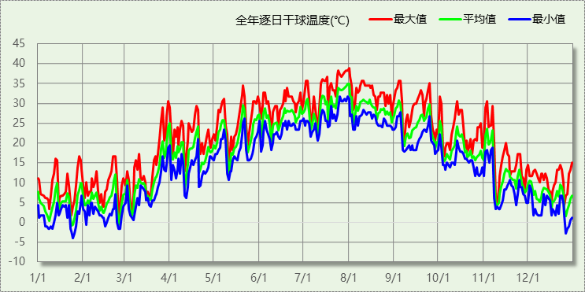

## 逐月辐照量表

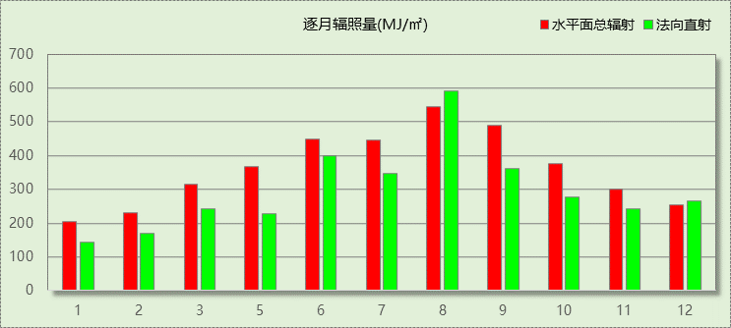

## 峰值工况

|  |  |  |  |  |  |
| --- | --- | --- | --- | --- | --- |
| 气象数据 | 时刻 | 干球温度(℃) | 湿球温度(℃) | 含湿量(g/kg) | 焓值(kj/kg) |
| 最大值 | 07月31日15时 | 38.9 | 27.8 | 19.6 | 89.5 |
| 最小值 | 01月24日04时 | -3.9 | -3.9 | 2.5 | 2.3 |

# 软件介绍

本报告采用的软件为绿建斯维尔暖通负荷BECH2020，该软件紧密结合暖通和节能设计规范、可根据项目实际情况建立建筑热工模型，并可对围护结构材料、房间内扰发热、作息时间表、热回收方式等参数进行设置。

软件包含全国各地典型气象年数据，内置DOE2.1E内核，对于建筑的逐时负荷进行动态模拟，既可以模拟8760小时理想负荷，也可以根据设定好的采暖期/空调期进行逐时模拟。

软件还支持分析全年建筑能耗的来源构成，依据日射得热、新风负荷、围护传热和内扰得热进行归类分项，生成设计建筑全年负荷计算报告书，提供详实的数据和多样的图表，为设计师在设备选型、制定运行策略等方面提供参考和帮助。

# 围护结构

## 屋顶构造

### 屋顶构造一

|  |  |  |  |  |  |  |
| --- | --- | --- | --- | --- | --- | --- |
| 材料名称 （由上到下） | 厚度δ | 导热系数λ | 蓄热系数S | 修正系数 | 热阻R | 热惰性指标 |
| (mm) | W/(m.K) | W/(㎡.K) | α | (㎡K)/W | D=R*S |
| 聚氨酯硬泡沫塑料(1) | 100 | 0.025 | 0.390 | 1.10 | 3.636 | 1.560 |
| 钢筋混凝土 | 100 | 1.740 | 17.200 | 1.00 | 0.057 | 0.989 |
| 各层之和∑ | 200 | － | － | － | 3.694 | 2.549 |
| 外表面太阳辐射吸收系数 | 0.70[默认] | | | | | |
| 传热系数K=1/(0.15+∑R) | 0.26 | | | | | |
| 数据来源 | 黑龙江居建节能65%标准第82页 | | | | | |

## 外墙构造

### 外墙构造一

|  |  |  |  |  |  |  |
| --- | --- | --- | --- | --- | --- | --- |
| 材料名称 （由外到内） | 厚度δ | 导热系数λ | 蓄热系数S | 修正系数 | 热阻R | 热惰性指标 |
| (mm) | W/(m.K) | W/(㎡.K) | α | (㎡K)/W | D=R*S |
| 耐碱玻纤网布抗裂砂浆 | 5 | 0.930 | 11.306 | 1.00 | 0.005 | 0.061 |
| 聚氨酯硬泡沫塑料 | 60 | 0.033 | 0.391 | 1.20 | 1.515 | 0.711 |
| 混凝土空心砖(190单排孔） | 190 | 0.860 | 7.480 | 1.00 | 0.221 | 1.653 |
| 石灰水泥砂浆 | 20 | 0.870 | 10.627 | 1.00 | 0.023 | 0.244 |
| 各层之和∑ | 275 | － | － | － | 1.764 | 2.669 |
| 外表面太阳辐射吸收系数 | 0.70[默认] | | | | | |
| 传热系数K=1/(0.15+∑R) | 0.52 | | | | | |
| 修正后K, D | K = 0.53, D = 2.67 | | | | | |
| 修正原因 |  | | | | | |

### 热桥梁构造一

|  |  |  |  |  |  |  |
| --- | --- | --- | --- | --- | --- | --- |
| 材料名称 （由外到内） | 厚度δ | 导热系数λ | 蓄热系数S | 修正系数 | 热阻R | 热惰性指标 |
| (mm) | W/(m.K) | W/(㎡.K) | α | (㎡K)/W | D=R*S |
| 水泥砂浆 | 20 | 0.930 | 11.370 | 1.00 | 0.022 | 0.245 |
| 挤塑聚苯乙烯泡沫塑料（带表皮） | 20 | 0.030 | 0.340 | 1.20 | 0.556 | 0.227 |
| 水泥砂浆 | 20 | 0.930 | 11.370 | 1.00 | 0.022 | 0.245 |
| 钢筋混凝土 | 200 | 1.740 | 17.200 | 1.00 | 0.115 | 1.977 |
| 石灰砂浆 | 20 | 0.810 | 10.070 | 1.00 | 0.025 | 0.249 |
| 各层之和∑ | 280 | － | － | － | 0.738 | 2.941 |
| 外表面太阳辐射吸收系数 | 0.70[默认] | | | | | |
| 传热系数K=1/(0.15+∑R) | 1.13 | | | | | |

## 挑空楼板构造

### 挑空楼板构造一

|  |  |  |  |  |  |  |
| --- | --- | --- | --- | --- | --- | --- |
| 材料名称 （由上到下） | 厚度δ | 导热系数λ | 蓄热系数S | 修正系数 | 热阻R | 热惰性指标 |
| (mm) | W/(m.K) | W/(㎡.K) | α | (㎡K)/W | D=R*S |
| 水泥砂浆面层 | 20 | 0.930 | 11.370 | 1.00 | 0.022 | 0.245 |
| 现浇钢筋砼板 | 100 | 1.740 | 17.060 | 1.00 | 0.057 | 0.980 |
| 挤塑聚苯板(XPS)(P=25~32) | 55 | 0.030 | 0.365 | 1.10 | 1.667 | 0.669 |
| 聚合物抗裂砂浆(网格布) | 5 | 0.930 | 11.306 | 1.00 | 0.005 | 0.061 |
| 各层之和∑ | 180 | － | － | － | 1.751 | 1.955 |
| 传热系数K=1/(0.15+∑R) | 0.53 | | | | | |
| 修正后K, D | K = 0.53, D = 0.05 | | | | | |
| 修正原因 |  | | | | | |

## 楼板构造

### 控温房间楼板构造一

|  |  |  |  |  |  |  |
| --- | --- | --- | --- | --- | --- | --- |
| 材料名称 | 厚度δ | 导热系数λ | 蓄热系数S | 修正系数 | 热阻R | 热惰性指标 |
| (mm) | W/(m.K) | W/(㎡.K) | α | (㎡K)/W | D=R*S |
| 水泥砂浆 | 20 | 0.930 | 11.370 | 1.00 | 0.022 | 0.245 |
| 钢筋混凝土 | 120 | 1.740 | 17.200 | 1.00 | 0.069 | 1.186 |
| 石灰砂浆 | 20 | 0.810 | 10.070 | 1.00 | 0.025 | 0.249 |
| 各层之和∑ | 160 | － | － | － | 0.115 | 1.679 |
| 传热系数K=1/(0.22+∑R) | 2.98 | | | | | |

## 周边地面构造

### 周边地面构造一

|  |  |  |  |  |  |  |
| --- | --- | --- | --- | --- | --- | --- |
| 材料名称 | 厚度δ | 导热系数λ | 蓄热系数S | 修正系数 | 热阻R | 热惰性指标 |
| (mm) | W/(m.K) | W/(㎡.K) | α | (㎡K)/W | D=R*S |
| 水泥砂浆 | 20 | 0.930 | 11.370 | 1.00 | 0.022 | 0.245 |
| 钢筋混凝土 | 120 | 1.740 | 17.200 | 1.00 | 0.069 | 1.186 |
| 各层之和∑ | 140 | － | － | － | 0.090 | 1.431 |
| 传热系数K=1/(0.11+∑R) | 0.52 | | | | | |
|  |  |  |  |  |  |  |

## 非周边地面构造

### 非周边地面构造一

|  |  |  |  |  |  |  |
| --- | --- | --- | --- | --- | --- | --- |
| 材料名称 | 厚度δ | 导热系数λ | 蓄热系数S | 修正系数 | 热阻R | 热惰性指标 |
| (mm) | W/(m.K) | W/(㎡.K) | α | (㎡K)/W | D=R*S |
| 水泥砂浆 | 20 | 0.930 | 11.370 | 1.00 | 0.022 | 0.245 |
| 钢筋混凝土 | 120 | 1.740 | 17.200 | 1.00 | 0.069 | 1.186 |
| 各层之和∑ | 140 | － | － | － | 0.090 | 1.431 |
| 传热系数K=1/(0.11+∑R) | 0.30 | | | | | |
|  |  |  |  |  |  |  |

## 门构造

|  |  |  |  |
| --- | --- | --- | --- |
| 序号 | 构造名称 | 传热系数 | 备注 |
| 1 | 多功能户门 | 1.500 |  |

## 窗构造

|  |  |  |  |  |  |
| --- | --- | --- | --- | --- | --- |
| 序号 | 构造名称 | 传热系数 | 遮阳系数 | 可见光透射比 | 备注 |
| 1 | 6＋12A＋6中透低辐射玻璃 | 1.800 | 0.570 | 0.160 | 同上 |
| 2 | 6＋12A＋6中透低辐射玻璃 | 1.800 | 0.570 | 0.160 | 同上 |
| 3 | 100-140A钢铝单层+单框双玻窗（上限） | 2.300 | 0.172 | 0.290 | 来源《民用建筑热工设计规范》 |

# 房间类型

## 房间表

|  |  |  |  |  |  |  |
| --- | --- | --- | --- | --- | --- | --- |
| 房间类型 | 空调温度 ℃ | 供暖温度 ℃ | 新风量 | 人员密度 | 照明功率 密度 | 电器设备 功率 |
| 办公-普通办公室 | 26 | 20 | 30(m^3/h.人) | 8(m^2/人) | 9(W/m^2) | 15(W/m^2) |
| 办公-走廊 | 26 | 16 | 20(m^3/h.人) | 50(m^2/人) | 5(W/m^2) | 15(W/m^2) |
| 教育-书库 | 28 | 10 | 0(m^3/h.人) | 0(m^2/人) | 7(W/m^2) | 5(W/m^2) |
| 教育-健身活动室 | 24 | 19 | 40(m^3/h.人) | 4(m^2/人) | 9(W/m^2) | 5(W/m^2) |
| 教育-办公室 | 26 | 20 | 30(m^3/h.人) | 6(m^2/人) | 9(W/m^2) | 5(W/m^2) |
| 教育-卫生间 | 28 | 16 | 0(m^3/h.人) | 0(m^2/人) | 6(W/m^2) | 5(W/m^2) |
| 教育-多媒体教室 | 26 | 18 | 20(m^3/h.人) | 4(m^2/人) | 9(W/m^2) | 5(W/m^2) |
| 教育-更衣室 | 26 | 20 | 6(次/h) | 4(m^2/人) | 6(W/m^2) | 5(W/m^2) |
| 教育-舞蹈教室 | 26 | 20 | 30(m^3/h.人) | 4(m^2/人) | 9(W/m^2) | 5(W/m^2) |
| 教育-视听阅览室 | 26 | 18 | 20(m^3/h.人) | 1.9(m^2/人) | 15(W/m^2) | 5(W/m^2) |
| 教育-阅览室 | 26 | 20 | 20(m^3/h.人) | 1.9(m^2/人) | 9(W/m^2) | 5(W/m^2) |
| 教育-音乐教室 | 26 | 18 | 20(m^3/h.人) | 4(m^2/人) | 9(W/m^2) | 5(W/m^2) |
| 教育-高级办公室 | 26 | 20 | 30(m^3/h.人) | 8(m^2/人) | 15(W/m^2) | 5(W/m^2) |

## 作息时间表

详见附录

# 系统设置

## 系统划分

|  |  |  |  |  |  |  |
| --- | --- | --- | --- | --- | --- | --- |
| 系统编号 | 热回收 类型 | 启动 条件 | 回收 效率 | 排风 比例 | 面积(m2) | 包含的房间 |
| 默认 | 无 | -- | -- | -- | 2939.79 | 所有房间 |

## 运行时间表

详见附录

# 计算结果

## 模拟周期

全年8760小时模拟

## 全年冷暖需求

|  |  |  |  |  |
| --- | --- | --- | --- | --- |
| 系统名称\负荷 | 供暖需求 (kWh) | 供暖指标 (kWh/㎡·a) | 供冷需求 (kWh) | 供冷指标 (kWh/㎡·a) |
| 默认系统 | 66026 | 22 | 323777 | 110 |
| 总计 | 66026 | 22 | 323777 | 110 |

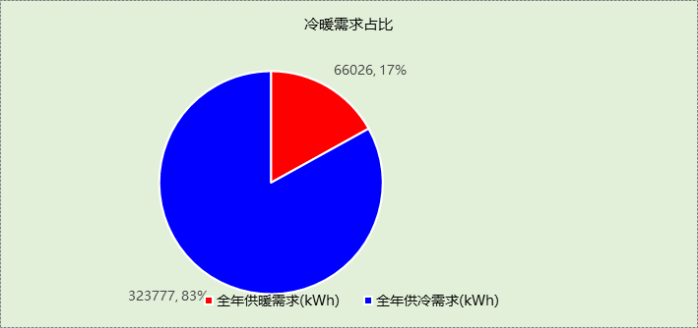

## 能耗分项统计

|  |  |  |  |  |  |  |
| --- | --- | --- | --- | --- | --- | --- |
| 分类 | 围护传热 | 室内得热 | 窗日射 | 新风/渗透 | 热回收 | 合计 |
| 供暖需求(kWh) | -67317 | 38817 | 9378 | -46905 | 0 | -66026 |
| 供冷需求(kWh) | 20936 | 126536 | 58665 | 117640 | 0 | 323777 |

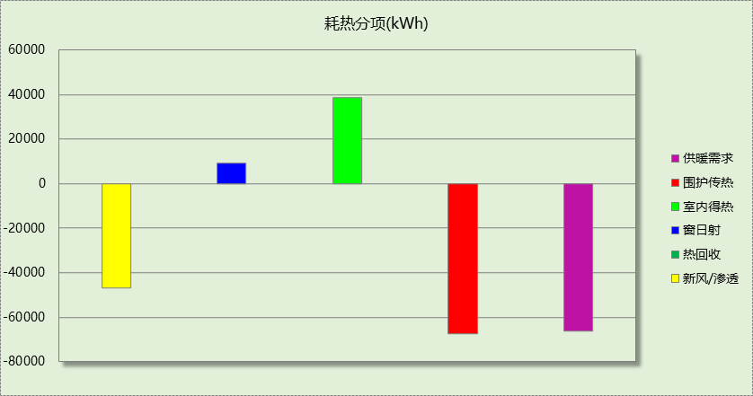

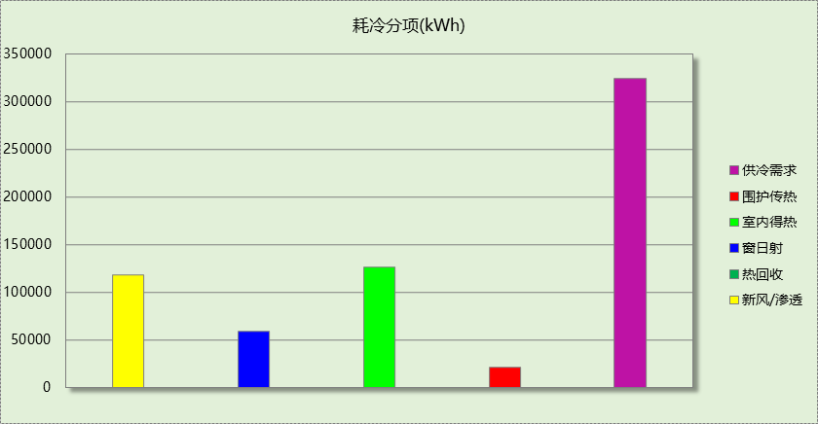

## 逐月负荷表

|  |  |  |  |  |  |  |
| --- | --- | --- | --- | --- | --- | --- |
| 月份 | 供暖需求 (kWh) | 供冷需求 (kWh) | 热负荷 峰值(kW) | 热负荷 峰值时刻 | 冷负荷 峰值(kW) | 冷负荷 峰值时刻 |
| 1月 | 23169 | 201 | 299.678 | 01月07日08时 | 27.022 | 01月28日15时 |
| 2月 | 15769 | 398 | 389.343 | 02月14日08时 | 31.148 | 02月20日13时 |
| 3月 | 13365 | 3145 | 296.990 | 03月18日08时 | 135.886 | 03月29日14时 |
| 4月 | 413 | 8385 | 21.403 | 04月11日08时 | 166.698 | 04月19日14时 |
| 5月 | 22 | 27325 | 2.231 | 05月10日17时 | 381.488 | 05月21日16时 |
| 6月 | 0 | 49945 | 0.000 | -- | 371.470 | 06月17日15时 |
| 7月 | 0 | 79938 | 0.000 | -- | 501.520 | 07月29日08时 |
| 8月 | 0 | 79830 | 0.000 | -- | 474.851 | 08月12日08时 |
| 9月 | 0 | 50106 | 0.000 | -- | 506.876 | 09月04日10时 |
| 10月 | 0 | 15902 | 0.000 | -- | 267.414 | 10月14日14时 |
| 11月 | 1937 | 7947 | 142.485 | 11月11日08时 | 216.918 | 11月01日14时 |
| 12月 | 11351 | 657 | 220.833 | 12月16日08时 | 31.888 | 12月06日14时 |

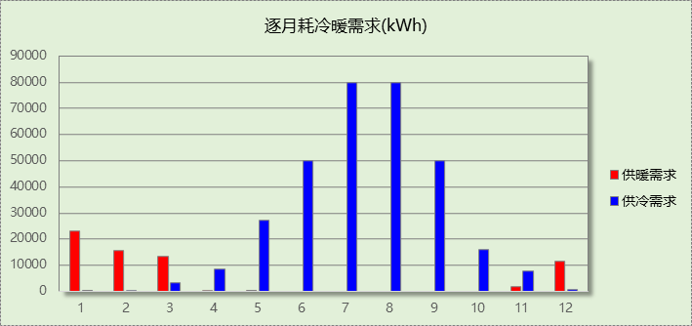

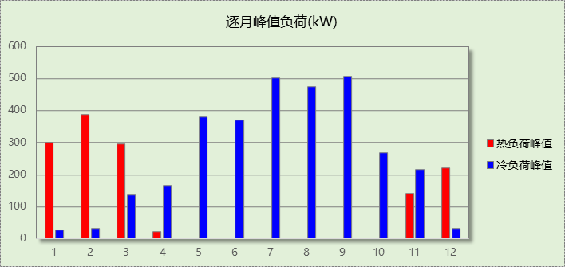

# 附录

**工作日/节假日人员逐时在室率(%)**

|  |  |  |  |  |  |  |  |  |  |  |  |  |  |  |  |  |  |  |  |  |  |  |  |  |
| --- | --- | --- | --- | --- | --- | --- | --- | --- | --- | --- | --- | --- | --- | --- | --- | --- | --- | --- | --- | --- | --- | --- | --- | --- |
| 房间类型 | 1 | 2 | 3 | 4 | 5 | 6 | 7 | 8 | 9 | 10 | 11 | 12 | 13 | 14 | 15 | 16 | 17 | 18 | 19 | 20 | 21 | 22 | 23 | 24 |
| 办公-普通办公室 | 0 | 0 | 0 | 0 | 0 | 0 | 10 | 50 | 100 | 100 | 100 | 30 | 100 | 100 | 100 | 100 | 50 | 20 | 10 | 0 | 0 | 0 | 0 | 0 |
| 0 | 0 | 0 | 0 | 0 | 0 | 0 | 20 | 45 | 0 | 0 | 0 | 0 | 0 | 0 | 0 | 0 | 0 | 0 | 0 | 0 | 0 | 0 | 0 |
| 办公-走廊 | 0 | 0 | 0 | 0 | 0 | 0 | 10 | 50 | 95 | 95 | 95 | 80 | 80 | 95 | 95 | 95 | 95 | 30 | 30 | 0 | 0 | 0 | 0 | 0 |
| 0 | 0 | 0 | 0 | 0 | 0 | 0 | 0 | 0 | 0 | 0 | 0 | 0 | 0 | 0 | 0 | 0 | 0 | 0 | 0 | 0 | 0 | 0 | 0 |
| 教育-书库 | 0 | 0 | 0 | 0 | 0 | 0 | 10 | 50 | 95 | 95 | 95 | 80 | 80 | 95 | 95 | 95 | 95 | 30 | 30 | 0 | 0 | 0 | 0 | 0 |
| 0 | 0 | 0 | 0 | 0 | 0 | 0 | 0 | 0 | 0 | 0 | 0 | 0 | 0 | 0 | 0 | 0 | 0 | 0 | 0 | 0 | 0 | 0 | 0 |
| 教育-健身活动室 | 0 | 0 | 0 | 0 | 0 | 0 | 10 | 50 | 95 | 95 | 95 | 80 | 80 | 95 | 95 | 95 | 95 | 30 | 30 | 0 | 0 | 0 | 0 | 0 |
| 0 | 0 | 0 | 0 | 0 | 0 | 0 | 0 | 0 | 0 | 0 | 0 | 0 | 0 | 0 | 0 | 0 | 0 | 0 | 0 | 0 | 0 | 0 | 0 |
| 教育-办公室 | 0 | 0 | 0 | 0 | 0 | 0 | 10 | 50 | 95 | 95 | 95 | 80 | 80 | 95 | 95 | 95 | 95 | 30 | 30 | 0 | 0 | 0 | 0 | 0 |
| 0 | 0 | 0 | 0 | 0 | 0 | 0 | 0 | 0 | 0 | 0 | 0 | 0 | 0 | 0 | 0 | 0 | 0 | 0 | 0 | 0 | 0 | 0 | 0 |
| 教育-卫生间 | 0 | 0 | 0 | 0 | 0 | 0 | 10 | 50 | 95 | 95 | 95 | 80 | 80 | 95 | 95 | 95 | 95 | 30 | 30 | 0 | 0 | 0 | 0 | 0 |
| 0 | 0 | 0 | 0 | 0 | 0 | 0 | 0 | 0 | 0 | 0 | 0 | 0 | 0 | 0 | 0 | 0 | 0 | 0 | 0 | 0 | 0 | 0 | 0 |
| 教育-多媒体教室 | 0 | 0 | 0 | 0 | 0 | 0 | 10 | 50 | 95 | 95 | 95 | 80 | 80 | 95 | 95 | 95 | 95 | 30 | 30 | 0 | 0 | 0 | 0 | 0 |
| 0 | 0 | 0 | 0 | 0 | 0 | 0 | 0 | 0 | 0 | 0 | 0 | 0 | 0 | 0 | 0 | 0 | 0 | 0 | 0 | 0 | 0 | 0 | 0 |
| 教育-更衣室 | 0 | 0 | 0 | 0 | 0 | 0 | 10 | 50 | 95 | 95 | 95 | 80 | 80 | 95 | 95 | 95 | 95 | 30 | 30 | 0 | 0 | 0 | 0 | 0 |
| 0 | 0 | 0 | 0 | 0 | 0 | 0 | 0 | 0 | 0 | 0 | 0 | 0 | 0 | 0 | 0 | 0 | 0 | 0 | 0 | 0 | 0 | 0 | 0 |
| 教育-舞蹈教室 | 0 | 0 | 0 | 0 | 0 | 0 | 10 | 50 | 95 | 95 | 95 | 80 | 80 | 95 | 95 | 95 | 95 | 30 | 30 | 0 | 0 | 0 | 0 | 0 |
| 0 | 0 | 0 | 0 | 0 | 0 | 0 | 0 | 0 | 0 | 0 | 0 | 0 | 0 | 0 | 0 | 0 | 0 | 0 | 0 | 0 | 0 | 0 | 0 |
| 教育-视听阅览室 | 0 | 0 | 0 | 0 | 0 | 0 | 10 | 50 | 95 | 95 | 95 | 80 | 80 | 95 | 95 | 95 | 95 | 30 | 30 | 0 | 0 | 0 | 0 | 0 |
| 0 | 0 | 0 | 0 | 0 | 0 | 0 | 0 | 0 | 0 | 0 | 0 | 0 | 0 | 0 | 0 | 0 | 0 | 0 | 0 | 0 | 0 | 0 | 0 |
| 教育-阅览室 | 0 | 0 | 0 | 0 | 0 | 0 | 10 | 50 | 95 | 95 | 95 | 80 | 80 | 95 | 95 | 95 | 95 | 30 | 30 | 0 | 0 | 0 | 0 | 0 |
| 0 | 0 | 0 | 0 | 0 | 0 | 0 | 0 | 0 | 0 | 0 | 0 | 0 | 0 | 0 | 0 | 0 | 0 | 0 | 0 | 0 | 0 | 0 | 0 |
| 教育-音乐教室 | 0 | 0 | 0 | 0 | 0 | 0 | 10 | 50 | 95 | 95 | 95 | 80 | 80 | 95 | 95 | 95 | 95 | 30 | 30 | 0 | 0 | 0 | 0 | 0 |
| 0 | 0 | 0 | 0 | 0 | 0 | 0 | 0 | 0 | 0 | 0 | 0 | 0 | 0 | 0 | 0 | 0 | 0 | 0 | 0 | 0 | 0 | 0 | 0 |
| 教育-高级办公室 | 0 | 0 | 0 | 0 | 0 | 0 | 10 | 50 | 95 | 95 | 95 | 80 | 80 | 95 | 95 | 95 | 95 | 30 | 30 | 0 | 0 | 0 | 0 | 0 |
| 0 | 0 | 0 | 0 | 0 | 0 | 0 | 0 | 0 | 0 | 0 | 0 | 0 | 0 | 0 | 0 | 0 | 0 | 0 | 0 | 0 | 0 | 0 | 0 |

注：上行：工作日；下行：节假日

**工作日/节假日照明开关时间表(%)**

|  |  |  |  |  |  |  |  |  |  |  |  |  |  |  |  |  |  |  |  |  |  |  |  |  |
| --- | --- | --- | --- | --- | --- | --- | --- | --- | --- | --- | --- | --- | --- | --- | --- | --- | --- | --- | --- | --- | --- | --- | --- | --- |
| 房间类型 | 1 | 2 | 3 | 4 | 5 | 6 | 7 | 8 | 9 | 10 | 11 | 12 | 13 | 14 | 15 | 16 | 17 | 18 | 19 | 20 | 21 | 22 | 23 | 24 |
| 办公-普通办公室 | 10 | 10 | 10 | 10 | 10 | 10 | 10 | 36 | 62 | 56 | 54 | 43 | 53 | 55 | 58 | 67 | 40 | 18 | 10 | 10 | 10 | 10 | 10 | 10 |
| 0 | 0 | 0 | 0 | 0 | 0 | 0 | 0 | 0 | 0 | 0 | 0 | 0 | 0 | 0 | 0 | 0 | 0 | 0 | 0 | 0 | 0 | 0 | 0 |
| 办公-走廊 | 0 | 0 | 0 | 0 | 0 | 0 | 10 | 50 | 95 | 95 | 95 | 80 | 80 | 95 | 95 | 95 | 95 | 30 | 30 | 0 | 0 | 0 | 0 | 0 |
| 0 | 0 | 0 | 0 | 0 | 0 | 0 | 0 | 0 | 0 | 0 | 0 | 0 | 0 | 0 | 0 | 0 | 0 | 0 | 0 | 0 | 0 | 0 | 0 |
| 教育-书库 | 0 | 0 | 0 | 0 | 0 | 0 | 10 | 50 | 95 | 95 | 95 | 80 | 80 | 95 | 95 | 95 | 95 | 30 | 30 | 0 | 0 | 0 | 0 | 0 |
| 0 | 0 | 0 | 0 | 0 | 0 | 0 | 0 | 0 | 0 | 0 | 0 | 0 | 0 | 0 | 0 | 0 | 0 | 0 | 0 | 0 | 0 | 0 | 0 |
| 教育-健身活动室 | 0 | 0 | 0 | 0 | 0 | 0 | 10 | 50 | 95 | 95 | 95 | 80 | 80 | 95 | 95 | 95 | 95 | 30 | 30 | 0 | 0 | 0 | 0 | 0 |
| 0 | 0 | 0 | 0 | 0 | 0 | 0 | 0 | 0 | 0 | 0 | 0 | 0 | 0 | 0 | 0 | 0 | 0 | 0 | 0 | 0 | 0 | 0 | 0 |
| 教育-办公室 | 0 | 0 | 0 | 0 | 0 | 0 | 10 | 50 | 95 | 95 | 95 | 80 | 80 | 95 | 95 | 95 | 95 | 30 | 30 | 0 | 0 | 0 | 0 | 0 |
| 0 | 0 | 0 | 0 | 0 | 0 | 0 | 0 | 0 | 0 | 0 | 0 | 0 | 0 | 0 | 0 | 0 | 0 | 0 | 0 | 0 | 0 | 0 | 0 |
| 教育-卫生间 | 0 | 0 | 0 | 0 | 0 | 0 | 10 | 50 | 95 | 95 | 95 | 80 | 80 | 95 | 95 | 95 | 95 | 30 | 30 | 0 | 0 | 0 | 0 | 0 |
| 0 | 0 | 0 | 0 | 0 | 0 | 0 | 0 | 0 | 0 | 0 | 0 | 0 | 0 | 0 | 0 | 0 | 0 | 0 | 0 | 0 | 0 | 0 | 0 |
| 教育-多媒体教室 | 0 | 0 | 0 | 0 | 0 | 0 | 10 | 50 | 95 | 95 | 95 | 80 | 80 | 95 | 95 | 95 | 95 | 30 | 30 | 0 | 0 | 0 | 0 | 0 |
| 0 | 0 | 0 | 0 | 0 | 0 | 0 | 0 | 0 | 0 | 0 | 0 | 0 | 0 | 0 | 0 | 0 | 0 | 0 | 0 | 0 | 0 | 0 | 0 |
| 教育-更衣室 | 0 | 0 | 0 | 0 | 0 | 0 | 10 | 50 | 95 | 95 | 95 | 80 | 80 | 95 | 95 | 95 | 95 | 30 | 30 | 0 | 0 | 0 | 0 | 0 |
| 0 | 0 | 0 | 0 | 0 | 0 | 0 | 0 | 0 | 0 | 0 | 0 | 0 | 0 | 0 | 0 | 0 | 0 | 0 | 0 | 0 | 0 | 0 | 0 |
| 教育-舞蹈教室 | 0 | 0 | 0 | 0 | 0 | 0 | 10 | 50 | 95 | 95 | 95 | 80 | 80 | 95 | 95 | 95 | 95 | 30 | 30 | 0 | 0 | 0 | 0 | 0 |
| 0 | 0 | 0 | 0 | 0 | 0 | 0 | 0 | 0 | 0 | 0 | 0 | 0 | 0 | 0 | 0 | 0 | 0 | 0 | 0 | 0 | 0 | 0 | 0 |
| 教育-视听阅览室 | 0 | 0 | 0 | 0 | 0 | 0 | 10 | 50 | 95 | 95 | 95 | 80 | 80 | 95 | 95 | 95 | 95 | 30 | 30 | 0 | 0 | 0 | 0 | 0 |
| 0 | 0 | 0 | 0 | 0 | 0 | 0 | 0 | 0 | 0 | 0 | 0 | 0 | 0 | 0 | 0 | 0 | 0 | 0 | 0 | 0 | 0 | 0 | 0 |
| 教育-阅览室 | 0 | 0 | 0 | 0 | 0 | 0 | 10 | 50 | 95 | 95 | 95 | 80 | 80 | 95 | 95 | 95 | 95 | 30 | 30 | 0 | 0 | 0 | 0 | 0 |
| 0 | 0 | 0 | 0 | 0 | 0 | 0 | 0 | 0 | 0 | 0 | 0 | 0 | 0 | 0 | 0 | 0 | 0 | 0 | 0 | 0 | 0 | 0 | 0 |
| 教育-音乐教室 | 0 | 0 | 0 | 0 | 0 | 0 | 10 | 50 | 95 | 95 | 95 | 80 | 80 | 95 | 95 | 95 | 95 | 30 | 30 | 0 | 0 | 0 | 0 | 0 |
| 0 | 0 | 0 | 0 | 0 | 0 | 0 | 0 | 0 | 0 | 0 | 0 | 0 | 0 | 0 | 0 | 0 | 0 | 0 | 0 | 0 | 0 | 0 | 0 |
| 教育-高级办公室 | 0 | 0 | 0 | 0 | 0 | 0 | 10 | 50 | 95 | 95 | 95 | 80 | 80 | 95 | 95 | 95 | 95 | 30 | 30 | 0 | 0 | 0 | 0 | 0 |
| 0 | 0 | 0 | 0 | 0 | 0 | 0 | 0 | 0 | 0 | 0 | 0 | 0 | 0 | 0 | 0 | 0 | 0 | 0 | 0 | 0 | 0 | 0 | 0 |

注：上行：工作日；下行：节假日

**工作日/节假日设备逐时使用率(%)**

|  |  |  |  |  |  |  |  |  |  |  |  |  |  |  |  |  |  |  |  |  |  |  |  |  |
| --- | --- | --- | --- | --- | --- | --- | --- | --- | --- | --- | --- | --- | --- | --- | --- | --- | --- | --- | --- | --- | --- | --- | --- | --- |
| 房间类型 | 1 | 2 | 3 | 4 | 5 | 6 | 7 | 8 | 9 | 10 | 11 | 12 | 13 | 14 | 15 | 16 | 17 | 18 | 19 | 20 | 21 | 22 | 23 | 24 |
| 办公-普通办公室 | 0 | 0 | 0 | 0 | 0 | 0 | 10 | 50 | 100 | 100 | 100 | 100 | 100 | 100 | 100 | 100 | 50 | 20 | 10 | 0 | 0 | 0 | 0 | 0 |
| 0 | 0 | 0 | 0 | 0 | 0 | 0 | 0 | 0 | 0 | 0 | 0 | 0 | 0 | 0 | 0 | 0 | 0 | 0 | 0 | 0 | 0 | 0 | 0 |
| 办公-走廊 | 0 | 0 | 0 | 0 | 0 | 0 | 10 | 50 | 95 | 95 | 95 | 50 | 50 | 95 | 95 | 95 | 95 | 30 | 30 | 0 | 0 | 0 | 0 | 0 |
| 0 | 0 | 0 | 0 | 0 | 0 | 0 | 0 | 0 | 0 | 0 | 0 | 0 | 0 | 0 | 0 | 0 | 0 | 0 | 0 | 0 | 0 | 0 | 0 |
| 教育-书库 | 0 | 0 | 0 | 0 | 0 | 0 | 10 | 50 | 95 | 95 | 95 | 50 | 50 | 95 | 95 | 95 | 95 | 30 | 30 | 0 | 0 | 0 | 0 | 0 |
| 0 | 0 | 0 | 0 | 0 | 0 | 0 | 0 | 0 | 0 | 0 | 0 | 0 | 0 | 0 | 0 | 0 | 0 | 0 | 0 | 0 | 0 | 0 | 0 |
| 教育-健身活动室 | 0 | 0 | 0 | 0 | 0 | 0 | 10 | 50 | 95 | 95 | 95 | 50 | 50 | 95 | 95 | 95 | 95 | 30 | 30 | 0 | 0 | 0 | 0 | 0 |
| 0 | 0 | 0 | 0 | 0 | 0 | 0 | 0 | 0 | 0 | 0 | 0 | 0 | 0 | 0 | 0 | 0 | 0 | 0 | 0 | 0 | 0 | 0 | 0 |
| 教育-办公室 | 0 | 0 | 0 | 0 | 0 | 0 | 10 | 50 | 95 | 95 | 95 | 50 | 50 | 95 | 95 | 95 | 95 | 30 | 30 | 0 | 0 | 0 | 0 | 0 |
| 0 | 0 | 0 | 0 | 0 | 0 | 0 | 0 | 0 | 0 | 0 | 0 | 0 | 0 | 0 | 0 | 0 | 0 | 0 | 0 | 0 | 0 | 0 | 0 |
| 教育-卫生间 | 0 | 0 | 0 | 0 | 0 | 0 | 10 | 50 | 95 | 95 | 95 | 50 | 50 | 95 | 95 | 95 | 95 | 30 | 30 | 0 | 0 | 0 | 0 | 0 |
| 0 | 0 | 0 | 0 | 0 | 0 | 0 | 0 | 0 | 0 | 0 | 0 | 0 | 0 | 0 | 0 | 0 | 0 | 0 | 0 | 0 | 0 | 0 | 0 |
| 教育-多媒体教室 | 0 | 0 | 0 | 0 | 0 | 0 | 10 | 50 | 95 | 95 | 95 | 50 | 50 | 95 | 95 | 95 | 95 | 30 | 30 | 0 | 0 | 0 | 0 | 0 |
| 0 | 0 | 0 | 0 | 0 | 0 | 0 | 0 | 0 | 0 | 0 | 0 | 0 | 0 | 0 | 0 | 0 | 0 | 0 | 0 | 0 | 0 | 0 | 0 |
| 教育-更衣室 | 0 | 0 | 0 | 0 | 0 | 0 | 10 | 50 | 95 | 95 | 95 | 50 | 50 | 95 | 95 | 95 | 95 | 30 | 30 | 0 | 0 | 0 | 0 | 0 |
| 0 | 0 | 0 | 0 | 0 | 0 | 0 | 0 | 0 | 0 | 0 | 0 | 0 | 0 | 0 | 0 | 0 | 0 | 0 | 0 | 0 | 0 | 0 | 0 |
| 教育-舞蹈教室 | 0 | 0 | 0 | 0 | 0 | 0 | 10 | 50 | 95 | 95 | 95 | 50 | 50 | 95 | 95 | 95 | 95 | 30 | 30 | 0 | 0 | 0 | 0 | 0 |
| 0 | 0 | 0 | 0 | 0 | 0 | 0 | 0 | 0 | 0 | 0 | 0 | 0 | 0 | 0 | 0 | 0 | 0 | 0 | 0 | 0 | 0 | 0 | 0 |
| 教育-视听阅览室 | 0 | 0 | 0 | 0 | 0 | 0 | 10 | 50 | 95 | 95 | 95 | 50 | 50 | 95 | 95 | 95 | 95 | 30 | 30 | 0 | 0 | 0 | 0 | 0 |
| 0 | 0 | 0 | 0 | 0 | 0 | 0 | 0 | 0 | 0 | 0 | 0 | 0 | 0 | 0 | 0 | 0 | 0 | 0 | 0 | 0 | 0 | 0 | 0 |
| 教育-阅览室 | 0 | 0 | 0 | 0 | 0 | 0 | 10 | 50 | 95 | 95 | 95 | 50 | 50 | 95 | 95 | 95 | 95 | 30 | 30 | 0 | 0 | 0 | 0 | 0 |
| 0 | 0 | 0 | 0 | 0 | 0 | 0 | 0 | 0 | 0 | 0 | 0 | 0 | 0 | 0 | 0 | 0 | 0 | 0 | 0 | 0 | 0 | 0 | 0 |
| 教育-音乐教室 | 0 | 0 | 0 | 0 | 0 | 0 | 10 | 50 | 95 | 95 | 95 | 50 | 50 | 95 | 95 | 95 | 95 | 30 | 30 | 0 | 0 | 0 | 0 | 0 |
| 0 | 0 | 0 | 0 | 0 | 0 | 0 | 0 | 0 | 0 | 0 | 0 | 0 | 0 | 0 | 0 | 0 | 0 | 0 | 0 | 0 | 0 | 0 | 0 |
| 教育-高级办公室 | 0 | 0 | 0 | 0 | 0 | 0 | 10 | 50 | 95 | 95 | 95 | 50 | 50 | 95 | 95 | 95 | 95 | 30 | 30 | 0 | 0 | 0 | 0 | 0 |
| 0 | 0 | 0 | 0 | 0 | 0 | 0 | 0 | 0 | 0 | 0 | 0 | 0 | 0 | 0 | 0 | 0 | 0 | 0 | 0 | 0 | 0 | 0 | 0 |

注：上行：工作日；下行：节假日

**工作日/节假日空调系统开关时间表**

|  |  |  |  |  |  |  |  |  |  |  |  |  |  |  |  |  |  |  |  |  |  |  |  |  |
| --- | --- | --- | --- | --- | --- | --- | --- | --- | --- | --- | --- | --- | --- | --- | --- | --- | --- | --- | --- | --- | --- | --- | --- | --- |
| 系统编号 | 1 | 2 | 3 | 4 | 5 | 6 | 7 | 8 | 9 | 10 | 11 | 12 | 13 | 14 | 15 | 16 | 17 | 18 | 19 | 20 | 21 | 22 | 23 | 24 |
| 默认 | 0 | 0 | 0 | 0 | 0 | 0 | 0 | 1 | 1 | 1 | 1 | 1 | 1 | 1 | 1 | 1 | 1 | 1 | 0 | 0 | 0 | 0 | 0 | 0 |
| 0 | 0 | 0 | 0 | 0 | 0 | 0 | 0 | 0 | 0 | 0 | 0 | 0 | 0 | 0 | 0 | 0 | 0 | 0 | 0 | 0 | 0 | 0 | 0 |

注：上行：工作日；下行：节假日