**住宅改造**

全年负荷计算书

|  |  |
| --- | --- |
| 工程名称 | 住宅改造 |
| 设计编号 |  |
| 建设单位 |  |
| 设计单位 |  |
| 计 算 人 |  |
| 校 对 人 |  |
| 审 核 人 |  |
| 计算日期 |  |



|  |  |
| --- | --- |
| 采用软件 | 斯维尔暖通负荷BECH2020 |
| 软件版本 | 20190909 |
| 研发单位 | 北京绿建软件有限公司 |
| 正版授权码 | T17690593753 |

**目 录**

1 建筑概况 1

2 气象数据 1

2.1 气象地点 1

2.2 逐日干球温度表 1

2.3 逐月辐照量表 2

2.4 峰值工况 2

3 软件介绍 2

4 围护结构 2

4.1 屋顶构造 2

4.1.1 屋顶构造一 2

4.2 外墙构造 3

4.2.1 外墙构造一 3

4.2.2 外墙构造二 3

4.3 户墙构造 3

4.3.1 楼梯间隔墙构造一 3

4.3.2 楼梯间隔墙构造二 4

4.4 分户墙构造 4

4.4.1 户间隔墙构造一 4

4.4.2 户间隔墙构造二 4

4.5 楼板构造 4

4.5.1 控温房间楼板构造一 4

4.6 接触室外顶板构造 5

4.6.1 阳台顶板构造一 5

4.7 接触室外底板构造 5

4.7.1 阳台底板构造一 5

4.8 栏板构造 5

4.8.1 阳台栏板构造一 5

4.9 周边地面构造 5

4.9.1 周边地面构造一 5

4.10 非周边地面构造 6

4.10.1 非周边地面构造一 6

4.11 地下墙构造 6

4.11.1 地下墙构造一 6

4.12 门构造 6

4.13 窗构造 6

5 房间类型 7

5.1 房间表 7

5.2 作息时间表 7

6 系统设置 7

6.1 系统划分 7

6.2 运行时间表 8

7 计算结果 8

7.1 模拟周期 8

7.2 全年冷暖需求 8

7.3 能耗分项统计 8

7.4 逐月负荷表 9

8 附录 11

# 建筑概况

|  |  |  |
| --- | --- | --- |
| 地理位置 | 新疆-乌鲁木齐 | |
| 气候分区 | 严寒B区 | |
| 北纬 | 44.00 | |
| 东经 | 87.61 | |
| 建筑名称 | 住宅改造 | |
| 建筑类型 | 居住建筑 |  |
| 建筑面积 | 地上 2756.50 ㎡ | 地下 428.56 ㎡ |
| 建筑高度 | 地上 19.60 m | 地下2.45 |
| 建筑层数 | 地上 6 | 地下 1 |
| 北向角度 | 60° | |

# 气象数据

## 气象地点

新疆-乌鲁木齐, 《建筑节能气象参数标准》JGJ346-2014

## 逐日干球温度表

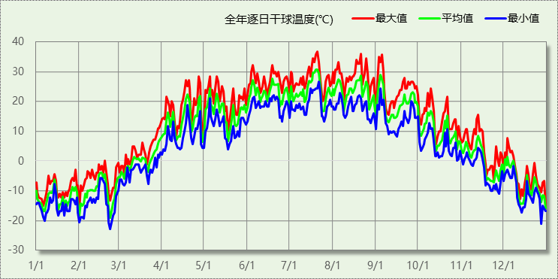

## 逐月辐照量表

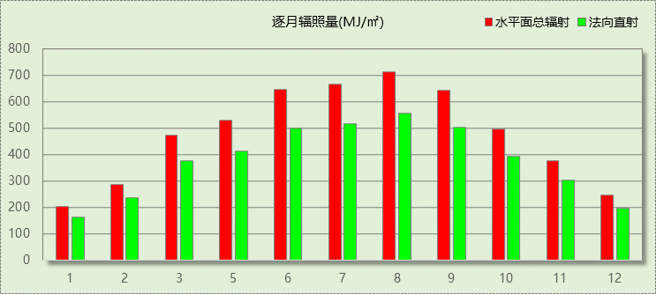

## 峰值工况

|  |  |  |  |  |  |
| --- | --- | --- | --- | --- | --- |
| 气象数据 | 时刻 | 干球温度(℃) | 湿球温度(℃) | 含湿量(g/kg) | 焓值(kj/kg) |
| 最大值 | 07月20日15时 | 36.7 | 16.7 | 5.3 | 50.5 |
| 最小值 | 02月22日08时 | -22.8 | -22.8 | 0.3 | -22.2 |

# 软件介绍

本报告采用的软件为绿建斯维尔暖通负荷BECH2020，该软件紧密结合暖通和节能设计规范、可根据项目实际情况建立建筑热工模型，并可对围护结构材料、房间内扰发热、作息时间表、热回收方式等参数进行设置。

软件包含全国各地典型气象年数据，内置DOE2.1E内核，对于建筑的逐时负荷进行动态模拟，既可以模拟8760小时理想负荷，也可以根据设定好的采暖期/空调期进行逐时模拟。

软件还支持分析全年建筑能耗的来源构成，依据日射得热、新风负荷、围护传热和内扰得热进行归类分项，生成设计建筑全年负荷计算报告书，提供详实的数据和多样的图表，为设计师在设备选型、制定运行策略等方面提供参考和帮助。

# 围护结构

## 屋顶构造

### 屋顶构造一

|  |  |  |  |  |  |  |
| --- | --- | --- | --- | --- | --- | --- |
| 材料名称 （由上到下） | 厚度δ | 导热系数λ | 蓄热系数S | 修正系数 | 热阻R | 热惰性指标 |
| (mm) | W/(m.K) | W/(㎡.K) | α | (㎡K)/W | D=R*S |
| 细石混凝土 | 30 | 1.280 | 13.570 | 1.00 | 0.023 | 0.318 |
| 粘土陶粒混凝土 | 30 | 0.530 | 7.250 | 1.15 | 0.049 | 0.410 |
| 建筑用真空绝热板 | 250 | 0.008 | 0.340 | 1.20 | 26.042 | 10.625 |
| 钢筋混凝土 | 120 | 1.740 | 17.200 | 1.00 | 0.069 | 1.186 |
| 各层之和∑ | 430 | － | － | － | 26.183 | 12.540 |
| 外表面太阳辐射吸收系数 | 0.75[默认] | | | | | |
| 传热系数K=1/(0.15+∑R) | 0.04 | | | | | |

## 外墙构造

### 外墙构造一

|  |  |  |  |  |  |  |
| --- | --- | --- | --- | --- | --- | --- |
| 材料名称 （由外到内） | 厚度δ | 导热系数λ | 蓄热系数S | 修正系数 | 热阻R | 热惰性指标 |
| (mm) | W/(m.K) | W/(㎡.K) | α | (㎡K)/W | D=R*S |
| 水泥砂浆 | 20 | 0.930 | 11.370 | 1.00 | 0.022 | 0.245 |
| 挤塑聚苯板(ρ=25-32) | 150 | 0.030 | 0.320 | 1.00 | 5.000 | 1.600 |
| 水泥砂浆 | 20 | 0.930 | 11.306 | 1.00 | 0.022 | 0.243 |
| 实心粘土砖 | 370 | 0.760 | 10.551 | 1.00 | 0.487 | 5.137 |
| 水泥砂浆 | 20 | 0.930 | 11.370 | 1.00 | 0.022 | 0.245 |
| 各层之和∑ | 580 | － | － | － | 5.551 | 7.469 |
| 外表面太阳辐射吸收系数 | 0.75[默认] | | | | | |
| 传热系数K=1/(0.15+∑R) | 0.17 | | | | | |

### 外墙构造二

|  |  |  |  |  |  |  |
| --- | --- | --- | --- | --- | --- | --- |
| 材料名称 （由外到内） | 厚度δ | 导热系数λ | 蓄热系数S | 修正系数 | 热阻R | 热惰性指标 |
| (mm) | W/(m.K) | W/(㎡.K) | α | (㎡K)/W | D=R*S |
| 水泥砂浆 | 10 | 0.930 | 11.370 | 1.00 | 0.011 | 0.122 |
| 挤塑聚苯板(ρ=25-32) | 150 | 0.030 | 0.320 | 1.00 | 5.000 | 1.600 |
| 水泥砂浆 | 20 | 0.930 | 11.306 | 1.00 | 0.022 | 0.243 |
| 钢筋混凝土 | 240 | 1.740 | 17.200 | 1.00 | 0.138 | 2.372 |
| 水泥砂浆 | 20 | 0.930 | 11.370 | 1.00 | 0.022 | 0.245 |
| 各层之和∑ | 440 | － | － | － | 5.192 | 4.582 |
| 外表面太阳辐射吸收系数 | 0.75[默认] | | | | | |
| 传热系数K=1/(0.15+∑R) | 0.19 | | | | | |

## 户墙构造

### 楼梯间隔墙构造一

|  |  |  |  |  |  |  |
| --- | --- | --- | --- | --- | --- | --- |
| 材料名称 | 厚度δ | 导热系数λ | 蓄热系数S | 修正系数 | 热阻R | 热惰性指标 |
| (mm) | W/(m.K) | W/(㎡.K) | α | (㎡K)/W | D=R*S |
| 专用饰面沙浆与涂料 | 20 | 0.930 | 11.306 | 1.00 | 0.022 | 0.243 |
| 挤塑聚苯板(ρ=25-32) | 50 | 0.030 | 0.320 | 1.00 | 1.667 | 0.533 |
| 实心粘土砖 | 240 | 0.760 | 10.551 | 1.00 | 0.316 | 3.332 |
| 混合砂浆 | 20 | 0.870 | 10.627 | 1.00 | 0.023 | 0.244 |
| 各层之和∑ | 330 | － | － | － | 2.027 | 4.353 |
| 传热系数K=1/(0.22+∑R) | 0.45 | | | | | |

### 楼梯间隔墙构造二

|  |  |  |  |  |  |  |
| --- | --- | --- | --- | --- | --- | --- |
| 材料名称 | 厚度δ | 导热系数λ | 蓄热系数S | 修正系数 | 热阻R | 热惰性指标 |
| (mm) | W/(m.K) | W/(㎡.K) | α | (㎡K)/W | D=R*S |
| 专用饰面沙浆与涂料 | 20 | 0.930 | 11.306 | 1.00 | 0.022 | 0.243 |
| 挤塑聚苯板(ρ=25-32) | 80 | 0.030 | 0.320 | 1.00 | 2.667 | 0.853 |
| 加气混凝土砌块 | 200 | 0.220 | 4.099 | 1.25 | 0.727 | 3.726 |
| 混合砂浆 | 20 | 0.870 | 10.627 | 1.00 | 0.023 | 0.244 |
| 各层之和∑ | 320 | － | － | － | 3.438 | 5.067 |
| 传热系数K=1/(0.22+∑R) | 0.27 | | | | | |

## 分户墙构造

### 户间隔墙构造一

|  |  |  |  |  |  |  |
| --- | --- | --- | --- | --- | --- | --- |
| 材料名称 | 厚度δ | 导热系数λ | 蓄热系数S | 修正系数 | 热阻R | 热惰性指标 |
| (mm) | W/(m.K) | W/(㎡.K) | α | (㎡K)/W | D=R*S |
| 水泥砂浆 | 20 | 0.930 | 11.370 | 1.00 | 0.022 | 0.245 |
| 挤塑聚苯板(ρ=25-32) | 80 | 0.030 | 0.320 | 1.00 | 2.667 | 0.853 |
| 实心粘土砖 | 240 | 0.760 | 10.551 | 1.00 | 0.316 | 3.332 |
| 混合砂浆 | 20 | 0.870 | 10.627 | 1.00 | 0.023 | 0.244 |
| 各层之和∑ | 360 | － | － | － | 3.027 | 4.674 |
| 传热系数K=1/(0.22+∑R) | 0.31 | | | | | |

### 户间隔墙构造二

|  |  |  |  |  |  |  |
| --- | --- | --- | --- | --- | --- | --- |
| 材料名称 | 厚度δ | 导热系数λ | 蓄热系数S | 修正系数 | 热阻R | 热惰性指标 |
| (mm) | W/(m.K) | W/(㎡.K) | α | (㎡K)/W | D=R*S |
| 水泥砂浆 | 20 | 0.930 | 11.370 | 1.00 | 0.022 | 0.245 |
| 挤塑聚苯板(ρ=25-32) | 80 | 0.030 | 0.320 | 1.00 | 2.667 | 0.853 |
| 加气混凝土砌块 | 200 | 0.220 | 4.099 | 1.25 | 0.727 | 3.726 |
| 混合砂浆 | 20 | 0.870 | 10.627 | 1.00 | 0.023 | 0.244 |
| 各层之和∑ | 320 | － | － | － | 3.438 | 5.069 |
| 传热系数K=1/(0.22+∑R) | 0.27 | | | | | |

## 楼板构造

### 控温房间楼板构造一

|  |  |  |  |  |  |  |
| --- | --- | --- | --- | --- | --- | --- |
| 材料名称 | 厚度δ | 导热系数λ | 蓄热系数S | 修正系数 | 热阻R | 热惰性指标 |
| (mm) | W/(m.K) | W/(㎡.K) | α | (㎡K)/W | D=R*S |
| 水泥砂浆 | 20 | 0.930 | 11.306 | 1.00 | 0.022 | 0.243 |
| 钢筋混凝土 | 100 | 1.740 | 17.200 | 1.00 | 0.057 | 0.989 |
| 挤塑聚苯板(ρ=25-32) | 50 | 0.030 | 0.320 | 1.00 | 1.667 | 0.533 |
| 水泥砂浆 | 20 | 0.930 | 11.306 | 1.00 | 0.022 | 0.243 |
| 各层之和∑ | 190 | － | － | － | 1.767 | 2.008 |
| 传热系数K=1/(0.22+∑R) | 0.50 | | | | | |

## 接触室外顶板构造

### 阳台顶板构造一

|  |  |  |  |  |  |  |
| --- | --- | --- | --- | --- | --- | --- |
| 材料名称 | 厚度δ | 导热系数λ | 蓄热系数S | 修正系数 | 热阻R | 热惰性指标 |
| (mm) | W/(m.K) | W/(㎡.K) | α | (㎡K)/W | D=R*S |
| 钢筋混凝土 | 50 | 1.740 | 17.200 | 1.00 | 0.029 | 0.494 |
| 各层之和∑ | 50 | － | － | － | 0.029 | 0.494 |
| 传热系数K=1/(0.15+∑R) | 5.59 | | | | | |

## 接触室外底板构造

### 阳台底板构造一

|  |  |  |  |  |  |  |
| --- | --- | --- | --- | --- | --- | --- |
| 材料名称 | 厚度δ | 导热系数λ | 蓄热系数S | 修正系数 | 热阻R | 热惰性指标 |
| (mm) | W/(m.K) | W/(㎡.K) | α | (㎡K)/W | D=R*S |
| 钢筋混凝土 | 50 | 1.740 | 17.200 | 1.00 | 0.029 | 0.494 |
| 各层之和∑ | 50 | － | － | － | 0.029 | 0.494 |
| 传热系数K=1/(0.15+∑R) | 5.59 | | | | | |

## 栏板构造

### 阳台栏板构造一

|  |  |  |  |  |  |  |
| --- | --- | --- | --- | --- | --- | --- |
| 材料名称 | 厚度δ | 导热系数λ | 蓄热系数S | 修正系数 | 热阻R | 热惰性指标 |
| (mm) | W/(m.K) | W/(㎡.K) | α | (㎡K)/W | D=R*S |
| 钢筋混凝土 | 50 | 1.740 | 17.200 | 1.00 | 0.029 | 0.494 |
| 各层之和∑ | 50 | － | － | － | 0.029 | 0.494 |
| 传热系数K=1/(0.15+∑R) | 5.59 | | | | | |

## 周边地面构造

### 周边地面构造一

|  |  |  |  |  |  |  |
| --- | --- | --- | --- | --- | --- | --- |
| 材料名称 | 厚度δ | 导热系数λ | 蓄热系数S | 修正系数 | 热阻R | 热惰性指标 |
| (mm) | W/(m.K) | W/(㎡.K) | α | (㎡K)/W | D=R*S |
| 碎石、卵石混凝土(ρ=2300) | 30 | 1.510 | 15.360 | 1.00 | 0.020 | 0.305 |
| 钢筋混凝土 | 120 | 1.740 | 17.200 | 1.00 | 0.069 | 1.186 |
| 水泥砂浆 | 20 | 0.930 | 11.370 | 1.00 | 0.022 | 0.245 |
| 聚苯颗粒保温浆料(ρ=230) | 120 | 0.060 | 1.020 | 1.00 | 2.000 | 2.040 |
| 各层之和∑ | 290 | － | － | － | 2.110 | 3.776 |
| 传热系数K=1/(0.11+∑R) | 0.26 | | | | | |
|  |  |  |  |  |  |  |

## 非周边地面构造

### 非周边地面构造一

|  |  |  |  |  |  |  |
| --- | --- | --- | --- | --- | --- | --- |
| 材料名称 | 厚度δ | 导热系数λ | 蓄热系数S | 修正系数 | 热阻R | 热惰性指标 |
| (mm) | W/(m.K) | W/(㎡.K) | α | (㎡K)/W | D=R*S |
| 水泥砂浆 | 20 | 0.930 | 11.370 | 1.00 | 0.022 | 0.245 |
| 钢筋混凝土 | 120 | 1.740 | 17.200 | 1.00 | 0.069 | 1.186 |
| 各层之和∑ | 140 | － | － | － | 0.090 | 1.431 |
| 传热系数K=1/(0.11+∑R) | 0.30 | | | | | |
|  |  |  |  |  |  |  |

## 地下墙构造

### 地下墙构造一

|  |  |  |  |  |  |  |
| --- | --- | --- | --- | --- | --- | --- |
| 材料名称 | 厚度δ | 导热系数λ | 蓄热系数S | 修正系数 | 热阻R | 热惰性指标 |
| (mm) | W/(m.K) | W/(㎡.K) | α | (㎡K)/W | D=R*S |
| 挤塑聚苯板(ρ=25-32) | 80 | 0.030 | 0.320 | 1.00 | 2.667 | 0.853 |
| 水泥砂浆 | 20 | 0.930 | 11.370 | 1.00 | 0.022 | 0.245 |
| 钢筋混凝土 | 370 | 1.740 | 17.200 | 1.00 | 0.213 | 3.657 |
| 石灰水泥砂浆（混合砂浆） | 20 | 0.870 | 10.750 | 1.00 | 0.023 | 0.247 |
| 各层之和∑ | 490 | － | － | － | 2.924 | 5.002 |
| 传热系数K=1/(0.11+∑R) | 0.33 | | | | | |
|  |  |  |  |  |  |  |

## 门构造

|  |  |  |  |
| --- | --- | --- | --- |
| 序号 | 构造名称 | 传热系数 | 备注 |
| 1 | 保温门（多功能门） | 1.972 |  |
| 2 | 单层实体门 | 2.295 |  |
| 3 | 金属三防门 | 1.350 |  |

## 窗构造

|  |  |  |  |  |  |
| --- | --- | --- | --- | --- | --- |
| 序号 | 构造名称 | 传热系数 | 遮阳系数 | 可见光透射比 | 备注 |
| 1 | 塑料框70系列（5单银Low-E +12A+5+12A+5） | 1.500 | 0.330 | 0.800 | 可见光透射比≈0.230 |
| 2 | 12A钢铝单框双玻窗（平均） | 3.900 | 0.750 | 1.000 | 来源《民用建筑热工设计规范》 |
| 3 | 塑料框70系列（5单银Low-E +12A+5+12A+5） | 1.500 | 0.330 | 1.000 | 可见光透射比≈0.230 |

# 房间类型

## 房间表

|  |  |  |  |  |  |  |
| --- | --- | --- | --- | --- | --- | --- |
| 房间类型 | 空调温度 ℃ | 供暖温度 ℃ | 新风量 | 人员密度 | 照明功率 密度 | 电器设备 功率 |
| 卧室 | 26 | 18 | 0.5(次/h) | 2(人) | 5(W/m^2) | 3.8(W/m^2) |
| 卫生间 | 26 | 18 | 0.5(次/h) | 0(m^2/人) | 6(W/m^2) | 0(W/m^2) |
| 厨房 | 26 | 18 | 0.5(次/h) | 0(m^2/人) | 6(W/m^2) | 24(W/m^2) |
| 封闭阳台 | － | － | 0.5(次/h) | 32(m^2/人) | 6(W/m^2) | 5(W/m^2) |
| 楼梯间 | － | － | 0(m^3/h.人) | 0(m^2/人) | 0(W/m^2) | 0(W/m^2) |
| 空房间 | － | － | 0(m^3/h.人) | 0(m^2/人) | 0(W/m^2) | 0(W/m^2) |
| 起居室 | 26 | 18 | 0.5(次/h) | 3(人) | 5(W/m^2) | 3.8(W/m^2) |
| 辅助房间 | 26 | 18 | 0.5(次/h) | 1(人) | 5(W/m^2) | 3.8(W/m^2) |

## 作息时间表

详见附录

# 系统设置

## 系统划分

|  |  |  |  |  |  |  |
| --- | --- | --- | --- | --- | --- | --- |
| 系统编号 | 热回收 类型 | 启动 条件 | 回收 效率 | 排风 比例 | 面积(m2) | 包含的房间 |
| 默认 | 无 | -- | -- | -- | 0.00 |  |
| Sys | 无 | -- | -- | -- | 1118.58 | -1020,-1019,-1016,-1015,-1014,-1013,-1012,-1011,-1010,-1009,-1008,-1007,-1003,-1002,-1001,-1004,1008,1007,1002,1001,1032,1031,1030,1029,1028,1027,1024,1023,1022,1021,1016,1015,1014,1013,1012,1011,2008,2007,2030,2025,2029,2028,2027,2026,2024,2023,2022,2021,2020,2019,2018,2017,2014,2013,3008,3007,3030,3025,3029,3028,3027,3026,3024,3023,3022,3021,3020,3019,3018,3017,3014,3013,4008,4007,4030,4025,4029,4028,4027,4026,4024,4023,4022,4021,4020,4019,4018,4017,4014,4013,5008,5007,5030,5025,5029,5028,5027,5026,5024,5023,5022,5021,5020,5019,5018,5017,5014,5013,6008,6007,6030,6025,6029,6028,6027,6026,6024,6023,6022,6021,6020,6019,6018,6017,6014,6013 |

## 运行时间表

详见附录

# 计算结果

## 模拟周期

全年8760小时模拟

## 全年冷暖需求

|  |  |  |  |  |
| --- | --- | --- | --- | --- |
| 系统名称\负荷 | 供暖需求 (kWh) | 供暖指标 (kWh/㎡·a) | 供冷需求 (kWh) | 供冷指标 (kWh/㎡·a) |
| Sys | 66138 | 59 | 6622 | 6 |
| 默认系统 | 0 |  | 0 |  |
| 总计 | 66138 | 59 | 6622 | 6 |

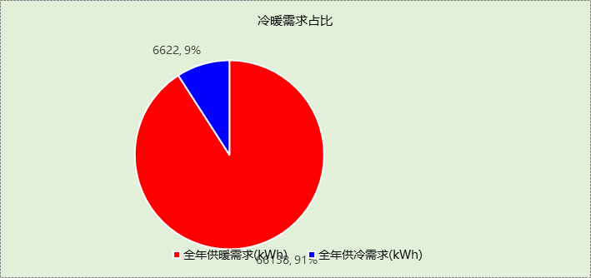

## 能耗分项统计

|  |  |  |  |  |  |  |
| --- | --- | --- | --- | --- | --- | --- |
| 分类 | 围护传热 | 室内得热 | 窗日射 | 新风/渗透 | 热回收 | 合计 |
| 供暖需求(kWh) | -60996 | 6643 | 1538 | -13323 | 0 | -66138 |
| 供冷需求(kWh) | 3629 | 2708 | 1003 | -719 | 0 | 6622 |

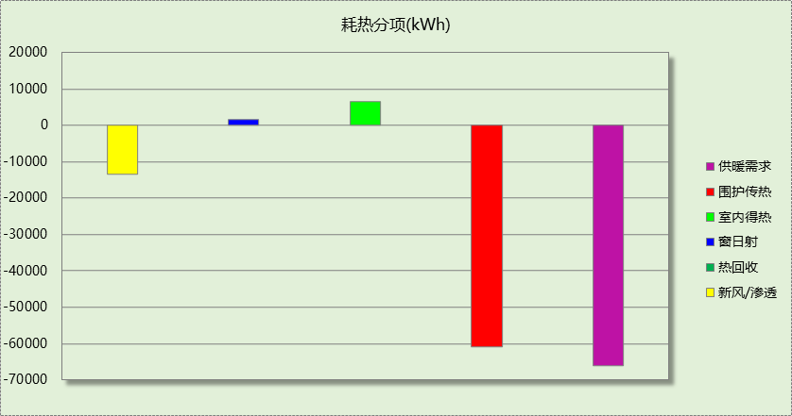

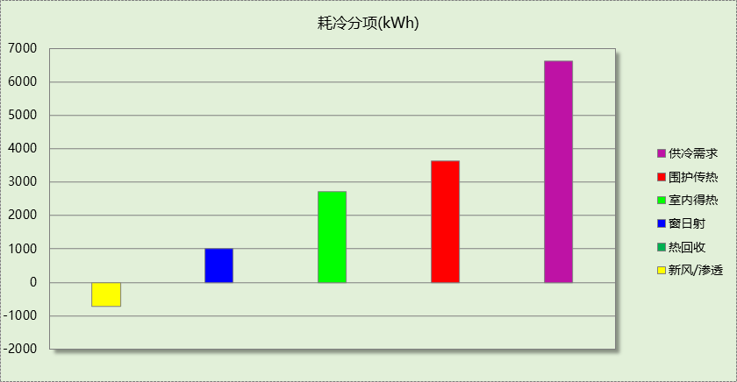

## 逐月负荷表

|  |  |  |  |  |  |  |
| --- | --- | --- | --- | --- | --- | --- |
| 月份 | 供暖需求 (kWh) | 供冷需求 (kWh) | 热负荷 峰值(kW) | 热负荷 峰值时刻 | 冷负荷 峰值(kW) | 冷负荷 峰值时刻 |
| 1月 | 19109 | 0 | 100.872 | 01月02日00时 | 0.000 | -- |
| 2月 | 13390 | 0 | 99.283 | 02月14日00时 | 0.000 | -- |
| 3月 | 8114 | 0 | 59.026 | 03月04日00时 | 0.000 | -- |
| 4月 | 803 | 0 | 16.738 | 04月01日00时 | 0.000 | -- |
| 5月 | 0 | 2 | 0.031 | 05月20日08时 | 0.324 | 05月14日20时 |
| 6月 | 0 | 1315 | 0.000 | -- | 8.563 | 06月24日00时 |
| 7月 | 0 | 2517 | 0.000 | -- | 25.377 | 07月22日00时 |
| 8月 | 0 | 2231 | 0.000 | -- | 17.423 | 08月19日00时 |
| 9月 | 0 | 557 | 0.000 | -- | 8.491 | 09月04日20时 |
| 10月 | 1708 | 0 | 13.625 | 10月28日00时 | 0.000 | -- |
| 11月 | 8014 | 0 | 62.472 | 11月25日00时 | 0.000 | -- |
| 12月 | 15000 | 0 | 82.567 | 12月30日00时 | 0.000 | -- |

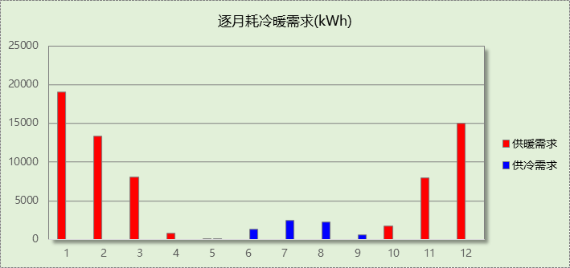

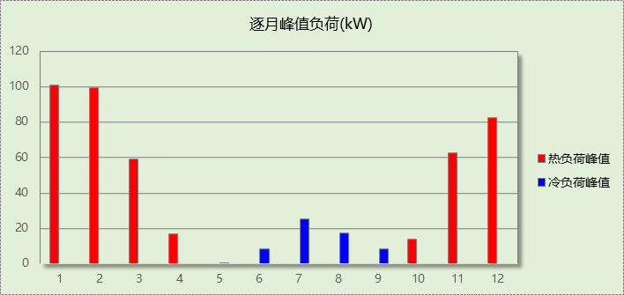

# 附录

**工作日/节假日人员逐时在室率(%)**

|  |  |  |  |  |  |  |  |  |  |  |  |  |  |  |  |  |  |  |  |  |  |  |  |  |
| --- | --- | --- | --- | --- | --- | --- | --- | --- | --- | --- | --- | --- | --- | --- | --- | --- | --- | --- | --- | --- | --- | --- | --- | --- |
| 房间类型 | 1 | 2 | 3 | 4 | 5 | 6 | 7 | 8 | 9 | 10 | 11 | 12 | 13 | 14 | 15 | 16 | 17 | 18 | 19 | 20 | 21 | 22 | 23 | 24 |
| 卧室 | 100 | 100 | 100 | 100 | 100 | 100 | 50 | 50 | 0 | 0 | 0 | 0 | 0 | 0 | 0 | 0 | 0 | 0 | 0 | 0 | 50 | 10 | 10 | 10 |
| 100 | 100 | 100 | 100 | 100 | 100 | 50 | 50 | 0 | 0 | 0 | 0 | 0 | 0 | 0 | 0 | 0 | 0 | 0 | 0 | 50 | 10 | 10 | 10 |
| 卫生间 | 0 | 0 | 0 | 0 | 0 | 50 | 50 | 10 | 10 | 10 | 10 | 10 | 10 | 10 | 10 | 10 | 10 | 10 | 10 | 50 | 50 | 0 | 0 | 0 |
| 0 | 0 | 0 | 0 | 0 | 50 | 50 | 10 | 10 | 10 | 10 | 10 | 10 | 10 | 10 | 10 | 10 | 10 | 10 | 50 | 50 | 0 | 0 | 0 |
| 厨房 | 0 | 0 | 0 | 0 | 0 | 0 | 100 | 0 | 0 | 0 | 0 | 100 | 0 | 0 | 0 | 0 | 0 | 100 | 0 | 0 | 0 | 0 | 0 | 0 |
| 0 | 0 | 0 | 0 | 0 | 0 | 100 | 0 | 0 | 0 | 0 | 100 | 0 | 0 | 0 | 0 | 0 | 100 | 0 | 0 | 0 | 0 | 0 | 0 |
| 封闭阳台 | 0 | 0 | 0 | 0 | 0 | 10 | 10 | 10 | 10 | 10 | 10 | 10 | 10 | 10 | 10 | 10 | 10 | 10 | 10 | 10 | 10 | 0 | 0 | 0 |
| 0 | 0 | 0 | 0 | 0 | 10 | 10 | 10 | 10 | 10 | 10 | 10 | 10 | 10 | 10 | 10 | 10 | 10 | 10 | 10 | 10 | 0 | 0 | 0 |
| 楼梯间 | 0 | 0 | 0 | 0 | 0 | 10 | 10 | 10 | 10 | 10 | 10 | 10 | 10 | 10 | 10 | 10 | 10 | 10 | 10 | 10 | 10 | 0 | 0 | 0 |
| 0 | 0 | 0 | 0 | 0 | 10 | 10 | 10 | 10 | 10 | 10 | 10 | 10 | 10 | 10 | 10 | 10 | 10 | 10 | 10 | 10 | 0 | 0 | 0 |
| 空房间 | 0 | 0 | 0 | 0 | 0 | 0 | 0 | 0 | 0 | 0 | 0 | 0 | 0 | 0 | 0 | 0 | 0 | 0 | 0 | 0 | 0 | 0 | 0 | 0 |
| 0 | 0 | 0 | 0 | 0 | 0 | 0 | 0 | 0 | 0 | 0 | 0 | 0 | 0 | 0 | 0 | 0 | 0 | 0 | 0 | 0 | 0 | 0 | 0 |
| 起居室 | 0 | 0 | 0 | 0 | 0 | 0 | 50 | 50 | 100 | 100 | 100 | 100 | 100 | 100 | 100 | 100 | 100 | 100 | 100 | 100 | 50 | 0 | 0 | 0 |
| 0 | 0 | 0 | 0 | 0 | 0 | 50 | 50 | 100 | 100 | 100 | 100 | 100 | 100 | 100 | 100 | 100 | 100 | 100 | 100 | 50 | 0 | 0 | 0 |
| 辅助房间 | 0 | 0 | 0 | 0 | 0 | 10 | 10 | 10 | 10 | 10 | 10 | 10 | 10 | 10 | 10 | 10 | 10 | 10 | 10 | 10 | 10 | 0 | 0 | 0 |
| 0 | 0 | 0 | 0 | 0 | 10 | 10 | 10 | 10 | 10 | 10 | 10 | 10 | 10 | 10 | 10 | 10 | 10 | 10 | 10 | 10 | 0 | 0 | 0 |

注：上行：工作日；下行：节假日

**工作日/节假日照明开关时间表(%)**

|  |  |  |  |  |  |  |  |  |  |  |  |  |  |  |  |  |  |  |  |  |  |  |  |  |
| --- | --- | --- | --- | --- | --- | --- | --- | --- | --- | --- | --- | --- | --- | --- | --- | --- | --- | --- | --- | --- | --- | --- | --- | --- |
| 房间类型 | 1 | 2 | 3 | 4 | 5 | 6 | 7 | 8 | 9 | 10 | 11 | 12 | 13 | 14 | 15 | 16 | 17 | 18 | 19 | 20 | 21 | 22 | 23 | 24 |
| 卧室 | 0 | 0 | 0 | 0 | 0 | 100 | 50 | 0 | 0 | 0 | 0 | 0 | 0 | 0 | 0 | 0 | 0 | 0 | 0 | 0 | 100 | 100 | 0 | 0 |
| 0 | 0 | 0 | 0 | 0 | 100 | 50 | 0 | 0 | 0 | 0 | 0 | 0 | 0 | 0 | 0 | 0 | 0 | 0 | 0 | 100 | 100 | 0 | 0 |
| 卫生间 | 0 | 0 | 0 | 0 | 0 | 50 | 50 | 10 | 10 | 10 | 10 | 10 | 10 | 10 | 10 | 10 | 10 | 10 | 10 | 50 | 50 | 0 | 0 | 0 |
| 0 | 0 | 0 | 0 | 0 | 50 | 50 | 10 | 10 | 10 | 10 | 10 | 10 | 10 | 10 | 10 | 10 | 10 | 10 | 50 | 50 | 0 | 0 | 0 |
| 厨房 | 0 | 0 | 0 | 0 | 0 | 0 | 100 | 0 | 0 | 0 | 0 | 100 | 0 | 0 | 0 | 0 | 0 | 100 | 0 | 0 | 0 | 0 | 0 | 0 |
| 0 | 0 | 0 | 0 | 0 | 0 | 100 | 0 | 0 | 0 | 0 | 100 | 0 | 0 | 0 | 0 | 0 | 100 | 0 | 0 | 0 | 0 | 0 | 0 |
| 封闭阳台 | 0 | 0 | 0 | 0 | 0 | 10 | 10 | 10 | 10 | 10 | 10 | 10 | 10 | 10 | 10 | 10 | 10 | 10 | 10 | 10 | 10 | 0 | 0 | 0 |
| 0 | 0 | 0 | 0 | 0 | 10 | 10 | 10 | 10 | 10 | 10 | 10 | 10 | 10 | 10 | 10 | 10 | 10 | 10 | 10 | 10 | 0 | 0 | 0 |
| 楼梯间 | 0 | 0 | 0 | 0 | 0 | 10 | 10 | 10 | 10 | 10 | 10 | 10 | 10 | 10 | 10 | 10 | 10 | 10 | 10 | 10 | 10 | 0 | 0 | 0 |
| 0 | 0 | 0 | 0 | 0 | 10 | 10 | 10 | 10 | 10 | 10 | 10 | 10 | 10 | 10 | 10 | 10 | 10 | 10 | 10 | 10 | 0 | 0 | 0 |
| 空房间 | 0 | 0 | 0 | 0 | 0 | 0 | 0 | 0 | 0 | 0 | 0 | 0 | 0 | 0 | 0 | 0 | 100 | 100 | 100 | 100 | 100 | 100 | 100 | 0 |
| 0 | 0 | 0 | 0 | 0 | 0 | 0 | 0 | 0 | 0 | 0 | 0 | 0 | 0 | 0 | 0 | 100 | 100 | 100 | 100 | 100 | 100 | 100 | 0 |
| 起居室 | 0 | 0 | 0 | 0 | 0 | 50 | 100 | 0 | 0 | 0 | 0 | 0 | 0 | 0 | 0 | 0 | 0 | 0 | 100 | 100 | 50 | 0 | 0 | 0 |
| 0 | 0 | 0 | 0 | 0 | 50 | 100 | 0 | 0 | 0 | 0 | 0 | 0 | 0 | 0 | 0 | 0 | 0 | 100 | 100 | 50 | 0 | 0 | 0 |
| 辅助房间 | 0 | 0 | 0 | 0 | 0 | 10 | 10 | 10 | 10 | 10 | 10 | 10 | 10 | 10 | 10 | 10 | 10 | 10 | 10 | 10 | 10 | 0 | 0 | 0 |
| 0 | 0 | 0 | 0 | 0 | 10 | 10 | 10 | 10 | 10 | 10 | 10 | 10 | 10 | 10 | 10 | 10 | 10 | 10 | 10 | 10 | 0 | 0 | 0 |

注：上行：工作日；下行：节假日

**工作日/节假日设备逐时使用率(%)**

|  |  |  |  |  |  |  |  |  |  |  |  |  |  |  |  |  |  |  |  |  |  |  |  |  |
| --- | --- | --- | --- | --- | --- | --- | --- | --- | --- | --- | --- | --- | --- | --- | --- | --- | --- | --- | --- | --- | --- | --- | --- | --- |
| 房间类型 | 1 | 2 | 3 | 4 | 5 | 6 | 7 | 8 | 9 | 10 | 11 | 12 | 13 | 14 | 15 | 16 | 17 | 18 | 19 | 20 | 21 | 22 | 23 | 24 |
| 卧室 | 0 | 0 | 0 | 0 | 0 | 0 | 100 | 100 | 0 | 0 | 0 | 0 | 0 | 0 | 0 | 0 | 0 | 0 | 0 | 0 | 100 | 100 | 0 | 0 |
| 0 | 0 | 0 | 0 | 0 | 0 | 100 | 100 | 0 | 0 | 0 | 0 | 0 | 0 | 0 | 0 | 0 | 0 | 0 | 0 | 100 | 100 | 0 | 0 |
| 卫生间 | 0 | 0 | 0 | 0 | 0 | 0 | 0 | 0 | 0 | 0 | 0 | 0 | 0 | 0 | 0 | 0 | 0 | 0 | 0 | 0 | 0 | 0 | 0 | 0 |
| 0 | 0 | 0 | 0 | 0 | 0 | 0 | 0 | 0 | 0 | 0 | 0 | 0 | 0 | 0 | 0 | 0 | 0 | 0 | 0 | 0 | 0 | 0 | 0 |
| 厨房 | 0 | 0 | 0 | 0 | 0 | 0 | 100 | 0 | 0 | 0 | 0 | 100 | 0 | 0 | 0 | 0 | 0 | 100 | 0 | 0 | 0 | 0 | 0 | 0 |
| 0 | 0 | 0 | 0 | 0 | 0 | 100 | 0 | 0 | 0 | 0 | 100 | 0 | 0 | 0 | 0 | 0 | 100 | 0 | 0 | 0 | 0 | 0 | 0 |
| 封闭阳台 | 0 | 0 | 0 | 0 | 0 | 0 | 0 | 0 | 0 | 0 | 0 | 0 | 0 | 0 | 0 | 0 | 0 | 0 | 0 | 0 | 0 | 0 | 0 | 0 |
| 0 | 0 | 0 | 0 | 0 | 0 | 0 | 0 | 0 | 0 | 0 | 0 | 0 | 0 | 0 | 0 | 0 | 0 | 0 | 0 | 0 | 0 | 0 | 0 |
| 楼梯间 | 0 | 0 | 0 | 0 | 0 | 0 | 0 | 0 | 0 | 0 | 0 | 0 | 0 | 0 | 0 | 0 | 0 | 0 | 0 | 0 | 0 | 0 | 0 | 0 |
| 0 | 0 | 0 | 0 | 0 | 0 | 0 | 0 | 0 | 0 | 0 | 0 | 0 | 0 | 0 | 0 | 0 | 0 | 0 | 0 | 0 | 0 | 0 | 0 |
| 空房间 | 100 | 100 | 100 | 100 | 100 | 100 | 100 | 100 | 100 | 100 | 100 | 100 | 100 | 100 | 100 | 100 | 100 | 100 | 100 | 100 | 100 | 100 | 100 | 100 |
| 100 | 100 | 100 | 100 | 100 | 100 | 100 | 100 | 100 | 100 | 100 | 100 | 100 | 100 | 100 | 100 | 100 | 100 | 100 | 100 | 100 | 100 | 100 | 100 |
| 起居室 | 0 | 0 | 0 | 0 | 0 | 0 | 50 | 100 | 100 | 50 | 50 | 100 | 100 | 50 | 50 | 50 | 50 | 100 | 100 | 100 | 50 | 0 | 0 | 0 |
| 0 | 0 | 0 | 0 | 0 | 0 | 50 | 100 | 100 | 50 | 50 | 100 | 100 | 50 | 50 | 50 | 50 | 100 | 100 | 100 | 50 | 0 | 0 | 0 |
| 辅助房间 | 0 | 0 | 0 | 0 | 0 | 0 | 0 | 0 | 0 | 0 | 0 | 0 | 0 | 0 | 0 | 0 | 0 | 0 | 0 | 0 | 0 | 0 | 0 | 0 |
| 0 | 0 | 0 | 0 | 0 | 0 | 0 | 0 | 0 | 0 | 0 | 0 | 0 | 0 | 0 | 0 | 0 | 0 | 0 | 0 | 0 | 0 | 0 | 0 |

注：上行：工作日；下行：节假日

**工作日/节假日空调系统开关时间表**

|  |  |  |  |  |  |  |  |  |  |  |  |  |  |  |  |  |  |  |  |  |  |  |  |  |
| --- | --- | --- | --- | --- | --- | --- | --- | --- | --- | --- | --- | --- | --- | --- | --- | --- | --- | --- | --- | --- | --- | --- | --- | --- |
| 系统编号 | 1 | 2 | 3 | 4 | 5 | 6 | 7 | 8 | 9 | 10 | 11 | 12 | 13 | 14 | 15 | 16 | 17 | 18 | 19 | 20 | 21 | 22 | 23 | 24 |
| 默认 | 1 | 1 | 1 | 1 | 1 | 1 | 1 | 1 | 1 | 1 | 1 | 1 | 1 | 1 | 1 | 1 | 1 | 1 | 1 | 1 | 1 | 1 | 1 | 1 |
| 1 | 1 | 1 | 1 | 1 | 1 | 1 | 1 | 1 | 1 | 1 | 1 | 1 | 1 | 1 | 1 | 1 | 1 | 1 | 1 | 1 | 1 | 1 | 1 |
| Sys | 1 | 1 | 1 | 1 | 1 | 1 | 1 | 1 | 1 | 1 | 1 | 1 | 1 | 1 | 1 | 1 | 1 | 1 | 1 | 1 | 1 | 1 | 1 | 1 |
| 0 | 0 | 0 | 0 | 0 | 0 | 0 | 0 | 0 | 0 | 0 | 0 | 0 | 0 | 0 | 0 | 0 | 0 | 0 | 0 | 0 | 0 | 0 | 0 |

注：上行：工作日；下行：节假日