**建筑能效测评报告书**

公共建筑

|  |  |
| --- | --- |
| 工程名称 | 海次方 |
| 工程地点 | 海南-海口 |
| 设计编号 |  |
| 建设单位 |  |
| 设计单位 |  |
| 设 计 人 |  |
| 审 核 人 |  |
| 审 定 人 |  |
| 设计日期 | 2022年3月2日 |



|  |  |
| --- | --- |
| 采用软件 | 能耗计算BESI2020 |
| 软件版本 | 20200909(SP1) |
| 研发单位 | 北京绿建软件有限公司 |
| 正版授权码 | T15808939691 |

**目 录**

1 建筑概况 3

2 测评依据 4

3 围护结构 4

3.1 工程材料 4

4 标识建筑 5

4.1 房间类型 5

4.1.1 房间表 5

4.1.2 作息时间表 5

4.2 系统类型 5

4.3 制冷系统 5

4.3.1 冷水机组 5

4.3.2 水泵系统 6

4.3.3 运行工况 6

4.3.4 制冷能耗 6

4.4 照明 6

5 比对建筑 7

5.1 房间类型 7

5.1.1 房间表 7

5.1.2 作息时间表 7

5.2 系统类型 7

5.3 制冷系统 7

5.3.1 冷水机组 7

5.3.2 冷却水泵 8

5.3.3 冷冻水泵 8

5.4 照明 8

6 计算结果 8

7 附录 12

7.1 工作日/节假日人员逐时在室率(%) 12

7.2 工作日/节假日照明开关时间表(%) 12

7.3 工作日/节假日设备逐时使用率(%) 13

7.4 工作日/节假日空调系统运行时间表(1:开,0:关) 13

# 建筑概况

|  |  |  |
| --- | --- | --- |
| 工程名称 | 海次方 | |
| 工程地点 | 海南-海口 | |
| 地理位置 | 北纬：20.00° | 东经：110.35° |
| 建筑面积(m2) | 地上4754 地下0 | |
| 建筑层数 | 地上4 地下0 | |
| 建筑高度（m） | 地上21.1 地下0.0 | |
| 建筑体积(m3) | 28135.27 | |
| 建筑外表面积(m2) | 18021.57 | |
| 北向角度 | 90 | |
| 结构类型 |  | |
| 外墙太阳辐射吸收系数 | 0.75 | |
| 屋顶太阳辐射吸收系数 | 0.75 | |
| 控温期 | 全年控温 | |

|  |  |  |  |  |  |  |  |
| --- | --- | --- | --- | --- | --- | --- | --- |
|  | | 标识建筑 | | | 比对建筑 | | |
| 体形系数S | | 0.64 | | | 0.64 | | |
| 屋顶传热系数K [W/(m2·K)] | | 0.77 | | | 0.90 | | |
| 外墙（包括非透明幕墙）传热系数K [W/(m2·K)] | | 1.11 | | | 1.50 | | |
| 屋顶透明部分传热系数  K [W/(m2·K)] | | － | | | － | | |
| 屋顶透明部分遮阳系数 | | － | | | － | | |
| 底面接触室外的架空或外挑楼板传热系数K [W/(m2·K)] | | 1.18 | | | 1.50 | | |
| 地下墙热阻R[(m2·K)/W] | | － | | | － | | |
| 周边地面热阻R[(m2·K)/W] | | 0.09 | | | 1.00 | | |
| 非周边地面热阻R[(m2·K)/W] | | 0.09 | | | 1.00 | | |
| 外窗（包括透明幕墙） | 朝向 | 窗墙比 | 传热  系数 | 遮阳  系数 | 窗墙比 | 传热  系数 | 遮阳  系数 |
| 南向 | 0.77 | 1.80 | 0.57 | 0.70 | 3.00 | 0.35 |
| 北向 | 0.78 | 1.82 | 0.57 | 0.70 | 3.00 | 0.45 |
| 东向 | 0.38 | 1.88 | 0.59 | 0.38 | 3.50 | 0.45 |
| 西向 | 0.40 | 1.84 | 0.58 | 0.40 | 3.50 | 0.45 |

# 测评依据

1. 《建筑能效标识技术标准》(JGJ/T 288-2012)

2. 《公共建筑节能设计标准》(GB50189-2005)

3. 《民用建筑热工设计规范》(GB50176)

4. 《建筑外窗气密性能分级及检测方法》（GB/T7107-2002）

5. 《建筑幕墙物理性能分级》(GB/T15225-94)

# 围护结构

## 工程材料

|  |  |  |  |  |  |  |
| --- | --- | --- | --- | --- | --- | --- |
| 材料名称 | 导热系数λ | 蓄热系数S | 密度ρ | 比热容Cp | 蒸汽渗透系数u | 备注 |
| W/(m.K) | W/(㎡.K) | kg/m3 | J/(kg.K) | g/(m.h.kPa) |
| 水泥砂浆 | 0.930 | 11.370 | 1800.0 | 1050.0 | 0.0210 | 来源：《民用建筑热工设计规范》GB50176-2016 |
| 石灰砂浆 | 0.810 | 10.070 | 1600.0 | 1050.0 | 0.0443 | 来源：《民用建筑热工设计规范》GB50176-2016 |
| 钢筋混凝土 | 1.740 | 17.200 | 2500.0 | 920.0 | 0.0158 | 来源：《民用建筑热工设计规范》GB50176-2016 |
| 碎石、卵石混凝土(ρ=2300) | 1.510 | 15.360 | 2300.0 | 920.0 | 0.0173 | 来源：《民用建筑热工设计规范》GB50176-2016 |
| 挤塑聚苯乙烯泡沫塑料（带表皮） | 0.030 | 0.340 | 35.0 | 1380.0 | 0.0000 | 来源：《民用建筑热工设计规范》GB50176-2016，蒸汽渗透系数没有给出 |
| 加气混凝土、泡沫混凝土(ρ=700) | 0.180 | 3.100 | 700.0 | 1050.0 | 0.0998 | 来源：《民用建筑热工设计规范》GB50176-2016 |
| 混凝土多孔砖(190六孔砖） | 0.750 | 7.490 | 1450.0 | 709.4 | 0.0000 |  |

# 标识建筑

## 房间类型

### 房间表

|  |  |  |  |  |  |  |  |
| --- | --- | --- | --- | --- | --- | --- | --- |
| 房间类型 | 空调 温度℃ | 供暖 温度℃ | 新风量 | 渗透风 换气次数 | 人员密度 | 照明功率 密度 | 电器设备 功率 |
| 办公-会议室 | 26 | 18 | 14(m3/h.人) | 0(次/h) | 2.5(㎡/人) | 9(W/㎡) | 15(W/㎡) |
| 办公-其它 | 26 | 20 | 30(m3/h.人) | 0(次/h) | 20(㎡/人) | 11(W/㎡) | 5(W/㎡) |
| 办公-普通办公室 | 26 | 20 | 30(m3/h.人) | 0(次/h) | 8(㎡/人) | 9(W/㎡) | 15(W/㎡) |
| 办公-走廊 | 26 | 16 | 20(m3/h.人) | 0(次/h) | 50(㎡/人) | 5(W/㎡) | 15(W/㎡) |
| 空房间 | － | － | 20(m3/h.人) | 0(次/h) | 50(㎡/人) | 0(W/㎡) | 0(W/㎡) |

### 作息时间表

详见附录

## 系统类型

|  |  |  |  |  |  |
| --- | --- | --- | --- | --- | --- |
| 系统编号 | 系统类型 | 供冷 能效比 | 供热 能效比 | 面积(㎡) | 包含的房间 |
| 默认 | 双管制风机盘管 | － | － | 993.07 | 1001(1) |
| Sys | 双管制风机盘管 | － | － | 7212.34 | 1004(1),1003(1),1017(1),1016(1),1015(1),1014(1),1013(1),1010(1),1012(1),1011(1),1009(1),1008(1),1007(1),1006(1),1005(1),2014(2),2013(2),2012(2),2011(2),2010(2),2008(2),2007(2),2004(2),2001(2),3034(3),3033(3),3032(3),3031(3),3030(3),3029(3),3026(3),3025(3),3024(3),3023(3),3022(3),3021(3),3020(3),3019(3),3014(3),3012(3),3011(3),3006(3),3005(3),3004(3),3003(3),3002(3),3001(3),4005(4),4022(4),4021(4),4020(4),4019(4),4018(4),4017(4),4016(4),4015(4),4014(4),4013(4),4012(4),4011(4),4010(4),4008(4),4007(4),4006(4),4004(4),4003(4),4002(4),4001(4) |

## 制冷系统

### 冷水机组

|  |  |  |  |  |  |
| --- | --- | --- | --- | --- | --- |
| 名称 | 类型 | 额定耗电量 (kW) | 额定制冷量 (kW) | 额定性能系数 (COP) | 台数 |
| 水冷-螺杆式冷水机组 | 水冷-螺杆式冷水机组 | 100 | 500 | 5.00 | 1 |

### 水泵系统

|  |  |  |  |  |  |
| --- | --- | --- | --- | --- | --- |
| 类型 | 流量(m3/h) | 扬程(m) | 设计工作效率(%) | 输入功率(kW) | 台数 |
| 冷却水泵 | 320 | 25 | 80 | 31.3 | 1 |
| 冷冻水泵 | 320 | 30 | 80 | 37.6 | 1 |

### 运行工况

|  |  |  |  |  |  |
| --- | --- | --- | --- | --- | --- |
| 负荷率 (%) | 机组制冷量 (kW) | 机组功率 (kW) | 性能系数 (COP) | 冷却水泵功率 (kW) | 冷冻水泵功率 (kW) |
| 25 | 125 | 30 | 4.17 | 10 | 8 |
| 50 | 250 | 55 | 4.55 | 10 | 8 |
| 75 | 375 | 75 | 5.00 | 10 | 8 |
| 100 | 500 | 100 | 5.00 | 10 | 8 |

### 制冷能耗

|  |  |  |  |  |  |  |
| --- | --- | --- | --- | --- | --- | --- |
| 负荷区间 (%) | 区间负荷 (kWh) | 运行时长(h) | 性能系数 (COP) | 制冷机组 (kWh) | 冷却水泵 (kWh) | 冷冻水泵 (kWh) |
| 0~25 | 18154 | 358 | 4.17 | 4357 | 3580 | 2864 |
| 25~50 | 58285 | 303 | 4.55 | 12823 | 3030 | 2424 |
| 50~75 | 105109 | 335 | 5.00 | 21022 | 3350 | 2680 |
| 75~100 | 126787 | 289 | 5.00 | 25357 | 2890 | 2312 |
| >100 | 1153090 | 1660 | － | 166000 | 16600 | 13280 |
| 合计 | 1461426 | 2945 |  | 229559 | 29450 | 23560 |

## 照明

|  |  |  |  |  |
| --- | --- | --- | --- | --- |
| 房间类型 | 单位面积电耗 (kWh/㎡) | 房间个数 | 房间合计面积 (㎡) | 合计电耗 (kWh) |
| 办公-会议室 | 15.12 | 1 | 422 | 6380 |
| 办公-其它 | 25.99 | 21 | 1250 | 32475 |
| 办公-普通办公室 | 15.12 | 15 | 3795 | 57378 |
| 办公-走廊 | 11.81 | 32 | 3039 | 35898 |
| 空房间 | 0.00 | 89 | 2895 | 0 |
| 总计 | | | | 132131 |

# 比对建筑

## 房间类型

### 房间表

|  |  |  |  |  |  |  |  |
| --- | --- | --- | --- | --- | --- | --- | --- |
| 房间类型 | 空调 温度℃ | 供暖 温度℃ | 新风量 | 渗透风 换气次数 | 人员密度 | 照明功率 密度 | 电器设备 功率 |
| 办公-会议室 | 26 | 18 | 14(m3/h.人) | 0(次/h) | 2.5(㎡/人) | 9(W/㎡) | 15(W/㎡) |
| 办公-其它 | 26 | 20 | 30(m3/h.人) | 0(次/h) | 20(㎡/人) | 11(W/㎡) | 5(W/㎡) |
| 办公-普通办公室 | 26 | 20 | 30(m3/h.人) | 0(次/h) | 8(㎡/人) | 9(W/㎡) | 15(W/㎡) |
| 办公-走廊 | 26 | 16 | 20(m3/h.人) | 0(次/h) | 50(㎡/人) | 5(W/㎡) | 15(W/㎡) |
| 空房间 | － | － | 20(m3/h.人) | 0(次/h) | 50(㎡/人) | 0(W/㎡) | 0(W/㎡) |

### 作息时间表

同标识建筑

## 系统类型

|  |  |  |  |  |  |
| --- | --- | --- | --- | --- | --- |
| 系统编号 | 系统类型 | 供冷 能效比 | 供热 能效比 | 面积(㎡) | 包含的房间 |
| 默认 | 双管制风机盘管 | － | － | 993.07 | 同标识建筑 |
| Sys | 双管制风机盘管 | － | － | 7212.34 | 同标识建筑 |

## 制冷系统

### 冷水机组

#### 机组选型

|  |  |  |  |  |  |
| --- | --- | --- | --- | --- | --- |
| 名称 | 类型 | 额定耗电量 (kW) | 额定制冷量 (kW) | 额定性能系数 (COP) | 台数 |
| 水冷-螺杆式冷水机组 | 水冷-螺杆式冷水机组 | 242 | 1034 | 4.28 | 1 |

#### 机组能耗

|  |  |  |  |  |
| --- | --- | --- | --- | --- |
| 负荷率 (%) | 机组制冷量 (kW) | 性能系数 COP | 区间负荷 (kWh) | 机组电耗 (kWh) |
| 25 | 259 | 4.23 | 69472 | 16424 |
| 50 | 517 | 5.12 | 212898 | 41582 |
| 75 | 776 | 4.65 | 809379 | 174060 |
| 100 | 1034 | 4.28 | 227684 | 53197 |
| 合计 | | 4.63 | 1319433 | 285263 |

### 冷却水泵

|  |  |  |  |  |  |
| --- | --- | --- | --- | --- | --- |
| 负荷率 (%) | 台数 | 区间时长 (h) | 输送能效比 ERe | 最大冷负荷 (kW) | 水泵电耗 (kWh) |
| 25 | 1 | 687 | 0.0214 | 1034 | 74734 |
| 50 | 1 | 552 |
| 75 | 1 | 1227 |
| 100 | 1 | 274 |

### 冷冻水泵

|  |  |  |  |  |  |
| --- | --- | --- | --- | --- | --- |
| 负荷率 (%) | 台数 | 区间时长 (h) | 输送能效比 ER0 | 最大冷负荷 (kW) | 水泵电耗 (kWh) |
| 25 | 1 | 687 | 0.0241 | 1034 | 68284 |
| 50 | 1 | 552 |
| 75 | 1 | 1227 |
| 100 | 1 | 274 |

## 照明

|  |  |  |  |  |
| --- | --- | --- | --- | --- |
| 房间类型 | 单位面积电耗 (kWh/㎡) | 房间个数 | 房间合计面积 (㎡) | 合计电耗 (kWh) |
| 办公-会议室 | 15.12 | 1 | 422 | 6380 |
| 办公-其它 | 25.99 | 21 | 1250 | 32475 |
| 办公-普通办公室 | 15.12 | 15 | 3795 | 57378 |
| 办公-走廊 | 11.81 | 32 | 3039 | 35898 |
| 空房间 | 0.00 | 89 | 2895 | 0 |
| 总计 | | | | 132131 |

# 计算结果

|  |  |  |  |  |  |  |
| --- | --- | --- | --- | --- | --- | --- |
| 能耗分类 | 能耗子类 | 标识建筑  (kWh/㎡) | 比对建筑  (kWh/㎡) | 比对节能率  （%） | 基础建筑  (kWh/㎡) | 基础节能率  （%） |
| 建筑负荷 | 耗冷量 | 307.39 | 277.53 | -10.76% |  |  |
| 供冷电耗 | 中央冷源 | 48.28 | 60.00 | 34.02% |  |  |
| 冷却水泵 | 6.19 | 15.72 |
| 冷冻水泵 | 4.96 | 14.36 |
| 多联机/单元式空调 | 0.00 | 0.00 |
| 供冷合计 | 59.43 | 90.08 |
| 照明电耗 | | 27.79 | 27.79 | 0.00% |  |  |
| 合计电耗 | | 87.23 | 117.88 | 26.00% | 235.75 | 63.00% |

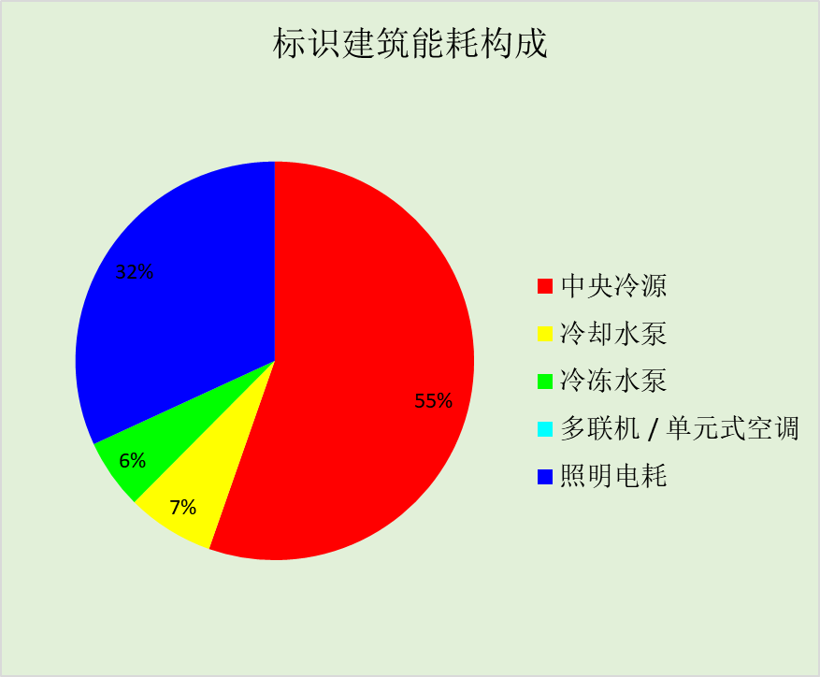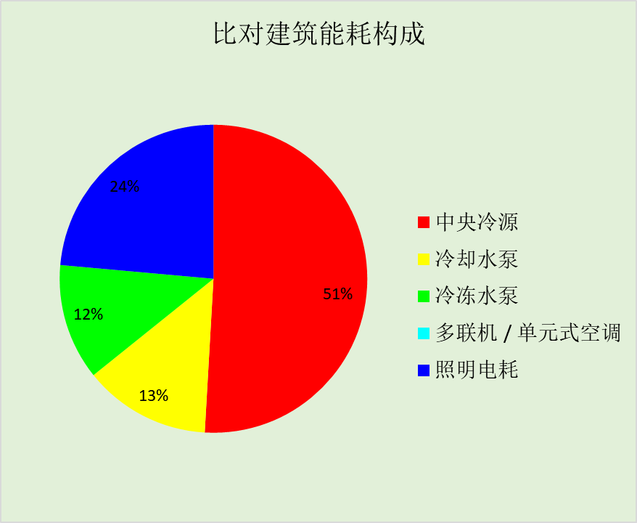

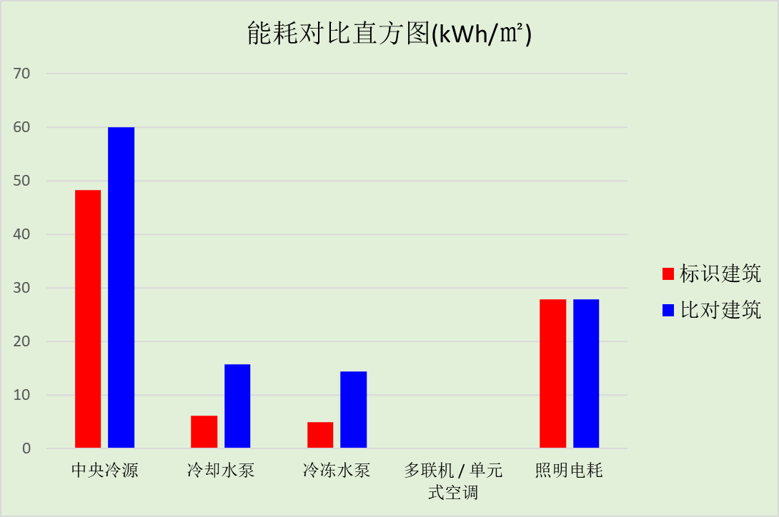

# 附录

## 工作日/节假日人员逐时在室率(%)

|  |  |  |  |  |  |  |  |  |  |  |  |  |  |  |  |  |  |  |  |  |  |  |  |  |
| --- | --- | --- | --- | --- | --- | --- | --- | --- | --- | --- | --- | --- | --- | --- | --- | --- | --- | --- | --- | --- | --- | --- | --- | --- |
| 房间类型 | 1 | 2 | 3 | 4 | 5 | 6 | 7 | 8 | 9 | 10 | 11 | 12 | 13 | 14 | 15 | 16 | 17 | 18 | 19 | 20 | 21 | 22 | 23 | 24 |
| 办公-会议室 | 0 | 0 | 0 | 0 | 0 | 0 | 10 | 50 | 100 | 100 | 100 | 30 | 100 | 100 | 100 | 100 | 50 | 20 | 10 | 0 | 0 | 0 | 0 | 0 |
| 0 | 0 | 0 | 0 | 0 | 0 | 0 | 20 | 45 | 0 | 0 | 0 | 0 | 0 | 0 | 0 | 0 | 0 | 0 | 0 | 0 | 0 | 0 | 0 |
| 办公-其它 | 0 | 0 | 0 | 0 | 0 | 0 | 10 | 50 | 95 | 95 | 95 | 80 | 80 | 95 | 95 | 95 | 95 | 30 | 30 | 0 | 0 | 0 | 0 | 0 |
| 0 | 0 | 0 | 0 | 0 | 0 | 0 | 0 | 0 | 0 | 0 | 0 | 0 | 0 | 0 | 0 | 0 | 0 | 0 | 0 | 0 | 0 | 0 | 0 |
| 办公-普通办公室 | 0 | 0 | 0 | 0 | 0 | 0 | 10 | 50 | 100 | 100 | 100 | 30 | 100 | 100 | 100 | 100 | 50 | 20 | 10 | 0 | 0 | 0 | 0 | 0 |
| 0 | 0 | 0 | 0 | 0 | 0 | 0 | 20 | 45 | 0 | 0 | 0 | 0 | 0 | 0 | 0 | 0 | 0 | 0 | 0 | 0 | 0 | 0 | 0 |
| 办公-走廊 | 0 | 0 | 0 | 0 | 0 | 0 | 10 | 50 | 95 | 95 | 95 | 80 | 80 | 95 | 95 | 95 | 95 | 30 | 30 | 0 | 0 | 0 | 0 | 0 |
| 0 | 0 | 0 | 0 | 0 | 0 | 0 | 0 | 0 | 0 | 0 | 0 | 0 | 0 | 0 | 0 | 0 | 0 | 0 | 0 | 0 | 0 | 0 | 0 |
| 空房间 | 0 | 0 | 0 | 0 | 0 | 0 | 0 | 20 | 50 | 80 | 80 | 80 | 80 | 80 | 80 | 80 | 80 | 80 | 80 | 70 | 50 | 0 | 0 | 0 |
| 0 | 0 | 0 | 0 | 0 | 0 | 0 | 20 | 50 | 80 | 80 | 80 | 80 | 80 | 80 | 80 | 80 | 80 | 80 | 70 | 50 | 0 | 0 | 0 |

注：上行：工作日；下行：节假日

## 工作日/节假日照明开关时间表(%)

|  |  |  |  |  |  |  |  |  |  |  |  |  |  |  |  |  |  |  |  |  |  |  |  |  |
| --- | --- | --- | --- | --- | --- | --- | --- | --- | --- | --- | --- | --- | --- | --- | --- | --- | --- | --- | --- | --- | --- | --- | --- | --- |
| 房间类型 | 1 | 2 | 3 | 4 | 5 | 6 | 7 | 8 | 9 | 10 | 11 | 12 | 13 | 14 | 15 | 16 | 17 | 18 | 19 | 20 | 21 | 22 | 23 | 24 |
| 办公-会议室 | 10 | 10 | 10 | 10 | 10 | 10 | 10 | 36 | 62 | 56 | 54 | 43 | 53 | 55 | 58 | 67 | 40 | 18 | 10 | 10 | 10 | 10 | 10 | 10 |
| 0 | 0 | 0 | 0 | 0 | 0 | 0 | 0 | 0 | 0 | 0 | 0 | 0 | 0 | 0 | 0 | 0 | 0 | 0 | 0 | 0 | 0 | 0 | 0 |
| 办公-其它 | 0 | 0 | 0 | 0 | 0 | 0 | 10 | 50 | 95 | 95 | 95 | 80 | 80 | 95 | 95 | 95 | 95 | 30 | 30 | 0 | 0 | 0 | 0 | 0 |
| 0 | 0 | 0 | 0 | 0 | 0 | 0 | 0 | 0 | 0 | 0 | 0 | 0 | 0 | 0 | 0 | 0 | 0 | 0 | 0 | 0 | 0 | 0 | 0 |
| 办公-普通办公室 | 10 | 10 | 10 | 10 | 10 | 10 | 10 | 36 | 62 | 56 | 54 | 43 | 53 | 55 | 58 | 67 | 40 | 18 | 10 | 10 | 10 | 10 | 10 | 10 |
| 0 | 0 | 0 | 0 | 0 | 0 | 0 | 0 | 0 | 0 | 0 | 0 | 0 | 0 | 0 | 0 | 0 | 0 | 0 | 0 | 0 | 0 | 0 | 0 |
| 办公-走廊 | 0 | 0 | 0 | 0 | 0 | 0 | 10 | 50 | 95 | 95 | 95 | 80 | 80 | 95 | 95 | 95 | 95 | 30 | 30 | 0 | 0 | 0 | 0 | 0 |
| 0 | 0 | 0 | 0 | 0 | 0 | 0 | 0 | 0 | 0 | 0 | 0 | 0 | 0 | 0 | 0 | 0 | 0 | 0 | 0 | 0 | 0 | 0 | 0 |
| 空房间 | 10 | 10 | 10 | 10 | 10 | 10 | 10 | 50 | 60 | 60 | 60 | 60 | 60 | 60 | 60 | 60 | 80 | 90 | 100 | 100 | 100 | 10 | 10 | 10 |
| 10 | 10 | 10 | 10 | 10 | 10 | 10 | 50 | 60 | 60 | 60 | 60 | 60 | 60 | 60 | 60 | 80 | 90 | 100 | 100 | 100 | 10 | 10 | 10 |

注：上行：工作日；下行：节假日

## 工作日/节假日设备逐时使用率(%)

|  |  |  |  |  |  |  |  |  |  |  |  |  |  |  |  |  |  |  |  |  |  |  |  |  |
| --- | --- | --- | --- | --- | --- | --- | --- | --- | --- | --- | --- | --- | --- | --- | --- | --- | --- | --- | --- | --- | --- | --- | --- | --- |
| 房间类型 | 1 | 2 | 3 | 4 | 5 | 6 | 7 | 8 | 9 | 10 | 11 | 12 | 13 | 14 | 15 | 16 | 17 | 18 | 19 | 20 | 21 | 22 | 23 | 24 |
| 办公-会议室 | 0 | 0 | 0 | 0 | 0 | 0 | 10 | 50 | 100 | 100 | 100 | 100 | 100 | 100 | 100 | 100 | 50 | 20 | 10 | 0 | 0 | 0 | 0 | 0 |
| 0 | 0 | 0 | 0 | 0 | 0 | 0 | 0 | 0 | 0 | 0 | 0 | 0 | 0 | 0 | 0 | 0 | 0 | 0 | 0 | 0 | 0 | 0 | 0 |
| 办公-其它 | 0 | 0 | 0 | 0 | 0 | 0 | 10 | 50 | 95 | 95 | 95 | 50 | 50 | 95 | 95 | 95 | 95 | 30 | 30 | 0 | 0 | 0 | 0 | 0 |
| 0 | 0 | 0 | 0 | 0 | 0 | 0 | 0 | 0 | 0 | 0 | 0 | 0 | 0 | 0 | 0 | 0 | 0 | 0 | 0 | 0 | 0 | 0 | 0 |
| 办公-普通办公室 | 0 | 0 | 0 | 0 | 0 | 0 | 10 | 50 | 100 | 100 | 100 | 100 | 100 | 100 | 100 | 100 | 50 | 20 | 10 | 0 | 0 | 0 | 0 | 0 |
| 0 | 0 | 0 | 0 | 0 | 0 | 0 | 0 | 0 | 0 | 0 | 0 | 0 | 0 | 0 | 0 | 0 | 0 | 0 | 0 | 0 | 0 | 0 | 0 |
| 办公-走廊 | 0 | 0 | 0 | 0 | 0 | 0 | 10 | 50 | 95 | 95 | 95 | 50 | 50 | 95 | 95 | 95 | 95 | 30 | 30 | 0 | 0 | 0 | 0 | 0 |
| 0 | 0 | 0 | 0 | 0 | 0 | 0 | 0 | 0 | 0 | 0 | 0 | 0 | 0 | 0 | 0 | 0 | 0 | 0 | 0 | 0 | 0 | 0 | 0 |
| 空房间 | 0 | 0 | 0 | 0 | 0 | 0 | 0 | 30 | 50 | 80 | 80 | 80 | 80 | 80 | 80 | 80 | 80 | 80 | 80 | 70 | 50 | 0 | 0 | 0 |
| 0 | 0 | 0 | 0 | 0 | 0 | 0 | 30 | 50 | 80 | 80 | 80 | 80 | 80 | 80 | 80 | 80 | 80 | 80 | 70 | 50 | 0 | 0 | 0 |

注：上行：工作日；下行：节假日

## 工作日/节假日空调系统运行时间表(1:开,0:关)

|  |  |  |  |  |  |  |  |  |  |  |  |  |  |  |  |  |  |  |  |  |  |  |  |  |
| --- | --- | --- | --- | --- | --- | --- | --- | --- | --- | --- | --- | --- | --- | --- | --- | --- | --- | --- | --- | --- | --- | --- | --- | --- |
| 系统编号 | 1 | 2 | 3 | 4 | 5 | 6 | 7 | 8 | 9 | 10 | 11 | 12 | 13 | 14 | 15 | 16 | 17 | 18 | 19 | 20 | 21 | 22 | 23 | 24 |
| 默认 | 0 | 0 | 0 | 0 | 0 | 0 | 1 | 1 | 1 | 1 | 1 | 1 | 1 | 1 | 1 | 1 | 1 | 1 | 0 | 0 | 0 | 0 | 0 | 0 |
| 0 | 0 | 0 | 0 | 0 | 0 | 0 | 0 | 0 | 0 | 0 | 0 | 0 | 0 | 0 | 0 | 0 | 0 | 0 | 0 | 0 | 0 | 0 | 0 |
| Sys | 0 | 0 | 0 | 0 | 0 | 0 | 1 | 1 | 1 | 1 | 1 | 1 | 1 | 1 | 1 | 1 | 1 | 1 | 0 | 0 | 0 | 0 | 0 | 0 |
| 0 | 0 | 0 | 0 | 0 | 0 | 0 | 0 | 0 | 0 | 0 | 0 | 0 | 0 | 0 | 0 | 0 | 0 | 0 | 0 | 0 | 0 | 0 | 0 |

注：上行：工作日；下行：节假日