**暖阳苑**

全年负荷计算书

|  |  |
| --- | --- |
| 工程名称 | 暖阳苑 |
| 设计编号 |  |
| 建设单位 | 真的闲的没事干 |
| 设计单位 | 真的闲的没事干 |
| 计 算 人 |  |
| 校 对 人 |  |
| 审 核 人 |  |
| 计算日期 | 2021年12月18日 |



|  |  |
| --- | --- |
| 采用软件 | 斯维尔暖通负荷BECH2020 |
| 软件版本 | 20200606(SP1) |
| 研发单位 | 北京绿建软件股份有限公司 |
| 正版授权码 | T18943122392 |

**目 录**

1 建筑概况 1

2 气象数据 1

2.1 气象地点 1

2.2 逐日干球温度表 1

2.3 逐月辐照量表 2

2.4 峰值工况 2

3 软件介绍 2

4 围护结构 2

4.1 屋顶构造 2

4.1.1 挤塑聚苯板20+加气砼80＋钢筋砼120 2

4.2 外墙构造 3

4.2.1 外-挤塑聚苯板20+钢筋砼200 3

4.3 楼板构造 3

4.3.1 钢筋砼楼板120 3

4.4 周边地面构造 3

4.4.1 混凝土120不保温地面 3

4.5 非周边地面构造 4

4.5.1 混凝土120不保温地面 4

4.6 门构造 4

4.7 窗构造 4

5 房间类型 4

5.1 房间表 4

5.2 作息时间表 5

6 系统设置 5

6.1 系统划分 5

6.2 运行时间表 5

7 计算结果 5

7.1 模拟周期 5

7.2 全年冷暖需求 5

7.3 能耗分项统计 6

7.4 逐月负荷表 7

8 附录 9

# 建筑概况

|  |  |  |
| --- | --- | --- |
| 地理位置 | 吉林-长春 | |
| 气候分区 | 严寒B区 | |
| 北纬 | 43.90 | |
| 东经 | 125.22 | |
| 建筑名称 | 暖阳苑 | |
| 建筑类型 | 公共建筑 |  |
| 建筑面积 | 地上 9592.09 ㎡ | 地下 0.00 ㎡ |
| 建筑高度 | 地上 27.30 m | 地下0.00 |
| 建筑层数 | 地上 7 | 地下 0 |
| 北向角度 | 180° | |

# 气象数据

## 气象地点

吉林-长春, 《中国建筑热环境分析专用气象数据集》

## 逐日干球温度表

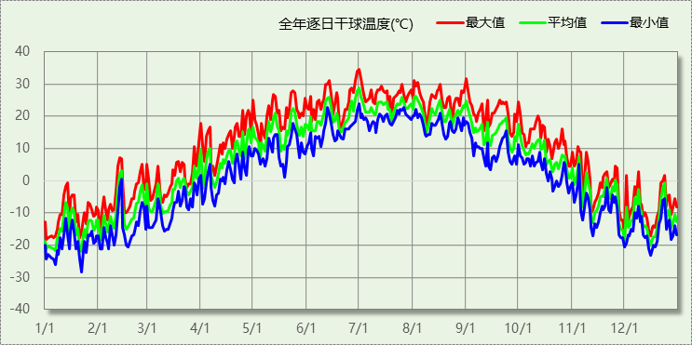

## 逐月辐照量表

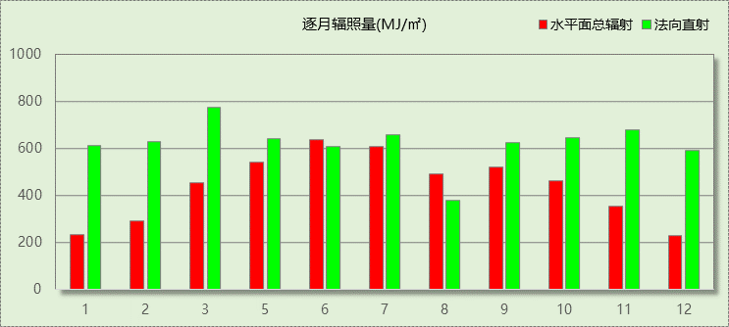

## 峰值工况

|  |  |  |  |  |  |
| --- | --- | --- | --- | --- | --- |
| 气象数据 | 时刻 | 干球温度(℃) | 湿球温度(℃) | 含湿量(g/kg) | 焓值(kj/kg) |
| 最大值 | 06月30日15时 | 34.4 | 21.1 | 10.8 | 62.3 |
| 最小值 | 01月21日07时 | -28.3 | -28.3 | 0.2 | -28.0 |

# 软件介绍

本报告采用的软件为绿建斯维尔暖通负荷BECH2020，该软件紧密结合暖通和节能设计规范、可根据项目实际情况建立建筑热工模型，并可对围护结构材料、房间内扰发热、作息时间表、热回收方式等参数进行设置。

软件包含全国各地典型气象年数据，内置DOE2.1E内核，对于建筑的逐时负荷进行动态模拟，既可以模拟8760小时理想负荷，也可以根据设定好的采暖期/空调期进行逐时模拟。

软件还支持分析全年建筑能耗的来源构成，依据日射得热、新风负荷、围护传热和内扰得热进行归类分项，生成设计建筑全年负荷计算报告书，提供详实的数据和多样的图表，为设计师在设备选型、制定运行策略等方面提供参考和帮助。

# 围护结构

## 屋顶构造

### 挤塑聚苯板20+加气砼80＋钢筋砼120

|  |  |  |  |  |  |  |
| --- | --- | --- | --- | --- | --- | --- |
| 材料名称 （由上到下） | 厚度δ | 导热系数λ | 蓄热系数S | 修正系数 | 热阻R | 热惰性指标 |
| (mm) | W/(m.K) | W/(㎡.K) | α | (㎡K)/W | D=R*S |
| 水泥砂浆 | 20 | 0.930 | 11.370 | 1.00 | 0.022 | 0.245 |
| 水泥膨胀珍珠岩(ρ=800) | 40 | 0.260 | 4.370 | 1.50 | 0.103 | 0.672 |
| 聚苯乙烯泡沫塑料（白板） | 120 | 0.039 | 0.280 | 1.05 | 2.930 | 0.862 |
| 水泥砂浆 | 20 | 0.930 | 11.370 | 1.00 | 0.022 | 0.245 |
| 钢筋混凝土 | 120 | 1.740 | 17.200 | 1.00 | 0.069 | 1.186 |
| 石灰水泥砂浆 | 20 | 0.870 | 10.750 | 1.00 | 0.023 | 0.247 |
| 各层之和∑ | 340 | － | － | － | 3.168 | 3.456 |
| 外表面太阳辐射吸收系数 | 0.75[默认] | | | | | |
| 传热系数K=1/(0.15+∑R) | 0.30 | | | | | |

## 外墙构造

### 外-挤塑聚苯板20+钢筋砼200

|  |  |  |  |  |  |  |
| --- | --- | --- | --- | --- | --- | --- |
| 材料名称 （由外到内） | 厚度δ | 导热系数λ | 蓄热系数S | 修正系数 | 热阻R | 热惰性指标 |
| (mm) | W/(m.K) | W/(㎡.K) | α | (㎡K)/W | D=R*S |
| 岩棉板(ρ=60-160) | 110 | 0.041 | 0.615 | 1.10 | 2.439 | 1.650 |
| 水泥砂浆 | 20 | 0.930 | 11.370 | 1.00 | 0.022 | 0.245 |
| 煤矸石空心砖 | 370 | 0.520 | 7.920 | 1.00 | 0.712 | 5.635 |
| 各层之和∑ | 500 | － | － | － | 3.172 | 7.530 |
| 外表面太阳辐射吸收系数 | 0.75[默认] | | | | | |
| 传热系数K=1/(0.15+∑R) | 0.30 | | | | | |

## 楼板构造

### 钢筋砼楼板120

|  |  |  |  |  |  |  |
| --- | --- | --- | --- | --- | --- | --- |
| 材料名称 | 厚度δ | 导热系数λ | 蓄热系数S | 修正系数 | 热阻R | 热惰性指标 |
| (mm) | W/(m.K) | W/(㎡.K) | α | (㎡K)/W | D=R*S |
| 水泥砂浆 | 20 | 0.930 | 11.370 | 1.00 | 0.022 | 0.245 |
| 钢筋混凝土 | 120 | 1.740 | 17.200 | 1.00 | 0.069 | 1.186 |
| 石灰砂浆 | 20 | 0.810 | 10.070 | 1.00 | 0.025 | 0.249 |
| 各层之和∑ | 160 | － | － | － | 0.115 | 1.679 |
| 传热系数K=1/(0.22+∑R) | 2.98 | | | | | |

## 周边地面构造

### 混凝土120不保温地面

|  |  |  |  |  |  |  |
| --- | --- | --- | --- | --- | --- | --- |
| 材料名称 | 厚度δ | 导热系数λ | 蓄热系数S | 修正系数 | 热阻R | 热惰性指标 |
| (mm) | W/(m.K) | W/(㎡.K) | α | (㎡K)/W | D=R*S |
| 水泥砂浆 | 20 | 0.930 | 11.370 | 1.00 | 0.022 | 0.245 |
| 钢筋混凝土 | 60 | 1.740 | 17.200 | 1.00 | 0.034 | 0.593 |
| 聚苯乙烯泡沫塑料（白板） | 80 | 0.039 | 0.280 | 1.05 | 1.954 | 0.574 |
| 碎石、卵石混凝土(ρ=2300) | 80 | 1.510 | 15.360 | 1.00 | 0.053 | 0.814 |
| 夯实粘土(ρ=2000) | 1670 | 1.160 | 12.990 | 1.00 | 1.440 | 18.701 |
| 各层之和∑ | 1910 | － | － | － | 3.502 | 20.927 |
| 传热系数K=1/(0.11+∑R) | 0.26 | | | | | |
|  |  |  |  |  |  |  |

## 非周边地面构造

### 混凝土120不保温地面

|  |  |  |  |  |  |  |
| --- | --- | --- | --- | --- | --- | --- |
| 材料名称 | 厚度δ | 导热系数λ | 蓄热系数S | 修正系数 | 热阻R | 热惰性指标 |
| (mm) | W/(m.K) | W/(㎡.K) | α | (㎡K)/W | D=R*S |
| 水泥砂浆 | 20 | 0.930 | 11.370 | 1.00 | 0.022 | 0.245 |
| 钢筋混凝土 | 120 | 1.740 | 17.200 | 1.00 | 0.069 | 1.186 |
| 各层之和∑ | 140 | － | － | － | 0.090 | 1.431 |
| 传热系数K=1/(0.11+∑R) | 0.30 | | | | | |
|  |  |  |  |  |  |  |

## 门构造

|  |  |  |  |
| --- | --- | --- | --- |
| 序号 | 构造名称 | 传热系数 | 备注 |
| 1 | 保温门（多功能门） | 1.972 |  |

## 窗构造

|  |  |  |  |  |  |
| --- | --- | --- | --- | --- | --- |
| 序号 | 构造名称 | 传热系数 | 遮阳系数 | 可见光透射比 | 备注 |
| 1 | 断桥铝 5+12A+5Low-E 氩气 断桥宽24.0mm 胶条封边 | 2.000 | 0.500 | 1.000 | 窗性能以检测报告为准。 |
| 2 | 70系列平开推拉窗（五腔） 空气 5+12A+5 铝条密封 | 2.610 | 0.880 | 1.000 | 选自《吉J2011-772》，仅作为设计参考，实际选用时应以生产企业的实测数据为准。 |
| 3 | Low-E+白玻 中空 5+12A+5Low-E+9A+5 铝条密封 | 1.330 | 0.630 | 1.000 | 选自《吉J2011-772》，仅作为设计参考，实际选用时应以生产企业的实测数据为准。 |

# 房间类型

## 房间表

|  |  |  |  |  |  |  |
| --- | --- | --- | --- | --- | --- | --- |
| 房间类型 | 空调温度 ℃ | 供暖温度 ℃ | 新风量 | 人员密度 | 照明功率 密度 | 电器设备 功率 |
| 办公-普通办公室 | 26 | 20 | 30(m^3/h.人) | 8(m^2/人) | 9(W/m^2) | 15(W/m^2) |
| 办公-走廊 | 26 | 16 | 20(m^3/h.人) | 50(m^2/人) | 5(W/m^2) | 15(W/m^2) |
| 学校办公室 | 26 | 22 | 2(m^3/h.人) | 5(m^2/人) | 9(W/m^2) | 15(W/m^2) |
| 学校卫生间 | 26 | 22 | 5(m^3/h.人) | 3.5(m^2/人) | 11(W/m^2) | 15(W/m^2) |
| 学校教室 | 26 | 18 | 3(m^3/h.人) | 1.5(m^2/人) | 9(W/m^2) | 15(W/m^2) |
| 学校楼梯间 | 26 | 22 | 3(m^3/h.人) | 2(m^2/人) | 11(W/m^2) | 15(W/m^2) |
| 学校走廊 | 26 | 22 | 3(m^3/h.人) | 30(m^2/人) | 9(W/m^2) | 15(W/m^2) |

## 作息时间表

详见附录

# 系统设置

## 系统划分

|  |  |  |  |  |  |  |
| --- | --- | --- | --- | --- | --- | --- |
| 系统编号 | 热回收 类型 | 启动 条件 | 回收 效率 | 排风 比例 | 面积(m2) | 包含的房间 |
| 默认 | 无 | -- | -- | -- | 8764.09 | 所有房间 |

## 运行时间表

详见附录

# 计算结果

## 模拟周期

供冷季(7.16-7.24) 供暖季(10.20-4.6)

## 全年冷暖需求

|  |  |  |  |  |
| --- | --- | --- | --- | --- |
| 系统名称\负荷 | 供暖需求 (kWh) | 供暖指标 (kWh/㎡·a) | 供冷需求 (kWh) | 供冷指标 (kWh/㎡·a) |
| 默认系统 | 42050 | 5 | 741 | 0 |
| 总计 | 42050 | 5 | 741 | 0 |

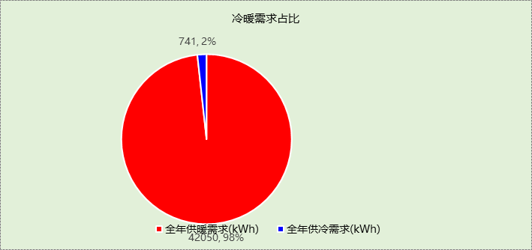

## 能耗分项统计

|  |  |  |  |  |  |  |
| --- | --- | --- | --- | --- | --- | --- |
| 分类 | 围护传热 | 室内得热 | 窗日射 | 新风/渗透 | 热回收 | 合计 |
| 供暖需求(kWh) | -63073 | 40794 | 5770 | -25541 | 0 | -42050 |
| 供冷需求(kWh) | 508 | 77 | 134 | 22 | 0 | 741 |

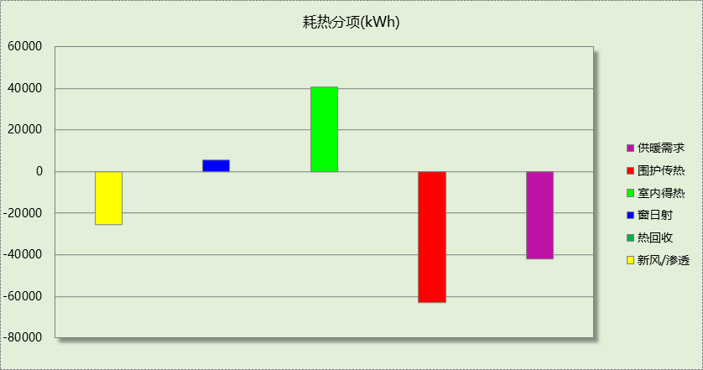

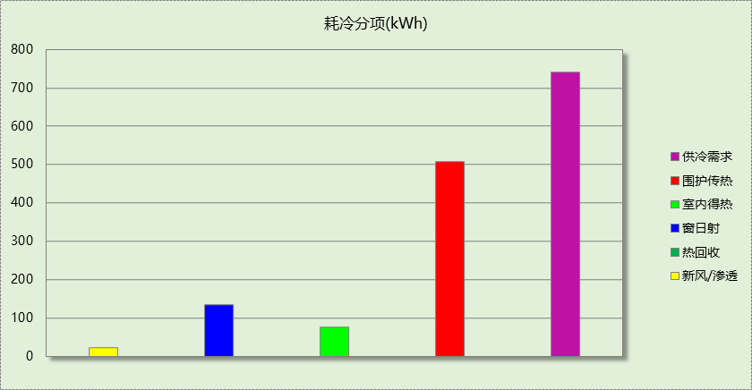

## 逐月负荷表

|  |  |  |  |  |  |  |
| --- | --- | --- | --- | --- | --- | --- |
| 月份 | 供暖需求 (kWh) | 供冷需求 (kWh) | 热负荷 峰值(kW) | 热负荷 峰值时刻 | 冷负荷 峰值(kW) | 冷负荷 峰值时刻 |
| 1月 | 30042 | 0 | 1265.456 | 01月02日07时 | 0.000 | -- |
| 2月 | 3050 | 0 | 212.646 | 02月04日07时 | 0.000 | -- |
| 3月 | 59 | 0 | 13.031 | 03月11日07时 | 0.000 | -- |
| 4月 | 0 | 0 | 0.000 | -- | 0.000 | -- |
| 5月 | 0 | 0 | 0.000 | -- | 0.000 | -- |
| 6月 | 0 | 0 | 0.000 | -- | 0.000 | -- |
| 7月 | 0 | 741 | 0.000 | -- | 45.599 | 07月16日06时 |
| 8月 | 0 | 0 | 0.000 | -- | 0.000 | -- |
| 9月 | 0 | 0 | 0.000 | -- | 0.000 | -- |
| 10月 | 0 | 0 | 0.000 | -- | 0.000 | -- |
| 11月 | 117 | 0 | 15.079 | 11月29日07时 | 0.000 | -- |
| 12月 | 8783 | 0 | 324.422 | 12月16日07时 | 0.000 | -- |

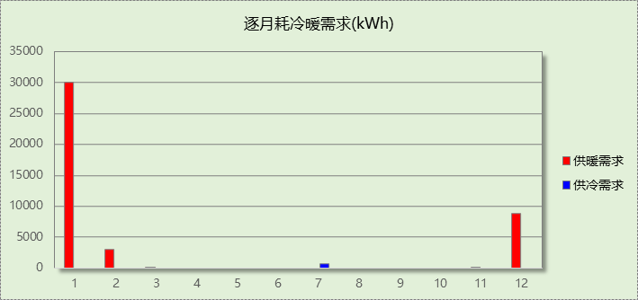

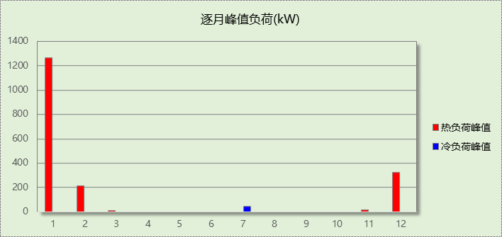

# 附录

**工作日/节假日人员逐时在室率(%)**

|  |  |  |  |  |  |  |  |  |  |  |  |  |  |  |  |  |  |  |  |  |  |  |  |  |
| --- | --- | --- | --- | --- | --- | --- | --- | --- | --- | --- | --- | --- | --- | --- | --- | --- | --- | --- | --- | --- | --- | --- | --- | --- |
| 房间类型 | 1 | 2 | 3 | 4 | 5 | 6 | 7 | 8 | 9 | 10 | 11 | 12 | 13 | 14 | 15 | 16 | 17 | 18 | 19 | 20 | 21 | 22 | 23 | 24 |
| 办公-普通办公室 | 0 | 0 | 0 | 0 | 0 | 0 | 10 | 50 | 100 | 100 | 100 | 30 | 100 | 100 | 100 | 100 | 50 | 20 | 10 | 0 | 0 | 0 | 0 | 0 |
| 0 | 0 | 0 | 0 | 0 | 0 | 0 | 20 | 45 | 0 | 0 | 0 | 0 | 0 | 0 | 0 | 0 | 0 | 0 | 0 | 0 | 0 | 0 | 0 |
| 办公-走廊 | 0 | 0 | 0 | 0 | 0 | 0 | 10 | 50 | 95 | 95 | 95 | 80 | 80 | 95 | 95 | 95 | 95 | 30 | 30 | 0 | 0 | 0 | 0 | 0 |
| 0 | 0 | 0 | 0 | 0 | 0 | 0 | 0 | 0 | 0 | 0 | 0 | 0 | 0 | 0 | 0 | 0 | 0 | 0 | 0 | 0 | 0 | 0 | 0 |
| 学校办公室 | 0 | 0 | 0 | 0 | 0 | 0 | 10 | 50 | 100 | 100 | 100 | 30 | 100 | 100 | 100 | 100 | 50 | 20 | 10 | 0 | 0 | 0 | 0 | 0 |
| 0 | 0 | 0 | 0 | 0 | 0 | 0 | 20 | 45 | 0 | 0 | 0 | 0 | 0 | 0 | 0 | 0 | 0 | 0 | 0 | 0 | 0 | 0 | 0 |
| 学校卫生间 | 0 | 0 | 0 | 0 | 0 | 0 | 10 | 50 | 100 | 100 | 100 | 30 | 100 | 100 | 100 | 100 | 50 | 20 | 10 | 0 | 0 | 0 | 0 | 0 |
| 0 | 0 | 0 | 0 | 0 | 0 | 0 | 20 | 45 | 0 | 0 | 0 | 0 | 0 | 0 | 0 | 0 | 0 | 0 | 0 | 0 | 0 | 0 | 0 |
| 学校教室 | 0 | 0 | 0 | 0 | 0 | 0 | 10 | 50 | 100 | 100 | 100 | 30 | 100 | 100 | 100 | 100 | 50 | 20 | 10 | 0 | 0 | 0 | 0 | 0 |
| 0 | 0 | 0 | 0 | 0 | 0 | 0 | 20 | 45 | 0 | 0 | 0 | 0 | 0 | 0 | 0 | 0 | 0 | 0 | 0 | 0 | 0 | 0 | 0 |
| 学校楼梯间 | 0 | 0 | 0 | 0 | 0 | 0 | 10 | 50 | 100 | 100 | 100 | 30 | 100 | 100 | 100 | 100 | 50 | 20 | 10 | 0 | 0 | 0 | 0 | 0 |
| 0 | 0 | 0 | 0 | 0 | 0 | 0 | 20 | 45 | 0 | 0 | 0 | 0 | 0 | 0 | 0 | 0 | 0 | 0 | 0 | 0 | 0 | 0 | 0 |
| 学校走廊 | 0 | 0 | 0 | 0 | 0 | 0 | 10 | 50 | 100 | 100 | 100 | 30 | 100 | 100 | 100 | 100 | 50 | 20 | 10 | 0 | 0 | 0 | 0 | 0 |
| 0 | 0 | 0 | 0 | 0 | 0 | 0 | 20 | 45 | 0 | 0 | 0 | 0 | 0 | 0 | 0 | 0 | 0 | 0 | 0 | 0 | 0 | 0 | 0 |

注：上行：工作日；下行：节假日

**工作日/节假日照明开关时间表(%)**

|  |  |  |  |  |  |  |  |  |  |  |  |  |  |  |  |  |  |  |  |  |  |  |  |  |
| --- | --- | --- | --- | --- | --- | --- | --- | --- | --- | --- | --- | --- | --- | --- | --- | --- | --- | --- | --- | --- | --- | --- | --- | --- |
| 房间类型 | 1 | 2 | 3 | 4 | 5 | 6 | 7 | 8 | 9 | 10 | 11 | 12 | 13 | 14 | 15 | 16 | 17 | 18 | 19 | 20 | 21 | 22 | 23 | 24 |
| 办公-普通办公室 | 10 | 10 | 10 | 10 | 10 | 10 | 10 | 36 | 62 | 56 | 54 | 43 | 53 | 55 | 58 | 67 | 40 | 18 | 10 | 10 | 10 | 10 | 10 | 10 |
| 0 | 0 | 0 | 0 | 0 | 0 | 0 | 0 | 0 | 0 | 0 | 0 | 0 | 0 | 0 | 0 | 0 | 0 | 0 | 0 | 0 | 0 | 0 | 0 |
| 办公-走廊 | 0 | 0 | 0 | 0 | 0 | 0 | 10 | 50 | 95 | 95 | 95 | 80 | 80 | 95 | 95 | 95 | 95 | 30 | 30 | 0 | 0 | 0 | 0 | 0 |
| 0 | 0 | 0 | 0 | 0 | 0 | 0 | 0 | 0 | 0 | 0 | 0 | 0 | 0 | 0 | 0 | 0 | 0 | 0 | 0 | 0 | 0 | 0 | 0 |
| 学校办公室 | 10 | 10 | 10 | 10 | 10 | 10 | 10 | 36 | 62 | 56 | 54 | 43 | 53 | 55 | 58 | 67 | 40 | 18 | 10 | 10 | 10 | 10 | 10 | 10 |
| 0 | 0 | 0 | 0 | 0 | 0 | 0 | 0 | 0 | 0 | 0 | 0 | 0 | 0 | 0 | 0 | 0 | 0 | 0 | 0 | 0 | 0 | 0 | 0 |
| 学校卫生间 | 10 | 10 | 10 | 10 | 10 | 10 | 10 | 36 | 62 | 56 | 54 | 43 | 53 | 55 | 58 | 67 | 40 | 18 | 10 | 10 | 10 | 10 | 10 | 10 |
| 0 | 0 | 0 | 0 | 0 | 0 | 0 | 0 | 0 | 0 | 0 | 0 | 0 | 0 | 0 | 0 | 0 | 0 | 0 | 0 | 0 | 0 | 0 | 0 |
| 学校教室 | 10 | 10 | 10 | 10 | 10 | 10 | 10 | 36 | 62 | 56 | 54 | 43 | 53 | 55 | 58 | 67 | 40 | 18 | 10 | 10 | 10 | 10 | 10 | 10 |
| 0 | 0 | 0 | 0 | 0 | 0 | 0 | 0 | 0 | 0 | 0 | 0 | 0 | 0 | 0 | 0 | 0 | 0 | 0 | 0 | 0 | 0 | 0 | 0 |
| 学校楼梯间 | 10 | 10 | 10 | 10 | 10 | 10 | 10 | 36 | 62 | 56 | 54 | 43 | 53 | 55 | 58 | 67 | 40 | 18 | 10 | 10 | 10 | 10 | 10 | 10 |
| 0 | 0 | 0 | 0 | 0 | 0 | 0 | 0 | 0 | 0 | 0 | 0 | 0 | 0 | 0 | 0 | 0 | 0 | 0 | 0 | 0 | 0 | 0 | 0 |
| 学校走廊 | 10 | 10 | 10 | 10 | 10 | 10 | 10 | 36 | 62 | 56 | 54 | 43 | 53 | 55 | 58 | 67 | 40 | 18 | 10 | 10 | 10 | 10 | 10 | 10 |
| 0 | 0 | 0 | 0 | 0 | 0 | 0 | 0 | 0 | 0 | 0 | 0 | 0 | 0 | 0 | 0 | 0 | 0 | 0 | 0 | 0 | 0 | 0 | 0 |

注：上行：工作日；下行：节假日

**工作日/节假日设备逐时使用率(%)**

|  |  |  |  |  |  |  |  |  |  |  |  |  |  |  |  |  |  |  |  |  |  |  |  |  |
| --- | --- | --- | --- | --- | --- | --- | --- | --- | --- | --- | --- | --- | --- | --- | --- | --- | --- | --- | --- | --- | --- | --- | --- | --- |
| 房间类型 | 1 | 2 | 3 | 4 | 5 | 6 | 7 | 8 | 9 | 10 | 11 | 12 | 13 | 14 | 15 | 16 | 17 | 18 | 19 | 20 | 21 | 22 | 23 | 24 |
| 办公-普通办公室 | 0 | 0 | 0 | 0 | 0 | 0 | 10 | 50 | 100 | 100 | 100 | 100 | 100 | 100 | 100 | 100 | 50 | 20 | 10 | 0 | 0 | 0 | 0 | 0 |
| 0 | 0 | 0 | 0 | 0 | 0 | 0 | 0 | 0 | 0 | 0 | 0 | 0 | 0 | 0 | 0 | 0 | 0 | 0 | 0 | 0 | 0 | 0 | 0 |
| 办公-走廊 | 0 | 0 | 0 | 0 | 0 | 0 | 10 | 50 | 95 | 95 | 95 | 50 | 50 | 95 | 95 | 95 | 95 | 30 | 30 | 0 | 0 | 0 | 0 | 0 |
| 0 | 0 | 0 | 0 | 0 | 0 | 0 | 0 | 0 | 0 | 0 | 0 | 0 | 0 | 0 | 0 | 0 | 0 | 0 | 0 | 0 | 0 | 0 | 0 |
| 学校办公室 | 0 | 0 | 0 | 0 | 0 | 0 | 10 | 50 | 100 | 100 | 100 | 100 | 100 | 100 | 100 | 100 | 50 | 20 | 10 | 0 | 0 | 0 | 0 | 0 |
| 0 | 0 | 0 | 0 | 0 | 0 | 0 | 0 | 0 | 0 | 0 | 0 | 0 | 0 | 0 | 0 | 0 | 0 | 0 | 0 | 0 | 0 | 0 | 0 |
| 学校卫生间 | 0 | 0 | 0 | 0 | 0 | 0 | 10 | 50 | 100 | 100 | 100 | 100 | 100 | 100 | 100 | 100 | 50 | 20 | 10 | 0 | 0 | 0 | 0 | 0 |
| 0 | 0 | 0 | 0 | 0 | 0 | 0 | 0 | 0 | 0 | 0 | 0 | 0 | 0 | 0 | 0 | 0 | 0 | 0 | 0 | 0 | 0 | 0 | 0 |
| 学校教室 | 0 | 0 | 0 | 0 | 0 | 0 | 10 | 50 | 100 | 100 | 100 | 100 | 100 | 100 | 100 | 100 | 50 | 20 | 10 | 0 | 0 | 0 | 0 | 0 |
| 0 | 0 | 0 | 0 | 0 | 0 | 0 | 0 | 0 | 0 | 0 | 0 | 0 | 0 | 0 | 0 | 0 | 0 | 0 | 0 | 0 | 0 | 0 | 0 |
| 学校楼梯间 | 0 | 0 | 0 | 0 | 0 | 0 | 10 | 50 | 100 | 100 | 100 | 100 | 100 | 100 | 100 | 100 | 50 | 20 | 10 | 0 | 0 | 0 | 0 | 0 |
| 0 | 0 | 0 | 0 | 0 | 0 | 0 | 0 | 0 | 0 | 0 | 0 | 0 | 0 | 0 | 0 | 0 | 0 | 0 | 0 | 0 | 0 | 0 | 0 |
| 学校走廊 | 0 | 0 | 0 | 0 | 0 | 0 | 10 | 50 | 100 | 100 | 100 | 100 | 100 | 100 | 100 | 100 | 50 | 20 | 10 | 0 | 0 | 0 | 0 | 0 |
| 0 | 0 | 0 | 0 | 0 | 0 | 0 | 0 | 0 | 0 | 0 | 0 | 0 | 0 | 0 | 0 | 0 | 0 | 0 | 0 | 0 | 0 | 0 | 0 |

注：上行：工作日；下行：节假日

**工作日/节假日空调系统开关时间表**

采暖期：

|  |  |  |  |  |  |  |  |  |  |  |  |  |  |  |  |  |  |  |  |  |  |  |  |  |
| --- | --- | --- | --- | --- | --- | --- | --- | --- | --- | --- | --- | --- | --- | --- | --- | --- | --- | --- | --- | --- | --- | --- | --- | --- |
| 系统编号 | 1 | 2 | 3 | 4 | 5 | 6 | 7 | 8 | 9 | 10 | 11 | 12 | 13 | 14 | 15 | 16 | 17 | 18 | 19 | 20 | 21 | 22 | 23 | 24 |
| 默认 | 0 | 0 | 0 | 0 | 0 | 0 | 1 | 1 | 1 | 1 | 1 | 1 | 1 | 1 | 1 | 1 | 1 | 1 | 0 | 0 | 0 | 0 | 0 | 0 |
| 0 | 0 | 0 | 0 | 0 | 0 | 0 | 0 | 0 | 0 | 0 | 0 | 0 | 0 | 0 | 0 | 0 | 0 | 0 | 0 | 0 | 0 | 0 | 0 |

供冷期：

|  |  |  |  |  |  |  |  |  |  |  |  |  |  |  |  |  |  |  |  |  |  |  |  |  |
| --- | --- | --- | --- | --- | --- | --- | --- | --- | --- | --- | --- | --- | --- | --- | --- | --- | --- | --- | --- | --- | --- | --- | --- | --- |
| 系统编号 | 1 | 2 | 3 | 4 | 5 | 6 | 7 | 8 | 9 | 10 | 11 | 12 | 13 | 14 | 15 | 16 | 17 | 18 | 19 | 20 | 21 | 22 | 23 | 24 |
| 默认 | 0 | 0 | 0 | 0 | 0 | 0 | 1 | 1 | 1 | 1 | 1 | 1 | 1 | 1 | 1 | 1 | 1 | 1 | 0 | 0 | 0 | 0 | 0 | 0 |
| 0 | 0 | 0 | 0 | 0 | 0 | 0 | 0 | 0 | 0 | 0 | 0 | 0 | 0 | 0 | 0 | 0 | 0 | 0 | 0 | 0 | 0 | 0 | 0 |

注：上行：工作日；下行：节假日