采光分析报告
改造后一层采光系数
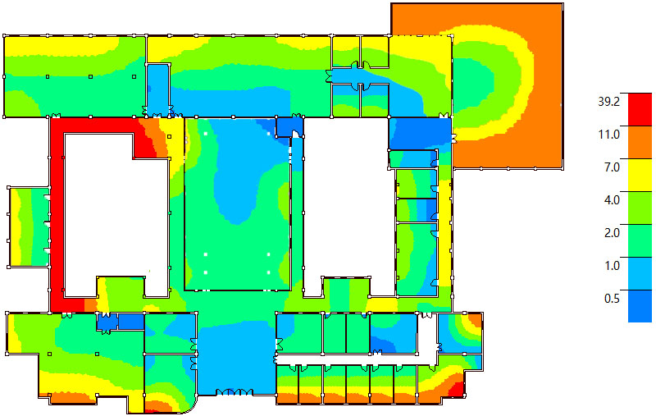
改造后二层采光系数
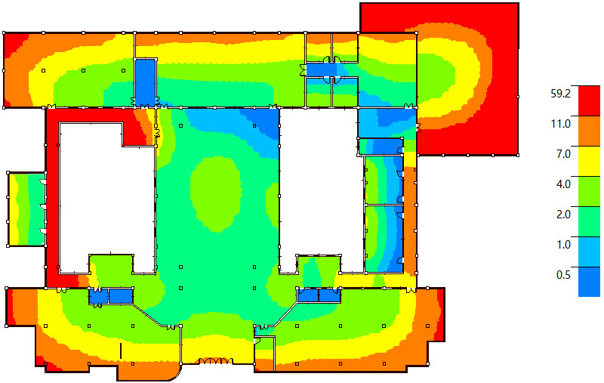

改造后三层采光系数
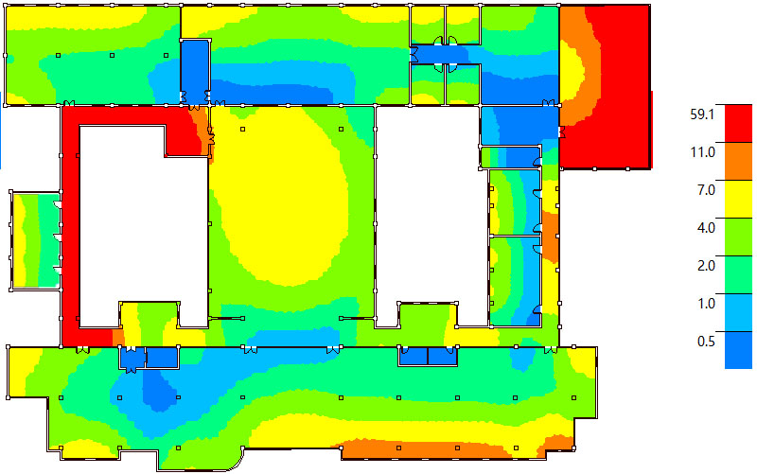
改造后四层采光系数
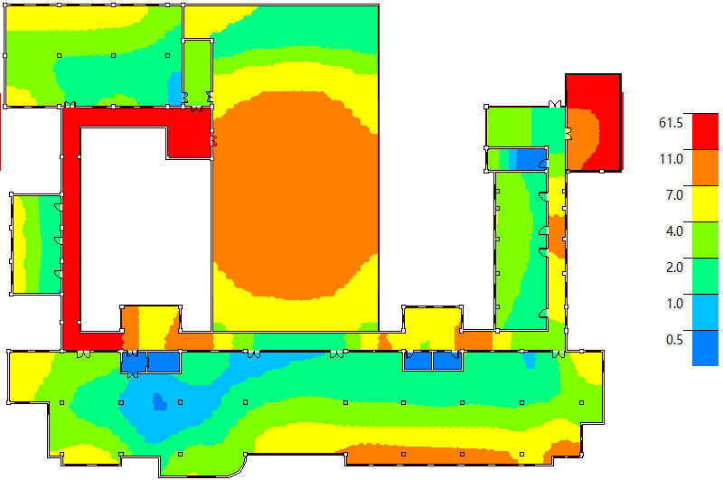
改造后五层采光系数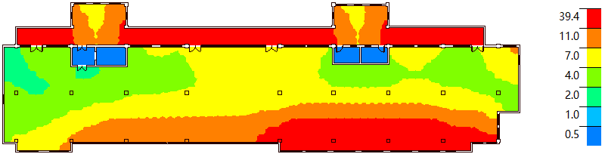
改造后部分房间采光评价
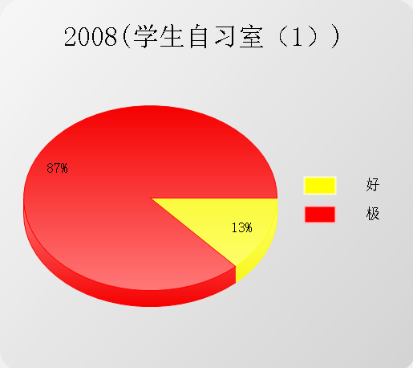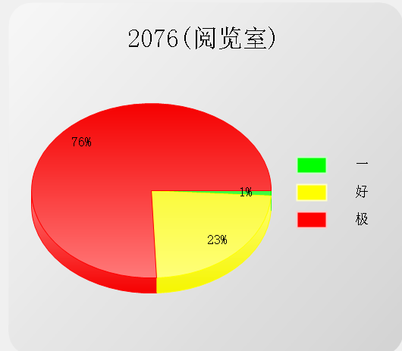
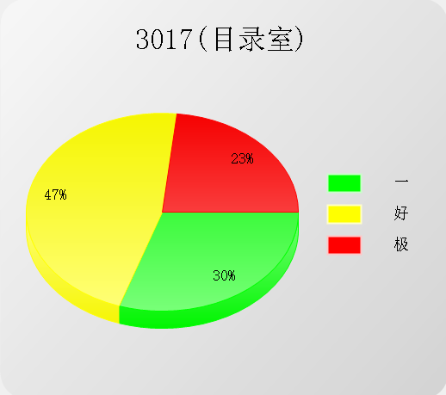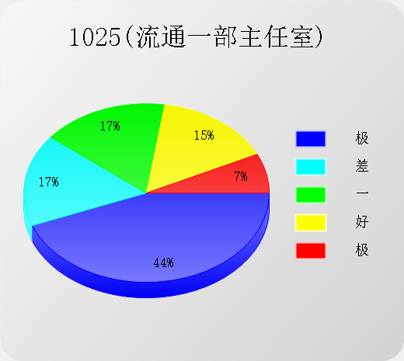
改造后采光达标率彩图
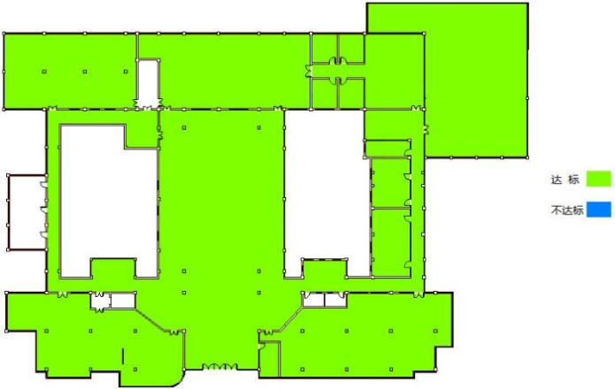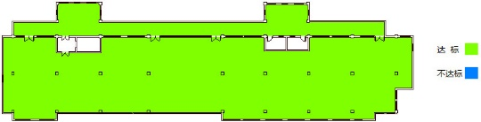

改造后各个房间采光分析汇总表
分类 | 采光等级 | 采光类型 | 房间面积 | 采光系数C(%) | 采光系数  标准值(%) | 结论
○1
├ 1001[书库] | Ⅴ | 侧面采光 | 63.09 | 1.4 | 1.1 | 满足
├ 1002[目录室] | Ⅳ | 侧面采光 | 209.31 | 2.3 | 2.2 | 满足
├ 1003[目录室] | Ⅳ | 侧面采光 | 16.95 | 4.63 | 2.2 | 满足
├ 1004[目录室] | Ⅳ | 侧面采光 | 18.48 | 4.43 | 2.2 | 满足
├ 1005[目录室] | Ⅳ | 侧面采光 | 18.15 | 4.46 | 2.2 | 满足
├ 1006[目录室] | Ⅳ | 侧面采光 | 18.4 | 4.39 | 2.2 | 满足
├ 1007[目录室] | Ⅳ | 侧面采光 | 18.4 | 4.45 | 2.2 | 满足
├ 1008[目录室] | Ⅳ | 侧面采光 | 18.11 | 4.48 | 2.2 | 满足
├ 1009[目录室] | Ⅳ | 侧面采光 | 46.52 | 5.8 | 2.2 | 满足
├ 1012[目录室] | Ⅳ | 侧面采光 | 43.38 | 1.06 | 2.2 | 满足
├ 1013[目录室] | Ⅳ | 侧面采光 | 38.2 | 2.51 | 2.2 | 满足
├ 1016[开架书库] | Ⅲ | 侧面采光 | 39.32 | 3.45 | 3.3 | 满足
├ 1017[目录室] | Ⅳ | 侧面采光 | 36.98 | 2.32 | 2.2 | 满足
├ 1022[阅览室] | Ⅲ | 侧面采光 | 64.28 | 3.38 | 3.3 | 满足
├ 1023[开架书库] | Ⅲ | 侧面采光 | 20.65 | 3.2 | 3.3 | 满足
├ 1024[书库] | Ⅴ | 侧面采光 | 43.55 | 1.97 | 1.1 | 满足
├ 1025[目录室] | Ⅳ | 侧面采光 | 20.47 | 2.96 | 2.2 | 满足
├ 1026[书库] | Ⅴ | 侧面采光 | 25.31 | 1.27 | 1.1 | 满足
├ 1028[书库] | Ⅴ | 侧面采光 | 147.12 | 2.58 | 1.1 | 满足
├ 1030[阅览室] | Ⅲ | 侧面采光 | 245 | 3.31 | 3.3 | 满足
├ 1032[书库] | Ⅴ | 侧面采光 | 293.38 | 2.89 | 1.1 | 满足
├ 1033[目录室] | Ⅳ | 侧面采光 | 18.79 | 3.04 | 2.2 | 满足
├ 1034[目录室] | Ⅳ | 侧面采光 | 18.78 | 2.82 | 2.2 | 满足
├ 1035[书库] | Ⅴ | 侧面采光 | 126.96 | 1.2 | 1.1 | 满足
├ 1036[目录室] | Ⅳ | 侧面采光 | 17.99 | 6.55 | 2.2 | 满足
└ 1037[目录室] | Ⅳ | 侧面采光 | 17.99 | 6.29 | 2.2 | 满足
○2
├ 2004[阅览室] | Ⅲ | 侧面采光 | 315.24 | 3.42 | 3.3 | 满足
├ 2005[阅览室] | Ⅲ | 侧面采光 | 293.41 | 3.48 | 3.3 | 满足
├ 2006[阅览室] | Ⅲ | 侧面采光 | 283.04 | 0.71 | 3.3 | 满足
├ 2007[阅览室] | Ⅲ | 侧面采光 | 245 | 3.41 | 3.3 | 满足
├ 2008[阅览室] | Ⅲ | 侧面采光 | 147.12 | 7.29 | 3.3 | 满足
├ 2009[目录室] | Ⅳ | 侧面采光 | 126.96 | 2.28 | 2.2 | 满足
├ 2010[目录室] | Ⅳ | 侧面采光 | 115.17 | 3.03 | 2.2 | 满足
├ 2011[阅览室] | Ⅲ | 侧面采光 | 64.28 | 3.69 | 3.3 | 满足
├ 2012[开架书库] | Ⅲ | 侧面采光 | 47.1 | 3.4 | 3.3 | 满足
├ 2013[书库] | Ⅴ | 侧面采光 | 43.55 | 2.14 | 1.1 | 满足
├ 2015[开架书库] | Ⅲ | 侧面采光 | 20.65 | 3.5 | 3.3 | 满足
├ 2016[目录室] | Ⅳ | 侧面采光 | 18.79 | 3.88 | 2.2 | 满足
├ 2017[目录室] | Ⅳ | 侧面采光 | 18.78 | 3.38 | 2.2 | 满足
├ 2019[目录室] | Ⅳ | 侧面采光 | 17.99 | 6.44 | 2.2 | 满足
├ 2020[目录室] | Ⅳ | 侧面采光 | 17.99 | 6.47 | 2.2 | 满足
└ 2021[目录室] | Ⅳ | 侧面采光 | 16.48 | 5.34 | 2.2 | 满足
○3
├ 3002[阅览室] | Ⅲ | 侧面采光 | 830.25 | 3.69 | 3.3 | 满足
├ 3005[阅览室] | Ⅲ | 侧面采光 | 293.41 | 3.59 | 3.3 | 满足
├ 3006[阅览室] | Ⅲ | 侧面采光 | 245 | 3.52 | 3.3 | 满足
├ 3007[阅览室] | Ⅲ | 侧面采光 | 147.12 | 7.63 | 3.3 | 满足
├ 3008[目录室] | Ⅳ | 侧面采光 | 126.96 | 2.29 | 2.2 | 满足
├ 3009[阅览室] | Ⅲ | 侧面采光 | 64.28 | 3.96 | 3.3 | 满足
├ 3010[开架书库] | Ⅲ | 侧面采光 | 47.1 | 3.81 | 3.3 | 满足
├ 3011[书库] | Ⅴ | 侧面采光 | 43.55 | 2.15 | 1.1 | 满足
├ 3013[开架书库] | Ⅲ | 侧面采光 | 20.65 | 3.46 | 3.3 | 满足
├ 3014[目录室] | Ⅳ | 侧面采光 | 18.79 | 4.78 | 2.2 | 满足
├ 3015[目录室] | Ⅳ | 侧面采光 | 18.78 | 4.17 | 2.2 | 满足
├ 3017[目录室] | Ⅳ | 侧面采光 | 17.99 | 6.49 | 2.2 | 满足
└ 3018[目录室] | Ⅳ | 侧面采光 | 17.99 | 6.44 | 2.2 | 满足
○4
├ 4001[阅览室] | Ⅲ | 侧面采光 | 830.25 | 3.36 | 3.3 | 满足
├ 4003[阅览室] | Ⅲ | 侧面采光 | 245 | 3.7 | 3.3 | 满足
├ 4004[阅览室] | Ⅲ | 侧面采光 | 147.12 | 8.13 | 3.3 | 过亮不宜
├ 4005[书库] | Ⅴ | 侧面采光 | 112.7 | 2.1 | 1.1 | 满足
└ 4007[书库] | Ⅴ | 侧面采光 | 65.31 | 2.24 | 1.1 | 满足
○5
└ 5001[阅览室] | Ⅲ | 侧面采光 | 783.42 | 5.09 | 3.3 | 满足
○6
├ 6001[阅览室] | Ⅲ | 侧面采光 | 317.59 | 3.98 | 3.3 | 满足
├ 6002[阅览室] | Ⅲ | 侧面采光 | 259.18 | 3.54 | 3.3 | 满足
└ 6004[阅览室] | Ⅲ | 侧面采光 | 170.02 | 3.56 | 3.3 | 满足

