#### 5.2.8 充分利用天然光。（12分）

**1 得分自评**

|  |  |  |  |  |
| --- | --- | --- | --- | --- |
| 序号 | 评价内容 | | 评价分值 | 自评得分 |
| 1 | 住宅建筑：主要功能空间至少60%面积比例区域采光照度值不低于300lx的小时数平均不少于8h/d | | 9 |  |
| 2 | 公共建筑 | 内区采光系数满足采光要求的面积比例达到60% | 3 |  |
| 地下空间平均采光系数≥0.5%的面积与首层地下室面积的比例达到10%以上 | 3 |
| 主要功能空间至少60%面积比例区域采光照度值不低于采光要求的小时数平均不少于4h/d | 3 |
| 3 | 主要功能房间有眩光控制措施 | | 3 |  |
| 合计 | | | 12 |  |

**2 评价要点**

概述改善室内防眩光采用的措施。

|  |
| --- |
| 本项目主要功能房间采用下列措施控制不舒适眩光：  1、作业区域避免直射阳光。  2、室内人员的视觉背景不为窗口。  3、采用室内遮挡措施。  4、窗结构的内表面或窗周围的内墙面采用浅色饰面。 |

采光达标统计

| 内区 | 分析区域 | 主要功能空间面积  （m2） | 内区面积  （m2） | 采光达标面积  （m2） | 达标比例（%） |
| --- | --- | --- | --- | --- | --- |
|  |  |  |  |  |
|  |  |  |  |  |
|  |  |  |  |  |
| 合计 |  |  |  |  |
| 住宅主要功能空间 | 分析区域 | 采光照度值不低于300lx的小时数平均不少于8h/d面积（m2） | | 主要功能空间面积（m2） | 达标比例 |
|  |  | |  |  |
|  |  | |  |  |
|  |  | |  |  |
| 合计 |  | |  |  |
| 公建主要功能空间 | 分析区域 | 采光照度值不低于采光要求的小时数平均不少于8h/d面积（m2） | | 主要功能空间面积（m2） | 达标比例 |
|  |  | |  |  |
|  |  | |  |  |

**3 证明材料**

提交材料及要求：

1）建筑竣工图及说明文件，应体现室内防眩光设计措施；

2）动态采光计算书、采光系数及面积比例计算书；

3）公共建筑内区及地下空间采光系数计算书或检测报告。

实际提交材料：

|  |  |  |  |  |  |  |  |  |  |  |  |  |  |  |  |  |  |  |  |  |  |  |  |  |  |  |  |  |  |  |  |  |  |  |  |  |  |  |  |  |  |  |  |  |  |  |  |  |  |  |  |  |  |  |  |  |  |  |  |  |  |  |  |  |  |  |  |  |  |  |  |  |  |  |  |  |  |  |  |  |  |  |  |  |  |  |  |  |  |  |  |  |  |  |  |  |  |  |  |  |  |  |  |  |  |  |  |  |  |  |  |  |  |  |  |  |  |  |  |  |  |  |  |  |  |  |  |  |  |  |  |  |  |  |  |  |  |  |  |  |  |  |  |  |  |  |  |  |  |  |  |  |  |  |  |  |  |  |  |  |  |  |  |  |  |  |  |  |  |  |  |  |  |  |  |  |  |  |  |  |  |  |  |  |  |  |  |  |  |  |  |  |  |  |  |  |  |  |  |  |  |  |  |  |  |  |  |  |  |  |  |  |  |  |  |  |  |  |  |  |  |  |  |  |  |  |  |  |  |  |  |  |  |  |  |  |  |  |  |  |  |  |  |  |  |  |  |  |  |  |  |  |  |  |  |  |  |  |  |  |  |  |  |  |  |  |  |  |  |  |  |  |  |  |  |  |  |  |  |  |  |  |  |  |  |  |  |  |  |  |  |  |  |  |  |  |  |  |  |  |  |  |  |  |  |  |  |  |  |  |  |  |  |  |  |  |  |  |  |  |  |  |  |  |  |  |  |  |  |  |  |  |  |  |  |  |  |  |  |  |  |  |  |  |  |  |  |  |  |  |  |  |  |  |  |  |  |  |  |  |  |  |  |  |  |  |  |  |  |  |  |  |  |  |  |  |  |  |  |  |  |  |  |  |  |  |  |  |  |  |  |  |  |  |  |  |  |  |  |  |  |  |  |  |  |  |  |  |  |  |  |  |  |  |  |  |  |  |  |  |  |  |  |  |  |  |  |  |  |  |  |  |  |  |  |  |  |  |  |  |  |  |  |  |  |  |  |  |  |  |  |  |  |  |  |  |  |  |  |  |  |  |  |  |  |  |  |  |  |  |  |  |  |  |  |  |  |  |  |  |
| --- | --- | --- | --- | --- | --- | --- | --- | --- | --- | --- | --- | --- | --- | --- | --- | --- | --- | --- | --- | --- | --- | --- | --- | --- | --- | --- | --- | --- | --- | --- | --- | --- | --- | --- | --- | --- | --- | --- | --- | --- | --- | --- | --- | --- | --- | --- | --- | --- | --- | --- | --- | --- | --- | --- | --- | --- | --- | --- | --- | --- | --- | --- | --- | --- | --- | --- | --- | --- | --- | --- | --- | --- | --- | --- | --- | --- | --- | --- | --- | --- | --- | --- | --- | --- | --- | --- | --- | --- | --- | --- | --- | --- | --- | --- | --- | --- | --- | --- | --- | --- | --- | --- | --- | --- | --- | --- | --- | --- | --- | --- | --- | --- | --- | --- | --- | --- | --- | --- | --- | --- | --- | --- | --- | --- | --- | --- | --- | --- | --- | --- | --- | --- | --- | --- | --- | --- | --- | --- | --- | --- | --- | --- | --- | --- | --- | --- | --- | --- | --- | --- | --- | --- | --- | --- | --- | --- | --- | --- | --- | --- | --- | --- | --- | --- | --- | --- | --- | --- | --- | --- | --- | --- | --- | --- | --- | --- | --- | --- | --- | --- | --- | --- | --- | --- | --- | --- | --- | --- | --- | --- | --- | --- | --- | --- | --- | --- | --- | --- | --- | --- | --- | --- | --- | --- | --- | --- | --- | --- | --- | --- | --- | --- | --- | --- | --- | --- | --- | --- | --- | --- | --- | --- | --- | --- | --- | --- | --- | --- | --- | --- | --- | --- | --- | --- | --- | --- | --- | --- | --- | --- | --- | --- | --- | --- | --- | --- | --- | --- | --- | --- | --- | --- | --- | --- | --- | --- | --- | --- | --- | --- | --- | --- | --- | --- | --- | --- | --- | --- | --- | --- | --- | --- | --- | --- | --- | --- | --- | --- | --- | --- | --- | --- | --- | --- | --- | --- | --- | --- | --- | --- | --- | --- | --- | --- | --- | --- | --- | --- | --- | --- | --- | --- | --- | --- | --- | --- | --- | --- | --- | --- | --- | --- | --- | --- | --- | --- | --- | --- | --- | --- | --- | --- | --- | --- | --- | --- | --- | --- | --- | --- | --- | --- | --- | --- | --- | --- | --- | --- | --- | --- | --- | --- | --- | --- | --- | --- | --- | --- | --- | --- | --- | --- | --- | --- | --- | --- | --- | --- | --- | --- | --- | --- | --- | --- | --- | --- | --- | --- | --- | --- | --- | --- | --- | --- | --- | --- | --- | --- | --- | --- | --- | --- | --- | --- | --- | --- | --- | --- | --- | --- | --- | --- | --- | --- | --- | --- | --- | --- | --- | --- | --- | --- | --- | --- | --- | --- | --- | --- | --- | --- | --- | --- | --- | --- | --- | --- | --- | --- | --- | --- | --- | --- | --- | --- | --- | --- | --- | --- | --- | --- | --- | --- | --- | --- | --- | --- | --- | --- | --- | --- | --- | --- | --- | --- | --- | --- | --- | --- | --- | --- | --- | --- | --- | --- | --- | --- | --- | --- | --- | --- | --- | --- | --- | --- | --- | --- | --- | --- | --- | --- | --- | --- | --- | --- | --- | --- | --- | --- | --- | --- |
| |  |  |  |  |  |  |  |  |  |  |  |  |  |  | | --- | --- | --- | --- | --- | --- | --- | --- | --- | --- | --- | --- | --- | --- | | 楼层 | 房间 编号 | | 房间类型 | 采光 等级 | | 采光 类型 | 设计照度 要求(Lx) | | 房间面积 (m2) | | 达标面积 比例(%) | | 结论 | | 1 | 1006 | | 餐厅 | IV | | 侧面 | 300 | | 187.84 | | 100 | | 满足 | | 1007 | | 展厅（单层及顶层） | III | | 侧面 | 450 | | 210.80 | | 100 | | 满足 | | 1008 | | 阅览室 | III | | 侧面 | 450 | | 188.40 | | 100 | | 满足 | | 1009 | | 报告厅 | III | | 侧面 | 450 | | 210.21 | | 100 | | 满足 | | 1011 | | 普通教室 | III | | 侧面 | 450 | | 142.75 | | 100 | | 满足 | | 1012 | | 办公室 | III | | 侧面 | 450 | | 18.00 | | 100 | | 满足 | | 1014 | | 办公室 | III | | 侧面 | 450 | | 18.00 | | 100 | | 满足 | | 1016 | | 健身房 | IV | | 侧面 | 300 | | 142.58 | | 100 | | 满足 | | 1018 | | 健身房 | IV | | 侧面 | 300 | | 26.47 | | 100 | | 满足 | | 1019 | | 健身房 | IV | | 侧面 | 300 | | 26.96 | | 100 | | 满足 | | 1020 | | 健身房 | IV | | 侧面 | 300 | | 26.92 | | 100 | | 满足 | | 1023 | | 健身房 | IV | | 侧面 | 300 | | 26.47 | | 100 | | 满足 | | 1024 | | 健身房 | IV | | 侧面 | 300 | | 26.96 | | 100 | | 满足 | | 1025 | | 健身房 | IV | | 侧面 | 300 | | 26.92 | | 100 | | 满足 | | 2 | 2003 | | 办公室 | III | | 侧面 | 450 | | 29.16 | | 100 | | 满足 | | 2005 | | 办公室 | III | | 侧面 | 450 | | 22.54 | | 100 | | 满足 | | 2006 | | 办公室 | III | | 侧面 | 450 | | 22.68 | | 100 | | 满足 | | 2007 | | 办公室 | III | | 侧面 | 450 | | 17.76 | | 100 | | 满足 | | 2009 | | 普通教室 | III | | 侧面 | 450 | | 25.60 | | 100 | | 满足 | | 2010 | | 普通教室 | III | | 侧面 | 450 | | 26.47 | | 100 | | 满足 | | 2011 | | 普通教室 | III | | 侧面 | 450 | | 26.96 | | 100 | | 满足 | | 2012 | | 普通教室 | III | | 侧面 | 450 | | 26.92 | | 100 | | 满足 | | 2015 | | 普通教室 | III | | 侧面 | 450 | | 31.04 | | 100 | | 满足 | | 2016 | | 普通教室 | III | | 侧面 | 450 | | 32.09 | | 100 | | 满足 | | 2017 | | 普通教室 | III | | 侧面 | 450 | | 32.66 | | 100 | | 满足 | | 2018 | | 普通教室 | III | | 侧面 | 450 | | 32.66 | | 100 | | 满足 | | 房间类型 | | 采光类型 | | | 设计照度(Lx) | | | 总面积(m2) | | 达标面积比例(%) | | 结论 | | | 餐厅 | | 侧面 | | | 300 | | | 187.84 | | 100 | | 满足 | | | 展厅（单层及顶层） | | 侧面 | | | 450 | | | 210.80 | | 100 | | 满足 | | | 阅览室 | | 侧面 | | | 450 | | | 188.40 | | 100 | | 满足 | | | 报告厅 | | 侧面 | | | 450 | | | 210.21 | | 100 | | 满足 | | | 普通教室 | | 侧面 | | | 450 | | | 377.15 | | 100 | | 满足 | | | 办公室 | | 侧面 | | | 450 | | | 128.14 | | 100 | | 满足 | | | 健身房 | | 侧面 | | | 300 | | | 303.28 | | 100 | | 满足 | | | 多区域面积加权平均 | | | | | | | | | | 100 | | **3分** | | |

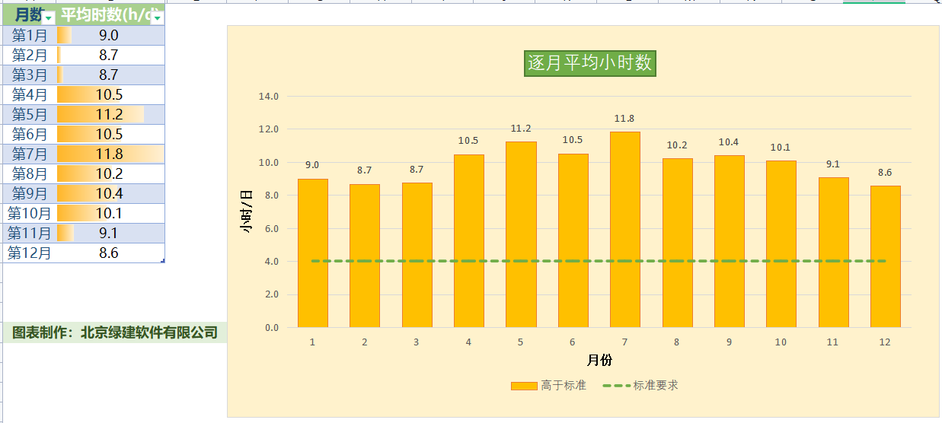

总结：全部达标