**1.节能计算**

**1.1设计依据**

①《绿色建筑评价标准》(GB/T50378-2019)

②《民用建筑绿色性能计算标准》(JGJ/T 449-2018)

③《建筑能效标识技术标准》(JGJ/T 288-2012)

④《夏热冬冷地区居住建筑节能设计标准》（JGJ 134-2010）

⑤《民用建筑热工设计规范》(GB50176)

**1.2围护结构**

2.2.1屋顶构造

表1.5.1屋顶构造统计表

|  |  |  |  |  |  |  |
| --- | --- | --- | --- | --- | --- | --- |
| **材料名称 （由上到下）** | **厚度δ** | **导热系数λ** | **蓄热系数S** | **修正系数** | **热阻R** | **热惰性指标** |
| **(mm)** | **W/(m.K)** | **W/(㎡.K)** | **α** | **(㎡K)/W** | **D=R*S** |
| 预制钢筋混凝土板 | 60 | 1.740 | 17.060 | 1.00 | 0.034 | 0.588 |
| 细石混凝土（双向配筋） | 40 | 1.740 | 17.060 | 1.00 | 0.023 | 0.392 |
| 挤塑聚苯板 | 30 | 0.030 | 0.317 | 1.10 | 0.909 | 0.317 |
| 水泥砂浆 | 20 | 0.930 | 11.306 | 1.00 | 0.022 | 0.243 |
| 现浇混凝土屋面板 | 120 | 1.740 | 17.060 | 1.00 | 0.069 | 1.177 |
| 各层之和∑ | 270 | － | － | － | 1.057 | 2.717 |
| **外表面太阳辐射吸收系数** | 0.75[默认] | | | | | |
| **传热系数K=1/(0.15+∑R)** | 0.83 | | | | | |
| **数据来源** | 浙江居住DB33-1015-2003第44页 | | | | | |

1.2.2外墙构造

表1.5.2外墙构造统计表

|  |  |  |  |  |  |  |
| --- | --- | --- | --- | --- | --- | --- |
| **材料名称 （由外到内）** | **厚度δ** | **导热系数λ** | **蓄热系数S** | **修正系数** | **热阻R** | **热惰性指标** |
| **(mm)** | **W/(m.K)** | **W/(㎡.K)** | **α** | **(㎡K)/W** | **D=R*S** |
| 蒸压砂加气混凝土砌块蒸压粉煤灰加气混凝土砌块 B07 | 20 | 0.180 | 3.598 | 1.00 | 0.111 | 0.400 |
| 硅藻土类烧结保温砖（900级） | 240 | 0.250 | 4.170 | 1.00 | 0.960 | 4.003 |
| 水泥砂浆 | 20 | 0.930 | 11.306 | 1.00 | 0.022 | 0.243 |
| 轻集料混凝土空心砖 | 30 | 0.750 | 6.010 | 1.10 | 0.036 | 0.240 |
| 泡沫混凝土砌块 B06 | 3 | 0.160 | 2.830 | 1.00 | 0.019 | 0.053 |
| 各层之和∑ | 313 | － | － | － | 1.148 | 4.940 |
| **外表面太阳辐射吸收系数** | 0.75[默认] | | | | | |
| **传热系数K=1/(0.15+∑R)** | 0.77 | | | | | |
| **数据来源** | 浙江居住DB33-1015-2003第20页 | | | | | |

1.2.3外窗热工

1.2.3.1外窗构造

表1.5.3外窗构造统计表

|  |  |  |  |  |  |  |
| --- | --- | --- | --- | --- | --- | --- |
| **序号** | **构造名称** | **构造编号** | **传热系数** | **自遮阳系数** | **可见光透射比** | **备注** |
| 1 | 断桥铝窗框(Kf=4.0,框面积20%）(Low_E中空5mm+6A+5mm) | 18 | 2.80 | 0.48 | 0.800 | 资料来源:DB33/1015-2015 附录G |

1.2.3.2外遮阳类型

表1.5.4外遮阳类型统计表

|  |  |  |  |  |  |
| --- | --- | --- | --- | --- | --- |
| **序号** | **编号** | **夏季遮阳系数** | **冬季遮阳系数** | **平均遮阳系数** | **备注** |
| 1 | 活动遮阳0 | 0.500 | 1.000 | 0.750 |  |

1.南向：

表1.5.5南向外遮阳类型统计表

|  |  |  |  |  |  |  |  |  |  |  |  |  |
| --- | --- | --- | --- | --- | --- | --- | --- | --- | --- | --- | --- | --- |
| **序号** | **门窗编号** | **楼层** | **数量** | **单个面积（㎡）** | **总面积（㎡）** | **自遮阳系数** | **夏季外遮阳系数** | **冬季外遮阳系数** | **平均外遮阳系数** | **夏季综合遮阳系数** | **冬季综合遮阳系数** | **平均综合遮阳系数** |
| 1 |  | 1 | 3 | 29.25 | 29.25 | 1 | 0.935 | 0.935 | 0.935 | 0.935 | 0.935 | 0.935 |
| 2 |  | 1 | 1 | 29.25 | 29.25 | 1 | 0.738 | 0.738 | 0.738 | 0.738 | 0.738 | 0.738 |
| 3 |  | 1 | 1 | 29.25 | 29.25 | 1 | 0.201 | 0.201 | 0.201 | 0.201 | 0.201 | 0.201 |
| 4 |  | 1 | 4 | 14.04 | 14.04 | 1 | 0.35 | 0.35 | 0.35 | 0.35 | 0.35 | 0.35 |
| 5 |  | 1 | 2 | 9.578 | 9.578 | 1 | 0.779 | 0.779 | 0.779 | 0.779 | 0.779 | 0.779 |
| 6 |  | 1 | 4 | 1.62 | 6.48 | 1 | 0.779 | 0.779 | 0.779 | 0.779 | 0.779 | 0.779 |
| 7 |  | 1 | 2 | 0.269 | 0.538 | 1 | 0.779 | 0.779 | 0.779 | 0.779 | 0.779 | 0.779 |
| 8 |  | 1 | 1 | 0.647 | 0.647 | 1 | 0.779 | 0.779 | 0.779 | 0.779 | 0.779 | 0.779 |
| 9 |  | 1 | 1 | 6.786 | 6.786 | 1 | 0.779 | 0.779 | 0.779 | 0.779 | 0.779 | 0.779 |
| 10 |  | 1~3 | 4 | 117 | 468 | 1 | 0.315 | 0.315 | 0.315 | 0.315 | 0.315 | 0.315 |
|  |  |  |  |  |  |  |  |  |  |  |  |  |
| 11 |  | 1 | 1 | 63.18 | 63.18 | 1 | 0.887 | 0.887 | 0.887 | 0.887 | 0.887 | 0.887 |
| 12 |  | 2 | 1 | 29.25 | 29.25 | 1 | 0.241 | 0.241 | 0.241 | 0.241 | 0.241 | 0.241 |
| 13 |  | 2 | 1 | 18.252 | 18.252 | 1 | 0.408 | 0.408 | 0.408 | 0.408 | 0.408 | 0.408 |
| 14 |  | 2 | 1 | 47.19 | 47.19 | 1 | 0.321 | 0.321 | 0.321 | 0.321 | 0.321 | 0.321 |
| 15 |  | 2 | 1 | 10.998 | 10.998 | 1 | 0.302 | 0.302 | 0.302 | 0.302 | 0.302 | 0.302 |
| 16 |  | 2~3 | 2 | 29.25 | 58.5 | 1 | 0.427 | 0.427 | 0.427 | 0.427 | 0.427 | 0.427 |
| 17 |  | 3 | 1 | 8.19 | 8.19 | 1 | 0.323 | 0.323 | 0.323 | 0.323 | 0.323 | 0.323 |
| 18 |  | 3 | 1 | 14.035 | 14.035 | 1 | 0.349 | 0.349 | 0.349 | 0.349 | 0.349 | 0.349 |
| 19 |  | 4 | 1 | 115.362 | 115.362 | 1 | 0.999 | 0.999 | 0.999 | 0.999 | 0.999 | 0.999 |
| 20 | C0815 | 1 | 1 | 1.2 | 1.2 | 0.4 | 0.195 | 0.195 | 0.195 | 0.078 | 0.078 | 0.078 |
| 21 | C0815 | 2 | 1 | 1.2 | 1.2 | 0.4 | 0.991 | 0.991 | 0.991 | 0.396 | 0.396 | 0.396 |
| 22 | C0815 | 2 | 1 | 1.2 | 1.2 | 0.4 | 0.986 | 0.986 | 0.986 | 0.394 | 0.394 | 0.394 |
| 23 | C0815 | 2 | 1 | 1.2 | 1.2 | 0.4 | 0.977 | 0.977 | 0.977 | 0.391 | 0.391 | 0.391 |
| 24 | C0815 | 2 | 1 | 1.2 | 1.2 | 0.4 | 0.998 | 0.998 | 0.998 | 0.399 | 0.399 | 0.399 |
| 25 | C0815 | 2 | 1 | 1.2 | 1.2 | 0.4 | 0.907 | 0.907 | 0.907 | 0.363 | 0.363 | 0.363 |
| 26 | C0815 | 2 | 1 | 1.2 | 1.2 | 0.4 | 0.818 | 0.818 | 0.818 | 0.327 | 0.327 | 0.327 |
| 27 | C0815 | 2 | 1 | 1.2 | 1.2 | 0.4 | 0.646 | 0.646 | 0.646 | 0.258 | 0.258 | 0.258 |
| **朝向总面积(㎡)** | | | | | 829.379 | **朝向综合遮阳系数** | |  |  |  |  | 0.575 |

2.北向

表1.5.6北向外遮阳类型统计表

|  |  |  |  |  |  |  |  |  |  |  |  |  |
| --- | --- | --- | --- | --- | --- | --- | --- | --- | --- | --- | --- | --- |
| **序号** | **门窗编号** | **楼层** | **数量** | **单个面积（㎡）** | **总面积（㎡）** | **自遮阳系数** | **夏季外遮阳系数** | **冬季外遮阳系数** | **平均外遮阳系数** | **夏季综合遮阳系数** | **冬季综合遮阳系数** | **平均综合遮阳系数** |
| 1 |  | 1 | 1 | 21.06 | 21.06 | 1 | 0.376 | 0.376 | 0.376 | 0.376 | 0.376 | 0.376 |
| 2 |  | 1 | 1 | 30.42 | 30.42 | 1 | 0.116 | 0.116 | 0.116 | 0.116 | 0.116 | 0.116 |
| 3 |  | 1 | 1 | 10.528 | 10.528 | 1 | 0.672 | 0.672 | 0.672 | 0.672 | 0.672 | 0.672 |
| 4 |  | 2 | 1 | 65.567 | 65.567 | 1 | 0.279 | 0.279 | 0.279 | 0.279 | 0.279 | 0.279 |
| 5 |  | 2 | 1 | 13.95 | 13.95 | 1 | 0.193 | 0.193 | 0.193 | 0.193 | 0.193 | 0.193 |
| 6 |  | 2 | 1 | 1.669 | 1.669 | 1 | 0.275 | 0.275 | 0.275 | 0.275 | 0.275 | 0.275 |
| 7 |  | 2 | 1 | 1.62 | 1.62 | 1 | 0.275 | 0.275 | 0.275 | 0.275 | 0.275 | 0.275 |
| 8 |  | 2 | 1 | 41.621 | 41.621 | 1 | 0.275 | 0.275 | 0.275 | 0.275 | 0.275 | 0.275 |
| 9 |  | 3 | 1 | 0.154 | 0.154 | 1 | 0.845 | 0.845 | 0.845 | 0.845 | 0.845 | 0.845 |
| 10 |  | 3 | 1 | 0.27 | 0.27 | 1 | 0.602 | 0.602 | 0.602 | 0.602 | 0.602 | 0.602 |
| 11 |  | 3 | 1 | 64.35 | 64.35 | 1 | 0.408 | 0.408 | 0.408 | 0.408 | 0.408 | 0.408 |
| 12 |  | 4 | 1 | 9.407 | 9.407 | 1 | 1 | 1 | 1 | 1.000 | 1.000 | 1.000 |
| 13 |  | 4 | 1 | 46.8 | 46.8 | 1 | 1 | 1 | 1 | 1.000 | 1.000 | 1.000 |
| 14 |  | 4 | 1 | 9.36 | 9.36 | 1 | 1 | 1 | 1 | 1.000 | 1.000 | 1.000 |
| 15 |  | 4 | 1 | 33.93 | 33.93 | 1 | 1 | 1 | 1 | 1.000 | 1.000 | 1.000 |
| 16 | C0815 | 1 | 3 | 1.2 | 3.6 | 0.4 | 0.417 | 0.417 | 0.417 | 0.167 | 0.167 | 0.167 |
| 17 | C0815 | 1 | 2 | 1.2 | 2.4 | 0.4 | 0.416 | 0.416 | 0.416 | 0.166 | 0.166 | 0.166 |
| 18 | C0815 | 1 | 1 | 1.2 | 1 | 0.4 | 0.418 | 0.418 | 0.418 | 0.167 | 0.167 | 0.167 |
| 19 | C0815 | 1 | 1 | 1.2 | 1 | 0.4 | 0.426 | 0.426 | 0.426 | 0.170 | 0.170 | 0.170 |
| 20 | C0815 | 2 | 1 | 1.2 | 1 | 0.4 | 0.63 | 0.63 | 0.63 | 0.252 | 0.252 | 0.252 |
| **朝向总面积(㎡)** |  |  |  |  | 356.706 | **朝向综合遮阳系数** | |  |  |  |  | 0.498 |

**1.3模拟分析**

1.3.1全年负荷统计图

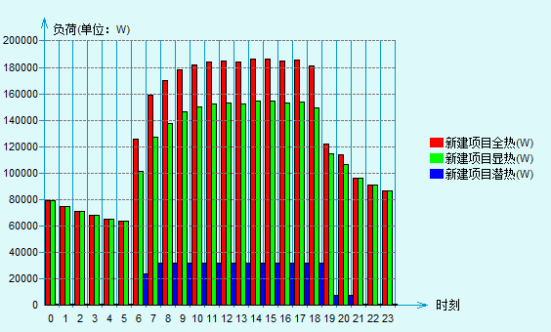

图1.1.1冷负荷结果柱状图

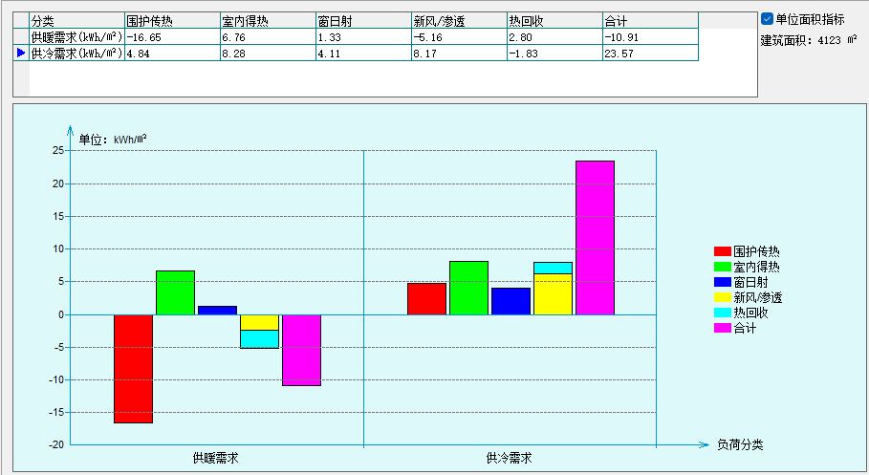

图1.1.2全年负荷分项

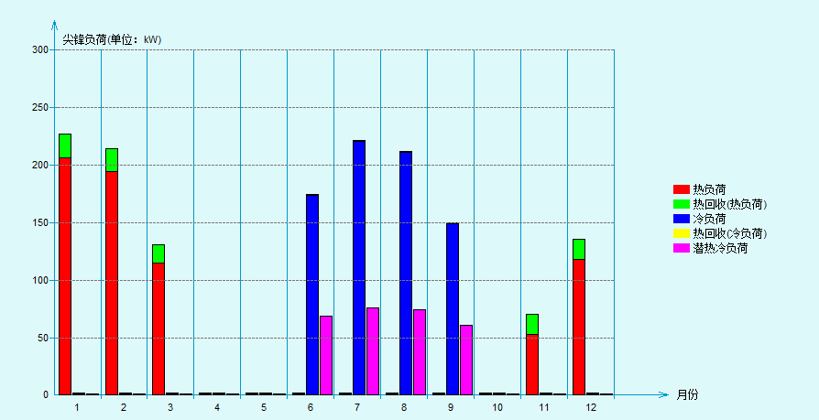

图1.1.3全年负荷曲线

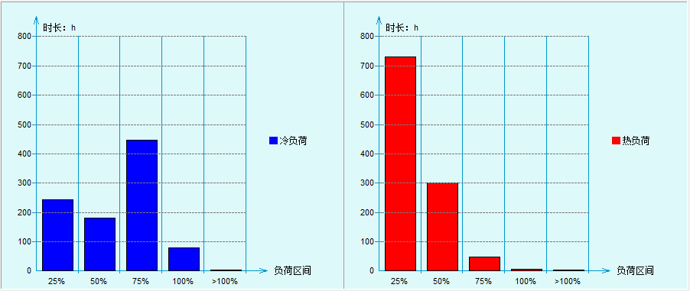

图1.1.4全年负荷统计

1.3.2全年负荷统计表

|  |  |  |  |
| --- | --- | --- | --- |
| **能耗分类** | **能耗子类** | **设计建筑** | **备注** |
| (kWh/㎡) |
| **建筑负荷** | 耗冷量 | 131.04 |  |
| 耗热量 | 116.78 |  |
| 冷热合计 | 14.26 |  |
| **热回收** | 供冷 | 2.8 |  |
| 供暖 | 3 |  |
| 冷热合计 | 5.8 |  |
| **供冷电耗** | 中央冷源 | 20.09 |  |
| **(Ec)** | 冷却水泵 | 2.75 |  |
|  | 冷冻水泵 | 2.2 |  |
|  | 冷却塔 | 0 |  |
|  | 多联机/单元式空调 | 0 |  |
|  | 供冷合计 | 25.03 |  |
| **供暖电耗** | 中央热源 | 3.56 |  |
| **(Eh)** | 供暖水泵 | 2.3 |  |
|  | 多联机/单元式热泵 | 0 |  |
|  | 供暖合计 | 5.87 |  |
| **风机电耗** | 新排风 | 2.69 |  |
| **(Ef)** | 风机盘管 | 0.22 |  |
|  | 多联机室内机 | 0 |  |
|  | 全空气系统 | 0 |  |
|  | 风机合计 | 2.91 |  |
| **其他电耗** | 照明 | 23.7 |  |
| **(Eo)** | 插座设备 | 51.16 |  |
|  | 电梯 | 4.03 |  |
|  | 独立排风机 | 21.28 |  |
|  | 生活热水 | 0 | 扣减了太阳能热水 |
|  | 其他合计 | 25.31 |  |
| **可再生能源** | 太阳能热水(Es) | 5.52 |  |
| **(Er)** | 光伏发电(Ep) | 0 |  |
|  | 合计 | 0.04 |  |
| **建筑总能耗(E1)：电耗(kWh/㎡)** | | 133.94 | E1=Ec+Eh+Ef+Eo-Ep |