**隔热检查计算书**

公共建筑

|  |  |
| --- | --- |
| 工程名称 | 石家庄旅投智慧康养中心项目 |
| 工程地点 | 河北-石家庄 |
| 设计编号 |  |
| 建设单位 |  |
| 设计单位 | 河北建筑设计研究院有限责任公司 |
| 设 计 人 |  |
| 校 对 人 |  |
| 审 核 人 |  |
| 计算日期 | 2023年5月3日 |



|  |  |
| --- | --- |
| 采用软件 | 斯维尔节能设计Becs2023 |
| 软件版本 | 20220323 |
| 研发单位 | 北京绿建软件股份有限公司 |
| 正版授权码 | T18222286039 |

**目 录**

1 建筑概况 3

2 评价依据 3

3 评价目标与方法 3

3.1 评价目标 3

3.2 评价方法 3

4 边界条件参数设置 4

4.1 基本设置 4

4.2 室外空气温度 5

4.3 室外太阳辐射照度 5

4.4 室内空气温度 7

5 工程材料 7

6 工程构造 8

6.1 屋顶构造 8

6.1.1 屋顶构造二（种植屋面） 8

6.1.2 屋顶构造一（保温屋面） 9

6.2 外墙构造 10

6.2.1 外墙构造一（钢筋混凝土+岩棉） 10

6.2.2 外墙构造三（钢筋混凝土墙+岩棉条） 13

6.2.3 外墙构造二（蒸压轻质砂加气混凝土砌块墙） 15

6.2.4 外墙构造四（蒸压轻质砂加气混凝土砌块墙） 18

6.3 热桥柱构造 20

6.3.1 热桥柱构造一（钢筋混凝土+岩棉） 20

6.4 热桥梁构造 23

6.4.1 热桥梁构造（钢筋混凝土+岩棉） 23

6.4.2 热桥梁构造（保温结构一体化） 25

7 验算结论 28

7.1 自然通风房间 28

# 建筑概况

|  |  |  |
| --- | --- | --- |
| 工程名称 | 石家庄旅投智慧康养中心项目 | |
| 工程地点 | 河北-石家庄 | |
| 地理位置 | 北纬：38.00° | 东经：114.41° |
| 气候子区 | 寒冷B区 | |
| 大气透明度等级 | 4 | |
| 建筑面积 | 地上47927㎡ 地下11518㎡ | |
| 建筑层数 | 地上29 地下1 | |
| 建筑高度 | 101.7m | |
| 结构类型 | 框架剪力墙结构 | |

# 评价依据

1. 《建筑节能与可再生能源利用通用规范》GB55015-2021

2. 《建筑环境通用规范》GB 55016

3. 河北省《绿色建筑评价标准》DB13(J)/T 8352-2020

4. 《民用建筑热工设计规范》GB50176

5. 施工图、设计说明、墙身大样图、节能计算书

# 评价目标与方法

## 评价目标

1. 依据《建筑环境通用规范》和河北省《绿色建筑评价标准》DB13(J)/T 8352-2020的要求和规定，屋顶和外墙的隔热性能应满足要求。
2. 通过房间围护结构的内表面温度计算，判断是否不大于《建筑环境通用规范》给出的内表面最高温度。

## 评价方法

1. 在给定两侧空气温度及变化规律的情况下，外墙内表面最高温度应符合表3.2.1的要求：

**表3.2.1 外墙内表面最高温度的限值**

|  |  |  |  |
| --- | --- | --- | --- |
| **房间类型** | **自然通风房间** | **空调房间** | |
| **重质围护结构**  **（D≥2.5）** | **轻质围护结构**  **（D＜2.5）** |
| **内表面最高温度** | ≤ te.max | ≤ti+2 | ≤ti+3 |

1. 在给定两侧空气温度及变化规律的情况下，屋面内表面最高温度应符合表3.2.2的要求：

**表3.2.2 屋顶内表面最高温度的限值**

|  |  |  |  |
| --- | --- | --- | --- |
| **房间类型** | **自然通风房间** | **空调房间** | |
| **重质围护结构**  **（D≥2.5）** | **轻质围护结构**  **（D＜2.5）** |
| **内表面最高温度** | ≤ te.max | ≤ti+2.5 | ≤ti+3.5 |

表中：—围护结构内表面最高温度（），应按《民用建筑热工设计规范》 GB50176-2016附录C.3 的规定计算；



$t_{i}$—室内空气温度，（）。



te.max—累年日平均温度最高日的最高温度（）,应按《民用建筑热工设计规范》



GB50176-2016配套软件气象数据取用。

1. 外围护结构内表面最高温度按照规范《民用建筑热工设计规范》GB50176-2016附录C.3 的规定计算：
2. 按式3.2.3-1建立常物性、无内热源的一维非稳态导热的内部微分方程，微分方程的求解可采用有限差分法：

（3.2.3-1）



式中： —温度对于时间的导数，/s。



—材料的导温系数，，m2/s。



1. 按式3.2.3-2建立第三类边界条件隐式差分格式边界节点方程（边界节点1，节点n 可参照）：

（3.2.3-2）



式中： $C_{p}$—材料的比热， J /(kg·K)；

$ρ$—材料的密度，kg/m³；

—材料的导温系数，，m2/s；



—差分步长，m；

—材料的导热系数，［W/(m·K)］；



$t_{f}^{k}$—对流换热温度，。



1. 按式3.2.3-3列出各内部节点和边界点的节点方程，并求解节点方程组得到外墙、屋顶内表面温度值。

,i=1,2,……n （3.2.3-3）



式中： $t_{i}$—差分节点温度值，。



# 边界条件参数设置

## 基本设置

|  |  |  |  |  |
| --- | --- | --- | --- | --- |
| **公式及变量** | **变量名** | | **数值** | **说明** |
| **（一）内表面边界条件（第三类边界条件）** | | | | |
|  | | 夏季室内温度， |  | 按《民用建筑热工设计规范》GB50176-2016第3.3.2条的规定取值。 |
|  | | 室内侧对流换热系数，W/(m2·K) | 8.7 | 按《民用建筑热工设计规范》 GB50176-2016附录B.4.1，表B.4.1-1取值。 |
| **（二）外表面边界条件（第三类边界条件）** | | | | |
|  | | 室外侧对流换热系数，(m2·K) | 19.0 | 按《民用建筑热工设计规范》 GB50176-2016附录B.4.1，表B.4.1-2取值。 |
|  | | 室外空气逐时温度， |  | 按《民用建筑热工设计规范》 GB50176-2016配套软件气象数据取用。 |
|  | | 表面法向太阳总辐射强度，包括直射和散射，W/m2 |  | 按《民用建筑热工设计规范》 GB50176-2016配套软件气象参数取值。 |
|  | | 外表面太阳辐射吸收系数 |  | 根据工程构造取值。 |

## 室外空气温度

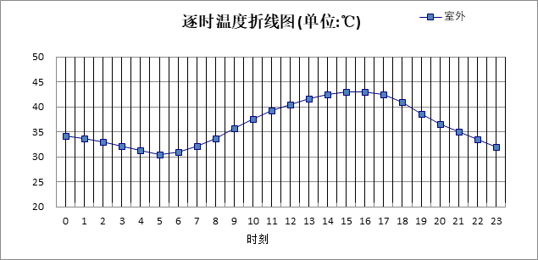

|  |  |  |  |  |  |  |  |  |  |  |  |
| --- | --- | --- | --- | --- | --- | --- | --- | --- | --- | --- | --- |
| 0:00 | 1:00 | 2:00 | 3:00 | 4:00 | 5:00 | 6:00 | 7:00 | 8:00 | 9:00 | 10:00 | 11:00 |
| 34.20 | 33.60 | 33.00 | 32.20 | 31.30 | 30.50 | 31.00 | 32.10 | 33.70 | 35.60 | 37.50 | 39.20 |
| 12:00 | 13:00 | 14:00 | 15:00 | 16:00 | 17:00 | 18:00 | 19:00 | 20:00 | 21:00 | 22:00 | 23:00 |
| 40.50 | 41.60 | 42.40 | 42.90 | 42.90 | 42.40 | 40.90 | 38.50 | 36.50 | 35.00 | 33.40 | 31.90 |

## 室外太阳辐射照度

|  |  |  |
| --- | --- | --- |
| **变量** | **变量名** | **公式来源** |
|  | 表面法向太阳总辐射强度，包括直射和散射，W/ m2 | 按《民用建筑热工设计规范GB  50176-2016》配套软件气象数据取用。 |

|  |  |  |  |  |  |
| --- | --- | --- | --- | --- | --- |
| 时刻\朝向 | 东 | 南 | 西 | 北 | 水平 |
| 0:00 | 0.00 | 0.00 | 0.00 | 0.00 | 0.00 |
| 1:00 | 0.00 | 0.00 | 0.00 | 0.00 | 0.00 |
| 2:00 | 0.00 | 0.00 | 0.00 | 0.00 | 0.00 |
| 3:00 | 0.00 | 0.00 | 0.00 | 0.00 | 0.00 |
| 4:00 | 0.00 | 0.00 | 0.00 | 0.00 | 0.00 |
| 5:00 | 134.90 | 49.43 | 60.20 | 24.13 | 115.60 |
| 6:00 | 280.60 | 116.46 | 118.34 | 68.45 | 260.10 |
| 7:00 | 423.68 | 183.10 | 155.42 | 124.33 | 424.00 |
| 8:00 | 487.60 | 259.36 | 175.14 | 144.87 | 587.30 |
| 9:00 | 458.45 | 341.90 | 194.17 | 162.72 | 732.10 |
| 10:00 | 362.26 | 409.00 | 213.31 | 179.64 | 838.00 |
| 11:00 | 225.53 | 440.36 | 225.53 | 189.93 | 885.80 |
| 12:00 | 225.93 | 427.66 | 378.17 | 189.80 | 869.70 |
| 13:00 | 219.53 | 379.72 | 501.24 | 183.29 | 801.30 |
| 14:00 | 210.79 | 309.95 | 571.99 | 174.00 | 692.80 |
| 15:00 | 193.11 | 226.98 | 549.96 | 154.71 | 541.30 |
| 16:00 | 161.55 | 152.68 | 420.29 | 87.88 | 369.50 |
| 17:00 | 95.60 | 70.19 | 240.26 | 30.30 | 188.90 |
| 18:00 | 8.86 | 8.93 | 12.63 | 5.10 | 14.90 |
| 19:00 | 0.00 | 0.00 | 0.00 | 0.00 | 0.00 |
| 20:00 | 0.00 | 0.00 | 0.00 | 0.00 | 0.00 |
| 21:00 | 0.00 | 0.00 | 0.00 | 0.00 | 0.00 |
| 22:00 | 0.00 | 0.00 | 0.00 | 0.00 | 0.00 |
| 23:00 | 0.00 | 0.00 | 0.00 | 0.00 | 0.00 |

## 室内空气温度

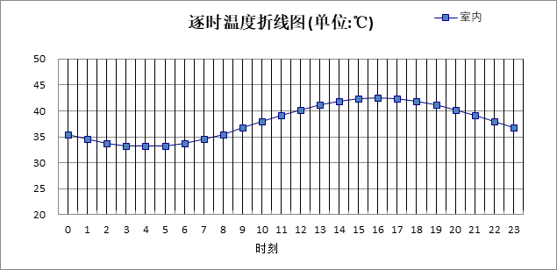

|  |  |  |  |  |  |  |  |  |  |  |  |
| --- | --- | --- | --- | --- | --- | --- | --- | --- | --- | --- | --- |
| 0:00 | 1:00 | 2:00 | 3:00 | 4:00 | 5:00 | 6:00 | 7:00 | 8:00 | 9:00 | 10:00 | 11:00 |
| 35.52 | 34.54 | 33.80 | 33.33 | 33.17 | 33.33 | 33.80 | 34.54 | 35.52 | 36.65 | 37.87 | 39.08 |
| 12:00 | 13:00 | 14:00 | 15:00 | 16:00 | 17:00 | 18:00 | 19:00 | 20:00 | 21:00 | 22:00 | 23:00 |
| 40.22 | 41.19 | 41.94 | 42.41 | 42.57 | 42.41 | 41.94 | 41.19 | 40.22 | 39.08 | 37.87 | 36.65 |

# 工程材料

|  |  |  |  |  |  |  |
| --- | --- | --- | --- | --- | --- | --- |
| 材料名称 | 导热系数λ | 蓄热系数S | 密度ρ | 比热容Cp | 蒸汽渗透系数u | 备注 |
| W/(m.K) | W/(㎡.K) | kg/m3 | J/(kg.K) | g/(m.h.kPa) |
| 水泥砂浆 | 0.930 | 11.370 | 1800.0 | 1050.0 | 0.0210 | 来源：《民用建筑热工设计规范》GB50176-2016 |
| 石灰砂浆 | 0.810 | 10.070 | 1600.0 | 1050.0 | 0.0443 | 来源：《民用建筑热工设计规范》GB50176-2016 |
| 钢筋混凝土 | 1.740 | 17.200 | 2500.0 | 920.0 | 0.0158 | 来源：《民用建筑热工设计规范》GB50176-2016 |
| C20细石混凝土(ρ=2300) | 1.510 | 15.243 | 2300.0 | 920.0 | 0.0000 |  |
| 挤塑聚苯板 | 0.030 | 0.340 | 35.0 | 1380.0 | 0.0000 | 来源：《民用建筑热工设计规范》GB50176-2016，蒸汽渗透系数没有给出 |
| 岩棉(ρ=80-200) | 0.041 | 0.748 | 140.0 | 1220.0 | 0.4880 |  |
| 岩棉条 | 0.045 | 0.750 | 100.0 | 1718.9 | 0.0000 |  |
| 无机纤维喷涂棉 | 0.035 | 0.315 | 38.0 | 1380.0 | 0.0000 |  |
| 加气混凝土、泡沫混凝土(ρ=700) | 0.180 | 3.100 | 700.0 | 1050.0 | 0.0998 | 来源：《民用建筑热工设计规范》GB50176-2016 |
| 玻化微珠保温浆料 | 0.070 | 1.462 | 350.0 | 1050.0 | 0.0000 | 蒸汽渗透系数没有给出 |
| 石灰砂浆（1） | 0.810 | 9.948 | 1600.0 | 1050.0 | 0.0000 |  |
| 加气混凝土砌块 | 0.220 | 3.601 | 700.0 | 1158.0 | 0.0000 |  |
| 蒸压轻质砂加气混凝土砌块(ρ=500) | 0.160 | 2.310 | 500.0 | 1050.0 | 0.1110 |  |
| 抗裂砂浆 | 0.930 | 11.306 | 1800.0 | 1050.0 | 0.0000 |  |
| 钢筋混凝土（1） | 1.740 | 17.060 | 2500.0 | 920.0 | 0.0000 |  |
| 聚苯板(EPS板) | 0.041 | 0.287 | 20.0 | 1380.0 | 0.0000 |  |
| 挤塑聚苯乙烯泡沫板（XPS）(ρ=30) | 0.030 | 0.540 | 30.0 | 4455.3 | 0.0000 |  |

# 工程构造

## 屋顶构造

### 屋顶构造二（种植屋面）

|  |  |  |  |  |  |  |  |
| --- | --- | --- | --- | --- | --- | --- | --- |
| 材料名称 由外到内 | 厚度 | 差分 步长 | 导热 系数 | 蓄热 系数 | 修正 系数 | 热阻 | 热惰性 指标 |
| (mm) | (mm) | W/(m.K) | W/(㎡.K) | α | (㎡K)/W | D=R*S |
| C20细石混凝土(ρ=2300) | 50 | 12.5 | 1.510 | 15.243 | 1.00 | 0.033 | 0.505 |
| 挤塑聚苯乙烯泡沫板（XPS）(ρ=30) | 80 | 6.7 | 0.030 | 0.540 | 1.10 | 2.424 | 1.440 |
| 钢筋混凝土 | 120 | 12.0 | 1.740 | 17.200 | 1.00 | 0.069 | 1.186 |
| 各层之和∑ | 250 | － | － | － | － | 2.526 | 3.131 |
| 差分时间步长(分钟) | 5.0 | | | | | | |
| 外表面太阳辐射吸收系数 | 0.75 | | | | | | |
| 传热系数K=1/(0.16+∑R) | 0.37 | | | | | | |
| 重质/轻质 | 重质围护结构 | | | | | | |

#### 自然通风房间：逐时温度

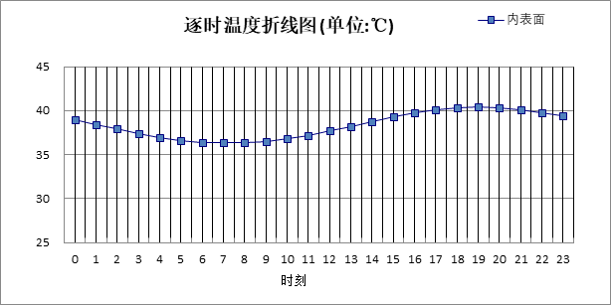

|  |  |  |  |  |  |  |  |  |  |  |  |
| --- | --- | --- | --- | --- | --- | --- | --- | --- | --- | --- | --- |
| 0:00 | 1:00 | 2:00 | 3:00 | 4:00 | 5:00 | 6:00 | 7:00 | 8:00 | 9:00 | 10:00 | 11:00 |
| 38.91 | 38.39 | 37.86 | 37.37 | 36.95 | 36.62 | 36.39 | 36.29 | 36.33 | 36.49 | 36.78 | 37.18 |
| 12:00 | 13:00 | 14:00 | 15:00 | 16:00 | 17:00 | 18:00 | 19:00 | 20:00 | 21:00 | 22:00 | 23:00 |
| 37.67 | 38.20 | 38.74 | 39.26 | 39.71 | 40.07 | 40.30 | 40.39 | 40.34 | 40.14 | 39.82 | 39.40 |

### 屋顶构造一（保温屋面）

|  |  |  |  |  |  |  |  |
| --- | --- | --- | --- | --- | --- | --- | --- |
| 材料名称 由外到内 | 厚度 | 差分 步长 | 导热 系数 | 蓄热 系数 | 修正 系数 | 热阻 | 热惰性 指标 |
| (mm) | (mm) | W/(m.K) | W/(㎡.K) | α | (㎡K)/W | D=R*S |
| 水泥砂浆 | 30 | 10.0 | 0.930 | 11.370 | 1.00 | 0.032 | 0.367 |
| 加气混凝土、泡沫混凝土(ρ=700) | 30 | 6.0 | 0.180 | 3.100 | 1.00 | 0.167 | 0.517 |
| 挤塑聚苯乙烯泡沫板（XPS）(ρ=30) | 80 | 6.7 | 0.030 | 0.540 | 1.10 | 2.424 | 1.440 |
| 钢筋混凝土 | 120 | 12.0 | 1.740 | 17.200 | 1.00 | 0.069 | 1.186 |
| 各层之和∑ | 260 | － | － | － | － | 2.692 | 3.510 |
| 差分时间步长(分钟) | 5.0 | | | | | | |
| 外表面太阳辐射吸收系数 | 0.75 | | | | | | |
| 传热系数K=1/(0.16+∑R) | 0.35 | | | | | | |
| 重质/轻质 | 重质围护结构 | | | | | | |

#### 自然通风房间：逐时温度

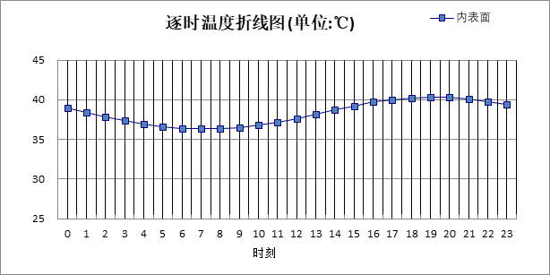

|  |  |  |  |  |  |  |  |  |  |  |  |
| --- | --- | --- | --- | --- | --- | --- | --- | --- | --- | --- | --- |
| 0:00 | 1:00 | 2:00 | 3:00 | 4:00 | 5:00 | 6:00 | 7:00 | 8:00 | 9:00 | 10:00 | 11:00 |
| 38.89 | 38.37 | 37.85 | 37.36 | 36.94 | 36.61 | 36.39 | 36.29 | 36.32 | 36.48 | 36.77 | 37.16 |
| 12:00 | 13:00 | 14:00 | 15:00 | 16:00 | 17:00 | 18:00 | 19:00 | 20:00 | 21:00 | 22:00 | 23:00 |
| 37.64 | 38.16 | 38.70 | 39.21 | 39.66 | 40.02 | 40.25 | 40.35 | 40.30 | 40.10 | 39.79 | 39.37 |

## 外墙构造

### 外墙构造一（钢筋混凝土+岩棉）

|  |  |  |  |  |  |  |  |
| --- | --- | --- | --- | --- | --- | --- | --- |
| 材料名称 由外到内 | 厚度 | 差分 步长 | 导热 系数 | 蓄热 系数 | 修正 系数 | 热阻 | 热惰性 指标 |
| (mm) | (mm) | W/(m.K) | W/(㎡.K) | α | (㎡K)/W | D=R*S |
| 岩棉(ρ=80-200) | 110 | 7.3 | 0.041 | 0.748 | 1.10 | 2.439 | 2.007 |
| 钢筋混凝土 | 300 | 13.0 | 1.740 | 17.200 | 1.00 | 0.172 | 2.966 |
| 石灰砂浆 | 20 | 10.0 | 0.810 | 10.070 | 1.00 | 0.025 | 0.249 |
| 各层之和∑ | 430 | － | － | － | － | 2.636 | 5.221 |
| 差分时间步长(分钟) | 5.0 | | | | | | |
| 外表面太阳辐射吸收系数 | 0.75 | | | | | | |
| 传热系数K=1/(0.16+∑R) | 0.36 | | | | | | |
| 重质/轻质 | 重质围护结构 | | | | | | |

#### 自然通风房间：东向逐时温度

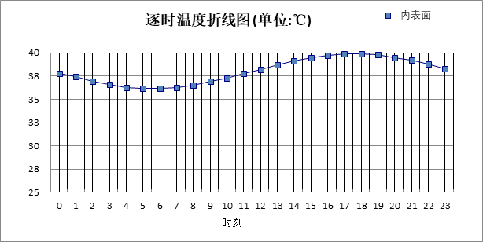

|  |  |  |  |  |  |  |  |  |  |  |  |
| --- | --- | --- | --- | --- | --- | --- | --- | --- | --- | --- | --- |
| 0:00 | 1:00 | 2:00 | 3:00 | 4:00 | 5:00 | 6:00 | 7:00 | 8:00 | 9:00 | 10:00 | 11:00 |
| 37.83 | 37.36 | 36.94 | 36.59 | 36.34 | 36.20 | 36.20 | 36.31 | 36.55 | 36.88 | 37.30 | 37.76 |
| 12:00 | 13:00 | 14:00 | 15:00 | 16:00 | 17:00 | 18:00 | 19:00 | 20:00 | 21:00 | 22:00 | 23:00 |
| 38.25 | 38.72 | 39.14 | 39.49 | 39.74 | 39.88 | 39.89 | 39.77 | 39.53 | 39.20 | 38.78 | 38.32 |

#### 自然通风房间：西向逐时温度

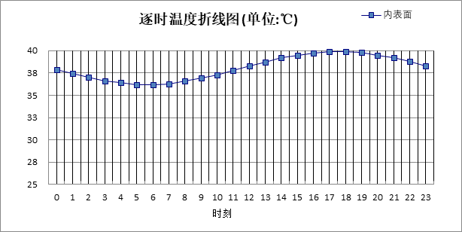

|  |  |  |  |  |  |  |  |  |  |  |  |
| --- | --- | --- | --- | --- | --- | --- | --- | --- | --- | --- | --- |
| 0:00 | 1:00 | 2:00 | 3:00 | 4:00 | 5:00 | 6:00 | 7:00 | 8:00 | 9:00 | 10:00 | 11:00 |
| 37.86 | 37.39 | 36.97 | 36.62 | 36.37 | 36.24 | 36.23 | 36.35 | 36.58 | 36.92 | 37.33 | 37.79 |
| 12:00 | 13:00 | 14:00 | 15:00 | 16:00 | 17:00 | 18:00 | 19:00 | 20:00 | 21:00 | 22:00 | 23:00 |
| 38.27 | 38.73 | 39.15 | 39.50 | 39.74 | 39.87 | 39.88 | 39.77 | 39.54 | 39.21 | 38.80 | 38.34 |

#### 自然通风房间：南向逐时温度



|  |  |  |  |  |  |  |  |  |  |  |  |
| --- | --- | --- | --- | --- | --- | --- | --- | --- | --- | --- | --- |
| 0:00 | 1:00 | 2:00 | 3:00 | 4:00 | 5:00 | 6:00 | 7:00 | 8:00 | 9:00 | 10:00 | 11:00 |
| 37.83 | 37.36 | 36.93 | 36.59 | 36.34 | 36.20 | 36.19 | 36.31 | 36.55 | 36.88 | 37.29 | 37.76 |
| 12:00 | 13:00 | 14:00 | 15:00 | 16:00 | 17:00 | 18:00 | 19:00 | 20:00 | 21:00 | 22:00 | 23:00 |
| 38.24 | 38.70 | 39.13 | 39.47 | 39.72 | 39.86 | 39.87 | 39.76 | 39.52 | 39.19 | 38.78 | 38.31 |

#### 自然通风房间：北向逐时温度

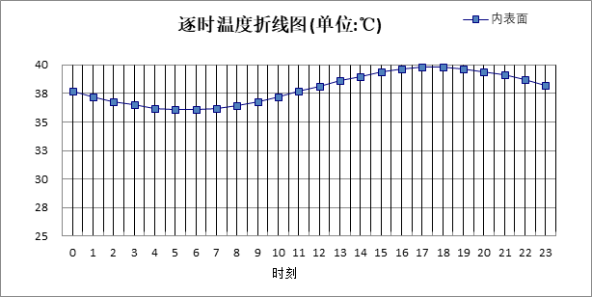

|  |  |  |  |  |  |  |  |  |  |  |  |
| --- | --- | --- | --- | --- | --- | --- | --- | --- | --- | --- | --- |
| 0:00 | 1:00 | 2:00 | 3:00 | 4:00 | 5:00 | 6:00 | 7:00 | 8:00 | 9:00 | 10:00 | 11:00 |
| 37.70 | 37.24 | 36.81 | 36.47 | 36.22 | 36.09 | 36.08 | 36.20 | 36.44 | 36.78 | 37.19 | 37.66 |
| 12:00 | 13:00 | 14:00 | 15:00 | 16:00 | 17:00 | 18:00 | 19:00 | 20:00 | 21:00 | 22:00 | 23:00 |
| 38.14 | 38.61 | 39.03 | 39.37 | 39.62 | 39.75 | 39.76 | 39.64 | 39.40 | 39.07 | 38.65 | 38.19 |

### 外墙构造三（钢筋混凝土墙+岩棉条）

|  |  |  |  |  |  |  |  |
| --- | --- | --- | --- | --- | --- | --- | --- |
| 材料名称 由外到内 | 厚度 | 差分 步长 | 导热 系数 | 蓄热 系数 | 修正 系数 | 热阻 | 热惰性 指标 |
| (mm) | (mm) | W/(m.K) | W/(㎡.K) | α | (㎡K)/W | D=R*S |
| 抗裂砂浆 | 5 | 5.0 | 0.930 | 11.306 | 1.00 | 0.005 | 0.061 |
| 岩棉条 | 110 | 7.3 | 0.045 | 0.750 | 1.10 | 2.222 | 1.833 |
| 抗裂砂浆 | 5 | 5.0 | 0.930 | 11.306 | 1.00 | 0.005 | 0.061 |
| 钢筋混凝土 | 300 | 13.0 | 1.740 | 17.200 | 1.00 | 0.172 | 2.966 |
| 石灰砂浆 | 20 | 10.0 | 0.810 | 10.070 | 1.00 | 0.025 | 0.249 |
| 各层之和∑ | 440 | － | － | － | － | 2.430 | 5.169 |
| 差分时间步长(分钟) | 5.0 | | | | | | |
| 外表面太阳辐射吸收系数 | 0.75 | | | | | | |
| 传热系数K=1/(0.16+∑R) | 0.39 | | | | | | |
| 重质/轻质 | 重质围护结构 | | | | | | |

#### 自然通风房间：东向逐时温度

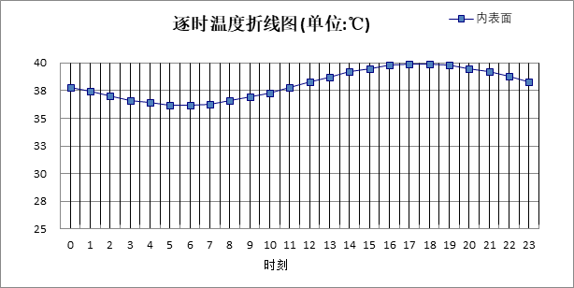

|  |  |  |  |  |  |  |  |  |  |  |  |
| --- | --- | --- | --- | --- | --- | --- | --- | --- | --- | --- | --- |
| 0:00 | 1:00 | 2:00 | 3:00 | 4:00 | 5:00 | 6:00 | 7:00 | 8:00 | 9:00 | 10:00 | 11:00 |
| 37.85 | 37.38 | 36.95 | 36.60 | 36.35 | 36.22 | 36.21 | 36.32 | 36.56 | 36.89 | 37.31 | 37.77 |
| 12:00 | 13:00 | 14:00 | 15:00 | 16:00 | 17:00 | 18:00 | 19:00 | 20:00 | 21:00 | 22:00 | 23:00 |
| 38.26 | 38.73 | 39.15 | 39.51 | 39.76 | 39.89 | 39.90 | 39.78 | 39.55 | 39.21 | 38.80 | 38.33 |

#### 自然通风房间：西向逐时温度

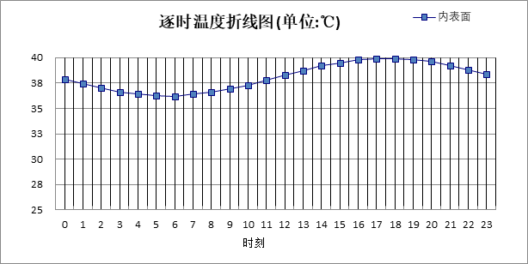

|  |  |  |  |  |  |  |  |  |  |  |  |
| --- | --- | --- | --- | --- | --- | --- | --- | --- | --- | --- | --- |
| 0:00 | 1:00 | 2:00 | 3:00 | 4:00 | 5:00 | 6:00 | 7:00 | 8:00 | 9:00 | 10:00 | 11:00 |
| 37.88 | 37.41 | 36.99 | 36.64 | 36.39 | 36.26 | 36.25 | 36.36 | 36.60 | 36.93 | 37.34 | 37.80 |
| 12:00 | 13:00 | 14:00 | 15:00 | 16:00 | 17:00 | 18:00 | 19:00 | 20:00 | 21:00 | 22:00 | 23:00 |
| 38.28 | 38.75 | 39.17 | 39.51 | 39.76 | 39.89 | 39.90 | 39.79 | 39.56 | 39.23 | 38.82 | 38.36 |

#### 自然通风房间：南向逐时温度

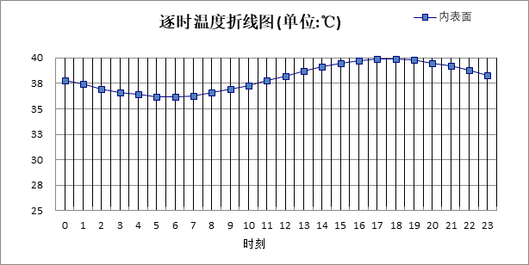

|  |  |  |  |  |  |  |  |  |  |  |  |
| --- | --- | --- | --- | --- | --- | --- | --- | --- | --- | --- | --- |
| 0:00 | 1:00 | 2:00 | 3:00 | 4:00 | 5:00 | 6:00 | 7:00 | 8:00 | 9:00 | 10:00 | 11:00 |
| 37.84 | 37.37 | 36.95 | 36.60 | 36.35 | 36.22 | 36.21 | 36.32 | 36.56 | 36.89 | 37.30 | 37.77 |
| 12:00 | 13:00 | 14:00 | 15:00 | 16:00 | 17:00 | 18:00 | 19:00 | 20:00 | 21:00 | 22:00 | 23:00 |
| 38.25 | 38.71 | 39.14 | 39.48 | 39.74 | 39.87 | 39.88 | 39.77 | 39.54 | 39.21 | 38.79 | 38.33 |

#### 自然通风房间：北向逐时温度



|  |  |  |  |  |  |  |  |  |  |  |  |
| --- | --- | --- | --- | --- | --- | --- | --- | --- | --- | --- | --- |
| 0:00 | 1:00 | 2:00 | 3:00 | 4:00 | 5:00 | 6:00 | 7:00 | 8:00 | 9:00 | 10:00 | 11:00 |
| 37.71 | 37.24 | 36.82 | 36.47 | 36.22 | 36.09 | 36.09 | 36.21 | 36.44 | 36.78 | 37.19 | 37.66 |
| 12:00 | 13:00 | 14:00 | 15:00 | 16:00 | 17:00 | 18:00 | 19:00 | 20:00 | 21:00 | 22:00 | 23:00 |
| 38.14 | 38.61 | 39.03 | 39.38 | 39.62 | 39.75 | 39.76 | 39.64 | 39.41 | 39.07 | 38.66 | 38.19 |

### 外墙构造二（蒸压轻质砂加气混凝土砌块墙）

|  |  |  |  |  |  |  |  |
| --- | --- | --- | --- | --- | --- | --- | --- |
| 材料名称 由外到内 | 厚度 | 差分 步长 | 导热 系数 | 蓄热 系数 | 修正 系数 | 热阻 | 热惰性 指标 |
| (mm) | (mm) | W/(m.K) | W/(㎡.K) | α | (㎡K)/W | D=R*S |
| 石灰砂浆（1） | 20 | 10.0 | 0.810 | 9.948 | 1.00 | 0.025 | 0.246 |
| 蒸压轻质砂加气混凝土砌块(ρ=500) | 350 | 8.1 | 0.160 | 2.310 | 1.10 | 1.989 | 5.053 |
| 抗裂砂浆 | 10 | 10.0 | 0.930 | 11.306 | 1.00 | 0.011 | 0.122 |
| 各层之和∑ | 380 | － | － | － | － | 2.024 | 5.420 |
| 差分时间步长(分钟) | 5.0 | | | | | | |
| 外表面太阳辐射吸收系数 | 0.75 | | | | | | |
| 传热系数K=1/(0.16+∑R) | 0.46 | | | | | | |
| 重质/轻质 | 重质围护结构 | | | | | | |

#### 自然通风房间：东向逐时温度

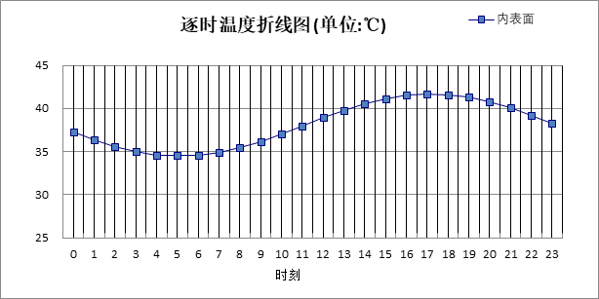

|  |  |  |  |  |  |  |  |  |  |  |  |
| --- | --- | --- | --- | --- | --- | --- | --- | --- | --- | --- | --- |
| 0:00 | 1:00 | 2:00 | 3:00 | 4:00 | 5:00 | 6:00 | 7:00 | 8:00 | 9:00 | 10:00 | 11:00 |
| 37.32 | 36.42 | 35.64 | 35.03 | 34.62 | 34.45 | 34.54 | 34.86 | 35.40 | 36.12 | 36.98 | 37.91 |
| 12:00 | 13:00 | 14:00 | 15:00 | 16:00 | 17:00 | 18:00 | 19:00 | 20:00 | 21:00 | 22:00 | 23:00 |
| 38.86 | 39.75 | 40.53 | 41.15 | 41.56 | 41.73 | 41.65 | 41.33 | 40.78 | 40.06 | 39.20 | 38.26 |

#### 自然通风房间：西向逐时温度

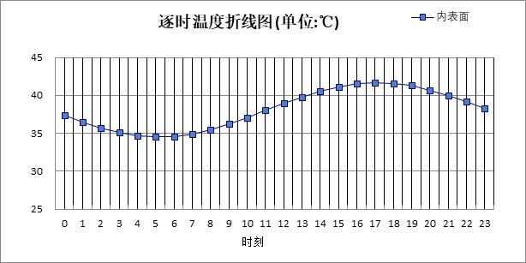

|  |  |  |  |  |  |  |  |  |  |  |  |
| --- | --- | --- | --- | --- | --- | --- | --- | --- | --- | --- | --- |
| 0:00 | 1:00 | 2:00 | 3:00 | 4:00 | 5:00 | 6:00 | 7:00 | 8:00 | 9:00 | 10:00 | 11:00 |
| 37.36 | 36.48 | 35.71 | 35.10 | 34.70 | 34.54 | 34.61 | 34.93 | 35.47 | 36.19 | 37.04 | 37.97 |
| 12:00 | 13:00 | 14:00 | 15:00 | 16:00 | 17:00 | 18:00 | 19:00 | 20:00 | 21:00 | 22:00 | 23:00 |
| 38.90 | 39.77 | 40.54 | 41.13 | 41.52 | 41.68 | 41.59 | 41.28 | 40.75 | 40.04 | 39.20 | 38.29 |

#### 自然通风房间：南向逐时温度

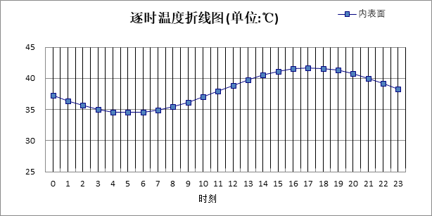

|  |  |  |  |  |  |  |  |  |  |  |  |
| --- | --- | --- | --- | --- | --- | --- | --- | --- | --- | --- | --- |
| 0:00 | 1:00 | 2:00 | 3:00 | 4:00 | 5:00 | 6:00 | 7:00 | 8:00 | 9:00 | 10:00 | 11:00 |
| 37.32 | 36.43 | 35.65 | 35.04 | 34.63 | 34.47 | 34.55 | 34.87 | 35.41 | 36.13 | 36.99 | 37.91 |
| 12:00 | 13:00 | 14:00 | 15:00 | 16:00 | 17:00 | 18:00 | 19:00 | 20:00 | 21:00 | 22:00 | 23:00 |
| 38.85 | 39.73 | 40.50 | 41.11 | 41.51 | 41.68 | 41.60 | 41.29 | 40.76 | 40.04 | 39.19 | 38.26 |

#### 自然通风房间：北向逐时温度

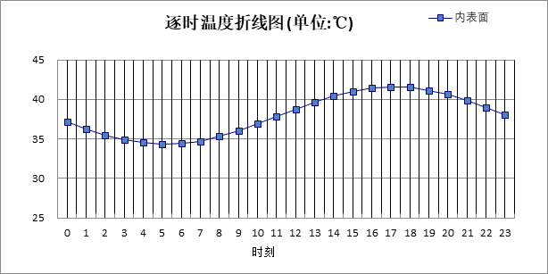

|  |  |  |  |  |  |  |  |  |  |  |  |
| --- | --- | --- | --- | --- | --- | --- | --- | --- | --- | --- | --- |
| 0:00 | 1:00 | 2:00 | 3:00 | 4:00 | 5:00 | 6:00 | 7:00 | 8:00 | 9:00 | 10:00 | 11:00 |
| 37.13 | 36.25 | 35.47 | 34.87 | 34.47 | 34.31 | 34.40 | 34.73 | 35.28 | 36.01 | 36.87 | 37.81 |
| 12:00 | 13:00 | 14:00 | 15:00 | 16:00 | 17:00 | 18:00 | 19:00 | 20:00 | 21:00 | 22:00 | 23:00 |
| 38.75 | 39.63 | 40.40 | 41.00 | 41.39 | 41.55 | 41.46 | 41.14 | 40.59 | 39.86 | 39.01 | 38.08 |

### 外墙构造四（蒸压轻质砂加气混凝土砌块墙）

|  |  |  |  |  |  |  |  |
| --- | --- | --- | --- | --- | --- | --- | --- |
| 材料名称 由外到内 | 厚度 | 差分 步长 | 导热 系数 | 蓄热 系数 | 修正 系数 | 热阻 | 热惰性 指标 |
| (mm) | (mm) | W/(m.K) | W/(㎡.K) | α | (㎡K)/W | D=R*S |
| 水泥砂浆 | 20 | 10.0 | 0.930 | 11.370 | 1.00 | 0.022 | 0.245 |
| 蒸压轻质砂加气混凝土砌块(ρ=500) | 350 | 8.1 | 0.160 | 2.310 | 1.10 | 1.989 | 5.053 |
| 石灰砂浆 | 20 | 10.0 | 0.810 | 10.070 | 1.00 | 0.025 | 0.249 |
| 各层之和∑ | 390 | － | － | － | － | 2.035 | 5.546 |
| 差分时间步长(分钟) | 5.0 | | | | | | |
| 外表面太阳辐射吸收系数 | 0.75 | | | | | | |
| 传热系数K=1/(0.16+∑R) | 0.46 | | | | | | |
| 重质/轻质 | 重质围护结构 | | | | | | |

#### 自然通风房间：东向逐时温度

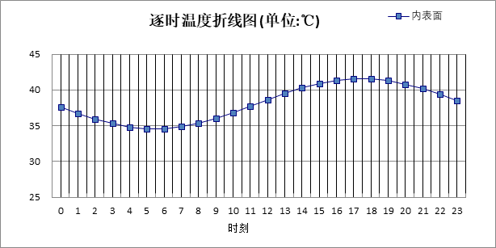

|  |  |  |  |  |  |  |  |  |  |  |  |
| --- | --- | --- | --- | --- | --- | --- | --- | --- | --- | --- | --- |
| 0:00 | 1:00 | 2:00 | 3:00 | 4:00 | 5:00 | 6:00 | 7:00 | 8:00 | 9:00 | 10:00 | 11:00 |
| 37.59 | 36.70 | 35.92 | 35.28 | 34.83 | 34.60 | 34.61 | 34.86 | 35.33 | 35.99 | 36.78 | 37.67 |
| 12:00 | 13:00 | 14:00 | 15:00 | 16:00 | 17:00 | 18:00 | 19:00 | 20:00 | 21:00 | 22:00 | 23:00 |
| 38.58 | 39.47 | 40.26 | 40.90 | 41.35 | 41.58 | 41.57 | 41.32 | 40.85 | 40.19 | 39.39 | 38.50 |

#### 自然通风房间：西向逐时温度

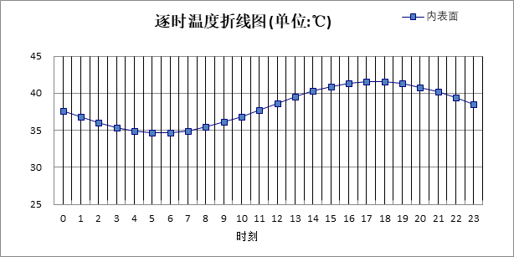

|  |  |  |  |  |  |  |  |  |  |  |  |
| --- | --- | --- | --- | --- | --- | --- | --- | --- | --- | --- | --- |
| 0:00 | 1:00 | 2:00 | 3:00 | 4:00 | 5:00 | 6:00 | 7:00 | 8:00 | 9:00 | 10:00 | 11:00 |
| 37.62 | 36.76 | 35.98 | 35.35 | 34.90 | 34.68 | 34.69 | 34.94 | 35.41 | 36.06 | 36.85 | 37.73 |
| 12:00 | 13:00 | 14:00 | 15:00 | 16:00 | 17:00 | 18:00 | 19:00 | 20:00 | 21:00 | 22:00 | 23:00 |
| 38.63 | 39.50 | 40.27 | 40.89 | 41.32 | 41.54 | 41.52 | 41.27 | 40.81 | 40.17 | 39.39 | 38.52 |

#### 自然通风房间：南向逐时温度

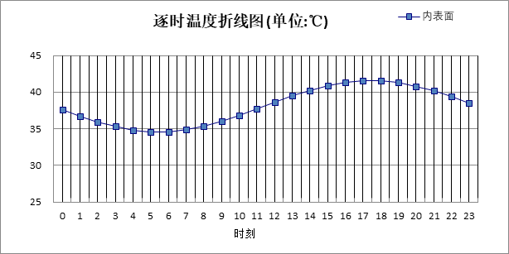

|  |  |  |  |  |  |  |  |  |  |  |  |
| --- | --- | --- | --- | --- | --- | --- | --- | --- | --- | --- | --- |
| 0:00 | 1:00 | 2:00 | 3:00 | 4:00 | 5:00 | 6:00 | 7:00 | 8:00 | 9:00 | 10:00 | 11:00 |
| 37.59 | 36.71 | 35.92 | 35.28 | 34.84 | 34.61 | 34.62 | 34.87 | 35.34 | 36.00 | 36.79 | 37.67 |
| 12:00 | 13:00 | 14:00 | 15:00 | 16:00 | 17:00 | 18:00 | 19:00 | 20:00 | 21:00 | 22:00 | 23:00 |
| 38.58 | 39.45 | 40.23 | 40.86 | 41.31 | 41.53 | 41.52 | 41.28 | 40.82 | 40.17 | 39.38 | 38.50 |

#### 自然通风房间：北向逐时温度

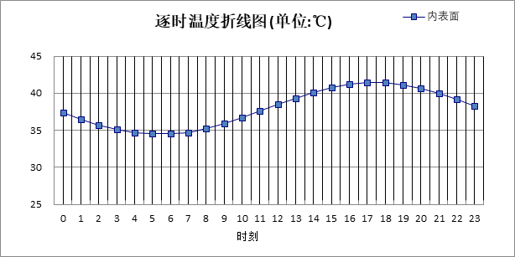

|  |  |  |  |  |  |  |  |  |  |  |  |
| --- | --- | --- | --- | --- | --- | --- | --- | --- | --- | --- | --- |
| 0:00 | 1:00 | 2:00 | 3:00 | 4:00 | 5:00 | 6:00 | 7:00 | 8:00 | 9:00 | 10:00 | 11:00 |
| 37.40 | 36.53 | 35.75 | 35.11 | 34.67 | 34.46 | 34.48 | 34.73 | 35.21 | 35.87 | 36.67 | 37.56 |
| 12:00 | 13:00 | 14:00 | 15:00 | 16:00 | 17:00 | 18:00 | 19:00 | 20:00 | 21:00 | 22:00 | 23:00 |
| 38.47 | 39.35 | 40.13 | 40.76 | 41.19 | 41.41 | 41.39 | 41.13 | 40.66 | 40.00 | 39.20 | 38.32 |

## 热桥柱构造

### 热桥柱构造一（钢筋混凝土+岩棉）

|  |  |  |  |  |  |  |  |
| --- | --- | --- | --- | --- | --- | --- | --- |
| 材料名称 由外到内 | 厚度 | 差分 步长 | 导热 系数 | 蓄热 系数 | 修正 系数 | 热阻 | 热惰性 指标 |
| (mm) | (mm) | W/(m.K) | W/(㎡.K) | α | (㎡K)/W | D=R*S |
| 水泥砂浆 | 20 | 10.0 | 0.930 | 11.370 | 1.10 | 0.020 | 0.245 |
| 岩棉(ρ=80-200) | 110 | 7.3 | 0.041 | 0.748 | 1.10 | 2.439 | 2.007 |
| 钢筋混凝土 | 300 | 13.0 | 1.740 | 17.200 | 1.00 | 0.172 | 2.966 |
| 石灰砂浆 | 20 | 10.0 | 0.810 | 10.070 | 1.00 | 0.025 | 0.249 |
| 各层之和∑ | 450 | － | － | － | － | 2.656 | 5.466 |
| 差分时间步长(分钟) | 5.0 | | | | | | |
| 外表面太阳辐射吸收系数 | 0.75 | | | | | | |
| 传热系数K=1/(0.16+∑R) | 0.36 | | | | | | |
| 重质/轻质 | 重质围护结构 | | | | | | |

#### 自然通风房间：东向逐时温度

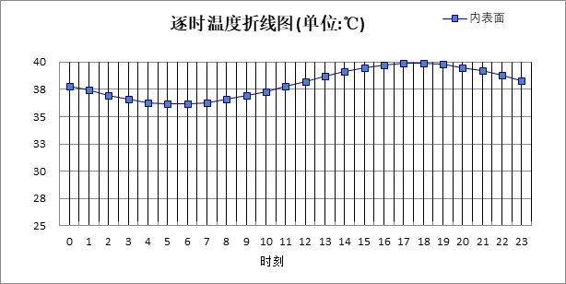

|  |  |  |  |  |  |  |  |  |  |  |  |
| --- | --- | --- | --- | --- | --- | --- | --- | --- | --- | --- | --- |
| 0:00 | 1:00 | 2:00 | 3:00 | 4:00 | 5:00 | 6:00 | 7:00 | 8:00 | 9:00 | 10:00 | 11:00 |
| 37.83 | 37.36 | 36.94 | 36.59 | 36.34 | 36.21 | 36.20 | 36.32 | 36.55 | 36.89 | 37.30 | 37.76 |
| 12:00 | 13:00 | 14:00 | 15:00 | 16:00 | 17:00 | 18:00 | 19:00 | 20:00 | 21:00 | 22:00 | 23:00 |
| 38.25 | 38.72 | 39.14 | 39.49 | 39.74 | 39.87 | 39.88 | 39.76 | 39.53 | 39.19 | 38.78 | 38.31 |

#### 自然通风房间：西向逐时温度

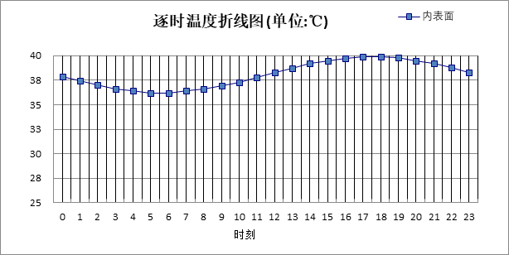

|  |  |  |  |  |  |  |  |  |  |  |  |
| --- | --- | --- | --- | --- | --- | --- | --- | --- | --- | --- | --- |
| 0:00 | 1:00 | 2:00 | 3:00 | 4:00 | 5:00 | 6:00 | 7:00 | 8:00 | 9:00 | 10:00 | 11:00 |
| 37.86 | 37.39 | 36.97 | 36.62 | 36.38 | 36.24 | 36.24 | 36.35 | 36.59 | 36.92 | 37.33 | 37.79 |
| 12:00 | 13:00 | 14:00 | 15:00 | 16:00 | 17:00 | 18:00 | 19:00 | 20:00 | 21:00 | 22:00 | 23:00 |
| 38.27 | 38.74 | 39.15 | 39.50 | 39.74 | 39.87 | 39.88 | 39.76 | 39.53 | 39.20 | 38.79 | 38.33 |

#### 自然通风房间：南向逐时温度

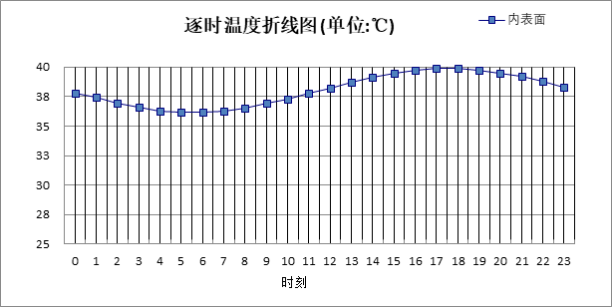

|  |  |  |  |  |  |  |  |  |  |  |  |
| --- | --- | --- | --- | --- | --- | --- | --- | --- | --- | --- | --- |
| 0:00 | 1:00 | 2:00 | 3:00 | 4:00 | 5:00 | 6:00 | 7:00 | 8:00 | 9:00 | 10:00 | 11:00 |
| 37.82 | 37.36 | 36.93 | 36.59 | 36.34 | 36.21 | 36.20 | 36.32 | 36.55 | 36.88 | 37.30 | 37.76 |
| 12:00 | 13:00 | 14:00 | 15:00 | 16:00 | 17:00 | 18:00 | 19:00 | 20:00 | 21:00 | 22:00 | 23:00 |
| 38.24 | 38.71 | 39.13 | 39.47 | 39.72 | 39.85 | 39.86 | 39.75 | 39.52 | 39.18 | 38.77 | 38.31 |

#### 自然通风房间：北向逐时温度

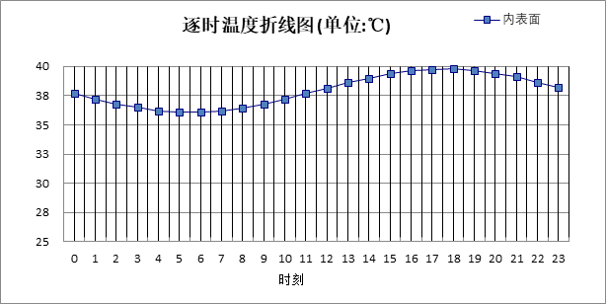

|  |  |  |  |  |  |  |  |  |  |  |  |
| --- | --- | --- | --- | --- | --- | --- | --- | --- | --- | --- | --- |
| 0:00 | 1:00 | 2:00 | 3:00 | 4:00 | 5:00 | 6:00 | 7:00 | 8:00 | 9:00 | 10:00 | 11:00 |
| 37.70 | 37.23 | 36.81 | 36.47 | 36.22 | 36.09 | 36.09 | 36.21 | 36.44 | 36.78 | 37.20 | 37.66 |
| 12:00 | 13:00 | 14:00 | 15:00 | 16:00 | 17:00 | 18:00 | 19:00 | 20:00 | 21:00 | 22:00 | 23:00 |
| 38.14 | 38.61 | 39.03 | 39.37 | 39.62 | 39.75 | 39.75 | 39.63 | 39.40 | 39.06 | 38.65 | 38.18 |

## 热桥梁构造

### 热桥梁构造（钢筋混凝土+岩棉）

|  |  |  |  |  |  |  |  |
| --- | --- | --- | --- | --- | --- | --- | --- |
| 材料名称 由外到内 | 厚度 | 差分 步长 | 导热 系数 | 蓄热 系数 | 修正 系数 | 热阻 | 热惰性 指标 |
| (mm) | (mm) | W/(m.K) | W/(㎡.K) | α | (㎡K)/W | D=R*S |
| 岩棉(ρ=80-200) | 110 | 7.3 | 0.041 | 0.748 | 1.10 | 2.439 | 2.007 |
| 钢筋混凝土 | 300 | 13.0 | 1.740 | 17.200 | 1.00 | 0.172 | 2.966 |
| 石灰砂浆 | 20 | 10.0 | 0.810 | 10.070 | 1.00 | 0.025 | 0.249 |
| 各层之和∑ | 430 | － | － | － | － | 2.636 | 5.221 |
| 差分时间步长(分钟) | 5.0 | | | | | | |
| 外表面太阳辐射吸收系数 | 0.75 | | | | | | |
| 传热系数K=1/(0.16+∑R) | 0.36 | | | | | | |
| 重质/轻质 | 重质围护结构 | | | | | | |

#### 自然通风房间：东向逐时温度



|  |  |  |  |  |  |  |  |  |  |  |  |
| --- | --- | --- | --- | --- | --- | --- | --- | --- | --- | --- | --- |
| 0:00 | 1:00 | 2:00 | 3:00 | 4:00 | 5:00 | 6:00 | 7:00 | 8:00 | 9:00 | 10:00 | 11:00 |
| 37.83 | 37.36 | 36.94 | 36.59 | 36.34 | 36.20 | 36.20 | 36.31 | 36.55 | 36.88 | 37.30 | 37.76 |
| 12:00 | 13:00 | 14:00 | 15:00 | 16:00 | 17:00 | 18:00 | 19:00 | 20:00 | 21:00 | 22:00 | 23:00 |
| 38.25 | 38.72 | 39.14 | 39.49 | 39.74 | 39.88 | 39.89 | 39.77 | 39.53 | 39.20 | 38.78 | 38.32 |

#### 自然通风房间：西向逐时温度



|  |  |  |  |  |  |  |  |  |  |  |  |
| --- | --- | --- | --- | --- | --- | --- | --- | --- | --- | --- | --- |
| 0:00 | 1:00 | 2:00 | 3:00 | 4:00 | 5:00 | 6:00 | 7:00 | 8:00 | 9:00 | 10:00 | 11:00 |
| 37.86 | 37.39 | 36.97 | 36.62 | 36.37 | 36.24 | 36.23 | 36.35 | 36.58 | 36.92 | 37.33 | 37.79 |
| 12:00 | 13:00 | 14:00 | 15:00 | 16:00 | 17:00 | 18:00 | 19:00 | 20:00 | 21:00 | 22:00 | 23:00 |
| 38.27 | 38.73 | 39.15 | 39.50 | 39.74 | 39.87 | 39.88 | 39.77 | 39.54 | 39.21 | 38.80 | 38.34 |

#### 自然通风房间：南向逐时温度



|  |  |  |  |  |  |  |  |  |  |  |  |
| --- | --- | --- | --- | --- | --- | --- | --- | --- | --- | --- | --- |
| 0:00 | 1:00 | 2:00 | 3:00 | 4:00 | 5:00 | 6:00 | 7:00 | 8:00 | 9:00 | 10:00 | 11:00 |
| 37.83 | 37.36 | 36.93 | 36.59 | 36.34 | 36.20 | 36.19 | 36.31 | 36.55 | 36.88 | 37.29 | 37.76 |
| 12:00 | 13:00 | 14:00 | 15:00 | 16:00 | 17:00 | 18:00 | 19:00 | 20:00 | 21:00 | 22:00 | 23:00 |
| 38.24 | 38.70 | 39.13 | 39.47 | 39.72 | 39.86 | 39.87 | 39.76 | 39.52 | 39.19 | 38.78 | 38.31 |

#### 自然通风房间：北向逐时温度



|  |  |  |  |  |  |  |  |  |  |  |  |
| --- | --- | --- | --- | --- | --- | --- | --- | --- | --- | --- | --- |
| 0:00 | 1:00 | 2:00 | 3:00 | 4:00 | 5:00 | 6:00 | 7:00 | 8:00 | 9:00 | 10:00 | 11:00 |
| 37.70 | 37.24 | 36.81 | 36.47 | 36.22 | 36.09 | 36.08 | 36.20 | 36.44 | 36.78 | 37.19 | 37.66 |
| 12:00 | 13:00 | 14:00 | 15:00 | 16:00 | 17:00 | 18:00 | 19:00 | 20:00 | 21:00 | 22:00 | 23:00 |
| 38.14 | 38.61 | 39.03 | 39.37 | 39.62 | 39.75 | 39.76 | 39.64 | 39.40 | 39.07 | 38.65 | 38.19 |

### 热桥梁构造（保温结构一体化）

|  |  |  |  |  |  |  |  |
| --- | --- | --- | --- | --- | --- | --- | --- |
| 材料名称 由外到内 | 厚度 | 差分 步长 | 导热 系数 | 蓄热 系数 | 修正 系数 | 热阻 | 热惰性 指标 |
| (mm) | (mm) | W/(m.K) | W/(㎡.K) | α | (㎡K)/W | D=R*S |
| 抗裂砂浆 | 5 | 5.0 | 0.930 | 11.306 | 1.00 | 0.005 | 0.061 |
| 岩棉条 | 110 | 7.3 | 0.045 | 0.750 | 1.10 | 2.222 | 1.833 |
| 抗裂砂浆 | 5 | 5.0 | 0.930 | 11.306 | 1.00 | 0.005 | 0.061 |
| 钢筋混凝土 | 300 | 13.0 | 1.740 | 17.200 | 1.00 | 0.172 | 2.966 |
| 石灰砂浆 | 20 | 10.0 | 0.810 | 10.070 | 1.00 | 0.025 | 0.249 |
| 各层之和∑ | 440 | － | － | － | － | 2.430 | 5.169 |
| 差分时间步长(分钟) | 5.0 | | | | | | |
| 外表面太阳辐射吸收系数 | 0.75 | | | | | | |
| 传热系数K=1/(0.16+∑R) | 0.39 | | | | | | |
| 重质/轻质 | 重质围护结构 | | | | | | |

#### 自然通风房间：东向逐时温度



|  |  |  |  |  |  |  |  |  |  |  |  |
| --- | --- | --- | --- | --- | --- | --- | --- | --- | --- | --- | --- |
| 0:00 | 1:00 | 2:00 | 3:00 | 4:00 | 5:00 | 6:00 | 7:00 | 8:00 | 9:00 | 10:00 | 11:00 |
| 37.85 | 37.38 | 36.95 | 36.60 | 36.35 | 36.22 | 36.21 | 36.32 | 36.56 | 36.89 | 37.31 | 37.77 |
| 12:00 | 13:00 | 14:00 | 15:00 | 16:00 | 17:00 | 18:00 | 19:00 | 20:00 | 21:00 | 22:00 | 23:00 |
| 38.26 | 38.73 | 39.15 | 39.51 | 39.76 | 39.89 | 39.90 | 39.78 | 39.55 | 39.21 | 38.80 | 38.33 |

#### 自然通风房间：西向逐时温度



|  |  |  |  |  |  |  |  |  |  |  |  |
| --- | --- | --- | --- | --- | --- | --- | --- | --- | --- | --- | --- |
| 0:00 | 1:00 | 2:00 | 3:00 | 4:00 | 5:00 | 6:00 | 7:00 | 8:00 | 9:00 | 10:00 | 11:00 |
| 37.88 | 37.41 | 36.99 | 36.64 | 36.39 | 36.26 | 36.25 | 36.36 | 36.60 | 36.93 | 37.34 | 37.80 |
| 12:00 | 13:00 | 14:00 | 15:00 | 16:00 | 17:00 | 18:00 | 19:00 | 20:00 | 21:00 | 22:00 | 23:00 |
| 38.28 | 38.75 | 39.17 | 39.51 | 39.76 | 39.89 | 39.90 | 39.79 | 39.56 | 39.23 | 38.82 | 38.36 |

#### 自然通风房间：南向逐时温度



|  |  |  |  |  |  |  |  |  |  |  |  |
| --- | --- | --- | --- | --- | --- | --- | --- | --- | --- | --- | --- |
| 0:00 | 1:00 | 2:00 | 3:00 | 4:00 | 5:00 | 6:00 | 7:00 | 8:00 | 9:00 | 10:00 | 11:00 |
| 37.84 | 37.37 | 36.95 | 36.60 | 36.35 | 36.22 | 36.21 | 36.32 | 36.56 | 36.89 | 37.30 | 37.77 |
| 12:00 | 13:00 | 14:00 | 15:00 | 16:00 | 17:00 | 18:00 | 19:00 | 20:00 | 21:00 | 22:00 | 23:00 |
| 38.25 | 38.71 | 39.14 | 39.48 | 39.74 | 39.87 | 39.88 | 39.77 | 39.54 | 39.21 | 38.79 | 38.33 |

#### 自然通风房间：北向逐时温度



|  |  |  |  |  |  |  |  |  |  |  |  |
| --- | --- | --- | --- | --- | --- | --- | --- | --- | --- | --- | --- |
| 0:00 | 1:00 | 2:00 | 3:00 | 4:00 | 5:00 | 6:00 | 7:00 | 8:00 | 9:00 | 10:00 | 11:00 |
| 37.71 | 37.24 | 36.82 | 36.47 | 36.22 | 36.09 | 36.09 | 36.21 | 36.44 | 36.78 | 37.19 | 37.66 |
| 12:00 | 13:00 | 14:00 | 15:00 | 16:00 | 17:00 | 18:00 | 19:00 | 20:00 | 21:00 | 22:00 | 23:00 |
| 38.14 | 38.61 | 39.03 | 39.38 | 39.62 | 39.75 | 39.76 | 39.64 | 39.41 | 39.07 | 38.66 | 38.19 |

# 验算结论

## 自然通风房间

|  |  |  |  |  |  |
| --- | --- | --- | --- | --- | --- |
| 类型 | 构造 | 时刻 | 最高温度(℃) | 限值(℃) | 结论 |
| 屋顶 | 上:屋顶构造二（种植屋面） | 19:05 | 40.39 | 42.90 | 满足 |
| 上:屋顶构造一（保温屋面） | 19:10 | 40.35 | 42.90 | 满足 |
| 外墙 | 东:外墙构造一（钢筋混凝土+岩棉） | 17:30 | 39.89 | 42.90 | 满足 |
| 西:外墙构造一（钢筋混凝土+岩棉） | 17:35 | 39.89 | 42.90 | 满足 |
| 南:外墙构造一（钢筋混凝土+岩棉） | 17:35 | 39.88 | 42.90 | 满足 |
| 北:外墙构造一（钢筋混凝土+岩棉） | 17:30 | 39.76 | 42.90 | 满足 |
| 东:外墙构造三（钢筋混凝土墙+岩棉条） | 17:35 | 39.91 | 42.90 | 满足 |
| 西:外墙构造三（钢筋混凝土墙+岩棉条） | 17:35 | 39.90 | 42.90 | 满足 |
| 南:外墙构造三（钢筋混凝土墙+岩棉条） | 17:35 | 39.89 | 42.90 | 满足 |
| 北:外墙构造三（钢筋混凝土墙+岩棉条） | 17:30 | 39.77 | 42.90 | 满足 |
| 东:外墙构造二（蒸压轻质砂加气混凝土砌块墙） | 17:10 | 41.73 | 42.90 | 满足 |
| 西:外墙构造二（蒸压轻质砂加气混凝土砌块墙） | 17:10 | 41.68 | 42.90 | 满足 |
| 南:外墙构造二（蒸压轻质砂加气混凝土砌块墙） | 17:10 | 41.68 | 42.90 | 满足 |
| 北:外墙构造二（蒸压轻质砂加气混凝土砌块墙） | 17:05 | 41.55 | 42.90 | 满足 |
| 东:外墙构造四（蒸压轻质砂加气混凝土砌块墙） | 17:25 | 41.60 | 42.90 | 满足 |
| 西:外墙构造四（蒸压轻质砂加气混凝土砌块墙） | 17:20 | 41.55 | 42.90 | 满足 |
| 南:外墙构造四（蒸压轻质砂加气混凝土砌块墙） | 17:25 | 41.55 | 42.90 | 满足 |
| 北:外墙构造四（蒸压轻质砂加气混凝土砌块墙） | 17:20 | 41.43 | 42.90 | 满足 |
| 热桥柱 | 东:热桥柱构造一（钢筋混凝土+岩棉） | 17:30 | 39.89 | 42.90 | 满足 |
| 西:热桥柱构造一（钢筋混凝土+岩棉） | 17:30 | 39.89 | 42.90 | 满足 |
| 南:热桥柱构造一（钢筋混凝土+岩棉） | 17:35 | 39.87 | 42.90 | 满足 |
| 北:热桥柱构造一（钢筋混凝土+岩棉） | 17:30 | 39.76 | 42.90 | 满足 |
| 热桥梁 | 东:热桥梁构造（钢筋混凝土+岩棉） | 17:30 | 39.89 | 42.90 | 满足 |
| 西:热桥梁构造（钢筋混凝土+岩棉） | 17:35 | 39.89 | 42.90 | 满足 |
| 南:热桥梁构造（钢筋混凝土+岩棉） | 17:35 | 39.88 | 42.90 | 满足 |
| 北:热桥梁构造（钢筋混凝土+岩棉） | 17:30 | 39.76 | 42.90 | 满足 |
| 东:热桥梁构造（保温结构一体化） | 17:35 | 39.91 | 42.90 | 满足 |
| 西:热桥梁构造（保温结构一体化） | 17:35 | 39.90 | 42.90 | 满足 |
| 南:热桥梁构造（保温结构一体化） | 17:35 | 39.89 | 42.90 | 满足 |
| 北:热桥梁构造（保温结构一体化） | 17:30 | 39.77 | 42.90 | 满足 |