暖通负荷分析报告
- 工程概况
大连海洋大学獐子岛教学楼，坐落在美丽的黑石礁海滨，建筑共6层，共有教室72个，总建筑面积21630平方米，总资4200万元。
由于我校獐子岛教学楼只承担教学与考试等任务，目前獐子岛教学楼内无空调房间，因此只考虑热负荷计算问题。
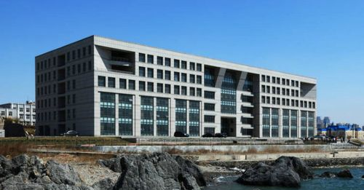
图1 獐子岛教学楼

- 工程设置
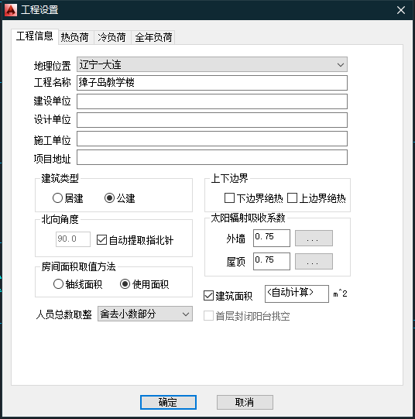
图2 工程设置
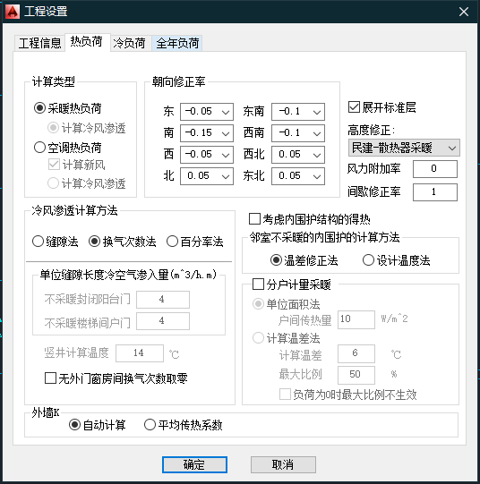
图3 工程热负荷设置

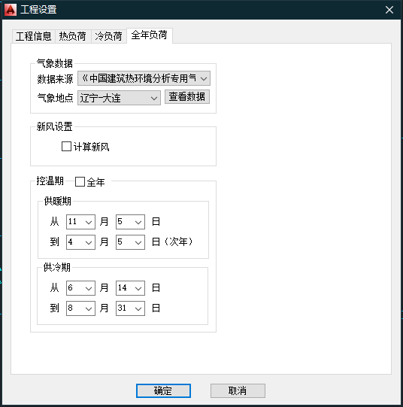
图4 全年负荷设置
大连市的供暖期在11月5日到次年4月5日。

- 其他设置
在暖通负荷BECH软件中，还需要对房间类型、工程构造与门窗类型等进行设置，以确保后续计算热负荷与全年负荷结果的准确性。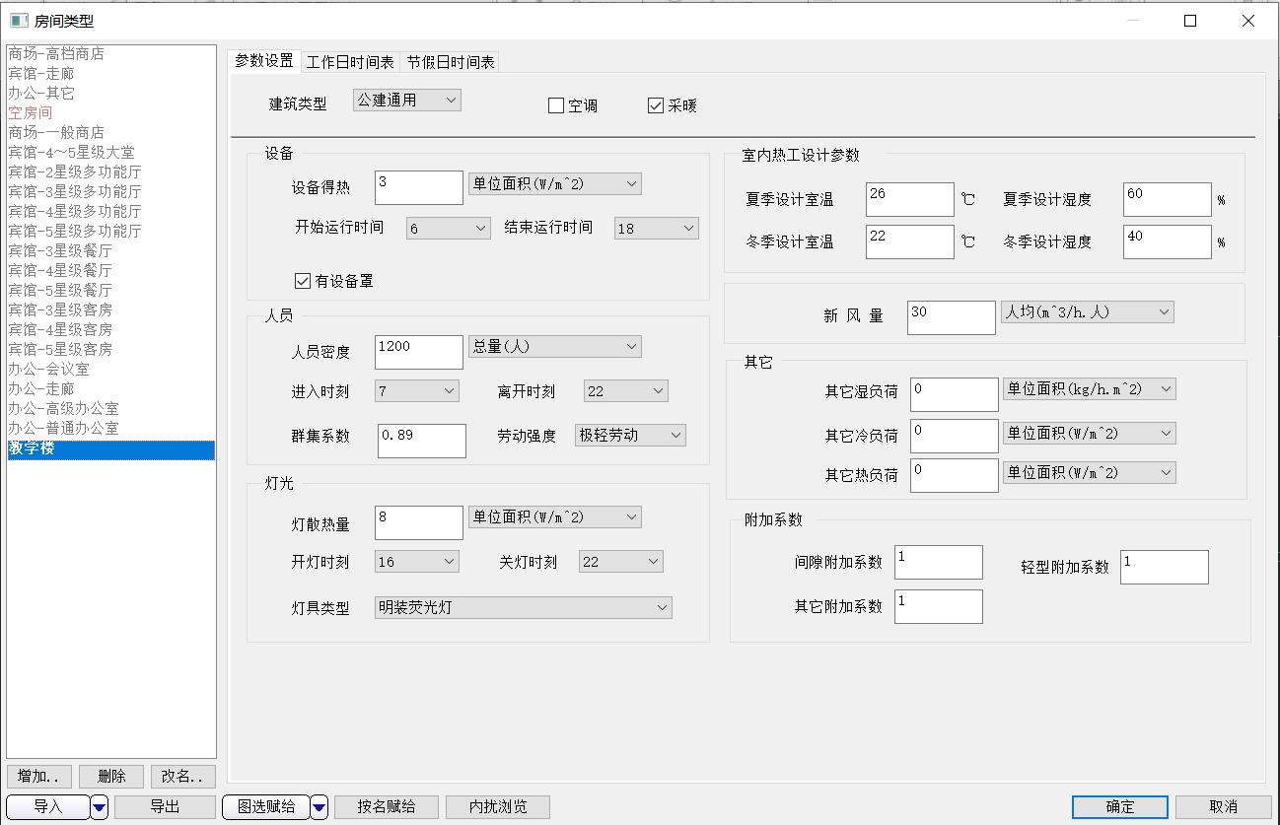------/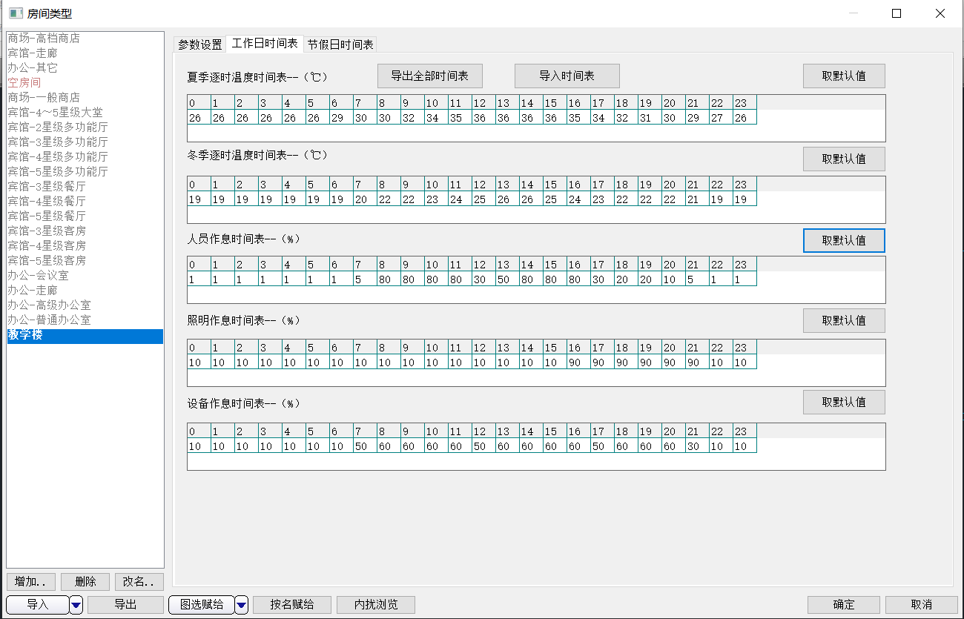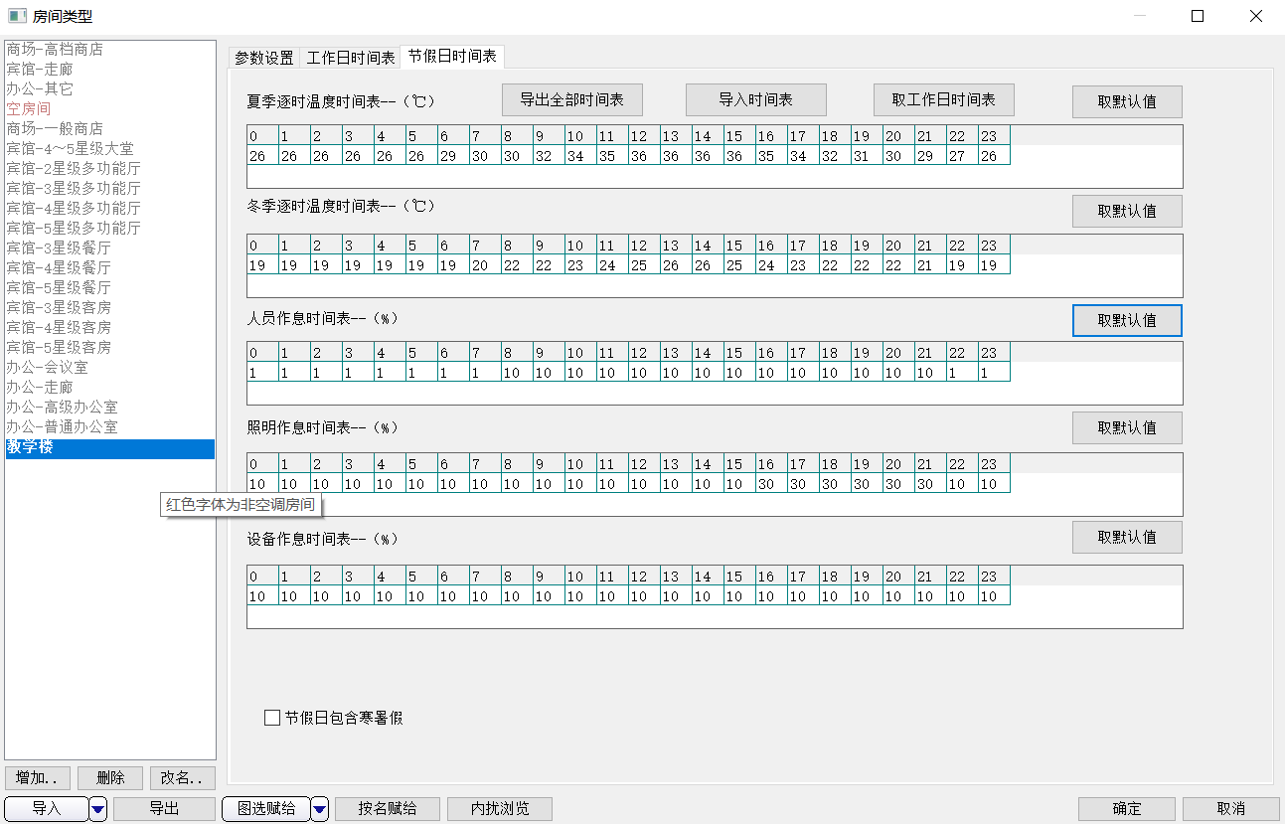
图5 房间类型设置
关于房间类型的参数设置，依据教学楼利用率取1200人。獐子岛教学楼早晨大约在6:50左右开门，在22:00左右锁门，经查询教学楼内群集系数为0.89，在教学楼内上课的同学占多数，皆为极轻劳动。大约在16:00左右开灯，直至22:00熄灯。夏季无空调，设计室温选择26摄氏度，冬季采用散热片供暖，考虑上课师生在冬季穿得多，设计室温在20℃左右为舒适。其他设置均取系统默认值。
关于房间类型的时间表设置，工作日时间表与节假日时间表在人员作息、照明作息与设备作息时间表有区别，在夏季与冬季逐时温度时间表相同，且节假日时间表包含寒暑假。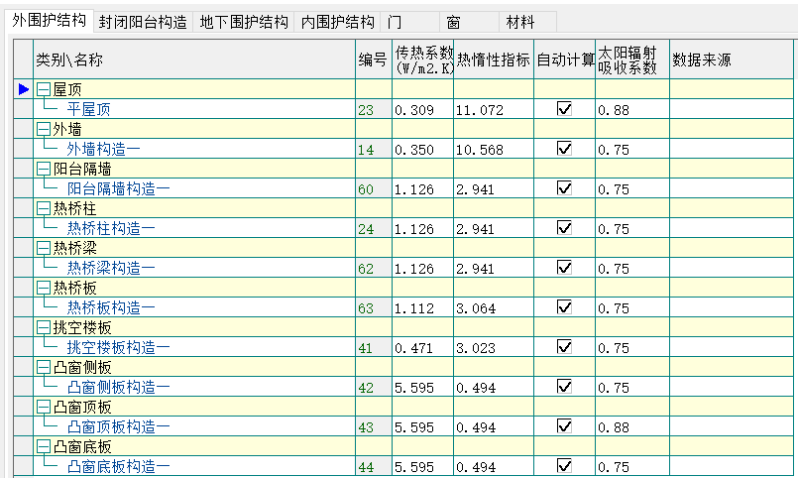 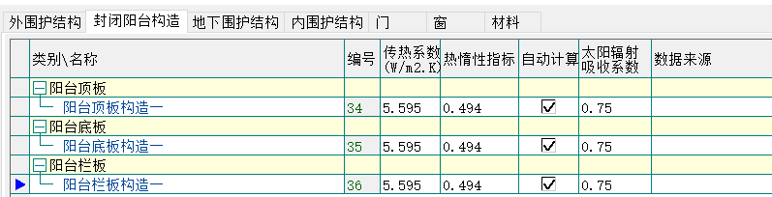 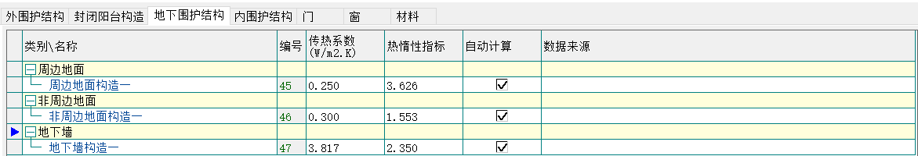 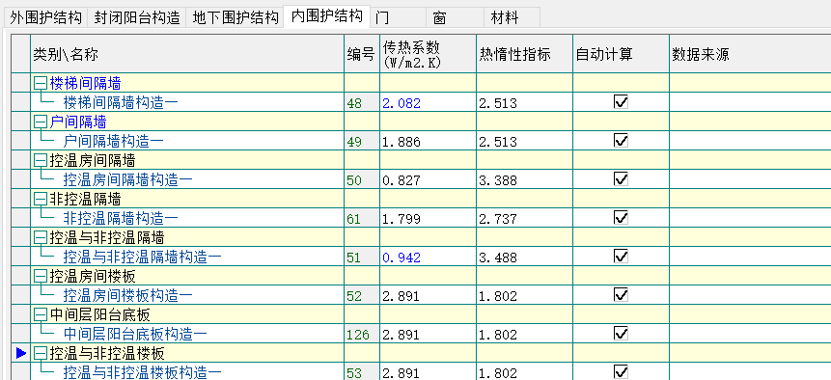 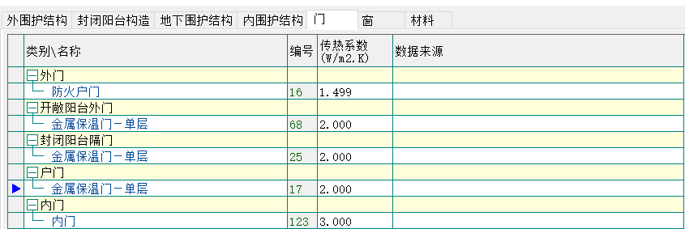 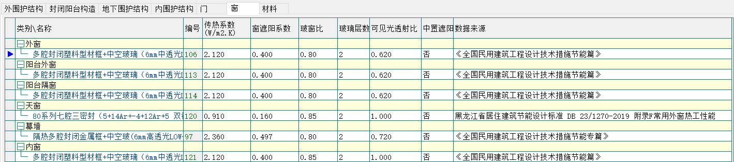 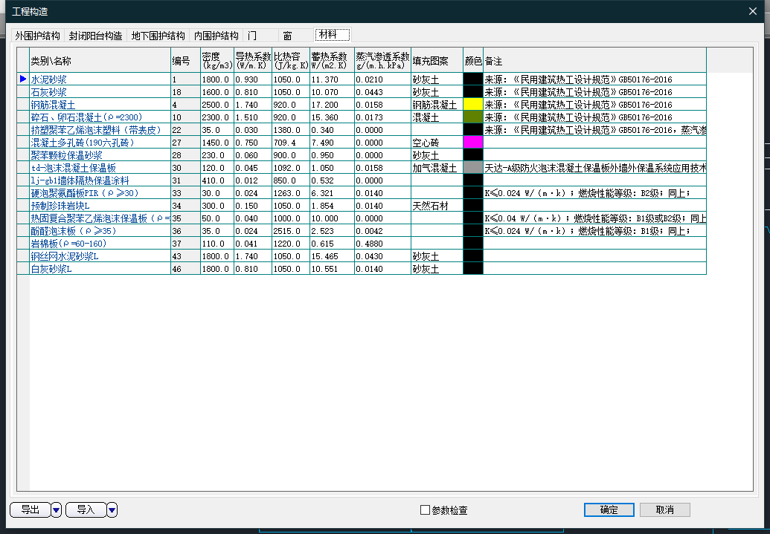
图6 工程构造设置
工程构造采取的材料如上。所采取材料系统均有传热系数的数值供查看，有效帮助进行快速计算。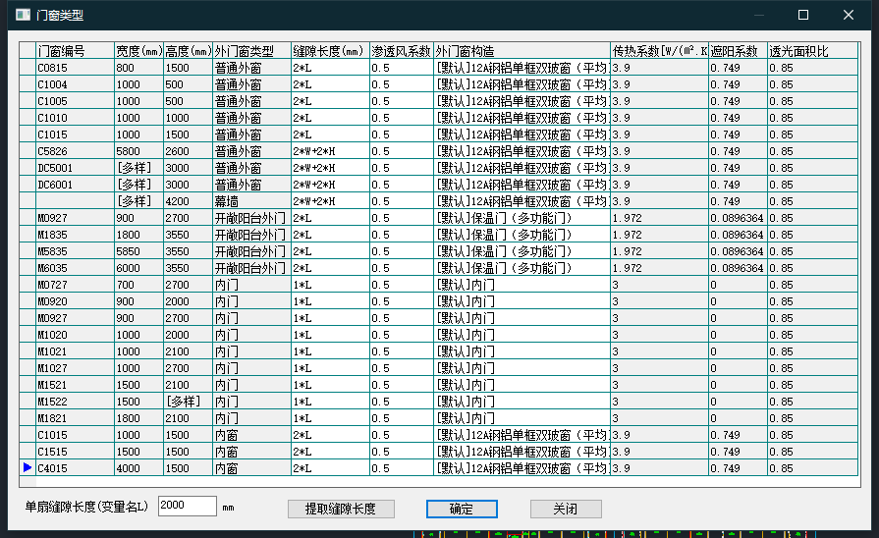
图7 门窗类型设置
门窗类型设置如上。
- 计算结果

房间热负荷汇总表(按楼层)如下：
楼层 | 房间 | 面积 | 室温 | 围护  结构 | 新风 | 冷风  渗透 | 间歇  采暖 | 户间  传热 | 热负荷 | 指标
楼层 | 房间 | ㎡ | ℃ | W | W | W | W | W | W | W/㎡
1层 | 1001[大厅] | 1001.19 | 22 | 38419 | 5213 | 0 | 0 | 0 | 43632 | 43.6
1层 | 1002[教室] | 134.55 | 22 | 5333 | 196 | 0 | 0 | 0 | 5528 | 41.1
1层 | 1003[教室] | 134.55 | 22 | 5333 | 195 | 0 | 0 | 0 | 5528 | 41.1
1层 | 1004[教室] | 129.53 | 22 | 6458 | 810 | 0 | 0 | 0 | 7268 | 56.1
1层 | 1005,1007[教室] | 129.53 | 22 | 7155 | 1186 | 0 | 0 | 0 | 8340 | 64.4
1层 | 1006[教室] | 129.53 | 22 | 7552 | 1186 | 0 | 0 | 0 | 8737 | 67.5
1层 | 1008[教室] | 129.04 | 22 | 7570 | 810 | 0 | 0 | 0 | 8380 | 64.9
1层 | 1009[教室] | 129.04 | 22 | 8662 | 1186 | 0 | 0 | 0 | 9848 | 76.3
1层 | 1010[教室] | 129.03 | 22 | 7570 | 810 | 0 | 0 | 0 | 8380 | 64.9
1层 | 1011[教室] | 129.03 | 22 | 7823 | 1005 | 0 | 0 | 0 | 8828 | 68.4
1层 | 1012,1013[教室] | 128.05 | 22 | 6026 | 810 | 0 | 0 | 0 | 6836 | 53.4
1层 | 1014[教师休息室] | 73.31 | 22 | 3903 | 93 | 0 | 0 | 0 | 3996 | 54.5
1层 | 1015[教师休息室] | 73.29 | 22 | 4254 | 132 | 0 | 0 | 0 | 4386 | 59.9
1层 | 1016[学生活动室] | 71.50 | 22 | 2753 | 93 | 0 | 0 | 0 | 2846 | 39.8
1层 | 1017[楼梯间] | 55.76 | 22 | 2606 | 0 | 0 | 0 | 0 | 2606 | 46.7
1层 | 1018[楼梯间] | 54.45 | 22 | 518 | 0 | 0 | 0 | 0 | 518 | 9.5
1层 | 1019[配电室] | 45.33 | 22 | 1524 | 0 | 0 | 0 | 0 | 1524 | 33.6
1层 | 1020[大门（正门）] | 32.13 | 22 | 1648 | 95 | 0 | 0 | 0 | 1743 | 54.2
1层 | 1021[卫生间（女）] | 30.41 | 22 | 1357 | 86 | 0 | 0 | 0 | 1443 | 47.5
1层 | 1022[楼梯间] | 29.91 | 22 | 1674 | 93 | 0 | 0 | 0 | 1767 | 59.1
1层 | 1023[大门（后门）] | 29.74 | 22 | 1911 | 132 | 0 | 0 | 0 | 2043 | 68.7
1层 | 1024[楼梯间] | 29.45 | 22 | 1789 | 93 | 0 | 0 | 0 | 1882 | 63.9
1层 | 1025[楼梯间] | 29.08 | 22 | 1642 | 93 | 0 | 0 | 0 | 1735 | 59.7
1层 | 1026[楼梯间] | 29.06 | 22 | 1778 | 93 | 0 | 0 | 0 | 1871 | 64.4
1层 | 1027[卫生间（男）] | 28.26 | 22 | 1560 | 172 | 0 | 0 | 0 | 1731 | 61.3
1层 | 1028[卫生间（男）] | 28.22 | 22 | 1559 | 172 | 0 | 0 | 0 | 1730 | 61.3
1层 | 1029[管理室] | 26.17 | 22 | 1573 | 132 | 0 | 0 | 0 | 1706 | 65.2
1层 | 1030[卫生间（女）] | 25.96 | 22 | 1324 | 86 | 0 | 0 | 0 | 1410 | 54.3
1层 | 1031[教学楼] | 16.68 | 22 | 159 | 0 | 0 | 0 | 0 | 159 | 9.5
1层 | 1032[洗漱间] | 14.90 | 22 | 832 | 86 | 0 | 0 | 0 | 918 | 61.6
1层 | 1033[洗漱间] | 14.88 | 22 | 831 | 86 | 0 | 0 | 0 | 917 | 61.6
1层 | 1034[卫生间（男）] | 13.33 | 22 | 726 | 86 | 0 | 0 | 0 | 812 | 60.9
1层 | 1035[卫生间（男）] | 13.32 | 22 | 726 | 86 | 0 | 0 | 0 | 812 | 61.0
1层 | 1036[开水间] | 10.74 | 22 | 102 | 0 | 0 | 0 | 0 | 102 | 9.5
1层 | 1037[洗漱间] | 7.54 | 22 | 72 | 0 | 0 | 0 | 0 | 72 | 9.5
1层 | 1038[洗漱间] | 7.45 | 22 | 71 | 0 | 0 | 0 | 0 | 71 | 9.5
1层 | 1039[教学楼] | 5.99 | 22 | 57 | 0 | 0 | 0 | 0 | 57 | 9.5
1层 | 1040[无障碍卫生间] | 4.62 | 22 | 44 | 0 | 0 | 0 | 0 | 44 | 9.5
1层 | 1041,1042[排风井] | 0.59 | 22 | 6 | 0 | 0 | 0 | 0 | 6 | 9.5
1层 | 合计 | 3363.28 |  | 158087 | 17308 | 0 | 0 |  | 175395 | 52.2
2层 | 2002[教室] | 134.03 | 22 | 4003 | 249 | 0 | 0 | 0 | 4252 | 31.7
2层 | 2003[教室] | 133.96 | 22 | 4002 | 249 | 0 | 0 | 0 | 4251 | 31.7
2层 | 2004[教室] | 129.58 | 22 | 5742 | 1181 | 0 | 0 | 0 | 6923 | 53.4
2层 | 2005[教室] | 129.53 | 22 | 5035 | 591 | 0 | 0 | 0 | 5626 | 43.4
2层 | 2006[教室] | 129.48 | 22 | 6127 | 1181 | 0 | 0 | 0 | 7308 | 56.4
2层 | 2007[教室] | 129.48 | 22 | 5740 | 1181 | 0 | 0 | 0 | 6921 | 53.5
2层 | 2008[教室] | 129.09 | 22 | 6054 | 591 | 0 | 0 | 0 | 6646 | 51.5
2层 | 2009[教室] | 129.09 | 22 | 7147 | 1181 | 0 | 0 | 0 | 8328 | 64.5
2层 | 2010[教室] | 129.03 | 22 | 6432 | 778 | 0 | 0 | 0 | 7210 | 55.9
2层 | 2011[教室] | 128.98 | 22 | 6432 | 778 | 0 | 0 | 0 | 7210 | 55.9
2层 | 2012[教室] | 128.05 | 22 | 4628 | 591 | 0 | 0 | 0 | 5219 | 40.8
2层 | 2013[教室] | 128.05 | 22 | 4628 | 591 | 0 | 0 | 0 | 5219 | 40.8
2层 | 2014[教师休息室] | 73.29 | 22 | 3321 | 134 | 0 | 0 | 0 | 3454 | 47.1
2层 | 2015[教师休息室] | 73.29 | 22 | 2978 | 69 | 0 | 0 | 0 | 3047 | 41.6
2层 | 2016[学生活动室] | 71.50 | 22 | 2256 | 134 | 0 | 0 | 0 | 2389 | 33.4
2层 | 2017[学生活动室] | 71.50 | 22 | 1913 | 68 | 0 | 0 | 0 | 1981 | 27.7
2层 | 2018[楼梯间] | 55.76 | 22 | 2146 | 145 | 0 | 0 | 0 | 2291 | 41.1
2层 | 2019[楼梯间] | 54.41 | 22 | 0 | 0 | 0 | 0 | 0 | 0 | 0.0
2层 | 2020[卫生间（男）] | 43.15 | 22 | 1840 | 180 | 0 | 0 | 0 | 2020 | 46.8
2层 | 2021[阳台] | 32.13 | 22 | 1161 | 0 | 0 | 0 | 0 | 1161 | 36.2
2层 | 2022[阳台] | 31.22 | 22 | 1435 | 0 | 0 | 0 | 0 | 1435 | 46.0
2层 | 2023[楼梯间] | 29.92 | 22 | 1271 | 62 | 0 | 0 | 0 | 1333 | 44.6
2层 | 2024[楼梯间] | 29.84 | 22 | 1400 | 62 | 0 | 0 | 0 | 1463 | 49.0
2层 | 2025[楼梯间] | 29.84 | 22 | 1392 | 62 | 0 | 0 | 0 | 1454 | 48.7
2层 | 2026[楼梯间] | 29.84 | 22 | 1284 | 62 | 0 | 0 | 0 | 1346 | 45.1
2层 | 2027[卫生间（男）] | 28.74 | 22 | 1199 | 120 | 0 | 0 | 0 | 1319 | 45.9
2层 | 2028[卫生间（女）] | 25.82 | 22 | 987 | 60 | 0 | 0 | 0 | 1047 | 40.5
2层 | 2029[洗漱间] | 14.37 | 22 | 641 | 60 | 0 | 0 | 0 | 701 | 48.8
2层 | 2030[洗漱间] | 13.34 | 22 | 558 | 60 | 0 | 0 | 0 | 618 | 46.3
2层 | 2031[卫生间（男）] | 13.32 | 22 | 558 | 60 | 0 | 0 | 0 | 618 | 46.4
2层 | 2032[开水间] | 10.74 | 22 | 0 | 0 | 0 | 0 | 0 | 0 | 0.0
2层 | 2033[库房] | 9.61 | 22 | 0 | 0 | 0 | 0 | 0 | 0 | 0.0
2层 | 2034[电气设备间] | 7.47 | 22 | 0 | 0 | 0 | 0 | 0 | 0 | 0.0
2层 | 2035[洗漱间] | 7.43 | 22 | 0 | 0 | 0 | 0 | 0 | 0 | 0.0
2层 | 2037[电梯井] | 6.00 | 22 | 0 | 0 | 0 | 0 | 0 | 0 | 0.0
2层 | 2038[无障碍卫生间] | 4.61 | 22 | 0 | 0 | 0 | 0 | 0 | 0 | 0.0
2层 | 2039,2040[排风井] | 0.59 | 22 | 0 | 0 | 0 | 0 | 0 | 0 | 0.0
2层 | 2041[大厅] | 1036.90 | 22 | 34349 | 5961 | 0 | 0 | 0 | 40311 | 38.9
2层 | 合计 | 3363.55 |  | 126660 | 16442 | 0 | 0 |  | 143101 | 42.5
3层 | 3002[教室] | 134.03 | 22 | 4003 | 117 | 0 | 0 | 0 | 4120 | 30.7
3层 | 3003[教室] | 133.96 | 22 | 4002 | 117 | 0 | 0 | 0 | 4119 | 30.7
3层 | 3004[教室] | 129.53 | 22 | 5741 | 1116 | 0 | 0 | 0 | 6857 | 52.9
3层 | 3005[教室] | 129.52 | 22 | 5741 | 1116 | 0 | 0 | 0 | 6857 | 52.9
3层 | 3006[教室] | 129.49 | 22 | 6128 | 1116 | 0 | 0 | 0 | 7245 | 55.9
3层 | 3007[教室] | 129.48 | 22 | 5034 | 313 | 0 | 0 | 0 | 5347 | 41.3
3层 | 3008[教室] | 129.04 | 22 | 7146 | 1116 | 0 | 0 | 0 | 8262 | 64.0
3层 | 3009[教室] | 129.04 | 22 | 6054 | 313 | 0 | 0 | 0 | 6367 | 49.3
3层 | 3010[教室] | 129.03 | 22 | 6432 | 401 | 0 | 0 | 0 | 6833 | 53.0
3层 | 3011[教室] | 128.98 | 22 | 6432 | 401 | 0 | 0 | 0 | 6833 | 53.0
3层 | 3012[教室] | 128.05 | 22 | 4628 | 313 | 0 | 0 | 0 | 4941 | 38.6
3层 | 3013[教室] | 128.05 | 22 | 4628 | 313 | 0 | 0 | 0 | 4941 | 38.6
3层 | 3014[教师休息室] | 73.29 | 22 | 2790 | 127 | 0 | 0 | 0 | 2917 | 39.8
3层 | 3015[教师休息室] | 72.98 | 22 | 2450 | 38 | 0 | 0 | 0 | 2488 | 34.1
3层 | 3016[学生活动室] | 71.54 | 22 | 1726 | 127 | 0 | 0 | 0 | 1853 | 25.9
3层 | 3017[学生活动室] | 71.54 | 22 | 1397 | 37 | 0 | 0 | 0 | 1434 | 20.1
3层 | 3018[楼梯间] | 55.75 | 22 | 2146 | 87 | 0 | 0 | 0 | 2232 | 40.0
3层 | 3019[楼梯间] | 54.40 | 22 | 0 | 0 | 0 | 0 | 0 | 0 | 0.0
3层 | 3020[卫生间（男）] | 43.11 | 22 | 1840 | 77 | 0 | 0 | 0 | 1917 | 44.5
3层 | 3021[卫生间（女）] | 31.25 | 22 | 1023 | 26 | 0 | 0 | 0 | 1048 | 33.5
3层 | 3022[楼梯间] | 29.84 | 22 | 1392 | 29 | 0 | 0 | 0 | 1421 | 47.6
3层 | 3023[楼梯间] | 29.82 | 22 | 1391 | 29 | 0 | 0 | 0 | 1420 | 47.6
3层 | 3024[楼梯间] | 29.47 | 22 | 1249 | 29 | 0 | 0 | 0 | 1278 | 43.4
3层 | 3025[卫生间（男）] | 28.75 | 22 | 1199 | 51 | 0 | 0 | 0 | 1250 | 43.5
3层 | 3026[楼梯间] | 27.88 | 22 | 1219 | 29 | 0 | 0 | 0 | 1249 | 44.8
3层 | 3027[卫生间（女）] | 25.96 | 22 | 994 | 26 | 0 | 0 | 0 | 1020 | 39.3
3层 | 3028[洗漱间] | 14.37 | 22 | 641 | 26 | 0 | 0 | 0 | 667 | 46.4
3层 | 3029[卫生间（男）] | 12.75 | 22 | 558 | 26 | 0 | 0 | 0 | 584 | 45.8
3层 | 3030[卫生间（男）] | 12.73 | 22 | 558 | 26 | 0 | 0 | 0 | 584 | 45.8
3层 | 3031[开水间] | 10.74 | 22 | 0 | 0 | 0 | 0 | 0 | 0 | 0.0
3层 | 3032[库房] | 9.38 | 22 | 0 | 0 | 0 | 0 | 0 | 0 | 0.0
3层 | 3033[洗漱间] | 7.54 | 22 | 0 | 0 | 0 | 0 | 0 | 0 | 0.0
3层 | 3034[电气设备间] | 7.47 | 22 | 0 | 0 | 0 | 0 | 0 | 0 | 0.0
3层 | 3035[洗漱间] | 7.43 | 22 | 0 | 0 | 0 | 0 | 0 | 0 | 0.0
3层 | 3037[电梯井] | 5.93 | 22 | 0 | 0 | 0 | 0 | 0 | 0 | 0.0
3层 | 3038[无障碍卫生间] | 4.62 | 22 | 0 | 0 | 0 | 0 | 0 | 0 | 0.0
3层 | 3039,3040[排风井] | 0.59 | 22 | 0 | 0 | 0 | 0 | 0 | 0 | 0.0
3层 | 3041,3042[排风井] | 0.58 | 22 | 0 | 0 | 0 | 0 | 0 | 0 | 0.0
3层 | 3043[大厅] | 1129.45 | 22 | 44770 | 5912 | 0 | 0 | 0 | 50683 | 44.9
3层 | 合计 | 3428.51 |  | 133312 | 13455 | 0 | 0 |  | 146768 | 42.8
4层 | 4002[教室] | 258.55 | 22 | 6690 | 908 | 0 | 0 | 0 | 7598 | 29.4
4层 | 4003[教室] | 134.03 | 22 | 4003 | 0 | 0 | 0 | 0 | 4003 | 29.9
4层 | 4004[教室] | 134.00 | 22 | 4003 | 0 | 0 | 0 | 0 | 4003 | 29.9
4层 | 4005[教室] | 129.52 | 22 | 2643 | 454 | 0 | 0 | 0 | 3097 | 23.9
4层 | 4006[教室] | 129.50 | 22 | 2526 | 0 | 0 | 0 | 0 | 2526 | 19.5
4层 | 4007[教室] | 129.49 | 22 | 3030 | 454 | 0 | 0 | 0 | 3484 | 26.9
4层 | 4008[教室] | 129.03 | 22 | 4518 | 0 | 0 | 0 | 0 | 4518 | 35.0
4层 | 4009[教室] | 129.03 | 22 | 3546 | 0 | 0 | 0 | 0 | 3546 | 27.5
4层 | 4010[教室] | 129.03 | 22 | 4514 | 0 | 0 | 0 | 0 | 4514 | 35.0
4层 | 4011[教室] | 128.05 | 22 | 2120 | 0 | 0 | 0 | 0 | 2120 | 16.6
4层 | 4012[教室] | 128.05 | 22 | 2120 | 0 | 0 | 0 | 0 | 2120 | 16.6
4层 | 4013[教师休息室] | 73.29 | 22 | 2790 | 117 | 0 | 0 | 0 | 2907 | 39.7
4层 | 4014[教师休息室] | 73.29 | 22 | 2466 | 0 | 0 | 0 | 0 | 2466 | 33.6
4层 | 4015[学生活动室] | 71.54 | 22 | 1726 | 117 | 0 | 0 | 0 | 1842 | 25.8
4层 | 4016[学生活动室] | 71.52 | 22 | 1397 | 0 | 0 | 0 | 0 | 1397 | 19.5
4层 | 4017[楼梯间] | 55.75 | 22 | 2146 | 0 | 0 | 0 | 0 | 2146 | 38.5
4层 | 4018[楼梯间] | 54.41 | 22 | 0 | 0 | 0 | 0 | 0 | 0 | 0.0
4层 | 4019[卫生间（男）] | 43.12 | 22 | 1853 | 0 | 0 | 0 | 0 | 1853 | 43.0
4层 | 4020[卫生间（女）] | 30.44 | 22 | 987 | 0 | 0 | 0 | 0 | 987 | 32.4
4层 | 4021,4022[楼梯间] | 29.84 | 22 | 1392 | 0 | 0 | 0 | 0 | 1392 | 46.6
4层 | 4023[楼梯间] | 29.84 | 22 | 1299 | 0 | 0 | 0 | 0 | 1299 | 43.5
4层 | 4024[楼梯间] | 29.47 | 22 | 1249 | 0 | 0 | 0 | 0 | 1249 | 42.4
4层 | 4025[卫生间（男）] | 28.22 | 22 | 1199 | 0 | 0 | 0 | 0 | 1199 | 42.5
4层 | 4026[卫生间（女）] | 25.96 | 22 | 994 | 0 | 0 | 0 | 0 | 994 | 38.3
4层 | 4027[洗漱间] | 14.37 | 22 | 641 | 0 | 0 | 0 | 0 | 641 | 44.6
4层 | 4028[卫生间（男）] | 13.32 | 22 | 558 | 0 | 0 | 0 | 0 | 558 | 41.9
4层 | 4029[卫生间（男）] | 12.73 | 22 | 558 | 0 | 0 | 0 | 0 | 558 | 43.8
4层 | 4030[开水间] | 10.30 | 22 | 0 | 0 | 0 | 0 | 0 | 0 | 0.0
4层 | 4031[库房] | 9.38 | 22 | 0 | 0 | 0 | 0 | 0 | 0 | 0.0
4层 | 4032,4033[洗漱间] | 7.54 | 22 | 0 | 0 | 0 | 0 | 0 | 0 | 0.0
4层 | 4034[电气设备间] | 7.47 | 22 | 0 | 0 | 0 | 0 | 0 | 0 | 0.0
4层 | 4035[电梯井] | 6.44 | 22 | 0 | 0 | 0 | 0 | 0 | 0 | 0.0
4层 | 4037[无障碍卫生间] | 4.62 | 22 | 0 | 0 | 0 | 0 | 0 | 0 | 0.0
4层 | 4038,4039,4040[排风井] | 0.59 | 22 | 0 | 0 | 0 | 0 | 0 | 0 | 0.0
4层 | 4041[排风井] | 0.53 | 22 | 0 | 0 | 0 | 0 | 0 | 0 | 0.0
4层 | 4044[大厅] | 1129.26 | 22 | 42173 | 4235 | 0 | 0 | 0 | 46408 | 41.1
4层 | 合计 | 3430.05 |  | 104532 | 6284 | 0 | 0 |  | 110816 | 32.3
5层 | 5001[大厅] | 1156.88 | 22 | 42289 | 3770 | 0 | 0 | 0 | 46059 | 39.8
5层 | 5002,5003[教室] | 134.03 | 22 | 4003 | 0 | 0 | 0 | 0 | 4003 | 29.9
5层 | 5004,5006[教室] | 129.53 | 22 | 2643 | 402 | 0 | 0 | 0 | 3044 | 23.5
5层 | 5005[教室] | 129.53 | 22 | 3030 | 402 | 0 | 0 | 0 | 3432 | 26.5
5层 | 5007[教室] | 129.53 | 22 | 2355 | 0 | 0 | 0 | 0 | 2355 | 18.2
5层 | 5008[教室] | 129.53 | 22 | 2358 | 0 | 0 | 0 | 0 | 2358 | 18.2
5层 | 5009[教室] | 129.53 | 22 | 2527 | 0 | 0 | 0 | 0 | 2527 | 19.5
5层 | 5010[教室] | 129.04 | 22 | 4048 | 402 | 0 | 0 | 0 | 4449 | 34.5
5层 | 5011[教室] | 129.03 | 22 | 3546 | 0 | 0 | 0 | 0 | 3546 | 27.5
5层 | 5012[教师休息室] | 73.29 | 22 | 2790 | 104 | 0 | 0 | 0 | 2894 | 39.5
5层 | 5013[教师休息室] | 73.29 | 22 | 2454 | 0 | 0 | 0 | 0 | 2454 | 33.5
5层 | 5014[学生活动室] | 71.50 | 22 | 1396 | 0 | 0 | 0 | 0 | 1396 | 19.5
5层 | 5015[学生活动室] | 71.50 | 22 | 1725 | 104 | 0 | 0 | 0 | 1829 | 25.6
5层 | 5016[楼梯间] | 55.76 | 22 | 2142 | 0 | 0 | 0 | 0 | 2142 | 38.4
5层 | 5017[楼梯间] | 54.40 | 22 | 0 | 0 | 0 | 0 | 0 | 0 | 0.0
5层 | 5018[教室（50人）] | 53.92 | 22 | 2626 | 0 | 0 | 0 | 0 | 2626 | 48.7
5层 | 5019[教室（50人）] | 53.92 | 22 | 2630 | 0 | 0 | 0 | 0 | 2630 | 48.8
5层 | 5020[阳台] | 37.32 | 22 | 2569 | 0 | 0 | 0 | 0 | 2569 | 68.8
5层 | 5021[阳台] | 37.13 | 22 | 2558 | 0 | 0 | 0 | 0 | 2558 | 68.9
5层 | 5022[卫生间（女）] | 30.44 | 22 | 987 | 0 | 0 | 0 | 0 | 987 | 32.4
5层 | 5023[楼梯间] | 29.84 | 22 | 1392 | 0 | 0 | 0 | 0 | 1392 | 46.6
5层 | 5024[楼梯间] | 29.84 | 22 | 1392 | 0 | 0 | 0 | 0 | 1392 | 46.6
5层 | 5025[楼梯间] | 29.84 | 22 | 1256 | 0 | 0 | 0 | 0 | 1256 | 42.1
5层 | 5026[楼梯间] | 29.47 | 22 | 1254 | 0 | 0 | 0 | 0 | 1254 | 42.6
5层 | 5027[卫生间（男）] | 28.22 | 22 | 1199 | 0 | 0 | 0 | 0 | 1199 | 42.5
5层 | 5028[卫生间（男）] | 28.21 | 22 | 1303 | 0 | 0 | 0 | 0 | 1303 | 46.2
5层 | 5029[洗漱间] | 27.69 | 22 | 1417 | 0 | 0 | 0 | 0 | 1417 | 51.2
5层 | 5030[卫生间（女）] | 25.96 | 22 | 994 | 0 | 0 | 0 | 0 | 994 | 38.3
5层 | 5031[洗漱间] | 14.90 | 22 | 641 | 0 | 0 | 0 | 0 | 641 | 43.0
5层 | 5032[卫生间（男）] | 13.32 | 22 | 558 | 0 | 0 | 0 | 0 | 558 | 41.9
5层 | 5033[开水间] | 10.46 | 22 | 0 | 0 | 0 | 0 | 0 | 0 | 0.0
5层 | 5034[库房] | 8.91 | 22 | 0 | 0 | 0 | 0 | 0 | 0 | 0.0
5层 | 5035,5036[洗漱间] | 7.54 | 22 | 0 | 0 | 0 | 0 | 0 | 0 | 0.0
5层 | 5037[电气设备间] | 7.41 | 22 | 0 | 0 | 0 | 0 | 0 | 0 | 0.0
5层 | 5038[电梯井] | 5.86 | 22 | 0 | 0 | 0 | 0 | 0 | 0 | 0.0
5层 | 5039[无障碍卫生间] | 4.62 | 22 | 0 | 0 | 0 | 0 | 0 | 0 | 0.0
5层 | 5040,5041[排风井] | 0.59 | 22 | 0 | 0 | 0 | 0 | 0 | 0 | 0.0
5层 | 合计 | 3383.45 |  | 106727 | 5586 | 0 | 0 |  | 112313 | 33.2
6层 | 6001[大厅] | 1156.57 | 22 | 70502 | 2962 | 0 | 0 | 0 | 73464 | 63.5
6层 | 6002[教室] | 134.03 | 22 | 7324 | 0 | 0 | 0 | 0 | 7324 | 54.6
6层 | 6003[教室] | 134.03 | 22 | 7324 | 0 | 0 | 0 | 0 | 7324 | 54.6
6层 | 6004,6005[教室] | 129.53 | 22 | 5852 | 356 | 0 | 0 | 0 | 6208 | 47.9
6层 | 6006[教室] | 129.53 | 22 | 6239 | 356 | 0 | 0 | 0 | 6595 | 50.9
6层 | 6007[教室] | 129.53 | 22 | 5564 | 0 | 0 | 0 | 0 | 5564 | 43.0
6层 | 6008[教室] | 129.53 | 22 | 5567 | 0 | 0 | 0 | 0 | 5567 | 43.0
6层 | 6009[教室] | 129.53 | 22 | 5736 | 0 | 0 | 0 | 0 | 5736 | 44.3
6层 | 6010[教室] | 129.04 | 22 | 7245 | 356 | 0 | 0 | 0 | 7601 | 58.9
6层 | 6011[教室] | 129.03 | 22 | 6743 | 0 | 0 | 0 | 0 | 6743 | 52.3
6层 | 6012[教师休息室] | 73.29 | 22 | 4270 | 0 | 0 | 0 | 0 | 4270 | 58.3
6层 | 6013[教师休息室] | 73.29 | 22 | 4606 | 90 | 0 | 0 | 0 | 4696 | 64.1
6层 | 6014[学生活动室] | 71.50 | 22 | 3496 | 90 | 0 | 0 | 0 | 3586 | 50.2
6层 | 6015[学生活动室] | 71.50 | 22 | 3168 | 0 | 0 | 0 | 0 | 3168 | 44.3
6层 | 6016[楼梯间] | 55.76 | 22 | 3524 | 0 | 0 | 0 | 0 | 3524 | 63.2
6层 | 6017[楼梯间] | 54.40 | 22 | 1348 | 0 | 0 | 0 | 0 | 1348 | 24.8
6层 | 6018[教室（50人）] | 53.95 | 22 | 3968 | 0 | 0 | 0 | 0 | 3968 | 73.5
6层 | 6019[教室（50人）] | 53.89 | 22 | 3959 | 0 | 0 | 0 | 0 | 3959 | 73.5
6层 | 6020[阳台] | 37.33 | 22 | 3484 | 0 | 0 | 0 | 0 | 3484 | 93.3
6层 | 6021[阳台] | 37.13 | 22 | 3464 | 0 | 0 | 0 | 0 | 3464 | 93.3
6层 | 6022[卫生间（女）] | 31.02 | 22 | 1755 | 0 | 0 | 0 | 0 | 1755 | 56.6
6层 | 6023[楼梯间] | 29.88 | 22 | 2132 | 0 | 0 | 0 | 0 | 2132 | 71.4
6层 | 6024[楼梯间] | 29.84 | 22 | 2131 | 0 | 0 | 0 | 0 | 2131 | 71.4
6层 | 6025[楼梯间] | 29.84 | 22 | 1995 | 0 | 0 | 0 | 0 | 1995 | 66.9
6层 | 6026[楼梯间] | 29.09 | 22 | 1962 | 0 | 0 | 0 | 0 | 1962 | 67.5
6层 | 6027[卫生间（男）] | 28.22 | 22 | 1898 | 0 | 0 | 0 | 0 | 1898 | 67.3
6层 | 6028[卫生间（男）] | 28.21 | 22 | 1898 | 0 | 0 | 0 | 0 | 1898 | 67.3
6层 | 6029[洗漱间] | 27.69 | 22 | 1882 | 0 | 0 | 0 | 0 | 1882 | 68.0
6层 | 6030[卫生间（女）] | 27.05 | 22 | 1671 | 0 | 0 | 0 | 0 | 1671 | 61.8
6层 | 6031[洗漱间] | 14.90 | 22 | 1010 | 0 | 0 | 0 | 0 | 1010 | 67.8
6层 | 6032[卫生间（男）] | 13.32 | 22 | 888 | 0 | 0 | 0 | 0 | 888 | 66.7
6层 | 6033[开水间] | 10.14 | 22 | 251 | 0 | 0 | 0 | 0 | 251 | 24.8
6层 | 6034[库房] | 9.22 | 22 | 228 | 0 | 0 | 0 | 0 | 228 | 24.8
6层 | 6035[洗漱间] | 7.45 | 22 | 185 | 0 | 0 | 0 | 0 | 185 | 24.8
6层 | 6036[电气设备间] | 7.28 | 22 | 180 | 0 | 0 | 0 | 0 | 180 | 24.8
6层 | 6037[洗漱间] | 7.20 | 22 | 178 | 0 | 0 | 0 | 0 | 178 | 24.8
6层 | 6038[电梯井] | 6.36 | 22 | 158 | 0 | 0 | 0 | 0 | 158 | 24.8
6层 | 6039[无障碍卫生间] | 4.62 | 22 | 115 | 0 | 0 | 0 | 0 | 115 | 24.8
6层 | 6040[排风井] | 0.52 | 22 | 33 | 0 | 0 | 0 | 0 | 33 | 62.8
6层 | 合计 | 3383.74 |  | 189785 | 4566 | 0 | 0 |  | 194351 | 57.4
总计 |  | 20352.57 |  | 819102 | 63642 | 0 | 0 |  | 882744 | 43.4

表1 房间热负荷汇总表(按楼层)

