**老旧小区改造**

**全年负荷计算书**

|  |  |
| --- | --- |
| 工程名称 | 老旧小区改造 |
| 设计编号 |  |
| 建设单位 |  |
| 设计单位 |  |
| 计 算 人 |  |
| 校 对 人 |  |
| 审 核 人 |  |
| 计算日期 | 2024年1月10日 |



|  |  |
| --- | --- |
| 采用软件 | 暖通负荷BECH2023 |
| 软件版本 | 20220808(SP1) |
| 研发单位 | 北京绿建软件股份有限公司 |
| 正版授权码 | T19330235087 |

**目 录**

1 建筑概况 1

2 气象数据 1

2.1 气象地点 1

2.2 逐日干球温度表 1

2.3 逐月辐照量表 2

2.4 峰值工况 2

3 软件介绍 2

4 围护结构 2

4.1 屋顶构造 2

4.1.1 屋顶构造一 2

4.2 外墙构造 3

4.2.1 外墙构造一 3

4.3 户墙构造 3

4.3.1 楼梯间隔墙构造一 3

4.4 分户墙构造 3

4.4.1 户间隔墙构造一 3

4.5 楼板构造 4

4.5.1 控温房间楼板构造二 4

4.6 门构造 4

4.7 窗构造 4

5 房间类型 4

5.1 房间表 4

5.2 作息时间表 5

6 系统设置 5

6.1 系统划分 5

6.2 运行时间表 5

7 计算结果 5

7.1 模拟周期 5

7.2 全年冷暖需求 5

7.3 负荷分项统计 6

7.4 逐月负荷表 7

8 附录 9

# 建筑概况

|  |  |  |
| --- | --- | --- |
| 地理位置 | 湖南-长沙 | |
| 气候分区 | 夏热冬冷 | |
| 北纬 | 28.00 | |
| 东经 | 113.08 | |
| 建筑名称 | 老旧小区改造 | |
| 建筑类型 | 居住建筑 |  |
| 建筑面积 | 地上 468.16 ㎡ | 地下 0.00 ㎡ |
| 建筑高度 | 地上 8.94 m | 地下0.00 |
| 建筑层数 | 地上 2 | 地下 0 |
| 北向角度 | 90° | |

# 气象数据

## 气象地点

湖南-长沙（望城）, 《中国建筑热环境分析专用气象数据集》

## 逐日干球温度表

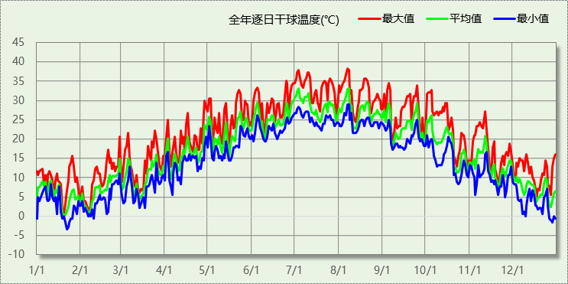

## 逐月辐照量表

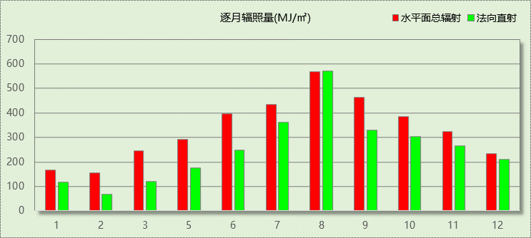

## 峰值工况

|  |  |  |  |  |  |
| --- | --- | --- | --- | --- | --- |
| 气象数据 | 时刻 | 干球温度(℃) | 湿球温度(℃) | 含湿量(g/kg) | 焓值(kj/kg) |
| 最热 | 08月06日14时 | 38.3 | 28.9 | 21.4 | 93.5 |
| 最冷 | 01月21日04时 | -3.3 | -3.3 | 2.9 | 3.9 |

# 软件介绍

本报告采用的软件为绿建暖通负荷BECH2023，该软件紧密结合暖通和节能设计规范、可根据项目实际情况建立建筑热工模型，并可对围护结构材料、房间内扰发热、作息时间表、热回收方式等参数进行设置。

软件包含全国各地典型气象年数据，内置DOE2.1E内核，对于建筑的逐时负荷进行动态模拟，既可以模拟8760小时理想负荷，也可以根据设定好的采暖期/空调期进行逐时模拟。

软件还支持分析全年建筑能耗的来源构成，依据日射得热、新风负荷、围护传热和内扰得热进行归类分项，生成设计建筑全年负荷计算报告书，提供详实的数据和多样的图表，为设计师在设备选型、制定运行策略等方面提供参考和帮助。

# 围护结构

## 屋顶构造

### 屋顶构造一

|  |  |  |  |  |  |  |
| --- | --- | --- | --- | --- | --- | --- |
| 材料名称 （由上到下） | 厚度δ | 导热系数λ | 蓄热系数S | 修正系数 | 热阻R | 热惰性指标 |
| (mm) | W/(m.K) | W/(㎡.K) | α | (㎡K)/W | D=R*S |
| 袋装珍珠岩 | 180 | 0.070 | 0.845 | 1.00 | 2.571 | 2.173 |
| 各层之和∑ | 180 | － | － | － | 2.571 | 2.173 |
| 外表面太阳辐射吸收系数 | 0.75 | | | | | |
| 传热系数K=1/(0.15+∑R) | 0.37 | | | | | |

## 外墙构造

### 外墙构造一

|  |  |  |  |  |  |  |
| --- | --- | --- | --- | --- | --- | --- |
| 材料名称 （由外到内） | 厚度δ | 导热系数λ | 蓄热系数S | 修正系数 | 热阻R | 热惰性指标 |
| (mm) | W/(m.K) | W/(㎡.K) | α | (㎡K)/W | D=R*S |
| 耐碱玻纤网布抗裂砂浆 | 5 | 0.930 | 11.306 | 1.00 | 0.005 | 0.061 |
| 膨胀聚苯板(ρ=20~30) | 85 | 0.042 | 0.360 | 1.20 | 1.687 | 0.729 |
| 陶粒混凝土多孔砖(240） | 100 | 0.600 | 6.010 | 1.00 | 0.167 | 1.002 |
| 石灰水泥砂浆 | 10 | 0.870 | 10.627 | 1.00 | 0.011 | 0.122 |
| 各层之和∑ | 200 | － | － | － | 1.870 | 1.913 |
| 外表面太阳辐射吸收系数 | 0.75 | | | | | |
| 传热系数K=1/(0.15+∑R) | 0.50 | | | | | |

## 户墙构造

### 楼梯间隔墙构造一

|  |  |  |  |  |  |  |
| --- | --- | --- | --- | --- | --- | --- |
| 材料名称 | 厚度δ | 导热系数λ | 蓄热系数S | 修正系数 | 热阻R | 热惰性指标 |
| (mm) | W/(m.K) | W/(㎡.K) | α | (㎡K)/W | D=R*S |
| 石灰水泥砂浆 | 20 | 0.870 | 10.627 | 1.00 | 0.023 | 0.244 |
| 加气混凝土(ρ=500) | 150 | 0.190 | 3.123 | 1.25 | 0.632 | 2.466 |
| 石灰水泥砂浆 | 20 | 0.870 | 10.627 | 1.00 | 0.023 | 0.244 |
| 各层之和∑ | 190 | － | － | － | 0.678 | 2.954 |
| 传热系数K=1/(0.22+∑R) | 1.11 | | | | | |
| 修正后K, D | K = 1.12, D = 2.68 | | | | | |
| 修正原因 |  | | | | | |

## 分户墙构造

### 户间隔墙构造一

|  |  |  |  |  |  |  |
| --- | --- | --- | --- | --- | --- | --- |
| 材料名称 | 厚度δ | 导热系数λ | 蓄热系数S | 修正系数 | 热阻R | 热惰性指标 |
| (mm) | W/(m.K) | W/(㎡.K) | α | (㎡K)/W | D=R*S |
| 石灰水泥砂浆 | 20 | 0.870 | 10.627 | 1.00 | 0.023 | 0.244 |
| 加气混凝土(ρ=500) | 150 | 0.190 | 3.123 | 1.25 | 0.632 | 2.466 |
| 石灰水泥砂浆 | 20 | 0.870 | 10.627 | 1.00 | 0.023 | 0.244 |
| 各层之和∑ | 190 | － | － | － | 0.678 | 2.954 |
| 传热系数K=1/(0.22+∑R) | 1.11 | | | | | |
| 修正后K, D | K = 1.12, D = 2.68 | | | | | |
| 修正原因 |  | | | | | |

## 楼板构造

### 控温房间楼板构造二

|  |  |  |  |  |  |  |
| --- | --- | --- | --- | --- | --- | --- |
| 材料名称 | 厚度δ | 导热系数λ | 蓄热系数S | 修正系数 | 热阻R | 热惰性指标 |
| (mm) | W/(m.K) | W/(㎡.K) | α | (㎡K)/W | D=R*S |
| 1:3水泥砂浆找平层 | 20 | 0.930 | 11.370 | 1.00 | 0.022 | 0.245 |
| 挤塑聚苯板 | 30 | 0.030 | 0.381 | 1.10 | 0.909 | 0.381 |
| 钢筋混凝土屋面板 | 120 | 1.740 | 17.060 | 1.00 | 0.069 | 1.177 |
| 石灰水泥砂浆 | 20 | 0.870 | 10.627 | 1.00 | 0.023 | 0.244 |
| 各层之和∑ | 190 | － | － | － | 1.023 | 2.046 |
| 传热系数K=1/(0.22+∑R) | 0.81 | | | | | |
| 修正后K, D | K = 0.81, D = 2.03 | | | | | |
| 修正原因 |  | | | | | |

## 门构造

|  |  |  |  |
| --- | --- | --- | --- |
| 序号 | 构造名称 | 传热系数 | 备注 |
| 1 | 保温门（多功能门） | 1.500 |  |
| 2 | 单层实体门 | 1.500 |  |

## 窗构造

|  |  |  |  |  |  |
| --- | --- | --- | --- | --- | --- |
| 序号 | 构造名称 | 传热系数 | 遮阳系数 | 可见光透射比 | 备注 |
| 1 | 单框低辐射中空玻璃窗(钢、铝合金窗框) | 2.000 | 0.345 | 0.830 | 窗框窗洞面积比20~30% |
| 2 | 12A钢铝单框双玻窗（平均） | 2.000 | 0.345 | 1.000 | 来源《民用建筑热工设计规范》 |

# 房间类型

## 房间表

|  |  |  |  |  |  |  |
| --- | --- | --- | --- | --- | --- | --- |
| 房间类型 | 空调温度 ℃ | 供暖温度 ℃ | 新风量 | 人员密度 | 照明功率 密度 | 电器设备 功率 |
| 卫生间 | － | － | 0.5(次/h) | 0(人) | 6(W/m^2) | 0(W/m^2) |
| 厨房 | － | － | 0.5(次/h) | 0(人) | 6(W/m^2) | 24(W/m^2) |
| 封闭阳台 | 26 | 18 | 0.5(次/h) | 32(m^2/人) | 6(W/m^2) | 5(W/m^2) |
| 楼梯间 | － | － | 0(m^3/h.人) | 0(人) | 0(W/m^2) | 0(W/m^2) |
| 次卧室 | 26 | 18 | 0.5(次/h) | 32(m^2/人) | 6(W/m^2) | 5(W/m^2) |
| 起居室 | 26 | 18 | 0.5(次/h) | 32(m^2/人) | 6(W/m^2) | 5(W/m^2) |
| 过厅 | 26 | 18 | 0.5(次/h) | 32(m^2/人) | 6(W/m^2) | 5(W/m^2) |
| 餐厅 | 26 | 18 | 0.5(次/h) | 32(m^2/人) | 6(W/m^2) | 5(W/m^2) |

## 作息时间表

详见附录

# 系统设置

## 系统划分

|  |  |  |  |  |  |  |
| --- | --- | --- | --- | --- | --- | --- |
| 系统编号 | 热回收 类型 | 启动 条件 | 回收 效率 | 排风 比例 | 面积(m2) | 包含的房间 |
| 默认 | 无 | -- | -- | -- | 317.40 | 所有房间 |

## 运行时间表

详见附录

# 计算结果

## 模拟周期

全年8760小时模拟

## 全年冷暖需求

|  |  |  |  |  |
| --- | --- | --- | --- | --- |
| 系统名称\负荷 | 供暖需求 (kWh) | 供暖指标 (kWh/㎡·a) | 供冷需求 (kWh) | 供冷指标 (kWh/㎡·a) |
| 默认系统 | 17769 | 55.98 | 26929 | 84.84 |
| 建筑总计 | 17769 | 37.96 | 26929 | 57.52 |

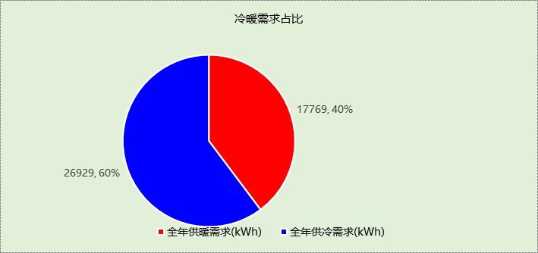

## 负荷分项统计

|  |  |  |  |  |  |  |
| --- | --- | --- | --- | --- | --- | --- |
| 分类 | 围护传热 | 室内得热 | 窗日射 | 新风/渗透 | 热回收 | 合计 |
| 供暖需求(kWh/㎡) | -42.47 | 7.42 | 6.34 | -9.25 | 0.00 | -37.96 |
| 供冷需求(kWh/㎡) | 14.52 | 9.11 | 16.61 | 17.28 | 0.00 | 57.52 |

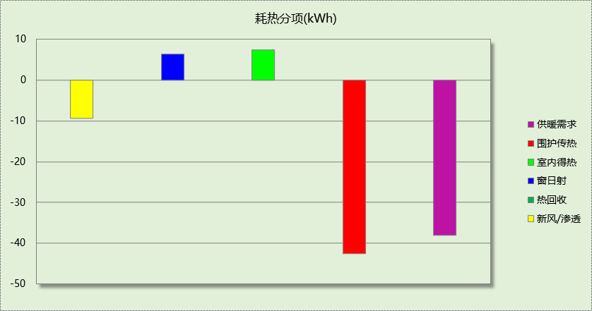

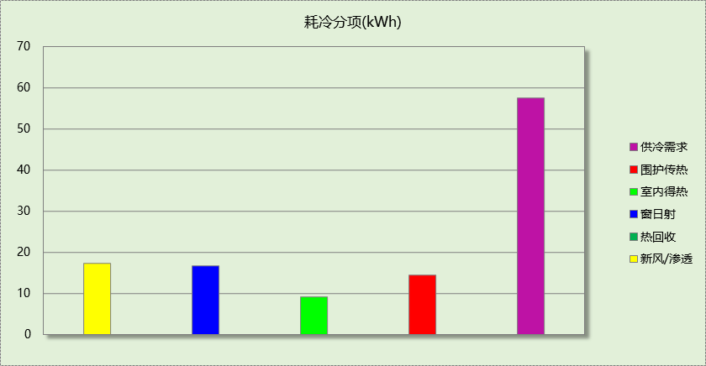

## 逐月负荷表

|  |  |  |  |  |  |  |
| --- | --- | --- | --- | --- | --- | --- |
| 月份 | 供暖需求 (kWh) | 供冷需求 (kWh) | 热负荷 峰值(kW) | 热负荷 峰值时刻 | 冷负荷 峰值(kW) | 冷负荷 峰值时刻 |
| 1月 | 5145 | 0 | 14.038 | 01月21日05时 | 0.000 | -- |
| 2月 | 4224 | 0 | 12.964 | 02月07日06时 | 0.000 | -- |
| 3月 | 2769 | 0 | 10.384 | 03月17日05时 | 0.051 | 03月24日16时 |
| 4月 | 373 | 187 | 6.385 | 04月05日05时 | 6.880 | 04月30日19时 |
| 5月 | 0 | 1913 | 0.000 | -- | 12.672 | 05月01日14时 |
| 6月 | 0 | 5028 | 0.000 | -- | 16.852 | 06月29日14时 |
| 7月 | 0 | 8433 | 0.000 | -- | 19.854 | 07月03日15时 |
| 8月 | 0 | 6867 | 0.000 | -- | 20.212 | 08月07日14时 |
| 9月 | 0 | 3211 | 0.000 | -- | 17.537 | 09月04日14时 |
| 10月 | 305 | 1225 | 5.359 | 10月23日05时 | 12.267 | 10月03日14时 |
| 11月 | 1211 | 65 | 8.147 | 11月20日11时 | 3.952 | 11月11日15时 |
| 12月 | 3744 | 0 | 12.004 | 12月28日06时 | 0.000 | -- |

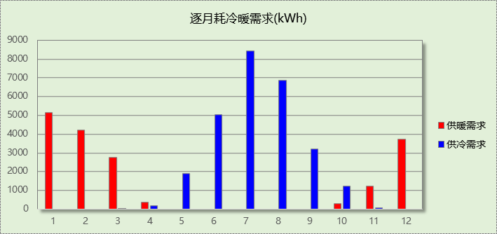

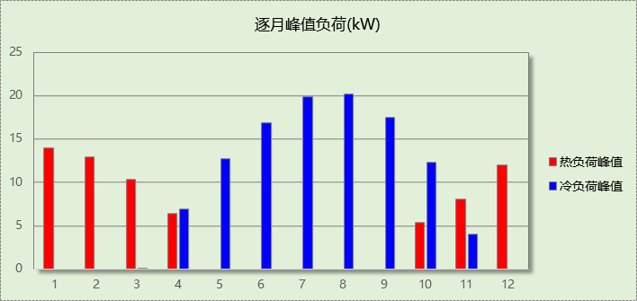

# 附录

**工作日/节假日人员逐时在室率(%)**

|  |  |  |  |  |  |  |  |  |  |  |  |  |  |  |  |  |  |  |  |  |  |  |  |  |
| --- | --- | --- | --- | --- | --- | --- | --- | --- | --- | --- | --- | --- | --- | --- | --- | --- | --- | --- | --- | --- | --- | --- | --- | --- |
| 房间类型 | 1 | 2 | 3 | 4 | 5 | 6 | 7 | 8 | 9 | 10 | 11 | 12 | 13 | 14 | 15 | 16 | 17 | 18 | 19 | 20 | 21 | 22 | 23 | 24 |
| 卫生间 | 0 | 0 | 0 | 0 | 0 | 0 | 0 | 0 | 0 | 0 | 0 | 0 | 0 | 0 | 0 | 0 | 0 | 0 | 0 | 0 | 0 | 0 | 0 | 0 |
| 0 | 0 | 0 | 0 | 0 | 0 | 0 | 0 | 0 | 0 | 0 | 0 | 0 | 0 | 0 | 0 | 0 | 0 | 0 | 0 | 0 | 0 | 0 | 0 |
| 厨房 | 0 | 0 | 0 | 0 | 0 | 7 | 41 | 42 | 9 | 1 | 10 | 41 | 19 | 2 | 0 | 1 | 21 | 71 | 74 | 19 | 2 | 0 | 1 | 0 |
| 0 | 0 | 0 | 0 | 0 | 7 | 41 | 42 | 9 | 1 | 10 | 41 | 19 | 2 | 0 | 1 | 21 | 71 | 74 | 19 | 2 | 0 | 1 | 0 |
| 封闭阳台 | 16 | 16 | 16 | 15 | 16 | 24 | 31 | 19 | 15 | 14 | 14 | 19 | 22 | 19 | 13 | 14 | 18 | 35 | 49 | 54 | 50 | 35 | 21 | 15 |
| 14 | 13 | 13 | 13 | 13 | 18 | 22 | 24 | 29 | 32 | 34 | 37 | 35 | 32 | 26 | 28 | 33 | 39 | 44 | 47 | 45 | 34 | 23 | 16 |
| 楼梯间 | 0 | 0 | 0 | 0 | 0 | 0 | 0 | 0 | 0 | 0 | 0 | 0 | 0 | 0 | 0 | 0 | 0 | 0 | 0 | 0 | 0 | 0 | 0 | 0 |
| 0 | 0 | 0 | 0 | 0 | 0 | 0 | 0 | 0 | 0 | 0 | 0 | 0 | 0 | 0 | 0 | 0 | 0 | 0 | 0 | 0 | 0 | 0 | 0 |
| 次卧室 | 61 | 61 | 62 | 61 | 61 | 58 | 40 | 21 | 17 | 16 | 15 | 16 | 18 | 18 | 15 | 14 | 14 | 14 | 15 | 18 | 24 | 37 | 52 | 57 |
| 57 | 57 | 58 | 58 | 58 | 59 | 55 | 42 | 30 | 21 | 15 | 14 | 17 | 17 | 14 | 14 | 13 | 13 | 14 | 17 | 23 | 32 | 46 | 52 |
| 起居室 | 16 | 16 | 16 | 15 | 16 | 24 | 31 | 19 | 15 | 14 | 14 | 19 | 22 | 19 | 13 | 14 | 18 | 35 | 49 | 54 | 50 | 35 | 21 | 15 |
| 14 | 13 | 13 | 13 | 13 | 18 | 22 | 24 | 29 | 32 | 34 | 37 | 35 | 32 | 26 | 28 | 33 | 39 | 44 | 47 | 45 | 34 | 23 | 16 |
| 过厅 | 16 | 16 | 16 | 15 | 16 | 24 | 31 | 19 | 15 | 14 | 14 | 19 | 22 | 19 | 13 | 14 | 18 | 35 | 49 | 54 | 50 | 35 | 21 | 15 |
| 14 | 13 | 13 | 13 | 13 | 18 | 22 | 24 | 29 | 32 | 34 | 37 | 35 | 32 | 26 | 28 | 33 | 39 | 44 | 47 | 45 | 34 | 23 | 16 |
| 餐厅 | 16 | 16 | 16 | 15 | 16 | 24 | 31 | 19 | 15 | 14 | 14 | 19 | 22 | 19 | 13 | 14 | 18 | 35 | 49 | 54 | 50 | 35 | 21 | 15 |
| 14 | 13 | 13 | 13 | 13 | 18 | 22 | 24 | 29 | 32 | 34 | 37 | 35 | 32 | 26 | 28 | 33 | 39 | 44 | 47 | 45 | 34 | 23 | 16 |

注：上行：工作日；下行：节假日

**工作日/节假日照明开关时间表(%)**

|  |  |  |  |  |  |  |  |  |  |  |  |  |  |  |  |  |  |  |  |  |  |  |  |  |
| --- | --- | --- | --- | --- | --- | --- | --- | --- | --- | --- | --- | --- | --- | --- | --- | --- | --- | --- | --- | --- | --- | --- | --- | --- |
| 房间类型 | 1 | 2 | 3 | 4 | 5 | 6 | 7 | 8 | 9 | 10 | 11 | 12 | 13 | 14 | 15 | 16 | 17 | 18 | 19 | 20 | 21 | 22 | 23 | 24 |
| 卫生间 | 0 | 0 | 0 | 0 | 0 | 0 | 0 | 0 | 0 | 0 | 0 | 0 | 0 | 0 | 0 | 0 | 100 | 100 | 100 | 100 | 100 | 100 | 100 | 0 |
| 0 | 0 | 0 | 0 | 0 | 0 | 0 | 0 | 0 | 0 | 0 | 0 | 0 | 0 | 0 | 0 | 100 | 100 | 100 | 100 | 100 | 100 | 100 | 0 |
| 厨房 | 0 | 0 | 0 | 0 | 0 | 0 | 0 | 0 | 0 | 0 | 0 | 0 | 0 | 0 | 0 | 0 | 100 | 100 | 100 | 100 | 100 | 100 | 100 | 0 |
| 0 | 0 | 0 | 0 | 0 | 0 | 0 | 0 | 0 | 0 | 0 | 0 | 0 | 0 | 0 | 0 | 100 | 100 | 100 | 100 | 100 | 100 | 100 | 0 |
| 封闭阳台 | 0 | 0 | 0 | 0 | 0 | 0 | 0 | 0 | 0 | 0 | 0 | 0 | 0 | 0 | 0 | 0 | 0 | 0 | 100 | 100 | 100 | 100 | 100 | 50 |
| 0 | 0 | 0 | 0 | 0 | 0 | 0 | 0 | 0 | 0 | 0 | 0 | 0 | 0 | 0 | 0 | 0 | 0 | 100 | 100 | 100 | 100 | 100 | 50 |
| 楼梯间 | 0 | 0 | 0 | 0 | 0 | 0 | 0 | 0 | 0 | 0 | 0 | 0 | 0 | 0 | 0 | 0 | 100 | 100 | 100 | 100 | 100 | 100 | 100 | 0 |
| 0 | 0 | 0 | 0 | 0 | 0 | 0 | 0 | 0 | 0 | 0 | 0 | 0 | 0 | 0 | 0 | 100 | 100 | 100 | 100 | 100 | 100 | 100 | 0 |
| 次卧室 | 0 | 0 | 0 | 0 | 0 | 0 | 0 | 0 | 0 | 0 | 0 | 0 | 0 | 0 | 0 | 0 | 0 | 0 | 50 | 50 | 50 | 10 | 10 | 10 |
| 0 | 0 | 0 | 0 | 0 | 0 | 0 | 0 | 0 | 0 | 0 | 0 | 0 | 0 | 0 | 0 | 0 | 0 | 50 | 50 | 50 | 10 | 10 | 10 |
| 起居室 | 0 | 0 | 0 | 0 | 0 | 0 | 0 | 0 | 0 | 0 | 0 | 0 | 0 | 0 | 0 | 0 | 0 | 0 | 100 | 100 | 100 | 100 | 100 | 50 |
| 0 | 0 | 0 | 0 | 0 | 0 | 0 | 0 | 0 | 0 | 0 | 0 | 0 | 0 | 0 | 0 | 0 | 0 | 100 | 100 | 100 | 100 | 100 | 50 |
| 过厅 | 0 | 0 | 0 | 0 | 0 | 0 | 0 | 0 | 0 | 0 | 0 | 0 | 0 | 0 | 0 | 0 | 0 | 0 | 100 | 100 | 100 | 100 | 100 | 50 |
| 0 | 0 | 0 | 0 | 0 | 0 | 0 | 0 | 0 | 0 | 0 | 0 | 0 | 0 | 0 | 0 | 0 | 0 | 100 | 100 | 100 | 100 | 100 | 50 |
| 餐厅 | 0 | 0 | 0 | 0 | 0 | 0 | 0 | 0 | 0 | 0 | 0 | 0 | 0 | 0 | 0 | 0 | 0 | 0 | 100 | 100 | 100 | 100 | 100 | 50 |
| 0 | 0 | 0 | 0 | 0 | 0 | 0 | 0 | 0 | 0 | 0 | 0 | 0 | 0 | 0 | 0 | 0 | 0 | 100 | 100 | 100 | 100 | 100 | 50 |

注：上行：工作日；下行：节假日

**工作日/节假日设备逐时使用率(%)**

|  |  |  |  |  |  |  |  |  |  |  |  |  |  |  |  |  |  |  |  |  |  |  |  |  |
| --- | --- | --- | --- | --- | --- | --- | --- | --- | --- | --- | --- | --- | --- | --- | --- | --- | --- | --- | --- | --- | --- | --- | --- | --- |
| 房间类型 | 1 | 2 | 3 | 4 | 5 | 6 | 7 | 8 | 9 | 10 | 11 | 12 | 13 | 14 | 15 | 16 | 17 | 18 | 19 | 20 | 21 | 22 | 23 | 24 |
| 卫生间 | 100 | 100 | 100 | 100 | 100 | 100 | 100 | 100 | 100 | 100 | 100 | 100 | 100 | 100 | 100 | 100 | 100 | 100 | 100 | 100 | 100 | 100 | 100 | 100 |
| 100 | 100 | 100 | 100 | 100 | 100 | 100 | 100 | 100 | 100 | 100 | 100 | 100 | 100 | 100 | 100 | 100 | 100 | 100 | 100 | 100 | 100 | 100 | 100 |
| 厨房 | 100 | 100 | 100 | 100 | 100 | 100 | 100 | 100 | 100 | 100 | 100 | 100 | 100 | 100 | 100 | 100 | 100 | 100 | 100 | 100 | 100 | 100 | 100 | 100 |
| 100 | 100 | 100 | 100 | 100 | 100 | 100 | 100 | 100 | 100 | 100 | 100 | 100 | 100 | 100 | 100 | 100 | 100 | 100 | 100 | 100 | 100 | 100 | 100 |
| 封闭阳台 | 23 | 23 | 23 | 23 | 23 | 23 | 23 | 23 | 23 | 23 | 23 | 23 | 69 | 69 | 23 | 23 | 23 | 23 | 23 | 100 | 100 | 100 | 100 | 69 |
| 23 | 23 | 23 | 23 | 23 | 23 | 23 | 23 | 23 | 23 | 23 | 23 | 69 | 69 | 23 | 23 | 23 | 23 | 23 | 100 | 100 | 100 | 100 | 69 |
| 楼梯间 | 100 | 100 | 100 | 100 | 100 | 100 | 100 | 100 | 100 | 100 | 100 | 100 | 100 | 100 | 100 | 100 | 100 | 100 | 100 | 100 | 100 | 100 | 100 | 100 |
| 100 | 100 | 100 | 100 | 100 | 100 | 100 | 100 | 100 | 100 | 100 | 100 | 100 | 100 | 100 | 100 | 100 | 100 | 100 | 100 | 100 | 100 | 100 | 100 |
| 次卧室 | 0 | 0 | 0 | 0 | 0 | 0 | 0 | 0 | 0 | 0 | 0 | 0 | 0 | 0 | 0 | 0 | 0 | 0 | 0 | 70 | 10 | 10 | 10 | 10 |
| 0 | 0 | 0 | 0 | 0 | 0 | 0 | 0 | 0 | 0 | 0 | 0 | 0 | 0 | 0 | 0 | 0 | 0 | 0 | 70 | 10 | 10 | 10 | 10 |
| 起居室 | 23 | 23 | 23 | 23 | 23 | 23 | 23 | 23 | 23 | 23 | 23 | 23 | 69 | 69 | 23 | 23 | 23 | 23 | 23 | 100 | 100 | 100 | 100 | 69 |
| 23 | 23 | 23 | 23 | 23 | 23 | 23 | 23 | 23 | 23 | 23 | 23 | 69 | 69 | 23 | 23 | 23 | 23 | 23 | 100 | 100 | 100 | 100 | 69 |
| 过厅 | 23 | 23 | 23 | 23 | 23 | 23 | 23 | 23 | 23 | 23 | 23 | 23 | 69 | 69 | 23 | 23 | 23 | 23 | 23 | 100 | 100 | 100 | 100 | 69 |
| 23 | 23 | 23 | 23 | 23 | 23 | 23 | 23 | 23 | 23 | 23 | 23 | 69 | 69 | 23 | 23 | 23 | 23 | 23 | 100 | 100 | 100 | 100 | 69 |
| 餐厅 | 23 | 23 | 23 | 23 | 23 | 23 | 23 | 23 | 23 | 23 | 23 | 23 | 69 | 69 | 23 | 23 | 23 | 23 | 23 | 100 | 100 | 100 | 100 | 69 |
| 23 | 23 | 23 | 23 | 23 | 23 | 23 | 23 | 23 | 23 | 23 | 23 | 69 | 69 | 23 | 23 | 23 | 23 | 23 | 100 | 100 | 100 | 100 | 69 |

注：上行：工作日；下行：节假日

**工作日/节假日空调系统开关时间表**

|  |  |  |  |  |  |  |  |  |  |  |  |  |  |  |  |  |  |  |  |  |  |  |  |  |
| --- | --- | --- | --- | --- | --- | --- | --- | --- | --- | --- | --- | --- | --- | --- | --- | --- | --- | --- | --- | --- | --- | --- | --- | --- |
| 系统编号 | 1 | 2 | 3 | 4 | 5 | 6 | 7 | 8 | 9 | 10 | 11 | 12 | 13 | 14 | 15 | 16 | 17 | 18 | 19 | 20 | 21 | 22 | 23 | 24 |
| 默认 | 1 | 1 | 1 | 1 | 1 | 1 | 1 | 1 | 1 | 1 | 1 | 1 | 1 | 1 | 1 | 1 | 1 | 1 | 1 | 1 | 1 | 1 | 1 | 1 |
| 1 | 1 | 1 | 1 | 1 | 1 | 1 | 1 | 1 | 1 | 1 | 1 | 1 | 1 | 1 | 1 | 1 | 1 | 1 | 1 | 1 | 1 | 1 | 1 |

注：上行：工作日；下行：节假日