新建项目
全年负荷计算书

工程名称 | 新建项目
设计编号
建设单位 | 江西科技师范大学
设计单位 | 江西省设计研究总院
计 算 人
校 对 人
审 核 人
计算日期 | 2023年12月29日



采用软件 | 暖通负荷BECH2023
软件版本 | 20220808(SP1)
研发单位 | 北京绿建软件股份有限公司
正版授权码 | T17779942886
目 录

1 建筑概况 1
2 气象数据 1
2.1 气象地点 1
2.2 逐日干球温度表 1
2.3 逐月辐照量表 2
2.4 峰值工况 2
3 软件介绍 2
4 围护结构 2
4.1 屋顶构造 2
4.1.1 屋顶构造一 2
4.2 外墙构造 3
4.2.1 外墙构造一 3
4.3 挑空楼板构造 3
4.3.1 挑空楼板构造一 3
4.4 楼板构造 3
4.4.1 控温房间楼板构造一 3
4.5 周边地面构造 4
4.5.1 周边地面构造一 4
4.6 非周边地面构造 4
4.6.1 非周边地面构造一 4
4.7 门构造 4
4.8 窗构造 4
5 房间类型 5
5.1 房间表 5
5.2 作息时间表 5
6 系统设置 5
6.1 系统划分 5
6.2 运行时间表 6
7 计算结果 6
7.1 模拟周期 6
7.2 全年冷暖需求 7
7.3 负荷分项统计 7
7.4 逐月负荷表 8
8 附录 10

建筑概况
地理位置 | 江西-南昌
气候分区 | 夏热冬冷
北纬 | 28.60
东经 | 115.92
建筑名称 | 新建项目
建筑类型 | 公共建筑
建筑面积 | 地上 5309.22 ㎡ | 地下 0.00 ㎡
建筑高度 | 地上 28.60 m | 地下0.00
建筑层数 | 地上 7 | 地下 0
北向角度 | 90°

气象数据

气象地点
江西-南昌, 《中国建筑热环境分析专用气象数据集》

逐日干球温度表
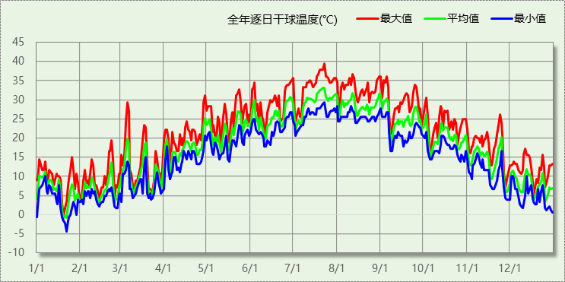

逐月辐照量表
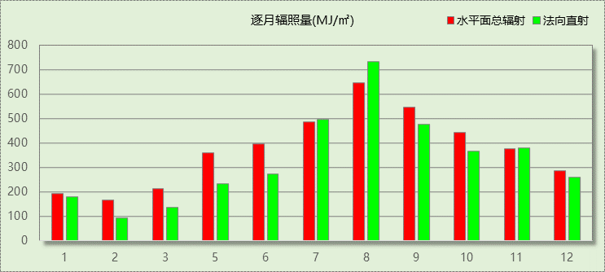

峰值工况
气象数据 | 时刻 | 干球温度(℃) | 湿球温度(℃) | 含湿量(g/kg) | 焓值(kj/kg)
最热 | 07月22日14时 | 39.4 | 28.3 | 20.2 | 91.6
最冷 | 01月21日05时 | -4.4 | -4.4 | 2.4 | 1.5

软件介绍
本报告采用的软件为绿建暖通负荷BECH2023，该软件紧密结合暖通和节能设计规范、可根据项目实际情况建立建筑热工模型，并可对围护结构材料、房间内扰发热、作息时间表、热回收方式等参数进行设置。
软件包含全国各地典型气象年数据，内置DOE2.1E内核，对于建筑的逐时负荷进行动态模拟，既可以模拟8760小时理想负荷，也可以根据设定好的采暖期/空调期进行逐时模拟。
软件还支持分析全年建筑能耗的来源构成，依据日射得热、新风负荷、围护传热和内扰得热进行归类分项，生成设计建筑全年负荷计算报告书，提供详实的数据和多样的图表，为设计师在设备选型、制定运行策略等方面提供参考和帮助。

围护结构

屋顶构造

屋顶构造一
材料名称  （由上到下） | 厚度δ | 导热系数λ | 蓄热系数S | 修正系数 | 热阻R | 热惰性指标
材料名称  （由上到下） | (mm) | W/(m.K) | W/(㎡.K) | α | (㎡K)/W | D=R*S
细石混凝土 | 20 | 1.510 | 15.360 | 1.00 | 0.013 | 0.203
挤塑聚苯乙烯泡沫板（xps）(ρ=30) | 80 | 0.030 | 0.540 | 1.00 | 2.667 | 1.440
水泥砂浆 | 20 | 0.930 | 11.370 | 1.00 | 0.022 | 0.245
钢筋混凝土 | 120 | 1.740 | 17.200 | 1.00 | 0.069 | 1.186
石灰砂浆 | 20 | 0.810 | 10.070 | 1.00 | 0.025 | 0.249
各层之和∑ | 260 | － | － | － | 2.795 | 3.323
外表面太阳辐射吸收系数 | 0.75
传热系数K=1/(0.15+∑R) | 0.34

外墙构造

外墙构造一
材料名称  （由外到内） | 厚度δ | 导热系数λ | 蓄热系数S | 修正系数 | 热阻R | 热惰性指标
材料名称  （由外到内） | (mm) | W/(m.K) | W/(㎡.K) | α | (㎡K)/W | D=R*S
保温砂浆 | 40 | 0.030 | 10.000 | 1.00 | 1.333 | 13.333
重砂浆砌筑粘土砖砌体 | 240 | 0.810 | 10.551 | 1.00 | 0.296 | 3.126
石灰砂浆 | 20 | 0.810 | 10.070 | 1.00 | 0.025 | 0.249
各层之和∑ | 300 | － | － | － | 1.654 | 16.708
外表面太阳辐射吸收系数 | 0.75
传热系数K=1/(0.15+∑R) | 0.55

挑空楼板构造

挑空楼板构造一
材料名称  （由上到下） | 厚度δ | 导热系数λ | 蓄热系数S | 修正系数 | 热阻R | 热惰性指标
材料名称  （由上到下） | (mm) | W/(m.K) | W/(㎡.K) | α | (㎡K)/W | D=R*S
水泥砂浆 | 20 | 0.930 | 11.370 | 1.00 | 0.022 | 0.245
钢筋混凝土 | 120 | 1.740 | 17.200 | 1.00 | 0.069 | 1.186
保温砂浆 | 40 | 0.030 | 10.000 | 1.00 | 1.333 | 13.333
各层之和∑ | 180 | － | － | － | 1.424 | 14.764
传热系数K=1/(0.15+∑R) | 0.64

楼板构造

控温房间楼板构造一
材料名称 | 厚度δ | 导热系数λ | 蓄热系数S | 修正系数 | 热阻R | 热惰性指标
材料名称 | (mm) | W/(m.K) | W/(㎡.K) | α | (㎡K)/W | D=R*S
保温砂浆 | 20 | 0.030 | 10.000 | 1.00 | 0.667 | 6.667
钢筋混凝土 | 120 | 1.740 | 17.200 | 1.00 | 0.069 | 1.186
保温砂浆 | 20 | 0.030 | 10.000 | 1.00 | 0.667 | 6.667
各层之和∑ | 160 | － | － | － | 1.402 | 14.520
传热系数K=1/(0.22+∑R) | 0.62

周边地面构造

周边地面构造一
材料名称 | 厚度δ | 导热系数λ | 蓄热系数S | 修正系数 | 热阻R | 热惰性指标
材料名称 | (mm) | W/(m.K) | W/(㎡.K) | α | (㎡K)/W | D=R*S
水泥砂浆 | 20 | 0.930 | 11.370 | 1.00 | 0.022 | 0.245
钢筋混凝土 | 120 | 1.740 | 17.200 | 1.00 | 0.069 | 1.186
各层之和∑ | 140 | － | － | － | 0.090 | 1.431
传热系数K=1/(0.11+∑R) | 0.52

非周边地面构造

非周边地面构造一
材料名称 | 厚度δ | 导热系数λ | 蓄热系数S | 修正系数 | 热阻R | 热惰性指标
材料名称 | (mm) | W/(m.K) | W/(㎡.K) | α | (㎡K)/W | D=R*S
水泥砂浆 | 20 | 0.930 | 11.370 | 1.00 | 0.022 | 0.245
钢筋混凝土 | 120 | 1.740 | 17.200 | 1.00 | 0.069 | 1.186
各层之和∑ | 140 | － | － | － | 0.090 | 1.431
传热系数K=1/(0.11+∑R) | 0.30

门构造
序号 | 构造名称 | 传热系数 | 备注
1 | 双层实体木制外门 | 1.300

窗构造
序号 | 构造名称 | 传热系数 | 遮阳系数 | 可见光透射比 | 备注
1 | 6＋12A＋6中透低辐射玻璃 | 1.550 | 0.375 | 0.620 | 同上
2 | 6＋12A＋6中透低辐射玻璃 | 1.550 | 0.375 | 0.620 | 同上
3 | 6低透光热反射+12空气+6透明 | 2.300 | 0.180 | 0.160 | 可见光透射比=0.16

房间类型

房间表
房间类型 | 空调温度  ℃ | 供暖温度  ℃ | 新风量 | 人员密度 | 照明功率  密度 | 电器设备  功率
专用教室 | 26 | 20 | 30(m^3/h.人) | 2.5(m^2/人) | 10(W/m^2) | 13(W/m^2)
休息厅 | 26 | 20 | 30(m^3/h.人) | 20(m^2/人) | 10(W/m^2) | 0(W/m^2)
储藏室 | 26 | 20 | 30(m^3/h.人) | 60(m^2/人) | 0.5(W/m^2) | 0(W/m^2)
办公-普通办公室 | 26 | 20 | 30(m^3/h.人) | 8(m^2/人) | 9(W/m^2) | 15(W/m^2)
办公室 | 26 | 20 | 30(m^3/h.人) | 15(m^2/人) | 1(W/m^2) | 15(W/m^2)
厕所 | 26 | 20 | 30(m^3/h.人) | 20(m^2/人) | 1.5(W/m^2) | 0(W/m^2)
多功能厅 | 26 | 20 | 30(m^3/h.人) | 2.5(m^2/人) | 18(W/m^2) | 13(W/m^2)
普通教室 | 26 | 20 | 30(m^3/h.人) | 3(m^2/人) | 4.5(W/m^2) | 25(W/m^2)
档案室 | 26 | 20 | 30(m^3/h.人) | 20(m^2/人) | 10(W/m^2) | 0(W/m^2)
楼梯间 | 26 | 16 | 20(m^3/h.人) | 50(m^2/人) | 0.9(W/m^2) | 0(W/m^2)
灯控制室 | 26 | 20 | 30(m^3/h.人) | 15(m^2/人) | 0.7(W/m^2) | 15(W/m^2)
琴房 | 26 | 20 | 30(m^3/h.人) | 6.61(m^2/人) | 2.5(W/m^2) | 0(W/m^2)
综合大厅 | 26 | 20 | 30(m^3/h.人) | 20(m^2/人) | 10(W/m^2) | 0(W/m^2)
耳灯室 | 26 | 20 | 30(m^3/h.人) | 8(m^2/人) | 3(W/m^2) | 20(W/m^2)
走廊 | 26 | 16 | 20(m^3/h.人) | 50(m^2/人) | 0.6(W/m^2) | 0(W/m^2)
通风井 | 26 | 20 | 20(m^3/h.人) | 0(m^2/人) | 0(W/m^2) | 0(W/m^2)
门厅 | 26 | 20 | 30(m^3/h.人) | 20(m^2/人) | 10(W/m^2) | 0(W/m^2)
阳台 | 26 | 16 | 20(m^3/h.人) | 50(m^2/人) | 0(W/m^2) | 0(W/m^2)

作息时间表
详见附录

系统设置

系统划分
系统编号 | 热回收  类型 | 启动  条件 | 回收  效率 | 排风  比例 | 面积(m2) | 包含的房间
默认 | 无 | -- | -- | -- | 4409.36 | 1039,1038,1037,1036,1035,1034,1033,1032,1031,1030,1029,1028,1027,1026,1025,1024,1023,1022,1021,1020,1019,1018,1017,1016,1015,1014,1013,1011,1007,2001,2004,2010,2005,2011,2017,2028,2029,2019,2020,2021,2023,2034,2022,2018,2033,2032,2031,2030,2035,2016,2027,2012,2015,2024,2013,2014,3015,3009,3001,3004,3002,3018,3017,3027,3033,3030,3041,3040,3034,3022,3024,3023,3026,3025,3039,3021,3038,3037,3036,3035,3008,3006,3007,3005,3020,3016,3032,3003,3019,3014,4008,4012,4025,4013,4032,4026,4015,4031,4017,4016,4014,4019,4018,4030,4029,4028,4027,4011,4005,4010,4024,4020,4004,5018,5019,5004,5017,5016,5015,5012,5006,5013,5014,5008,5005,5009,5010,5011,5007,5003,5002,5001,6004,6019,6018,6013,6014,6010,6012,6011,6016,6009,6015,6017,6007,6006,6008,6005,6003,6002,6001,7001
Sys1 | 无 | -- | -- | -- | 1541.10 | 1012,1010,1009,1008,1002,1006,1005,1004,1003,1001,2006,2026,2025,2003,2002,2007,2008,2009,3031,3029,3011,3010,3012,3013,3028,4001,4002,4022,4023,4003,4009,4007,4006,4021

运行时间表
详见附录

计算结果

模拟周期
供冷季(6.14-7.1) 供暖季(11.30-1.15)

全年冷暖需求
系统名称\负荷 | 供暖需求  (kWh) | 供暖指标  (kWh/㎡·a) | 供冷需求  (kWh) | 供冷指标  (kWh/㎡·a)
Sys1 | 4417 | 2.87 | 4632 | 3.01
默认系统 | 445 | 0.10 | 18273 | 4.14
建筑总计 | 4863 | 0.92 | 22904 | 4.31
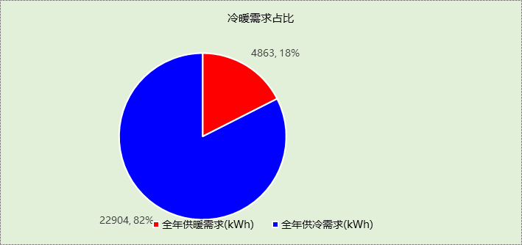

负荷分项统计
分类 | 围护传热 | 室内得热 | 窗日射 | 新风/渗透 | 热回收 | 合计
供暖需求(kWh/㎡) | -1.23 | 0.39 | 0.08 | -0.16 | 0.00 | -0.92
供冷需求(kWh/㎡) | 1.81 | 0.77 | 0.13 | 1.60 | 0.00 | 4.31
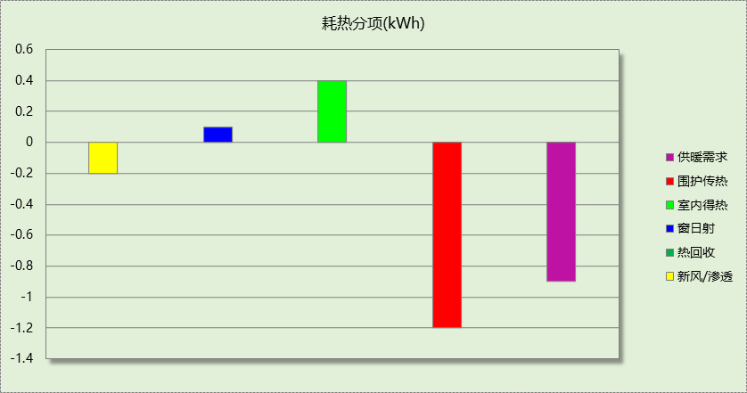

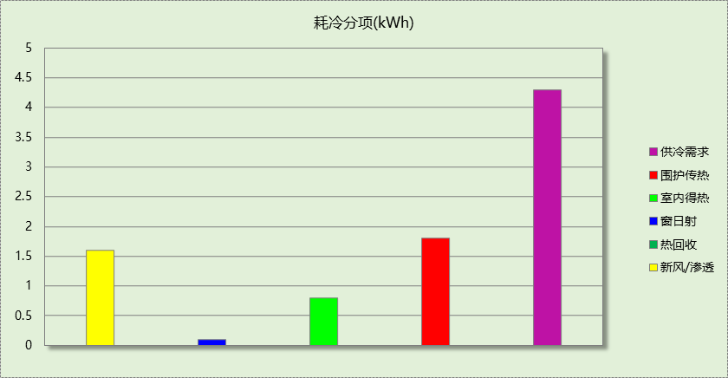

逐月负荷表
月份 | 供暖需求  (kWh) | 供冷需求  (kWh) | 热负荷  峰值(kW) | 热负荷  峰值时刻 | 冷负荷  峰值(kW) | 冷负荷  峰值时刻
1月 | 1984 | 0 | 35.971 | 01月14日07时 | 0.000 | --
2月 | 0 | 0 | 0.000 | -- | 0.000 | --
3月 | 0 | 0 | 0.000 | -- | 0.000 | --
4月 | 0 | 0 | 0.000 | -- | 0.000 | --
5月 | 0 | 0 | 0.000 | -- | 0.000 | --
6月 | 0 | 21199 | 0.000 | -- | 724.904 | 06月28日07时
7月 | 0 | 1705 | 0.000 | -- | 635.216 | 07月01日07时
8月 | 0 | 0 | 0.000 | -- | 0.000 | --
9月 | 0 | 0 | 0.000 | -- | 0.000 | --
10月 | 0 | 0 | 0.000 | -- | 0.000 | --
11月 | 0 | 0 | 0.000 | -- | 0.000 | --
12月 | 2878 | 0 | 30.638 | 12月18日11时 | 0.000 | --
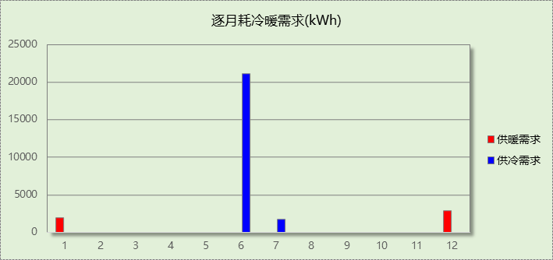

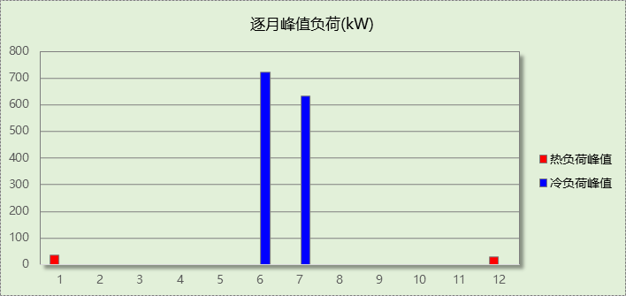

附录
工作日/节假日人员逐时在室率(%)

房间类型 | 1 | 2 | 3 | 4 | 5 | 6 | 7 | 8 | 9 | 10 | 11 | 12 | 13 | 14 | 15 | 16 | 17 | 18 | 19 | 20 | 21 | 22 | 23 | 24
专用教室 | 0 | 0 | 0 | 0 | 0 | 0 | 10 | 50 | 100 | 100 | 100 | 30 | 100 | 100 | 100 | 100 | 50 | 20 | 10 | 0 | 0 | 0 | 0 | 0
专用教室 | 0 | 0 | 0 | 0 | 0 | 0 | 0 | 0 | 0 | 0 | 0 | 0 | 0 | 0 | 0 | 0 | 0 | 0 | 0 | 0 | 0 | 0 | 0 | 0
休息厅 | 0 | 0 | 0 | 0 | 0 | 0 | 10 | 50 | 100 | 100 | 100 | 30 | 100 | 100 | 100 | 100 | 50 | 20 | 10 | 0 | 0 | 0 | 0 | 0
休息厅 | 0 | 0 | 0 | 0 | 0 | 0 | 0 | 0 | 0 | 0 | 0 | 0 | 0 | 0 | 0 | 0 | 0 | 0 | 0 | 0 | 0 | 0 | 0 | 0
储藏室 | 0 | 0 | 0 | 0 | 0 | 0 | 10 | 50 | 100 | 100 | 100 | 30 | 100 | 100 | 100 | 100 | 50 | 20 | 10 | 0 | 0 | 0 | 0 | 0
储藏室 | 0 | 0 | 0 | 0 | 0 | 0 | 0 | 0 | 0 | 0 | 0 | 0 | 0 | 0 | 0 | 0 | 0 | 0 | 0 | 0 | 0 | 0 | 0 | 0
办公-普通办公室 | 0 | 0 | 0 | 0 | 0 | 0 | 10 | 50 | 100 | 100 | 100 | 30 | 100 | 100 | 100 | 100 | 50 | 20 | 10 | 0 | 0 | 0 | 0 | 0
办公-普通办公室 | 0 | 0 | 0 | 0 | 0 | 0 | 0 | 20 | 45 | 0 | 0 | 0 | 0 | 0 | 0 | 0 | 0 | 0 | 0 | 0 | 0 | 0 | 0 | 0
办公室 | 0 | 0 | 0 | 0 | 0 | 0 | 10 | 50 | 100 | 100 | 100 | 30 | 100 | 100 | 100 | 100 | 50 | 20 | 10 | 0 | 0 | 0 | 0 | 0
办公室 | 0 | 0 | 0 | 0 | 0 | 0 | 0 | 0 | 0 | 0 | 0 | 0 | 0 | 0 | 0 | 0 | 0 | 0 | 0 | 0 | 0 | 0 | 0 | 0
厕所 | 0 | 0 | 0 | 0 | 0 | 0 | 10 | 50 | 100 | 100 | 100 | 30 | 100 | 100 | 100 | 100 | 50 | 20 | 10 | 0 | 0 | 0 | 0 | 0
厕所 | 0 | 0 | 0 | 0 | 0 | 0 | 0 | 0 | 0 | 0 | 0 | 0 | 0 | 0 | 0 | 0 | 0 | 0 | 0 | 0 | 0 | 0 | 0 | 0
多功能厅 | 0 | 0 | 0 | 0 | 0 | 0 | 10 | 50 | 100 | 100 | 100 | 30 | 100 | 100 | 100 | 100 | 50 | 20 | 10 | 0 | 0 | 0 | 0 | 0
多功能厅 | 0 | 0 | 0 | 0 | 0 | 0 | 0 | 0 | 0 | 0 | 0 | 0 | 0 | 0 | 0 | 0 | 0 | 0 | 0 | 0 | 0 | 0 | 0 | 0
普通教室 | 0 | 0 | 0 | 0 | 0 | 0 | 10 | 50 | 100 | 100 | 100 | 30 | 100 | 100 | 100 | 100 | 50 | 20 | 10 | 0 | 0 | 0 | 0 | 0
普通教室 | 0 | 0 | 0 | 0 | 0 | 0 | 0 | 0 | 0 | 0 | 0 | 0 | 0 | 0 | 0 | 0 | 0 | 0 | 0 | 0 | 0 | 0 | 0 | 0
档案室 | 0 | 0 | 0 | 0 | 0 | 0 | 10 | 50 | 100 | 100 | 100 | 30 | 100 | 100 | 100 | 100 | 50 | 20 | 10 | 0 | 0 | 0 | 0 | 0
档案室 | 0 | 0 | 0 | 0 | 0 | 0 | 0 | 0 | 0 | 0 | 0 | 0 | 0 | 0 | 0 | 0 | 0 | 0 | 0 | 0 | 0 | 0 | 0 | 0
楼梯间 | 0 | 0 | 0 | 0 | 0 | 0 | 10 | 50 | 100 | 100 | 100 | 30 | 100 | 100 | 100 | 100 | 50 | 20 | 10 | 0 | 0 | 0 | 0 | 0
楼梯间 | 0 | 0 | 0 | 0 | 0 | 0 | 0 | 0 | 0 | 0 | 0 | 0 | 0 | 0 | 0 | 0 | 0 | 0 | 0 | 0 | 0 | 0 | 0 | 0
灯控制室 | 0 | 0 | 0 | 0 | 0 | 0 | 10 | 50 | 100 | 100 | 100 | 30 | 100 | 100 | 100 | 100 | 50 | 20 | 10 | 0 | 0 | 0 | 0 | 0
灯控制室 | 0 | 0 | 0 | 0 | 0 | 0 | 0 | 0 | 0 | 0 | 0 | 0 | 0 | 0 | 0 | 0 | 0 | 0 | 0 | 0 | 0 | 0 | 0 | 0
琴房 | 0 | 0 | 0 | 0 | 0 | 0 | 10 | 50 | 100 | 100 | 100 | 30 | 100 | 100 | 100 | 100 | 50 | 20 | 10 | 0 | 0 | 0 | 0 | 0
琴房 | 0 | 0 | 0 | 0 | 0 | 0 | 0 | 0 | 0 | 0 | 0 | 0 | 0 | 0 | 0 | 0 | 0 | 0 | 0 | 0 | 0 | 0 | 0 | 0
综合大厅 | 0 | 0 | 0 | 0 | 0 | 0 | 10 | 50 | 100 | 100 | 100 | 30 | 100 | 100 | 100 | 100 | 50 | 20 | 10 | 0 | 0 | 0 | 0 | 0
综合大厅 | 0 | 0 | 0 | 0 | 0 | 0 | 0 | 0 | 0 | 0 | 0 | 0 | 0 | 0 | 0 | 0 | 0 | 0 | 0 | 0 | 0 | 0 | 0 | 0
耳灯室 | 0 | 0 | 0 | 0 | 0 | 0 | 10 | 50 | 100 | 100 | 100 | 30 | 100 | 100 | 100 | 100 | 50 | 20 | 10 | 0 | 0 | 0 | 0 | 0
耳灯室 | 0 | 0 | 0 | 0 | 0 | 0 | 0 | 0 | 0 | 0 | 0 | 0 | 0 | 0 | 0 | 0 | 0 | 0 | 0 | 0 | 0 | 0 | 0 | 0
走廊 | 0 | 0 | 0 | 0 | 0 | 0 | 10 | 50 | 100 | 100 | 100 | 30 | 100 | 100 | 100 | 100 | 50 | 20 | 10 | 0 | 0 | 0 | 0 | 0
走廊 | 0 | 0 | 0 | 0 | 0 | 0 | 0 | 0 | 0 | 0 | 0 | 0 | 0 | 0 | 0 | 0 | 0 | 0 | 0 | 0 | 0 | 0 | 0 | 0
通风井 | 0 | 0 | 0 | 0 | 0 | 0 | 10 | 50 | 100 | 100 | 100 | 30 | 100 | 100 | 100 | 100 | 50 | 20 | 10 | 0 | 0 | 0 | 0 | 0
通风井 | 0 | 0 | 0 | 0 | 0 | 0 | 0 | 0 | 0 | 0 | 0 | 0 | 0 | 0 | 0 | 0 | 0 | 0 | 0 | 0 | 0 | 0 | 0 | 0
门厅 | 0 | 0 | 0 | 0 | 0 | 0 | 10 | 50 | 100 | 100 | 100 | 30 | 100 | 100 | 100 | 100 | 50 | 20 | 10 | 0 | 0 | 0 | 0 | 0
门厅 | 0 | 0 | 0 | 0 | 0 | 0 | 0 | 0 | 0 | 0 | 0 | 0 | 0 | 0 | 0 | 0 | 0 | 0 | 0 | 0 | 0 | 0 | 0 | 0
阳台 | 0 | 0 | 0 | 0 | 0 | 0 | 10 | 50 | 100 | 100 | 100 | 30 | 100 | 100 | 100 | 100 | 50 | 20 | 10 | 0 | 0 | 0 | 0 | 0
阳台 | 0 | 0 | 0 | 0 | 0 | 0 | 0 | 0 | 0 | 0 | 0 | 0 | 0 | 0 | 0 | 0 | 0 | 0 | 0 | 0 | 0 | 0 | 0 | 0
注：上行：工作日；下行：节假日

工作日/节假日照明开关时间表(%)

房间类型 | 1 | 2 | 3 | 4 | 5 | 6 | 7 | 8 | 9 | 10 | 11 | 12 | 13 | 14 | 15 | 16 | 17 | 18 | 19 | 20 | 21 | 22 | 23 | 24
专用教室 | 0 | 0 | 0 | 0 | 0 | 0 | 0 | 0 | 0 | 0 | 0 | 0 | 0 | 0 | 0 | 0 | 0 | 90 | 100 | 100 | 100 | 10 | 10 | 10
专用教室 | 0 | 0 | 0 | 0 | 0 | 0 | 0 | 0 | 0 | 0 | 0 | 0 | 0 | 0 | 0 | 0 | 0 | 0 | 0 | 0 | 0 | 0 | 0 | 10
休息厅 | 0 | 0 | 0 | 0 | 0 | 0 | 0 | 0 | 0 | 0 | 0 | 0 | 0 | 0 | 0 | 0 | 0 | 90 | 100 | 100 | 100 | 10 | 10 | 10
休息厅 | 0 | 0 | 0 | 0 | 0 | 0 | 0 | 0 | 0 | 0 | 0 | 0 | 0 | 0 | 0 | 0 | 0 | 0 | 0 | 0 | 0 | 0 | 0 | 10
储藏室 | 0 | 0 | 0 | 0 | 0 | 0 | 0 | 0 | 0 | 0 | 0 | 0 | 0 | 0 | 0 | 0 | 0 | 90 | 100 | 100 | 100 | 10 | 10 | 10
储藏室 | 0 | 0 | 0 | 0 | 0 | 0 | 0 | 0 | 0 | 0 | 0 | 0 | 0 | 0 | 0 | 0 | 0 | 0 | 0 | 0 | 0 | 0 | 0 | 10
办公-普通办公室 | 10 | 10 | 10 | 10 | 10 | 10 | 10 | 36 | 62 | 56 | 54 | 43 | 53 | 55 | 58 | 67 | 40 | 18 | 10 | 10 | 10 | 10 | 10 | 10
办公-普通办公室 | 0 | 0 | 0 | 0 | 0 | 0 | 0 | 0 | 0 | 0 | 0 | 0 | 0 | 0 | 0 | 0 | 0 | 0 | 0 | 0 | 0 | 0 | 0 | 0
办公室 | 10 | 10 | 10 | 10 | 10 | 10 | 10 | 36 | 62 | 56 | 54 | 43 | 53 | 55 | 58 | 67 | 40 | 18 | 10 | 10 | 10 | 10 | 10 | 10
办公室 | 0 | 0 | 0 | 0 | 0 | 0 | 0 | 0 | 0 | 0 | 0 | 0 | 0 | 0 | 0 | 0 | 0 | 0 | 0 | 0 | 0 | 0 | 0 | 10
厕所 | 0 | 0 | 0 | 0 | 0 | 0 | 0 | 0 | 0 | 0 | 0 | 0 | 0 | 0 | 0 | 0 | 0 | 90 | 100 | 100 | 100 | 10 | 10 | 10
厕所 | 0 | 0 | 0 | 0 | 0 | 0 | 0 | 0 | 0 | 0 | 0 | 0 | 0 | 0 | 0 | 0 | 0 | 0 | 0 | 0 | 0 | 0 | 0 | 10
多功能厅 | 0 | 0 | 0 | 0 | 0 | 0 | 0 | 0 | 0 | 0 | 0 | 0 | 0 | 0 | 0 | 0 | 0 | 90 | 100 | 100 | 100 | 10 | 10 | 10
多功能厅 | 0 | 0 | 0 | 0 | 0 | 0 | 0 | 0 | 0 | 0 | 0 | 0 | 0 | 0 | 0 | 0 | 0 | 0 | 0 | 0 | 0 | 0 | 0 | 10
普通教室 | 0 | 0 | 0 | 0 | 0 | 0 | 0 | 0 | 0 | 0 | 0 | 0 | 0 | 0 | 0 | 0 | 0 | 90 | 100 | 100 | 100 | 10 | 10 | 10
普通教室 | 0 | 0 | 0 | 0 | 0 | 0 | 0 | 0 | 0 | 0 | 0 | 0 | 0 | 0 | 0 | 0 | 0 | 0 | 0 | 0 | 0 | 0 | 0 | 10
档案室 | 0 | 0 | 0 | 0 | 0 | 0 | 0 | 0 | 0 | 0 | 0 | 0 | 0 | 0 | 0 | 0 | 0 | 90 | 100 | 100 | 100 | 10 | 10 | 10
档案室 | 0 | 0 | 0 | 0 | 0 | 0 | 0 | 0 | 0 | 0 | 0 | 0 | 0 | 0 | 0 | 0 | 0 | 0 | 0 | 0 | 0 | 0 | 0 | 10
楼梯间 | 0 | 0 | 0 | 0 | 0 | 0 | 0 | 0 | 0 | 0 | 0 | 0 | 0 | 0 | 0 | 0 | 0 | 90 | 100 | 100 | 100 | 10 | 10 | 10
楼梯间 | 0 | 0 | 0 | 0 | 0 | 0 | 0 | 0 | 0 | 0 | 0 | 0 | 0 | 0 | 0 | 0 | 0 | 0 | 0 | 0 | 0 | 0 | 0 | 10
灯控制室 | 0 | 0 | 0 | 0 | 0 | 0 | 0 | 0 | 0 | 0 | 0 | 0 | 0 | 0 | 0 | 0 | 0 | 90 | 100 | 100 | 100 | 10 | 10 | 10
灯控制室 | 0 | 0 | 0 | 0 | 0 | 0 | 0 | 0 | 0 | 0 | 0 | 0 | 0 | 0 | 0 | 0 | 0 | 0 | 0 | 0 | 0 | 0 | 0 | 10
琴房 | 0 | 0 | 0 | 0 | 0 | 0 | 0 | 0 | 0 | 0 | 0 | 0 | 0 | 0 | 0 | 0 | 0 | 90 | 100 | 100 | 100 | 10 | 10 | 10
琴房 | 0 | 0 | 0 | 0 | 0 | 0 | 0 | 0 | 0 | 0 | 0 | 0 | 0 | 0 | 0 | 0 | 0 | 0 | 0 | 0 | 0 | 0 | 0 | 10
综合大厅 | 0 | 0 | 0 | 0 | 0 | 0 | 0 | 0 | 0 | 0 | 0 | 0 | 0 | 0 | 0 | 0 | 0 | 90 | 100 | 100 | 100 | 10 | 10 | 10
综合大厅 | 0 | 0 | 0 | 0 | 0 | 0 | 0 | 0 | 0 | 0 | 0 | 0 | 0 | 0 | 0 | 0 | 0 | 0 | 0 | 0 | 0 | 0 | 0 | 10
耳灯室 | 0 | 0 | 0 | 0 | 0 | 0 | 0 | 0 | 0 | 0 | 0 | 0 | 0 | 0 | 0 | 0 | 0 | 90 | 100 | 100 | 100 | 10 | 10 | 10
耳灯室 | 0 | 0 | 0 | 0 | 0 | 0 | 0 | 0 | 0 | 0 | 0 | 0 | 0 | 0 | 0 | 0 | 0 | 0 | 0 | 0 | 0 | 0 | 0 | 10
走廊 | 0 | 0 | 0 | 0 | 0 | 0 | 0 | 0 | 0 | 0 | 0 | 0 | 0 | 0 | 0 | 0 | 0 | 90 | 100 | 100 | 100 | 10 | 10 | 10
走廊 | 0 | 0 | 0 | 0 | 0 | 0 | 0 | 0 | 0 | 0 | 0 | 0 | 0 | 0 | 0 | 0 | 0 | 0 | 0 | 0 | 0 | 0 | 0 | 10
通风井 | 0 | 0 | 0 | 0 | 0 | 0 | 0 | 0 | 0 | 0 | 0 | 0 | 0 | 0 | 0 | 0 | 0 | 90 | 100 | 100 | 100 | 10 | 10 | 10
通风井 | 0 | 0 | 0 | 0 | 0 | 0 | 0 | 0 | 0 | 0 | 0 | 0 | 0 | 0 | 0 | 0 | 0 | 0 | 0 | 0 | 0 | 0 | 0 | 10
门厅 | 0 | 0 | 0 | 0 | 0 | 0 | 0 | 0 | 0 | 0 | 0 | 0 | 0 | 0 | 0 | 0 | 0 | 90 | 100 | 100 | 100 | 10 | 10 | 10
门厅 | 0 | 0 | 0 | 0 | 0 | 0 | 0 | 0 | 0 | 0 | 0 | 0 | 0 | 0 | 0 | 0 | 0 | 0 | 0 | 0 | 0 | 0 | 0 | 10
阳台 | 0 | 0 | 0 | 0 | 0 | 0 | 0 | 0 | 0 | 0 | 0 | 0 | 0 | 0 | 0 | 0 | 0 | 90 | 100 | 100 | 100 | 10 | 10 | 10
阳台 | 0 | 0 | 0 | 0 | 0 | 0 | 0 | 0 | 0 | 0 | 0 | 0 | 0 | 0 | 0 | 0 | 0 | 0 | 0 | 0 | 0 | 0 | 0 | 10
注：上行：工作日；下行：节假日

工作日/节假日设备逐时使用率(%)

房间类型 | 1 | 2 | 3 | 4 | 5 | 6 | 7 | 8 | 9 | 10 | 11 | 12 | 13 | 14 | 15 | 16 | 17 | 18 | 19 | 20 | 21 | 22 | 23 | 24
专用教室 | 0 | 0 | 0 | 0 | 0 | 0 | 10 | 50 | 50 | 50 | 50 | 50 | 50 | 50 | 50 | 50 | 50 | 20 | 10 | 0 | 0 | 0 | 0 | 0
专用教室 | 0 | 0 | 0 | 0 | 0 | 0 | 0 | 0 | 0 | 0 | 0 | 0 | 0 | 0 | 0 | 0 | 0 | 0 | 0 | 0 | 0 | 0 | 0 | 0
休息厅 | 0 | 0 | 0 | 0 | 0 | 0 | 10 | 50 | 50 | 50 | 50 | 50 | 50 | 50 | 50 | 50 | 50 | 20 | 10 | 0 | 0 | 0 | 0 | 0
休息厅 | 0 | 0 | 0 | 0 | 0 | 0 | 0 | 0 | 0 | 0 | 0 | 0 | 0 | 0 | 0 | 0 | 0 | 0 | 0 | 0 | 0 | 0 | 0 | 0
储藏室 | 0 | 0 | 0 | 0 | 0 | 0 | 10 | 50 | 50 | 50 | 50 | 50 | 50 | 50 | 50 | 50 | 50 | 20 | 10 | 0 | 0 | 0 | 0 | 0
储藏室 | 0 | 0 | 0 | 0 | 0 | 0 | 0 | 0 | 0 | 0 | 0 | 0 | 0 | 0 | 0 | 0 | 0 | 0 | 0 | 0 | 0 | 0 | 0 | 0
办公-普通办公室 | 0 | 0 | 0 | 0 | 0 | 0 | 10 | 50 | 100 | 100 | 100 | 100 | 100 | 100 | 100 | 100 | 50 | 20 | 10 | 0 | 0 | 0 | 0 | 0
办公-普通办公室 | 0 | 0 | 0 | 0 | 0 | 0 | 0 | 0 | 0 | 0 | 0 | 0 | 0 | 0 | 0 | 0 | 0 | 0 | 0 | 0 | 0 | 0 | 0 | 0
办公室 | 0 | 0 | 0 | 0 | 0 | 0 | 10 | 50 | 100 | 100 | 100 | 100 | 100 | 100 | 100 | 100 | 50 | 20 | 10 | 0 | 0 | 0 | 0 | 0
办公室 | 0 | 0 | 0 | 0 | 0 | 0 | 0 | 0 | 0 | 0 | 0 | 0 | 0 | 0 | 0 | 0 | 0 | 0 | 0 | 0 | 0 | 0 | 0 | 0
厕所 | 0 | 0 | 0 | 0 | 0 | 0 | 10 | 50 | 50 | 50 | 50 | 50 | 50 | 50 | 50 | 50 | 50 | 20 | 10 | 0 | 0 | 0 | 0 | 0
厕所 | 0 | 0 | 0 | 0 | 0 | 0 | 0 | 0 | 0 | 0 | 0 | 0 | 0 | 0 | 0 | 0 | 0 | 0 | 0 | 0 | 0 | 0 | 0 | 0
多功能厅 | 0 | 0 | 0 | 0 | 0 | 0 | 10 | 50 | 50 | 50 | 50 | 50 | 50 | 50 | 50 | 50 | 50 | 20 | 10 | 0 | 0 | 0 | 0 | 0
多功能厅 | 0 | 0 | 0 | 0 | 0 | 0 | 0 | 0 | 0 | 0 | 0 | 0 | 0 | 0 | 0 | 0 | 0 | 0 | 0 | 0 | 0 | 0 | 0 | 0
普通教室 | 0 | 0 | 0 | 0 | 0 | 0 | 10 | 50 | 50 | 50 | 50 | 50 | 50 | 50 | 50 | 50 | 50 | 20 | 10 | 0 | 0 | 0 | 0 | 0
普通教室 | 0 | 0 | 0 | 0 | 0 | 0 | 0 | 0 | 0 | 0 | 0 | 0 | 0 | 0 | 0 | 0 | 0 | 0 | 0 | 0 | 0 | 0 | 0 | 0
档案室 | 0 | 0 | 0 | 0 | 0 | 0 | 10 | 50 | 50 | 50 | 50 | 50 | 50 | 50 | 50 | 50 | 50 | 20 | 10 | 0 | 0 | 0 | 0 | 0
档案室 | 0 | 0 | 0 | 0 | 0 | 0 | 0 | 0 | 0 | 0 | 0 | 0 | 0 | 0 | 0 | 0 | 0 | 0 | 0 | 0 | 0 | 0 | 0 | 0
楼梯间 | 0 | 0 | 0 | 0 | 0 | 0 | 10 | 50 | 50 | 50 | 50 | 50 | 50 | 50 | 50 | 50 | 50 | 20 | 10 | 0 | 0 | 0 | 0 | 0
楼梯间 | 0 | 0 | 0 | 0 | 0 | 0 | 0 | 0 | 0 | 0 | 0 | 0 | 0 | 0 | 0 | 0 | 0 | 0 | 0 | 0 | 0 | 0 | 0 | 0
灯控制室 | 0 | 0 | 0 | 0 | 0 | 0 | 10 | 50 | 50 | 50 | 50 | 50 | 50 | 50 | 50 | 50 | 50 | 20 | 10 | 0 | 0 | 0 | 0 | 0
灯控制室 | 0 | 0 | 0 | 0 | 0 | 0 | 0 | 0 | 0 | 0 | 0 | 0 | 0 | 0 | 0 | 0 | 0 | 0 | 0 | 0 | 0 | 0 | 0 | 0
琴房 | 0 | 0 | 0 | 0 | 0 | 0 | 10 | 50 | 50 | 50 | 50 | 50 | 50 | 50 | 50 | 50 | 50 | 20 | 10 | 0 | 0 | 0 | 0 | 0
琴房 | 0 | 0 | 0 | 0 | 0 | 0 | 0 | 0 | 0 | 0 | 0 | 0 | 0 | 0 | 0 | 0 | 0 | 0 | 0 | 0 | 0 | 0 | 0 | 0
综合大厅 | 0 | 0 | 0 | 0 | 0 | 0 | 10 | 50 | 50 | 50 | 50 | 50 | 50 | 50 | 50 | 50 | 50 | 20 | 10 | 0 | 0 | 0 | 0 | 0
综合大厅 | 0 | 0 | 0 | 0 | 0 | 0 | 0 | 0 | 0 | 0 | 0 | 0 | 0 | 0 | 0 | 0 | 0 | 0 | 0 | 0 | 0 | 0 | 0 | 0
耳灯室 | 0 | 0 | 0 | 0 | 0 | 0 | 10 | 50 | 50 | 50 | 50 | 50 | 50 | 50 | 50 | 50 | 50 | 20 | 10 | 0 | 0 | 0 | 0 | 0
耳灯室 | 0 | 0 | 0 | 0 | 0 | 0 | 0 | 0 | 0 | 0 | 0 | 0 | 0 | 0 | 0 | 0 | 0 | 0 | 0 | 0 | 0 | 0 | 0 | 0
走廊 | 0 | 0 | 0 | 0 | 0 | 0 | 10 | 50 | 50 | 50 | 50 | 50 | 50 | 50 | 50 | 50 | 50 | 20 | 10 | 0 | 0 | 0 | 0 | 0
走廊 | 0 | 0 | 0 | 0 | 0 | 0 | 0 | 0 | 0 | 0 | 0 | 0 | 0 | 0 | 0 | 0 | 0 | 0 | 0 | 0 | 0 | 0 | 0 | 0
通风井 | 0 | 0 | 0 | 0 | 0 | 0 | 10 | 50 | 50 | 50 | 50 | 50 | 50 | 50 | 50 | 50 | 50 | 20 | 10 | 0 | 0 | 0 | 0 | 0
通风井 | 0 | 0 | 0 | 0 | 0 | 0 | 0 | 0 | 0 | 0 | 0 | 0 | 0 | 0 | 0 | 0 | 0 | 0 | 0 | 0 | 0 | 0 | 0 | 0
门厅 | 0 | 0 | 0 | 0 | 0 | 0 | 10 | 50 | 50 | 50 | 50 | 50 | 50 | 50 | 50 | 50 | 50 | 20 | 10 | 0 | 0 | 0 | 0 | 0
门厅 | 0 | 0 | 0 | 0 | 0 | 0 | 0 | 0 | 0 | 0 | 0 | 0 | 0 | 0 | 0 | 0 | 0 | 0 | 0 | 0 | 0 | 0 | 0 | 0
阳台 | 0 | 0 | 0 | 0 | 0 | 0 | 10 | 50 | 50 | 50 | 50 | 50 | 50 | 50 | 50 | 50 | 50 | 20 | 10 | 0 | 0 | 0 | 0 | 0
阳台 | 0 | 0 | 0 | 0 | 0 | 0 | 0 | 0 | 0 | 0 | 0 | 0 | 0 | 0 | 0 | 0 | 0 | 0 | 0 | 0 | 0 | 0 | 0 | 0
注：上行：工作日；下行：节假日

工作日/节假日空调系统开关时间表
采暖期：
系统编号 | 1 | 2 | 3 | 4 | 5 | 6 | 7 | 8 | 9 | 10 | 11 | 12 | 13 | 14 | 15 | 16 | 17 | 18 | 19 | 20 | 21 | 22 | 23 | 24
默认 | 0 | 0 | 0 | 0 | 0 | 0 | 0 | 1 | 1 | 1 | 1 | 1 | 1 | 1 | 1 | 1 | 1 | 1 | 0 | 0 | 0 | 0 | 0 | 0
默认 | 0 | 0 | 0 | 0 | 0 | 0 | 0 | 0 | 0 | 0 | 0 | 0 | 0 | 0 | 0 | 0 | 0 | 0 | 0 | 0 | 0 | 0 | 0 | 0
Sys1 | 0 | 0 | 0 | 0 | 0 | 0 | 0 | 1 | 1 | 1 | 1 | 1 | 1 | 1 | 1 | 1 | 1 | 1 | 0 | 0 | 0 | 0 | 0 | 0
Sys1 | 0 | 0 | 0 | 0 | 0 | 0 | 0 | 0 | 0 | 0 | 0 | 0 | 0 | 0 | 0 | 0 | 0 | 0 | 0 | 0 | 0 | 0 | 0 | 0
供冷期：

系统编号 | 1 | 2 | 3 | 4 | 5 | 6 | 7 | 8 | 9 | 10 | 11 | 12 | 13 | 14 | 15 | 16 | 17 | 18 | 19 | 20 | 21 | 22 | 23 | 24
默认 | 0 | 0 | 0 | 0 | 0 | 0 | 0 | 1 | 1 | 1 | 1 | 1 | 1 | 1 | 1 | 1 | 1 | 1 | 0 | 0 | 0 | 0 | 0 | 0
默认 | 0 | 0 | 0 | 0 | 0 | 0 | 0 | 0 | 0 | 0 | 0 | 0 | 0 | 0 | 0 | 0 | 0 | 0 | 0 | 0 | 0 | 0 | 0 | 0
Sys1 | 0 | 0 | 0 | 0 | 0 | 0 | 0 | 1 | 1 | 1 | 1 | 1 | 1 | 1 | 1 | 1 | 1 | 1 | 0 | 0 | 0 | 0 | 0 | 0
Sys1 | 0 | 0 | 0 | 0 | 0 | 0 | 0 | 0 | 0 | 0 | 0 | 0 | 0 | 0 | 0 | 0 | 0 | 0 | 0 | 0 | 0 | 0 | 0 | 0
注：上行：工作日；下行：节假日

