**新建项目**

**全年负荷计算书**

|  |  |
| --- | --- |
| 工程名称 | 新建项目 |
| 设计编号 |  |
| 建设单位 |  |
| 设计单位 |  |
| 计 算 人 |  |
| 校 对 人 |  |
| 审 核 人 |  |
| 计算日期 | 2024年1月4日 |



|  |  |
| --- | --- |
| 采用软件 | 暖通负荷BECH2023 |
| 软件版本 | 20220808(SP1) |
| 研发单位 | 北京绿建软件股份有限公司 |
| 正版授权码 | T19950663386 |

**目 录**

1 建筑概况 1

2 气象数据 1

2.1 气象地点 1

2.2 逐日干球温度表 1

2.3 逐月辐照量表 2

2.4 峰值工况 2

3 软件介绍 2

4 围护结构 2

4.1 屋顶构造 2

4.1.1 屋顶构造一 2

4.2 外墙构造 3

4.2.1 外墙构造一 3

4.3 挑空楼板构造 3

4.3.1 挑空楼板构造一 3

4.4 楼板构造 3

4.4.1 楼板构造一 3

4.5 周边地面构造 4

4.5.1 周边地面构造一 4

4.6 非周边地面构造 4

4.6.1 非周边地面构造一 4

4.7 门构造 4

4.8 窗构造 4

5 房间类型 5

5.1 房间表 5

5.2 作息时间表 5

6 系统设置 5

6.1 系统划分 5

6.2 运行时间表 5

7 计算结果 5

7.1 模拟周期 5

7.2 全年冷暖需求 6

7.3 负荷分项统计 6

7.4 逐月负荷表 7

8 附录 9

# 建筑概况

|  |  |  |
| --- | --- | --- |
| 地理位置 | 青海-西宁 | |
| 气候分区 | 严寒B区 | |
| 北纬 | 36.72 | |
| 东经 | 101.75 | |
| 建筑名称 | 新建项目 | |
| 建筑类型 | 公共建筑 |  |
| 建筑面积 | 地上 1637.61 ㎡ | 地下 0.00 ㎡ |
| 建筑高度 | 地上 15.00 m | 地下0.00 |
| 建筑层数 | 地上 4 | 地下 0 |
| 北向角度 | 31° | |

# 气象数据

## 气象地点

青海-西宁, 《中国建筑热环境分析专用气象数据集》

## 逐日干球温度表

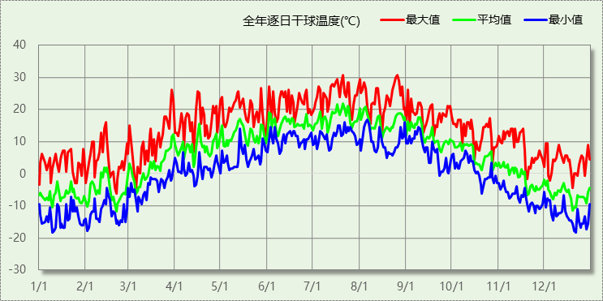

## 逐月辐照量表

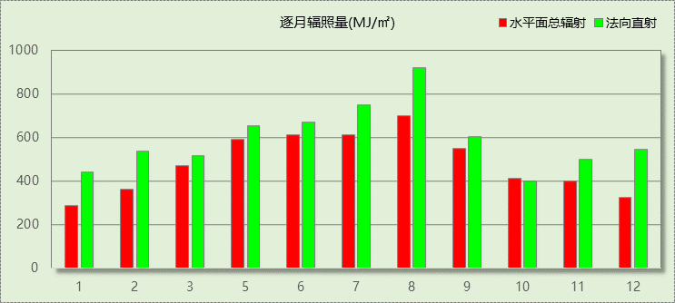

## 峰值工况

|  |  |  |  |  |  |
| --- | --- | --- | --- | --- | --- |
| 气象数据 | 时刻 | 干球温度(℃) | 湿球温度(℃) | 含湿量(g/kg) | 焓值(kj/kg) |
| 最热 | 07月20日16时 | 30.6 | 15.0 | 7.6 | 50.1 |
| 最冷 | 01月09日06时 | -18.3 | -18.3 | 0.9 | -16.2 |

# 软件介绍

本报告采用的软件为绿建暖通负荷BECH2023，该软件紧密结合暖通和节能设计规范、可根据项目实际情况建立建筑热工模型，并可对围护结构材料、房间内扰发热、作息时间表、热回收方式等参数进行设置。

软件包含全国各地典型气象年数据，内置DOE2.1E内核，对于建筑的逐时负荷进行动态模拟，既可以模拟8760小时理想负荷，也可以根据设定好的采暖期/空调期进行逐时模拟。

软件还支持分析全年建筑能耗的来源构成，依据日射得热、新风负荷、围护传热和内扰得热进行归类分项，生成设计建筑全年负荷计算报告书，提供详实的数据和多样的图表，为设计师在设备选型、制定运行策略等方面提供参考和帮助。

# 围护结构

## 屋顶构造

### 屋顶构造一

|  |  |  |  |  |  |  |
| --- | --- | --- | --- | --- | --- | --- |
| 材料名称 （由上到下） | 厚度δ | 导热系数λ | 蓄热系数S | 修正系数 | 热阻R | 热惰性指标 |
| (mm) | W/(m.K) | W/(㎡.K) | α | (㎡K)/W | D=R*S |
| LJ-GB1墙体隔热保温涂料 | 20 | 0.012 | 0.532 | 1.00 | 1.667 | 0.887 |
| STP(VIPB)真空绝热板I型 | 20 | 0.005 | 1.200 | 1.00 | 4.000 | 4.800 |
| 钢筋混凝土 | 120 | 1.740 | 17.200 | 1.00 | 0.069 | 1.186 |
| 现场发泡聚氨酯硬泡体 | 20 | 0.024 | 10.000 | 1.00 | 0.833 | 8.333 |
| STP(VIPB)真空绝热板II型 | 20 | 0.008 | 1.200 | 1.00 | 2.500 | 3.000 |
| 各层之和∑ | 200 | － | － | － | 9.069 | 18.206 |
| 外表面太阳辐射吸收系数 | 0.75[默认] | | | | | |
| 传热系数K=1/(0.15+∑R) | 0.11 | | | | | |

## 外墙构造

### 外墙构造一

|  |  |  |  |  |  |  |
| --- | --- | --- | --- | --- | --- | --- |
| 材料名称 （由外到内） | 厚度δ | 导热系数λ | 蓄热系数S | 修正系数 | 热阻R | 热惰性指标 |
| (mm) | W/(m.K) | W/(㎡.K) | α | (㎡K)/W | D=R*S |
| LJ-GB1墙体隔热保温涂料 | 20 | 0.012 | 0.532 | 1.00 | 1.667 | 0.887 |
| STP(VIPB)真空绝热板I型 | 20 | 0.005 | 1.200 | 1.00 | 4.000 | 4.800 |
| 钢筋混凝土 | 200 | 1.740 | 17.200 | 1.00 | 0.115 | 1.977 |
| 现场发泡聚氨酯硬泡体 | 20 | 0.024 | 10.000 | 1.00 | 0.833 | 8.333 |
| STP(VIPB)真空绝热板II型 | 20 | 0.008 | 1.200 | 1.00 | 2.500 | 3.000 |
| 各层之和∑ | 280 | － | － | － | 9.115 | 18.997 |
| 外表面太阳辐射吸收系数 | 0.75[默认] | | | | | |
| 传热系数K=1/(0.15+∑R) | 0.11 | | | | | |

## 挑空楼板构造

### 挑空楼板构造一

|  |  |  |  |  |  |  |
| --- | --- | --- | --- | --- | --- | --- |
| 材料名称 （由上到下） | 厚度δ | 导热系数λ | 蓄热系数S | 修正系数 | 热阻R | 热惰性指标 |
| (mm) | W/(m.K) | W/(㎡.K) | α | (㎡K)/W | D=R*S |
| LJ-GB1墙体隔热保温涂料 | 20 | 0.012 | 0.532 | 1.00 | 1.667 | 0.887 |
| STP(VIPB)真空绝热板I型 | 20 | 0.005 | 1.200 | 1.00 | 4.000 | 4.800 |
| 钢筋混凝土 | 120 | 1.740 | 17.200 | 1.00 | 0.069 | 1.186 |
| 现场发泡聚氨酯硬泡体 | 20 | 0.024 | 10.000 | 1.00 | 0.833 | 8.333 |
| STP(VIPB)真空绝热板II型 | 20 | 0.008 | 1.200 | 1.00 | 2.500 | 3.000 |
| 各层之和∑ | 200 | － | － | － | 9.069 | 18.206 |
| 传热系数K=1/(0.15+∑R) | 0.11 | | | | | |

## 楼板构造

### 楼板构造一

|  |  |  |  |  |  |  |
| --- | --- | --- | --- | --- | --- | --- |
| 材料名称 | 厚度δ | 导热系数λ | 蓄热系数S | 修正系数 | 热阻R | 热惰性指标 |
| (mm) | W/(m.K) | W/(㎡.K) | α | (㎡K)/W | D=R*S |
| 水泥砂浆 | 20 | 0.930 | 11.370 | 1.00 | 0.022 | 0.245 |
| 钢筋混凝土 | 120 | 1.740 | 17.200 | 1.00 | 0.069 | 1.186 |
| 石灰砂浆 | 20 | 0.810 | 10.070 | 1.00 | 0.025 | 0.249 |
| 各层之和∑ | 160 | － | － | － | 0.115 | 1.679 |
| 传热系数K=1/(0.22+∑R) | 2.98 | | | | | |

## 周边地面构造

### 周边地面构造一

|  |  |  |  |  |  |  |
| --- | --- | --- | --- | --- | --- | --- |
| 材料名称 | 厚度δ | 导热系数λ | 蓄热系数S | 修正系数 | 热阻R | 热惰性指标 |
| (mm) | W/(m.K) | W/(㎡.K) | α | (㎡K)/W | D=R*S |
| 水泥砂浆 | 20 | 0.930 | 11.370 | 1.00 | 0.022 | 0.245 |
| 钢筋混凝土 | 120 | 1.740 | 17.200 | 1.00 | 0.069 | 1.186 |
| 各层之和∑ | 140 | － | － | － | 0.090 | 1.431 |
| 传热系数K=1/(0.11+∑R) | 0.52 | | | | | |
|  |  |  |  |  |  |  |

## 非周边地面构造

### 非周边地面构造一

|  |  |  |  |  |  |  |
| --- | --- | --- | --- | --- | --- | --- |
| 材料名称 | 厚度δ | 导热系数λ | 蓄热系数S | 修正系数 | 热阻R | 热惰性指标 |
| (mm) | W/(m.K) | W/(㎡.K) | α | (㎡K)/W | D=R*S |
| 水泥砂浆 | 20 | 0.930 | 11.370 | 1.00 | 0.022 | 0.245 |
| 钢筋混凝土 | 120 | 1.740 | 17.200 | 1.00 | 0.069 | 1.186 |
| 各层之和∑ | 140 | － | － | － | 0.090 | 1.431 |
| 传热系数K=1/(0.11+∑R) | 0.30 | | | | | |
|  |  |  |  |  |  |  |

## 门构造

|  |  |  |  |
| --- | --- | --- | --- |
| 序号 | 构造名称 | 传热系数 | 备注 |
| 1 | 保温门（多功能门） | 1.972 |  |

## 窗构造

|  |  |  |  |  |  |
| --- | --- | --- | --- | --- | --- |
| 序号 | 构造名称 | 传热系数 | 遮阳系数 | 可见光透射比 | 备注 |
| 1 | 12A钢铝单框双玻窗（平均） | 3.900 | 0.750 | 0.800 | 来源《民用建筑热工设计规范》 |
| 2 | 12A钢铝单框双玻窗（平均） | 3.900 | 0.750 | 1.000 | 来源《民用建筑热工设计规范》 |

# 房间类型

## 房间表

|  |  |  |  |  |  |  |
| --- | --- | --- | --- | --- | --- | --- |
| 房间类型 | 空调温度 ℃ | 供暖温度 ℃ | 新风量 | 人员密度 | 照明功率 密度 | 电器设备 功率 |
| 健身房 | 26 | 20 | 30(m^3/h.人) | 8(m^2/人) | 9(W/m^2) | 15(W/m^2) |
| 办公-会议室 | 26 | 18 | 14(m^3/h.人) | 2.5(m^2/人) | 9(W/m^2) | 15(W/m^2) |
| 办公-走廊 | 26 | 20 | 20(m^3/h.人) | 50(m^2/人) | 5(W/m^2) | 15(W/m^2) |
| 卫生间 | 25 | 20 | 2(m^3/h.人) | 3.33(m^2/人) | 9(W/m^2) | 15(W/m^2) |
| 大堂 | 26 | 20 | 30(m^3/h.人) | 20(m^2/人) | 13(W/m^2) | 5(W/m^2) |
| 客房 | 26 | 20 | 30(m^3/h.人) | 14.3(m^2/人) | 18(W/m^2) | 5(W/m^2) |
| 餐厅 | 26 | 20 | 30(m^3/h.人) | 2(m^2/人) | 13(W/m^2) | 5(W/m^2) |

## 作息时间表

详见附录

# 系统设置

## 系统划分

|  |  |  |  |  |  |  |
| --- | --- | --- | --- | --- | --- | --- |
| 系统编号 | 热回收 类型 | 启动 条件 | 回收 效率 | 排风 比例 | 面积(m2) | 包含的房间 |
| 制冷 | 无 | -- | -- | -- | 49.22 | 1003,2012,3014,4010 |
| 制热 | 无 | -- | -- | -- | 1436.08 | 1002,1001,2013,2011,2010,2009,2008,2007,2006,2005,2004,2003,2002,2001,3011,3010,3009,3008,3007,3006,3005,3004,3002,3001,3013,3003,4009,4008,4007,4006,4005,4004,4003,4002,4001 |

## 运行时间表

详见附录

# 计算结果

## 模拟周期

供冷季(4.16-4.16) 供暖季(10.15-4.15)

## 全年冷暖需求

|  |  |  |  |  |
| --- | --- | --- | --- | --- |
| 系统名称\负荷 | 供暖需求 (kWh) | 供暖指标 (kWh/㎡·a) | 供冷需求 (kWh) | 供冷指标 (kWh/㎡·a) |
| 制热 | 76343 | 53.16 | 409 | 0.28 |
| 制冷 | 5999 | 121.88 | 6 | 0.13 |
| 建筑总计 | 82342 | 50.28 | 415 | 0.25 |

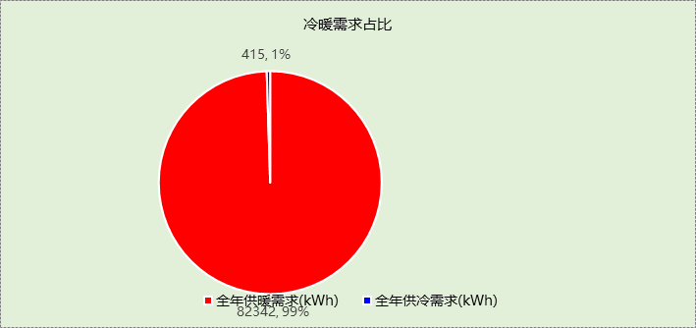

## 负荷分项统计

|  |  |  |  |  |  |  |
| --- | --- | --- | --- | --- | --- | --- |
| 分类 | 围护传热 | 室内得热 | 窗日射 | 新风/渗透 | 热回收 | 合计 |
| 供暖需求(kWh/㎡) | -22.04 | 12.41 | 8.65 | -49.30 | 0.00 | -50.28 |
| 供冷需求(kWh/㎡) | 0.00 | 0.21 | 0.17 | -0.13 | 0.00 | 0.25 |

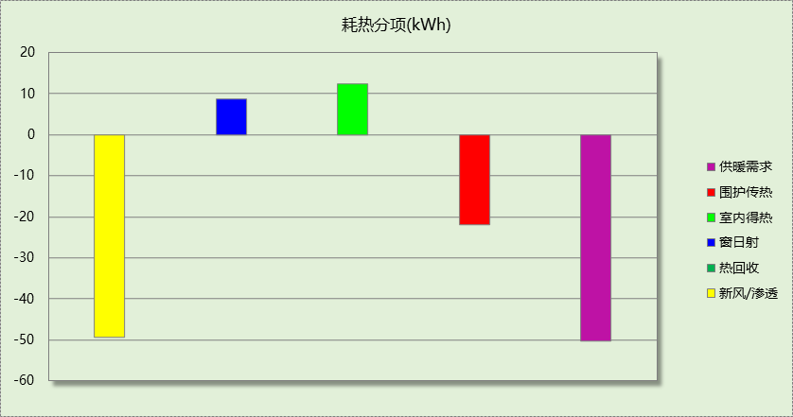

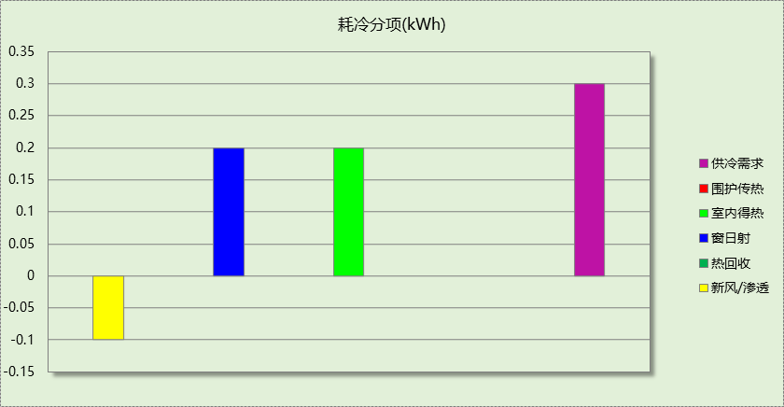

## 逐月负荷表

|  |  |  |  |  |  |  |
| --- | --- | --- | --- | --- | --- | --- |
| 月份 | 供暖需求 (kWh) | 供冷需求 (kWh) | 热负荷 峰值(kW) | 热负荷 峰值时刻 | 冷负荷 峰值(kW) | 冷负荷 峰值时刻 |
| 1月 | 22215 | 0 | 251.104 | 01月02日06时 | 0.000 | -- |
| 2月 | 14734 | 0 | 185.467 | 02月18日06时 | 0.000 | -- |
| 3月 | 10161 | 0 | 127.758 | 03月06日06时 | 0.000 | -- |
| 4月 | 1605 | 415 | 33.116 | 04月03日06时 | 60.343 | 04月16日15时 |
| 5月 | 0 | 0 | 0.000 | -- | 0.000 | -- |
| 6月 | 0 | 0 | 0.000 | -- | 0.000 | -- |
| 7月 | 0 | 0 | 0.000 | -- | 0.000 | -- |
| 8月 | 0 | 0 | 0.000 | -- | 0.000 | -- |
| 9月 | 0 | 0 | 0.000 | -- | 0.000 | -- |
| 10月 | 2679 | 0 | 71.129 | 10月31日06时 | 0.000 | -- |
| 11月 | 11071 | 0 | 132.084 | 11月20日06时 | 0.000 | -- |
| 12月 | 19877 | 0 | 205.727 | 12月23日06时 | 0.000 | -- |

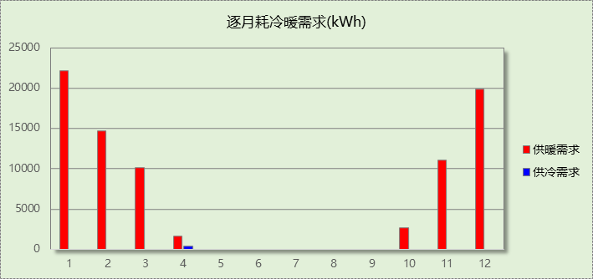

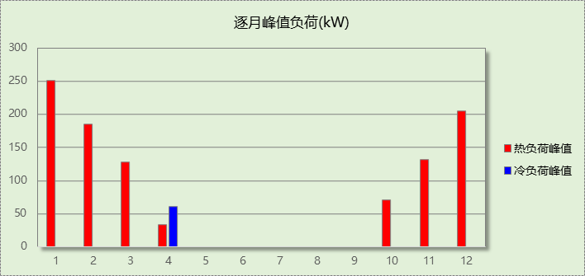

# 附录

**工作日/节假日人员逐时在室率(%)**

|  |  |  |  |  |  |  |  |  |  |  |  |  |  |  |  |  |  |  |  |  |  |  |  |  |
| --- | --- | --- | --- | --- | --- | --- | --- | --- | --- | --- | --- | --- | --- | --- | --- | --- | --- | --- | --- | --- | --- | --- | --- | --- |
| 房间类型 | 1 | 2 | 3 | 4 | 5 | 6 | 7 | 8 | 9 | 10 | 11 | 12 | 13 | 14 | 15 | 16 | 17 | 18 | 19 | 20 | 21 | 22 | 23 | 24 |
| 健身房 | 0 | 0 | 0 | 0 | 0 | 0 | 10 | 50 | 100 | 100 | 100 | 30 | 100 | 100 | 100 | 100 | 50 | 20 | 10 | 0 | 0 | 0 | 0 | 0 |
| 0 | 0 | 0 | 0 | 0 | 0 | 0 | 20 | 45 | 0 | 0 | 0 | 0 | 0 | 0 | 0 | 0 | 0 | 0 | 0 | 0 | 0 | 0 | 0 |
| 办公-会议室 | 0 | 0 | 0 | 0 | 0 | 0 | 10 | 50 | 100 | 100 | 100 | 30 | 100 | 100 | 100 | 100 | 50 | 20 | 10 | 0 | 0 | 0 | 0 | 0 |
| 0 | 0 | 0 | 0 | 0 | 0 | 0 | 20 | 45 | 0 | 0 | 0 | 0 | 0 | 0 | 0 | 0 | 0 | 0 | 0 | 0 | 0 | 0 | 0 |
| 办公-走廊 | 0 | 0 | 0 | 0 | 0 | 0 | 10 | 50 | 95 | 95 | 95 | 80 | 80 | 95 | 95 | 95 | 95 | 30 | 30 | 0 | 0 | 0 | 0 | 0 |
| 0 | 0 | 0 | 0 | 0 | 0 | 0 | 0 | 0 | 0 | 0 | 0 | 0 | 0 | 0 | 0 | 0 | 0 | 0 | 0 | 0 | 0 | 0 | 0 |
| 卫生间 | 0 | 0 | 0 | 0 | 0 | 0 | 10 | 50 | 100 | 100 | 100 | 30 | 100 | 100 | 100 | 100 | 50 | 20 | 10 | 0 | 0 | 0 | 0 | 0 |
| 0 | 0 | 0 | 0 | 0 | 0 | 0 | 20 | 45 | 0 | 0 | 0 | 0 | 0 | 0 | 0 | 0 | 0 | 0 | 0 | 0 | 0 | 0 | 0 |
| 大堂 | 70 | 70 | 70 | 70 | 70 | 70 | 70 | 70 | 50 | 50 | 50 | 50 | 50 | 50 | 50 | 50 | 50 | 50 | 70 | 70 | 70 | 70 | 70 | 70 |
| 70 | 70 | 70 | 70 | 70 | 70 | 70 | 70 | 50 | 50 | 50 | 50 | 50 | 50 | 50 | 50 | 50 | 50 | 70 | 70 | 70 | 70 | 70 | 70 |
| 客房 | 70 | 70 | 70 | 70 | 70 | 70 | 70 | 70 | 50 | 50 | 50 | 50 | 50 | 50 | 50 | 50 | 50 | 50 | 70 | 70 | 70 | 70 | 70 | 70 |
| 70 | 70 | 70 | 70 | 70 | 70 | 70 | 70 | 50 | 50 | 50 | 50 | 50 | 50 | 50 | 50 | 50 | 50 | 70 | 70 | 70 | 70 | 70 | 70 |
| 餐厅 | 70 | 70 | 70 | 70 | 70 | 70 | 70 | 70 | 50 | 50 | 50 | 50 | 50 | 50 | 50 | 50 | 50 | 50 | 70 | 70 | 70 | 70 | 70 | 70 |
| 70 | 70 | 70 | 70 | 70 | 70 | 70 | 70 | 50 | 50 | 50 | 50 | 50 | 50 | 50 | 50 | 50 | 50 | 70 | 70 | 70 | 70 | 70 | 70 |

注：上行：工作日；下行：节假日

**工作日/节假日照明开关时间表(%)**

|  |  |  |  |  |  |  |  |  |  |  |  |  |  |  |  |  |  |  |  |  |  |  |  |  |
| --- | --- | --- | --- | --- | --- | --- | --- | --- | --- | --- | --- | --- | --- | --- | --- | --- | --- | --- | --- | --- | --- | --- | --- | --- |
| 房间类型 | 1 | 2 | 3 | 4 | 5 | 6 | 7 | 8 | 9 | 10 | 11 | 12 | 13 | 14 | 15 | 16 | 17 | 18 | 19 | 20 | 21 | 22 | 23 | 24 |
| 健身房 | 10 | 10 | 10 | 10 | 10 | 10 | 10 | 36 | 62 | 56 | 54 | 43 | 53 | 55 | 58 | 67 | 40 | 18 | 10 | 10 | 10 | 10 | 10 | 10 |
| 0 | 0 | 0 | 0 | 0 | 0 | 0 | 0 | 0 | 0 | 0 | 0 | 0 | 0 | 0 | 0 | 0 | 0 | 0 | 0 | 0 | 0 | 0 | 0 |
| 办公-会议室 | 10 | 10 | 10 | 10 | 10 | 10 | 10 | 36 | 62 | 56 | 54 | 43 | 53 | 55 | 58 | 67 | 40 | 18 | 10 | 10 | 10 | 10 | 10 | 10 |
| 0 | 0 | 0 | 0 | 0 | 0 | 0 | 0 | 0 | 0 | 0 | 0 | 0 | 0 | 0 | 0 | 0 | 0 | 0 | 0 | 0 | 0 | 0 | 0 |
| 办公-走廊 | 0 | 0 | 0 | 0 | 0 | 0 | 10 | 50 | 95 | 95 | 95 | 80 | 80 | 95 | 95 | 95 | 95 | 30 | 30 | 0 | 0 | 0 | 0 | 0 |
| 0 | 0 | 0 | 0 | 0 | 0 | 0 | 0 | 0 | 0 | 0 | 0 | 0 | 0 | 0 | 0 | 0 | 0 | 0 | 0 | 0 | 0 | 0 | 0 |
| 卫生间 | 10 | 10 | 10 | 10 | 10 | 10 | 10 | 36 | 62 | 56 | 54 | 43 | 53 | 55 | 58 | 67 | 40 | 18 | 10 | 10 | 10 | 10 | 10 | 10 |
| 0 | 0 | 0 | 0 | 0 | 0 | 0 | 0 | 0 | 0 | 0 | 0 | 0 | 0 | 0 | 0 | 0 | 0 | 0 | 0 | 0 | 0 | 0 | 0 |
| 大堂 | 10 | 10 | 10 | 10 | 10 | 10 | 30 | 30 | 30 | 30 | 30 | 30 | 30 | 30 | 50 | 50 | 60 | 90 | 90 | 90 | 90 | 80 | 10 | 10 |
| 10 | 10 | 10 | 10 | 10 | 10 | 30 | 30 | 30 | 30 | 30 | 30 | 30 | 30 | 50 | 50 | 60 | 90 | 90 | 90 | 90 | 80 | 10 | 10 |
| 客房 | 10 | 10 | 10 | 10 | 10 | 10 | 30 | 30 | 30 | 30 | 30 | 30 | 30 | 30 | 50 | 50 | 60 | 90 | 90 | 90 | 90 | 80 | 10 | 10 |
| 10 | 10 | 10 | 10 | 10 | 10 | 30 | 30 | 30 | 30 | 30 | 30 | 30 | 30 | 50 | 50 | 60 | 90 | 90 | 90 | 90 | 80 | 10 | 10 |
| 餐厅 | 10 | 10 | 10 | 10 | 10 | 10 | 30 | 30 | 30 | 30 | 30 | 30 | 30 | 30 | 50 | 50 | 60 | 90 | 90 | 90 | 90 | 80 | 10 | 10 |
| 10 | 10 | 10 | 10 | 10 | 10 | 30 | 30 | 30 | 30 | 30 | 30 | 30 | 30 | 50 | 50 | 60 | 90 | 90 | 90 | 90 | 80 | 10 | 10 |

注：上行：工作日；下行：节假日

**工作日/节假日设备逐时使用率(%)**

|  |  |  |  |  |  |  |  |  |  |  |  |  |  |  |  |  |  |  |  |  |  |  |  |  |
| --- | --- | --- | --- | --- | --- | --- | --- | --- | --- | --- | --- | --- | --- | --- | --- | --- | --- | --- | --- | --- | --- | --- | --- | --- |
| 房间类型 | 1 | 2 | 3 | 4 | 5 | 6 | 7 | 8 | 9 | 10 | 11 | 12 | 13 | 14 | 15 | 16 | 17 | 18 | 19 | 20 | 21 | 22 | 23 | 24 |
| 健身房 | 0 | 0 | 0 | 0 | 0 | 0 | 10 | 50 | 100 | 100 | 100 | 100 | 100 | 100 | 100 | 100 | 50 | 20 | 10 | 0 | 0 | 0 | 0 | 0 |
| 0 | 0 | 0 | 0 | 0 | 0 | 0 | 0 | 0 | 0 | 0 | 0 | 0 | 0 | 0 | 0 | 0 | 0 | 0 | 0 | 0 | 0 | 0 | 0 |
| 办公-会议室 | 0 | 0 | 0 | 0 | 0 | 0 | 10 | 50 | 100 | 100 | 100 | 100 | 100 | 100 | 100 | 100 | 50 | 20 | 10 | 0 | 0 | 0 | 0 | 0 |
| 0 | 0 | 0 | 0 | 0 | 0 | 0 | 0 | 0 | 0 | 0 | 0 | 0 | 0 | 0 | 0 | 0 | 0 | 0 | 0 | 0 | 0 | 0 | 0 |
| 办公-走廊 | 0 | 0 | 0 | 0 | 0 | 0 | 10 | 50 | 95 | 95 | 95 | 50 | 50 | 95 | 95 | 95 | 95 | 30 | 30 | 0 | 0 | 0 | 0 | 0 |
| 0 | 0 | 0 | 0 | 0 | 0 | 0 | 0 | 0 | 0 | 0 | 0 | 0 | 0 | 0 | 0 | 0 | 0 | 0 | 0 | 0 | 0 | 0 | 0 |
| 卫生间 | 0 | 0 | 0 | 0 | 0 | 0 | 10 | 50 | 100 | 100 | 100 | 100 | 100 | 100 | 100 | 100 | 50 | 20 | 10 | 0 | 0 | 0 | 0 | 0 |
| 0 | 0 | 0 | 0 | 0 | 0 | 0 | 0 | 0 | 0 | 0 | 0 | 0 | 0 | 0 | 0 | 0 | 0 | 0 | 0 | 0 | 0 | 0 | 0 |
| 大堂 | 0 | 0 | 0 | 0 | 0 | 0 | 0 | 0 | 0 | 0 | 0 | 0 | 0 | 0 | 0 | 0 | 0 | 80 | 80 | 80 | 80 | 80 | 0 | 0 |
| 0 | 0 | 0 | 0 | 0 | 0 | 0 | 0 | 0 | 0 | 0 | 0 | 0 | 0 | 0 | 0 | 0 | 80 | 80 | 80 | 80 | 80 | 0 | 0 |
| 客房 | 0 | 0 | 0 | 0 | 0 | 0 | 0 | 0 | 0 | 0 | 0 | 0 | 0 | 0 | 0 | 0 | 0 | 80 | 80 | 80 | 80 | 80 | 0 | 0 |
| 0 | 0 | 0 | 0 | 0 | 0 | 0 | 0 | 0 | 0 | 0 | 0 | 0 | 0 | 0 | 0 | 0 | 80 | 80 | 80 | 80 | 80 | 0 | 0 |
| 餐厅 | 0 | 0 | 0 | 0 | 0 | 0 | 0 | 0 | 0 | 0 | 0 | 0 | 0 | 0 | 0 | 0 | 0 | 80 | 80 | 80 | 80 | 80 | 0 | 0 |
| 0 | 0 | 0 | 0 | 0 | 0 | 0 | 0 | 0 | 0 | 0 | 0 | 0 | 0 | 0 | 0 | 0 | 80 | 80 | 80 | 80 | 80 | 0 | 0 |

注：上行：工作日；下行：节假日

**工作日/节假日空调系统开关时间表**

采暖期：

|  |  |  |  |  |  |  |  |  |  |  |  |  |  |  |  |  |  |  |  |  |  |  |  |  |
| --- | --- | --- | --- | --- | --- | --- | --- | --- | --- | --- | --- | --- | --- | --- | --- | --- | --- | --- | --- | --- | --- | --- | --- | --- |
| 系统编号 | 1 | 2 | 3 | 4 | 5 | 6 | 7 | 8 | 9 | 10 | 11 | 12 | 13 | 14 | 15 | 16 | 17 | 18 | 19 | 20 | 21 | 22 | 23 | 24 |
| 制冷 | 0 | 0 | 0 | 0 | 0 | 0 | 1 | 1 | 1 | 1 | 1 | 1 | 1 | 1 | 1 | 1 | 1 | 1 | 0 | 0 | 0 | 0 | 0 | 0 |
| 0 | 0 | 0 | 0 | 0 | 0 | 0 | 0 | 0 | 0 | 0 | 0 | 0 | 0 | 0 | 0 | 0 | 0 | 0 | 0 | 0 | 0 | 0 | 0 |
| 制热 | 0 | 0 | 0 | 0 | 0 | 0 | 1 | 1 | 1 | 1 | 1 | 1 | 1 | 1 | 1 | 1 | 1 | 1 | 0 | 0 | 0 | 0 | 0 | 0 |
| 0 | 0 | 0 | 0 | 0 | 0 | 0 | 0 | 0 | 0 | 0 | 0 | 0 | 0 | 0 | 0 | 0 | 0 | 0 | 0 | 0 | 0 | 0 | 0 |

供冷期：

|  |  |  |  |  |  |  |  |  |  |  |  |  |  |  |  |  |  |  |  |  |  |  |  |  |
| --- | --- | --- | --- | --- | --- | --- | --- | --- | --- | --- | --- | --- | --- | --- | --- | --- | --- | --- | --- | --- | --- | --- | --- | --- |
| 系统编号 | 1 | 2 | 3 | 4 | 5 | 6 | 7 | 8 | 9 | 10 | 11 | 12 | 13 | 14 | 15 | 16 | 17 | 18 | 19 | 20 | 21 | 22 | 23 | 24 |
| 制冷 | 0 | 0 | 0 | 0 | 0 | 0 | 1 | 1 | 1 | 1 | 1 | 1 | 1 | 1 | 1 | 1 | 1 | 1 | 0 | 0 | 0 | 0 | 0 | 0 |
| 0 | 0 | 0 | 0 | 0 | 0 | 0 | 0 | 0 | 0 | 0 | 0 | 0 | 0 | 0 | 0 | 0 | 0 | 0 | 0 | 0 | 0 | 0 | 0 |
| 制热 | 0 | 0 | 0 | 0 | 0 | 0 | 1 | 1 | 1 | 1 | 1 | 1 | 1 | 1 | 1 | 1 | 1 | 1 | 0 | 0 | 0 | 0 | 0 | 0 |
| 0 | 0 | 0 | 0 | 0 | 0 | 0 | 0 | 0 | 0 | 0 | 0 | 0 | 0 | 0 | 0 | 0 | 0 | 0 | 0 | 0 | 0 | 0 | 0 |

注：上行：工作日；下行：节假日