**苏州某高校教学楼设计**

**全年负荷计算书**

|  |  |
| --- | --- |
| 工程名称 | 苏州某高校教学楼设计 |
| 设计编号 | C |
| 建设单位 | A |
| 设计单位 | B |
| 计 算 人 |  |
| 校 对 人 |  |
| 审 核 人 |  |
| 计算日期 | 2024年12月21日 |



|  |  |
| --- | --- |
| 采用软件 | 暖通负荷BECH2024 |
| 软件版本 | 20240430(SP1) |
| 研发单位 | 北京绿建软件股份有限公司 |
| 正版授权码 | T18918990944 |

**目 录**

1 建筑概况 1

2 气象数据 1

2.1 气象地点 1

2.2 逐日干球温度表 1

2.3 逐月辐照量表 2

2.4 峰值工况 2

3 软件介绍 2

4 围护结构 2

4.1 屋顶构造 2

4.1.1 保温平屋面：挤塑聚苯板(XPS)+钢筋混凝土 2

4.2 外墙构造 3

4.2.1 外墙（填充墙）构造一 3

4.3 挑空楼板构造 3

4.3.1 挑空楼板构造：TD3-90钢筋桁架楼承板+岩棉板 3

4.4 楼板构造 3

4.4.1 控温房间楼板构造一：挤塑聚苯板(XPS)+钢筋混凝土 3

4.5 周边地面构造 4

4.5.1 地面构造一 4

4.6 非周边地面构造 4

4.6.1 地面构造一 4

4.7 门构造 4

4.8 窗构造 4

5 房间类型 5

5.1 房间参数表 5

5.2 作息时间表 5

6 系统设置 5

6.1 系统划分 5

6.2 运行时间表 6

7 计算结果 6

7.1 模拟周期 6

7.2 全年冷暖需求 7

7.3 负荷分项统计 7

7.4 逐月负荷表 8

8 附录 10

# 建筑概况

|  |  |  |
| --- | --- | --- |
| 地理位置 | 江苏-苏州 | |
| 气候分区 | 夏热冬冷A区 | |
| 北纬 | 31.32 | |
| 东经 | 120.62 | |
| 建筑名称 | 苏州某高校教学楼设计 | |
| 建筑类型 | 公共建筑 |  |
| 建筑面积 | 地上 10851.33 ㎡ | 地下 0.00 ㎡ |
| 建筑高度 | 地上 26.10 m | 地下0.00 |
| 建筑层数 | 地上 6 | 地下 0 |
| 北向角度 | 82° | |

# 气象数据

## 气象地点

江苏-东山, 《建筑节能气象参数标准》JGJ346-2014

## 逐日干球温度表

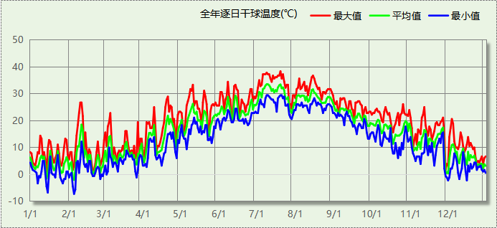

## 逐月辐照量表

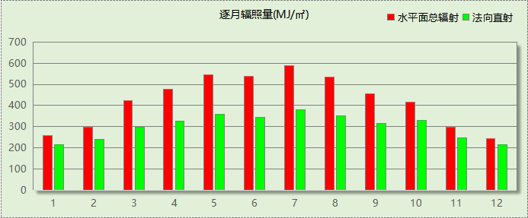

## 峰值工况

|  |  |  |  |  |  |
| --- | --- | --- | --- | --- | --- |
| 气象数据 | 时刻 | 干球温度(℃) | 湿球温度(℃) | 含湿量(g/kg) | 焓值(kj/kg) |
| 最热 | 07月19日13时 | 38.3 | 26.7 | 18.0 | 84.8 |
| 最冷 | 02月04日06时 | -7.2 | -7.2 | 2.0 | -2.3 |

# 软件介绍

本报告采用的软件为绿建暖通负荷BECH2024，该软件紧密结合暖通和节能设计规范、可根据项目实际情况建立建筑热工模型，并可对围护结构材料、房间内扰发热、作息时间表、热回收方式等参数进行设置。

软件包含全国各地典型气象年数据，内置DOE2.1E内核，对于建筑的逐时负荷进行动态模拟，既可以模拟8760小时理想负荷，也可以根据设定好的采暖期/空调期进行逐时模拟。

软件还支持分析全年建筑能耗的来源构成，依据日射得热、新风负荷、围护传热和内扰得热进行归类分项，生成设计建筑全年负荷计算报告书，提供详实的数据和多样的图表，为设计师在设备选型、制定运行策略等方面提供参考和帮助。

# 围护结构

## 屋顶构造

### 保温平屋面：挤塑聚苯板(XPS)+钢筋混凝土

|  |  |  |  |  |  |  |
| --- | --- | --- | --- | --- | --- | --- |
| 材料名称 （由上到下） | 厚度δ | 导热系数λ | 蓄热系数S | 修正 系数 | 热阻R | 热惰性 指标 |
| (mm) | W/(m.K) | W/(㎡.K) | α | (㎡K)/W | D=R*S |
| 细石混凝土 | 40 | 1.740 | 17.200 | 1.00 | 0.023 | 0.395 |
| 挤塑聚苯板(XPS) | 120 | 0.030 | 0.540 | 1.25 | 3.200 | 2.160 |
| 防水卷材 | 1 | － | － | － | － | － |
| 陶粒混凝土找坡 | 30 | 0.890 | 10.360 | 1.50 | 0.022 | 0.349 |
| 钢筋混凝土 | 120 | 1.740 | 17.200 | 1.00 | 0.069 | 1.186 |
| 各层之和∑ | 311 | － | － | － | 3.314 | 4.091 |
| 传热系数K=1/(0.15+∑R) | 0.29 | | | | | |

## 外墙构造

### 外墙（填充墙）构造一

|  |  |  |  |  |  |  |
| --- | --- | --- | --- | --- | --- | --- |
| 材料名称 （由外到内） | 厚度δ | 导热系数λ | 蓄热系数S | 修正 系数 | 热阻R | 热惰性 指标 |
| (mm) | W/(m.K) | W/(㎡.K) | α | (㎡K)/W | D=R*S |
| 花岗岩、玄武岩 | 1 | 3.490 | 25.490 | 1.00 | 0.000 | 0.007 |
| 轻钢主龙骨+副龙骨 | 1 | － | － | － | － | － |
| 锚固件固定 | 1 | － | － | － | － | － |
| 高分子防水透气层 | 1 | － | － | － | － | － |
| 岩棉板（夏热冬冷地区） | 30 | 0.040 | 0.700 | 1.20 | 0.625 | 0.525 |
| 防水砂浆 | 10 | 0.930 | 11.370 | 1.00 | 0.011 | 0.122 |
| ALC外墙板 | 200 | 0.170 | 2.180 | 1.10 | 1.070 | 2.565 |
| 各层之和∑ | 244 | － | － | － | 1.706 | 3.219 |
| 传热系数K=1/(0.15+∑R) | 0.54 | | | | | |

## 挑空楼板构造

### 挑空楼板构造：TD3-90钢筋桁架楼承板+岩棉板

|  |  |  |  |  |  |  |
| --- | --- | --- | --- | --- | --- | --- |
| 材料名称 （由上到下） | 厚度δ | 导热系数λ | 蓄热系数S | 修正 系数 | 热阻R | 热惰性 指标 |
| (mm) | W/(m.K) | W/(㎡.K) | α | (㎡K)/W | D=R*S |
| TD3-90钢筋桁架楼承板 | 120 | 1.740 | 17.200 | 1.00 | 0.069 | 1.186 |
| 胶粘剂 | 1 | － | － | － | － | － |
| 岩棉板（夏热冬冷地区） | 60 | 0.040 | 0.700 | 1.20 | 1.250 | 1.050 |
| 抹面砂浆 | 10 | 0.930 | 11.306 | 1.00 | 0.011 | 0.122 |
| 各层之和∑ | 191 | － | － | － | 1.330 | 2.358 |
| 传热系数K=1/(0.15+∑R) | 0.68 | | | | | |

## 楼板构造

### 控温房间楼板构造一：挤塑聚苯板(XPS)+钢筋混凝土

|  |  |  |  |  |  |  |
| --- | --- | --- | --- | --- | --- | --- |
| 材料名称 | 厚度δ | 导热系数λ | 蓄热系数S | 修正 系数 | 热阻R | 热惰性 指标 |
| (mm) | W/(m.K) | W/(㎡.K) | α | (㎡K)/W | D=R*S |
| 饰面层 | 1 | － | － | － | － | － |
| 细石混凝土（内配筋） | 40 | 1.740 | 17.200 | 1.00 | 0.023 | 0.395 |
| 挤塑聚苯板(XPS) | 10 | 0.030 | 0.540 | 1.25 | 0.267 | 0.180 |
| 钢筋混凝土 | 120 | 1.740 | 17.200 | 1.00 | 0.069 | 1.186 |
| 各层之和∑ | 171 | － | － | － | 0.359 | 1.762 |
| 传热系数K=1/(0.22+∑R) | 1.73 | | | | | |

## 周边地面构造

### 地面构造一

|  |  |  |  |  |  |  |
| --- | --- | --- | --- | --- | --- | --- |
| 材料名称 | 厚度δ | 导热系数λ | 蓄热系数S | 修正 系数 | 热阻R | 热惰性 指标 |
| (mm) | W/(m.K) | W/(㎡.K) | α | (㎡K)/W | D=R*S |
| 水泥砂浆 | 20 | 0.930 | 11.370 | 1.00 | 0.022 | 0.245 |
| 挤塑聚苯板(XPS) | 45 | 0.030 | 0.540 | 1.25 | 1.200 | 0.810 |
| 钢筋混凝土 | 120 | 1.740 | 17.200 | 1.00 | 0.069 | 1.186 |
| 各层之和∑ | 185 | － | － | － | 1.290 | 2.241 |
| 传热系数K=1/(0.11+∑R) | 0.32 | | | | | |

## 非周边地面构造

### 地面构造一

|  |  |  |  |  |  |  |
| --- | --- | --- | --- | --- | --- | --- |
| 材料名称 | 厚度δ | 导热系数λ | 蓄热系数S | 修正 系数 | 热阻R | 热惰性 指标 |
| (mm) | W/(m.K) | W/(㎡.K) | α | (㎡K)/W | D=R*S |
| 水泥砂浆 | 20 | 0.930 | 11.370 | 1.00 | 0.022 | 0.245 |
| 挤塑聚苯板(XPS) | 45 | 0.030 | 0.540 | 1.25 | 1.200 | 0.810 |
| 钢筋混凝土 | 120 | 1.740 | 17.200 | 1.00 | 0.069 | 1.186 |
| 各层之和∑ | 185 | － | － | － | 1.290 | 2.241 |
| 传热系数K=1/(0.11+∑R) | 0.22 | | | | | |

## 门构造

|  |  |  |  |
| --- | --- | --- | --- |
| 序号 | 构造名称 | 传热系数 | 备注 |
| 1 | 节能门 | 1.400 |  |

## 窗构造

|  |  |  |  |  |  |
| --- | --- | --- | --- | --- | --- |
| 序号 | 构造名称 | 传热系数 | 窗遮阳系数 | 可见光透射比 | 备注 |
| 1 | 65系列内平开隔热铝合金窗(6mm双银离线Low-E镀膜玻璃(室外侧)+12Ar+6mm普通透明玻璃+12Ar+6mm普通透明玻璃(室内侧)(暖边)) | 1.600 | 0.260 | 0.350 |  |
| 2 | 65系列内平开隔热铝合金窗(6mm双银离线Low-E镀膜玻璃(室外侧)+12Ar+6mm普通透明玻璃+12Ar+6mm普通透明玻璃(室内侧)(暖边)) | 1.600 | 0.260 | 0.350 |  |

# 房间类型

## 房间参数表

|  |  |  |  |  |  |  |
| --- | --- | --- | --- | --- | --- | --- |
| 房间类型 | 空调温度 ℃ | 供暖温度 ℃ | 新风量 | 人员密度 | 照明功率 密度 | 电器设备 功率 |
| 休息室 | 26 | 18 | 24(m^3/h.人) | 1.39(m^2/人) | 9(W/m^2) | 5(W/m^2) |
| 会议室 | 26 | 20 | 30(m^3/h.人) | 3.3(m^2/人) | 8(W/m^2) | 5(W/m^2) |
| 健身活动室 | 24 | 19 | 40(m^3/h.人) | 4(m^2/人) | 8(W/m^2) | 5(W/m^2) |
| 卫生间 | 28 | 16 | 0(m^3/h.人) | 0(人) | 5(W/m^2) | 5(W/m^2) |
| 大厅 | 26 | 20 | 30(m^3/h.人) | 20(m^2/人) | 10(W/m^2) | 0(W/m^2) |
| 实验教室 | 26 | 18 | 20(m^3/h.人) | 4(m^2/人) | 8(W/m^2) | 5(W/m^2) |
| 展示区 | 26 | 20 | 30(m^3/h.人) | 2.5(m^2/人) | 8(W/m^2) | 15(W/m^2) |
| 开水间 | 26 | 18 | 24(m^3/h.人) | 1.39(m^2/人) | 9(W/m^2) | 5(W/m^2) |
| 报告厅 | 26 | 18 | 14(m^3/h.人) | 2.5(m^2/人) | 12(W/m^2) | 5(W/m^2) |
| 普通办公室 | 26 | 20 | 30(m^3/h.人) | 6(m^2/人) | 8(W/m^2) | 5(W/m^2) |
| 普通教室 | 26 | 18 | 24(m^3/h.人) | 1.39(m^2/人) | 8(W/m^2) | 5(W/m^2) |
| 楼梯间 | － | － | 0(m^3/h.人) | 0(人) | 5(W/m^2) | 5(W/m^2) |
| 空房间 | － | － | 20(m^3/h.人) | 0(人) | 0(W/m^2) | 0(W/m^2) |
| 设备间 | － | － | 0(次/h) | 0(人) | 6(W/m^2) | 15(W/m^2) |
| 走廊 | － | － | 0(m^3/h.人) | 0(人) | 5(W/m^2) | 5(W/m^2) |
| 餐厅 | 26 | 18 | 25(m^3/h.人) | 2(m^2/人) | 8(W/m^2) | 5(W/m^2) |
| 高档办公室 | 26 | 20 | 30(m^3/h.人) | 8(m^2/人) | 13.5(W/m^2) | 5(W/m^2) |

## 作息时间表

详见附录

# 系统设置

## 系统划分

|  |  |  |  |  |  |  |
| --- | --- | --- | --- | --- | --- | --- |
| 系统编号 | 热回收 类型 | 启动 条件 | 回收 效率 | 排风 比例 | 面积(m2) | 包含的房间 |
| 默认 | 无 | -- | -- | -- | 1355.30 | 1164,1144,1140,1127,1126,1125,1124,1120,1110,1109,1108,1102,1098,1086,1075,2141,2130,2129,2128,2121,2113,2112,2111,2103,2099,3142,3134,3133,3132,3122,3116,3115,3114,3105,3104,3100,4045,4044,4043,4042,4040,4039,4038,4037,4036,4035,4034,5019,5018,5016,5014,5013,5012,5011,5010,5009,6156,6155,6143,6138,6137,6136,6123,6119,6118,6117,6107,6106,6101,6093 |
| Sys | 全热回收 | 温差启动 冷:≥5.0(℃) 暖:≥5.0(℃) | 冷:0.50, 暖:0.55 | 0.80 | 8714.22 | 1163,1162,1145,1139,1091,1090,1089,1088,1085,1077,1076,1057,1056,1055,1054,1053,2148,2147,2146,2081,2080,2079,2078,3165,3154,3153,3152,3151,3150,3149,3131,3082,3063,3062,3061,3060,3059,3058,4052,4051,4050,4049,4048,4047,4046,4041,4033,4032,4031,4030,4029,4028,4027,5026,5025,5024,5023,5022,5021,5020,5017,5015,5008,5007,5006,5005,5004,5003,5002,5001,6177,6176,6175,6174,6173,6172,6171,6170,6169,6168,6167,6166,6161,6160,6159,6158,6157,6135,6097,6096,6095,6094,6092,6084,6083,6074,6073,6072,6071,6070,6069,6068,6067,6066,6065,6064 |

## 运行时间表

详见附录

# 计算结果

## 模拟周期

全年8760小时模拟

## 全年冷暖需求

|  |  |  |  |  |
| --- | --- | --- | --- | --- |
| 系统名称\负荷 | 供暖需求 (kWh) | 供暖指标 (kWh/㎡·a) | 供冷需求 (kWh) | 供冷指标 (kWh/㎡·a) |
| Sys | 92153 | 10.57 | 1237294 | 141.99 |
| 默认系统 | 2399 | 1.77 | 71949 | 53.09 |
| 建筑总计 | 94552 | 8.71 | 1309243 | 120.65 |

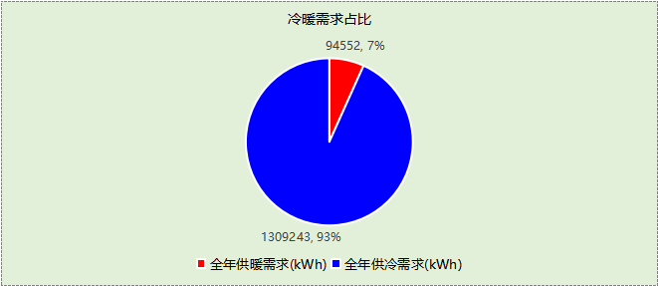

## 负荷分项统计

|  |  |  |  |  |  |  |
| --- | --- | --- | --- | --- | --- | --- |
| 分类 | 围护传热 | 室内得热 | 窗日射 | 新风/渗透 | 热回收 | 合计 |
| 供暖(kWh/㎡) | -12.77 | 20.03 | 2.00 | -31.21 | 13.24 | -8.71 |
| 供冷(kWh/㎡) | 13.22 | 54.24 | 3.37 | 62.37 | -12.55 | 120.65 |

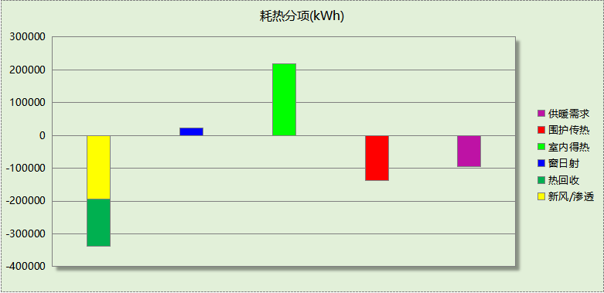

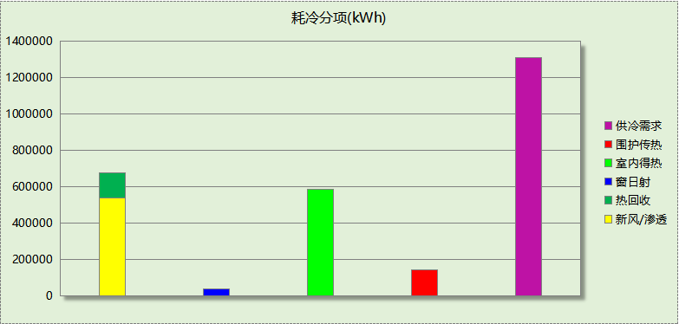

## 逐月负荷表

|  |  |  |  |  |  |  |
| --- | --- | --- | --- | --- | --- | --- |
| 月份 | 供暖(kWh) | 供冷(kWh) | 热负荷 峰值(kW) | 热负荷 峰值时刻 | 冷负荷 峰值(kW) | 冷负荷 峰值时刻 |
| 1月 | 34177 | 0 | 733.388 | 1月14日8时 | 0.000 | -- |
| 2月 | 27848 | 0 | 769.878 | 2月4日8时 | 0.000 | -- |
| 3月 | 8988 | 21 | 425.724 | 3月11日8时 | 7.887 | 3月5日16时 |
| 4月 | 2880 | 30357 | 234.806 | 4月1日17时 | 759.398 | 4月23日15时 |
| 5月 | 0 | 114729 | 0.000 | -- | 1292.877 | 5月13日14时 |
| 6月 | 0 | 202231 | 0.000 | -- | 1651.693 | 6月13日8时 |
| 7月 | 0 | 367332 | 0.000 | -- | 2098.599 | 7月12日8时 |
| 8月 | 0 | 346597 | 0.000 | -- | 2096.232 | 8月15日8时 |
| 9月 | 0 | 193575 | 0.000 | -- | 1456.487 | 9月2日13时 |
| 10月 | 0 | 49442 | 0.000 | -- | 766.735 | 10月15日14时 |
| 11月 | 1286 | 4960 | 204.507 | 11月29日8时 | 474.803 | 11月26日14时 |
| 12月 | 19373 | 0 | 519.600 | 12月30日8时 | 0.000 | -- |

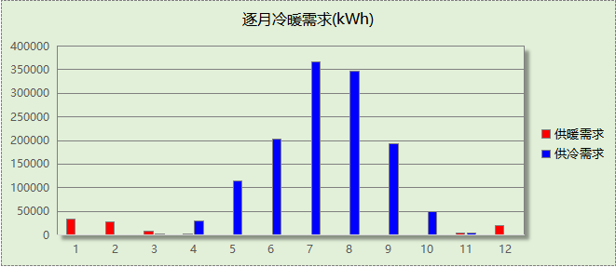

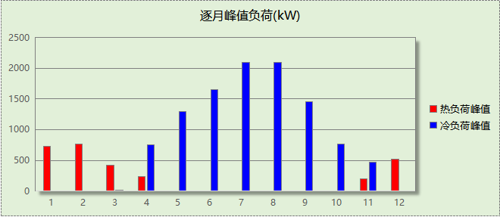

# 附录

**工作日/节假日人员逐时在室率(%)**

|  |  |  |  |  |  |  |  |  |  |  |  |  |  |  |  |  |  |  |  |  |  |  |  |  |
| --- | --- | --- | --- | --- | --- | --- | --- | --- | --- | --- | --- | --- | --- | --- | --- | --- | --- | --- | --- | --- | --- | --- | --- | --- |
| 房间类型 | 1 | 2 | 3 | 4 | 5 | 6 | 7 | 8 | 9 | 10 | 11 | 12 | 13 | 14 | 15 | 16 | 17 | 18 | 19 | 20 | 21 | 22 | 23 | 24 |
| 休息室 | 0 | 0 | 0 | 0 | 0 | 0 | 10 | 50 | 95 | 95 | 95 | 80 | 80 | 95 | 95 | 95 | 95 | 30 | 30 | 0 | 0 | 0 | 0 | 0 |
| 0 | 0 | 0 | 0 | 0 | 0 | 0 | 0 | 0 | 0 | 0 | 0 | 0 | 0 | 0 | 0 | 0 | 0 | 0 | 0 | 0 | 0 | 0 | 0 |
| 会议室 | 0 | 0 | 0 | 0 | 0 | 0 | 10 | 50 | 95 | 95 | 95 | 80 | 80 | 95 | 95 | 95 | 95 | 30 | 30 | 0 | 0 | 0 | 0 | 0 |
| 0 | 0 | 0 | 0 | 0 | 0 | 0 | 0 | 0 | 0 | 0 | 0 | 0 | 0 | 0 | 0 | 0 | 0 | 0 | 0 | 0 | 0 | 0 | 0 |
| 健身活动室 | 0 | 0 | 0 | 0 | 0 | 0 | 10 | 50 | 95 | 95 | 95 | 80 | 80 | 95 | 95 | 95 | 95 | 30 | 30 | 0 | 0 | 0 | 0 | 0 |
| 0 | 0 | 0 | 0 | 0 | 0 | 0 | 0 | 0 | 0 | 0 | 0 | 0 | 0 | 0 | 0 | 0 | 0 | 0 | 0 | 0 | 0 | 0 | 0 |
| 卫生间 | 0 | 0 | 0 | 0 | 0 | 0 | 10 | 50 | 95 | 95 | 95 | 80 | 80 | 95 | 95 | 95 | 95 | 30 | 30 | 0 | 0 | 0 | 0 | 0 |
| 0 | 0 | 0 | 0 | 0 | 0 | 0 | 0 | 0 | 0 | 0 | 0 | 0 | 0 | 0 | 0 | 0 | 0 | 0 | 0 | 0 | 0 | 0 | 0 |
| 大厅 | 0 | 0 | 0 | 0 | 0 | 0 | 10 | 50 | 95 | 95 | 95 | 80 | 80 | 95 | 95 | 95 | 95 | 30 | 30 | 0 | 0 | 0 | 0 | 0 |
| 0 | 0 | 0 | 0 | 0 | 0 | 0 | 0 | 0 | 0 | 0 | 0 | 0 | 0 | 0 | 0 | 0 | 0 | 0 | 0 | 0 | 0 | 0 | 0 |
| 实验教室 | 0 | 0 | 0 | 0 | 0 | 0 | 10 | 50 | 95 | 95 | 95 | 80 | 80 | 95 | 95 | 95 | 95 | 30 | 30 | 0 | 0 | 0 | 0 | 0 |
| 0 | 0 | 0 | 0 | 0 | 0 | 0 | 0 | 0 | 0 | 0 | 0 | 0 | 0 | 0 | 0 | 0 | 0 | 0 | 0 | 0 | 0 | 0 | 0 |
| 展示区 | 0 | 0 | 0 | 0 | 0 | 0 | 10 | 50 | 100 | 100 | 100 | 30 | 100 | 100 | 100 | 100 | 50 | 20 | 10 | 0 | 0 | 0 | 0 | 0 |
| 0 | 0 | 0 | 0 | 0 | 0 | 0 | 20 | 45 | 0 | 0 | 0 | 0 | 0 | 0 | 0 | 0 | 0 | 0 | 0 | 0 | 0 | 0 | 0 |
| 开水间 | 0 | 0 | 0 | 0 | 0 | 0 | 10 | 50 | 95 | 95 | 95 | 80 | 80 | 95 | 95 | 95 | 95 | 30 | 30 | 0 | 0 | 0 | 0 | 0 |
| 0 | 0 | 0 | 0 | 0 | 0 | 0 | 0 | 0 | 0 | 0 | 0 | 0 | 0 | 0 | 0 | 0 | 0 | 0 | 0 | 0 | 0 | 0 | 0 |
| 报告厅 | 0 | 0 | 0 | 0 | 0 | 0 | 10 | 50 | 95 | 95 | 95 | 80 | 80 | 95 | 95 | 95 | 95 | 30 | 30 | 0 | 0 | 0 | 0 | 0 |
| 0 | 0 | 0 | 0 | 0 | 0 | 0 | 0 | 0 | 0 | 0 | 0 | 0 | 0 | 0 | 0 | 0 | 0 | 0 | 0 | 0 | 0 | 0 | 0 |
| 普通办公室 | 0 | 0 | 0 | 0 | 0 | 0 | 10 | 50 | 95 | 95 | 95 | 80 | 80 | 95 | 95 | 95 | 95 | 30 | 30 | 0 | 0 | 0 | 0 | 0 |
| 0 | 0 | 0 | 0 | 0 | 0 | 0 | 0 | 0 | 0 | 0 | 0 | 0 | 0 | 0 | 0 | 0 | 0 | 0 | 0 | 0 | 0 | 0 | 0 |
| 普通教室 | 0 | 0 | 0 | 0 | 0 | 0 | 10 | 50 | 95 | 95 | 95 | 80 | 80 | 95 | 95 | 95 | 95 | 30 | 30 | 0 | 0 | 0 | 0 | 0 |
| 0 | 0 | 0 | 0 | 0 | 0 | 0 | 0 | 0 | 0 | 0 | 0 | 0 | 0 | 0 | 0 | 0 | 0 | 0 | 0 | 0 | 0 | 0 | 0 |
| 楼梯间 | 0 | 0 | 0 | 0 | 0 | 0 | 10 | 50 | 95 | 95 | 95 | 80 | 80 | 95 | 95 | 95 | 95 | 30 | 30 | 0 | 0 | 0 | 0 | 0 |
| 0 | 0 | 0 | 0 | 0 | 0 | 0 | 0 | 0 | 0 | 0 | 0 | 0 | 0 | 0 | 0 | 0 | 0 | 0 | 0 | 0 | 0 | 0 | 0 |
| 空房间 | 0 | 0 | 0 | 0 | 0 | 0 | 0 | 20 | 50 | 80 | 80 | 80 | 80 | 80 | 80 | 80 | 80 | 80 | 80 | 70 | 50 | 0 | 0 | 0 |
| 0 | 0 | 0 | 0 | 0 | 0 | 0 | 0 | 0 | 0 | 0 | 0 | 0 | 0 | 0 | 0 | 0 | 0 | 0 | 0 | 0 | 0 | 0 | 0 |
| 设备间 | 0 | 0 | 0 | 0 | 0 | 0 | 0 | 0 | 0 | 0 | 0 | 0 | 0 | 0 | 0 | 0 | 0 | 0 | 0 | 0 | 0 | 0 | 0 | 0 |
| 0 | 0 | 0 | 0 | 0 | 0 | 0 | 0 | 0 | 0 | 0 | 0 | 0 | 0 | 0 | 0 | 0 | 0 | 0 | 0 | 0 | 0 | 0 | 0 |
| 走廊 | 0 | 0 | 0 | 0 | 0 | 0 | 10 | 50 | 95 | 95 | 95 | 80 | 80 | 95 | 95 | 95 | 95 | 30 | 30 | 0 | 0 | 0 | 0 | 0 |
| 0 | 0 | 0 | 0 | 0 | 0 | 0 | 0 | 0 | 0 | 0 | 0 | 0 | 0 | 0 | 0 | 0 | 0 | 0 | 0 | 0 | 0 | 0 | 0 |
| 餐厅 | 0 | 0 | 0 | 0 | 0 | 0 | 10 | 50 | 95 | 95 | 95 | 80 | 80 | 95 | 95 | 95 | 95 | 30 | 30 | 0 | 0 | 0 | 0 | 0 |
| 0 | 0 | 0 | 0 | 0 | 0 | 0 | 0 | 0 | 0 | 0 | 0 | 0 | 0 | 0 | 0 | 0 | 0 | 0 | 0 | 0 | 0 | 0 | 0 |
| 高档办公室 | 0 | 0 | 0 | 0 | 0 | 0 | 10 | 50 | 95 | 95 | 95 | 80 | 80 | 95 | 95 | 95 | 95 | 30 | 30 | 0 | 0 | 0 | 0 | 0 |
| 0 | 0 | 0 | 0 | 0 | 0 | 0 | 0 | 0 | 0 | 0 | 0 | 0 | 0 | 0 | 0 | 0 | 0 | 0 | 0 | 0 | 0 | 0 | 0 |

注：上行：工作日；下行：节假日

**工作日/节假日照明开关时间表(%)**

|  |  |  |  |  |  |  |  |  |  |  |  |  |  |  |  |  |  |  |  |  |  |  |  |  |
| --- | --- | --- | --- | --- | --- | --- | --- | --- | --- | --- | --- | --- | --- | --- | --- | --- | --- | --- | --- | --- | --- | --- | --- | --- |
| 房间类型 | 1 | 2 | 3 | 4 | 5 | 6 | 7 | 8 | 9 | 10 | 11 | 12 | 13 | 14 | 15 | 16 | 17 | 18 | 19 | 20 | 21 | 22 | 23 | 24 |
| 休息室 | 0 | 0 | 0 | 0 | 0 | 0 | 10 | 50 | 95 | 95 | 95 | 80 | 80 | 95 | 95 | 95 | 95 | 30 | 30 | 0 | 0 | 0 | 0 | 0 |
| 0 | 0 | 0 | 0 | 0 | 0 | 0 | 0 | 0 | 0 | 0 | 0 | 0 | 0 | 0 | 0 | 0 | 0 | 0 | 0 | 0 | 0 | 0 | 0 |
| 会议室 | 0 | 0 | 0 | 0 | 0 | 0 | 10 | 50 | 95 | 95 | 95 | 80 | 80 | 95 | 95 | 95 | 95 | 30 | 30 | 0 | 0 | 0 | 0 | 0 |
| 0 | 0 | 0 | 0 | 0 | 0 | 0 | 0 | 0 | 0 | 0 | 0 | 0 | 0 | 0 | 0 | 0 | 0 | 0 | 0 | 0 | 0 | 0 | 0 |
| 健身活动室 | 0 | 0 | 0 | 0 | 0 | 0 | 10 | 50 | 95 | 95 | 95 | 80 | 80 | 95 | 95 | 95 | 95 | 30 | 30 | 0 | 0 | 0 | 0 | 0 |
| 0 | 0 | 0 | 0 | 0 | 0 | 0 | 0 | 0 | 0 | 0 | 0 | 0 | 0 | 0 | 0 | 0 | 0 | 0 | 0 | 0 | 0 | 0 | 0 |
| 卫生间 | 0 | 0 | 0 | 0 | 0 | 0 | 10 | 50 | 95 | 95 | 95 | 80 | 80 | 95 | 95 | 95 | 95 | 30 | 30 | 0 | 0 | 0 | 0 | 0 |
| 0 | 0 | 0 | 0 | 0 | 0 | 0 | 0 | 0 | 0 | 0 | 0 | 0 | 0 | 0 | 0 | 0 | 0 | 0 | 0 | 0 | 0 | 0 | 0 |
| 大厅 | 0 | 0 | 0 | 0 | 0 | 0 | 10 | 50 | 95 | 95 | 95 | 80 | 80 | 95 | 95 | 95 | 95 | 30 | 30 | 0 | 0 | 0 | 0 | 0 |
| 0 | 0 | 0 | 0 | 0 | 0 | 0 | 0 | 0 | 0 | 0 | 0 | 0 | 0 | 0 | 0 | 0 | 0 | 0 | 0 | 0 | 0 | 0 | 0 |
| 实验教室 | 0 | 0 | 0 | 0 | 0 | 0 | 10 | 50 | 95 | 95 | 95 | 80 | 80 | 95 | 95 | 95 | 95 | 30 | 30 | 0 | 0 | 0 | 0 | 0 |
| 0 | 0 | 0 | 0 | 0 | 0 | 0 | 0 | 0 | 0 | 0 | 0 | 0 | 0 | 0 | 0 | 0 | 0 | 0 | 0 | 0 | 0 | 0 | 0 |
| 展示区 | 10 | 10 | 10 | 10 | 10 | 10 | 10 | 36 | 62 | 56 | 54 | 43 | 53 | 55 | 58 | 67 | 40 | 18 | 10 | 10 | 10 | 10 | 10 | 10 |
| 0 | 0 | 0 | 0 | 0 | 0 | 0 | 0 | 0 | 0 | 0 | 0 | 0 | 0 | 0 | 0 | 0 | 0 | 0 | 0 | 0 | 0 | 0 | 0 |
| 开水间 | 0 | 0 | 0 | 0 | 0 | 0 | 10 | 50 | 95 | 95 | 95 | 80 | 80 | 95 | 95 | 95 | 95 | 30 | 30 | 0 | 0 | 0 | 0 | 0 |
| 0 | 0 | 0 | 0 | 0 | 0 | 0 | 0 | 0 | 0 | 0 | 0 | 0 | 0 | 0 | 0 | 0 | 0 | 0 | 0 | 0 | 0 | 0 | 0 |
| 报告厅 | 0 | 0 | 0 | 0 | 0 | 0 | 10 | 50 | 95 | 95 | 95 | 80 | 80 | 95 | 95 | 95 | 95 | 30 | 30 | 0 | 0 | 0 | 0 | 0 |
| 0 | 0 | 0 | 0 | 0 | 0 | 0 | 0 | 0 | 0 | 0 | 0 | 0 | 0 | 0 | 0 | 0 | 0 | 0 | 0 | 0 | 0 | 0 | 0 |
| 普通办公室 | 0 | 0 | 0 | 0 | 0 | 0 | 10 | 50 | 95 | 95 | 95 | 80 | 80 | 95 | 95 | 95 | 95 | 30 | 30 | 0 | 0 | 0 | 0 | 0 |
| 0 | 0 | 0 | 0 | 0 | 0 | 0 | 0 | 0 | 0 | 0 | 0 | 0 | 0 | 0 | 0 | 0 | 0 | 0 | 0 | 0 | 0 | 0 | 0 |
| 普通教室 | 0 | 0 | 0 | 0 | 0 | 0 | 10 | 50 | 95 | 95 | 95 | 80 | 80 | 95 | 95 | 95 | 95 | 30 | 30 | 0 | 0 | 0 | 0 | 0 |
| 0 | 0 | 0 | 0 | 0 | 0 | 0 | 0 | 0 | 0 | 0 | 0 | 0 | 0 | 0 | 0 | 0 | 0 | 0 | 0 | 0 | 0 | 0 | 0 |
| 楼梯间 | 0 | 0 | 0 | 0 | 0 | 0 | 10 | 50 | 95 | 95 | 95 | 80 | 80 | 95 | 95 | 95 | 95 | 30 | 30 | 0 | 0 | 0 | 0 | 0 |
| 0 | 0 | 0 | 0 | 0 | 0 | 0 | 0 | 0 | 0 | 0 | 0 | 0 | 0 | 0 | 0 | 0 | 0 | 0 | 0 | 0 | 0 | 0 | 0 |
| 空房间 | 10 | 10 | 10 | 10 | 10 | 10 | 10 | 50 | 60 | 60 | 60 | 60 | 60 | 60 | 60 | 60 | 80 | 90 | 100 | 100 | 100 | 10 | 10 | 10 |
| 0 | 0 | 0 | 0 | 0 | 0 | 0 | 0 | 0 | 0 | 0 | 0 | 0 | 0 | 0 | 0 | 0 | 0 | 0 | 0 | 0 | 0 | 0 | 0 |
| 设备间 | 100 | 100 | 100 | 100 | 100 | 100 | 100 | 100 | 100 | 100 | 100 | 100 | 100 | 100 | 100 | 100 | 100 | 100 | 100 | 100 | 100 | 100 | 100 | 100 |
| 0 | 0 | 0 | 0 | 0 | 0 | 0 | 0 | 0 | 0 | 0 | 0 | 0 | 0 | 0 | 0 | 0 | 0 | 0 | 0 | 0 | 0 | 0 | 0 |
| 走廊 | 0 | 0 | 0 | 0 | 0 | 0 | 10 | 50 | 95 | 95 | 95 | 80 | 80 | 95 | 95 | 95 | 95 | 30 | 30 | 0 | 0 | 0 | 0 | 0 |
| 0 | 0 | 0 | 0 | 0 | 0 | 0 | 0 | 0 | 0 | 0 | 0 | 0 | 0 | 0 | 0 | 0 | 0 | 0 | 0 | 0 | 0 | 0 | 0 |
| 餐厅 | 0 | 0 | 0 | 0 | 0 | 0 | 10 | 50 | 95 | 95 | 95 | 80 | 80 | 95 | 95 | 95 | 95 | 30 | 30 | 0 | 0 | 0 | 0 | 0 |
| 0 | 0 | 0 | 0 | 0 | 0 | 0 | 0 | 0 | 0 | 0 | 0 | 0 | 0 | 0 | 0 | 0 | 0 | 0 | 0 | 0 | 0 | 0 | 0 |
| 高档办公室 | 0 | 0 | 0 | 0 | 0 | 0 | 10 | 50 | 95 | 95 | 95 | 80 | 80 | 95 | 95 | 95 | 95 | 30 | 30 | 0 | 0 | 0 | 0 | 0 |
| 0 | 0 | 0 | 0 | 0 | 0 | 0 | 0 | 0 | 0 | 0 | 0 | 0 | 0 | 0 | 0 | 0 | 0 | 0 | 0 | 0 | 0 | 0 | 0 |

注：上行：工作日；下行：节假日

**工作日/节假日设备逐时使用率(%)**

|  |  |  |  |  |  |  |  |  |  |  |  |  |  |  |  |  |  |  |  |  |  |  |  |  |
| --- | --- | --- | --- | --- | --- | --- | --- | --- | --- | --- | --- | --- | --- | --- | --- | --- | --- | --- | --- | --- | --- | --- | --- | --- |
| 房间类型 | 1 | 2 | 3 | 4 | 5 | 6 | 7 | 8 | 9 | 10 | 11 | 12 | 13 | 14 | 15 | 16 | 17 | 18 | 19 | 20 | 21 | 22 | 23 | 24 |
| 休息室 | 0 | 0 | 0 | 0 | 0 | 0 | 10 | 50 | 95 | 95 | 95 | 50 | 50 | 95 | 95 | 95 | 95 | 30 | 30 | 0 | 0 | 0 | 0 | 0 |
| 0 | 0 | 0 | 0 | 0 | 0 | 0 | 0 | 0 | 0 | 0 | 0 | 0 | 0 | 0 | 0 | 0 | 0 | 0 | 0 | 0 | 0 | 0 | 0 |
| 会议室 | 0 | 0 | 0 | 0 | 0 | 0 | 10 | 50 | 95 | 95 | 95 | 50 | 50 | 95 | 95 | 95 | 95 | 30 | 30 | 0 | 0 | 0 | 0 | 0 |
| 0 | 0 | 0 | 0 | 0 | 0 | 0 | 0 | 0 | 0 | 0 | 0 | 0 | 0 | 0 | 0 | 0 | 0 | 0 | 0 | 0 | 0 | 0 | 0 |
| 健身活动室 | 0 | 0 | 0 | 0 | 0 | 0 | 10 | 50 | 95 | 95 | 95 | 50 | 50 | 95 | 95 | 95 | 95 | 30 | 30 | 0 | 0 | 0 | 0 | 0 |
| 0 | 0 | 0 | 0 | 0 | 0 | 0 | 0 | 0 | 0 | 0 | 0 | 0 | 0 | 0 | 0 | 0 | 0 | 0 | 0 | 0 | 0 | 0 | 0 |
| 卫生间 | 0 | 0 | 0 | 0 | 0 | 0 | 10 | 50 | 95 | 95 | 95 | 50 | 50 | 95 | 95 | 95 | 95 | 30 | 30 | 0 | 0 | 0 | 0 | 0 |
| 0 | 0 | 0 | 0 | 0 | 0 | 0 | 0 | 0 | 0 | 0 | 0 | 0 | 0 | 0 | 0 | 0 | 0 | 0 | 0 | 0 | 0 | 0 | 0 |
| 大厅 | 0 | 0 | 0 | 0 | 0 | 0 | 10 | 50 | 95 | 95 | 95 | 50 | 50 | 95 | 95 | 95 | 95 | 30 | 30 | 0 | 0 | 0 | 0 | 0 |
| 0 | 0 | 0 | 0 | 0 | 0 | 0 | 0 | 0 | 0 | 0 | 0 | 0 | 0 | 0 | 0 | 0 | 0 | 0 | 0 | 0 | 0 | 0 | 0 |
| 实验教室 | 0 | 0 | 0 | 0 | 0 | 0 | 10 | 50 | 95 | 95 | 95 | 50 | 50 | 95 | 95 | 95 | 95 | 30 | 30 | 0 | 0 | 0 | 0 | 0 |
| 0 | 0 | 0 | 0 | 0 | 0 | 0 | 0 | 0 | 0 | 0 | 0 | 0 | 0 | 0 | 0 | 0 | 0 | 0 | 0 | 0 | 0 | 0 | 0 |
| 展示区 | 0 | 0 | 0 | 0 | 0 | 0 | 10 | 50 | 100 | 100 | 100 | 100 | 100 | 100 | 100 | 100 | 50 | 20 | 10 | 0 | 0 | 0 | 0 | 0 |
| 0 | 0 | 0 | 0 | 0 | 0 | 0 | 0 | 0 | 0 | 0 | 0 | 0 | 0 | 0 | 0 | 0 | 0 | 0 | 0 | 0 | 0 | 0 | 0 |
| 开水间 | 0 | 0 | 0 | 0 | 0 | 0 | 10 | 50 | 95 | 95 | 95 | 50 | 50 | 95 | 95 | 95 | 95 | 30 | 30 | 0 | 0 | 0 | 0 | 0 |
| 0 | 0 | 0 | 0 | 0 | 0 | 0 | 0 | 0 | 0 | 0 | 0 | 0 | 0 | 0 | 0 | 0 | 0 | 0 | 0 | 0 | 0 | 0 | 0 |
| 报告厅 | 0 | 0 | 0 | 0 | 0 | 0 | 10 | 50 | 95 | 95 | 95 | 50 | 50 | 95 | 95 | 95 | 95 | 30 | 30 | 0 | 0 | 0 | 0 | 0 |
| 0 | 0 | 0 | 0 | 0 | 0 | 0 | 0 | 0 | 0 | 0 | 0 | 0 | 0 | 0 | 0 | 0 | 0 | 0 | 0 | 0 | 0 | 0 | 0 |
| 普通办公室 | 0 | 0 | 0 | 0 | 0 | 0 | 10 | 50 | 95 | 95 | 95 | 50 | 50 | 95 | 95 | 95 | 95 | 30 | 30 | 0 | 0 | 0 | 0 | 0 |
| 0 | 0 | 0 | 0 | 0 | 0 | 0 | 0 | 0 | 0 | 0 | 0 | 0 | 0 | 0 | 0 | 0 | 0 | 0 | 0 | 0 | 0 | 0 | 0 |
| 普通教室 | 0 | 0 | 0 | 0 | 0 | 0 | 10 | 50 | 95 | 95 | 95 | 50 | 50 | 95 | 95 | 95 | 95 | 30 | 30 | 0 | 0 | 0 | 0 | 0 |
| 0 | 0 | 0 | 0 | 0 | 0 | 0 | 0 | 0 | 0 | 0 | 0 | 0 | 0 | 0 | 0 | 0 | 0 | 0 | 0 | 0 | 0 | 0 | 0 |
| 楼梯间 | 0 | 0 | 0 | 0 | 0 | 0 | 10 | 50 | 95 | 95 | 95 | 50 | 50 | 95 | 95 | 95 | 95 | 30 | 30 | 0 | 0 | 0 | 0 | 0 |
| 0 | 0 | 0 | 0 | 0 | 0 | 0 | 0 | 0 | 0 | 0 | 0 | 0 | 0 | 0 | 0 | 0 | 0 | 0 | 0 | 0 | 0 | 0 | 0 |
| 空房间 | 0 | 0 | 0 | 0 | 0 | 0 | 0 | 30 | 50 | 80 | 80 | 80 | 80 | 80 | 80 | 80 | 80 | 80 | 80 | 70 | 50 | 0 | 0 | 0 |
| 0 | 0 | 0 | 0 | 0 | 0 | 0 | 0 | 0 | 0 | 0 | 0 | 0 | 0 | 0 | 0 | 0 | 0 | 0 | 0 | 0 | 0 | 0 | 0 |
| 设备间 | 100 | 100 | 100 | 100 | 100 | 100 | 100 | 100 | 100 | 100 | 100 | 100 | 100 | 100 | 100 | 100 | 100 | 100 | 100 | 100 | 100 | 100 | 100 | 100 |
| 0 | 0 | 0 | 0 | 0 | 0 | 0 | 0 | 0 | 0 | 0 | 0 | 0 | 0 | 0 | 0 | 0 | 0 | 0 | 0 | 0 | 0 | 0 | 0 |
| 走廊 | 0 | 0 | 0 | 0 | 0 | 0 | 10 | 50 | 95 | 95 | 95 | 50 | 50 | 95 | 95 | 95 | 95 | 30 | 30 | 0 | 0 | 0 | 0 | 0 |
| 0 | 0 | 0 | 0 | 0 | 0 | 0 | 0 | 0 | 0 | 0 | 0 | 0 | 0 | 0 | 0 | 0 | 0 | 0 | 0 | 0 | 0 | 0 | 0 |
| 餐厅 | 0 | 0 | 0 | 0 | 0 | 0 | 10 | 50 | 95 | 95 | 95 | 50 | 50 | 95 | 95 | 95 | 95 | 30 | 30 | 0 | 0 | 0 | 0 | 0 |
| 0 | 0 | 0 | 0 | 0 | 0 | 0 | 0 | 0 | 0 | 0 | 0 | 0 | 0 | 0 | 0 | 0 | 0 | 0 | 0 | 0 | 0 | 0 | 0 |
| 高档办公室 | 0 | 0 | 0 | 0 | 0 | 0 | 10 | 50 | 95 | 95 | 95 | 50 | 50 | 95 | 95 | 95 | 95 | 30 | 30 | 0 | 0 | 0 | 0 | 0 |
| 0 | 0 | 0 | 0 | 0 | 0 | 0 | 0 | 0 | 0 | 0 | 0 | 0 | 0 | 0 | 0 | 0 | 0 | 0 | 0 | 0 | 0 | 0 | 0 |

注：上行：工作日；下行：节假日

**工作日/节假日空调系统开关时间表**

|  |  |  |  |  |  |  |  |  |  |  |  |  |  |  |  |  |  |  |  |  |  |  |  |  |
| --- | --- | --- | --- | --- | --- | --- | --- | --- | --- | --- | --- | --- | --- | --- | --- | --- | --- | --- | --- | --- | --- | --- | --- | --- |
| 系统编号 | 1 | 2 | 3 | 4 | 5 | 6 | 7 | 8 | 9 | 10 | 11 | 12 | 13 | 14 | 15 | 16 | 17 | 18 | 19 | 20 | 21 | 22 | 23 | 24 |
| 默认 | 0 | 0 | 0 | 0 | 0 | 0 | 0 | 1 | 1 | 1 | 1 | 1 | 1 | 1 | 1 | 1 | 1 | 1 | 0 | 0 | 0 | 0 | 0 | 0 |
| 0 | 0 | 0 | 0 | 0 | 0 | 0 | 0 | 0 | 0 | 0 | 0 | 0 | 0 | 0 | 0 | 0 | 0 | 0 | 0 | 0 | 0 | 0 | 0 |
| Sys | 0 | 0 | 0 | 0 | 0 | 0 | 0 | 1 | 1 | 1 | 1 | 1 | 1 | 1 | 1 | 1 | 1 | 1 | 0 | 0 | 0 | 0 | 0 | 0 |
| 0 | 0 | 0 | 0 | 0 | 0 | 0 | 0 | 0 | 0 | 0 | 0 | 0 | 0 | 0 | 0 | 0 | 0 | 0 | 0 | 0 | 0 | 0 | 0 |

注：上行：工作日；下行：节假日