**超低能耗**

**建筑能效报告书**

公共建筑

|  |  |
| --- | --- |
| 工程名称 | 数据要素产业园项目（C地块）1#方案设计 |
| 工程地点 | 江苏-苏州 |
| 设计编号 |  |
| 建设单位 |  |
| 设计单位 |  |
| 设 计 人 |  |
| 审 核 人 |  |
| 审 定 人 |  |
| 设计日期 | 2024年5月27日 |



|  |  |
| --- | --- |
| 采用软件 | 超低能耗PHES2024 |
| 软件版本 | 20240315(SP1) |
| 研发单位 | 北京绿建软件股份有限公司 |
| 正版授权码 | T13851430749 |

**目 录**

1 建筑概况 4

2 评估依据 4

3 气象数据 4

3.1 气象地点 4

3.2 逐日干球温度表 5

3.3 逐月辐照量表 5

3.4 峰值工况 5

4 建筑大样 6

5 围护结构 9

5.1 工程材料 9

5.1.1 普通材料 9

5.1.2 其他材料 10

5.2 屋顶 11

5.2.1 平屋面基层（有保温） 11

5.3 天窗类型 11

5.4 外墙 11

5.4.1 外墙相关构造 11

5.4.2 外墙平均热工特性 12

5.5 外窗热工 13

5.5.1 外窗 13

5.5.2 外遮阳类型 14

5.5.3 总体热工性能 14

5.6 外窗气密性 15

5.7 外门气密性 15

5.8 户门气密性 15

5.9 规定项检查 15

6 围护结构概况 15

7 设计建筑 16

7.1 房间类型 16

7.1.1 房间参数表 16

7.1.2 作息时间表 17

7.2 系统类型 17

7.2.1 系统分区 17

7.2.2 热回收参数 18

7.3 制冷系统 18

7.3.1 冷源1 18

7.4 供暖系统 19

7.4.1 默认热源 19

7.5 照明 20

7.6 生活热水 21

7.6.1 热水需求 21

7.6.2 太阳能集热 21

7.6.3 热水设备 21

7.7 电梯 21

7.7.1 直梯 21

7.8 光伏发电 21

7.9 负荷分项统计 22

7.10 逐月负荷表 22

8 基准建筑 24

8.1 房间类型 24

8.1.1 房间参数表 24

8.1.2 作息时间表 24

8.2 系统类型 24

8.3 制冷系统 25

8.3.1 冷源1 25

8.4 供暖系统 26

8.4.1 默认热源 26

8.5 照明 26

8.6 生活热水 27

8.6.1 热水需求 27

8.6.2 热水设备 27

8.7 电梯 27

8.7.1 直梯 27

8.8 负荷分项统计 27

8.9 逐月负荷表 28

9 能效结果 29

9.1 建筑能耗 29

9.2 结论 32

10 附录 33

10.1 工作日/节假日人员逐时在室率(%) 33

10.2 工作日/节假日照明开关时间表(%) 33

10.3 工作日/节假日设备逐时使用率(%) 34

10.4 工作日/节假日空调系统运行时间表(1:开,0:关) 35

10.5 工作日/节假日新风运行时间表(%) 37

# 建筑概况

|  |  |  |
| --- | --- | --- |
| 工程名称 | 数据要素产业园项目 | |
| 工程地点 | 江苏-苏州 | |
| 地理位置 | 北纬：31.32° | 东经：120.62° |
| 建筑面积(m2) | 地上75576 地下0 | |
| 建筑层数 | 地上24 地下0 | |
| 建筑高度（m） | 地上108.0 地下0.0 | |
| 建筑体积(m3) | 341795.80 | |
| 建筑外表面积(m2) | 44921.79 | |
| 建筑气密性（换气次数N50） | 0.60 | |
| 建筑类型细化 | 办公建筑 | |
| 北向角度 | 116 | |
| 结构类型 |  | |
| 外墙太阳辐射吸收系数 | 0.65 | |
| 屋顶太阳辐射吸收系数 | 0.70 | |
| 控温期 | 供冷期:6.14-8.31,供暖期:11.30-2.28 | |

# 评估依据

1. 《近零能耗建筑技术标准》(GB/T51350-2019)

2. 《公共建筑节能设计标准》(GB50189-2015)

3. 《民用建筑热工设计规范》(GB50176-2016-2016)

4. 《建筑幕墙、门窗通用技术条件》(GB/T31433-2015)

# 气象数据

## 气象地点

江苏-东山 (当前地点无气象数据，选用较近可用的气象地点), 《建筑节能气象参数标准》

## 逐日干球温度表

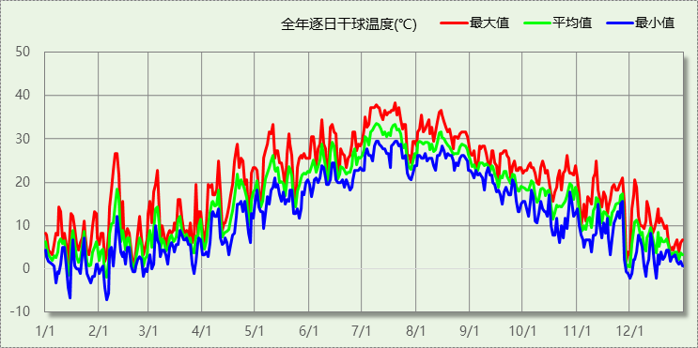

## 逐月辐照量表

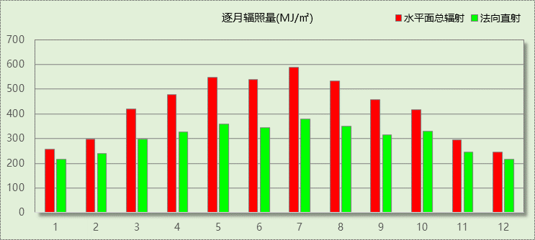

## 峰值工况

|  |  |  |  |  |  |
| --- | --- | --- | --- | --- | --- |
| 气象数据 | 时刻 | 干球温度(℃) | 湿球温度(℃) | 含湿量(g/kg) | 焓值(kj/kg) |
| 最热 | 07月19日13时 | 38.3 | 26.7 | 18.0 | 84.8 |
| 最冷 | 02月04日06时 | -7.2 | -7.2 | 2.0 | -2.3 |

# 建筑大样

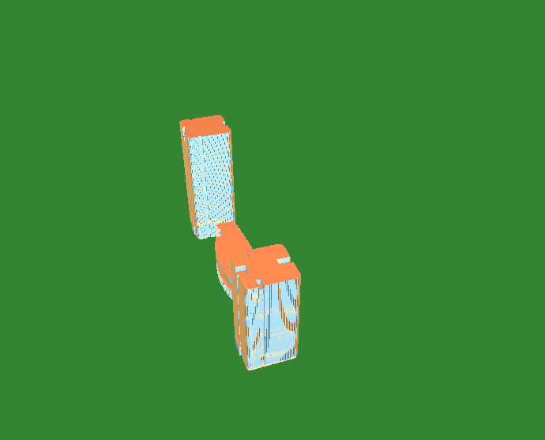

西南轴侧图

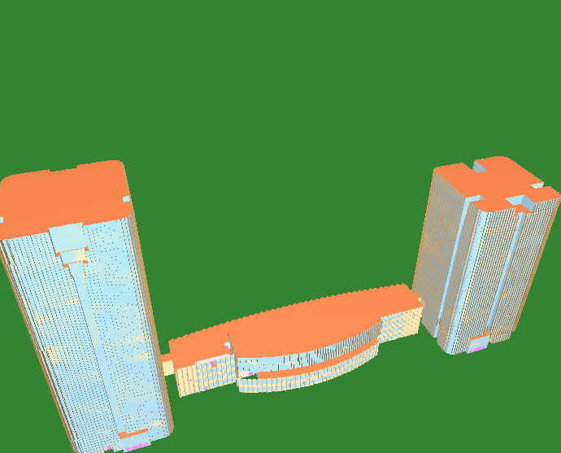

东南轴侧图

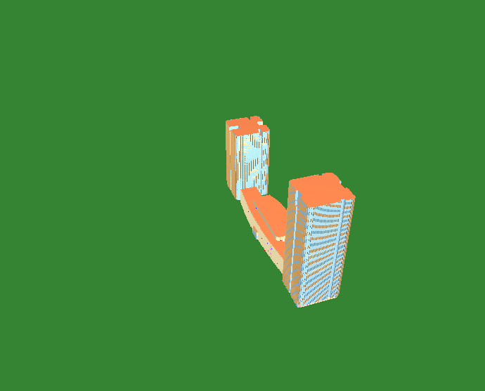

西北轴侧图

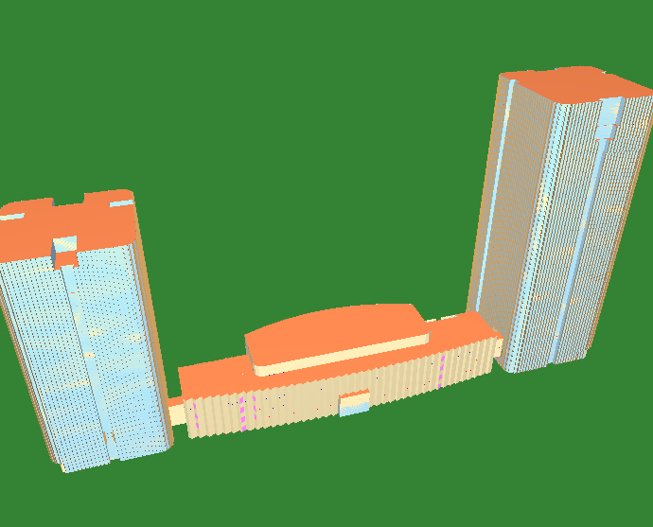

东北轴侧图

# 围护结构

## 工程材料

### 普通材料

|  |  |  |  |  |  |  |
| --- | --- | --- | --- | --- | --- | --- |
| 材料名称 | 导热系数λ | 蓄热系数S | 密度ρ | 比热容Cp | 蒸汽渗透 系数u | 数据来源 |
| W/(m.K) | W/(㎡.K) | kg/m3 | J/(kg.K) | g/(m.h.kPa) |
| 水泥砂浆 | 0.930 | 11.370 | 1800.0 | 1050.0 | 0.0210 | 民用建筑热工设计规范 GB50176-2016 |
| 抹面砂浆 | 0.930 | 11.306 | 1800.0 | 1050.0 | 0.0140 | 民用建筑热工设计规范 GB50176-2016 |
| 防水砂浆 | 0.930 | 11.370 | 1800.0 | 1050.0 | 0.0210 | 民用建筑热工设计规范 GB50176-2016 |
| 石灰砂浆 | 0.810 | 10.070 | 1600.0 | 1050.0 | 0.0443 | 民用建筑热工设计规范 GB50176-2016 |
| 钢筋混凝土 | 1.740 | 17.200 | 2500.0 | 920.0 | 0.0158 | 民用建筑热工设计规范 GB50176-2016 |
| TD3-90钢筋桁架楼承板 | 1.740 | 17.200 | 2500.0 | 920.0 | 0.0158 | 民用建筑热工设计规范 GB50176-2016 |
| 细石混凝土（内配筋） | 1.740 | 17.200 | 2500.0 | 920.0 | 0.0158 | 民用建筑热工设计规范 GB50176-2016 |
| 细石混凝土 | 1.740 | 17.200 | 2500.0 | 920.0 | 0.0158 | 民用建筑热工设计规范 GB50176-2016 |
| 岩棉板（夏热冬冷地区） | 0.040 | 0.700 | 140.0 | 1203.2 | 0.4880 | JGJT 480-2019 |
| 挤塑聚苯板(XPS) | 0.030 | 0.540 | 25.0 | 5346.4 | 0.0162 | 民用建筑热工设计规范 GB50176-2016 |
| 聚合物砂浆（网格布） | 0.930 | 11.306 | 1800.0 | 1050.0 | 0.0000 | 安徽公共建筑节能设计标准 DB34 T753-2007 |
| 砂加气混凝土砌块B06 | 0.190 | 2.790 | 600.0 | 938.9 | 0.1200 | DGJ32TJ107-2010 |
| 陶板（铝板、石材）幕墙（另详见幕墙二次设计） | 1.000 | 10.000 | 1000.0 | 1000.0 | 0.0000 |  |
| 加气混凝土、泡沫混凝土(ρ=300)找坡 | 0.100 | 1.514 | 300.0 | 1050.0 | 0.1110 | 民用建筑热工设计规范 GB50176-2016 |
| 聚氨酯防水涂料 | 1.000 | 10.000 | 1000.0 | 1000.0 | 0.0000 |  |

### 其他材料

|  |  |  |  |  |
| --- | --- | --- | --- | --- |
| 材料名称 | 厚度 | 热阻R | 太阳辐射吸收系数 | 备注 |
| mm | (㎡K)/W |
| 胶粘剂 | － | － | － |  |
| 饰面层 | － | － | － |  |
| 防水卷材 | － | － | － |  |
| PE薄膜隔离层一层 | － | － | － |  |

## 屋顶

### 平屋面基层（有保温）

|  |  |  |  |  |  |  |
| --- | --- | --- | --- | --- | --- | --- |
| 材料名称 （由上到下） | 厚度δ | 导热系数λ | 蓄热系数S | 修正 系数 | 热阻R | 热惰性 指标 |
| (mm) | W/(m.K) | W/(㎡.K) | α | (㎡K)/W | D=R*S |
| 细石混凝土 | 50 | 1.740 | 17.200 | 1.00 | 0.029 | 0.494 |
| 防水卷材 | 1 | － | － | － | － | － |
| 挤塑聚苯板(XPS) | 106 | 0.030 | 0.540 | 1.25 | 2.827 | 1.908 |
| PE薄膜隔离层一层 | － | － | － | － | － | － |
| 水泥砂浆 | 20 | 0.930 | 11.370 | 1.00 | 0.022 | 0.245 |
| 加气混凝土、泡沫混凝土(ρ=300)找坡 | 30 | 0.100 | 1.514 | 1.00 | 0.300 | 0.454 |
| 钢筋混凝土 | 120 | 1.740 | 17.200 | 1.00 | 0.069 | 1.186 |
| 各层之和∑ | 327 | － | － | － | 3.246 | 4.287 |
| 外表面太阳辐射吸收系数 | 0.70 | | | | | |
| 传热系数K=1/(0.15+∑R) | 0.29 | | | | | |

## 天窗类型

本工程无此项内容

## 外墙

### 外墙相关构造

#### 陶板（铝板、石材）幕墙

|  |  |  |  |  |  |  |
| --- | --- | --- | --- | --- | --- | --- |
| 材料名称 （由外到内） | 厚度δ | 导热系数λ | 蓄热系数S | 修正 系数 | 热阻R | 热惰性 指标 |
| (mm) | W/(m.K) | W/(㎡.K) | α | (㎡K)/W | D=R*S |
| 陶板（铝板、石材）幕墙（另详见幕墙二次设计） | － | － | － | － | 0.000 | － |
| 聚合物砂浆（网格布） | 6 | 0.930 | 11.306 | 1.00 | 0.006 | 0.073 |
| 岩棉板（夏热冬冷地区） | 55 | 0.040 | 0.700 | 1.20 | 1.146 | 0.963 |
| 胶粘剂 | － | － | － | － | － | － |
| 聚氨酯防水涂料 | － | － | － | － | 0.000 | － |
| 防水砂浆 | 15 | 0.930 | 11.370 | 1.00 | 0.016 | 0.183 |
| 砂加气混凝土砌块B06 | 200 | 0.190 | 2.790 | 1.00 | 1.053 | 2.937 |
| 各层之和∑ | 276 | － | － | － | 2.221 | 4.156 |
| 外表面太阳辐射吸收系数 | 0.65[默认] | | | | | |
| 传热系数K=1/(0.15+∑R) | 0.42 | | | | | |

#### 热桥柱构造一

|  |  |  |  |  |  |  |
| --- | --- | --- | --- | --- | --- | --- |
| 材料名称 （由外到内） | 厚度δ | 导热系数λ | 蓄热系数S | 修正 系数 | 热阻R | 热惰性 指标 |
| (mm) | W/(m.K) | W/(㎡.K) | α | (㎡K)/W | D=R*S |
| 水泥砂浆 | 20 | 0.930 | 11.370 | 1.00 | 0.022 | 0.245 |
| 岩棉板（夏热冬冷地区） | 55 | 0.040 | 0.700 | 1.20 | 1.146 | 0.963 |
| 石灰砂浆 | 20 | 0.810 | 10.070 | 1.00 | 0.025 | 0.249 |
| 各层之和∑ | 95 | － | － | － | 1.192 | 1.456 |
| 外表面太阳辐射吸收系数 | 0.65[默认] | | | | | |
| 传热系数K=1/(0.15+∑R) | 0.75 | | | | | |

#### 外墙基层

|  |  |  |  |  |  |  |
| --- | --- | --- | --- | --- | --- | --- |
| 材料名称 （由外到内） | 厚度δ | 导热系数λ | 蓄热系数S | 修正 系数 | 热阻R | 热惰性 指标 |
| (mm) | W/(m.K) | W/(㎡.K) | α | (㎡K)/W | D=R*S |
| 聚氨酯防水涂料 | － | － | － | － | 0.000 | － |
| 防水砂浆 | 15 | 0.930 | 11.370 | 1.00 | 0.016 | 0.183 |
| 细石混凝土 | 200 | 1.740 | 17.200 | 1.00 | 0.115 | 1.977 |
| 各层之和∑ | 215 | － | － | － | 0.131 | 2.160 |
| 外表面太阳辐射吸收系数 | 0.65[默认] | | | | | |
| 传热系数K=1/(0.15+∑R) | 3.56 | | | | | |

### 外墙平均热工特性

1.　南向

|  |  |  |  |  |  |  |
| --- | --- | --- | --- | --- | --- | --- |
| 构造名称 | 构件 类型 | 面积(㎡) | 面积所占比例 | 传热系数K W / (㎡K) | 热惰性 指标D | 太阳辐射 吸收系数 |
| 陶板（铝板、石材）幕墙 | 主墙体 | 1018.05 | 0.994 | 0.42 | 4.16 | 0.65 |
| 热桥柱构造一 | 热桥柱 | 3.60 | 0.004 | 0.75 | 1.46 | 0.65 |
| 外墙基层 | 主墙体 | 2.35 | 0.002 | 3.56 | 2.16 | 0.65 |
| 合计 |  | 1023.99 | 1.000 | 0.43 | 4.14 | 0.65 |

2.　北向

|  |  |  |  |  |  |  |
| --- | --- | --- | --- | --- | --- | --- |
| 构造名称 | 构件 类型 | 面积(㎡) | 面积所占比例 | 传热系数K W / (㎡K) | 热惰性 指标D | 太阳辐射 吸收系数 |
| 陶板（铝板、石材）幕墙 | 主墙体 | 2217.57 | 0.999 | 0.42 | 4.16 | 0.65 |
| 热桥柱构造一 | 热桥柱 | 3.15 | 0.001 | 0.75 | 1.46 | 0.65 |
| 合计 |  | 2220.72 | 1.000 | 0.42 | 4.15 | 0.65 |

3.　东向

|  |  |  |  |  |  |  |
| --- | --- | --- | --- | --- | --- | --- |
| 构造名称 | 构件 类型 | 面积(㎡) | 面积所占比例 | 传热系数K W / (㎡K) | 热惰性 指标D | 太阳辐射 吸收系数 |
| 陶板（铝板、石材）幕墙 | 主墙体 | 1528.17 | 0.967 | 0.42 | 4.16 | 0.65 |
| 热桥柱构造一 | 热桥柱 | 33.75 | 0.021 | 0.75 | 1.46 | 0.65 |
| 外墙基层 | 主墙体 | 18.00 | 0.011 | 3.56 | 2.16 | 0.65 |
| 合计 |  | 1579.92 | 1.000 | 0.46 | 4.08 | 0.65 |

4.　西向

|  |  |  |  |  |  |  |
| --- | --- | --- | --- | --- | --- | --- |
| 构造名称 | 构件 类型 | 面积(㎡) | 面积所占比例 | 传热系数K W / (㎡K) | 热惰性 指标D | 太阳辐射 吸收系数 |
| 陶板（铝板、石材）幕墙 | 主墙体 | 1054.47 | 0.946 | 0.42 | 4.16 | 0.65 |
| 热桥柱构造一 | 热桥柱 | 34.65 | 0.031 | 0.75 | 1.46 | 0.65 |
| 外墙基层 | 主墙体 | 25.56 | 0.023 | 3.56 | 2.16 | 0.65 |
| 合计 |  | 1114.67 | 1.000 | 0.50 | 4.03 | 0.65 |

5.　总体

|  |  |  |  |  |  |  |
| --- | --- | --- | --- | --- | --- | --- |
| 构造名称 | 构件 类型 | 面积(㎡) | 面积所占比例 | 传热系数K W / (㎡K) | 热惰性 指标D | 太阳辐射 吸收系数 |
| 陶板（铝板、石材）幕墙 | 主墙体 | 5818.26 | 0.980 | 0.42 | 4.16 | 0.65 |
| 热桥柱构造一 | 热桥柱 | 75.15 | 0.013 | 0.75 | 1.46 | 0.65 |
| 外墙基层 | 主墙体 | 45.90 | 0.008 | 3.56 | 2.16 | 0.65 |
| 合计 |  | 5939.31 | 1.000 | 0.45 | 4.11 | 0.65 |

## 外窗热工

### 外窗

|  |  |  |  |  |  |  |
| --- | --- | --- | --- | --- | --- | --- |
| 序号 | 构造名称 | 构造 编号 | 传热 系数 | 窗遮阳 系数 | 可见光 透射比 | 数据来源 |
| 1 | 60系列内平开铝合金窗5Low-E+15Ar+3+0.38PVB+3暖边(窗框比0.3) | 65 | 1.60 | 0.27 | 0.620 | 北京居住建筑节能设计标准 DB11/891-2012 |
| 窗编号 | | | | |
| 幕墙 | | | | |
| 2 | 隔热铝合金窗框(6Low-E+12Ar+6+12Ar+6中空钢化超白玻璃) | 18 | 1.90 | 0.34 | 0.600 | GB/T 51350-2019 |
| 窗编号 | | | | |
| C1228，C0628，C0828，C1128，C1328，C1628，C2028[0628]，C2028[1228]，C4918[0218]，C4918[0318]，DC0328，DC0418，DC0618，DC0628，DC0918，DC1228，DC1628， | | | | |

### 外遮阳类型

#### 百叶遮阳

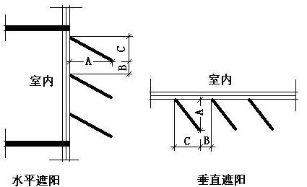

|  |  |  |  |  |
| --- | --- | --- | --- | --- |
| 序号 | 编号 | 挑出 A (m) | 百叶间距 D (m) | 下垂 C (m) |
| 1 | 百叶遮阳0 | 0.500 | 1.200 | 0.000 |

### 总体热工性能

|  |  |  |  |  |  |  |  |
| --- | --- | --- | --- | --- | --- | --- | --- |
| 朝向 | 面积 | 传热系数 | 夏季综合 太阳得热系数 | 冬季综合 太阳得热系数 | 窗墙比 | 标准要求 | 结论 |
| 南向 | 8857.83 | 1.62 | 0.19 | 0.19 | 0.89 | K≤2.20, SHGCSum≤0.15, SHGCWin≥0.40 | 不需要 |
| 北向 | 7612.68 | 1.60 | 0.18 | 0.18 | 0.77 | K≤2.20, SHGCSum≤0.15, SHGCWin≥0.40 | 不需要 |
| 东向 | 7387.33 | 1.60 | 0.19 | 0.19 | 0.82 | K≤2.20, SHGCSum≤0.15, SHGCWin≥0.40 | 不需要 |
| 西向 | 7370.97 | 1.60 | 0.18 | 0.18 | 0.87 | K≤2.20, SHGCSum≤0.15, SHGCWin≥0.40 | 不需要 |
| 综合平均 | 31228.82 | 1.61 | 0.19 | 0.19 | 0.84 |  |  |
| 标准依据 | 《近零能耗建筑技术标准》(GB/T51350-2019)第6.1.5条 | | | | | | |
| 标准要求 | K和SHGC值可按表6.1.5-2选取 | | | | | | |
| 结论 | 不需要 | | | | | | |

注：本表所统计的外窗包含凸窗。

## 外窗气密性

|  |  |
| --- | --- |
| 最不利气密性等级 | 6级（窗编号：） |
| 外窗气密性措施 |  |
| 标准依据 | 《近零能耗建筑技术标准》第6.1.4条，分级与检测方法《建筑幕墙、门窗通用技术条件》(GB/T31433-2015) |
| 标准要求 | 外窗及外门户门气密性不宜低于《建筑幕墙、门窗通用技术条件》(GB/T31433-2015)的8级 |
| 结论 | 不适宜 |

## 外门气密性

|  |  |
| --- | --- |
| 最不利气密性等级 | 6级（窗编号：M1123） |
| 外门气密性措施 |  |
| 标准依据 | 《近零能耗建筑技术标准》第6.1.4条，分级与检测方法《建筑幕墙、门窗通用技术条件》(GB/T31433-2015) |
| 标准要求 | 外窗及外门户门气密性不宜低于《建筑幕墙、门窗通用技术条件》(GB/T31433-2015)的6级 |
| 结论 | 适宜 |

## 户门气密性

|  |  |
| --- | --- |
| 最不利气密性等级 | － |
| 户门气密性措施 |  |
| 标准依据 | 《近零能耗建筑技术标准》第6.1.4条，分级与检测方法《建筑幕墙、门窗通用技术条件》(GB/T31433-2015) |
| 标准要求 | 外窗及外门户门气密性不宜低于《建筑幕墙、门窗通用技术条件》(GB/T31433-2015)的6级 |
| 结论 | － |

## 规定项检查

|  |  |  |
| --- | --- | --- |
| 序号 | 检查项 | 结论 |
| 1 | 屋顶 | 不需要 |
| 2 | 天窗类型 | 无屋顶透光部分 |
| 3 | 外墙 | 不需要 |
| 4 | 外窗热工 | 不需要 |
| 5 | 外窗气密性 | 不适宜 |
| 6 | 外门气密性 | 适宜 |
| 7 | 户门气密性 | 适宜 |

# 围护结构概况

|  |  |  |  |  |  |  |  |
| --- | --- | --- | --- | --- | --- | --- | --- |
|  | | 设计建筑 | | | 基准建筑 | | |
| 屋顶传热系数K  和热惰性指标 D | | 0.29  4.29 | | | 0.50  3.35 | | |
| 外墙传热系数K  和热惰性指标 D | | 0.45  4.11 | | | 0.80  2.54 | | |
| 挑空(或架空)楼板传热系数K  和热惰性指标 D | | 0.59  2.53 | | | 0.70  2.31 | | |
| 天窗传热系数K  和太阳得热系数 SHGC | | －  － | | | －  － | | |
| 外窗（包括透明幕墙） | 朝向 | 窗墙比 | 传热  系数 | 太阳得热系数 | 窗墙比 | 传热  系数 | 太阳得热系数 |
| 南向 | 0.89 | 1.62 | 0.19 | 0.40 | 2.60 | 0.40 |
| 北向 | 0.77 | 1.60 | 0.18 | 0.40 | 2.60 | 0.44 |
| 东向 | 0.82 | 1.60 | 0.19 | 0.40 | 2.60 | 0.40 |
| 西向 | 0.87 | 1.60 | 0.18 | 0.40 | 2.60 | 0.40 |

备注：

1. 传热系数的单位W/(m2.k)，其他参数无量纲.

2. 屋顶和外墙的传热系数K和热情性指标D指平均值.

3. 设计建筑：“—”代表本工程无对应项.

# 设计建筑

## 房间类型

### 房间参数表

|  |  |  |  |  |  |  |  |
| --- | --- | --- | --- | --- | --- | --- | --- |
| 房间类型 | 空调 温度℃ | 供暖 温度℃ | 新风量 | 渗透风 换气次数 | 人员密度 | 照明功率 密度 | 电器设备 功率 |
| 办公-普通办公室 | 26 | 20 | 30(m3/h.人) | 0(次/h) | 10(㎡/人) | 8(W/㎡) | 13(W/㎡) |
| 卫生间 | 26 | 20 | 30(m3/h.人) | 0(次/h) | 10(㎡/人) | 8(W/㎡) | 13(W/㎡) |
| 厨房 | 26 | 20 | 30(m3/h.人) | 0(次/h) | 10(㎡/人) | 8(W/㎡) | 13(W/㎡) |
| 大厅 | 26 | 20 | 30(m3/h.人) | 0(次/h) | 20(㎡/人) | 5(W/㎡) | 0(W/㎡) |
| 开水间 | － | － | 20(m3/h.人) | 0(次/h) | 50(㎡/人) | 0(W/㎡) | 0(W/㎡) |
| 接待室 | 26 | 20 | 30(m3/h.人) | 0(次/h) | 10(㎡/人) | 8(W/㎡) | 13(W/㎡) |
| 普通办公室 | 26 | 20 | 30(m3/h.人) | 0(次/h) | 10(㎡/人) | 8(W/㎡) | 13(W/㎡) |
| 楼梯间 | － | － | 20(m3/h.人) | 0(次/h) | 50(㎡/人) | 0(W/㎡) | 0(W/㎡) |
| 空房间 | － | － | 20(m3/h.人) | 0(次/h) | 50(㎡/人) | 0(W/㎡) | 0(W/㎡) |
| 设备间 | － | － | 0(m3/h.人) | 0(次/h) | 0(人) | 5(W/㎡) | 0(W/㎡) |
| 走廊 | 26 | 20 | 30(m3/h.人) | 0(次/h) | 20(㎡/人) | 5(W/㎡) | 0(W/㎡) |
| 餐厅 | 26 | 20 | 30(m3/h.人) | 0(次/h) | 10(㎡/人) | 8(W/㎡) | 13(W/㎡) |

### 作息时间表

详见附录

## 系统类型

### 系统分区

|  |  |  |  |  |  |
| --- | --- | --- | --- | --- | --- |
| 系统编号 | 系统类型 | 制冷 SEER | 制热 HSPF | 面积(㎡) | 包含的房间 |
| 默认 | 双管制风机盘管 | － | － | 5283.88 | 1122(1),1083(1),1069(1),1014(1),1008(1),1022(1),1021(1),1036(1),1044(1),2134(2),2133(2),2107(2),2093(2),2092(2),2087(2),2075(2),2029(2),2021(2),2017(2),2022(2),2039(2),2051(2),3124(3),3035(3),3027(3),3026(3),3018(3),3014(3),3125(3),3094(3),3003(3),3019(3),3048(3),4085(4),4071(4),4047(4),4035(4),4028(4),4018(4),4015(4),4013(4),4019(4),5473(5),5465(5),5455(5),5452(5),5450(5),5456(5),6401@6~14,6394@6~14,6392@6~14,6385@6~14,6382@6~14,6380@6~14,15332(15),15325(15),15323(15),15316(15),15313(15),15311(15),16263(16),16256(16),16254(16),16247(16),16244(16),16242(16),17196(17),17187(17),17185(17),18153(18),18146(18),18144(18),19115@19~20,19109@19~20,19107@19~20,21080(21),21074(21),21072(21),22045(22),22039(22),22037(22) |
| Sys15 | 辐射供冷 | － | － | 2461.60 | 15302(15),15301(15) |
| Sys16 | 辐射供冷 | － | － | 2457.70 | 16233(16),16232(16) |
| Sys17 | 辐射供冷 | － | － | 1226.12 | 17177(17) |
| Sys18 | 辐射供冷 | － | － | 1226.12 | 18137(18) |
| Sys19-20 | 辐射供冷 | － | － | 2452.25 | 19102@19~20 |
| Sys2 | 辐射供冷 | － | － | 1733.54 | 2050(2),2004(2),2003(2) |
| Sys21 | 辐射供冷 | － | － | 1222.42 | 21067(21) |
| Sys22 | 辐射供冷 | － | － | 1208.05 | 22032(22) |
| Sys2群 | 全空气定风量(CAV)机组 | － | － | 1021.48 | 2005(2),2057(2) |
| Sys3 | 辐射供冷 | － | － | 1070.82 | 3127(3),3080(3),3067(3),3044(3),3046(3) |
| Sys4 | 辐射供冷 | － | － | 2538.06 | 4042(4),4001(4),4002(4) |
| Sys5 | 辐射供冷 | － | － | 2462.64 | 5439(5),5440(5) |
| Sys6-14 | 辐射供冷 | － | － | 22163.77 | 6370@6~14,6371@6~14 |
| 风机盘管 | 双管制风机盘管 | － | － | 2331.75 | 1050(1),2056(2) |

### 热回收参数

|  |  |  |  |  |  |
| --- | --- | --- | --- | --- | --- |
| 系统编号 | 热回收 | 供冷 | | 供暖 | |
| 回收效率 | 启动温(焓)差 | 回收效率 | 启动温(焓)差 |
| 默认 | 无 | － | － | － | － |
| Sys15 | 无 | － | － | － | － |
| Sys16 | 无 | － | － | － | － |
| Sys17 | 无 | － | － | － | － |
| Sys18 | 无 | － | － | － | － |
| Sys19-20 | 无 | － | － | － | － |
| Sys2 | 无 | － | － | － | － |
| Sys21 | 无 | － | － | － | － |
| Sys22 | 无 | － | － | － | － |
| Sys2群 | 无 | － | － | － | － |
| Sys3 | 无 | － | － | － | － |
| Sys4 | 无 | － | － | － | － |
| Sys5 | 无 | － | － | － | － |
| Sys6-14 | 无 | － | － | － | － |
| 风机盘管 | 无 | － | － | － | － |

## 制冷系统

### 冷源1

#### 供应的系统

|  |  |
| --- | --- |
| 系统编号 | 默认, Sys15, Sys16, Sys17, Sys18, Sys19-20, Sys2, Sys21, Sys22, Sys2群, Sys3, Sys4, Sys5, Sys6-14, 风机盘管 |

#### 冷水机组

|  |  |  |  |  |  |
| --- | --- | --- | --- | --- | --- |
| 名称 | 类型 | 额定耗电量 (kW) | 额定制冷量 (kW) | 额定性能系数 (COP) | 台数 |
| 机组1 | 水冷-螺杆式冷水机组 | 58 | 240 | 4.17 | 2 |
| 机组1 | 地源/水源热泵 | 90 | 584 | 6.49 | 2 |

#### 水泵系统

|  |  |  |  |  |  |  |  |
| --- | --- | --- | --- | --- | --- | --- | --- |
| 类型 | 调节 | 流量 (m3/h) | 扬程 (m) | 设计工作效率(%) | 输入功率 (kW) | 冷却塔耗电比 (kWh/m3) | 台数 |
| 冷冻水泵 | 单速 | 69 | 18 | 63 | 6.2 | － | 3 |
| 冷冻水泵 | 单速 | 60 | 29 | 59 | 9.2 | － | 3 |
| 冷却水泵 | 单速 | 60 | 20 | 58 | 6.5 | 0.03 | 3 |
| 冷冻水泵 | 单速 | 52 | 22 | 58 | 6.2 | － | 3 |
| 冷冻水泵 | 单速 | 51 | 28 | 59 | 7.6 | － | 3 |
| 冷却水泵 | 单速 | 30 | 13 | 65 | 1.9 | 0.8 | 3 |
| 冷冻水泵 | 单速 | 13 | 18 | 52 | 1.4 | － | 3 |
| 冷冻水泵 | 单速 | 36 | 16 | 65 | 2.8 | － | 3 |
| 冷却水泵 | 单速 | 40 | 20 | 66 | 3.8 | 2.21 | 3 |
| 冷冻水泵 | 单速 | 320 | 30 | 80 | 37.6 | － | 1 |

#### 运行工况

|  |  |  |  |  |  |  |
| --- | --- | --- | --- | --- | --- | --- |
| 负载率 (%) | 机组制冷量 (kW) | 机组功率 (kW) | 性能系数 (COP) | 冷却水泵功率 (kW) | 冷冻水泵功率 (kW) | 冷却塔功率 (kW) |
| 20 | 329.6 | 59.2 | 5.57 | 2.28 | 2.52 | 0.22 |
| 40 | 659.2 | 118.4 | 5.57 | 4.56 | 5.04 | 0.44 |
| 60 | 988.8 | 177.6 | 5.57 | 6.84 | 7.56 | 0.66 |
| 80 | 1318.4 | 236.8 | 5.57 | 9.12 | 10.08 | 0.88 |
| 100 | 1648 | 296 | 5.57 | 11.4 | 12.6 | 1.1 |

#### 制冷能耗

|  |  |  |  |  |  |  |  |
| --- | --- | --- | --- | --- | --- | --- | --- |
| 负荷区间 (%) | 区间负荷 (kWh) | 运行时长(h) | 制冷机组 (kWh) | 平均性能系数(COP) | 冷却水泵 (kWh) | 冷冻水泵 (kWh) | 冷却塔 (kWh) |
| 0~20 | 0 | 0 | 0 | 0.00 | 0 | 0 | 0 |
| 20~40 | 0 | 0 | 0 | 0.00 | 0 | 0 | 0 |
| 40~60 | 0 | 0 | 0 | 0.00 | 0 | 0 | 0 |
| 60~80 | 0 | 0 | 0 | 0.00 | 0 | 0 | 0 |
| 80~100 | 7742 | 5 | 1391 | 5.57 | 57 | 63 | 6 |
| >100 | 2022100 | 574 | 169904 | － | 6544 | 7232 | 631 |
| 合计 | 2029842 | 579 | 171295 |  | 6601 | 7295 | 637 |

## 供暖系统

### 默认热源

#### 供应的系统

|  |  |
| --- | --- |
| 系统编号 | 默认, Sys15, Sys16, Sys17, Sys18, Sys19-20, Sys2, Sys21, Sys22, Sys2群, Sys3, Sys4, Sys5, Sys6-14, 风机盘管 |

#### 热泵系统

##### 热泵机组

|  |  |  |  |  |  |
| --- | --- | --- | --- | --- | --- |
| 名称 | 类型 | 额定耗电量(kW) | 额定制热量(kW) | 额定性能系数 COP | 台数 |
| 热泵机组 | 空气源热泵 | 157 | 629 | 4.00 | 2 |

##### 热水循环泵

|  |  |  |  |  |  |
| --- | --- | --- | --- | --- | --- |
| 类型 | 流量(m3/h) | 扬程(m) | 设计工作效率(%) | 输入功率(kW) | 台数 |
| 单速 | 13 | 18 | 52 | 1.4 | 3 |
| 单速 | 36 | 16 | 65 | 2.8 | 3 |
| 单速 | 69 | 18 | 63 | 6.2 | 3 |
| 单速 | 60 | 29 | 59 | 9.2 | 3 |
| 单速 | 52 | 22 | 58 | 6.2 | 3 |
| 单速 | 51 | 28 | 59 | 7.6 | 3 |

##### 运行工况

|  |  |  |  |  |
| --- | --- | --- | --- | --- |
| 负载率(%) | 机组制热量(kW) | 机组功率(kW) | 性能系数(COP) | 供暖水泵功率(kW) |
| 20 | 251.6 | 62.8 | 4.01 | 20.01 |
| 40 | 503.2 | 125.6 | 4.01 | 40.08 |
| 60 | 754.8 | 188.4 | 4.01 | 60.12 |
| 80 | 1006.4 | 251.2 | 4.01 | 80.16 |
| 100 | 1258 | 314 | 4.01 | 100.2 |

##### 制热能耗

|  |  |  |  |  |  |
| --- | --- | --- | --- | --- | --- |
| 负荷区间 (%) | 区间负荷 (kWh) | 运行时长 (h) | 平均性能系数 (COP) | 热泵机组 (kWh) | 供暖水泵 (kWh) |
| 0~20 | 79399 | 546 | 4.01 | 19818 | 10926 |
| 20~40 | 38346 | 121 | 4.01 | 9571 | 4850 |
| 40~60 | 2187 | 4 | 4.01 | 546 | 240 |
| 60~80 | 0 | 0 | 0.00 | 0 | 0 |
| 80~100 | 0 | 0 | 0.00 | 0 | 0 |
| >100 | 0 | 0 | － | 0 | 0 |
| 合计 | 119932 | 671 |  | 29935 | 16016 |

## 照明

|  |  |  |  |  |
| --- | --- | --- | --- | --- |
| 房间类型 | 单位面积电耗 (kWh/㎡) | 房间个数 | 房间合计面积 (㎡) | 合计电耗 (kWh) |
| 卫生间 | 24.00 | 123 | 1431 | 34349 |
| 厨房 | 24.00 | 2 | 703 | 16872 |
| 大厅 | 15.00 | 3 | 3464 | 51953 |
| 开水间 | 0.00 | 38 | 461 | 0 |
| 接待室 | 24.00 | 1 | 65 | 1561 |
| 普通办公室 | 24.00 | 43 | 44882 | 1077173 |
| 楼梯间 | 0.00 | 103 | 2728 | 0 |
| 空房间 | 0.00 | 294 | 10948 | 0 |
| 设备间 | 0.00 | 974 | 4920 | 0 |
| 走廊 | 15.00 | 4 | 89 | 1341 |
| 餐厅 | 24.00 | 1 | 739 | 17734 |
| 总计 | | | | 1200982 |

## 生活热水

### 热水需求

|  |  |  |  |  |  |
| --- | --- | --- | --- | --- | --- |
| 分区 | 用水定额 (L/人·d) | 热水温差(℃) | 用水人数 | 年使用天数 | 所需热量 (kWh/a) |
| 办公 | 5 | 45 | 1000 | 365 | 93892 |
| 总计 | | | | | 93892 |

### 太阳能集热

|  |  |  |  |  |  |  |
| --- | --- | --- | --- | --- | --- | --- |
| 太阳能板 分组名称 | 集热器面积(㎡) | 日均辐照量(kj/(㎡·d) | 年利用天数 | 年均集 热效率 | 热量 损失率 | 太阳能供热(kWh/a) |
| 1 | 0 | 16340 | 256 | 0.4 | 0.25 | 0 |
| 总计 | | | | | | 0 |

### 热水设备

|  |  |  |  |  |  |
| --- | --- | --- | --- | --- | --- |
| 热水设备 | 供热比例 | 供热量(kWh/a) | 能源 | 效率 | 耗电量(kWh/a) |
| 电加热 | 1 | 93892 | 电 | 0.9 | 104325 |
| 备注 |  | | | | |

## 电梯

### 直梯

|  |  |  |  |  |  |  |  |  |
| --- | --- | --- | --- | --- | --- | --- | --- | --- |
| 名称 | 特定能量消耗(mWh/kgm) | 额定载重量(kg) | 速度(m/s) | 待机功率(W) | 运行时长(h/天) | 年运行天数 | 数量 | 全年电耗 (kWh) |
| 直梯1 | 1.26 | 1600 | 1.75 | 200 | 1.5 | 365 | 2 | 17192 |
| 直梯2 | 1.26 | 1600 | 1.75 | 200 | 1.5 | 365 | 6 | 51577 |
| 直梯3 | 1.26 | 1050 | 1.75 | 200 | 1.5 | 365 | 2 | 12412 |
| 直梯4 | 1.26 | 250 | 1.75 | 200 | 1.5 | 365 | 2 | 5458 |
| 直梯5 | 1.26 | 1600 | 1.75 | 200 | 1.5 | 365 | 6 | 51577 |
| 总计 | | | | | | | | 138216 |

## 光伏发电

日照辐照量(kJ/㎡.天)：16340，年运行天数：365

|  |  |  |  |  |
| --- | --- | --- | --- | --- |
| 光伏板面积 (㎡) | 光电转换 效率(%) | 光伏系统效率 | 光伏电池性能衰减修正系数 | 全年供电 (kWh) |
| 5679 | 15 | 0.75 | 0.85 | 899675 |
| 总计 | | | | 899675 |

## 负荷分项统计

|  |  |  |  |  |  |  |
| --- | --- | --- | --- | --- | --- | --- |
| 分类 | 围护传热 | 室内得热 | 窗日射 | 新风/渗透 | 热回收 | 合计 |
| 供暖(kWh/㎡) | -5.90 | 3.54 | 1.69 | -0.92 | 0.00 | -1.59 |
| 供冷(kWh/㎡) | 6.01 | 5.88 | 3.41 | 11.57 | 0.00 | 26.86 |

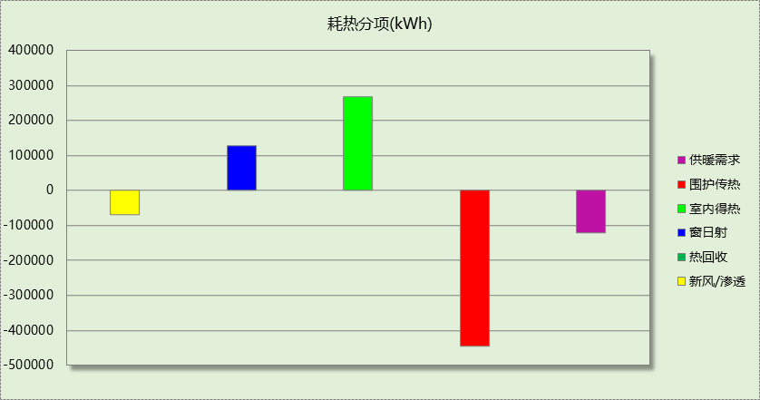

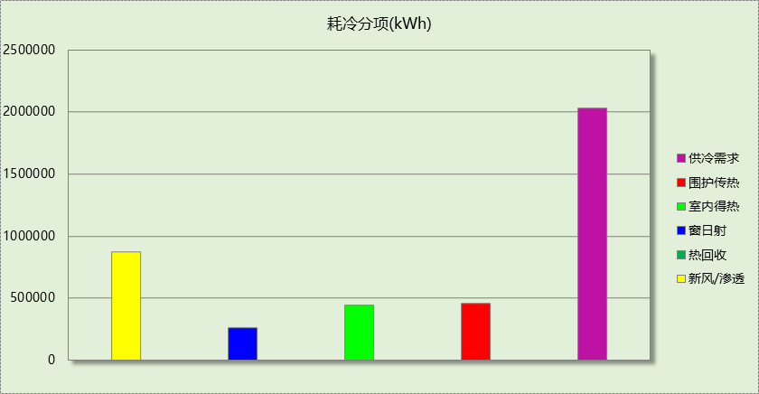

## 逐月负荷表

|  |  |  |  |  |  |  |
| --- | --- | --- | --- | --- | --- | --- |
| 月份 | 供暖(kWh) | 供冷(kWh) | 热负荷 峰值(kW) | 热负荷 峰值时刻 | 冷负荷 峰值(kW) | 冷负荷 峰值时刻 |
| 1月 | 47803 | 0 | 570.288 | 1月14日8时 | 0.000 | -- |
| 2月 | 37132 | 0 | 585.395 | 2月4日8时 | 0.000 | -- |
| 3月 | 0 | 0 | 0.000 | -- | 0.000 | -- |
| 4月 | 0 | 0 | 0.000 | -- | 0.000 | -- |
| 5月 | 0 | 0 | 0.000 | -- | 0.000 | -- |
| 6月 | 0 | 203918 | 0.000 | -- | 3325.435 | 6月14日8时 |
| 7月 | 0 | 971846 | 0.000 | -- | 6172.856 | 7月8日8时 |
| 8月 | 0 | 854076 | 0.000 | -- | 5086.753 | 8月19日8时 |
| 9月 | 0 | 0 | 0.000 | -- | 0.000 | -- |
| 10月 | 0 | 0 | 0.000 | -- | 0.000 | -- |
| 11月 | 0 | 0 | 0.000 | -- | 0.000 | -- |
| 12月 | 34997 | 0 | 483.938 | 12月2日8时 | 0.000 | -- |

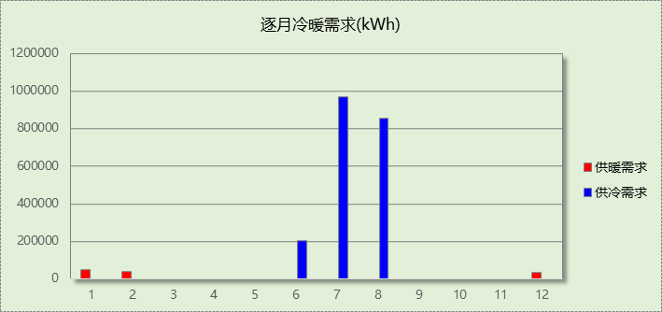

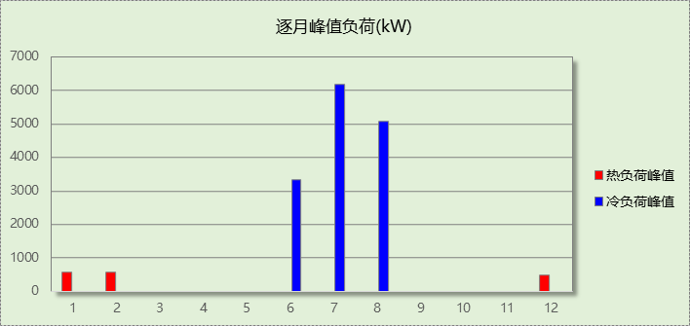

# 基准建筑

## 房间类型

### 房间参数表

|  |  |  |  |  |  |  |  |
| --- | --- | --- | --- | --- | --- | --- | --- |
| 房间类型 | 空调 温度℃ | 供暖 温度℃ | 新风量 | 渗透风 换气次数 | 人员密度 | 照明功率 密度 | 电器设备 功率 |
| 办公-普通办公室 | 26 | 20 | 30(m3/h.人) | 0(次/h) | 10(㎡/人) | 9(W/㎡) | 13(W/㎡) |
| 卫生间 | 26 | 20 | 30(m3/h.人) | 0(次/h) | 10(㎡/人) | 9(W/㎡) | 13(W/㎡) |
| 厨房 | 26 | 20 | 30(m3/h.人) | 0(次/h) | 10(㎡/人) | 9(W/㎡) | 13(W/㎡) |
| 大厅 | 26 | 20 | 30(m3/h.人) | 0(次/h) | 20(㎡/人) | 5(W/㎡) | 0(W/㎡) |
| 开水间 | － | － | 20(m3/h.人) | 0(次/h) | 50(㎡/人) | 0(W/㎡) | 0(W/㎡) |
| 接待室 | 26 | 20 | 30(m3/h.人) | 0(次/h) | 10(㎡/人) | 9(W/㎡) | 13(W/㎡) |
| 普通办公室 | 26 | 20 | 30(m3/h.人) | 0(次/h) | 10(㎡/人) | 9(W/㎡) | 13(W/㎡) |
| 楼梯间 | － | － | 20(m3/h.人) | 0(次/h) | 50(㎡/人) | 0(W/㎡) | 0(W/㎡) |
| 空房间 | － | － | 20(m3/h.人) | 0(次/h) | 50(㎡/人) | 0(W/㎡) | 0(W/㎡) |
| 设备间 | － | － | 0(m3/h.人) | 0(次/h) | 0(人) | 5(W/㎡) | 0(W/㎡) |
| 走廊 | 26 | 20 | 30(m3/h.人) | 0(次/h) | 20(㎡/人) | 5(W/㎡) | 0(W/㎡) |
| 餐厅 | 26 | 20 | 30(m3/h.人) | 0(次/h) | 10(㎡/人) | 9(W/㎡) | 13(W/㎡) |

### 作息时间表

同设计建筑

## 系统类型

|  |  |  |  |  |  |
| --- | --- | --- | --- | --- | --- |
| 系统编号 | 系统类型 | 制冷 SEER | 制热 HSPF | 面积(㎡) | 包含的房间 |
| 默认 | 双管制风机盘管 | － | － | 同设计建筑 | 同设计建筑 |
| Sys15 | 双管制风机盘管 | － | － | 同设计建筑 | 同设计建筑 |
| Sys16 | 双管制风机盘管 | － | － | 同设计建筑 | 同设计建筑 |
| Sys17 | 双管制风机盘管 | － | － | 同设计建筑 | 同设计建筑 |
| Sys18 | 双管制风机盘管 | － | － | 同设计建筑 | 同设计建筑 |
| Sys19-20 | 双管制风机盘管 | － | － | 同设计建筑 | 同设计建筑 |
| Sys2 | 双管制风机盘管 | － | － | 同设计建筑 | 同设计建筑 |
| Sys21 | 双管制风机盘管 | － | － | 同设计建筑 | 同设计建筑 |
| Sys22 | 双管制风机盘管 | － | － | 同设计建筑 | 同设计建筑 |
| Sys2群 | 双管制风机盘管 | － | － | 同设计建筑 | 同设计建筑 |
| Sys3 | 双管制风机盘管 | － | － | 同设计建筑 | 同设计建筑 |
| Sys4 | 双管制风机盘管 | － | － | 同设计建筑 | 同设计建筑 |
| Sys5 | 双管制风机盘管 | － | － | 同设计建筑 | 同设计建筑 |
| Sys6-14 | 双管制风机盘管 | － | － | 同设计建筑 | 同设计建筑 |
| 风机盘管 | 双管制风机盘管 | － | － | 同设计建筑 | 同设计建筑 |

## 制冷系统

### 冷源1

#### 供应的系统

|  |  |
| --- | --- |
| 系统编号 | 默认, Sys15, Sys16, Sys17, Sys18, Sys19-20, Sys2, Sys21, Sys22, Sys2群, Sys3, Sys4, Sys5, Sys6-14, 风机盘管 |

#### 冷水机组

|  |  |  |  |  |  |  |  |  |
| --- | --- | --- | --- | --- | --- | --- | --- | --- |
| 名称 | 类型 | 额定 耗电量(kW) | 额定 制冷量(kW) | 额定性 能系数 (COP) | 台数 | 全年 供冷量(kWh) | 综合部分 负荷性能系数(IPLV) | 电耗 (kWh) |
| 机组1 | 水冷-螺杆式冷水机组 | 178.15 | 926.37 | 5.20 | 2 | 677738 | 5.90 | 114871 |
| 机组1 | 水冷-螺杆式冷水机组 | 402.53 | 2254.17 | 5.60 | 2 | 1649163 | 6.30 | 261772 |
| 合计 | | | | | | | | 376643 |

#### 冷却水泵

|  |  |  |  |  |  |  |
| --- | --- | --- | --- | --- | --- | --- |
| 机组名称 | 冷水机组 制冷量(kW) | 机组性能 系数(COP) | 冷凝负荷(kW) | 输送能效比 | 运行时长 (h) | 水泵电耗 (kWh) |
| 机组1 | 1853 | 5.20 | 2209 | 0.0214 | 616 | 29120 |
| 机组1 | 4508 | 5.60 | 5313 | 70043 |
| 合计 | 6361 |  | 7522 |  |  | 99164 |

#### 冷冻水泵

|  |  |  |  |  |
| --- | --- | --- | --- | --- |
| 机组名称 | 机组制冷量(kW) | 输送能效比 | 运行时长(h) | 水泵电耗(kWh) |
| 机组1 | 1853 | 0.0241 | 616 | 27505 |
| 机组1 | 4508 | 66929 |
| 合计 | 6361 |  |  | 94434 |

#### 冷却塔

|  |  |  |  |  |  |
| --- | --- | --- | --- | --- | --- |
| 类型 | 机组制冷量(kW) | 冷却塔风机单位 电耗制冷量(kW/kW) | 冷却塔风机 功率(kW) | 运行时长(h) | 冷却塔电耗 (kWh) |
| 冷却塔 | 6361 | 170 | 10.90 | 616 | 23050 |

## 供暖系统

### 默认热源

#### 供应的系统

|  |  |
| --- | --- |
| 系统编号 | 默认, Sys15, Sys16, Sys17, Sys18, Sys19-20, Sys2, Sys21, Sys22, Sys2群, Sys3, Sys4, Sys5, Sys6-14, 风机盘管 |

#### 热水锅炉能耗

|  |  |  |  |  |  |  |  |
| --- | --- | --- | --- | --- | --- | --- | --- |
| 燃料类型 | 容量 (MW) | 台数 | 累计热负荷 (kWh) | 锅炉 热效率 | 外网热 输送效率 | 天然气热值(kWh/m3) | 天然气消耗(m3) |
| 燃气 | 0.75 | 1 | 142656 | 0.88 | 0.92 | 9.85 | 17888.89 |

#### 热水循环水泵能耗

|  |  |  |  |
| --- | --- | --- | --- |
| 锅炉制热量(kW) | 输送能效比 | 运行时长(h) | 供暖水泵电耗(kWh) |
| 746 | 0.00433 | 671 | 2169 |

## 照明

|  |  |  |  |  |
| --- | --- | --- | --- | --- |
| 房间类型 | 单位面积电耗 (kWh/㎡) | 房间个数 | 房间合计面积 (㎡) | 合计电耗 (kWh) |
| 卫生间 | 27.00 | 123 | 1431 | 38642 |
| 厨房 | 27.00 | 2 | 703 | 18981 |
| 大厅 | 15.00 | 3 | 3464 | 51953 |
| 开水间 | 0.00 | 38 | 461 | 0 |
| 接待室 | 27.00 | 1 | 65 | 1756 |
| 普通办公室 | 27.00 | 43 | 44882 | 1211819 |
| 楼梯间 | 0.00 | 103 | 2728 | 0 |
| 空房间 | 0.00 | 294 | 10948 | 0 |
| 设备间 | 0.00 | 974 | 4920 | 0 |
| 走廊 | 15.00 | 4 | 89 | 1341 |
| 餐厅 | 27.00 | 1 | 739 | 19950 |
| 总计 | | | | 1344443 |

## 生活热水

### 热水需求

|  |  |  |  |  |  |
| --- | --- | --- | --- | --- | --- |
| 分区 | 用水定额 (L/人·d) | 热水温差(℃) | 用水人数 | 年使用天数 | 所需热量 (kWh/a) |
| 办公 | 5 | 45 | 1000 | 365 | 93892 |
| 总计 | | | | | 93892 |

### 热水设备

|  |  |  |  |  |  |
| --- | --- | --- | --- | --- | --- |
| 热水设备 | 供热比例 | 供热量(kWh/a) | 能源 | 效率 | 耗气量(m3/a) |
| 锅炉 | 1 | 93892 | 天然气 | 0.9 | 10591.3 |
| 备注 |  | | | | |

## 电梯

### 直梯

|  |  |  |  |  |  |  |  |  |
| --- | --- | --- | --- | --- | --- | --- | --- | --- |
| 名称 | 特定能量消耗(mWh/kgm) | 额定载重量(kg) | 速度(m/s) | 待机功率(W) | 运行时长(h/天) | 年运行天数 | 数量 | 全年电耗 (kWh) |
| 直梯1 | 1.26 | 1600 | 1.75 | 200 | 1.5 | 365 | 2 | 17192 |
| 直梯2 | 1.26 | 1600 | 1.75 | 200 | 1.5 | 365 | 6 | 51577 |
| 直梯3 | 1.26 | 1050 | 1.75 | 200 | 1.5 | 365 | 2 | 12412 |
| 直梯4 | 1.26 | 250 | 1.75 | 200 | 1.5 | 365 | 2 | 5458 |
| 直梯5 | 1.26 | 1600 | 1.75 | 200 | 1.5 | 365 | 6 | 51577 |
| 总计 | | | | | | | | 138216 |

## 负荷分项统计

|  |  |  |  |  |  |  |
| --- | --- | --- | --- | --- | --- | --- |
| 分类 | 围护传热 | 室内得热 | 窗日射 | 新风/渗透 | 热回收 | 合计 |
| 供暖(kWh/㎡) | -6.23 | 3.49 | 1.76 | -0.91 | 0.00 | -1.89 |
| 供冷(kWh/㎡) | 7.91 | 6.64 | 4.46 | 11.77 | 0.00 | 30.79 |

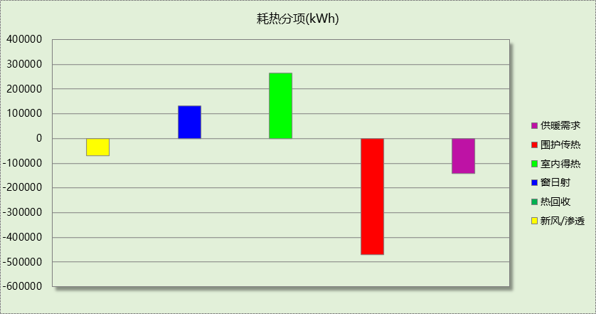

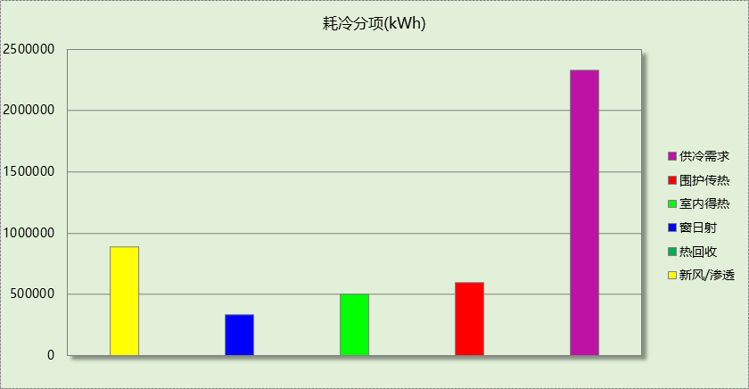

## 逐月负荷表

|  |  |  |  |  |  |  |
| --- | --- | --- | --- | --- | --- | --- |
| 月份 | 供暖(kWh) | 供冷(kWh) | 热负荷 峰值(kW) | 热负荷 峰值时刻 | 冷负荷 峰值(kW) | 冷负荷 峰值时刻 |
| 1月 | 57024 | 0 | 657.875 | 1月14日8时 | 0.000 | -- |
| 2月 | 43396 | 0 | 669.058 | 2月4日8时 | 0.000 | -- |
| 3月 | 0 | 0 | 0.000 | -- | 0.000 | -- |
| 4月 | 0 | 0 | 0.000 | -- | 0.000 | -- |
| 5月 | 0 | 0 | 0.000 | -- | 0.000 | -- |
| 6月 | 0 | 313301 | 0.000 | -- | 3764.611 | 6月14日8时 |
| 7月 | 0 | 1073061 | 0.000 | -- | 7094.858 | 7月8日8时 |
| 8月 | 0 | 940539 | 0.000 | -- | 5899.707 | 8月19日8时 |
| 9月 | 0 | 0 | 0.000 | -- | 0.000 | -- |
| 10月 | 0 | 0 | 0.000 | -- | 0.000 | -- |
| 11月 | 0 | 0 | 0.000 | -- | 0.000 | -- |
| 12月 | 42236 | 0 | 564.792 | 12月2日8时 | 0.000 | -- |

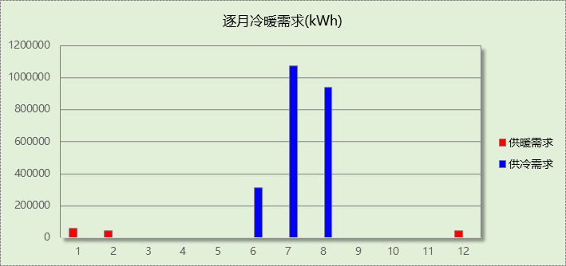

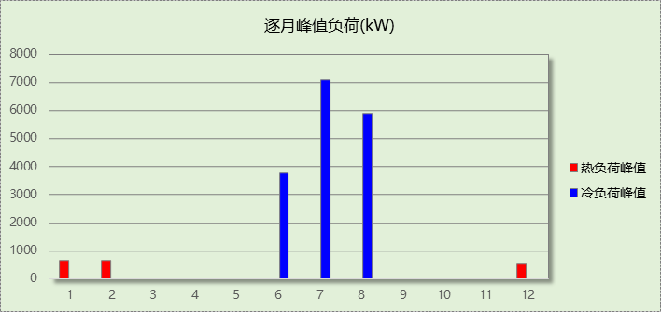

# 能效结果

## 建筑能耗

|  |  |  |  |  |
| --- | --- | --- | --- | --- |
| **设计建筑** | | | | |
| 用能分类 | | | 能耗值 | 一次能源(kWh/㎡) |
| 电力(kWh/㎡) | 供  冷 | 中央冷源 | 2.27 | 5.90 |
| 冷却水泵 | 0.09 | 0.23 |
| 冷冻水泵 | 0.10 | 0.26 |
| 冷却塔 | 0.01 | 0.03 |
| 多联机/单元式空调 | 0.00 | 0.00 |
| 供  暖 | 中央热源 | 0.40 | 1.04 |
| 供暖水泵 | 0.21 | 0.55 |
| 多联机/单元式热泵 | 0.00 | 0.00 |
| 热源侧水泵 | 0.00 | 0.00 |
| 照明 | | 15.89 | 41.31 |
| 生活热水 | | 1.38 | 3.59 |
| 电梯 | | 1.83 | 4.76 |
| 标准煤(kgce/㎡) | 供暖锅炉 | | 0.00 | 0.00 |
| 天然气(m³/㎡) | 供暖锅炉 | | 0.00 | 0.00 |
| 生活热水 | | 0.00 | 0.00 |
| 市政热力(kWh/㎡) | 市政热力 | | 0.00 | 0.00 |
| 可再生发电  (kWh/㎡) | 光伏发电 | | 11.90 | 30.94 |
| 风力发电 | | 0.00 | 0.00 |
| 建筑本体能耗(一次能源) (kWh/㎡) | | | 57.63 | |
| 建筑综合能耗(一次能源) (kWh/㎡) | | | 26.68 | |

|  |  |  |  |  |
| --- | --- | --- | --- | --- |
| **基准建筑** | | | | |
| 用能分类 | | | 能耗值 | 一次能源(kWh/㎡) |
| 电力(kWh/㎡) | 供  冷 | 中央冷源 | 4.98 | 12.95 |
| 冷却水泵 | 1.31 | 3.41 |
| 冷冻水泵 | 1.25 | 3.25 |
| 冷却塔 | 0.30 | 0.78 |
| 多联机/单元式空调 | 0.00 | 0.00 |
| 供  暖 | 中央热源 | 0.00 | 0.00 |
| 供暖水泵 | 0.03 | 0.08 |
| 多联机/单元式热泵 | 0.00 | 0.00 |
| 照明 | | 17.79 | 46.25 |
| 生活热水 | | 0.00 | 0.00 |
| 电梯 | | 1.83 | 4.76 |
| 标准煤(kgce/㎡) | 供暖锅炉 | | 0.00 | 0.00 |
| 天然气(m³/㎡) | 供暖锅炉 | | 0.24 | 2.36 |
| 生活热水 | | 0.14 | 1.38 |
| 市政热力(kWh/㎡) | 市政热力 | | 0.00 | 0.00 |
| 建筑本体能耗(一次能源) (kWh/㎡) | | | 75.20 | |
| 建筑综合能耗(一次能源) (kWh/㎡) | | | 75.20 | |

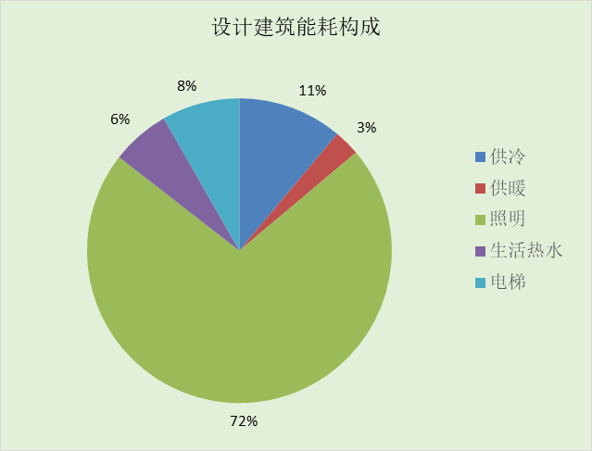

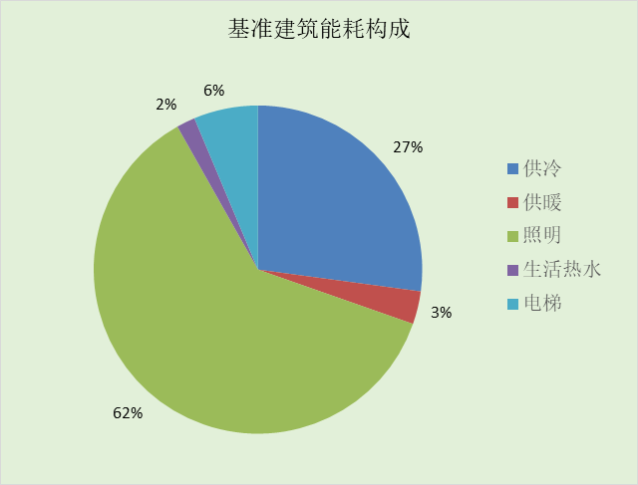

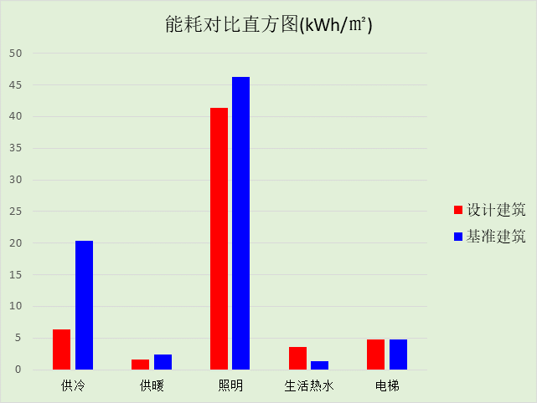

## 结论

|  |  |  |
| --- | --- | --- |
|  | 设计建筑 | 基准建筑 |
| 建筑本体能耗(一次能源) (kWh/㎡) | 57.63 | 75.20 |
| 建筑综合能耗(一次能源) (kWh/㎡) | 26.68 | 75.20 |
|  | 值 | 限值 |
| 建筑本体能耗节能率(%) | 23.36 | 20.00 |
| 建筑综合能耗节能率(%) | 64.52 | 50.00 |
| 标准依据 | 《近零能耗建筑技术标准》(GB/T51350-2019)表5.0.4 | |
| 标准要求 | 建筑综合节能率应≥50%; 建筑本体节能率应符合表5.0.4的要求 | |
| 结论 | 满足 | |

# 附录

## 工作日/节假日人员逐时在室率(%)

|  |  |  |  |  |  |  |  |  |  |  |  |  |  |  |  |  |  |  |  |  |  |  |  |  |
| --- | --- | --- | --- | --- | --- | --- | --- | --- | --- | --- | --- | --- | --- | --- | --- | --- | --- | --- | --- | --- | --- | --- | --- | --- |
| 房间类型 | 1 | 2 | 3 | 4 | 5 | 6 | 7 | 8 | 9 | 10 | 11 | 12 | 13 | 14 | 15 | 16 | 17 | 18 | 19 | 20 | 21 | 22 | 23 | 24 |
| 办公-普通办公室 | 0 | 0 | 0 | 0 | 0 | 0 | 0 | 33 | 33 | 33 | 33 | 33 | 33 | 33 | 33 | 33 | 33 | 33 | 0 | 0 | 0 | 0 | 0 | 0 |
| 0 | 0 | 0 | 0 | 0 | 0 | 0 | 0 | 0 | 0 | 0 | 0 | 0 | 0 | 0 | 0 | 0 | 0 | 0 | 0 | 0 | 0 | 0 | 0 |
| 卫生间 | 0 | 0 | 0 | 0 | 0 | 0 | 0 | 33 | 33 | 33 | 33 | 33 | 33 | 33 | 33 | 33 | 33 | 33 | 0 | 0 | 0 | 0 | 0 | 0 |
| 0 | 0 | 0 | 0 | 0 | 0 | 0 | 0 | 0 | 0 | 0 | 0 | 0 | 0 | 0 | 0 | 0 | 0 | 0 | 0 | 0 | 0 | 0 | 0 |
| 厨房 | 0 | 0 | 0 | 0 | 0 | 0 | 0 | 33 | 33 | 33 | 33 | 33 | 33 | 33 | 33 | 33 | 33 | 33 | 0 | 0 | 0 | 0 | 0 | 0 |
| 0 | 0 | 0 | 0 | 0 | 0 | 0 | 0 | 0 | 0 | 0 | 0 | 0 | 0 | 0 | 0 | 0 | 0 | 0 | 0 | 0 | 0 | 0 | 0 |
| 大厅 | 0 | 0 | 0 | 0 | 0 | 0 | 0 | 33 | 33 | 33 | 33 | 33 | 33 | 33 | 33 | 33 | 33 | 33 | 0 | 0 | 0 | 0 | 0 | 0 |
| 0 | 0 | 0 | 0 | 0 | 0 | 0 | 0 | 0 | 0 | 0 | 0 | 0 | 0 | 0 | 0 | 0 | 0 | 0 | 0 | 0 | 0 | 0 | 0 |
| 开水间 | 0 | 0 | 0 | 0 | 0 | 0 | 0 | 20 | 50 | 80 | 80 | 80 | 80 | 80 | 80 | 80 | 80 | 80 | 80 | 70 | 50 | 0 | 0 | 0 |
| 0 | 0 | 0 | 0 | 0 | 0 | 0 | 0 | 0 | 0 | 0 | 0 | 0 | 0 | 0 | 0 | 0 | 0 | 0 | 0 | 0 | 0 | 0 | 0 |
| 接待室 | 0 | 0 | 0 | 0 | 0 | 0 | 0 | 33 | 33 | 33 | 33 | 33 | 33 | 33 | 33 | 33 | 33 | 33 | 0 | 0 | 0 | 0 | 0 | 0 |
| 0 | 0 | 0 | 0 | 0 | 0 | 0 | 0 | 0 | 0 | 0 | 0 | 0 | 0 | 0 | 0 | 0 | 0 | 0 | 0 | 0 | 0 | 0 | 0 |
| 普通办公室 | 0 | 0 | 0 | 0 | 0 | 0 | 0 | 33 | 33 | 33 | 33 | 33 | 33 | 33 | 33 | 33 | 33 | 33 | 0 | 0 | 0 | 0 | 0 | 0 |
| 0 | 0 | 0 | 0 | 0 | 0 | 0 | 0 | 0 | 0 | 0 | 0 | 0 | 0 | 0 | 0 | 0 | 0 | 0 | 0 | 0 | 0 | 0 | 0 |
| 楼梯间 | 0 | 0 | 0 | 0 | 0 | 0 | 0 | 20 | 50 | 80 | 80 | 80 | 80 | 80 | 80 | 80 | 80 | 80 | 80 | 70 | 50 | 0 | 0 | 0 |
| 0 | 0 | 0 | 0 | 0 | 0 | 0 | 0 | 0 | 0 | 0 | 0 | 0 | 0 | 0 | 0 | 0 | 0 | 0 | 0 | 0 | 0 | 0 | 0 |
| 空房间 | 0 | 0 | 0 | 0 | 0 | 0 | 0 | 20 | 50 | 80 | 80 | 80 | 80 | 80 | 80 | 80 | 80 | 80 | 80 | 70 | 50 | 0 | 0 | 0 |
| 0 | 0 | 0 | 0 | 0 | 0 | 0 | 0 | 0 | 0 | 0 | 0 | 0 | 0 | 0 | 0 | 0 | 0 | 0 | 0 | 0 | 0 | 0 | 0 |
| 设备间 | 0 | 0 | 0 | 0 | 0 | 0 | 0 | 0 | 0 | 0 | 0 | 0 | 0 | 0 | 0 | 0 | 0 | 0 | 0 | 0 | 0 | 0 | 0 | 0 |
| 0 | 0 | 0 | 0 | 0 | 0 | 0 | 0 | 0 | 0 | 0 | 0 | 0 | 0 | 0 | 0 | 0 | 0 | 0 | 0 | 0 | 0 | 0 | 0 |
| 走廊 | 0 | 0 | 0 | 0 | 0 | 0 | 0 | 33 | 33 | 33 | 33 | 33 | 33 | 33 | 33 | 33 | 33 | 33 | 0 | 0 | 0 | 0 | 0 | 0 |
| 0 | 0 | 0 | 0 | 0 | 0 | 0 | 0 | 0 | 0 | 0 | 0 | 0 | 0 | 0 | 0 | 0 | 0 | 0 | 0 | 0 | 0 | 0 | 0 |
| 餐厅 | 0 | 0 | 0 | 0 | 0 | 0 | 0 | 33 | 33 | 33 | 33 | 33 | 33 | 33 | 33 | 33 | 33 | 33 | 0 | 0 | 0 | 0 | 0 | 0 |
| 0 | 0 | 0 | 0 | 0 | 0 | 0 | 0 | 0 | 0 | 0 | 0 | 0 | 0 | 0 | 0 | 0 | 0 | 0 | 0 | 0 | 0 | 0 | 0 |

注：上行：工作日；下行：节假日

## 工作日/节假日照明开关时间表(%)

|  |  |  |  |  |  |  |  |  |  |  |  |  |  |  |  |  |  |  |  |  |  |  |  |  |
| --- | --- | --- | --- | --- | --- | --- | --- | --- | --- | --- | --- | --- | --- | --- | --- | --- | --- | --- | --- | --- | --- | --- | --- | --- |
| 房间类型 | 1 | 2 | 3 | 4 | 5 | 6 | 7 | 8 | 9 | 10 | 11 | 12 | 13 | 14 | 15 | 16 | 17 | 18 | 19 | 20 | 21 | 22 | 23 | 24 |
| 办公-普通办公室 | 0 | 0 | 0 | 0 | 0 | 0 | 0 | 100 | 100 | 100 | 100 | 100 | 100 | 100 | 100 | 100 | 100 | 100 | 100 | 0 | 0 | 0 | 0 | 0 |
| 0 | 0 | 0 | 0 | 0 | 0 | 0 | 0 | 0 | 0 | 0 | 0 | 0 | 0 | 0 | 0 | 0 | 0 | 0 | 0 | 0 | 0 | 0 | 0 |
| 卫生间 | 0 | 0 | 0 | 0 | 0 | 0 | 0 | 100 | 100 | 100 | 100 | 100 | 100 | 100 | 100 | 100 | 100 | 100 | 100 | 0 | 0 | 0 | 0 | 0 |
| 0 | 0 | 0 | 0 | 0 | 0 | 0 | 0 | 0 | 0 | 0 | 0 | 0 | 0 | 0 | 0 | 0 | 0 | 0 | 0 | 0 | 0 | 0 | 0 |
| 厨房 | 0 | 0 | 0 | 0 | 0 | 0 | 0 | 100 | 100 | 100 | 100 | 100 | 100 | 100 | 100 | 100 | 100 | 100 | 100 | 0 | 0 | 0 | 0 | 0 |
| 0 | 0 | 0 | 0 | 0 | 0 | 0 | 0 | 0 | 0 | 0 | 0 | 0 | 0 | 0 | 0 | 0 | 0 | 0 | 0 | 0 | 0 | 0 | 0 |
| 大厅 | 0 | 0 | 0 | 0 | 0 | 0 | 0 | 100 | 100 | 100 | 100 | 100 | 100 | 100 | 100 | 100 | 100 | 100 | 100 | 0 | 0 | 0 | 0 | 0 |
| 0 | 0 | 0 | 0 | 0 | 0 | 0 | 0 | 0 | 0 | 0 | 0 | 0 | 0 | 0 | 0 | 0 | 0 | 0 | 0 | 0 | 0 | 0 | 0 |
| 开水间 | 10 | 10 | 10 | 10 | 10 | 10 | 10 | 50 | 60 | 60 | 60 | 60 | 60 | 60 | 60 | 60 | 80 | 90 | 100 | 100 | 100 | 10 | 10 | 10 |
| 0 | 0 | 0 | 0 | 0 | 0 | 0 | 0 | 0 | 0 | 0 | 0 | 0 | 0 | 0 | 0 | 0 | 0 | 0 | 0 | 0 | 0 | 0 | 0 |
| 接待室 | 0 | 0 | 0 | 0 | 0 | 0 | 0 | 100 | 100 | 100 | 100 | 100 | 100 | 100 | 100 | 100 | 100 | 100 | 100 | 0 | 0 | 0 | 0 | 0 |
| 0 | 0 | 0 | 0 | 0 | 0 | 0 | 0 | 0 | 0 | 0 | 0 | 0 | 0 | 0 | 0 | 0 | 0 | 0 | 0 | 0 | 0 | 0 | 0 |
| 普通办公室 | 0 | 0 | 0 | 0 | 0 | 0 | 0 | 100 | 100 | 100 | 100 | 100 | 100 | 100 | 100 | 100 | 100 | 100 | 100 | 0 | 0 | 0 | 0 | 0 |
| 0 | 0 | 0 | 0 | 0 | 0 | 0 | 0 | 0 | 0 | 0 | 0 | 0 | 0 | 0 | 0 | 0 | 0 | 0 | 0 | 0 | 0 | 0 | 0 |
| 楼梯间 | 10 | 10 | 10 | 10 | 10 | 10 | 10 | 50 | 60 | 60 | 60 | 60 | 60 | 60 | 60 | 60 | 80 | 90 | 100 | 100 | 100 | 10 | 10 | 10 |
| 0 | 0 | 0 | 0 | 0 | 0 | 0 | 0 | 0 | 0 | 0 | 0 | 0 | 0 | 0 | 0 | 0 | 0 | 0 | 0 | 0 | 0 | 0 | 0 |
| 空房间 | 10 | 10 | 10 | 10 | 10 | 10 | 10 | 50 | 60 | 60 | 60 | 60 | 60 | 60 | 60 | 60 | 80 | 90 | 100 | 100 | 100 | 10 | 10 | 10 |
| 0 | 0 | 0 | 0 | 0 | 0 | 0 | 0 | 0 | 0 | 0 | 0 | 0 | 0 | 0 | 0 | 0 | 0 | 0 | 0 | 0 | 0 | 0 | 0 |
| 设备间 | 0 | 0 | 0 | 0 | 0 | 0 | 0 | 0 | 0 | 0 | 0 | 0 | 0 | 0 | 0 | 0 | 0 | 0 | 0 | 0 | 0 | 0 | 0 | 0 |
| 0 | 0 | 0 | 0 | 0 | 0 | 0 | 0 | 0 | 0 | 0 | 0 | 0 | 0 | 0 | 0 | 0 | 0 | 0 | 0 | 0 | 0 | 0 | 0 |
| 走廊 | 0 | 0 | 0 | 0 | 0 | 0 | 0 | 100 | 100 | 100 | 100 | 100 | 100 | 100 | 100 | 100 | 100 | 100 | 100 | 0 | 0 | 0 | 0 | 0 |
| 0 | 0 | 0 | 0 | 0 | 0 | 0 | 0 | 0 | 0 | 0 | 0 | 0 | 0 | 0 | 0 | 0 | 0 | 0 | 0 | 0 | 0 | 0 | 0 |
| 餐厅 | 0 | 0 | 0 | 0 | 0 | 0 | 0 | 100 | 100 | 100 | 100 | 100 | 100 | 100 | 100 | 100 | 100 | 100 | 100 | 0 | 0 | 0 | 0 | 0 |
| 0 | 0 | 0 | 0 | 0 | 0 | 0 | 0 | 0 | 0 | 0 | 0 | 0 | 0 | 0 | 0 | 0 | 0 | 0 | 0 | 0 | 0 | 0 | 0 |

注：上行：工作日；下行：节假日

## 工作日/节假日设备逐时使用率(%)

|  |  |  |  |  |  |  |  |  |  |  |  |  |  |  |  |  |  |  |  |  |  |  |  |  |
| --- | --- | --- | --- | --- | --- | --- | --- | --- | --- | --- | --- | --- | --- | --- | --- | --- | --- | --- | --- | --- | --- | --- | --- | --- |
| 房间类型 | 1 | 2 | 3 | 4 | 5 | 6 | 7 | 8 | 9 | 10 | 11 | 12 | 13 | 14 | 15 | 16 | 17 | 18 | 19 | 20 | 21 | 22 | 23 | 24 |
| 办公-普通办公室 | 0 | 0 | 0 | 0 | 0 | 0 | 0 | 33 | 33 | 33 | 33 | 33 | 33 | 33 | 33 | 33 | 33 | 33 | 0 | 0 | 0 | 0 | 0 | 0 |
| 0 | 0 | 0 | 0 | 0 | 0 | 0 | 0 | 0 | 0 | 0 | 0 | 0 | 0 | 0 | 0 | 0 | 0 | 0 | 0 | 0 | 0 | 0 | 0 |
| 卫生间 | 0 | 0 | 0 | 0 | 0 | 0 | 0 | 33 | 33 | 33 | 33 | 33 | 33 | 33 | 33 | 33 | 33 | 33 | 0 | 0 | 0 | 0 | 0 | 0 |
| 0 | 0 | 0 | 0 | 0 | 0 | 0 | 0 | 0 | 0 | 0 | 0 | 0 | 0 | 0 | 0 | 0 | 0 | 0 | 0 | 0 | 0 | 0 | 0 |
| 厨房 | 0 | 0 | 0 | 0 | 0 | 0 | 0 | 33 | 33 | 33 | 33 | 33 | 33 | 33 | 33 | 33 | 33 | 33 | 0 | 0 | 0 | 0 | 0 | 0 |
| 0 | 0 | 0 | 0 | 0 | 0 | 0 | 0 | 0 | 0 | 0 | 0 | 0 | 0 | 0 | 0 | 0 | 0 | 0 | 0 | 0 | 0 | 0 | 0 |
| 大厅 | 0 | 0 | 0 | 0 | 0 | 0 | 0 | 0 | 0 | 0 | 0 | 0 | 0 | 0 | 0 | 0 | 0 | 0 | 0 | 0 | 0 | 0 | 0 | 0 |
| 0 | 0 | 0 | 0 | 0 | 0 | 0 | 0 | 0 | 0 | 0 | 0 | 0 | 0 | 0 | 0 | 0 | 0 | 0 | 0 | 0 | 0 | 0 | 0 |
| 开水间 | 0 | 0 | 0 | 0 | 0 | 0 | 0 | 30 | 50 | 80 | 80 | 80 | 80 | 80 | 80 | 80 | 80 | 80 | 80 | 70 | 50 | 0 | 0 | 0 |
| 0 | 0 | 0 | 0 | 0 | 0 | 0 | 0 | 0 | 0 | 0 | 0 | 0 | 0 | 0 | 0 | 0 | 0 | 0 | 0 | 0 | 0 | 0 | 0 |
| 接待室 | 0 | 0 | 0 | 0 | 0 | 0 | 0 | 33 | 33 | 33 | 33 | 33 | 33 | 33 | 33 | 33 | 33 | 33 | 0 | 0 | 0 | 0 | 0 | 0 |
| 0 | 0 | 0 | 0 | 0 | 0 | 0 | 0 | 0 | 0 | 0 | 0 | 0 | 0 | 0 | 0 | 0 | 0 | 0 | 0 | 0 | 0 | 0 | 0 |
| 普通办公室 | 0 | 0 | 0 | 0 | 0 | 0 | 0 | 33 | 33 | 33 | 33 | 33 | 33 | 33 | 33 | 33 | 33 | 33 | 0 | 0 | 0 | 0 | 0 | 0 |
| 0 | 0 | 0 | 0 | 0 | 0 | 0 | 0 | 0 | 0 | 0 | 0 | 0 | 0 | 0 | 0 | 0 | 0 | 0 | 0 | 0 | 0 | 0 | 0 |
| 楼梯间 | 0 | 0 | 0 | 0 | 0 | 0 | 0 | 30 | 50 | 80 | 80 | 80 | 80 | 80 | 80 | 80 | 80 | 80 | 80 | 70 | 50 | 0 | 0 | 0 |
| 0 | 0 | 0 | 0 | 0 | 0 | 0 | 0 | 0 | 0 | 0 | 0 | 0 | 0 | 0 | 0 | 0 | 0 | 0 | 0 | 0 | 0 | 0 | 0 |
| 空房间 | 0 | 0 | 0 | 0 | 0 | 0 | 0 | 30 | 50 | 80 | 80 | 80 | 80 | 80 | 80 | 80 | 80 | 80 | 80 | 70 | 50 | 0 | 0 | 0 |
| 0 | 0 | 0 | 0 | 0 | 0 | 0 | 0 | 0 | 0 | 0 | 0 | 0 | 0 | 0 | 0 | 0 | 0 | 0 | 0 | 0 | 0 | 0 | 0 |
| 设备间 | 0 | 0 | 0 | 0 | 0 | 0 | 0 | 0 | 0 | 0 | 0 | 0 | 0 | 0 | 0 | 0 | 0 | 0 | 0 | 0 | 0 | 0 | 0 | 0 |
| 0 | 0 | 0 | 0 | 0 | 0 | 0 | 0 | 0 | 0 | 0 | 0 | 0 | 0 | 0 | 0 | 0 | 0 | 0 | 0 | 0 | 0 | 0 | 0 |
| 走廊 | 0 | 0 | 0 | 0 | 0 | 0 | 0 | 0 | 0 | 0 | 0 | 0 | 0 | 0 | 0 | 0 | 0 | 0 | 0 | 0 | 0 | 0 | 0 | 0 |
| 0 | 0 | 0 | 0 | 0 | 0 | 0 | 0 | 0 | 0 | 0 | 0 | 0 | 0 | 0 | 0 | 0 | 0 | 0 | 0 | 0 | 0 | 0 | 0 |
| 餐厅 | 0 | 0 | 0 | 0 | 0 | 0 | 0 | 33 | 33 | 33 | 33 | 33 | 33 | 33 | 33 | 33 | 33 | 33 | 0 | 0 | 0 | 0 | 0 | 0 |
| 0 | 0 | 0 | 0 | 0 | 0 | 0 | 0 | 0 | 0 | 0 | 0 | 0 | 0 | 0 | 0 | 0 | 0 | 0 | 0 | 0 | 0 | 0 | 0 |

注：上行：工作日；下行：节假日

## 工作日/节假日空调系统运行时间表(1:开,0:关)

采暖期：

|  |  |  |  |  |  |  |  |  |  |  |  |  |  |  |  |  |  |  |  |  |  |  |  |  |
| --- | --- | --- | --- | --- | --- | --- | --- | --- | --- | --- | --- | --- | --- | --- | --- | --- | --- | --- | --- | --- | --- | --- | --- | --- |
| 系统编号 | 1 | 2 | 3 | 4 | 5 | 6 | 7 | 8 | 9 | 10 | 11 | 12 | 13 | 14 | 15 | 16 | 17 | 18 | 19 | 20 | 21 | 22 | 23 | 24 |
| 默认 | 0 | 0 | 0 | 0 | 0 | 0 | 0 | 1 | 1 | 1 | 1 | 1 | 1 | 1 | 1 | 1 | 1 | 1 | 0 | 0 | 0 | 0 | 0 | 0 |
| 0 | 0 | 0 | 0 | 0 | 0 | 0 | 0 | 0 | 0 | 0 | 0 | 0 | 0 | 0 | 0 | 0 | 0 | 0 | 0 | 0 | 0 | 0 | 0 |
| Sys15 | 0 | 0 | 0 | 0 | 0 | 0 | 0 | 1 | 1 | 1 | 1 | 1 | 1 | 1 | 1 | 1 | 1 | 1 | 0 | 0 | 0 | 0 | 0 | 0 |
| 0 | 0 | 0 | 0 | 0 | 0 | 0 | 0 | 0 | 0 | 0 | 0 | 0 | 0 | 0 | 0 | 0 | 0 | 0 | 0 | 0 | 0 | 0 | 0 |
| Sys16 | 0 | 0 | 0 | 0 | 0 | 0 | 0 | 1 | 1 | 1 | 1 | 1 | 1 | 1 | 1 | 1 | 1 | 1 | 0 | 0 | 0 | 0 | 0 | 0 |
| 0 | 0 | 0 | 0 | 0 | 0 | 0 | 0 | 0 | 0 | 0 | 0 | 0 | 0 | 0 | 0 | 0 | 0 | 0 | 0 | 0 | 0 | 0 | 0 |
| Sys17 | 0 | 0 | 0 | 0 | 0 | 0 | 0 | 1 | 1 | 1 | 1 | 1 | 1 | 1 | 1 | 1 | 1 | 1 | 0 | 0 | 0 | 0 | 0 | 0 |
| 0 | 0 | 0 | 0 | 0 | 0 | 0 | 0 | 0 | 0 | 0 | 0 | 0 | 0 | 0 | 0 | 0 | 0 | 0 | 0 | 0 | 0 | 0 | 0 |
| Sys18 | 0 | 0 | 0 | 0 | 0 | 0 | 0 | 1 | 1 | 1 | 1 | 1 | 1 | 1 | 1 | 1 | 1 | 1 | 0 | 0 | 0 | 0 | 0 | 0 |
| 0 | 0 | 0 | 0 | 0 | 0 | 0 | 0 | 0 | 0 | 0 | 0 | 0 | 0 | 0 | 0 | 0 | 0 | 0 | 0 | 0 | 0 | 0 | 0 |
| Sys19-20 | 0 | 0 | 0 | 0 | 0 | 0 | 0 | 1 | 1 | 1 | 1 | 1 | 1 | 1 | 1 | 1 | 1 | 1 | 0 | 0 | 0 | 0 | 0 | 0 |
| 0 | 0 | 0 | 0 | 0 | 0 | 0 | 0 | 0 | 0 | 0 | 0 | 0 | 0 | 0 | 0 | 0 | 0 | 0 | 0 | 0 | 0 | 0 | 0 |
| Sys2 | 0 | 0 | 0 | 0 | 0 | 0 | 0 | 1 | 1 | 1 | 1 | 1 | 1 | 1 | 1 | 1 | 1 | 1 | 0 | 0 | 0 | 0 | 0 | 0 |
| 0 | 0 | 0 | 0 | 0 | 0 | 0 | 0 | 0 | 0 | 0 | 0 | 0 | 0 | 0 | 0 | 0 | 0 | 0 | 0 | 0 | 0 | 0 | 0 |
| Sys21 | 0 | 0 | 0 | 0 | 0 | 0 | 0 | 1 | 1 | 1 | 1 | 1 | 1 | 1 | 1 | 1 | 1 | 1 | 0 | 0 | 0 | 0 | 0 | 0 |
| 0 | 0 | 0 | 0 | 0 | 0 | 0 | 0 | 0 | 0 | 0 | 0 | 0 | 0 | 0 | 0 | 0 | 0 | 0 | 0 | 0 | 0 | 0 | 0 |
| Sys22 | 0 | 0 | 0 | 0 | 0 | 0 | 0 | 1 | 1 | 1 | 1 | 1 | 1 | 1 | 1 | 1 | 1 | 1 | 0 | 0 | 0 | 0 | 0 | 0 |
| 0 | 0 | 0 | 0 | 0 | 0 | 0 | 0 | 0 | 0 | 0 | 0 | 0 | 0 | 0 | 0 | 0 | 0 | 0 | 0 | 0 | 0 | 0 | 0 |
| Sys2群 | 0 | 0 | 0 | 0 | 0 | 0 | 0 | 1 | 1 | 1 | 1 | 1 | 1 | 1 | 1 | 1 | 1 | 1 | 0 | 0 | 0 | 0 | 0 | 0 |
| 0 | 0 | 0 | 0 | 0 | 0 | 0 | 0 | 0 | 0 | 0 | 0 | 0 | 0 | 0 | 0 | 0 | 0 | 0 | 0 | 0 | 0 | 0 | 0 |
| Sys3 | 0 | 0 | 0 | 0 | 0 | 0 | 0 | 1 | 1 | 1 | 1 | 1 | 1 | 1 | 1 | 1 | 1 | 1 | 0 | 0 | 0 | 0 | 0 | 0 |
| 0 | 0 | 0 | 0 | 0 | 0 | 0 | 0 | 0 | 0 | 0 | 0 | 0 | 0 | 0 | 0 | 0 | 0 | 0 | 0 | 0 | 0 | 0 | 0 |
| Sys4 | 0 | 0 | 0 | 0 | 0 | 0 | 0 | 1 | 1 | 1 | 1 | 1 | 1 | 1 | 1 | 1 | 1 | 1 | 0 | 0 | 0 | 0 | 0 | 0 |
| 0 | 0 | 0 | 0 | 0 | 0 | 0 | 0 | 0 | 0 | 0 | 0 | 0 | 0 | 0 | 0 | 0 | 0 | 0 | 0 | 0 | 0 | 0 | 0 |
| Sys5 | 0 | 0 | 0 | 0 | 0 | 0 | 0 | 1 | 1 | 1 | 1 | 1 | 1 | 1 | 1 | 1 | 1 | 1 | 0 | 0 | 0 | 0 | 0 | 0 |
| 0 | 0 | 0 | 0 | 0 | 0 | 0 | 0 | 0 | 0 | 0 | 0 | 0 | 0 | 0 | 0 | 0 | 0 | 0 | 0 | 0 | 0 | 0 | 0 |
| Sys6-14 | 0 | 0 | 0 | 0 | 0 | 0 | 0 | 1 | 1 | 1 | 1 | 1 | 1 | 1 | 1 | 1 | 1 | 1 | 0 | 0 | 0 | 0 | 0 | 0 |
| 0 | 0 | 0 | 0 | 0 | 0 | 0 | 0 | 0 | 0 | 0 | 0 | 0 | 0 | 0 | 0 | 0 | 0 | 0 | 0 | 0 | 0 | 0 | 0 |
| 风机盘管 | 0 | 0 | 0 | 0 | 0 | 0 | 0 | 1 | 1 | 1 | 1 | 1 | 1 | 1 | 1 | 1 | 1 | 1 | 0 | 0 | 0 | 0 | 0 | 0 |
| 0 | 0 | 0 | 0 | 0 | 0 | 0 | 0 | 0 | 0 | 0 | 0 | 0 | 0 | 0 | 0 | 0 | 0 | 0 | 0 | 0 | 0 | 0 | 0 |

供冷期：

|  |  |  |  |  |  |  |  |  |  |  |  |  |  |  |  |  |  |  |  |  |  |  |  |  |
| --- | --- | --- | --- | --- | --- | --- | --- | --- | --- | --- | --- | --- | --- | --- | --- | --- | --- | --- | --- | --- | --- | --- | --- | --- |
| 系统编号 | 1 | 2 | 3 | 4 | 5 | 6 | 7 | 8 | 9 | 10 | 11 | 12 | 13 | 14 | 15 | 16 | 17 | 18 | 19 | 20 | 21 | 22 | 23 | 24 |
| 默认 | 0 | 0 | 0 | 0 | 0 | 0 | 0 | 1 | 1 | 1 | 1 | 1 | 1 | 1 | 1 | 1 | 1 | 1 | 0 | 0 | 0 | 0 | 0 | 0 |
| 0 | 0 | 0 | 0 | 0 | 0 | 0 | 0 | 0 | 0 | 0 | 0 | 0 | 0 | 0 | 0 | 0 | 0 | 0 | 0 | 0 | 0 | 0 | 0 |
| Sys15 | 0 | 0 | 0 | 0 | 0 | 0 | 0 | 1 | 1 | 1 | 1 | 1 | 1 | 1 | 1 | 1 | 1 | 1 | 0 | 0 | 0 | 0 | 0 | 0 |
| 0 | 0 | 0 | 0 | 0 | 0 | 0 | 0 | 0 | 0 | 0 | 0 | 0 | 0 | 0 | 0 | 0 | 0 | 0 | 0 | 0 | 0 | 0 | 0 |
| Sys16 | 0 | 0 | 0 | 0 | 0 | 0 | 0 | 1 | 1 | 1 | 1 | 1 | 1 | 1 | 1 | 1 | 1 | 1 | 0 | 0 | 0 | 0 | 0 | 0 |
| 0 | 0 | 0 | 0 | 0 | 0 | 0 | 0 | 0 | 0 | 0 | 0 | 0 | 0 | 0 | 0 | 0 | 0 | 0 | 0 | 0 | 0 | 0 | 0 |
| Sys17 | 0 | 0 | 0 | 0 | 0 | 0 | 0 | 1 | 1 | 1 | 1 | 1 | 1 | 1 | 1 | 1 | 1 | 1 | 0 | 0 | 0 | 0 | 0 | 0 |
| 0 | 0 | 0 | 0 | 0 | 0 | 0 | 0 | 0 | 0 | 0 | 0 | 0 | 0 | 0 | 0 | 0 | 0 | 0 | 0 | 0 | 0 | 0 | 0 |
| Sys18 | 0 | 0 | 0 | 0 | 0 | 0 | 0 | 1 | 1 | 1 | 1 | 1 | 1 | 1 | 1 | 1 | 1 | 1 | 0 | 0 | 0 | 0 | 0 | 0 |
| 0 | 0 | 0 | 0 | 0 | 0 | 0 | 0 | 0 | 0 | 0 | 0 | 0 | 0 | 0 | 0 | 0 | 0 | 0 | 0 | 0 | 0 | 0 | 0 |
| Sys19-20 | 0 | 0 | 0 | 0 | 0 | 0 | 0 | 1 | 1 | 1 | 1 | 1 | 1 | 1 | 1 | 1 | 1 | 1 | 0 | 0 | 0 | 0 | 0 | 0 |
| 0 | 0 | 0 | 0 | 0 | 0 | 0 | 0 | 0 | 0 | 0 | 0 | 0 | 0 | 0 | 0 | 0 | 0 | 0 | 0 | 0 | 0 | 0 | 0 |
| Sys2 | 0 | 0 | 0 | 0 | 0 | 0 | 0 | 1 | 1 | 1 | 1 | 1 | 1 | 1 | 1 | 1 | 1 | 1 | 0 | 0 | 0 | 0 | 0 | 0 |
| 0 | 0 | 0 | 0 | 0 | 0 | 0 | 0 | 0 | 0 | 0 | 0 | 0 | 0 | 0 | 0 | 0 | 0 | 0 | 0 | 0 | 0 | 0 | 0 |
| Sys21 | 0 | 0 | 0 | 0 | 0 | 0 | 0 | 1 | 1 | 1 | 1 | 1 | 1 | 1 | 1 | 1 | 1 | 1 | 0 | 0 | 0 | 0 | 0 | 0 |
| 0 | 0 | 0 | 0 | 0 | 0 | 0 | 0 | 0 | 0 | 0 | 0 | 0 | 0 | 0 | 0 | 0 | 0 | 0 | 0 | 0 | 0 | 0 | 0 |
| Sys22 | 0 | 0 | 0 | 0 | 0 | 0 | 0 | 1 | 1 | 1 | 1 | 1 | 1 | 1 | 1 | 1 | 1 | 1 | 0 | 0 | 0 | 0 | 0 | 0 |
| 0 | 0 | 0 | 0 | 0 | 0 | 0 | 0 | 0 | 0 | 0 | 0 | 0 | 0 | 0 | 0 | 0 | 0 | 0 | 0 | 0 | 0 | 0 | 0 |
| Sys2群 | 0 | 0 | 0 | 0 | 0 | 0 | 0 | 1 | 1 | 1 | 1 | 1 | 1 | 1 | 1 | 1 | 1 | 1 | 0 | 0 | 0 | 0 | 0 | 0 |
| 0 | 0 | 0 | 0 | 0 | 0 | 0 | 0 | 0 | 0 | 0 | 0 | 0 | 0 | 0 | 0 | 0 | 0 | 0 | 0 | 0 | 0 | 0 | 0 |
| Sys3 | 0 | 0 | 0 | 0 | 0 | 0 | 0 | 1 | 1 | 1 | 1 | 1 | 1 | 1 | 1 | 1 | 1 | 1 | 0 | 0 | 0 | 0 | 0 | 0 |
| 0 | 0 | 0 | 0 | 0 | 0 | 0 | 0 | 0 | 0 | 0 | 0 | 0 | 0 | 0 | 0 | 0 | 0 | 0 | 0 | 0 | 0 | 0 | 0 |
| Sys4 | 0 | 0 | 0 | 0 | 0 | 0 | 0 | 1 | 1 | 1 | 1 | 1 | 1 | 1 | 1 | 1 | 1 | 1 | 0 | 0 | 0 | 0 | 0 | 0 |
| 0 | 0 | 0 | 0 | 0 | 0 | 0 | 0 | 0 | 0 | 0 | 0 | 0 | 0 | 0 | 0 | 0 | 0 | 0 | 0 | 0 | 0 | 0 | 0 |
| Sys5 | 0 | 0 | 0 | 0 | 0 | 0 | 0 | 1 | 1 | 1 | 1 | 1 | 1 | 1 | 1 | 1 | 1 | 1 | 0 | 0 | 0 | 0 | 0 | 0 |
| 0 | 0 | 0 | 0 | 0 | 0 | 0 | 0 | 0 | 0 | 0 | 0 | 0 | 0 | 0 | 0 | 0 | 0 | 0 | 0 | 0 | 0 | 0 | 0 |
| Sys6-14 | 0 | 0 | 0 | 0 | 0 | 0 | 0 | 1 | 1 | 1 | 1 | 1 | 1 | 1 | 1 | 1 | 1 | 1 | 0 | 0 | 0 | 0 | 0 | 0 |
| 0 | 0 | 0 | 0 | 0 | 0 | 0 | 0 | 0 | 0 | 0 | 0 | 0 | 0 | 0 | 0 | 0 | 0 | 0 | 0 | 0 | 0 | 0 | 0 |
| 风机盘管 | 0 | 0 | 0 | 0 | 0 | 0 | 0 | 1 | 1 | 1 | 1 | 1 | 1 | 1 | 1 | 1 | 1 | 1 | 0 | 0 | 0 | 0 | 0 | 0 |
| 0 | 0 | 0 | 0 | 0 | 0 | 0 | 0 | 0 | 0 | 0 | 0 | 0 | 0 | 0 | 0 | 0 | 0 | 0 | 0 | 0 | 0 | 0 | 0 |

注：上行：工作日；下行：节假日

## 工作日/节假日新风运行时间表(%)

采暖期：

|  |  |  |  |  |  |  |  |  |  |  |  |  |  |  |  |  |  |  |  |  |  |  |  |  |
| --- | --- | --- | --- | --- | --- | --- | --- | --- | --- | --- | --- | --- | --- | --- | --- | --- | --- | --- | --- | --- | --- | --- | --- | --- |
| 系统编号 | 1 | 2 | 3 | 4 | 5 | 6 | 7 | 8 | 9 | 10 | 11 | 12 | 13 | 14 | 15 | 16 | 17 | 18 | 19 | 20 | 21 | 22 | 23 | 24 |
| 默认 | 0 | 0 | 0 | 0 | 0 | 0 | 0 | 100 | 100 | 100 | 100 | 100 | 100 | 100 | 100 | 100 | 100 | 100 | 0 | 0 | 0 | 0 | 0 | 0 |
| 0 | 0 | 0 | 0 | 0 | 0 | 0 | 0 | 0 | 0 | 0 | 0 | 0 | 0 | 0 | 0 | 0 | 0 | 0 | 0 | 0 | 0 | 0 | 0 |
| Sys15 | 0 | 0 | 0 | 0 | 0 | 0 | 0 | 100 | 100 | 100 | 100 | 100 | 100 | 100 | 100 | 100 | 100 | 100 | 0 | 0 | 0 | 0 | 0 | 0 |
| 0 | 0 | 0 | 0 | 0 | 0 | 0 | 0 | 0 | 0 | 0 | 0 | 0 | 0 | 0 | 0 | 0 | 0 | 0 | 0 | 0 | 0 | 0 | 0 |
| Sys16 | 0 | 0 | 0 | 0 | 0 | 0 | 0 | 100 | 100 | 100 | 100 | 100 | 100 | 100 | 100 | 100 | 100 | 100 | 0 | 0 | 0 | 0 | 0 | 0 |
| 0 | 0 | 0 | 0 | 0 | 0 | 0 | 0 | 0 | 0 | 0 | 0 | 0 | 0 | 0 | 0 | 0 | 0 | 0 | 0 | 0 | 0 | 0 | 0 |
| Sys17 | 0 | 0 | 0 | 0 | 0 | 0 | 0 | 100 | 100 | 100 | 100 | 100 | 100 | 100 | 100 | 100 | 100 | 100 | 0 | 0 | 0 | 0 | 0 | 0 |
| 0 | 0 | 0 | 0 | 0 | 0 | 0 | 0 | 0 | 0 | 0 | 0 | 0 | 0 | 0 | 0 | 0 | 0 | 0 | 0 | 0 | 0 | 0 | 0 |
| Sys18 | 0 | 0 | 0 | 0 | 0 | 0 | 0 | 100 | 100 | 100 | 100 | 100 | 100 | 100 | 100 | 100 | 100 | 100 | 0 | 0 | 0 | 0 | 0 | 0 |
| 0 | 0 | 0 | 0 | 0 | 0 | 0 | 0 | 0 | 0 | 0 | 0 | 0 | 0 | 0 | 0 | 0 | 0 | 0 | 0 | 0 | 0 | 0 | 0 |
| Sys19-20 | 0 | 0 | 0 | 0 | 0 | 0 | 0 | 100 | 100 | 100 | 100 | 100 | 100 | 100 | 100 | 100 | 100 | 100 | 0 | 0 | 0 | 0 | 0 | 0 |
| 0 | 0 | 0 | 0 | 0 | 0 | 0 | 0 | 0 | 0 | 0 | 0 | 0 | 0 | 0 | 0 | 0 | 0 | 0 | 0 | 0 | 0 | 0 | 0 |
| Sys2 | 0 | 0 | 0 | 0 | 0 | 0 | 0 | 100 | 100 | 100 | 100 | 100 | 100 | 100 | 100 | 100 | 100 | 100 | 0 | 0 | 0 | 0 | 0 | 0 |
| 0 | 0 | 0 | 0 | 0 | 0 | 0 | 0 | 0 | 0 | 0 | 0 | 0 | 0 | 0 | 0 | 0 | 0 | 0 | 0 | 0 | 0 | 0 | 0 |
| Sys21 | 0 | 0 | 0 | 0 | 0 | 0 | 0 | 100 | 100 | 100 | 100 | 100 | 100 | 100 | 100 | 100 | 100 | 100 | 0 | 0 | 0 | 0 | 0 | 0 |
| 0 | 0 | 0 | 0 | 0 | 0 | 0 | 0 | 0 | 0 | 0 | 0 | 0 | 0 | 0 | 0 | 0 | 0 | 0 | 0 | 0 | 0 | 0 | 0 |
| Sys22 | 0 | 0 | 0 | 0 | 0 | 0 | 0 | 100 | 100 | 100 | 100 | 100 | 100 | 100 | 100 | 100 | 100 | 100 | 0 | 0 | 0 | 0 | 0 | 0 |
| 0 | 0 | 0 | 0 | 0 | 0 | 0 | 0 | 0 | 0 | 0 | 0 | 0 | 0 | 0 | 0 | 0 | 0 | 0 | 0 | 0 | 0 | 0 | 0 |
| Sys2群 | 0 | 0 | 0 | 0 | 0 | 0 | 0 | 100 | 100 | 100 | 100 | 100 | 100 | 100 | 100 | 100 | 100 | 100 | 0 | 0 | 0 | 0 | 0 | 0 |
| 0 | 0 | 0 | 0 | 0 | 0 | 0 | 0 | 0 | 0 | 0 | 0 | 0 | 0 | 0 | 0 | 0 | 0 | 0 | 0 | 0 | 0 | 0 | 0 |
| Sys3 | 0 | 0 | 0 | 0 | 0 | 0 | 0 | 100 | 100 | 100 | 100 | 100 | 100 | 100 | 100 | 100 | 100 | 100 | 0 | 0 | 0 | 0 | 0 | 0 |
| 0 | 0 | 0 | 0 | 0 | 0 | 0 | 0 | 0 | 0 | 0 | 0 | 0 | 0 | 0 | 0 | 0 | 0 | 0 | 0 | 0 | 0 | 0 | 0 |
| Sys4 | 0 | 0 | 0 | 0 | 0 | 0 | 0 | 100 | 100 | 100 | 100 | 100 | 100 | 100 | 100 | 100 | 100 | 100 | 0 | 0 | 0 | 0 | 0 | 0 |
| 0 | 0 | 0 | 0 | 0 | 0 | 0 | 0 | 0 | 0 | 0 | 0 | 0 | 0 | 0 | 0 | 0 | 0 | 0 | 0 | 0 | 0 | 0 | 0 |
| Sys5 | 0 | 0 | 0 | 0 | 0 | 0 | 0 | 100 | 100 | 100 | 100 | 100 | 100 | 100 | 100 | 100 | 100 | 100 | 0 | 0 | 0 | 0 | 0 | 0 |
| 0 | 0 | 0 | 0 | 0 | 0 | 0 | 0 | 0 | 0 | 0 | 0 | 0 | 0 | 0 | 0 | 0 | 0 | 0 | 0 | 0 | 0 | 0 | 0 |
| Sys6-14 | 0 | 0 | 0 | 0 | 0 | 0 | 0 | 100 | 100 | 100 | 100 | 100 | 100 | 100 | 100 | 100 | 100 | 100 | 0 | 0 | 0 | 0 | 0 | 0 |
| 0 | 0 | 0 | 0 | 0 | 0 | 0 | 0 | 0 | 0 | 0 | 0 | 0 | 0 | 0 | 0 | 0 | 0 | 0 | 0 | 0 | 0 | 0 | 0 |
| 风机盘管 | 0 | 0 | 0 | 0 | 0 | 0 | 0 | 100 | 100 | 100 | 100 | 100 | 100 | 100 | 100 | 100 | 100 | 100 | 0 | 0 | 0 | 0 | 0 | 0 |
| 0 | 0 | 0 | 0 | 0 | 0 | 0 | 0 | 0 | 0 | 0 | 0 | 0 | 0 | 0 | 0 | 0 | 0 | 0 | 0 | 0 | 0 | 0 | 0 |

供冷期：

|  |  |  |  |  |  |  |  |  |  |  |  |  |  |  |  |  |  |  |  |  |  |  |  |  |
| --- | --- | --- | --- | --- | --- | --- | --- | --- | --- | --- | --- | --- | --- | --- | --- | --- | --- | --- | --- | --- | --- | --- | --- | --- |
| 系统编号 | 1 | 2 | 3 | 4 | 5 | 6 | 7 | 8 | 9 | 10 | 11 | 12 | 13 | 14 | 15 | 16 | 17 | 18 | 19 | 20 | 21 | 22 | 23 | 24 |
| 默认 | 0 | 0 | 0 | 0 | 0 | 0 | 0 | 100 | 100 | 100 | 100 | 100 | 100 | 100 | 100 | 100 | 100 | 100 | 0 | 0 | 0 | 0 | 0 | 0 |
| 0 | 0 | 0 | 0 | 0 | 0 | 0 | 0 | 0 | 0 | 0 | 0 | 0 | 0 | 0 | 0 | 0 | 0 | 0 | 0 | 0 | 0 | 0 | 0 |
| Sys15 | 0 | 0 | 0 | 0 | 0 | 0 | 0 | 100 | 100 | 100 | 100 | 100 | 100 | 100 | 100 | 100 | 100 | 100 | 0 | 0 | 0 | 0 | 0 | 0 |
| 0 | 0 | 0 | 0 | 0 | 0 | 0 | 0 | 0 | 0 | 0 | 0 | 0 | 0 | 0 | 0 | 0 | 0 | 0 | 0 | 0 | 0 | 0 | 0 |
| Sys16 | 0 | 0 | 0 | 0 | 0 | 0 | 0 | 100 | 100 | 100 | 100 | 100 | 100 | 100 | 100 | 100 | 100 | 100 | 0 | 0 | 0 | 0 | 0 | 0 |
| 0 | 0 | 0 | 0 | 0 | 0 | 0 | 0 | 0 | 0 | 0 | 0 | 0 | 0 | 0 | 0 | 0 | 0 | 0 | 0 | 0 | 0 | 0 | 0 |
| Sys17 | 0 | 0 | 0 | 0 | 0 | 0 | 0 | 100 | 100 | 100 | 100 | 100 | 100 | 100 | 100 | 100 | 100 | 100 | 0 | 0 | 0 | 0 | 0 | 0 |
| 0 | 0 | 0 | 0 | 0 | 0 | 0 | 0 | 0 | 0 | 0 | 0 | 0 | 0 | 0 | 0 | 0 | 0 | 0 | 0 | 0 | 0 | 0 | 0 |
| Sys18 | 0 | 0 | 0 | 0 | 0 | 0 | 0 | 100 | 100 | 100 | 100 | 100 | 100 | 100 | 100 | 100 | 100 | 100 | 0 | 0 | 0 | 0 | 0 | 0 |
| 0 | 0 | 0 | 0 | 0 | 0 | 0 | 0 | 0 | 0 | 0 | 0 | 0 | 0 | 0 | 0 | 0 | 0 | 0 | 0 | 0 | 0 | 0 | 0 |
| Sys19-20 | 0 | 0 | 0 | 0 | 0 | 0 | 0 | 100 | 100 | 100 | 100 | 100 | 100 | 100 | 100 | 100 | 100 | 100 | 0 | 0 | 0 | 0 | 0 | 0 |
| 0 | 0 | 0 | 0 | 0 | 0 | 0 | 0 | 0 | 0 | 0 | 0 | 0 | 0 | 0 | 0 | 0 | 0 | 0 | 0 | 0 | 0 | 0 | 0 |
| Sys2 | 0 | 0 | 0 | 0 | 0 | 0 | 0 | 100 | 100 | 100 | 100 | 100 | 100 | 100 | 100 | 100 | 100 | 100 | 0 | 0 | 0 | 0 | 0 | 0 |
| 0 | 0 | 0 | 0 | 0 | 0 | 0 | 0 | 0 | 0 | 0 | 0 | 0 | 0 | 0 | 0 | 0 | 0 | 0 | 0 | 0 | 0 | 0 | 0 |
| Sys21 | 0 | 0 | 0 | 0 | 0 | 0 | 0 | 100 | 100 | 100 | 100 | 100 | 100 | 100 | 100 | 100 | 100 | 100 | 0 | 0 | 0 | 0 | 0 | 0 |
| 0 | 0 | 0 | 0 | 0 | 0 | 0 | 0 | 0 | 0 | 0 | 0 | 0 | 0 | 0 | 0 | 0 | 0 | 0 | 0 | 0 | 0 | 0 | 0 |
| Sys22 | 0 | 0 | 0 | 0 | 0 | 0 | 0 | 100 | 100 | 100 | 100 | 100 | 100 | 100 | 100 | 100 | 100 | 100 | 0 | 0 | 0 | 0 | 0 | 0 |
| 0 | 0 | 0 | 0 | 0 | 0 | 0 | 0 | 0 | 0 | 0 | 0 | 0 | 0 | 0 | 0 | 0 | 0 | 0 | 0 | 0 | 0 | 0 | 0 |
| Sys2群 | 0 | 0 | 0 | 0 | 0 | 0 | 0 | 100 | 100 | 100 | 100 | 100 | 100 | 100 | 100 | 100 | 100 | 100 | 0 | 0 | 0 | 0 | 0 | 0 |
| 0 | 0 | 0 | 0 | 0 | 0 | 0 | 0 | 0 | 0 | 0 | 0 | 0 | 0 | 0 | 0 | 0 | 0 | 0 | 0 | 0 | 0 | 0 | 0 |
| Sys3 | 0 | 0 | 0 | 0 | 0 | 0 | 0 | 100 | 100 | 100 | 100 | 100 | 100 | 100 | 100 | 100 | 100 | 100 | 0 | 0 | 0 | 0 | 0 | 0 |
| 0 | 0 | 0 | 0 | 0 | 0 | 0 | 0 | 0 | 0 | 0 | 0 | 0 | 0 | 0 | 0 | 0 | 0 | 0 | 0 | 0 | 0 | 0 | 0 |
| Sys4 | 0 | 0 | 0 | 0 | 0 | 0 | 0 | 100 | 100 | 100 | 100 | 100 | 100 | 100 | 100 | 100 | 100 | 100 | 0 | 0 | 0 | 0 | 0 | 0 |
| 0 | 0 | 0 | 0 | 0 | 0 | 0 | 0 | 0 | 0 | 0 | 0 | 0 | 0 | 0 | 0 | 0 | 0 | 0 | 0 | 0 | 0 | 0 | 0 |
| Sys5 | 0 | 0 | 0 | 0 | 0 | 0 | 0 | 100 | 100 | 100 | 100 | 100 | 100 | 100 | 100 | 100 | 100 | 100 | 0 | 0 | 0 | 0 | 0 | 0 |
| 0 | 0 | 0 | 0 | 0 | 0 | 0 | 0 | 0 | 0 | 0 | 0 | 0 | 0 | 0 | 0 | 0 | 0 | 0 | 0 | 0 | 0 | 0 | 0 |
| Sys6-14 | 0 | 0 | 0 | 0 | 0 | 0 | 0 | 100 | 100 | 100 | 100 | 100 | 100 | 100 | 100 | 100 | 100 | 100 | 0 | 0 | 0 | 0 | 0 | 0 |
| 0 | 0 | 0 | 0 | 0 | 0 | 0 | 0 | 0 | 0 | 0 | 0 | 0 | 0 | 0 | 0 | 0 | 0 | 0 | 0 | 0 | 0 | 0 | 0 |
| 风机盘管 | 0 | 0 | 0 | 0 | 0 | 0 | 0 | 100 | 100 | 100 | 100 | 100 | 100 | 100 | 100 | 100 | 100 | 100 | 0 | 0 | 0 | 0 | 0 | 0 |
| 0 | 0 | 0 | 0 | 0 | 0 | 0 | 0 | 0 | 0 | 0 | 0 | 0 | 0 | 0 | 0 | 0 | 0 | 0 | 0 | 0 | 0 | 0 | 0 |

注：上行：工作日；下行：节假日