**综合能耗节能率计算书**

公共建筑

|  |  |
| --- | --- |
| 工程名称 | 循零碳之路，筑绿建之美 |
| 工程地点 | 江西-南昌 |
| 设计编号 |  |
| 建设单位 |  |
| 设计单位 |  |
| 设 计 人 |  |
| 审 核 人 |  |
| 审 定 人 |  |
| 设计日期 | 2025年1月30日 |



|  |  |
| --- | --- |
| 采用软件 | 能耗计算BESI2024 |
| 软件版本 | 20240430(SP1) |
| 研发单位 | 北京绿建软件股份有限公司 |
| 正版授权码 | T15779943254 |

**目 录**

1 建筑概况 4

2 计算依据 4

3 计算要求 4

3.1 计算目标 4

3.2 计算方法 5

4 软件介绍 5

5 气象数据 5

5.1 气象地点 5

5.2 逐日干球温度表 6

5.3 逐月辐照量表 6

5.4 峰值工况 6

6 建筑大样 7

7 围护结构 10

7.1 工程材料 10

7.2 围护结构作法简要说明 11

8 围护结构概况 12

9 设计建筑 13

9.1 房间类型 13

9.1.1 房间参数表 13

9.1.2 作息时间表 14

9.2 系统类型 14

9.2.1 系统分区 14

9.2.2 热回收参数 15

9.3 制冷系统 15

9.3.1 默认冷源 15

9.4 供暖系统 16

9.4.1 默认热源 16

9.5 空调风机 17

9.5.1 独立新排风 17

9.5.2 风机盘管 17

9.6 照明 17

9.7 负荷分项统计 18

9.8 逐月负荷表 19

9.9 逐月电耗 20

10 参照建筑 21

10.1 房间类型 21

10.1.1 房间参数表 21

10.1.2 作息时间表 22

10.2 制冷系统 22

10.3 供暖系统 22

10.4 照明 22

10.5 负荷分项统计 23

10.6 逐月负荷表 24

10.7 逐月电耗 25

11 计算结果 26

12 绿色建筑性能评估得分 26

13 附录 30

13.1 工作日/节假日人员逐时在室率(%) 30

13.2 工作日/节假日照明开关时间表(%) 32

13.3 工作日/节假日设备逐时使用率(%) 34

13.4 工作日/节假日空调系统运行时间表(1:开,0:关) 36

13.5 工作日/节假日新风运行时间表(%) 36

# 建筑概况

|  |  |  |
| --- | --- | --- |
| 工程名称 | 循零碳之路，筑绿建之美 | |
| 工程地点 | 江西-南昌 | |
| 地理位置 | 北纬：28.68° | 东经：115.86° |
| 建筑面积(m2) | 地上8195 地下5249 | |
| 建筑层数 | 地上4 地下2 | |
| 建筑高度（m） | 地上17.8 地下9.0 | |
| 建筑体积(m3) | 44683.39 | |
| 建筑外表面积(m2) | 8636.04 | |
| 北向角度 | 30 | |
| 结构类型 |  | |
| 外墙太阳辐射吸收系数 | 0.75 | |
| 屋顶太阳辐射吸收系数 | 0.75 | |
| 控温期 | 供冷期:6.14-8.31,供暖期:11.30-2.28 | |

# 计算依据

1. 《绿色建筑评价标准》(GB/T50378-2019)

2. 《民用建筑绿色性能计算标准》(JGJ/T 449-2018)

3. 《建筑能效标识技术标准》(JGJ/T 288-2012)

4. 《建筑节能与可再生能源利用通用规范》GB55015-2021

5. 《公共建筑节能设计标准》GB50189-2015

6. 《民用建筑热工设计规范》GB50176-2016

7. 《建筑幕墙、门窗通用技术条件》GB/T31433-2015

# 计算要求

## 计算目标

《绿色建筑评价标准》(GB/T50378-2019) 第7.2.8条：采取措施降低建筑能耗，评价总分值10分。建筑能耗相比国家现行有关建筑节能标准降低10%，得5分；降低20%，得10分。

《绿色建筑评价标准》(GB/T50378-2019) 第9.2.1条：采取措施进一步降低建筑供暖空调系统的能耗，评价总分值30分。建筑供暖空调系统能耗相比国家现行有关建筑节能标准降低40%，得10分；每再降低10%，再得5分；最高得30分。

## 计算方法

建立参照建筑，参照建筑的热工参数、采暖空调照明形式及设备满足现行国家节能标准要求。

根据现行行业标准《民用建筑绿色性能计算标准》JGJ/T449的相关规定，分别计算设计建筑及参照建筑的供暖空调和照明系统能耗，计算其节能率并进行得分判定。

即：建筑综合节能率 （7.2.8条）＝ （参照建筑全年采暖空调照明耗电量 － 设计建筑全年采暖空调照明耗电量） / 参照建筑全年采暖空调照明耗电量 × 100%

建筑采暖空调节能率 （9.2.1条）＝ （参照建筑全年采暖空调耗电量 － 设计建筑全年采暖空调耗电量） / 参照建筑全年采暖空调耗电量 × 100%

# 软件介绍

本报告内容由能耗计算BESI2024计算并输出，能耗计算BESI以CAD为平台，内置DOE2内核，可与建筑节能模型无缝对接，精准快速得到动态理想负荷，完美支持从《建筑能效标识技术标准》到《绿色建筑评价标准》要求的节能率，以及建筑全能耗的计算；软件充分考虑工程实际需求，从冷热源、输配水泵到末端风机，覆盖了常见暖通设备的能耗计算；并支持灵活的采暖供冷期、系统划分、运行策略设置等功能以及强大的结果数据分析。

# 气象数据

## 气象地点

江西-南昌, 《建筑节能气象参数标准》JGJ346-2014

## 逐日干球温度表

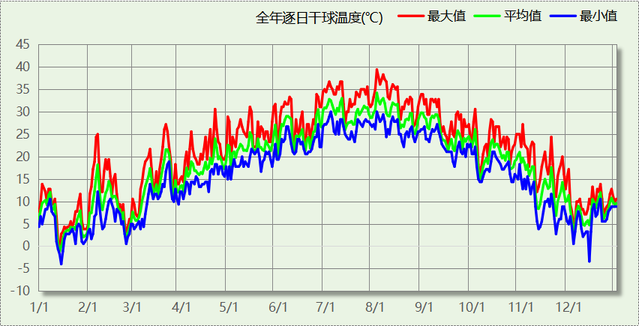

## 逐月辐照量表

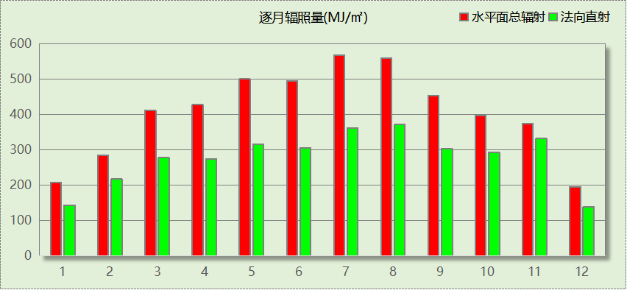

## 峰值工况

|  |  |  |  |  |  |
| --- | --- | --- | --- | --- | --- |
| 气象数据 | 时刻 | 干球温度(℃) | 湿球温度(℃) | 含湿量(g/kg) | 焓值(kj/kg) |
| 最热 | 08月01日15时 | 39.4 | 27.8 | 19.3 | 89.3 |
| 最冷 | 01月14日08时 | -3.9 | -3.9 | 2.7 | 2.8 |

# 建筑大样



西南轴侧图



东南轴侧图



西北轴侧图



东北轴侧图

# 围护结构

## 工程材料

|  |  |  |  |  |  |  |
| --- | --- | --- | --- | --- | --- | --- |
| 材料名称 | 导热系数λ | 蓄热系数S | 密度ρ | 比热容Cp | 蒸汽渗透 系数u | 数据来源 |
| W/(m.K) | W/(㎡.K) | kg/m3 | J/(kg.K) | g/(m.h.kPa) |
| 水泥砂浆 | 0.930 | 11.370 | 1800.0 | 1050.0 | 0.0210 | 民用建筑热工设计规范 GB50176-2016 |
| 钢筋混凝土 | 1.740 | 17.200 | 2500.0 | 920.0 | 0.0158 | 民用建筑热工设计规范 GB50176-2016 |
| 加气混凝土、泡沫混凝土(ρ=700) | 0.180 | 3.100 | 700.0 | 1050.0 | 0.0998 | 民用建筑热工设计规范 GB50176-2016 |
| 岩棉板(ρ=60-160) | 0.041 | 0.615 | 110.0 | 1220.0 | 0.4880 | 民用建筑热工设计规范 GB50176-2016 |
| 挤塑聚苯乙烯泡沫板（xps）(ρ=30) | 0.030 | 0.540 | 30.0 | 4455.3 | 0.0162 | 民用建筑热工设计规范 GB50176-2016 |
| 蒸压加气混凝土砌块（B06级） | 0.190 | 3.010 | 600.0 | 1092.9 | 0.9980 | DBJ/T36-024-2014 |
| 抗裂砂浆（网格布） | 0.930 | 11.306 | 1800.0 | 1050.0 | 0.0210 | 民用建筑热工设计规范 GB50176-2016 |
| 夯实粘土(ρ=2000) | 1.160 | 12.990 | 2000.0 | 1010.0 | 0.0975 | 民用建筑热工设计规范 GB50176-2016 |
| 防水层(沥青油毡、油毡纸) | 0.170 | 3.302 | 600.0 | 1470.0 | 0.0000 | 安徽公共建筑节能设计标准 DB34 T753-2007 |
| 岩棉板(ρ=60-160)（1） | 0.041 | 0.615 | 110.0 | 1220.0 | 0.4880 | 民用建筑热工设计规范 GB50176-2016 |
| 抗裂砂浆 | 0.930 | 11.306 | 1800.0 | 1050.0 | 0.0140 | 广东居住建筑节能设计标准 DB45-221-2005 |
| 石材发泡轻质墙板 | 0.150 | 2.970 | 500.0 | 1617.3 | 0.0000 | DBJ/T45-073-2018 |
| 无机保温砂浆(ρ=600) | 0.180 | 2.870 | 600.0 | 1050.0 | 0.0210 | 民用建筑热工设计规范 GB50176-2016 |
| 石灰水泥砂浆（混合砂浆） | 0.870 | 10.750 | 1700.0 | 1050.0 | 0.0975 | 民用建筑热工设计规范 GB50176-2016 |
| 泡沫玻璃 | 0.050 | 0.650 | 140.0 | 840.0 | 0.0225 | 民用建筑热工设计规范 GB50176-2016 |
| 无机保温砂浆(ρ=400) | 0.140 | 2.068 | 400.0 | 1050.0 | 0.0210 | 民用建筑热工设计规范 GB50176-2016 |

## 围护结构作法简要说明

**1. 屋顶：**屋面 (K=0.318,D=4.159)：（由上到下）

钢筋混凝土 20mm＋防水层(沥青油毡、油毡纸) 20mm＋泡沫玻璃 115.1mm＋钢筋混凝土 70mm＋石材发泡轻质墙板 55mm＋无机保温砂浆(ρ=400) 20mm

**2. 外墙：**外墙1-主墙体 (K=0.335,D=7.102)：（由外到内）

加气混凝土、泡沫混凝土(ρ=700) 170mm＋水泥砂浆 20mm＋防水层(沥青油毡、油毡纸) 20mm＋岩棉板(ρ=60-160)（1） 30mm＋抗裂砂浆 10mm＋石材发泡轻质墙板 150mm

**3. 挑空楼板：**底面接触室外的外挑空楼板 (K=0.680,D=1.400)：（由上到下）

钢筋混凝土 90mm＋岩棉板(ρ=60-160) 30mm＋抗裂砂浆（网格布） 5mm

**4. 幕墙：**塑钢型材窗 6 中透光三银 Low-E +12Ar+6 透明  
+12A+6 透明 (K=1.790)：

传热系数1.790W/㎡.K，窗太阳得热系数0.200

**5. 外窗：**60系列内外开下悬铝合金窗[5Low-E+9Ar+5Low-E+9A+5] (K=1.600)：

传热系数1.600W/㎡.K，窗太阳得热系数0.278

# 围护结构概况

|  |  |  |  |  |  |  |  |  |
| --- | --- | --- | --- | --- | --- | --- | --- | --- |
|  | | | 设计建筑 | | | 参照建筑 | | |
| 天窗屋顶比 | | | － | | | － | | |
| 屋顶传热系数K  和热惰性指标 D | | | K=0.32  D=4.16 | | | K=0.40  D=3.74 | | |
| 外墙传热系数K  和热惰性指标 D | | | K=0.37  D=7.10 | | | K=0.80  D=3.45 | | |
| 挑空楼板传热系数K  和热惰性指标 D | | | K=0.68  D=1.40 | | | K=0.70  D=1.37 | | |
| 天窗传热系数K  和太阳得热系数 SHGC | | | K=－  SHGC=－ | | | K=－  SHGC=－ | | |
| 外窗（包括透明幕墙） | 朝向 | 立面 | 窗墙比 | 传热  系数 | 太阳得热系数 | 窗墙比 | 传热  系数 | 太阳得热系数 |
| 南向 | 南-默认立面 | 0.19 | 1.65 | 0.26 | 0.19 | 3.00 | 0.45 |
| 北向 | 北-默认立面 | 0.36 | 1.71 | 0.23 | 0.36 | 2.20 | 0.40 |
| 东向 | 东-默认立面 | 0.61 | 1.72 | 0.23 | 0.61 | 2.10 | 0.25 |
| 西向 | 西-默认立面 | 0.50 | 1.73 | 0.22 | 0.50 | 2.20 | 0.30 |
| 室内参数和气象条件设置 | | | 按《公共建筑节能设计标准》附录B设置 | | | | | |

备注：

1. 传热系数的单位W/(m2.k)，其他参数无量纲.

2. 屋顶和外墙的传热系数K和热情性指标D指平均值.

3. 设计建筑：“—”代表本工程无对应项.

# 设计建筑

## 房间类型

### 房间参数表

|  |  |  |  |  |  |  |  |
| --- | --- | --- | --- | --- | --- | --- | --- |
| 房间类型 | 空调 温度℃ | 供暖 温度℃ | 新风量 | 渗透风 换气次数 | 人员密度 | 照明功率 密度 | 电器设备 功率 |
| 三层标本制作室 | 26 | 20 | 16(m3/h.人) | 0(次/h) | 0.3(人/㎡) | 3(W/㎡) | 15(W/㎡) |
| 下沉庭院 | － | － | 30(m3/h.人) | 0(次/h) | 0.2(人/㎡) | 3(W/㎡) | 5(W/㎡) |
| 书画装裱室 | 26 | 20 | 30(m3/h.人) | 0(次/h) | 8(㎡/人) | 3(W/㎡) | 15(W/㎡) |
| 会议室（暖通） | 26 | 20 | 30(m3/h.人) | 0(次/h) | 0.47(人/㎡) | 3(W/㎡) | 15(W/㎡) |
| 卫生间 | 26 | 20 | 30(m3/h.人) | 0(次/h) | 8(㎡/人) | 3(W/㎡) | 15(W/㎡) |
| 员工休息室（暖通） | 26 | 20 | 16(m3/h.人) | 0(次/h) | 0.51(人/㎡) | 3(W/㎡) | 10(W/㎡) |
| 地下准备室 | 26 | 20 | 20(m3/h.人) | 0(次/h) | 0.37(人/㎡) | 3(W/㎡) | 9(W/㎡) |
| 地下多功能厅 | 26 | 20 | 12(m3/h.人) | 0(次/h) | 0.88(人/㎡) | 3(W/㎡) | 10(W/㎡) |
| 地下室美术教育室 | 26 | 20 | 30(m3/h.人) | 0(次/h) | 0.36(人/㎡) | 3(W/㎡) | 15(W/㎡) |
| 地下报告厅 | 26 | 20 | 20(m3/h.人) | 0(次/h) | 0.79(人/㎡) | 3(W/㎡) | 15(W/㎡) |
| 地下控制室 | 26 | 20 | 20(m3/h.人) | 0(次/h) | 0.31(人/㎡) | 3(W/㎡) | 15(W/㎡) |
| 地下摄影室 | 26 | 20 | 30(m3/h.人) | 0(次/h) | 0.48(人/㎡) | 3(W/㎡) | 15(W/㎡) |
| 地下艺术体验中心 | 26 | 20 | 30(m3/h.人) | 0(次/h) | 0.25(人/㎡) | 3(W/㎡) | 15(W/㎡) |
| 地下艺术沙龙 | 26 | 20 | 30(m3/h.人) | 0(次/h) | 0.5(人/㎡) | 3(W/㎡) | 15(W/㎡) |
| 地下鉴赏室 | 26 | 20 | 30(m3/h.人) | 0(次/h) | 0.35(人/㎡) | 3(W/㎡) | 10(W/㎡) |
| 大厅 | 26 | 20 | 30(m3/h.人) | 0(次/h) | 8(㎡/人) | 3(W/㎡) | 15(W/㎡) |
| 展览馆 | 26 | 20 | 30(m3/h.人) | 0(次/h) | 8(㎡/人) | 3(W/㎡) | 15(W/㎡) |
| 库房 | 26 | 20 | 30(m3/h.人) | 0(次/h) | 8(㎡/人) | 3(W/㎡) | 15(W/㎡) |
| 接待室（暖通） | 26 | 20 | 30(m3/h.人) | 0(次/h) | 0.16(人/㎡) | 3(W/㎡) | 15(W/㎡) |
| 数据机房（空调） | 26 | 20 | 30(m3/h.人) | 0(次/h) | 0.03(人/㎡) | 3(W/㎡) | 430(W/㎡) |
| 文物修复室 | 26 | 20 | 30(m3/h.人) | 0(次/h) | 8(㎡/人) | 9(W/㎡) | 15(W/㎡) |
| 暖通库房 | 26 | 20 | 0(m3/h.人) | 0(次/h) | 0(人/㎡) | 3(W/㎡) | 15(W/㎡) |
| 标本制作室 | 26 | 20 | 30(m3/h.人) | 0(次/h) | 8(㎡/人) | 3(W/㎡) | 15(W/㎡) |
| 楼梯间 | 26 | 20 | 30(m3/h.人) | 0(次/h) | 8(㎡/人) | 3(W/㎡) | 15(W/㎡) |
| 模拟画室（暖通） | 26 | 20 | 30(m3/h.人) | 0(次/h) | 0.27(人/㎡) | 3(W/㎡) | 10(W/㎡) |
| 母婴室（暖通） | 26 | 20 | 30(m3/h.人) | 0(次/h) | 0.28(人/㎡) | 3(W/㎡) | 5(W/㎡) |
| 空房间 | － | － | 0(m3/h.人) | 0(次/h) | 0(人) | 0(W/㎡) | 0(W/㎡) |
| 行政办公室 | 26 | 20 | 30(m3/h.人) | 0(次/h) | 0.16(人/㎡) | 3(W/㎡) | 15(W/㎡) |
| 设备间 | － | － | 0(次/h) | 0(次/h) | 0(人) | 3(W/㎡) | 15(W/㎡) |
| 贵宾室（暖通） | 26 | 20 | 30(m3/h.人) | 0(次/h) | 0.21(人/㎡) | 3(W/㎡) | 15(W/㎡) |
| 走廊 | 26 | 20 | 30(m3/h.人) | 0(次/h) | 8(㎡/人) | 3(W/㎡) | 15(W/㎡) |
| 车库 | － | － | 0(次/h) | 0(次/h) | 0(人) | 3(W/㎡) | 15(W/㎡) |
| 陈列室 | 26 | 20 | 30(m3/h.人) | 0(次/h) | 8(㎡/人) | 3(W/㎡) | 15(W/㎡) |

### 作息时间表

详见附录

## 系统类型

### 系统分区

|  |  |  |  |  |  |
| --- | --- | --- | --- | --- | --- |
| 系统编号 | 系统类型 | 制冷 SEER | 制热 HSPF | 面积(㎡) | 包含的房间 |
| 默认 | 双管制风机盘管 | － | － | 1003.00 | 2003(2),3003(3) |
| Sys | 双管制风机盘管 | － | － | 7316.88 | -2107(-2),-2162(-2),-2110(-2),-2086(-2),-2085(-2),-2075(-2),-1113(-1),-1061(-1),-1039(-1),-1050(-1),-1176(-1),-1102(-1),-1148(-1),-1062(-1),-1054(-1),-1028(-1),-1161(-1),-1145(-1),-1140(-1),-1139(-1),-1136(-1),-1129(-1),-1121(-1),-1120(-1),-1105(-1),-1104(-1),-1087(-1),-1072(-1),-1066(-1),-1043(-1),-1030(-1),-1036(-1),-1021(-1),-1019(-1),-1014(-1),1186(1),1190(1),1164(1),1141(1),1124(1),1103(1),1092(1),1088(1),1081(1),1070(1),1064(1),1053(1),1047(1),1012(1),1009(1),1004(1),2029(2),2168(2),2138(2),2137(2),2099(2),2098(2),2094(2),2033(2),3006(3),3007(3),3178(3),3165(3),3122(3),3100(3),3093(3),3083(3),3074(3),3071(3),3037(3),4008(4),4025(4),4042(4),4130(4),4123(4),4118(4),4116(4),4108(4),4106(4),4101(4),4095(4),4091(4),4078(4),4069(4),4067(4),4065(4),4063(4),4055(4),4049(4),4044(4),4020(4),4015(4),4005(4) |

### 热回收参数

|  |  |  |  |  |  |
| --- | --- | --- | --- | --- | --- |
| 系统编号 | 热回收 | 供冷 | | 供暖 | |
| 回收效率 | 启动温(焓)差 | 回收效率 | 启动温(焓)差 |
| 默认 | 无 | － | － | － | － |
| Sys | 全热回收 | 0.20 | 5℃ | 0.00 | 5(℃) |

## 制冷系统

### 默认冷源

#### 供应的系统

|  |  |
| --- | --- |
| 系统编号 | 默认, Sys |

#### 冷水机组

|  |  |  |  |  |  |
| --- | --- | --- | --- | --- | --- |
| 名称 | 类型 | 额定耗电量 (kW) | 额定制冷量 (kW) | 额定性能系数 (COP) | 台数 |
| 机组1 | 水冷-螺杆式冷水机组 | 90 | 450 | 5.00 | 3 |

#### 水泵系统

|  |  |  |  |  |  |  |  |
| --- | --- | --- | --- | --- | --- | --- | --- |
| 类型 | 调节 | 流量 (m3/h) | 扬程 (m) | 设计工作效率(%) | 输入功率 (kW) | 冷却塔耗电比 (kWh/m3) | 台数 |
| 冷却水泵 | 单速 | 320 | 25 | 90 | 27.8 | 0.03 | 1 |
| 冷冻水泵 | 单速 | 320 | 30 | 90 | 33.4 | － | 1 |

#### 运行工况

|  |  |  |  |  |  |  |
| --- | --- | --- | --- | --- | --- | --- |
| 负载率 (%) | 机组制冷量 (kW) | 机组功率 (kW) | 性能系数 (COP) | 冷却水泵功率 (kW) | 冷冻水泵功率 (kW) | 冷却塔功率 (kW) |
| 20 | 270 | 26.8 | 10.07 | 27.8 | 33.4 | 9.6 |
| 40 | 540 | 49.9 | 10.82 | 27.8 | 33.4 | 9.6 |
| 60 | 810 | 73.8 | 10.98 | 55.7 | 66.8 | 19.2 |
| 80 | 1080 | 99.7 | 10.83 | 55.7 | 66.8 | 19.2 |
| 100 | 1350 | 140 | 9.64 | 55.7 | 66.8 | 19.2 |

#### 制冷能耗

|  |  |  |  |  |  |  |  |
| --- | --- | --- | --- | --- | --- | --- | --- |
| 负荷区间 (%) | 区间负荷 (kWh) | 运行时长(h) | 制冷机组 (kWh) | 平均性能系数(COP) | 冷却水泵 (kWh) | 冷冻水泵 (kWh) | 冷却塔 (kWh) |
| 0~20 | 6155 | 98 | 611 | 10.07 | 2724 | 3273 | 941 |
| 20~40 | 16573 | 37 | 1564 | 10.60 | 1029 | 1236 | 355 |
| 40~60 | 124672 | 170 | 11401 | 10.94 | 9469 | 11356 | 3264 |
| 60~80 | 301712 | 337 | 27609 | 10.93 | 18771 | 22512 | 6470 |
| 80~100 | 14990 | 13 | 1430 | 10.49 | 724 | 868 | 250 |
| >100 | 0 | 0 | 0 | － | 0 | 0 | 0 |
| 合计 | 464102 | 655 | 42615 |  | 32717 | 39245 | 11280 |

## 供暖系统

### 默认热源

#### 供应的系统

|  |  |
| --- | --- |
| 系统编号 | 默认, Sys |

#### 热泵系统

##### 热泵机组

|  |  |  |  |  |  |
| --- | --- | --- | --- | --- | --- |
| 名称 | 类型 | 额定耗电量(kW) | 额定制热量(kW) | 额定性能系数 COP | 台数 |
| 热泵机组 | 空气源热泵 | 60 | 300 | 5.00 | 1 |

##### 热水循环泵

|  |  |  |  |  |  |
| --- | --- | --- | --- | --- | --- |
| 类型 | 流量(m3/h) | 扬程(m) | 设计工作效率(%) | 输入功率(kW) | 台数 |
| 单速 | 320 | 30 | 90 | 33.4 | 1 |

##### 运行工况

|  |  |  |  |  |
| --- | --- | --- | --- | --- |
| 负载率(%) | 机组制热量(kW) | 机组功率(kW) | 性能系数(COP) | 供暖水泵功率(kW) |
| 20 | 60 | 7.9 | 7.59 | 37.6 |
| 40 | 120 | 15.9 | 7.55 | 37.6 |
| 60 | 180 | 26.2 | 6.87 | 37.6 |
| 80 | 240 | 39.7 | 6.05 | 37.6 |
| 100 | 300 | 49.7 | 6.04 | 37.6 |

##### 制热能耗

|  |  |  |  |  |  |
| --- | --- | --- | --- | --- | --- |
| 负荷区间 (%) | 区间负荷 (kWh) | 运行时长 (h) | 平均性能系数 (COP) | 热泵机组 (kWh) | 供暖水泵 (kWh) |
| 0~20 | 7583 | 368 | 7.59 | 998 | 13837 |
| 20~40 | 12142 | 137 | 7.57 | 1604 | 5151 |
| 40~60 | 10943 | 74 | 7.20 | 1519 | 2782 |
| 60~80 | 9852 | 47 | 6.43 | 1531 | 1767 |
| 80~100 | 8920 | 33 | 6.04 | 1477 | 1241 |
| >100 | 19080 | 44 | － | 2187 | 1654 |
| 合计 | 68521 | 703 |  | 9316 | 26433 |

## 空调风机

### 独立新排风

|  |  |  |  |  |  |
| --- | --- | --- | --- | --- | --- |
| 系统编号 | 新风量 (m3/h) | 单位风量耗功率 W/(m3/h) | 风机功率(W) | 运行时长(h) | 新风电耗(kWh) |
| 默认 | 3902 | 0.24 | 937 | 1404 | 1315 |
| Sys | 38550 | 0.24 | 9252 | 1870 | 17301 |
| 合计 | | | | | 18616 |

|  |  |  |  |  |  |  |
| --- | --- | --- | --- | --- | --- | --- |
| 系统编号 | 排风量 (m3/h) | 排风比 | 单位风量耗功率W/(m3/h) | 风机功率(W) | 运行时长(h) | 排风电耗 (kWh) |
| 默认 | 3122 | 0.8 | 0.24 | 749 | 1404 | 1052 |
| Sys | 30840 | 0.8 | 0.24 | 7402 | 1870 | 13841 |
| 合计 | | | | | | 14893 |

### 风机盘管

|  |  |  |  |  |
| --- | --- | --- | --- | --- |
| 系统编号 | 总功率(W) | 同时使用系数 | 运行时长(h) | 风机盘管电耗(kWh) |
| 默认 | 400 | 1 | 1203 | 481 |
| Sys | 400 | 1 | 1247 | 499 |
| 合计 | | | | 980 |

## 照明

|  |  |  |  |  |
| --- | --- | --- | --- | --- |
| 房间类型 | 单位面积电耗 (kWh/㎡) | 房间个数 | 房间合计面积 (㎡) | 合计电耗 (kWh) |
| 三层标本制作室 | 5.04 | 1 | 47 | 234 |
| 下沉庭院 | 5.04 | 1 | 439 | 2210 |
| 书画装裱室 | 5.04 | 2 | 282 | 1423 |
| 会议室（暖通） | 5.04 | 1 | 41 | 205 |
| 卫生间 | 5.04 | 20 | 345 | 1740 |
| 员工休息室（暖通） | 5.04 | 1 | 113 | 570 |
| 地下准备室 | 5.04 | 1 | 9 | 44 |
| 地下多功能厅 | 5.04 | 1 | 66 | 331 |
| 地下室美术教育室 | 5.04 | 1 | 39 | 195 |
| 地下报告厅 | 5.04 | 1 | 191 | 964 |
| 地下控制室 | 5.04 | 1 | 11 | 55 |
| 地下摄影室 | 5.04 | 1 | 17 | 84 |
| 地下艺术体验中心 | 5.04 | 1 | 74 | 374 |
| 地下艺术沙龙 | 5.04 | 1 | 56 | 281 |
| 地下鉴赏室 | 5.04 | 1 | 13 | 67 |
| 大厅 | 5.04 | 4 | 2175 | 10960 |
| 展览馆 | 5.04 | 2 | 1055 | 5318 |
| 库房 | 5.04 | 3 | 167 | 840 |
| 接待室（暖通） | 5.04 | 1 | 20 | 101 |
| 数据机房（空调） | 5.04 | 1 | 39 | 197 |
| 文物修复室 | 15.12 | 1 | 179 | 2701 |
| 暖通库房 | 5.04 | 2 | 286 | 1441 |
| 标本制作室 | 5.04 | 1 | 83 | 419 |
| 楼梯间 | 5.04 | 19 | 547 | 2757 |
| 模拟画室（暖通） | 5.04 | 1 | 56 | 285 |
| 母婴室（暖通） | 5.04 | 1 | 12 | 62 |
| 空房间 | 0.00 | 83 | 1112 | 0 |
| 行政办公室 | 5.04 | 3 | 85 | 428 |
| 设备间 | 26.28 | 39 | 1217 | 31984 |
| 贵宾室（暖通） | 5.04 | 1 | 49 | 248 |
| 走廊 | 5.04 | 18 | 1047 | 5276 |
| 车库 | 26.28 | 2 | 1731 | 45496 |
| 陈列室 | 5.04 | 3 | 1653 | 8332 |
| 总计 | | | | 125624 |

## 负荷分项统计

|  |  |  |  |  |  |  |
| --- | --- | --- | --- | --- | --- | --- |
| 分类 | 围护传热 | 室内得热 | 窗日射 | 新风/渗透 | 热回收 | 合计 |
| 供暖(kWh/㎡) | -3.08 | 3.69 | 0.64 | -6.35 | 0.00 | -5.10 |
| 供冷(kWh/㎡) | 7.80 | 10.54 | 1.89 | 15.64 | -1.36 | 34.52 |

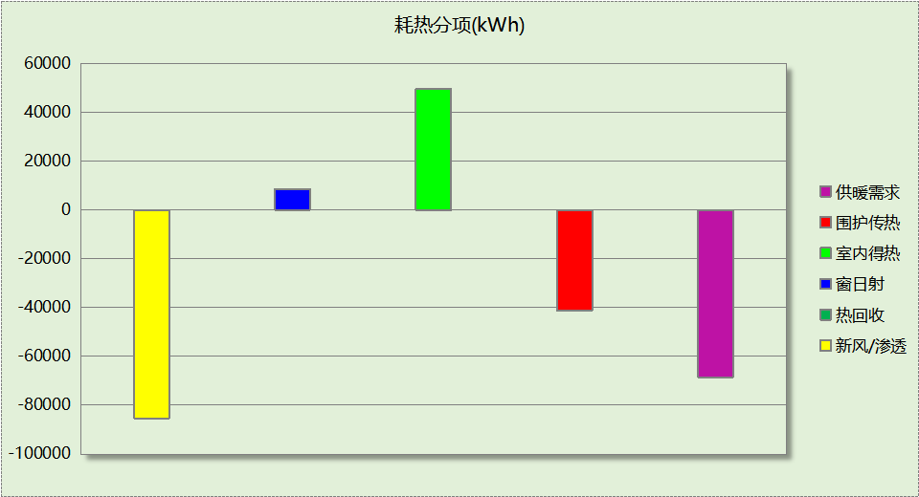

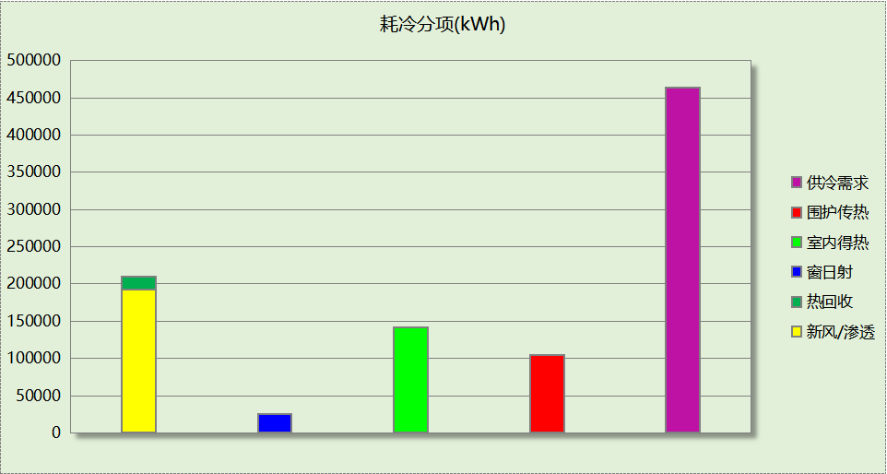

## 逐月负荷表

|  |  |  |  |  |  |  |
| --- | --- | --- | --- | --- | --- | --- |
| 月份 | 供暖(kWh) | 供冷(kWh) | 热负荷 峰值(kW) | 热负荷 峰值时刻 | 冷负荷 峰值(kW) | 冷负荷 峰值时刻 |
| 1月 | 39469 | 0 | 843.000 | 1月14日8时 | 0.000 | -- |
| 2月 | 14411 | 0 | 725.170 | 2月25日8时 | 0.000 | -- |
| 3月 | 0 | 0 | 0.000 | -- | 0.000 | -- |
| 4月 | 0 | 0 | 0.000 | -- | 0.000 | -- |
| 5月 | 0 | 0 | 0.000 | -- | 0.000 | -- |
| 6月 | 0 | 63379 | 0.000 | -- | 871.468 | 6月28日11时 |
| 7月 | 0 | 207676 | 0.000 | -- | 1110.677 | 7月1日8时 |
| 8月 | 0 | 193048 | 0.000 | -- | 1343.605 | 8月5日8时 |
| 9月 | 0 | 0 | 0.000 | -- | 0.000 | -- |
| 10月 | 0 | 0 | 0.000 | -- | 0.000 | -- |
| 11月 | 0 | 0 | 0.000 | -- | 0.000 | -- |
| 12月 | 14640 | 0 | 414.625 | 12月9日8时 | 0.000 | -- |

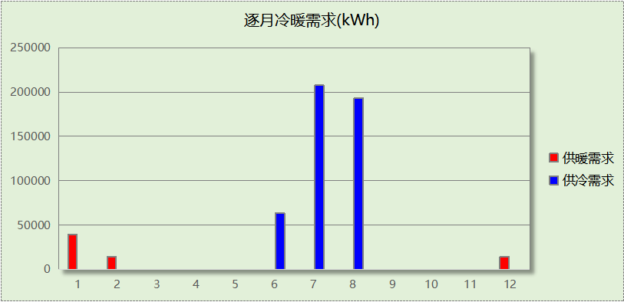

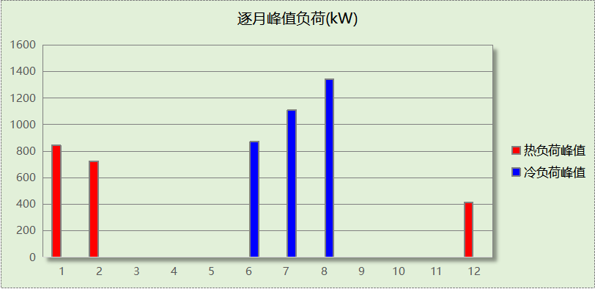

## 逐月电耗

注:供冷供暖为冷热源及输配水泵电耗，热水为扣减太阳能后电耗，所有数据单位kWh/㎡。

|  |  |  |  |  |  |  |  |  |
| --- | --- | --- | --- | --- | --- | --- | --- | --- |
| 月 | 供冷 | 供暖 | 空调风机 | 照明 | 插座设备 | 排风机 | 电梯 | 热水 |
| 1 | 0.00 | 1.12 | 0.47 | 0.80 | － | － | － | － |
| 2 | 0.00 | 0.68 | 0.42 | 0.69 | － |
| 3 | 0.00 | 0.00 | 0.00 | 0.79 | － |
| 4 | 0.00 | 0.00 | 0.00 | 0.77 | － |
| 5 | 0.00 | 0.00 | 0.00 | 0.80 | － |
| 6 | 1.42 | 0.00 | 0.25 | 0.75 | － |
| 7 | 4.08 | 0.00 | 0.47 | 0.82 | － |
| 8 | 3.85 | 0.00 | 0.47 | 0.80 | － |
| 9 | 0.00 | 0.00 | 0.00 | 0.76 | － |
| 10 | 0.00 | 0.00 | 0.00 | 0.78 | － |
| 11 | 0.00 | 0.00 | 0.01 | 0.77 | － |
| 12 | 0.00 | 0.86 | 0.47 | 0.80 | － |
| 合计 | 9.36 | 2.66 | 2.57 | 9.34 | － | － | － | － |

# 参照建筑

## 房间类型

### 房间参数表

|  |  |  |  |  |  |  |  |
| --- | --- | --- | --- | --- | --- | --- | --- |
| 房间类型 | 空调 温度℃ | 供暖 温度℃ | 新风量 | 渗透风 换气次数 | 人员密度 | 照明功率 密度 | 电器设备 功率 |
| 三层标本制作室 | 26 | 20 | 16(m3/h.人) | 0(次/h) | 0.3(人/㎡) | 8(W/㎡) | 15(W/㎡) |
| 下沉庭院 | － | － | 30(m3/h.人) | 0(次/h) | 0.2(人/㎡) | 8(W/㎡) | 5(W/㎡) |
| 书画装裱室 | 26 | 20 | 30(m3/h.人) | 0(次/h) | 8(㎡/人) | 9(W/㎡) | 15(W/㎡) |
| 会议室（暖通） | 26 | 20 | 30(m3/h.人) | 0(次/h) | 0.47(人/㎡) | 8(W/㎡) | 15(W/㎡) |
| 卫生间 | 26 | 20 | 30(m3/h.人) | 0(次/h) | 8(㎡/人) | 9(W/㎡) | 15(W/㎡) |
| 员工休息室（暖通） | 26 | 20 | 16(m3/h.人) | 0(次/h) | 0.51(人/㎡) | 8(W/㎡) | 10(W/㎡) |
| 地下准备室 | 26 | 20 | 20(m3/h.人) | 0(次/h) | 0.37(人/㎡) | 8(W/㎡) | 9(W/㎡) |
| 地下多功能厅 | 26 | 20 | 30(m3/h.人) | 0(次/h) | 0.88(人/㎡) | 8(W/㎡) | 10(W/㎡) |
| 地下室美术教育室 | 26 | 20 | 30(m3/h.人) | 0(次/h) | 0.36(人/㎡) | 8(W/㎡) | 15(W/㎡) |
| 地下报告厅 | 26 | 20 | 20(m3/h.人) | 0(次/h) | 0.79(人/㎡) | 8(W/㎡) | 15(W/㎡) |
| 地下控制室 | 26 | 20 | 20(m3/h.人) | 0(次/h) | 0.31(人/㎡) | 8(W/㎡) | 15(W/㎡) |
| 地下摄影室 | 26 | 20 | 30(m3/h.人) | 0(次/h) | 0.48(人/㎡) | 9(W/㎡) | 15(W/㎡) |
| 地下艺术体验中心 | 26 | 20 | 30(m3/h.人) | 0(次/h) | 0.25(人/㎡) | 8(W/㎡) | 15(W/㎡) |
| 地下艺术沙龙 | 26 | 20 | 30(m3/h.人) | 0(次/h) | 0.5(人/㎡) | 8(W/㎡) | 15(W/㎡) |
| 地下鉴赏室 | 26 | 20 | 30(m3/h.人) | 0(次/h) | 0.35(人/㎡) | 8(W/㎡) | 10(W/㎡) |
| 大厅 | 26 | 20 | 30(m3/h.人) | 0(次/h) | 8(㎡/人) | 9(W/㎡) | 15(W/㎡) |
| 展览馆 | 26 | 20 | 30(m3/h.人) | 0(次/h) | 8(㎡/人) | 9(W/㎡) | 15(W/㎡) |
| 库房 | 26 | 20 | 30(m3/h.人) | 0(次/h) | 8(㎡/人) | 9(W/㎡) | 15(W/㎡) |
| 接待室（暖通） | 26 | 20 | 30(m3/h.人) | 0(次/h) | 0.16(人/㎡) | 8(W/㎡) | 15(W/㎡) |
| 数据机房（空调） | 26 | 20 | 30(m3/h.人) | 0(次/h) | 0.03(人/㎡) | 8(W/㎡) | 430(W/㎡) |
| 文物修复室 | 26 | 20 | 30(m3/h.人) | 0(次/h) | 8(㎡/人) | 9(W/㎡) | 15(W/㎡) |
| 暖通库房 | 26 | 20 | 0(m3/h.人) | 0(次/h) | 0(人/㎡) | 8(W/㎡) | 15(W/㎡) |
| 标本制作室 | 26 | 20 | 30(m3/h.人) | 0(次/h) | 8(㎡/人) | 9(W/㎡) | 15(W/㎡) |
| 楼梯间 | 26 | 20 | 30(m3/h.人) | 0(次/h) | 8(㎡/人) | 9(W/㎡) | 15(W/㎡) |
| 模拟画室（暖通） | 26 | 20 | 30(m3/h.人) | 0(次/h) | 0.27(人/㎡) | 8(W/㎡) | 10(W/㎡) |
| 母婴室（暖通） | 26 | 20 | 30(m3/h.人) | 0(次/h) | 0.28(人/㎡) | 8(W/㎡) | 5(W/㎡) |
| 空房间 | － | － | 0(m3/h.人) | 0(次/h) | 0(人) | 0(W/㎡) | 0(W/㎡) |
| 行政办公室 | 26 | 20 | 30(m3/h.人) | 0(次/h) | 0.16(人/㎡) | 8(W/㎡) | 15(W/㎡) |
| 设备间 | － | － | 0(次/h) | 0(次/h) | 0(人) | 6(W/㎡) | 15(W/㎡) |
| 贵宾室（暖通） | 26 | 20 | 30(m3/h.人) | 0(次/h) | 0.21(人/㎡) | 8(W/㎡) | 15(W/㎡) |
| 走廊 | 26 | 20 | 30(m3/h.人) | 0(次/h) | 8(㎡/人) | 9(W/㎡) | 15(W/㎡) |
| 车库 | － | － | 0(次/h) | 0(次/h) | 0(人) | 4(W/㎡) | 15(W/㎡) |
| 陈列室 | 26 | 20 | 30(m3/h.人) | 0(次/h) | 8(㎡/人) | 9(W/㎡) | 15(W/㎡) |

### 作息时间表

同设计建筑

## 制冷系统

|  |  |  |
| --- | --- | --- |
| 负荷(kWh/a) | 系统综合性能系数 | 耗电(kWh/a) |
| 546988 | 3.50 | 156282 |

## 供暖系统

|  |  |  |
| --- | --- | --- |
| 负荷(kWh/a) | 系统综合性能系数 | 耗电(kWh/a) |
| 79419 | 2.29 | 34681 |

## 照明

|  |  |  |  |  |
| --- | --- | --- | --- | --- |
| 房间类型 | 单位面积电耗 (kWh/㎡) | 房间个数 | 房间合计面积 (㎡) | 合计电耗 (kWh) |
| 三层标本制作室 | 13.44 | 1 | 47 | 625 |
| 下沉庭院 | 13.44 | 1 | 439 | 5894 |
| 书画装裱室 | 15.12 | 2 | 282 | 4269 |
| 会议室（暖通） | 13.44 | 1 | 41 | 545 |
| 卫生间 | 15.12 | 20 | 345 | 5221 |
| 员工休息室（暖通） | 13.44 | 1 | 113 | 1521 |
| 地下准备室 | 13.44 | 1 | 9 | 116 |
| 地下多功能厅 | 13.44 | 1 | 66 | 882 |
| 地下室美术教育室 | 13.44 | 1 | 39 | 520 |
| 地下报告厅 | 13.44 | 1 | 191 | 2571 |
| 地下控制室 | 13.44 | 1 | 11 | 146 |
| 地下摄影室 | 15.12 | 1 | 17 | 252 |
| 地下艺术体验中心 | 13.44 | 1 | 74 | 998 |
| 地下艺术沙龙 | 13.44 | 1 | 56 | 750 |
| 地下鉴赏室 | 13.44 | 1 | 13 | 178 |
| 大厅 | 15.12 | 4 | 2175 | 32879 |
| 展览馆 | 15.12 | 2 | 1055 | 15954 |
| 库房 | 15.12 | 3 | 167 | 2521 |
| 接待室（暖通） | 13.44 | 1 | 20 | 269 |
| 数据机房（空调） | 13.44 | 1 | 39 | 524 |
| 文物修复室 | 15.12 | 1 | 179 | 2701 |
| 暖通库房 | 13.44 | 2 | 286 | 3843 |
| 标本制作室 | 15.12 | 1 | 83 | 1258 |
| 楼梯间 | 15.12 | 19 | 547 | 8272 |
| 模拟画室（暖通） | 13.44 | 1 | 56 | 759 |
| 母婴室（暖通） | 13.44 | 1 | 12 | 166 |
| 空房间 | 0.00 | 83 | 1112 | 0 |
| 行政办公室 | 13.44 | 3 | 85 | 1142 |
| 设备间 | 52.56 | 39 | 1217 | 63968 |
| 贵宾室（暖通） | 13.44 | 1 | 49 | 661 |
| 走廊 | 15.12 | 18 | 1047 | 15828 |
| 车库 | 35.04 | 2 | 1731 | 60662 |
| 陈列室 | 15.12 | 3 | 1653 | 24997 |
| 总计 | | | | 260894 |

## 负荷分项统计

|  |  |  |  |  |  |  |
| --- | --- | --- | --- | --- | --- | --- |
| 分类 | 围护传热 | 室内得热 | 窗日射 | 新风/渗透 | 热回收 | 合计 |
| 供暖(kWh/㎡) | -4.36 | 4.22 | 0.81 | -6.58 | 0.00 | -5.91 |
| 供冷(kWh/㎡) | 9.71 | 11.98 | 2.49 | 16.51 | 0.00 | 40.68 |

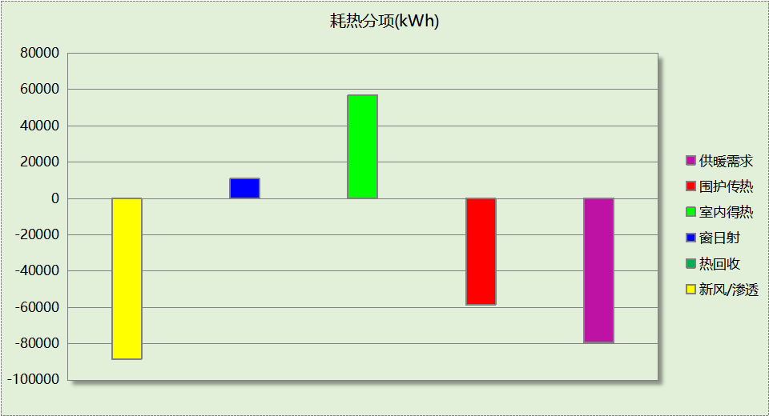

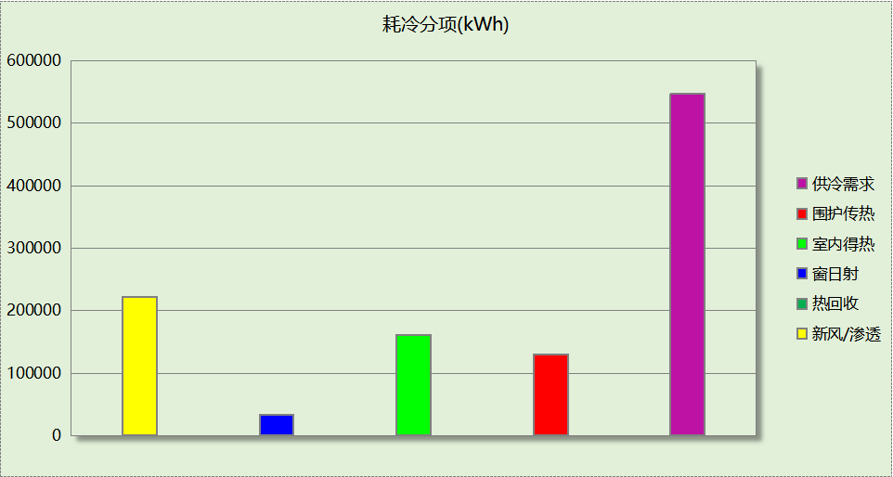

## 逐月负荷表

|  |  |  |  |  |  |  |
| --- | --- | --- | --- | --- | --- | --- |
| 月份 | 供暖(kWh) | 供冷(kWh) | 热负荷 峰值(kW) | 热负荷 峰值时刻 | 冷负荷 峰值(kW) | 冷负荷 峰值时刻 |
| 1月 | 45533 | 0 | 955.127 | 1月14日8时 | 0.000 | -- |
| 2月 | 15895 | 0 | 800.747 | 2月25日8时 | 0.000 | -- |
| 3月 | 0 | 0 | 0.000 | -- | 0.000 | -- |
| 4月 | 0 | 0 | 0.000 | -- | 0.000 | -- |
| 5月 | 0 | 0 | 0.000 | -- | 0.000 | -- |
| 6月 | 0 | 79700 | 0.000 | -- | 993.851 | 6月24日16时 |
| 7月 | 0 | 242331 | 0.000 | -- | 1241.469 | 7月1日8时 |
| 8月 | 0 | 224957 | 0.000 | -- | 1479.995 | 8月5日8时 |
| 9月 | 0 | 0 | 0.000 | -- | 0.000 | -- |
| 10月 | 0 | 0 | 0.000 | -- | 0.000 | -- |
| 11月 | 0 | 0 | 0.000 | -- | 0.000 | -- |
| 12月 | 17990 | 0 | 490.766 | 12月9日8时 | 0.000 | -- |

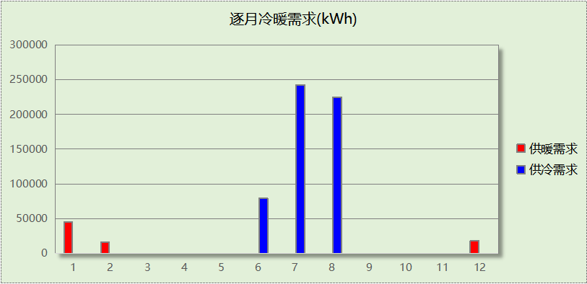

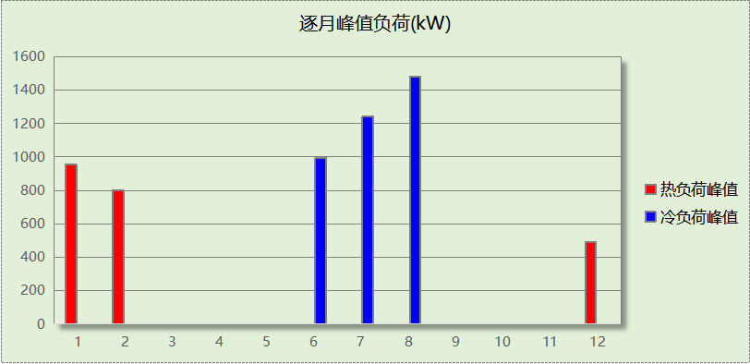

## 逐月电耗

注:供冷供暖为冷热源及输配水泵电耗，热水为扣减太阳能后电耗，所有数据单位kWh/㎡。

|  |  |  |  |  |  |  |  |  |
| --- | --- | --- | --- | --- | --- | --- | --- | --- |
| 月 | 供冷 | 供暖 | 空调风机 | 照明 | 插座设备 | 排风机 | 电梯 | 热水 |
| 1 | 0.00 | 0.00 | 0.00 | 1.68 | － | － | － | － |
| 2 | 0.00 | 0.00 | 0.00 | 1.40 | － |
| 3 | 0.00 | 0.00 | 0.00 | 1.64 | － |
| 4 | 0.00 | 0.00 | 0.00 | 1.61 | － |
| 5 | 0.00 | 0.00 | 0.00 | 1.68 | － |
| 6 | 0.00 | 0.00 | 0.00 | 1.53 | － |
| 7 | 0.00 | 0.00 | 0.00 | 1.72 | － |
| 8 | 0.00 | 0.00 | 0.00 | 1.68 | － |
| 9 | 0.00 | 0.00 | 0.00 | 1.57 | － |
| 10 | 0.00 | 0.00 | 0.00 | 1.60 | － |
| 11 | 0.00 | 0.00 | 0.00 | 1.61 | － |
| 12 | 0.00 | 0.00 | 0.00 | 1.68 | － |
| 合计 | 0.00 | 0.00 | 0.00 | 19.40 | － | － | － | － |

# 计算结果

|  |  |  |  |  |
| --- | --- | --- | --- | --- |
| 能耗分类 | 能耗子类 | 设计建筑  (kWh/㎡) | 参照建筑  (kWh/㎡) | 节能率  （%） |
| 建筑负荷 | 耗冷量 | 34.52 | 40.68 | 15.15% |
| 耗热量 | 5.10 | 5.91 | 13.72% |
| 冷热合计 | 39.62 | 46.59 | 14.97% |
| 热回收负荷 | 供冷 | 1.36 | － |  |
| 供暖 | 0.00 | － |  |
| 冷热合计 | 1.36 | － |  |
| 供冷电耗 | 中央冷源 | 3.17 | － | 19.47% |
| 冷却水泵 | 2.43 | － |
| 冷冻水泵 | 2.92 | － |
| 冷却塔 | 0.84 | － |
| 多联机/单元式空调 | 0.00 | － |
| 供冷合计 | 9.36 | 11.62 |
| 供暖电耗 | 中央热源 | 0.69 | － | -3.08% |
| 热源侧水泵 | 0.00 | － |
| 供暖水泵 | 1.97 | － |
| 多联机/单元式热泵 | 0.00 | － |
| 供暖合计 | 2.66 | 2.58 |
| 空调风机电耗 | 独立新排风 | 2.49 | － | - |
| 风机盘管 | 0.07 | － |
| 全空气系统 | 0.00 | － |
| 风机合计 | 2.57 | － |
| 采暖空调电耗 | | 14.59 | 14.20 | -2.72% |
| 照明电耗 | | 9.34 | 19.40 | 51.85% |
| 建筑综合电耗 | | 23.93 | 33.61 | 28.79% |

# 绿色建筑性能评估得分

|  |  |  |  |
| --- | --- | --- | --- |
| 标准条文 | 得分评价 | 节能率 | 得分 |
| 7.2.8 采取措施降低建筑能耗 | 建筑能耗相比国家现行有关建筑节能标准降低10%, 得5 分；降低20%,得10 分。 | 28.79% | 10 |
| 标准依据 | 《绿色建筑评价标准》GB-T 50378-2019 | | |

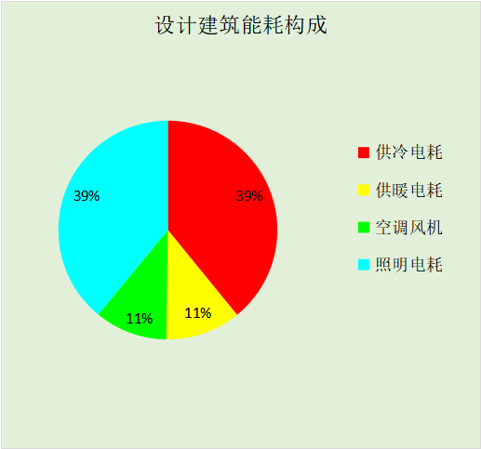

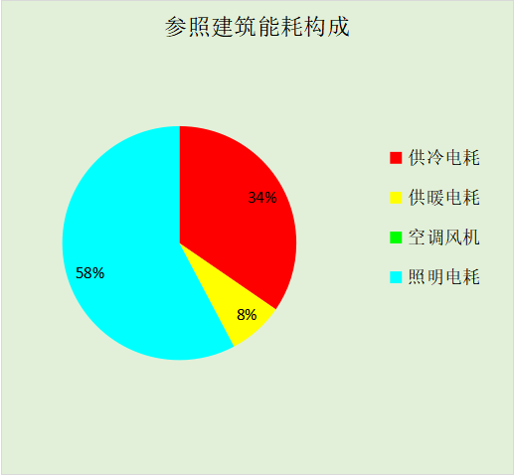

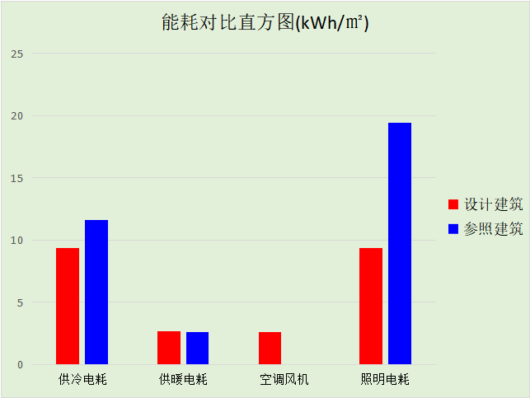

# 附录

## 工作日/节假日人员逐时在室率(%)

|  |  |  |  |  |  |  |  |  |  |  |  |  |  |  |  |  |  |  |  |  |  |  |  |  |
| --- | --- | --- | --- | --- | --- | --- | --- | --- | --- | --- | --- | --- | --- | --- | --- | --- | --- | --- | --- | --- | --- | --- | --- | --- |
| 房间类型 | 1 | 2 | 3 | 4 | 5 | 6 | 7 | 8 | 9 | 10 | 11 | 12 | 13 | 14 | 15 | 16 | 17 | 18 | 19 | 20 | 21 | 22 | 23 | 24 |
| 三层标本制作室 | 0 | 0 | 0 | 0 | 0 | 0 | 10 | 50 | 100 | 100 | 100 | 30 | 100 | 100 | 100 | 100 | 50 | 20 | 10 | 0 | 0 | 0 | 0 | 0 |
| 0 | 0 | 0 | 0 | 0 | 0 | 0 | 20 | 45 | 0 | 0 | 0 | 0 | 0 | 0 | 0 | 0 | 0 | 0 | 0 | 0 | 0 | 0 | 0 |
| 下沉庭院 | 0 | 0 | 0 | 0 | 0 | 0 | 10 | 50 | 100 | 100 | 100 | 30 | 100 | 100 | 100 | 100 | 50 | 20 | 10 | 0 | 0 | 0 | 0 | 0 |
| 0 | 0 | 0 | 0 | 0 | 0 | 0 | 20 | 45 | 0 | 0 | 0 | 0 | 0 | 0 | 0 | 0 | 0 | 0 | 0 | 0 | 0 | 0 | 0 |
| 书画装裱室 | 0 | 0 | 0 | 0 | 0 | 0 | 10 | 50 | 100 | 100 | 100 | 30 | 100 | 100 | 100 | 100 | 50 | 20 | 10 | 0 | 0 | 0 | 0 | 0 |
| 0 | 0 | 0 | 0 | 0 | 0 | 0 | 20 | 45 | 0 | 0 | 0 | 0 | 0 | 0 | 0 | 0 | 0 | 0 | 0 | 0 | 0 | 0 | 0 |
| 会议室（暖通） | 0 | 0 | 0 | 0 | 0 | 0 | 10 | 50 | 100 | 100 | 100 | 30 | 100 | 100 | 100 | 100 | 50 | 20 | 10 | 0 | 0 | 0 | 0 | 0 |
| 0 | 0 | 0 | 0 | 0 | 0 | 0 | 20 | 45 | 0 | 0 | 0 | 0 | 0 | 0 | 0 | 0 | 0 | 0 | 0 | 0 | 0 | 0 | 0 |
| 卫生间 | 0 | 0 | 0 | 0 | 0 | 0 | 10 | 50 | 100 | 100 | 100 | 30 | 100 | 100 | 100 | 100 | 50 | 20 | 10 | 0 | 0 | 0 | 0 | 0 |
| 0 | 0 | 0 | 0 | 0 | 0 | 0 | 20 | 45 | 0 | 0 | 0 | 0 | 0 | 0 | 0 | 0 | 0 | 0 | 0 | 0 | 0 | 0 | 0 |
| 员工休息室（暖通） | 0 | 0 | 0 | 0 | 0 | 0 | 10 | 50 | 100 | 100 | 100 | 30 | 100 | 100 | 100 | 100 | 50 | 20 | 10 | 0 | 0 | 0 | 0 | 0 |
| 0 | 0 | 0 | 0 | 0 | 0 | 0 | 20 | 45 | 0 | 0 | 0 | 0 | 0 | 0 | 0 | 0 | 0 | 0 | 0 | 0 | 0 | 0 | 0 |
| 地下准备室 | 0 | 0 | 0 | 0 | 0 | 0 | 10 | 50 | 100 | 100 | 100 | 30 | 100 | 100 | 100 | 100 | 50 | 20 | 10 | 0 | 0 | 0 | 0 | 0 |
| 0 | 0 | 0 | 0 | 0 | 0 | 0 | 20 | 45 | 0 | 0 | 0 | 0 | 0 | 0 | 0 | 0 | 0 | 0 | 0 | 0 | 0 | 0 | 0 |
| 地下多功能厅 | 0 | 0 | 0 | 0 | 0 | 0 | 10 | 50 | 100 | 100 | 100 | 30 | 100 | 100 | 100 | 100 | 50 | 20 | 10 | 0 | 0 | 0 | 0 | 0 |
| 0 | 0 | 0 | 0 | 0 | 0 | 0 | 20 | 45 | 0 | 0 | 0 | 0 | 0 | 0 | 0 | 0 | 0 | 0 | 0 | 0 | 0 | 0 | 0 |
| 地下室美术教育室 | 0 | 0 | 0 | 0 | 0 | 0 | 10 | 50 | 100 | 100 | 100 | 30 | 100 | 100 | 100 | 100 | 50 | 20 | 10 | 0 | 0 | 0 | 0 | 0 |
| 0 | 0 | 0 | 0 | 0 | 0 | 0 | 20 | 45 | 0 | 0 | 0 | 0 | 0 | 0 | 0 | 0 | 0 | 0 | 0 | 0 | 0 | 0 | 0 |
| 地下报告厅 | 0 | 0 | 0 | 0 | 0 | 0 | 10 | 50 | 100 | 100 | 100 | 30 | 100 | 100 | 100 | 100 | 50 | 20 | 10 | 0 | 0 | 0 | 0 | 0 |
| 0 | 0 | 0 | 0 | 0 | 0 | 0 | 20 | 45 | 0 | 0 | 0 | 0 | 0 | 0 | 0 | 0 | 0 | 0 | 0 | 0 | 0 | 0 | 0 |
| 地下控制室 | 0 | 0 | 0 | 0 | 0 | 0 | 10 | 50 | 100 | 100 | 100 | 30 | 100 | 100 | 100 | 100 | 50 | 20 | 10 | 0 | 0 | 0 | 0 | 0 |
| 0 | 0 | 0 | 0 | 0 | 0 | 0 | 20 | 45 | 0 | 0 | 0 | 0 | 0 | 0 | 0 | 0 | 0 | 0 | 0 | 0 | 0 | 0 | 0 |
| 地下摄影室 | 0 | 0 | 0 | 0 | 0 | 0 | 10 | 50 | 100 | 100 | 100 | 30 | 100 | 100 | 100 | 100 | 50 | 20 | 10 | 0 | 0 | 0 | 0 | 0 |
| 0 | 0 | 0 | 0 | 0 | 0 | 0 | 20 | 45 | 0 | 0 | 0 | 0 | 0 | 0 | 0 | 0 | 0 | 0 | 0 | 0 | 0 | 0 | 0 |
| 地下艺术体验中心 | 0 | 0 | 0 | 0 | 0 | 0 | 10 | 50 | 100 | 100 | 100 | 30 | 100 | 100 | 100 | 100 | 50 | 20 | 10 | 0 | 0 | 0 | 0 | 0 |
| 0 | 0 | 0 | 0 | 0 | 0 | 0 | 20 | 45 | 0 | 0 | 0 | 0 | 0 | 0 | 0 | 0 | 0 | 0 | 0 | 0 | 0 | 0 | 0 |
| 地下艺术沙龙 | 0 | 0 | 0 | 0 | 0 | 0 | 10 | 50 | 100 | 100 | 100 | 30 | 100 | 100 | 100 | 100 | 50 | 20 | 10 | 0 | 0 | 0 | 0 | 0 |
| 0 | 0 | 0 | 0 | 0 | 0 | 0 | 20 | 45 | 0 | 0 | 0 | 0 | 0 | 0 | 0 | 0 | 0 | 0 | 0 | 0 | 0 | 0 | 0 |
| 地下鉴赏室 | 0 | 0 | 0 | 0 | 0 | 0 | 10 | 50 | 100 | 100 | 100 | 30 | 100 | 100 | 100 | 100 | 50 | 20 | 10 | 0 | 0 | 0 | 0 | 0 |
| 0 | 0 | 0 | 0 | 0 | 0 | 0 | 20 | 45 | 0 | 0 | 0 | 0 | 0 | 0 | 0 | 0 | 0 | 0 | 0 | 0 | 0 | 0 | 0 |
| 大厅 | 0 | 0 | 0 | 0 | 0 | 0 | 10 | 50 | 100 | 100 | 100 | 30 | 100 | 100 | 100 | 100 | 50 | 20 | 10 | 0 | 0 | 0 | 0 | 0 |
| 0 | 0 | 0 | 0 | 0 | 0 | 0 | 20 | 45 | 0 | 0 | 0 | 0 | 0 | 0 | 0 | 0 | 0 | 0 | 0 | 0 | 0 | 0 | 0 |
| 展览馆 | 0 | 0 | 0 | 0 | 0 | 0 | 10 | 50 | 100 | 100 | 100 | 30 | 100 | 100 | 100 | 100 | 50 | 20 | 10 | 0 | 0 | 0 | 0 | 0 |
| 0 | 0 | 0 | 0 | 0 | 0 | 0 | 20 | 45 | 0 | 0 | 0 | 0 | 0 | 0 | 0 | 0 | 0 | 0 | 0 | 0 | 0 | 0 | 0 |
| 库房 | 0 | 0 | 0 | 0 | 0 | 0 | 10 | 50 | 100 | 100 | 100 | 30 | 100 | 100 | 100 | 100 | 50 | 20 | 10 | 0 | 0 | 0 | 0 | 0 |
| 0 | 0 | 0 | 0 | 0 | 0 | 0 | 20 | 45 | 0 | 0 | 0 | 0 | 0 | 0 | 0 | 0 | 0 | 0 | 0 | 0 | 0 | 0 | 0 |
| 接待室（暖通） | 0 | 0 | 0 | 0 | 0 | 0 | 10 | 50 | 100 | 100 | 100 | 30 | 100 | 100 | 100 | 100 | 50 | 20 | 10 | 0 | 0 | 0 | 0 | 0 |
| 0 | 0 | 0 | 0 | 0 | 0 | 0 | 20 | 45 | 0 | 0 | 0 | 0 | 0 | 0 | 0 | 0 | 0 | 0 | 0 | 0 | 0 | 0 | 0 |
| 数据机房（空调） | 0 | 0 | 0 | 0 | 0 | 0 | 10 | 50 | 100 | 100 | 100 | 30 | 100 | 100 | 100 | 100 | 50 | 20 | 10 | 0 | 0 | 0 | 0 | 0 |
| 0 | 0 | 0 | 0 | 0 | 0 | 0 | 20 | 45 | 0 | 0 | 0 | 0 | 0 | 0 | 0 | 0 | 0 | 0 | 0 | 0 | 0 | 0 | 0 |
| 文物修复室 | 0 | 0 | 0 | 0 | 0 | 0 | 10 | 50 | 100 | 100 | 100 | 30 | 100 | 100 | 100 | 100 | 50 | 20 | 10 | 0 | 0 | 0 | 0 | 0 |
| 0 | 0 | 0 | 0 | 0 | 0 | 0 | 20 | 45 | 0 | 0 | 0 | 0 | 0 | 0 | 0 | 0 | 0 | 0 | 0 | 0 | 0 | 0 | 0 |
| 暖通库房 | 0 | 0 | 0 | 0 | 0 | 0 | 10 | 50 | 100 | 100 | 100 | 30 | 100 | 100 | 100 | 100 | 50 | 20 | 10 | 0 | 0 | 0 | 0 | 0 |
| 0 | 0 | 0 | 0 | 0 | 0 | 0 | 20 | 45 | 0 | 0 | 0 | 0 | 0 | 0 | 0 | 0 | 0 | 0 | 0 | 0 | 0 | 0 | 0 |
| 标本制作室 | 0 | 0 | 0 | 0 | 0 | 0 | 10 | 50 | 100 | 100 | 100 | 30 | 100 | 100 | 100 | 100 | 50 | 20 | 10 | 0 | 0 | 0 | 0 | 0 |
| 0 | 0 | 0 | 0 | 0 | 0 | 0 | 20 | 45 | 0 | 0 | 0 | 0 | 0 | 0 | 0 | 0 | 0 | 0 | 0 | 0 | 0 | 0 | 0 |
| 楼梯间 | 0 | 0 | 0 | 0 | 0 | 0 | 10 | 50 | 100 | 100 | 100 | 30 | 100 | 100 | 100 | 100 | 50 | 20 | 10 | 0 | 0 | 0 | 0 | 0 |
| 0 | 0 | 0 | 0 | 0 | 0 | 0 | 20 | 45 | 0 | 0 | 0 | 0 | 0 | 0 | 0 | 0 | 0 | 0 | 0 | 0 | 0 | 0 | 0 |
| 模拟画室（暖通） | 0 | 0 | 0 | 0 | 0 | 0 | 10 | 50 | 100 | 100 | 100 | 30 | 100 | 100 | 100 | 100 | 50 | 20 | 10 | 0 | 0 | 0 | 0 | 0 |
| 0 | 0 | 0 | 0 | 0 | 0 | 0 | 20 | 45 | 0 | 0 | 0 | 0 | 0 | 0 | 0 | 0 | 0 | 0 | 0 | 0 | 0 | 0 | 0 |
| 母婴室（暖通） | 0 | 0 | 0 | 0 | 0 | 0 | 10 | 50 | 100 | 100 | 100 | 30 | 100 | 100 | 100 | 100 | 50 | 20 | 10 | 0 | 0 | 0 | 0 | 0 |
| 0 | 0 | 0 | 0 | 0 | 0 | 0 | 20 | 45 | 0 | 0 | 0 | 0 | 0 | 0 | 0 | 0 | 0 | 0 | 0 | 0 | 0 | 0 | 0 |
| 空房间 | 0 | 0 | 0 | 0 | 0 | 0 | 0 | 20 | 50 | 80 | 80 | 80 | 80 | 80 | 80 | 80 | 80 | 80 | 80 | 70 | 50 | 0 | 0 | 0 |
| 0 | 0 | 0 | 0 | 0 | 0 | 0 | 20 | 50 | 80 | 80 | 80 | 80 | 80 | 80 | 80 | 80 | 80 | 80 | 70 | 50 | 0 | 0 | 0 |
| 行政办公室 | 0 | 0 | 0 | 0 | 0 | 0 | 10 | 50 | 100 | 100 | 100 | 30 | 100 | 100 | 100 | 100 | 50 | 20 | 10 | 0 | 0 | 0 | 0 | 0 |
| 0 | 0 | 0 | 0 | 0 | 0 | 0 | 20 | 45 | 0 | 0 | 0 | 0 | 0 | 0 | 0 | 0 | 0 | 0 | 0 | 0 | 0 | 0 | 0 |
| 设备间 | 0 | 0 | 0 | 0 | 0 | 0 | 0 | 0 | 0 | 0 | 0 | 0 | 0 | 0 | 0 | 0 | 0 | 0 | 0 | 0 | 0 | 0 | 0 | 0 |
| 0 | 0 | 0 | 0 | 0 | 0 | 0 | 0 | 0 | 0 | 0 | 0 | 0 | 0 | 0 | 0 | 0 | 0 | 0 | 0 | 0 | 0 | 0 | 0 |
| 贵宾室（暖通） | 0 | 0 | 0 | 0 | 0 | 0 | 10 | 50 | 100 | 100 | 100 | 30 | 100 | 100 | 100 | 100 | 50 | 20 | 10 | 0 | 0 | 0 | 0 | 0 |
| 0 | 0 | 0 | 0 | 0 | 0 | 0 | 20 | 45 | 0 | 0 | 0 | 0 | 0 | 0 | 0 | 0 | 0 | 0 | 0 | 0 | 0 | 0 | 0 |
| 走廊 | 0 | 0 | 0 | 0 | 0 | 0 | 10 | 50 | 100 | 100 | 100 | 30 | 100 | 100 | 100 | 100 | 50 | 20 | 10 | 0 | 0 | 0 | 0 | 0 |
| 0 | 0 | 0 | 0 | 0 | 0 | 0 | 20 | 45 | 0 | 0 | 0 | 0 | 0 | 0 | 0 | 0 | 0 | 0 | 0 | 0 | 0 | 0 | 0 |
| 车库 | 0 | 0 | 0 | 0 | 0 | 0 | 0 | 0 | 0 | 0 | 0 | 0 | 0 | 0 | 0 | 0 | 0 | 0 | 0 | 0 | 0 | 0 | 0 | 0 |
| 0 | 0 | 0 | 0 | 0 | 0 | 0 | 0 | 0 | 0 | 0 | 0 | 0 | 0 | 0 | 0 | 0 | 0 | 0 | 0 | 0 | 0 | 0 | 0 |
| 陈列室 | 0 | 0 | 0 | 0 | 0 | 0 | 10 | 50 | 100 | 100 | 100 | 30 | 100 | 100 | 100 | 100 | 50 | 20 | 10 | 0 | 0 | 0 | 0 | 0 |
| 0 | 0 | 0 | 0 | 0 | 0 | 0 | 20 | 45 | 0 | 0 | 0 | 0 | 0 | 0 | 0 | 0 | 0 | 0 | 0 | 0 | 0 | 0 | 0 |

注：上行：工作日；下行：节假日

## 工作日/节假日照明开关时间表(%)

|  |  |  |  |  |  |  |  |  |  |  |  |  |  |  |  |  |  |  |  |  |  |  |  |  |
| --- | --- | --- | --- | --- | --- | --- | --- | --- | --- | --- | --- | --- | --- | --- | --- | --- | --- | --- | --- | --- | --- | --- | --- | --- |
| 房间类型 | 1 | 2 | 3 | 4 | 5 | 6 | 7 | 8 | 9 | 10 | 11 | 12 | 13 | 14 | 15 | 16 | 17 | 18 | 19 | 20 | 21 | 22 | 23 | 24 |
| 三层标本制作室 | 10 | 10 | 10 | 10 | 10 | 10 | 10 | 36 | 62 | 56 | 54 | 43 | 53 | 55 | 58 | 67 | 40 | 18 | 10 | 10 | 10 | 10 | 10 | 10 |
| 0 | 0 | 0 | 0 | 0 | 0 | 0 | 0 | 0 | 0 | 0 | 0 | 0 | 0 | 0 | 0 | 0 | 0 | 0 | 0 | 0 | 0 | 0 | 0 |
| 下沉庭院 | 10 | 10 | 10 | 10 | 10 | 10 | 10 | 36 | 62 | 56 | 54 | 43 | 53 | 55 | 58 | 67 | 40 | 18 | 10 | 10 | 10 | 10 | 10 | 10 |
| 0 | 0 | 0 | 0 | 0 | 0 | 0 | 0 | 0 | 0 | 0 | 0 | 0 | 0 | 0 | 0 | 0 | 0 | 0 | 0 | 0 | 0 | 0 | 0 |
| 书画装裱室 | 10 | 10 | 10 | 10 | 10 | 10 | 10 | 36 | 62 | 56 | 54 | 43 | 53 | 55 | 58 | 67 | 40 | 18 | 10 | 10 | 10 | 10 | 10 | 10 |
| 0 | 0 | 0 | 0 | 0 | 0 | 0 | 0 | 0 | 0 | 0 | 0 | 0 | 0 | 0 | 0 | 0 | 0 | 0 | 0 | 0 | 0 | 0 | 0 |
| 会议室（暖通） | 10 | 10 | 10 | 10 | 10 | 10 | 10 | 36 | 62 | 56 | 54 | 43 | 53 | 55 | 58 | 67 | 40 | 18 | 10 | 10 | 10 | 10 | 10 | 10 |
| 0 | 0 | 0 | 0 | 0 | 0 | 0 | 0 | 0 | 0 | 0 | 0 | 0 | 0 | 0 | 0 | 0 | 0 | 0 | 0 | 0 | 0 | 0 | 0 |
| 卫生间 | 10 | 10 | 10 | 10 | 10 | 10 | 10 | 36 | 62 | 56 | 54 | 43 | 53 | 55 | 58 | 67 | 40 | 18 | 10 | 10 | 10 | 10 | 10 | 10 |
| 0 | 0 | 0 | 0 | 0 | 0 | 0 | 0 | 0 | 0 | 0 | 0 | 0 | 0 | 0 | 0 | 0 | 0 | 0 | 0 | 0 | 0 | 0 | 0 |
| 员工休息室（暖通） | 10 | 10 | 10 | 10 | 10 | 10 | 10 | 36 | 62 | 56 | 54 | 43 | 53 | 55 | 58 | 67 | 40 | 18 | 10 | 10 | 10 | 10 | 10 | 10 |
| 0 | 0 | 0 | 0 | 0 | 0 | 0 | 0 | 0 | 0 | 0 | 0 | 0 | 0 | 0 | 0 | 0 | 0 | 0 | 0 | 0 | 0 | 0 | 0 |
| 地下准备室 | 10 | 10 | 10 | 10 | 10 | 10 | 10 | 36 | 62 | 56 | 54 | 43 | 53 | 55 | 58 | 67 | 40 | 18 | 10 | 10 | 10 | 10 | 10 | 10 |
| 0 | 0 | 0 | 0 | 0 | 0 | 0 | 0 | 0 | 0 | 0 | 0 | 0 | 0 | 0 | 0 | 0 | 0 | 0 | 0 | 0 | 0 | 0 | 0 |
| 地下多功能厅 | 10 | 10 | 10 | 10 | 10 | 10 | 10 | 36 | 62 | 56 | 54 | 43 | 53 | 55 | 58 | 67 | 40 | 18 | 10 | 10 | 10 | 10 | 10 | 10 |
| 0 | 0 | 0 | 0 | 0 | 0 | 0 | 0 | 0 | 0 | 0 | 0 | 0 | 0 | 0 | 0 | 0 | 0 | 0 | 0 | 0 | 0 | 0 | 0 |
| 地下室美术教育室 | 10 | 10 | 10 | 10 | 10 | 10 | 10 | 36 | 62 | 56 | 54 | 43 | 53 | 55 | 58 | 67 | 40 | 18 | 10 | 10 | 10 | 10 | 10 | 10 |
| 0 | 0 | 0 | 0 | 0 | 0 | 0 | 0 | 0 | 0 | 0 | 0 | 0 | 0 | 0 | 0 | 0 | 0 | 0 | 0 | 0 | 0 | 0 | 0 |
| 地下报告厅 | 10 | 10 | 10 | 10 | 10 | 10 | 10 | 36 | 62 | 56 | 54 | 43 | 53 | 55 | 58 | 67 | 40 | 18 | 10 | 10 | 10 | 10 | 10 | 10 |
| 0 | 0 | 0 | 0 | 0 | 0 | 0 | 0 | 0 | 0 | 0 | 0 | 0 | 0 | 0 | 0 | 0 | 0 | 0 | 0 | 0 | 0 | 0 | 0 |
| 地下控制室 | 10 | 10 | 10 | 10 | 10 | 10 | 10 | 36 | 62 | 56 | 54 | 43 | 53 | 55 | 58 | 67 | 40 | 18 | 10 | 10 | 10 | 10 | 10 | 10 |
| 0 | 0 | 0 | 0 | 0 | 0 | 0 | 0 | 0 | 0 | 0 | 0 | 0 | 0 | 0 | 0 | 0 | 0 | 0 | 0 | 0 | 0 | 0 | 0 |
| 地下摄影室 | 10 | 10 | 10 | 10 | 10 | 10 | 10 | 36 | 62 | 56 | 54 | 43 | 53 | 55 | 58 | 67 | 40 | 18 | 10 | 10 | 10 | 10 | 10 | 10 |
| 0 | 0 | 0 | 0 | 0 | 0 | 0 | 0 | 0 | 0 | 0 | 0 | 0 | 0 | 0 | 0 | 0 | 0 | 0 | 0 | 0 | 0 | 0 | 0 |
| 地下艺术体验中心 | 10 | 10 | 10 | 10 | 10 | 10 | 10 | 36 | 62 | 56 | 54 | 43 | 53 | 55 | 58 | 67 | 40 | 18 | 10 | 10 | 10 | 10 | 10 | 10 |
| 0 | 0 | 0 | 0 | 0 | 0 | 0 | 0 | 0 | 0 | 0 | 0 | 0 | 0 | 0 | 0 | 0 | 0 | 0 | 0 | 0 | 0 | 0 | 0 |
| 地下艺术沙龙 | 10 | 10 | 10 | 10 | 10 | 10 | 10 | 36 | 62 | 56 | 54 | 43 | 53 | 55 | 58 | 67 | 40 | 18 | 10 | 10 | 10 | 10 | 10 | 10 |
| 0 | 0 | 0 | 0 | 0 | 0 | 0 | 0 | 0 | 0 | 0 | 0 | 0 | 0 | 0 | 0 | 0 | 0 | 0 | 0 | 0 | 0 | 0 | 0 |
| 地下鉴赏室 | 10 | 10 | 10 | 10 | 10 | 10 | 10 | 36 | 62 | 56 | 54 | 43 | 53 | 55 | 58 | 67 | 40 | 18 | 10 | 10 | 10 | 10 | 10 | 10 |
| 0 | 0 | 0 | 0 | 0 | 0 | 0 | 0 | 0 | 0 | 0 | 0 | 0 | 0 | 0 | 0 | 0 | 0 | 0 | 0 | 0 | 0 | 0 | 0 |
| 大厅 | 10 | 10 | 10 | 10 | 10 | 10 | 10 | 36 | 62 | 56 | 54 | 43 | 53 | 55 | 58 | 67 | 40 | 18 | 10 | 10 | 10 | 10 | 10 | 10 |
| 0 | 0 | 0 | 0 | 0 | 0 | 0 | 0 | 0 | 0 | 0 | 0 | 0 | 0 | 0 | 0 | 0 | 0 | 0 | 0 | 0 | 0 | 0 | 0 |
| 展览馆 | 10 | 10 | 10 | 10 | 10 | 10 | 10 | 36 | 62 | 56 | 54 | 43 | 53 | 55 | 58 | 67 | 40 | 18 | 10 | 10 | 10 | 10 | 10 | 10 |
| 0 | 0 | 0 | 0 | 0 | 0 | 0 | 0 | 0 | 0 | 0 | 0 | 0 | 0 | 0 | 0 | 0 | 0 | 0 | 0 | 0 | 0 | 0 | 0 |
| 库房 | 10 | 10 | 10 | 10 | 10 | 10 | 10 | 36 | 62 | 56 | 54 | 43 | 53 | 55 | 58 | 67 | 40 | 18 | 10 | 10 | 10 | 10 | 10 | 10 |
| 0 | 0 | 0 | 0 | 0 | 0 | 0 | 0 | 0 | 0 | 0 | 0 | 0 | 0 | 0 | 0 | 0 | 0 | 0 | 0 | 0 | 0 | 0 | 0 |
| 接待室（暖通） | 10 | 10 | 10 | 10 | 10 | 10 | 10 | 36 | 62 | 56 | 54 | 43 | 53 | 55 | 58 | 67 | 40 | 18 | 10 | 10 | 10 | 10 | 10 | 10 |
| 0 | 0 | 0 | 0 | 0 | 0 | 0 | 0 | 0 | 0 | 0 | 0 | 0 | 0 | 0 | 0 | 0 | 0 | 0 | 0 | 0 | 0 | 0 | 0 |
| 数据机房（空调） | 10 | 10 | 10 | 10 | 10 | 10 | 10 | 36 | 62 | 56 | 54 | 43 | 53 | 55 | 58 | 67 | 40 | 18 | 10 | 10 | 10 | 10 | 10 | 10 |
| 0 | 0 | 0 | 0 | 0 | 0 | 0 | 0 | 0 | 0 | 0 | 0 | 0 | 0 | 0 | 0 | 0 | 0 | 0 | 0 | 0 | 0 | 0 | 0 |
| 文物修复室 | 10 | 10 | 10 | 10 | 10 | 10 | 10 | 36 | 62 | 56 | 54 | 43 | 53 | 55 | 58 | 67 | 40 | 18 | 10 | 10 | 10 | 10 | 10 | 10 |
| 0 | 0 | 0 | 0 | 0 | 0 | 0 | 0 | 0 | 0 | 0 | 0 | 0 | 0 | 0 | 0 | 0 | 0 | 0 | 0 | 0 | 0 | 0 | 0 |
| 暖通库房 | 10 | 10 | 10 | 10 | 10 | 10 | 10 | 36 | 62 | 56 | 54 | 43 | 53 | 55 | 58 | 67 | 40 | 18 | 10 | 10 | 10 | 10 | 10 | 10 |
| 0 | 0 | 0 | 0 | 0 | 0 | 0 | 0 | 0 | 0 | 0 | 0 | 0 | 0 | 0 | 0 | 0 | 0 | 0 | 0 | 0 | 0 | 0 | 0 |
| 标本制作室 | 10 | 10 | 10 | 10 | 10 | 10 | 10 | 36 | 62 | 56 | 54 | 43 | 53 | 55 | 58 | 67 | 40 | 18 | 10 | 10 | 10 | 10 | 10 | 10 |
| 0 | 0 | 0 | 0 | 0 | 0 | 0 | 0 | 0 | 0 | 0 | 0 | 0 | 0 | 0 | 0 | 0 | 0 | 0 | 0 | 0 | 0 | 0 | 0 |
| 楼梯间 | 10 | 10 | 10 | 10 | 10 | 10 | 10 | 36 | 62 | 56 | 54 | 43 | 53 | 55 | 58 | 67 | 40 | 18 | 10 | 10 | 10 | 10 | 10 | 10 |
| 0 | 0 | 0 | 0 | 0 | 0 | 0 | 0 | 0 | 0 | 0 | 0 | 0 | 0 | 0 | 0 | 0 | 0 | 0 | 0 | 0 | 0 | 0 | 0 |
| 模拟画室（暖通） | 10 | 10 | 10 | 10 | 10 | 10 | 10 | 36 | 62 | 56 | 54 | 43 | 53 | 55 | 58 | 67 | 40 | 18 | 10 | 10 | 10 | 10 | 10 | 10 |
| 0 | 0 | 0 | 0 | 0 | 0 | 0 | 0 | 0 | 0 | 0 | 0 | 0 | 0 | 0 | 0 | 0 | 0 | 0 | 0 | 0 | 0 | 0 | 0 |
| 母婴室（暖通） | 10 | 10 | 10 | 10 | 10 | 10 | 10 | 36 | 62 | 56 | 54 | 43 | 53 | 55 | 58 | 67 | 40 | 18 | 10 | 10 | 10 | 10 | 10 | 10 |
| 0 | 0 | 0 | 0 | 0 | 0 | 0 | 0 | 0 | 0 | 0 | 0 | 0 | 0 | 0 | 0 | 0 | 0 | 0 | 0 | 0 | 0 | 0 | 0 |
| 空房间 | 10 | 10 | 10 | 10 | 10 | 10 | 10 | 50 | 60 | 60 | 60 | 60 | 60 | 60 | 60 | 60 | 80 | 90 | 100 | 100 | 100 | 10 | 10 | 10 |
| 10 | 10 | 10 | 10 | 10 | 10 | 10 | 50 | 60 | 60 | 60 | 60 | 60 | 60 | 60 | 60 | 80 | 90 | 100 | 100 | 100 | 10 | 10 | 10 |
| 行政办公室 | 10 | 10 | 10 | 10 | 10 | 10 | 10 | 36 | 62 | 56 | 54 | 43 | 53 | 55 | 58 | 67 | 40 | 18 | 10 | 10 | 10 | 10 | 10 | 10 |
| 0 | 0 | 0 | 0 | 0 | 0 | 0 | 0 | 0 | 0 | 0 | 0 | 0 | 0 | 0 | 0 | 0 | 0 | 0 | 0 | 0 | 0 | 0 | 0 |
| 设备间 | 100 | 100 | 100 | 100 | 100 | 100 | 100 | 100 | 100 | 100 | 100 | 100 | 100 | 100 | 100 | 100 | 100 | 100 | 100 | 100 | 100 | 100 | 100 | 100 |
| 100 | 100 | 100 | 100 | 100 | 100 | 100 | 100 | 100 | 100 | 100 | 100 | 100 | 100 | 100 | 100 | 100 | 100 | 100 | 100 | 100 | 100 | 100 | 100 |
| 贵宾室（暖通） | 10 | 10 | 10 | 10 | 10 | 10 | 10 | 36 | 62 | 56 | 54 | 43 | 53 | 55 | 58 | 67 | 40 | 18 | 10 | 10 | 10 | 10 | 10 | 10 |
| 0 | 0 | 0 | 0 | 0 | 0 | 0 | 0 | 0 | 0 | 0 | 0 | 0 | 0 | 0 | 0 | 0 | 0 | 0 | 0 | 0 | 0 | 0 | 0 |
| 走廊 | 10 | 10 | 10 | 10 | 10 | 10 | 10 | 36 | 62 | 56 | 54 | 43 | 53 | 55 | 58 | 67 | 40 | 18 | 10 | 10 | 10 | 10 | 10 | 10 |
| 0 | 0 | 0 | 0 | 0 | 0 | 0 | 0 | 0 | 0 | 0 | 0 | 0 | 0 | 0 | 0 | 0 | 0 | 0 | 0 | 0 | 0 | 0 | 0 |
| 车库 | 100 | 100 | 100 | 100 | 100 | 100 | 100 | 100 | 100 | 100 | 100 | 100 | 100 | 100 | 100 | 100 | 100 | 100 | 100 | 100 | 100 | 100 | 100 | 100 |
| 100 | 100 | 100 | 100 | 100 | 100 | 100 | 100 | 100 | 100 | 100 | 100 | 100 | 100 | 100 | 100 | 100 | 100 | 100 | 100 | 100 | 100 | 100 | 100 |
| 陈列室 | 10 | 10 | 10 | 10 | 10 | 10 | 10 | 36 | 62 | 56 | 54 | 43 | 53 | 55 | 58 | 67 | 40 | 18 | 10 | 10 | 10 | 10 | 10 | 10 |
| 0 | 0 | 0 | 0 | 0 | 0 | 0 | 0 | 0 | 0 | 0 | 0 | 0 | 0 | 0 | 0 | 0 | 0 | 0 | 0 | 0 | 0 | 0 | 0 |

注：上行：工作日；下行：节假日

## 工作日/节假日设备逐时使用率(%)

|  |  |  |  |  |  |  |  |  |  |  |  |  |  |  |  |  |  |  |  |  |  |  |  |  |
| --- | --- | --- | --- | --- | --- | --- | --- | --- | --- | --- | --- | --- | --- | --- | --- | --- | --- | --- | --- | --- | --- | --- | --- | --- |
| 房间类型 | 1 | 2 | 3 | 4 | 5 | 6 | 7 | 8 | 9 | 10 | 11 | 12 | 13 | 14 | 15 | 16 | 17 | 18 | 19 | 20 | 21 | 22 | 23 | 24 |
| 三层标本制作室 | 0 | 0 | 0 | 0 | 0 | 0 | 10 | 50 | 100 | 100 | 100 | 100 | 100 | 100 | 100 | 100 | 50 | 20 | 10 | 0 | 0 | 0 | 0 | 0 |
| 0 | 0 | 0 | 0 | 0 | 0 | 0 | 0 | 0 | 0 | 0 | 0 | 0 | 0 | 0 | 0 | 0 | 0 | 0 | 0 | 0 | 0 | 0 | 0 |
| 下沉庭院 | 0 | 0 | 0 | 0 | 0 | 0 | 10 | 50 | 100 | 100 | 100 | 100 | 100 | 100 | 100 | 100 | 50 | 20 | 10 | 0 | 0 | 0 | 0 | 0 |
| 0 | 0 | 0 | 0 | 0 | 0 | 0 | 0 | 0 | 0 | 0 | 0 | 0 | 0 | 0 | 0 | 0 | 0 | 0 | 0 | 0 | 0 | 0 | 0 |
| 书画装裱室 | 0 | 0 | 0 | 0 | 0 | 0 | 10 | 50 | 100 | 100 | 100 | 100 | 100 | 100 | 100 | 100 | 50 | 20 | 10 | 0 | 0 | 0 | 0 | 0 |
| 0 | 0 | 0 | 0 | 0 | 0 | 0 | 0 | 0 | 0 | 0 | 0 | 0 | 0 | 0 | 0 | 0 | 0 | 0 | 0 | 0 | 0 | 0 | 0 |
| 会议室（暖通） | 0 | 0 | 0 | 0 | 0 | 0 | 10 | 50 | 100 | 100 | 100 | 100 | 100 | 100 | 100 | 100 | 50 | 20 | 10 | 0 | 0 | 0 | 0 | 0 |
| 0 | 0 | 0 | 0 | 0 | 0 | 0 | 0 | 0 | 0 | 0 | 0 | 0 | 0 | 0 | 0 | 0 | 0 | 0 | 0 | 0 | 0 | 0 | 0 |
| 卫生间 | 0 | 0 | 0 | 0 | 0 | 0 | 10 | 50 | 100 | 100 | 100 | 100 | 100 | 100 | 100 | 100 | 50 | 20 | 10 | 0 | 0 | 0 | 0 | 0 |
| 0 | 0 | 0 | 0 | 0 | 0 | 0 | 0 | 0 | 0 | 0 | 0 | 0 | 0 | 0 | 0 | 0 | 0 | 0 | 0 | 0 | 0 | 0 | 0 |
| 员工休息室（暖通） | 0 | 0 | 0 | 0 | 0 | 0 | 10 | 50 | 100 | 100 | 100 | 100 | 100 | 100 | 100 | 100 | 50 | 20 | 10 | 0 | 0 | 0 | 0 | 0 |
| 0 | 0 | 0 | 0 | 0 | 0 | 0 | 0 | 0 | 0 | 0 | 0 | 0 | 0 | 0 | 0 | 0 | 0 | 0 | 0 | 0 | 0 | 0 | 0 |
| 地下准备室 | 0 | 0 | 0 | 0 | 0 | 0 | 10 | 50 | 100 | 100 | 100 | 100 | 100 | 100 | 100 | 100 | 50 | 20 | 10 | 0 | 0 | 0 | 0 | 0 |
| 0 | 0 | 0 | 0 | 0 | 0 | 0 | 0 | 0 | 0 | 0 | 0 | 0 | 0 | 0 | 0 | 0 | 0 | 0 | 0 | 0 | 0 | 0 | 0 |
| 地下多功能厅 | 0 | 0 | 0 | 0 | 0 | 0 | 10 | 50 | 100 | 100 | 100 | 100 | 100 | 100 | 100 | 100 | 50 | 20 | 10 | 0 | 0 | 0 | 0 | 0 |
| 0 | 0 | 0 | 0 | 0 | 0 | 0 | 0 | 0 | 0 | 0 | 0 | 0 | 0 | 0 | 0 | 0 | 0 | 0 | 0 | 0 | 0 | 0 | 0 |
| 地下室美术教育室 | 0 | 0 | 0 | 0 | 0 | 0 | 10 | 50 | 100 | 100 | 100 | 100 | 100 | 100 | 100 | 100 | 50 | 20 | 10 | 0 | 0 | 0 | 0 | 0 |
| 0 | 0 | 0 | 0 | 0 | 0 | 0 | 0 | 0 | 0 | 0 | 0 | 0 | 0 | 0 | 0 | 0 | 0 | 0 | 0 | 0 | 0 | 0 | 0 |
| 地下报告厅 | 0 | 0 | 0 | 0 | 0 | 0 | 10 | 50 | 100 | 100 | 100 | 100 | 100 | 100 | 100 | 100 | 50 | 20 | 10 | 0 | 0 | 0 | 0 | 0 |
| 0 | 0 | 0 | 0 | 0 | 0 | 0 | 0 | 0 | 0 | 0 | 0 | 0 | 0 | 0 | 0 | 0 | 0 | 0 | 0 | 0 | 0 | 0 | 0 |
| 地下控制室 | 0 | 0 | 0 | 0 | 0 | 0 | 10 | 50 | 100 | 100 | 100 | 100 | 100 | 100 | 100 | 100 | 50 | 20 | 10 | 0 | 0 | 0 | 0 | 0 |
| 0 | 0 | 0 | 0 | 0 | 0 | 0 | 0 | 0 | 0 | 0 | 0 | 0 | 0 | 0 | 0 | 0 | 0 | 0 | 0 | 0 | 0 | 0 | 0 |
| 地下摄影室 | 0 | 0 | 0 | 0 | 0 | 0 | 10 | 50 | 100 | 100 | 100 | 100 | 100 | 100 | 100 | 100 | 50 | 20 | 10 | 0 | 0 | 0 | 0 | 0 |
| 0 | 0 | 0 | 0 | 0 | 0 | 0 | 0 | 0 | 0 | 0 | 0 | 0 | 0 | 0 | 0 | 0 | 0 | 0 | 0 | 0 | 0 | 0 | 0 |
| 地下艺术体验中心 | 0 | 0 | 0 | 0 | 0 | 0 | 10 | 50 | 100 | 100 | 100 | 100 | 100 | 100 | 100 | 100 | 50 | 20 | 10 | 0 | 0 | 0 | 0 | 0 |
| 0 | 0 | 0 | 0 | 0 | 0 | 0 | 0 | 0 | 0 | 0 | 0 | 0 | 0 | 0 | 0 | 0 | 0 | 0 | 0 | 0 | 0 | 0 | 0 |
| 地下艺术沙龙 | 0 | 0 | 0 | 0 | 0 | 0 | 10 | 50 | 100 | 100 | 100 | 100 | 100 | 100 | 100 | 100 | 50 | 20 | 10 | 0 | 0 | 0 | 0 | 0 |
| 0 | 0 | 0 | 0 | 0 | 0 | 0 | 0 | 0 | 0 | 0 | 0 | 0 | 0 | 0 | 0 | 0 | 0 | 0 | 0 | 0 | 0 | 0 | 0 |
| 地下鉴赏室 | 0 | 0 | 0 | 0 | 0 | 0 | 10 | 50 | 100 | 100 | 100 | 100 | 100 | 100 | 100 | 100 | 50 | 20 | 10 | 0 | 0 | 0 | 0 | 0 |
| 0 | 0 | 0 | 0 | 0 | 0 | 0 | 0 | 0 | 0 | 0 | 0 | 0 | 0 | 0 | 0 | 0 | 0 | 0 | 0 | 0 | 0 | 0 | 0 |
| 大厅 | 0 | 0 | 0 | 0 | 0 | 0 | 10 | 50 | 100 | 100 | 100 | 100 | 100 | 100 | 100 | 100 | 50 | 20 | 10 | 0 | 0 | 0 | 0 | 0 |
| 0 | 0 | 0 | 0 | 0 | 0 | 0 | 0 | 0 | 0 | 0 | 0 | 0 | 0 | 0 | 0 | 0 | 0 | 0 | 0 | 0 | 0 | 0 | 0 |
| 展览馆 | 0 | 0 | 0 | 0 | 0 | 0 | 10 | 50 | 100 | 100 | 100 | 100 | 100 | 100 | 100 | 100 | 50 | 20 | 10 | 0 | 0 | 0 | 0 | 0 |
| 0 | 0 | 0 | 0 | 0 | 0 | 0 | 0 | 0 | 0 | 0 | 0 | 0 | 0 | 0 | 0 | 0 | 0 | 0 | 0 | 0 | 0 | 0 | 0 |
| 库房 | 0 | 0 | 0 | 0 | 0 | 0 | 10 | 50 | 100 | 100 | 100 | 100 | 100 | 100 | 100 | 100 | 50 | 20 | 10 | 0 | 0 | 0 | 0 | 0 |
| 0 | 0 | 0 | 0 | 0 | 0 | 0 | 0 | 0 | 0 | 0 | 0 | 0 | 0 | 0 | 0 | 0 | 0 | 0 | 0 | 0 | 0 | 0 | 0 |
| 接待室（暖通） | 0 | 0 | 0 | 0 | 0 | 0 | 10 | 50 | 100 | 100 | 100 | 100 | 100 | 100 | 100 | 100 | 50 | 20 | 10 | 0 | 0 | 0 | 0 | 0 |
| 0 | 0 | 0 | 0 | 0 | 0 | 0 | 0 | 0 | 0 | 0 | 0 | 0 | 0 | 0 | 0 | 0 | 0 | 0 | 0 | 0 | 0 | 0 | 0 |
| 数据机房（空调） | 0 | 0 | 0 | 0 | 0 | 0 | 10 | 50 | 100 | 100 | 100 | 100 | 100 | 100 | 100 | 100 | 50 | 20 | 10 | 0 | 0 | 0 | 0 | 0 |
| 0 | 0 | 0 | 0 | 0 | 0 | 0 | 0 | 0 | 0 | 0 | 0 | 0 | 0 | 0 | 0 | 0 | 0 | 0 | 0 | 0 | 0 | 0 | 0 |
| 文物修复室 | 0 | 0 | 0 | 0 | 0 | 0 | 10 | 50 | 100 | 100 | 100 | 100 | 100 | 100 | 100 | 100 | 50 | 20 | 10 | 0 | 0 | 0 | 0 | 0 |
| 0 | 0 | 0 | 0 | 0 | 0 | 0 | 0 | 0 | 0 | 0 | 0 | 0 | 0 | 0 | 0 | 0 | 0 | 0 | 0 | 0 | 0 | 0 | 0 |
| 暖通库房 | 0 | 0 | 0 | 0 | 0 | 0 | 10 | 50 | 100 | 100 | 100 | 100 | 100 | 100 | 100 | 100 | 50 | 20 | 10 | 0 | 0 | 0 | 0 | 0 |
| 0 | 0 | 0 | 0 | 0 | 0 | 0 | 0 | 0 | 0 | 0 | 0 | 0 | 0 | 0 | 0 | 0 | 0 | 0 | 0 | 0 | 0 | 0 | 0 |
| 标本制作室 | 0 | 0 | 0 | 0 | 0 | 0 | 10 | 50 | 100 | 100 | 100 | 100 | 100 | 100 | 100 | 100 | 50 | 20 | 10 | 0 | 0 | 0 | 0 | 0 |
| 0 | 0 | 0 | 0 | 0 | 0 | 0 | 0 | 0 | 0 | 0 | 0 | 0 | 0 | 0 | 0 | 0 | 0 | 0 | 0 | 0 | 0 | 0 | 0 |
| 楼梯间 | 0 | 0 | 0 | 0 | 0 | 0 | 10 | 50 | 100 | 100 | 100 | 100 | 100 | 100 | 100 | 100 | 50 | 20 | 10 | 0 | 0 | 0 | 0 | 0 |
| 0 | 0 | 0 | 0 | 0 | 0 | 0 | 0 | 0 | 0 | 0 | 0 | 0 | 0 | 0 | 0 | 0 | 0 | 0 | 0 | 0 | 0 | 0 | 0 |
| 模拟画室（暖通） | 0 | 0 | 0 | 0 | 0 | 0 | 10 | 50 | 100 | 100 | 100 | 100 | 100 | 100 | 100 | 100 | 50 | 20 | 10 | 0 | 0 | 0 | 0 | 0 |
| 0 | 0 | 0 | 0 | 0 | 0 | 0 | 0 | 0 | 0 | 0 | 0 | 0 | 0 | 0 | 0 | 0 | 0 | 0 | 0 | 0 | 0 | 0 | 0 |
| 母婴室（暖通） | 0 | 0 | 0 | 0 | 0 | 0 | 10 | 50 | 100 | 100 | 100 | 100 | 100 | 100 | 100 | 100 | 50 | 20 | 10 | 0 | 0 | 0 | 0 | 0 |
| 0 | 0 | 0 | 0 | 0 | 0 | 0 | 0 | 0 | 0 | 0 | 0 | 0 | 0 | 0 | 0 | 0 | 0 | 0 | 0 | 0 | 0 | 0 | 0 |
| 空房间 | 0 | 0 | 0 | 0 | 0 | 0 | 0 | 30 | 50 | 80 | 80 | 80 | 80 | 80 | 80 | 80 | 80 | 80 | 80 | 70 | 50 | 0 | 0 | 0 |
| 0 | 0 | 0 | 0 | 0 | 0 | 0 | 30 | 50 | 80 | 80 | 80 | 80 | 80 | 80 | 80 | 80 | 80 | 80 | 70 | 50 | 0 | 0 | 0 |
| 行政办公室 | 0 | 0 | 0 | 0 | 0 | 0 | 10 | 50 | 100 | 100 | 100 | 100 | 100 | 100 | 100 | 100 | 50 | 20 | 10 | 0 | 0 | 0 | 0 | 0 |
| 0 | 0 | 0 | 0 | 0 | 0 | 0 | 0 | 0 | 0 | 0 | 0 | 0 | 0 | 0 | 0 | 0 | 0 | 0 | 0 | 0 | 0 | 0 | 0 |
| 设备间 | 100 | 100 | 100 | 100 | 100 | 100 | 100 | 100 | 100 | 100 | 100 | 100 | 100 | 100 | 100 | 100 | 100 | 100 | 100 | 100 | 100 | 100 | 100 | 100 |
| 100 | 100 | 100 | 100 | 100 | 100 | 100 | 100 | 100 | 100 | 100 | 100 | 100 | 100 | 100 | 100 | 100 | 100 | 100 | 100 | 100 | 100 | 100 | 100 |
| 贵宾室（暖通） | 0 | 0 | 0 | 0 | 0 | 0 | 10 | 50 | 100 | 100 | 100 | 100 | 100 | 100 | 100 | 100 | 50 | 20 | 10 | 0 | 0 | 0 | 0 | 0 |
| 0 | 0 | 0 | 0 | 0 | 0 | 0 | 0 | 0 | 0 | 0 | 0 | 0 | 0 | 0 | 0 | 0 | 0 | 0 | 0 | 0 | 0 | 0 | 0 |
| 走廊 | 0 | 0 | 0 | 0 | 0 | 0 | 10 | 50 | 100 | 100 | 100 | 100 | 100 | 100 | 100 | 100 | 50 | 20 | 10 | 0 | 0 | 0 | 0 | 0 |
| 0 | 0 | 0 | 0 | 0 | 0 | 0 | 0 | 0 | 0 | 0 | 0 | 0 | 0 | 0 | 0 | 0 | 0 | 0 | 0 | 0 | 0 | 0 | 0 |
| 车库 | 100 | 100 | 100 | 100 | 100 | 100 | 100 | 100 | 100 | 100 | 100 | 100 | 100 | 100 | 100 | 100 | 100 | 100 | 100 | 100 | 100 | 100 | 100 | 100 |
| 100 | 100 | 100 | 100 | 100 | 100 | 100 | 100 | 100 | 100 | 100 | 100 | 100 | 100 | 100 | 100 | 100 | 100 | 100 | 100 | 100 | 100 | 100 | 100 |
| 陈列室 | 0 | 0 | 0 | 0 | 0 | 0 | 10 | 50 | 100 | 100 | 100 | 100 | 100 | 100 | 100 | 100 | 50 | 20 | 10 | 0 | 0 | 0 | 0 | 0 |
| 0 | 0 | 0 | 0 | 0 | 0 | 0 | 0 | 0 | 0 | 0 | 0 | 0 | 0 | 0 | 0 | 0 | 0 | 0 | 0 | 0 | 0 | 0 | 0 |

注：上行：工作日；下行：节假日

## 工作日/节假日空调系统运行时间表(1:开,0:关)

采暖期：

|  |  |  |  |  |  |  |  |  |  |  |  |  |  |  |  |  |  |  |  |  |  |  |  |  |
| --- | --- | --- | --- | --- | --- | --- | --- | --- | --- | --- | --- | --- | --- | --- | --- | --- | --- | --- | --- | --- | --- | --- | --- | --- |
| 系统编号 | 1 | 2 | 3 | 4 | 5 | 6 | 7 | 8 | 9 | 10 | 11 | 12 | 13 | 14 | 15 | 16 | 17 | 18 | 19 | 20 | 21 | 22 | 23 | 24 |
| 默认 | 0 | 0 | 0 | 0 | 0 | 0 | 1 | 1 | 1 | 1 | 1 | 1 | 1 | 1 | 1 | 1 | 1 | 1 | 0 | 0 | 0 | 0 | 0 | 0 |
| 0 | 0 | 0 | 0 | 0 | 0 | 0 | 0 | 0 | 0 | 0 | 0 | 0 | 0 | 0 | 0 | 0 | 0 | 0 | 0 | 0 | 0 | 0 | 0 |
| Sys | 0 | 0 | 0 | 0 | 0 | 0 | 1 | 1 | 1 | 1 | 1 | 1 | 1 | 1 | 1 | 1 | 1 | 0 | 0 | 0 | 0 | 0 | 0 | 0 |
| 0 | 0 | 0 | 0 | 0 | 0 | 1 | 1 | 1 | 1 | 1 | 1 | 1 | 1 | 1 | 1 | 1 | 0 | 0 | 0 | 0 | 0 | 0 | 0 |

供冷期：

|  |  |  |  |  |  |  |  |  |  |  |  |  |  |  |  |  |  |  |  |  |  |  |  |  |
| --- | --- | --- | --- | --- | --- | --- | --- | --- | --- | --- | --- | --- | --- | --- | --- | --- | --- | --- | --- | --- | --- | --- | --- | --- |
| 系统编号 | 1 | 2 | 3 | 4 | 5 | 6 | 7 | 8 | 9 | 10 | 11 | 12 | 13 | 14 | 15 | 16 | 17 | 18 | 19 | 20 | 21 | 22 | 23 | 24 |
| 默认 | 0 | 0 | 0 | 0 | 0 | 0 | 1 | 1 | 1 | 1 | 1 | 1 | 1 | 1 | 1 | 1 | 1 | 1 | 0 | 0 | 0 | 0 | 0 | 0 |
| 0 | 0 | 0 | 0 | 0 | 0 | 0 | 0 | 0 | 0 | 0 | 0 | 0 | 0 | 0 | 0 | 0 | 0 | 0 | 0 | 0 | 0 | 0 | 0 |
| Sys | 0 | 0 | 0 | 0 | 0 | 0 | 1 | 1 | 1 | 1 | 1 | 1 | 1 | 1 | 1 | 1 | 1 | 0 | 0 | 0 | 0 | 0 | 0 | 0 |
| 0 | 0 | 0 | 0 | 0 | 0 | 1 | 1 | 1 | 1 | 1 | 1 | 1 | 1 | 1 | 1 | 1 | 0 | 0 | 0 | 0 | 0 | 0 | 0 |

注：上行：工作日；下行：节假日

## 工作日/节假日新风运行时间表(%)

采暖期：

|  |  |  |  |  |  |  |  |  |  |  |  |  |  |  |  |  |  |  |  |  |  |  |  |  |
| --- | --- | --- | --- | --- | --- | --- | --- | --- | --- | --- | --- | --- | --- | --- | --- | --- | --- | --- | --- | --- | --- | --- | --- | --- |
| 系统编号 | 1 | 2 | 3 | 4 | 5 | 6 | 7 | 8 | 9 | 10 | 11 | 12 | 13 | 14 | 15 | 16 | 17 | 18 | 19 | 20 | 21 | 22 | 23 | 24 |
| 默认 | 0 | 0 | 0 | 0 | 0 | 0 | 100 | 100 | 100 | 100 | 100 | 100 | 100 | 100 | 100 | 100 | 100 | 100 | 0 | 0 | 0 | 0 | 0 | 0 |
| 0 | 0 | 0 | 0 | 0 | 0 | 0 | 0 | 0 | 0 | 0 | 0 | 0 | 0 | 0 | 0 | 0 | 0 | 0 | 0 | 0 | 0 | 0 | 0 |
| Sys | 0 | 0 | 0 | 0 | 0 | 0 | 100 | 100 | 100 | 100 | 100 | 100 | 100 | 100 | 100 | 100 | 100 | 0 | 0 | 0 | 0 | 0 | 0 | 0 |
| 0 | 0 | 0 | 0 | 0 | 0 | 100 | 100 | 100 | 100 | 100 | 100 | 100 | 100 | 100 | 100 | 100 | 0 | 0 | 0 | 0 | 0 | 0 | 0 |

供冷期：

|  |  |  |  |  |  |  |  |  |  |  |  |  |  |  |  |  |  |  |  |  |  |  |  |  |
| --- | --- | --- | --- | --- | --- | --- | --- | --- | --- | --- | --- | --- | --- | --- | --- | --- | --- | --- | --- | --- | --- | --- | --- | --- |
| 系统编号 | 1 | 2 | 3 | 4 | 5 | 6 | 7 | 8 | 9 | 10 | 11 | 12 | 13 | 14 | 15 | 16 | 17 | 18 | 19 | 20 | 21 | 22 | 23 | 24 |
| 默认 | 0 | 0 | 0 | 0 | 0 | 0 | 100 | 100 | 100 | 100 | 100 | 100 | 100 | 100 | 100 | 100 | 100 | 100 | 0 | 0 | 0 | 0 | 0 | 0 |
| 0 | 0 | 0 | 0 | 0 | 0 | 0 | 0 | 0 | 0 | 0 | 0 | 0 | 0 | 0 | 0 | 0 | 0 | 0 | 0 | 0 | 0 | 0 | 0 |
| Sys | 0 | 0 | 0 | 0 | 0 | 0 | 100 | 100 | 100 | 100 | 100 | 100 | 100 | 100 | 100 | 100 | 100 | 0 | 0 | 0 | 0 | 0 | 0 | 0 |
| 0 | 0 | 0 | 0 | 0 | 0 | 100 | 100 | 100 | 100 | 100 | 100 | 100 | 100 | 100 | 100 | 100 | 0 | 0 | 0 | 0 | 0 | 0 | 0 |

注：上行：工作日；下行：节假日