**空调照明系统节能率计算书**

公共建筑

|  |  |
| --- | --- |
| 工程名称 | 新建项目 |
| 工程地点 | 河南-焦作 |
| 设计编号 |  |
| 建设单位 |  |
| 设计单位 |  |
| 设 计 人 |  |
| 审 核 人 |  |
| 审 定 人 |  |
| 设计日期 | 2024年12月21日 |



|  |  |
| --- | --- |
| 采用软件 | 能耗计算BESI2024 |
| 软件版本 | 20240430(SP1) |
| 研发单位 | 北京绿建软件股份有限公司 |
| 正版授权码 | T17629375361 |

**目 录**

1 建筑概况 4

2 计算依据 4

3 计算要求 4

3.1 计算目标 4

3.2 计算方法 5

4 软件介绍 5

5 气象数据 5

5.1 气象地点 5

5.2 逐日干球温度表 6

5.3 逐月辐照量表 6

5.4 峰值工况 6

6 围护结构 7

6.1 工程材料 7

6.2 围护结构作法简要说明 7

7 围护结构概况 8

8 设计建筑 8

8.1 房间类型 8

8.1.1 房间参数表 8

8.1.2 作息时间表 9

8.2 系统类型 9

8.2.1 系统分区 9

8.2.2 热回收参数 9

8.3 制冷系统 9

8.3.1 多联机/单元式空调能耗 9

8.4 供暖系统 9

8.4.1 默认热源 9

8.5 空调风机 9

8.5.1 独立新排风 9

8.6 照明 10

8.7 负荷分项统计 10

8.8 逐月负荷表 11

8.9 逐月电耗 12

9 参照建筑 13

9.1 房间类型 13

9.1.1 房间参数表 13

9.1.2 作息时间表 13

9.2 制冷系统 13

9.3 供暖系统 13

9.4 照明 13

9.5 负荷分项统计 14

9.6 逐月负荷表 15

9.7 逐月电耗 16

10 计算结果 17

11 绿色建筑性能评估得分 17

12 附录 21

12.1 工作日/节假日人员逐时在室率(%) 21

12.2 工作日/节假日照明开关时间表(%) 22

12.3 工作日/节假日设备逐时使用率(%) 24

12.4 工作日/节假日空调系统运行时间表(1:开,0:关) 25

12.5 工作日/节假日新风运行时间表(%) 26

# 建筑概况

|  |  |  |
| --- | --- | --- |
| 工程名称 | 新建项目 | |
| 工程地点 | 河南-焦作 | |
| 地理位置 | 北纬：35.20° | 东经：113.20° |
| 建筑面积(m2) | 地上3299 地下0 | |
| 建筑层数 | 地上2 地下0 | |
| 建筑高度（m） | 地上9.2 地下0.0 | |
| 建筑体积(m3) | 13587.89 | |
| 建筑外表面积(m2) | 5455.02 | |
| 北向角度 | 90 | |
| 结构类型 |  | |
| 外墙太阳辐射吸收系数 | 0.75 | |
| 屋顶太阳辐射吸收系数 | 0.75 | |
| 控温期 | 供冷期:6.14-8.31,供暖期:11.30-2.28 | |

# 计算依据

1. 《绿色建筑评价标准》(GB/T50378-2019)

2. 《民用建筑绿色性能计算标准》(JGJ/T 449-2018)

3. 《建筑能效标识技术标准》(JGJ/T 288-2012)

4. 《公共建筑节能设计标准》(GB50189-2015)

5. 《民用建筑热工设计规范》(GB50176)

# 计算要求

## 计算目标

《绿色建筑评价标准》(GB/T50378-2019) 第7.2.8条：采取措施降低建筑能耗，评价总分值10分。建筑能耗相比国家现行有关建筑节能标准降低10%，得5分；降低20%，得10分。

《绿色建筑评价标准》(GB/T50378-2019) 第9.2.1条：采取措施进一步降低建筑供暖空调系统的能耗，评价总分值30分。建筑供暖空调系统能耗相比国家现行有关建筑节能标准降低40%，得10分；每再降低10%，再得5分；最高得30分。

## 计算方法

建立参照建筑，参照建筑的热工参数、采暖空调照明形式及设备满足现行国家节能标准要求。

根据现行行业标准《民用建筑绿色性能计算标准》JGJ/T449的相关规定，分别计算设计建筑及参照建筑的供暖空调和照明系统能耗，计算其节能率并进行得分判定。

即：建筑综合节能率 （7.2.8条）＝ （参照建筑全年采暖空调照明耗电量 － 设计建筑全年采暖空调照明耗电量） / 参照建筑全年采暖空调照明耗电量 × 100%

建筑采暖空调节能率 （9.2.1条）＝ （参照建筑全年采暖空调耗电量 － 设计建筑全年采暖空调耗电量） / 参照建筑全年采暖空调耗电量 × 100%

# 软件介绍

本报告内容由能耗计算BESI2024计算并输出，能耗计算BESI以CAD为平台，内置DOE2内核，可与建筑节能模型无缝对接，精准快速得到动态理想负荷，完美支持从《建筑能效标识技术标准》到《绿色建筑评价标准》要求的节能率，以及建筑全能耗的计算；软件充分考虑工程实际需求，从冷热源、输配水泵到末端风机，覆盖了常见暖通设备的能耗计算；并支持灵活的采暖供冷期、系统划分、运行策略设置等功能以及强大的结果数据分析。

# 气象数据

## 气象地点

河南-郑州, 《建筑节能气象参数标准》

## 逐日干球温度表

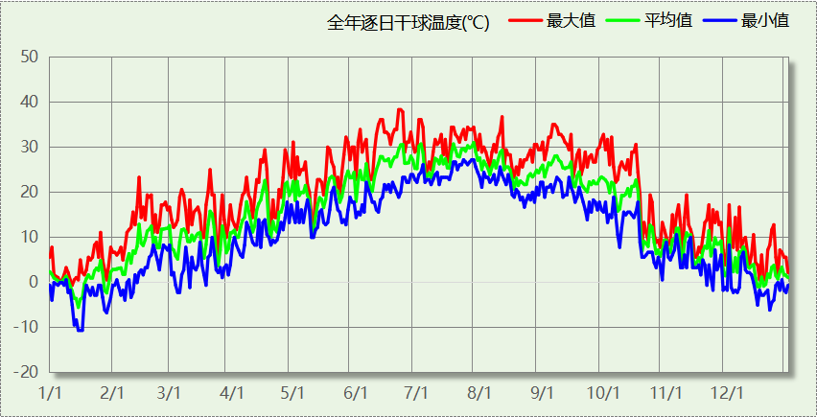

## 逐月辐照量表

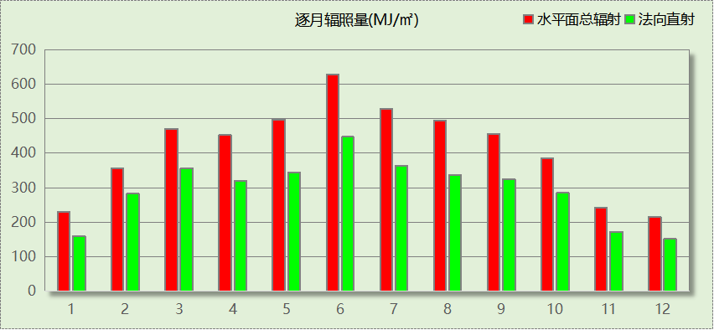

## 峰值工况

|  |  |  |  |  |  |
| --- | --- | --- | --- | --- | --- |
| 气象数据 | 时刻 | 干球温度(℃) | 湿球温度(℃) | 含湿量(g/kg) | 焓值(kj/kg) |
| 最热 | 06月21日15时 | 38.3 | 21.1 | 8.9 | 61.4 |
| 最冷 | 01月14日07时 | -10.6 | -10.6 | 1.4 | -7.1 |

# 围护结构

## 工程材料

|  |  |  |  |  |  |  |
| --- | --- | --- | --- | --- | --- | --- |
| 材料名称 | 导热系数λ | 蓄热系数S | 密度ρ | 比热容Cp | 蒸汽渗透 系数u | 数据来源 |
| W/(m.K) | W/(㎡.K) | kg/m3 | J/(kg.K) | g/(m.h.kPa) |
| 水泥砂浆 | 0.930 | 11.370 | 1800.0 | 1050.0 | 0.0210 | 民用建筑热工设计规范 GB50176-2016 |
| 混合砂浆 | 0.870 | 10.750 | 1700.0 | 1074.4 | 0.0975 | 民用建筑热工设计规范 GB50176-2016 |
| 钢筋混凝土 | 1.740 | 17.200 | 2500.0 | 920.0 | 0.0158 | 民用建筑热工设计规范 GB50176-2016 |
| 挤塑聚苯板(ρ=25-32) | 0.030 | 0.320 | 28.5 | 1647.0 | 0.0162 | 民用建筑热工设计规范 GB50176-2016 |
| 加气混凝土、泡沫混凝土(ρ=700) | 0.180 | 3.100 | 700.0 | 1050.0 | 0.0998 | 民用建筑热工设计规范 GB50176-2016 |
| 岩棉板(ρ=60-160) | 0.041 | 0.615 | 110.0 | 1220.0 | 0.4880 | 民用建筑热工设计规范 GB50176-2016 |
| c20细石混凝土(ρ=2300) | 1.510 | 15.243 | 2300.0 | 920.0 | 0.0173 | 民用建筑热工设计规范 GB50176-2016 |
| 轻骨料混凝土(找坡层) | 0.300 | 5.000 | 1050.0 | 1091.3 | 0.0140 | 民用建筑热工设计规范 GB50176-2016 |

## 围护结构作法简要说明

**1. 屋顶：**屋顶构造一 (K=0.271,D=3.755)：（由上到下）

水泥砂浆 20mm＋c20细石混凝土(ρ=2300) 40mm＋挤塑聚苯板(ρ=25-32) 110mm＋轻骨料混凝土(找坡层) 30mm＋钢筋混凝土 120mm＋混合砂浆 20mm

**2. 外墙：**填充墙构造一 (K=0.340,D=5.543)：（由外到内）

水泥砂浆 60mm＋挤塑聚苯板(ρ=25-32) 58.5mm＋加气混凝土、泡沫混凝土(ρ=700) 200mm＋混合砂浆 60mm

**3. 采暖与非采暖隔墙：**控温与非控温隔墙构造一 (K=0.902,D=3.764)：

水泥砂浆 20mm＋加气混凝土、泡沫混凝土(ρ=700) 190mm＋混合砂浆 20mm

**4. 外窗：**断桥铝框(框洞比0.2)--6mm+12A+6mm(Low-E中空SuperSE-I） (K=2.200)：

传热系数2.200W/㎡.K，窗太阳得热系数0.411

**5. 周边地面：**周边地面构造一 (K=1.258,D=1.446)：

水泥砂浆 20mm＋挤塑聚苯板(ρ=25-32) 20mm＋钢筋混凝土 100mm

# 围护结构概况

|  |  |  |  |  |  |
| --- | --- | --- | --- | --- | --- |
|  | | | 设计建筑 | | |
| 屋顶传热系数K  和热情性指标 D | | | 0.27  3.76 | | |
| 外墙传热系数K  和热情性指标 D | | | 0.41  5.54 | | |
| 挑空(或架空)楼板传热系数K  和热惰性指标 D | | | －  － | | |
| 天窗传热系数K  和太阳得热系数 SHGC | | | －  － | | |
| 外窗（包括透明幕墙） | 朝向 | 立面 | 窗墙比 | 传热  系数 | 太阳得热系数 |
| 北向 | 北-默认立面 | 0.07 | 2.20 | 0.41 |
| 东向 | 东-默认立面 | 0.10 | 2.20 | 0.41 |
| 西向 | 西-默认立面 | 0.03 | 2.20 | 0.41 |
|  |  |  |  |  |

# 设计建筑

## 房间类型

### 房间参数表

|  |  |  |  |  |  |  |  |
| --- | --- | --- | --- | --- | --- | --- | --- |
| 房间类型 | 空调 温度℃ | 供暖 温度℃ | 新风量 | 渗透风 换气次数 | 人员密度 | 照明功率 密度 | 电器设备 功率 |
| 会议室 | 26 | 18 | 14(m3/h.人) | 0(次/h) | 2.5(㎡/人) | 8(W/㎡) | 15(W/㎡) |
| 厨房 | 27 | 18 | 28(次/h) | 0(次/h) | 5(㎡/人) | 8(W/㎡) | 15(W/㎡) |
| 大厅 | 26 | 18 | 20(m3/h.人) | 0(次/h) | 30(㎡/人) | 10(W/㎡) | 15(W/㎡) |
| 展示区 | 26 | 20 | 30(m3/h.人) | 0(次/h) | 2.5(㎡/人) | 8(W/㎡) | 15(W/㎡) |
| 库房 | 26 | 20 | 30(m3/h.人) | 0(次/h) | 8(㎡/人) | 8(W/㎡) | 15(W/㎡) |
| 接待室 | 26 | 20 | 30(m3/h.人) | 0(次/h) | 8(㎡/人) | 8(W/㎡) | 15(W/㎡) |
| 普通办公室 | 26 | 20 | 30(m3/h.人) | 0(次/h) | 8(㎡/人) | 8(W/㎡) | 15(W/㎡) |
| 楼梯间 | － | － | 0(m3/h.人) | 0(次/h) | 0(人) | 3.5(W/㎡) | 15(W/㎡) |
| 走廊 | 26 | 16 | 20(m3/h.人) | 0(次/h) | 50(㎡/人) | 3.5(W/㎡) | 15(W/㎡) |
| 阅览室 | 26 | 18 | 30(m3/h.人) | 0(次/h) | 8(㎡/人) | 8(W/㎡) | 15(W/㎡) |
| 陈列室 | 26 | 20 | 30(m3/h.人) | 0(次/h) | 8(㎡/人) | 8(W/㎡) | 15(W/㎡) |
| 餐厅 | 26 | 18 | 30(m3/h.人) | 0(次/h) | 2.5(㎡/人) | 8(W/㎡) | 15(W/㎡) |

### 作息时间表

详见附录

## 系统类型

### 系统分区

|  |  |  |  |  |  |
| --- | --- | --- | --- | --- | --- |
| 系统编号 | 系统类型 | 制冷 SEER | 制热 HSPF | 面积(㎡) | 包含的房间 |
| 默认 | 地暖/辐射板采暖/散热器采暖+空调器供冷 | 5.40 | － | 2904.18 | 所有房间 |

### 热回收参数

|  |  |  |  |  |  |
| --- | --- | --- | --- | --- | --- |
| 系统编号 | 热回收 | 供冷 | | 供暖 | |
| 回收效率 | 启动温(焓)差 | 回收效率 | 启动温(焓)差 |
| 默认 | 无 | － | － | － | － |

## 制冷系统

### 多联机/单元式空调能耗

|  |  |  |  |
| --- | --- | --- | --- |
| 系统编号 | 制冷SEER | 耗冷量(kWh) | 耗电量(kWh) |
| 默认 | 5.40 | 61162 | 11326 |

## 供暖系统

### 默认热源

#### 供应的系统

|  |  |
| --- | --- |
| 系统编号 | 默认 |

#### 市政热力系统能耗

|  |  |  |  |  |  |  |
| --- | --- | --- | --- | --- | --- | --- |
| 累计 热负荷 (kWh) | 外网热 输送效率 | 耗电 输热比 EHR | 热/电 转换系数 (kWh/kWh) | 热源折合 电耗 (kWh) | 供暖水 泵电耗 (kWh) | 合计 电耗 (kWh) |
| 55944 | 0.92 | 0.00433 | 2.93 | 20751 | 242 | 20993 |

## 空调风机

### 独立新排风

|  |  |  |  |  |  |
| --- | --- | --- | --- | --- | --- |
| 系统编号 | 新风量 (m3/h) | 单位风量耗功率 W/(m3/h) | 风机功率(W) | 运行时长(h) | 新风电耗(kWh) |
| 默认 | 26014 | 0.24 | 6243 | 1044 | 6518 |
| 合计 | | | | | 6518 |

## 照明

|  |  |  |  |  |
| --- | --- | --- | --- | --- |
| 房间类型 | 单位面积电耗 (kWh/㎡) | 房间个数 | 房间合计面积 (㎡) | 合计电耗 (kWh) |
| 会议室 | 11.77 | 2 | 58 | 685 |
| 厨房 | 11.77 | 2 | 53 | 629 |
| 大厅 | 14.72 | 3 | 223 | 3286 |
| 展示区 | 11.77 | 6 | 997 | 11744 |
| 库房 | 11.77 | 1 | 23 | 272 |
| 接待室 | 11.77 | 2 | 228 | 2689 |
| 普通办公室 | 11.77 | 3 | 261 | 3077 |
| 楼梯间 | 8.43 | 3 | 156 | 1318 |
| 走廊 | 7.24 | 3 | 105 | 758 |
| 阅览室 | 11.77 | 2 | 189 | 2221 |
| 陈列室 | 11.77 | 3 | 629 | 7407 |
| 餐厅 | 11.77 | 2 | 262 | 3090 |
| 总计 | | | | 37175 |

## 负荷分项统计

|  |  |  |  |  |  |  |
| --- | --- | --- | --- | --- | --- | --- |
| 分类 | 围护传热 | 室内得热 | 窗日射 | 新风/渗透 | 热回收 | 合计 |
| 供暖(kWh/㎡) | -6.76 | 6.83 | 0.40 | -17.43 | 0.00 | -16.96 |
| 供冷(kWh/㎡) | 0.71 | 6.92 | 0.51 | 10.40 | 0.00 | 18.54 |

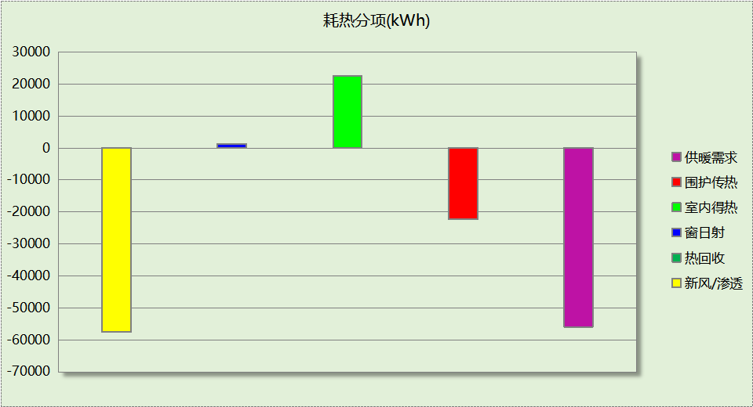

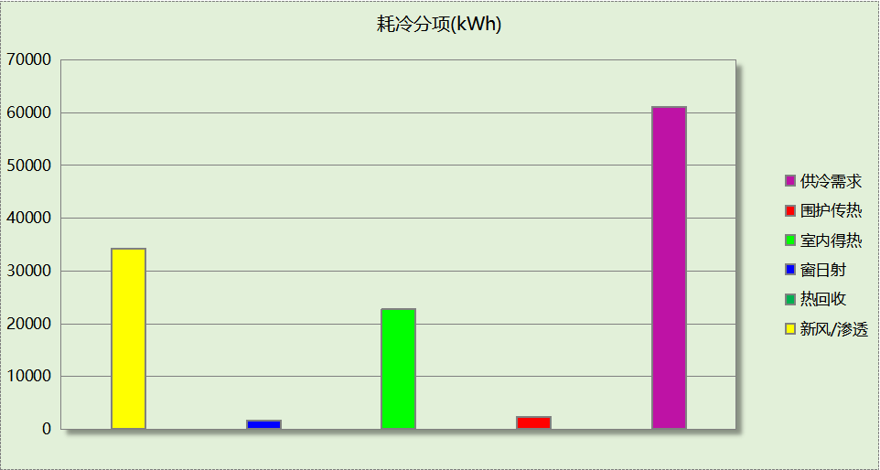

## 逐月负荷表

|  |  |  |  |  |  |  |
| --- | --- | --- | --- | --- | --- | --- |
| 月份 | 供暖(kWh) | 供冷(kWh) | 热负荷 峰值(kW) | 热负荷 峰值时刻 | 冷负荷 峰值(kW) | 冷负荷 峰值时刻 |
| 1月 | 22989 | 0 | 486.896 | 1月2日8时 | 0.000 | -- |
| 2月 | 0 | 0 | 0.000 | -- | 0.000 | -- |
| 3月 | 0 | 0 | 0.000 | -- | 0.000 | -- |
| 4月 | 0 | 0 | 0.000 | -- | 0.000 | -- |
| 5月 | 0 | 0 | 0.000 | -- | 0.000 | -- |
| 6月 | 0 | 19315 | 0.000 | -- | 304.771 | 6月28日15时 |
| 7月 | 0 | 30345 | 0.000 | -- | 397.154 | 7月2日9时 |
| 8月 | 0 | 11502 | 0.000 | -- | 322.957 | 8月30日16时 |
| 9月 | 0 | 0 | 0.000 | -- | 0.000 | -- |
| 10月 | 0 | 0 | 0.000 | -- | 0.000 | -- |
| 11月 | 0 | 0 | 0.000 | -- | 0.000 | -- |
| 12月 | 32955 | 0 | 341.456 | 12月2日8时 | 0.000 | -- |

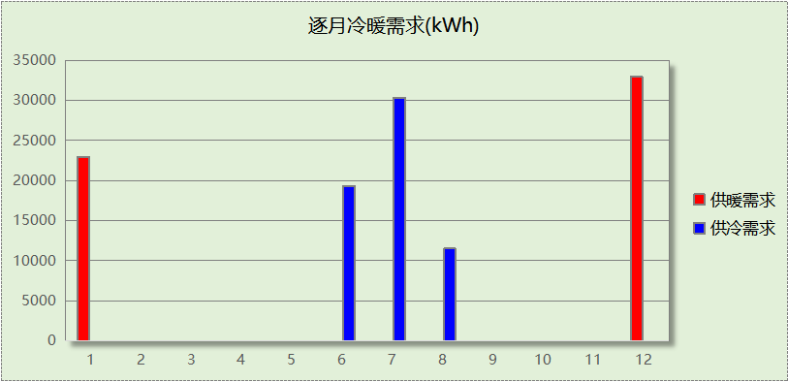

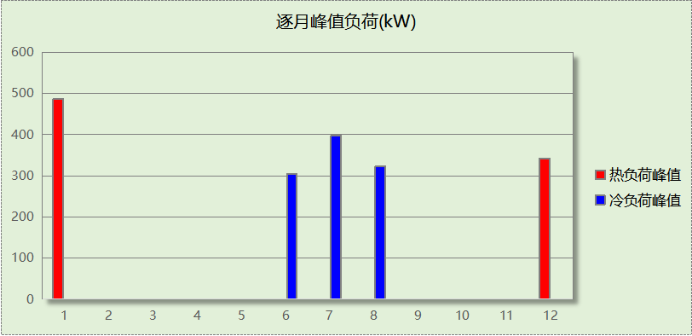

## 逐月电耗

注:供冷供暖为冷热源及输配水泵电耗，热水为扣减太阳能后电耗，所有数据单位kWh/㎡。

|  |  |  |  |  |  |  |  |  |
| --- | --- | --- | --- | --- | --- | --- | --- | --- |
| 月 | 供冷 | 供暖 | 空调风机 | 照明 | 插座设备 | 排风机 | 电梯 | 热水 |
| 1 | 0.00 | 2.62 | 0.20 | 0.46 | － | － | － | － |
| 2 | 0.00 | 0.00 | 0.00 | 0.00 | － |
| 3 | 0.00 | 0.00 | 0.00 | 1.03 | － |
| 4 | 0.00 | 0.00 | 0.00 | 1.08 | － |
| 5 | 0.00 | 0.00 | 0.00 | 1.13 | － |
| 6 | 1.08 | 0.00 | 0.25 | 0.98 | － |
| 7 | 1.70 | 0.00 | 0.52 | 1.18 | － |
| 8 | 0.65 | 0.00 | 0.50 | 1.13 | － |
| 9 | 0.00 | 0.00 | 0.00 | 1.03 | － |
| 10 | 0.00 | 0.00 | 0.00 | 1.03 | － |
| 11 | 0.00 | 0.00 | 0.00 | 1.08 | － |
| 12 | 0.00 | 3.75 | 0.50 | 1.13 | － |
| 合计 | 3.43 | 6.36 | 1.98 | 11.27 | － | － | － | － |

# 参照建筑

## 房间类型

### 房间参数表

|  |  |  |  |  |  |  |  |
| --- | --- | --- | --- | --- | --- | --- | --- |
| 房间类型 | 空调 温度℃ | 供暖 温度℃ | 新风量 | 渗透风 换气次数 | 人员密度 | 照明功率 密度 | 电器设备 功率 |
| 会议室 | 26 | 18 | 14(m3/h.人) | 0(次/h) | 2.5(㎡/人) | 9(W/㎡) | 15(W/㎡) |
| 厨房 | 27 | 18 | 28(次/h) | 0(次/h) | 5(㎡/人) | 9(W/㎡) | 15(W/㎡) |
| 大厅 | 26 | 18 | 20(m3/h.人) | 0(次/h) | 30(㎡/人) | 11(W/㎡) | 15(W/㎡) |
| 展示区 | 26 | 20 | 30(m3/h.人) | 0(次/h) | 2.5(㎡/人) | 9(W/㎡) | 15(W/㎡) |
| 库房 | 26 | 20 | 30(m3/h.人) | 0(次/h) | 8(㎡/人) | 9(W/㎡) | 15(W/㎡) |
| 接待室 | 26 | 20 | 30(m3/h.人) | 0(次/h) | 8(㎡/人) | 9(W/㎡) | 15(W/㎡) |
| 普通办公室 | 26 | 20 | 30(m3/h.人) | 0(次/h) | 8(㎡/人) | 9(W/㎡) | 15(W/㎡) |
| 楼梯间 | － | － | 0(m3/h.人) | 0(次/h) | 0(人) | 6(W/㎡) | 15(W/㎡) |
| 走廊 | 26 | 16 | 20(m3/h.人) | 0(次/h) | 50(㎡/人) | 5(W/㎡) | 15(W/㎡) |
| 阅览室 | 26 | 18 | 30(m3/h.人) | 0(次/h) | 8(㎡/人) | 9(W/㎡) | 15(W/㎡) |
| 陈列室 | 26 | 20 | 30(m3/h.人) | 0(次/h) | 8(㎡/人) | 9(W/㎡) | 15(W/㎡) |
| 餐厅 | 26 | 18 | 30(m3/h.人) | 0(次/h) | 2.5(㎡/人) | 9(W/㎡) | 15(W/㎡) |

### 作息时间表

同设计建筑

## 制冷系统

|  |  |  |
| --- | --- | --- |
| 负荷(kWh/a) | 系统综合性能系数 | 耗电(kWh/a) |
| 70931 | 2.50 | 28373 |

## 供暖系统

|  |  |  |
| --- | --- | --- |
| 负荷(kWh/a) | 系统综合性能系数 | 耗电(kWh/a) |
| 55336 | 1.80 | 34585 |

## 照明

|  |  |  |  |  |
| --- | --- | --- | --- | --- |
| 房间类型 | 单位面积电耗 (kWh/㎡) | 房间个数 | 房间合计面积 (㎡) | 合计电耗 (kWh) |
| 会议室 | 13.25 | 2 | 58 | 770 |
| 厨房 | 13.25 | 2 | 53 | 708 |
| 大厅 | 16.19 | 3 | 223 | 3614 |
| 展示区 | 13.25 | 6 | 997 | 13212 |
| 库房 | 13.25 | 1 | 23 | 306 |
| 接待室 | 13.25 | 2 | 228 | 3025 |
| 普通办公室 | 13.25 | 3 | 261 | 3461 |
| 楼梯间 | 14.45 | 3 | 156 | 2260 |
| 走廊 | 10.35 | 3 | 105 | 1083 |
| 阅览室 | 13.25 | 2 | 189 | 2498 |
| 陈列室 | 13.25 | 3 | 629 | 8333 |
| 餐厅 | 13.25 | 2 | 262 | 3476 |
| 总计 | | | | 42747 |

## 负荷分项统计

|  |  |  |  |  |  |  |
| --- | --- | --- | --- | --- | --- | --- |
| 分类 | 围护传热 | 室内得热 | 窗日射 | 新风/渗透 | 热回收 | 合计 |
| 供暖(kWh/㎡) | -6.70 | 6.93 | 0.40 | -17.40 | 0.00 | -16.78 |
| 供冷(kWh/㎡) | 1.00 | 8.32 | 0.61 | 11.58 | 0.00 | 21.50 |

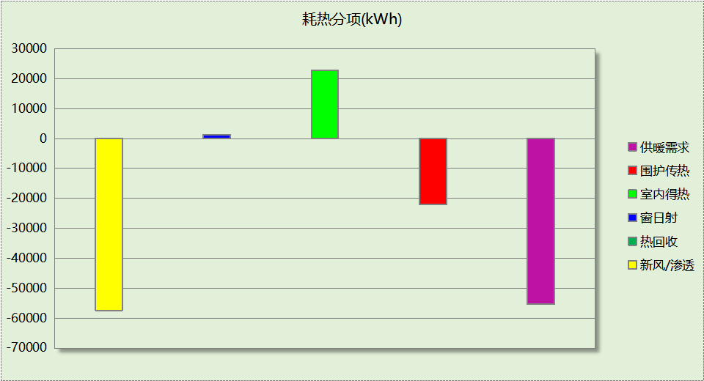

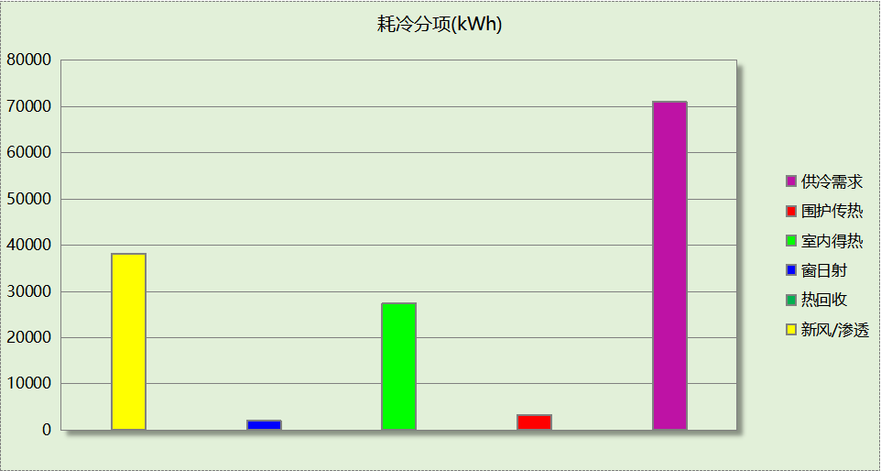

## 逐月负荷表

|  |  |  |  |  |  |  |
| --- | --- | --- | --- | --- | --- | --- |
| 月份 | 供暖(kWh) | 供冷(kWh) | 热负荷 峰值(kW) | 热负荷 峰值时刻 | 冷负荷 峰值(kW) | 冷负荷 峰值时刻 |
| 1月 | 22811 | 0 | 486.187 | 1月2日8时 | 0.000 | -- |
| 2月 | 0 | 0 | 0.000 | -- | 0.000 | -- |
| 3月 | 0 | 0 | 0.000 | -- | 0.000 | -- |
| 4月 | 0 | 0 | 0.000 | -- | 0.000 | -- |
| 5月 | 0 | 0 | 0.000 | -- | 0.000 | -- |
| 6月 | 0 | 25575 | 0.000 | -- | 306.717 | 6月28日15时 |
| 7月 | 0 | 31934 | 0.000 | -- | 399.115 | 7月2日9时 |
| 8月 | 0 | 13423 | 0.000 | -- | 325.148 | 8月30日16时 |
| 9月 | 0 | 0 | 0.000 | -- | 0.000 | -- |
| 10月 | 0 | 0 | 0.000 | -- | 0.000 | -- |
| 11月 | 0 | 0 | 0.000 | -- | 0.000 | -- |
| 12月 | 32525 | 0 | 340.359 | 12月2日8时 | 0.000 | -- |

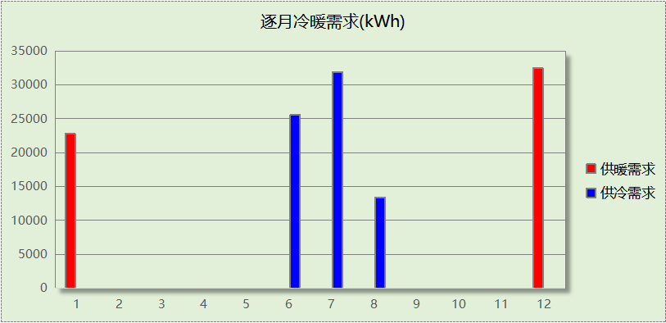

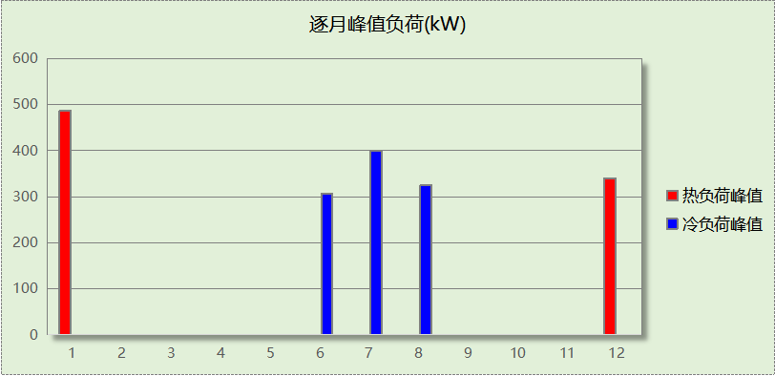

## 逐月电耗

注:供冷供暖为冷热源及输配水泵电耗，热水为扣减太阳能后电耗，所有数据单位kWh/㎡。

|  |  |  |  |  |  |  |  |  |
| --- | --- | --- | --- | --- | --- | --- | --- | --- |
| 月 | 供冷 | 供暖 | 空调风机 | 照明 | 插座设备 | 排风机 | 电梯 | 热水 |
| 1 | 0.00 | 0.00 | 0.00 | 0.53 | － | － | － | － |
| 2 | 0.00 | 0.00 | 0.00 | 0.00 | － |
| 3 | 0.00 | 0.00 | 0.00 | 1.18 | － |
| 4 | 0.00 | 0.00 | 0.00 | 1.24 | － |
| 5 | 0.00 | 0.00 | 0.00 | 1.30 | － |
| 6 | 1.76 | 0.00 | 0.00 | 1.12 | － |
| 7 | 2.20 | 0.00 | 0.00 | 1.36 | － |
| 8 | 0.92 | 0.00 | 0.00 | 1.30 | － |
| 9 | 0.00 | 0.00 | 0.00 | 1.18 | － |
| 10 | 0.00 | 0.00 | 0.00 | 1.18 | － |
| 11 | 0.00 | 0.00 | 0.00 | 1.24 | － |
| 12 | 0.00 | 0.00 | 0.00 | 1.30 | － |
| 合计 | 4.89 | 0.00 | 0.00 | 12.96 | － | － | － | － |

# 计算结果

|  |  |  |  |  |
| --- | --- | --- | --- | --- |
| 能耗分类 | 能耗子类 | 设计建筑  (kWh/㎡) | 参照建筑  (kWh/㎡) | 节能率  （%） |
| 建筑负荷 | 耗冷量 | 18.54 | 21.50 | 7.26% |
| 耗热量 | 16.96 | 16.78 |
| 冷热合计 | 35.50 | 38.28 |
| 热回收负荷 | 供冷 | 0.00 | － |  |
| 供暖 | 0.00 | － |  |
| 冷热合计 | 0.00 | － |  |
| 供冷电耗 | 中央冷源 | 0.00 | － | 60.08% |
| 冷却水泵 | 0.00 | － |
| 冷冻水泵 | 0.00 | － |
| 冷却塔 | 0.00 | － |
| 多联机/单元式空调 | 3.43 | － |
| 供冷合计 | 3.43 | 8.60 |
| 供暖电耗 | 中央热源 | 6.29 | － | 39.30% |
| 供暖水泵 | 0.07 | － |
| 热源侧水泵 | 0.00 | － |
| 多联机/单元式热泵 | 0.00 | － |
| 供暖合计 | 6.36 | 10.48 |
| 空调风机电耗 | 独立新排风 | 1.98 | － | - |
| 风机盘管 | 0.00 | － |
| 全空气系统 | 0.00 | － |
| 风机合计 | 1.98 | － |
| 采暖空调电耗 | | 11.78 | 19.09 | 38.29% |
| 照明电耗 | | 11.27 | 12.96 | 13.03% |
| 建筑综合电耗 | | 23.05 | 32.05 | 28.08% |

# 绿色建筑性能评估得分

|  |  |  |  |
| --- | --- | --- | --- |
| 标准条文 | 得分评价 | 节能率 | 得分 |
| 7.2.8 采取措施降低建筑能耗 | 建筑能耗相比国家现行有关建筑节能标准降低10%, 得5 分；降低20%,得10 分。 | 28.08% | 10 |
| 标准依据 | 《绿色建筑评价标准》GB-T 50378-2019 | | |

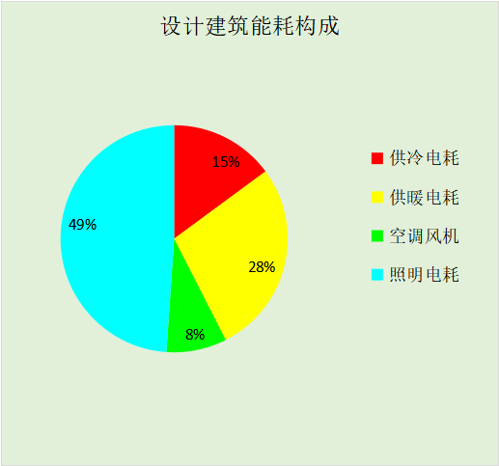

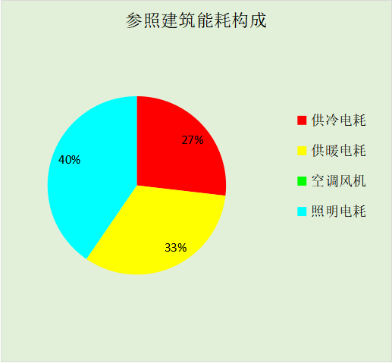

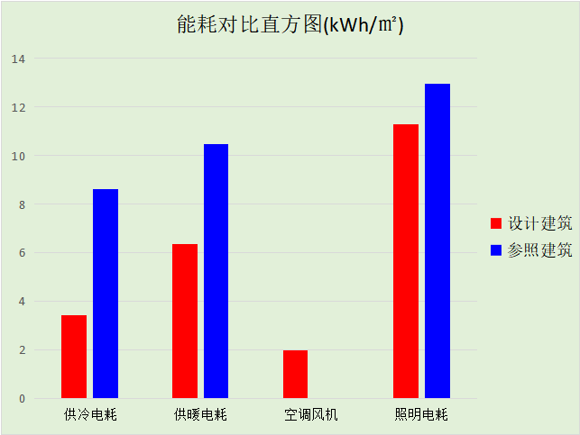

# 附录

暑假:7.15~8.25; 寒假：1.15~3.1

## 工作日/节假日人员逐时在室率(%)

|  |  |  |  |  |  |  |  |  |  |  |  |  |  |  |  |  |  |  |  |  |  |  |  |  |
| --- | --- | --- | --- | --- | --- | --- | --- | --- | --- | --- | --- | --- | --- | --- | --- | --- | --- | --- | --- | --- | --- | --- | --- | --- |
| 房间类型 | 1 | 2 | 3 | 4 | 5 | 6 | 7 | 8 | 9 | 10 | 11 | 12 | 13 | 14 | 15 | 16 | 17 | 18 | 19 | 20 | 21 | 22 | 23 | 24 |
| 会议室 | 0 | 0 | 0 | 0 | 0 | 0 | 10 | 50 | 100 | 100 | 100 | 30 | 100 | 100 | 100 | 100 | 50 | 20 | 10 | 0 | 0 | 0 | 0 | 0 |
| 0 | 0 | 0 | 0 | 0 | 0 | 0 | 20 | 45 | 0 | 0 | 0 | 0 | 0 | 0 | 0 | 0 | 0 | 0 | 0 | 0 | 0 | 0 | 0 |
| 0 | 0 | 0 | 0 | 0 | 0 | 0 | 20 | 45 | 0 | 0 | 0 | 0 | 0 | 0 | 0 | 0 | 0 | 0 | 0 | 0 | 0 | 0 | 0 |
| 0 | 0 | 0 | 0 | 0 | 0 | 0 | 20 | 45 | 0 | 0 | 0 | 0 | 0 | 0 | 0 | 0 | 0 | 0 | 0 | 0 | 0 | 0 | 0 |
| 厨房 | 0 | 0 | 0 | 0 | 0 | 0 | 10 | 50 | 100 | 100 | 100 | 30 | 100 | 100 | 100 | 100 | 50 | 20 | 10 | 0 | 0 | 0 | 0 | 0 |
| 0 | 0 | 0 | 0 | 0 | 0 | 0 | 20 | 45 | 0 | 0 | 0 | 0 | 0 | 0 | 0 | 0 | 0 | 0 | 0 | 0 | 0 | 0 | 0 |
| 0 | 0 | 0 | 0 | 0 | 0 | 0 | 20 | 45 | 0 | 0 | 0 | 0 | 0 | 0 | 0 | 0 | 0 | 0 | 0 | 0 | 0 | 0 | 0 |
| 0 | 0 | 0 | 0 | 0 | 0 | 0 | 20 | 45 | 0 | 0 | 0 | 0 | 0 | 0 | 0 | 0 | 0 | 0 | 0 | 0 | 0 | 0 | 0 |
| 大厅 | 0 | 0 | 0 | 0 | 0 | 0 | 10 | 50 | 100 | 100 | 100 | 30 | 100 | 100 | 100 | 100 | 50 | 20 | 10 | 0 | 0 | 0 | 0 | 0 |
| 0 | 0 | 0 | 0 | 0 | 0 | 0 | 20 | 45 | 0 | 0 | 0 | 0 | 0 | 0 | 0 | 0 | 0 | 0 | 0 | 0 | 0 | 0 | 0 |
| 0 | 0 | 0 | 0 | 0 | 0 | 0 | 20 | 45 | 0 | 0 | 0 | 0 | 0 | 0 | 0 | 0 | 0 | 0 | 0 | 0 | 0 | 0 | 0 |
| 0 | 0 | 0 | 0 | 0 | 0 | 0 | 20 | 45 | 0 | 0 | 0 | 0 | 0 | 0 | 0 | 0 | 0 | 0 | 0 | 0 | 0 | 0 | 0 |
| 展示区 | 0 | 0 | 0 | 0 | 0 | 0 | 10 | 50 | 100 | 100 | 100 | 30 | 100 | 100 | 100 | 100 | 50 | 20 | 10 | 0 | 0 | 0 | 0 | 0 |
| 0 | 0 | 0 | 0 | 0 | 0 | 0 | 20 | 45 | 0 | 0 | 0 | 0 | 0 | 0 | 0 | 0 | 0 | 0 | 0 | 0 | 0 | 0 | 0 |
| 0 | 0 | 0 | 0 | 0 | 0 | 0 | 20 | 45 | 0 | 0 | 0 | 0 | 0 | 0 | 0 | 0 | 0 | 0 | 0 | 0 | 0 | 0 | 0 |
| 0 | 0 | 0 | 0 | 0 | 0 | 0 | 20 | 45 | 0 | 0 | 0 | 0 | 0 | 0 | 0 | 0 | 0 | 0 | 0 | 0 | 0 | 0 | 0 |
| 库房 | 0 | 0 | 0 | 0 | 0 | 0 | 10 | 50 | 100 | 100 | 100 | 30 | 100 | 100 | 100 | 100 | 50 | 20 | 10 | 0 | 0 | 0 | 0 | 0 |
| 0 | 0 | 0 | 0 | 0 | 0 | 0 | 20 | 45 | 0 | 0 | 0 | 0 | 0 | 0 | 0 | 0 | 0 | 0 | 0 | 0 | 0 | 0 | 0 |
| 0 | 0 | 0 | 0 | 0 | 0 | 0 | 20 | 45 | 0 | 0 | 0 | 0 | 0 | 0 | 0 | 0 | 0 | 0 | 0 | 0 | 0 | 0 | 0 |
| 0 | 0 | 0 | 0 | 0 | 0 | 0 | 20 | 45 | 0 | 0 | 0 | 0 | 0 | 0 | 0 | 0 | 0 | 0 | 0 | 0 | 0 | 0 | 0 |
| 接待室 | 0 | 0 | 0 | 0 | 0 | 0 | 10 | 50 | 100 | 100 | 100 | 30 | 100 | 100 | 100 | 100 | 50 | 20 | 10 | 0 | 0 | 0 | 0 | 0 |
| 0 | 0 | 0 | 0 | 0 | 0 | 0 | 20 | 45 | 0 | 0 | 0 | 0 | 0 | 0 | 0 | 0 | 0 | 0 | 0 | 0 | 0 | 0 | 0 |
| 0 | 0 | 0 | 0 | 0 | 0 | 0 | 20 | 45 | 0 | 0 | 0 | 0 | 0 | 0 | 0 | 0 | 0 | 0 | 0 | 0 | 0 | 0 | 0 |
| 0 | 0 | 0 | 0 | 0 | 0 | 0 | 20 | 45 | 0 | 0 | 0 | 0 | 0 | 0 | 0 | 0 | 0 | 0 | 0 | 0 | 0 | 0 | 0 |
| 普通办公室 | 0 | 0 | 0 | 0 | 0 | 0 | 10 | 50 | 100 | 100 | 100 | 30 | 100 | 100 | 100 | 100 | 50 | 20 | 10 | 0 | 0 | 0 | 0 | 0 |
| 0 | 0 | 0 | 0 | 0 | 0 | 0 | 20 | 45 | 0 | 0 | 0 | 0 | 0 | 0 | 0 | 0 | 0 | 0 | 0 | 0 | 0 | 0 | 0 |
| 0 | 0 | 0 | 0 | 0 | 0 | 0 | 20 | 45 | 0 | 0 | 0 | 0 | 0 | 0 | 0 | 0 | 0 | 0 | 0 | 0 | 0 | 0 | 0 |
| 0 | 0 | 0 | 0 | 0 | 0 | 0 | 20 | 45 | 0 | 0 | 0 | 0 | 0 | 0 | 0 | 0 | 0 | 0 | 0 | 0 | 0 | 0 | 0 |
| 楼梯间 | 0 | 0 | 0 | 0 | 0 | 0 | 0 | 20 | 50 | 80 | 80 | 80 | 80 | 80 | 80 | 80 | 80 | 80 | 80 | 70 | 50 | 0 | 0 | 0 |
| 0 | 0 | 0 | 0 | 0 | 0 | 0 | 0 | 0 | 0 | 0 | 0 | 0 | 0 | 0 | 0 | 0 | 0 | 0 | 0 | 0 | 0 | 0 | 0 |
| 0 | 0 | 0 | 0 | 0 | 0 | 0 | 0 | 0 | 0 | 0 | 0 | 0 | 0 | 0 | 0 | 0 | 0 | 0 | 0 | 0 | 0 | 0 | 0 |
| 0 | 0 | 0 | 0 | 0 | 0 | 0 | 0 | 0 | 0 | 0 | 0 | 0 | 0 | 0 | 0 | 0 | 0 | 0 | 0 | 0 | 0 | 0 | 0 |
| 走廊 | 0 | 0 | 0 | 0 | 0 | 0 | 10 | 50 | 95 | 95 | 95 | 80 | 80 | 95 | 95 | 95 | 95 | 30 | 30 | 0 | 0 | 0 | 0 | 0 |
| 0 | 0 | 0 | 0 | 0 | 0 | 0 | 0 | 0 | 0 | 0 | 0 | 0 | 0 | 0 | 0 | 0 | 0 | 0 | 0 | 0 | 0 | 0 | 0 |
| 0 | 0 | 0 | 0 | 0 | 0 | 0 | 0 | 0 | 0 | 0 | 0 | 0 | 0 | 0 | 0 | 0 | 0 | 0 | 0 | 0 | 0 | 0 | 0 |
| 0 | 0 | 0 | 0 | 0 | 0 | 0 | 0 | 0 | 0 | 0 | 0 | 0 | 0 | 0 | 0 | 0 | 0 | 0 | 0 | 0 | 0 | 0 | 0 |
| 阅览室 | 0 | 0 | 0 | 0 | 0 | 0 | 10 | 50 | 100 | 100 | 100 | 30 | 100 | 100 | 100 | 100 | 50 | 20 | 10 | 0 | 0 | 0 | 0 | 0 |
| 0 | 0 | 0 | 0 | 0 | 0 | 0 | 20 | 45 | 0 | 0 | 0 | 0 | 0 | 0 | 0 | 0 | 0 | 0 | 0 | 0 | 0 | 0 | 0 |
| 0 | 0 | 0 | 0 | 0 | 0 | 0 | 20 | 45 | 0 | 0 | 0 | 0 | 0 | 0 | 0 | 0 | 0 | 0 | 0 | 0 | 0 | 0 | 0 |
| 0 | 0 | 0 | 0 | 0 | 0 | 0 | 20 | 45 | 0 | 0 | 0 | 0 | 0 | 0 | 0 | 0 | 0 | 0 | 0 | 0 | 0 | 0 | 0 |
| 陈列室 | 0 | 0 | 0 | 0 | 0 | 0 | 10 | 50 | 100 | 100 | 100 | 30 | 100 | 100 | 100 | 100 | 50 | 20 | 10 | 0 | 0 | 0 | 0 | 0 |
| 0 | 0 | 0 | 0 | 0 | 0 | 0 | 20 | 45 | 0 | 0 | 0 | 0 | 0 | 0 | 0 | 0 | 0 | 0 | 0 | 0 | 0 | 0 | 0 |
| 0 | 0 | 0 | 0 | 0 | 0 | 0 | 20 | 45 | 0 | 0 | 0 | 0 | 0 | 0 | 0 | 0 | 0 | 0 | 0 | 0 | 0 | 0 | 0 |
| 0 | 0 | 0 | 0 | 0 | 0 | 0 | 20 | 45 | 0 | 0 | 0 | 0 | 0 | 0 | 0 | 0 | 0 | 0 | 0 | 0 | 0 | 0 | 0 |
| 餐厅 | 0 | 0 | 0 | 0 | 0 | 0 | 10 | 50 | 100 | 100 | 100 | 30 | 100 | 100 | 100 | 100 | 50 | 20 | 10 | 0 | 0 | 0 | 0 | 0 |
| 0 | 0 | 0 | 0 | 0 | 0 | 0 | 20 | 45 | 0 | 0 | 0 | 0 | 0 | 0 | 0 | 0 | 0 | 0 | 0 | 0 | 0 | 0 | 0 |
| 0 | 0 | 0 | 0 | 0 | 0 | 0 | 20 | 45 | 0 | 0 | 0 | 0 | 0 | 0 | 0 | 0 | 0 | 0 | 0 | 0 | 0 | 0 | 0 |
| 0 | 0 | 0 | 0 | 0 | 0 | 0 | 20 | 45 | 0 | 0 | 0 | 0 | 0 | 0 | 0 | 0 | 0 | 0 | 0 | 0 | 0 | 0 | 0 |

注：第一行：工作日；第二行：节假日；第三行：寒假；第四行：暑假

## 工作日/节假日照明开关时间表(%)

|  |  |  |  |  |  |  |  |  |  |  |  |  |  |  |  |  |  |  |  |  |  |  |  |  |
| --- | --- | --- | --- | --- | --- | --- | --- | --- | --- | --- | --- | --- | --- | --- | --- | --- | --- | --- | --- | --- | --- | --- | --- | --- |
| 房间类型 | 1 | 2 | 3 | 4 | 5 | 6 | 7 | 8 | 9 | 10 | 11 | 12 | 13 | 14 | 15 | 16 | 17 | 18 | 19 | 20 | 21 | 22 | 23 | 24 |
| 会议室 | 10 | 10 | 10 | 10 | 10 | 10 | 10 | 36 | 62 | 56 | 54 | 43 | 53 | 55 | 58 | 67 | 40 | 18 | 10 | 10 | 10 | 10 | 10 | 10 |
| 0 | 0 | 0 | 0 | 0 | 0 | 0 | 0 | 0 | 0 | 0 | 0 | 0 | 0 | 0 | 0 | 0 | 0 | 0 | 0 | 0 | 0 | 0 | 0 |
| 0 | 0 | 0 | 0 | 0 | 0 | 0 | 0 | 0 | 0 | 0 | 0 | 0 | 0 | 0 | 0 | 0 | 0 | 0 | 0 | 0 | 0 | 0 | 0 |
| 0 | 0 | 0 | 0 | 0 | 0 | 0 | 0 | 0 | 0 | 0 | 0 | 0 | 0 | 0 | 0 | 0 | 0 | 0 | 0 | 0 | 0 | 0 | 0 |
| 厨房 | 10 | 10 | 10 | 10 | 10 | 10 | 10 | 36 | 62 | 56 | 54 | 43 | 53 | 55 | 58 | 67 | 40 | 18 | 10 | 10 | 10 | 10 | 10 | 10 |
| 0 | 0 | 0 | 0 | 0 | 0 | 0 | 0 | 0 | 0 | 0 | 0 | 0 | 0 | 0 | 0 | 0 | 0 | 0 | 0 | 0 | 0 | 0 | 0 |
| 0 | 0 | 0 | 0 | 0 | 0 | 0 | 0 | 0 | 0 | 0 | 0 | 0 | 0 | 0 | 0 | 0 | 0 | 0 | 0 | 0 | 0 | 0 | 0 |
| 0 | 0 | 0 | 0 | 0 | 0 | 0 | 0 | 0 | 0 | 0 | 0 | 0 | 0 | 0 | 0 | 0 | 0 | 0 | 0 | 0 | 0 | 0 | 0 |
| 大厅 | 10 | 10 | 10 | 10 | 10 | 10 | 10 | 36 | 62 | 56 | 54 | 43 | 53 | 55 | 58 | 67 | 40 | 18 | 10 | 10 | 10 | 10 | 10 | 10 |
| 0 | 0 | 0 | 0 | 0 | 0 | 0 | 0 | 0 | 0 | 0 | 0 | 0 | 0 | 0 | 0 | 0 | 0 | 0 | 0 | 0 | 0 | 0 | 0 |
| 0 | 0 | 0 | 0 | 0 | 0 | 0 | 0 | 0 | 0 | 0 | 0 | 0 | 0 | 0 | 0 | 0 | 0 | 0 | 0 | 0 | 0 | 0 | 0 |
| 0 | 0 | 0 | 0 | 0 | 0 | 0 | 0 | 0 | 0 | 0 | 0 | 0 | 0 | 0 | 0 | 0 | 0 | 0 | 0 | 0 | 0 | 0 | 0 |
| 展示区 | 10 | 10 | 10 | 10 | 10 | 10 | 10 | 36 | 62 | 56 | 54 | 43 | 53 | 55 | 58 | 67 | 40 | 18 | 10 | 10 | 10 | 10 | 10 | 10 |
| 0 | 0 | 0 | 0 | 0 | 0 | 0 | 0 | 0 | 0 | 0 | 0 | 0 | 0 | 0 | 0 | 0 | 0 | 0 | 0 | 0 | 0 | 0 | 0 |
| 0 | 0 | 0 | 0 | 0 | 0 | 0 | 0 | 0 | 0 | 0 | 0 | 0 | 0 | 0 | 0 | 0 | 0 | 0 | 0 | 0 | 0 | 0 | 0 |
| 0 | 0 | 0 | 0 | 0 | 0 | 0 | 0 | 0 | 0 | 0 | 0 | 0 | 0 | 0 | 0 | 0 | 0 | 0 | 0 | 0 | 0 | 0 | 0 |
| 库房 | 10 | 10 | 10 | 10 | 10 | 10 | 10 | 36 | 62 | 56 | 54 | 43 | 53 | 55 | 58 | 67 | 40 | 18 | 10 | 10 | 10 | 10 | 10 | 10 |
| 0 | 0 | 0 | 0 | 0 | 0 | 0 | 0 | 0 | 0 | 0 | 0 | 0 | 0 | 0 | 0 | 0 | 0 | 0 | 0 | 0 | 0 | 0 | 0 |
| 0 | 0 | 0 | 0 | 0 | 0 | 0 | 0 | 0 | 0 | 0 | 0 | 0 | 0 | 0 | 0 | 0 | 0 | 0 | 0 | 0 | 0 | 0 | 0 |
| 0 | 0 | 0 | 0 | 0 | 0 | 0 | 0 | 0 | 0 | 0 | 0 | 0 | 0 | 0 | 0 | 0 | 0 | 0 | 0 | 0 | 0 | 0 | 0 |
| 接待室 | 10 | 10 | 10 | 10 | 10 | 10 | 10 | 36 | 62 | 56 | 54 | 43 | 53 | 55 | 58 | 67 | 40 | 18 | 10 | 10 | 10 | 10 | 10 | 10 |
| 0 | 0 | 0 | 0 | 0 | 0 | 0 | 0 | 0 | 0 | 0 | 0 | 0 | 0 | 0 | 0 | 0 | 0 | 0 | 0 | 0 | 0 | 0 | 0 |
| 0 | 0 | 0 | 0 | 0 | 0 | 0 | 0 | 0 | 0 | 0 | 0 | 0 | 0 | 0 | 0 | 0 | 0 | 0 | 0 | 0 | 0 | 0 | 0 |
| 0 | 0 | 0 | 0 | 0 | 0 | 0 | 0 | 0 | 0 | 0 | 0 | 0 | 0 | 0 | 0 | 0 | 0 | 0 | 0 | 0 | 0 | 0 | 0 |
| 普通办公室 | 10 | 10 | 10 | 10 | 10 | 10 | 10 | 36 | 62 | 56 | 54 | 43 | 53 | 55 | 58 | 67 | 40 | 18 | 10 | 10 | 10 | 10 | 10 | 10 |
| 0 | 0 | 0 | 0 | 0 | 0 | 0 | 0 | 0 | 0 | 0 | 0 | 0 | 0 | 0 | 0 | 0 | 0 | 0 | 0 | 0 | 0 | 0 | 0 |
| 0 | 0 | 0 | 0 | 0 | 0 | 0 | 0 | 0 | 0 | 0 | 0 | 0 | 0 | 0 | 0 | 0 | 0 | 0 | 0 | 0 | 0 | 0 | 0 |
| 0 | 0 | 0 | 0 | 0 | 0 | 0 | 0 | 0 | 0 | 0 | 0 | 0 | 0 | 0 | 0 | 0 | 0 | 0 | 0 | 0 | 0 | 0 | 0 |
| 楼梯间 | 10 | 10 | 10 | 10 | 10 | 10 | 10 | 50 | 60 | 60 | 60 | 60 | 60 | 60 | 60 | 60 | 80 | 90 | 100 | 100 | 100 | 10 | 10 | 10 |
| 0 | 0 | 0 | 0 | 0 | 0 | 0 | 0 | 0 | 0 | 0 | 0 | 0 | 0 | 0 | 0 | 0 | 0 | 0 | 0 | 0 | 0 | 0 | 0 |
| 0 | 0 | 0 | 0 | 0 | 0 | 0 | 0 | 0 | 0 | 0 | 0 | 0 | 0 | 0 | 0 | 0 | 0 | 0 | 0 | 0 | 0 | 0 | 0 |
| 0 | 0 | 0 | 0 | 0 | 0 | 0 | 0 | 0 | 0 | 0 | 0 | 0 | 0 | 0 | 0 | 0 | 0 | 0 | 0 | 0 | 0 | 0 | 0 |
| 走廊 | 0 | 0 | 0 | 0 | 0 | 0 | 10 | 50 | 95 | 95 | 95 | 80 | 80 | 95 | 95 | 95 | 95 | 30 | 30 | 0 | 0 | 0 | 0 | 0 |
| 0 | 0 | 0 | 0 | 0 | 0 | 0 | 0 | 0 | 0 | 0 | 0 | 0 | 0 | 0 | 0 | 0 | 0 | 0 | 0 | 0 | 0 | 0 | 0 |
| 0 | 0 | 0 | 0 | 0 | 0 | 0 | 0 | 0 | 0 | 0 | 0 | 0 | 0 | 0 | 0 | 0 | 0 | 0 | 0 | 0 | 0 | 0 | 0 |
| 0 | 0 | 0 | 0 | 0 | 0 | 0 | 0 | 0 | 0 | 0 | 0 | 0 | 0 | 0 | 0 | 0 | 0 | 0 | 0 | 0 | 0 | 0 | 0 |
| 阅览室 | 10 | 10 | 10 | 10 | 10 | 10 | 10 | 36 | 62 | 56 | 54 | 43 | 53 | 55 | 58 | 67 | 40 | 18 | 10 | 10 | 10 | 10 | 10 | 10 |
| 0 | 0 | 0 | 0 | 0 | 0 | 0 | 0 | 0 | 0 | 0 | 0 | 0 | 0 | 0 | 0 | 0 | 0 | 0 | 0 | 0 | 0 | 0 | 0 |
| 0 | 0 | 0 | 0 | 0 | 0 | 0 | 0 | 0 | 0 | 0 | 0 | 0 | 0 | 0 | 0 | 0 | 0 | 0 | 0 | 0 | 0 | 0 | 0 |
| 0 | 0 | 0 | 0 | 0 | 0 | 0 | 0 | 0 | 0 | 0 | 0 | 0 | 0 | 0 | 0 | 0 | 0 | 0 | 0 | 0 | 0 | 0 | 0 |
| 陈列室 | 10 | 10 | 10 | 10 | 10 | 10 | 10 | 36 | 62 | 56 | 54 | 43 | 53 | 55 | 58 | 67 | 40 | 18 | 10 | 10 | 10 | 10 | 10 | 10 |
| 0 | 0 | 0 | 0 | 0 | 0 | 0 | 0 | 0 | 0 | 0 | 0 | 0 | 0 | 0 | 0 | 0 | 0 | 0 | 0 | 0 | 0 | 0 | 0 |
| 0 | 0 | 0 | 0 | 0 | 0 | 0 | 0 | 0 | 0 | 0 | 0 | 0 | 0 | 0 | 0 | 0 | 0 | 0 | 0 | 0 | 0 | 0 | 0 |
| 0 | 0 | 0 | 0 | 0 | 0 | 0 | 0 | 0 | 0 | 0 | 0 | 0 | 0 | 0 | 0 | 0 | 0 | 0 | 0 | 0 | 0 | 0 | 0 |
| 餐厅 | 10 | 10 | 10 | 10 | 10 | 10 | 10 | 36 | 62 | 56 | 54 | 43 | 53 | 55 | 58 | 67 | 40 | 18 | 10 | 10 | 10 | 10 | 10 | 10 |
| 0 | 0 | 0 | 0 | 0 | 0 | 0 | 0 | 0 | 0 | 0 | 0 | 0 | 0 | 0 | 0 | 0 | 0 | 0 | 0 | 0 | 0 | 0 | 0 |
| 0 | 0 | 0 | 0 | 0 | 0 | 0 | 0 | 0 | 0 | 0 | 0 | 0 | 0 | 0 | 0 | 0 | 0 | 0 | 0 | 0 | 0 | 0 | 0 |
| 0 | 0 | 0 | 0 | 0 | 0 | 0 | 0 | 0 | 0 | 0 | 0 | 0 | 0 | 0 | 0 | 0 | 0 | 0 | 0 | 0 | 0 | 0 | 0 |

注：第一行：工作日；第二行：节假日；第三行：寒假；第四行：暑假

## 工作日/节假日设备逐时使用率(%)

|  |  |  |  |  |  |  |  |  |  |  |  |  |  |  |  |  |  |  |  |  |  |  |  |  |
| --- | --- | --- | --- | --- | --- | --- | --- | --- | --- | --- | --- | --- | --- | --- | --- | --- | --- | --- | --- | --- | --- | --- | --- | --- |
| 房间类型 | 1 | 2 | 3 | 4 | 5 | 6 | 7 | 8 | 9 | 10 | 11 | 12 | 13 | 14 | 15 | 16 | 17 | 18 | 19 | 20 | 21 | 22 | 23 | 24 |
| 会议室 | 0 | 0 | 0 | 0 | 0 | 0 | 10 | 50 | 100 | 100 | 100 | 100 | 100 | 100 | 100 | 100 | 50 | 20 | 10 | 0 | 0 | 0 | 0 | 0 |
| 0 | 0 | 0 | 0 | 0 | 0 | 0 | 0 | 0 | 0 | 0 | 0 | 0 | 0 | 0 | 0 | 0 | 0 | 0 | 0 | 0 | 0 | 0 | 0 |
| 0 | 0 | 0 | 0 | 0 | 0 | 0 | 0 | 0 | 0 | 0 | 0 | 0 | 0 | 0 | 0 | 0 | 0 | 0 | 0 | 0 | 0 | 0 | 0 |
| 0 | 0 | 0 | 0 | 0 | 0 | 0 | 0 | 0 | 0 | 0 | 0 | 0 | 0 | 0 | 0 | 0 | 0 | 0 | 0 | 0 | 0 | 0 | 0 |
| 厨房 | 0 | 0 | 0 | 0 | 0 | 0 | 10 | 50 | 100 | 100 | 100 | 100 | 100 | 100 | 100 | 100 | 50 | 20 | 10 | 0 | 0 | 0 | 0 | 0 |
| 0 | 0 | 0 | 0 | 0 | 0 | 0 | 0 | 0 | 0 | 0 | 0 | 0 | 0 | 0 | 0 | 0 | 0 | 0 | 0 | 0 | 0 | 0 | 0 |
| 0 | 0 | 0 | 0 | 0 | 0 | 0 | 0 | 0 | 0 | 0 | 0 | 0 | 0 | 0 | 0 | 0 | 0 | 0 | 0 | 0 | 0 | 0 | 0 |
| 0 | 0 | 0 | 0 | 0 | 0 | 0 | 0 | 0 | 0 | 0 | 0 | 0 | 0 | 0 | 0 | 0 | 0 | 0 | 0 | 0 | 0 | 0 | 0 |
| 大厅 | 0 | 0 | 0 | 0 | 0 | 0 | 10 | 50 | 100 | 100 | 100 | 100 | 100 | 100 | 100 | 100 | 50 | 20 | 10 | 0 | 0 | 0 | 0 | 0 |
| 0 | 0 | 0 | 0 | 0 | 0 | 0 | 0 | 0 | 0 | 0 | 0 | 0 | 0 | 0 | 0 | 0 | 0 | 0 | 0 | 0 | 0 | 0 | 0 |
| 0 | 0 | 0 | 0 | 0 | 0 | 0 | 0 | 0 | 0 | 0 | 0 | 0 | 0 | 0 | 0 | 0 | 0 | 0 | 0 | 0 | 0 | 0 | 0 |
| 0 | 0 | 0 | 0 | 0 | 0 | 0 | 0 | 0 | 0 | 0 | 0 | 0 | 0 | 0 | 0 | 0 | 0 | 0 | 0 | 0 | 0 | 0 | 0 |
| 展示区 | 0 | 0 | 0 | 0 | 0 | 0 | 10 | 50 | 100 | 100 | 100 | 100 | 100 | 100 | 100 | 100 | 50 | 20 | 10 | 0 | 0 | 0 | 0 | 0 |
| 0 | 0 | 0 | 0 | 0 | 0 | 0 | 0 | 0 | 0 | 0 | 0 | 0 | 0 | 0 | 0 | 0 | 0 | 0 | 0 | 0 | 0 | 0 | 0 |
| 0 | 0 | 0 | 0 | 0 | 0 | 0 | 0 | 0 | 0 | 0 | 0 | 0 | 0 | 0 | 0 | 0 | 0 | 0 | 0 | 0 | 0 | 0 | 0 |
| 0 | 0 | 0 | 0 | 0 | 0 | 0 | 0 | 0 | 0 | 0 | 0 | 0 | 0 | 0 | 0 | 0 | 0 | 0 | 0 | 0 | 0 | 0 | 0 |
| 库房 | 0 | 0 | 0 | 0 | 0 | 0 | 10 | 50 | 100 | 100 | 100 | 100 | 100 | 100 | 100 | 100 | 50 | 20 | 10 | 0 | 0 | 0 | 0 | 0 |
| 0 | 0 | 0 | 0 | 0 | 0 | 0 | 0 | 0 | 0 | 0 | 0 | 0 | 0 | 0 | 0 | 0 | 0 | 0 | 0 | 0 | 0 | 0 | 0 |
| 0 | 0 | 0 | 0 | 0 | 0 | 0 | 0 | 0 | 0 | 0 | 0 | 0 | 0 | 0 | 0 | 0 | 0 | 0 | 0 | 0 | 0 | 0 | 0 |
| 0 | 0 | 0 | 0 | 0 | 0 | 0 | 0 | 0 | 0 | 0 | 0 | 0 | 0 | 0 | 0 | 0 | 0 | 0 | 0 | 0 | 0 | 0 | 0 |
| 接待室 | 0 | 0 | 0 | 0 | 0 | 0 | 10 | 50 | 100 | 100 | 100 | 100 | 100 | 100 | 100 | 100 | 50 | 20 | 10 | 0 | 0 | 0 | 0 | 0 |
| 0 | 0 | 0 | 0 | 0 | 0 | 0 | 0 | 0 | 0 | 0 | 0 | 0 | 0 | 0 | 0 | 0 | 0 | 0 | 0 | 0 | 0 | 0 | 0 |
| 0 | 0 | 0 | 0 | 0 | 0 | 0 | 0 | 0 | 0 | 0 | 0 | 0 | 0 | 0 | 0 | 0 | 0 | 0 | 0 | 0 | 0 | 0 | 0 |
| 0 | 0 | 0 | 0 | 0 | 0 | 0 | 0 | 0 | 0 | 0 | 0 | 0 | 0 | 0 | 0 | 0 | 0 | 0 | 0 | 0 | 0 | 0 | 0 |
| 普通办公室 | 0 | 0 | 0 | 0 | 0 | 0 | 10 | 50 | 100 | 100 | 100 | 100 | 100 | 100 | 100 | 100 | 50 | 20 | 10 | 0 | 0 | 0 | 0 | 0 |
| 0 | 0 | 0 | 0 | 0 | 0 | 0 | 0 | 0 | 0 | 0 | 0 | 0 | 0 | 0 | 0 | 0 | 0 | 0 | 0 | 0 | 0 | 0 | 0 |
| 0 | 0 | 0 | 0 | 0 | 0 | 0 | 0 | 0 | 0 | 0 | 0 | 0 | 0 | 0 | 0 | 0 | 0 | 0 | 0 | 0 | 0 | 0 | 0 |
| 0 | 0 | 0 | 0 | 0 | 0 | 0 | 0 | 0 | 0 | 0 | 0 | 0 | 0 | 0 | 0 | 0 | 0 | 0 | 0 | 0 | 0 | 0 | 0 |
| 楼梯间 | 0 | 0 | 0 | 0 | 0 | 0 | 0 | 30 | 50 | 80 | 80 | 80 | 80 | 80 | 80 | 80 | 80 | 80 | 80 | 70 | 50 | 0 | 0 | 0 |
| 0 | 0 | 0 | 0 | 0 | 0 | 0 | 0 | 0 | 0 | 0 | 0 | 0 | 0 | 0 | 0 | 0 | 0 | 0 | 0 | 0 | 0 | 0 | 0 |
| 0 | 0 | 0 | 0 | 0 | 0 | 0 | 0 | 0 | 0 | 0 | 0 | 0 | 0 | 0 | 0 | 0 | 0 | 0 | 0 | 0 | 0 | 0 | 0 |
| 0 | 0 | 0 | 0 | 0 | 0 | 0 | 0 | 0 | 0 | 0 | 0 | 0 | 0 | 0 | 0 | 0 | 0 | 0 | 0 | 0 | 0 | 0 | 0 |
| 走廊 | 0 | 0 | 0 | 0 | 0 | 0 | 10 | 50 | 95 | 95 | 95 | 50 | 50 | 95 | 95 | 95 | 95 | 30 | 30 | 0 | 0 | 0 | 0 | 0 |
| 0 | 0 | 0 | 0 | 0 | 0 | 0 | 0 | 0 | 0 | 0 | 0 | 0 | 0 | 0 | 0 | 0 | 0 | 0 | 0 | 0 | 0 | 0 | 0 |
| 0 | 0 | 0 | 0 | 0 | 0 | 0 | 0 | 0 | 0 | 0 | 0 | 0 | 0 | 0 | 0 | 0 | 0 | 0 | 0 | 0 | 0 | 0 | 0 |
| 0 | 0 | 0 | 0 | 0 | 0 | 0 | 0 | 0 | 0 | 0 | 0 | 0 | 0 | 0 | 0 | 0 | 0 | 0 | 0 | 0 | 0 | 0 | 0 |
| 阅览室 | 0 | 0 | 0 | 0 | 0 | 0 | 10 | 50 | 100 | 100 | 100 | 100 | 100 | 100 | 100 | 100 | 50 | 20 | 10 | 0 | 0 | 0 | 0 | 0 |
| 0 | 0 | 0 | 0 | 0 | 0 | 0 | 0 | 0 | 0 | 0 | 0 | 0 | 0 | 0 | 0 | 0 | 0 | 0 | 0 | 0 | 0 | 0 | 0 |
| 0 | 0 | 0 | 0 | 0 | 0 | 0 | 0 | 0 | 0 | 0 | 0 | 0 | 0 | 0 | 0 | 0 | 0 | 0 | 0 | 0 | 0 | 0 | 0 |
| 0 | 0 | 0 | 0 | 0 | 0 | 0 | 0 | 0 | 0 | 0 | 0 | 0 | 0 | 0 | 0 | 0 | 0 | 0 | 0 | 0 | 0 | 0 | 0 |
| 陈列室 | 0 | 0 | 0 | 0 | 0 | 0 | 10 | 50 | 100 | 100 | 100 | 100 | 100 | 100 | 100 | 100 | 50 | 20 | 10 | 0 | 0 | 0 | 0 | 0 |
| 0 | 0 | 0 | 0 | 0 | 0 | 0 | 0 | 0 | 0 | 0 | 0 | 0 | 0 | 0 | 0 | 0 | 0 | 0 | 0 | 0 | 0 | 0 | 0 |
| 0 | 0 | 0 | 0 | 0 | 0 | 0 | 0 | 0 | 0 | 0 | 0 | 0 | 0 | 0 | 0 | 0 | 0 | 0 | 0 | 0 | 0 | 0 | 0 |
| 0 | 0 | 0 | 0 | 0 | 0 | 0 | 0 | 0 | 0 | 0 | 0 | 0 | 0 | 0 | 0 | 0 | 0 | 0 | 0 | 0 | 0 | 0 | 0 |
| 餐厅 | 0 | 0 | 0 | 0 | 0 | 0 | 10 | 50 | 100 | 100 | 100 | 100 | 100 | 100 | 100 | 100 | 50 | 20 | 10 | 0 | 0 | 0 | 0 | 0 |
| 0 | 0 | 0 | 0 | 0 | 0 | 0 | 0 | 0 | 0 | 0 | 0 | 0 | 0 | 0 | 0 | 0 | 0 | 0 | 0 | 0 | 0 | 0 | 0 |
| 0 | 0 | 0 | 0 | 0 | 0 | 0 | 0 | 0 | 0 | 0 | 0 | 0 | 0 | 0 | 0 | 0 | 0 | 0 | 0 | 0 | 0 | 0 | 0 |
| 0 | 0 | 0 | 0 | 0 | 0 | 0 | 0 | 0 | 0 | 0 | 0 | 0 | 0 | 0 | 0 | 0 | 0 | 0 | 0 | 0 | 0 | 0 | 0 |

注：第一行：工作日；第二行：节假日；第三行：寒假；第四行：暑假

## 工作日/节假日空调系统运行时间表(1:开,0:关)

采暖期：

|  |  |  |  |  |  |  |  |  |  |  |  |  |  |  |  |  |  |  |  |  |  |  |  |  |
| --- | --- | --- | --- | --- | --- | --- | --- | --- | --- | --- | --- | --- | --- | --- | --- | --- | --- | --- | --- | --- | --- | --- | --- | --- |
| 系统编号 | 1 | 2 | 3 | 4 | 5 | 6 | 7 | 8 | 9 | 10 | 11 | 12 | 13 | 14 | 15 | 16 | 17 | 18 | 19 | 20 | 21 | 22 | 23 | 24 |
| 默认 | 0 | 0 | 0 | 0 | 0 | 0 | 1 | 1 | 1 | 1 | 1 | 1 | 1 | 1 | 1 | 1 | 1 | 1 | 0 | 0 | 0 | 0 | 0 | 0 |
| 0 | 0 | 0 | 0 | 0 | 0 | 0 | 0 | 0 | 0 | 0 | 0 | 0 | 0 | 0 | 0 | 0 | 0 | 0 | 0 | 0 | 0 | 0 | 0 |
| 0 | 0 | 0 | 0 | 0 | 0 | 0 | 0 | 0 | 0 | 0 | 0 | 0 | 0 | 0 | 0 | 0 | 0 | 0 | 0 | 0 | 0 | 0 | 0 |
| 0 | 0 | 0 | 0 | 0 | 0 | 0 | 0 | 0 | 0 | 0 | 0 | 0 | 0 | 0 | 0 | 0 | 0 | 0 | 0 | 0 | 0 | 0 | 0 |

供冷期：

|  |  |  |  |  |  |  |  |  |  |  |  |  |  |  |  |  |  |  |  |  |  |  |  |  |
| --- | --- | --- | --- | --- | --- | --- | --- | --- | --- | --- | --- | --- | --- | --- | --- | --- | --- | --- | --- | --- | --- | --- | --- | --- |
| 系统编号 | 1 | 2 | 3 | 4 | 5 | 6 | 7 | 8 | 9 | 10 | 11 | 12 | 13 | 14 | 15 | 16 | 17 | 18 | 19 | 20 | 21 | 22 | 23 | 24 |
| 默认 | 0 | 0 | 0 | 0 | 0 | 0 | 1 | 1 | 1 | 1 | 1 | 1 | 1 | 1 | 1 | 1 | 1 | 1 | 0 | 0 | 0 | 0 | 0 | 0 |
| 0 | 0 | 0 | 0 | 0 | 0 | 0 | 0 | 0 | 0 | 0 | 0 | 0 | 0 | 0 | 0 | 0 | 0 | 0 | 0 | 0 | 0 | 0 | 0 |
| 0 | 0 | 0 | 0 | 0 | 0 | 0 | 0 | 0 | 0 | 0 | 0 | 0 | 0 | 0 | 0 | 0 | 0 | 0 | 0 | 0 | 0 | 0 | 0 |
| 0 | 0 | 0 | 0 | 0 | 0 | 0 | 0 | 0 | 0 | 0 | 0 | 0 | 0 | 0 | 0 | 0 | 0 | 0 | 0 | 0 | 0 | 0 | 0 |

注：第一行：工作日；第二行：节假日；第三行：寒假；第四行：暑假

## 工作日/节假日新风运行时间表(%)

|  |  |  |  |  |  |  |  |  |  |  |  |  |  |  |  |  |  |  |  |  |  |  |  |  |
| --- | --- | --- | --- | --- | --- | --- | --- | --- | --- | --- | --- | --- | --- | --- | --- | --- | --- | --- | --- | --- | --- | --- | --- | --- |
| 房间类型 | 1 | 2 | 3 | 4 | 5 | 6 | 7 | 8 | 9 | 10 | 11 | 12 | 13 | 14 | 15 | 16 | 17 | 18 | 19 | 20 | 21 | 22 | 23 | 24 |
| 会议室 | 0 | 0 | 0 | 0 | 0 | 0 | 100 | 100 | 100 | 100 | 100 | 100 | 100 | 100 | 100 | 100 | 100 | 100 | 0 | 0 | 0 | 0 | 0 | 0 |
| 0 | 0 | 0 | 0 | 0 | 0 | 0 | 0 | 0 | 0 | 0 | 0 | 0 | 0 | 0 | 0 | 0 | 0 | 0 | 0 | 0 | 0 | 0 | 0 |
| 0 | 0 | 0 | 0 | 0 | 0 | 0 | 0 | 0 | 0 | 0 | 0 | 0 | 0 | 0 | 0 | 0 | 0 | 0 | 0 | 0 | 0 | 0 | 0 |
| 0 | 0 | 0 | 0 | 0 | 0 | 0 | 0 | 0 | 0 | 0 | 0 | 0 | 0 | 0 | 0 | 0 | 0 | 0 | 0 | 0 | 0 | 0 | 0 |
| 厨房 | 0 | 0 | 0 | 0 | 0 | 0 | 100 | 100 | 100 | 100 | 100 | 100 | 100 | 100 | 100 | 100 | 100 | 100 | 0 | 0 | 0 | 0 | 0 | 0 |
| 0 | 0 | 0 | 0 | 0 | 0 | 0 | 0 | 0 | 0 | 0 | 0 | 0 | 0 | 0 | 0 | 0 | 0 | 0 | 0 | 0 | 0 | 0 | 0 |
| 0 | 0 | 0 | 0 | 0 | 0 | 0 | 0 | 0 | 0 | 0 | 0 | 0 | 0 | 0 | 0 | 0 | 0 | 0 | 0 | 0 | 0 | 0 | 0 |
| 0 | 0 | 0 | 0 | 0 | 0 | 0 | 0 | 0 | 0 | 0 | 0 | 0 | 0 | 0 | 0 | 0 | 0 | 0 | 0 | 0 | 0 | 0 | 0 |
| 大厅 | 0 | 0 | 0 | 0 | 0 | 0 | 100 | 100 | 100 | 100 | 100 | 100 | 100 | 100 | 100 | 100 | 100 | 100 | 0 | 0 | 0 | 0 | 0 | 0 |
| 0 | 0 | 0 | 0 | 0 | 0 | 0 | 0 | 0 | 0 | 0 | 0 | 0 | 0 | 0 | 0 | 0 | 0 | 0 | 0 | 0 | 0 | 0 | 0 |
| 0 | 0 | 0 | 0 | 0 | 0 | 0 | 0 | 0 | 0 | 0 | 0 | 0 | 0 | 0 | 0 | 0 | 0 | 0 | 0 | 0 | 0 | 0 | 0 |
| 0 | 0 | 0 | 0 | 0 | 0 | 0 | 0 | 0 | 0 | 0 | 0 | 0 | 0 | 0 | 0 | 0 | 0 | 0 | 0 | 0 | 0 | 0 | 0 |
| 展示区 | 0 | 0 | 0 | 0 | 0 | 0 | 100 | 100 | 100 | 100 | 100 | 100 | 100 | 100 | 100 | 100 | 100 | 100 | 0 | 0 | 0 | 0 | 0 | 0 |
| 0 | 0 | 0 | 0 | 0 | 0 | 0 | 0 | 0 | 0 | 0 | 0 | 0 | 0 | 0 | 0 | 0 | 0 | 0 | 0 | 0 | 0 | 0 | 0 |
| 0 | 0 | 0 | 0 | 0 | 0 | 0 | 0 | 0 | 0 | 0 | 0 | 0 | 0 | 0 | 0 | 0 | 0 | 0 | 0 | 0 | 0 | 0 | 0 |
| 0 | 0 | 0 | 0 | 0 | 0 | 0 | 0 | 0 | 0 | 0 | 0 | 0 | 0 | 0 | 0 | 0 | 0 | 0 | 0 | 0 | 0 | 0 | 0 |
| 库房 | 0 | 0 | 0 | 0 | 0 | 0 | 100 | 100 | 100 | 100 | 100 | 100 | 100 | 100 | 100 | 100 | 100 | 100 | 0 | 0 | 0 | 0 | 0 | 0 |
| 0 | 0 | 0 | 0 | 0 | 0 | 0 | 0 | 0 | 0 | 0 | 0 | 0 | 0 | 0 | 0 | 0 | 0 | 0 | 0 | 0 | 0 | 0 | 0 |
| 0 | 0 | 0 | 0 | 0 | 0 | 0 | 0 | 0 | 0 | 0 | 0 | 0 | 0 | 0 | 0 | 0 | 0 | 0 | 0 | 0 | 0 | 0 | 0 |
| 0 | 0 | 0 | 0 | 0 | 0 | 0 | 0 | 0 | 0 | 0 | 0 | 0 | 0 | 0 | 0 | 0 | 0 | 0 | 0 | 0 | 0 | 0 | 0 |
| 接待室 | 0 | 0 | 0 | 0 | 0 | 0 | 100 | 100 | 100 | 100 | 100 | 100 | 100 | 100 | 100 | 100 | 100 | 100 | 0 | 0 | 0 | 0 | 0 | 0 |
| 0 | 0 | 0 | 0 | 0 | 0 | 0 | 0 | 0 | 0 | 0 | 0 | 0 | 0 | 0 | 0 | 0 | 0 | 0 | 0 | 0 | 0 | 0 | 0 |
| 0 | 0 | 0 | 0 | 0 | 0 | 0 | 0 | 0 | 0 | 0 | 0 | 0 | 0 | 0 | 0 | 0 | 0 | 0 | 0 | 0 | 0 | 0 | 0 |
| 0 | 0 | 0 | 0 | 0 | 0 | 0 | 0 | 0 | 0 | 0 | 0 | 0 | 0 | 0 | 0 | 0 | 0 | 0 | 0 | 0 | 0 | 0 | 0 |
| 普通办公室 | 0 | 0 | 0 | 0 | 0 | 0 | 100 | 100 | 100 | 100 | 100 | 100 | 100 | 100 | 100 | 100 | 100 | 100 | 0 | 0 | 0 | 0 | 0 | 0 |
| 0 | 0 | 0 | 0 | 0 | 0 | 0 | 0 | 0 | 0 | 0 | 0 | 0 | 0 | 0 | 0 | 0 | 0 | 0 | 0 | 0 | 0 | 0 | 0 |
| 0 | 0 | 0 | 0 | 0 | 0 | 0 | 0 | 0 | 0 | 0 | 0 | 0 | 0 | 0 | 0 | 0 | 0 | 0 | 0 | 0 | 0 | 0 | 0 |
| 0 | 0 | 0 | 0 | 0 | 0 | 0 | 0 | 0 | 0 | 0 | 0 | 0 | 0 | 0 | 0 | 0 | 0 | 0 | 0 | 0 | 0 | 0 | 0 |
| 楼梯间 | 0 | 0 | 0 | 0 | 0 | 0 | 0 | 100 | 100 | 100 | 100 | 100 | 100 | 100 | 100 | 100 | 100 | 100 | 100 | 100 | 100 | 0 | 0 | 0 |
| 0 | 0 | 0 | 0 | 0 | 0 | 0 | 0 | 0 | 0 | 0 | 0 | 0 | 0 | 0 | 0 | 0 | 0 | 0 | 0 | 0 | 0 | 0 | 0 |
| 0 | 0 | 0 | 0 | 0 | 0 | 0 | 0 | 0 | 0 | 0 | 0 | 0 | 0 | 0 | 0 | 0 | 0 | 0 | 0 | 0 | 0 | 0 | 0 |
| 0 | 0 | 0 | 0 | 0 | 0 | 0 | 0 | 0 | 0 | 0 | 0 | 0 | 0 | 0 | 0 | 0 | 0 | 0 | 0 | 0 | 0 | 0 | 0 |
| 走廊 | 0 | 0 | 0 | 0 | 0 | 0 | 100 | 100 | 100 | 100 | 100 | 100 | 100 | 100 | 100 | 100 | 100 | 100 | 0 | 0 | 0 | 0 | 0 | 0 |
| 0 | 0 | 0 | 0 | 0 | 0 | 0 | 0 | 0 | 0 | 0 | 0 | 0 | 0 | 0 | 0 | 0 | 0 | 0 | 0 | 0 | 0 | 0 | 0 |
| 0 | 0 | 0 | 0 | 0 | 0 | 0 | 0 | 0 | 0 | 0 | 0 | 0 | 0 | 0 | 0 | 0 | 0 | 0 | 0 | 0 | 0 | 0 | 0 |
| 0 | 0 | 0 | 0 | 0 | 0 | 0 | 0 | 0 | 0 | 0 | 0 | 0 | 0 | 0 | 0 | 0 | 0 | 0 | 0 | 0 | 0 | 0 | 0 |
| 阅览室 | 0 | 0 | 0 | 0 | 0 | 0 | 100 | 100 | 100 | 100 | 100 | 100 | 100 | 100 | 100 | 100 | 100 | 100 | 0 | 0 | 0 | 0 | 0 | 0 |
| 0 | 0 | 0 | 0 | 0 | 0 | 0 | 0 | 0 | 0 | 0 | 0 | 0 | 0 | 0 | 0 | 0 | 0 | 0 | 0 | 0 | 0 | 0 | 0 |
| 0 | 0 | 0 | 0 | 0 | 0 | 0 | 0 | 0 | 0 | 0 | 0 | 0 | 0 | 0 | 0 | 0 | 0 | 0 | 0 | 0 | 0 | 0 | 0 |
| 0 | 0 | 0 | 0 | 0 | 0 | 0 | 0 | 0 | 0 | 0 | 0 | 0 | 0 | 0 | 0 | 0 | 0 | 0 | 0 | 0 | 0 | 0 | 0 |
| 陈列室 | 0 | 0 | 0 | 0 | 0 | 0 | 100 | 100 | 100 | 100 | 100 | 100 | 100 | 100 | 100 | 100 | 100 | 100 | 0 | 0 | 0 | 0 | 0 | 0 |
| 0 | 0 | 0 | 0 | 0 | 0 | 0 | 0 | 0 | 0 | 0 | 0 | 0 | 0 | 0 | 0 | 0 | 0 | 0 | 0 | 0 | 0 | 0 | 0 |
| 0 | 0 | 0 | 0 | 0 | 0 | 0 | 0 | 0 | 0 | 0 | 0 | 0 | 0 | 0 | 0 | 0 | 0 | 0 | 0 | 0 | 0 | 0 | 0 |
| 0 | 0 | 0 | 0 | 0 | 0 | 0 | 0 | 0 | 0 | 0 | 0 | 0 | 0 | 0 | 0 | 0 | 0 | 0 | 0 | 0 | 0 | 0 | 0 |
| 餐厅 | 0 | 0 | 0 | 0 | 0 | 0 | 100 | 100 | 100 | 100 | 100 | 100 | 100 | 100 | 100 | 100 | 100 | 100 | 0 | 0 | 0 | 0 | 0 | 0 |
| 0 | 0 | 0 | 0 | 0 | 0 | 0 | 0 | 0 | 0 | 0 | 0 | 0 | 0 | 0 | 0 | 0 | 0 | 0 | 0 | 0 | 0 | 0 | 0 |
| 0 | 0 | 0 | 0 | 0 | 0 | 0 | 0 | 0 | 0 | 0 | 0 | 0 | 0 | 0 | 0 | 0 | 0 | 0 | 0 | 0 | 0 | 0 | 0 |
| 0 | 0 | 0 | 0 | 0 | 0 | 0 | 0 | 0 | 0 | 0 | 0 | 0 | 0 | 0 | 0 | 0 | 0 | 0 | 0 | 0 | 0 | 0 | 0 |

注：第一行：工作日；第二行：节假日；第三行：寒假；第四行：暑假