**福州青少年活动中心**

**全年负荷计算书**

|  |  |
| --- | --- |
| 工程名称 | 福州青少年活动中心 |
| 设计编号 |  |
| 建设单位 |  |
| 设计单位 |  |
| 计 算 人 |  |
| 校 对 人 |  |
| 审 核 人 |  |
| 计算日期 | 2024年12月26日 |



|  |  |
| --- | --- |
| 采用软件 | 暖通负荷BECH2024 |
| 软件版本 | 20240430(SP1) |
| 研发单位 | 北京绿建软件股份有限公司 |
| 正版授权码 | T15340794845 |

**目 录**

1 建筑概况 1

2 气象数据 1

2.1 气象地点 1

2.2 逐日干球温度表 1

2.3 逐月辐照量表 2

2.4 峰值工况 2

3 软件介绍 2

4 围护结构 2

4.1 屋顶构造 2

4.1.1 屋顶构造一 2

4.2 外墙构造 3

4.2.1 外墙（填充墙）构造一 3

4.3 挑空楼板构造 3

4.3.1 挑空楼板构造一 3

4.4 楼板构造 3

4.4.1 控温房间楼板构造一 3

4.5 周边地面构造 4

4.5.1 周边地面构造一 4

4.6 非周边地面构造 4

4.6.1 非周边地面构造一 4

4.7 门构造 4

4.8 窗构造 4

5 房间类型 5

5.1 房间参数表 5

5.2 作息时间表 5

6 系统设置 5

6.1 系统划分 5

6.2 运行时间表 5

7 计算结果 5

7.1 模拟周期 5

7.2 全年冷暖需求 6

7.3 负荷分项统计 6

7.4 逐月负荷表 7

8 附录 9

# 建筑概况

|  |  |  |
| --- | --- | --- |
| 地理位置 | 福建-福州 | |
| 气候分区 | 夏热冬暖A区 | |
| 北纬 | 26.00 | |
| 东经 | 119.28 | |
| 建筑名称 | 福州青少年活动中心 | |
| 建筑类型 | 公共建筑 |  |
| 建筑面积 | 地上 4327.80 ㎡ | 地下 0.00 ㎡ |
| 建筑高度 | 地上 21.10 m | 地下0.00 |
| 建筑层数 | 地上 4 | 地下 0 |
| 北向角度 | 90° | |

# 气象数据

## 气象地点

福建-福州, 《建筑节能气象参数标准》JGJ346-2014

## 逐日干球温度表

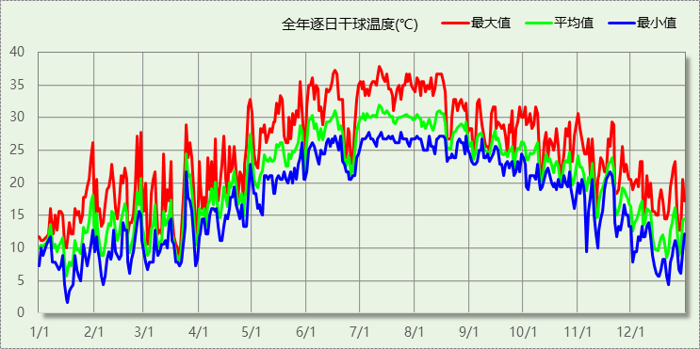

## 逐月辐照量表

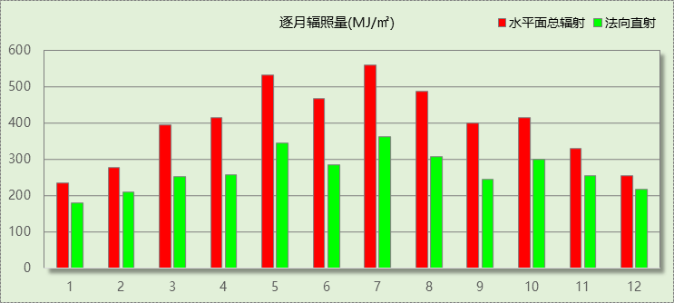

## 峰值工况

|  |  |  |  |  |  |
| --- | --- | --- | --- | --- | --- |
| 气象数据 | 时刻 | 干球温度(℃) | 湿球温度(℃) | 含湿量(g/kg) | 焓值(kj/kg) |
| 最热 | 07月11日14时 | 37.8 | 26.1 | 17.1 | 81.9 |
| 最冷 | 01月16日06时 | 1.7 | 1.1 | 3.8 | 11.2 |

# 软件介绍

本报告采用的软件为绿建暖通负荷BECH2024，该软件紧密结合暖通和节能设计规范、可根据项目实际情况建立建筑热工模型，并可对围护结构材料、房间内扰发热、作息时间表、热回收方式等参数进行设置。

软件包含全国各地典型气象年数据，内置DOE2.1E内核，对于建筑的逐时负荷进行动态模拟，既可以模拟8760小时理想负荷，也可以根据设定好的采暖期/空调期进行逐时模拟。

软件还支持分析全年建筑能耗的来源构成，依据日射得热、新风负荷、围护传热和内扰得热进行归类分项，生成设计建筑全年负荷计算报告书，提供详实的数据和多样的图表，为设计师在设备选型、制定运行策略等方面提供参考和帮助。

# 围护结构

## 屋顶构造

### 屋顶构造一

|  |  |  |  |  |  |  |
| --- | --- | --- | --- | --- | --- | --- |
| 材料名称 （由上到下） | 厚度δ | 导热系数λ | 蓄热系数S | 修正 系数 | 热阻R | 热惰性 指标 |
| (mm) | W/(m.K) | W/(㎡.K) | α | (㎡K)/W | D=R*S |
| C20细石混凝土 | 40 | 1.740 | 17.200 | 1.00 | 0.023 | 0.395 |
| 保温砂浆(K=0.085) | 10 | 0.085 | 1.500 | 1.00 | 0.118 | 0.176 |
| 挤塑聚苯乙烯泡沫塑料板 | 80 | 0.030 | 0.340 | 1.20 | 2.222 | 0.907 |
| 保温砂浆(K=0.085) | 20 | 0.085 | 1.500 | 1.00 | 0.235 | 0.353 |
| 轻集料混凝土2%找坡层 | 30 | 0.450 | 7.500 | 1.00 | 0.067 | 0.500 |
| 浮石混凝土(ρ=1100) | 120 | 0.420 | 6.130 | 1.00 | 0.286 | 1.751 |
| 各层之和∑ | 300 | － | － | － | 2.951 | 4.083 |
| 传热系数K=1/(0.15+∑R) | 0.32 | | | | | |

## 外墙构造

### 外墙（填充墙）构造一

|  |  |  |  |  |  |  |
| --- | --- | --- | --- | --- | --- | --- |
| 材料名称 （由外到内） | 厚度δ | 导热系数λ | 蓄热系数S | 修正 系数 | 热阻R | 热惰性 指标 |
| (mm) | W/(m.K) | W/(㎡.K) | α | (㎡K)/W | D=R*S |
| 保温砂浆(K=0.085) | 20 | 0.085 | 1.500 | 1.00 | 0.235 | 0.353 |
| 蒸压加气混凝土砌块(ρ=600) | 200 | 0.160 | 3.200 | 1.25 | 1.000 | 4.000 |
| 石灰砂浆 | 20 | 0.810 | 10.070 | 1.00 | 0.025 | 0.249 |
| 各层之和∑ | 240 | － | － | － | 1.260 | 4.602 |
| 传热系数K=1/(0.15+∑R) | 0.71 | | | | | |

## 挑空楼板构造

### 挑空楼板构造一

|  |  |  |  |  |  |  |
| --- | --- | --- | --- | --- | --- | --- |
| 材料名称 （由上到下） | 厚度δ | 导热系数λ | 蓄热系数S | 修正 系数 | 热阻R | 热惰性 指标 |
| (mm) | W/(m.K) | W/(㎡.K) | α | (㎡K)/W | D=R*S |
| 保温砂浆(K=0.085) | 20 | 0.085 | 1.500 | 1.00 | 0.235 | 0.353 |
| 浮石混凝土(ρ=1100) | 120 | 0.420 | 6.130 | 1.00 | 0.286 | 1.751 |
| 保温砂浆(K=0.085) | 20 | 0.085 | 1.500 | 1.00 | 0.235 | 0.353 |
| 岩棉板(ρ=60-160) | 20 | 0.041 | 0.615 | 1.30 | 0.375 | 0.300 |
| 保温砂浆(K=0.085) | 20 | 0.085 | 1.500 | 1.00 | 0.235 | 0.353 |
| 各层之和∑ | 200 | － | － | － | 1.367 | 3.110 |
| 传热系数K=1/(0.15+∑R) | 0.66 | | | | | |

## 楼板构造

### 控温房间楼板构造一

|  |  |  |  |  |  |  |
| --- | --- | --- | --- | --- | --- | --- |
| 材料名称 | 厚度δ | 导热系数λ | 蓄热系数S | 修正 系数 | 热阻R | 热惰性 指标 |
| (mm) | W/(m.K) | W/(㎡.K) | α | (㎡K)/W | D=R*S |
| 保温砂浆(K=0.085) | 20 | 0.085 | 1.500 | 1.00 | 0.235 | 0.353 |
| 浮石混凝土(ρ=1100) | 120 | 0.420 | 6.130 | 1.00 | 0.286 | 1.751 |
| 石灰砂浆 | 20 | 0.810 | 10.070 | 1.00 | 0.025 | 0.249 |
| 各层之和∑ | 160 | － | － | － | 0.546 | 2.353 |
| 传热系数K=1/(0.22+∑R) | 1.31 | | | | | |

## 周边地面构造

### 周边地面构造一

|  |  |  |  |  |  |  |
| --- | --- | --- | --- | --- | --- | --- |
| 材料名称 | 厚度δ | 导热系数λ | 蓄热系数S | 修正 系数 | 热阻R | 热惰性 指标 |
| (mm) | W/(m.K) | W/(㎡.K) | α | (㎡K)/W | D=R*S |
| 保温砂浆(K=0.085) | 20 | 0.085 | 1.500 | 1.00 | 0.235 | 0.353 |
| 浮石混凝土(ρ=1100) | 120 | 0.420 | 6.130 | 1.00 | 0.286 | 1.751 |
| 各层之和∑ | 140 | － | － | － | 0.521 | 2.104 |
| 传热系数K=1/(0.11+∑R) | 0.46 | | | | | |

## 非周边地面构造

### 非周边地面构造一

|  |  |  |  |  |  |  |
| --- | --- | --- | --- | --- | --- | --- |
| 材料名称 | 厚度δ | 导热系数λ | 蓄热系数S | 修正 系数 | 热阻R | 热惰性 指标 |
| (mm) | W/(m.K) | W/(㎡.K) | α | (㎡K)/W | D=R*S |
| 保温砂浆(K=0.085) | 20 | 0.085 | 1.500 | 1.00 | 0.235 | 0.353 |
| 浮石混凝土(ρ=1100) | 120 | 0.420 | 6.130 | 1.00 | 0.286 | 1.751 |
| 各层之和∑ | 140 | － | － | － | 0.521 | 2.104 |
| 传热系数K=1/(0.11+∑R) | 0.28 | | | | | |

## 门构造

|  |  |  |  |
| --- | --- | --- | --- |
| 序号 | 构造名称 | 传热系数 | 备注 |
| 1 | 保温门（多功能门） | 1.972 |  |

## 窗构造

|  |  |  |  |  |  |
| --- | --- | --- | --- | --- | --- |
| 序号 | 构造名称 | 传热系数 | 窗遮阳系数 | 可见光透射比 | 备注 |
| 1 | 断热铝合金窗--5低透光双银Low-E玻璃+9Ar+5透明玻璃+9Ar+5透明玻璃 | 2.080 | 0.184 | 0.330 |  |

# 房间类型

## 房间参数表

|  |  |  |  |  |  |  |
| --- | --- | --- | --- | --- | --- | --- |
| 房间类型 | 空调温度 ℃ | 供暖温度 ℃ | 新风量 | 人员密度 | 照明功率 密度 | 电器设备 功率 |
| 休息室 | 26 | 20 | 30(m^3/h.人) | 0.3(m^2/人) | 9(W/m^2) | 5(W/m^2) |
| 会议室 | 26 | 20 | 12(m^3/h.人) | 0.5(人/m^2) | 8(W/m^2) | 5(W/m^2) |
| 卫生间 | － | － | 0(m^3/h.人) | 0(人) | 5(W/m^2) | 5(W/m^2) |
| 大厅 | 26 | 20 | 14(m^3/h.人) | 0.4(人/m^2) | 10(W/m^2) | 5(W/m^2) |
| 展览馆 | 26 | 20 | 30(m^3/h.人) | 8(m^2/人) | 9(W/m^2) | 15(W/m^2) |
| 开水间 | － | － | 19(m^3/h.人) | 0.1(人/m^2) | 9(W/m^2) | 5(W/m^2) |
| 报告厅 | 26 | 20 | 12(m^3/h.人) | 1(人/m^2) | 12(W/m^2) | 5(W/m^2) |
| 普通办公室 | 26 | 20 | 30(m^3/h.人) | 4(m^2/人) | 8(W/m^2) | 20(W/m^2) |
| 普通教室 | 26 | 20 | 24(m^3/h.人) | 1(人/m^2) | 8(W/m^2) | 5(W/m^2) |
| 楼梯间 | － | － | 0(m^3/h.人) | 0(人) | 5(W/m^2) | 5(W/m^2) |
| 空房间 | － | － | 20(m^3/h.人) | 0(人) | 0(W/m^2) | 0(W/m^2) |
| 设备间 | － | － | 0(次/h) | 0(人) | 6(W/m^2) | 15(W/m^2) |
| 走廊 | － | － | 0(m^3/h.人) | 0(人) | 5(W/m^2) | 5(W/m^2) |
| 阅览室 | 26 | 20 | 20(m^3/h.人) | 0.3(人/m^2) | 8(W/m^2) | 5(W/m^2) |

## 作息时间表

详见附录

# 系统设置

## 系统划分

|  |  |  |  |  |  |  |
| --- | --- | --- | --- | --- | --- | --- |
| 系统编号 | 热回收 类型 | 启动 条件 | 回收 效率 | 排风 比例 | 面积(m2) | 包含的房间 |
| 默认 | 无 | -- | -- | -- | 2931.38 | 所有房间 |

## 运行时间表

详见附录

# 计算结果

## 模拟周期

全年8760小时模拟

## 全年冷暖需求

|  |  |  |  |  |
| --- | --- | --- | --- | --- |
| 系统名称\负荷 | 供暖需求 (kWh) | 供暖指标 (kWh/㎡·a) | 供冷需求 (kWh) | 供冷指标 (kWh/㎡·a) |
| 建筑总计 | 28615 | 6.61 | 449516 | 103.87 |

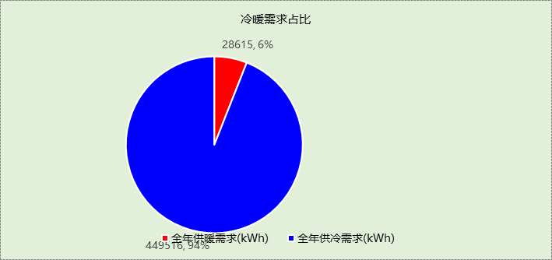

## 负荷分项统计

|  |  |  |  |  |  |  |
| --- | --- | --- | --- | --- | --- | --- |
| 分类 | 围护传热 | 室内得热 | 窗日射 | 新风/渗透 | 热回收 | 合计 |
| 供暖(kWh/㎡) | -8.17 | 9.60 | 0.21 | -8.25 | 0.00 | -6.61 |
| 供冷(kWh/㎡) | 4.47 | 45.01 | 0.84 | 53.55 | 0.00 | 103.87 |

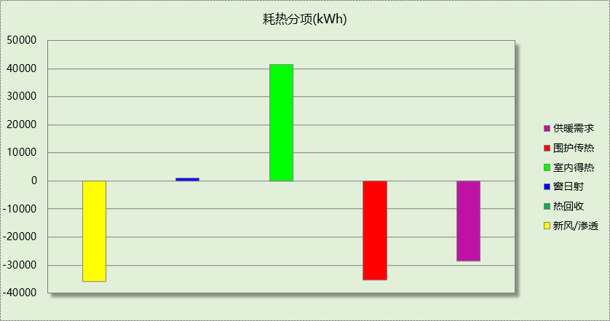

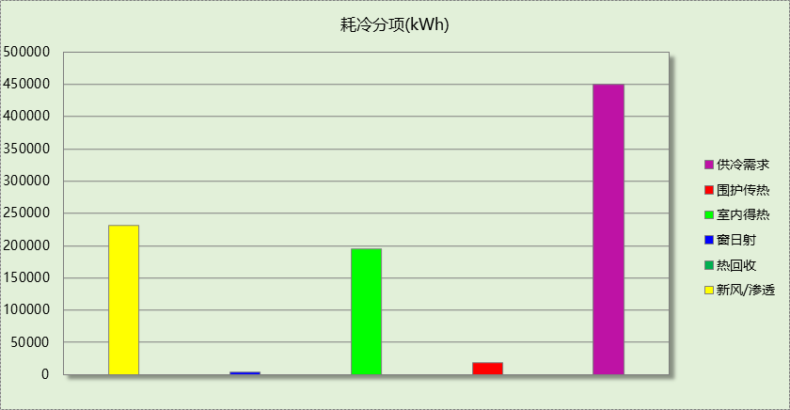

## 逐月负荷表

|  |  |  |  |  |  |  |
| --- | --- | --- | --- | --- | --- | --- |
| 月份 | 供暖(kWh) | 供冷(kWh) | 热负荷 峰值(kW) | 热负荷 峰值时刻 | 冷负荷 峰值(kW) | 冷负荷 峰值时刻 |
| 1月 | 11785 | 413 | 164.833 | 1月2日8时 | 122.989 | 1月30日16时 |
| 2月 | 4427 | 477 | 137.762 | 2月14日8时 | 103.372 | 2月26日16时 |
| 3月 | 6852 | 2036 | 157.519 | 3月4日8时 | 131.163 | 3月26日11时 |
| 4月 | 1600 | 7998 | 74.878 | 4月1日8时 | 261.878 | 4月29日15时 |
| 5月 | 0 | 40278 | 0.000 | -- | 395.273 | 5月28日14时 |
| 6月 | 0 | 66578 | 0.000 | -- | 482.591 | 6月17日13时 |
| 7月 | 0 | 102377 | 0.000 | -- | 510.536 | 7月8日14时 |
| 8月 | 0 | 92375 | 0.000 | -- | 512.118 | 8月14日15时 |
| 9月 | 0 | 70451 | 0.000 | -- | 441.922 | 9月12日14时 |
| 10月 | 0 | 41949 | 0.000 | -- | 382.542 | 10月8日13时 |
| 11月 | 17 | 23664 | 6.672 | 11月11日8时 | 302.536 | 11月20日14时 |
| 12月 | 3934 | 918 | 131.620 | 12月16日8时 | 104.681 | 12月6日14时 |

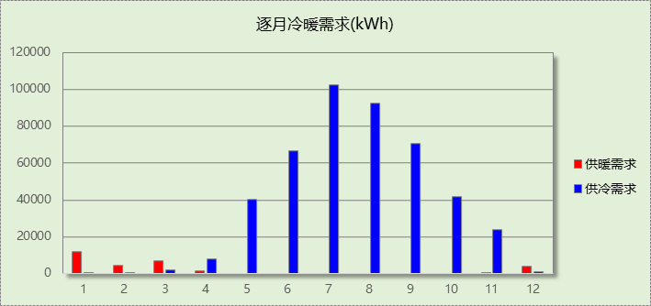

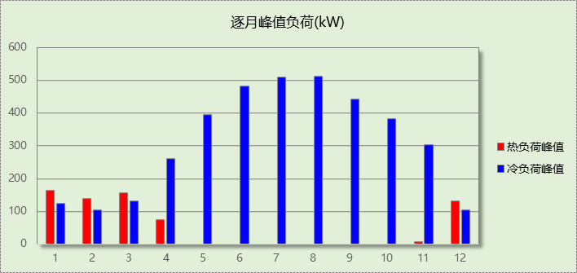

# 附录

**工作日/节假日人员逐时在室率(%)**

|  |  |  |  |  |  |  |  |  |  |  |  |  |  |  |  |  |  |  |  |  |  |  |  |  |
| --- | --- | --- | --- | --- | --- | --- | --- | --- | --- | --- | --- | --- | --- | --- | --- | --- | --- | --- | --- | --- | --- | --- | --- | --- |
| 房间类型 | 1 | 2 | 3 | 4 | 5 | 6 | 7 | 8 | 9 | 10 | 11 | 12 | 13 | 14 | 15 | 16 | 17 | 18 | 19 | 20 | 21 | 22 | 23 | 24 |
| 休息室 | 0 | 0 | 0 | 0 | 0 | 0 | 10 | 50 | 95 | 95 | 95 | 80 | 80 | 95 | 95 | 95 | 95 | 30 | 30 | 0 | 0 | 0 | 0 | 0 |
| 0 | 0 | 0 | 0 | 0 | 0 | 0 | 0 | 0 | 0 | 0 | 0 | 0 | 0 | 0 | 0 | 0 | 0 | 0 | 0 | 0 | 0 | 0 | 0 |
| 会议室 | 0 | 0 | 0 | 0 | 0 | 0 | 10 | 50 | 95 | 95 | 95 | 80 | 80 | 95 | 95 | 95 | 95 | 30 | 30 | 0 | 0 | 0 | 0 | 0 |
| 0 | 0 | 0 | 0 | 0 | 0 | 0 | 0 | 0 | 0 | 0 | 0 | 0 | 0 | 0 | 0 | 0 | 0 | 0 | 0 | 0 | 0 | 0 | 0 |
| 卫生间 | 0 | 0 | 0 | 0 | 0 | 0 | 10 | 50 | 95 | 95 | 95 | 80 | 80 | 95 | 95 | 95 | 95 | 30 | 30 | 0 | 0 | 0 | 0 | 0 |
| 0 | 0 | 0 | 0 | 0 | 0 | 0 | 0 | 0 | 0 | 0 | 0 | 0 | 0 | 0 | 0 | 0 | 0 | 0 | 0 | 0 | 0 | 0 | 0 |
| 大厅 | 0 | 0 | 0 | 0 | 0 | 0 | 10 | 50 | 95 | 95 | 95 | 80 | 80 | 95 | 95 | 95 | 95 | 30 | 30 | 0 | 0 | 0 | 0 | 0 |
| 0 | 0 | 0 | 0 | 0 | 0 | 0 | 0 | 0 | 0 | 0 | 0 | 0 | 0 | 0 | 0 | 0 | 0 | 0 | 0 | 0 | 0 | 0 | 0 |
| 展览馆 | 0 | 0 | 0 | 0 | 0 | 0 | 10 | 50 | 100 | 100 | 100 | 30 | 100 | 100 | 100 | 100 | 50 | 20 | 10 | 0 | 0 | 0 | 0 | 0 |
| 0 | 0 | 0 | 0 | 0 | 0 | 0 | 20 | 45 | 0 | 0 | 0 | 0 | 0 | 0 | 0 | 0 | 0 | 0 | 0 | 0 | 0 | 0 | 0 |
| 开水间 | 0 | 0 | 0 | 0 | 0 | 0 | 10 | 50 | 95 | 95 | 95 | 80 | 80 | 95 | 95 | 95 | 95 | 30 | 30 | 0 | 0 | 0 | 0 | 0 |
| 0 | 0 | 0 | 0 | 0 | 0 | 0 | 0 | 0 | 0 | 0 | 0 | 0 | 0 | 0 | 0 | 0 | 0 | 0 | 0 | 0 | 0 | 0 | 0 |
| 报告厅 | 0 | 0 | 0 | 0 | 0 | 0 | 10 | 50 | 95 | 95 | 95 | 80 | 80 | 95 | 95 | 95 | 95 | 30 | 30 | 0 | 0 | 0 | 0 | 0 |
| 0 | 0 | 0 | 0 | 0 | 0 | 0 | 0 | 0 | 0 | 0 | 0 | 0 | 0 | 0 | 0 | 0 | 0 | 0 | 0 | 0 | 0 | 0 | 0 |
| 普通办公室 | 0 | 0 | 0 | 0 | 0 | 0 | 10 | 50 | 95 | 95 | 95 | 80 | 80 | 95 | 95 | 95 | 95 | 30 | 30 | 0 | 0 | 0 | 0 | 0 |
| 0 | 0 | 0 | 0 | 0 | 0 | 0 | 0 | 0 | 0 | 0 | 0 | 0 | 0 | 0 | 0 | 0 | 0 | 0 | 0 | 0 | 0 | 0 | 0 |
| 普通教室 | 0 | 0 | 0 | 0 | 0 | 0 | 10 | 50 | 95 | 95 | 95 | 80 | 80 | 95 | 95 | 95 | 95 | 30 | 30 | 0 | 0 | 0 | 0 | 0 |
| 0 | 0 | 0 | 0 | 0 | 0 | 0 | 0 | 0 | 0 | 0 | 0 | 0 | 0 | 0 | 0 | 0 | 0 | 0 | 0 | 0 | 0 | 0 | 0 |
| 楼梯间 | 0 | 0 | 0 | 0 | 0 | 0 | 10 | 50 | 95 | 95 | 95 | 80 | 80 | 95 | 95 | 95 | 95 | 30 | 30 | 0 | 0 | 0 | 0 | 0 |
| 0 | 0 | 0 | 0 | 0 | 0 | 0 | 0 | 0 | 0 | 0 | 0 | 0 | 0 | 0 | 0 | 0 | 0 | 0 | 0 | 0 | 0 | 0 | 0 |
| 空房间 | 0 | 0 | 0 | 0 | 0 | 0 | 0 | 20 | 50 | 80 | 80 | 80 | 80 | 80 | 80 | 80 | 80 | 80 | 80 | 70 | 50 | 0 | 0 | 0 |
| 0 | 0 | 0 | 0 | 0 | 0 | 0 | 0 | 0 | 0 | 0 | 0 | 0 | 0 | 0 | 0 | 0 | 0 | 0 | 0 | 0 | 0 | 0 | 0 |
| 设备间 | 0 | 0 | 0 | 0 | 0 | 0 | 0 | 0 | 0 | 0 | 0 | 0 | 0 | 0 | 0 | 0 | 0 | 0 | 0 | 0 | 0 | 0 | 0 | 0 |
| 0 | 0 | 0 | 0 | 0 | 0 | 0 | 0 | 0 | 0 | 0 | 0 | 0 | 0 | 0 | 0 | 0 | 0 | 0 | 0 | 0 | 0 | 0 | 0 |
| 走廊 | 0 | 0 | 0 | 0 | 0 | 0 | 10 | 50 | 95 | 95 | 95 | 80 | 80 | 95 | 95 | 95 | 95 | 30 | 30 | 0 | 0 | 0 | 0 | 0 |
| 0 | 0 | 0 | 0 | 0 | 0 | 0 | 0 | 0 | 0 | 0 | 0 | 0 | 0 | 0 | 0 | 0 | 0 | 0 | 0 | 0 | 0 | 0 | 0 |
| 阅览室 | 0 | 0 | 0 | 0 | 0 | 0 | 10 | 50 | 95 | 95 | 95 | 80 | 80 | 95 | 95 | 95 | 95 | 30 | 30 | 0 | 0 | 0 | 0 | 0 |
| 0 | 0 | 0 | 0 | 0 | 0 | 0 | 0 | 0 | 0 | 0 | 0 | 0 | 0 | 0 | 0 | 0 | 0 | 0 | 0 | 0 | 0 | 0 | 0 |

注：上行：工作日；下行：节假日

**工作日/节假日照明开关时间表(%)**

|  |  |  |  |  |  |  |  |  |  |  |  |  |  |  |  |  |  |  |  |  |  |  |  |  |
| --- | --- | --- | --- | --- | --- | --- | --- | --- | --- | --- | --- | --- | --- | --- | --- | --- | --- | --- | --- | --- | --- | --- | --- | --- |
| 房间类型 | 1 | 2 | 3 | 4 | 5 | 6 | 7 | 8 | 9 | 10 | 11 | 12 | 13 | 14 | 15 | 16 | 17 | 18 | 19 | 20 | 21 | 22 | 23 | 24 |
| 休息室 | 0 | 0 | 0 | 0 | 0 | 0 | 10 | 50 | 95 | 95 | 95 | 80 | 80 | 95 | 95 | 95 | 95 | 30 | 30 | 0 | 0 | 0 | 0 | 0 |
| 0 | 0 | 0 | 0 | 0 | 0 | 0 | 0 | 0 | 0 | 0 | 0 | 0 | 0 | 0 | 0 | 0 | 0 | 0 | 0 | 0 | 0 | 0 | 0 |
| 会议室 | 0 | 0 | 0 | 0 | 0 | 0 | 10 | 50 | 95 | 95 | 95 | 80 | 80 | 95 | 95 | 95 | 95 | 30 | 30 | 0 | 0 | 0 | 0 | 0 |
| 0 | 0 | 0 | 0 | 0 | 0 | 0 | 0 | 0 | 0 | 0 | 0 | 0 | 0 | 0 | 0 | 0 | 0 | 0 | 0 | 0 | 0 | 0 | 0 |
| 卫生间 | 0 | 0 | 0 | 0 | 0 | 0 | 10 | 50 | 95 | 95 | 95 | 80 | 80 | 95 | 95 | 95 | 95 | 30 | 30 | 0 | 0 | 0 | 0 | 0 |
| 0 | 0 | 0 | 0 | 0 | 0 | 0 | 0 | 0 | 0 | 0 | 0 | 0 | 0 | 0 | 0 | 0 | 0 | 0 | 0 | 0 | 0 | 0 | 0 |
| 大厅 | 0 | 0 | 0 | 0 | 0 | 0 | 10 | 50 | 95 | 95 | 95 | 80 | 80 | 95 | 95 | 95 | 95 | 30 | 30 | 0 | 0 | 0 | 0 | 0 |
| 0 | 0 | 0 | 0 | 0 | 0 | 0 | 0 | 0 | 0 | 0 | 0 | 0 | 0 | 0 | 0 | 0 | 0 | 0 | 0 | 0 | 0 | 0 | 0 |
| 展览馆 | 10 | 10 | 10 | 10 | 10 | 10 | 10 | 36 | 62 | 56 | 54 | 43 | 53 | 55 | 58 | 67 | 40 | 18 | 10 | 10 | 10 | 10 | 10 | 10 |
| 0 | 0 | 0 | 0 | 0 | 0 | 0 | 0 | 0 | 0 | 0 | 0 | 0 | 0 | 0 | 0 | 0 | 0 | 0 | 0 | 0 | 0 | 0 | 0 |
| 开水间 | 0 | 0 | 0 | 0 | 0 | 0 | 10 | 50 | 95 | 95 | 95 | 80 | 80 | 95 | 95 | 95 | 95 | 30 | 30 | 0 | 0 | 0 | 0 | 0 |
| 0 | 0 | 0 | 0 | 0 | 0 | 0 | 0 | 0 | 0 | 0 | 0 | 0 | 0 | 0 | 0 | 0 | 0 | 0 | 0 | 0 | 0 | 0 | 0 |
| 报告厅 | 0 | 0 | 0 | 0 | 0 | 0 | 10 | 50 | 95 | 95 | 95 | 80 | 80 | 95 | 95 | 95 | 95 | 30 | 30 | 0 | 0 | 0 | 0 | 0 |
| 0 | 0 | 0 | 0 | 0 | 0 | 0 | 0 | 0 | 0 | 0 | 0 | 0 | 0 | 0 | 0 | 0 | 0 | 0 | 0 | 0 | 0 | 0 | 0 |
| 普通办公室 | 0 | 0 | 0 | 0 | 0 | 0 | 10 | 50 | 95 | 95 | 95 | 80 | 80 | 95 | 95 | 95 | 95 | 30 | 30 | 0 | 0 | 0 | 0 | 0 |
| 0 | 0 | 0 | 0 | 0 | 0 | 0 | 0 | 0 | 0 | 0 | 0 | 0 | 0 | 0 | 0 | 0 | 0 | 0 | 0 | 0 | 0 | 0 | 0 |
| 普通教室 | 0 | 0 | 0 | 0 | 0 | 0 | 10 | 50 | 95 | 95 | 95 | 80 | 80 | 95 | 95 | 95 | 95 | 30 | 30 | 0 | 0 | 0 | 0 | 0 |
| 0 | 0 | 0 | 0 | 0 | 0 | 0 | 0 | 0 | 0 | 0 | 0 | 0 | 0 | 0 | 0 | 0 | 0 | 0 | 0 | 0 | 0 | 0 | 0 |
| 楼梯间 | 0 | 0 | 0 | 0 | 0 | 0 | 10 | 50 | 95 | 95 | 95 | 80 | 80 | 95 | 95 | 95 | 95 | 30 | 30 | 0 | 0 | 0 | 0 | 0 |
| 0 | 0 | 0 | 0 | 0 | 0 | 0 | 0 | 0 | 0 | 0 | 0 | 0 | 0 | 0 | 0 | 0 | 0 | 0 | 0 | 0 | 0 | 0 | 0 |
| 空房间 | 10 | 10 | 10 | 10 | 10 | 10 | 10 | 50 | 60 | 60 | 60 | 60 | 60 | 60 | 60 | 60 | 80 | 90 | 100 | 100 | 100 | 10 | 10 | 10 |
| 0 | 0 | 0 | 0 | 0 | 0 | 0 | 0 | 0 | 0 | 0 | 0 | 0 | 0 | 0 | 0 | 0 | 0 | 0 | 0 | 0 | 0 | 0 | 0 |
| 设备间 | 100 | 100 | 100 | 100 | 100 | 100 | 100 | 100 | 100 | 100 | 100 | 100 | 100 | 100 | 100 | 100 | 100 | 100 | 100 | 100 | 100 | 100 | 100 | 100 |
| 0 | 0 | 0 | 0 | 0 | 0 | 0 | 0 | 0 | 0 | 0 | 0 | 0 | 0 | 0 | 0 | 0 | 0 | 0 | 0 | 0 | 0 | 0 | 0 |
| 走廊 | 0 | 0 | 0 | 0 | 0 | 0 | 10 | 50 | 95 | 95 | 95 | 80 | 80 | 95 | 95 | 95 | 95 | 30 | 30 | 0 | 0 | 0 | 0 | 0 |
| 0 | 0 | 0 | 0 | 0 | 0 | 0 | 0 | 0 | 0 | 0 | 0 | 0 | 0 | 0 | 0 | 0 | 0 | 0 | 0 | 0 | 0 | 0 | 0 |
| 阅览室 | 0 | 0 | 0 | 0 | 0 | 0 | 10 | 50 | 95 | 95 | 95 | 80 | 80 | 95 | 95 | 95 | 95 | 30 | 30 | 0 | 0 | 0 | 0 | 0 |
| 0 | 0 | 0 | 0 | 0 | 0 | 0 | 0 | 0 | 0 | 0 | 0 | 0 | 0 | 0 | 0 | 0 | 0 | 0 | 0 | 0 | 0 | 0 | 0 |

注：上行：工作日；下行：节假日

**工作日/节假日设备逐时使用率(%)**

|  |  |  |  |  |  |  |  |  |  |  |  |  |  |  |  |  |  |  |  |  |  |  |  |  |
| --- | --- | --- | --- | --- | --- | --- | --- | --- | --- | --- | --- | --- | --- | --- | --- | --- | --- | --- | --- | --- | --- | --- | --- | --- |
| 房间类型 | 1 | 2 | 3 | 4 | 5 | 6 | 7 | 8 | 9 | 10 | 11 | 12 | 13 | 14 | 15 | 16 | 17 | 18 | 19 | 20 | 21 | 22 | 23 | 24 |
| 休息室 | 0 | 0 | 0 | 0 | 0 | 0 | 10 | 50 | 95 | 95 | 95 | 50 | 50 | 95 | 95 | 95 | 95 | 30 | 30 | 0 | 0 | 0 | 0 | 0 |
| 0 | 0 | 0 | 0 | 0 | 0 | 0 | 0 | 0 | 0 | 0 | 0 | 0 | 0 | 0 | 0 | 0 | 0 | 0 | 0 | 0 | 0 | 0 | 0 |
| 会议室 | 0 | 0 | 0 | 0 | 0 | 0 | 10 | 50 | 95 | 95 | 95 | 50 | 50 | 95 | 95 | 95 | 95 | 30 | 30 | 0 | 0 | 0 | 0 | 0 |
| 0 | 0 | 0 | 0 | 0 | 0 | 0 | 0 | 0 | 0 | 0 | 0 | 0 | 0 | 0 | 0 | 0 | 0 | 0 | 0 | 0 | 0 | 0 | 0 |
| 卫生间 | 0 | 0 | 0 | 0 | 0 | 0 | 10 | 50 | 95 | 95 | 95 | 50 | 50 | 95 | 95 | 95 | 95 | 30 | 30 | 0 | 0 | 0 | 0 | 0 |
| 0 | 0 | 0 | 0 | 0 | 0 | 0 | 0 | 0 | 0 | 0 | 0 | 0 | 0 | 0 | 0 | 0 | 0 | 0 | 0 | 0 | 0 | 0 | 0 |
| 大厅 | 0 | 0 | 0 | 0 | 0 | 0 | 10 | 50 | 95 | 95 | 95 | 50 | 50 | 95 | 95 | 95 | 95 | 30 | 30 | 0 | 0 | 0 | 0 | 0 |
| 0 | 0 | 0 | 0 | 0 | 0 | 0 | 0 | 0 | 0 | 0 | 0 | 0 | 0 | 0 | 0 | 0 | 0 | 0 | 0 | 0 | 0 | 0 | 0 |
| 展览馆 | 0 | 0 | 0 | 0 | 0 | 0 | 10 | 50 | 100 | 100 | 100 | 100 | 100 | 100 | 100 | 100 | 50 | 20 | 10 | 0 | 0 | 0 | 0 | 0 |
| 0 | 0 | 0 | 0 | 0 | 0 | 0 | 0 | 0 | 0 | 0 | 0 | 0 | 0 | 0 | 0 | 0 | 0 | 0 | 0 | 0 | 0 | 0 | 0 |
| 开水间 | 0 | 0 | 0 | 0 | 0 | 0 | 10 | 50 | 95 | 95 | 95 | 50 | 50 | 95 | 95 | 95 | 95 | 30 | 30 | 0 | 0 | 0 | 0 | 0 |
| 0 | 0 | 0 | 0 | 0 | 0 | 0 | 0 | 0 | 0 | 0 | 0 | 0 | 0 | 0 | 0 | 0 | 0 | 0 | 0 | 0 | 0 | 0 | 0 |
| 报告厅 | 0 | 0 | 0 | 0 | 0 | 0 | 10 | 50 | 95 | 95 | 95 | 50 | 50 | 95 | 95 | 95 | 95 | 30 | 30 | 0 | 0 | 0 | 0 | 0 |
| 0 | 0 | 0 | 0 | 0 | 0 | 0 | 0 | 0 | 0 | 0 | 0 | 0 | 0 | 0 | 0 | 0 | 0 | 0 | 0 | 0 | 0 | 0 | 0 |
| 普通办公室 | 0 | 0 | 0 | 0 | 0 | 0 | 10 | 50 | 95 | 95 | 95 | 50 | 50 | 95 | 95 | 95 | 95 | 30 | 30 | 0 | 0 | 0 | 0 | 0 |
| 0 | 0 | 0 | 0 | 0 | 0 | 0 | 0 | 0 | 0 | 0 | 0 | 0 | 0 | 0 | 0 | 0 | 0 | 0 | 0 | 0 | 0 | 0 | 0 |
| 普通教室 | 0 | 0 | 0 | 0 | 0 | 0 | 10 | 50 | 95 | 95 | 95 | 50 | 50 | 95 | 95 | 95 | 95 | 30 | 30 | 0 | 0 | 0 | 0 | 0 |
| 0 | 0 | 0 | 0 | 0 | 0 | 0 | 0 | 0 | 0 | 0 | 0 | 0 | 0 | 0 | 0 | 0 | 0 | 0 | 0 | 0 | 0 | 0 | 0 |
| 楼梯间 | 0 | 0 | 0 | 0 | 0 | 0 | 10 | 50 | 95 | 95 | 95 | 50 | 50 | 95 | 95 | 95 | 95 | 30 | 30 | 0 | 0 | 0 | 0 | 0 |
| 0 | 0 | 0 | 0 | 0 | 0 | 0 | 0 | 0 | 0 | 0 | 0 | 0 | 0 | 0 | 0 | 0 | 0 | 0 | 0 | 0 | 0 | 0 | 0 |
| 空房间 | 0 | 0 | 0 | 0 | 0 | 0 | 0 | 30 | 50 | 80 | 80 | 80 | 80 | 80 | 80 | 80 | 80 | 80 | 80 | 70 | 50 | 0 | 0 | 0 |
| 0 | 0 | 0 | 0 | 0 | 0 | 0 | 0 | 0 | 0 | 0 | 0 | 0 | 0 | 0 | 0 | 0 | 0 | 0 | 0 | 0 | 0 | 0 | 0 |
| 设备间 | 100 | 100 | 100 | 100 | 100 | 100 | 100 | 100 | 100 | 100 | 100 | 100 | 100 | 100 | 100 | 100 | 100 | 100 | 100 | 100 | 100 | 100 | 100 | 100 |
| 0 | 0 | 0 | 0 | 0 | 0 | 0 | 0 | 0 | 0 | 0 | 0 | 0 | 0 | 0 | 0 | 0 | 0 | 0 | 0 | 0 | 0 | 0 | 0 |
| 走廊 | 0 | 0 | 0 | 0 | 0 | 0 | 10 | 50 | 95 | 95 | 95 | 50 | 50 | 95 | 95 | 95 | 95 | 30 | 30 | 0 | 0 | 0 | 0 | 0 |
| 0 | 0 | 0 | 0 | 0 | 0 | 0 | 0 | 0 | 0 | 0 | 0 | 0 | 0 | 0 | 0 | 0 | 0 | 0 | 0 | 0 | 0 | 0 | 0 |
| 阅览室 | 0 | 0 | 0 | 0 | 0 | 0 | 10 | 50 | 95 | 95 | 95 | 50 | 50 | 95 | 95 | 95 | 95 | 30 | 30 | 0 | 0 | 0 | 0 | 0 |
| 0 | 0 | 0 | 0 | 0 | 0 | 0 | 0 | 0 | 0 | 0 | 0 | 0 | 0 | 0 | 0 | 0 | 0 | 0 | 0 | 0 | 0 | 0 | 0 |

注：上行：工作日；下行：节假日

**工作日/节假日空调系统开关时间表**

|  |  |  |  |  |  |  |  |  |  |  |  |  |  |  |  |  |  |  |  |  |  |  |  |  |
| --- | --- | --- | --- | --- | --- | --- | --- | --- | --- | --- | --- | --- | --- | --- | --- | --- | --- | --- | --- | --- | --- | --- | --- | --- |
| 系统编号 | 1 | 2 | 3 | 4 | 5 | 6 | 7 | 8 | 9 | 10 | 11 | 12 | 13 | 14 | 15 | 16 | 17 | 18 | 19 | 20 | 21 | 22 | 23 | 24 |
| 默认 | 0 | 0 | 0 | 0 | 0 | 0 | 0 | 1 | 1 | 1 | 1 | 1 | 1 | 1 | 1 | 1 | 1 | 1 | 0 | 0 | 0 | 0 | 0 | 0 |
| 0 | 0 | 0 | 0 | 0 | 0 | 0 | 0 | 0 | 0 | 0 | 0 | 0 | 0 | 0 | 0 | 0 | 0 | 0 | 0 | 0 | 0 | 0 | 0 |

注：上行：工作日；下行：节假日