**办公楼**

**全年负荷计算书**

|  |  |
| --- | --- |
| 工程名称 | 办公楼 |
| 设计编号 |  |
| 建设单位 |  |
| 设计单位 |  |
| 计 算 人 |  |
| 校 对 人 |  |
| 审 核 人 |  |
| 计算日期 | 2025年3月3日 |



|  |  |
| --- | --- |
| 采用软件 | 暖通负荷BECH2024 |
| 软件版本 | 20240430(SP1) |
| 研发单位 | 北京绿建软件股份有限公司 |
| 正版授权码 | T13850219223 |

**目 录**

1 建筑概况 1

2 气象数据 1

2.1 气象地点 1

2.2 逐日干球温度表 1

2.3 逐月辐照量表 2

2.4 峰值工况 2

3 软件介绍 2

4 围护结构 2

4.1 屋顶构造 2

4.1.1 屋顶构造一 2

4.2 外墙构造 3

4.2.1 外墙（填充墙）构造一 3

4.3 楼板构造 3

4.3.1 控温房间楼板构造一 3

4.4 周边地面构造 3

4.4.1 周边地面构造一 3

4.5 非周边地面构造 4

4.5.1 地面构造一 4

4.6 门构造 4

4.7 窗构造 4

5 房间类型 4

5.1 房间参数表 4

5.2 作息时间表 5

6 系统设置 5

6.1 系统划分 5

6.2 运行时间表 5

7 计算结果 5

7.1 模拟周期 5

7.2 全年冷暖需求 5

7.3 负荷分项统计 6

7.4 逐月负荷表 6

8 附录 8

# 建筑概况

|  |  |  |
| --- | --- | --- |
| 地理位置 | 福建-龙岩 | |
| 气候分区 | 夏热冬暖A区 | |
| 北纬 | 25.06 | |
| 东经 | 117.01 | |
| 建筑名称 | 办公楼 | |
| 建筑类型 | 公共建筑 |  |
| 建筑面积 | 地上 1502.45 ㎡ | 地下 0.00 ㎡ |
| 建筑高度 | 地上 23.70 m | 地下0.00 |
| 建筑层数 | 地上 5 | 地下 0 |
| 北向角度 | 90° | |

# 气象数据

## 气象地点

福建-龙岩, 《建筑节能气象参数标准》JGJ346-2014

## 逐日干球温度表

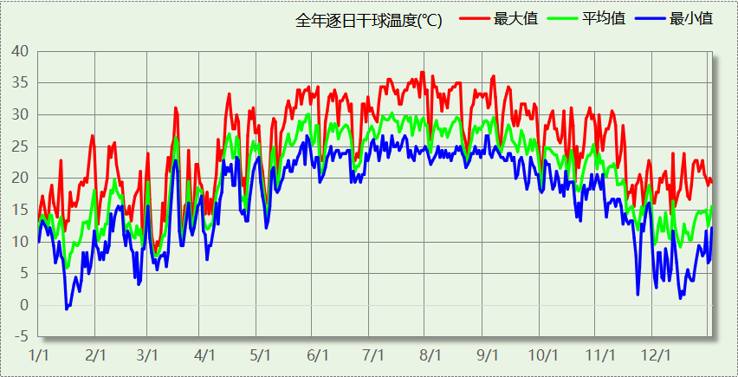

## 逐月辐照量表

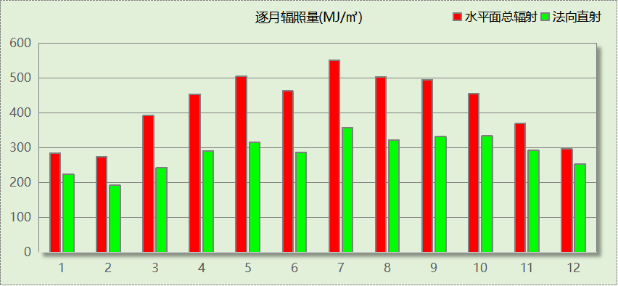

## 峰值工况

|  |  |  |  |  |  |
| --- | --- | --- | --- | --- | --- |
| 气象数据 | 时刻 | 干球温度(℃) | 湿球温度(℃) | 含湿量(g/kg) | 焓值(kj/kg) |
| 最热 | 07月26日14时 | 36.7 | 23.9 | 14.6 | 74.3 |
| 最冷 | 01月15日06时 | -0.6 | -2.2 | 2.5 | 5.7 |

# 软件介绍

本报告采用的软件为绿建暖通负荷BECH2024，该软件紧密结合暖通和节能设计规范、可根据项目实际情况建立建筑热工模型，并可对围护结构材料、房间内扰发热、作息时间表、热回收方式等参数进行设置。

软件包含全国各地典型气象年数据，内置DOE2.1E内核，对于建筑的逐时负荷进行动态模拟，既可以模拟8760小时理想负荷，也可以根据设定好的采暖期/空调期进行逐时模拟。

软件还支持分析全年建筑能耗的来源构成，依据日射得热、新风负荷、围护传热和内扰得热进行归类分项，生成设计建筑全年负荷计算报告书，提供详实的数据和多样的图表，为设计师在设备选型、制定运行策略等方面提供参考和帮助。

# 围护结构

## 屋顶构造

### 屋顶构造一

|  |  |  |  |  |  |  |
| --- | --- | --- | --- | --- | --- | --- |
| 材料名称 （由上到下） | 厚度δ | 导热系数λ | 蓄热系数S | 修正 系数 | 热阻R | 热惰性 指标 |
| (mm) | W/(m.K) | W/(㎡.K) | α | (㎡K)/W | D=R*S |
| C20细石混凝土 | 40 | 1.740 | 17.200 | 1.00 | 0.023 | 0.395 |
| 挤塑聚苯乙烯泡沫塑料板 | 80 | 0.030 | 0.340 | 1.20 | 2.222 | 0.907 |
| 1:3水泥砂浆找平层 | 20 | 0.930 | 11.370 | 1.00 | 0.022 | 0.245 |
| 水泥砂浆 | 20 | 0.930 | 11.370 | 1.00 | 0.022 | 0.245 |
| 轻集料混凝土2%找坡层 | 20 | 0.450 | 7.500 | 1.00 | 0.044 | 0.333 |
| 钢筋混凝土 | 120 | 1.740 | 17.200 | 1.00 | 0.069 | 1.186 |
| 各层之和∑ | 300 | － | － | － | 2.402 | 3.311 |
| 传热系数K=1/(0.15+∑R) | 0.39 | | | | | |

## 外墙构造

### 外墙（填充墙）构造一

|  |  |  |  |  |  |  |
| --- | --- | --- | --- | --- | --- | --- |
| 材料名称 （由外到内） | 厚度δ | 导热系数λ | 蓄热系数S | 修正 系数 | 热阻R | 热惰性 指标 |
| (mm) | W/(m.K) | W/(㎡.K) | α | (㎡K)/W | D=R*S |
| 水泥砂浆 | 20 | 0.930 | 11.370 | 1.00 | 0.022 | 0.245 |
| 烧结煤矸石多孔砖 | 190 | 0.400 | 5.550 | 1.00 | 0.475 | 2.636 |
| 无机轻集料保温砂浆 i 型 | 18 | 0.070 | 1.200 | 1.25 | 0.206 | 0.309 |
| 水泥砂浆 | 20 | 0.930 | 11.370 | 1.00 | 0.022 | 0.245 |
| 各层之和∑ | 248 | － | － | － | 0.724 | 3.434 |
| 传热系数K=1/(0.15+∑R) | 1.15 | | | | | |

## 楼板构造

### 控温房间楼板构造一

|  |  |  |  |  |  |  |
| --- | --- | --- | --- | --- | --- | --- |
| 材料名称 | 厚度δ | 导热系数λ | 蓄热系数S | 修正 系数 | 热阻R | 热惰性 指标 |
| (mm) | W/(m.K) | W/(㎡.K) | α | (㎡K)/W | D=R*S |
| 水泥砂浆 | 20 | 0.930 | 11.370 | 1.00 | 0.022 | 0.245 |
| 钢筋混凝土 | 150 | 1.740 | 17.200 | 1.00 | 0.086 | 1.483 |
| 挤塑聚苯乙烯泡沫塑料板 | 20 | 0.030 | 0.340 | 1.00 | 0.667 | 0.227 |
| 水泥砂浆 | 20 | 0.930 | 11.370 | 1.00 | 0.022 | 0.245 |
| 地砖 | 10 | 1.740 | 17.200 | 1.00 | 0.006 | 0.099 |
| 各层之和∑ | 220 | － | － | － | 0.802 | 2.297 |
| 传热系数K=1/(0.22+∑R) | 0.98 | | | | | |

## 周边地面构造

### 周边地面构造一

|  |  |  |  |  |  |  |
| --- | --- | --- | --- | --- | --- | --- |
| 材料名称 | 厚度δ | 导热系数λ | 蓄热系数S | 修正 系数 | 热阻R | 热惰性 指标 |
| (mm) | W/(m.K) | W/(㎡.K) | α | (㎡K)/W | D=R*S |
| 水泥砂浆 | 20 | 0.930 | 11.370 | 1.00 | 0.022 | 0.245 |
| 钢筋混凝土 | 120 | 1.740 | 17.200 | 1.00 | 0.069 | 1.186 |
| 各层之和∑ | 140 | － | － | － | 0.090 | 1.431 |
| 传热系数K=1/(0.11+∑R) | 0.52 | | | | | |

## 非周边地面构造

### 地面构造一

|  |  |  |  |  |  |  |
| --- | --- | --- | --- | --- | --- | --- |
| 材料名称 | 厚度δ | 导热系数λ | 蓄热系数S | 修正 系数 | 热阻R | 热惰性 指标 |
| (mm) | W/(m.K) | W/(㎡.K) | α | (㎡K)/W | D=R*S |
| 水泥砂浆 | 20 | 0.930 | 11.370 | 1.00 | 0.022 | 0.245 |
| 钢筋混凝土 | 120 | 1.740 | 17.200 | 1.00 | 0.069 | 1.186 |
| 各层之和∑ | 140 | － | － | － | 0.090 | 1.431 |
| 传热系数K=1/(0.11+∑R) | 0.30 | | | | | |

## 门构造

|  |  |  |  |
| --- | --- | --- | --- |
| 序号 | 构造名称 | 传热系数 | 备注 |

## 窗构造

|  |  |  |  |  |  |
| --- | --- | --- | --- | --- | --- |
| 序号 | 构造名称 | 传热系数 | 窗遮阳系数 | 可见光透射比 | 备注 |
| 1 | 铝合金窗--6高透光单银Low+12空气+6透明玻璃 | 2.730 | 0.530 | 0.710 | 福建省民用建筑围护结构节能工程做法及数据 （闽 2015-J-39） |

# 房间类型

## 房间参数表

|  |  |  |  |  |  |  |
| --- | --- | --- | --- | --- | --- | --- |
| 房间类型 | 空调温度 ℃ | 供暖温度 ℃ | 新风量 | 人员密度 | 照明功率 密度 | 电器设备 功率 |
| 卫生间 | 28 | 18 | 20(m^3/h.人) | 20(m^2/人) | 5(W/m^2) | 15(W/m^2) |
| 大厅 | 26 | 18 | 20(m^3/h.人) | 30(m^2/人) | 10(W/m^2) | 15(W/m^2) |
| 普通办公室 | 26 | 20 | 30(m^3/h.人) | 8(m^2/人) | 8(W/m^2) | 15(W/m^2) |
| 楼梯间 | － | － | 0(m^3/h.人) | 0(人) | 3.5(W/m^2) | 15(W/m^2) |
| 空房间 | － | － | 20(m^3/h.人) | 0(人) | 0(W/m^2) | 0(W/m^2) |
| 视屏工作室 | 26 | 18 | 30(m^3/h.人) | 8(m^2/人) | 13.5(W/m^2) | 15(W/m^2) |
| 设备间 | － | － | 0(次/h) | 0(人) | 6(W/m^2) | 15(W/m^2) |
| 走廊 | 26 | 16 | 20(m^3/h.人) | 50(m^2/人) | 3.5(W/m^2) | 15(W/m^2) |

## 作息时间表

详见附录

# 系统设置

## 系统划分

|  |  |  |  |  |  |  |
| --- | --- | --- | --- | --- | --- | --- |
| 系统编号 | 热回收 类型 | 启动 条件 | 回收 效率 | 排风 比例 | 面积(m2) | 包含的房间 |
| 默认 | 无 | -- | -- | -- | 1376.16 | 所有房间 |

## 运行时间表

详见附录

# 计算结果

## 模拟周期

全年8760小时模拟

## 全年冷暖需求

|  |  |  |  |  |
| --- | --- | --- | --- | --- |
| 系统名称\负荷 | 供暖需求 (kWh) | 供暖指标 (kWh/㎡·a) | 供冷需求 (kWh) | 供冷指标 (kWh/㎡·a) |
| 建筑总计 | 11880 | 7.91 | 118374 | 78.79 |

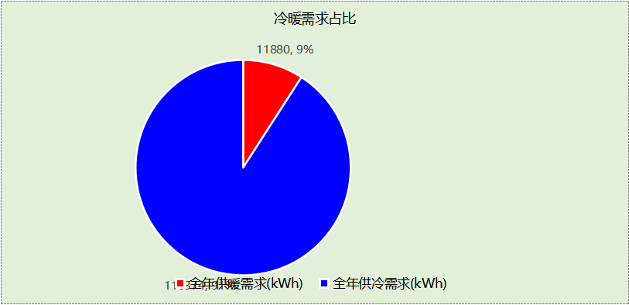

## 负荷分项统计

|  |  |  |  |  |  |  |
| --- | --- | --- | --- | --- | --- | --- |
| 分类 | 围护传热 | 室内得热 | 窗日射 | 新风/渗透 | 热回收 | 合计 |
| 供暖(kWh/㎡) | -13.79 | 7.55 | 2.50 | -4.17 | 0.00 | -7.91 |
| 供冷(kWh/㎡) | 14.20 | 32.42 | 10.56 | 21.61 | 0.00 | 78.79 |

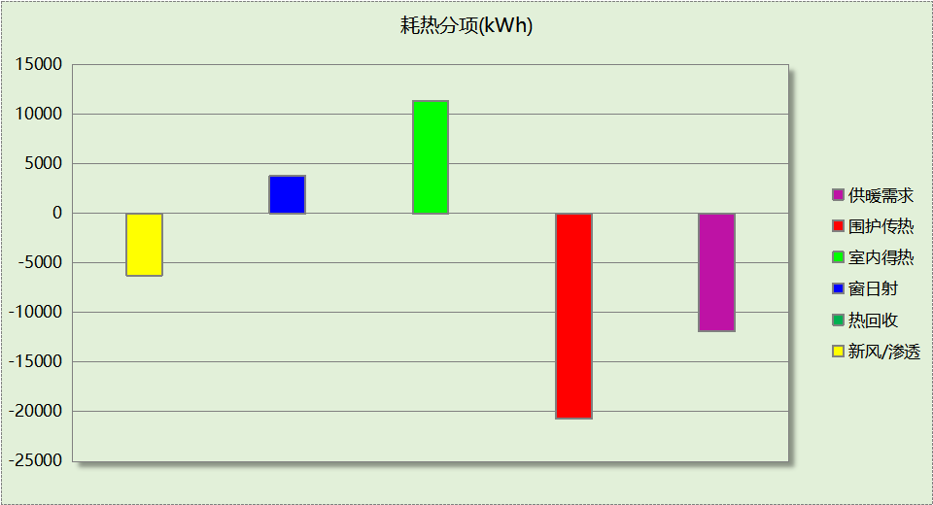

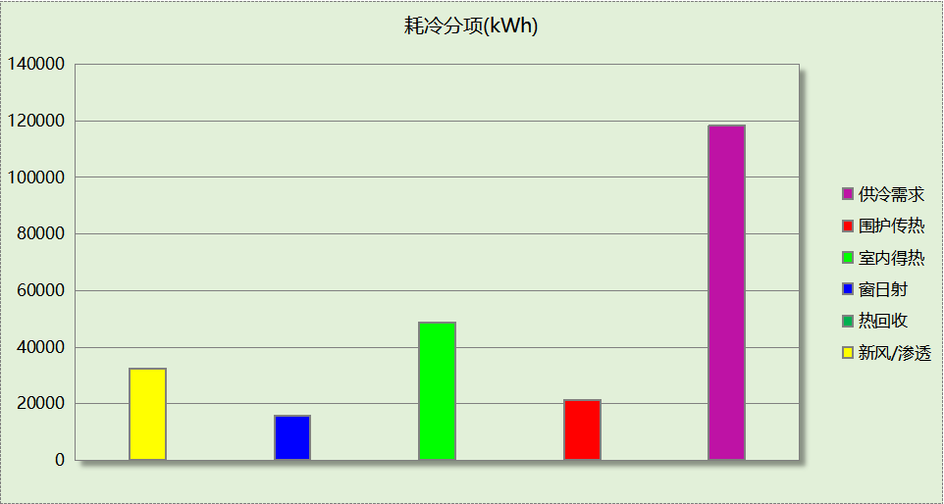

## 逐月负荷表

|  |  |  |  |  |  |  |
| --- | --- | --- | --- | --- | --- | --- |
| 月份 | 供暖(kWh) | 供冷(kWh) | 热负荷 峰值(kW) | 热负荷 峰值时刻 | 冷负荷 峰值(kW) | 冷负荷 峰值时刻 |
| 1月 | 3585 | 2 | 75.649 | 1月21日7时 | 0.481 | 1月30日15时 |
| 2月 | 1977 | 0 | 64.758 | 2月4日7时 | 0.000 | -- |
| 3月 | 3629 | 749 | 89.895 | 3月4日7时 | 58.713 | 3月15日15时 |
| 4月 | 1148 | 6383 | 46.761 | 4月1日7时 | 68.122 | 4月29日12时 |
| 5月 | 74 | 13289 | 8.421 | 5月6日7时 | 108.116 | 5月27日10时 |
| 6月 | 0 | 13964 | 0.110 | 6月24日6时 | 97.548 | 6月10日12时 |
| 7月 | 0 | 23830 | 0.000 | -- | 117.157 | 7月8日12时 |
| 8月 | 0 | 22860 | 0.000 | -- | 122.147 | 8月5日13时 |
| 9月 | 0 | 19788 | 0.000 | -- | 123.449 | 9月3日14时 |
| 10月 | 0 | 12822 | 0.000 | -- | 92.152 | 10月28日15时 |
| 11月 | 32 | 4683 | 10.466 | 11月20日7时 | 71.280 | 11月6日15时 |
| 12月 | 1434 | 5 | 51.819 | 12月16日7时 | 0.338 | 12月25日15时 |

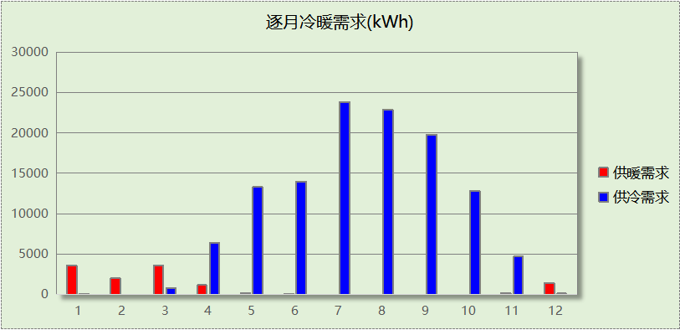

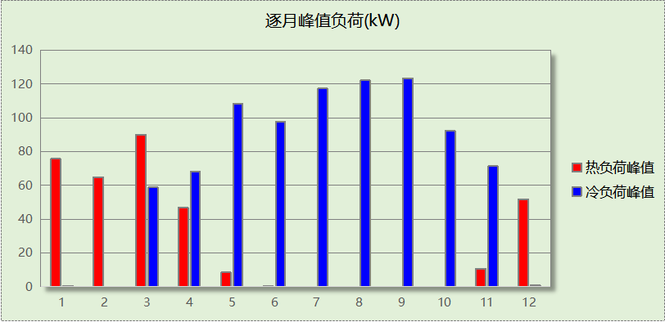

# 附录

**工作日/节假日人员逐时在室率(%)**

|  |  |  |  |  |  |  |  |  |  |  |  |  |  |  |  |  |  |  |  |  |  |  |  |  |
| --- | --- | --- | --- | --- | --- | --- | --- | --- | --- | --- | --- | --- | --- | --- | --- | --- | --- | --- | --- | --- | --- | --- | --- | --- |
| 房间类型 | 1 | 2 | 3 | 4 | 5 | 6 | 7 | 8 | 9 | 10 | 11 | 12 | 13 | 14 | 15 | 16 | 17 | 18 | 19 | 20 | 21 | 22 | 23 | 24 |
| 卫生间 | 0 | 0 | 0 | 0 | 0 | 0 | 10 | 50 | 100 | 100 | 100 | 30 | 100 | 100 | 100 | 100 | 50 | 20 | 10 | 0 | 0 | 0 | 0 | 0 |
| 0 | 0 | 0 | 0 | 0 | 0 | 0 | 20 | 45 | 0 | 0 | 0 | 0 | 0 | 0 | 0 | 0 | 0 | 0 | 0 | 0 | 0 | 0 | 0 |
| 大厅 | 0 | 0 | 0 | 0 | 0 | 0 | 10 | 50 | 100 | 100 | 100 | 30 | 100 | 100 | 100 | 100 | 50 | 20 | 10 | 0 | 0 | 0 | 0 | 0 |
| 0 | 0 | 0 | 0 | 0 | 0 | 0 | 20 | 45 | 0 | 0 | 0 | 0 | 0 | 0 | 0 | 0 | 0 | 0 | 0 | 0 | 0 | 0 | 0 |
| 普通办公室 | 0 | 0 | 0 | 0 | 0 | 0 | 10 | 50 | 100 | 100 | 100 | 30 | 100 | 100 | 100 | 100 | 50 | 20 | 10 | 0 | 0 | 0 | 0 | 0 |
| 0 | 0 | 0 | 0 | 0 | 0 | 0 | 20 | 45 | 0 | 0 | 0 | 0 | 0 | 0 | 0 | 0 | 0 | 0 | 0 | 0 | 0 | 0 | 0 |
| 楼梯间 | 0 | 0 | 0 | 0 | 0 | 0 | 0 | 20 | 50 | 80 | 80 | 80 | 80 | 80 | 80 | 80 | 80 | 80 | 80 | 70 | 50 | 0 | 0 | 0 |
| 0 | 0 | 0 | 0 | 0 | 0 | 0 | 0 | 0 | 0 | 0 | 0 | 0 | 0 | 0 | 0 | 0 | 0 | 0 | 0 | 0 | 0 | 0 | 0 |
| 空房间 | 0 | 0 | 0 | 0 | 0 | 0 | 0 | 20 | 50 | 80 | 80 | 80 | 80 | 80 | 80 | 80 | 80 | 80 | 80 | 70 | 50 | 0 | 0 | 0 |
| 0 | 0 | 0 | 0 | 0 | 0 | 0 | 0 | 0 | 0 | 0 | 0 | 0 | 0 | 0 | 0 | 0 | 0 | 0 | 0 | 0 | 0 | 0 | 0 |
| 视屏工作室 | 0 | 0 | 0 | 0 | 0 | 0 | 10 | 50 | 100 | 100 | 100 | 30 | 100 | 100 | 100 | 100 | 50 | 20 | 10 | 0 | 0 | 0 | 0 | 0 |
| 0 | 0 | 0 | 0 | 0 | 0 | 0 | 20 | 45 | 0 | 0 | 0 | 0 | 0 | 0 | 0 | 0 | 0 | 0 | 0 | 0 | 0 | 0 | 0 |
| 设备间 | 0 | 0 | 0 | 0 | 0 | 0 | 0 | 0 | 0 | 0 | 0 | 0 | 0 | 0 | 0 | 0 | 0 | 0 | 0 | 0 | 0 | 0 | 0 | 0 |
| 0 | 0 | 0 | 0 | 0 | 0 | 0 | 0 | 0 | 0 | 0 | 0 | 0 | 0 | 0 | 0 | 0 | 0 | 0 | 0 | 0 | 0 | 0 | 0 |
| 走廊 | 0 | 0 | 0 | 0 | 0 | 0 | 10 | 50 | 95 | 95 | 95 | 80 | 80 | 95 | 95 | 95 | 95 | 30 | 30 | 0 | 0 | 0 | 0 | 0 |
| 0 | 0 | 0 | 0 | 0 | 0 | 0 | 0 | 0 | 0 | 0 | 0 | 0 | 0 | 0 | 0 | 0 | 0 | 0 | 0 | 0 | 0 | 0 | 0 |

注：上行：工作日；下行：节假日

**工作日/节假日照明开关时间表(%)**

|  |  |  |  |  |  |  |  |  |  |  |  |  |  |  |  |  |  |  |  |  |  |  |  |  |
| --- | --- | --- | --- | --- | --- | --- | --- | --- | --- | --- | --- | --- | --- | --- | --- | --- | --- | --- | --- | --- | --- | --- | --- | --- |
| 房间类型 | 1 | 2 | 3 | 4 | 5 | 6 | 7 | 8 | 9 | 10 | 11 | 12 | 13 | 14 | 15 | 16 | 17 | 18 | 19 | 20 | 21 | 22 | 23 | 24 |
| 卫生间 | 10 | 10 | 10 | 10 | 10 | 10 | 10 | 36 | 62 | 56 | 54 | 43 | 53 | 55 | 58 | 67 | 40 | 18 | 10 | 10 | 10 | 10 | 10 | 10 |
| 0 | 0 | 0 | 0 | 0 | 0 | 0 | 0 | 0 | 0 | 0 | 0 | 0 | 0 | 0 | 0 | 0 | 0 | 0 | 0 | 0 | 0 | 0 | 0 |
| 大厅 | 10 | 10 | 10 | 10 | 10 | 10 | 10 | 36 | 62 | 56 | 54 | 43 | 53 | 55 | 58 | 67 | 40 | 18 | 10 | 10 | 10 | 10 | 10 | 10 |
| 0 | 0 | 0 | 0 | 0 | 0 | 0 | 0 | 0 | 0 | 0 | 0 | 0 | 0 | 0 | 0 | 0 | 0 | 0 | 0 | 0 | 0 | 0 | 0 |
| 普通办公室 | 10 | 10 | 10 | 10 | 10 | 10 | 10 | 36 | 62 | 56 | 54 | 43 | 53 | 55 | 58 | 67 | 40 | 18 | 10 | 10 | 10 | 10 | 10 | 10 |
| 0 | 0 | 0 | 0 | 0 | 0 | 0 | 0 | 0 | 0 | 0 | 0 | 0 | 0 | 0 | 0 | 0 | 0 | 0 | 0 | 0 | 0 | 0 | 0 |
| 楼梯间 | 10 | 10 | 10 | 10 | 10 | 10 | 10 | 50 | 60 | 60 | 60 | 60 | 60 | 60 | 60 | 60 | 80 | 90 | 100 | 100 | 100 | 10 | 10 | 10 |
| 0 | 0 | 0 | 0 | 0 | 0 | 0 | 0 | 0 | 0 | 0 | 0 | 0 | 0 | 0 | 0 | 0 | 0 | 0 | 0 | 0 | 0 | 0 | 0 |
| 空房间 | 10 | 10 | 10 | 10 | 10 | 10 | 10 | 50 | 60 | 60 | 60 | 60 | 60 | 60 | 60 | 60 | 80 | 90 | 100 | 100 | 100 | 10 | 10 | 10 |
| 0 | 0 | 0 | 0 | 0 | 0 | 0 | 0 | 0 | 0 | 0 | 0 | 0 | 0 | 0 | 0 | 0 | 0 | 0 | 0 | 0 | 0 | 0 | 0 |
| 视屏工作室 | 10 | 10 | 10 | 10 | 10 | 10 | 10 | 36 | 62 | 56 | 54 | 43 | 53 | 55 | 58 | 67 | 40 | 18 | 10 | 10 | 10 | 10 | 10 | 10 |
| 0 | 0 | 0 | 0 | 0 | 0 | 0 | 0 | 0 | 0 | 0 | 0 | 0 | 0 | 0 | 0 | 0 | 0 | 0 | 0 | 0 | 0 | 0 | 0 |
| 设备间 | 100 | 100 | 100 | 100 | 100 | 100 | 100 | 100 | 100 | 100 | 100 | 100 | 100 | 100 | 100 | 100 | 100 | 100 | 100 | 100 | 100 | 100 | 100 | 100 |
| 0 | 0 | 0 | 0 | 0 | 0 | 0 | 0 | 0 | 0 | 0 | 0 | 0 | 0 | 0 | 0 | 0 | 0 | 0 | 0 | 0 | 0 | 0 | 0 |
| 走廊 | 0 | 0 | 0 | 0 | 0 | 0 | 10 | 50 | 95 | 95 | 95 | 80 | 80 | 95 | 95 | 95 | 95 | 30 | 30 | 0 | 0 | 0 | 0 | 0 |
| 0 | 0 | 0 | 0 | 0 | 0 | 0 | 0 | 0 | 0 | 0 | 0 | 0 | 0 | 0 | 0 | 0 | 0 | 0 | 0 | 0 | 0 | 0 | 0 |

注：上行：工作日；下行：节假日

**工作日/节假日设备逐时使用率(%)**

|  |  |  |  |  |  |  |  |  |  |  |  |  |  |  |  |  |  |  |  |  |  |  |  |  |
| --- | --- | --- | --- | --- | --- | --- | --- | --- | --- | --- | --- | --- | --- | --- | --- | --- | --- | --- | --- | --- | --- | --- | --- | --- |
| 房间类型 | 1 | 2 | 3 | 4 | 5 | 6 | 7 | 8 | 9 | 10 | 11 | 12 | 13 | 14 | 15 | 16 | 17 | 18 | 19 | 20 | 21 | 22 | 23 | 24 |
| 卫生间 | 0 | 0 | 0 | 0 | 0 | 0 | 10 | 50 | 100 | 100 | 100 | 100 | 100 | 100 | 100 | 100 | 50 | 20 | 10 | 0 | 0 | 0 | 0 | 0 |
| 0 | 0 | 0 | 0 | 0 | 0 | 0 | 0 | 0 | 0 | 0 | 0 | 0 | 0 | 0 | 0 | 0 | 0 | 0 | 0 | 0 | 0 | 0 | 0 |
| 大厅 | 0 | 0 | 0 | 0 | 0 | 0 | 10 | 50 | 100 | 100 | 100 | 100 | 100 | 100 | 100 | 100 | 50 | 20 | 10 | 0 | 0 | 0 | 0 | 0 |
| 0 | 0 | 0 | 0 | 0 | 0 | 0 | 0 | 0 | 0 | 0 | 0 | 0 | 0 | 0 | 0 | 0 | 0 | 0 | 0 | 0 | 0 | 0 | 0 |
| 普通办公室 | 0 | 0 | 0 | 0 | 0 | 0 | 10 | 50 | 100 | 100 | 100 | 100 | 100 | 100 | 100 | 100 | 50 | 20 | 10 | 0 | 0 | 0 | 0 | 0 |
| 0 | 0 | 0 | 0 | 0 | 0 | 0 | 0 | 0 | 0 | 0 | 0 | 0 | 0 | 0 | 0 | 0 | 0 | 0 | 0 | 0 | 0 | 0 | 0 |
| 楼梯间 | 0 | 0 | 0 | 0 | 0 | 0 | 0 | 30 | 50 | 80 | 80 | 80 | 80 | 80 | 80 | 80 | 80 | 80 | 80 | 70 | 50 | 0 | 0 | 0 |
| 0 | 0 | 0 | 0 | 0 | 0 | 0 | 0 | 0 | 0 | 0 | 0 | 0 | 0 | 0 | 0 | 0 | 0 | 0 | 0 | 0 | 0 | 0 | 0 |
| 空房间 | 0 | 0 | 0 | 0 | 0 | 0 | 0 | 30 | 50 | 80 | 80 | 80 | 80 | 80 | 80 | 80 | 80 | 80 | 80 | 70 | 50 | 0 | 0 | 0 |
| 0 | 0 | 0 | 0 | 0 | 0 | 0 | 0 | 0 | 0 | 0 | 0 | 0 | 0 | 0 | 0 | 0 | 0 | 0 | 0 | 0 | 0 | 0 | 0 |
| 视屏工作室 | 0 | 0 | 0 | 0 | 0 | 0 | 10 | 50 | 100 | 100 | 100 | 100 | 100 | 100 | 100 | 100 | 50 | 20 | 10 | 0 | 0 | 0 | 0 | 0 |
| 0 | 0 | 0 | 0 | 0 | 0 | 0 | 0 | 0 | 0 | 0 | 0 | 0 | 0 | 0 | 0 | 0 | 0 | 0 | 0 | 0 | 0 | 0 | 0 |
| 设备间 | 100 | 100 | 100 | 100 | 100 | 100 | 100 | 100 | 100 | 100 | 100 | 100 | 100 | 100 | 100 | 100 | 100 | 100 | 100 | 100 | 100 | 100 | 100 | 100 |
| 0 | 0 | 0 | 0 | 0 | 0 | 0 | 0 | 0 | 0 | 0 | 0 | 0 | 0 | 0 | 0 | 0 | 0 | 0 | 0 | 0 | 0 | 0 | 0 |
| 走廊 | 0 | 0 | 0 | 0 | 0 | 0 | 10 | 50 | 95 | 95 | 95 | 50 | 50 | 95 | 95 | 95 | 95 | 30 | 30 | 0 | 0 | 0 | 0 | 0 |
| 0 | 0 | 0 | 0 | 0 | 0 | 0 | 0 | 0 | 0 | 0 | 0 | 0 | 0 | 0 | 0 | 0 | 0 | 0 | 0 | 0 | 0 | 0 | 0 |

注：上行：工作日；下行：节假日

**工作日/节假日空调系统开关时间表**

|  |  |  |  |  |  |  |  |  |  |  |  |  |  |  |  |  |  |  |  |  |  |  |  |  |
| --- | --- | --- | --- | --- | --- | --- | --- | --- | --- | --- | --- | --- | --- | --- | --- | --- | --- | --- | --- | --- | --- | --- | --- | --- |
| 系统编号 | 1 | 2 | 3 | 4 | 5 | 6 | 7 | 8 | 9 | 10 | 11 | 12 | 13 | 14 | 15 | 16 | 17 | 18 | 19 | 20 | 21 | 22 | 23 | 24 |
| 默认 | 0 | 0 | 0 | 0 | 0 | 0 | 1 | 1 | 1 | 1 | 1 | 1 | 1 | 1 | 1 | 1 | 1 | 1 | 0 | 0 | 0 | 0 | 0 | 0 |
| 0 | 0 | 0 | 0 | 0 | 0 | 0 | 0 | 0 | 0 | 0 | 0 | 0 | 0 | 0 | 0 | 0 | 0 | 0 | 0 | 0 | 0 | 0 | 0 |

注：上行：工作日；下行：节假日