**超低能耗**

**建筑能效报告书**

公共建筑

|  |  |
| --- | --- |
| 工程名称 | 新建项目 |
| 工程地点 | 湖南-长沙 |
| 设计编号 | BKA70432 |
| 建设单位 | 湖南大学 |
| 设计单位 |  |
| 设 计 人 |  |
| 审 核 人 |  |
| 审 定 人 |  |
| 设计日期 | 2024年12月28日 |



|  |  |
| --- | --- |
| 采用软件 | 超低能耗PHES2024 |
| 软件版本 | 20240430(SP1) |
| 研发单位 | 北京绿建软件股份有限公司 |
| 正版授权码 | T18711922979 |

**目 录**

1 建筑概况 4

2 评估依据 4

3 气象数据 4

3.1 气象地点 4

3.2 逐日干球温度表 5

3.3 逐月辐照量表 5

3.4 峰值工况 5

4 建筑大样 6

5 围护结构 8

5.1 工程材料 8

5.2 屋顶 9

5.2.1 屋顶构造一 9

5.3 天窗类型 9

5.4 外墙 10

5.4.1 外墙相关构造 10

5.4.2 外墙平均热工特性 10

5.5 外窗热工 11

5.5.1 外窗 11

5.5.2 外遮阳类型 12

5.5.3 总体热工性能 12

5.6 外窗气密性 13

5.7 外门气密性 13

5.8 户门气密性 13

5.9 规定项检查 13

6 围护结构概况 13

7 设计建筑 14

7.1 房间类型 14

7.1.1 房间参数表 14

7.1.2 作息时间表 15

7.2 系统类型 15

7.2.1 系统分区 15

7.2.2 热回收参数 15

7.3 制冷系统 15

7.3.1 多联机/单元式空调能耗 15

7.4 供暖系统 15

7.4.1 多联机/单元式热泵能耗 15

7.5 照明 15

7.6 光伏发电 16

7.7 风力发电 16

7.8 负荷分项统计 16

7.9 逐月负荷表 17

8 基准建筑 18

8.1 房间类型 18

8.1.1 房间参数表 18

8.1.2 作息时间表 18

8.2 系统类型 18

8.3 制冷系统 19

8.3.1 默认冷源 19

8.4 供暖系统 19

8.4.1 默认热源 19

8.5 照明 20

8.6 负荷分项统计 20

8.7 逐月负荷表 21

9 能效结果 22

9.1 建筑能耗 22

9.2 结论 24

10 附录 26

10.1 工作日/节假日人员逐时在室率(%) 26

10.2 工作日/节假日照明开关时间表(%) 27

10.3 工作日/节假日设备逐时使用率(%) 29

10.4 工作日/节假日空调系统运行时间表(1:开,0:关) 30

10.5 工作日/节假日新风运行时间表(%) 31

# 建筑概况

|  |  |  |
| --- | --- | --- |
| 工程名称 | 新建项目 | |
| 工程地点 | 湖南-长沙 | |
| 地理位置 | 北纬：28.00° | 东经：113.08° |
| 建筑面积(m2) | 地上3418 地下0 | |
| 建筑层数 | 地上3 地下0 | |
| 建筑高度（m） | 地上12.0 地下0.0 | |
| 建筑体积(m3) | 13673.33 | |
| 建筑外表面积(m2) | 4695.02 | |
| 建筑气密性（换气次数N50） | 0.60 | |
| 建筑类型细化 | 办公建筑 | |
| 北向角度 | 90 | |
| 结构类型 | 框架结构 | |
| 外墙太阳辐射吸收系数 | 0.75 | |
| 屋顶太阳辐射吸收系数 | 0.75 | |
| 控温期 | 供冷期:6.14-8.31,供暖期:11.30-2.28 | |

# 评估依据

1. 《近零能耗建筑技术标准》(GB/T51350-2019)

2. 《公共建筑节能设计标准》(GB50189-2015)

3. 《民用建筑热工设计规范》(GB50176-2016-2016)

4. 《建筑幕墙、门窗通用技术条件》(GB/T31433-2015)

# 气象数据

## 气象地点

湖南-长沙, 《建筑节能气象参数标准》

## 逐日干球温度表

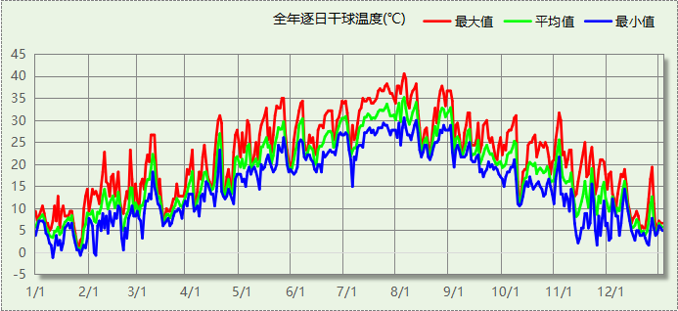

## 逐月辐照量表

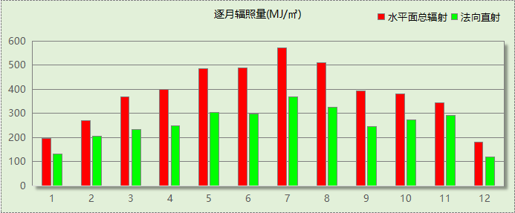

## 峰值工况

|  |  |  |  |  |  |
| --- | --- | --- | --- | --- | --- |
| 气象数据 | 时刻 | 干球温度(℃) | 湿球温度(℃) | 含湿量(g/kg) | 焓值(kj/kg) |
| 最热 | 08月02日15时 | 40.6 | 26.7 | 17.1 | 84.8 |
| 最冷 | 01月10日06时 | -1.1 | -1.1 | 3.4 | 7.4 |

# 建筑大样



西南轴侧图



东南轴侧图



西北轴侧图



东北轴侧图

# 围护结构

## 工程材料

|  |  |  |  |  |  |  |
| --- | --- | --- | --- | --- | --- | --- |
| 材料名称 | 导热系数λ | 蓄热系数S | 密度ρ | 比热容Cp | 蒸汽渗透 系数u | 数据来源 |
| W/(m.K) | W/(㎡.K) | kg/m3 | J/(kg.K) | g/(m.h.kPa) |
| 水泥刨花板 | 0.190 | 4.560 | 700.0 | 2149.9 | 0.0000 | 湖南省公/居建节能设计标准常用材料-2022 |
| 松木、云杉（热流方向垂直木纹） | 0.140 | 3.850 | 500.0 | 2911.8 | 0.0000 | 湖南省公/居建节能设计标准常用材料-2022 |
| 改性玻化微珠轻质砂浆 （保温隔热型） | 0.100 | 3.120 | 600.0 | 2231.0 | 0.0000 | 湖南省公/居建节能设计标准常用材料-2022 |
| 屋面复合防水保温装饰板（与水泥聚苯颗粒复合） | 0.070 | 1.500 | 180.0 | 2455.5 | 0.0000 | 湖南省公/居建节能设计标准常用材料-2022 |
| SBS改性沥青防水卷材 | 0.230 | 9.370 | 900.0 | 5832.3 | 0.0000 | 湖南省公/居建节能设计标准常用材料-2022 |
| 胶合板 | 0.170 | 4.570 | 600.0 | 2815.6 | 0.0000 | 湖南省公/居建节能设计标准常用材料-2022 |
| 膨胀玻化微珠保温装饰板 | 0.058 | 1.200 | 280.0 | 1219.3 | 0.0000 | 湖南省公/居建节能设计标准常用材料-2022 |
| 挤塑聚苯乙烯泡沫塑料（带表皮） | 0.030 | 0.340 | 35.0 | 1380.0 | 0.0000 |  |
| 内置成孔芯模混凝土空心楼板（220mm厚） | 0.810 | 4.030 | 1780.0 | 154.9 | 0.0000 | 湖南省公/居建节能设计标准常用材料-2022 |
| 混凝土多孔砖(190六孔砖） | 0.750 | 7.490 | 1450.0 | 709.4 | 0.0000 |  |

## 屋顶

### 屋顶构造一

|  |  |  |  |  |  |  |
| --- | --- | --- | --- | --- | --- | --- |
| 材料名称 （由上到下） | 厚度δ | 导热系数λ | 蓄热系数S | 修正 系数 | 热阻R | 热惰性 指标 |
| (mm) | W/(m.K) | W/(㎡.K) | α | (㎡K)/W | D=R*S |
| 屋面复合防水保温装饰板（与水泥聚苯颗粒复合） | 20 | 0.070 | 1.500 | 1.25 | 0.229 | 0.429 |
| SBS改性沥青防水卷材 | 20 | 0.230 | 9.370 | 1.20 | 0.072 | 0.815 |
| 内置成孔芯模混凝土空心楼板（220mm厚） | 60 | 0.810 | 4.030 | 1.00 | 0.074 | 0.299 |
| 改性玻化微珠轻质砂浆 （保温隔热型） | 40 | 0.100 | 3.120 | 1.20 | 0.333 | 1.248 |
| 挤塑聚苯乙烯泡沫塑料（带表皮） | 60 | 0.030 | 0.340 | 1.20 | 1.667 | 0.680 |
| 各层之和∑ | 200 | － | － | － | 2.375 | 3.470 |
| 外表面太阳辐射吸收系数 | 0.75[默认] | | | | | |
| 传热系数K=1/(0.15+∑R) | 0.40 | | | | | |

## 天窗类型

本工程无此项内容

## 外墙

### 外墙相关构造

#### 外墙构造一

|  |  |  |  |  |  |  |
| --- | --- | --- | --- | --- | --- | --- |
| 材料名称 （由外到内） | 厚度δ | 导热系数λ | 蓄热系数S | 修正 系数 | 热阻R | 热惰性 指标 |
| (mm) | W/(m.K) | W/(㎡.K) | α | (㎡K)/W | D=R*S |
| 松木、云杉（热流方向垂直木纹） | 40 | 0.140 | 3.850 | 1.00 | 0.286 | 1.100 |
| 胶合板 | 20 | 0.170 | 4.570 | 1.00 | 0.118 | 0.538 |
| 改性玻化微珠轻质砂浆 （保温隔热型） | 100 | 0.100 | 3.120 | 1.20 | 0.833 | 3.120 |
| 胶合板 | 20 | 0.170 | 4.570 | 1.00 | 0.118 | 0.538 |
| 挤塑聚苯乙烯泡沫塑料（带表皮） | 60 | 0.030 | 0.340 | 1.20 | 1.667 | 0.680 |
| 各层之和∑ | 240 | － | － | － | 3.021 | 5.975 |
| 外表面太阳辐射吸收系数 | 0.75[默认] | | | | | |
| 传热系数K=1/(0.15+∑R) | 0.32 | | | | | |

#### 外墙构造一

|  |  |  |  |  |  |  |
| --- | --- | --- | --- | --- | --- | --- |
| 材料名称 （由外到内） | 厚度δ | 导热系数λ | 蓄热系数S | 修正 系数 | 热阻R | 热惰性 指标 |
| (mm) | W/(m.K) | W/(㎡.K) | α | (㎡K)/W | D=R*S |
| 水泥刨花板 | 20 | 0.190 | 4.560 | 1.00 | 0.105 | 0.480 |
| 挤塑聚苯乙烯泡沫塑料（带表皮） | 20 | 0.030 | 0.340 | 1.20 | 0.556 | 0.227 |
| 水泥刨花板 | 20 | 0.190 | 4.560 | 1.00 | 0.105 | 0.480 |
| 膨胀玻化微珠保温装饰板 | 200 | 0.058 | 1.200 | 1.00 | 3.448 | 4.138 |
| 胶合板 | 20 | 0.170 | 4.570 | 1.00 | 0.118 | 0.538 |
| 各层之和∑ | 280 | － | － | － | 4.332 | 5.862 |
| 外表面太阳辐射吸收系数 | 0.75[默认] | | | | | |
| 传热系数K=1/(0.15+∑R) | 0.22 | | | | | |
| 修正后K, D | K = 1.13, D = 5.86 | | | | | |
| 修正原因 |  | | | | | |

### 外墙平均热工特性

1.　南向

|  |  |  |  |  |  |  |
| --- | --- | --- | --- | --- | --- | --- |
| 构造名称 | 构件 类型 | 面积(㎡) | 面积所占比例 | 传热系数K W / (㎡K) | 热惰性 指标D | 太阳辐射 吸收系数 |
| 外墙构造一 | 主墙体 | 274.35 | 1.000 | 0.32 | 5.98 | 0.75 |

2.　北向

|  |  |  |  |  |  |  |
| --- | --- | --- | --- | --- | --- | --- |
| 构造名称 | 构件 类型 | 面积(㎡) | 面积所占比例 | 传热系数K W / (㎡K) | 热惰性 指标D | 太阳辐射 吸收系数 |
| 外墙构造一 | 主墙体 | 350.15 | 0.984 | 0.32 | 5.98 | 0.75 |
| 外墙构造一 | 外墙（剪力墙） | 5.60 | 0.016 | 1.13 | 5.86 | 0.75 |
| 合计 |  | 355.75 | 1.000 | 0.33 | 5.97 | 0.75 |

3.　东向

|  |  |  |  |  |  |  |
| --- | --- | --- | --- | --- | --- | --- |
| 构造名称 | 构件 类型 | 面积(㎡) | 面积所占比例 | 传热系数K W / (㎡K) | 热惰性 指标D | 太阳辐射 吸收系数 |
| 外墙构造一 | 主墙体 | 324.23 | 1.000 | 0.32 | 5.98 | 0.75 |

4.　西向

|  |  |  |  |  |  |  |
| --- | --- | --- | --- | --- | --- | --- |
| 构造名称 | 构件 类型 | 面积(㎡) | 面积所占比例 | 传热系数K W / (㎡K) | 热惰性 指标D | 太阳辐射 吸收系数 |
| 外墙构造一 | 主墙体 | 308.19 | 0.972 | 0.32 | 5.98 | 0.75 |
| 外墙构造一 | 外墙（剪力墙） | 8.80 | 0.028 | 1.13 | 5.86 | 0.75 |
| 合计 |  | 316.99 | 1.000 | 0.34 | 5.97 | 0.75 |

5.　总体

|  |  |  |  |  |  |  |
| --- | --- | --- | --- | --- | --- | --- |
| 构造名称 | 构件 类型 | 面积(㎡) | 面积所占比例 | 传热系数K W / (㎡K) | 热惰性 指标D | 太阳辐射 吸收系数 |
| 外墙构造一 | 主墙体 | 1256.91 | 0.989 | 0.32 | 5.98 | 0.75 |
| 外墙构造一 | 外墙（剪力墙） | 14.40 | 0.011 | 1.13 | 5.86 | 0.75 |
| 合计 |  | 1271.31 | 1.000 | 0.32 | 5.97 | 0.75 |

## 外窗热工

### 外窗

|  |  |  |  |  |  |  |
| --- | --- | --- | --- | --- | --- | --- |
| 序号 | 构造名称 | 构造 编号 | 传热 系数 | 窗遮阳 系数 | 可见光 透射比 | 数据来源 |
| 1 | 86系列内平开木窗 5+12A+5Low-E+12A+5Low-E | 65 | 1.40 | 0.32 | 0.620 | 湖南省超低能耗居住建筑设计标准 DBJ43/T 017-2021 |
| 窗编号 | | | | |
| 幕墙 | | | | |
| 2 | 断桥铝合金型材窗多腔密封35mm 6 高透光双银 Low-E+12A+6 透明(暖边间隔条) | 18 | 1.92 | 0.40 | 0.680 | 湖南省居住建筑节能设计标准 DBJ43/T025-2022 |
| 窗编号 | | | | |
| C1230，C2030，C2718，C3030，，C2815，C1415，C2712，C2818，C1318，C2430，C2615，C2715，C2812 | | | | |

### 外遮阳类型

已启用环境遮阳.

#### 百叶遮阳

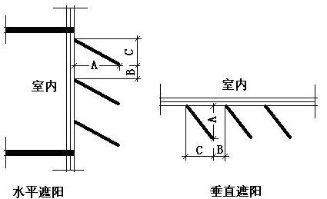

|  |  |  |  |  |
| --- | --- | --- | --- | --- |
| 序号 | 编号 | 挑出 A (m) | 百叶间距 D (m) | 下垂 C (m) |
| 1 | 百叶遮阳0 | 0.200 | 0.400 | 0.200 |

### 总体热工性能

|  |  |  |  |  |  |  |  |
| --- | --- | --- | --- | --- | --- | --- | --- |
| 朝向 | 面积 | 传热系数 | 夏季综合 太阳得热系数 | 冬季综合 太阳得热系数 | 窗墙比 | 标准要求 | 结论 |
| 南向 | 244.55 | 1.49 | 0.20 | 0.20 | 0.44 | K≤2.20, SHGCSum≤0.15, SHGCWin≥0.40 | 不需要 |
| 北向 | 256.07 | 1.66 | 0.25 | 0.26 | 0.40 | K≤2.20, SHGCSum≤0.15, SHGCWin≥0.40 | 不需要 |
| 东向 | 255.78 | 1.63 | 0.28 | 0.28 | 0.41 | K≤2.20, SHGCSum≤0.15, SHGCWin≥0.40 | 不需要 |
| 西向 | 251.71 | 1.71 | 0.29 | 0.29 | 0.42 | K≤2.20, SHGCSum≤0.15, SHGCWin≥0.40 | 不需要 |
| 综合平均 | 1008.12 | 1.62 | 0.26 | 0.26 | 0.42 |  |  |
| 标准依据 | 《近零能耗建筑技术标准》(GB/T51350-2019)第6.1.5条 | | | | | | |
| 标准要求 | K和SHGC值可按表6.1.5-2选取 | | | | | | |
| 结论 | 不需要 | | | | | | |

注：本表所统计的外窗包含凸窗。

## 外窗气密性

|  |  |
| --- | --- |
| 最不利气密性等级 | 6级（窗编号：C1230） |
| 外窗气密性措施 |  |
| 标准依据 | 《近零能耗建筑技术标准》第6.1.4条，分级与检测方法《建筑幕墙、门窗通用技术条件》(GB/T31433-2015) |
| 标准要求 | 外窗及外门户门气密性不宜低于《建筑幕墙、门窗通用技术条件》(GB/T31433-2015)的8级 |
| 结论 | 不适宜 |

## 外门气密性

|  |  |
| --- | --- |
| 最不利气密性等级 | 4级（窗编号：M0921） |
| 外门气密性措施 |  |
| 标准依据 | 《近零能耗建筑技术标准》第6.1.4条，分级与检测方法《建筑幕墙、门窗通用技术条件》(GB/T31433-2015) |
| 标准要求 | 外窗及外门户门气密性不宜低于《建筑幕墙、门窗通用技术条件》(GB/T31433-2015)的6级 |
| 结论 | 不适宜 |

## 户门气密性

|  |  |
| --- | --- |
| 最不利气密性等级 | － |
| 户门气密性措施 |  |
| 标准依据 | 《近零能耗建筑技术标准》第6.1.4条，分级与检测方法《建筑幕墙、门窗通用技术条件》(GB/T31433-2015) |
| 标准要求 | 外窗及外门户门气密性不宜低于《建筑幕墙、门窗通用技术条件》(GB/T31433-2015)的6级 |
| 结论 | － |

## 规定项检查

|  |  |  |
| --- | --- | --- |
| 序号 | 检查项 | 结论 |
| 1 | 屋顶 | 不需要 |
| 2 | 天窗类型 | 无屋顶透光部分 |
| 3 | 外墙 | 不需要 |
| 4 | 外窗热工 | 不需要 |
| 5 | 外窗气密性 | 不适宜 |
| 6 | 外门气密性 | 不适宜 |
| 7 | 户门气密性 | 适宜 |

# 围护结构概况

|  |  |  |  |  |  |  |  |
| --- | --- | --- | --- | --- | --- | --- | --- |
|  | | 设计建筑 | | | 基准建筑 | | |
| 屋顶传热系数K  和热惰性指标 D | | 0.40  3.47 | | | 0.50  3.26 | | |
| 外墙传热系数K  和热惰性指标 D | | 0.32  5.97 | | | 0.80  3.19 | | |
| 挑空(或架空)楼板传热系数K  和热惰性指标 D | | 0.32  4.15 | | | 0.70  3.25 | | |
| 天窗传热系数K  和太阳得热系数 SHGC | | －  － | | | －  － | | |
| 外窗（包括透明幕墙） | 朝向 | 窗墙比 | 传热  系数 | 太阳得热系数 | 窗墙比 | 传热  系数 | 太阳得热系数 |
| 南向 | 0.44 | 1.49 | 0.20 | 0.31 | 2.60 | 0.40 |
| 北向 | 0.40 | 1.66 | 0.26 | 0.31 | 2.60 | 0.44 |
| 东向 | 0.41 | 1.63 | 0.28 | 0.31 | 2.60 | 0.40 |
| 西向 | 0.42 | 1.71 | 0.29 | 0.31 | 2.60 | 0.40 |

备注：

1. 传热系数的单位W/(m2.k)，其他参数无量纲.

2. 屋顶和外墙的传热系数K和热情性指标D指平均值.

3. 设计建筑：“—”代表本工程无对应项.

# 设计建筑

## 房间类型

### 房间参数表

|  |  |  |  |  |  |  |  |
| --- | --- | --- | --- | --- | --- | --- | --- |
| 房间类型 | 空调 温度℃ | 供暖 温度℃ | 新风量 | 渗透风 换气次数 | 人员密度 | 照明功率 密度 | 电器设备 功率 |
| 健身活动室 | 26 | 20 | 30(m3/h.人) | 0(次/h) | 8(㎡/人) | 8(W/㎡) | 0(W/㎡) |
| 办公-普通办公室 | 26 | 20 | 30(m3/h.人) | 0(次/h) | 10(㎡/人) | 8(W/㎡) | 13(W/㎡) |
| 卫生间 | 26 | 20 | 30(m3/h.人) | 0(次/h) | 10(㎡/人) | 8(W/㎡) | 13(W/㎡) |
| 文印间 | 26 | 20 | 30(m3/h.人) | 0(次/h) | 10(㎡/人) | 8(W/㎡) | 13(W/㎡) |
| 普通办公室 | 26 | 20 | 30(m3/h.人) | 0(次/h) | 10(㎡/人) | 8(W/㎡) | 13(W/㎡) |
| 普通办公室 | 26 | 20 | 30(m3/h.人) | 0(次/h) | 10(㎡/人) | 8(W/㎡) | 13(W/㎡) |
| 普通教室 | 26 | 20 | 30(m3/h.人) | 0(次/h) | 1.12(㎡/人) | 8(W/㎡) | 5(W/㎡) |
| 楼梯间 | － | － | 20(m3/h.人) | 0(次/h) | 50(㎡/人) | 0(W/㎡) | 0(W/㎡) |
| 舞蹈教室 | 26 | 20 | 30(m3/h.人) | 0(次/h) | 1.12(㎡/人) | 8(W/㎡) | 5(W/㎡) |
| 走廊 | 26 | 20 | 30(m3/h.人) | 0(次/h) | 20(㎡/人) | 8(W/㎡) | 0(W/㎡) |
| 餐厅 | 26 | 20 | 30(m3/h.人) | 0(次/h) | 4(㎡/人) | 8(W/㎡) | 0(W/㎡) |

### 作息时间表

详见附录

## 系统类型

### 系统分区

|  |  |  |  |  |  |
| --- | --- | --- | --- | --- | --- |
| 系统编号 | 系统类型 | 制冷 SEER | 制热 HSPF | 面积(㎡) | 包含的房间 |
| 默认 | 多联式空调(热泵)机组 | 4.00[全年能源消耗效率(APF)] | | 3105.94 | 所有房间 |

### 热回收参数

|  |  |  |  |  |  |
| --- | --- | --- | --- | --- | --- |
| 系统编号 | 热回收 | 供冷 | | 供暖 | |
| 回收效率 | 启动温(焓)差 | 回收效率 | 启动温(焓)差 |
| 默认 | 显热回收 | 0.60 | 5℃ | 0.65 | 5(℃) |

## 制冷系统

### 多联机/单元式空调能耗

|  |  |  |  |
| --- | --- | --- | --- |
| 系统编号 | 制冷SEER | 耗冷量(kWh) | 耗电量(kWh) |
| 默认 | 4.00[全年能源消耗效率(APF)] | 105924 | 26481 |

## 供暖系统

### 多联机/单元式热泵能耗

|  |  |  |  |
| --- | --- | --- | --- |
| 系统编号 | 制热HSPF | 耗热量(kWh) | 耗电量(kWh) |
| 默认 | 4.00[全年能源消耗效率(APF)] | 34390 | 8598 |

## 照明

|  |  |  |  |  |
| --- | --- | --- | --- | --- |
| 房间类型 | 单位面积电耗 (kWh/㎡) | 房间个数 | 房间合计面积 (㎡) | 合计电耗 (kWh) |
| 健身活动室 | 12.26 | 4 | 382 | 4681 |
| 卫生间 | 22.78 | 4 | 93 | 2127 |
| 文印间 | 21.02 | 1 | 23 | 488 |
| 普通办公室 | 21.02 | 12 | 319 | 6702 |
| 普通教室 | 15.80 | 7 | 984 | 15553 |
| 楼梯间 | 0.00 | 2 | 36 | 0 |
| 舞蹈教室 | 15.80 | 1 | 86 | 1357 |
| 走廊 | 2.28 | 6 | 1245 | 2835 |
| 餐厅 | 17.66 | 1 | 106 | 1865 |
| 总计 | | | | 35608 |

## 光伏发电

日照辐照量(kJ/㎡.天)：11589，年运行天数：365

|  |  |  |  |  |
| --- | --- | --- | --- | --- |
| 光伏板面积 (㎡) | 光电转换 效率(%) | 光伏系统效率 | 光伏电池性能衰减修正系数 | 全年供电 (kWh) |
| 20 | 15 | 0.75 | 0.85 | 2247 |
| 180 | 15 | 0.75 | 0.85 | 20225 |
| 总计 | | | | 22472 |

## 风力发电

|  |  |  |  |  |  |  |
| --- | --- | --- | --- | --- | --- | --- |
| 地形 | 叶片直径 (m) | 叶片离地高度(m) | 年可利用平均风速(m/s) | 转换 效率 | 台数 | 年供电(kWh) |
| 有护栏的农村,临时的农村建筑、房屋 | 2 | 12 | 5 | 0.35 | 10 | 2 |
| 总计 | | | | | | 2 |

## 负荷分项统计

|  |  |  |  |  |  |  |
| --- | --- | --- | --- | --- | --- | --- |
| 分类 | 围护传热 | 室内得热 | 窗日射 | 新风/渗透 | 热回收 | 合计 |
| 供暖(kWh/㎡) | -6.70 | 3.38 | 1.05 | -15.98 | 8.19 | -10.06 |
| 供冷(kWh/㎡) | 4.18 | 3.98 | 1.72 | 22.66 | -1.55 | 30.99 |

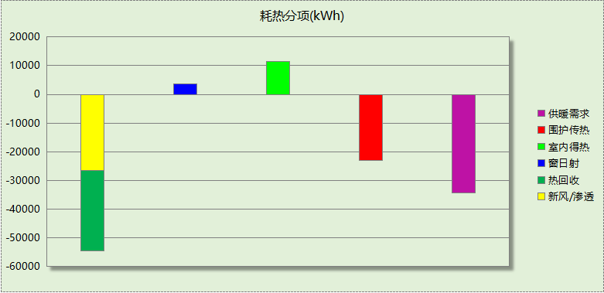

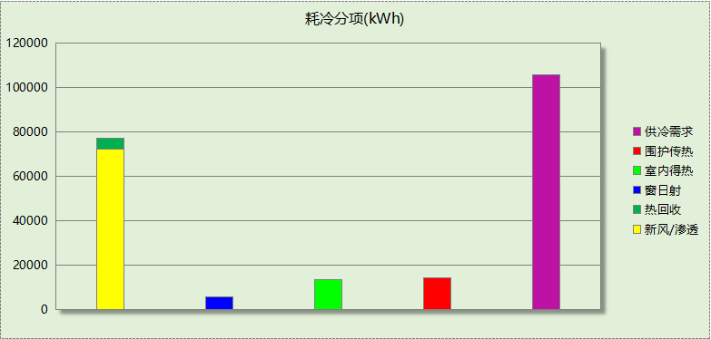

## 逐月负荷表

|  |  |  |  |  |  |  |
| --- | --- | --- | --- | --- | --- | --- |
| 月份 | 供暖(kWh) | 供冷(kWh) | 热负荷 峰值(kW) | 热负荷 峰值时刻 | 冷负荷 峰值(kW) | 冷负荷 峰值时刻 |
| 1月 | 13351 | 0 | 324.914 | 1月2日8时 | 0.000 | -- |
| 2月 | 0 | 0 | 0.000 | -- | 0.000 | -- |
| 3月 | 0 | 0 | 0.000 | -- | 0.000 | -- |
| 4月 | 0 | 0 | 0.000 | -- | 0.000 | -- |
| 5月 | 0 | 0 | 0.000 | -- | 0.000 | -- |
| 6月 | 0 | 40134 | 0.000 | -- | 470.290 | 6月24日16时 |
| 7月 | 0 | 39410 | 0.000 | -- | 482.076 | 7月9日12时 |
| 8月 | 0 | 26380 | 0.000 | -- | 662.630 | 8月26日8时 |
| 9月 | 0 | 0 | 0.000 | -- | 0.000 | -- |
| 10月 | 0 | 0 | 0.000 | -- | 0.000 | -- |
| 11月 | 0 | 0 | 0.000 | -- | 0.000 | -- |
| 12月 | 21039 | 0 | 225.061 | 12月23日8时 | 0.000 | -- |

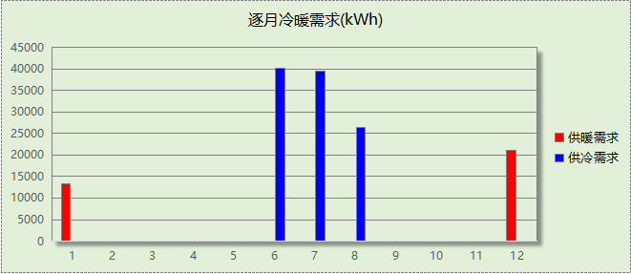

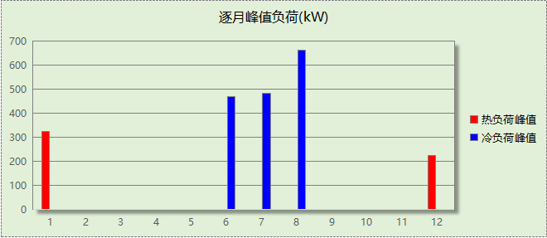

# 基准建筑

## 房间类型

### 房间参数表

|  |  |  |  |  |  |  |  |
| --- | --- | --- | --- | --- | --- | --- | --- |
| 房间类型 | 空调 温度℃ | 供暖 温度℃ | 新风量 | 渗透风 换气次数 | 人员密度 | 照明功率 密度 | 电器设备 功率 |
| 健身活动室 | 26 | 20 | 30(m3/h.人) | 0(次/h) | 8(㎡/人) | 11(W/㎡) | 0(W/㎡) |
| 办公-普通办公室 | 26 | 20 | 30(m3/h.人) | 0(次/h) | 10(㎡/人) | 9(W/㎡) | 13(W/㎡) |
| 卫生间 | 26 | 20 | 30(m3/h.人) | 0(次/h) | 10(㎡/人) | 8(W/㎡) | 13(W/㎡) |
| 文印间 | 26 | 20 | 30(m3/h.人) | 0(次/h) | 10(㎡/人) | 9(W/㎡) | 13(W/㎡) |
| 普通办公室 | 26 | 20 | 30(m3/h.人) | 0(次/h) | 10(㎡/人) | 9(W/㎡) | 13(W/㎡) |
| 普通办公室 | 26 | 20 | 30(m3/h.人) | 0(次/h) | 10(㎡/人) | 8(W/㎡) | 13(W/㎡) |
| 普通教室 | 26 | 20 | 30(m3/h.人) | 0(次/h) | 1.12(㎡/人) | 9(W/㎡) | 5(W/㎡) |
| 楼梯间 | － | － | 20(m3/h.人) | 0(次/h) | 50(㎡/人) | 0(W/㎡) | 0(W/㎡) |
| 舞蹈教室 | 26 | 20 | 30(m3/h.人) | 0(次/h) | 1.12(㎡/人) | 9(W/㎡) | 5(W/㎡) |
| 走廊 | 26 | 20 | 30(m3/h.人) | 0(次/h) | 20(㎡/人) | 10(W/㎡) | 0(W/㎡) |
| 餐厅 | 26 | 20 | 30(m3/h.人) | 0(次/h) | 4(㎡/人) | 9(W/㎡) | 0(W/㎡) |

### 作息时间表

同设计建筑

## 系统类型

|  |  |  |  |  |  |
| --- | --- | --- | --- | --- | --- |
| 系统编号 | 系统类型 | 制冷 SEER | 制热 HSPF | 面积(㎡) | 包含的房间 |
| 默认 | 双管制风机盘管 | － | － | 同设计建筑 | 同设计建筑 |

## 制冷系统

### 默认冷源

#### 供应的系统

|  |  |
| --- | --- |
| 系统编号 | 默认 |

#### 冷水机组

|  |  |  |  |  |  |  |  |  |
| --- | --- | --- | --- | --- | --- | --- | --- | --- |
| 名称 | 类型 | 额定 耗电量(kW) | 额定 制冷量(kW) | 额定性 能系数 (COP) | 台数 | 全年 供冷量(kWh) | 综合部分 负荷性能系数(IPLV) | 电耗 (kWh) |
| 机组1 | 水冷-螺杆式冷水机组 | 132.76 | 690.33 | 5.20 | 1 | 116202 | 5.90 | 19695 |
| 合计 | | | | | | | | 19695 |

#### 冷却水泵

|  |  |  |  |  |  |  |
| --- | --- | --- | --- | --- | --- | --- |
| 机组名称 | 冷水机组 制冷量(kW) | 机组性能 系数(COP) | 冷凝负荷(kW) | 输送能效比 | 运行时长 (h) | 水泵电耗 (kWh) |
| 机组1 | 690 | 5.20 | 823 | 0.0214 | 286 | 5038 |
| 合计 | 690 |  | 823 |  |  | 5038 |

#### 冷冻水泵

|  |  |  |  |  |
| --- | --- | --- | --- | --- |
| 机组名称 | 机组制冷量(kW) | 输送能效比 | 运行时长(h) | 水泵电耗(kWh) |
| 机组1 | 690 | 0.0241 | 286 | 4758 |
| 合计 | 690 |  |  | 4758 |

#### 冷却塔

|  |  |  |  |  |  |
| --- | --- | --- | --- | --- | --- |
| 类型 | 机组制冷量(kW) | 冷却塔风机单位 电耗制冷量(kW/kW) | 冷却塔风机 功率(kW) | 运行时长(h) | 冷却塔电耗 (kWh) |
| 冷却塔 | 690 | 170 | 4.06 | 286 | 1161 |

## 供暖系统

### 默认热源

#### 供应的系统

|  |  |
| --- | --- |
| 系统编号 | 默认 |

#### 热水锅炉能耗

|  |  |  |  |  |  |  |  |
| --- | --- | --- | --- | --- | --- | --- | --- |
| 燃料类型 | 容量 (MW) | 台数 | 累计热负荷 (kWh) | 锅炉 热效率 | 外网热 输送效率 | 天然气热值(kWh/m3) | 天然气消耗(m3) |
| 燃气 | 0.57 | 1 | 72548 | 0.88 | 0.92 | 9.85 | 9097.44 |

#### 热水循环水泵能耗

|  |  |  |  |
| --- | --- | --- | --- |
| 锅炉制热量(kW) | 输送能效比 | 运行时长(h) | 供暖水泵电耗(kWh) |
| 565 | 0.00433 | 341 | 835 |

## 照明

|  |  |  |  |  |
| --- | --- | --- | --- | --- |
| 房间类型 | 单位面积电耗 (kWh/㎡) | 房间个数 | 房间合计面积 (㎡) | 合计电耗 (kWh) |
| 健身活动室 | 16.86 | 4 | 382 | 6437 |
| 卫生间 | 22.78 | 4 | 93 | 2127 |
| 文印间 | 23.65 | 1 | 23 | 549 |
| 普通办公室 | 23.65 | 12 | 319 | 7540 |
| 普通教室 | 17.78 | 7 | 984 | 17498 |
| 楼梯间 | 0.00 | 2 | 36 | 0 |
| 舞蹈教室 | 17.78 | 1 | 86 | 1526 |
| 走廊 | 2.85 | 6 | 1245 | 3543 |
| 餐厅 | 19.87 | 1 | 106 | 2098 |
| 总计 | | | | 41318 |

## 负荷分项统计

|  |  |  |  |  |  |  |
| --- | --- | --- | --- | --- | --- | --- |
| 分类 | 围护传热 | 室内得热 | 窗日射 | 新风/渗透 | 热回收 | 合计 |
| 供暖(kWh/㎡) | -9.91 | 3.60 | 1.06 | -15.97 | 0.00 | -21.22 |
| 供冷(kWh/㎡) | 4.90 | 4.26 | 1.75 | 23.09 | 0.00 | 33.99 |

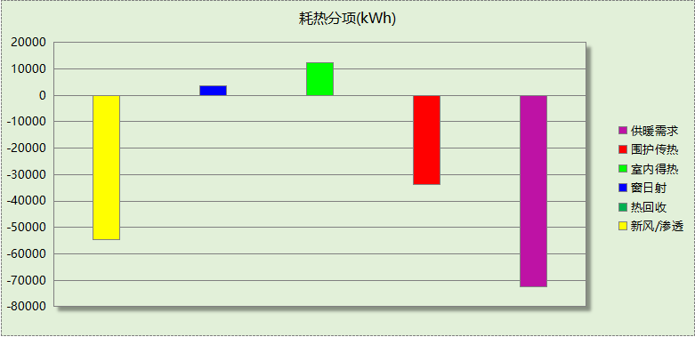

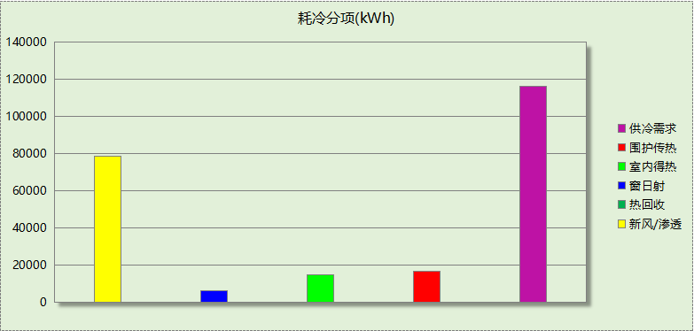

## 逐月负荷表

|  |  |  |  |  |  |  |
| --- | --- | --- | --- | --- | --- | --- |
| 月份 | 供暖(kWh) | 供冷(kWh) | 热负荷 峰值(kW) | 热负荷 峰值时刻 | 冷负荷 峰值(kW) | 冷负荷 峰值时刻 |
| 1月 | 26380 | 0 | 497.939 | 1月2日8时 | 0.000 | -- |
| 2月 | 0 | 0 | 0.000 | -- | 0.000 | -- |
| 3月 | 0 | 0 | 0.000 | -- | 0.000 | -- |
| 4月 | 0 | 0 | 0.000 | -- | 0.000 | -- |
| 5月 | 0 | 0 | 0.000 | -- | 0.000 | -- |
| 6月 | 0 | 44635 | 0.000 | -- | 476.919 | 6月24日16时 |
| 7月 | 0 | 42722 | 0.000 | -- | 546.972 | 7月12日15时 |
| 8月 | 0 | 28844 | 0.000 | -- | 658.260 | 8月26日8时 |
| 9月 | 0 | 0 | 0.000 | -- | 0.000 | -- |
| 10月 | 0 | 0 | 0.000 | -- | 0.000 | -- |
| 11月 | 0 | 0 | 0.000 | -- | 0.000 | -- |
| 12月 | 46168 | 0 | 392.562 | 12月23日8时 | 0.000 | -- |

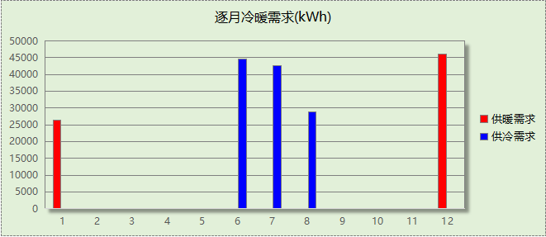

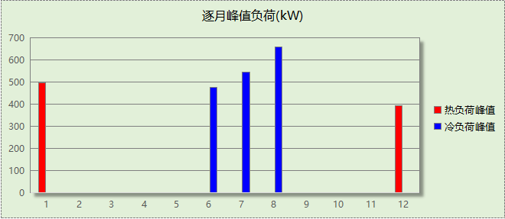

# 能效结果

## 建筑能耗

|  |  |  |  |  |
| --- | --- | --- | --- | --- |
| **设计建筑** | | | | |
| 用能分类 | | | 能耗值 | 一次能源(kWh/㎡) |
| 电力(kWh/㎡) | 供  冷 | 中央冷源 | 0.00 | 0.00 |
| 冷却水泵 | 0.00 | 0.00 |
| 冷冻水泵 | 0.00 | 0.00 |
| 冷却塔 | 0.00 | 0.00 |
| 多联机/单元式空调 | 7.75 | 20.15 |
| 供  暖 | 中央热源 | 0.00 | 0.00 |
| 供暖水泵 | 0.00 | 0.00 |
| 多联机/单元式热泵 | 2.52 | 6.55 |
| 热源侧水泵 | 0.00 | 0.00 |
| 照明 | | 10.42 | 27.09 |
| 生活热水 | | 0.00 | 0.00 |
| 电梯 | | 0.00 | 0.00 |
| 标准煤(kgce/㎡) | 供暖锅炉 | | 0.00 | 0.00 |
| 天然气(m³/㎡) | 供暖锅炉 | | 0.00 | 0.00 |
| 生活热水 | | 0.00 | 0.00 |
| 市政热力(kWh/㎡) | 市政热力 | | 0.00 | 0.00 |
| 可再生发电  (kWh/㎡) | 光伏发电 | | 6.57 | 17.08 |
| 风力发电 | | 0.00 | 0.00 |
| 建筑本体能耗(一次能源) (kWh/㎡) | | | 53.76 | |
| 建筑综合能耗(一次能源) (kWh/㎡) | | | 36.67 | |

|  |  |  |  |  |
| --- | --- | --- | --- | --- |
| **基准建筑** | | | | |
| 用能分类 | | | 能耗值 | 一次能源(kWh/㎡) |
| 电力(kWh/㎡) | 供  冷 | 中央冷源 | 5.76 | 14.98 |
| 冷却水泵 | 1.47 | 3.82 |
| 冷冻水泵 | 1.39 | 3.61 |
| 冷却塔 | 0.34 | 0.88 |
| 多联机/单元式空调 | 0.00 | 0.00 |
| 供  暖 | 中央热源 | 0.00 | 0.00 |
| 供暖水泵 | 0.24 | 0.62 |
| 多联机/单元式热泵 | 0.00 | 0.00 |
| 照明 | | 12.09 | 31.43 |
| 生活热水 | | 0.00 | 0.00 |
| 电梯 | | 0.00 | 0.00 |
| 标准煤(kgce/㎡) | 供暖锅炉 | | 0.00 | 0.00 |
| 天然气(m³/㎡) | 供暖锅炉 | | 2.66 | 26.20 |
| 生活热水 | | 0.00 | 0.00 |
| 市政热力(kWh/㎡) | 市政热力 | | 0.00 | 0.00 |
| 建筑本体能耗(一次能源) (kWh/㎡) | | | 81.59 | |
| 建筑综合能耗(一次能源) (kWh/㎡) | | | 81.59 | |

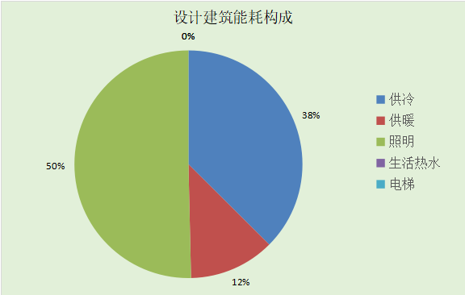

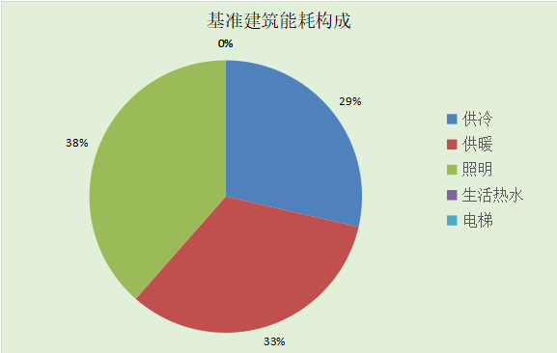

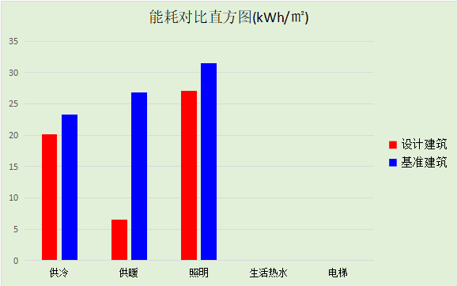

## 结论

|  |  |  |
| --- | --- | --- |
|  | 设计建筑 | 基准建筑 |
| 建筑本体能耗(一次能源) (kWh/㎡) | 53.76 | 81.59 |
| 建筑综合能耗(一次能源) (kWh/㎡) | 36.67 | 81.59 |
|  | 值 | 限值 |
| 建筑本体能耗节能率(%) | 34.10 | 20.00 |
| 建筑综合能耗节能率(%) | 55.05 | 50.00 |
| 标准依据 | 《近零能耗建筑技术标准》(GB/T51350-2019)表5.0.4 | |
| 标准要求 | 建筑综合节能率应≥50%; 建筑本体节能率应符合表5.0.4的要求 | |
| 结论 | 满足 | |

# 附录

暑假:7.15~8.25; 寒假：1.15~3.1

## 工作日/节假日人员逐时在室率(%)

|  |  |  |  |  |  |  |  |  |  |  |  |  |  |  |  |  |  |  |  |  |  |  |  |  |
| --- | --- | --- | --- | --- | --- | --- | --- | --- | --- | --- | --- | --- | --- | --- | --- | --- | --- | --- | --- | --- | --- | --- | --- | --- |
| 房间类型 | 1 | 2 | 3 | 4 | 5 | 6 | 7 | 8 | 9 | 10 | 11 | 12 | 13 | 14 | 15 | 16 | 17 | 18 | 19 | 20 | 21 | 22 | 23 | 24 |
| 健身活动室 | 0 | 0 | 0 | 0 | 0 | 0 | 0 | 45 | 45 | 45 | 45 | 45 | 45 | 45 | 45 | 45 | 45 | 45 | 45 | 45 | 45 | 0 | 0 | 0 |
| 0 | 0 | 0 | 0 | 0 | 0 | 0 | 0 | 0 | 0 | 0 | 0 | 0 | 0 | 0 | 0 | 0 | 0 | 0 | 0 | 0 | 0 | 0 | 0 |
| 0 | 0 | 0 | 0 | 0 | 0 | 0 | 0 | 0 | 0 | 0 | 0 | 0 | 0 | 0 | 0 | 0 | 0 | 0 | 0 | 0 | 0 | 0 | 0 |
| 0 | 0 | 0 | 0 | 0 | 0 | 0 | 0 | 0 | 0 | 0 | 0 | 0 | 0 | 0 | 0 | 0 | 0 | 0 | 0 | 0 | 0 | 0 | 0 |
| 办公-普通办公室 | 0 | 0 | 0 | 0 | 0 | 0 | 0 | 33 | 33 | 33 | 33 | 33 | 33 | 33 | 33 | 33 | 33 | 33 | 0 | 0 | 0 | 0 | 0 | 0 |
| 0 | 0 | 0 | 0 | 0 | 0 | 0 | 0 | 0 | 0 | 0 | 0 | 0 | 0 | 0 | 0 | 0 | 0 | 0 | 0 | 0 | 0 | 0 | 0 |
| 0 | 0 | 0 | 0 | 0 | 0 | 0 | 0 | 0 | 0 | 0 | 0 | 0 | 0 | 0 | 0 | 0 | 0 | 0 | 0 | 0 | 0 | 0 | 0 |
| 0 | 0 | 0 | 0 | 0 | 0 | 0 | 0 | 0 | 0 | 0 | 0 | 0 | 0 | 0 | 0 | 0 | 0 | 0 | 0 | 0 | 0 | 0 | 0 |
| 卫生间 | 0 | 0 | 0 | 0 | 0 | 0 | 0 | 33 | 33 | 33 | 33 | 33 | 33 | 33 | 33 | 33 | 33 | 33 | 0 | 0 | 0 | 0 | 0 | 0 |
| 0 | 0 | 0 | 0 | 0 | 0 | 0 | 0 | 0 | 0 | 0 | 0 | 0 | 0 | 0 | 0 | 0 | 0 | 0 | 0 | 0 | 0 | 0 | 0 |
| 0 | 0 | 0 | 0 | 0 | 0 | 0 | 0 | 0 | 0 | 0 | 0 | 0 | 0 | 0 | 0 | 0 | 0 | 0 | 0 | 0 | 0 | 0 | 0 |
| 0 | 0 | 0 | 0 | 0 | 0 | 0 | 0 | 0 | 0 | 0 | 0 | 0 | 0 | 0 | 0 | 0 | 0 | 0 | 0 | 0 | 0 | 0 | 0 |
| 文印间 | 0 | 0 | 0 | 0 | 0 | 0 | 0 | 33 | 33 | 33 | 33 | 33 | 33 | 33 | 33 | 33 | 33 | 33 | 0 | 0 | 0 | 0 | 0 | 0 |
| 0 | 0 | 0 | 0 | 0 | 0 | 0 | 0 | 0 | 0 | 0 | 0 | 0 | 0 | 0 | 0 | 0 | 0 | 0 | 0 | 0 | 0 | 0 | 0 |
| 0 | 0 | 0 | 0 | 0 | 0 | 0 | 0 | 0 | 0 | 0 | 0 | 0 | 0 | 0 | 0 | 0 | 0 | 0 | 0 | 0 | 0 | 0 | 0 |
| 0 | 0 | 0 | 0 | 0 | 0 | 0 | 0 | 0 | 0 | 0 | 0 | 0 | 0 | 0 | 0 | 0 | 0 | 0 | 0 | 0 | 0 | 0 | 0 |
| 普通办公室 | 0 | 0 | 0 | 0 | 0 | 0 | 0 | 33 | 33 | 33 | 33 | 33 | 33 | 33 | 33 | 33 | 33 | 33 | 0 | 0 | 0 | 0 | 0 | 0 |
| 0 | 0 | 0 | 0 | 0 | 0 | 0 | 0 | 0 | 0 | 0 | 0 | 0 | 0 | 0 | 0 | 0 | 0 | 0 | 0 | 0 | 0 | 0 | 0 |
| 0 | 0 | 0 | 0 | 0 | 0 | 0 | 0 | 0 | 0 | 0 | 0 | 0 | 0 | 0 | 0 | 0 | 0 | 0 | 0 | 0 | 0 | 0 | 0 |
| 0 | 0 | 0 | 0 | 0 | 0 | 0 | 0 | 0 | 0 | 0 | 0 | 0 | 0 | 0 | 0 | 0 | 0 | 0 | 0 | 0 | 0 | 0 | 0 |
| 普通办公室 | 0 | 0 | 0 | 0 | 0 | 0 | 0 | 33 | 33 | 33 | 33 | 33 | 33 | 33 | 33 | 33 | 33 | 33 | 0 | 0 | 0 | 0 | 0 | 0 |
| 0 | 0 | 0 | 0 | 0 | 0 | 0 | 0 | 0 | 0 | 0 | 0 | 0 | 0 | 0 | 0 | 0 | 0 | 0 | 0 | 0 | 0 | 0 | 0 |
| 0 | 0 | 0 | 0 | 0 | 0 | 0 | 0 | 0 | 0 | 0 | 0 | 0 | 0 | 0 | 0 | 0 | 0 | 0 | 0 | 0 | 0 | 0 | 0 |
| 0 | 0 | 0 | 0 | 0 | 0 | 0 | 0 | 0 | 0 | 0 | 0 | 0 | 0 | 0 | 0 | 0 | 0 | 0 | 0 | 0 | 0 | 0 | 0 |
| 普通教室 | 0 | 0 | 0 | 0 | 0 | 0 | 0 | 27 | 27 | 27 | 27 | 27 | 27 | 27 | 27 | 27 | 27 | 27 | 0 | 0 | 0 | 0 | 0 | 0 |
| 0 | 0 | 0 | 0 | 0 | 0 | 0 | 0 | 0 | 0 | 0 | 0 | 0 | 0 | 0 | 0 | 0 | 0 | 0 | 0 | 0 | 0 | 0 | 0 |
| 0 | 0 | 0 | 0 | 0 | 0 | 0 | 0 | 0 | 0 | 0 | 0 | 0 | 0 | 0 | 0 | 0 | 0 | 0 | 0 | 0 | 0 | 0 | 0 |
| 0 | 0 | 0 | 0 | 0 | 0 | 0 | 0 | 0 | 0 | 0 | 0 | 0 | 0 | 0 | 0 | 0 | 0 | 0 | 0 | 0 | 0 | 0 | 0 |
| 楼梯间 | 0 | 0 | 0 | 0 | 0 | 0 | 0 | 20 | 50 | 80 | 80 | 80 | 80 | 80 | 80 | 80 | 80 | 80 | 80 | 70 | 50 | 0 | 0 | 0 |
| 0 | 0 | 0 | 0 | 0 | 0 | 0 | 0 | 0 | 0 | 0 | 0 | 0 | 0 | 0 | 0 | 0 | 0 | 0 | 0 | 0 | 0 | 0 | 0 |
| 0 | 0 | 0 | 0 | 0 | 0 | 0 | 0 | 0 | 0 | 0 | 0 | 0 | 0 | 0 | 0 | 0 | 0 | 0 | 0 | 0 | 0 | 0 | 0 |
| 0 | 0 | 0 | 0 | 0 | 0 | 0 | 0 | 0 | 0 | 0 | 0 | 0 | 0 | 0 | 0 | 0 | 0 | 0 | 0 | 0 | 0 | 0 | 0 |
| 舞蹈教室 | 0 | 0 | 0 | 0 | 0 | 0 | 0 | 27 | 27 | 27 | 27 | 27 | 27 | 27 | 27 | 27 | 27 | 27 | 0 | 0 | 0 | 0 | 0 | 0 |
| 0 | 0 | 0 | 0 | 0 | 0 | 0 | 0 | 0 | 0 | 0 | 0 | 0 | 0 | 0 | 0 | 0 | 0 | 0 | 0 | 0 | 0 | 0 | 0 |
| 0 | 0 | 0 | 0 | 0 | 0 | 0 | 0 | 0 | 0 | 0 | 0 | 0 | 0 | 0 | 0 | 0 | 0 | 0 | 0 | 0 | 0 | 0 | 0 |
| 0 | 0 | 0 | 0 | 0 | 0 | 0 | 0 | 0 | 0 | 0 | 0 | 0 | 0 | 0 | 0 | 0 | 0 | 0 | 0 | 0 | 0 | 0 | 0 |
| 走廊 | 0 | 0 | 0 | 0 | 0 | 0 | 0 | 55 | 55 | 55 | 55 | 55 | 55 | 55 | 55 | 55 | 55 | 55 | 0 | 0 | 0 | 0 | 0 | 0 |
| 0 | 0 | 0 | 0 | 0 | 0 | 0 | 0 | 0 | 0 | 0 | 0 | 0 | 0 | 0 | 0 | 0 | 0 | 0 | 0 | 0 | 0 | 0 | 0 |
| 0 | 0 | 0 | 0 | 0 | 0 | 0 | 0 | 0 | 0 | 0 | 0 | 0 | 0 | 0 | 0 | 0 | 0 | 0 | 0 | 0 | 0 | 0 | 0 |
| 0 | 0 | 0 | 0 | 0 | 0 | 0 | 0 | 0 | 0 | 0 | 0 | 0 | 0 | 0 | 0 | 0 | 0 | 0 | 0 | 0 | 0 | 0 | 0 |
| 餐厅 | 0 | 0 | 0 | 0 | 0 | 0 | 29 | 29 | 29 | 29 | 29 | 29 | 29 | 29 | 29 | 29 | 29 | 29 | 29 | 29 | 0 | 0 | 0 | 0 |
| 0 | 0 | 0 | 0 | 0 | 0 | 0 | 0 | 0 | 0 | 0 | 0 | 0 | 0 | 0 | 0 | 0 | 0 | 0 | 0 | 0 | 0 | 0 | 0 |
| 0 | 0 | 0 | 0 | 0 | 0 | 0 | 0 | 0 | 0 | 0 | 0 | 0 | 0 | 0 | 0 | 0 | 0 | 0 | 0 | 0 | 0 | 0 | 0 |
| 0 | 0 | 0 | 0 | 0 | 0 | 0 | 0 | 0 | 0 | 0 | 0 | 0 | 0 | 0 | 0 | 0 | 0 | 0 | 0 | 0 | 0 | 0 | 0 |

注：第一行：工作日；第二行：节假日；第三行：寒假；第四行：暑假

## 工作日/节假日照明开关时间表(%)

|  |  |  |  |  |  |  |  |  |  |  |  |  |  |  |  |  |  |  |  |  |  |  |  |  |
| --- | --- | --- | --- | --- | --- | --- | --- | --- | --- | --- | --- | --- | --- | --- | --- | --- | --- | --- | --- | --- | --- | --- | --- | --- |
| 房间类型 | 1 | 2 | 3 | 4 | 5 | 6 | 7 | 8 | 9 | 10 | 11 | 12 | 13 | 14 | 15 | 16 | 17 | 18 | 19 | 20 | 21 | 22 | 23 | 24 |
| 健身活动室 | 0 | 0 | 0 | 0 | 0 | 0 | 0 | 50 | 50 | 50 | 50 | 50 | 50 | 50 | 50 | 50 | 50 | 50 | 50 | 50 | 50 | 0 | 0 | 0 |
| 0 | 0 | 0 | 0 | 0 | 0 | 0 | 0 | 0 | 0 | 0 | 0 | 0 | 0 | 0 | 0 | 0 | 0 | 0 | 0 | 0 | 0 | 0 | 0 |
| 0 | 0 | 0 | 0 | 0 | 0 | 0 | 0 | 0 | 0 | 0 | 0 | 0 | 0 | 0 | 0 | 0 | 0 | 0 | 0 | 0 | 0 | 0 | 0 |
| 0 | 0 | 0 | 0 | 0 | 0 | 0 | 0 | 0 | 0 | 0 | 0 | 0 | 0 | 0 | 0 | 0 | 0 | 0 | 0 | 0 | 0 | 0 | 0 |
| 办公-普通办公室 | 0 | 0 | 0 | 0 | 0 | 0 | 0 | 100 | 100 | 100 | 100 | 100 | 100 | 100 | 100 | 100 | 100 | 100 | 100 | 0 | 0 | 0 | 0 | 0 |
| 0 | 0 | 0 | 0 | 0 | 0 | 0 | 0 | 0 | 0 | 0 | 0 | 0 | 0 | 0 | 0 | 0 | 0 | 0 | 0 | 0 | 0 | 0 | 0 |
| 0 | 0 | 0 | 0 | 0 | 0 | 0 | 0 | 0 | 0 | 0 | 0 | 0 | 0 | 0 | 0 | 0 | 0 | 0 | 0 | 0 | 0 | 0 | 0 |
| 0 | 0 | 0 | 0 | 0 | 0 | 0 | 0 | 0 | 0 | 0 | 0 | 0 | 0 | 0 | 0 | 0 | 0 | 0 | 0 | 0 | 0 | 0 | 0 |
| 卫生间 | 0 | 0 | 0 | 0 | 0 | 0 | 100 | 100 | 100 | 100 | 100 | 100 | 100 | 100 | 100 | 100 | 100 | 100 | 100 | 0 | 0 | 0 | 0 | 0 |
| 0 | 0 | 0 | 0 | 0 | 0 | 0 | 0 | 0 | 0 | 0 | 0 | 0 | 0 | 0 | 0 | 0 | 0 | 0 | 0 | 0 | 0 | 0 | 0 |
| 0 | 0 | 0 | 0 | 0 | 0 | 0 | 0 | 0 | 0 | 0 | 0 | 0 | 0 | 0 | 0 | 0 | 0 | 0 | 0 | 0 | 0 | 0 | 0 |
| 0 | 0 | 0 | 0 | 0 | 0 | 0 | 0 | 0 | 0 | 0 | 0 | 0 | 0 | 0 | 0 | 0 | 0 | 0 | 0 | 0 | 0 | 0 | 0 |
| 文印间 | 0 | 0 | 0 | 0 | 0 | 0 | 0 | 100 | 100 | 100 | 100 | 100 | 100 | 100 | 100 | 100 | 100 | 100 | 100 | 0 | 0 | 0 | 0 | 0 |
| 0 | 0 | 0 | 0 | 0 | 0 | 0 | 0 | 0 | 0 | 0 | 0 | 0 | 0 | 0 | 0 | 0 | 0 | 0 | 0 | 0 | 0 | 0 | 0 |
| 0 | 0 | 0 | 0 | 0 | 0 | 0 | 0 | 0 | 0 | 0 | 0 | 0 | 0 | 0 | 0 | 0 | 0 | 0 | 0 | 0 | 0 | 0 | 0 |
| 0 | 0 | 0 | 0 | 0 | 0 | 0 | 0 | 0 | 0 | 0 | 0 | 0 | 0 | 0 | 0 | 0 | 0 | 0 | 0 | 0 | 0 | 0 | 0 |
| 普通办公室 | 0 | 0 | 0 | 0 | 0 | 0 | 0 | 100 | 100 | 100 | 100 | 100 | 100 | 100 | 100 | 100 | 100 | 100 | 100 | 0 | 0 | 0 | 0 | 0 |
| 0 | 0 | 0 | 0 | 0 | 0 | 0 | 0 | 0 | 0 | 0 | 0 | 0 | 0 | 0 | 0 | 0 | 0 | 0 | 0 | 0 | 0 | 0 | 0 |
| 0 | 0 | 0 | 0 | 0 | 0 | 0 | 0 | 0 | 0 | 0 | 0 | 0 | 0 | 0 | 0 | 0 | 0 | 0 | 0 | 0 | 0 | 0 | 0 |
| 0 | 0 | 0 | 0 | 0 | 0 | 0 | 0 | 0 | 0 | 0 | 0 | 0 | 0 | 0 | 0 | 0 | 0 | 0 | 0 | 0 | 0 | 0 | 0 |
| 普通办公室 | 0 | 0 | 0 | 0 | 0 | 0 | 100 | 100 | 100 | 100 | 100 | 100 | 100 | 100 | 100 | 100 | 100 | 100 | 100 | 0 | 0 | 0 | 0 | 0 |
| 0 | 0 | 0 | 0 | 0 | 0 | 0 | 0 | 0 | 0 | 0 | 0 | 0 | 0 | 0 | 0 | 0 | 0 | 0 | 0 | 0 | 0 | 0 | 0 |
| 0 | 0 | 0 | 0 | 0 | 0 | 0 | 0 | 0 | 0 | 0 | 0 | 0 | 0 | 0 | 0 | 0 | 0 | 0 | 0 | 0 | 0 | 0 | 0 |
| 0 | 0 | 0 | 0 | 0 | 0 | 0 | 0 | 0 | 0 | 0 | 0 | 0 | 0 | 0 | 0 | 0 | 0 | 0 | 0 | 0 | 0 | 0 | 0 |
| 普通教室 | 0 | 0 | 0 | 0 | 0 | 0 | 0 | 82 | 82 | 82 | 82 | 82 | 82 | 82 | 82 | 82 | 82 | 82 | 0 | 0 | 0 | 0 | 0 | 0 |
| 0 | 0 | 0 | 0 | 0 | 0 | 0 | 0 | 0 | 0 | 0 | 0 | 0 | 0 | 0 | 0 | 0 | 0 | 0 | 0 | 0 | 0 | 0 | 0 |
| 0 | 0 | 0 | 0 | 0 | 0 | 0 | 0 | 0 | 0 | 0 | 0 | 0 | 0 | 0 | 0 | 0 | 0 | 0 | 0 | 0 | 0 | 0 | 0 |
| 0 | 0 | 0 | 0 | 0 | 0 | 0 | 0 | 0 | 0 | 0 | 0 | 0 | 0 | 0 | 0 | 0 | 0 | 0 | 0 | 0 | 0 | 0 | 0 |
| 楼梯间 | 10 | 10 | 10 | 10 | 10 | 10 | 10 | 50 | 60 | 60 | 60 | 60 | 60 | 60 | 60 | 60 | 80 | 90 | 100 | 100 | 100 | 10 | 10 | 10 |
| 0 | 0 | 0 | 0 | 0 | 0 | 0 | 0 | 0 | 0 | 0 | 0 | 0 | 0 | 0 | 0 | 0 | 0 | 0 | 0 | 0 | 0 | 0 | 0 |
| 0 | 0 | 0 | 0 | 0 | 0 | 0 | 0 | 0 | 0 | 0 | 0 | 0 | 0 | 0 | 0 | 0 | 0 | 0 | 0 | 0 | 0 | 0 | 0 |
| 0 | 0 | 0 | 0 | 0 | 0 | 0 | 0 | 0 | 0 | 0 | 0 | 0 | 0 | 0 | 0 | 0 | 0 | 0 | 0 | 0 | 0 | 0 | 0 |
| 舞蹈教室 | 0 | 0 | 0 | 0 | 0 | 0 | 0 | 82 | 82 | 82 | 82 | 82 | 82 | 82 | 82 | 82 | 82 | 82 | 0 | 0 | 0 | 0 | 0 | 0 |
| 0 | 0 | 0 | 0 | 0 | 0 | 0 | 0 | 0 | 0 | 0 | 0 | 0 | 0 | 0 | 0 | 0 | 0 | 0 | 0 | 0 | 0 | 0 | 0 |
| 0 | 0 | 0 | 0 | 0 | 0 | 0 | 0 | 0 | 0 | 0 | 0 | 0 | 0 | 0 | 0 | 0 | 0 | 0 | 0 | 0 | 0 | 0 | 0 |
| 0 | 0 | 0 | 0 | 0 | 0 | 0 | 0 | 0 | 0 | 0 | 0 | 0 | 0 | 0 | 0 | 0 | 0 | 0 | 0 | 0 | 0 | 0 | 0 |
| 走廊 | 0 | 0 | 0 | 0 | 0 | 0 | 10 | 10 | 10 | 10 | 10 | 10 | 10 | 10 | 10 | 10 | 10 | 10 | 10 | 0 | 0 | 0 | 0 | 0 |
| 0 | 0 | 0 | 0 | 0 | 0 | 0 | 0 | 0 | 0 | 0 | 0 | 0 | 0 | 0 | 0 | 0 | 0 | 0 | 0 | 0 | 0 | 0 | 0 |
| 0 | 0 | 0 | 0 | 0 | 0 | 0 | 0 | 0 | 0 | 0 | 0 | 0 | 0 | 0 | 0 | 0 | 0 | 0 | 0 | 0 | 0 | 0 | 0 |
| 0 | 0 | 0 | 0 | 0 | 0 | 0 | 0 | 0 | 0 | 0 | 0 | 0 | 0 | 0 | 0 | 0 | 0 | 0 | 0 | 0 | 0 | 0 | 0 |
| 餐厅 | 0 | 0 | 0 | 0 | 0 | 0 | 72 | 72 | 72 | 72 | 72 | 72 | 72 | 72 | 72 | 72 | 72 | 72 | 72 | 72 | 0 | 0 | 0 | 0 |
| 0 | 0 | 0 | 0 | 0 | 0 | 0 | 0 | 0 | 0 | 0 | 0 | 0 | 0 | 0 | 0 | 0 | 0 | 0 | 0 | 0 | 0 | 0 | 0 |
| 0 | 0 | 0 | 0 | 0 | 0 | 0 | 0 | 0 | 0 | 0 | 0 | 0 | 0 | 0 | 0 | 0 | 0 | 0 | 0 | 0 | 0 | 0 | 0 |
| 0 | 0 | 0 | 0 | 0 | 0 | 0 | 0 | 0 | 0 | 0 | 0 | 0 | 0 | 0 | 0 | 0 | 0 | 0 | 0 | 0 | 0 | 0 | 0 |

注：第一行：工作日；第二行：节假日；第三行：寒假；第四行：暑假

## 工作日/节假日设备逐时使用率(%)

|  |  |  |  |  |  |  |  |  |  |  |  |  |  |  |  |  |  |  |  |  |  |  |  |  |
| --- | --- | --- | --- | --- | --- | --- | --- | --- | --- | --- | --- | --- | --- | --- | --- | --- | --- | --- | --- | --- | --- | --- | --- | --- |
| 房间类型 | 1 | 2 | 3 | 4 | 5 | 6 | 7 | 8 | 9 | 10 | 11 | 12 | 13 | 14 | 15 | 16 | 17 | 18 | 19 | 20 | 21 | 22 | 23 | 24 |
| 健身活动室 | 0 | 0 | 0 | 0 | 0 | 0 | 0 | 0 | 0 | 0 | 0 | 0 | 0 | 0 | 0 | 0 | 0 | 0 | 0 | 0 | 0 | 0 | 0 | 0 |
| 0 | 0 | 0 | 0 | 0 | 0 | 0 | 0 | 0 | 0 | 0 | 0 | 0 | 0 | 0 | 0 | 0 | 0 | 0 | 0 | 0 | 0 | 0 | 0 |
| 0 | 0 | 0 | 0 | 0 | 0 | 0 | 0 | 0 | 0 | 0 | 0 | 0 | 0 | 0 | 0 | 0 | 0 | 0 | 0 | 0 | 0 | 0 | 0 |
| 0 | 0 | 0 | 0 | 0 | 0 | 0 | 0 | 0 | 0 | 0 | 0 | 0 | 0 | 0 | 0 | 0 | 0 | 0 | 0 | 0 | 0 | 0 | 0 |
| 办公-普通办公室 | 0 | 0 | 0 | 0 | 0 | 0 | 0 | 33 | 33 | 33 | 33 | 33 | 33 | 33 | 33 | 33 | 33 | 33 | 0 | 0 | 0 | 0 | 0 | 0 |
| 0 | 0 | 0 | 0 | 0 | 0 | 0 | 0 | 0 | 0 | 0 | 0 | 0 | 0 | 0 | 0 | 0 | 0 | 0 | 0 | 0 | 0 | 0 | 0 |
| 0 | 0 | 0 | 0 | 0 | 0 | 0 | 0 | 0 | 0 | 0 | 0 | 0 | 0 | 0 | 0 | 0 | 0 | 0 | 0 | 0 | 0 | 0 | 0 |
| 0 | 0 | 0 | 0 | 0 | 0 | 0 | 0 | 0 | 0 | 0 | 0 | 0 | 0 | 0 | 0 | 0 | 0 | 0 | 0 | 0 | 0 | 0 | 0 |
| 卫生间 | 0 | 0 | 0 | 0 | 0 | 0 | 0 | 33 | 33 | 33 | 33 | 33 | 33 | 33 | 33 | 33 | 33 | 33 | 0 | 0 | 0 | 0 | 0 | 0 |
| 0 | 0 | 0 | 0 | 0 | 0 | 0 | 0 | 0 | 0 | 0 | 0 | 0 | 0 | 0 | 0 | 0 | 0 | 0 | 0 | 0 | 0 | 0 | 0 |
| 0 | 0 | 0 | 0 | 0 | 0 | 0 | 0 | 0 | 0 | 0 | 0 | 0 | 0 | 0 | 0 | 0 | 0 | 0 | 0 | 0 | 0 | 0 | 0 |
| 0 | 0 | 0 | 0 | 0 | 0 | 0 | 0 | 0 | 0 | 0 | 0 | 0 | 0 | 0 | 0 | 0 | 0 | 0 | 0 | 0 | 0 | 0 | 0 |
| 文印间 | 0 | 0 | 0 | 0 | 0 | 0 | 0 | 33 | 33 | 33 | 33 | 33 | 33 | 33 | 33 | 33 | 33 | 33 | 0 | 0 | 0 | 0 | 0 | 0 |
| 0 | 0 | 0 | 0 | 0 | 0 | 0 | 0 | 0 | 0 | 0 | 0 | 0 | 0 | 0 | 0 | 0 | 0 | 0 | 0 | 0 | 0 | 0 | 0 |
| 0 | 0 | 0 | 0 | 0 | 0 | 0 | 0 | 0 | 0 | 0 | 0 | 0 | 0 | 0 | 0 | 0 | 0 | 0 | 0 | 0 | 0 | 0 | 0 |
| 0 | 0 | 0 | 0 | 0 | 0 | 0 | 0 | 0 | 0 | 0 | 0 | 0 | 0 | 0 | 0 | 0 | 0 | 0 | 0 | 0 | 0 | 0 | 0 |
| 普通办公室 | 0 | 0 | 0 | 0 | 0 | 0 | 0 | 33 | 33 | 33 | 33 | 33 | 33 | 33 | 33 | 33 | 33 | 33 | 0 | 0 | 0 | 0 | 0 | 0 |
| 0 | 0 | 0 | 0 | 0 | 0 | 0 | 0 | 0 | 0 | 0 | 0 | 0 | 0 | 0 | 0 | 0 | 0 | 0 | 0 | 0 | 0 | 0 | 0 |
| 0 | 0 | 0 | 0 | 0 | 0 | 0 | 0 | 0 | 0 | 0 | 0 | 0 | 0 | 0 | 0 | 0 | 0 | 0 | 0 | 0 | 0 | 0 | 0 |
| 0 | 0 | 0 | 0 | 0 | 0 | 0 | 0 | 0 | 0 | 0 | 0 | 0 | 0 | 0 | 0 | 0 | 0 | 0 | 0 | 0 | 0 | 0 | 0 |
| 普通办公室 | 0 | 0 | 0 | 0 | 0 | 0 | 0 | 33 | 33 | 33 | 33 | 33 | 33 | 33 | 33 | 33 | 33 | 33 | 0 | 0 | 0 | 0 | 0 | 0 |
| 0 | 0 | 0 | 0 | 0 | 0 | 0 | 0 | 0 | 0 | 0 | 0 | 0 | 0 | 0 | 0 | 0 | 0 | 0 | 0 | 0 | 0 | 0 | 0 |
| 0 | 0 | 0 | 0 | 0 | 0 | 0 | 0 | 0 | 0 | 0 | 0 | 0 | 0 | 0 | 0 | 0 | 0 | 0 | 0 | 0 | 0 | 0 | 0 |
| 0 | 0 | 0 | 0 | 0 | 0 | 0 | 0 | 0 | 0 | 0 | 0 | 0 | 0 | 0 | 0 | 0 | 0 | 0 | 0 | 0 | 0 | 0 | 0 |
| 普通教室 | 0 | 0 | 0 | 0 | 0 | 0 | 0 | 15 | 15 | 15 | 15 | 15 | 15 | 15 | 15 | 15 | 15 | 15 | 0 | 0 | 0 | 0 | 0 | 0 |
| 0 | 0 | 0 | 0 | 0 | 0 | 0 | 0 | 0 | 0 | 0 | 0 | 0 | 0 | 0 | 0 | 0 | 0 | 0 | 0 | 0 | 0 | 0 | 0 |
| 0 | 0 | 0 | 0 | 0 | 0 | 0 | 0 | 0 | 0 | 0 | 0 | 0 | 0 | 0 | 0 | 0 | 0 | 0 | 0 | 0 | 0 | 0 | 0 |
| 0 | 0 | 0 | 0 | 0 | 0 | 0 | 0 | 0 | 0 | 0 | 0 | 0 | 0 | 0 | 0 | 0 | 0 | 0 | 0 | 0 | 0 | 0 | 0 |
| 楼梯间 | 0 | 0 | 0 | 0 | 0 | 0 | 0 | 30 | 50 | 80 | 80 | 80 | 80 | 80 | 80 | 80 | 80 | 80 | 80 | 70 | 50 | 0 | 0 | 0 |
| 0 | 0 | 0 | 0 | 0 | 0 | 0 | 0 | 0 | 0 | 0 | 0 | 0 | 0 | 0 | 0 | 0 | 0 | 0 | 0 | 0 | 0 | 0 | 0 |
| 0 | 0 | 0 | 0 | 0 | 0 | 0 | 0 | 0 | 0 | 0 | 0 | 0 | 0 | 0 | 0 | 0 | 0 | 0 | 0 | 0 | 0 | 0 | 0 |
| 0 | 0 | 0 | 0 | 0 | 0 | 0 | 0 | 0 | 0 | 0 | 0 | 0 | 0 | 0 | 0 | 0 | 0 | 0 | 0 | 0 | 0 | 0 | 0 |
| 舞蹈教室 | 0 | 0 | 0 | 0 | 0 | 0 | 0 | 15 | 15 | 15 | 15 | 15 | 15 | 15 | 15 | 15 | 15 | 15 | 0 | 0 | 0 | 0 | 0 | 0 |
| 0 | 0 | 0 | 0 | 0 | 0 | 0 | 0 | 0 | 0 | 0 | 0 | 0 | 0 | 0 | 0 | 0 | 0 | 0 | 0 | 0 | 0 | 0 | 0 |
| 0 | 0 | 0 | 0 | 0 | 0 | 0 | 0 | 0 | 0 | 0 | 0 | 0 | 0 | 0 | 0 | 0 | 0 | 0 | 0 | 0 | 0 | 0 | 0 |
| 0 | 0 | 0 | 0 | 0 | 0 | 0 | 0 | 0 | 0 | 0 | 0 | 0 | 0 | 0 | 0 | 0 | 0 | 0 | 0 | 0 | 0 | 0 | 0 |
| 走廊 | 0 | 0 | 0 | 0 | 0 | 0 | 0 | 0 | 0 | 0 | 0 | 0 | 0 | 0 | 0 | 0 | 0 | 0 | 0 | 0 | 0 | 0 | 0 | 0 |
| 0 | 0 | 0 | 0 | 0 | 0 | 0 | 0 | 0 | 0 | 0 | 0 | 0 | 0 | 0 | 0 | 0 | 0 | 0 | 0 | 0 | 0 | 0 | 0 |
| 0 | 0 | 0 | 0 | 0 | 0 | 0 | 0 | 0 | 0 | 0 | 0 | 0 | 0 | 0 | 0 | 0 | 0 | 0 | 0 | 0 | 0 | 0 | 0 |
| 0 | 0 | 0 | 0 | 0 | 0 | 0 | 0 | 0 | 0 | 0 | 0 | 0 | 0 | 0 | 0 | 0 | 0 | 0 | 0 | 0 | 0 | 0 | 0 |
| 餐厅 | 0 | 0 | 0 | 0 | 0 | 0 | 0 | 0 | 0 | 0 | 0 | 0 | 0 | 0 | 0 | 0 | 0 | 0 | 0 | 0 | 0 | 0 | 0 | 0 |
| 0 | 0 | 0 | 0 | 0 | 0 | 0 | 0 | 0 | 0 | 0 | 0 | 0 | 0 | 0 | 0 | 0 | 0 | 0 | 0 | 0 | 0 | 0 | 0 |
| 0 | 0 | 0 | 0 | 0 | 0 | 0 | 0 | 0 | 0 | 0 | 0 | 0 | 0 | 0 | 0 | 0 | 0 | 0 | 0 | 0 | 0 | 0 | 0 |
| 0 | 0 | 0 | 0 | 0 | 0 | 0 | 0 | 0 | 0 | 0 | 0 | 0 | 0 | 0 | 0 | 0 | 0 | 0 | 0 | 0 | 0 | 0 | 0 |

注：第一行：工作日；第二行：节假日；第三行：寒假；第四行：暑假

## 工作日/节假日空调系统运行时间表(1:开,0:关)

采暖期：

|  |  |  |  |  |  |  |  |  |  |  |  |  |  |  |  |  |  |  |  |  |  |  |  |  |
| --- | --- | --- | --- | --- | --- | --- | --- | --- | --- | --- | --- | --- | --- | --- | --- | --- | --- | --- | --- | --- | --- | --- | --- | --- |
| 系统编号 | 1 | 2 | 3 | 4 | 5 | 6 | 7 | 8 | 9 | 10 | 11 | 12 | 13 | 14 | 15 | 16 | 17 | 18 | 19 | 20 | 21 | 22 | 23 | 24 |
| 默认 | 0 | 0 | 0 | 0 | 0 | 0 | 0 | 1 | 1 | 1 | 1 | 1 | 1 | 1 | 1 | 1 | 1 | 1 | 0 | 0 | 0 | 0 | 0 | 0 |
| 0 | 0 | 0 | 0 | 0 | 0 | 0 | 0 | 0 | 0 | 0 | 0 | 0 | 0 | 0 | 0 | 0 | 0 | 0 | 0 | 0 | 0 | 0 | 0 |
| 0 | 0 | 0 | 0 | 0 | 0 | 0 | 0 | 0 | 0 | 0 | 0 | 0 | 0 | 0 | 0 | 0 | 0 | 0 | 0 | 0 | 0 | 0 | 0 |
| 0 | 0 | 0 | 0 | 0 | 0 | 0 | 0 | 0 | 0 | 0 | 0 | 0 | 0 | 0 | 0 | 0 | 0 | 0 | 0 | 0 | 0 | 0 | 0 |

供冷期：

|  |  |  |  |  |  |  |  |  |  |  |  |  |  |  |  |  |  |  |  |  |  |  |  |  |
| --- | --- | --- | --- | --- | --- | --- | --- | --- | --- | --- | --- | --- | --- | --- | --- | --- | --- | --- | --- | --- | --- | --- | --- | --- |
| 系统编号 | 1 | 2 | 3 | 4 | 5 | 6 | 7 | 8 | 9 | 10 | 11 | 12 | 13 | 14 | 15 | 16 | 17 | 18 | 19 | 20 | 21 | 22 | 23 | 24 |
| 默认 | 0 | 0 | 0 | 0 | 0 | 0 | 0 | 1 | 1 | 1 | 1 | 1 | 1 | 1 | 1 | 1 | 1 | 1 | 0 | 0 | 0 | 0 | 0 | 0 |
| 0 | 0 | 0 | 0 | 0 | 0 | 0 | 0 | 0 | 0 | 0 | 0 | 0 | 0 | 0 | 0 | 0 | 0 | 0 | 0 | 0 | 0 | 0 | 0 |
| 0 | 0 | 0 | 0 | 0 | 0 | 0 | 0 | 0 | 0 | 0 | 0 | 0 | 0 | 0 | 0 | 0 | 0 | 0 | 0 | 0 | 0 | 0 | 0 |
| 0 | 0 | 0 | 0 | 0 | 0 | 0 | 0 | 0 | 0 | 0 | 0 | 0 | 0 | 0 | 0 | 0 | 0 | 0 | 0 | 0 | 0 | 0 | 0 |

注：第一行：工作日；第二行：节假日；第三行：寒假；第四行：暑假

## 工作日/节假日新风运行时间表(%)

采暖期：

|  |  |  |  |  |  |  |  |  |  |  |  |  |  |  |  |  |  |  |  |  |  |  |  |  |
| --- | --- | --- | --- | --- | --- | --- | --- | --- | --- | --- | --- | --- | --- | --- | --- | --- | --- | --- | --- | --- | --- | --- | --- | --- |
| 系统编号 | 1 | 2 | 3 | 4 | 5 | 6 | 7 | 8 | 9 | 10 | 11 | 12 | 13 | 14 | 15 | 16 | 17 | 18 | 19 | 20 | 21 | 22 | 23 | 24 |
| 默认 | 0 | 0 | 0 | 0 | 0 | 0 | 0 | 100 | 100 | 100 | 100 | 100 | 100 | 100 | 100 | 100 | 100 | 100 | 0 | 0 | 0 | 0 | 0 | 0 |
| 0 | 0 | 0 | 0 | 0 | 0 | 0 | 0 | 0 | 0 | 0 | 0 | 0 | 0 | 0 | 0 | 0 | 0 | 0 | 0 | 0 | 0 | 0 | 0 |
| 0 | 0 | 0 | 0 | 0 | 0 | 0 | 0 | 0 | 0 | 0 | 0 | 0 | 0 | 0 | 0 | 0 | 0 | 0 | 0 | 0 | 0 | 0 | 0 |
| 0 | 0 | 0 | 0 | 0 | 0 | 0 | 0 | 0 | 0 | 0 | 0 | 0 | 0 | 0 | 0 | 0 | 0 | 0 | 0 | 0 | 0 | 0 | 0 |

供冷期：

|  |  |  |  |  |  |  |  |  |  |  |  |  |  |  |  |  |  |  |  |  |  |  |  |  |
| --- | --- | --- | --- | --- | --- | --- | --- | --- | --- | --- | --- | --- | --- | --- | --- | --- | --- | --- | --- | --- | --- | --- | --- | --- |
| 系统编号 | 1 | 2 | 3 | 4 | 5 | 6 | 7 | 8 | 9 | 10 | 11 | 12 | 13 | 14 | 15 | 16 | 17 | 18 | 19 | 20 | 21 | 22 | 23 | 24 |
| 默认 | 0 | 0 | 0 | 0 | 0 | 0 | 0 | 100 | 100 | 100 | 100 | 100 | 100 | 100 | 100 | 100 | 100 | 100 | 0 | 0 | 0 | 0 | 0 | 0 |
| 0 | 0 | 0 | 0 | 0 | 0 | 0 | 0 | 0 | 0 | 0 | 0 | 0 | 0 | 0 | 0 | 0 | 0 | 0 | 0 | 0 | 0 | 0 | 0 |
| 0 | 0 | 0 | 0 | 0 | 0 | 0 | 0 | 0 | 0 | 0 | 0 | 0 | 0 | 0 | 0 | 0 | 0 | 0 | 0 | 0 | 0 | 0 | 0 |
| 0 | 0 | 0 | 0 | 0 | 0 | 0 | 0 | 0 | 0 | 0 | 0 | 0 | 0 | 0 | 0 | 0 | 0 | 0 | 0 | 0 | 0 | 0 | 0 |

注：第一行：工作日；第二行：节假日；第三行：寒假；第四行：暑假