**近零能耗**

**建筑能效报告书**

居住建筑

|  |  |
| --- | --- |
| 工程名称 | 新建项目 |
| 工程地点 | 云南-保山 |
| 设计编号 |  |
| 建设单位 | 保山学院 |
| 设计单位 | 保山学院 |
| 设 计 人 |  |
| 校 对 人 |  |
| 审 核 人 |  |
| 计算日期 | 2024年12月26日 |



|  |  |
| --- | --- |
| 采用软件 | 超低能耗PHES2024 |
| 软件版本 | 20240430(SP1) |
| 研发单位 | 北京绿建软件股份有限公司 |
| 正版授权码 | T19188240249 |

**目 录**

1 建筑概况 4

2 设计依据 4

3 气象数据 4

3.1 气象地点 4

3.2 逐日干球温度表 5

3.3 逐月辐照量表 5

3.4 峰值工况 5

4 工程材料 6

4.1 普通材料 6

4.2 其他材料 6

5 屋顶 7

5.1 屋顶相关构造 7

5.1.1 上人屋面 7

5.1.2 屋顶防火隔离带构造一 7

5.2 屋顶平均热工特性 7

6 外墙 8

6.1 外墙（填充墙）构造一 8

7 外窗热工 8

7.1 外窗 8

7.2 外遮阳类型 9

7.2.1 平板遮阳 9

7.3 总体热工性能 9

8 外窗气密性 10

9 外门气密性 10

10 户门气密性 10

11 围护结构检查结论 10

12 房间类型 11

12.1 房间参数表 11

12.2 作息时间表 11

13 系统类型 11

13.1 系统分区 11

13.2 热回收参数 11

14 制冷系统 12

14.1 默认冷源 12

14.1.1 供应的系统 12

14.1.2 冷水机组 12

14.1.3 水泵系统 12

14.1.4 运行工况 12

14.1.5 制冷能耗 12

15 空调风机 13

15.1 独立新排风 13

16 照明 13

17 生活热水 13

17.1 热水需求 13

17.2 太阳能集热 14

17.3 热水设备 14

18 光伏发电 14

19 能效结果 14

19.1 建筑负荷 14

19.1.1 负荷分项统计 14

19.1.2 逐月负荷表 15

19.2 建筑能耗 16

19.3 可再生能源利用 17

19.4 结论 18

20 附录 19

20.1 工作日/节假日人员逐时在室率(%) 19

20.2 工作日/节假日照明开关时间表(%) 19

20.3 工作日/节假日设备逐时使用率(%) 20

20.4 工作日/节假日空调系统运行时间表(1:开,0:关) 21

20.5 工作日/节假日新风运行时间表(%) 21

# 建筑概况

|  |  |  |
| --- | --- | --- |
| 工程名称 | 新建项目 | |
| 工程地点 | 云南-保山 | |
| 地理位置 | 北纬：25.00° | 东经：98.48° |
| 建筑面积(m2) | 地上975 地下0 | |
| 建筑层数 | 地上6 地下0 | |
| 建筑高度（m） | 地上18.2 地下0.0 | |
| 建筑体积(m3) | 3163.61 | |
| 建筑外表面积(m2) | 1946.36 | |
| 建筑气密性（换气次数N50） | 0.60 | |
| 北向角度 | 90 | |
| 结构类型 |  | |
| 外墙太阳辐射吸收系数 | 0.50 | |
| 屋顶太阳辐射吸收系数 | 0.50 | |
| 控温期 | 供冷期:4.1-10.30 | |

# 设计依据

1. 《近零能耗建筑技术标准》(GB/T 51350-2019)

2. 《民用建筑热工设计规范》(GB50176-2016)

3. 《建筑幕墙、门窗通用技术条件》(GB/T31433-2015)

# 气象数据

## 气象地点

云南-保山, 《建筑节能气象参数标准》

## 逐日干球温度表

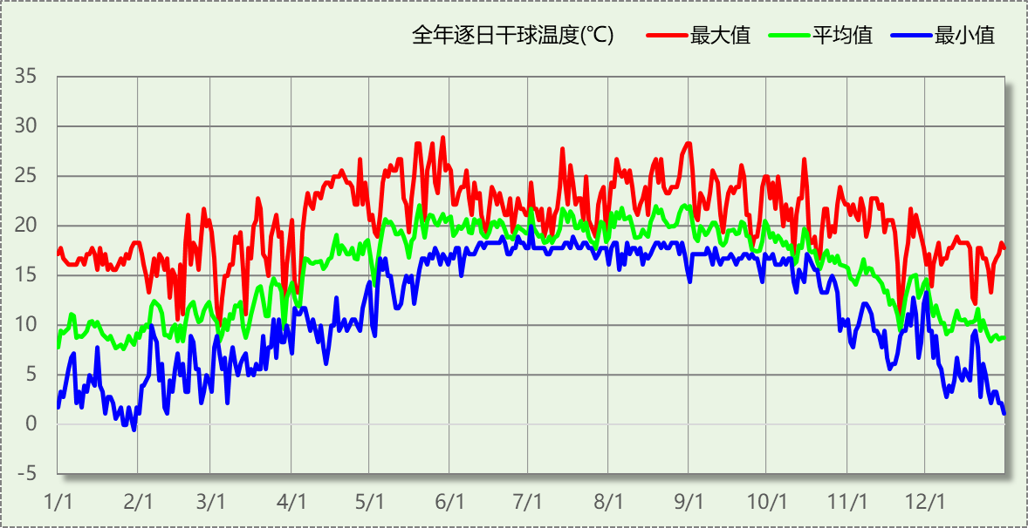

## 逐月辐照量表

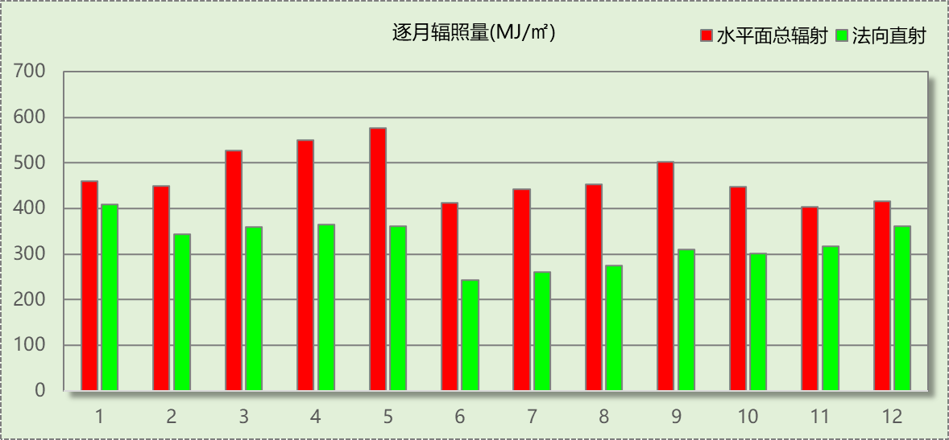

## 峰值工况

|  |  |  |  |  |  |
| --- | --- | --- | --- | --- | --- |
| 气象数据 | 时刻 | 干球温度(℃) | 湿球温度(℃) | 含湿量(g/kg) | 焓值(kj/kg) |
| 最热 | 05月28日20时 | 28.9 | 19.4 | 13.8 | 64.3 |
| 最冷 | 01月29日07时 | -0.6 | -2.8 | 2.6 | 5.9 |

# 工程材料

## 普通材料

|  |  |  |  |  |  |  |
| --- | --- | --- | --- | --- | --- | --- |
| 材料名称 | 导热系数λ | 蓄热系数S | 密度ρ | 比热容Cp | 蒸汽渗透 系数u | 数据来源 |
| W/(m.K) | W/(㎡.K) | kg/m3 | J/(kg.K) | g/(m.h.kPa) |
| 石灰砂浆 | 0.810 | 9.948 | 1600.0 | 1050.0 | 0.0443 | 民用建筑热工设计规范 GB50176-2016 |
| 钢筋混凝土 | 1.740 | 17.200 | 2500.0 | 920.0 | 0.0158 | 民用建筑热工设计规范 GB50176-2016 |
| 石灰水泥砂浆 | 0.870 | 10.750 | 1700.0 | 1074.4 | 0.0443 | 民用建筑热工设计规范 GB50176-2016 |
| 耐碱玻纤网布抗裂砂浆 | 0.930 | 11.306 | 1800.0 | 1050.0 | 0.0140 | 广东居住建筑节能设计标准 DB45-221-2005 |
| c20细石混凝土(ρ=2300) | 1.510 | 15.243 | 2300.0 | 920.0 | 0.0158 | 安徽公共建筑节能设计标准 DB34 T753-2007 |
| 挤塑聚苯板 | 0.030 | 0.340 | 35.0 | 1380.0 | 0.0140 | 民用建筑热工设计规范 GB50176-2016 |
| 聚苯颗粒保温砂浆 | 0.060 | 0.950 | 230.0 | 900.0 | 0.0210 | DB34-T753-2007 |
| 蒸压加气混凝土砌块（525-625） | 0.160 | 2.750 | 600.0 | 1050.0 | 0.0000 | 云南省民用建筑节能设计标准 DBJ53/T-39-2020 |
| 轻骨料混凝土(找坡层) | 0.300 | 5.000 | 1050.0 | 1091.3 | 0.0140 | 工程详细做法图集 05J909 |
| 玻化微珠保温隔热砂浆 | 0.070 | 1.500 | 300.0 | 1473.3 | 0.0100 | JC/T 2164-2013 |
| sbs改性沥青防水卷材 | 0.230 | 9.370 | 900.0 | 1620.0 | 0.0014 | 云南省民用建筑节能设计标准 DBJ53/T-39-2020 |
| C20细石混凝土 | 1.510 | 15.243 | 2300.0 | 920.0 | 0.0173 |  |
| 界面砂浆 | － | － | － | － | － |  |
| 胶粘剂 | － | － | － | － | － |  |

## 其他材料

|  |  |  |  |  |
| --- | --- | --- | --- | --- |
| 材料名称 | 厚度 | 热阻R | 太阳辐射吸收系数 | 备注 |
| mm | (㎡K)/W |
| 水泥砂浆 | － | － | － |  |
| 合成高分子防水涂料 | － | － | － |  |

# 屋顶

## 屋顶相关构造

### 上人屋面

|  |  |  |  |  |  |  |
| --- | --- | --- | --- | --- | --- | --- |
| 材料名称 （由上到下） | 厚度δ | 导热系数λ | 蓄热系数S | 修正 系数 | 热阻R | 热惰性 指标 |
| (mm) | W/(m.K) | W/(㎡.K) | α | (㎡K)/W | D=R*S |
| C20细石混凝土 | 40 | 1.510 | 15.243 | 1.00 | 0.026 | 0.404 |
| sbs改性沥青防水卷材 | 3 | 0.230 | 9.370 | 1.00 | 0.013 | 0.122 |
| 合成高分子防水涂料 | 1 | － | － | － | － | － |
| 水泥砂浆 | 1 | － | － | － | － | － |
| 挤塑聚苯板 | 70 | 0.030 | 0.340 | 1.05 | 2.222 | 0.793 |
| 水泥砂浆 | 1 | － | － | － | － | － |
| 轻骨料混凝土(找坡层) | 30 | 0.300 | 5.000 | 1.50 | 0.067 | 0.500 |
| 钢筋混凝土 | 100 | 1.740 | 17.200 | 1.00 | 0.057 | 0.989 |
| 各层之和∑ | 246 | － | － | － | 2.386 | 2.808 |
| 外表面太阳辐射吸收系数 | 0.50 | | | | | |
| 传热系数K=1/(0.15+∑R) | 0.39 | | | | | |

### 屋顶防火隔离带构造一

|  |  |  |  |  |  |  |
| --- | --- | --- | --- | --- | --- | --- |
| 材料名称 （由上到下） | 厚度δ | 导热系数λ | 蓄热系数S | 修正 系数 | 热阻R | 热惰性 指标 |
| (mm) | W/(m.K) | W/(㎡.K) | α | (㎡K)/W | D=R*S |
| 水泥砂浆 | 1 | － | － | － | － | － |
| 聚苯颗粒保温砂浆 | 20 | 0.060 | 0.950 | 1.20 | 0.278 | 0.317 |
| 水泥砂浆 | 1 | － | － | － | － | － |
| 钢筋混凝土 | 200 | 1.740 | 17.200 | 1.00 | 0.115 | 1.977 |
| 石灰砂浆 | 1 | 0.810 | 9.948 | 1.00 | 0.001 | 0.012 |
| 各层之和∑ | 223 | － | － | － | 0.394 | 2.306 |
| 外表面太阳辐射吸收系数 | 0.50 | | | | | |
| 传热系数K=1/(0.15+∑R) | 1.84 | | | | | |

## 屋顶平均热工特性

|  |  |  |  |  |  |
| --- | --- | --- | --- | --- | --- |
| 构造名称 | 面积(㎡) | 面积所占比例 | 传热系数K W / (㎡K) | 热惰性 指标D | 太阳辐射 吸收系数 |
| 上人屋面 | 397.67 | 0.801 | 0.39 | 2.81 | 0.50 |
| 屋顶防火隔离带构造一 | 98.96 | 0.199 | 1.84 | 2.31 | 0.50 |
| 合计 | 496.63 | 1.000 | 0.68 | 2.71 | 0.50 |

# 外墙

## 外墙（填充墙）构造一

|  |  |  |  |  |  |  |
| --- | --- | --- | --- | --- | --- | --- |
| 材料名称 （由外到内） | 厚度δ | 导热系数λ | 蓄热系数S | 修正 系数 | 热阻R | 热惰性 指标 |
| (mm) | W/(m.K) | W/(㎡.K) | α | (㎡K)/W | D=R*S |
| 耐碱玻纤网布抗裂砂浆 | 5 | 0.930 | 11.306 | 1.00 | 0.005 | 0.061 |
| 玻化微珠保温隔热砂浆 | 30 | 0.070 | 1.500 | 1.20 | 0.357 | 0.643 |
| 界面砂浆 | 1 | － | － | － | 0.000 | － |
| 蒸压加气混凝土砌块（525-625） | 200 | 0.160 | 2.750 | 1.25 | 1.000 | 3.438 |
| 界面砂浆 | 1 | － | － | － | 0.000 | － |
| 玻化微珠保温隔热砂浆 | 30 | 0.070 | 1.500 | 1.10 | 0.390 | 0.643 |
| 耐碱玻纤网布抗裂砂浆 | 5 | 0.930 | 11.306 | 1.00 | 0.005 | 0.061 |
| 各层之和∑ | 272 | － | － | － | 1.758 | 4.845 |
| 外表面太阳辐射吸收系数 | 0.50 | | | | | |
| 传热系数K=1/(0.15+∑R) | 0.52 | | | | | |

# 外窗热工

## 外窗

|  |  |  |  |  |  |  |
| --- | --- | --- | --- | --- | --- | --- |
| 序号 | 构造名称 | 构造 编号 | 传热 系数 | 窗遮阳 系数 | 可见光 透射比 | 数据来源 |
| 1 | 6中透光Low-E+12空气+6透明-铝合金窗框[Kf=6.21W/(㎡·K),框面积20%] | 18 | 3.50 | 0.43 | 0.550 |  |
| 窗编号 | | | | |
| ，透光门- | | | | |

## 外遮阳类型

### 平板遮阳

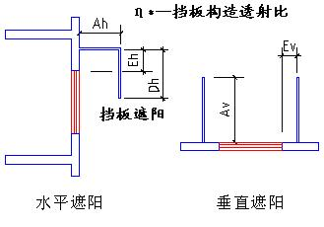

|  |  |  |  |  |  |  |  |
| --- | --- | --- | --- | --- | --- | --- | --- |
| 序号 | 编号 | 水平挑出Ah (m) | 距离上沿Eh (m) | 垂直挑出Av (m) | 距离边沿Ev (m) | 挡板高Dh (m) | 挡板透射η* |
| 1 | 平板遮阳0 | 1.500 | 0.000 | 0.000 | 0.000 | 0.000 | 0.000 |

## 总体热工性能

|  |  |  |  |  |  |  |  |
| --- | --- | --- | --- | --- | --- | --- | --- |
| 朝向 | 面积 | 传热系数 | 夏季综合 太阳得热系数 | 冬季综合 太阳得热系数 | 窗墙比 | 标准要求 | 结论 |
| 南向 | 98.04 | 3.50 | 0.27 | 0.27 | 0.34 | K≤2.00, SHGCSum≤0.30, SHGCWin≥0.40 | 不需要 |
| 北向 | 137.61 | 3.50 | 0.32 | 0.32 | 0.55 | K≤2.00, SHGCSum≤0.30, SHGCWin≥0.40 | 不需要 |
| 东向 | 52.37 | 3.50 | 0.31 | 0.31 | 0.20 | K≤2.00, SHGCSum≤0.30, SHGCWin≥0.40 | 不需要 |
| 西向 | 73.47 | 3.50 | 0.25 | 0.25 | 0.25 | K≤2.00, SHGCSum≤0.30, SHGCWin≥0.40 | 不需要 |
| 综合平均 | 361.49 | 3.50 | 0.29 | 0.29 | 0.33 |  |  |
| 标准依据 | 《近零能耗建筑技术标准》第6.1.5条 | | | | | | |
| 标准要求 | K和SHGC值应当符合表6.1.5-1的要求 | | | | | | |
| 结论 | 不需要 | | | | | | |

注：本表所统计的外窗包含凸窗。

# 外窗气密性

|  |  |
| --- | --- |
| 最不利气密性等级 | 8级（窗编号：） |
| 外窗气密性措施 |  |
| 标准依据 | 《近零能耗建筑技术标准》第6.1.4条，分级与检测方法《建筑幕墙、门窗通用技术条件》(GB/T31433-2015) |
| 标准要求 | 外窗及外门户门气密性不宜低于《建筑幕墙、门窗通用技术条件》(GB/T31433-2015)的8级 |
| 结论 | 适宜 |

# 外门气密性

|  |  |
| --- | --- |
| 最不利气密性等级 | 8级（窗编号：） |
| 外门气密性措施 |  |
| 标准依据 | 《近零能耗建筑技术标准》第6.1.4条，分级与检测方法《建筑幕墙、门窗通用技术条件》(GB/T31433-2015) |
| 标准要求 | 外窗及外门户门气密性不宜低于《建筑幕墙、门窗通用技术条件》(GB/T31433-2015)的6级 |
| 结论 | 适宜 |

# 户门气密性

|  |  |
| --- | --- |
| 最不利气密性等级 | － |
| 户门气密性措施 |  |
| 标准依据 | 《近零能耗建筑技术标准》第6.1.4条，分级与检测方法《建筑幕墙、门窗通用技术条件》(GB/T31433-2015) |
| 标准要求 | 外窗及外门户门气密性不宜低于《建筑幕墙、门窗通用技术条件》(GB/T31433-2015)的6级 |
| 结论 | － |

# 围护结构检查结论

|  |  |  |
| --- | --- | --- |
| 序号 | 检查项 | 结论 |
| 1 | 屋顶 | 不需要 |
| 2 | 外墙 | 不需要 |
| 3 | 外窗热工 | 不需要 |
| 4 | 外窗气密性 | 适宜 |
| 5 | 外门气密性 | 适宜 |
| 6 | 户门气密性 | 适宜 |

# 房间类型

## 房间参数表

|  |  |  |  |  |  |  |  |
| --- | --- | --- | --- | --- | --- | --- | --- |
| 房间类型 | 空调 温度℃ | 供暖 温度℃ | 新风量 | 渗透风 换气次数 | 人员密度 | 照明功率 密度 | 电器设备 功率 |
| 休息室 | 26 | 16 | 5(m3/h.人) | 0.5(次/h) | 6(人) | 5(W/㎡) | 3(W/㎡) |
| 卧室 | 26 | 20 | 30(m3/h.人) | 0.5(次/h) | 6(㎡/人) | 15(W/㎡) | 6(W/㎡) |
| 卫生间 | 26 | 20 | 10(m3/h.人) | 0.2(次/h) | 2(㎡/人) | 4(W/㎡) | 0(W/㎡) |
| 楼梯间 | － | － | 1(m3/h.人) | 0.3(次/h) | 2(人) | 2(W/㎡) | 0(W/㎡) |
| 设备间 | － | － | 1(m3/h.人) | 0.1(次/h) | 2(人) | 3(W/㎡) | 2(W/㎡) |
| 车库 | － | － | 0(m3/h.人) | 0.5(次/h) | 2(人) | 2(W/㎡) | 0(W/㎡) |
| 酒吧、茶座 | 26 | 16 | 5(m3/h.人) | 0.5(次/h) | 6(人) | 5(W/㎡) | 3(W/㎡) |
| 餐厅 | 26 | 20 | 10(m3/h.人) | 0.4(次/h) | 6(㎡/人) | 5(W/㎡) | 5(W/㎡) |

## 作息时间表

详见附录

# 系统类型

## 系统分区

|  |  |  |  |  |  |
| --- | --- | --- | --- | --- | --- |
| 系统编号 | 系统类型 | 制冷 SEER | 制热 HSPF | 面积(㎡) | 包含的房间 |
| 默认 | 双管制风机盘管 | － | － | 0.00 |  |
| Sys | 双管制风机盘管 | － | － | 349.95 | 2018(2),2017(2),2016(2),2015(2),2014(2),2013(2),2012(2),2011(2),2010(2),2009(2) |
| Sys0 | 双管制风机盘管 | － | － | 220.72 | 3022(3),3021(3),3020(3),4024(4) |
| Sys1 | 双管制风机盘管 | － | － | 0.00 |  |

## 热回收参数

|  |  |  |  |  |  |
| --- | --- | --- | --- | --- | --- |
| 系统编号 | 热回收 | 供冷 | | 供暖 | |
| 回收效率 | 启动温(焓)差 | 回收效率 | 启动温(焓)差 |
| 默认 | 无 | － | － | － | － |
| Sys | 无 | － | － | － | － |
| Sys0 | 无 | － | － | － | － |
| Sys1 | 无 | － | － | － | － |

# 制冷系统

## 默认冷源

### 供应的系统

|  |  |
| --- | --- |
| 系统编号 | Sys, Sys0 |

### 冷水机组

|  |  |  |  |  |  |
| --- | --- | --- | --- | --- | --- |
| 名称 | 类型 | 额定耗电量 (kW) | 额定制冷量 (kW) | 额定性能系数 (COP) | 台数 |
| 机组1 | 水冷-螺杆式冷水机组 | 65 | 651 | 10.00 | 2 |

### 水泵系统

|  |  |  |  |  |  |  |  |
| --- | --- | --- | --- | --- | --- | --- | --- |
| 类型 | 调节 | 流量 (m3/h) | 扬程 (m) | 设计工作效率(%) | 输入功率 (kW) | 冷却塔耗电比 (kWh/m3) | 台数 |
| 冷却水泵 | 单速 | 320 | 25 | 80 | 31.3 | 0.03 | 1 |
| 冷冻水泵 | 单速 | 320 | 30 | 80 | 37.6 | － | 1 |

### 运行工况

|  |  |  |  |  |  |  |
| --- | --- | --- | --- | --- | --- | --- |
| 负载率 (%) | 机组制冷量 (kW) | 机组功率 (kW) | 性能系数 (COP) | 冷却水泵功率 (kW) | 冷冻水泵功率 (kW) | 冷却塔功率 (kW) |
| 20 | 260.4 | 20 | 13.02 | 31.3 | 37.6 | 9.6 |
| 40 | 520.8 | 40 | 13.02 | 31.3 | 37.6 | 9.6 |
| 60 | 781.2 | 70 | 11.16 | 62.6 | 75.1 | 19.2 |
| 80 | 1041.6 | 90 | 11.57 | 62.6 | 75.1 | 19.2 |
| 100 | 1302 | 100 | 13.02 | 62.6 | 75.1 | 19.2 |

### 制冷能耗

|  |  |  |  |  |  |  |  |
| --- | --- | --- | --- | --- | --- | --- | --- |
| 负荷区间 (%) | 区间负荷 (kWh) | 运行时长(h) | 制冷机组 (kWh) | 平均性能系数(COP) | 冷却水泵 (kWh) | 冷冻水泵 (kWh) | 冷却塔 (kWh) |
| 0~20 | 933 | 263 | 72 | 13.02 | 8232 | 9889 | 2525 |
| 20~40 | 0 | 0 | 0 | 0.00 | 0 | 0 | 0 |
| 40~60 | 0 | 0 | 0 | 0.00 | 0 | 0 | 0 |
| 60~80 | 0 | 0 | 0 | 0.00 | 0 | 0 | 0 |
| 80~100 | 0 | 0 | 0 | 0.00 | 0 | 0 | 0 |
| >100 | 0 | 0 | 0 | － | 0 | 0 | 0 |
| 合计 | 933 | 263 | 72 |  | 8232 | 9889 | 2525 |

# 空调风机

## 独立新排风

|  |  |  |  |  |  |
| --- | --- | --- | --- | --- | --- |
| 系统编号 | 新风量 (m3/h) | 单位风量耗功率 W/(m3/h) | 风机功率(W) | 运行时长(h) | 新风电耗(kWh) |
| Sys | 610 | 0.24 | 146 | 3504 | 513 |
| Sys0 | 451 | 0.24 | 108 | 5112 | 554 |
| 合计 | | | | | 1067 |

|  |  |  |  |  |  |  |
| --- | --- | --- | --- | --- | --- | --- |
| 系统编号 | 排风量 (m3/h) | 排风比 | 单位风量耗功率W/(m3/h) | 风机功率(W) | 运行时长(h) | 排风电耗 (kWh) |
| Sys | 488 | 0.8 | 0.24 | 117 | 3504 | 411 |
| Sys0 | 361 | 0.8 | 0.24 | 87 | 5112 | 443 |
| 合计 | | | | | | 854 |

# 照明

|  |  |  |  |  |
| --- | --- | --- | --- | --- |
| 房间类型 | 单位面积电耗 (kWh/㎡) | 房间个数 | 房间合计面积 (㎡) | 合计电耗 (kWh) |
| 休息室 | 5.48 | 1 | 44 | 242 |
| 卧室 | 16.43 | 6 | 159 | 2606 |
| 卫生间 | 4.38 | 3 | 11 | 46 |
| 楼梯间 | 0.00 | 5 | 80 | 0 |
| 设备间 | 0.00 | 5 | 100 | 0 |
| 车库 | 2.92 | 1 | 136 | 397 |
| 酒吧、茶座 | 5.48 | 3 | 300 | 1642 |
| 餐厅 | 5.48 | 1 | 57 | 313 |
| 总计 | | | | 5247 |

# 生活热水

## 热水需求

|  |  |  |  |  |  |
| --- | --- | --- | --- | --- | --- |
| 分区 | 用水定额 (L/人·d) | 热水温差(℃) | 用水人数 | 年使用天数 | 所需热量 (kWh/a) |
| 卧室 | 8 | 45 | 2 | 365 | 300 |
| 酒吧、茶座 | 8 | 45 | 10 | 365 | 1502 |
| 卫生间 | 10 | 45 | 2 | 365 | 376 |
| 厨房 | 12 | 45 | 3 | 365 | 676 |
| 总计 | | | | | 2854 |

## 太阳能集热

|  |  |  |  |  |  |  |
| --- | --- | --- | --- | --- | --- | --- |
| 太阳能板 分组名称 | 集热器面积(㎡) | 日均辐照量(kj/(㎡·d) | 年利用天数 | 年均集 热效率 | 热量 损失率 | 太阳能供热(kWh/a) |
| 1 | 100 | 15333 | 256 | 0.42 | 0.25 | 34346 |
| 总计 | | | | | | 34346 |

## 热水设备

|  |  |  |  |  |  |
| --- | --- | --- | --- | --- | --- |
| 热水设备 | 供热比例 | 供热量(kWh/a) | 能源 | 效率 | 耗电量(kWh/a) |
| 电加热 | 0.5 | 0 | 电 | 0.9 | 0 |
| 备注 |  | | | | |

|  |  |  |  |  |  |
| --- | --- | --- | --- | --- | --- |
| 热水设备 | 供热比例 | 供热量(kWh/a) | 能源 | 效率 | 耗气量(m3/a) |
| 锅炉 | 0.2 | 0 | 天然气 | 0.9 | 0 |
| 备注 |  | | | | |

|  |  |  |  |  |  |  |
| --- | --- | --- | --- | --- | --- | --- |
| 热水设备 | 供热比例 | 供热量(kWh/a) | 性能系数 | 联供比例 | 耗电量(kWh/a) | 一次能源(kWh) |
| 热泵 | 0.3 | 0 | 3.5 | 0 | 0 | 0 |
| 备注 |  | | | | | |

注：

1.设计建筑热水设备承担的热水全年累计负荷=需求热量－太阳能供热量。

2.使用天然气锅炉时，按照《公共建筑节能设计标准》GB50189-2015附录B.0.6中有关数据折算标煤和折电。

# 光伏发电

日照辐照量(kJ/㎡.天)：15333，年运行天数：365

|  |  |  |  |  |
| --- | --- | --- | --- | --- |
| 光伏板面积 (㎡) | 光电转换 效率(%) | 光伏系统效率 | 光伏电池性能衰减修正系数 | 全年供电 (kWh) |
| 250 | 20 | 0.75 | 0.85 | 49553 |
| 总计 | | | | 49553 |

# 能效结果

## 建筑负荷

### 负荷分项统计

|  |  |  |  |  |  |  |
| --- | --- | --- | --- | --- | --- | --- |
| 分类 | 围护传热 | 室内得热 | 窗日射 | 新风/渗透 | 热回收 | 合计 |
| 供暖(kWh) | 0 | 0 | 0 | 0 | 0 | 0 |
| 供冷(kWh) | -538 | 365 | 563 | 542 | 0 | 933 |

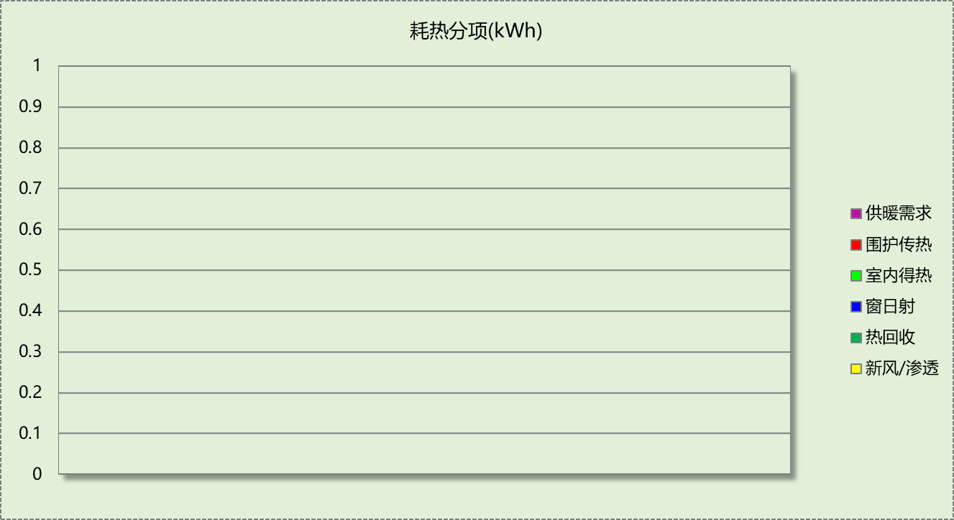

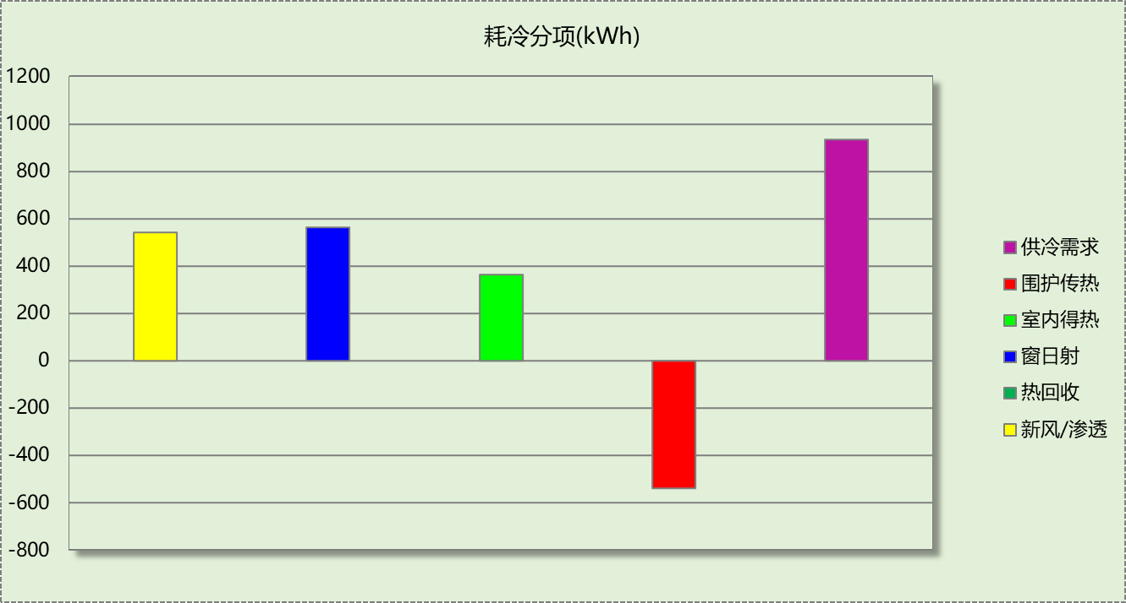

### 逐月负荷表

|  |  |  |  |  |  |  |
| --- | --- | --- | --- | --- | --- | --- |
| 月份 | 供暖(kWh) | 供冷(kWh) | 热负荷 峰值(kW) | 热负荷 峰值时刻 | 冷负荷 峰值(kW) | 冷负荷 峰值时刻 |
| 1月 | 0 | 0 | 0.000 | -- | 0.000 | -- |
| 2月 | 0 | 0 | 0.000 | -- | 0.000 | -- |
| 3月 | 0 | 0 | 0.000 | -- | 0.000 | -- |
| 4月 | 0 | 0 | 0.000 | -- | 0.000 | -- |
| 5月 | 0 | 144 | 0.000 | -- | 16.245 | 5月28日21时 |
| 6月 | 0 | 56 | 0.000 | -- | 5.740 | 6月11日17时 |
| 7月 | 0 | 169 | 0.000 | -- | 9.098 | 7月16日21时 |
| 8月 | 0 | 301 | 0.000 | -- | 11.587 | 8月29日22时 |
| 9月 | 0 | 257 | 0.000 | -- | 12.904 | 9月11日18时 |
| 10月 | 0 | 5 | 0.000 | -- | 3.259 | 10月1日18时 |
| 11月 | 0 | 0 | 0.000 | -- | 0.000 | -- |
| 12月 | 0 | 0 | 0.000 | -- | 0.000 | -- |

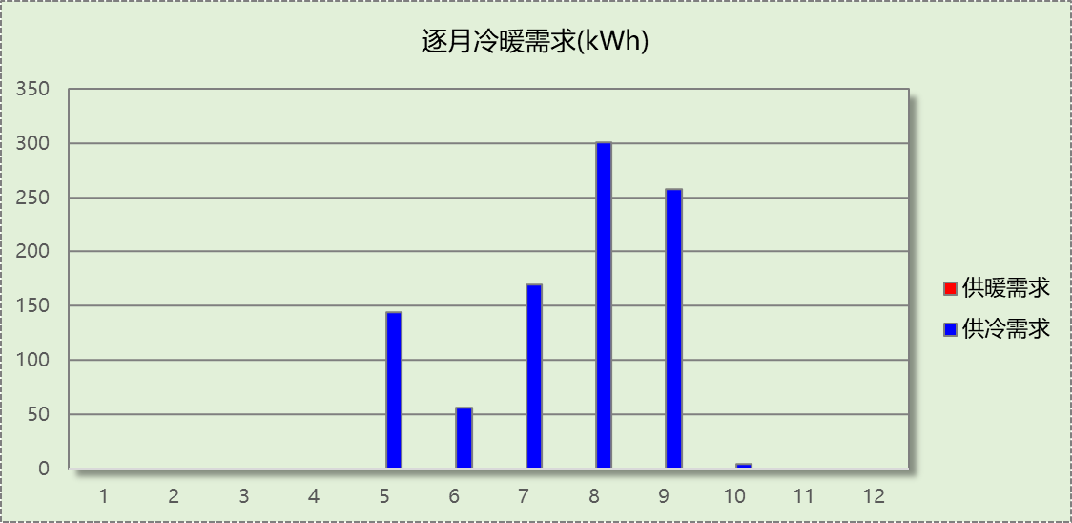

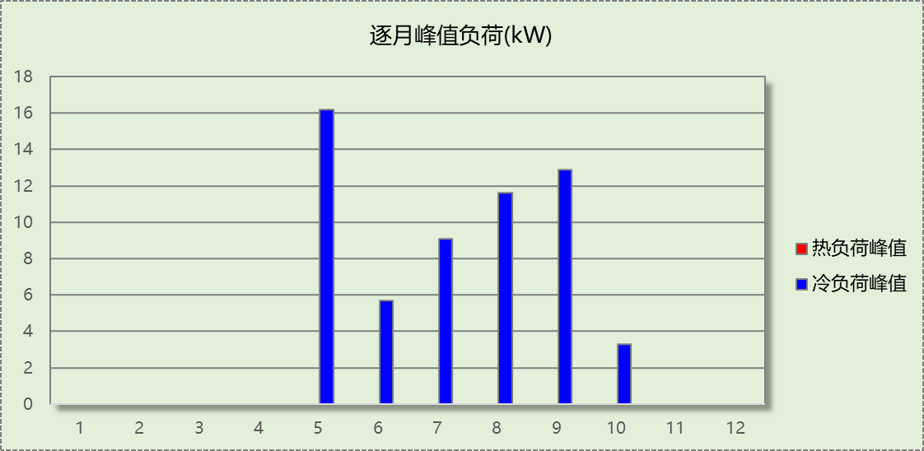

## 建筑能耗

|  |  |  |  |
| --- | --- | --- | --- |
| 用能分类 | | 能耗值 | 一次能源(kWh/㎡) |
| 电力(kWh/㎡) | 供冷 | 36.30 | 94.38 |
| 供暖 | 0.00 | 0.00 |
| 照明 | 9.20 | 23.92 |
| 新排风机 | 3.37 | 8.76 |
| 生活热水 | 0.00 | 0.00 |
| 电梯 | 0.00 | 0.00 |
| 标准煤(kgce/㎡) | 供暖锅炉 | 0.00 | 0.00 |
| 天然气(m³/㎡) | 供暖锅炉 | 0.00 | 0.00 |
| 生活热水 | 0.00 | 0.00 |
| 市政热力(kWh/㎡) | 市政热力 | 0.00 | 0.00 |
| 可再生发电(kWh/㎡) | 光伏发电 | 86.83 | 225.76 |
| 风力发电 | 0.00 | 0.00 |
| 一次能源需求(kWh/㎡) | | | 0.00 |

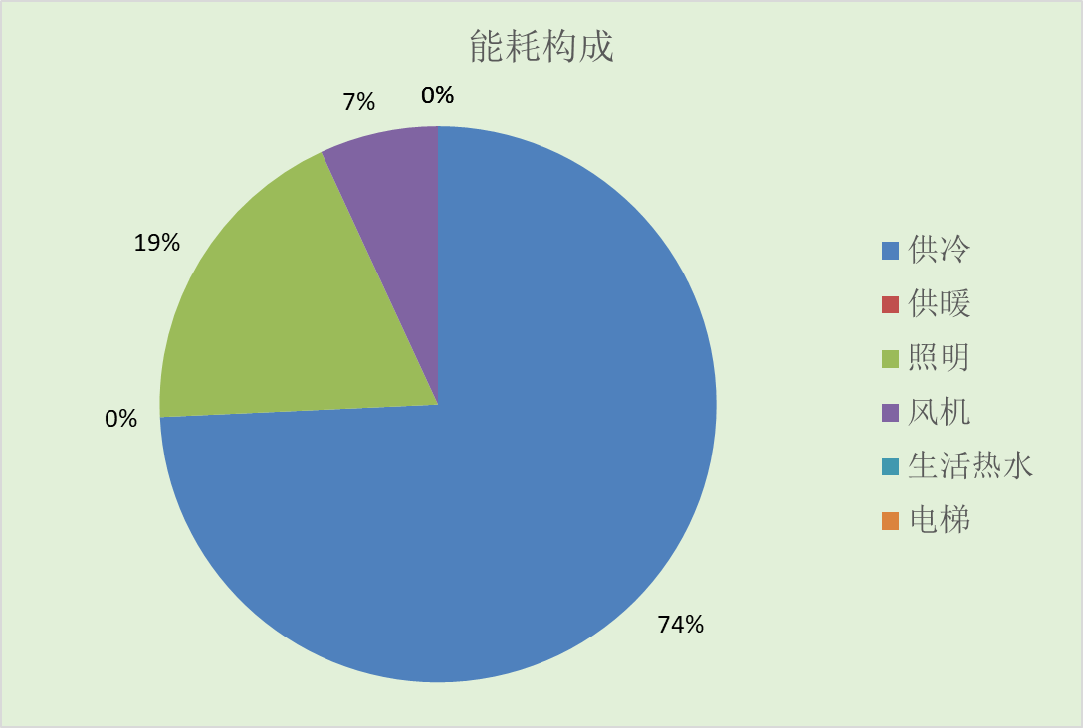

## 可再生能源利用

|  |  |  |
| --- | --- | --- |
| 能耗分项 | 需求量（电）(kWh/㎡) | 需求量（热）(kWh/㎡) |
| 耗冷量 | ­- | 1.64 |
| 耗热量 | - | 0.00 |
| 照明 | 9.20 | 23.92 |
| 空调风机 | 3.37 | 8.76 |
| 电梯 | 0.00 | 0.00 |
| 生活热水 | - | 5.00 |
| 合计 | | 39.31 |
| 可再生分项 | 可再生发电 (kWh/㎡) | 可再生利用（热）(kWh/㎡) |
| 地源\空气源供热 | - | 0.00 |
| 单体空调\多联机供热 | - | 0.00 |
| 太阳能热水 | - | 5.00 |
| 热泵热水 | - | 0.00 |
| 光伏发电 | 86.83 | 225.76 |
| 风力发电 | 0.00 | 0.00 |
| 合计 | | 230.76 |
| 可再生能源利用率(%) | 587 | |

## 结论

|  |  |  |
| --- | --- | --- |
| 检查项 | 值 | 限值 |
| 供冷年耗冷量(kWh/㎡) | 1.64 | 3.02 |
| 供暖年耗热量(kWh/㎡) | 0.00 | 8.00 |
| 建筑综合能耗(一次能源)值(kWh/㎡) | 0.00 | 55.00 |
| 可再生能源利用率(%) | 587 | 10 |
| 标准依据 | 《近零能耗建筑技术标准》第5.0.1条 | |
| 标准要求 | 近零能耗居住建筑的能效指标应符合表5.0.1的规定 | |
| 结论 | 满足 | |

# 附录

## 工作日/节假日人员逐时在室率(%)

|  |  |  |  |  |  |  |  |  |  |  |  |  |  |  |  |  |  |  |  |  |  |  |  |  |
| --- | --- | --- | --- | --- | --- | --- | --- | --- | --- | --- | --- | --- | --- | --- | --- | --- | --- | --- | --- | --- | --- | --- | --- | --- |
| 房间类型 | 1 | 2 | 3 | 4 | 5 | 6 | 7 | 8 | 9 | 10 | 11 | 12 | 13 | 14 | 15 | 16 | 17 | 18 | 19 | 20 | 21 | 22 | 23 | 24 |
| 休息室 | 20 | 20 | 20 | 20 | 20 | 20 | 20 | 20 | 20 | 20 | 20 | 20 | 20 | 20 | 20 | 20 | 20 | 20 | 20 | 20 | 20 | 20 | 20 | 20 |
| 20 | 20 | 20 | 20 | 20 | 20 | 20 | 20 | 20 | 20 | 20 | 20 | 20 | 20 | 20 | 20 | 20 | 20 | 20 | 20 | 20 | 20 | 20 | 20 |
| 卧室 | 35 | 35 | 35 | 35 | 35 | 35 | 35 | 35 | 35 | 35 | 35 | 35 | 35 | 35 | 35 | 35 | 35 | 35 | 35 | 35 | 35 | 35 | 35 | 35 |
| 35 | 35 | 35 | 35 | 35 | 35 | 35 | 35 | 35 | 35 | 35 | 35 | 35 | 35 | 35 | 35 | 35 | 35 | 35 | 35 | 35 | 35 | 35 | 35 |
| 卫生间 | 17 | 17 | 17 | 17 | 17 | 17 | 17 | 17 | 17 | 17 | 17 | 17 | 17 | 17 | 17 | 17 | 17 | 17 | 17 | 17 | 17 | 17 | 17 | 17 |
| 17 | 17 | 17 | 17 | 17 | 17 | 17 | 17 | 17 | 17 | 17 | 17 | 17 | 17 | 17 | 17 | 17 | 17 | 17 | 17 | 17 | 17 | 17 | 17 |
| 楼梯间 | 0 | 0 | 0 | 0 | 0 | 0 | 0 | 0 | 0 | 0 | 0 | 0 | 0 | 0 | 0 | 0 | 0 | 0 | 0 | 0 | 0 | 0 | 0 | 0 |
| 0 | 0 | 0 | 0 | 0 | 0 | 0 | 0 | 0 | 0 | 0 | 0 | 0 | 0 | 0 | 0 | 0 | 0 | 0 | 0 | 0 | 0 | 0 | 0 |
| 设备间 | 0 | 0 | 0 | 0 | 0 | 0 | 0 | 0 | 0 | 0 | 0 | 0 | 0 | 0 | 0 | 0 | 0 | 0 | 0 | 0 | 0 | 0 | 0 | 0 |
| 0 | 0 | 0 | 0 | 0 | 0 | 0 | 0 | 0 | 0 | 0 | 0 | 0 | 0 | 0 | 0 | 0 | 0 | 0 | 0 | 0 | 0 | 0 | 0 |
| 车库 | 0 | 0 | 0 | 0 | 0 | 0 | 0 | 0 | 0 | 0 | 0 | 0 | 0 | 0 | 0 | 0 | 0 | 0 | 0 | 0 | 0 | 0 | 0 | 0 |
| 0 | 0 | 0 | 0 | 0 | 0 | 0 | 0 | 0 | 0 | 0 | 0 | 0 | 0 | 0 | 0 | 0 | 0 | 0 | 0 | 0 | 0 | 0 | 0 |
| 酒吧、茶座 | 20 | 20 | 20 | 20 | 20 | 20 | 20 | 20 | 20 | 20 | 20 | 20 | 20 | 20 | 20 | 20 | 20 | 20 | 20 | 20 | 20 | 20 | 20 | 20 |
| 20 | 20 | 20 | 20 | 20 | 20 | 20 | 20 | 20 | 20 | 20 | 20 | 20 | 20 | 20 | 20 | 20 | 20 | 20 | 20 | 20 | 20 | 20 | 20 |
| 餐厅 | 20 | 20 | 20 | 20 | 20 | 20 | 20 | 20 | 20 | 20 | 20 | 20 | 20 | 20 | 20 | 20 | 20 | 20 | 20 | 20 | 20 | 20 | 20 | 20 |
| 20 | 20 | 20 | 20 | 20 | 20 | 20 | 20 | 20 | 20 | 20 | 20 | 20 | 20 | 20 | 20 | 20 | 20 | 20 | 20 | 20 | 20 | 20 | 20 |

注：上行：工作日；下行：节假日

## 工作日/节假日照明开关时间表(%)

|  |  |  |  |  |  |  |  |  |  |  |  |  |  |  |  |  |  |  |  |  |  |  |  |  |
| --- | --- | --- | --- | --- | --- | --- | --- | --- | --- | --- | --- | --- | --- | --- | --- | --- | --- | --- | --- | --- | --- | --- | --- | --- |
| 房间类型 | 1 | 2 | 3 | 4 | 5 | 6 | 7 | 8 | 9 | 10 | 11 | 12 | 13 | 14 | 15 | 16 | 17 | 18 | 19 | 20 | 21 | 22 | 23 | 24 |
| 休息室 | 0 | 0 | 0 | 0 | 0 | 0 | 0 | 0 | 0 | 0 | 0 | 0 | 0 | 0 | 0 | 0 | 50 | 50 | 50 | 50 | 50 | 50 | 0 | 0 |
| 0 | 0 | 0 | 0 | 0 | 0 | 0 | 0 | 0 | 0 | 0 | 0 | 0 | 0 | 0 | 0 | 50 | 50 | 50 | 50 | 50 | 50 | 0 | 0 |
| 卧室 | 0 | 0 | 0 | 0 | 0 | 0 | 0 | 0 | 0 | 0 | 0 | 0 | 0 | 0 | 0 | 0 | 50 | 50 | 50 | 50 | 50 | 50 | 0 | 0 |
| 0 | 0 | 0 | 0 | 0 | 0 | 0 | 0 | 0 | 0 | 0 | 0 | 0 | 0 | 0 | 0 | 50 | 50 | 50 | 50 | 50 | 50 | 0 | 0 |
| 卫生间 | 0 | 0 | 0 | 0 | 0 | 0 | 0 | 0 | 0 | 0 | 0 | 0 | 0 | 0 | 0 | 0 | 50 | 50 | 50 | 50 | 50 | 50 | 0 | 0 |
| 0 | 0 | 0 | 0 | 0 | 0 | 0 | 0 | 0 | 0 | 0 | 0 | 0 | 0 | 0 | 0 | 50 | 50 | 50 | 50 | 50 | 50 | 0 | 0 |
| 楼梯间 | 0 | 0 | 0 | 0 | 0 | 0 | 0 | 0 | 0 | 0 | 0 | 0 | 0 | 0 | 0 | 0 | 0 | 0 | 0 | 0 | 0 | 0 | 0 | 0 |
| 0 | 0 | 0 | 0 | 0 | 0 | 0 | 0 | 0 | 0 | 0 | 0 | 0 | 0 | 0 | 0 | 0 | 0 | 0 | 0 | 0 | 0 | 0 | 0 |
| 设备间 | 0 | 0 | 0 | 0 | 0 | 0 | 0 | 0 | 0 | 0 | 0 | 0 | 0 | 0 | 0 | 0 | 0 | 0 | 0 | 0 | 0 | 0 | 0 | 0 |
| 0 | 0 | 0 | 0 | 0 | 0 | 0 | 0 | 0 | 0 | 0 | 0 | 0 | 0 | 0 | 0 | 0 | 0 | 0 | 0 | 0 | 0 | 0 | 0 |
| 车库 | 0 | 0 | 0 | 0 | 0 | 0 | 0 | 0 | 0 | 0 | 0 | 0 | 0 | 0 | 0 | 0 | 0 | 100 | 100 | 100 | 100 | 0 | 0 | 0 |
| 0 | 0 | 0 | 0 | 0 | 0 | 0 | 0 | 0 | 0 | 0 | 0 | 0 | 0 | 0 | 0 | 0 | 100 | 100 | 100 | 100 | 0 | 0 | 0 |
| 酒吧、茶座 | 0 | 0 | 0 | 0 | 0 | 0 | 0 | 0 | 0 | 0 | 0 | 0 | 0 | 0 | 0 | 0 | 50 | 50 | 50 | 50 | 50 | 50 | 0 | 0 |
| 0 | 0 | 0 | 0 | 0 | 0 | 0 | 0 | 0 | 0 | 0 | 0 | 0 | 0 | 0 | 0 | 50 | 50 | 50 | 50 | 50 | 50 | 0 | 0 |
| 餐厅 | 0 | 0 | 0 | 0 | 0 | 0 | 0 | 0 | 0 | 0 | 0 | 0 | 0 | 0 | 0 | 0 | 50 | 50 | 50 | 50 | 50 | 50 | 0 | 0 |
| 0 | 0 | 0 | 0 | 0 | 0 | 0 | 0 | 0 | 0 | 0 | 0 | 0 | 0 | 0 | 0 | 50 | 50 | 50 | 50 | 50 | 50 | 0 | 0 |

注：上行：工作日；下行：节假日

## 工作日/节假日设备逐时使用率(%)

|  |  |  |  |  |  |  |  |  |  |  |  |  |  |  |  |  |  |  |  |  |  |  |  |  |
| --- | --- | --- | --- | --- | --- | --- | --- | --- | --- | --- | --- | --- | --- | --- | --- | --- | --- | --- | --- | --- | --- | --- | --- | --- |
| 房间类型 | 1 | 2 | 3 | 4 | 5 | 6 | 7 | 8 | 9 | 10 | 11 | 12 | 13 | 14 | 15 | 16 | 17 | 18 | 19 | 20 | 21 | 22 | 23 | 24 |
| 休息室 | 40 | 40 | 40 | 40 | 40 | 40 | 40 | 40 | 40 | 40 | 40 | 40 | 40 | 40 | 40 | 40 | 40 | 40 | 40 | 40 | 40 | 40 | 40 | 40 |
| 40 | 40 | 40 | 40 | 40 | 40 | 40 | 40 | 40 | 40 | 40 | 40 | 40 | 40 | 40 | 40 | 40 | 40 | 40 | 40 | 40 | 40 | 40 | 40 |
| 卧室 | 20 | 20 | 20 | 20 | 20 | 20 | 20 | 20 | 20 | 20 | 20 | 20 | 20 | 20 | 20 | 20 | 20 | 20 | 20 | 20 | 20 | 20 | 20 | 20 |
| 20 | 20 | 20 | 20 | 20 | 20 | 20 | 20 | 20 | 20 | 20 | 20 | 20 | 20 | 20 | 20 | 20 | 20 | 20 | 20 | 20 | 20 | 20 | 20 |
| 卫生间 | 0 | 0 | 0 | 0 | 0 | 0 | 0 | 0 | 0 | 0 | 0 | 0 | 0 | 0 | 0 | 0 | 0 | 0 | 0 | 0 | 0 | 0 | 0 | 0 |
| 0 | 0 | 0 | 0 | 0 | 0 | 0 | 0 | 0 | 0 | 0 | 0 | 0 | 0 | 0 | 0 | 0 | 0 | 0 | 0 | 0 | 0 | 0 | 0 |
| 楼梯间 | 0 | 0 | 0 | 0 | 0 | 0 | 0 | 0 | 0 | 0 | 0 | 0 | 0 | 0 | 0 | 0 | 0 | 0 | 0 | 0 | 0 | 0 | 0 | 0 |
| 0 | 0 | 0 | 0 | 0 | 0 | 0 | 0 | 0 | 0 | 0 | 0 | 0 | 0 | 0 | 0 | 0 | 0 | 0 | 0 | 0 | 0 | 0 | 0 |
| 设备间 | 0 | 0 | 0 | 0 | 0 | 0 | 0 | 0 | 0 | 0 | 0 | 0 | 0 | 0 | 0 | 0 | 0 | 0 | 0 | 0 | 0 | 0 | 0 | 0 |
| 0 | 0 | 0 | 0 | 0 | 0 | 0 | 0 | 0 | 0 | 0 | 0 | 0 | 0 | 0 | 0 | 0 | 0 | 0 | 0 | 0 | 0 | 0 | 0 |
| 车库 | 0 | 0 | 0 | 0 | 0 | 0 | 0 | 0 | 0 | 0 | 0 | 0 | 0 | 0 | 0 | 0 | 0 | 0 | 0 | 0 | 0 | 0 | 0 | 0 |
| 0 | 0 | 0 | 0 | 0 | 0 | 0 | 0 | 0 | 0 | 0 | 0 | 0 | 0 | 0 | 0 | 0 | 0 | 0 | 0 | 0 | 0 | 0 | 0 |
| 酒吧、茶座 | 40 | 40 | 40 | 40 | 40 | 40 | 40 | 40 | 40 | 40 | 40 | 40 | 40 | 40 | 40 | 40 | 40 | 40 | 40 | 40 | 40 | 40 | 40 | 40 |
| 40 | 40 | 40 | 40 | 40 | 40 | 40 | 40 | 40 | 40 | 40 | 40 | 40 | 40 | 40 | 40 | 40 | 40 | 40 | 40 | 40 | 40 | 40 | 40 |
| 餐厅 | 40 | 40 | 40 | 40 | 40 | 40 | 40 | 40 | 40 | 40 | 40 | 40 | 40 | 40 | 40 | 40 | 40 | 40 | 40 | 40 | 40 | 40 | 40 | 40 |
| 40 | 40 | 40 | 40 | 40 | 40 | 40 | 40 | 40 | 40 | 40 | 40 | 40 | 40 | 40 | 40 | 40 | 40 | 40 | 40 | 40 | 40 | 40 | 40 |

注：上行：工作日；下行：节假日

## 工作日/节假日空调系统运行时间表(1:开,0:关)

采暖期：

|  |  |  |  |  |  |  |  |  |  |  |  |  |  |  |  |  |  |  |  |  |  |  |  |  |
| --- | --- | --- | --- | --- | --- | --- | --- | --- | --- | --- | --- | --- | --- | --- | --- | --- | --- | --- | --- | --- | --- | --- | --- | --- |
| 系统编号 | 1 | 2 | 3 | 4 | 5 | 6 | 7 | 8 | 9 | 10 | 11 | 12 | 13 | 14 | 15 | 16 | 17 | 18 | 19 | 20 | 21 | 22 | 23 | 24 |
| 默认 | 0 | 0 | 0 | 0 | 0 | 0 | 0 | 0 | 0 | 0 | 0 | 0 | 0 | 0 | 0 | 0 | 0 | 0 | 0 | 0 | 0 | 0 | 0 | 0 |
| 0 | 0 | 0 | 0 | 0 | 0 | 0 | 0 | 0 | 0 | 0 | 0 | 0 | 0 | 0 | 0 | 0 | 0 | 0 | 0 | 0 | 0 | 0 | 0 |
| Sys | 0 | 0 | 0 | 0 | 0 | 0 | 0 | 0 | 0 | 0 | 0 | 0 | 0 | 0 | 0 | 0 | 0 | 0 | 0 | 0 | 0 | 0 | 0 | 0 |
| 0 | 0 | 0 | 0 | 0 | 0 | 0 | 0 | 0 | 0 | 0 | 0 | 0 | 0 | 0 | 0 | 0 | 0 | 0 | 0 | 0 | 0 | 0 | 0 |
| Sys0 | 0 | 0 | 0 | 0 | 0 | 0 | 0 | 0 | 0 | 0 | 0 | 0 | 0 | 0 | 0 | 0 | 0 | 0 | 0 | 0 | 0 | 0 | 0 | 0 |
| 0 | 0 | 0 | 0 | 0 | 0 | 0 | 0 | 0 | 0 | 0 | 0 | 0 | 0 | 0 | 0 | 0 | 0 | 0 | 0 | 0 | 0 | 0 | 0 |
| Sys1 | 0 | 0 | 0 | 0 | 0 | 0 | 0 | 0 | 0 | 0 | 0 | 0 | 0 | 0 | 0 | 0 | 0 | 0 | 0 | 0 | 0 | 0 | 0 | 0 |
| 0 | 0 | 0 | 0 | 0 | 0 | 0 | 0 | 0 | 0 | 0 | 0 | 0 | 0 | 0 | 0 | 0 | 0 | 0 | 0 | 0 | 0 | 0 | 0 |

供冷期：

|  |  |  |  |  |  |  |  |  |  |  |  |  |  |  |  |  |  |  |  |  |  |  |  |  |
| --- | --- | --- | --- | --- | --- | --- | --- | --- | --- | --- | --- | --- | --- | --- | --- | --- | --- | --- | --- | --- | --- | --- | --- | --- |
| 系统编号 | 1 | 2 | 3 | 4 | 5 | 6 | 7 | 8 | 9 | 10 | 11 | 12 | 13 | 14 | 15 | 16 | 17 | 18 | 19 | 20 | 21 | 22 | 23 | 24 |
| 默认 | 0 | 0 | 0 | 0 | 0 | 0 | 0 | 0 | 0 | 0 | 0 | 0 | 0 | 0 | 0 | 0 | 0 | 0 | 0 | 0 | 0 | 0 | 0 | 0 |
| 0 | 0 | 0 | 0 | 0 | 0 | 0 | 0 | 0 | 0 | 0 | 0 | 0 | 0 | 0 | 0 | 0 | 0 | 0 | 0 | 0 | 0 | 0 | 0 |
| Sys | 1 | 1 | 1 | 1 | 1 | 1 | 1 | 1 | 1 | 1 | 1 | 1 | 1 | 1 | 1 | 1 | 1 | 1 | 1 | 1 | 1 | 1 | 1 | 1 |
| 0 | 0 | 0 | 0 | 0 | 0 | 0 | 0 | 0 | 0 | 0 | 0 | 0 | 0 | 0 | 0 | 0 | 0 | 0 | 0 | 0 | 0 | 0 | 0 |
| Sys0 | 1 | 1 | 1 | 1 | 1 | 1 | 1 | 1 | 1 | 1 | 1 | 1 | 1 | 1 | 1 | 1 | 1 | 1 | 1 | 1 | 1 | 1 | 1 | 1 |
| 1 | 1 | 1 | 1 | 1 | 1 | 1 | 1 | 1 | 1 | 1 | 1 | 1 | 1 | 1 | 1 | 1 | 1 | 1 | 1 | 1 | 1 | 1 | 1 |
| Sys1 | 0 | 0 | 0 | 0 | 0 | 0 | 0 | 0 | 0 | 0 | 0 | 0 | 0 | 0 | 0 | 0 | 0 | 0 | 0 | 0 | 0 | 0 | 0 | 0 |
| 0 | 0 | 0 | 0 | 0 | 0 | 0 | 0 | 0 | 0 | 0 | 0 | 0 | 0 | 0 | 0 | 0 | 0 | 0 | 0 | 0 | 0 | 0 | 0 |

注：上行：工作日；下行：节假日

## 工作日/节假日新风运行时间表(%)

采暖期：

|  |  |  |  |  |  |  |  |  |  |  |  |  |  |  |  |  |  |  |  |  |  |  |  |  |
| --- | --- | --- | --- | --- | --- | --- | --- | --- | --- | --- | --- | --- | --- | --- | --- | --- | --- | --- | --- | --- | --- | --- | --- | --- |
| 系统编号 | 1 | 2 | 3 | 4 | 5 | 6 | 7 | 8 | 9 | 10 | 11 | 12 | 13 | 14 | 15 | 16 | 17 | 18 | 19 | 20 | 21 | 22 | 23 | 24 |
| 默认 | 0 | 0 | 0 | 0 | 0 | 0 | 0 | 0 | 0 | 0 | 0 | 0 | 0 | 0 | 0 | 0 | 0 | 0 | 0 | 0 | 0 | 0 | 0 | 0 |
| 0 | 0 | 0 | 0 | 0 | 0 | 0 | 0 | 0 | 0 | 0 | 0 | 0 | 0 | 0 | 0 | 0 | 0 | 0 | 0 | 0 | 0 | 0 | 0 |
| Sys | 0 | 0 | 0 | 0 | 0 | 0 | 0 | 0 | 0 | 0 | 0 | 0 | 0 | 0 | 0 | 0 | 0 | 0 | 0 | 0 | 0 | 0 | 0 | 0 |
| 0 | 0 | 0 | 0 | 0 | 0 | 0 | 0 | 0 | 0 | 0 | 0 | 0 | 0 | 0 | 0 | 0 | 0 | 0 | 0 | 0 | 0 | 0 | 0 |
| Sys0 | 0 | 0 | 0 | 0 | 0 | 0 | 0 | 0 | 0 | 0 | 0 | 0 | 0 | 0 | 0 | 0 | 0 | 0 | 0 | 0 | 0 | 0 | 0 | 0 |
| 0 | 0 | 0 | 0 | 0 | 0 | 0 | 0 | 0 | 0 | 0 | 0 | 0 | 0 | 0 | 0 | 0 | 0 | 0 | 0 | 0 | 0 | 0 | 0 |
| Sys1 | 0 | 0 | 0 | 0 | 0 | 0 | 0 | 0 | 0 | 0 | 0 | 0 | 0 | 0 | 0 | 0 | 0 | 0 | 0 | 0 | 0 | 0 | 0 | 0 |
| 0 | 0 | 0 | 0 | 0 | 0 | 0 | 0 | 0 | 0 | 0 | 0 | 0 | 0 | 0 | 0 | 0 | 0 | 0 | 0 | 0 | 0 | 0 | 0 |

供冷期：

|  |  |  |  |  |  |  |  |  |  |  |  |  |  |  |  |  |  |  |  |  |  |  |  |  |
| --- | --- | --- | --- | --- | --- | --- | --- | --- | --- | --- | --- | --- | --- | --- | --- | --- | --- | --- | --- | --- | --- | --- | --- | --- |
| 系统编号 | 1 | 2 | 3 | 4 | 5 | 6 | 7 | 8 | 9 | 10 | 11 | 12 | 13 | 14 | 15 | 16 | 17 | 18 | 19 | 20 | 21 | 22 | 23 | 24 |
| 默认 | 0 | 0 | 0 | 0 | 0 | 0 | 0 | 0 | 0 | 0 | 0 | 0 | 0 | 0 | 0 | 0 | 0 | 0 | 0 | 0 | 0 | 0 | 0 | 0 |
| 0 | 0 | 0 | 0 | 0 | 0 | 0 | 0 | 0 | 0 | 0 | 0 | 0 | 0 | 0 | 0 | 0 | 0 | 0 | 0 | 0 | 0 | 0 | 0 |
| Sys | 100 | 100 | 100 | 100 | 100 | 100 | 100 | 100 | 100 | 100 | 100 | 100 | 100 | 100 | 100 | 100 | 100 | 100 | 100 | 100 | 100 | 100 | 100 | 100 |
| 0 | 0 | 0 | 0 | 0 | 0 | 0 | 0 | 0 | 0 | 0 | 0 | 0 | 0 | 0 | 0 | 0 | 0 | 0 | 0 | 0 | 0 | 0 | 0 |
| Sys0 | 100 | 100 | 100 | 100 | 100 | 100 | 100 | 100 | 100 | 100 | 100 | 100 | 100 | 100 | 100 | 100 | 100 | 100 | 100 | 100 | 100 | 100 | 100 | 100 |
| 100 | 100 | 100 | 100 | 100 | 100 | 100 | 100 | 100 | 100 | 100 | 100 | 100 | 100 | 100 | 100 | 100 | 100 | 100 | 100 | 100 | 100 | 100 | 100 |
| Sys1 | 0 | 0 | 0 | 0 | 0 | 0 | 0 | 0 | 0 | 0 | 0 | 0 | 0 | 0 | 0 | 0 | 0 | 0 | 0 | 0 | 0 | 0 | 0 | 0 |
| 0 | 0 | 0 | 0 | 0 | 0 | 0 | 0 | 0 | 0 | 0 | 0 | 0 | 0 | 0 | 0 | 0 | 0 | 0 | 0 | 0 | 0 | 0 | 0 |

注：上行：工作日；下行：节假日