**新建项目**

**全年负荷计算书**

|  |  |
| --- | --- |
| 工程名称 | 新建项目 |
| 设计编号 |  |
| 建设单位 |  |
| 设计单位 |  |
| 计 算 人 |  |
| 校 对 人 |  |
| 审 核 人 |  |
| 计算日期 | 2024年12月28日 |



|  |  |
| --- | --- |
| 采用软件 | 暖通负荷BECH2024 |
| 软件版本 | 20240430(SP1) |
| 研发单位 | 北京绿建软件股份有限公司 |
| 正版授权码 | T18110494826 |

**目 录**

1 建筑概况 1

2 气象数据 1

2.1 气象地点 1

2.2 逐日干球温度表 1

2.3 逐月辐照量表 2

2.4 峰值工况 2

3 软件介绍 2

4 围护结构 2

4.1 屋顶构造 2

4.1.1 屋顶构造一 2

4.2 外墙构造 3

4.2.1 填充墙构造一 3

4.3 挑空楼板构造 3

4.3.1 挑空楼板构造一 3

4.4 楼板构造 3

4.4.1 控温房间楼板构造一 3

4.5 周边地面构造 4

4.5.1 地面构造一 4

4.6 非周边地面构造 4

4.6.1 地面构造一 4

4.7 门构造 4

4.8 窗构造 4

5 房间类型 5

5.1 房间参数表 5

5.2 作息时间表 5

6 系统设置 5

6.1 系统划分 5

6.2 运行时间表 6

7 计算结果 6

7.1 模拟周期 6

7.2 全年冷暖需求 7

7.3 负荷分项统计 7

7.4 逐月负荷表 8

8 附录 10

# 建筑概况

|  |  |  |
| --- | --- | --- |
| 地理位置 | 安徽-马鞍山 | |
| 气候分区 | 夏热冬冷A区 | |
| 北纬 | 31.43 | |
| 东经 | 118.28 | |
| 建筑名称 | 新建项目 | |
| 建筑类型 | 公共建筑 |  |
| 建筑面积 | 地上 17614.60 ㎡ | 地下 0.00 ㎡ |
| 建筑高度 | 地上 20.10 m | 地下0.00 |
| 建筑层数 | 地上 5 | 地下 0 |
| 北向角度 | 90° | |

# 气象数据

## 气象地点

安徽-芜湖县, 《建筑节能气象参数标准》JGJ346-2014

## 逐日干球温度表

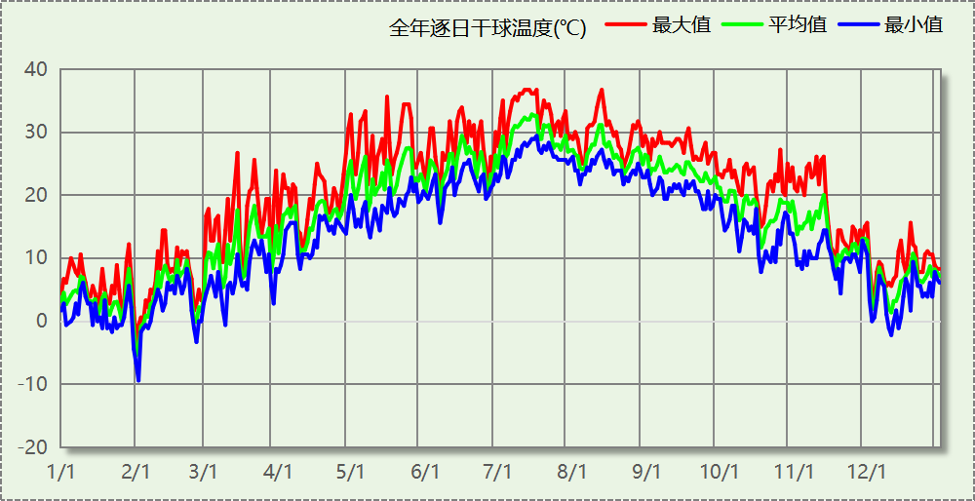

## 逐月辐照量表

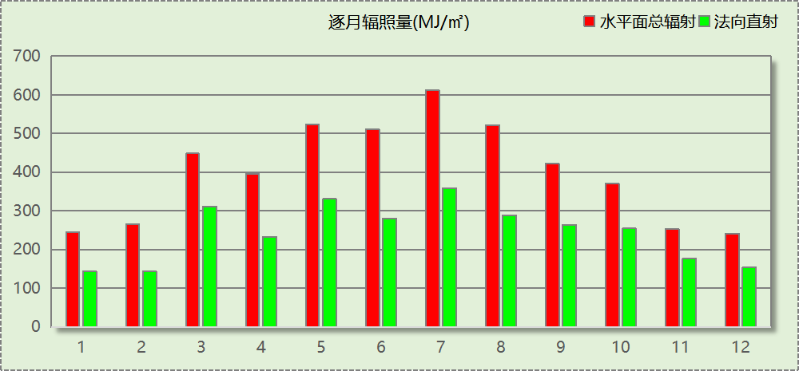

## 峰值工况

|  |  |  |  |  |  |
| --- | --- | --- | --- | --- | --- |
| 气象数据 | 时刻 | 干球温度(℃) | 湿球温度(℃) | 含湿量(g/kg) | 焓值(kj/kg) |
| 最热 | 07月11日15时 | 36.7 | 28.3 | 21.6 | 92.3 |
| 最冷 | 02月01日06时 | -9.4 | -9.4 | 1.6 | -5.5 |

# 软件介绍

本报告采用的软件为绿建暖通负荷BECH2024，该软件紧密结合暖通和节能设计规范、可根据项目实际情况建立建筑热工模型，并可对围护结构材料、房间内扰发热、作息时间表、热回收方式等参数进行设置。

软件包含全国各地典型气象年数据，内置DOE2.1E内核，对于建筑的逐时负荷进行动态模拟，既可以模拟8760小时理想负荷，也可以根据设定好的采暖期/空调期进行逐时模拟。

软件还支持分析全年建筑能耗的来源构成，依据日射得热、新风负荷、围护传热和内扰得热进行归类分项，生成设计建筑全年负荷计算报告书，提供详实的数据和多样的图表，为设计师在设备选型、制定运行策略等方面提供参考和帮助。

# 围护结构

## 屋顶构造

### 屋顶构造一

|  |  |  |  |  |  |  |
| --- | --- | --- | --- | --- | --- | --- |
| 材料名称 （由上到下） | 厚度δ | 导热系数λ | 蓄热系数S | 修正 系数 | 热阻R | 热惰性 指标 |
| (mm) | W/(m.K) | W/(㎡.K) | α | (㎡K)/W | D=R*S |
| 水泥砂浆 | 20 | 0.930 | 11.370 | 1.00 | 0.022 | 0.245 |
| c20细石混凝土(ρ=2300) | 40 | 1.510 | 15.243 | 1.00 | 0.026 | 0.404 |
| 挤塑聚苯板(ρ=25-32) | 130 | 0.030 | 0.320 | 1.10 | 3.939 | 1.387 |
| 轻骨料混凝土(找坡层) | 30 | 0.300 | 5.000 | 1.50 | 0.067 | 0.500 |
| 钢筋混凝土 | 120 | 1.740 | 17.200 | 1.00 | 0.069 | 1.186 |
| 混合砂浆 | 20 | 0.870 | 10.750 | 1.00 | 0.023 | 0.247 |
| 各层之和∑ | 360 | － | － | － | 4.146 | 3.968 |
| 传热系数K=1/(0.15+∑R) | 0.23 | | | | | |

## 外墙构造

### 填充墙构造一

|  |  |  |  |  |  |  |
| --- | --- | --- | --- | --- | --- | --- |
| 材料名称 （由外到内） | 厚度δ | 导热系数λ | 蓄热系数S | 修正 系数 | 热阻R | 热惰性 指标 |
| (mm) | W/(m.K) | W/(㎡.K) | α | (㎡K)/W | D=R*S |
| 水泥砂浆 | 40 | 0.930 | 11.370 | 1.00 | 0.043 | 0.489 |
| 匀质防火保温板 | 70 | 0.065 | 1.500 | 1.20 | 0.897 | 1.615 |
| 煤矸石空心砖 | 240 | 0.580 | 7.920 | 1.00 | 0.414 | 3.277 |
| 混合砂浆 | 40 | 0.870 | 10.750 | 1.00 | 0.046 | 0.494 |
| 各层之和∑ | 390 | － | － | － | 1.400 | 5.876 |
| 传热系数K=1/(0.15+∑R) | 0.65 | | | | | |

## 挑空楼板构造

### 挑空楼板构造一

|  |  |  |  |  |  |  |
| --- | --- | --- | --- | --- | --- | --- |
| 材料名称 （由上到下） | 厚度δ | 导热系数λ | 蓄热系数S | 修正 系数 | 热阻R | 热惰性 指标 |
| (mm) | W/(m.K) | W/(㎡.K) | α | (㎡K)/W | D=R*S |
| 水泥砂浆 | 20 | 0.930 | 11.370 | 1.00 | 0.022 | 0.245 |
| 石墨聚苯乙烯保温隔声板(b1级)（经压缩、覆膜处理） | 15 | 0.035 | 0.360 | 1.20 | 0.357 | 0.154 |
| 钢筋混凝土 | 120 | 1.740 | 17.200 | 1.00 | 0.069 | 1.186 |
| 水泥砂浆 | 20 | 0.930 | 11.370 | 1.00 | 0.022 | 0.245 |
| 岩棉条复合板（tr10,0,a级） | 40 | 0.046 | 0.700 | 1.00 | 0.870 | 0.609 |
| 混合砂浆 | 20 | 0.870 | 10.750 | 1.00 | 0.023 | 0.247 |
| 各层之和∑ | 235 | － | － | － | 1.362 | 2.685 |
| 传热系数K=1/(0.15+∑R) | 0.66 | | | | | |

## 楼板构造

### 控温房间楼板构造一

|  |  |  |  |  |  |  |
| --- | --- | --- | --- | --- | --- | --- |
| 材料名称 | 厚度δ | 导热系数λ | 蓄热系数S | 修正 系数 | 热阻R | 热惰性 指标 |
| (mm) | W/(m.K) | W/(㎡.K) | α | (㎡K)/W | D=R*S |
| 水泥砂浆 | 40 | 0.930 | 11.370 | 1.00 | 0.043 | 0.489 |
| 钢筋混凝土 | 150 | 1.740 | 17.200 | 1.00 | 0.086 | 1.483 |
| 石墨聚苯乙烯保温隔声板(b1级)（经压缩、覆膜处理） | 15 | 0.035 | 0.360 | 1.20 | 0.357 | 0.154 |
| 混合砂浆 | 40 | 0.870 | 10.750 | 1.00 | 0.046 | 0.494 |
| 各层之和∑ | 245 | － | － | － | 0.532 | 2.620 |
| 传热系数K=1/(0.22+∑R) | 1.33 | | | | | |

## 周边地面构造

### 地面构造一

|  |  |  |  |  |  |  |
| --- | --- | --- | --- | --- | --- | --- |
| 材料名称 | 厚度δ | 导热系数λ | 蓄热系数S | 修正 系数 | 热阻R | 热惰性 指标 |
| (mm) | W/(m.K) | W/(㎡.K) | α | (㎡K)/W | D=R*S |
| 水泥砂浆 | 20 | 0.930 | 11.370 | 1.00 | 0.022 | 0.245 |
| 钢筋混凝土 | 120 | 1.740 | 17.200 | 1.00 | 0.069 | 1.186 |
| 各层之和∑ | 140 | － | － | － | 0.090 | 1.431 |
| 传热系数K=1/(0.11+∑R) | 0.52 | | | | | |

## 非周边地面构造

### 地面构造一

|  |  |  |  |  |  |  |
| --- | --- | --- | --- | --- | --- | --- |
| 材料名称 | 厚度δ | 导热系数λ | 蓄热系数S | 修正 系数 | 热阻R | 热惰性 指标 |
| (mm) | W/(m.K) | W/(㎡.K) | α | (㎡K)/W | D=R*S |
| 水泥砂浆 | 20 | 0.930 | 11.370 | 1.00 | 0.022 | 0.245 |
| 钢筋混凝土 | 120 | 1.740 | 17.200 | 1.00 | 0.069 | 1.186 |
| 各层之和∑ | 140 | － | － | － | 0.090 | 1.431 |
| 传热系数K=1/(0.11+∑R) | 0.30 | | | | | |

## 门构造

|  |  |  |  |
| --- | --- | --- | --- |
| 序号 | 构造名称 | 传热系数 | 备注 |
| 1 | 保温门（多功能门） | 6.250 |  |

## 窗构造

|  |  |  |  |  |  |
| --- | --- | --- | --- | --- | --- |
| 序号 | 构造名称 | 传热系数 | 窗遮阳系数 | 可见光透射比 | 备注 |
| 1 | 60系列内平开下悬玻璃钢窗[5涂膜+12A+5Low-E] | 2.200 | 0.255 | 0.620 |  |

# 房间类型

## 房间参数表

|  |  |  |  |  |  |  |
| --- | --- | --- | --- | --- | --- | --- |
| 房间类型 | 空调温度 ℃ | 供暖温度 ℃ | 新风量 | 人员密度 | 照明功率 密度 | 电器设备 功率 |
| 休息室 | 26 | 18 | 24(m^3/h.人) | 1.39(m^2/人) | 9(W/m^2) | 5(W/m^2) |
| 会议室 | 26 | 20 | 30(m^3/h.人) | 3.3(m^2/人) | 8(W/m^2) | 5(W/m^2) |
| 卫生间 | 28 | 16 | 0(m^3/h.人) | 0(人) | 5(W/m^2) | 5(W/m^2) |
| 大厅 | 26 | 20 | 30(m^3/h.人) | 20(m^2/人) | 10(W/m^2) | 0(W/m^2) |
| 实验教室 | 26 | 18 | 20(m^3/h.人) | 4(m^2/人) | 8(W/m^2) | 5(W/m^2) |
| 开水间 | 26 | 18 | 24(m^3/h.人) | 1.39(m^2/人) | 9(W/m^2) | 5(W/m^2) |
| 普通办公室 | 26 | 20 | 30(m^3/h.人) | 6(m^2/人) | 8(W/m^2) | 5(W/m^2) |
| 普通教室 | 26 | 18 | 24(m^3/h.人) | 1.39(m^2/人) | 8(W/m^2) | 5(W/m^2) |
| 更衣室 | 26 | 20 | 6(次/h) | 4(m^2/人) | 5(W/m^2) | 5(W/m^2) |
| 楼梯间 | 28 | 16 | 0(m^3/h.人) | 0(人) | 5(W/m^2) | 5(W/m^2) |
| 空房间 | － | － | 20(m^3/h.人) | 0(人) | 0(W/m^2) | 0(W/m^2) |
| 设备间 | － | － | 0(次/h) | 0(人) | 6(W/m^2) | 15(W/m^2) |
| 走廊 | － | － | 0(m^3/h.人) | 0(人) | 5(W/m^2) | 5(W/m^2) |
| 阅览室 | 26 | 20 | 20(m^3/h.人) | 1.9(m^2/人) | 8(W/m^2) | 5(W/m^2) |

## 作息时间表

详见附录

# 系统设置

## 系统划分

|  |  |  |  |  |  |  |
| --- | --- | --- | --- | --- | --- | --- |
| 系统编号 | 热回收 类型 | 启动 条件 | 回收 效率 | 排风 比例 | 面积(m2) | 包含的房间 |
| 默认 | 无 | -- | -- | -- | 7321.60 | 1149,1074,1170,1250,1247,1241,1239,1234,1230,1229,1227,1225,1224,1217,1005,1002,1001,1004,1194,1190,1183,1179,1177,1173,1163,1162,1156,1151,1147,1137,1132,1104,1078,1067,1042,1007,1003,6020,2252,2246,2245,2031,2032,2013,2203,2201,2196,2189,2016,6008,2176,2175,2018,2027,2160,6010,2153,2015,2146,2139,2134,2026,2012,2125,2006,6012,6013,2021,2020,2024,2023,2003,2004,2002,2011,2088,2025,2080,2030,2064,2007,6015,2009,2028,2022,2017,2014,3033,3032,3030,3029,3026,3022,3015,3012,3010,6008,3138,3066,3038,3014,3001,3011,3024,3023,3257,3244,3027,3028,3226,3215,3193,3016,3017,3164,3159,3141,3118,3009,3081,3072,3021,3018,3005,4009,4006,4024,4023,4020,4021,4025,4022,4007,4192,6007,4011,4012,4165,4157,4154,4144,4135,4016,4003,4015,4082,4069,4017,4065,4004,4005,4008,4010,5005,5145,5013,6002,5007,6019,5008,5191,6009,6023,5178,5174,5158,5152,6011,5136,5002,5006,5077,5063,5003 |
| Sys | 全热回收 | 温差启动 冷:≥5.0(℃) 暖:≥5.0(℃) | 冷:0.20, 暖:0.00 | 1.00 | 3653.44 | 6020,1128,1123,1119,1110,1108,1102,1100,1084,1044,1040,1023,1020,1016,2029,2019,2121,2005,3200,3025,3008,3007,3006,6021,3004,3003,3087,3020,3019,3002,6016,3052,3031,6017,4001,4018,4142,6014,4054,4050,4014,4002,4039,4032,4027,4013,6020,6022,5086,5001,6004,6005,5140,5117,5109,5103,5079,5049,5004 |

## 运行时间表

详见附录

# 计算结果

## 模拟周期

全年8760小时模拟

## 全年冷暖需求

|  |  |  |  |  |
| --- | --- | --- | --- | --- |
| 系统名称\负荷 | 供暖需求 (kWh) | 供暖指标 (kWh/㎡·a) | 供冷需求 (kWh) | 供冷指标 (kWh/㎡·a) |
| Sys | 120037 | 32.86 | 398073 | 108.96 |
| 默认系统 | 140720 | 19.22 | 313651 | 42.84 |
| 建筑总计 | 260757 | 14.80 | 711724 | 40.41 |

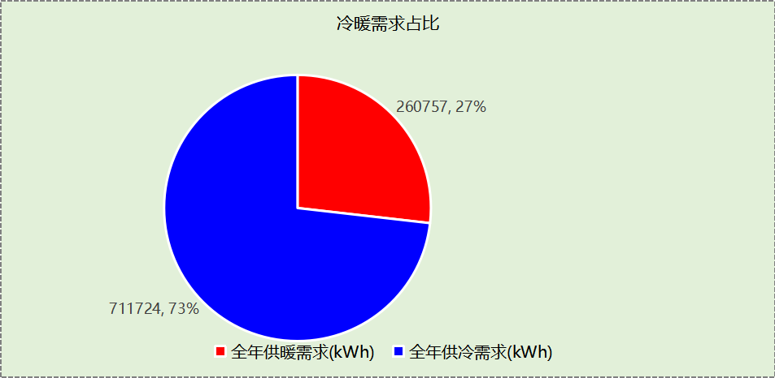

## 负荷分项统计

|  |  |  |  |  |  |  |
| --- | --- | --- | --- | --- | --- | --- |
| 分类 | 围护传热 | 室内得热 | 窗日射 | 新风/渗透 | 热回收 | 合计 |
| 供暖(kWh/㎡) | -16.32 | 9.02 | 1.02 | -8.51 | 0.00 | -14.80 |
| 供冷(kWh/㎡) | 8.55 | 16.58 | 2.24 | 13.62 | -0.59 | 40.41 |

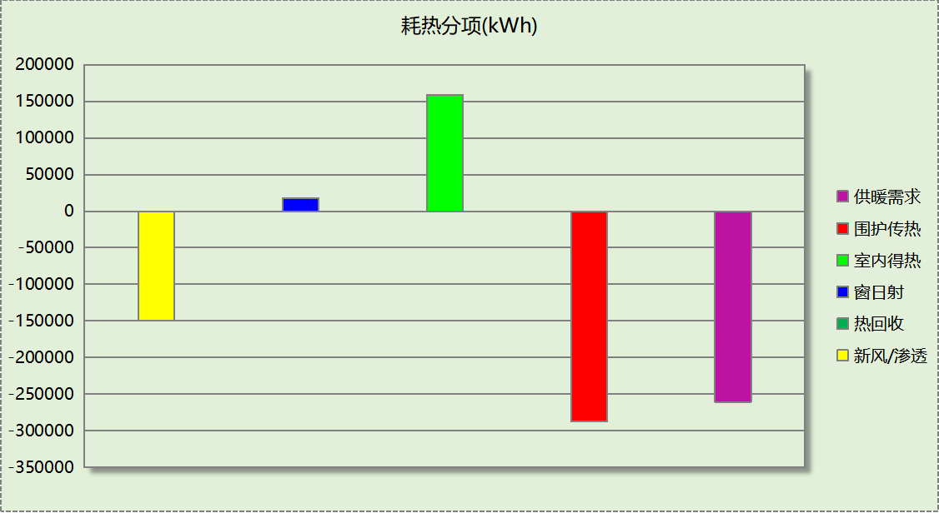

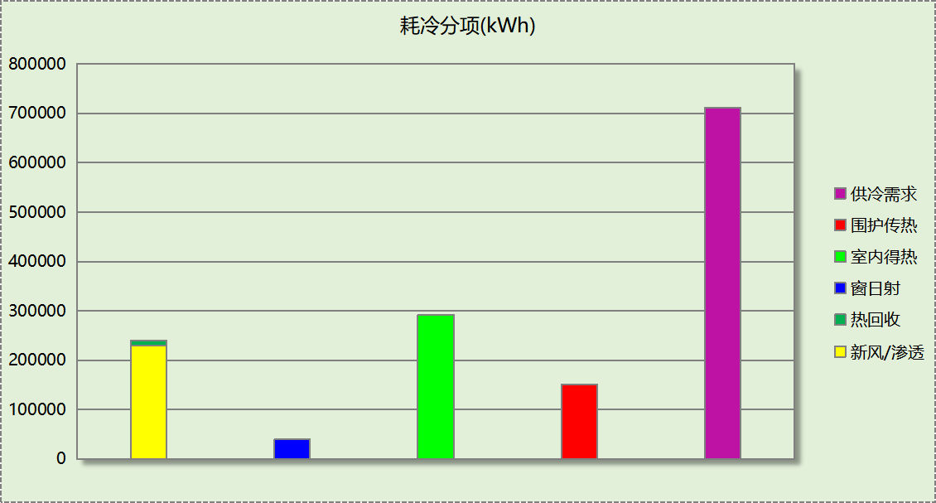

## 逐月负荷表

|  |  |  |  |  |  |  |
| --- | --- | --- | --- | --- | --- | --- |
| 月份 | 供暖(kWh) | 供冷(kWh) | 热负荷 峰值(kW) | 热负荷 峰值时刻 | 冷负荷 峰值(kW) | 冷负荷 峰值时刻 |
| 1月 | 90699 | 0 | 1076.890 | 1月2日8时 | 0.000 | -- |
| 2月 | 69647 | 0 | 1068.654 | 2月4日8时 | 0.000 | -- |
| 3月 | 27322 | 136 | 566.705 | 3月4日8时 | 28.764 | 3月21日16时 |
| 4月 | 15998 | 4778 | 288.013 | 4月1日8时 | 359.781 | 4月30日16时 |
| 5月 | 3680 | 64839 | 62.371 | 5月2日8时 | 531.836 | 5月16日16时 |
| 6月 | 393 | 102691 | 5.397 | 6月3日8时 | 847.581 | 6月20日10时 |
| 7月 | 10 | 217022 | 1.464 | 7月1日8时 | 1232.610 | 7月15日8时 |
| 8月 | 0 | 184486 | 0.000 | -- | 1172.674 | 8月12日16时 |
| 9月 | 0 | 111583 | 0.000 | -- | 787.663 | 9月6日14时 |
| 10月 | 235 | 21087 | 22.732 | 10月21日8时 | 339.730 | 10月11日16时 |
| 11月 | 5656 | 5102 | 169.306 | 11月19日8时 | 245.642 | 11月12日15时 |
| 12月 | 47118 | 0 | 697.686 | 12月9日8时 | 0.000 | -- |

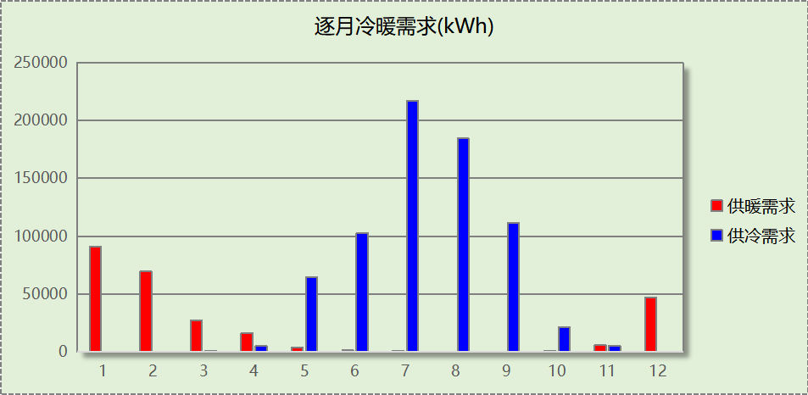

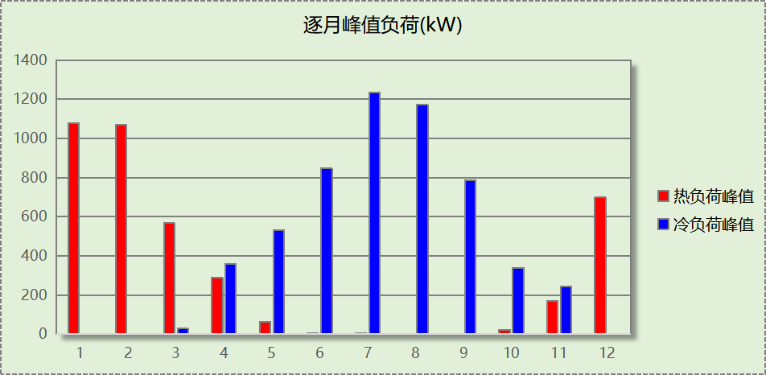

# 附录

**工作日/节假日人员逐时在室率(%)**

|  |  |  |  |  |  |  |  |  |  |  |  |  |  |  |  |  |  |  |  |  |  |  |  |  |
| --- | --- | --- | --- | --- | --- | --- | --- | --- | --- | --- | --- | --- | --- | --- | --- | --- | --- | --- | --- | --- | --- | --- | --- | --- |
| 房间类型 | 1 | 2 | 3 | 4 | 5 | 6 | 7 | 8 | 9 | 10 | 11 | 12 | 13 | 14 | 15 | 16 | 17 | 18 | 19 | 20 | 21 | 22 | 23 | 24 |
| 休息室 | 0 | 0 | 0 | 0 | 0 | 0 | 10 | 50 | 95 | 95 | 95 | 80 | 80 | 95 | 95 | 95 | 95 | 30 | 30 | 0 | 0 | 0 | 0 | 0 |
| 0 | 0 | 0 | 0 | 0 | 0 | 0 | 0 | 0 | 0 | 0 | 0 | 0 | 0 | 0 | 0 | 0 | 0 | 0 | 0 | 0 | 0 | 0 | 0 |
| 会议室 | 0 | 0 | 0 | 0 | 0 | 0 | 10 | 50 | 95 | 95 | 95 | 80 | 80 | 95 | 95 | 95 | 95 | 30 | 30 | 0 | 0 | 0 | 0 | 0 |
| 0 | 0 | 0 | 0 | 0 | 0 | 0 | 0 | 0 | 0 | 0 | 0 | 0 | 0 | 0 | 0 | 0 | 0 | 0 | 0 | 0 | 0 | 0 | 0 |
| 卫生间 | 0 | 0 | 0 | 0 | 0 | 0 | 10 | 50 | 95 | 95 | 95 | 80 | 80 | 95 | 95 | 95 | 95 | 30 | 30 | 0 | 0 | 0 | 0 | 0 |
| 0 | 0 | 0 | 0 | 0 | 0 | 0 | 0 | 0 | 0 | 0 | 0 | 0 | 0 | 0 | 0 | 0 | 0 | 0 | 0 | 0 | 0 | 0 | 0 |
| 大厅 | 0 | 0 | 0 | 0 | 0 | 0 | 10 | 50 | 95 | 95 | 95 | 80 | 80 | 95 | 95 | 95 | 95 | 30 | 30 | 0 | 0 | 0 | 0 | 0 |
| 0 | 0 | 0 | 0 | 0 | 0 | 0 | 0 | 0 | 0 | 0 | 0 | 0 | 0 | 0 | 0 | 0 | 0 | 0 | 0 | 0 | 0 | 0 | 0 |
| 实验教室 | 0 | 0 | 0 | 0 | 0 | 0 | 10 | 50 | 95 | 95 | 95 | 80 | 80 | 95 | 95 | 95 | 95 | 30 | 30 | 0 | 0 | 0 | 0 | 0 |
| 0 | 0 | 0 | 0 | 0 | 0 | 0 | 0 | 0 | 0 | 0 | 0 | 0 | 0 | 0 | 0 | 0 | 0 | 0 | 0 | 0 | 0 | 0 | 0 |
| 开水间 | 0 | 0 | 0 | 0 | 0 | 0 | 10 | 50 | 95 | 95 | 95 | 80 | 80 | 95 | 95 | 95 | 95 | 30 | 30 | 0 | 0 | 0 | 0 | 0 |
| 0 | 0 | 0 | 0 | 0 | 0 | 0 | 0 | 0 | 0 | 0 | 0 | 0 | 0 | 0 | 0 | 0 | 0 | 0 | 0 | 0 | 0 | 0 | 0 |
| 普通办公室 | 0 | 0 | 0 | 0 | 0 | 0 | 10 | 50 | 95 | 95 | 95 | 80 | 80 | 95 | 95 | 95 | 95 | 30 | 30 | 0 | 0 | 0 | 0 | 0 |
| 0 | 0 | 0 | 0 | 0 | 0 | 0 | 0 | 0 | 0 | 0 | 0 | 0 | 0 | 0 | 0 | 0 | 0 | 0 | 0 | 0 | 0 | 0 | 0 |
| 普通教室 | 0 | 0 | 0 | 0 | 0 | 0 | 10 | 50 | 95 | 95 | 95 | 80 | 80 | 95 | 95 | 95 | 95 | 30 | 30 | 0 | 0 | 0 | 0 | 0 |
| 0 | 0 | 0 | 0 | 0 | 0 | 0 | 0 | 0 | 0 | 0 | 0 | 0 | 0 | 0 | 0 | 0 | 0 | 0 | 0 | 0 | 0 | 0 | 0 |
| 更衣室 | 0 | 0 | 0 | 0 | 0 | 0 | 10 | 50 | 95 | 95 | 95 | 80 | 80 | 95 | 95 | 95 | 95 | 30 | 30 | 0 | 0 | 0 | 0 | 0 |
| 0 | 0 | 0 | 0 | 0 | 0 | 0 | 0 | 0 | 0 | 0 | 0 | 0 | 0 | 0 | 0 | 0 | 0 | 0 | 0 | 0 | 0 | 0 | 0 |
| 楼梯间 | 0 | 0 | 0 | 0 | 0 | 0 | 10 | 50 | 95 | 95 | 95 | 80 | 80 | 95 | 95 | 95 | 95 | 30 | 30 | 0 | 0 | 0 | 0 | 0 |
| 0 | 0 | 0 | 0 | 0 | 0 | 0 | 0 | 0 | 0 | 0 | 0 | 0 | 0 | 0 | 0 | 0 | 0 | 0 | 0 | 0 | 0 | 0 | 0 |
| 空房间 | 0 | 0 | 0 | 0 | 0 | 0 | 0 | 20 | 50 | 80 | 80 | 80 | 80 | 80 | 80 | 80 | 80 | 80 | 80 | 70 | 50 | 0 | 0 | 0 |
| 0 | 0 | 0 | 0 | 0 | 0 | 0 | 0 | 0 | 0 | 0 | 0 | 0 | 0 | 0 | 0 | 0 | 0 | 0 | 0 | 0 | 0 | 0 | 0 |
| 设备间 | 0 | 0 | 0 | 0 | 0 | 0 | 0 | 0 | 0 | 0 | 0 | 0 | 0 | 0 | 0 | 0 | 0 | 0 | 0 | 0 | 0 | 0 | 0 | 0 |
| 0 | 0 | 0 | 0 | 0 | 0 | 0 | 0 | 0 | 0 | 0 | 0 | 0 | 0 | 0 | 0 | 0 | 0 | 0 | 0 | 0 | 0 | 0 | 0 |
| 走廊 | 0 | 0 | 0 | 0 | 0 | 0 | 10 | 50 | 95 | 95 | 95 | 80 | 80 | 95 | 95 | 95 | 95 | 30 | 30 | 0 | 0 | 0 | 0 | 0 |
| 0 | 0 | 0 | 0 | 0 | 0 | 0 | 0 | 0 | 0 | 0 | 0 | 0 | 0 | 0 | 0 | 0 | 0 | 0 | 0 | 0 | 0 | 0 | 0 |
| 阅览室 | 0 | 0 | 0 | 0 | 0 | 0 | 10 | 50 | 95 | 95 | 95 | 80 | 80 | 95 | 95 | 95 | 95 | 30 | 30 | 0 | 0 | 0 | 0 | 0 |
| 0 | 0 | 0 | 0 | 0 | 0 | 0 | 0 | 0 | 0 | 0 | 0 | 0 | 0 | 0 | 0 | 0 | 0 | 0 | 0 | 0 | 0 | 0 | 0 |

注：上行：工作日；下行：节假日

**工作日/节假日照明开关时间表(%)**

|  |  |  |  |  |  |  |  |  |  |  |  |  |  |  |  |  |  |  |  |  |  |  |  |  |
| --- | --- | --- | --- | --- | --- | --- | --- | --- | --- | --- | --- | --- | --- | --- | --- | --- | --- | --- | --- | --- | --- | --- | --- | --- |
| 房间类型 | 1 | 2 | 3 | 4 | 5 | 6 | 7 | 8 | 9 | 10 | 11 | 12 | 13 | 14 | 15 | 16 | 17 | 18 | 19 | 20 | 21 | 22 | 23 | 24 |
| 休息室 | 0 | 0 | 0 | 0 | 0 | 0 | 10 | 50 | 95 | 95 | 95 | 80 | 80 | 95 | 95 | 95 | 95 | 30 | 30 | 0 | 0 | 0 | 0 | 0 |
| 0 | 0 | 0 | 0 | 0 | 0 | 0 | 0 | 0 | 0 | 0 | 0 | 0 | 0 | 0 | 0 | 0 | 0 | 0 | 0 | 0 | 0 | 0 | 0 |
| 会议室 | 0 | 0 | 0 | 0 | 0 | 0 | 10 | 50 | 95 | 95 | 95 | 80 | 80 | 95 | 95 | 95 | 95 | 30 | 30 | 0 | 0 | 0 | 0 | 0 |
| 0 | 0 | 0 | 0 | 0 | 0 | 0 | 0 | 0 | 0 | 0 | 0 | 0 | 0 | 0 | 0 | 0 | 0 | 0 | 0 | 0 | 0 | 0 | 0 |
| 卫生间 | 0 | 0 | 0 | 0 | 0 | 0 | 10 | 50 | 95 | 95 | 95 | 80 | 80 | 95 | 95 | 95 | 95 | 30 | 30 | 0 | 0 | 0 | 0 | 0 |
| 0 | 0 | 0 | 0 | 0 | 0 | 0 | 0 | 0 | 0 | 0 | 0 | 0 | 0 | 0 | 0 | 0 | 0 | 0 | 0 | 0 | 0 | 0 | 0 |
| 大厅 | 0 | 0 | 0 | 0 | 0 | 0 | 10 | 50 | 95 | 95 | 95 | 80 | 80 | 95 | 95 | 95 | 95 | 30 | 30 | 0 | 0 | 0 | 0 | 0 |
| 0 | 0 | 0 | 0 | 0 | 0 | 0 | 0 | 0 | 0 | 0 | 0 | 0 | 0 | 0 | 0 | 0 | 0 | 0 | 0 | 0 | 0 | 0 | 0 |
| 实验教室 | 0 | 0 | 0 | 0 | 0 | 0 | 10 | 50 | 95 | 95 | 95 | 80 | 80 | 95 | 95 | 95 | 95 | 30 | 30 | 0 | 0 | 0 | 0 | 0 |
| 0 | 0 | 0 | 0 | 0 | 0 | 0 | 0 | 0 | 0 | 0 | 0 | 0 | 0 | 0 | 0 | 0 | 0 | 0 | 0 | 0 | 0 | 0 | 0 |
| 开水间 | 0 | 0 | 0 | 0 | 0 | 0 | 10 | 50 | 95 | 95 | 95 | 80 | 80 | 95 | 95 | 95 | 95 | 30 | 30 | 0 | 0 | 0 | 0 | 0 |
| 0 | 0 | 0 | 0 | 0 | 0 | 0 | 0 | 0 | 0 | 0 | 0 | 0 | 0 | 0 | 0 | 0 | 0 | 0 | 0 | 0 | 0 | 0 | 0 |
| 普通办公室 | 0 | 0 | 0 | 0 | 0 | 0 | 10 | 50 | 95 | 95 | 95 | 80 | 80 | 95 | 95 | 95 | 95 | 30 | 30 | 0 | 0 | 0 | 0 | 0 |
| 0 | 0 | 0 | 0 | 0 | 0 | 0 | 0 | 0 | 0 | 0 | 0 | 0 | 0 | 0 | 0 | 0 | 0 | 0 | 0 | 0 | 0 | 0 | 0 |
| 普通教室 | 0 | 0 | 0 | 0 | 0 | 0 | 10 | 50 | 95 | 95 | 95 | 80 | 80 | 95 | 95 | 95 | 95 | 30 | 30 | 0 | 0 | 0 | 0 | 0 |
| 0 | 0 | 0 | 0 | 0 | 0 | 0 | 0 | 0 | 0 | 0 | 0 | 0 | 0 | 0 | 0 | 0 | 0 | 0 | 0 | 0 | 0 | 0 | 0 |
| 更衣室 | 0 | 0 | 0 | 0 | 0 | 0 | 10 | 50 | 95 | 95 | 95 | 80 | 80 | 95 | 95 | 95 | 95 | 30 | 30 | 0 | 0 | 0 | 0 | 0 |
| 0 | 0 | 0 | 0 | 0 | 0 | 0 | 0 | 0 | 0 | 0 | 0 | 0 | 0 | 0 | 0 | 0 | 0 | 0 | 0 | 0 | 0 | 0 | 0 |
| 楼梯间 | 0 | 0 | 0 | 0 | 0 | 0 | 10 | 50 | 95 | 95 | 95 | 80 | 80 | 95 | 95 | 95 | 95 | 30 | 30 | 0 | 0 | 0 | 0 | 0 |
| 0 | 0 | 0 | 0 | 0 | 0 | 0 | 0 | 0 | 0 | 0 | 0 | 0 | 0 | 0 | 0 | 0 | 0 | 0 | 0 | 0 | 0 | 0 | 0 |
| 空房间 | 10 | 10 | 10 | 10 | 10 | 10 | 10 | 50 | 60 | 60 | 60 | 60 | 60 | 60 | 60 | 60 | 80 | 90 | 100 | 100 | 100 | 10 | 10 | 10 |
| 0 | 0 | 0 | 0 | 0 | 0 | 0 | 0 | 0 | 0 | 0 | 0 | 0 | 0 | 0 | 0 | 0 | 0 | 0 | 0 | 0 | 0 | 0 | 0 |
| 设备间 | 100 | 100 | 100 | 100 | 100 | 100 | 100 | 100 | 100 | 100 | 100 | 100 | 100 | 100 | 100 | 100 | 100 | 100 | 100 | 100 | 100 | 100 | 100 | 100 |
| 0 | 0 | 0 | 0 | 0 | 0 | 0 | 0 | 0 | 0 | 0 | 0 | 0 | 0 | 0 | 0 | 0 | 0 | 0 | 0 | 0 | 0 | 0 | 0 |
| 走廊 | 0 | 0 | 0 | 0 | 0 | 0 | 10 | 50 | 95 | 95 | 95 | 80 | 80 | 95 | 95 | 95 | 95 | 30 | 30 | 0 | 0 | 0 | 0 | 0 |
| 0 | 0 | 0 | 0 | 0 | 0 | 0 | 0 | 0 | 0 | 0 | 0 | 0 | 0 | 0 | 0 | 0 | 0 | 0 | 0 | 0 | 0 | 0 | 0 |
| 阅览室 | 0 | 0 | 0 | 0 | 0 | 0 | 10 | 50 | 95 | 95 | 95 | 80 | 80 | 95 | 95 | 95 | 95 | 30 | 30 | 0 | 0 | 0 | 0 | 0 |
| 0 | 0 | 0 | 0 | 0 | 0 | 0 | 0 | 0 | 0 | 0 | 0 | 0 | 0 | 0 | 0 | 0 | 0 | 0 | 0 | 0 | 0 | 0 | 0 |

注：上行：工作日；下行：节假日

**工作日/节假日设备逐时使用率(%)**

|  |  |  |  |  |  |  |  |  |  |  |  |  |  |  |  |  |  |  |  |  |  |  |  |  |
| --- | --- | --- | --- | --- | --- | --- | --- | --- | --- | --- | --- | --- | --- | --- | --- | --- | --- | --- | --- | --- | --- | --- | --- | --- |
| 房间类型 | 1 | 2 | 3 | 4 | 5 | 6 | 7 | 8 | 9 | 10 | 11 | 12 | 13 | 14 | 15 | 16 | 17 | 18 | 19 | 20 | 21 | 22 | 23 | 24 |
| 休息室 | 0 | 0 | 0 | 0 | 0 | 0 | 10 | 50 | 95 | 95 | 95 | 50 | 50 | 95 | 95 | 95 | 95 | 30 | 30 | 0 | 0 | 0 | 0 | 0 |
| 0 | 0 | 0 | 0 | 0 | 0 | 0 | 0 | 0 | 0 | 0 | 0 | 0 | 0 | 0 | 0 | 0 | 0 | 0 | 0 | 0 | 0 | 0 | 0 |
| 会议室 | 0 | 0 | 0 | 0 | 0 | 0 | 10 | 50 | 95 | 95 | 95 | 50 | 50 | 95 | 95 | 95 | 95 | 30 | 30 | 0 | 0 | 0 | 0 | 0 |
| 0 | 0 | 0 | 0 | 0 | 0 | 0 | 0 | 0 | 0 | 0 | 0 | 0 | 0 | 0 | 0 | 0 | 0 | 0 | 0 | 0 | 0 | 0 | 0 |
| 卫生间 | 0 | 0 | 0 | 0 | 0 | 0 | 10 | 50 | 95 | 95 | 95 | 50 | 50 | 95 | 95 | 95 | 95 | 30 | 30 | 0 | 0 | 0 | 0 | 0 |
| 0 | 0 | 0 | 0 | 0 | 0 | 0 | 0 | 0 | 0 | 0 | 0 | 0 | 0 | 0 | 0 | 0 | 0 | 0 | 0 | 0 | 0 | 0 | 0 |
| 大厅 | 0 | 0 | 0 | 0 | 0 | 0 | 10 | 50 | 95 | 95 | 95 | 50 | 50 | 95 | 95 | 95 | 95 | 30 | 30 | 0 | 0 | 0 | 0 | 0 |
| 0 | 0 | 0 | 0 | 0 | 0 | 0 | 0 | 0 | 0 | 0 | 0 | 0 | 0 | 0 | 0 | 0 | 0 | 0 | 0 | 0 | 0 | 0 | 0 |
| 实验教室 | 0 | 0 | 0 | 0 | 0 | 0 | 10 | 50 | 95 | 95 | 95 | 50 | 50 | 95 | 95 | 95 | 95 | 30 | 30 | 0 | 0 | 0 | 0 | 0 |
| 0 | 0 | 0 | 0 | 0 | 0 | 0 | 0 | 0 | 0 | 0 | 0 | 0 | 0 | 0 | 0 | 0 | 0 | 0 | 0 | 0 | 0 | 0 | 0 |
| 开水间 | 0 | 0 | 0 | 0 | 0 | 0 | 10 | 50 | 95 | 95 | 95 | 50 | 50 | 95 | 95 | 95 | 95 | 30 | 30 | 0 | 0 | 0 | 0 | 0 |
| 0 | 0 | 0 | 0 | 0 | 0 | 0 | 0 | 0 | 0 | 0 | 0 | 0 | 0 | 0 | 0 | 0 | 0 | 0 | 0 | 0 | 0 | 0 | 0 |
| 普通办公室 | 0 | 0 | 0 | 0 | 0 | 0 | 10 | 50 | 95 | 95 | 95 | 50 | 50 | 95 | 95 | 95 | 95 | 30 | 30 | 0 | 0 | 0 | 0 | 0 |
| 0 | 0 | 0 | 0 | 0 | 0 | 0 | 0 | 0 | 0 | 0 | 0 | 0 | 0 | 0 | 0 | 0 | 0 | 0 | 0 | 0 | 0 | 0 | 0 |
| 普通教室 | 0 | 0 | 0 | 0 | 0 | 0 | 10 | 50 | 95 | 95 | 95 | 50 | 50 | 95 | 95 | 95 | 95 | 30 | 30 | 0 | 0 | 0 | 0 | 0 |
| 0 | 0 | 0 | 0 | 0 | 0 | 0 | 0 | 0 | 0 | 0 | 0 | 0 | 0 | 0 | 0 | 0 | 0 | 0 | 0 | 0 | 0 | 0 | 0 |
| 更衣室 | 0 | 0 | 0 | 0 | 0 | 0 | 10 | 50 | 95 | 95 | 95 | 50 | 50 | 95 | 95 | 95 | 95 | 30 | 30 | 0 | 0 | 0 | 0 | 0 |
| 0 | 0 | 0 | 0 | 0 | 0 | 0 | 0 | 0 | 0 | 0 | 0 | 0 | 0 | 0 | 0 | 0 | 0 | 0 | 0 | 0 | 0 | 0 | 0 |
| 楼梯间 | 0 | 0 | 0 | 0 | 0 | 0 | 10 | 50 | 95 | 95 | 95 | 50 | 50 | 95 | 95 | 95 | 95 | 30 | 30 | 0 | 0 | 0 | 0 | 0 |
| 0 | 0 | 0 | 0 | 0 | 0 | 0 | 0 | 0 | 0 | 0 | 0 | 0 | 0 | 0 | 0 | 0 | 0 | 0 | 0 | 0 | 0 | 0 | 0 |
| 空房间 | 0 | 0 | 0 | 0 | 0 | 0 | 0 | 30 | 50 | 80 | 80 | 80 | 80 | 80 | 80 | 80 | 80 | 80 | 80 | 70 | 50 | 0 | 0 | 0 |
| 0 | 0 | 0 | 0 | 0 | 0 | 0 | 0 | 0 | 0 | 0 | 0 | 0 | 0 | 0 | 0 | 0 | 0 | 0 | 0 | 0 | 0 | 0 | 0 |
| 设备间 | 100 | 100 | 100 | 100 | 100 | 100 | 100 | 100 | 100 | 100 | 100 | 100 | 100 | 100 | 100 | 100 | 100 | 100 | 100 | 100 | 100 | 100 | 100 | 100 |
| 0 | 0 | 0 | 0 | 0 | 0 | 0 | 0 | 0 | 0 | 0 | 0 | 0 | 0 | 0 | 0 | 0 | 0 | 0 | 0 | 0 | 0 | 0 | 0 |
| 走廊 | 0 | 0 | 0 | 0 | 0 | 0 | 10 | 50 | 95 | 95 | 95 | 50 | 50 | 95 | 95 | 95 | 95 | 30 | 30 | 0 | 0 | 0 | 0 | 0 |
| 0 | 0 | 0 | 0 | 0 | 0 | 0 | 0 | 0 | 0 | 0 | 0 | 0 | 0 | 0 | 0 | 0 | 0 | 0 | 0 | 0 | 0 | 0 | 0 |
| 阅览室 | 0 | 0 | 0 | 0 | 0 | 0 | 10 | 50 | 95 | 95 | 95 | 50 | 50 | 95 | 95 | 95 | 95 | 30 | 30 | 0 | 0 | 0 | 0 | 0 |
| 0 | 0 | 0 | 0 | 0 | 0 | 0 | 0 | 0 | 0 | 0 | 0 | 0 | 0 | 0 | 0 | 0 | 0 | 0 | 0 | 0 | 0 | 0 | 0 |

注：上行：工作日；下行：节假日

**工作日/节假日空调系统开关时间表**

|  |  |  |  |  |  |  |  |  |  |  |  |  |  |  |  |  |  |  |  |  |  |  |  |  |
| --- | --- | --- | --- | --- | --- | --- | --- | --- | --- | --- | --- | --- | --- | --- | --- | --- | --- | --- | --- | --- | --- | --- | --- | --- |
| 系统编号 | 1 | 2 | 3 | 4 | 5 | 6 | 7 | 8 | 9 | 10 | 11 | 12 | 13 | 14 | 15 | 16 | 17 | 18 | 19 | 20 | 21 | 22 | 23 | 24 |
| 默认 | 0 | 0 | 0 | 0 | 0 | 0 | 0 | 1 | 1 | 1 | 1 | 1 | 1 | 1 | 1 | 1 | 1 | 1 | 0 | 0 | 0 | 0 | 0 | 0 |
| 0 | 0 | 0 | 0 | 0 | 0 | 0 | 0 | 0 | 0 | 0 | 0 | 0 | 0 | 0 | 0 | 0 | 0 | 0 | 0 | 0 | 0 | 0 | 0 |
| Sys | 0 | 0 | 0 | 0 | 0 | 0 | 0 | 1 | 1 | 1 | 1 | 1 | 1 | 1 | 1 | 1 | 1 | 1 | 0 | 0 | 0 | 0 | 0 | 0 |
| 0 | 0 | 0 | 0 | 0 | 0 | 0 | 0 | 0 | 0 | 0 | 0 | 0 | 0 | 0 | 0 | 0 | 0 | 0 | 0 | 0 | 0 | 0 | 0 |

注：上行：工作日；下行：节假日