**宾馆**

**全年负荷计算书**

|  |  |
| --- | --- |
| 工程名称 | 宾馆 |
| 设计编号 | 999 |
| 建设单位 | 小飞侠有限责任公司 |
| 设计单位 | 小飞侠设计院 |
| 计 算 人 |  |
| 校 对 人 |  |
| 审 核 人 |  |
| 计算日期 | 2024年11月17日 |



|  |  |
| --- | --- |
| 采用软件 | 暖通负荷BECH2024 |
| 软件版本 | 20240430(SP1) |
| 研发单位 | 北京绿建软件股份有限公司 |
| 正版授权码 | T18847879305 |

**目 录**

1 建筑概况 1

2 气象数据 1

2.1 气象地点 1

2.2 逐日干球温度表 1

2.3 逐月辐照量表 2

2.4 峰值工况 2

3 软件介绍 2

4 围护结构 2

4.1 屋顶构造 2

4.1.1 屋顶构造一 2

4.2 外墙构造 3

4.2.1 填充墙构造一 3

4.3 挑空楼板构造 3

4.3.1 挑空楼板构造一 3

4.4 楼板构造 3

4.4.1 控温房间楼板构造二 3

4.5 周边地面构造 4

4.5.1 周边地面构造一 4

4.6 非周边地面构造 4

4.6.1 非周边地面构造一 4

4.7 地下墙构造 4

4.7.1 地下墙构造一 4

4.8 门构造 5

4.9 窗构造 5

5 房间类型 5

5.1 房间参数表 5

5.2 作息时间表 5

6 系统设置 6

6.1 系统划分 6

6.2 运行时间表 16

7 计算结果 16

7.1 模拟周期 16

7.2 全年冷暖需求 16

7.3 负荷分项统计 16

7.4 逐月负荷表 17

8 附录 19

# 建筑概况

|  |  |  |
| --- | --- | --- |
| 地理位置 | 黑龙江-哈尔滨 | |
| 气候分区 | 严寒B区 | |
| 北纬 | 46.00 | |
| 东经 | 126.61 | |
| 建筑名称 | 宾馆 | |
| 建筑类型 | 公共建筑 |  |
| 建筑面积 | 地上 30518.62 ㎡ | 地下 0.00 ㎡ |
| 建筑高度 | 地上 67.50 m | 地下0.00 |
| 建筑层数 | 地上 17 | 地下 0 |
| 北向角度 | 90° | |

# 气象数据

## 气象地点

黑龙江-哈尔滨, 《建筑节能气象参数标准》JGJ346-2014

## 逐日干球温度表

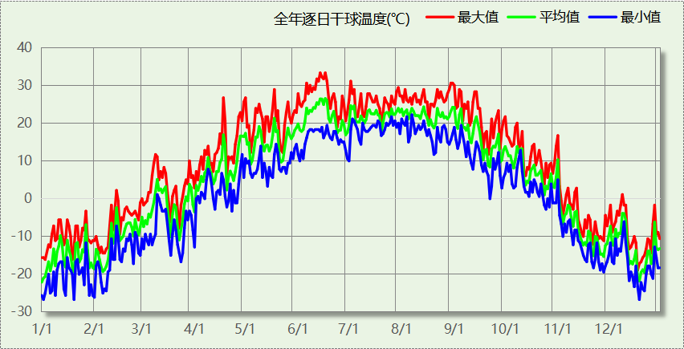

## 逐月辐照量表

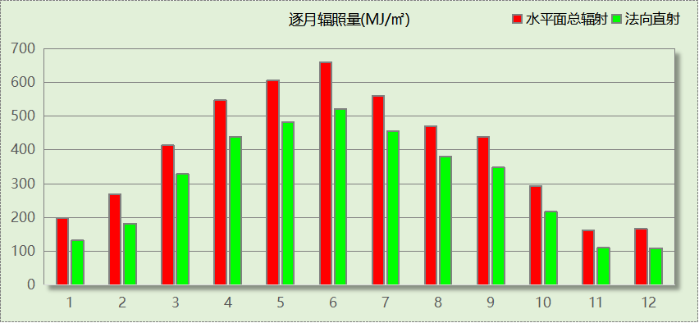

## 峰值工况

|  |  |  |  |  |  |
| --- | --- | --- | --- | --- | --- |
| 气象数据 | 时刻 | 干球温度(℃) | 湿球温度(℃) | 含湿量(g/kg) | 焓值(kj/kg) |
| 最热 | 06月13日15时 | 33.3 | 19.4 | 8.4 | 55.0 |
| 最冷 | 01月02日06时 | -26.7 | -26.7 | 0.1 | -26.6 |

# 软件介绍

本报告采用的软件为绿建暖通负荷BECH2024，该软件紧密结合暖通和节能设计规范、可根据项目实际情况建立建筑热工模型，并可对围护结构材料、房间内扰发热、作息时间表、热回收方式等参数进行设置。

软件包含全国各地典型气象年数据，内置DOE2.1E内核，对于建筑的逐时负荷进行动态模拟，既可以模拟8760小时理想负荷，也可以根据设定好的采暖期/空调期进行逐时模拟。

软件还支持分析全年建筑能耗的来源构成，依据日射得热、新风负荷、围护传热和内扰得热进行归类分项，生成设计建筑全年负荷计算报告书，提供详实的数据和多样的图表，为设计师在设备选型、制定运行策略等方面提供参考和帮助。

# 围护结构

## 屋顶构造

### 屋顶构造一

|  |  |  |  |  |  |  |
| --- | --- | --- | --- | --- | --- | --- |
| 材料名称 （由上到下） | 厚度δ | 导热系数λ | 蓄热系数S | 修正 系数 | 热阻R | 热惰性 指标 |
| (mm) | W/(m.K) | W/(㎡.K) | α | (㎡K)/W | D=R*S |
| 细石混凝土 | 40 | 1.740 | 17.398 | 1.00 | 0.023 | 0.400 |
| 石灰砂浆 | 10 | 0.810 | 10.070 | 1.00 | 0.012 | 0.124 |
| 防水层(忽略保温性能) | 5 | － | － | － | － | － |
| c20细石混凝土(ρ=2300) | 30 | 1.510 | 15.243 | 1.00 | 0.020 | 0.303 |
| 保温结构一体化-挤塑板芯材 | 200 | 0.030 | 0.340 | 1.00 | 6.667 | 2.267 |
| 水泥砂浆找平层 | 20 | 0.930 | 11.306 | 1.00 | 0.022 | 0.243 |
| 1：6水泥焦渣（炉渣） | 30 | 0.350 | 4.862 | 1.50 | 0.057 | 0.417 |
| 水泥砂浆找平层 | 20 | 0.930 | 11.306 | 1.00 | 0.022 | 0.243 |
| 钢筋混凝土 | 120 | 1.740 | 17.200 | 1.00 | 0.069 | 1.186 |
| 各层之和∑ | 475 | － | － | － | 6.891 | 5.183 |
| 传热系数K=1/(0.15+∑R) | 0.14 | | | | | |

## 外墙构造

### 填充墙构造一

|  |  |  |  |  |  |  |
| --- | --- | --- | --- | --- | --- | --- |
| 材料名称 （由外到内） | 厚度δ | 导热系数λ | 蓄热系数S | 修正 系数 | 热阻R | 热惰性 指标 |
| (mm) | W/(m.K) | W/(㎡.K) | α | (㎡K)/W | D=R*S |
| 水泥砂浆 | 20 | 0.930 | 11.370 | 1.00 | 0.022 | 0.245 |
| 保温结构一体化-挤塑板芯材 | 150 | 0.030 | 0.340 | 1.00 | 5.000 | 1.700 |
| 水泥砂浆 | 15 | 0.930 | 11.370 | 1.00 | 0.016 | 0.183 |
| 蒸压加气混凝土砌块B07 | 200 | 0.180 | 3.490 | 1.25 | 0.889 | 3.878 |
| 水泥砂浆 | 20 | 0.930 | 11.370 | 1.00 | 0.022 | 0.245 |
| 各层之和∑ | 405 | － | － | － | 5.948 | 6.250 |
| 传热系数K=1/(0.15+∑R) | 0.16 | | | | | |

## 挑空楼板构造

### 挑空楼板构造一

|  |  |  |  |  |  |  |
| --- | --- | --- | --- | --- | --- | --- |
| 材料名称 （由上到下） | 厚度δ | 导热系数λ | 蓄热系数S | 修正 系数 | 热阻R | 热惰性 指标 |
| (mm) | W/(m.K) | W/(㎡.K) | α | (㎡K)/W | D=R*S |
| 水泥砂浆 | 20 | 0.930 | 11.370 | 1.00 | 0.022 | 0.245 |
| 钢筋混凝土 | 120 | 1.740 | 17.200 | 1.00 | 0.069 | 1.186 |
| 岩棉板(ρ=60-160) | 70 | 0.041 | 0.615 | 1.10 | 1.552 | 1.050 |
| 水泥砂浆 | 20 | 0.930 | 11.370 | 1.00 | 0.022 | 0.245 |
| 各层之和∑ | 230 | － | － | － | 1.664 | 2.725 |
| 传热系数K=1/(0.15+∑R) | 0.55 | | | | | |

## 楼板构造

### 控温房间楼板构造二

|  |  |  |  |  |  |  |
| --- | --- | --- | --- | --- | --- | --- |
| 材料名称 | 厚度δ | 导热系数λ | 蓄热系数S | 修正 系数 | 热阻R | 热惰性 指标 |
| (mm) | W/(m.K) | W/(㎡.K) | α | (㎡K)/W | D=R*S |
| 水泥砂浆 | 20 | 0.930 | 11.370 | 1.00 | 0.022 | 0.245 |
| 细石混凝土 | 40 | 1.740 | 17.398 | 1.00 | 0.023 | 0.400 |
| 钢筋混凝土 | 120 | 1.740 | 17.200 | 1.00 | 0.069 | 1.186 |
| 水泥砂浆 | 20 | 0.930 | 11.370 | 1.00 | 0.022 | 0.245 |
| 各层之和∑ | 200 | － | － | － | 0.135 | 2.075 |
| 传热系数K=1/(0.22+∑R) | 2.82 | | | | | |

## 周边地面构造

### 周边地面构造一

|  |  |  |  |  |  |  |
| --- | --- | --- | --- | --- | --- | --- |
| 材料名称 | 厚度δ | 导热系数λ | 蓄热系数S | 修正 系数 | 热阻R | 热惰性 指标 |
| (mm) | W/(m.K) | W/(㎡.K) | α | (㎡K)/W | D=R*S |
| 挤塑聚苯乙烯泡沫塑料（带表皮） | 150 | 0.030 | 0.340 | 1.10 | 4.545 | 1.700 |
| 各层之和∑ | 150 | － | － | － | 4.545 | 1.700 |
| 传热系数K=1/(0.11+∑R) | 0.16 | | | | | |

## 非周边地面构造

### 非周边地面构造一

|  |  |  |  |  |  |  |
| --- | --- | --- | --- | --- | --- | --- |
| 材料名称 | 厚度δ | 导热系数λ | 蓄热系数S | 修正 系数 | 热阻R | 热惰性 指标 |
| (mm) | W/(m.K) | W/(㎡.K) | α | (㎡K)/W | D=R*S |
| 挤塑聚苯乙烯泡沫塑料（带表皮） | 50 | 0.030 | 0.340 | 1.20 | 1.389 | 0.567 |
| 各层之和∑ | 50 | － | － | － | 1.389 | 0.567 |
| 传热系数K=1/(0.11+∑R) | 0.21 | | | | | |

## 地下墙构造

### 地下墙构造一

|  |  |  |  |  |  |  |
| --- | --- | --- | --- | --- | --- | --- |
| 材料名称 | 厚度δ | 导热系数λ | 蓄热系数S | 修正 系数 | 热阻R | 热惰性 指标 |
| (mm) | W/(m.K) | W/(㎡.K) | α | (㎡K)/W | D=R*S |
| 水泥砂浆 | 20 | 0.930 | 11.370 | 1.00 | 0.022 | 0.245 |
| 挤塑聚苯乙烯泡沫塑料（带表皮） | 80 | 0.030 | 0.340 | 1.20 | 2.222 | 0.907 |
| 水泥砂浆 | 15 | 0.930 | 11.370 | 1.00 | 0.016 | 0.183 |
| 钢筋混凝土 | 200 | 1.740 | 17.200 | 1.00 | 0.115 | 1.977 |
| 水泥砂浆 | 20 | 0.930 | 11.370 | 1.00 | 0.022 | 0.245 |
| 各层之和∑ | 335 | － | － | － | 2.396 | 3.556 |
| 传热系数K=1/(0.11+∑R) | 0.40 | | | | | |

## 门构造

|  |  |  |  |
| --- | --- | --- | --- |
| 序号 | 构造名称 | 传热系数 | 备注 |
| 1 | 金属三防门(硅酸铝板保温-普通型) | 1.500 |  |

## 窗构造

|  |  |  |  |  |  |
| --- | --- | --- | --- | --- | --- |
| 序号 | 构造名称 | 传热系数 | 窗遮阳系数 | 可见光透射比 | 备注 |
| 1 | 70系列内平开隔热铝合金窗(5+12A+5+12A+5Low-E) | 1.900 | 0.385 | 0.620 | 近零能耗建筑技术标准GBT51350-2019 |

# 房间类型

## 房间参数表

|  |  |  |  |  |  |  |
| --- | --- | --- | --- | --- | --- | --- |
| 房间类型 | 空调温度 ℃ | 供暖温度 ℃ | 新风量 | 人员密度 | 照明功率 密度 | 电器设备 功率 |
| 3星客房 | 25 | 22 | 30(m^3/h.人) | 2(人) | 7(W/m^2) | 20(W/m^2) |
| 一般商店 | 25 | 20 | 30(m^3/h.人) | 10(m^2/人) | 9(W/m^2) | 15(W/m^2) |
| 中餐厅 | 26 | 20 | 30(m^3/h.人) | 2.5(m^2/人) | 8(W/m^2) | 15(W/m^2) |
| 休息室 | 26 | 18 | 10(m^3/h.人) | 10(m^2/人) | 8(W/m^2) | 15(W/m^2) |
| 会客室 | 26 | 20 | 30(m^3/h.人) | 8(m^2/人) | 8(W/m^2) | 15(W/m^2) |
| 会议室 | 26 | 18 | 14(m^3/h.人) | 2.5(m^2/人) | 12(W/m^2) | 15(W/m^2) |
| 卫生间 | 27 | 18 | 0(m^3/h.人) | 10(m^2/人) | 6(W/m^2) | 15(W/m^2) |
| 厨房 | 27 | 18 | 28(次/h) | 5(m^2/人) | 8(W/m^2) | 15(W/m^2) |
| 大厅 | 28 | 18 | 20(m^3/h.人) | 50(m^2/人) | 8(W/m^2) | 15(W/m^2) |
| 布草间 | 26 | 20 | 30(m^3/h.人) | 10(m^2/人) | 5(W/m^2) | 15(W/m^2) |
| 普通办公室 | 26 | 20 | 30(m^3/h.人) | 8(m^2/人) | 8(W/m^2) | 15(W/m^2) |
| 楼梯间 | － | － | 0(m^3/h.人) | 50(m^2/人) | 3.5(W/m^2) | 15(W/m^2) |
| 浴室 | 27 | 25 | 20(m^3/h.人) | 5(m^2/人) | 6(W/m^2) | 15(W/m^2) |
| 设备间 | － | － | 0(次/h) | 0(人) | 6(W/m^2) | 15(W/m^2) |
| 走廊 | 26 | 18 | 0(m^3/h.人) | 50(m^2/人) | 3.5(W/m^2) | 15(W/m^2) |
| 酒吧、茶座 | 26 | 20 | 30(m^3/h.人) | 4(m^2/人) | 8(W/m^2) | 0(W/m^2) |
| 餐厅 | 26 | 20 | 30(m^3/h.人) | 2.5(m^2/人) | 8(W/m^2) | 15(W/m^2) |

## 作息时间表

详见附录

# 系统设置

## 系统划分

|  |  |  |  |  |  |  |
| --- | --- | --- | --- | --- | --- | --- |
| 系统编号 | 热回收 类型 | 启动 条件 | 回收 效率 | 排风 比例 | 面积(m2) | 包含的房间 |
| Sys | 全热回收 | 温差启动 冷:≥5.0(℃) 暖:≥5.0(℃) | 冷:0.20, 暖:0.00 | 1.00 | 9135.42 | 1070,1069,1068,1067,1066,1065,1064,1063,1062,1061,1060,1059,1058,1057,1056,1055,1054,1053,1052,1051,1050,1049,1048,1047,1046,1045,1044,1043,1042,1041,1040,1039,1038,1037,1036,1035,1034,1033,1032,1031,1030,1029,1028,1027,1026,1025,1024,1023,1022,1021,1020,1019,1018,1017,1016,1015,1014,1013,1012,1011,1010,1009,1008,1007,1006,1005,1004,1003,1002,1001,2064,2063,2062,2061,2060,2059,2058,2057,2056,2055,2054,2053,2052,2051,2050,2049,2048,2047,2046,2045,2044,2033,2032,2031,2030,2029,2028,2027,2026,2025,2024,2023,2022,2021,2020,2019,2018,2016,2015,2014,2013,2012,2008,2007,2006,2005,2004,2003,2001,3038,3037,3036,3035,3034,3033,3032,3030,3029,3028,3027,3026,3023,3021,3019,3018,3017,3015,3013,3012,3011,3010,3009,3007,3006,3003,3002,4037,4036,4035,4034,4033,4032,4031,4030,4029,4028,4027,4026,4025,4024,4023,4022,4021,4020,4019,4018,4017,4016,4015,4014,4013,4012,4011,4010,4009,4008,4007,4006,4005,4004,4003,4002,4001,5025,5024,5023,5022,5021,5020,5019,5018,5017,5016,5015,5014,5013,5012,5011,5010,5009,5008,5007,5006,5005,5004,5003,5002,5001 |
| 标准层@10 | 全热回收 | 温差启动 冷:≥5.0(℃) 暖:≥5.0(℃) | 冷:0.20, 暖:0.00 | 1.00 | 1473.87 | 6111@10,6110@10,6109@10,6108@10,6107@10,6106@10,6105@10,6104@10,6103@10,6102@10,6101@10,6100@10,6099@10,6098@10,6084@10,6083@10,6082@10,6081@10,6080@10,6079@10,6078@10,6077@10,6076@10,6075@10,6074@10,6073@10,6072@10,6071@10,6070@10,6069@10,6068@10,6067@10,6066@10,6065@10,6064@10,6063@10,6062@10,6061@10,6060@10,6059@10,6058@10,6057@10,6056@10,6055@10,6054@10,6053@10,6052@10,6051@10,6050@10,6049@10,6048@10,6047@10,6046@10,6045@10,6044@10,6043@10,6042@10,6041@10,6040@10,6039@10,6038@10,6037@10,6036@10,6035@10,6034@10,6033@10,6032@10,6031@10,6030@10,6029@10,6028@10,6027@10,6026@10,6025@10,6024@10,6023@10,6022@10,6021@10,6020@10,6019@10,6018@10,6017@10,6016@10,6015@10,6014@10,6013@10,6012@10,6011@10,6010@10,6009@10,6008@10,6007@10,6006@10,6005@10,6004@10,6003@10,6002@10,6001@10 |
| 标准层@11 | 全热回收 | 温差启动 冷:≥5.0(℃) 暖:≥5.0(℃) | 冷:0.20, 暖:0.00 | 1.00 | 1473.87 | 6111@11,6110@11,6109@11,6108@11,6107@11,6106@11,6105@11,6104@11,6103@11,6102@11,6101@11,6100@11,6099@11,6098@11,6084@11,6083@11,6082@11,6081@11,6080@11,6079@11,6078@11,6077@11,6076@11,6075@11,6074@11,6073@11,6072@11,6071@11,6070@11,6069@11,6068@11,6067@11,6066@11,6065@11,6064@11,6063@11,6062@11,6061@11,6060@11,6059@11,6058@11,6057@11,6056@11,6055@11,6054@11,6053@11,6052@11,6051@11,6050@11,6049@11,6048@11,6047@11,6046@11,6045@11,6044@11,6043@11,6042@11,6041@11,6040@11,6039@11,6038@11,6037@11,6036@11,6035@11,6034@11,6033@11,6032@11,6031@11,6030@11,6029@11,6028@11,6027@11,6026@11,6025@11,6024@11,6023@11,6022@11,6021@11,6020@11,6019@11,6018@11,6017@11,6016@11,6015@11,6014@11,6013@11,6012@11,6011@11,6010@11,6009@11,6008@11,6007@11,6006@11,6005@11,6004@11,6003@11,6002@11,6001@11 |
| 标准层@12 | 全热回收 | 温差启动 冷:≥5.0(℃) 暖:≥5.0(℃) | 冷:0.20, 暖:0.00 | 1.00 | 1473.87 | 6111@12,6110@12,6109@12,6108@12,6107@12,6106@12,6105@12,6104@12,6103@12,6102@12,6101@12,6100@12,6099@12,6098@12,6084@12,6083@12,6082@12,6081@12,6080@12,6079@12,6078@12,6077@12,6076@12,6075@12,6074@12,6073@12,6072@12,6071@12,6070@12,6069@12,6068@12,6067@12,6066@12,6065@12,6064@12,6063@12,6062@12,6061@12,6060@12,6059@12,6058@12,6057@12,6056@12,6055@12,6054@12,6053@12,6052@12,6051@12,6050@12,6049@12,6048@12,6047@12,6046@12,6045@12,6044@12,6043@12,6042@12,6041@12,6040@12,6039@12,6038@12,6037@12,6036@12,6035@12,6034@12,6033@12,6032@12,6031@12,6030@12,6029@12,6028@12,6027@12,6026@12,6025@12,6024@12,6023@12,6022@12,6021@12,6020@12,6019@12,6018@12,6017@12,6016@12,6015@12,6014@12,6013@12,6012@12,6011@12,6010@12,6009@12,6008@12,6007@12,6006@12,6005@12,6004@12,6003@12,6002@12,6001@12 |
| 标准层@13 | 全热回收 | 温差启动 冷:≥5.0(℃) 暖:≥5.0(℃) | 冷:0.20, 暖:0.00 | 1.00 | 1473.87 | 6111@13,6110@13,6109@13,6108@13,6107@13,6106@13,6105@13,6104@13,6103@13,6102@13,6101@13,6100@13,6099@13,6098@13,6084@13,6083@13,6082@13,6081@13,6080@13,6079@13,6078@13,6077@13,6076@13,6075@13,6074@13,6073@13,6072@13,6071@13,6070@13,6069@13,6068@13,6067@13,6066@13,6065@13,6064@13,6063@13,6062@13,6061@13,6060@13,6059@13,6058@13,6057@13,6056@13,6055@13,6054@13,6053@13,6052@13,6051@13,6050@13,6049@13,6048@13,6047@13,6046@13,6045@13,6044@13,6043@13,6042@13,6041@13,6040@13,6039@13,6038@13,6037@13,6036@13,6035@13,6034@13,6033@13,6032@13,6031@13,6030@13,6029@13,6028@13,6027@13,6026@13,6025@13,6024@13,6023@13,6022@13,6021@13,6020@13,6019@13,6018@13,6017@13,6016@13,6015@13,6014@13,6013@13,6012@13,6011@13,6010@13,6009@13,6008@13,6007@13,6006@13,6005@13,6004@13,6003@13,6002@13,6001@13 |
| 标准层@14 | 全热回收 | 温差启动 冷:≥5.0(℃) 暖:≥5.0(℃) | 冷:0.20, 暖:0.00 | 1.00 | 1473.87 | 6111@14,6110@14,6109@14,6108@14,6107@14,6106@14,6105@14,6104@14,6103@14,6102@14,6101@14,6100@14,6099@14,6098@14,6084@14,6083@14,6082@14,6081@14,6080@14,6079@14,6078@14,6077@14,6076@14,6075@14,6074@14,6073@14,6072@14,6071@14,6070@14,6069@14,6068@14,6067@14,6066@14,6065@14,6064@14,6063@14,6062@14,6061@14,6060@14,6059@14,6058@14,6057@14,6056@14,6055@14,6054@14,6053@14,6052@14,6051@14,6050@14,6049@14,6048@14,6047@14,6046@14,6045@14,6044@14,6043@14,6042@14,6041@14,6040@14,6039@14,6038@14,6037@14,6036@14,6035@14,6034@14,6033@14,6032@14,6031@14,6030@14,6029@14,6028@14,6027@14,6026@14,6025@14,6024@14,6023@14,6022@14,6021@14,6020@14,6019@14,6018@14,6017@14,6016@14,6015@14,6014@14,6013@14,6012@14,6011@14,6010@14,6009@14,6008@14,6007@14,6006@14,6005@14,6004@14,6003@14,6002@14,6001@14 |
| 标准层@15 | 全热回收 | 温差启动 冷:≥5.0(℃) 暖:≥5.0(℃) | 冷:0.20, 暖:0.00 | 1.00 | 1473.87 | 6111@15,6110@15,6109@15,6108@15,6107@15,6106@15,6105@15,6104@15,6103@15,6102@15,6101@15,6100@15,6099@15,6098@15,6084@15,6083@15,6082@15,6081@15,6080@15,6079@15,6078@15,6077@15,6076@15,6075@15,6074@15,6073@15,6072@15,6071@15,6070@15,6069@15,6068@15,6067@15,6066@15,6065@15,6064@15,6063@15,6062@15,6061@15,6060@15,6059@15,6058@15,6057@15,6056@15,6055@15,6054@15,6053@15,6052@15,6051@15,6050@15,6049@15,6048@15,6047@15,6046@15,6045@15,6044@15,6043@15,6042@15,6041@15,6040@15,6039@15,6038@15,6037@15,6036@15,6035@15,6034@15,6033@15,6032@15,6031@15,6030@15,6029@15,6028@15,6027@15,6026@15,6025@15,6024@15,6023@15,6022@15,6021@15,6020@15,6019@15,6018@15,6017@15,6016@15,6015@15,6014@15,6013@15,6012@15,6011@15,6010@15,6009@15,6008@15,6007@15,6006@15,6005@15,6004@15,6003@15,6002@15,6001@15 |
| 标准层@16 | 全热回收 | 温差启动 冷:≥5.0(℃) 暖:≥5.0(℃) | 冷:0.20, 暖:0.00 | 1.00 | 1473.87 | 6111@16,6110@16,6109@16,6108@16,6107@16,6106@16,6105@16,6104@16,6103@16,6102@16,6101@16,6100@16,6099@16,6098@16,6084@16,6083@16,6082@16,6081@16,6080@16,6079@16,6078@16,6077@16,6076@16,6075@16,6074@16,6073@16,6072@16,6071@16,6070@16,6069@16,6068@16,6067@16,6066@16,6065@16,6064@16,6063@16,6062@16,6061@16,6060@16,6059@16,6058@16,6057@16,6056@16,6055@16,6054@16,6053@16,6052@16,6051@16,6050@16,6049@16,6048@16,6047@16,6046@16,6045@16,6044@16,6043@16,6042@16,6041@16,6040@16,6039@16,6038@16,6037@16,6036@16,6035@16,6034@16,6033@16,6032@16,6031@16,6030@16,6029@16,6028@16,6027@16,6026@16,6025@16,6024@16,6023@16,6022@16,6021@16,6020@16,6019@16,6018@16,6017@16,6016@16,6015@16,6014@16,6013@16,6012@16,6011@16,6010@16,6009@16,6008@16,6007@16,6006@16,6005@16,6004@16,6003@16,6002@16,6001@16 |
| 标准层@17 | 全热回收 | 温差启动 冷:≥5.0(℃) 暖:≥5.0(℃) | 冷:0.20, 暖:0.00 | 1.00 | 1473.87 | 6111@17,6110@17,6109@17,6108@17,6107@17,6106@17,6105@17,6104@17,6103@17,6102@17,6101@17,6100@17,6099@17,6098@17,6084@17,6083@17,6082@17,6081@17,6080@17,6079@17,6078@17,6077@17,6076@17,6075@17,6074@17,6073@17,6072@17,6071@17,6070@17,6069@17,6068@17,6067@17,6066@17,6065@17,6064@17,6063@17,6062@17,6061@17,6060@17,6059@17,6058@17,6057@17,6056@17,6055@17,6054@17,6053@17,6052@17,6051@17,6050@17,6049@17,6048@17,6047@17,6046@17,6045@17,6044@17,6043@17,6042@17,6041@17,6040@17,6039@17,6038@17,6037@17,6036@17,6035@17,6034@17,6033@17,6032@17,6031@17,6030@17,6029@17,6028@17,6027@17,6026@17,6025@17,6024@17,6023@17,6022@17,6021@17,6020@17,6019@17,6018@17,6017@17,6016@17,6015@17,6014@17,6013@17,6012@17,6011@17,6010@17,6009@17,6008@17,6007@17,6006@17,6005@17,6004@17,6003@17,6002@17,6001@17 |
| 标准层@6 | 全热回收 | 温差启动 冷:≥5.0(℃) 暖:≥5.0(℃) | 冷:0.20, 暖:0.00 | 1.00 | 1473.87 | 6111@6,6110@6,6109@6,6108@6,6107@6,6106@6,6105@6,6104@6,6103@6,6102@6,6101@6,6100@6,6099@6,6098@6,6084@6,6083@6,6082@6,6081@6,6080@6,6079@6,6078@6,6077@6,6076@6,6075@6,6074@6,6073@6,6072@6,6071@6,6070@6,6069@6,6068@6,6067@6,6066@6,6065@6,6064@6,6063@6,6062@6,6061@6,6060@6,6059@6,6058@6,6057@6,6056@6,6055@6,6054@6,6053@6,6052@6,6051@6,6050@6,6049@6,6048@6,6047@6,6046@6,6045@6,6044@6,6043@6,6042@6,6041@6,6040@6,6039@6,6038@6,6037@6,6036@6,6035@6,6034@6,6033@6,6032@6,6031@6,6030@6,6029@6,6028@6,6027@6,6026@6,6025@6,6024@6,6023@6,6022@6,6021@6,6020@6,6019@6,6018@6,6017@6,6016@6,6015@6,6014@6,6013@6,6012@6,6011@6,6010@6,6009@6,6008@6,6007@6,6006@6,6005@6,6004@6,6003@6,6002@6,6001@6 |
| 标准层@7 | 全热回收 | 温差启动 冷:≥5.0(℃) 暖:≥5.0(℃) | 冷:0.20, 暖:0.00 | 1.00 | 1473.87 | 6111@7,6110@7,6109@7,6108@7,6107@7,6106@7,6105@7,6104@7,6103@7,6102@7,6101@7,6100@7,6099@7,6098@7,6084@7,6083@7,6082@7,6081@7,6080@7,6079@7,6078@7,6077@7,6076@7,6075@7,6074@7,6073@7,6072@7,6071@7,6070@7,6069@7,6068@7,6067@7,6066@7,6065@7,6064@7,6063@7,6062@7,6061@7,6060@7,6059@7,6058@7,6057@7,6056@7,6055@7,6054@7,6053@7,6052@7,6051@7,6050@7,6049@7,6048@7,6047@7,6046@7,6045@7,6044@7,6043@7,6042@7,6041@7,6040@7,6039@7,6038@7,6037@7,6036@7,6035@7,6034@7,6033@7,6032@7,6031@7,6030@7,6029@7,6028@7,6027@7,6026@7,6025@7,6024@7,6023@7,6022@7,6021@7,6020@7,6019@7,6018@7,6017@7,6016@7,6015@7,6014@7,6013@7,6012@7,6011@7,6010@7,6009@7,6008@7,6007@7,6006@7,6005@7,6004@7,6003@7,6002@7,6001@7 |
| 标准层@8 | 全热回收 | 温差启动 冷:≥5.0(℃) 暖:≥5.0(℃) | 冷:0.20, 暖:0.00 | 1.00 | 1473.87 | 6111@8,6110@8,6109@8,6108@8,6107@8,6106@8,6105@8,6104@8,6103@8,6102@8,6101@8,6100@8,6099@8,6098@8,6084@8,6083@8,6082@8,6081@8,6080@8,6079@8,6078@8,6077@8,6076@8,6075@8,6074@8,6073@8,6072@8,6071@8,6070@8,6069@8,6068@8,6067@8,6066@8,6065@8,6064@8,6063@8,6062@8,6061@8,6060@8,6059@8,6058@8,6057@8,6056@8,6055@8,6054@8,6053@8,6052@8,6051@8,6050@8,6049@8,6048@8,6047@8,6046@8,6045@8,6044@8,6043@8,6042@8,6041@8,6040@8,6039@8,6038@8,6037@8,6036@8,6035@8,6034@8,6033@8,6032@8,6031@8,6030@8,6029@8,6028@8,6027@8,6026@8,6025@8,6024@8,6023@8,6022@8,6021@8,6020@8,6019@8,6018@8,6017@8,6016@8,6015@8,6014@8,6013@8,6012@8,6011@8,6010@8,6009@8,6008@8,6007@8,6006@8,6005@8,6004@8,6003@8,6002@8,6001@8 |
| 标准层@9 | 全热回收 | 温差启动 冷:≥5.0(℃) 暖:≥5.0(℃) | 冷:0.20, 暖:0.00 | 1.00 | 1473.87 | 6111@9,6110@9,6109@9,6108@9,6107@9,6106@9,6105@9,6104@9,6103@9,6102@9,6101@9,6100@9,6099@9,6098@9,6084@9,6083@9,6082@9,6081@9,6080@9,6079@9,6078@9,6077@9,6076@9,6075@9,6074@9,6073@9,6072@9,6071@9,6070@9,6069@9,6068@9,6067@9,6066@9,6065@9,6064@9,6063@9,6062@9,6061@9,6060@9,6059@9,6058@9,6057@9,6056@9,6055@9,6054@9,6053@9,6052@9,6051@9,6050@9,6049@9,6048@9,6047@9,6046@9,6045@9,6044@9,6043@9,6042@9,6041@9,6040@9,6039@9,6038@9,6037@9,6036@9,6035@9,6034@9,6033@9,6032@9,6031@9,6030@9,6029@9,6028@9,6027@9,6026@9,6025@9,6024@9,6023@9,6022@9,6021@9,6020@9,6019@9,6018@9,6017@9,6016@9,6015@9,6014@9,6013@9,6012@9,6011@9,6010@9,6009@9,6008@9,6007@9,6006@9,6005@9,6004@9,6003@9,6002@9,6001@9 |

## 运行时间表

详见附录

# 计算结果

## 模拟周期

全年8760小时模拟

## 全年冷暖需求

|  |  |  |  |  |
| --- | --- | --- | --- | --- |
| 系统名称\负荷 | 供暖需求 (kWh) | 供暖指标 (kWh/㎡·a) | 供冷需求 (kWh) | 供冷指标 (kWh/㎡·a) |
| 标准层 | 1389946 |  | 670055 |  |
| Sys | 5310578 | 581.32 | 425416 | 46.57 |
| 建筑总计 | 6700524 | 219.56 | 1095471 | 35.90 |

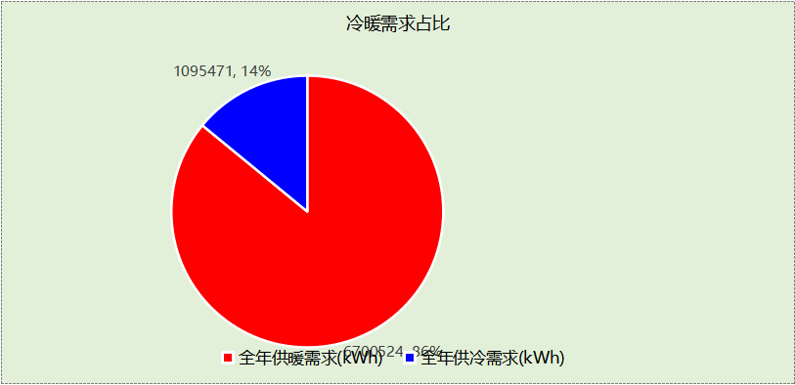

## 负荷分项统计

|  |  |  |  |  |  |  |
| --- | --- | --- | --- | --- | --- | --- |
| 分类 | 围护传热 | 室内得热 | 窗日射 | 新风/渗透 | 热回收 | 合计 |
| 供暖(kWh/㎡) | -3.54 | 30.09 | 3.81 | -249.91 | 0.00 | -219.56 |
| 供冷(kWh/㎡) | -0.39 | 25.43 | 3.26 | 7.67 | -0.07 | 35.90 |

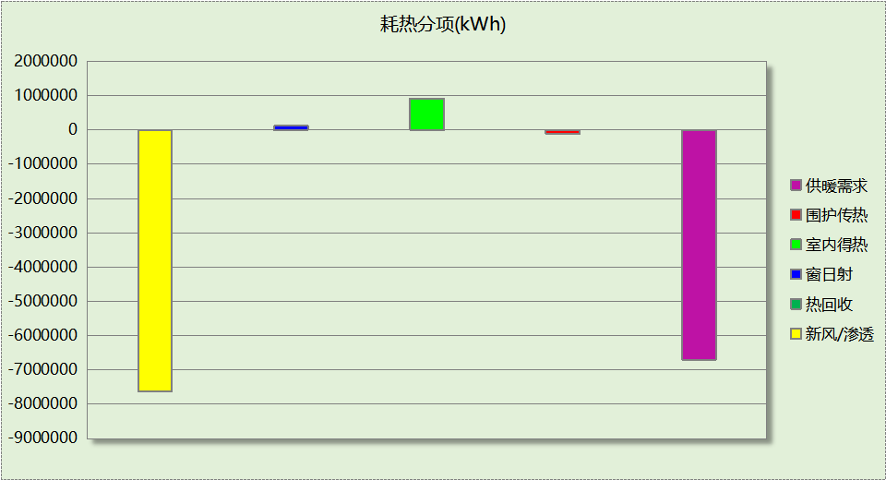

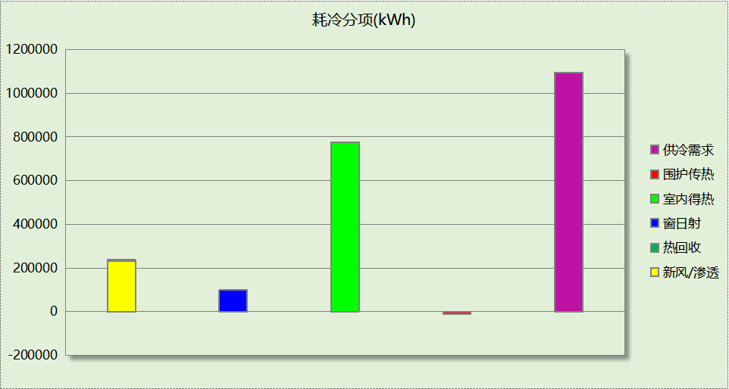

## 逐月负荷表

|  |  |  |  |  |  |  |
| --- | --- | --- | --- | --- | --- | --- |
| 月份 | 供暖(kWh) | 供冷(kWh) | 热负荷 峰值(kW) | 热负荷 峰值时刻 | 冷负荷 峰值(kW) | 冷负荷 峰值时刻 |
| 1月 | 1463021 | 0 | 2808.809 | 1月19日5时 | 0.000 | -- |
| 2月 | 1089743 | 0 | 2632.752 | 2月5日8时 | 0.000 | -- |
| 3月 | 813843 | 0 | 2133.916 | 3月23日5时 | 0.000 | -- |
| 4月 | 318602 | 6387 | 1169.480 | 4月12日5时 | 258.673 | 4月29日18时 |
| 5月 | 92815 | 43612 | 599.078 | 5月13日5时 | 458.596 | 5月29日19时 |
| 6月 | 7960 | 226735 | 287.530 | 6月30日4时 | 1156.315 | 6月17日17时 |
| 7月 | 407 | 355607 | 100.409 | 7月7日4时 | 1707.561 | 7月28日18时 |
| 8月 | 2273 | 373945 | 216.373 | 8月19日5时 | 1833.079 | 8月2日17时 |
| 9月 | 86835 | 87816 | 897.164 | 9月21日5时 | 1222.927 | 9月3日17时 |
| 10月 | 363853 | 1369 | 1221.553 | 10月24日5时 | 49.255 | 10月1日20时 |
| 11月 | 1098059 | 0 | 2327.095 | 11月25日5时 | 0.000 | -- |
| 12月 | 1363113 | 0 | 2792.841 | 12月18日5时 | 0.000 | -- |

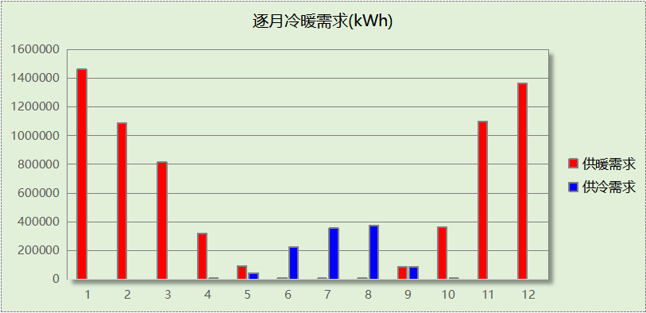

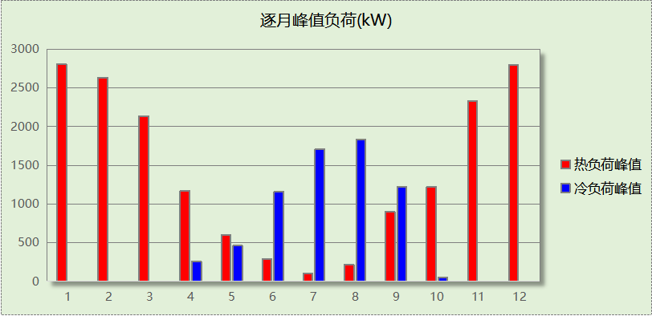

# 附录

**工作日/节假日人员逐时在室率(%)**

|  |  |  |  |  |  |  |  |  |  |  |  |  |  |  |  |  |  |  |  |  |  |  |  |  |
| --- | --- | --- | --- | --- | --- | --- | --- | --- | --- | --- | --- | --- | --- | --- | --- | --- | --- | --- | --- | --- | --- | --- | --- | --- |
| 房间类型 | 1 | 2 | 3 | 4 | 5 | 6 | 7 | 8 | 9 | 10 | 11 | 12 | 13 | 14 | 15 | 16 | 17 | 18 | 19 | 20 | 21 | 22 | 23 | 24 |
| 3星客房 | 70 | 70 | 70 | 70 | 70 | 70 | 70 | 70 | 50 | 50 | 50 | 50 | 50 | 50 | 50 | 50 | 50 | 50 | 70 | 70 | 70 | 70 | 70 | 70 |
| 70 | 70 | 70 | 70 | 70 | 70 | 70 | 70 | 50 | 50 | 50 | 50 | 50 | 50 | 50 | 50 | 50 | 50 | 70 | 70 | 70 | 70 | 70 | 70 |
| 一般商店 | 70 | 70 | 70 | 70 | 70 | 70 | 70 | 70 | 50 | 50 | 50 | 50 | 50 | 50 | 50 | 50 | 50 | 50 | 70 | 70 | 70 | 70 | 70 | 70 |
| 70 | 70 | 70 | 70 | 70 | 70 | 70 | 70 | 50 | 50 | 50 | 50 | 50 | 50 | 50 | 50 | 50 | 50 | 70 | 70 | 70 | 70 | 70 | 70 |
| 中餐厅 | 70 | 70 | 70 | 70 | 70 | 70 | 70 | 70 | 50 | 50 | 50 | 50 | 50 | 50 | 50 | 50 | 50 | 50 | 70 | 70 | 70 | 70 | 70 | 70 |
| 70 | 70 | 70 | 70 | 70 | 70 | 70 | 70 | 50 | 50 | 50 | 50 | 50 | 50 | 50 | 50 | 50 | 50 | 70 | 70 | 70 | 70 | 70 | 70 |
| 休息室 | 70 | 70 | 70 | 70 | 70 | 70 | 70 | 70 | 50 | 50 | 50 | 50 | 50 | 50 | 50 | 50 | 50 | 50 | 70 | 70 | 70 | 70 | 70 | 70 |
| 70 | 70 | 70 | 70 | 70 | 70 | 70 | 70 | 50 | 50 | 50 | 50 | 50 | 50 | 50 | 50 | 50 | 50 | 70 | 70 | 70 | 70 | 70 | 70 |
| 会客室 | 70 | 70 | 70 | 70 | 70 | 70 | 70 | 70 | 50 | 50 | 50 | 50 | 50 | 50 | 50 | 50 | 50 | 50 | 70 | 70 | 70 | 70 | 70 | 70 |
| 70 | 70 | 70 | 70 | 70 | 70 | 70 | 70 | 50 | 50 | 50 | 50 | 50 | 50 | 50 | 50 | 50 | 50 | 70 | 70 | 70 | 70 | 70 | 70 |
| 会议室 | 70 | 70 | 70 | 70 | 70 | 70 | 70 | 70 | 50 | 50 | 50 | 50 | 50 | 50 | 50 | 50 | 50 | 50 | 70 | 70 | 70 | 70 | 70 | 70 |
| 70 | 70 | 70 | 70 | 70 | 70 | 70 | 70 | 50 | 50 | 50 | 50 | 50 | 50 | 50 | 50 | 50 | 50 | 70 | 70 | 70 | 70 | 70 | 70 |
| 卫生间 | 70 | 70 | 70 | 70 | 70 | 70 | 70 | 70 | 50 | 50 | 50 | 50 | 50 | 50 | 50 | 50 | 50 | 50 | 70 | 70 | 70 | 70 | 70 | 70 |
| 70 | 70 | 70 | 70 | 70 | 70 | 70 | 70 | 50 | 50 | 50 | 50 | 50 | 50 | 50 | 50 | 50 | 50 | 70 | 70 | 70 | 70 | 70 | 70 |
| 厨房 | 70 | 70 | 70 | 70 | 70 | 70 | 70 | 70 | 50 | 50 | 50 | 50 | 50 | 50 | 50 | 50 | 50 | 50 | 70 | 70 | 70 | 70 | 70 | 70 |
| 70 | 70 | 70 | 70 | 70 | 70 | 70 | 70 | 50 | 50 | 50 | 50 | 50 | 50 | 50 | 50 | 50 | 50 | 70 | 70 | 70 | 70 | 70 | 70 |
| 大厅 | 70 | 70 | 70 | 70 | 70 | 70 | 70 | 70 | 50 | 50 | 50 | 50 | 50 | 50 | 50 | 50 | 50 | 50 | 70 | 70 | 70 | 70 | 70 | 70 |
| 70 | 70 | 70 | 70 | 70 | 70 | 70 | 70 | 50 | 50 | 50 | 50 | 50 | 50 | 50 | 50 | 50 | 50 | 70 | 70 | 70 | 70 | 70 | 70 |
| 布草间 | 70 | 70 | 70 | 70 | 70 | 70 | 70 | 70 | 50 | 50 | 50 | 50 | 50 | 50 | 50 | 50 | 50 | 50 | 70 | 70 | 70 | 70 | 70 | 70 |
| 70 | 70 | 70 | 70 | 70 | 70 | 70 | 70 | 50 | 50 | 50 | 50 | 50 | 50 | 50 | 50 | 50 | 50 | 70 | 70 | 70 | 70 | 70 | 70 |
| 普通办公室 | 70 | 70 | 70 | 70 | 70 | 70 | 70 | 70 | 50 | 50 | 50 | 50 | 50 | 50 | 50 | 50 | 50 | 50 | 70 | 70 | 70 | 70 | 70 | 70 |
| 70 | 70 | 70 | 70 | 70 | 70 | 70 | 70 | 50 | 50 | 50 | 50 | 50 | 50 | 50 | 50 | 50 | 50 | 70 | 70 | 70 | 70 | 70 | 70 |
| 楼梯间 | 70 | 70 | 70 | 70 | 70 | 70 | 70 | 70 | 50 | 50 | 50 | 50 | 50 | 50 | 50 | 50 | 50 | 50 | 70 | 70 | 70 | 70 | 70 | 70 |
| 70 | 70 | 70 | 70 | 70 | 70 | 70 | 70 | 50 | 50 | 50 | 50 | 50 | 50 | 50 | 50 | 50 | 50 | 70 | 70 | 70 | 70 | 70 | 70 |
| 浴室 | 70 | 70 | 70 | 70 | 70 | 70 | 70 | 70 | 50 | 50 | 50 | 50 | 50 | 50 | 50 | 50 | 50 | 50 | 70 | 70 | 70 | 70 | 70 | 70 |
| 70 | 70 | 70 | 70 | 70 | 70 | 70 | 70 | 50 | 50 | 50 | 50 | 50 | 50 | 50 | 50 | 50 | 50 | 70 | 70 | 70 | 70 | 70 | 70 |
| 设备间 | 0 | 0 | 0 | 0 | 0 | 0 | 0 | 0 | 0 | 0 | 0 | 0 | 0 | 0 | 0 | 0 | 0 | 0 | 0 | 0 | 0 | 0 | 0 | 0 |
| 0 | 0 | 0 | 0 | 0 | 0 | 0 | 0 | 0 | 0 | 0 | 0 | 0 | 0 | 0 | 0 | 0 | 0 | 0 | 0 | 0 | 0 | 0 | 0 |
| 走廊 | 70 | 70 | 70 | 70 | 70 | 70 | 70 | 70 | 50 | 50 | 50 | 50 | 50 | 50 | 50 | 50 | 50 | 50 | 70 | 70 | 70 | 70 | 70 | 70 |
| 70 | 70 | 70 | 70 | 70 | 70 | 70 | 70 | 50 | 50 | 50 | 50 | 50 | 50 | 50 | 50 | 50 | 50 | 70 | 70 | 70 | 70 | 70 | 70 |
| 酒吧、茶座 | 70 | 70 | 70 | 70 | 70 | 70 | 70 | 70 | 50 | 50 | 50 | 50 | 50 | 50 | 50 | 50 | 50 | 50 | 70 | 70 | 70 | 70 | 70 | 70 |
| 70 | 70 | 70 | 70 | 70 | 70 | 70 | 70 | 50 | 50 | 50 | 50 | 50 | 50 | 50 | 50 | 50 | 50 | 70 | 70 | 70 | 70 | 70 | 70 |
| 餐厅 | 70 | 70 | 70 | 70 | 70 | 70 | 70 | 70 | 50 | 50 | 50 | 50 | 50 | 50 | 50 | 50 | 50 | 50 | 70 | 70 | 70 | 70 | 70 | 70 |
| 70 | 70 | 70 | 70 | 70 | 70 | 70 | 70 | 50 | 50 | 50 | 50 | 50 | 50 | 50 | 50 | 50 | 50 | 70 | 70 | 70 | 70 | 70 | 70 |

注：上行：工作日；下行：节假日

**工作日/节假日照明开关时间表(%)**

|  |  |  |  |  |  |  |  |  |  |  |  |  |  |  |  |  |  |  |  |  |  |  |  |  |
| --- | --- | --- | --- | --- | --- | --- | --- | --- | --- | --- | --- | --- | --- | --- | --- | --- | --- | --- | --- | --- | --- | --- | --- | --- |
| 房间类型 | 1 | 2 | 3 | 4 | 5 | 6 | 7 | 8 | 9 | 10 | 11 | 12 | 13 | 14 | 15 | 16 | 17 | 18 | 19 | 20 | 21 | 22 | 23 | 24 |
| 3星客房 | 10 | 10 | 10 | 10 | 10 | 10 | 30 | 30 | 30 | 30 | 30 | 30 | 30 | 30 | 50 | 50 | 60 | 90 | 90 | 90 | 90 | 80 | 10 | 10 |
| 10 | 10 | 10 | 10 | 10 | 10 | 30 | 30 | 30 | 30 | 30 | 30 | 30 | 30 | 50 | 50 | 60 | 90 | 90 | 90 | 90 | 80 | 10 | 10 |
| 一般商店 | 10 | 10 | 10 | 10 | 10 | 10 | 30 | 30 | 30 | 30 | 30 | 30 | 30 | 30 | 50 | 50 | 60 | 90 | 90 | 90 | 90 | 80 | 10 | 10 |
| 10 | 10 | 10 | 10 | 10 | 10 | 30 | 30 | 30 | 30 | 30 | 30 | 30 | 30 | 50 | 50 | 60 | 90 | 90 | 90 | 90 | 80 | 10 | 10 |
| 中餐厅 | 10 | 10 | 10 | 10 | 10 | 10 | 30 | 30 | 30 | 30 | 30 | 30 | 30 | 30 | 50 | 50 | 60 | 90 | 90 | 90 | 90 | 80 | 10 | 10 |
| 10 | 10 | 10 | 10 | 10 | 10 | 30 | 30 | 30 | 30 | 30 | 30 | 30 | 30 | 50 | 50 | 60 | 90 | 90 | 90 | 90 | 80 | 10 | 10 |
| 休息室 | 10 | 10 | 10 | 10 | 10 | 10 | 30 | 30 | 30 | 30 | 30 | 30 | 30 | 30 | 50 | 50 | 60 | 90 | 90 | 90 | 90 | 80 | 10 | 10 |
| 10 | 10 | 10 | 10 | 10 | 10 | 30 | 30 | 30 | 30 | 30 | 30 | 30 | 30 | 50 | 50 | 60 | 90 | 90 | 90 | 90 | 80 | 10 | 10 |
| 会客室 | 10 | 10 | 10 | 10 | 10 | 10 | 30 | 30 | 30 | 30 | 30 | 30 | 30 | 30 | 50 | 50 | 60 | 90 | 90 | 90 | 90 | 80 | 10 | 10 |
| 10 | 10 | 10 | 10 | 10 | 10 | 30 | 30 | 30 | 30 | 30 | 30 | 30 | 30 | 50 | 50 | 60 | 90 | 90 | 90 | 90 | 80 | 10 | 10 |
| 会议室 | 10 | 10 | 10 | 10 | 10 | 10 | 30 | 30 | 30 | 30 | 30 | 30 | 30 | 30 | 50 | 50 | 60 | 90 | 90 | 90 | 90 | 80 | 10 | 10 |
| 10 | 10 | 10 | 10 | 10 | 10 | 30 | 30 | 30 | 30 | 30 | 30 | 30 | 30 | 50 | 50 | 60 | 90 | 90 | 90 | 90 | 80 | 10 | 10 |
| 卫生间 | 10 | 10 | 10 | 10 | 10 | 10 | 30 | 30 | 30 | 30 | 30 | 30 | 30 | 30 | 50 | 50 | 60 | 90 | 90 | 90 | 90 | 80 | 10 | 10 |
| 10 | 10 | 10 | 10 | 10 | 10 | 30 | 30 | 30 | 30 | 30 | 30 | 30 | 30 | 50 | 50 | 60 | 90 | 90 | 90 | 90 | 80 | 10 | 10 |
| 厨房 | 10 | 10 | 10 | 10 | 10 | 10 | 30 | 30 | 30 | 30 | 30 | 30 | 30 | 30 | 50 | 50 | 60 | 90 | 90 | 90 | 90 | 80 | 10 | 10 |
| 10 | 10 | 10 | 10 | 10 | 10 | 30 | 30 | 30 | 30 | 30 | 30 | 30 | 30 | 50 | 50 | 60 | 90 | 90 | 90 | 90 | 80 | 10 | 10 |
| 大厅 | 10 | 10 | 10 | 10 | 10 | 10 | 30 | 30 | 30 | 30 | 30 | 30 | 30 | 30 | 50 | 50 | 60 | 90 | 90 | 90 | 90 | 80 | 10 | 10 |
| 10 | 10 | 10 | 10 | 10 | 10 | 30 | 30 | 30 | 30 | 30 | 30 | 30 | 30 | 50 | 50 | 60 | 90 | 90 | 90 | 90 | 80 | 10 | 10 |
| 布草间 | 10 | 10 | 10 | 10 | 10 | 10 | 30 | 30 | 30 | 30 | 30 | 30 | 30 | 30 | 50 | 50 | 60 | 90 | 90 | 90 | 90 | 80 | 10 | 10 |
| 10 | 10 | 10 | 10 | 10 | 10 | 30 | 30 | 30 | 30 | 30 | 30 | 30 | 30 | 50 | 50 | 60 | 90 | 90 | 90 | 90 | 80 | 10 | 10 |
| 普通办公室 | 10 | 10 | 10 | 10 | 10 | 10 | 30 | 30 | 30 | 30 | 30 | 30 | 30 | 30 | 50 | 50 | 60 | 90 | 90 | 90 | 90 | 80 | 10 | 10 |
| 10 | 10 | 10 | 10 | 10 | 10 | 30 | 30 | 30 | 30 | 30 | 30 | 30 | 30 | 50 | 50 | 60 | 90 | 90 | 90 | 90 | 80 | 10 | 10 |
| 楼梯间 | 10 | 10 | 10 | 10 | 10 | 10 | 30 | 30 | 30 | 30 | 30 | 30 | 30 | 30 | 50 | 50 | 60 | 90 | 90 | 90 | 90 | 80 | 10 | 10 |
| 10 | 10 | 10 | 10 | 10 | 10 | 30 | 30 | 30 | 30 | 30 | 30 | 30 | 30 | 50 | 50 | 60 | 90 | 90 | 90 | 90 | 80 | 10 | 10 |
| 浴室 | 10 | 10 | 10 | 10 | 10 | 10 | 30 | 30 | 30 | 30 | 30 | 30 | 30 | 30 | 50 | 50 | 60 | 90 | 90 | 90 | 90 | 80 | 10 | 10 |
| 10 | 10 | 10 | 10 | 10 | 10 | 30 | 30 | 30 | 30 | 30 | 30 | 30 | 30 | 50 | 50 | 60 | 90 | 90 | 90 | 90 | 80 | 10 | 10 |
| 设备间 | 100 | 100 | 100 | 100 | 100 | 100 | 100 | 100 | 100 | 100 | 100 | 100 | 100 | 100 | 100 | 100 | 100 | 100 | 100 | 100 | 100 | 100 | 100 | 100 |
| 100 | 100 | 100 | 100 | 100 | 100 | 100 | 100 | 100 | 100 | 100 | 100 | 100 | 100 | 100 | 100 | 100 | 100 | 100 | 100 | 100 | 100 | 100 | 100 |
| 走廊 | 10 | 10 | 10 | 10 | 10 | 10 | 30 | 30 | 30 | 30 | 30 | 30 | 30 | 30 | 50 | 50 | 60 | 90 | 90 | 90 | 90 | 80 | 10 | 10 |
| 10 | 10 | 10 | 10 | 10 | 10 | 30 | 30 | 30 | 30 | 30 | 30 | 30 | 30 | 50 | 50 | 60 | 90 | 90 | 90 | 90 | 80 | 10 | 10 |
| 酒吧、茶座 | 10 | 10 | 10 | 10 | 10 | 10 | 30 | 30 | 30 | 30 | 30 | 30 | 30 | 30 | 50 | 50 | 60 | 90 | 90 | 90 | 90 | 80 | 10 | 10 |
| 10 | 10 | 10 | 10 | 10 | 10 | 30 | 30 | 30 | 30 | 30 | 30 | 30 | 30 | 50 | 50 | 60 | 90 | 90 | 90 | 90 | 80 | 10 | 10 |
| 餐厅 | 10 | 10 | 10 | 10 | 10 | 10 | 30 | 30 | 30 | 30 | 30 | 30 | 30 | 30 | 50 | 50 | 60 | 90 | 90 | 90 | 90 | 80 | 10 | 10 |
| 10 | 10 | 10 | 10 | 10 | 10 | 30 | 30 | 30 | 30 | 30 | 30 | 30 | 30 | 50 | 50 | 60 | 90 | 90 | 90 | 90 | 80 | 10 | 10 |

注：上行：工作日；下行：节假日

**工作日/节假日设备逐时使用率(%)**

|  |  |  |  |  |  |  |  |  |  |  |  |  |  |  |  |  |  |  |  |  |  |  |  |  |
| --- | --- | --- | --- | --- | --- | --- | --- | --- | --- | --- | --- | --- | --- | --- | --- | --- | --- | --- | --- | --- | --- | --- | --- | --- |
| 房间类型 | 1 | 2 | 3 | 4 | 5 | 6 | 7 | 8 | 9 | 10 | 11 | 12 | 13 | 14 | 15 | 16 | 17 | 18 | 19 | 20 | 21 | 22 | 23 | 24 |
| 3星客房 | 0 | 0 | 0 | 0 | 0 | 0 | 0 | 0 | 0 | 0 | 0 | 0 | 0 | 0 | 0 | 0 | 0 | 80 | 80 | 80 | 80 | 80 | 0 | 0 |
| 0 | 0 | 0 | 0 | 0 | 0 | 0 | 0 | 0 | 0 | 0 | 0 | 0 | 0 | 0 | 0 | 0 | 80 | 80 | 80 | 80 | 80 | 0 | 0 |
| 一般商店 | 0 | 0 | 0 | 0 | 0 | 0 | 0 | 0 | 0 | 0 | 0 | 0 | 0 | 0 | 0 | 0 | 0 | 80 | 80 | 80 | 80 | 80 | 0 | 0 |
| 0 | 0 | 0 | 0 | 0 | 0 | 0 | 0 | 0 | 0 | 0 | 0 | 0 | 0 | 0 | 0 | 0 | 80 | 80 | 80 | 80 | 80 | 0 | 0 |
| 中餐厅 | 0 | 0 | 0 | 0 | 0 | 0 | 0 | 0 | 0 | 0 | 0 | 0 | 0 | 0 | 0 | 0 | 0 | 80 | 80 | 80 | 80 | 80 | 0 | 0 |
| 0 | 0 | 0 | 0 | 0 | 0 | 0 | 0 | 0 | 0 | 0 | 0 | 0 | 0 | 0 | 0 | 0 | 80 | 80 | 80 | 80 | 80 | 0 | 0 |
| 休息室 | 0 | 0 | 0 | 0 | 0 | 0 | 0 | 0 | 0 | 0 | 0 | 0 | 0 | 0 | 0 | 0 | 0 | 80 | 80 | 80 | 80 | 80 | 0 | 0 |
| 0 | 0 | 0 | 0 | 0 | 0 | 0 | 0 | 0 | 0 | 0 | 0 | 0 | 0 | 0 | 0 | 0 | 80 | 80 | 80 | 80 | 80 | 0 | 0 |
| 会客室 | 0 | 0 | 0 | 0 | 0 | 0 | 0 | 0 | 0 | 0 | 0 | 0 | 0 | 0 | 0 | 0 | 0 | 80 | 80 | 80 | 80 | 80 | 0 | 0 |
| 0 | 0 | 0 | 0 | 0 | 0 | 0 | 0 | 0 | 0 | 0 | 0 | 0 | 0 | 0 | 0 | 0 | 80 | 80 | 80 | 80 | 80 | 0 | 0 |
| 会议室 | 0 | 0 | 0 | 0 | 0 | 0 | 0 | 0 | 0 | 0 | 0 | 0 | 0 | 0 | 0 | 0 | 0 | 80 | 80 | 80 | 80 | 80 | 0 | 0 |
| 0 | 0 | 0 | 0 | 0 | 0 | 0 | 0 | 0 | 0 | 0 | 0 | 0 | 0 | 0 | 0 | 0 | 80 | 80 | 80 | 80 | 80 | 0 | 0 |
| 卫生间 | 0 | 0 | 0 | 0 | 0 | 0 | 0 | 0 | 0 | 0 | 0 | 0 | 0 | 0 | 0 | 0 | 0 | 80 | 80 | 80 | 80 | 80 | 0 | 0 |
| 0 | 0 | 0 | 0 | 0 | 0 | 0 | 0 | 0 | 0 | 0 | 0 | 0 | 0 | 0 | 0 | 0 | 80 | 80 | 80 | 80 | 80 | 0 | 0 |
| 厨房 | 0 | 0 | 0 | 0 | 0 | 0 | 0 | 0 | 0 | 0 | 0 | 0 | 0 | 0 | 0 | 0 | 0 | 80 | 80 | 80 | 80 | 80 | 0 | 0 |
| 0 | 0 | 0 | 0 | 0 | 0 | 0 | 0 | 0 | 0 | 0 | 0 | 0 | 0 | 0 | 0 | 0 | 80 | 80 | 80 | 80 | 80 | 0 | 0 |
| 大厅 | 0 | 0 | 0 | 0 | 0 | 0 | 0 | 0 | 0 | 0 | 0 | 0 | 0 | 0 | 0 | 0 | 0 | 80 | 80 | 80 | 80 | 80 | 0 | 0 |
| 0 | 0 | 0 | 0 | 0 | 0 | 0 | 0 | 0 | 0 | 0 | 0 | 0 | 0 | 0 | 0 | 0 | 80 | 80 | 80 | 80 | 80 | 0 | 0 |
| 布草间 | 0 | 0 | 0 | 0 | 0 | 0 | 0 | 0 | 0 | 0 | 0 | 0 | 0 | 0 | 0 | 0 | 0 | 80 | 80 | 80 | 80 | 80 | 0 | 0 |
| 0 | 0 | 0 | 0 | 0 | 0 | 0 | 0 | 0 | 0 | 0 | 0 | 0 | 0 | 0 | 0 | 0 | 80 | 80 | 80 | 80 | 80 | 0 | 0 |
| 普通办公室 | 0 | 0 | 0 | 0 | 0 | 0 | 0 | 0 | 0 | 0 | 0 | 0 | 0 | 0 | 0 | 0 | 0 | 80 | 80 | 80 | 80 | 80 | 0 | 0 |
| 0 | 0 | 0 | 0 | 0 | 0 | 0 | 0 | 0 | 0 | 0 | 0 | 0 | 0 | 0 | 0 | 0 | 80 | 80 | 80 | 80 | 80 | 0 | 0 |
| 楼梯间 | 0 | 0 | 0 | 0 | 0 | 0 | 0 | 0 | 0 | 0 | 0 | 0 | 0 | 0 | 0 | 0 | 0 | 80 | 80 | 80 | 80 | 80 | 0 | 0 |
| 0 | 0 | 0 | 0 | 0 | 0 | 0 | 0 | 0 | 0 | 0 | 0 | 0 | 0 | 0 | 0 | 0 | 80 | 80 | 80 | 80 | 80 | 0 | 0 |
| 浴室 | 0 | 0 | 0 | 0 | 0 | 0 | 0 | 0 | 0 | 0 | 0 | 0 | 0 | 0 | 0 | 0 | 0 | 80 | 80 | 80 | 80 | 80 | 0 | 0 |
| 0 | 0 | 0 | 0 | 0 | 0 | 0 | 0 | 0 | 0 | 0 | 0 | 0 | 0 | 0 | 0 | 0 | 80 | 80 | 80 | 80 | 80 | 0 | 0 |
| 设备间 | 100 | 100 | 100 | 100 | 100 | 100 | 100 | 100 | 100 | 100 | 100 | 100 | 100 | 100 | 100 | 100 | 100 | 100 | 100 | 100 | 100 | 100 | 100 | 100 |
| 100 | 100 | 100 | 100 | 100 | 100 | 100 | 100 | 100 | 100 | 100 | 100 | 100 | 100 | 100 | 100 | 100 | 100 | 100 | 100 | 100 | 100 | 100 | 100 |
| 走廊 | 0 | 0 | 0 | 0 | 0 | 0 | 0 | 0 | 0 | 0 | 0 | 0 | 0 | 0 | 0 | 0 | 0 | 80 | 80 | 80 | 80 | 80 | 0 | 0 |
| 0 | 0 | 0 | 0 | 0 | 0 | 0 | 0 | 0 | 0 | 0 | 0 | 0 | 0 | 0 | 0 | 0 | 80 | 80 | 80 | 80 | 80 | 0 | 0 |
| 酒吧、茶座 | 0 | 0 | 0 | 0 | 0 | 0 | 0 | 0 | 0 | 0 | 0 | 0 | 0 | 0 | 0 | 0 | 0 | 80 | 80 | 80 | 80 | 80 | 0 | 0 |
| 0 | 0 | 0 | 0 | 0 | 0 | 0 | 0 | 0 | 0 | 0 | 0 | 0 | 0 | 0 | 0 | 0 | 80 | 80 | 80 | 80 | 80 | 0 | 0 |
| 餐厅 | 0 | 0 | 0 | 0 | 0 | 0 | 0 | 0 | 0 | 0 | 0 | 0 | 0 | 0 | 0 | 0 | 0 | 80 | 80 | 80 | 80 | 80 | 0 | 0 |
| 0 | 0 | 0 | 0 | 0 | 0 | 0 | 0 | 0 | 0 | 0 | 0 | 0 | 0 | 0 | 0 | 0 | 80 | 80 | 80 | 80 | 80 | 0 | 0 |

注：上行：工作日；下行：节假日

**工作日/节假日空调系统开关时间表**

|  |  |  |  |  |  |  |  |  |  |  |  |  |  |  |  |  |  |  |  |  |  |  |  |  |
| --- | --- | --- | --- | --- | --- | --- | --- | --- | --- | --- | --- | --- | --- | --- | --- | --- | --- | --- | --- | --- | --- | --- | --- | --- |
| 系统编号 | 1 | 2 | 3 | 4 | 5 | 6 | 7 | 8 | 9 | 10 | 11 | 12 | 13 | 14 | 15 | 16 | 17 | 18 | 19 | 20 | 21 | 22 | 23 | 24 |
| Sys | 1 | 1 | 1 | 1 | 1 | 1 | 1 | 1 | 1 | 1 | 1 | 1 | 1 | 1 | 1 | 1 | 1 | 1 | 1 | 1 | 1 | 1 | 1 | 1 |
| 1 | 1 | 1 | 1 | 1 | 1 | 1 | 1 | 1 | 1 | 1 | 1 | 1 | 1 | 1 | 1 | 1 | 1 | 1 | 1 | 1 | 1 | 1 | 1 |
| 标准层@10 | 1 | 1 | 1 | 1 | 1 | 1 | 1 | 1 | 1 | 1 | 1 | 1 | 1 | 1 | 1 | 1 | 1 | 1 | 1 | 1 | 1 | 1 | 1 | 1 |
| 1 | 1 | 1 | 1 | 1 | 1 | 1 | 1 | 1 | 1 | 1 | 1 | 1 | 1 | 1 | 1 | 1 | 1 | 1 | 1 | 1 | 1 | 1 | 1 |
| 标准层@11 | 1 | 1 | 1 | 1 | 1 | 1 | 1 | 1 | 1 | 1 | 1 | 1 | 1 | 1 | 1 | 1 | 1 | 1 | 1 | 1 | 1 | 1 | 1 | 1 |
| 1 | 1 | 1 | 1 | 1 | 1 | 1 | 1 | 1 | 1 | 1 | 1 | 1 | 1 | 1 | 1 | 1 | 1 | 1 | 1 | 1 | 1 | 1 | 1 |
| 标准层@12 | 1 | 1 | 1 | 1 | 1 | 1 | 1 | 1 | 1 | 1 | 1 | 1 | 1 | 1 | 1 | 1 | 1 | 1 | 1 | 1 | 1 | 1 | 1 | 1 |
| 1 | 1 | 1 | 1 | 1 | 1 | 1 | 1 | 1 | 1 | 1 | 1 | 1 | 1 | 1 | 1 | 1 | 1 | 1 | 1 | 1 | 1 | 1 | 1 |
| 标准层@13 | 1 | 1 | 1 | 1 | 1 | 1 | 1 | 1 | 1 | 1 | 1 | 1 | 1 | 1 | 1 | 1 | 1 | 1 | 1 | 1 | 1 | 1 | 1 | 1 |
| 1 | 1 | 1 | 1 | 1 | 1 | 1 | 1 | 1 | 1 | 1 | 1 | 1 | 1 | 1 | 1 | 1 | 1 | 1 | 1 | 1 | 1 | 1 | 1 |
| 标准层@14 | 1 | 1 | 1 | 1 | 1 | 1 | 1 | 1 | 1 | 1 | 1 | 1 | 1 | 1 | 1 | 1 | 1 | 1 | 1 | 1 | 1 | 1 | 1 | 1 |
| 1 | 1 | 1 | 1 | 1 | 1 | 1 | 1 | 1 | 1 | 1 | 1 | 1 | 1 | 1 | 1 | 1 | 1 | 1 | 1 | 1 | 1 | 1 | 1 |
| 标准层@15 | 1 | 1 | 1 | 1 | 1 | 1 | 1 | 1 | 1 | 1 | 1 | 1 | 1 | 1 | 1 | 1 | 1 | 1 | 1 | 1 | 1 | 1 | 1 | 1 |
| 1 | 1 | 1 | 1 | 1 | 1 | 1 | 1 | 1 | 1 | 1 | 1 | 1 | 1 | 1 | 1 | 1 | 1 | 1 | 1 | 1 | 1 | 1 | 1 |
| 标准层@16 | 1 | 1 | 1 | 1 | 1 | 1 | 1 | 1 | 1 | 1 | 1 | 1 | 1 | 1 | 1 | 1 | 1 | 1 | 1 | 1 | 1 | 1 | 1 | 1 |
| 1 | 1 | 1 | 1 | 1 | 1 | 1 | 1 | 1 | 1 | 1 | 1 | 1 | 1 | 1 | 1 | 1 | 1 | 1 | 1 | 1 | 1 | 1 | 1 |
| 标准层@17 | 1 | 1 | 1 | 1 | 1 | 1 | 1 | 1 | 1 | 1 | 1 | 1 | 1 | 1 | 1 | 1 | 1 | 1 | 1 | 1 | 1 | 1 | 1 | 1 |
| 1 | 1 | 1 | 1 | 1 | 1 | 1 | 1 | 1 | 1 | 1 | 1 | 1 | 1 | 1 | 1 | 1 | 1 | 1 | 1 | 1 | 1 | 1 | 1 |
| 标准层@6 | 1 | 1 | 1 | 1 | 1 | 1 | 1 | 1 | 1 | 1 | 1 | 1 | 1 | 1 | 1 | 1 | 1 | 1 | 1 | 1 | 1 | 1 | 1 | 1 |
| 1 | 1 | 1 | 1 | 1 | 1 | 1 | 1 | 1 | 1 | 1 | 1 | 1 | 1 | 1 | 1 | 1 | 1 | 1 | 1 | 1 | 1 | 1 | 1 |
| 标准层@7 | 1 | 1 | 1 | 1 | 1 | 1 | 1 | 1 | 1 | 1 | 1 | 1 | 1 | 1 | 1 | 1 | 1 | 1 | 1 | 1 | 1 | 1 | 1 | 1 |
| 1 | 1 | 1 | 1 | 1 | 1 | 1 | 1 | 1 | 1 | 1 | 1 | 1 | 1 | 1 | 1 | 1 | 1 | 1 | 1 | 1 | 1 | 1 | 1 |
| 标准层@8 | 1 | 1 | 1 | 1 | 1 | 1 | 1 | 1 | 1 | 1 | 1 | 1 | 1 | 1 | 1 | 1 | 1 | 1 | 1 | 1 | 1 | 1 | 1 | 1 |
| 1 | 1 | 1 | 1 | 1 | 1 | 1 | 1 | 1 | 1 | 1 | 1 | 1 | 1 | 1 | 1 | 1 | 1 | 1 | 1 | 1 | 1 | 1 | 1 |
| 标准层@9 | 1 | 1 | 1 | 1 | 1 | 1 | 1 | 1 | 1 | 1 | 1 | 1 | 1 | 1 | 1 | 1 | 1 | 1 | 1 | 1 | 1 | 1 | 1 | 1 |
| 1 | 1 | 1 | 1 | 1 | 1 | 1 | 1 | 1 | 1 | 1 | 1 | 1 | 1 | 1 | 1 | 1 | 1 | 1 | 1 | 1 | 1 | 1 | 1 |

注：上行：工作日；下行：节假日