**空调照明系统节能率计算书**

公共建筑

|  |  |
| --- | --- |
| 工程名称 |  |
| 工程地点 | 浙江-湖州 |
| 设计编号 |  |
| 建设单位 |  |
| 设计单位 |  |
| 设 计 人 |  |
| 审 核 人 |  |
| 审 定 人 |  |
| 设计日期 | 2024年12月27日 |



|  |  |
| --- | --- |
| 采用软件 | 能耗计算BESI2024 |
| 软件版本 | 20240430(SP1) |
| 研发单位 | 北京绿建软件股份有限公司 |
| 正版授权码 | T17338881075 |

**目 录**

1 建筑概况 4

2 计算依据 4

3 计算要求 4

3.1 计算目标 4

3.2 计算方法 5

4 软件介绍 5

5 气象数据 5

5.1 气象地点 5

5.2 逐日干球温度表 6

5.3 逐月辐照量表 6

5.4 峰值工况 6

6 围护结构 7

6.1 工程材料 7

6.1.1 普通材料 7

6.1.2 其他材料 8

6.2 围护结构作法简要说明 8

7 围护结构概况 8

8 设计建筑 9

8.1 房间类型 9

8.1.1 房间参数表 9

8.1.2 作息时间表 10

8.2 系统类型 10

8.2.1 系统分区 10

8.2.2 热回收参数 10

8.3 制冷系统 10

8.3.1 多联机/单元式空调能耗 10

8.4 供暖系统 11

8.4.1 多联机/单元式热泵能耗 11

8.5 空调风机 11

8.5.1 独立新排风 11

8.6 照明 12

8.7 负荷分项统计 12

8.8 逐月负荷表 13

8.9 逐月电耗 14

9 参照建筑 15

9.1 房间类型 15

9.1.1 房间参数表 15

9.1.2 作息时间表 15

9.2 制冷系统 15

9.3 供暖系统 16

9.4 照明 16

9.5 负荷分项统计 16

9.6 逐月负荷表 17

9.7 逐月电耗 18

10 计算结果 19

11 绿色建筑性能评估得分 19

12 附录 23

12.1 工作日/节假日人员逐时在室率(%) 23

12.2 工作日/节假日照明开关时间表(%) 24

12.3 工作日/节假日设备逐时使用率(%) 25

12.4 工作日/节假日空调系统运行时间表(1:开,0:关) 26

12.5 工作日/节假日新风运行时间表(%) 27

# 建筑概况

|  |  |  |
| --- | --- | --- |
| 工程名称 |  | |
| 工程地点 | 浙江-湖州 | |
| 地理位置 | 北纬：30.87° | 东经：120.05° |
| 建筑面积(m2) | 地上15561 地下0 | |
| 建筑层数 | 地上3 地下0 | |
| 建筑高度（m） | 地上9.9 地下0.0 | |
| 建筑体积(m3) | 53854.50 | |
| 建筑外表面积(m2) | 14760.45 | |
| 北向角度 | 90 | |
| 结构类型 |  | |
| 外墙太阳辐射吸收系数 | 0.75 | |
| 屋顶太阳辐射吸收系数 | 0.75 | |
| 控温期 | 供冷期:6.30-9.15,供暖期:12.28-2.28 | |

# 计算依据

1. 《绿色建筑评价标准》(GB/T50378-2019)

2. 《民用建筑绿色性能计算标准》(JGJ/T 449-2018)

3. 《建筑能效标识技术标准》(JGJ/T 288-2012)

4. 《建筑节能与可再生能源利用通用规范》GB55015-2021

5. 《公共建筑节能设计标准》GB50189-2015

6. 《民用建筑热工设计规范》GB50176-2016

7. 《建筑幕墙、门窗通用技术条件》GB/T31433-2015

# 计算要求

## 计算目标

《绿色建筑评价标准》(GB/T50378-2019) 第7.2.8条：采取措施降低建筑能耗，评价总分值10分。建筑能耗相比国家现行有关建筑节能标准降低10%，得5分；降低20%，得10分。

《绿色建筑评价标准》(GB/T50378-2019) 第9.2.1条：采取措施进一步降低建筑供暖空调系统的能耗，评价总分值30分。建筑供暖空调系统能耗相比国家现行有关建筑节能标准降低40%，得10分；每再降低10%，再得5分；最高得30分。

## 计算方法

建立参照建筑，参照建筑的热工参数、采暖空调照明形式及设备满足现行国家节能标准要求。

根据现行行业标准《民用建筑绿色性能计算标准》JGJ/T449的相关规定，分别计算设计建筑及参照建筑的供暖空调和照明系统能耗，计算其节能率并进行得分判定。

即：建筑综合节能率 （7.2.8条）＝ （参照建筑全年采暖空调照明耗电量 － 设计建筑全年采暖空调照明耗电量） / 参照建筑全年采暖空调照明耗电量 × 100%

建筑采暖空调节能率 （9.2.1条）＝ （参照建筑全年采暖空调耗电量 － 设计建筑全年采暖空调耗电量） / 参照建筑全年采暖空调耗电量 × 100%

# 软件介绍

本报告内容由能耗计算BESI2024计算并输出，能耗计算BESI以CAD为平台，内置DOE2内核，可与建筑节能模型无缝对接，精准快速得到动态理想负荷，完美支持从《建筑能效标识技术标准》到《绿色建筑评价标准》要求的节能率，以及建筑全能耗的计算；软件充分考虑工程实际需求，从冷热源、输配水泵到末端风机，覆盖了常见暖通设备的能耗计算；并支持灵活的采暖供冷期、系统划分、运行策略设置等功能以及强大的结果数据分析。

# 气象数据

## 气象地点

浙江-杭州, 《建筑节能气象参数标准》

## 逐日干球温度表

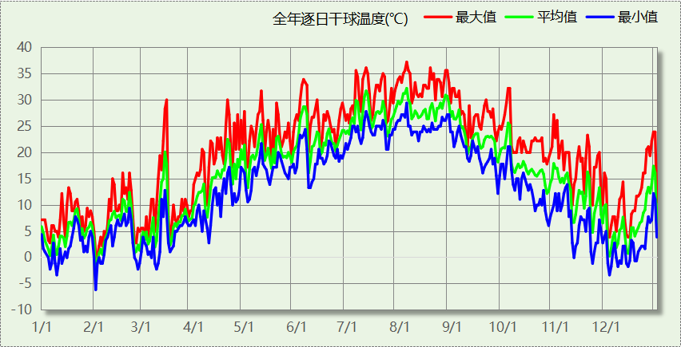

## 逐月辐照量表

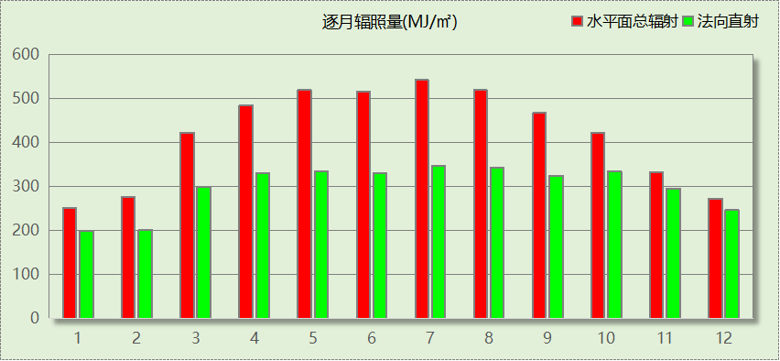

## 峰值工况

|  |  |  |  |  |  |
| --- | --- | --- | --- | --- | --- |
| 气象数据 | 时刻 | 干球温度(℃) | 湿球温度(℃) | 含湿量(g/kg) | 焓值(kj/kg) |
| 最热 | 08月04日15时 | 37.2 | 27.2 | 19.1 | 86.5 |
| 最冷 | 02月01日07时 | -6.1 | -6.7 | 1.7 | -1.9 |

# 围护结构

## 工程材料

### 普通材料

|  |  |  |  |  |  |  |
| --- | --- | --- | --- | --- | --- | --- |
| 材料名称 | 导热系数λ | 蓄热系数S | 密度ρ | 比热容Cp | 蒸汽渗透 系数u | 数据来源 |
| W/(m.K) | W/(㎡.K) | kg/m3 | J/(kg.K) | g/(m.h.kPa) |
| 水泥砂浆 | 0.930 | 11.370 | 1800.0 | 1050.0 | 0.0210 | 民用建筑热工设计规范 GB50176-2016 |
| 石灰砂浆 | 0.810 | 10.070 | 1600.0 | 1050.0 | 0.0443 | 民用建筑热工设计规范 GB50176-2016 |
| 钢筋混凝土 | 1.740 | 17.200 | 2500.0 | 920.0 | 0.0158 | 民用建筑热工设计规范 GB50176-2016 |
| 细石混凝土（双向配筋） | 1.740 | 17.060 | 2500.0 | 920.0 | 0.0158 | 民用建筑热工设计规范 GB50176-2016 |
| 蒸压砂加气混凝土砌块B07 | 0.180 | 3.598 | 700.0 | 1412.8 | 0.1110 | GB/T11968-2020 |
| 蒸压砂加气混凝土砌块B05 | 0.140 | 2.800 | 500.0 | 1540.0 | 0.1110 | GB/T11968-2020 |
| 聚苯颗粒保温砂浆 | 0.060 | 0.950 | 230.0 | 900.0 | 0.0210 | DB34-T753-2007 |
| 岩棉板(ρ0≥80) | 0.044 | 0.750 | 80.0 | 2200.0 | 0.4880 | 民用建筑热工设计规范 GB50176-2016 |
| 天然花岗岩板材 | 3.490 | 25.569 | 2800.0 | 920.0 | 0.0113 | 民用建筑热工设计规范 GB50176-2016 |
| 聚合物水泥砂浆 | 0.930 | 11.306 | 1800.0 | 1050.0 | 0.0100 | DB23-T120-2001 |
| 石灰水泥砂浆（混合砂浆） | 0.870 | 10.750 | 1700.0 | 1074.4 | 0.0230 | 无机轻集料防火保温板 JGT 435-2014 |
| 加气混凝土、泡沫混凝土(ρ=500) | 0.190 | 2.693 | 500.0 | 1050.0 | 0.1110 | 民用建筑热工设计规范 GB50176-2016 |
| 弹性体改性沥青防水卷材 | 0.230 | 9.370 | 900.0 | 1620.0 | 0.0014 | DB34-T753-2007 |
| 挤塑聚苯板（XPS）(屋面楼板) | 0.030 | 0.320 | 35.0 | 1340.0 | 0.0162 | 民用建筑热工设计规范 GB50176-2016 |
| 纤维增强水泥板 | 0.520 | 8.520 | 1800.0 | 1066.0 | 0.1910 | 浙江省居住建筑楼板构造(2018浙J76) |

### 其他材料

|  |  |  |  |  |
| --- | --- | --- | --- | --- |
| 材料名称 | 厚度 | 热阻R | 太阳辐射吸收系数 | 备注 |
| mm | (㎡K)/W |
| 胶黏剂 | － | － | － |  |
| 金属龙骨 | － | － | － |  |
| 外墙界面剂 | － | － | － |  |
| 非固化橡胶沥青防水涂料I型 | － | － | － |  |

## 围护结构作法简要说明

**1. 屋顶：**上人平屋顶(倒置式) (K=0.245,D=4.103)：（由上到下）

细石混凝土（双向配筋） 50mm＋石灰砂浆 10mm＋弹性体改性沥青防水卷材 3mm＋非固化橡胶沥青防水涂料I型 1.5mm＋水泥砂浆 20mm＋挤塑聚苯板（XPS）(屋面楼板) 130mm＋加气混凝土、泡沫混凝土(ρ=500) 30mm＋钢筋混凝土 120mm＋石灰水泥砂浆（混合砂浆） 10mm

**2. 外墙（填充墙）：**花岗岩外墙（B07） (K=0.547,D=5.046)：（由外到内）

天然花岗岩板材 25mm＋金属龙骨 0mm＋岩棉板(ρ0≥80) 40mm＋胶黏剂 2mm＋聚合物水泥砂浆 5mm＋水泥砂浆 10mm＋外墙界面剂 0mm＋蒸压砂加气混凝土砌块B07 200mm

**3. 外墙（剪力墙）：**花岗岩外墙（剪力墙） (K=0.947,D=3.025)：（由外到内）

天然花岗岩板材 25mm＋金属龙骨 0mm＋岩棉板(ρ0≥80) 40mm＋胶黏剂 2mm＋聚合物水泥砂浆 5mm＋水泥砂浆 10mm＋外墙界面剂 0mm＋钢筋混凝土 200mm

**4. 挑空楼板：**挑空楼板 (K=0.461,D=3.415)：（由上到下）

细石混凝土（双向配筋） 20mm＋钢筋混凝土 120mm＋岩棉板(ρ0≥80) 100mm＋纤维增强水泥板 20mm

**5. 天窗：**70系列平开隔热铝合金窗(5+12Ar+5Low_E+12Ar+5Low_E)(中低透) (K=1.500)：

传热系数1.500W/㎡.K，窗太阳得热系数0.240

**6. 外窗：**铝合金平开窗(5中透Low_E+12A+5)(双银)(34mm隔热条) (K=2.000)：

传热系数2.000W/㎡.K，窗太阳得热系数0.370

**7. 幕墙：**铝合金平开窗(5中透Low_E+12A+5)(双银)(34mm隔热条) (K=2.000)：

传热系数2.000W/㎡.K，窗太阳得热系数0.370

# 围护结构概况

|  |  |  |  |  |  |
| --- | --- | --- | --- | --- | --- |
|  | | | 设计建筑 | | |
| 屋顶传热系数K  和热情性指标 D | | | 0.25  4.10 | | |
| 外墙传热系数K  和热情性指标 D | | | 0.61  5.04 | | |
| 挑空(或架空)楼板传热系数K  和热惰性指标 D | | | 0.46  3.42 | | |
| 天窗传热系数K  和太阳得热系数 SHGC | | | 1.50  0.24 | | |
| 外窗（包括透明幕墙） | 朝向 | 立面 | 窗墙比 | 传热  系数 | 太阳得热系数 |
| 南向 | 南-默认立面 | 0.15 | 2.00 | 0.37 |
| 北向 | 北-默认立面 | 0.18 | 2.00 | 0.37 |
| 东向 | 东-默认立面 | 0.12 | 2.00 | 0.37 |
| 西向 | 西-默认立面 | 0.13 | 2.00 | 0.37 |

# 设计建筑

## 房间类型

### 房间参数表

|  |  |  |  |  |  |  |  |
| --- | --- | --- | --- | --- | --- | --- | --- |
| 房间类型 | 空调 温度℃ | 供暖 温度℃ | 新风量 | 渗透风 换气次数 | 人员密度 | 照明功率 密度 | 电器设备 功率 |
| 休闲空间 | 26 | 18 | 30(m3/h.人) | 0(次/h) | 4(㎡/人) | 8(W/㎡) | 13(W/㎡) |
| 会议室 | 26 | 18 | 14(m3/h.人) | 0(次/h) | 2.5(㎡/人) | 8(W/㎡) | 15(W/㎡) |
| 卫生间 | 28 | 18 | 20(m3/h.人) | 0(次/h) | 20(㎡/人) | 5(W/㎡) | 15(W/㎡) |
| 多媒体区 | 26 | 20 | 30(m3/h.人) | 0(次/h) | 2.5(㎡/人) | 13.5(W/㎡) | 15(W/㎡) |
| 大厅 | 26 | 18 | 20(m3/h.人) | 0(次/h) | 30(㎡/人) | 8(W/㎡) | 15(W/㎡) |
| 密集办公室 | 26 | 20 | 30(m3/h.人) | 0(次/h) | 4(㎡/人) | 8(W/㎡) | 20(W/㎡) |
| 展览馆 | 26 | 20 | 30(m3/h.人) | 0(次/h) | 8(㎡/人) | 9(W/㎡) | 15(W/㎡) |
| 报告厅 | 26 | 18 | 14(m3/h.人) | 0(次/h) | 2.5(㎡/人) | 8(W/㎡) | 15(W/㎡) |
| 普通办公室 | 26 | 20 | 30(m3/h.人) | 0(次/h) | 8(㎡/人) | 8(W/㎡) | 15(W/㎡) |
| 楼梯间 | － | － | 0(m3/h.人) | 0(次/h) | 0(人) | 3.5(W/㎡) | 15(W/㎡) |
| 电子信息机房 | 23 | 23 | 0(m3/h.人) | 0(次/h) | 20(㎡/人) | 8(W/㎡) | 15(W/㎡) |
| 视屏工作室 | 26 | 18 | 30(m3/h.人) | 0(次/h) | 8(㎡/人) | 13.5(W/㎡) | 15(W/㎡) |
| 走廊 | 26 | 16 | 20(m3/h.人) | 0(次/h) | 50(㎡/人) | 3.5(W/㎡) | 15(W/㎡) |
| 阅览室 | 26 | 18 | 30(m3/h.人) | 0(次/h) | 8(㎡/人) | 8(W/㎡) | 15(W/㎡) |
| 餐厅 | 26 | 18 | 30(m3/h.人) | 0(次/h) | 1(㎡/人) | 8(W/㎡) | 13(W/㎡) |
| 高档办公室 | 26 | 20 | 30(m3/h.人) | 0(次/h) | 8(㎡/人) | 8(W/㎡) | 15(W/㎡) |
| 高档超市 | 26 | 18 | 19(m3/h.人) | 0(次/h) | 2.5(㎡/人) | 8(W/㎡) | 13(W/㎡) |

### 作息时间表

详见附录

## 系统类型

### 系统分区

|  |  |  |  |  |  |
| --- | --- | --- | --- | --- | --- |
| 系统编号 | 系统类型 | 制冷 SEER | 制热 HSPF | 面积(㎡) | 包含的房间 |
| 默认 | 多联式空调(热泵)机组 | 4.00[全年能源消耗效率(APF)] | | 3054.46 | 2130(2),2121(2),2122(2),3313(3),3311(3),3323(3),3319(3) |
| 三层室内 | 多联式空调(热泵)机组 | 4.00[全年能源消耗效率(APF)] | | 689.65 | 3317(3),3318(3),3314(3),3325(3),3324(3),3321(3),3320(3),3322(3),3315(3),3316(3) |
| 三层工业 | 多联式空调(热泵)机组 | 4.00[全年能源消耗效率(APF)] | | 1149.92 | 3312(3) |
| 二层室内 | 多联式空调(热泵)机组 | 4.00[全年能源消耗效率(APF)] | | 2393.48 | 2133(2),2123(2),2152(2),2151(2),2150(2),2147(2),2146(2),2144(2),2148(2),2145(2),2143(2),2141(2),2140(2),2139(2),2138(2),2135(2),2132(2),2129(2),2128(2),2127(2) |
| 二层工业 | 多联式空调(热泵)机组 | 4.00[全年能源消耗效率(APF)] | | 7203.12 | 1341(1),11673(1),1143(1),1190(1),1357(1),1189(1),1125(1),1183(1),1363(1),1356(1),1188(1),1355(1),1344(1),1345(1),1349(1),1352(1),1350(1),1351(1),1347(1),1348(1),1360(1),1191(1),1187(1),1186(1),1343(1),1346(1),1362(1),1354(1),1361(1),1353(1),1358(1),1359(1),1342(1),2149(2),2142(2),2137(2),2136(2),2131(2),2124(2),2134(2) |

### 热回收参数

|  |  |  |  |  |  |
| --- | --- | --- | --- | --- | --- |
| 系统编号 | 热回收 | 供冷 | | 供暖 | |
| 回收效率 | 启动温(焓)差 | 回收效率 | 启动温(焓)差 |
| 默认 | 无 | － | － | － | － |
| 三层室内 | 全热回收 | 0.95 | 5kJ/kg | 0.80 | 5(kJ/kg) |
| 三层工业 | 全热回收 | 0.95 | 5kJ/kg | 0.80 | 5(kJ/kg) |
| 二层室内 | 全热回收 | 0.95 | 5kJ/kg | 0.80 | 5(kJ/kg) |
| 二层工业 | 全热回收 | 0.95 | 5kJ/kg | 0.80 | 5(kJ/kg) |

## 制冷系统

### 多联机/单元式空调能耗

|  |  |  |  |
| --- | --- | --- | --- |
| 系统编号 | 制冷SEER | 耗冷量(kWh) | 耗电量(kWh) |
| 三层室内 | 4.00[全年能源消耗效率(APF)] | 38040 | 9510 |
| 三层工业 | 4.00[全年能源消耗效率(APF)] | 26481 | 6620 |
| 二层室内 | 4.00[全年能源消耗效率(APF)] | 58960 | 14740 |
| 二层工业 | 4.00[全年能源消耗效率(APF)] | 50152 | 12538 |
| 默认 | 4.00[全年能源消耗效率(APF)] | 77473 | 19368 |
| 合计 | 4.00 | 251106 | 62777 |

## 供暖系统

### 多联机/单元式热泵能耗

|  |  |  |  |
| --- | --- | --- | --- |
| 系统编号 | 制热HSPF | 耗热量(kWh) | 耗电量(kWh) |
| 三层室内 | 4.00[全年能源消耗效率(APF)] | 2186 | 546 |
| 三层工业 | 4.00[全年能源消耗效率(APF)] | 1222 | 306 |
| 二层室内 | 4.00[全年能源消耗效率(APF)] | 7566 | 1892 |
| 二层工业 | 4.00[全年能源消耗效率(APF)] | 76153 | 19038 |
| 默认 | 4.00[全年能源消耗效率(APF)] | 3849 | 962 |
| 合计 | 4.00 | 90976 | 22744 |

## 空调风机

### 独立新排风

|  |  |  |  |  |  |
| --- | --- | --- | --- | --- | --- |
| 系统编号 | 新风量 (m3/h) | 单位风量耗功率 W/(m3/h) | 风机功率(W) | 运行时长(h) | 新风电耗(kWh) |
| 默认 | 1261 | 0.24 | 303 | 1104 | 334 |
| 三层室内 | 3405 | 0.24 | 817 | 1104 | 902 |
| 三层工业 | 4363 | 0.24 | 1047 | 1104 | 1156 |
| 二层室内 | 11669 | 0.24 | 2801 | 1104 | 3092 |
| 二层工业 | 33557 | 0.24 | 8054 | 1996 | 9169 |
| 合计 | | | | | 14653 |

|  |  |  |  |  |  |  |
| --- | --- | --- | --- | --- | --- | --- |
| 系统编号 | 排风量 (m3/h) | 排风比 | 单位风量耗功率W/(m3/h) | 风机功率(W) | 运行时长(h) | 排风电耗 (kWh) |
| 默认 | 1261 | 1 | 0.24 | 303 | 1104 | 334 |
| 三层室内 | 3405 | 1 | 0.24 | 817 | 1104 | 902 |
| 三层工业 | 4363 | 1 | 0.24 | 1047 | 1104 | 1156 |
| 二层室内 | 11669 | 1 | 0.24 | 2801 | 1104 | 3092 |
| 二层工业 | 33557 | 1 | 0.24 | 8054 | 1996 | 9169 |
| 合计 | | | | | | 14653 |

## 照明

|  |  |  |  |  |
| --- | --- | --- | --- | --- |
| 房间类型 | 单位面积电耗 (kWh/㎡) | 房间个数 | 房间合计面积 (㎡) | 合计电耗 (kWh) |
| 休闲空间 | 32.12 | 1 | 32 | 1044 |
| 会议室 | 13.44 | 2 | 131 | 1761 |
| 卫生间 | 8.40 | 6 | 263 | 2209 |
| 多媒体区 | 22.68 | 1 | 45 | 1014 |
| 密集办公室 | 13.44 | 2 | 100 | 1341 |
| 展览馆 | 15.12 | 7 | 682 | 10316 |
| 报告厅 | 13.44 | 1 | 390 | 5240 |
| 普通办公室 | 13.44 | 45 | 9516 | 127892 |
| 楼梯间 | 9.63 | 29 | 296 | 2845 |
| 电子信息机房 | 13.44 | 1 | 51 | 682 |
| 视屏工作室 | 22.68 | 1 | 45 | 1014 |
| 走廊 | 8.27 | 7 | 3281 | 27133 |
| 阅览室 | 13.44 | 1 | 65 | 873 |
| 餐厅 | 32.12 | 1 | 195 | 6261 |
| 高档办公室 | 13.44 | 1 | 81 | 1091 |
| 高档超市 | 32.12 | 1 | 130 | 4174 |
| 总计 | | | | 194890 |

## 负荷分项统计

|  |  |  |  |  |  |  |
| --- | --- | --- | --- | --- | --- | --- |
| 分类 | 围护传热 | 室内得热 | 窗日射 | 新风/渗透 | 热回收 | 合计 |
| 供暖(kWh/㎡) | -11.93 | 6.87 | 1.26 | -8.00 | 5.96 | -5.85 |
| 供冷(kWh/㎡) | 0.14 | 11.60 | 2.00 | 13.86 | -11.45 | 16.14 |

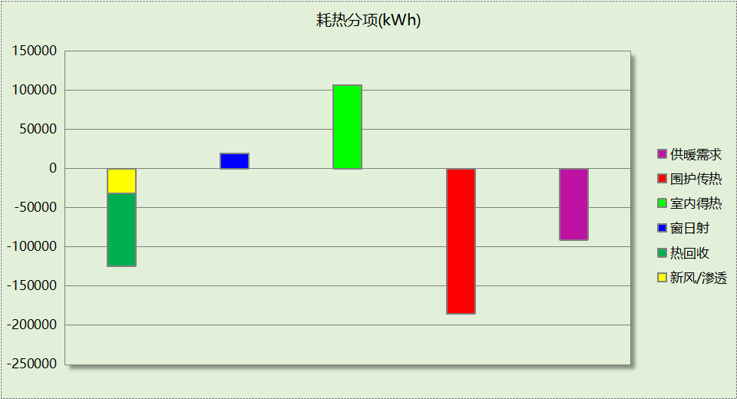

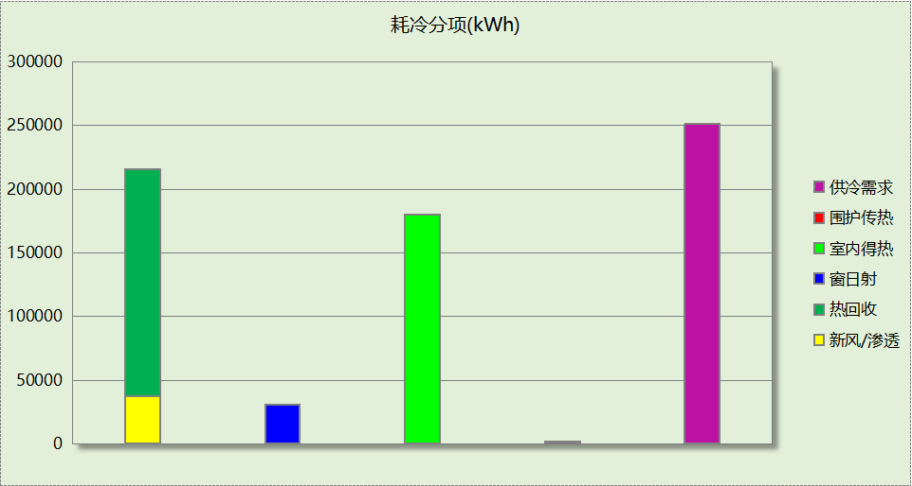

## 逐月负荷表

|  |  |  |  |  |  |  |
| --- | --- | --- | --- | --- | --- | --- |
| 月份 | 供暖(kWh) | 供冷(kWh) | 热负荷 峰值(kW) | 热负荷 峰值时刻 | 冷负荷 峰值(kW) | 冷负荷 峰值时刻 |
| 1月 | 29548 | 0 | 759.607 | 1月2日8时 | 0.000 | -- |
| 2月 | 61292 | 0 | 1005.199 | 2月14日8时 | 0.000 | -- |
| 3月 | 0 | 0 | 0.000 | -- | 0.000 | -- |
| 4月 | 0 | 0 | 0.000 | -- | 0.000 | -- |
| 5月 | 0 | 0 | 0.000 | -- | 0.000 | -- |
| 6月 | 0 | 0 | 0.000 | -- | 0.000 | -- |
| 7月 | 0 | 82932 | 0.000 | -- | 555.777 | 7月11日16时 |
| 8月 | 0 | 125288 | 0.000 | -- | 665.549 | 8月5日14时 |
| 9月 | 0 | 42886 | 0.000 | -- | 671.866 | 9月4日15时 |
| 10月 | 0 | 0 | 0.000 | -- | 0.000 | -- |
| 11月 | 0 | 0 | 0.000 | -- | 0.000 | -- |
| 12月 | 136 | 0 | 56.679 | 12月30日8时 | 0.000 | -- |

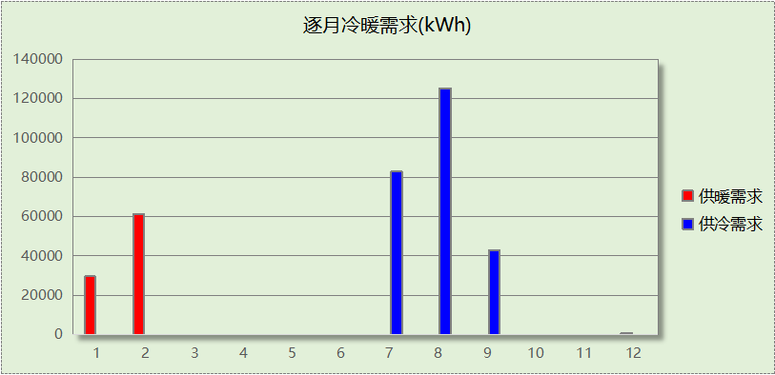

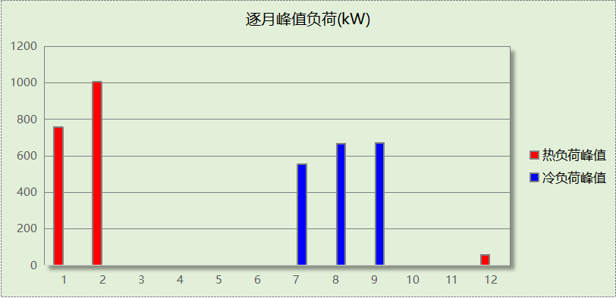

## 逐月电耗

注:供冷供暖为冷热源及输配水泵电耗，热水为扣减太阳能后电耗，所有数据单位kWh/㎡。

|  |  |  |  |  |  |  |  |  |
| --- | --- | --- | --- | --- | --- | --- | --- | --- |
| 月 | 供冷 | 供暖 | 空调风机 | 照明 | 插座设备 | 排风机 | 电梯 | 热水 |
| 1 | 0.00 | 0.47 | 0.45 | 1.10 | － | － | － | － |
| 2 | 0.00 | 0.98 | 0.35 | 0.86 | － |
| 3 | 0.00 | 0.00 | 0.00 | 1.05 | － |
| 4 | 0.00 | 0.00 | 0.00 | 1.05 | － |
| 5 | 0.00 | 0.00 | 0.00 | 1.10 | － |
| 6 | 0.00 | 0.00 | 0.00 | 0.96 | － |
| 7 | 1.33 | 0.00 | 0.39 | 1.15 | － |
| 8 | 2.01 | 0.00 | 0.45 | 1.10 | － |
| 9 | 0.69 | 0.00 | 0.20 | 1.00 | － |
| 10 | 0.00 | 0.00 | 0.00 | 1.01 | － |
| 11 | 0.00 | 0.00 | 0.00 | 1.05 | － |
| 12 | 0.00 | 0.00 | 0.04 | 1.10 | － |
| 合计 | 4.03 | 1.46 | 1.88 | 12.52 | － | － | － | － |

# 参照建筑

## 房间类型

### 房间参数表

|  |  |  |  |  |  |  |  |
| --- | --- | --- | --- | --- | --- | --- | --- |
| 房间类型 | 空调 温度℃ | 供暖 温度℃ | 新风量 | 渗透风 换气次数 | 人员密度 | 照明功率 密度 | 电器设备 功率 |
| 休闲空间 | 26 | 18 | 30(m3/h.人) | 0(次/h) | 4(㎡/人) | 9(W/㎡) | 13(W/㎡) |
| 会议室 | 26 | 18 | 14(m3/h.人) | 0(次/h) | 2.5(㎡/人) | 9(W/㎡) | 15(W/㎡) |
| 卫生间 | 28 | 18 | 20(m3/h.人) | 0(次/h) | 20(㎡/人) | 6(W/㎡) | 15(W/㎡) |
| 多媒体区 | 26 | 20 | 30(m3/h.人) | 0(次/h) | 2.5(㎡/人) | 15(W/㎡) | 15(W/㎡) |
| 大厅 | 26 | 18 | 20(m3/h.人) | 0(次/h) | 30(㎡/人) | 11(W/㎡) | 15(W/㎡) |
| 密集办公室 | 26 | 20 | 30(m3/h.人) | 0(次/h) | 4(㎡/人) | 15(W/㎡) | 20(W/㎡) |
| 展览馆 | 26 | 20 | 30(m3/h.人) | 0(次/h) | 8(㎡/人) | 9(W/㎡) | 15(W/㎡) |
| 报告厅 | 26 | 18 | 14(m3/h.人) | 0(次/h) | 2.5(㎡/人) | 9(W/㎡) | 15(W/㎡) |
| 普通办公室 | 26 | 20 | 30(m3/h.人) | 0(次/h) | 8(㎡/人) | 9(W/㎡) | 15(W/㎡) |
| 楼梯间 | － | － | 0(m3/h.人) | 0(次/h) | 0(人) | 6(W/㎡) | 15(W/㎡) |
| 电子信息机房 | 23 | 23 | 0(m3/h.人) | 0(次/h) | 20(㎡/人) | 16(W/㎡) | 15(W/㎡) |
| 视屏工作室 | 26 | 18 | 30(m3/h.人) | 0(次/h) | 8(㎡/人) | 15(W/㎡) | 15(W/㎡) |
| 走廊 | 26 | 16 | 20(m3/h.人) | 0(次/h) | 50(㎡/人) | 5(W/㎡) | 15(W/㎡) |
| 阅览室 | 26 | 18 | 30(m3/h.人) | 0(次/h) | 8(㎡/人) | 9(W/㎡) | 15(W/㎡) |
| 餐厅 | 26 | 18 | 30(m3/h.人) | 0(次/h) | 1(㎡/人) | 10(W/㎡) | 13(W/㎡) |
| 高档办公室 | 26 | 20 | 30(m3/h.人) | 0(次/h) | 8(㎡/人) | 15(W/㎡) | 15(W/㎡) |
| 高档超市 | 26 | 18 | 19(m3/h.人) | 0(次/h) | 2.5(㎡/人) | 17(W/㎡) | 13(W/㎡) |

### 作息时间表

同设计建筑

## 制冷系统

|  |  |  |
| --- | --- | --- |
| 负荷(kWh/a) | 系统综合性能系数 | 耗电(kWh/a) |
| 453879 | 2.50 | 129680 |

## 供暖系统

|  |  |  |
| --- | --- | --- |
| 负荷(kWh/a) | 系统综合性能系数 | 耗电(kWh/a) |
| 179038 | 1.80 | 78183 |

## 照明

|  |  |  |  |  |
| --- | --- | --- | --- | --- |
| 房间类型 | 单位面积电耗 (kWh/㎡) | 房间个数 | 房间合计面积 (㎡) | 合计电耗 (kWh) |
| 休闲空间 | 36.14 | 1 | 32 | 1174 |
| 会议室 | 15.12 | 2 | 131 | 1981 |
| 卫生间 | 10.08 | 6 | 263 | 2651 |
| 多媒体区 | 25.20 | 1 | 45 | 1126 |
| 密集办公室 | 25.20 | 2 | 100 | 2513 |
| 展览馆 | 15.12 | 7 | 682 | 10316 |
| 报告厅 | 15.12 | 1 | 390 | 5895 |
| 普通办公室 | 15.12 | 45 | 9516 | 143879 |
| 楼梯间 | 16.50 | 29 | 296 | 4877 |
| 电子信息机房 | 26.88 | 1 | 51 | 1365 |
| 视屏工作室 | 25.20 | 1 | 45 | 1126 |
| 走廊 | 11.81 | 7 | 3281 | 38761 |
| 阅览室 | 15.12 | 1 | 65 | 983 |
| 餐厅 | 40.15 | 1 | 195 | 7827 |
| 高档办公室 | 25.20 | 1 | 81 | 2046 |
| 高档超市 | 68.26 | 1 | 130 | 8870 |
| 总计 | | | | 235391 |

## 负荷分项统计

|  |  |  |  |  |  |  |
| --- | --- | --- | --- | --- | --- | --- |
| 分类 | 围护传热 | 室内得热 | 窗日射 | 新风/渗透 | 热回收 | 合计 |
| 供暖(kWh/㎡) | -11.84 | 7.01 | 1.24 | -7.92 | 0.00 | -11.51 |
| 供冷(kWh/㎡) | 0.18 | 12.59 | 2.13 | 14.27 | 0.00 | 29.17 |

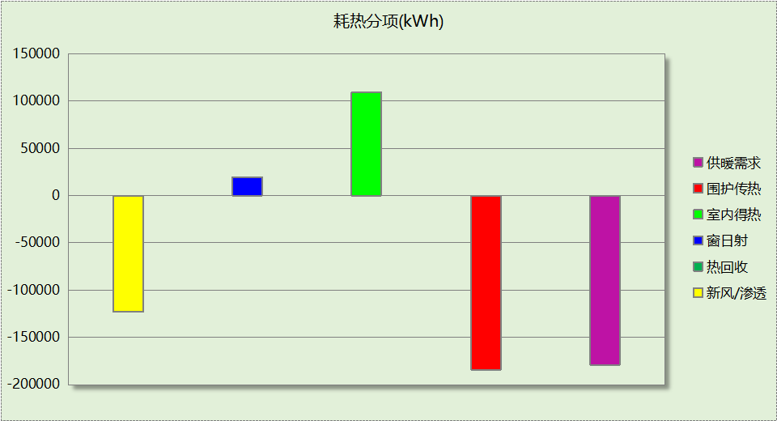

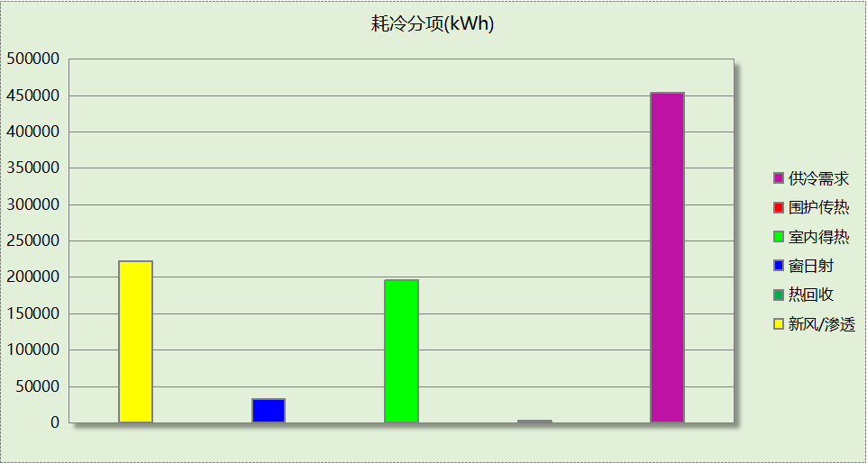

## 逐月负荷表

|  |  |  |  |  |  |  |
| --- | --- | --- | --- | --- | --- | --- |
| 月份 | 供暖(kWh) | 供冷(kWh) | 热负荷 峰值(kW) | 热负荷 峰值时刻 | 冷负荷 峰值(kW) | 冷负荷 峰值时刻 |
| 1月 | 77192 | 0 | 1002.986 | 1月2日8时 | 0.000 | -- |
| 2月 | 100287 | 0 | 1242.639 | 2月4日8时 | 0.000 | -- |
| 3月 | 0 | 0 | 0.000 | -- | 0.000 | -- |
| 4月 | 0 | 0 | 0.000 | -- | 0.000 | -- |
| 5月 | 0 | 0 | 0.000 | -- | 0.000 | -- |
| 6月 | 0 | 0 | 0.000 | -- | 0.000 | -- |
| 7月 | 0 | 150827 | 0.000 | -- | 1090.038 | 7月11日16时 |
| 8月 | 0 | 222596 | 0.000 | -- | 1191.286 | 8月22日14时 |
| 9月 | 0 | 80456 | 0.000 | -- | 1168.079 | 9月4日15时 |
| 10月 | 0 | 0 | 0.000 | -- | 0.000 | -- |
| 11月 | 0 | 0 | 0.000 | -- | 0.000 | -- |
| 12月 | 1560 | 0 | 244.555 | 12月31日8时 | 0.000 | -- |

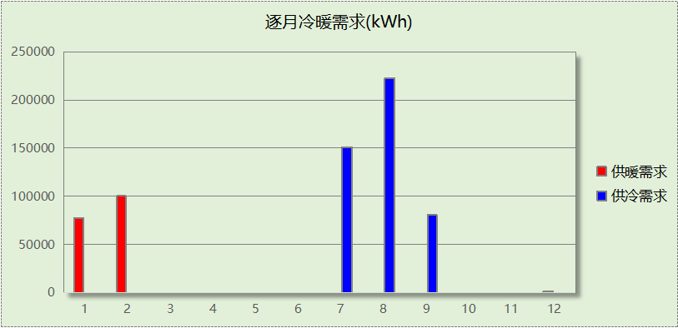

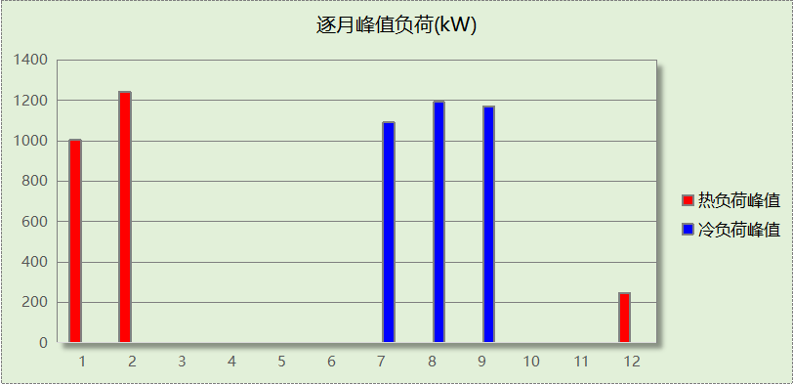

## 逐月电耗

注:供冷供暖为冷热源及输配水泵电耗，热水为扣减太阳能后电耗，所有数据单位kWh/㎡。

|  |  |  |  |  |  |  |  |  |
| --- | --- | --- | --- | --- | --- | --- | --- | --- |
| 月 | 供冷 | 供暖 | 空调风机 | 照明 | 插座设备 | 排风机 | 电梯 | 热水 |
| 1 | 0.00 | 1.42 | 0.00 | 1.33 | － | － | － | － |
| 2 | 0.00 | 1.84 | 0.00 | 1.04 | － |
| 3 | 0.00 | 0.00 | 0.00 | 1.27 | － |
| 4 | 0.00 | 0.00 | 0.00 | 1.27 | － |
| 5 | 0.00 | 0.00 | 0.00 | 1.33 | － |
| 6 | 0.00 | 0.00 | 0.00 | 1.16 | － |
| 7 | 2.77 | 0.00 | 0.00 | 1.38 | － |
| 8 | 4.09 | 0.00 | 0.00 | 1.33 | － |
| 9 | 1.48 | 0.00 | 0.00 | 1.21 | － |
| 10 | 0.00 | 0.00 | 0.00 | 1.22 | － |
| 11 | 0.00 | 0.00 | 0.00 | 1.27 | － |
| 12 | 0.00 | 0.03 | 0.00 | 1.33 | － |
| 合计 | 8.33 | 3.29 | 0.00 | 15.13 | － | － | － | － |

# 计算结果

|  |  |  |  |  |
| --- | --- | --- | --- | --- |
| 能耗分类 | 能耗子类 | 设计建筑  (kWh/㎡) | 参照建筑  (kWh/㎡) | 节能率  （%） |
| 建筑负荷 | 耗冷量 | 16.14 | 29.17 | 45.95% |
| 耗热量 | 5.85 | 11.51 |
| 冷热合计 | 21.98 | 40.67 |
| 热回收负荷 | 供冷 | 11.45 | － |  |
| 供暖 | 5.96 | － |  |
| 冷热合计 | 17.42 | － |  |
| 供冷电耗 | 中央冷源 | 0.00 | － | 51.59% |
| 冷却水泵 | 0.00 | － |
| 冷冻水泵 | 0.00 | － |
| 冷却塔 | 0.00 | － |
| 多联机/单元式空调 | 4.03 | － |
| 供冷合计 | 4.03 | 8.33 |
| 供暖电耗 | 中央热源 | 0.00 | － | 70.91% |
| 供暖水泵 | 0.00 | － |
| 热源侧水泵 | 0.00 | － |
| 多联机/单元式热泵 | 1.46 | － |
| 供暖合计 | 1.46 | 5.02 |
| 空调风机电耗 | 独立新排风 | 1.88 | － | - |
| 风机盘管 | 0.00 | － |
| 全空气系统 | 0.00 | － |
| 风机合计 | 1.88 | － |
| 采暖空调电耗 | | 7.38 | 13.36 | 44.78% |
| 照明电耗 | | 12.52 | 15.13 | 17.21% |
| 建筑综合电耗 | | 19.90 | 28.49 | 30.14% |

# 绿色建筑性能评估得分

|  |  |  |  |
| --- | --- | --- | --- |
| 标准条文 | 得分评价 | 节能率 | 得分 |
| 7.2.8 采取措施降低建筑能耗 | 建筑能耗相比国家现行有关建筑节能标准降低10%, 得5 分；降低20%,得10 分。 | 30.14% | 10 |
| 标准依据 | 《绿色建筑评价标准》GB-T 50378-2019 | | |

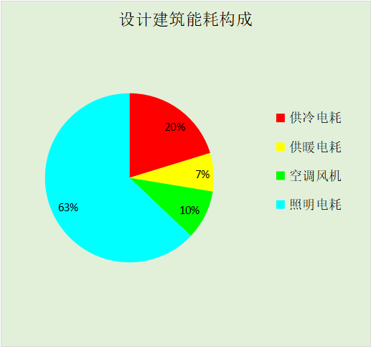

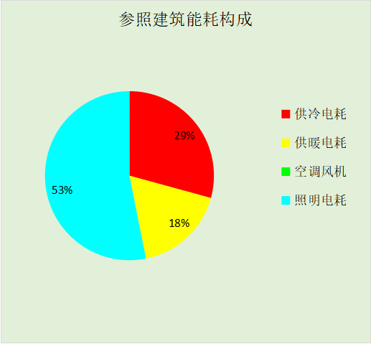

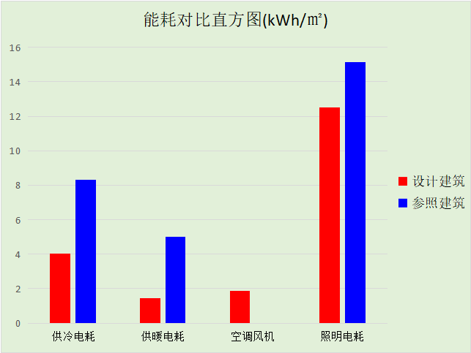

# 附录

## 工作日/节假日人员逐时在室率(%)

|  |  |  |  |  |  |  |  |  |  |  |  |  |  |  |  |  |  |  |  |  |  |  |  |  |
| --- | --- | --- | --- | --- | --- | --- | --- | --- | --- | --- | --- | --- | --- | --- | --- | --- | --- | --- | --- | --- | --- | --- | --- | --- |
| 房间类型 | 1 | 2 | 3 | 4 | 5 | 6 | 7 | 8 | 9 | 10 | 11 | 12 | 13 | 14 | 15 | 16 | 17 | 18 | 19 | 20 | 21 | 22 | 23 | 24 |
| 休闲空间 | 0 | 0 | 0 | 0 | 0 | 0 | 0 | 20 | 50 | 80 | 80 | 80 | 80 | 80 | 80 | 80 | 80 | 80 | 80 | 70 | 50 | 0 | 0 | 0 |
| 0 | 0 | 0 | 0 | 0 | 0 | 0 | 20 | 50 | 80 | 80 | 80 | 80 | 80 | 80 | 80 | 80 | 80 | 80 | 70 | 50 | 0 | 0 | 0 |
| 会议室 | 0 | 0 | 0 | 0 | 0 | 0 | 10 | 50 | 100 | 100 | 100 | 30 | 100 | 100 | 100 | 100 | 50 | 20 | 10 | 0 | 0 | 0 | 0 | 0 |
| 0 | 0 | 0 | 0 | 0 | 0 | 0 | 20 | 45 | 0 | 0 | 0 | 0 | 0 | 0 | 0 | 0 | 0 | 0 | 0 | 0 | 0 | 0 | 0 |
| 卫生间 | 0 | 0 | 0 | 0 | 0 | 0 | 10 | 50 | 100 | 100 | 100 | 30 | 100 | 100 | 100 | 100 | 50 | 20 | 10 | 0 | 0 | 0 | 0 | 0 |
| 0 | 0 | 0 | 0 | 0 | 0 | 0 | 20 | 45 | 0 | 0 | 0 | 0 | 0 | 0 | 0 | 0 | 0 | 0 | 0 | 0 | 0 | 0 | 0 |
| 多媒体区 | 0 | 0 | 0 | 0 | 0 | 0 | 10 | 50 | 100 | 100 | 100 | 30 | 100 | 100 | 100 | 100 | 50 | 20 | 10 | 0 | 0 | 0 | 0 | 0 |
| 0 | 0 | 0 | 0 | 0 | 0 | 0 | 20 | 45 | 0 | 0 | 0 | 0 | 0 | 0 | 0 | 0 | 0 | 0 | 0 | 0 | 0 | 0 | 0 |
| 大厅 | 0 | 0 | 0 | 0 | 0 | 0 | 10 | 50 | 100 | 100 | 100 | 30 | 100 | 100 | 100 | 100 | 50 | 20 | 10 | 0 | 0 | 0 | 0 | 0 |
| 0 | 0 | 0 | 0 | 0 | 0 | 0 | 20 | 45 | 0 | 0 | 0 | 0 | 0 | 0 | 0 | 0 | 0 | 0 | 0 | 0 | 0 | 0 | 0 |
| 密集办公室 | 0 | 0 | 0 | 0 | 0 | 0 | 10 | 50 | 100 | 100 | 100 | 30 | 100 | 100 | 100 | 100 | 50 | 20 | 10 | 0 | 0 | 0 | 0 | 0 |
| 0 | 0 | 0 | 0 | 0 | 0 | 0 | 20 | 45 | 0 | 0 | 0 | 0 | 0 | 0 | 0 | 0 | 0 | 0 | 0 | 0 | 0 | 0 | 0 |
| 展览馆 | 0 | 0 | 0 | 0 | 0 | 0 | 10 | 50 | 100 | 100 | 100 | 30 | 100 | 100 | 100 | 100 | 50 | 20 | 10 | 0 | 0 | 0 | 0 | 0 |
| 0 | 0 | 0 | 0 | 0 | 0 | 0 | 20 | 45 | 0 | 0 | 0 | 0 | 0 | 0 | 0 | 0 | 0 | 0 | 0 | 0 | 0 | 0 | 0 |
| 报告厅 | 0 | 0 | 0 | 0 | 0 | 0 | 10 | 50 | 100 | 100 | 100 | 30 | 100 | 100 | 100 | 100 | 50 | 20 | 10 | 0 | 0 | 0 | 0 | 0 |
| 0 | 0 | 0 | 0 | 0 | 0 | 0 | 20 | 45 | 0 | 0 | 0 | 0 | 0 | 0 | 0 | 0 | 0 | 0 | 0 | 0 | 0 | 0 | 0 |
| 普通办公室 | 0 | 0 | 0 | 0 | 0 | 0 | 10 | 50 | 100 | 100 | 100 | 30 | 100 | 100 | 100 | 100 | 50 | 20 | 10 | 0 | 0 | 0 | 0 | 0 |
| 0 | 0 | 0 | 0 | 0 | 0 | 0 | 20 | 45 | 0 | 0 | 0 | 0 | 0 | 0 | 0 | 0 | 0 | 0 | 0 | 0 | 0 | 0 | 0 |
| 楼梯间 | 0 | 0 | 0 | 0 | 0 | 0 | 0 | 20 | 50 | 80 | 80 | 80 | 80 | 80 | 80 | 80 | 80 | 80 | 80 | 70 | 50 | 0 | 0 | 0 |
| 0 | 0 | 0 | 0 | 0 | 0 | 0 | 0 | 0 | 0 | 0 | 0 | 0 | 0 | 0 | 0 | 0 | 0 | 0 | 0 | 0 | 0 | 0 | 0 |
| 电子信息机房 | 0 | 0 | 0 | 0 | 0 | 0 | 10 | 50 | 100 | 100 | 100 | 30 | 100 | 100 | 100 | 100 | 50 | 20 | 10 | 0 | 0 | 0 | 0 | 0 |
| 0 | 0 | 0 | 0 | 0 | 0 | 0 | 20 | 45 | 0 | 0 | 0 | 0 | 0 | 0 | 0 | 0 | 0 | 0 | 0 | 0 | 0 | 0 | 0 |
| 视屏工作室 | 0 | 0 | 0 | 0 | 0 | 0 | 10 | 50 | 100 | 100 | 100 | 30 | 100 | 100 | 100 | 100 | 50 | 20 | 10 | 0 | 0 | 0 | 0 | 0 |
| 0 | 0 | 0 | 0 | 0 | 0 | 0 | 20 | 45 | 0 | 0 | 0 | 0 | 0 | 0 | 0 | 0 | 0 | 0 | 0 | 0 | 0 | 0 | 0 |
| 走廊 | 0 | 0 | 0 | 0 | 0 | 0 | 10 | 50 | 95 | 95 | 95 | 80 | 80 | 95 | 95 | 95 | 95 | 30 | 30 | 0 | 0 | 0 | 0 | 0 |
| 0 | 0 | 0 | 0 | 0 | 0 | 0 | 0 | 0 | 0 | 0 | 0 | 0 | 0 | 0 | 0 | 0 | 0 | 0 | 0 | 0 | 0 | 0 | 0 |
| 阅览室 | 0 | 0 | 0 | 0 | 0 | 0 | 10 | 50 | 100 | 100 | 100 | 30 | 100 | 100 | 100 | 100 | 50 | 20 | 10 | 0 | 0 | 0 | 0 | 0 |
| 0 | 0 | 0 | 0 | 0 | 0 | 0 | 20 | 45 | 0 | 0 | 0 | 0 | 0 | 0 | 0 | 0 | 0 | 0 | 0 | 0 | 0 | 0 | 0 |
| 餐厅 | 0 | 0 | 0 | 0 | 0 | 0 | 0 | 20 | 50 | 80 | 80 | 80 | 80 | 80 | 80 | 80 | 80 | 80 | 80 | 70 | 50 | 0 | 0 | 0 |
| 0 | 0 | 0 | 0 | 0 | 0 | 0 | 20 | 50 | 80 | 80 | 80 | 80 | 80 | 80 | 80 | 80 | 80 | 80 | 70 | 50 | 0 | 0 | 0 |
| 高档办公室 | 0 | 0 | 0 | 0 | 0 | 0 | 10 | 50 | 100 | 100 | 100 | 30 | 100 | 100 | 100 | 100 | 50 | 20 | 10 | 0 | 0 | 0 | 0 | 0 |
| 0 | 0 | 0 | 0 | 0 | 0 | 0 | 20 | 45 | 0 | 0 | 0 | 0 | 0 | 0 | 0 | 0 | 0 | 0 | 0 | 0 | 0 | 0 | 0 |
| 高档超市 | 0 | 0 | 0 | 0 | 0 | 0 | 0 | 20 | 50 | 80 | 80 | 80 | 80 | 80 | 80 | 80 | 80 | 80 | 80 | 70 | 50 | 0 | 0 | 0 |
| 0 | 0 | 0 | 0 | 0 | 0 | 0 | 20 | 50 | 80 | 80 | 80 | 80 | 80 | 80 | 80 | 80 | 80 | 80 | 70 | 50 | 0 | 0 | 0 |

注：上行：工作日；下行：节假日

## 工作日/节假日照明开关时间表(%)

|  |  |  |  |  |  |  |  |  |  |  |  |  |  |  |  |  |  |  |  |  |  |  |  |  |
| --- | --- | --- | --- | --- | --- | --- | --- | --- | --- | --- | --- | --- | --- | --- | --- | --- | --- | --- | --- | --- | --- | --- | --- | --- |
| 房间类型 | 1 | 2 | 3 | 4 | 5 | 6 | 7 | 8 | 9 | 10 | 11 | 12 | 13 | 14 | 15 | 16 | 17 | 18 | 19 | 20 | 21 | 22 | 23 | 24 |
| 休闲空间 | 10 | 10 | 10 | 10 | 10 | 10 | 10 | 50 | 60 | 60 | 60 | 60 | 60 | 60 | 60 | 60 | 80 | 90 | 100 | 100 | 100 | 10 | 10 | 10 |
| 10 | 10 | 10 | 10 | 10 | 10 | 10 | 50 | 60 | 60 | 60 | 60 | 60 | 60 | 60 | 60 | 80 | 90 | 100 | 100 | 100 | 10 | 10 | 10 |
| 会议室 | 10 | 10 | 10 | 10 | 10 | 10 | 10 | 36 | 62 | 56 | 54 | 43 | 53 | 55 | 58 | 67 | 40 | 18 | 10 | 10 | 10 | 10 | 10 | 10 |
| 0 | 0 | 0 | 0 | 0 | 0 | 0 | 0 | 0 | 0 | 0 | 0 | 0 | 0 | 0 | 0 | 0 | 0 | 0 | 0 | 0 | 0 | 0 | 0 |
| 卫生间 | 10 | 10 | 10 | 10 | 10 | 10 | 10 | 36 | 62 | 56 | 54 | 43 | 53 | 55 | 58 | 67 | 40 | 18 | 10 | 10 | 10 | 10 | 10 | 10 |
| 0 | 0 | 0 | 0 | 0 | 0 | 0 | 0 | 0 | 0 | 0 | 0 | 0 | 0 | 0 | 0 | 0 | 0 | 0 | 0 | 0 | 0 | 0 | 0 |
| 多媒体区 | 10 | 10 | 10 | 10 | 10 | 10 | 10 | 36 | 62 | 56 | 54 | 43 | 53 | 55 | 58 | 67 | 40 | 18 | 10 | 10 | 10 | 10 | 10 | 10 |
| 0 | 0 | 0 | 0 | 0 | 0 | 0 | 0 | 0 | 0 | 0 | 0 | 0 | 0 | 0 | 0 | 0 | 0 | 0 | 0 | 0 | 0 | 0 | 0 |
| 大厅 | 10 | 10 | 10 | 10 | 10 | 10 | 10 | 36 | 62 | 56 | 54 | 43 | 53 | 55 | 58 | 67 | 40 | 18 | 10 | 10 | 10 | 10 | 10 | 10 |
| 0 | 0 | 0 | 0 | 0 | 0 | 0 | 0 | 0 | 0 | 0 | 0 | 0 | 0 | 0 | 0 | 0 | 0 | 0 | 0 | 0 | 0 | 0 | 0 |
| 密集办公室 | 10 | 10 | 10 | 10 | 10 | 10 | 10 | 36 | 62 | 56 | 54 | 43 | 53 | 55 | 58 | 67 | 40 | 18 | 10 | 10 | 10 | 10 | 10 | 10 |
| 0 | 0 | 0 | 0 | 0 | 0 | 0 | 0 | 0 | 0 | 0 | 0 | 0 | 0 | 0 | 0 | 0 | 0 | 0 | 0 | 0 | 0 | 0 | 0 |
| 展览馆 | 10 | 10 | 10 | 10 | 10 | 10 | 10 | 36 | 62 | 56 | 54 | 43 | 53 | 55 | 58 | 67 | 40 | 18 | 10 | 10 | 10 | 10 | 10 | 10 |
| 0 | 0 | 0 | 0 | 0 | 0 | 0 | 0 | 0 | 0 | 0 | 0 | 0 | 0 | 0 | 0 | 0 | 0 | 0 | 0 | 0 | 0 | 0 | 0 |
| 报告厅 | 10 | 10 | 10 | 10 | 10 | 10 | 10 | 36 | 62 | 56 | 54 | 43 | 53 | 55 | 58 | 67 | 40 | 18 | 10 | 10 | 10 | 10 | 10 | 10 |
| 0 | 0 | 0 | 0 | 0 | 0 | 0 | 0 | 0 | 0 | 0 | 0 | 0 | 0 | 0 | 0 | 0 | 0 | 0 | 0 | 0 | 0 | 0 | 0 |
| 普通办公室 | 10 | 10 | 10 | 10 | 10 | 10 | 10 | 36 | 62 | 56 | 54 | 43 | 53 | 55 | 58 | 67 | 40 | 18 | 10 | 10 | 10 | 10 | 10 | 10 |
| 0 | 0 | 0 | 0 | 0 | 0 | 0 | 0 | 0 | 0 | 0 | 0 | 0 | 0 | 0 | 0 | 0 | 0 | 0 | 0 | 0 | 0 | 0 | 0 |
| 楼梯间 | 10 | 10 | 10 | 10 | 10 | 10 | 10 | 50 | 60 | 60 | 60 | 60 | 60 | 60 | 60 | 60 | 80 | 90 | 100 | 100 | 100 | 10 | 10 | 10 |
| 0 | 0 | 0 | 0 | 0 | 0 | 0 | 0 | 0 | 0 | 0 | 0 | 0 | 0 | 0 | 0 | 0 | 0 | 0 | 0 | 0 | 0 | 0 | 0 |
| 电子信息机房 | 10 | 10 | 10 | 10 | 10 | 10 | 10 | 36 | 62 | 56 | 54 | 43 | 53 | 55 | 58 | 67 | 40 | 18 | 10 | 10 | 10 | 10 | 10 | 10 |
| 0 | 0 | 0 | 0 | 0 | 0 | 0 | 0 | 0 | 0 | 0 | 0 | 0 | 0 | 0 | 0 | 0 | 0 | 0 | 0 | 0 | 0 | 0 | 0 |
| 视屏工作室 | 10 | 10 | 10 | 10 | 10 | 10 | 10 | 36 | 62 | 56 | 54 | 43 | 53 | 55 | 58 | 67 | 40 | 18 | 10 | 10 | 10 | 10 | 10 | 10 |
| 0 | 0 | 0 | 0 | 0 | 0 | 0 | 0 | 0 | 0 | 0 | 0 | 0 | 0 | 0 | 0 | 0 | 0 | 0 | 0 | 0 | 0 | 0 | 0 |
| 走廊 | 0 | 0 | 0 | 0 | 0 | 0 | 10 | 50 | 95 | 95 | 95 | 80 | 80 | 95 | 95 | 95 | 95 | 30 | 30 | 0 | 0 | 0 | 0 | 0 |
| 0 | 0 | 0 | 0 | 0 | 0 | 0 | 0 | 0 | 0 | 0 | 0 | 0 | 0 | 0 | 0 | 0 | 0 | 0 | 0 | 0 | 0 | 0 | 0 |
| 阅览室 | 10 | 10 | 10 | 10 | 10 | 10 | 10 | 36 | 62 | 56 | 54 | 43 | 53 | 55 | 58 | 67 | 40 | 18 | 10 | 10 | 10 | 10 | 10 | 10 |
| 0 | 0 | 0 | 0 | 0 | 0 | 0 | 0 | 0 | 0 | 0 | 0 | 0 | 0 | 0 | 0 | 0 | 0 | 0 | 0 | 0 | 0 | 0 | 0 |
| 餐厅 | 10 | 10 | 10 | 10 | 10 | 10 | 10 | 50 | 60 | 60 | 60 | 60 | 60 | 60 | 60 | 60 | 80 | 90 | 100 | 100 | 100 | 10 | 10 | 10 |
| 10 | 10 | 10 | 10 | 10 | 10 | 10 | 50 | 60 | 60 | 60 | 60 | 60 | 60 | 60 | 60 | 80 | 90 | 100 | 100 | 100 | 10 | 10 | 10 |
| 高档办公室 | 10 | 10 | 10 | 10 | 10 | 10 | 10 | 36 | 62 | 56 | 54 | 43 | 53 | 55 | 58 | 67 | 40 | 18 | 10 | 10 | 10 | 10 | 10 | 10 |
| 0 | 0 | 0 | 0 | 0 | 0 | 0 | 0 | 0 | 0 | 0 | 0 | 0 | 0 | 0 | 0 | 0 | 0 | 0 | 0 | 0 | 0 | 0 | 0 |
| 高档超市 | 10 | 10 | 10 | 10 | 10 | 10 | 10 | 50 | 60 | 60 | 60 | 60 | 60 | 60 | 60 | 60 | 80 | 90 | 100 | 100 | 100 | 10 | 10 | 10 |
| 10 | 10 | 10 | 10 | 10 | 10 | 10 | 50 | 60 | 60 | 60 | 60 | 60 | 60 | 60 | 60 | 80 | 90 | 100 | 100 | 100 | 10 | 10 | 10 |

注：上行：工作日；下行：节假日

## 工作日/节假日设备逐时使用率(%)

|  |  |  |  |  |  |  |  |  |  |  |  |  |  |  |  |  |  |  |  |  |  |  |  |  |
| --- | --- | --- | --- | --- | --- | --- | --- | --- | --- | --- | --- | --- | --- | --- | --- | --- | --- | --- | --- | --- | --- | --- | --- | --- |
| 房间类型 | 1 | 2 | 3 | 4 | 5 | 6 | 7 | 8 | 9 | 10 | 11 | 12 | 13 | 14 | 15 | 16 | 17 | 18 | 19 | 20 | 21 | 22 | 23 | 24 |
| 休闲空间 | 0 | 0 | 0 | 0 | 0 | 0 | 0 | 30 | 50 | 80 | 80 | 80 | 80 | 80 | 80 | 80 | 80 | 80 | 80 | 70 | 50 | 0 | 0 | 0 |
| 0 | 0 | 0 | 0 | 0 | 0 | 0 | 30 | 50 | 80 | 80 | 80 | 80 | 80 | 80 | 80 | 80 | 80 | 80 | 70 | 50 | 0 | 0 | 0 |
| 会议室 | 0 | 0 | 0 | 0 | 0 | 0 | 10 | 50 | 100 | 100 | 100 | 100 | 100 | 100 | 100 | 100 | 50 | 20 | 10 | 0 | 0 | 0 | 0 | 0 |
| 0 | 0 | 0 | 0 | 0 | 0 | 0 | 0 | 0 | 0 | 0 | 0 | 0 | 0 | 0 | 0 | 0 | 0 | 0 | 0 | 0 | 0 | 0 | 0 |
| 卫生间 | 0 | 0 | 0 | 0 | 0 | 0 | 10 | 50 | 100 | 100 | 100 | 100 | 100 | 100 | 100 | 100 | 50 | 20 | 10 | 0 | 0 | 0 | 0 | 0 |
| 0 | 0 | 0 | 0 | 0 | 0 | 0 | 0 | 0 | 0 | 0 | 0 | 0 | 0 | 0 | 0 | 0 | 0 | 0 | 0 | 0 | 0 | 0 | 0 |
| 多媒体区 | 0 | 0 | 0 | 0 | 0 | 0 | 10 | 50 | 100 | 100 | 100 | 100 | 100 | 100 | 100 | 100 | 50 | 20 | 10 | 0 | 0 | 0 | 0 | 0 |
| 0 | 0 | 0 | 0 | 0 | 0 | 0 | 0 | 0 | 0 | 0 | 0 | 0 | 0 | 0 | 0 | 0 | 0 | 0 | 0 | 0 | 0 | 0 | 0 |
| 大厅 | 0 | 0 | 0 | 0 | 0 | 0 | 10 | 50 | 100 | 100 | 100 | 100 | 100 | 100 | 100 | 100 | 50 | 20 | 10 | 0 | 0 | 0 | 0 | 0 |
| 0 | 0 | 0 | 0 | 0 | 0 | 0 | 0 | 0 | 0 | 0 | 0 | 0 | 0 | 0 | 0 | 0 | 0 | 0 | 0 | 0 | 0 | 0 | 0 |
| 密集办公室 | 0 | 0 | 0 | 0 | 0 | 0 | 10 | 50 | 100 | 100 | 100 | 100 | 100 | 100 | 100 | 100 | 50 | 20 | 10 | 0 | 0 | 0 | 0 | 0 |
| 0 | 0 | 0 | 0 | 0 | 0 | 0 | 0 | 0 | 0 | 0 | 0 | 0 | 0 | 0 | 0 | 0 | 0 | 0 | 0 | 0 | 0 | 0 | 0 |
| 展览馆 | 0 | 0 | 0 | 0 | 0 | 0 | 10 | 50 | 100 | 100 | 100 | 100 | 100 | 100 | 100 | 100 | 50 | 20 | 10 | 0 | 0 | 0 | 0 | 0 |
| 0 | 0 | 0 | 0 | 0 | 0 | 0 | 0 | 0 | 0 | 0 | 0 | 0 | 0 | 0 | 0 | 0 | 0 | 0 | 0 | 0 | 0 | 0 | 0 |
| 报告厅 | 0 | 0 | 0 | 0 | 0 | 0 | 10 | 50 | 100 | 100 | 100 | 100 | 100 | 100 | 100 | 100 | 50 | 20 | 10 | 0 | 0 | 0 | 0 | 0 |
| 0 | 0 | 0 | 0 | 0 | 0 | 0 | 0 | 0 | 0 | 0 | 0 | 0 | 0 | 0 | 0 | 0 | 0 | 0 | 0 | 0 | 0 | 0 | 0 |
| 普通办公室 | 0 | 0 | 0 | 0 | 0 | 0 | 10 | 50 | 100 | 100 | 100 | 100 | 100 | 100 | 100 | 100 | 50 | 20 | 10 | 0 | 0 | 0 | 0 | 0 |
| 0 | 0 | 0 | 0 | 0 | 0 | 0 | 0 | 0 | 0 | 0 | 0 | 0 | 0 | 0 | 0 | 0 | 0 | 0 | 0 | 0 | 0 | 0 | 0 |
| 楼梯间 | 0 | 0 | 0 | 0 | 0 | 0 | 0 | 30 | 50 | 80 | 80 | 80 | 80 | 80 | 80 | 80 | 80 | 80 | 80 | 70 | 50 | 0 | 0 | 0 |
| 0 | 0 | 0 | 0 | 0 | 0 | 0 | 0 | 0 | 0 | 0 | 0 | 0 | 0 | 0 | 0 | 0 | 0 | 0 | 0 | 0 | 0 | 0 | 0 |
| 电子信息机房 | 0 | 0 | 0 | 0 | 0 | 0 | 10 | 50 | 100 | 100 | 100 | 100 | 100 | 100 | 100 | 100 | 50 | 20 | 10 | 0 | 0 | 0 | 0 | 0 |
| 0 | 0 | 0 | 0 | 0 | 0 | 0 | 0 | 0 | 0 | 0 | 0 | 0 | 0 | 0 | 0 | 0 | 0 | 0 | 0 | 0 | 0 | 0 | 0 |
| 视屏工作室 | 0 | 0 | 0 | 0 | 0 | 0 | 10 | 50 | 100 | 100 | 100 | 100 | 100 | 100 | 100 | 100 | 50 | 20 | 10 | 0 | 0 | 0 | 0 | 0 |
| 0 | 0 | 0 | 0 | 0 | 0 | 0 | 0 | 0 | 0 | 0 | 0 | 0 | 0 | 0 | 0 | 0 | 0 | 0 | 0 | 0 | 0 | 0 | 0 |
| 走廊 | 0 | 0 | 0 | 0 | 0 | 0 | 10 | 50 | 95 | 95 | 95 | 50 | 50 | 95 | 95 | 95 | 95 | 30 | 30 | 0 | 0 | 0 | 0 | 0 |
| 0 | 0 | 0 | 0 | 0 | 0 | 0 | 0 | 0 | 0 | 0 | 0 | 0 | 0 | 0 | 0 | 0 | 0 | 0 | 0 | 0 | 0 | 0 | 0 |
| 阅览室 | 0 | 0 | 0 | 0 | 0 | 0 | 10 | 50 | 100 | 100 | 100 | 100 | 100 | 100 | 100 | 100 | 50 | 20 | 10 | 0 | 0 | 0 | 0 | 0 |
| 0 | 0 | 0 | 0 | 0 | 0 | 0 | 0 | 0 | 0 | 0 | 0 | 0 | 0 | 0 | 0 | 0 | 0 | 0 | 0 | 0 | 0 | 0 | 0 |
| 餐厅 | 0 | 0 | 0 | 0 | 0 | 0 | 0 | 30 | 50 | 80 | 80 | 80 | 80 | 80 | 80 | 80 | 80 | 80 | 80 | 70 | 50 | 0 | 0 | 0 |
| 0 | 0 | 0 | 0 | 0 | 0 | 0 | 30 | 50 | 80 | 80 | 80 | 80 | 80 | 80 | 80 | 80 | 80 | 80 | 70 | 50 | 0 | 0 | 0 |
| 高档办公室 | 0 | 0 | 0 | 0 | 0 | 0 | 10 | 50 | 100 | 100 | 100 | 100 | 100 | 100 | 100 | 100 | 50 | 20 | 10 | 0 | 0 | 0 | 0 | 0 |
| 0 | 0 | 0 | 0 | 0 | 0 | 0 | 0 | 0 | 0 | 0 | 0 | 0 | 0 | 0 | 0 | 0 | 0 | 0 | 0 | 0 | 0 | 0 | 0 |
| 高档超市 | 0 | 0 | 0 | 0 | 0 | 0 | 0 | 30 | 50 | 80 | 80 | 80 | 80 | 80 | 80 | 80 | 80 | 80 | 80 | 70 | 50 | 0 | 0 | 0 |
| 0 | 0 | 0 | 0 | 0 | 0 | 0 | 30 | 50 | 80 | 80 | 80 | 80 | 80 | 80 | 80 | 80 | 80 | 80 | 70 | 50 | 0 | 0 | 0 |

注：上行：工作日；下行：节假日

## 工作日/节假日空调系统运行时间表(1:开,0:关)

采暖期：

|  |  |  |  |  |  |  |  |  |  |  |  |  |  |  |  |  |  |  |  |  |  |  |  |  |
| --- | --- | --- | --- | --- | --- | --- | --- | --- | --- | --- | --- | --- | --- | --- | --- | --- | --- | --- | --- | --- | --- | --- | --- | --- |
| 系统编号 | 1 | 2 | 3 | 4 | 5 | 6 | 7 | 8 | 9 | 10 | 11 | 12 | 13 | 14 | 15 | 16 | 17 | 18 | 19 | 20 | 21 | 22 | 23 | 24 |
| 默认 | 0 | 0 | 0 | 0 | 0 | 0 | 1 | 1 | 1 | 1 | 1 | 1 | 1 | 1 | 1 | 1 | 1 | 1 | 0 | 0 | 0 | 0 | 0 | 0 |
| 0 | 0 | 0 | 0 | 0 | 0 | 0 | 0 | 0 | 0 | 0 | 0 | 0 | 0 | 0 | 0 | 0 | 0 | 0 | 0 | 0 | 0 | 0 | 0 |
| 三层室内 | 0 | 0 | 0 | 0 | 0 | 0 | 1 | 1 | 1 | 1 | 1 | 1 | 1 | 1 | 1 | 1 | 1 | 1 | 0 | 0 | 0 | 0 | 0 | 0 |
| 0 | 0 | 0 | 0 | 0 | 0 | 0 | 0 | 0 | 0 | 0 | 0 | 0 | 0 | 0 | 0 | 0 | 0 | 0 | 0 | 0 | 0 | 0 | 0 |
| 三层工业 | 1 | 1 | 1 | 1 | 1 | 1 | 1 | 1 | 1 | 1 | 1 | 1 | 1 | 1 | 1 | 1 | 1 | 1 | 1 | 1 | 1 | 1 | 1 | 1 |
| 1 | 1 | 1 | 1 | 1 | 1 | 1 | 1 | 1 | 1 | 1 | 1 | 1 | 1 | 1 | 1 | 1 | 1 | 1 | 1 | 1 | 1 | 1 | 1 |
| 二层室内 | 0 | 0 | 0 | 0 | 0 | 0 | 1 | 1 | 1 | 1 | 1 | 1 | 1 | 1 | 1 | 1 | 1 | 1 | 0 | 0 | 0 | 0 | 0 | 0 |
| 0 | 0 | 0 | 0 | 0 | 0 | 0 | 0 | 0 | 0 | 0 | 0 | 0 | 0 | 0 | 0 | 0 | 0 | 0 | 0 | 0 | 0 | 0 | 0 |
| 二层工业 | 1 | 1 | 1 | 1 | 1 | 1 | 1 | 1 | 1 | 1 | 1 | 1 | 1 | 1 | 1 | 1 | 1 | 1 | 1 | 1 | 1 | 1 | 1 | 1 |
| 1 | 1 | 1 | 1 | 1 | 1 | 1 | 1 | 1 | 1 | 1 | 1 | 1 | 1 | 1 | 1 | 1 | 1 | 1 | 1 | 1 | 1 | 1 | 1 |

供冷期：

|  |  |  |  |  |  |  |  |  |  |  |  |  |  |  |  |  |  |  |  |  |  |  |  |  |
| --- | --- | --- | --- | --- | --- | --- | --- | --- | --- | --- | --- | --- | --- | --- | --- | --- | --- | --- | --- | --- | --- | --- | --- | --- |
| 系统编号 | 1 | 2 | 3 | 4 | 5 | 6 | 7 | 8 | 9 | 10 | 11 | 12 | 13 | 14 | 15 | 16 | 17 | 18 | 19 | 20 | 21 | 22 | 23 | 24 |
| 默认 | 0 | 0 | 0 | 0 | 0 | 0 | 1 | 1 | 1 | 1 | 1 | 1 | 1 | 1 | 1 | 1 | 1 | 1 | 0 | 0 | 0 | 0 | 0 | 0 |
| 0 | 0 | 0 | 0 | 0 | 0 | 0 | 0 | 0 | 0 | 0 | 0 | 0 | 0 | 0 | 0 | 0 | 0 | 0 | 0 | 0 | 0 | 0 | 0 |
| 三层室内 | 0 | 0 | 0 | 0 | 0 | 0 | 1 | 1 | 1 | 1 | 1 | 1 | 1 | 1 | 1 | 1 | 1 | 1 | 0 | 0 | 0 | 0 | 0 | 0 |
| 0 | 0 | 0 | 0 | 0 | 0 | 0 | 0 | 0 | 0 | 0 | 0 | 0 | 0 | 0 | 0 | 0 | 0 | 0 | 0 | 0 | 0 | 0 | 0 |
| 三层工业 | 1 | 1 | 1 | 1 | 1 | 1 | 1 | 1 | 1 | 1 | 1 | 1 | 1 | 1 | 1 | 1 | 1 | 1 | 1 | 1 | 1 | 1 | 1 | 1 |
| 1 | 1 | 1 | 1 | 1 | 1 | 1 | 1 | 1 | 1 | 1 | 1 | 1 | 1 | 1 | 1 | 1 | 1 | 1 | 1 | 1 | 1 | 1 | 1 |
| 二层室内 | 0 | 0 | 0 | 0 | 0 | 0 | 1 | 1 | 1 | 1 | 1 | 1 | 1 | 1 | 1 | 1 | 1 | 1 | 0 | 0 | 0 | 0 | 0 | 0 |
| 0 | 0 | 0 | 0 | 0 | 0 | 0 | 0 | 0 | 0 | 0 | 0 | 0 | 0 | 0 | 0 | 0 | 0 | 0 | 0 | 0 | 0 | 0 | 0 |
| 二层工业 | 1 | 1 | 1 | 1 | 1 | 1 | 1 | 1 | 1 | 1 | 1 | 1 | 1 | 1 | 1 | 1 | 1 | 1 | 1 | 1 | 1 | 1 | 1 | 1 |
| 1 | 1 | 1 | 1 | 1 | 1 | 1 | 1 | 1 | 1 | 1 | 1 | 1 | 1 | 1 | 1 | 1 | 1 | 1 | 1 | 1 | 1 | 1 | 1 |

注：上行：工作日；下行：节假日

## 工作日/节假日新风运行时间表(%)

|  |  |  |  |  |  |  |  |  |  |  |  |  |  |  |  |  |  |  |  |  |  |  |  |  |
| --- | --- | --- | --- | --- | --- | --- | --- | --- | --- | --- | --- | --- | --- | --- | --- | --- | --- | --- | --- | --- | --- | --- | --- | --- |
| 房间类型 | 1 | 2 | 3 | 4 | 5 | 6 | 7 | 8 | 9 | 10 | 11 | 12 | 13 | 14 | 15 | 16 | 17 | 18 | 19 | 20 | 21 | 22 | 23 | 24 |
| 休闲空间 | 0 | 0 | 0 | 0 | 0 | 0 | 0 | 100 | 100 | 100 | 100 | 100 | 100 | 100 | 100 | 100 | 100 | 100 | 100 | 100 | 100 | 0 | 0 | 0 |
| 0 | 0 | 0 | 0 | 0 | 0 | 0 | 100 | 100 | 100 | 100 | 100 | 100 | 100 | 100 | 100 | 100 | 100 | 100 | 100 | 100 | 0 | 0 | 0 |
| 会议室 | 0 | 0 | 0 | 0 | 0 | 0 | 100 | 100 | 100 | 100 | 100 | 100 | 100 | 100 | 100 | 100 | 100 | 100 | 0 | 0 | 0 | 0 | 0 | 0 |
| 0 | 0 | 0 | 0 | 0 | 0 | 0 | 0 | 0 | 0 | 0 | 0 | 0 | 0 | 0 | 0 | 0 | 0 | 0 | 0 | 0 | 0 | 0 | 0 |
| 卫生间 | 0 | 0 | 0 | 0 | 0 | 0 | 100 | 100 | 100 | 100 | 100 | 100 | 100 | 100 | 100 | 100 | 100 | 100 | 0 | 0 | 0 | 0 | 0 | 0 |
| 0 | 0 | 0 | 0 | 0 | 0 | 0 | 0 | 0 | 0 | 0 | 0 | 0 | 0 | 0 | 0 | 0 | 0 | 0 | 0 | 0 | 0 | 0 | 0 |
| 多媒体区 | 0 | 0 | 0 | 0 | 0 | 0 | 100 | 100 | 100 | 100 | 100 | 100 | 100 | 100 | 100 | 100 | 100 | 100 | 0 | 0 | 0 | 0 | 0 | 0 |
| 0 | 0 | 0 | 0 | 0 | 0 | 0 | 0 | 0 | 0 | 0 | 0 | 0 | 0 | 0 | 0 | 0 | 0 | 0 | 0 | 0 | 0 | 0 | 0 |
| 大厅 | 0 | 0 | 0 | 0 | 0 | 0 | 100 | 100 | 100 | 100 | 100 | 100 | 100 | 100 | 100 | 100 | 100 | 100 | 0 | 0 | 0 | 0 | 0 | 0 |
| 0 | 0 | 0 | 0 | 0 | 0 | 0 | 0 | 0 | 0 | 0 | 0 | 0 | 0 | 0 | 0 | 0 | 0 | 0 | 0 | 0 | 0 | 0 | 0 |
| 密集办公室 | 0 | 0 | 0 | 0 | 0 | 0 | 100 | 100 | 100 | 100 | 100 | 100 | 100 | 100 | 100 | 100 | 100 | 100 | 0 | 0 | 0 | 0 | 0 | 0 |
| 0 | 0 | 0 | 0 | 0 | 0 | 0 | 0 | 0 | 0 | 0 | 0 | 0 | 0 | 0 | 0 | 0 | 0 | 0 | 0 | 0 | 0 | 0 | 0 |
| 展览馆 | 0 | 0 | 0 | 0 | 0 | 0 | 100 | 100 | 100 | 100 | 100 | 100 | 100 | 100 | 100 | 100 | 100 | 100 | 0 | 0 | 0 | 0 | 0 | 0 |
| 0 | 0 | 0 | 0 | 0 | 0 | 0 | 0 | 0 | 0 | 0 | 0 | 0 | 0 | 0 | 0 | 0 | 0 | 0 | 0 | 0 | 0 | 0 | 0 |
| 报告厅 | 0 | 0 | 0 | 0 | 0 | 0 | 100 | 100 | 100 | 100 | 100 | 100 | 100 | 100 | 100 | 100 | 100 | 100 | 0 | 0 | 0 | 0 | 0 | 0 |
| 0 | 0 | 0 | 0 | 0 | 0 | 0 | 0 | 0 | 0 | 0 | 0 | 0 | 0 | 0 | 0 | 0 | 0 | 0 | 0 | 0 | 0 | 0 | 0 |
| 普通办公室 | 0 | 0 | 0 | 0 | 0 | 0 | 100 | 100 | 100 | 100 | 100 | 100 | 100 | 100 | 100 | 100 | 100 | 100 | 0 | 0 | 0 | 0 | 0 | 0 |
| 0 | 0 | 0 | 0 | 0 | 0 | 0 | 0 | 0 | 0 | 0 | 0 | 0 | 0 | 0 | 0 | 0 | 0 | 0 | 0 | 0 | 0 | 0 | 0 |
| 楼梯间 | 0 | 0 | 0 | 0 | 0 | 0 | 0 | 100 | 100 | 100 | 100 | 100 | 100 | 100 | 100 | 100 | 100 | 100 | 100 | 100 | 100 | 0 | 0 | 0 |
| 0 | 0 | 0 | 0 | 0 | 0 | 0 | 0 | 0 | 0 | 0 | 0 | 0 | 0 | 0 | 0 | 0 | 0 | 0 | 0 | 0 | 0 | 0 | 0 |
| 电子信息机房 | 0 | 0 | 0 | 0 | 0 | 0 | 100 | 100 | 100 | 100 | 100 | 100 | 100 | 100 | 100 | 100 | 100 | 100 | 0 | 0 | 0 | 0 | 0 | 0 |
| 0 | 0 | 0 | 0 | 0 | 0 | 0 | 0 | 0 | 0 | 0 | 0 | 0 | 0 | 0 | 0 | 0 | 0 | 0 | 0 | 0 | 0 | 0 | 0 |
| 视屏工作室 | 0 | 0 | 0 | 0 | 0 | 0 | 100 | 100 | 100 | 100 | 100 | 100 | 100 | 100 | 100 | 100 | 100 | 100 | 0 | 0 | 0 | 0 | 0 | 0 |
| 0 | 0 | 0 | 0 | 0 | 0 | 0 | 0 | 0 | 0 | 0 | 0 | 0 | 0 | 0 | 0 | 0 | 0 | 0 | 0 | 0 | 0 | 0 | 0 |
| 走廊 | 0 | 0 | 0 | 0 | 0 | 0 | 100 | 100 | 100 | 100 | 100 | 100 | 100 | 100 | 100 | 100 | 100 | 100 | 0 | 0 | 0 | 0 | 0 | 0 |
| 0 | 0 | 0 | 0 | 0 | 0 | 0 | 0 | 0 | 0 | 0 | 0 | 0 | 0 | 0 | 0 | 0 | 0 | 0 | 0 | 0 | 0 | 0 | 0 |
| 阅览室 | 0 | 0 | 0 | 0 | 0 | 0 | 100 | 100 | 100 | 100 | 100 | 100 | 100 | 100 | 100 | 100 | 100 | 100 | 0 | 0 | 0 | 0 | 0 | 0 |
| 0 | 0 | 0 | 0 | 0 | 0 | 0 | 0 | 0 | 0 | 0 | 0 | 0 | 0 | 0 | 0 | 0 | 0 | 0 | 0 | 0 | 0 | 0 | 0 |
| 餐厅 | 0 | 0 | 0 | 0 | 0 | 0 | 0 | 100 | 100 | 100 | 100 | 100 | 100 | 100 | 100 | 100 | 100 | 100 | 100 | 100 | 100 | 0 | 0 | 0 |
| 0 | 0 | 0 | 0 | 0 | 0 | 0 | 100 | 100 | 100 | 100 | 100 | 100 | 100 | 100 | 100 | 100 | 100 | 100 | 100 | 100 | 0 | 0 | 0 |
| 高档办公室 | 0 | 0 | 0 | 0 | 0 | 0 | 100 | 100 | 100 | 100 | 100 | 100 | 100 | 100 | 100 | 100 | 100 | 100 | 0 | 0 | 0 | 0 | 0 | 0 |
| 0 | 0 | 0 | 0 | 0 | 0 | 0 | 0 | 0 | 0 | 0 | 0 | 0 | 0 | 0 | 0 | 0 | 0 | 0 | 0 | 0 | 0 | 0 | 0 |
| 高档超市 | 0 | 0 | 0 | 0 | 0 | 0 | 0 | 100 | 100 | 100 | 100 | 100 | 100 | 100 | 100 | 100 | 100 | 100 | 100 | 100 | 100 | 0 | 0 | 0 |
| 0 | 0 | 0 | 0 | 0 | 0 | 0 | 100 | 100 | 100 | 100 | 100 | 100 | 100 | 100 | 100 | 100 | 100 | 100 | 100 | 100 | 0 | 0 | 0 |

注：上行：工作日；下行：节假日