**新建项目**

**全年负荷计算书**

|  |  |
| --- | --- |
| 工程名称 | 新建项目 |
| 设计编号 |  |
| 建设单位 |  |
| 设计单位 |  |
| 计 算 人 |  |
| 校 对 人 |  |
| 审 核 人 |  |
| 计算日期 | 2024年12月19日 |



|  |  |
| --- | --- |
| 采用软件 | 暖通负荷BECH2024 |
| 软件版本 | 20240430(SP1) |
| 研发单位 | 北京绿建软件股份有限公司 |
| 正版授权码 | T13251232807 |

**目 录**

1 建筑概况 1

2 气象数据 1

2.1 气象地点 1

2.2 逐日干球温度表 1

2.3 逐月辐照量表 2

2.4 峰值工况 2

3 软件介绍 2

4 围护结构 2

4.1 屋顶构造 2

4.1.1 屋顶构造一 2

4.2 外墙构造 3

4.2.1 外墙构造一 3

4.3 楼板构造 3

4.3.1 楼板构造一 3

4.4 周边地面构造 3

4.4.1 周边地面构造一 3

4.5 非周边地面构造 4

4.5.1 非周边地面构造一 4

4.6 门构造 4

4.7 窗构造 4

5 房间类型 4

5.1 房间参数表 4

5.2 作息时间表 5

6 系统设置 5

6.1 系统划分 5

6.2 运行时间表 5

7 计算结果 5

7.1 模拟周期 5

7.2 全年冷暖需求 5

7.3 负荷分项统计 6

7.4 逐月负荷表 7

8 附录 9

# 建筑概况

|  |  |  |
| --- | --- | --- |
| 地理位置 | 四川-广安 | |
| 气候分区 | 夏热冬冷A区 | |
| 北纬 | 30.46 | |
| 东经 | 106.63 | |
| 建筑名称 | 新建项目 | |
| 建筑类型 | 公共建筑 |  |
| 建筑面积 | 地上 8900.07 ㎡ | 地下 0.00 ㎡ |
| 建筑高度 | 地上 19.04 m | 地下0.00 |
| 建筑层数 | 地上 4 | 地下 0 |
| 北向角度 | 52° | |

# 气象数据

## 气象地点

四川-南充, 《建筑节能气象参数标准》JGJ346-2014

## 逐日干球温度表

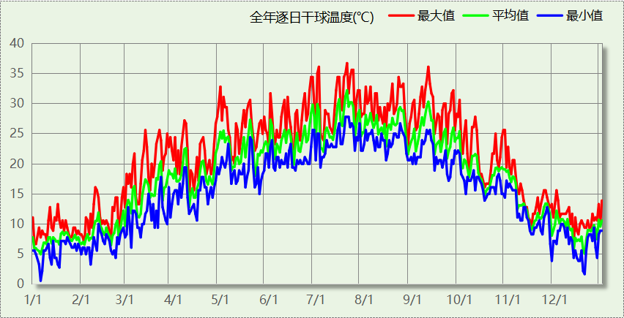

## 逐月辐照量表

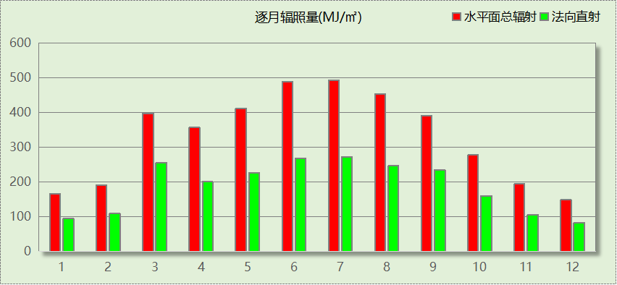

## 峰值工况

|  |  |  |  |  |  |
| --- | --- | --- | --- | --- | --- |
| 气象数据 | 时刻 | 干球温度(℃) | 湿球温度(℃) | 含湿量(g/kg) | 焓值(kj/kg) |
| 最热 | 07月20日15时 | 36.7 | 27.2 | 19.9 | 87.9 |
| 最冷 | 01月05日05时 | 0.6 | 0.6 | 4.1 | 10.8 |

# 软件介绍

本报告采用的软件为绿建暖通负荷BECH2024，该软件紧密结合暖通和节能设计规范、可根据项目实际情况建立建筑热工模型，并可对围护结构材料、房间内扰发热、作息时间表、热回收方式等参数进行设置。

软件包含全国各地典型气象年数据，内置DOE2.1E内核，对于建筑的逐时负荷进行动态模拟，既可以模拟8760小时理想负荷，也可以根据设定好的采暖期/空调期进行逐时模拟。

软件还支持分析全年建筑能耗的来源构成，依据日射得热、新风负荷、围护传热和内扰得热进行归类分项，生成设计建筑全年负荷计算报告书，提供详实的数据和多样的图表，为设计师在设备选型、制定运行策略等方面提供参考和帮助。

# 围护结构

## 屋顶构造

### 屋顶构造一

|  |  |  |  |  |  |  |
| --- | --- | --- | --- | --- | --- | --- |
| 材料名称 （由上到下） | 厚度δ | 导热系数λ | 蓄热系数S | 修正 系数 | 热阻R | 热惰性 指标 |
| (mm) | W/(m.K) | W/(㎡.K) | α | (㎡K)/W | D=R*S |
| 黏土陶粒混凝土(ρ=1000) | 40 | 0.220 | 4.080 | 1.00 | 0.182 | 0.742 |
| 挤塑聚苯乙烯泡沫塑料（带表皮） | 20 | 0.030 | 0.340 | 1.20 | 0.556 | 0.227 |
| 无机保温砂浆（ρ=400） | 20 | 0.140 | 2.870 | 1.00 | 0.143 | 0.410 |
| 加气混凝土、泡沫混凝土(ρ=700) | 80 | 0.180 | 3.100 | 1.00 | 0.444 | 1.378 |
| 黏土陶粒混凝土(ρ=1000) | 120 | 0.220 | 4.080 | 1.00 | 0.545 | 2.225 |
| 无机保温砂浆（ρ=600） | 20 | 0.180 | 2.870 | 1.00 | 0.111 | 0.319 |
| 各层之和∑ | 300 | － | － | － | 1.981 | 5.301 |
| 传热系数K=1/(0.15+∑R) | 0.47 | | | | | |

## 外墙构造

### 外墙构造一

|  |  |  |  |  |  |  |
| --- | --- | --- | --- | --- | --- | --- |
| 材料名称 （由外到内） | 厚度δ | 导热系数λ | 蓄热系数S | 修正 系数 | 热阻R | 热惰性 指标 |
| (mm) | W/(m.K) | W/(㎡.K) | α | (㎡K)/W | D=R*S |
| 无机保温砂浆（ρ=400） | 20 | 0.140 | 2.870 | 1.00 | 0.143 | 0.410 |
| 挤塑聚苯乙烯泡沫塑料（带表皮） | 20 | 0.030 | 0.340 | 1.20 | 0.556 | 0.227 |
| 无机保温砂浆（ρ=400） | 20 | 0.140 | 2.870 | 1.00 | 0.143 | 0.410 |
| 黏土陶粒混凝土(ρ=1000) | 200 | 0.220 | 4.080 | 1.00 | 0.909 | 3.709 |
| 无机保温砂浆（ρ=600） | 20 | 0.180 | 2.870 | 1.00 | 0.111 | 0.319 |
| 各层之和∑ | 280 | － | － | － | 1.861 | 5.075 |
| 传热系数K=1/(0.15+∑R) | 0.50 | | | | | |

## 楼板构造

### 楼板构造一

|  |  |  |  |  |  |  |
| --- | --- | --- | --- | --- | --- | --- |
| 材料名称 | 厚度δ | 导热系数λ | 蓄热系数S | 修正 系数 | 热阻R | 热惰性 指标 |
| (mm) | W/(m.K) | W/(㎡.K) | α | (㎡K)/W | D=R*S |
| 无机保温砂浆（ρ=400） | 20 | 0.140 | 2.870 | 1.00 | 0.143 | 0.410 |
| 黏土陶粒混凝土(ρ=1000) | 120 | 0.220 | 4.080 | 1.00 | 0.545 | 2.225 |
| 无机保温砂浆（ρ=600） | 20 | 0.180 | 2.870 | 1.00 | 0.111 | 0.319 |
| 各层之和∑ | 160 | － | － | － | 0.799 | 2.954 |
| 传热系数K=1/(0.22+∑R) | 0.98 | | | | | |

## 周边地面构造

### 周边地面构造一

|  |  |  |  |  |  |  |
| --- | --- | --- | --- | --- | --- | --- |
| 材料名称 | 厚度δ | 导热系数λ | 蓄热系数S | 修正 系数 | 热阻R | 热惰性 指标 |
| (mm) | W/(m.K) | W/(㎡.K) | α | (㎡K)/W | D=R*S |
| 无机保温砂浆（ρ=400） | 20 | 0.140 | 2.870 | 1.00 | 0.143 | 0.410 |
| 黏土陶粒混凝土(ρ=1000) | 120 | 0.220 | 4.080 | 1.00 | 0.545 | 2.225 |
| 各层之和∑ | 140 | － | － | － | 0.688 | 2.635 |
| 传热系数K=1/(0.11+∑R) | 0.38 | | | | | |

## 非周边地面构造

### 非周边地面构造一

|  |  |  |  |  |  |  |
| --- | --- | --- | --- | --- | --- | --- |
| 材料名称 | 厚度δ | 导热系数λ | 蓄热系数S | 修正 系数 | 热阻R | 热惰性 指标 |
| (mm) | W/(m.K) | W/(㎡.K) | α | (㎡K)/W | D=R*S |
| 无机保温砂浆（ρ=400） | 20 | 0.140 | 2.870 | 1.00 | 0.143 | 0.410 |
| 黏土陶粒混凝土(ρ=1000) | 120 | 0.220 | 4.080 | 1.00 | 0.545 | 2.225 |
| 各层之和∑ | 140 | － | － | － | 0.688 | 2.635 |
| 传热系数K=1/(0.11+∑R) | 0.25 | | | | | |

## 门构造

|  |  |  |  |
| --- | --- | --- | --- |
| 序号 | 构造名称 | 传热系数 | 备注 |
| 1 | 保温门（多功能门） | 1.972 |  |

## 窗构造

|  |  |  |  |  |  |
| --- | --- | --- | --- | --- | --- |
| 序号 | 构造名称 | 传热系数 | 窗遮阳系数 | 可见光透射比 | 备注 |
| 1 | 170系列内平开外百叶遮阳一体化集成窗[5Low-E+6A+5+外百叶] | 2.400 | 0.600 | 0.720 |  |
| 2 | 隔热金属型材(窗框比20%) 6中透光Low-E+12氩气+6透明 | 2.100 | 0.400 | 0.620 |  |

# 房间类型

## 房间参数表

|  |  |  |  |  |  |  |
| --- | --- | --- | --- | --- | --- | --- |
| 房间类型 | 空调温度 ℃ | 供暖温度 ℃ | 新风量 | 人员密度 | 照明功率 密度 | 电器设备 功率 |
| 办公-普通办公室 | 26 | 20 | 30(m^3/h.人) | 8(m^2/人) | 8(W/m^2) | 15(W/m^2) |
| 办公室 | 25 | 20 | 30(m^3/h.人) | 4(m^2/人) | 8(W/m^2) | 10(W/m^2) |
| 化妆室 | 26 | 20 | 30(m^3/h.人) | 4(m^2/人) | 25(W/m^2) | 10(W/m^2) |
| 卫生间 | 26 | 20 | 30(m^3/h.人) | 20(m^2/人) | 3(W/m^2) | 10(W/m^2) |
| 大厅 | 26 | 20 | 35(m^3/h.人) | 7(m^2/人) | 7.8(W/m^2) | 10(W/m^2) |
| 影音设备室 | 23 | 20 | 0(m^3/h.人) | 0(人) | 3.5(W/m^2) | 10(W/m^2) |
| 排练厅 | 25 | 20 | 50(m^3/h.人) | 1.5(m^2/人) | 25(W/m^2) | 10(W/m^2) |
| 更衣室 | 26 | 22 | 30(m^3/h.人) | 4(m^2/人) | 25(W/m^2) | 10(W/m^2) |
| 楼梯间 | 26 | 20 | 30(m^3/h.人) | 4(m^2/人) | 25(W/m^2) | 10(W/m^2) |
| 空房间 | － | － | 20(m^3/h.人) | 0(人) | 0(W/m^2) | 0(W/m^2) |
| 观众休息厅 | 25 | 20 | 50(m^3/h.人) | 4.5(m^2/人) | 25(W/m^2) | 10(W/m^2) |
| 观众厅 | 25 | 20 | 35(m^3/h.人) | 0.75(m^2/人) | 20(W/m^2) | 10(W/m^2) |
| 设备间 | － | － | 0(次/h) | 0(人) | 6(W/m^2) | 15(W/m^2) |
| 调光室 | 28 | 20 | 0(m^3/h.人) | 0(人) | 3.5(W/m^2) | 10(W/m^2) |
| 走廊 | 26 | 20 | 30(m^3/h.人) | 50(m^2/人) | 2.3(W/m^2) | 10(W/m^2) |

## 作息时间表

详见附录

# 系统设置

## 系统划分

|  |  |  |  |  |  |  |
| --- | --- | --- | --- | --- | --- | --- |
| 系统编号 | 热回收 类型 | 启动 条件 | 回收 效率 | 排风 比例 | 面积(m2) | 包含的房间 |
| Sys | 全热回收 | 温差启动 冷:≥5.0(℃) 暖:≥5.0(℃) | 冷:0.50, 暖:0.55 | 1.00 | 14823.75 | 所有房间 |

## 运行时间表

详见附录

# 计算结果

## 模拟周期

供冷季(6.14-8.31) 供暖季(11.30-2.28)

## 全年冷暖需求

|  |  |  |  |  |
| --- | --- | --- | --- | --- |
| 系统名称\负荷 | 供暖需求 (kWh) | 供暖指标 (kWh/㎡·a) | 供冷需求 (kWh) | 供冷指标 (kWh/㎡·a) |
| 建筑总计 | 1989 | 0.22 | 1702174 | 191.25 |

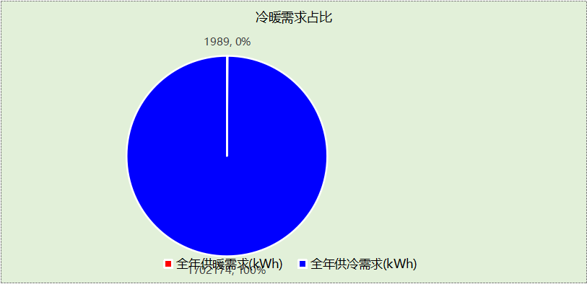

## 负荷分项统计

|  |  |  |  |  |  |  |
| --- | --- | --- | --- | --- | --- | --- |
| 分类 | 围护传热 | 室内得热 | 窗日射 | 新风/渗透 | 热回收 | 合计 |
| 供暖(kWh/㎡) | 9.37 | 19.66 | 0.62 | -46.14 | 16.27 | -0.22 |
| 供冷(kWh/㎡) | 25.18 | 59.39 | 6.94 | 119.07 | -19.32 | 191.25 |

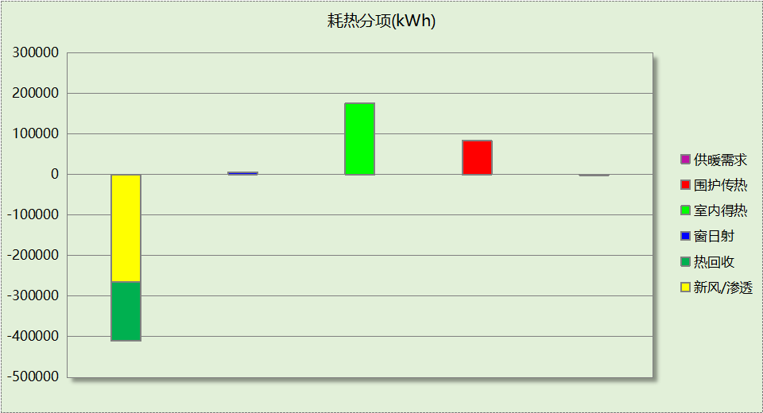

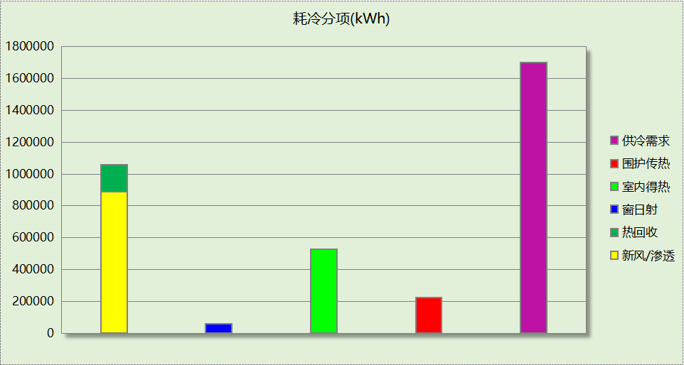

## 逐月负荷表

|  |  |  |  |  |  |  |
| --- | --- | --- | --- | --- | --- | --- |
| 月份 | 供暖(kWh) | 供冷(kWh) | 热负荷 峰值(kW) | 热负荷 峰值时刻 | 冷负荷 峰值(kW) | 冷负荷 峰值时刻 |
| 1月 | 1543 | 0 | 193.175 | 1月2日9时 | 0.000 | -- |
| 2月 | 321 | 0 | 67.625 | 2月14日9时 | 0.000 | -- |
| 3月 | 0 | 0 | 0.000 | -- | 0.000 | -- |
| 4月 | 0 | 0 | 0.000 | -- | 0.000 | -- |
| 5月 | 0 | 0 | 0.000 | -- | 0.000 | -- |
| 6月 | 0 | 367668 | 0.000 | -- | 5450.391 | 6月14日9时 |
| 7月 | 0 | 655832 | 0.000 | -- | 2679.329 | 7月23日9时 |
| 8月 | 0 | 678675 | 0.000 | -- | 2394.198 | 8月5日9时 |
| 9月 | 0 | 0 | 0.000 | -- | 0.000 | -- |
| 10月 | 0 | 0 | 0.000 | -- | 0.000 | -- |
| 11月 | 0 | 0 | 0.000 | -- | 0.000 | -- |
| 12月 | 125 | 0 | 39.153 | 12月16日9时 | 0.000 | -- |

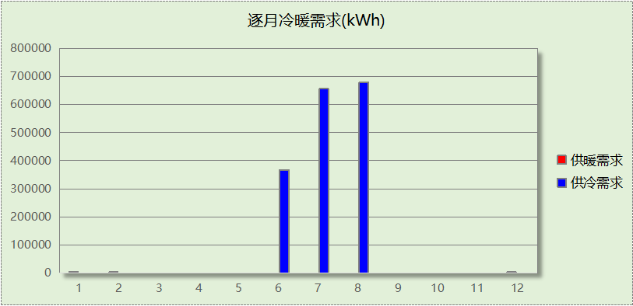

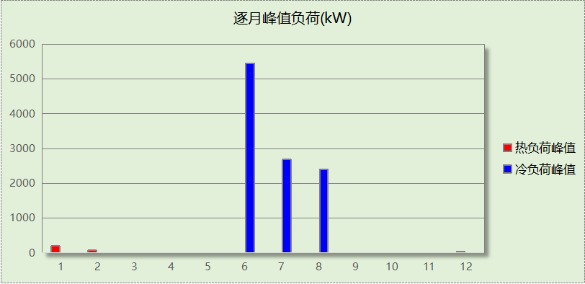

# 附录

**工作日/节假日人员逐时在室率(%)**

|  |  |  |  |  |  |  |  |  |  |  |  |  |  |  |  |  |  |  |  |  |  |  |  |  |
| --- | --- | --- | --- | --- | --- | --- | --- | --- | --- | --- | --- | --- | --- | --- | --- | --- | --- | --- | --- | --- | --- | --- | --- | --- |
| 房间类型 | 1 | 2 | 3 | 4 | 5 | 6 | 7 | 8 | 9 | 10 | 11 | 12 | 13 | 14 | 15 | 16 | 17 | 18 | 19 | 20 | 21 | 22 | 23 | 24 |
| 办公-普通办公室 | 0 | 0 | 0 | 0 | 0 | 0 | 10 | 50 | 100 | 100 | 100 | 30 | 100 | 100 | 100 | 100 | 50 | 20 | 10 | 0 | 0 | 0 | 0 | 0 |
| 0 | 0 | 0 | 0 | 0 | 0 | 0 | 20 | 45 | 0 | 0 | 0 | 0 | 0 | 0 | 0 | 0 | 0 | 0 | 0 | 0 | 0 | 0 | 0 |
| 办公室 | 0 | 0 | 0 | 0 | 0 | 0 | 0 | 0 | 10 | 90 | 90 | 90 | 90 | 90 | 90 | 90 | 90 | 90 | 90 | 90 | 90 | 90 | 10 | 0 |
| 0 | 0 | 0 | 0 | 0 | 0 | 0 | 0 | 10 | 90 | 90 | 90 | 90 | 90 | 90 | 90 | 90 | 90 | 90 | 90 | 90 | 90 | 10 | 0 |
| 化妆室 | 0 | 0 | 0 | 0 | 0 | 0 | 0 | 0 | 10 | 90 | 90 | 90 | 90 | 90 | 90 | 90 | 90 | 90 | 90 | 90 | 90 | 90 | 10 | 0 |
| 0 | 0 | 0 | 0 | 0 | 0 | 0 | 0 | 10 | 90 | 90 | 90 | 90 | 90 | 90 | 90 | 90 | 90 | 90 | 90 | 90 | 90 | 10 | 0 |
| 卫生间 | 0 | 0 | 0 | 0 | 0 | 0 | 0 | 0 | 10 | 90 | 90 | 90 | 90 | 90 | 90 | 90 | 90 | 90 | 90 | 90 | 90 | 90 | 10 | 0 |
| 0 | 0 | 0 | 0 | 0 | 0 | 0 | 0 | 10 | 90 | 90 | 90 | 90 | 90 | 90 | 90 | 90 | 90 | 90 | 90 | 90 | 90 | 10 | 0 |
| 大厅 | 0 | 0 | 0 | 0 | 0 | 0 | 0 | 0 | 10 | 90 | 90 | 90 | 90 | 90 | 90 | 90 | 90 | 90 | 90 | 90 | 90 | 90 | 10 | 0 |
| 0 | 0 | 0 | 0 | 0 | 0 | 0 | 0 | 10 | 90 | 90 | 90 | 90 | 90 | 90 | 90 | 90 | 90 | 90 | 90 | 90 | 90 | 10 | 0 |
| 影音设备室 | 0 | 0 | 0 | 0 | 0 | 0 | 0 | 0 | 10 | 90 | 90 | 90 | 90 | 90 | 90 | 90 | 90 | 90 | 90 | 90 | 90 | 90 | 10 | 0 |
| 0 | 0 | 0 | 0 | 0 | 0 | 0 | 0 | 10 | 90 | 90 | 90 | 90 | 90 | 90 | 90 | 90 | 90 | 90 | 90 | 90 | 90 | 10 | 0 |
| 排练厅 | 0 | 0 | 0 | 0 | 0 | 0 | 0 | 0 | 10 | 90 | 90 | 90 | 90 | 90 | 90 | 90 | 90 | 90 | 90 | 90 | 90 | 90 | 10 | 0 |
| 0 | 0 | 0 | 0 | 0 | 0 | 0 | 0 | 10 | 90 | 90 | 90 | 90 | 90 | 90 | 90 | 90 | 90 | 90 | 90 | 90 | 90 | 10 | 0 |
| 更衣室 | 0 | 0 | 0 | 0 | 0 | 0 | 0 | 0 | 10 | 90 | 90 | 90 | 90 | 90 | 90 | 90 | 90 | 90 | 90 | 90 | 90 | 90 | 10 | 0 |
| 0 | 0 | 0 | 0 | 0 | 0 | 0 | 0 | 10 | 90 | 90 | 90 | 90 | 90 | 90 | 90 | 90 | 90 | 90 | 90 | 90 | 90 | 10 | 0 |
| 楼梯间 | 0 | 0 | 0 | 0 | 0 | 0 | 0 | 0 | 10 | 90 | 90 | 90 | 90 | 90 | 90 | 90 | 90 | 90 | 90 | 90 | 90 | 90 | 10 | 0 |
| 0 | 0 | 0 | 0 | 0 | 0 | 0 | 0 | 10 | 90 | 90 | 90 | 90 | 90 | 90 | 90 | 90 | 90 | 90 | 90 | 90 | 90 | 10 | 0 |
| 空房间 | 0 | 0 | 0 | 0 | 0 | 0 | 0 | 20 | 50 | 80 | 80 | 80 | 80 | 80 | 80 | 80 | 80 | 80 | 80 | 70 | 50 | 0 | 0 | 0 |
| 0 | 0 | 0 | 0 | 0 | 0 | 0 | 20 | 50 | 80 | 80 | 80 | 80 | 80 | 80 | 80 | 80 | 80 | 80 | 70 | 50 | 0 | 0 | 0 |
| 观众休息厅 | 0 | 0 | 0 | 0 | 0 | 0 | 0 | 0 | 10 | 90 | 90 | 90 | 90 | 90 | 90 | 90 | 90 | 90 | 90 | 90 | 90 | 90 | 10 | 0 |
| 0 | 0 | 0 | 0 | 0 | 0 | 0 | 0 | 10 | 90 | 90 | 90 | 90 | 90 | 90 | 90 | 90 | 90 | 90 | 90 | 90 | 90 | 10 | 0 |
| 观众厅 | 0 | 0 | 0 | 0 | 0 | 0 | 0 | 0 | 10 | 90 | 90 | 90 | 90 | 90 | 90 | 90 | 90 | 90 | 90 | 90 | 90 | 90 | 10 | 0 |
| 0 | 0 | 0 | 0 | 0 | 0 | 0 | 0 | 10 | 90 | 90 | 90 | 90 | 90 | 90 | 90 | 90 | 90 | 90 | 90 | 90 | 90 | 10 | 0 |
| 设备间 | 0 | 0 | 0 | 0 | 0 | 0 | 0 | 0 | 0 | 0 | 0 | 0 | 0 | 0 | 0 | 0 | 0 | 0 | 0 | 0 | 0 | 0 | 0 | 0 |
| 0 | 0 | 0 | 0 | 0 | 0 | 0 | 0 | 0 | 0 | 0 | 0 | 0 | 0 | 0 | 0 | 0 | 0 | 0 | 0 | 0 | 0 | 0 | 0 |
| 调光室 | 0 | 0 | 0 | 0 | 0 | 0 | 0 | 0 | 10 | 90 | 90 | 90 | 90 | 90 | 90 | 90 | 90 | 90 | 90 | 90 | 90 | 90 | 10 | 0 |
| 0 | 0 | 0 | 0 | 0 | 0 | 0 | 0 | 10 | 90 | 90 | 90 | 90 | 90 | 90 | 90 | 90 | 90 | 90 | 90 | 90 | 90 | 10 | 0 |
| 走廊 | 0 | 0 | 0 | 0 | 0 | 0 | 0 | 0 | 10 | 90 | 90 | 90 | 90 | 90 | 90 | 90 | 90 | 90 | 90 | 90 | 90 | 90 | 10 | 0 |
| 0 | 0 | 0 | 0 | 0 | 0 | 0 | 0 | 10 | 90 | 90 | 90 | 90 | 90 | 90 | 90 | 90 | 90 | 90 | 90 | 90 | 90 | 10 | 0 |

注：上行：工作日；下行：节假日

**工作日/节假日照明开关时间表(%)**

|  |  |  |  |  |  |  |  |  |  |  |  |  |  |  |  |  |  |  |  |  |  |  |  |  |
| --- | --- | --- | --- | --- | --- | --- | --- | --- | --- | --- | --- | --- | --- | --- | --- | --- | --- | --- | --- | --- | --- | --- | --- | --- |
| 房间类型 | 1 | 2 | 3 | 4 | 5 | 6 | 7 | 8 | 9 | 10 | 11 | 12 | 13 | 14 | 15 | 16 | 17 | 18 | 19 | 20 | 21 | 22 | 23 | 24 |
| 办公-普通办公室 | 10 | 10 | 10 | 10 | 10 | 10 | 10 | 36 | 62 | 56 | 54 | 43 | 53 | 55 | 58 | 67 | 40 | 18 | 10 | 10 | 10 | 10 | 10 | 10 |
| 0 | 0 | 0 | 0 | 0 | 0 | 0 | 0 | 0 | 0 | 0 | 0 | 0 | 0 | 0 | 0 | 0 | 0 | 0 | 0 | 0 | 0 | 0 | 0 |
| 办公室 | 10 | 10 | 10 | 10 | 10 | 10 | 10 | 10 | 20 | 90 | 90 | 90 | 90 | 90 | 90 | 90 | 90 | 90 | 90 | 90 | 90 | 90 | 20 | 10 |
| 10 | 10 | 10 | 10 | 10 | 10 | 10 | 10 | 20 | 90 | 90 | 90 | 90 | 90 | 90 | 90 | 90 | 90 | 90 | 90 | 90 | 90 | 20 | 10 |
| 化妆室 | 10 | 10 | 10 | 10 | 10 | 10 | 10 | 10 | 20 | 90 | 90 | 90 | 90 | 90 | 90 | 90 | 90 | 90 | 90 | 90 | 90 | 90 | 20 | 10 |
| 10 | 10 | 10 | 10 | 10 | 10 | 10 | 10 | 20 | 90 | 90 | 90 | 90 | 90 | 90 | 90 | 90 | 90 | 90 | 90 | 90 | 90 | 20 | 10 |
| 卫生间 | 10 | 10 | 10 | 10 | 10 | 10 | 10 | 10 | 20 | 90 | 90 | 90 | 90 | 90 | 90 | 90 | 90 | 90 | 90 | 90 | 90 | 90 | 20 | 10 |
| 10 | 10 | 10 | 10 | 10 | 10 | 10 | 10 | 20 | 90 | 90 | 90 | 90 | 90 | 90 | 90 | 90 | 90 | 90 | 90 | 90 | 90 | 20 | 10 |
| 大厅 | 10 | 10 | 10 | 10 | 10 | 10 | 10 | 10 | 20 | 90 | 90 | 90 | 90 | 90 | 90 | 90 | 90 | 90 | 90 | 90 | 90 | 90 | 20 | 10 |
| 10 | 10 | 10 | 10 | 10 | 10 | 10 | 10 | 20 | 90 | 90 | 90 | 90 | 90 | 90 | 90 | 90 | 90 | 90 | 90 | 90 | 90 | 20 | 10 |
| 影音设备室 | 10 | 10 | 10 | 10 | 10 | 10 | 10 | 10 | 20 | 90 | 90 | 90 | 90 | 90 | 90 | 90 | 90 | 90 | 90 | 90 | 90 | 90 | 20 | 10 |
| 10 | 10 | 10 | 10 | 10 | 10 | 10 | 10 | 20 | 90 | 90 | 90 | 90 | 90 | 90 | 90 | 90 | 90 | 90 | 90 | 90 | 90 | 20 | 10 |
| 排练厅 | 10 | 10 | 10 | 10 | 10 | 10 | 10 | 10 | 20 | 90 | 90 | 90 | 90 | 90 | 90 | 90 | 90 | 90 | 90 | 90 | 90 | 90 | 20 | 10 |
| 10 | 10 | 10 | 10 | 10 | 10 | 10 | 10 | 20 | 90 | 90 | 90 | 90 | 90 | 90 | 90 | 90 | 90 | 90 | 90 | 90 | 90 | 20 | 10 |
| 更衣室 | 10 | 10 | 10 | 10 | 10 | 10 | 10 | 10 | 20 | 90 | 90 | 90 | 90 | 90 | 90 | 90 | 90 | 90 | 90 | 90 | 90 | 90 | 20 | 10 |
| 10 | 10 | 10 | 10 | 10 | 10 | 10 | 10 | 20 | 90 | 90 | 90 | 90 | 90 | 90 | 90 | 90 | 90 | 90 | 90 | 90 | 90 | 20 | 10 |
| 楼梯间 | 10 | 10 | 10 | 10 | 10 | 10 | 10 | 10 | 20 | 90 | 90 | 90 | 90 | 90 | 90 | 90 | 90 | 90 | 90 | 90 | 90 | 90 | 20 | 10 |
| 10 | 10 | 10 | 10 | 10 | 10 | 10 | 10 | 20 | 90 | 90 | 90 | 90 | 90 | 90 | 90 | 90 | 90 | 90 | 90 | 90 | 90 | 20 | 10 |
| 空房间 | 10 | 10 | 10 | 10 | 10 | 10 | 10 | 50 | 60 | 60 | 60 | 60 | 60 | 60 | 60 | 60 | 80 | 90 | 100 | 100 | 100 | 10 | 10 | 10 |
| 10 | 10 | 10 | 10 | 10 | 10 | 10 | 50 | 60 | 60 | 60 | 60 | 60 | 60 | 60 | 60 | 80 | 90 | 100 | 100 | 100 | 10 | 10 | 10 |
| 观众休息厅 | 10 | 10 | 10 | 10 | 10 | 10 | 10 | 10 | 20 | 90 | 90 | 90 | 90 | 90 | 90 | 90 | 90 | 90 | 90 | 90 | 90 | 90 | 20 | 10 |
| 10 | 10 | 10 | 10 | 10 | 10 | 10 | 10 | 20 | 90 | 90 | 90 | 90 | 90 | 90 | 90 | 90 | 90 | 90 | 90 | 90 | 90 | 20 | 10 |
| 观众厅 | 10 | 10 | 10 | 10 | 10 | 10 | 10 | 10 | 20 | 90 | 90 | 90 | 90 | 90 | 90 | 90 | 90 | 90 | 90 | 90 | 90 | 90 | 20 | 10 |
| 10 | 10 | 10 | 10 | 10 | 10 | 10 | 10 | 20 | 90 | 90 | 90 | 90 | 90 | 90 | 90 | 90 | 90 | 90 | 90 | 90 | 90 | 20 | 10 |
| 设备间 | 100 | 100 | 100 | 100 | 100 | 100 | 100 | 100 | 100 | 100 | 100 | 100 | 100 | 100 | 100 | 100 | 100 | 100 | 100 | 100 | 100 | 100 | 100 | 100 |
| 100 | 100 | 100 | 100 | 100 | 100 | 100 | 100 | 100 | 100 | 100 | 100 | 100 | 100 | 100 | 100 | 100 | 100 | 100 | 100 | 100 | 100 | 100 | 100 |
| 调光室 | 10 | 10 | 10 | 10 | 10 | 10 | 10 | 10 | 20 | 90 | 90 | 90 | 90 | 90 | 90 | 90 | 90 | 90 | 90 | 90 | 90 | 90 | 20 | 10 |
| 10 | 10 | 10 | 10 | 10 | 10 | 10 | 10 | 20 | 90 | 90 | 90 | 90 | 90 | 90 | 90 | 90 | 90 | 90 | 90 | 90 | 90 | 20 | 10 |
| 走廊 | 10 | 10 | 10 | 10 | 10 | 10 | 10 | 10 | 20 | 90 | 90 | 90 | 90 | 90 | 90 | 90 | 90 | 90 | 90 | 90 | 90 | 90 | 20 | 10 |
| 10 | 10 | 10 | 10 | 10 | 10 | 10 | 10 | 20 | 90 | 90 | 90 | 90 | 90 | 90 | 90 | 90 | 90 | 90 | 90 | 90 | 90 | 20 | 10 |

注：上行：工作日；下行：节假日

**工作日/节假日设备逐时使用率(%)**

|  |  |  |  |  |  |  |  |  |  |  |  |  |  |  |  |  |  |  |  |  |  |  |  |  |
| --- | --- | --- | --- | --- | --- | --- | --- | --- | --- | --- | --- | --- | --- | --- | --- | --- | --- | --- | --- | --- | --- | --- | --- | --- |
| 房间类型 | 1 | 2 | 3 | 4 | 5 | 6 | 7 | 8 | 9 | 10 | 11 | 12 | 13 | 14 | 15 | 16 | 17 | 18 | 19 | 20 | 21 | 22 | 23 | 24 |
| 办公-普通办公室 | 0 | 0 | 0 | 0 | 0 | 0 | 10 | 50 | 100 | 100 | 100 | 100 | 100 | 100 | 100 | 100 | 50 | 20 | 10 | 0 | 0 | 0 | 0 | 0 |
| 0 | 0 | 0 | 0 | 0 | 0 | 0 | 0 | 0 | 0 | 0 | 0 | 0 | 0 | 0 | 0 | 0 | 0 | 0 | 0 | 0 | 0 | 0 | 0 |
| 办公室 | 0 | 0 | 0 | 0 | 0 | 0 | 0 | 0 | 10 | 85 | 85 | 85 | 85 | 85 | 85 | 85 | 85 | 85 | 85 | 85 | 85 | 85 | 10 | 0 |
| 0 | 0 | 0 | 0 | 0 | 0 | 0 | 0 | 10 | 85 | 85 | 85 | 85 | 85 | 85 | 85 | 85 | 85 | 85 | 85 | 85 | 85 | 10 | 0 |
| 化妆室 | 0 | 0 | 0 | 0 | 0 | 0 | 0 | 0 | 10 | 85 | 85 | 85 | 85 | 85 | 85 | 85 | 85 | 85 | 85 | 85 | 85 | 85 | 10 | 0 |
| 0 | 0 | 0 | 0 | 0 | 0 | 0 | 0 | 10 | 85 | 85 | 85 | 85 | 85 | 85 | 85 | 85 | 85 | 85 | 85 | 85 | 85 | 10 | 0 |
| 卫生间 | 0 | 0 | 0 | 0 | 0 | 0 | 0 | 0 | 10 | 85 | 85 | 85 | 85 | 85 | 85 | 85 | 85 | 85 | 85 | 85 | 85 | 85 | 10 | 0 |
| 0 | 0 | 0 | 0 | 0 | 0 | 0 | 0 | 10 | 85 | 85 | 85 | 85 | 85 | 85 | 85 | 85 | 85 | 85 | 85 | 85 | 85 | 10 | 0 |
| 大厅 | 0 | 0 | 0 | 0 | 0 | 0 | 0 | 0 | 10 | 85 | 85 | 85 | 85 | 85 | 85 | 85 | 85 | 85 | 85 | 85 | 85 | 85 | 10 | 0 |
| 0 | 0 | 0 | 0 | 0 | 0 | 0 | 0 | 10 | 85 | 85 | 85 | 85 | 85 | 85 | 85 | 85 | 85 | 85 | 85 | 85 | 85 | 10 | 0 |
| 影音设备室 | 0 | 0 | 0 | 0 | 0 | 0 | 0 | 0 | 10 | 85 | 85 | 85 | 85 | 85 | 85 | 85 | 85 | 85 | 85 | 85 | 85 | 85 | 10 | 0 |
| 0 | 0 | 0 | 0 | 0 | 0 | 0 | 0 | 10 | 85 | 85 | 85 | 85 | 85 | 85 | 85 | 85 | 85 | 85 | 85 | 85 | 85 | 10 | 0 |
| 排练厅 | 0 | 0 | 0 | 0 | 0 | 0 | 0 | 0 | 10 | 85 | 85 | 85 | 85 | 85 | 85 | 85 | 85 | 85 | 85 | 85 | 85 | 85 | 10 | 0 |
| 0 | 0 | 0 | 0 | 0 | 0 | 0 | 0 | 10 | 85 | 85 | 85 | 85 | 85 | 85 | 85 | 85 | 85 | 85 | 85 | 85 | 85 | 10 | 0 |
| 更衣室 | 0 | 0 | 0 | 0 | 0 | 0 | 0 | 0 | 10 | 85 | 85 | 85 | 85 | 85 | 85 | 85 | 85 | 85 | 85 | 85 | 85 | 85 | 10 | 0 |
| 0 | 0 | 0 | 0 | 0 | 0 | 0 | 0 | 10 | 85 | 85 | 85 | 85 | 85 | 85 | 85 | 85 | 85 | 85 | 85 | 85 | 85 | 10 | 0 |
| 楼梯间 | 0 | 0 | 0 | 0 | 0 | 0 | 0 | 0 | 10 | 85 | 85 | 85 | 85 | 85 | 85 | 85 | 85 | 85 | 85 | 85 | 85 | 85 | 10 | 0 |
| 0 | 0 | 0 | 0 | 0 | 0 | 0 | 0 | 10 | 85 | 85 | 85 | 85 | 85 | 85 | 85 | 85 | 85 | 85 | 85 | 85 | 85 | 10 | 0 |
| 空房间 | 0 | 0 | 0 | 0 | 0 | 0 | 0 | 30 | 50 | 80 | 80 | 80 | 80 | 80 | 80 | 80 | 80 | 80 | 80 | 70 | 50 | 0 | 0 | 0 |
| 0 | 0 | 0 | 0 | 0 | 0 | 0 | 30 | 50 | 80 | 80 | 80 | 80 | 80 | 80 | 80 | 80 | 80 | 80 | 70 | 50 | 0 | 0 | 0 |
| 观众休息厅 | 0 | 0 | 0 | 0 | 0 | 0 | 0 | 0 | 10 | 85 | 85 | 85 | 85 | 85 | 85 | 85 | 85 | 85 | 85 | 85 | 85 | 85 | 10 | 0 |
| 0 | 0 | 0 | 0 | 0 | 0 | 0 | 0 | 10 | 85 | 85 | 85 | 85 | 85 | 85 | 85 | 85 | 85 | 85 | 85 | 85 | 85 | 10 | 0 |
| 观众厅 | 0 | 0 | 0 | 0 | 0 | 0 | 0 | 0 | 10 | 85 | 85 | 85 | 85 | 85 | 85 | 85 | 85 | 85 | 85 | 85 | 85 | 85 | 10 | 0 |
| 0 | 0 | 0 | 0 | 0 | 0 | 0 | 0 | 10 | 85 | 85 | 85 | 85 | 85 | 85 | 85 | 85 | 85 | 85 | 85 | 85 | 85 | 10 | 0 |
| 设备间 | 100 | 100 | 100 | 100 | 100 | 100 | 100 | 100 | 100 | 100 | 100 | 100 | 100 | 100 | 100 | 100 | 100 | 100 | 100 | 100 | 100 | 100 | 100 | 100 |
| 100 | 100 | 100 | 100 | 100 | 100 | 100 | 100 | 100 | 100 | 100 | 100 | 100 | 100 | 100 | 100 | 100 | 100 | 100 | 100 | 100 | 100 | 100 | 100 |
| 调光室 | 0 | 0 | 0 | 0 | 0 | 0 | 0 | 0 | 10 | 85 | 85 | 85 | 85 | 85 | 85 | 85 | 85 | 85 | 85 | 85 | 85 | 85 | 10 | 0 |
| 0 | 0 | 0 | 0 | 0 | 0 | 0 | 0 | 10 | 85 | 85 | 85 | 85 | 85 | 85 | 85 | 85 | 85 | 85 | 85 | 85 | 85 | 10 | 0 |
| 走廊 | 0 | 0 | 0 | 0 | 0 | 0 | 0 | 0 | 10 | 85 | 85 | 85 | 85 | 85 | 85 | 85 | 85 | 85 | 85 | 85 | 85 | 85 | 10 | 0 |
| 0 | 0 | 0 | 0 | 0 | 0 | 0 | 0 | 10 | 85 | 85 | 85 | 85 | 85 | 85 | 85 | 85 | 85 | 85 | 85 | 85 | 85 | 10 | 0 |

注：上行：工作日；下行：节假日

**工作日/节假日空调系统开关时间表**

采暖期：

|  |  |  |  |  |  |  |  |  |  |  |  |  |  |  |  |  |  |  |  |  |  |  |  |  |
| --- | --- | --- | --- | --- | --- | --- | --- | --- | --- | --- | --- | --- | --- | --- | --- | --- | --- | --- | --- | --- | --- | --- | --- | --- |
| 系统编号 | 1 | 2 | 3 | 4 | 5 | 6 | 7 | 8 | 9 | 10 | 11 | 12 | 13 | 14 | 15 | 16 | 17 | 18 | 19 | 20 | 21 | 22 | 23 | 24 |
| Sys | 0 | 0 | 0 | 0 | 0 | 0 | 0 | 0 | 0 | 1 | 1 | 1 | 1 | 1 | 1 | 1 | 1 | 1 | 1 | 1 | 1 | 1 | 0 | 0 |
| 0 | 0 | 0 | 0 | 0 | 0 | 0 | 0 | 0 | 1 | 1 | 1 | 1 | 1 | 1 | 1 | 1 | 1 | 1 | 1 | 1 | 1 | 0 | 0 |

供冷期：

|  |  |  |  |  |  |  |  |  |  |  |  |  |  |  |  |  |  |  |  |  |  |  |  |  |
| --- | --- | --- | --- | --- | --- | --- | --- | --- | --- | --- | --- | --- | --- | --- | --- | --- | --- | --- | --- | --- | --- | --- | --- | --- |
| 系统编号 | 1 | 2 | 3 | 4 | 5 | 6 | 7 | 8 | 9 | 10 | 11 | 12 | 13 | 14 | 15 | 16 | 17 | 18 | 19 | 20 | 21 | 22 | 23 | 24 |
| Sys | 0 | 0 | 0 | 0 | 0 | 0 | 0 | 0 | 0 | 1 | 1 | 1 | 1 | 1 | 1 | 1 | 1 | 1 | 1 | 1 | 1 | 1 | 0 | 0 |
| 0 | 0 | 0 | 0 | 0 | 0 | 0 | 0 | 0 | 1 | 1 | 1 | 1 | 1 | 1 | 1 | 1 | 1 | 1 | 1 | 1 | 1 | 0 | 0 |

注：上行：工作日；下行：节假日