**溪云初起——双碳理念下的官寺村乡村振兴文旅综合体**

**全年负荷计算书**

|  |  |
| --- | --- |
| 工程名称 | 溪云初起——双碳理念下的官寺村乡村振兴文旅综合体 |
| 设计编号 |  |
| 建设单位 |  |
| 设计单位 | 南阳师范学院土木建筑工程学院 |
| 计 算 人 |  |
| 校 对 人 |  |
| 审 核 人 |  |
| 计算日期 | 2024年12月21日 |



|  |  |
| --- | --- |
| 采用软件 | 暖通负荷BECH2024 |
| 软件版本 | 20240430(SP1) |
| 研发单位 | 北京绿建软件股份有限公司 |
| 正版授权码 | T16696692424 |

**目 录**

1 建筑概况 1

2 气象数据 1

2.1 气象地点 1

2.2 逐日干球温度表 1

2.3 逐月辐照量表 2

2.4 峰值工况 2

3 软件介绍 2

4 围护结构 2

4.1 屋顶构造 2

4.1.1 屋顶构造一 2

4.2 外墙构造 3

4.2.1 填充墙构造一 3

4.3 楼板构造 3

4.3.1 100 3

4.4 周边地面构造 4

4.4.1 周边地面构造一 4

4.5 非周边地面构造 4

4.5.1 非周边地面构造一 4

4.6 门构造 4

4.7 窗构造 4

5 房间类型 5

5.1 房间参数表 5

5.2 作息时间表 5

6 系统设置 5

6.1 系统划分 5

6.2 运行时间表 6

7 计算结果 6

7.1 模拟周期 6

7.2 全年冷暖需求 6

7.3 负荷分项统计 6

7.4 逐月负荷表 7

8 附录 9

# 建筑概况

|  |  |  |
| --- | --- | --- |
| 地理位置 | 河南-南阳 | |
| 气候分区 | 夏热冬冷A区 | |
| 北纬 | 33.00 | |
| 东经 | 112.58 | |
| 建筑名称 | 溪云初起——双碳理念下的官寺村乡村振兴文旅综合体 | |
| 建筑类型 | 公共建筑 |  |
| 建筑面积 | 地上 3004.18 ㎡ | 地下 0.00 ㎡ |
| 建筑高度 | 地上 9.50 m | 地下0.00 |
| 建筑层数 | 地上 2 | 地下 0 |
| 北向角度 | 100° | |

# 气象数据

## 气象地点

河南-南阳, 《中国建筑热环境分析专用气象数据集》

## 逐日干球温度表

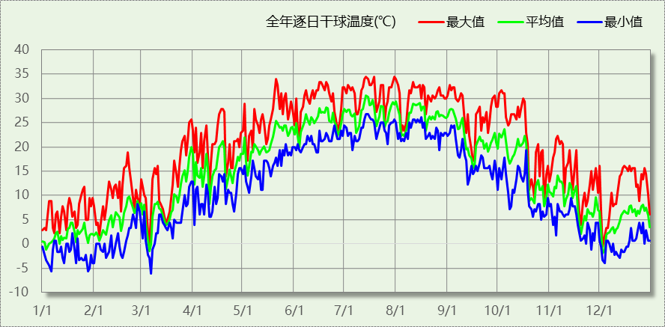

## 逐月辐照量表

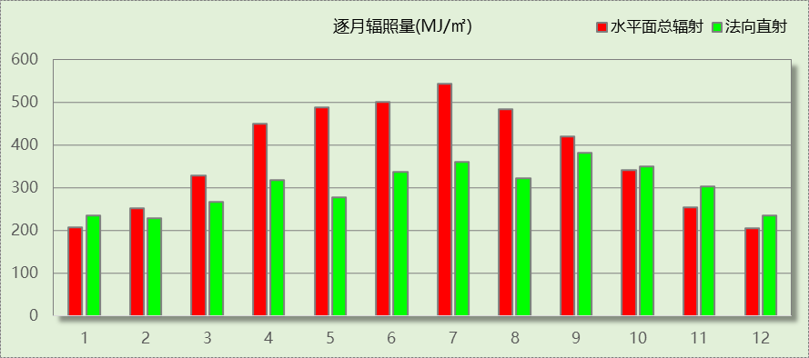

## 峰值工况

|  |  |  |  |  |  |
| --- | --- | --- | --- | --- | --- |
| 气象数据 | 时刻 | 干球温度(℃) | 湿球温度(℃) | 含湿量(g/kg) | 焓值(kj/kg) |
| 最热 | 07月13日15时 | 34.4 | 28.3 | 22.1 | 91.3 |
| 最冷 | 03月06日03时 | -6.1 | -6.1 | 2.1 | -0.9 |

# 软件介绍

本报告采用的软件为绿建暖通负荷BECH2024，该软件紧密结合暖通和节能设计规范、可根据项目实际情况建立建筑热工模型，并可对围护结构材料、房间内扰发热、作息时间表、热回收方式等参数进行设置。

软件包含全国各地典型气象年数据，内置DOE2.1E内核，对于建筑的逐时负荷进行动态模拟，既可以模拟8760小时理想负荷，也可以根据设定好的采暖期/空调期进行逐时模拟。

软件还支持分析全年建筑能耗的来源构成，依据日射得热、新风负荷、围护传热和内扰得热进行归类分项，生成设计建筑全年负荷计算报告书，提供详实的数据和多样的图表，为设计师在设备选型、制定运行策略等方面提供参考和帮助。

# 围护结构

## 屋顶构造

### 屋顶构造一

|  |  |  |  |  |  |  |
| --- | --- | --- | --- | --- | --- | --- |
| 材料名称 （由上到下） | 厚度δ | 导热系数λ | 蓄热系数S | 修正 系数 | 热阻R | 热惰性 指标 |
| (mm) | W/(m.K) | W/(㎡.K) | α | (㎡K)/W | D=R*S |
| 水泥砂浆 | 20 | 0.930 | 11.306 | 1.00 | 0.022 | 0.243 |
| 挤塑聚苯板(ρ=25-32) | 70 | 0.030 | 0.320 | 1.00 | 2.333 | 0.747 |
| c20细石混凝土(ρ=2300) | 20 | 1.510 | 15.243 | 1.00 | 0.013 | 0.202 |
| 轻骨料混凝土(找坡层) | 20 | 0.300 | 5.000 | 1.50 | 0.044 | 0.333 |
| 钢筋混凝土 | 70 | 1.740 | 17.060 | 1.00 | 0.040 | 0.686 |
| 加气混凝土、泡沫混凝土(ρ=700)（1） | 10 | 0.180 | 3.100 | 1.00 | 0.056 | 0.172 |
| 混凝土多孔砖(190六孔砖） | 20 | 0.750 | 7.490 | 1.00 | 0.027 | 0.200 |
| 加气混凝土、泡沫混凝土(ρ=700) | 10 | 0.180 | 3.102 | 1.00 | 0.056 | 0.172 |
| 各层之和∑ | 240 | － | － | － | 2.591 | 2.756 |
| 传热系数K=1/(0.15+∑R) | 0.37 | | | | | |

## 外墙构造

### 填充墙构造一

|  |  |  |  |  |  |  |
| --- | --- | --- | --- | --- | --- | --- |
| 材料名称 （由外到内） | 厚度δ | 导热系数λ | 蓄热系数S | 修正 系数 | 热阻R | 热惰性 指标 |
| (mm) | W/(m.K) | W/(㎡.K) | α | (㎡K)/W | D=R*S |
| 加气混凝土、泡沫混凝土(ρ=700) | 5 | 0.180 | 3.102 | 1.25 | 0.022 | 0.086 |
| 混凝土多孔砖(190六孔砖）（1） | 5 | 0.750 | 7.490 | 1.00 | 0.007 | 0.050 |
| c20细石混凝土(ρ=2300) | 20 | 1.510 | 15.243 | 1.00 | 0.013 | 0.202 |
| 钢筋混凝土 | 120 | 1.740 | 17.060 | 1.00 | 0.069 | 1.177 |
| 挤塑聚苯板(ρ=25-32) | 50 | 0.030 | 0.320 | 1.00 | 1.667 | 0.533 |
| 碎石、卵石混凝土(ρ=2300) | 20 | 1.510 | 15.243 | 1.00 | 0.013 | 0.202 |
| 灰砂砖砌体 | 10 | 1.100 | 12.633 | 1.00 | 0.009 | 0.115 |
| 细石混凝土(钢筋混凝土) | 10 | 1.740 | 17.200 | 1.00 | 0.006 | 0.099 |
| 各层之和∑ | 240 | － | － | － | 1.806 | 2.463 |
| 传热系数K=1/(0.15+∑R) | 0.51 | | | | | |

## 楼板构造

### 100

|  |  |  |  |  |  |  |
| --- | --- | --- | --- | --- | --- | --- |
| 材料名称 | 厚度δ | 导热系数λ | 蓄热系数S | 修正 系数 | 热阻R | 热惰性 指标 |
| (mm) | W/(m.K) | W/(㎡.K) | α | (㎡K)/W | D=R*S |
| 水泥砂浆 | 20 | 0.930 | 11.306 | 1.00 | 0.022 | 0.243 |
| 钢筋混凝土 | 100 | 1.740 | 17.060 | 1.00 | 0.057 | 0.980 |
| 石灰砂浆（1） | 20 | 0.810 | 9.948 | 1.00 | 0.025 | 0.246 |
| 细石混凝土(钢筋混凝土) | 20 | 1.740 | 17.200 | 1.00 | 0.011 | 0.198 |
| c20细石混凝土(ρ=2300)（1） | 20 | 1.510 | 15.243 | 1.00 | 0.013 | 0.202 |
| 各层之和∑ | 180 | － | － | － | 0.128 | 1.869 |
| 传热系数K=1/(0.22+∑R) | 2.87 | | | | | |

## 周边地面构造

### 周边地面构造一

|  |  |  |  |  |  |  |
| --- | --- | --- | --- | --- | --- | --- |
| 材料名称 | 厚度δ | 导热系数λ | 蓄热系数S | 修正 系数 | 热阻R | 热惰性 指标 |
| (mm) | W/(m.K) | W/(㎡.K) | α | (㎡K)/W | D=R*S |
| 水泥砂浆 | 20 | 0.930 | 11.306 | 1.00 | 0.022 | 0.243 |
| 挤塑聚苯板(ρ=25-32) | 20 | 0.030 | 0.320 | 1.10 | 0.606 | 0.213 |
| 钢筋混凝土 | 100 | 1.740 | 17.060 | 1.00 | 0.057 | 0.980 |
| 各层之和∑ | 140 | － | － | － | 0.685 | 1.437 |
| 传热系数K=1/(0.11+∑R) | 0.40 | | | | | |

## 非周边地面构造

### 非周边地面构造一

|  |  |  |  |  |  |  |
| --- | --- | --- | --- | --- | --- | --- |
| 材料名称 | 厚度δ | 导热系数λ | 蓄热系数S | 修正 系数 | 热阻R | 热惰性 指标 |
| (mm) | W/(m.K) | W/(㎡.K) | α | (㎡K)/W | D=R*S |
| 水泥砂浆 | 20 | 0.930 | 11.306 | 1.00 | 0.022 | 0.243 |
| 钢筋混凝土 | 120 | 1.740 | 17.060 | 1.00 | 0.069 | 1.177 |
| 石棉水泥隔热板 | 20 | 0.160 | 2.472 | 1.00 | 0.125 | 0.309 |
| 各层之和∑ | 160 | － | － | － | 0.215 | 1.729 |
| 传热系数K=1/(0.11+∑R) | 0.29 | | | | | |

## 门构造

|  |  |  |  |
| --- | --- | --- | --- |
| 序号 | 构造名称 | 传热系数 | 备注 |
| 1 | 双层实体木制外门 | 1.300 |  |

## 窗构造

|  |  |  |  |  |  |
| --- | --- | --- | --- | --- | --- |
| 序号 | 构造名称 | 传热系数 | 窗遮阳系数 | 可见光透射比 | 备注 |
| 1 | 65系列内平开隔热铝合金窗(5+12A+5) | 2.900 | 0.580 | 0.720 |  |
| 2 | 78系列内平开木窗(5+12A+5+12A+5Low-E) | 1.500 | 0.385 | 0.620 |  |

# 房间类型

## 房间参数表

|  |  |  |  |  |  |  |
| --- | --- | --- | --- | --- | --- | --- |
| 房间类型 | 空调温度 ℃ | 供暖温度 ℃ | 新风量 | 人员密度 | 照明功率 密度 | 电器设备 功率 |
| 一般商店 | 26 | 20 | 19(m^3/h.人) | 4(m^2/人) | 9(W/m^2) | 13(W/m^2) |
| 会议室 | 26 | 18 | 14(m^3/h.人) | 2.5(m^2/人) | 8(W/m^2) | 15(W/m^2) |
| 卫生间 | 28 | 18 | 20(m^3/h.人) | 20(m^2/人) | 5(W/m^2) | 15(W/m^2) |
| 卫生间 | 26 | 20 | 30(m^3/h.人) | 8(m^2/人) | 8(W/m^2) | 15(W/m^2) |
| 卫生间 | 26 | 20 | 30(m^3/h.人) | 8(m^2/人) | 8(W/m^2) | 15(W/m^2) |
| 多媒体区 | 26 | 20 | 30(m^3/h.人) | 2.5(m^2/人) | 13.5(W/m^2) | 15(W/m^2) |
| 大厅 | 26 | 18 | 20(m^3/h.人) | 30(m^2/人) | 10(W/m^2) | 15(W/m^2) |
| 展览馆 | 26 | 20 | 30(m^3/h.人) | 8(m^2/人) | 9(W/m^2) | 15(W/m^2) |
| 开水间 | 28 | 18 | 0(m^3/h.人) | 20(m^2/人) | 5(W/m^2) | 15(W/m^2) |
| 普通办公室 | 26 | 20 | 30(m^3/h.人) | 8(m^2/人) | 8(W/m^2) | 15(W/m^2) |
| 档案室 | 26 | 18 | 30(m^3/h.人) | 8(m^2/人) | 6(W/m^2) | 15(W/m^2) |
| 楼梯间 | － | － | 0(m^3/h.人) | 0(人) | 3.5(W/m^2) | 15(W/m^2) |
| 楼梯间 | 26 | 20 | 30(m^3/h.人) | 8(m^2/人) | 8(W/m^2) | 15(W/m^2) |
| 楼梯间 | 26 | 20 | 30(m^3/h.人) | 8(m^2/人) | 8(W/m^2) | 15(W/m^2) |
| 空房间 | － | － | 20(m^3/h.人) | 0(人) | 0(W/m^2) | 0(W/m^2) |
| 设备间 | － | － | 0(次/h) | 0(人) | 6(W/m^2) | 15(W/m^2) |
| 走廊 | 26 | 16 | 20(m^3/h.人) | 50(m^2/人) | 3.5(W/m^2) | 15(W/m^2) |
| 走廊 | 26 | 20 | 30(m^3/h.人) | 8(m^2/人) | 8(W/m^2) | 15(W/m^2) |
| 走廊 | 26 | 20 | 30(m^3/h.人) | 8(m^2/人) | 9(W/m^2) | 15(W/m^2) |
| 走廊 | 26 | 20 | 30(m^3/h.人) | 8(m^2/人) | 8(W/m^2) | 15(W/m^2) |
| 阅览室 | 26 | 20 | 30(m^3/h.人) | 8(m^2/人) | 8(W/m^2) | 15(W/m^2) |
| 陈列室 | 26 | 20 | 30(m^3/h.人) | 8(m^2/人) | 8(W/m^2) | 15(W/m^2) |
| 餐厅 | 26 | 18 | 30(m^3/h.人) | 2.5(m^2/人) | 8(W/m^2) | 15(W/m^2) |

## 作息时间表

详见附录

# 系统设置

## 系统划分

|  |  |  |  |  |  |  |
| --- | --- | --- | --- | --- | --- | --- |
| 系统编号 | 热回收 类型 | 启动 条件 | 回收 效率 | 排风 比例 | 面积(m2) | 包含的房间 |
| 默认 | 无 | -- | -- | -- | 2713.95 | 所有房间 |

## 运行时间表

详见附录

# 计算结果

## 模拟周期

供冷季(6.14-8.31) 供暖季(11.30-2.28)

## 全年冷暖需求

|  |  |  |  |  |
| --- | --- | --- | --- | --- |
| 系统名称\负荷 | 供暖需求 (kWh) | 供暖指标 (kWh/㎡·a) | 供冷需求 (kWh) | 供冷指标 (kWh/㎡·a) |
| 建筑总计 | 78371 | 26.09 | 146812 | 48.87 |

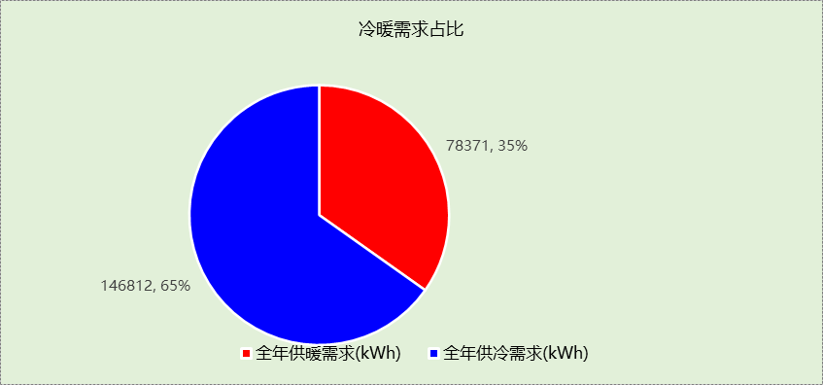

## 负荷分项统计

|  |  |  |  |  |  |  |
| --- | --- | --- | --- | --- | --- | --- |
| 分类 | 围护传热 | 室内得热 | 窗日射 | 新风/渗透 | 热回收 | 合计 |
| 供暖(kWh/㎡) | -26.41 | 11.93 | 2.09 | -13.69 | 0.00 | -26.09 |
| 供冷(kWh/㎡) | 9.32 | 16.75 | 4.17 | 18.63 | 0.00 | 48.87 |

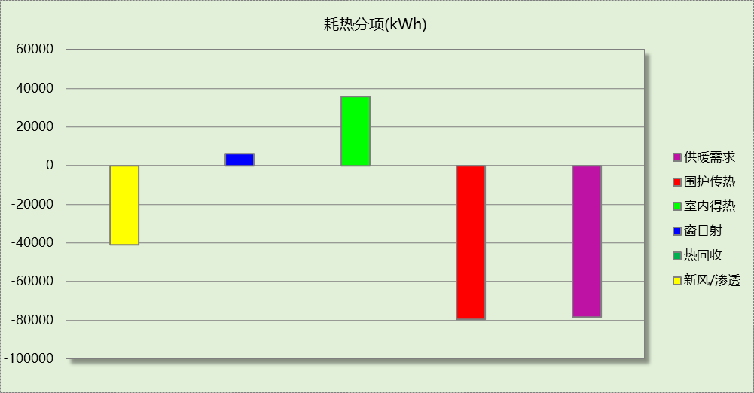

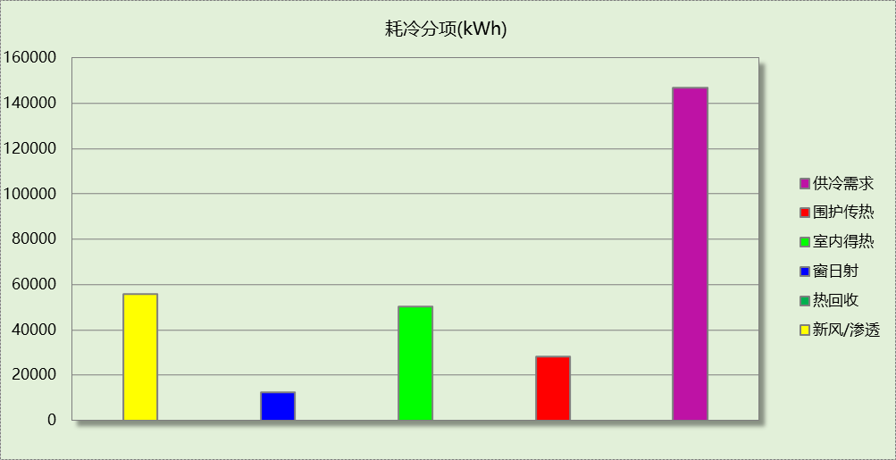

## 逐月负荷表

|  |  |  |  |  |  |  |
| --- | --- | --- | --- | --- | --- | --- |
| 月份 | 供暖(kWh) | 供冷(kWh) | 热负荷 峰值(kW) | 热负荷 峰值时刻 | 冷负荷 峰值(kW) | 冷负荷 峰值时刻 |
| 1月 | 36390 | 0 | 477.213 | 1月2日7时 | 0.000 | -- |
| 2月 | 18639 | 0 | 328.096 | 2月4日7时 | 0.000 | -- |
| 3月 | 0 | 0 | 0.000 | -- | 0.000 | -- |
| 4月 | 0 | 0 | 0.000 | -- | 0.000 | -- |
| 5月 | 0 | 0 | 0.000 | -- | 0.000 | -- |
| 6月 | 0 | 25955 | 0.000 | -- | 363.130 | 6月14日7时 |
| 7月 | 0 | 64925 | 0.000 | -- | 381.667 | 7月15日14时 |
| 8月 | 0 | 55932 | 0.000 | -- | 336.798 | 8月12日9时 |
| 9月 | 0 | 0 | 0.000 | -- | 0.000 | -- |
| 10月 | 0 | 0 | 0.000 | -- | 0.000 | -- |
| 11月 | 0 | 0 | 0.000 | -- | 0.000 | -- |
| 12月 | 23342 | 0 | 287.885 | 12月9日7时 | 0.000 | -- |

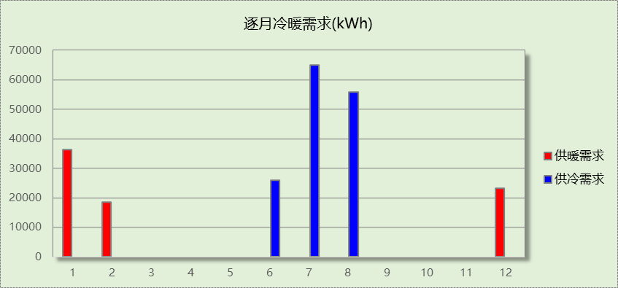

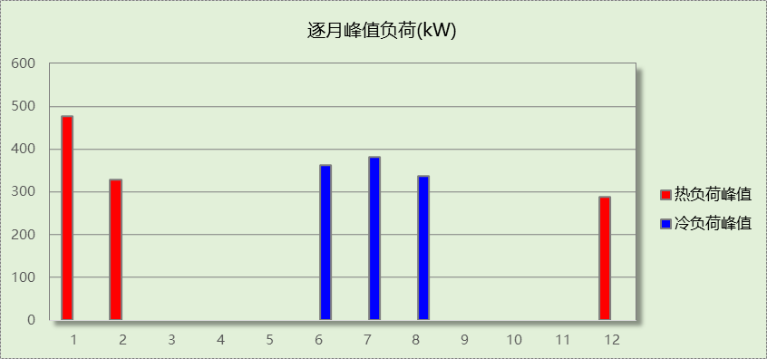

# 附录

**工作日/节假日人员逐时在室率(%)**

|  |  |  |  |  |  |  |  |  |  |  |  |  |  |  |  |  |  |  |  |  |  |  |  |  |
| --- | --- | --- | --- | --- | --- | --- | --- | --- | --- | --- | --- | --- | --- | --- | --- | --- | --- | --- | --- | --- | --- | --- | --- | --- |
| 房间类型 | 1 | 2 | 3 | 4 | 5 | 6 | 7 | 8 | 9 | 10 | 11 | 12 | 13 | 14 | 15 | 16 | 17 | 18 | 19 | 20 | 21 | 22 | 23 | 24 |
| 一般商店 | 0 | 0 | 0 | 0 | 0 | 0 | 0 | 20 | 50 | 80 | 80 | 80 | 80 | 80 | 80 | 80 | 80 | 80 | 80 | 70 | 50 | 0 | 0 | 0 |
| 0 | 0 | 0 | 0 | 0 | 0 | 0 | 20 | 50 | 80 | 80 | 80 | 80 | 80 | 80 | 80 | 80 | 80 | 80 | 70 | 50 | 0 | 0 | 0 |
| 会议室 | 0 | 0 | 0 | 0 | 0 | 0 | 10 | 50 | 100 | 100 | 100 | 30 | 100 | 100 | 100 | 100 | 50 | 20 | 10 | 0 | 0 | 0 | 0 | 0 |
| 0 | 0 | 0 | 0 | 0 | 0 | 0 | 20 | 45 | 0 | 0 | 0 | 0 | 0 | 0 | 0 | 0 | 0 | 0 | 0 | 0 | 0 | 0 | 0 |
| 卫生间 | 0 | 0 | 0 | 0 | 0 | 0 | 10 | 50 | 100 | 100 | 100 | 30 | 100 | 100 | 100 | 100 | 50 | 20 | 10 | 0 | 0 | 0 | 0 | 0 |
| 0 | 0 | 0 | 0 | 0 | 0 | 0 | 20 | 45 | 0 | 0 | 0 | 0 | 0 | 0 | 0 | 0 | 0 | 0 | 0 | 0 | 0 | 0 | 0 |
| 卫生间 | 0 | 0 | 0 | 0 | 0 | 0 | 10 | 50 | 100 | 100 | 100 | 30 | 100 | 100 | 100 | 100 | 50 | 20 | 10 | 0 | 0 | 0 | 0 | 0 |
| 0 | 0 | 0 | 0 | 0 | 0 | 0 | 20 | 45 | 0 | 0 | 0 | 0 | 0 | 0 | 0 | 0 | 0 | 0 | 0 | 0 | 0 | 0 | 0 |
| 卫生间 | 0 | 0 | 0 | 0 | 0 | 0 | 10 | 50 | 100 | 100 | 100 | 30 | 100 | 100 | 100 | 100 | 50 | 20 | 10 | 0 | 0 | 0 | 0 | 0 |
| 0 | 0 | 0 | 0 | 0 | 0 | 0 | 20 | 45 | 0 | 0 | 0 | 0 | 0 | 0 | 0 | 0 | 0 | 0 | 0 | 0 | 0 | 0 | 0 |
| 多媒体区 | 0 | 0 | 0 | 0 | 0 | 0 | 10 | 50 | 100 | 100 | 100 | 30 | 100 | 100 | 100 | 100 | 50 | 20 | 10 | 0 | 0 | 0 | 0 | 0 |
| 0 | 0 | 0 | 0 | 0 | 0 | 0 | 20 | 45 | 0 | 0 | 0 | 0 | 0 | 0 | 0 | 0 | 0 | 0 | 0 | 0 | 0 | 0 | 0 |
| 大厅 | 0 | 0 | 0 | 0 | 0 | 0 | 10 | 50 | 100 | 100 | 100 | 30 | 100 | 100 | 100 | 100 | 50 | 20 | 10 | 0 | 0 | 0 | 0 | 0 |
| 0 | 0 | 0 | 0 | 0 | 0 | 0 | 20 | 45 | 0 | 0 | 0 | 0 | 0 | 0 | 0 | 0 | 0 | 0 | 0 | 0 | 0 | 0 | 0 |
| 展览馆 | 0 | 0 | 0 | 0 | 0 | 0 | 10 | 50 | 100 | 100 | 100 | 30 | 100 | 100 | 100 | 100 | 50 | 20 | 10 | 0 | 0 | 0 | 0 | 0 |
| 0 | 0 | 0 | 0 | 0 | 0 | 0 | 20 | 45 | 0 | 0 | 0 | 0 | 0 | 0 | 0 | 0 | 0 | 0 | 0 | 0 | 0 | 0 | 0 |
| 开水间 | 0 | 0 | 0 | 0 | 0 | 0 | 10 | 50 | 100 | 100 | 100 | 30 | 100 | 100 | 100 | 100 | 50 | 20 | 10 | 0 | 0 | 0 | 0 | 0 |
| 0 | 0 | 0 | 0 | 0 | 0 | 0 | 20 | 45 | 0 | 0 | 0 | 0 | 0 | 0 | 0 | 0 | 0 | 0 | 0 | 0 | 0 | 0 | 0 |
| 普通办公室 | 0 | 0 | 0 | 0 | 0 | 0 | 10 | 50 | 100 | 100 | 100 | 30 | 100 | 100 | 100 | 100 | 50 | 20 | 10 | 0 | 0 | 0 | 0 | 0 |
| 0 | 0 | 0 | 0 | 0 | 0 | 0 | 20 | 45 | 0 | 0 | 0 | 0 | 0 | 0 | 0 | 0 | 0 | 0 | 0 | 0 | 0 | 0 | 0 |
| 档案室 | 0 | 0 | 0 | 0 | 0 | 0 | 10 | 50 | 100 | 100 | 100 | 30 | 100 | 100 | 100 | 100 | 50 | 20 | 10 | 0 | 0 | 0 | 0 | 0 |
| 0 | 0 | 0 | 0 | 0 | 0 | 0 | 20 | 45 | 0 | 0 | 0 | 0 | 0 | 0 | 0 | 0 | 0 | 0 | 0 | 0 | 0 | 0 | 0 |
| 楼梯间 | 0 | 0 | 0 | 0 | 0 | 0 | 0 | 20 | 50 | 80 | 80 | 80 | 80 | 80 | 80 | 80 | 80 | 80 | 80 | 70 | 50 | 0 | 0 | 0 |
| 0 | 0 | 0 | 0 | 0 | 0 | 0 | 0 | 0 | 0 | 0 | 0 | 0 | 0 | 0 | 0 | 0 | 0 | 0 | 0 | 0 | 0 | 0 | 0 |
| 楼梯间 | 0 | 0 | 0 | 0 | 0 | 0 | 10 | 50 | 100 | 100 | 100 | 30 | 100 | 100 | 100 | 100 | 50 | 20 | 10 | 0 | 0 | 0 | 0 | 0 |
| 0 | 0 | 0 | 0 | 0 | 0 | 0 | 20 | 45 | 0 | 0 | 0 | 0 | 0 | 0 | 0 | 0 | 0 | 0 | 0 | 0 | 0 | 0 | 0 |
| 楼梯间 | 0 | 0 | 0 | 0 | 0 | 0 | 10 | 50 | 100 | 100 | 100 | 30 | 100 | 100 | 100 | 100 | 50 | 20 | 10 | 0 | 0 | 0 | 0 | 0 |
| 0 | 0 | 0 | 0 | 0 | 0 | 0 | 20 | 45 | 0 | 0 | 0 | 0 | 0 | 0 | 0 | 0 | 0 | 0 | 0 | 0 | 0 | 0 | 0 |
| 空房间 | 0 | 0 | 0 | 0 | 0 | 0 | 0 | 20 | 50 | 80 | 80 | 80 | 80 | 80 | 80 | 80 | 80 | 80 | 80 | 70 | 50 | 0 | 0 | 0 |
| 0 | 0 | 0 | 0 | 0 | 0 | 0 | 20 | 50 | 80 | 80 | 80 | 80 | 80 | 80 | 80 | 80 | 80 | 80 | 70 | 50 | 0 | 0 | 0 |
| 设备间 | 0 | 0 | 0 | 0 | 0 | 0 | 0 | 0 | 0 | 0 | 0 | 0 | 0 | 0 | 0 | 0 | 0 | 0 | 0 | 0 | 0 | 0 | 0 | 0 |
| 0 | 0 | 0 | 0 | 0 | 0 | 0 | 0 | 0 | 0 | 0 | 0 | 0 | 0 | 0 | 0 | 0 | 0 | 0 | 0 | 0 | 0 | 0 | 0 |
| 走廊 | 0 | 0 | 0 | 0 | 0 | 0 | 10 | 50 | 95 | 95 | 95 | 80 | 80 | 95 | 95 | 95 | 95 | 30 | 30 | 0 | 0 | 0 | 0 | 0 |
| 0 | 0 | 0 | 0 | 0 | 0 | 0 | 0 | 0 | 0 | 0 | 0 | 0 | 0 | 0 | 0 | 0 | 0 | 0 | 0 | 0 | 0 | 0 | 0 |
| 走廊 | 0 | 0 | 0 | 0 | 0 | 0 | 10 | 50 | 100 | 100 | 100 | 30 | 100 | 100 | 100 | 100 | 50 | 20 | 10 | 0 | 0 | 0 | 0 | 0 |
| 0 | 0 | 0 | 0 | 0 | 0 | 0 | 20 | 45 | 0 | 0 | 0 | 0 | 0 | 0 | 0 | 0 | 0 | 0 | 0 | 0 | 0 | 0 | 0 |
| 走廊 | 0 | 0 | 0 | 0 | 0 | 0 | 10 | 50 | 100 | 100 | 100 | 30 | 100 | 100 | 100 | 100 | 50 | 20 | 10 | 0 | 0 | 0 | 0 | 0 |
| 0 | 0 | 0 | 0 | 0 | 0 | 0 | 20 | 45 | 0 | 0 | 0 | 0 | 0 | 0 | 0 | 0 | 0 | 0 | 0 | 0 | 0 | 0 | 0 |
| 走廊 | 0 | 0 | 0 | 0 | 0 | 0 | 10 | 50 | 100 | 100 | 100 | 30 | 100 | 100 | 100 | 100 | 50 | 20 | 10 | 0 | 0 | 0 | 0 | 0 |
| 0 | 0 | 0 | 0 | 0 | 0 | 0 | 20 | 45 | 0 | 0 | 0 | 0 | 0 | 0 | 0 | 0 | 0 | 0 | 0 | 0 | 0 | 0 | 0 |
| 阅览室 | 0 | 0 | 0 | 0 | 0 | 0 | 10 | 50 | 100 | 100 | 100 | 30 | 100 | 100 | 100 | 100 | 50 | 20 | 10 | 0 | 0 | 0 | 0 | 0 |
| 0 | 0 | 0 | 0 | 0 | 0 | 0 | 20 | 45 | 0 | 0 | 0 | 0 | 0 | 0 | 0 | 0 | 0 | 0 | 0 | 0 | 0 | 0 | 0 |
| 陈列室 | 0 | 0 | 0 | 0 | 0 | 0 | 10 | 50 | 100 | 100 | 100 | 30 | 100 | 100 | 100 | 100 | 50 | 20 | 10 | 0 | 0 | 0 | 0 | 0 |
| 0 | 0 | 0 | 0 | 0 | 0 | 0 | 20 | 45 | 0 | 0 | 0 | 0 | 0 | 0 | 0 | 0 | 0 | 0 | 0 | 0 | 0 | 0 | 0 |
| 餐厅 | 0 | 0 | 0 | 0 | 0 | 0 | 10 | 50 | 100 | 100 | 100 | 30 | 100 | 100 | 100 | 100 | 50 | 20 | 10 | 0 | 0 | 0 | 0 | 0 |
| 0 | 0 | 0 | 0 | 0 | 0 | 0 | 20 | 45 | 0 | 0 | 0 | 0 | 0 | 0 | 0 | 0 | 0 | 0 | 0 | 0 | 0 | 0 | 0 |

注：上行：工作日；下行：节假日

**工作日/节假日照明开关时间表(%)**

|  |  |  |  |  |  |  |  |  |  |  |  |  |  |  |  |  |  |  |  |  |  |  |  |  |
| --- | --- | --- | --- | --- | --- | --- | --- | --- | --- | --- | --- | --- | --- | --- | --- | --- | --- | --- | --- | --- | --- | --- | --- | --- |
| 房间类型 | 1 | 2 | 3 | 4 | 5 | 6 | 7 | 8 | 9 | 10 | 11 | 12 | 13 | 14 | 15 | 16 | 17 | 18 | 19 | 20 | 21 | 22 | 23 | 24 |
| 一般商店 | 10 | 10 | 10 | 10 | 10 | 10 | 10 | 50 | 60 | 60 | 60 | 60 | 60 | 60 | 60 | 60 | 80 | 90 | 100 | 100 | 100 | 10 | 10 | 10 |
| 10 | 10 | 10 | 10 | 10 | 10 | 10 | 50 | 60 | 60 | 60 | 60 | 60 | 60 | 60 | 60 | 80 | 90 | 100 | 100 | 100 | 10 | 10 | 10 |
| 会议室 | 10 | 10 | 10 | 10 | 10 | 10 | 10 | 36 | 62 | 56 | 54 | 43 | 53 | 55 | 58 | 67 | 40 | 18 | 10 | 10 | 10 | 10 | 10 | 10 |
| 0 | 0 | 0 | 0 | 0 | 0 | 0 | 0 | 0 | 0 | 0 | 0 | 0 | 0 | 0 | 0 | 0 | 0 | 0 | 0 | 0 | 0 | 0 | 0 |
| 卫生间 | 10 | 10 | 10 | 10 | 10 | 10 | 10 | 36 | 62 | 56 | 54 | 43 | 53 | 55 | 58 | 67 | 40 | 18 | 10 | 10 | 10 | 10 | 10 | 10 |
| 0 | 0 | 0 | 0 | 0 | 0 | 0 | 0 | 0 | 0 | 0 | 0 | 0 | 0 | 0 | 0 | 0 | 0 | 0 | 0 | 0 | 0 | 0 | 0 |
| 卫生间 | 10 | 10 | 10 | 10 | 10 | 10 | 10 | 36 | 62 | 56 | 54 | 43 | 53 | 55 | 58 | 67 | 40 | 18 | 10 | 10 | 10 | 10 | 10 | 10 |
| 0 | 0 | 0 | 0 | 0 | 0 | 0 | 0 | 0 | 0 | 0 | 0 | 0 | 0 | 0 | 0 | 0 | 0 | 0 | 0 | 0 | 0 | 0 | 0 |
| 卫生间 | 10 | 10 | 10 | 10 | 10 | 10 | 10 | 36 | 62 | 56 | 54 | 43 | 53 | 55 | 58 | 67 | 40 | 18 | 10 | 10 | 10 | 10 | 10 | 10 |
| 0 | 0 | 0 | 0 | 0 | 0 | 0 | 0 | 0 | 0 | 0 | 0 | 0 | 0 | 0 | 0 | 0 | 0 | 0 | 0 | 0 | 0 | 0 | 0 |
| 多媒体区 | 10 | 10 | 10 | 10 | 10 | 10 | 10 | 36 | 62 | 56 | 54 | 43 | 53 | 55 | 58 | 67 | 40 | 18 | 10 | 10 | 10 | 10 | 10 | 10 |
| 0 | 0 | 0 | 0 | 0 | 0 | 0 | 0 | 0 | 0 | 0 | 0 | 0 | 0 | 0 | 0 | 0 | 0 | 0 | 0 | 0 | 0 | 0 | 0 |
| 大厅 | 10 | 10 | 10 | 10 | 10 | 10 | 10 | 36 | 62 | 56 | 54 | 43 | 53 | 55 | 58 | 67 | 40 | 18 | 10 | 10 | 10 | 10 | 10 | 10 |
| 0 | 0 | 0 | 0 | 0 | 0 | 0 | 0 | 0 | 0 | 0 | 0 | 0 | 0 | 0 | 0 | 0 | 0 | 0 | 0 | 0 | 0 | 0 | 0 |
| 展览馆 | 10 | 10 | 10 | 10 | 10 | 10 | 10 | 36 | 62 | 56 | 54 | 43 | 53 | 55 | 58 | 67 | 40 | 18 | 10 | 10 | 10 | 10 | 10 | 10 |
| 0 | 0 | 0 | 0 | 0 | 0 | 0 | 0 | 0 | 0 | 0 | 0 | 0 | 0 | 0 | 0 | 0 | 0 | 0 | 0 | 0 | 0 | 0 | 0 |
| 开水间 | 10 | 10 | 10 | 10 | 10 | 10 | 10 | 36 | 62 | 56 | 54 | 43 | 53 | 55 | 58 | 67 | 40 | 18 | 10 | 10 | 10 | 10 | 10 | 10 |
| 0 | 0 | 0 | 0 | 0 | 0 | 0 | 0 | 0 | 0 | 0 | 0 | 0 | 0 | 0 | 0 | 0 | 0 | 0 | 0 | 0 | 0 | 0 | 0 |
| 普通办公室 | 10 | 10 | 10 | 10 | 10 | 10 | 10 | 36 | 62 | 56 | 54 | 43 | 53 | 55 | 58 | 67 | 40 | 18 | 10 | 10 | 10 | 10 | 10 | 10 |
| 0 | 0 | 0 | 0 | 0 | 0 | 0 | 0 | 0 | 0 | 0 | 0 | 0 | 0 | 0 | 0 | 0 | 0 | 0 | 0 | 0 | 0 | 0 | 0 |
| 档案室 | 10 | 10 | 10 | 10 | 10 | 10 | 10 | 36 | 62 | 56 | 54 | 43 | 53 | 55 | 58 | 67 | 40 | 18 | 10 | 10 | 10 | 10 | 10 | 10 |
| 0 | 0 | 0 | 0 | 0 | 0 | 0 | 0 | 0 | 0 | 0 | 0 | 0 | 0 | 0 | 0 | 0 | 0 | 0 | 0 | 0 | 0 | 0 | 0 |
| 楼梯间 | 10 | 10 | 10 | 10 | 10 | 10 | 10 | 50 | 60 | 60 | 60 | 60 | 60 | 60 | 60 | 60 | 80 | 90 | 100 | 100 | 100 | 10 | 10 | 10 |
| 0 | 0 | 0 | 0 | 0 | 0 | 0 | 0 | 0 | 0 | 0 | 0 | 0 | 0 | 0 | 0 | 0 | 0 | 0 | 0 | 0 | 0 | 0 | 0 |
| 楼梯间 | 10 | 10 | 10 | 10 | 10 | 10 | 10 | 36 | 62 | 56 | 54 | 43 | 53 | 55 | 58 | 67 | 40 | 18 | 10 | 10 | 10 | 10 | 10 | 10 |
| 0 | 0 | 0 | 0 | 0 | 0 | 0 | 0 | 0 | 0 | 0 | 0 | 0 | 0 | 0 | 0 | 0 | 0 | 0 | 0 | 0 | 0 | 0 | 0 |
| 楼梯间 | 10 | 10 | 10 | 10 | 10 | 10 | 10 | 36 | 62 | 56 | 54 | 43 | 53 | 55 | 58 | 67 | 40 | 18 | 10 | 10 | 10 | 10 | 10 | 10 |
| 0 | 0 | 0 | 0 | 0 | 0 | 0 | 0 | 0 | 0 | 0 | 0 | 0 | 0 | 0 | 0 | 0 | 0 | 0 | 0 | 0 | 0 | 0 | 0 |
| 空房间 | 10 | 10 | 10 | 10 | 10 | 10 | 10 | 50 | 60 | 60 | 60 | 60 | 60 | 60 | 60 | 60 | 80 | 90 | 100 | 100 | 100 | 10 | 10 | 10 |
| 10 | 10 | 10 | 10 | 10 | 10 | 10 | 50 | 60 | 60 | 60 | 60 | 60 | 60 | 60 | 60 | 80 | 90 | 100 | 100 | 100 | 10 | 10 | 10 |
| 设备间 | 100 | 100 | 100 | 100 | 100 | 100 | 100 | 100 | 100 | 100 | 100 | 100 | 100 | 100 | 100 | 100 | 100 | 100 | 100 | 100 | 100 | 100 | 100 | 100 |
| 100 | 100 | 100 | 100 | 100 | 100 | 100 | 100 | 100 | 100 | 100 | 100 | 100 | 100 | 100 | 100 | 100 | 100 | 100 | 100 | 100 | 100 | 100 | 100 |
| 走廊 | 0 | 0 | 0 | 0 | 0 | 0 | 10 | 50 | 95 | 95 | 95 | 80 | 80 | 95 | 95 | 95 | 95 | 30 | 30 | 0 | 0 | 0 | 0 | 0 |
| 0 | 0 | 0 | 0 | 0 | 0 | 0 | 0 | 0 | 0 | 0 | 0 | 0 | 0 | 0 | 0 | 0 | 0 | 0 | 0 | 0 | 0 | 0 | 0 |
| 走廊 | 10 | 10 | 10 | 10 | 10 | 10 | 10 | 36 | 62 | 56 | 54 | 43 | 53 | 55 | 58 | 67 | 40 | 18 | 10 | 10 | 10 | 10 | 10 | 10 |
| 0 | 0 | 0 | 0 | 0 | 0 | 0 | 0 | 0 | 0 | 0 | 0 | 0 | 0 | 0 | 0 | 0 | 0 | 0 | 0 | 0 | 0 | 0 | 0 |
| 走廊 | 10 | 10 | 10 | 10 | 10 | 10 | 10 | 36 | 62 | 56 | 54 | 43 | 53 | 55 | 58 | 67 | 40 | 18 | 10 | 10 | 10 | 10 | 10 | 10 |
| 0 | 0 | 0 | 0 | 0 | 0 | 0 | 0 | 0 | 0 | 0 | 0 | 0 | 0 | 0 | 0 | 0 | 0 | 0 | 0 | 0 | 0 | 0 | 0 |
| 走廊 | 10 | 10 | 10 | 10 | 10 | 10 | 10 | 36 | 62 | 56 | 54 | 43 | 53 | 55 | 58 | 67 | 40 | 18 | 10 | 10 | 10 | 10 | 10 | 10 |
| 0 | 0 | 0 | 0 | 0 | 0 | 0 | 0 | 0 | 0 | 0 | 0 | 0 | 0 | 0 | 0 | 0 | 0 | 0 | 0 | 0 | 0 | 0 | 0 |
| 阅览室 | 10 | 10 | 10 | 10 | 10 | 10 | 10 | 36 | 62 | 56 | 54 | 43 | 53 | 55 | 58 | 67 | 40 | 18 | 10 | 10 | 10 | 10 | 10 | 10 |
| 0 | 0 | 0 | 0 | 0 | 0 | 0 | 0 | 0 | 0 | 0 | 0 | 0 | 0 | 0 | 0 | 0 | 0 | 0 | 0 | 0 | 0 | 0 | 0 |
| 陈列室 | 10 | 10 | 10 | 10 | 10 | 10 | 10 | 36 | 62 | 56 | 54 | 43 | 53 | 55 | 58 | 67 | 40 | 18 | 10 | 10 | 10 | 10 | 10 | 10 |
| 0 | 0 | 0 | 0 | 0 | 0 | 0 | 0 | 0 | 0 | 0 | 0 | 0 | 0 | 0 | 0 | 0 | 0 | 0 | 0 | 0 | 0 | 0 | 0 |
| 餐厅 | 10 | 10 | 10 | 10 | 10 | 10 | 10 | 36 | 62 | 56 | 54 | 43 | 53 | 55 | 58 | 67 | 40 | 18 | 10 | 10 | 10 | 10 | 10 | 10 |
| 0 | 0 | 0 | 0 | 0 | 0 | 0 | 0 | 0 | 0 | 0 | 0 | 0 | 0 | 0 | 0 | 0 | 0 | 0 | 0 | 0 | 0 | 0 | 0 |

注：上行：工作日；下行：节假日

**工作日/节假日设备逐时使用率(%)**

|  |  |  |  |  |  |  |  |  |  |  |  |  |  |  |  |  |  |  |  |  |  |  |  |  |
| --- | --- | --- | --- | --- | --- | --- | --- | --- | --- | --- | --- | --- | --- | --- | --- | --- | --- | --- | --- | --- | --- | --- | --- | --- |
| 房间类型 | 1 | 2 | 3 | 4 | 5 | 6 | 7 | 8 | 9 | 10 | 11 | 12 | 13 | 14 | 15 | 16 | 17 | 18 | 19 | 20 | 21 | 22 | 23 | 24 |
| 一般商店 | 0 | 0 | 0 | 0 | 0 | 0 | 0 | 30 | 50 | 80 | 80 | 80 | 80 | 80 | 80 | 80 | 80 | 80 | 80 | 70 | 50 | 0 | 0 | 0 |
| 0 | 0 | 0 | 0 | 0 | 0 | 0 | 30 | 50 | 80 | 80 | 80 | 80 | 80 | 80 | 80 | 80 | 80 | 80 | 70 | 50 | 0 | 0 | 0 |
| 会议室 | 0 | 0 | 0 | 0 | 0 | 0 | 10 | 50 | 100 | 100 | 100 | 100 | 100 | 100 | 100 | 100 | 50 | 20 | 10 | 0 | 0 | 0 | 0 | 0 |
| 0 | 0 | 0 | 0 | 0 | 0 | 0 | 0 | 0 | 0 | 0 | 0 | 0 | 0 | 0 | 0 | 0 | 0 | 0 | 0 | 0 | 0 | 0 | 0 |
| 卫生间 | 0 | 0 | 0 | 0 | 0 | 0 | 10 | 50 | 100 | 100 | 100 | 100 | 100 | 100 | 100 | 100 | 50 | 20 | 10 | 0 | 0 | 0 | 0 | 0 |
| 0 | 0 | 0 | 0 | 0 | 0 | 0 | 0 | 0 | 0 | 0 | 0 | 0 | 0 | 0 | 0 | 0 | 0 | 0 | 0 | 0 | 0 | 0 | 0 |
| 卫生间 | 0 | 0 | 0 | 0 | 0 | 0 | 10 | 50 | 100 | 100 | 100 | 100 | 100 | 100 | 100 | 100 | 50 | 20 | 10 | 0 | 0 | 0 | 0 | 0 |
| 0 | 0 | 0 | 0 | 0 | 0 | 0 | 0 | 0 | 0 | 0 | 0 | 0 | 0 | 0 | 0 | 0 | 0 | 0 | 0 | 0 | 0 | 0 | 0 |
| 卫生间 | 0 | 0 | 0 | 0 | 0 | 0 | 10 | 50 | 100 | 100 | 100 | 100 | 100 | 100 | 100 | 100 | 50 | 20 | 10 | 0 | 0 | 0 | 0 | 0 |
| 0 | 0 | 0 | 0 | 0 | 0 | 0 | 0 | 0 | 0 | 0 | 0 | 0 | 0 | 0 | 0 | 0 | 0 | 0 | 0 | 0 | 0 | 0 | 0 |
| 多媒体区 | 0 | 0 | 0 | 0 | 0 | 0 | 10 | 50 | 100 | 100 | 100 | 100 | 100 | 100 | 100 | 100 | 50 | 20 | 10 | 0 | 0 | 0 | 0 | 0 |
| 0 | 0 | 0 | 0 | 0 | 0 | 0 | 0 | 0 | 0 | 0 | 0 | 0 | 0 | 0 | 0 | 0 | 0 | 0 | 0 | 0 | 0 | 0 | 0 |
| 大厅 | 0 | 0 | 0 | 0 | 0 | 0 | 10 | 50 | 100 | 100 | 100 | 100 | 100 | 100 | 100 | 100 | 50 | 20 | 10 | 0 | 0 | 0 | 0 | 0 |
| 0 | 0 | 0 | 0 | 0 | 0 | 0 | 0 | 0 | 0 | 0 | 0 | 0 | 0 | 0 | 0 | 0 | 0 | 0 | 0 | 0 | 0 | 0 | 0 |
| 展览馆 | 0 | 0 | 0 | 0 | 0 | 0 | 10 | 50 | 100 | 100 | 100 | 100 | 100 | 100 | 100 | 100 | 50 | 20 | 10 | 0 | 0 | 0 | 0 | 0 |
| 0 | 0 | 0 | 0 | 0 | 0 | 0 | 0 | 0 | 0 | 0 | 0 | 0 | 0 | 0 | 0 | 0 | 0 | 0 | 0 | 0 | 0 | 0 | 0 |
| 开水间 | 0 | 0 | 0 | 0 | 0 | 0 | 10 | 50 | 100 | 100 | 100 | 100 | 100 | 100 | 100 | 100 | 50 | 20 | 10 | 0 | 0 | 0 | 0 | 0 |
| 0 | 0 | 0 | 0 | 0 | 0 | 0 | 0 | 0 | 0 | 0 | 0 | 0 | 0 | 0 | 0 | 0 | 0 | 0 | 0 | 0 | 0 | 0 | 0 |
| 普通办公室 | 0 | 0 | 0 | 0 | 0 | 0 | 10 | 50 | 100 | 100 | 100 | 100 | 100 | 100 | 100 | 100 | 50 | 20 | 10 | 0 | 0 | 0 | 0 | 0 |
| 0 | 0 | 0 | 0 | 0 | 0 | 0 | 0 | 0 | 0 | 0 | 0 | 0 | 0 | 0 | 0 | 0 | 0 | 0 | 0 | 0 | 0 | 0 | 0 |
| 档案室 | 0 | 0 | 0 | 0 | 0 | 0 | 10 | 50 | 100 | 100 | 100 | 100 | 100 | 100 | 100 | 100 | 50 | 20 | 10 | 0 | 0 | 0 | 0 | 0 |
| 0 | 0 | 0 | 0 | 0 | 0 | 0 | 0 | 0 | 0 | 0 | 0 | 0 | 0 | 0 | 0 | 0 | 0 | 0 | 0 | 0 | 0 | 0 | 0 |
| 楼梯间 | 0 | 0 | 0 | 0 | 0 | 0 | 0 | 30 | 50 | 80 | 80 | 80 | 80 | 80 | 80 | 80 | 80 | 80 | 80 | 70 | 50 | 0 | 0 | 0 |
| 0 | 0 | 0 | 0 | 0 | 0 | 0 | 0 | 0 | 0 | 0 | 0 | 0 | 0 | 0 | 0 | 0 | 0 | 0 | 0 | 0 | 0 | 0 | 0 |
| 楼梯间 | 0 | 0 | 0 | 0 | 0 | 0 | 10 | 50 | 100 | 100 | 100 | 100 | 100 | 100 | 100 | 100 | 50 | 20 | 10 | 0 | 0 | 0 | 0 | 0 |
| 0 | 0 | 0 | 0 | 0 | 0 | 0 | 0 | 0 | 0 | 0 | 0 | 0 | 0 | 0 | 0 | 0 | 0 | 0 | 0 | 0 | 0 | 0 | 0 |
| 楼梯间 | 0 | 0 | 0 | 0 | 0 | 0 | 10 | 50 | 100 | 100 | 100 | 100 | 100 | 100 | 100 | 100 | 50 | 20 | 10 | 0 | 0 | 0 | 0 | 0 |
| 0 | 0 | 0 | 0 | 0 | 0 | 0 | 0 | 0 | 0 | 0 | 0 | 0 | 0 | 0 | 0 | 0 | 0 | 0 | 0 | 0 | 0 | 0 | 0 |
| 空房间 | 0 | 0 | 0 | 0 | 0 | 0 | 0 | 30 | 50 | 80 | 80 | 80 | 80 | 80 | 80 | 80 | 80 | 80 | 80 | 70 | 50 | 0 | 0 | 0 |
| 0 | 0 | 0 | 0 | 0 | 0 | 0 | 30 | 50 | 80 | 80 | 80 | 80 | 80 | 80 | 80 | 80 | 80 | 80 | 70 | 50 | 0 | 0 | 0 |
| 设备间 | 100 | 100 | 100 | 100 | 100 | 100 | 100 | 100 | 100 | 100 | 100 | 100 | 100 | 100 | 100 | 100 | 100 | 100 | 100 | 100 | 100 | 100 | 100 | 100 |
| 100 | 100 | 100 | 100 | 100 | 100 | 100 | 100 | 100 | 100 | 100 | 100 | 100 | 100 | 100 | 100 | 100 | 100 | 100 | 100 | 100 | 100 | 100 | 100 |
| 走廊 | 0 | 0 | 0 | 0 | 0 | 0 | 10 | 50 | 95 | 95 | 95 | 50 | 50 | 95 | 95 | 95 | 95 | 30 | 30 | 0 | 0 | 0 | 0 | 0 |
| 0 | 0 | 0 | 0 | 0 | 0 | 0 | 0 | 0 | 0 | 0 | 0 | 0 | 0 | 0 | 0 | 0 | 0 | 0 | 0 | 0 | 0 | 0 | 0 |
| 走廊 | 0 | 0 | 0 | 0 | 0 | 0 | 10 | 50 | 100 | 100 | 100 | 100 | 100 | 100 | 100 | 100 | 50 | 20 | 10 | 0 | 0 | 0 | 0 | 0 |
| 0 | 0 | 0 | 0 | 0 | 0 | 0 | 0 | 0 | 0 | 0 | 0 | 0 | 0 | 0 | 0 | 0 | 0 | 0 | 0 | 0 | 0 | 0 | 0 |
| 走廊 | 0 | 0 | 0 | 0 | 0 | 0 | 10 | 50 | 100 | 100 | 100 | 100 | 100 | 100 | 100 | 100 | 50 | 20 | 10 | 0 | 0 | 0 | 0 | 0 |
| 0 | 0 | 0 | 0 | 0 | 0 | 0 | 0 | 0 | 0 | 0 | 0 | 0 | 0 | 0 | 0 | 0 | 0 | 0 | 0 | 0 | 0 | 0 | 0 |
| 走廊 | 0 | 0 | 0 | 0 | 0 | 0 | 10 | 50 | 100 | 100 | 100 | 100 | 100 | 100 | 100 | 100 | 50 | 20 | 10 | 0 | 0 | 0 | 0 | 0 |
| 0 | 0 | 0 | 0 | 0 | 0 | 0 | 0 | 0 | 0 | 0 | 0 | 0 | 0 | 0 | 0 | 0 | 0 | 0 | 0 | 0 | 0 | 0 | 0 |
| 阅览室 | 0 | 0 | 0 | 0 | 0 | 0 | 10 | 50 | 100 | 100 | 100 | 100 | 100 | 100 | 100 | 100 | 50 | 20 | 10 | 0 | 0 | 0 | 0 | 0 |
| 0 | 0 | 0 | 0 | 0 | 0 | 0 | 0 | 0 | 0 | 0 | 0 | 0 | 0 | 0 | 0 | 0 | 0 | 0 | 0 | 0 | 0 | 0 | 0 |
| 陈列室 | 0 | 0 | 0 | 0 | 0 | 0 | 10 | 50 | 100 | 100 | 100 | 100 | 100 | 100 | 100 | 100 | 50 | 20 | 10 | 0 | 0 | 0 | 0 | 0 |
| 0 | 0 | 0 | 0 | 0 | 0 | 0 | 0 | 0 | 0 | 0 | 0 | 0 | 0 | 0 | 0 | 0 | 0 | 0 | 0 | 0 | 0 | 0 | 0 |
| 餐厅 | 0 | 0 | 0 | 0 | 0 | 0 | 10 | 50 | 100 | 100 | 100 | 100 | 100 | 100 | 100 | 100 | 50 | 20 | 10 | 0 | 0 | 0 | 0 | 0 |
| 0 | 0 | 0 | 0 | 0 | 0 | 0 | 0 | 0 | 0 | 0 | 0 | 0 | 0 | 0 | 0 | 0 | 0 | 0 | 0 | 0 | 0 | 0 | 0 |

注：上行：工作日；下行：节假日

**工作日/节假日空调系统开关时间表**

采暖期：

|  |  |  |  |  |  |  |  |  |  |  |  |  |  |  |  |  |  |  |  |  |  |  |  |  |
| --- | --- | --- | --- | --- | --- | --- | --- | --- | --- | --- | --- | --- | --- | --- | --- | --- | --- | --- | --- | --- | --- | --- | --- | --- |
| 系统编号 | 1 | 2 | 3 | 4 | 5 | 6 | 7 | 8 | 9 | 10 | 11 | 12 | 13 | 14 | 15 | 16 | 17 | 18 | 19 | 20 | 21 | 22 | 23 | 24 |
| 默认 | 0 | 0 | 0 | 0 | 0 | 0 | 1 | 1 | 1 | 1 | 1 | 1 | 1 | 1 | 1 | 1 | 1 | 1 | 0 | 0 | 0 | 0 | 0 | 0 |
| 0 | 0 | 0 | 0 | 0 | 0 | 0 | 0 | 0 | 0 | 0 | 0 | 0 | 0 | 0 | 0 | 0 | 0 | 0 | 0 | 0 | 0 | 0 | 0 |

供冷期：

|  |  |  |  |  |  |  |  |  |  |  |  |  |  |  |  |  |  |  |  |  |  |  |  |  |
| --- | --- | --- | --- | --- | --- | --- | --- | --- | --- | --- | --- | --- | --- | --- | --- | --- | --- | --- | --- | --- | --- | --- | --- | --- |
| 系统编号 | 1 | 2 | 3 | 4 | 5 | 6 | 7 | 8 | 9 | 10 | 11 | 12 | 13 | 14 | 15 | 16 | 17 | 18 | 19 | 20 | 21 | 22 | 23 | 24 |
| 默认 | 0 | 0 | 0 | 0 | 0 | 0 | 1 | 1 | 1 | 1 | 1 | 1 | 1 | 1 | 1 | 1 | 1 | 1 | 0 | 0 | 0 | 0 | 0 | 0 |
| 0 | 0 | 0 | 0 | 0 | 0 | 0 | 0 | 0 | 0 | 0 | 0 | 0 | 0 | 0 | 0 | 0 | 0 | 0 | 0 | 0 | 0 | 0 | 0 |

注：上行：工作日；下行：节假日