溪云初起——双碳理念下的官寺村乡村振兴文旅综合体
全年负荷计算书

工程名称 | 溪云初起——双碳理念下的官寺村乡村振兴文旅综合体
设计编号
建设单位
设计单位 | 南阳师范学院土木建筑工程学院
计 算 人
校 对 人
审 核 人
计算日期 | 2024年12月21日



采用软件 | 暖通负荷BECH2024
软件版本 | 20240430(SP1)
研发单位 | 北京绿建软件股份有限公司
正版授权码 | T16696692424
目 录

1 建筑概况 1
2 气象数据 1
2.1 气象地点 1
2.2 逐日干球温度表 1
2.3 逐月辐照量表 2
2.4 峰值工况 2
3 软件介绍 2
4 围护结构 2
4.1 屋顶构造 2
4.1.1 屋顶构造一 2
4.2 外墙构造 3
4.2.1 填充墙构造一 3
4.3 楼板构造 3
4.3.1 100 3
4.4 周边地面构造 4
4.4.1 周边地面构造一 4
4.5 非周边地面构造 4
4.5.1 非周边地面构造一 4
4.6 门构造 4
4.7 窗构造 4
5 房间类型 5
5.1 房间参数表 5
5.2 作息时间表 5
6 系统设置 5
6.1 系统划分 5
6.2 运行时间表 6
7 计算结果 6
7.1 模拟周期 6
7.2 全年冷暖需求 6
7.3 负荷分项统计 6
7.4 逐月负荷表 7
8 附录 9

建筑概况
地理位置 | 河南-南阳
气候分区 | 夏热冬冷A区
北纬 | 33.00
东经 | 112.58
建筑名称 | 溪云初起——双碳理念下的官寺村乡村振兴文旅综合体
建筑类型 | 公共建筑
建筑面积 | 地上 3004.18 ㎡ | 地下 0.00 ㎡
建筑高度 | 地上 9.50 m | 地下0.00
建筑层数 | 地上 2 | 地下 0
北向角度 | 100°

气象数据

气象地点
河南-南阳, 《中国建筑热环境分析专用气象数据集》

逐日干球温度表
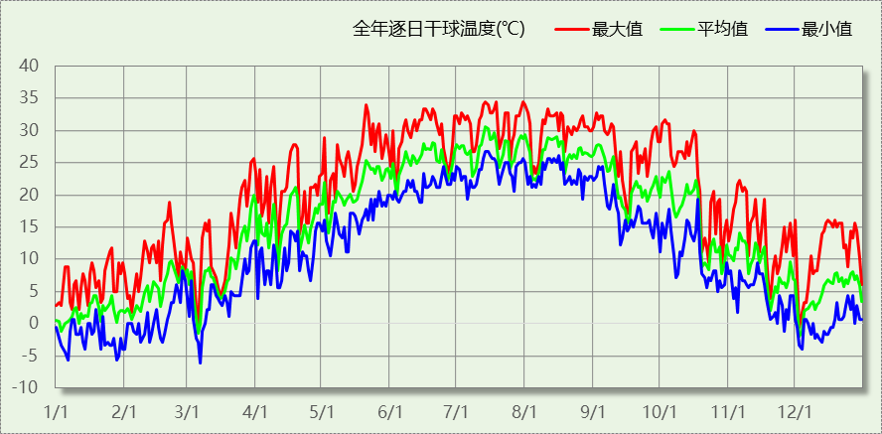

逐月辐照量表
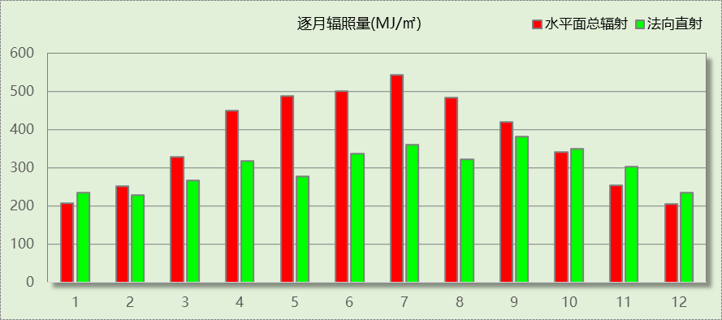

峰值工况
气象数据 | 时刻 | 干球温度(℃) | 湿球温度(℃) | 含湿量(g/kg) | 焓值(kj/kg)
最热 | 07月13日15时 | 34.4 | 28.3 | 22.1 | 91.3
最冷 | 03月06日03时 | -6.1 | -6.1 | 2.1 | -0.9

软件介绍
本报告采用的软件为绿建暖通负荷BECH2024，该软件紧密结合暖通和节能设计规范、可根据项目实际情况建立建筑热工模型，并可对围护结构材料、房间内扰发热、作息时间表、热回收方式等参数进行设置。
软件包含全国各地典型气象年数据，内置DOE2.1E内核，对于建筑的逐时负荷进行动态模拟，既可以模拟8760小时理想负荷，也可以根据设定好的采暖期/空调期进行逐时模拟。
软件还支持分析全年建筑能耗的来源构成，依据日射得热、新风负荷、围护传热和内扰得热进行归类分项，生成设计建筑全年负荷计算报告书，提供详实的数据和多样的图表，为设计师在设备选型、制定运行策略等方面提供参考和帮助。

围护结构

屋顶构造

屋顶构造一
材料名称  （由上到下） | 厚度δ | 导热系数λ | 蓄热系数S | 修正  系数 | 热阻R | 热惰性  指标
材料名称  （由上到下） | (mm) | W/(m.K) | W/(㎡.K) | α | (㎡K)/W | D=R*S
水泥砂浆 | 20 | 0.930 | 11.306 | 1.00 | 0.022 | 0.243
挤塑聚苯板(ρ=25-32) | 70 | 0.030 | 0.320 | 1.00 | 2.333 | 0.747
c20细石混凝土(ρ=2300) | 20 | 1.510 | 15.243 | 1.00 | 0.013 | 0.202
轻骨料混凝土(找坡层) | 20 | 0.300 | 5.000 | 1.50 | 0.044 | 0.333
钢筋混凝土 | 70 | 1.740 | 17.060 | 1.00 | 0.040 | 0.686
加气混凝土、泡沫混凝土(ρ=700)（1） | 10 | 0.180 | 3.100 | 1.00 | 0.056 | 0.172
混凝土多孔砖(190六孔砖） | 20 | 0.750 | 7.490 | 1.00 | 0.027 | 0.200
加气混凝土、泡沫混凝土(ρ=700) | 10 | 0.180 | 3.102 | 1.00 | 0.056 | 0.172
各层之和∑ | 240 | － | － | － | 2.591 | 2.756
传热系数K=1/(0.15+∑R) | 0.37

外墙构造

填充墙构造一
材料名称  （由外到内） | 厚度δ | 导热系数λ | 蓄热系数S | 修正  系数 | 热阻R | 热惰性  指标
材料名称  （由外到内） | (mm) | W/(m.K) | W/(㎡.K) | α | (㎡K)/W | D=R*S
加气混凝土、泡沫混凝土(ρ=700) | 5 | 0.180 | 3.102 | 1.25 | 0.022 | 0.086
混凝土多孔砖(190六孔砖）（1） | 5 | 0.750 | 7.490 | 1.00 | 0.007 | 0.050
c20细石混凝土(ρ=2300) | 20 | 1.510 | 15.243 | 1.00 | 0.013 | 0.202
钢筋混凝土 | 120 | 1.740 | 17.060 | 1.00 | 0.069 | 1.177
挤塑聚苯板(ρ=25-32) | 50 | 0.030 | 0.320 | 1.00 | 1.667 | 0.533
碎石、卵石混凝土(ρ=2300) | 20 | 1.510 | 15.243 | 1.00 | 0.013 | 0.202
灰砂砖砌体 | 10 | 1.100 | 12.633 | 1.00 | 0.009 | 0.115
细石混凝土(钢筋混凝土) | 10 | 1.740 | 17.200 | 1.00 | 0.006 | 0.099
各层之和∑ | 240 | － | － | － | 1.806 | 2.463
传热系数K=1/(0.15+∑R) | 0.51

楼板构造

100
材料名称 | 厚度δ | 导热系数λ | 蓄热系数S | 修正  系数 | 热阻R | 热惰性  指标
材料名称 | (mm) | W/(m.K) | W/(㎡.K) | α | (㎡K)/W | D=R*S
水泥砂浆 | 20 | 0.930 | 11.306 | 1.00 | 0.022 | 0.243
钢筋混凝土 | 100 | 1.740 | 17.060 | 1.00 | 0.057 | 0.980
石灰砂浆（1） | 20 | 0.810 | 9.948 | 1.00 | 0.025 | 0.246
细石混凝土(钢筋混凝土) | 20 | 1.740 | 17.200 | 1.00 | 0.011 | 0.198
c20细石混凝土(ρ=2300)（1） | 20 | 1.510 | 15.243 | 1.00 | 0.013 | 0.202
各层之和∑ | 180 | － | － | － | 0.128 | 1.869
传热系数K=1/(0.22+∑R) | 2.87

周边地面构造

周边地面构造一
材料名称 | 厚度δ | 导热系数λ | 蓄热系数S | 修正  系数 | 热阻R | 热惰性  指标
材料名称 | (mm) | W/(m.K) | W/(㎡.K) | α | (㎡K)/W | D=R*S
水泥砂浆 | 20 | 0.930 | 11.306 | 1.00 | 0.022 | 0.243
挤塑聚苯板(ρ=25-32) | 20 | 0.030 | 0.320 | 1.10 | 0.606 | 0.213
钢筋混凝土 | 100 | 1.740 | 17.060 | 1.00 | 0.057 | 0.980
各层之和∑ | 140 | － | － | － | 0.685 | 1.437
传热系数K=1/(0.11+∑R) | 0.40

非周边地面构造

非周边地面构造一
材料名称 | 厚度δ | 导热系数λ | 蓄热系数S | 修正  系数 | 热阻R | 热惰性  指标
材料名称 | (mm) | W/(m.K) | W/(㎡.K) | α | (㎡K)/W | D=R*S
水泥砂浆 | 20 | 0.930 | 11.306 | 1.00 | 0.022 | 0.243
钢筋混凝土 | 120 | 1.740 | 17.060 | 1.00 | 0.069 | 1.177
石棉水泥隔热板 | 20 | 0.160 | 2.472 | 1.00 | 0.125 | 0.309
各层之和∑ | 160 | － | － | － | 0.215 | 1.729
传热系数K=1/(0.11+∑R) | 0.29

门构造
序号 | 构造名称 | 传热系数 | 备注
1 | 双层实体木制外门 | 1.300

窗构造
序号 | 构造名称 | 传热系数 | 窗遮阳系数 | 可见光透射比 | 备注
1 | 65系列内平开隔热铝合金窗(5+12A+5) | 2.900 | 0.580 | 0.720
2 | 78系列内平开木窗(5+12A+5+12A+5Low-E) | 1.500 | 0.385 | 0.620

房间类型

房间参数表
房间类型 | 空调温度  ℃ | 供暖温度  ℃ | 新风量 | 人员密度 | 照明功率  密度 | 电器设备  功率
一般商店 | 26 | 20 | 19(m^3/h.人) | 4(m^2/人) | 9(W/m^2) | 13(W/m^2)
会议室 | 26 | 18 | 14(m^3/h.人) | 2.5(m^2/人) | 8(W/m^2) | 15(W/m^2)
卫生间 | 28 | 18 | 20(m^3/h.人) | 20(m^2/人) | 5(W/m^2) | 15(W/m^2)
卫生间 | 26 | 20 | 30(m^3/h.人) | 8(m^2/人) | 8(W/m^2) | 15(W/m^2)
卫生间 | 26 | 20 | 30(m^3/h.人) | 8(m^2/人) | 8(W/m^2) | 15(W/m^2)
多媒体区 | 26 | 20 | 30(m^3/h.人) | 2.5(m^2/人) | 13.5(W/m^2) | 15(W/m^2)
大厅 | 26 | 18 | 20(m^3/h.人) | 30(m^2/人) | 10(W/m^2) | 15(W/m^2)
展览馆 | 26 | 20 | 30(m^3/h.人) | 8(m^2/人) | 9(W/m^2) | 15(W/m^2)
开水间 | 28 | 18 | 0(m^3/h.人) | 20(m^2/人) | 5(W/m^2) | 15(W/m^2)
普通办公室 | 26 | 20 | 30(m^3/h.人) | 8(m^2/人) | 8(W/m^2) | 15(W/m^2)
档案室 | 26 | 18 | 30(m^3/h.人) | 8(m^2/人) | 6(W/m^2) | 15(W/m^2)
楼梯间 | － | － | 0(m^3/h.人) | 0(人) | 3.5(W/m^2) | 15(W/m^2)
楼梯间 | 26 | 20 | 30(m^3/h.人) | 8(m^2/人) | 8(W/m^2) | 15(W/m^2)
楼梯间 | 26 | 20 | 30(m^3/h.人) | 8(m^2/人) | 8(W/m^2) | 15(W/m^2)
空房间 | － | － | 20(m^3/h.人) | 0(人) | 0(W/m^2) | 0(W/m^2)
设备间 | － | － | 0(次/h) | 0(人) | 6(W/m^2) | 15(W/m^2)
走廊 | 26 | 16 | 20(m^3/h.人) | 50(m^2/人) | 3.5(W/m^2) | 15(W/m^2)
走廊 | 26 | 20 | 30(m^3/h.人) | 8(m^2/人) | 8(W/m^2) | 15(W/m^2)
走廊 | 26 | 20 | 30(m^3/h.人) | 8(m^2/人) | 9(W/m^2) | 15(W/m^2)
走廊 | 26 | 20 | 30(m^3/h.人) | 8(m^2/人) | 8(W/m^2) | 15(W/m^2)
阅览室 | 26 | 20 | 30(m^3/h.人) | 8(m^2/人) | 8(W/m^2) | 15(W/m^2)
陈列室 | 26 | 20 | 30(m^3/h.人) | 8(m^2/人) | 8(W/m^2) | 15(W/m^2)
餐厅 | 26 | 18 | 30(m^3/h.人) | 2.5(m^2/人) | 8(W/m^2) | 15(W/m^2)

作息时间表
详见附录

系统设置

系统划分
系统编号 | 热回收  类型 | 启动  条件 | 回收  效率 | 排风  比例 | 面积(m2) | 包含的房间
默认 | 无 | -- | -- | -- | 2713.95 | 所有房间

运行时间表
详见附录

计算结果

模拟周期
供冷季(6.14-8.31) 供暖季(11.30-2.28)

全年冷暖需求
系统名称\负荷 | 供暖需求  (kWh) | 供暖指标  (kWh/㎡·a) | 供冷需求  (kWh) | 供冷指标  (kWh/㎡·a)
建筑总计 | 78371 | 26.09 | 146812 | 48.87
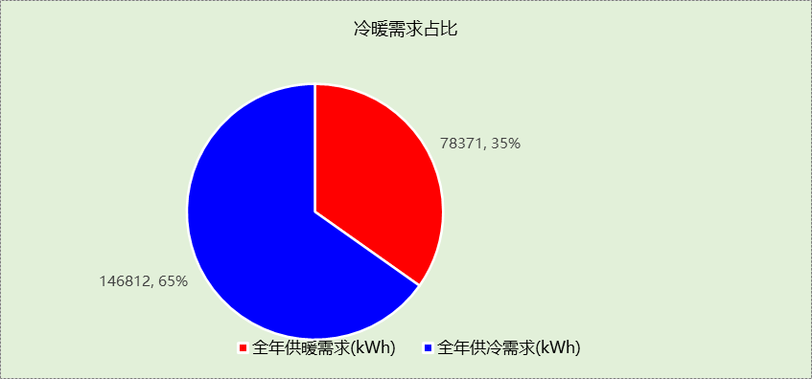

负荷分项统计
分类 | 围护传热 | 室内得热 | 窗日射 | 新风/渗透 | 热回收 | 合计
供暖(kWh/㎡) | -26.41 | 11.93 | 2.09 | -13.69 | 0.00 | -26.09
供冷(kWh/㎡) | 9.32 | 16.75 | 4.17 | 18.63 | 0.00 | 48.87
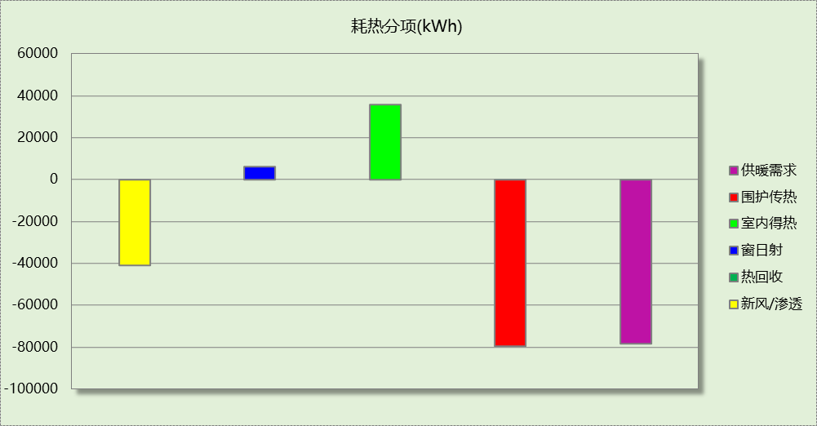
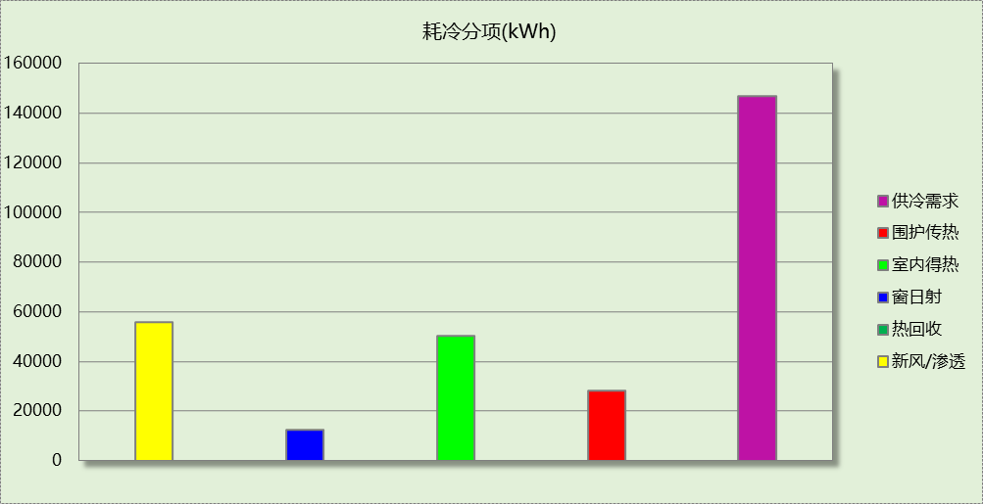

逐月负荷表
月份 | 供暖(kWh) | 供冷(kWh) | 热负荷  峰值(kW) | 热负荷  峰值时刻 | 冷负荷  峰值(kW) | 冷负荷  峰值时刻
1月 | 36390 | 0 | 477.213 | 1月2日7时 | 0.000 | --
2月 | 18639 | 0 | 328.096 | 2月4日7时 | 0.000 | --
3月 | 0 | 0 | 0.000 | -- | 0.000 | --
4月 | 0 | 0 | 0.000 | -- | 0.000 | --
5月 | 0 | 0 | 0.000 | -- | 0.000 | --
6月 | 0 | 25955 | 0.000 | -- | 363.130 | 6月14日7时
7月 | 0 | 64925 | 0.000 | -- | 381.667 | 7月15日14时
8月 | 0 | 55932 | 0.000 | -- | 336.798 | 8月12日9时
9月 | 0 | 0 | 0.000 | -- | 0.000 | --
10月 | 0 | 0 | 0.000 | -- | 0.000 | --
11月 | 0 | 0 | 0.000 | -- | 0.000 | --
12月 | 23342 | 0 | 287.885 | 12月9日7时 | 0.000 | --
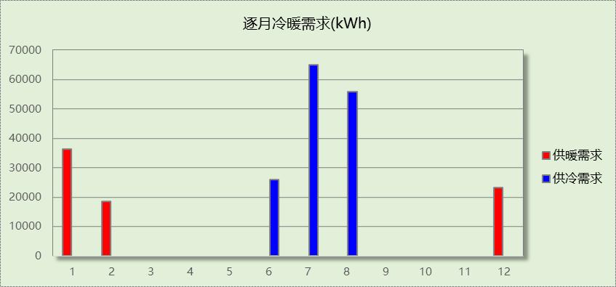
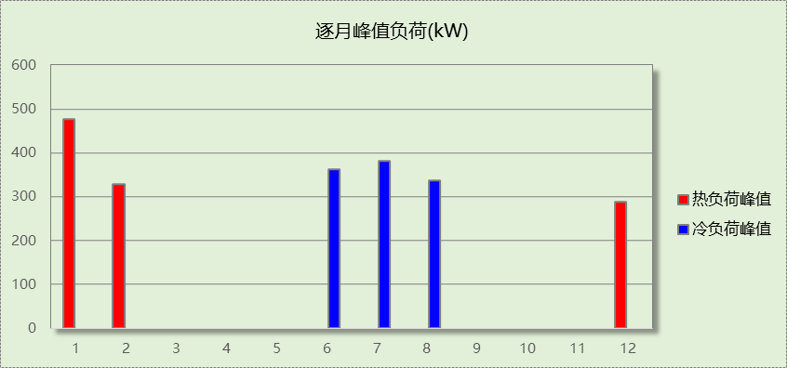

附录
工作日/节假日人员逐时在室率(%)

房间类型 | 1 | 2 | 3 | 4 | 5 | 6 | 7 | 8 | 9 | 10 | 11 | 12 | 13 | 14 | 15 | 16 | 17 | 18 | 19 | 20 | 21 | 22 | 23 | 24
一般商店 | 0 | 0 | 0 | 0 | 0 | 0 | 0 | 20 | 50 | 80 | 80 | 80 | 80 | 80 | 80 | 80 | 80 | 80 | 80 | 70 | 50 | 0 | 0 | 0
一般商店 | 0 | 0 | 0 | 0 | 0 | 0 | 0 | 20 | 50 | 80 | 80 | 80 | 80 | 80 | 80 | 80 | 80 | 80 | 80 | 70 | 50 | 0 | 0 | 0
会议室 | 0 | 0 | 0 | 0 | 0 | 0 | 10 | 50 | 100 | 100 | 100 | 30 | 100 | 100 | 100 | 100 | 50 | 20 | 10 | 0 | 0 | 0 | 0 | 0
会议室 | 0 | 0 | 0 | 0 | 0 | 0 | 0 | 20 | 45 | 0 | 0 | 0 | 0 | 0 | 0 | 0 | 0 | 0 | 0 | 0 | 0 | 0 | 0 | 0
卫生间 | 0 | 0 | 0 | 0 | 0 | 0 | 10 | 50 | 100 | 100 | 100 | 30 | 100 | 100 | 100 | 100 | 50 | 20 | 10 | 0 | 0 | 0 | 0 | 0
卫生间 | 0 | 0 | 0 | 0 | 0 | 0 | 0 | 20 | 45 | 0 | 0 | 0 | 0 | 0 | 0 | 0 | 0 | 0 | 0 | 0 | 0 | 0 | 0 | 0
卫生间 | 0 | 0 | 0 | 0 | 0 | 0 | 10 | 50 | 100 | 100 | 100 | 30 | 100 | 100 | 100 | 100 | 50 | 20 | 10 | 0 | 0 | 0 | 0 | 0
卫生间 | 0 | 0 | 0 | 0 | 0 | 0 | 0 | 20 | 45 | 0 | 0 | 0 | 0 | 0 | 0 | 0 | 0 | 0 | 0 | 0 | 0 | 0 | 0 | 0
卫生间 | 0 | 0 | 0 | 0 | 0 | 0 | 10 | 50 | 100 | 100 | 100 | 30 | 100 | 100 | 100 | 100 | 50 | 20 | 10 | 0 | 0 | 0 | 0 | 0
卫生间 | 0 | 0 | 0 | 0 | 0 | 0 | 0 | 20 | 45 | 0 | 0 | 0 | 0 | 0 | 0 | 0 | 0 | 0 | 0 | 0 | 0 | 0 | 0 | 0
多媒体区 | 0 | 0 | 0 | 0 | 0 | 0 | 10 | 50 | 100 | 100 | 100 | 30 | 100 | 100 | 100 | 100 | 50 | 20 | 10 | 0 | 0 | 0 | 0 | 0
多媒体区 | 0 | 0 | 0 | 0 | 0 | 0 | 0 | 20 | 45 | 0 | 0 | 0 | 0 | 0 | 0 | 0 | 0 | 0 | 0 | 0 | 0 | 0 | 0 | 0
大厅 | 0 | 0 | 0 | 0 | 0 | 0 | 10 | 50 | 100 | 100 | 100 | 30 | 100 | 100 | 100 | 100 | 50 | 20 | 10 | 0 | 0 | 0 | 0 | 0
大厅 | 0 | 0 | 0 | 0 | 0 | 0 | 0 | 20 | 45 | 0 | 0 | 0 | 0 | 0 | 0 | 0 | 0 | 0 | 0 | 0 | 0 | 0 | 0 | 0
展览馆 | 0 | 0 | 0 | 0 | 0 | 0 | 10 | 50 | 100 | 100 | 100 | 30 | 100 | 100 | 100 | 100 | 50 | 20 | 10 | 0 | 0 | 0 | 0 | 0
展览馆 | 0 | 0 | 0 | 0 | 0 | 0 | 0 | 20 | 45 | 0 | 0 | 0 | 0 | 0 | 0 | 0 | 0 | 0 | 0 | 0 | 0 | 0 | 0 | 0
开水间 | 0 | 0 | 0 | 0 | 0 | 0 | 10 | 50 | 100 | 100 | 100 | 30 | 100 | 100 | 100 | 100 | 50 | 20 | 10 | 0 | 0 | 0 | 0 | 0
开水间 | 0 | 0 | 0 | 0 | 0 | 0 | 0 | 20 | 45 | 0 | 0 | 0 | 0 | 0 | 0 | 0 | 0 | 0 | 0 | 0 | 0 | 0 | 0 | 0
普通办公室 | 0 | 0 | 0 | 0 | 0 | 0 | 10 | 50 | 100 | 100 | 100 | 30 | 100 | 100 | 100 | 100 | 50 | 20 | 10 | 0 | 0 | 0 | 0 | 0
普通办公室 | 0 | 0 | 0 | 0 | 0 | 0 | 0 | 20 | 45 | 0 | 0 | 0 | 0 | 0 | 0 | 0 | 0 | 0 | 0 | 0 | 0 | 0 | 0 | 0
档案室 | 0 | 0 | 0 | 0 | 0 | 0 | 10 | 50 | 100 | 100 | 100 | 30 | 100 | 100 | 100 | 100 | 50 | 20 | 10 | 0 | 0 | 0 | 0 | 0
档案室 | 0 | 0 | 0 | 0 | 0 | 0 | 0 | 20 | 45 | 0 | 0 | 0 | 0 | 0 | 0 | 0 | 0 | 0 | 0 | 0 | 0 | 0 | 0 | 0
楼梯间 | 0 | 0 | 0 | 0 | 0 | 0 | 0 | 20 | 50 | 80 | 80 | 80 | 80 | 80 | 80 | 80 | 80 | 80 | 80 | 70 | 50 | 0 | 0 | 0
楼梯间 | 0 | 0 | 0 | 0 | 0 | 0 | 0 | 0 | 0 | 0 | 0 | 0 | 0 | 0 | 0 | 0 | 0 | 0 | 0 | 0 | 0 | 0 | 0 | 0
楼梯间 | 0 | 0 | 0 | 0 | 0 | 0 | 10 | 50 | 100 | 100 | 100 | 30 | 100 | 100 | 100 | 100 | 50 | 20 | 10 | 0 | 0 | 0 | 0 | 0
楼梯间 | 0 | 0 | 0 | 0 | 0 | 0 | 0 | 20 | 45 | 0 | 0 | 0 | 0 | 0 | 0 | 0 | 0 | 0 | 0 | 0 | 0 | 0 | 0 | 0
楼梯间 | 0 | 0 | 0 | 0 | 0 | 0 | 10 | 50 | 100 | 100 | 100 | 30 | 100 | 100 | 100 | 100 | 50 | 20 | 10 | 0 | 0 | 0 | 0 | 0
楼梯间 | 0 | 0 | 0 | 0 | 0 | 0 | 0 | 20 | 45 | 0 | 0 | 0 | 0 | 0 | 0 | 0 | 0 | 0 | 0 | 0 | 0 | 0 | 0 | 0
空房间 | 0 | 0 | 0 | 0 | 0 | 0 | 0 | 20 | 50 | 80 | 80 | 80 | 80 | 80 | 80 | 80 | 80 | 80 | 80 | 70 | 50 | 0 | 0 | 0
空房间 | 0 | 0 | 0 | 0 | 0 | 0 | 0 | 20 | 50 | 80 | 80 | 80 | 80 | 80 | 80 | 80 | 80 | 80 | 80 | 70 | 50 | 0 | 0 | 0
设备间 | 0 | 0 | 0 | 0 | 0 | 0 | 0 | 0 | 0 | 0 | 0 | 0 | 0 | 0 | 0 | 0 | 0 | 0 | 0 | 0 | 0 | 0 | 0 | 0
设备间 | 0 | 0 | 0 | 0 | 0 | 0 | 0 | 0 | 0 | 0 | 0 | 0 | 0 | 0 | 0 | 0 | 0 | 0 | 0 | 0 | 0 | 0 | 0 | 0
走廊 | 0 | 0 | 0 | 0 | 0 | 0 | 10 | 50 | 95 | 95 | 95 | 80 | 80 | 95 | 95 | 95 | 95 | 30 | 30 | 0 | 0 | 0 | 0 | 0
走廊 | 0 | 0 | 0 | 0 | 0 | 0 | 0 | 0 | 0 | 0 | 0 | 0 | 0 | 0 | 0 | 0 | 0 | 0 | 0 | 0 | 0 | 0 | 0 | 0
走廊 | 0 | 0 | 0 | 0 | 0 | 0 | 10 | 50 | 100 | 100 | 100 | 30 | 100 | 100 | 100 | 100 | 50 | 20 | 10 | 0 | 0 | 0 | 0 | 0
走廊 | 0 | 0 | 0 | 0 | 0 | 0 | 0 | 20 | 45 | 0 | 0 | 0 | 0 | 0 | 0 | 0 | 0 | 0 | 0 | 0 | 0 | 0 | 0 | 0
走廊 | 0 | 0 | 0 | 0 | 0 | 0 | 10 | 50 | 100 | 100 | 100 | 30 | 100 | 100 | 100 | 100 | 50 | 20 | 10 | 0 | 0 | 0 | 0 | 0
走廊 | 0 | 0 | 0 | 0 | 0 | 0 | 0 | 20 | 45 | 0 | 0 | 0 | 0 | 0 | 0 | 0 | 0 | 0 | 0 | 0 | 0 | 0 | 0 | 0
走廊 | 0 | 0 | 0 | 0 | 0 | 0 | 10 | 50 | 100 | 100 | 100 | 30 | 100 | 100 | 100 | 100 | 50 | 20 | 10 | 0 | 0 | 0 | 0 | 0
走廊 | 0 | 0 | 0 | 0 | 0 | 0 | 0 | 20 | 45 | 0 | 0 | 0 | 0 | 0 | 0 | 0 | 0 | 0 | 0 | 0 | 0 | 0 | 0 | 0
阅览室 | 0 | 0 | 0 | 0 | 0 | 0 | 10 | 50 | 100 | 100 | 100 | 30 | 100 | 100 | 100 | 100 | 50 | 20 | 10 | 0 | 0 | 0 | 0 | 0
阅览室 | 0 | 0 | 0 | 0 | 0 | 0 | 0 | 20 | 45 | 0 | 0 | 0 | 0 | 0 | 0 | 0 | 0 | 0 | 0 | 0 | 0 | 0 | 0 | 0
陈列室 | 0 | 0 | 0 | 0 | 0 | 0 | 10 | 50 | 100 | 100 | 100 | 30 | 100 | 100 | 100 | 100 | 50 | 20 | 10 | 0 | 0 | 0 | 0 | 0
陈列室 | 0 | 0 | 0 | 0 | 0 | 0 | 0 | 20 | 45 | 0 | 0 | 0 | 0 | 0 | 0 | 0 | 0 | 0 | 0 | 0 | 0 | 0 | 0 | 0
餐厅 | 0 | 0 | 0 | 0 | 0 | 0 | 10 | 50 | 100 | 100 | 100 | 30 | 100 | 100 | 100 | 100 | 50 | 20 | 10 | 0 | 0 | 0 | 0 | 0
餐厅 | 0 | 0 | 0 | 0 | 0 | 0 | 0 | 20 | 45 | 0 | 0 | 0 | 0 | 0 | 0 | 0 | 0 | 0 | 0 | 0 | 0 | 0 | 0 | 0
注：上行：工作日；下行：节假日

工作日/节假日照明开关时间表(%)

房间类型 | 1 | 2 | 3 | 4 | 5 | 6 | 7 | 8 | 9 | 10 | 11 | 12 | 13 | 14 | 15 | 16 | 17 | 18 | 19 | 20 | 21 | 22 | 23 | 24
一般商店 | 10 | 10 | 10 | 10 | 10 | 10 | 10 | 50 | 60 | 60 | 60 | 60 | 60 | 60 | 60 | 60 | 80 | 90 | 100 | 100 | 100 | 10 | 10 | 10
一般商店 | 10 | 10 | 10 | 10 | 10 | 10 | 10 | 50 | 60 | 60 | 60 | 60 | 60 | 60 | 60 | 60 | 80 | 90 | 100 | 100 | 100 | 10 | 10 | 10
会议室 | 10 | 10 | 10 | 10 | 10 | 10 | 10 | 36 | 62 | 56 | 54 | 43 | 53 | 55 | 58 | 67 | 40 | 18 | 10 | 10 | 10 | 10 | 10 | 10
会议室 | 0 | 0 | 0 | 0 | 0 | 0 | 0 | 0 | 0 | 0 | 0 | 0 | 0 | 0 | 0 | 0 | 0 | 0 | 0 | 0 | 0 | 0 | 0 | 0
卫生间 | 10 | 10 | 10 | 10 | 10 | 10 | 10 | 36 | 62 | 56 | 54 | 43 | 53 | 55 | 58 | 67 | 40 | 18 | 10 | 10 | 10 | 10 | 10 | 10
卫生间 | 0 | 0 | 0 | 0 | 0 | 0 | 0 | 0 | 0 | 0 | 0 | 0 | 0 | 0 | 0 | 0 | 0 | 0 | 0 | 0 | 0 | 0 | 0 | 0
卫生间 | 10 | 10 | 10 | 10 | 10 | 10 | 10 | 36 | 62 | 56 | 54 | 43 | 53 | 55 | 58 | 67 | 40 | 18 | 10 | 10 | 10 | 10 | 10 | 10
卫生间 | 0 | 0 | 0 | 0 | 0 | 0 | 0 | 0 | 0 | 0 | 0 | 0 | 0 | 0 | 0 | 0 | 0 | 0 | 0 | 0 | 0 | 0 | 0 | 0
卫生间 | 10 | 10 | 10 | 10 | 10 | 10 | 10 | 36 | 62 | 56 | 54 | 43 | 53 | 55 | 58 | 67 | 40 | 18 | 10 | 10 | 10 | 10 | 10 | 10
卫生间 | 0 | 0 | 0 | 0 | 0 | 0 | 0 | 0 | 0 | 0 | 0 | 0 | 0 | 0 | 0 | 0 | 0 | 0 | 0 | 0 | 0 | 0 | 0 | 0
多媒体区 | 10 | 10 | 10 | 10 | 10 | 10 | 10 | 36 | 62 | 56 | 54 | 43 | 53 | 55 | 58 | 67 | 40 | 18 | 10 | 10 | 10 | 10 | 10 | 10
多媒体区 | 0 | 0 | 0 | 0 | 0 | 0 | 0 | 0 | 0 | 0 | 0 | 0 | 0 | 0 | 0 | 0 | 0 | 0 | 0 | 0 | 0 | 0 | 0 | 0
大厅 | 10 | 10 | 10 | 10 | 10 | 10 | 10 | 36 | 62 | 56 | 54 | 43 | 53 | 55 | 58 | 67 | 40 | 18 | 10 | 10 | 10 | 10 | 10 | 10
大厅 | 0 | 0 | 0 | 0 | 0 | 0 | 0 | 0 | 0 | 0 | 0 | 0 | 0 | 0 | 0 | 0 | 0 | 0 | 0 | 0 | 0 | 0 | 0 | 0
展览馆 | 10 | 10 | 10 | 10 | 10 | 10 | 10 | 36 | 62 | 56 | 54 | 43 | 53 | 55 | 58 | 67 | 40 | 18 | 10 | 10 | 10 | 10 | 10 | 10
展览馆 | 0 | 0 | 0 | 0 | 0 | 0 | 0 | 0 | 0 | 0 | 0 | 0 | 0 | 0 | 0 | 0 | 0 | 0 | 0 | 0 | 0 | 0 | 0 | 0
开水间 | 10 | 10 | 10 | 10 | 10 | 10 | 10 | 36 | 62 | 56 | 54 | 43 | 53 | 55 | 58 | 67 | 40 | 18 | 10 | 10 | 10 | 10 | 10 | 10
开水间 | 0 | 0 | 0 | 0 | 0 | 0 | 0 | 0 | 0 | 0 | 0 | 0 | 0 | 0 | 0 | 0 | 0 | 0 | 0 | 0 | 0 | 0 | 0 | 0
普通办公室 | 10 | 10 | 10 | 10 | 10 | 10 | 10 | 36 | 62 | 56 | 54 | 43 | 53 | 55 | 58 | 67 | 40 | 18 | 10 | 10 | 10 | 10 | 10 | 10
普通办公室 | 0 | 0 | 0 | 0 | 0 | 0 | 0 | 0 | 0 | 0 | 0 | 0 | 0 | 0 | 0 | 0 | 0 | 0 | 0 | 0 | 0 | 0 | 0 | 0
档案室 | 10 | 10 | 10 | 10 | 10 | 10 | 10 | 36 | 62 | 56 | 54 | 43 | 53 | 55 | 58 | 67 | 40 | 18 | 10 | 10 | 10 | 10 | 10 | 10
档案室 | 0 | 0 | 0 | 0 | 0 | 0 | 0 | 0 | 0 | 0 | 0 | 0 | 0 | 0 | 0 | 0 | 0 | 0 | 0 | 0 | 0 | 0 | 0 | 0
楼梯间 | 10 | 10 | 10 | 10 | 10 | 10 | 10 | 50 | 60 | 60 | 60 | 60 | 60 | 60 | 60 | 60 | 80 | 90 | 100 | 100 | 100 | 10 | 10 | 10
楼梯间 | 0 | 0 | 0 | 0 | 0 | 0 | 0 | 0 | 0 | 0 | 0 | 0 | 0 | 0 | 0 | 0 | 0 | 0 | 0 | 0 | 0 | 0 | 0 | 0
楼梯间 | 10 | 10 | 10 | 10 | 10 | 10 | 10 | 36 | 62 | 56 | 54 | 43 | 53 | 55 | 58 | 67 | 40 | 18 | 10 | 10 | 10 | 10 | 10 | 10
楼梯间 | 0 | 0 | 0 | 0 | 0 | 0 | 0 | 0 | 0 | 0 | 0 | 0 | 0 | 0 | 0 | 0 | 0 | 0 | 0 | 0 | 0 | 0 | 0 | 0
楼梯间 | 10 | 10 | 10 | 10 | 10 | 10 | 10 | 36 | 62 | 56 | 54 | 43 | 53 | 55 | 58 | 67 | 40 | 18 | 10 | 10 | 10 | 10 | 10 | 10
楼梯间 | 0 | 0 | 0 | 0 | 0 | 0 | 0 | 0 | 0 | 0 | 0 | 0 | 0 | 0 | 0 | 0 | 0 | 0 | 0 | 0 | 0 | 0 | 0 | 0
空房间 | 10 | 10 | 10 | 10 | 10 | 10 | 10 | 50 | 60 | 60 | 60 | 60 | 60 | 60 | 60 | 60 | 80 | 90 | 100 | 100 | 100 | 10 | 10 | 10
空房间 | 10 | 10 | 10 | 10 | 10 | 10 | 10 | 50 | 60 | 60 | 60 | 60 | 60 | 60 | 60 | 60 | 80 | 90 | 100 | 100 | 100 | 10 | 10 | 10
设备间 | 100 | 100 | 100 | 100 | 100 | 100 | 100 | 100 | 100 | 100 | 100 | 100 | 100 | 100 | 100 | 100 | 100 | 100 | 100 | 100 | 100 | 100 | 100 | 100
设备间 | 100 | 100 | 100 | 100 | 100 | 100 | 100 | 100 | 100 | 100 | 100 | 100 | 100 | 100 | 100 | 100 | 100 | 100 | 100 | 100 | 100 | 100 | 100 | 100
走廊 | 0 | 0 | 0 | 0 | 0 | 0 | 10 | 50 | 95 | 95 | 95 | 80 | 80 | 95 | 95 | 95 | 95 | 30 | 30 | 0 | 0 | 0 | 0 | 0
走廊 | 0 | 0 | 0 | 0 | 0 | 0 | 0 | 0 | 0 | 0 | 0 | 0 | 0 | 0 | 0 | 0 | 0 | 0 | 0 | 0 | 0 | 0 | 0 | 0
走廊 | 10 | 10 | 10 | 10 | 10 | 10 | 10 | 36 | 62 | 56 | 54 | 43 | 53 | 55 | 58 | 67 | 40 | 18 | 10 | 10 | 10 | 10 | 10 | 10
走廊 | 0 | 0 | 0 | 0 | 0 | 0 | 0 | 0 | 0 | 0 | 0 | 0 | 0 | 0 | 0 | 0 | 0 | 0 | 0 | 0 | 0 | 0 | 0 | 0
走廊 | 10 | 10 | 10 | 10 | 10 | 10 | 10 | 36 | 62 | 56 | 54 | 43 | 53 | 55 | 58 | 67 | 40 | 18 | 10 | 10 | 10 | 10 | 10 | 10
走廊 | 0 | 0 | 0 | 0 | 0 | 0 | 0 | 0 | 0 | 0 | 0 | 0 | 0 | 0 | 0 | 0 | 0 | 0 | 0 | 0 | 0 | 0 | 0 | 0
走廊 | 10 | 10 | 10 | 10 | 10 | 10 | 10 | 36 | 62 | 56 | 54 | 43 | 53 | 55 | 58 | 67 | 40 | 18 | 10 | 10 | 10 | 10 | 10 | 10
走廊 | 0 | 0 | 0 | 0 | 0 | 0 | 0 | 0 | 0 | 0 | 0 | 0 | 0 | 0 | 0 | 0 | 0 | 0 | 0 | 0 | 0 | 0 | 0 | 0
阅览室 | 10 | 10 | 10 | 10 | 10 | 10 | 10 | 36 | 62 | 56 | 54 | 43 | 53 | 55 | 58 | 67 | 40 | 18 | 10 | 10 | 10 | 10 | 10 | 10
阅览室 | 0 | 0 | 0 | 0 | 0 | 0 | 0 | 0 | 0 | 0 | 0 | 0 | 0 | 0 | 0 | 0 | 0 | 0 | 0 | 0 | 0 | 0 | 0 | 0
陈列室 | 10 | 10 | 10 | 10 | 10 | 10 | 10 | 36 | 62 | 56 | 54 | 43 | 53 | 55 | 58 | 67 | 40 | 18 | 10 | 10 | 10 | 10 | 10 | 10
陈列室 | 0 | 0 | 0 | 0 | 0 | 0 | 0 | 0 | 0 | 0 | 0 | 0 | 0 | 0 | 0 | 0 | 0 | 0 | 0 | 0 | 0 | 0 | 0 | 0
餐厅 | 10 | 10 | 10 | 10 | 10 | 10 | 10 | 36 | 62 | 56 | 54 | 43 | 53 | 55 | 58 | 67 | 40 | 18 | 10 | 10 | 10 | 10 | 10 | 10
餐厅 | 0 | 0 | 0 | 0 | 0 | 0 | 0 | 0 | 0 | 0 | 0 | 0 | 0 | 0 | 0 | 0 | 0 | 0 | 0 | 0 | 0 | 0 | 0 | 0
注：上行：工作日；下行：节假日

工作日/节假日设备逐时使用率(%)

房间类型 | 1 | 2 | 3 | 4 | 5 | 6 | 7 | 8 | 9 | 10 | 11 | 12 | 13 | 14 | 15 | 16 | 17 | 18 | 19 | 20 | 21 | 22 | 23 | 24
一般商店 | 0 | 0 | 0 | 0 | 0 | 0 | 0 | 30 | 50 | 80 | 80 | 80 | 80 | 80 | 80 | 80 | 80 | 80 | 80 | 70 | 50 | 0 | 0 | 0
一般商店 | 0 | 0 | 0 | 0 | 0 | 0 | 0 | 30 | 50 | 80 | 80 | 80 | 80 | 80 | 80 | 80 | 80 | 80 | 80 | 70 | 50 | 0 | 0 | 0
会议室 | 0 | 0 | 0 | 0 | 0 | 0 | 10 | 50 | 100 | 100 | 100 | 100 | 100 | 100 | 100 | 100 | 50 | 20 | 10 | 0 | 0 | 0 | 0 | 0
会议室 | 0 | 0 | 0 | 0 | 0 | 0 | 0 | 0 | 0 | 0 | 0 | 0 | 0 | 0 | 0 | 0 | 0 | 0 | 0 | 0 | 0 | 0 | 0 | 0
卫生间 | 0 | 0 | 0 | 0 | 0 | 0 | 10 | 50 | 100 | 100 | 100 | 100 | 100 | 100 | 100 | 100 | 50 | 20 | 10 | 0 | 0 | 0 | 0 | 0
卫生间 | 0 | 0 | 0 | 0 | 0 | 0 | 0 | 0 | 0 | 0 | 0 | 0 | 0 | 0 | 0 | 0 | 0 | 0 | 0 | 0 | 0 | 0 | 0 | 0
卫生间 | 0 | 0 | 0 | 0 | 0 | 0 | 10 | 50 | 100 | 100 | 100 | 100 | 100 | 100 | 100 | 100 | 50 | 20 | 10 | 0 | 0 | 0 | 0 | 0
卫生间 | 0 | 0 | 0 | 0 | 0 | 0 | 0 | 0 | 0 | 0 | 0 | 0 | 0 | 0 | 0 | 0 | 0 | 0 | 0 | 0 | 0 | 0 | 0 | 0
卫生间 | 0 | 0 | 0 | 0 | 0 | 0 | 10 | 50 | 100 | 100 | 100 | 100 | 100 | 100 | 100 | 100 | 50 | 20 | 10 | 0 | 0 | 0 | 0 | 0
卫生间 | 0 | 0 | 0 | 0 | 0 | 0 | 0 | 0 | 0 | 0 | 0 | 0 | 0 | 0 | 0 | 0 | 0 | 0 | 0 | 0 | 0 | 0 | 0 | 0
多媒体区 | 0 | 0 | 0 | 0 | 0 | 0 | 10 | 50 | 100 | 100 | 100 | 100 | 100 | 100 | 100 | 100 | 50 | 20 | 10 | 0 | 0 | 0 | 0 | 0
多媒体区 | 0 | 0 | 0 | 0 | 0 | 0 | 0 | 0 | 0 | 0 | 0 | 0 | 0 | 0 | 0 | 0 | 0 | 0 | 0 | 0 | 0 | 0 | 0 | 0
大厅 | 0 | 0 | 0 | 0 | 0 | 0 | 10 | 50 | 100 | 100 | 100 | 100 | 100 | 100 | 100 | 100 | 50 | 20 | 10 | 0 | 0 | 0 | 0 | 0
大厅 | 0 | 0 | 0 | 0 | 0 | 0 | 0 | 0 | 0 | 0 | 0 | 0 | 0 | 0 | 0 | 0 | 0 | 0 | 0 | 0 | 0 | 0 | 0 | 0
展览馆 | 0 | 0 | 0 | 0 | 0 | 0 | 10 | 50 | 100 | 100 | 100 | 100 | 100 | 100 | 100 | 100 | 50 | 20 | 10 | 0 | 0 | 0 | 0 | 0
展览馆 | 0 | 0 | 0 | 0 | 0 | 0 | 0 | 0 | 0 | 0 | 0 | 0 | 0 | 0 | 0 | 0 | 0 | 0 | 0 | 0 | 0 | 0 | 0 | 0
开水间 | 0 | 0 | 0 | 0 | 0 | 0 | 10 | 50 | 100 | 100 | 100 | 100 | 100 | 100 | 100 | 100 | 50 | 20 | 10 | 0 | 0 | 0 | 0 | 0
开水间 | 0 | 0 | 0 | 0 | 0 | 0 | 0 | 0 | 0 | 0 | 0 | 0 | 0 | 0 | 0 | 0 | 0 | 0 | 0 | 0 | 0 | 0 | 0 | 0
普通办公室 | 0 | 0 | 0 | 0 | 0 | 0 | 10 | 50 | 100 | 100 | 100 | 100 | 100 | 100 | 100 | 100 | 50 | 20 | 10 | 0 | 0 | 0 | 0 | 0
普通办公室 | 0 | 0 | 0 | 0 | 0 | 0 | 0 | 0 | 0 | 0 | 0 | 0 | 0 | 0 | 0 | 0 | 0 | 0 | 0 | 0 | 0 | 0 | 0 | 0
档案室 | 0 | 0 | 0 | 0 | 0 | 0 | 10 | 50 | 100 | 100 | 100 | 100 | 100 | 100 | 100 | 100 | 50 | 20 | 10 | 0 | 0 | 0 | 0 | 0
档案室 | 0 | 0 | 0 | 0 | 0 | 0 | 0 | 0 | 0 | 0 | 0 | 0 | 0 | 0 | 0 | 0 | 0 | 0 | 0 | 0 | 0 | 0 | 0 | 0
楼梯间 | 0 | 0 | 0 | 0 | 0 | 0 | 0 | 30 | 50 | 80 | 80 | 80 | 80 | 80 | 80 | 80 | 80 | 80 | 80 | 70 | 50 | 0 | 0 | 0
楼梯间 | 0 | 0 | 0 | 0 | 0 | 0 | 0 | 0 | 0 | 0 | 0 | 0 | 0 | 0 | 0 | 0 | 0 | 0 | 0 | 0 | 0 | 0 | 0 | 0
楼梯间 | 0 | 0 | 0 | 0 | 0 | 0 | 10 | 50 | 100 | 100 | 100 | 100 | 100 | 100 | 100 | 100 | 50 | 20 | 10 | 0 | 0 | 0 | 0 | 0
楼梯间 | 0 | 0 | 0 | 0 | 0 | 0 | 0 | 0 | 0 | 0 | 0 | 0 | 0 | 0 | 0 | 0 | 0 | 0 | 0 | 0 | 0 | 0 | 0 | 0
楼梯间 | 0 | 0 | 0 | 0 | 0 | 0 | 10 | 50 | 100 | 100 | 100 | 100 | 100 | 100 | 100 | 100 | 50 | 20 | 10 | 0 | 0 | 0 | 0 | 0
楼梯间 | 0 | 0 | 0 | 0 | 0 | 0 | 0 | 0 | 0 | 0 | 0 | 0 | 0 | 0 | 0 | 0 | 0 | 0 | 0 | 0 | 0 | 0 | 0 | 0
空房间 | 0 | 0 | 0 | 0 | 0 | 0 | 0 | 30 | 50 | 80 | 80 | 80 | 80 | 80 | 80 | 80 | 80 | 80 | 80 | 70 | 50 | 0 | 0 | 0
空房间 | 0 | 0 | 0 | 0 | 0 | 0 | 0 | 30 | 50 | 80 | 80 | 80 | 80 | 80 | 80 | 80 | 80 | 80 | 80 | 70 | 50 | 0 | 0 | 0
设备间 | 100 | 100 | 100 | 100 | 100 | 100 | 100 | 100 | 100 | 100 | 100 | 100 | 100 | 100 | 100 | 100 | 100 | 100 | 100 | 100 | 100 | 100 | 100 | 100
设备间 | 100 | 100 | 100 | 100 | 100 | 100 | 100 | 100 | 100 | 100 | 100 | 100 | 100 | 100 | 100 | 100 | 100 | 100 | 100 | 100 | 100 | 100 | 100 | 100
走廊 | 0 | 0 | 0 | 0 | 0 | 0 | 10 | 50 | 95 | 95 | 95 | 50 | 50 | 95 | 95 | 95 | 95 | 30 | 30 | 0 | 0 | 0 | 0 | 0
走廊 | 0 | 0 | 0 | 0 | 0 | 0 | 0 | 0 | 0 | 0 | 0 | 0 | 0 | 0 | 0 | 0 | 0 | 0 | 0 | 0 | 0 | 0 | 0 | 0
走廊 | 0 | 0 | 0 | 0 | 0 | 0 | 10 | 50 | 100 | 100 | 100 | 100 | 100 | 100 | 100 | 100 | 50 | 20 | 10 | 0 | 0 | 0 | 0 | 0
走廊 | 0 | 0 | 0 | 0 | 0 | 0 | 0 | 0 | 0 | 0 | 0 | 0 | 0 | 0 | 0 | 0 | 0 | 0 | 0 | 0 | 0 | 0 | 0 | 0
走廊 | 0 | 0 | 0 | 0 | 0 | 0 | 10 | 50 | 100 | 100 | 100 | 100 | 100 | 100 | 100 | 100 | 50 | 20 | 10 | 0 | 0 | 0 | 0 | 0
走廊 | 0 | 0 | 0 | 0 | 0 | 0 | 0 | 0 | 0 | 0 | 0 | 0 | 0 | 0 | 0 | 0 | 0 | 0 | 0 | 0 | 0 | 0 | 0 | 0
走廊 | 0 | 0 | 0 | 0 | 0 | 0 | 10 | 50 | 100 | 100 | 100 | 100 | 100 | 100 | 100 | 100 | 50 | 20 | 10 | 0 | 0 | 0 | 0 | 0
走廊 | 0 | 0 | 0 | 0 | 0 | 0 | 0 | 0 | 0 | 0 | 0 | 0 | 0 | 0 | 0 | 0 | 0 | 0 | 0 | 0 | 0 | 0 | 0 | 0
阅览室 | 0 | 0 | 0 | 0 | 0 | 0 | 10 | 50 | 100 | 100 | 100 | 100 | 100 | 100 | 100 | 100 | 50 | 20 | 10 | 0 | 0 | 0 | 0 | 0
阅览室 | 0 | 0 | 0 | 0 | 0 | 0 | 0 | 0 | 0 | 0 | 0 | 0 | 0 | 0 | 0 | 0 | 0 | 0 | 0 | 0 | 0 | 0 | 0 | 0
陈列室 | 0 | 0 | 0 | 0 | 0 | 0 | 10 | 50 | 100 | 100 | 100 | 100 | 100 | 100 | 100 | 100 | 50 | 20 | 10 | 0 | 0 | 0 | 0 | 0
陈列室 | 0 | 0 | 0 | 0 | 0 | 0 | 0 | 0 | 0 | 0 | 0 | 0 | 0 | 0 | 0 | 0 | 0 | 0 | 0 | 0 | 0 | 0 | 0 | 0
餐厅 | 0 | 0 | 0 | 0 | 0 | 0 | 10 | 50 | 100 | 100 | 100 | 100 | 100 | 100 | 100 | 100 | 50 | 20 | 10 | 0 | 0 | 0 | 0 | 0
餐厅 | 0 | 0 | 0 | 0 | 0 | 0 | 0 | 0 | 0 | 0 | 0 | 0 | 0 | 0 | 0 | 0 | 0 | 0 | 0 | 0 | 0 | 0 | 0 | 0
注：上行：工作日；下行：节假日

工作日/节假日空调系统开关时间表
采暖期：
系统编号 | 1 | 2 | 3 | 4 | 5 | 6 | 7 | 8 | 9 | 10 | 11 | 12 | 13 | 14 | 15 | 16 | 17 | 18 | 19 | 20 | 21 | 22 | 23 | 24
默认 | 0 | 0 | 0 | 0 | 0 | 0 | 1 | 1 | 1 | 1 | 1 | 1 | 1 | 1 | 1 | 1 | 1 | 1 | 0 | 0 | 0 | 0 | 0 | 0
默认 | 0 | 0 | 0 | 0 | 0 | 0 | 0 | 0 | 0 | 0 | 0 | 0 | 0 | 0 | 0 | 0 | 0 | 0 | 0 | 0 | 0 | 0 | 0 | 0
供冷期：

系统编号 | 1 | 2 | 3 | 4 | 5 | 6 | 7 | 8 | 9 | 10 | 11 | 12 | 13 | 14 | 15 | 16 | 17 | 18 | 19 | 20 | 21 | 22 | 23 | 24
默认 | 0 | 0 | 0 | 0 | 0 | 0 | 1 | 1 | 1 | 1 | 1 | 1 | 1 | 1 | 1 | 1 | 1 | 1 | 0 | 0 | 0 | 0 | 0 | 0
默认 | 0 | 0 | 0 | 0 | 0 | 0 | 0 | 0 | 0 | 0 | 0 | 0 | 0 | 0 | 0 | 0 | 0 | 0 | 0 | 0 | 0 | 0 | 0 | 0
注：上行：工作日；下行：节假日

