**建筑碳排放报告书**

公共建筑

|  |  |
| --- | --- |
| 工程名称 | 二食堂 |
| 工程地点 | 辽宁-沈阳 |
| 设计编号 |  |
| 建设单位 |  |
| 设计单位 |  |
| 设 计 人 |  |
| 审 核 人 |  |
| 审 定 人 |  |
| 设计日期 | 2024年11月26日 |



|  |  |
| --- | --- |
| 采用软件 | 建筑碳排放CEEB2024 |
| 软件版本 | 20240430(SP1) |
| 研发单位 | 北京绿建软件股份有限公司 |
| 正版授权码 | T18071947436 |

**目 录**

1 建筑概况 3

2 标准依据 3

3 软件介绍 3

4 气象数据 4

4.1 逐日干球温度表 4

4.2 逐月辐照量表 4

4.3 峰值工况 4

5 建筑大样 5

6 围护结构 8

6.1 工程材料 8

6.2 围护结构作法简要说明 9

7 围护结构概况 9

8 房间类型 10

8.1 房间参数表 10

8.2 作息时间表 10

9 暖通空调系统 10

9.1 系统类型 10

9.1.1 系统分区 10

9.1.2 热回收参数 10

9.2 供暖系统 10

9.2.1 默认热源 10

9.3 空调风机 11

10 照明 12

11 插座设备 12

12 炊事 12

13 计算结果 12

13.1 建材生产运输碳排放 12

13.1.1 建材生产阶段 12

13.1.2 建材运输阶段 12

13.2 碳汇 13

13.3 建筑运行碳排放 13

13.4 全生命周期 14

13.4.1 单位面积指标 14

13.4.2 总碳排放量 14

14 附录 17

14.1 工作日/节假日人员逐时在室率(%) 17

14.2 工作日/节假日照明开关时间表(%) 17

14.3 工作日/节假日设备逐时使用率(%) 18

14.4 工作日/节假日空调系统运行时间表(1:开,0:关) 19

14.5 工作日/节假日新风运行时间表(%) 19

# 建筑概况

|  |  |  |
| --- | --- | --- |
| 工程名称 | 二食堂 | |
| 工程地点 | 辽宁-沈阳 | |
| 地理位置 | 北纬：41.81° | 东经：123.43° |
| 建筑寿命(年) | 70 | |
| 建筑面积(m2) | 地上7321 地下0 | |
| 建筑层数 | 地上3 地下0 | |
| 建筑高度（m） | 地上15.9 地下0.0 | |
| 建筑体积(m3) | 38799.88 | |
| 建筑外表面积(m2) | 5344.76 | |
| 北向角度 | 270 | |
| 结构类型 |  | |
| 外墙太阳辐射吸收系数 | 0.75 | |
| 屋顶太阳辐射吸收系数 | 0.75 | |
| 控温期 | 供暖期:11.1-3.31 | |

# 标准依据

1. 《建筑节能与可再生能源利用通用规范》GB 55015-2021

2. 《建筑碳排放计算标准》GB/T 51366-2019

3. 《绿色建筑评价标准》GB/T50378-2019

4. 《民用建筑绿色性能计算标准》JGJ/T 449-2018

# 软件介绍

本报告内容由建筑碳排放CEEB2024计算并输出，建筑碳排放CEEB以CAD为平台，可与建筑节能模型无缝对接，以国家标准《建筑碳排放计算标准》为主要依据，完整支持建筑全生命周期的碳排放计算，包括建材生产运输、建造拆除、建筑运行和碳汇的计算，以及详细的结果数据分析。

# 气象数据

## 逐日干球温度表

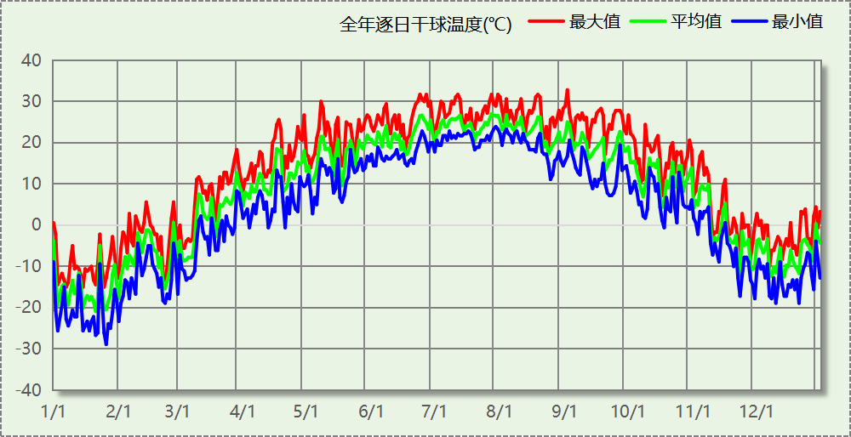

## 逐月辐照量表

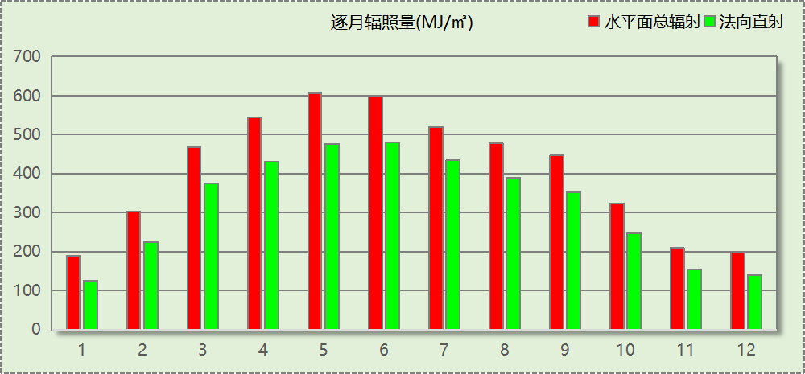

## 峰值工况

|  |  |  |  |  |  |
| --- | --- | --- | --- | --- | --- |
| 气象数据 | 时刻 | 干球温度(℃) | 湿球温度(℃) | 含湿量(g/kg) | 焓值(kj/kg) |
| 最热 | 09月01日15时 | 32.8 | 23.3 | 14.1 | 69.0 |
| 最冷 | 01月25日06时 | -28.9 | -28.9 | 0.0 | -29.0 |

# 建筑大样



西南轴侧图



东南轴侧图



西北轴侧图



东北轴侧图

# 围护结构

## 工程材料

|  |  |  |  |  |  |  |
| --- | --- | --- | --- | --- | --- | --- |
| 材料名称 | 导热系数λ | 蓄热系数S | 密度ρ | 比热容Cp | 蒸汽渗透 系数u | 数据来源 |
| W/(m.K) | W/(㎡.K) | kg/m3 | J/(kg.K) | g/(m.h.kPa) |
| 水泥砂浆 | 0.930 | 11.370 | 1800.0 | 1050.0 | 0.0210 |  |
| 石灰砂浆 | 0.810 | 10.070 | 1600.0 | 1050.0 | 0.0443 |  |
| 钢筋混凝土 | 1.740 | 17.200 | 2500.0 | 920.0 | 0.0158 |  |
| 碎石、卵石混凝土(ρ=2300) | 1.510 | 15.360 | 2300.0 | 920.0 | 0.0173 |  |
| 挤塑聚苯乙烯泡沫塑料（带表皮） | 0.030 | 0.340 | 35.0 | 1380.0 | 0.0000 |  |
| 加气混凝土、泡沫混凝土(ρ=700) | 0.180 | 3.100 | 700.0 | 1050.0 | 0.0998 |  |
| 混凝土多孔砖(190六孔砖） | 0.750 | 7.490 | 1450.0 | 709.4 | 0.0000 |  |

## 围护结构作法简要说明

**1. 屋顶：**屋顶构造一 (K=0.774,D=3.691)：（由上到下）

碎石、卵石混凝土(ρ=2300) 40mm＋挤塑聚苯乙烯泡沫塑料（带表皮） 20mm＋水泥砂浆 20mm＋加气混凝土、泡沫混凝土(ρ=700) 80mm＋钢筋混凝土 120mm＋石灰砂浆 20mm

**2. 外墙：**外墙构造一 (K=1.126,D=2.941)：（由外到内）

水泥砂浆 20mm＋挤塑聚苯乙烯泡沫塑料（带表皮） 20mm＋水泥砂浆 20mm＋钢筋混凝土 200mm＋石灰砂浆 20mm

**3. 挑空楼板：**挑空楼板构造一 (K=1.192,D=2.146)：（由上到下）

水泥砂浆 20mm＋钢筋混凝土 120mm＋水泥砂浆 20mm＋挤塑聚苯乙烯泡沫塑料（带表皮） 20mm＋水泥砂浆 20mm

**4. 外窗：**12A钢铝单框双玻窗（平均） (K=3.900)：

传热系数3.900W/㎡.K，窗太阳得热系数0.652

**5. 周边地面：**周边地面构造一 (K=4.988,D=1.431)：

水泥砂浆 20mm＋钢筋混凝土 120mm

# 围护结构概况

|  |  |  |  |  |
| --- | --- | --- | --- | --- |
|  | | | 设计建筑 | |
| 体形系数S | | | 0.14 | |
| 屋顶传热系数K  和热惰性指标 D | | | 0.77  3.69 | |
| 外墙传热系数K  和热惰性指标 D | | | 1.47  2.94 | |
| 挑空(或架空)楼板传热系数K  和热惰性指标 D | | | 1.19  2.15 | |
| 天窗传热系数K  和太阳得热系数 SHGC | | | －  － | |
| 外窗（包括透明幕墙） | 朝向 | 立面 | 窗墙比 | 传热系数 |
| 南向 | 南-默认立面 | 0.26 | 3.90 |
| 北向 | 北-默认立面 | 0.23 | 3.90 |
| 东向 | 东-默认立面 | 0.10 | 3.90 |
| 西向 | 西-默认立面 | 0.26 | 3.90 |

# 房间类型

## 房间参数表

|  |  |  |  |  |  |  |  |
| --- | --- | --- | --- | --- | --- | --- | --- |
| 房间类型 | 空调 温度℃ | 供暖 温度℃ | 新风量 | 渗透风 换气次数 | 人员密度 | 照明功率 密度 | 电器设备 功率 |
| 休息室 | 26 | 20 | 30(m3/h.人) | 0(次/h) | 3.3(㎡/人) | 5(W/㎡) | 0(W/㎡) |
| 办公-普通办公室 | 26 | 20 | 30(m3/h.人) | 0(次/h) | 8(㎡/人) | 8(W/㎡) | 15(W/㎡) |
| 普通办公室 | 26 | 20 | 30(m3/h.人) | 0(次/h) | 8(㎡/人) | 8(W/㎡) | 15(W/㎡) |
| 餐厅 | 26 | 18 | 30(m3/h.人) | 0(次/h) | 1(㎡/人) | 8(W/㎡) | 13(W/㎡) |

## 作息时间表

详见附录

# 暖通空调系统

## 系统类型

### 系统分区

|  |  |  |  |  |  |
| --- | --- | --- | --- | --- | --- |
| 系统编号 | 系统类型 | 制冷 SEER | 制热 HSPF | 面积(㎡) | 包含的房间 |
| Sys | 双管制风机盘管 | － | － | 6931.47 | 所有房间 |

### 热回收参数

|  |  |  |  |  |  |
| --- | --- | --- | --- | --- | --- |
| 系统编号 | 热回收 | 供冷 | | 供暖 | |
| 回收效率 | 启动温(焓)差 | 回收效率 | 启动温(焓)差 |
| Sys | 显热回收 | 0.60 | 5℃ | 0.65 | 5(℃) |

## 供暖系统

### 默认热源

#### 供应的系统

|  |  |
| --- | --- |
| 系统编号 | Sys |

#### 热泵系统

##### 热泵机组

|  |  |  |  |  |  |
| --- | --- | --- | --- | --- | --- |
| 名称 | 类型 | 额定耗电量(kW) | 额定制热量(kW) | 额定性能系数 COP | 台数 |
| 热泵机组 | 地源热泵 | 125 | 500 | 4.00 | 1 |

##### 热水循环泵

|  |  |  |  |  |  |
| --- | --- | --- | --- | --- | --- |
| 类型 | 流量(m3/h) | 扬程(m) | 设计工作效率(%) | 输入功率(kW) | 台数 |
| 变频 | 1000 | 20 | 80 | 78.3 | 2 |

##### 运行工况

|  |  |  |  |  |  |
| --- | --- | --- | --- | --- | --- |
| 负载率(%) | 机组制热量(kW) | 机组功率(kW) | 性能系数(COP) | 供暖水泵功率(kW) | 热源侧水泵功率(kW) |
| 20 | 100 | 25 | 4.00 | 37.6 | 8 |
| 40 | 200 | 50 | 4.00 | 37.6 | 8 |
| 60 | 300 | 75 | 4.00 | 37.6 | 8 |
| 80 | 400 | 100 | 4.00 | 37.6 | 8 |
| 100 | 500 | 125 | 4.00 | 37.6 | 8 |

##### 制热能耗

|  |  |  |  |  |  |  |
| --- | --- | --- | --- | --- | --- | --- |
| 负荷区间 (%) | 区间负荷 (kWh) | 运行时长 (h) | 平均性能系数 (COP) | 热泵机组 (kWh) | 供暖水泵 (kWh) | 热源侧水泵 (kWh) |
| 0~20 | 6233 | 147 | 4.00 | 1558 | 7097 | 1176 |
| 20~40 | 36403 | 236 | 4.00 | 9101 | 8986 | 1888 |
| 40~60 | 59613 | 234 | 4.00 | 14903 | 9174 | 1872 |
| 60~80 | 108455 | 312 | 4.00 | 27114 | 11919 | 2496 |
| 80~100 | 140119 | 313 | 4.00 | 35030 | 11318 | 2504 |
| >100 | 485290 | 699 | － | 87375 | 25906 | 5592 |
| 合计 | 836113 | 1941 |  | 175081 | 74401 | 15528 |

|  |  |  |  |
| --- | --- | --- | --- |
| 类别 | 电耗(kWh/a) | 碳排放因子(kgCO2/kWh) | 碳排放量(tCO2/a) |
| 热泵机组 | 175081 | 0.5703 | 99.848 |
| 供暖水泵 | 74401 | 42.431 |
| 热源侧水泵 | 15528 | 8.856 |
| 合计 | | | 151.135 |

## 空调风机

|  |  |  |  |
| --- | --- | --- | --- |
| 类别 | 电耗(kWh/a) | 碳排放因子(kgCO2/kWh) | 碳排放量(tCO2/a) |
| 独立新排风 | 116638 | 0.5703 | 66.518 |
| 风机盘管 | 1165 | 0.664 |
| 全空气机组 | 0 | 0.0000 |
| 合计 | | | 67.183 |

# 照明

|  |  |  |  |  |  |  |
| --- | --- | --- | --- | --- | --- | --- |
| 房间类型 | 单位面积电耗 (kWh/㎡.a) | 房间个数 | 房间合计面积 (㎡) | 合计电耗 (kWh/a) | 碳排放因子(kgCO2/kWh) | 碳排放量(tCO2/a) |
| 休息室 | 7.59 | 12 | 362 | 2752 | 0.5703 | 1.570 |
| 普通办公室 | 12.15 | 77 | 3151 | 38280 | 21.831 |
| 餐厅 | 32.12 | 3 | 3718 | 119410 | 68.100 |
| 总计 | | | | | | 91.500 |

# 插座设备

|  |  |  |  |  |  |  |
| --- | --- | --- | --- | --- | --- | --- |
| 房间类型 | 单位面积电耗 (kWh/㎡.a) | 房间个数 | 房间合计面积 (㎡) | 合计电耗 (kWh/a) | 碳排放因子(kgCO2/kWh) | 碳排放量(tCO2/a) |
| 休息室 | 0.00 | 12 | 362 | 0 | 0.5703 | 0.000 |
| 普通办公室 | 31.87 | 77 | 3151 | 100398 | 57.257 |
| 餐厅 | 47.93 | 3 | 3718 | 178190 | 101.622 |
| 总计 | | | | | | 158.879 |

# 炊事

|  |  |  |  |  |
| --- | --- | --- | --- | --- |
| 燃气用量指标 (m3/m2·a) | 燃气消耗 (m3/a) | 燃气热值 (kWh/m3) | 碳排放因子 (tCO2/TJ) | 碳排放量 (tCO2/a) |
| 54.7 | 400444 | 9.87 | 56 | 790.255 |

# 计算结果

## 建材生产运输碳排放

### 建材生产阶段

|  |  |  |  |  |  |  |
| --- | --- | --- | --- | --- | --- | --- |
| 材料 | 单位 | 用量 | 拆除后回收比例 | 寿命(年) | 碳排放因子 (kgCO2e/单位) | 碳排放量 (tCO2e) |
| 合计 | | | | | | 0.000 |

### 建材运输阶段

|  |  |  |  |  |  |
| --- | --- | --- | --- | --- | --- |
| 材料 | 重量(t) | 运输距离 (km) | 寿命(年) | 碳排放因子 (kgCO2e/t·km) | 碳排放量 (tCO2e) |
| 总计 | | | | | 0.000 |

## 碳汇

|  |  |  |  |  |  |
| --- | --- | --- | --- | --- | --- |
| 绿植 | 生长期 修正因子 | CO2固定量 (kg/㎡·a) | 面积(㎡) | 年数 | 碳固定量 (tCO2) |
| 密植灌木丛（高约0.45m，土壤深度>0.5m） | 0.6 | 5.13 | 15 | 70 | 3.232 |
| 多年生蔓藤（以立体攀附面积计算，土壤深度>0.5m） | 0.6 | 2.58 | 15 | 1.625 |
| 高草花花圃或高茎野草地（高约1.0m，土壤深度>0.3m） | 0.6 | 1.15 | 5 | 0.242 |
| 一年生蔓藤、低草花花圃或低茎野草地（高约0.25m，土壤深度>0.3m） | 0.6 | 0.34 | 20 | 0.286 |
| 草花花圃、自然野草、草坪、水生植物 | 0.6 | 0.5 | 15 | 0.315 |
| 合计 | | | | | 5.700 |

## 建筑运行碳排放

|  |  |  |  |  |
| --- | --- | --- | --- | --- |
| 电力 | 类别 | 耗电  (kWh/㎡) | 碳排放因子  (kgCO2/kWh) | 碳排放量(tCO2) |
| 供冷  (Ec) | 中央冷源 | 0.00 | 0.5703 | 0.000 |
|  | 冷却水泵 | 0.00 |  |  |
|  | 冷冻水泵 | 0.00 |  |  |
|  | 冷却塔 | 0.00 |  |  |
|  | 多联机/单元式空调 | 0.00 |  |  |
|  | 供冷合计 | 0.00 |  |  |
| 供暖  (Eh) | 中央热源 | 1674.10 | 0.5703 | 10579.450 |
|  | 供暖水泵 | 711.41 |  |  |
|  | 热源侧水泵 | 148.48 |  |  |
|  | 多联机/单元式热泵 | 0.00 |  |  |
|  | 供暖合计 | 2533.99 |  |  |
| 空调  风机(Ef) | 新排风 | 1115.28 | 0.5703 | 4702.777 |
|  | 风机盘管 | 11.14 |  |  |
|  | 全空气系统 | 0.00 |  |  |
|  | 风机合计 | 1126.41 |  |  |
| 照明 | | 1534.13 | 0.5703 | 6405.017 |
| 插座设备 | | 2663.83 | 0.5703 | 11121.513 |
| 其他(Eo) | 电梯 | 0.00 | 0.5703 | 0.000 |
|  | 排风机 | 0.00 |  |  |
|  | 生活热水(扣减了太阳能) | 0.00 |  |  |
|  | 其他设备 | 0.00 |  |  |
|  | 合计 | 0.00 |  |  |
| 化石燃料 | 所属类别 | 消耗量 | 碳排放因子(tCO2/TJ) | 碳排放量(tCO2) |
| 燃气 | 炊事 | 3829.00(m³/㎡) | 55.54 | 55317.862 |
| 其他 | 所属类别 | 消耗量(kg) | | 碳排放量(tCO2) |
| 制冷剂 | 供冷 | 0 | | 0.000 |
| 可再生 | 类别 | 供电(kWh/㎡) | 碳排放因子(kgCO2/kWh) | 碳减排量(tCO2) |
| 可再生能源(Er) | 光伏(Ep) | 0.00 | 0.5703 | 0.000 |
|  | 风力(Ew) | 0.00 |  | 0.000 |
| 建筑运行碳排放合计 | | | | 88126.619 |

## 全生命周期

### 单位面积指标

|  |  |  |
| --- | --- | --- |
| 类别 | 年碳排放量(kgCO2/㎡·a) | 碳排放量(kgCO2/㎡) |
| 建筑材料生产 | 0.00 | 0.00 |
| 建筑材料运输 | 0.00 | 0.00 |
| 建筑建造 | -- | -- |
| 建筑拆除 | -- | -- |
| 建筑运行 | 171.97 | 12037.95 |
| 碳汇 | -0.01 | -0.78 |
| 合计 | 171.96 | 12037.17 |

### 总碳排放量

|  |  |  |
| --- | --- | --- |
| 类别 | 年碳排放量(tCO2/a) | 碳排放量(tCO2) |
| 建筑材料生产 | 0.000 | 0.000 |
| 建筑材料运输 | 0.000 | 0.000 |
| 建筑建造 | -- | -- |
| 建筑拆除 | -- | -- |
| 建筑运行 | 1258.952 | 88126.619 |
| 碳汇 | -0.081 | -5.700 |
| 合计 | 1258.871 | 88120.919 |

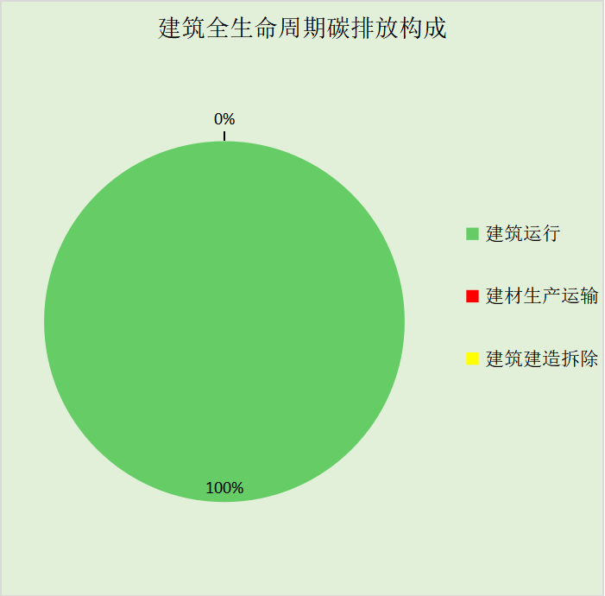

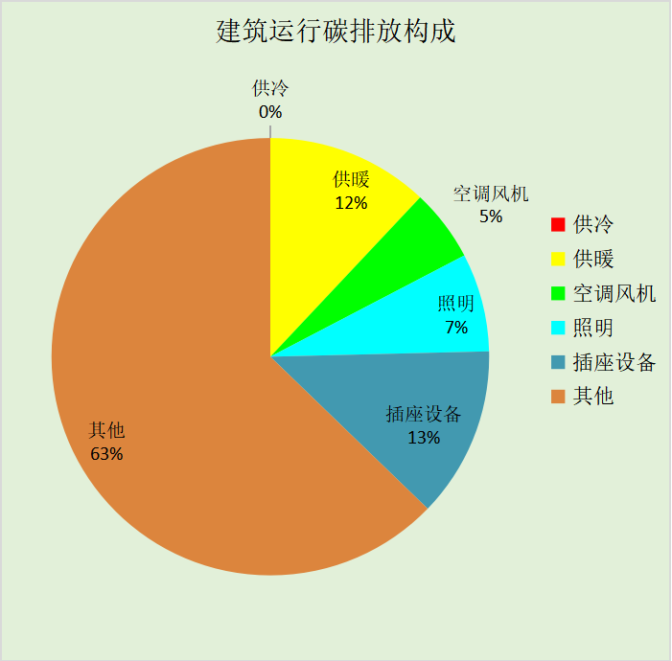

# 附录

暑假:7.15~8.25; 寒假：1.15~2.20

## 工作日/节假日人员逐时在室率(%)

|  |  |  |  |  |  |  |  |  |  |  |  |  |  |  |  |  |  |  |  |  |  |  |  |  |
| --- | --- | --- | --- | --- | --- | --- | --- | --- | --- | --- | --- | --- | --- | --- | --- | --- | --- | --- | --- | --- | --- | --- | --- | --- |
| 房间类型 | 1 | 2 | 3 | 4 | 5 | 6 | 7 | 8 | 9 | 10 | 11 | 12 | 13 | 14 | 15 | 16 | 17 | 18 | 19 | 20 | 21 | 22 | 23 | 24 |
| 休息室 | 0 | 0 | 0 | 0 | 0 | 0 | 10 | 50 | 100 | 100 | 100 | 30 | 100 | 100 | 100 | 100 | 50 | 20 | 10 | 0 | 0 | 0 | 0 | 0 |
| 0 | 0 | 0 | 0 | 0 | 0 | 0 | 20 | 45 | 0 | 0 | 0 | 0 | 0 | 0 | 0 | 0 | 0 | 0 | 0 | 0 | 0 | 0 | 0 |
| 0 | 0 | 0 | 0 | 0 | 0 | 0 | 20 | 45 | 0 | 0 | 0 | 0 | 0 | 0 | 0 | 0 | 0 | 0 | 0 | 0 | 0 | 0 | 0 |
| 0 | 0 | 0 | 0 | 0 | 0 | 0 | 20 | 45 | 0 | 0 | 0 | 0 | 0 | 0 | 0 | 0 | 0 | 0 | 0 | 0 | 0 | 0 | 0 |
| 办公-普通办公室 | 0 | 0 | 0 | 0 | 0 | 0 | 10 | 50 | 100 | 100 | 100 | 30 | 100 | 100 | 100 | 100 | 50 | 20 | 10 | 0 | 0 | 0 | 0 | 0 |
| 0 | 0 | 0 | 0 | 0 | 0 | 0 | 20 | 45 | 0 | 0 | 0 | 0 | 0 | 0 | 0 | 0 | 0 | 0 | 0 | 0 | 0 | 0 | 0 |
| 0 | 0 | 0 | 0 | 0 | 0 | 0 | 20 | 45 | 0 | 0 | 0 | 0 | 0 | 0 | 0 | 0 | 0 | 0 | 0 | 0 | 0 | 0 | 0 |
| 0 | 0 | 0 | 0 | 0 | 0 | 0 | 20 | 45 | 0 | 0 | 0 | 0 | 0 | 0 | 0 | 0 | 0 | 0 | 0 | 0 | 0 | 0 | 0 |
| 普通办公室 | 0 | 0 | 0 | 0 | 0 | 0 | 10 | 50 | 100 | 100 | 100 | 30 | 100 | 100 | 100 | 100 | 50 | 20 | 10 | 0 | 0 | 0 | 0 | 0 |
| 0 | 0 | 0 | 0 | 0 | 0 | 0 | 20 | 45 | 0 | 0 | 0 | 0 | 0 | 0 | 0 | 0 | 0 | 0 | 0 | 0 | 0 | 0 | 0 |
| 0 | 0 | 0 | 0 | 0 | 0 | 0 | 20 | 45 | 0 | 0 | 0 | 0 | 0 | 0 | 0 | 0 | 0 | 0 | 0 | 0 | 0 | 0 | 0 |
| 0 | 0 | 0 | 0 | 0 | 0 | 0 | 20 | 45 | 0 | 0 | 0 | 0 | 0 | 0 | 0 | 0 | 0 | 0 | 0 | 0 | 0 | 0 | 0 |
| 餐厅 | 0 | 0 | 0 | 0 | 0 | 0 | 0 | 20 | 50 | 80 | 80 | 80 | 80 | 80 | 80 | 80 | 80 | 80 | 80 | 70 | 50 | 0 | 0 | 0 |
| 0 | 0 | 0 | 0 | 0 | 0 | 0 | 20 | 50 | 80 | 80 | 80 | 80 | 80 | 80 | 80 | 80 | 80 | 80 | 70 | 50 | 0 | 0 | 0 |
| 0 | 0 | 0 | 0 | 0 | 0 | 0 | 20 | 50 | 80 | 80 | 80 | 80 | 80 | 80 | 80 | 80 | 80 | 80 | 70 | 50 | 0 | 0 | 0 |
| 0 | 0 | 0 | 0 | 0 | 0 | 0 | 20 | 50 | 80 | 80 | 80 | 80 | 80 | 80 | 80 | 80 | 80 | 80 | 70 | 50 | 0 | 0 | 0 |

注：第一行：工作日；第二行：节假日；第三行：寒假；第四行：暑假

## 工作日/节假日照明开关时间表(%)

|  |  |  |  |  |  |  |  |  |  |  |  |  |  |  |  |  |  |  |  |  |  |  |  |  |
| --- | --- | --- | --- | --- | --- | --- | --- | --- | --- | --- | --- | --- | --- | --- | --- | --- | --- | --- | --- | --- | --- | --- | --- | --- |
| 房间类型 | 1 | 2 | 3 | 4 | 5 | 6 | 7 | 8 | 9 | 10 | 11 | 12 | 13 | 14 | 15 | 16 | 17 | 18 | 19 | 20 | 21 | 22 | 23 | 24 |
| 休息室 | 10 | 10 | 10 | 10 | 10 | 10 | 10 | 36 | 62 | 56 | 54 | 43 | 53 | 55 | 58 | 67 | 40 | 18 | 10 | 10 | 10 | 10 | 10 | 10 |
| 0 | 0 | 0 | 0 | 0 | 0 | 0 | 0 | 0 | 0 | 0 | 0 | 0 | 0 | 0 | 0 | 0 | 0 | 0 | 0 | 0 | 0 | 0 | 0 |
| 0 | 0 | 0 | 0 | 0 | 0 | 0 | 0 | 0 | 0 | 0 | 0 | 0 | 0 | 0 | 0 | 0 | 0 | 0 | 0 | 0 | 0 | 0 | 0 |
| 0 | 0 | 0 | 0 | 0 | 0 | 0 | 0 | 0 | 0 | 0 | 0 | 0 | 0 | 0 | 0 | 0 | 0 | 0 | 0 | 0 | 0 | 0 | 0 |
| 办公-普通办公室 | 10 | 10 | 10 | 10 | 10 | 10 | 10 | 36 | 62 | 56 | 54 | 43 | 53 | 55 | 58 | 67 | 40 | 18 | 10 | 10 | 10 | 10 | 10 | 10 |
| 0 | 0 | 0 | 0 | 0 | 0 | 0 | 0 | 0 | 0 | 0 | 0 | 0 | 0 | 0 | 0 | 0 | 0 | 0 | 0 | 0 | 0 | 0 | 0 |
| 0 | 0 | 0 | 0 | 0 | 0 | 0 | 0 | 0 | 0 | 0 | 0 | 0 | 0 | 0 | 0 | 0 | 0 | 0 | 0 | 0 | 0 | 0 | 0 |
| 0 | 0 | 0 | 0 | 0 | 0 | 0 | 0 | 0 | 0 | 0 | 0 | 0 | 0 | 0 | 0 | 0 | 0 | 0 | 0 | 0 | 0 | 0 | 0 |
| 普通办公室 | 10 | 10 | 10 | 10 | 10 | 10 | 10 | 36 | 62 | 56 | 54 | 43 | 53 | 55 | 58 | 67 | 40 | 18 | 10 | 10 | 10 | 10 | 10 | 10 |
| 0 | 0 | 0 | 0 | 0 | 0 | 0 | 0 | 0 | 0 | 0 | 0 | 0 | 0 | 0 | 0 | 0 | 0 | 0 | 0 | 0 | 0 | 0 | 0 |
| 0 | 0 | 0 | 0 | 0 | 0 | 0 | 0 | 0 | 0 | 0 | 0 | 0 | 0 | 0 | 0 | 0 | 0 | 0 | 0 | 0 | 0 | 0 | 0 |
| 0 | 0 | 0 | 0 | 0 | 0 | 0 | 0 | 0 | 0 | 0 | 0 | 0 | 0 | 0 | 0 | 0 | 0 | 0 | 0 | 0 | 0 | 0 | 0 |
| 餐厅 | 10 | 10 | 10 | 10 | 10 | 10 | 10 | 50 | 60 | 60 | 60 | 60 | 60 | 60 | 60 | 60 | 80 | 90 | 100 | 100 | 100 | 10 | 10 | 10 |
| 10 | 10 | 10 | 10 | 10 | 10 | 10 | 50 | 60 | 60 | 60 | 60 | 60 | 60 | 60 | 60 | 80 | 90 | 100 | 100 | 100 | 10 | 10 | 10 |
| 10 | 10 | 10 | 10 | 10 | 10 | 10 | 50 | 60 | 60 | 60 | 60 | 60 | 60 | 60 | 60 | 80 | 90 | 100 | 100 | 100 | 10 | 10 | 10 |
| 10 | 10 | 10 | 10 | 10 | 10 | 10 | 50 | 60 | 60 | 60 | 60 | 60 | 60 | 60 | 60 | 80 | 90 | 100 | 100 | 100 | 10 | 10 | 10 |

注：第一行：工作日；第二行：节假日；第三行：寒假；第四行：暑假

## 工作日/节假日设备逐时使用率(%)

|  |  |  |  |  |  |  |  |  |  |  |  |  |  |  |  |  |  |  |  |  |  |  |  |  |
| --- | --- | --- | --- | --- | --- | --- | --- | --- | --- | --- | --- | --- | --- | --- | --- | --- | --- | --- | --- | --- | --- | --- | --- | --- |
| 房间类型 | 1 | 2 | 3 | 4 | 5 | 6 | 7 | 8 | 9 | 10 | 11 | 12 | 13 | 14 | 15 | 16 | 17 | 18 | 19 | 20 | 21 | 22 | 23 | 24 |
| 休息室 | 0 | 0 | 0 | 0 | 0 | 0 | 10 | 50 | 100 | 100 | 100 | 100 | 100 | 100 | 100 | 100 | 50 | 20 | 10 | 0 | 0 | 0 | 0 | 0 |
| 0 | 0 | 0 | 0 | 0 | 0 | 0 | 0 | 0 | 0 | 0 | 0 | 0 | 0 | 0 | 0 | 0 | 0 | 0 | 0 | 0 | 0 | 0 | 0 |
| 0 | 0 | 0 | 0 | 0 | 0 | 0 | 0 | 0 | 0 | 0 | 0 | 0 | 0 | 0 | 0 | 0 | 0 | 0 | 0 | 0 | 0 | 0 | 0 |
| 0 | 0 | 0 | 0 | 0 | 0 | 0 | 0 | 0 | 0 | 0 | 0 | 0 | 0 | 0 | 0 | 0 | 0 | 0 | 0 | 0 | 0 | 0 | 0 |
| 办公-普通办公室 | 0 | 0 | 0 | 0 | 0 | 0 | 10 | 50 | 100 | 100 | 100 | 100 | 100 | 100 | 100 | 100 | 50 | 20 | 10 | 0 | 0 | 0 | 0 | 0 |
| 0 | 0 | 0 | 0 | 0 | 0 | 0 | 0 | 0 | 0 | 0 | 0 | 0 | 0 | 0 | 0 | 0 | 0 | 0 | 0 | 0 | 0 | 0 | 0 |
| 0 | 0 | 0 | 0 | 0 | 0 | 0 | 0 | 0 | 0 | 0 | 0 | 0 | 0 | 0 | 0 | 0 | 0 | 0 | 0 | 0 | 0 | 0 | 0 |
| 0 | 0 | 0 | 0 | 0 | 0 | 0 | 0 | 0 | 0 | 0 | 0 | 0 | 0 | 0 | 0 | 0 | 0 | 0 | 0 | 0 | 0 | 0 | 0 |
| 普通办公室 | 0 | 0 | 0 | 0 | 0 | 0 | 10 | 50 | 100 | 100 | 100 | 100 | 100 | 100 | 100 | 100 | 50 | 20 | 10 | 0 | 0 | 0 | 0 | 0 |
| 0 | 0 | 0 | 0 | 0 | 0 | 0 | 0 | 0 | 0 | 0 | 0 | 0 | 0 | 0 | 0 | 0 | 0 | 0 | 0 | 0 | 0 | 0 | 0 |
| 0 | 0 | 0 | 0 | 0 | 0 | 0 | 0 | 0 | 0 | 0 | 0 | 0 | 0 | 0 | 0 | 0 | 0 | 0 | 0 | 0 | 0 | 0 | 0 |
| 0 | 0 | 0 | 0 | 0 | 0 | 0 | 0 | 0 | 0 | 0 | 0 | 0 | 0 | 0 | 0 | 0 | 0 | 0 | 0 | 0 | 0 | 0 | 0 |
| 餐厅 | 0 | 0 | 0 | 0 | 0 | 0 | 0 | 30 | 50 | 80 | 80 | 80 | 80 | 80 | 80 | 80 | 80 | 80 | 80 | 70 | 50 | 0 | 0 | 0 |
| 0 | 0 | 0 | 0 | 0 | 0 | 0 | 30 | 50 | 80 | 80 | 80 | 80 | 80 | 80 | 80 | 80 | 80 | 80 | 70 | 50 | 0 | 0 | 0 |
| 0 | 0 | 0 | 0 | 0 | 0 | 0 | 30 | 50 | 80 | 80 | 80 | 80 | 80 | 80 | 80 | 80 | 80 | 80 | 70 | 50 | 0 | 0 | 0 |
| 0 | 0 | 0 | 0 | 0 | 0 | 0 | 30 | 50 | 80 | 80 | 80 | 80 | 80 | 80 | 80 | 80 | 80 | 80 | 70 | 50 | 0 | 0 | 0 |

注：第一行：工作日；第二行：节假日；第三行：寒假；第四行：暑假

## 工作日/节假日空调系统运行时间表(1:开,0:关)

采暖期：

|  |  |  |  |  |  |  |  |  |  |  |  |  |  |  |  |  |  |  |  |  |  |  |  |  |
| --- | --- | --- | --- | --- | --- | --- | --- | --- | --- | --- | --- | --- | --- | --- | --- | --- | --- | --- | --- | --- | --- | --- | --- | --- |
| 系统编号 | 1 | 2 | 3 | 4 | 5 | 6 | 7 | 8 | 9 | 10 | 11 | 12 | 13 | 14 | 15 | 16 | 17 | 18 | 19 | 20 | 21 | 22 | 23 | 24 |
| Sys | 0 | 0 | 0 | 0 | 0 | 1 | 1 | 1 | 1 | 1 | 1 | 1 | 1 | 1 | 1 | 1 | 1 | 1 | 1 | 1 | 1 | 0 | 0 | 0 |
| 0 | 0 | 0 | 0 | 0 | 0 | 0 | 1 | 1 | 1 | 1 | 1 | 1 | 1 | 1 | 1 | 1 | 0 | 0 | 0 | 0 | 0 | 0 | 0 |
| 0 | 0 | 0 | 0 | 0 | 0 | 0 | 0 | 0 | 0 | 0 | 0 | 0 | 0 | 0 | 0 | 0 | 0 | 0 | 0 | 0 | 0 | 0 | 0 |
| 0 | 0 | 0 | 0 | 0 | 0 | 0 | 0 | 0 | 0 | 0 | 0 | 0 | 0 | 0 | 0 | 0 | 0 | 0 | 0 | 0 | 0 | 0 | 0 |

供冷期：

|  |  |  |  |  |  |  |  |  |  |  |  |  |  |  |  |  |  |  |  |  |  |  |  |  |
| --- | --- | --- | --- | --- | --- | --- | --- | --- | --- | --- | --- | --- | --- | --- | --- | --- | --- | --- | --- | --- | --- | --- | --- | --- |
| 系统编号 | 1 | 2 | 3 | 4 | 5 | 6 | 7 | 8 | 9 | 10 | 11 | 12 | 13 | 14 | 15 | 16 | 17 | 18 | 19 | 20 | 21 | 22 | 23 | 24 |
| Sys | 0 | 0 | 0 | 0 | 0 | 1 | 1 | 1 | 1 | 1 | 1 | 1 | 1 | 1 | 1 | 1 | 1 | 1 | 1 | 1 | 1 | 0 | 0 | 0 |
| 0 | 0 | 0 | 0 | 0 | 0 | 0 | 1 | 1 | 1 | 1 | 1 | 1 | 1 | 1 | 1 | 1 | 0 | 0 | 0 | 0 | 0 | 0 | 0 |
| 0 | 0 | 0 | 0 | 0 | 0 | 0 | 0 | 0 | 0 | 0 | 0 | 0 | 0 | 0 | 0 | 0 | 0 | 0 | 0 | 0 | 0 | 0 | 0 |
| 0 | 0 | 0 | 0 | 0 | 0 | 0 | 0 | 0 | 0 | 0 | 0 | 0 | 0 | 0 | 0 | 0 | 0 | 0 | 0 | 0 | 0 | 0 | 0 |

注：第一行：工作日；第二行：节假日；第三行：寒假；第四行：暑假

## 工作日/节假日新风运行时间表(%)

采暖期：

|  |  |  |  |  |  |  |  |  |  |  |  |  |  |  |  |  |  |  |  |  |  |  |  |  |
| --- | --- | --- | --- | --- | --- | --- | --- | --- | --- | --- | --- | --- | --- | --- | --- | --- | --- | --- | --- | --- | --- | --- | --- | --- |
| 系统编号 | 1 | 2 | 3 | 4 | 5 | 6 | 7 | 8 | 9 | 10 | 11 | 12 | 13 | 14 | 15 | 16 | 17 | 18 | 19 | 20 | 21 | 22 | 23 | 24 |
| Sys | 0 | 0 | 0 | 0 | 0 | 100 | 100 | 100 | 100 | 100 | 100 | 100 | 100 | 100 | 100 | 100 | 100 | 100 | 100 | 100 | 100 | 0 | 0 | 0 |
| 0 | 0 | 0 | 0 | 0 | 0 | 0 | 100 | 100 | 100 | 100 | 100 | 100 | 100 | 100 | 100 | 100 | 0 | 0 | 0 | 0 | 0 | 0 | 0 |
| 0 | 0 | 0 | 0 | 0 | 0 | 0 | 0 | 0 | 0 | 0 | 0 | 0 | 0 | 0 | 0 | 0 | 0 | 0 | 0 | 0 | 0 | 0 | 0 |
| 0 | 0 | 0 | 0 | 0 | 0 | 0 | 0 | 0 | 0 | 0 | 0 | 0 | 0 | 0 | 0 | 0 | 0 | 0 | 0 | 0 | 0 | 0 | 0 |

供冷期：

|  |  |  |  |  |  |  |  |  |  |  |  |  |  |  |  |  |  |  |  |  |  |  |  |  |
| --- | --- | --- | --- | --- | --- | --- | --- | --- | --- | --- | --- | --- | --- | --- | --- | --- | --- | --- | --- | --- | --- | --- | --- | --- |
| 系统编号 | 1 | 2 | 3 | 4 | 5 | 6 | 7 | 8 | 9 | 10 | 11 | 12 | 13 | 14 | 15 | 16 | 17 | 18 | 19 | 20 | 21 | 22 | 23 | 24 |
| Sys | 0 | 0 | 0 | 0 | 0 | 100 | 100 | 100 | 100 | 100 | 100 | 100 | 100 | 100 | 100 | 100 | 100 | 100 | 100 | 100 | 100 | 0 | 0 | 0 |
| 0 | 0 | 0 | 0 | 0 | 0 | 0 | 100 | 100 | 100 | 100 | 100 | 100 | 100 | 100 | 100 | 100 | 0 | 0 | 0 | 0 | 0 | 0 | 0 |
| 0 | 0 | 0 | 0 | 0 | 0 | 0 | 0 | 0 | 0 | 0 | 0 | 0 | 0 | 0 | 0 | 0 | 0 | 0 | 0 | 0 | 0 | 0 | 0 |
| 0 | 0 | 0 | 0 | 0 | 0 | 0 | 0 | 0 | 0 | 0 | 0 | 0 | 0 | 0 | 0 | 0 | 0 | 0 | 0 | 0 | 0 | 0 | 0 |

注：第一行：工作日；第二行：节假日；第三行：寒假；第四行：暑假