新建项目
全年负荷计算书

工程名称 | 新建项目
设计编号
建设单位
设计单位
计 算 人
校 对 人
审 核 人
计算日期 | 2024年12月28日

采用软件 | 暖通负荷BECH2024
软件版本 | 20240430(SP1)
研发单位 | 北京绿建软件股份有限公司
正版授权码 | T18110494826
目 录

1 建筑概况 1
2 气象数据 1
2.1 气象地点 1
2.2 逐日干球温度表 1
2.3 逐月辐照量表 2
2.4 峰值工况 2
3 软件介绍 2
4 围护结构 2
4.1 屋顶构造 2
4.1.1 屋顶构造一 2
4.2 外墙构造 3
4.2.1 填充墙构造一 3
4.3 挑空楼板构造 3
4.3.1 挑空楼板构造一 3
4.4 楼板构造 3
4.4.1 控温房间楼板构造一 3
4.5 周边地面构造 4
4.5.1 地面构造一 4
4.6 非周边地面构造 4
4.6.1 地面构造一 4
4.7 门构造 4
4.8 窗构造 4
5 房间类型 5
5.1 房间参数表 5
5.2 作息时间表 5
6 系统设置 5
6.1 系统划分 5
6.2 运行时间表 6
7 计算结果 6
7.1 模拟周期 6
7.2 全年冷暖需求 7
7.3 负荷分项统计 7
7.4 逐月负荷表 8
8 附录 10

建筑概况
地理位置 | 安徽-马鞍山
气候分区 | 夏热冬冷A区
北纬 | 31.43
东经 | 118.28
建筑名称 | 新建项目
建筑类型 | 公共建筑
建筑面积 | 地上 17614.60 ㎡ | 地下 0.00 ㎡
建筑高度 | 地上 20.10 m | 地下0.00
建筑层数 | 地上 5 | 地下 0
北向角度 | 90°

气象数据

气象地点
安徽-芜湖县, 《建筑节能气象参数标准》JGJ346-2014

逐日干球温度表
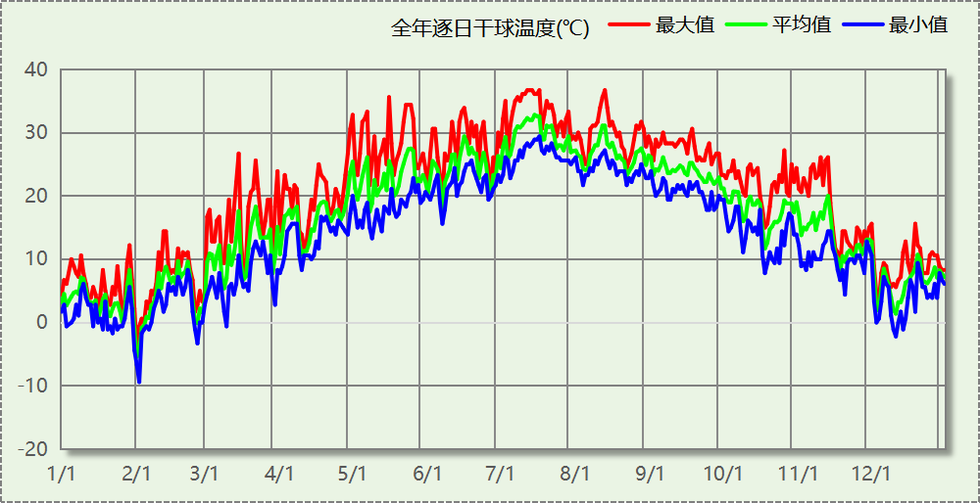

逐月辐照量表
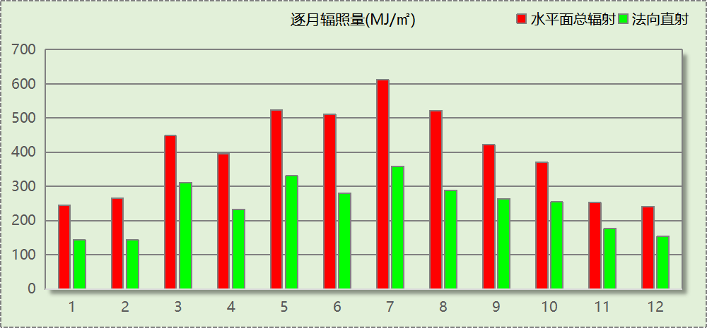

峰值工况
气象数据 | 时刻 | 干球温度(℃) | 湿球温度(℃) | 含湿量(g/kg) | 焓值(kj/kg)
最热 | 07月11日15时 | 36.7 | 28.3 | 21.6 | 92.3
最冷 | 02月01日06时 | -9.4 | -9.4 | 1.6 | -5.5

软件介绍
本报告采用的软件为绿建暖通负荷BECH2024，该软件紧密结合暖通和节能设计规范、可根据项目实际情况建立建筑热工模型，并可对围护结构材料、房间内扰发热、作息时间表、热回收方式等参数进行设置。
软件包含全国各地典型气象年数据，内置DOE2.1E内核，对于建筑的逐时负荷进行动态模拟，既可以模拟8760小时理想负荷，也可以根据设定好的采暖期/空调期进行逐时模拟。
软件还支持分析全年建筑能耗的来源构成，依据日射得热、新风负荷、围护传热和内扰得热进行归类分项，生成设计建筑全年负荷计算报告书，提供详实的数据和多样的图表，为设计师在设备选型、制定运行策略等方面提供参考和帮助。

围护结构

屋顶构造

屋顶构造一
材料名称  （由上到下） | 厚度δ | 导热系数λ | 蓄热系数S | 修正  系数 | 热阻R | 热惰性  指标
材料名称  （由上到下） | (mm) | W/(m.K) | W/(㎡.K) | α | (㎡K)/W | D=R*S
水泥砂浆 | 20 | 0.930 | 11.370 | 1.00 | 0.022 | 0.245
c20细石混凝土(ρ=2300) | 40 | 1.510 | 15.243 | 1.00 | 0.026 | 0.404
挤塑聚苯板(ρ=25-32) | 130 | 0.030 | 0.320 | 1.10 | 3.939 | 1.387
轻骨料混凝土(找坡层) | 30 | 0.300 | 5.000 | 1.50 | 0.067 | 0.500
钢筋混凝土 | 120 | 1.740 | 17.200 | 1.00 | 0.069 | 1.186
混合砂浆 | 20 | 0.870 | 10.750 | 1.00 | 0.023 | 0.247
各层之和∑ | 360 | － | － | － | 4.146 | 3.968
传热系数K=1/(0.15+∑R) | 0.23

外墙构造

填充墙构造一
材料名称  （由外到内） | 厚度δ | 导热系数λ | 蓄热系数S | 修正  系数 | 热阻R | 热惰性  指标
材料名称  （由外到内） | (mm) | W/(m.K) | W/(㎡.K) | α | (㎡K)/W | D=R*S
水泥砂浆 | 40 | 0.930 | 11.370 | 1.00 | 0.043 | 0.489
匀质防火保温板 | 70 | 0.065 | 1.500 | 1.20 | 0.897 | 1.615
煤矸石空心砖 | 240 | 0.580 | 7.920 | 1.00 | 0.414 | 3.277
混合砂浆 | 40 | 0.870 | 10.750 | 1.00 | 0.046 | 0.494
各层之和∑ | 390 | － | － | － | 1.400 | 5.876
传热系数K=1/(0.15+∑R) | 0.65

挑空楼板构造

挑空楼板构造一
材料名称  （由上到下） | 厚度δ | 导热系数λ | 蓄热系数S | 修正  系数 | 热阻R | 热惰性  指标
材料名称  （由上到下） | (mm) | W/(m.K) | W/(㎡.K) | α | (㎡K)/W | D=R*S
水泥砂浆 | 20 | 0.930 | 11.370 | 1.00 | 0.022 | 0.245
石墨聚苯乙烯保温隔声板(b1级)（经压缩、覆膜处理） | 15 | 0.035 | 0.360 | 1.20 | 0.357 | 0.154
钢筋混凝土 | 120 | 1.740 | 17.200 | 1.00 | 0.069 | 1.186
水泥砂浆 | 20 | 0.930 | 11.370 | 1.00 | 0.022 | 0.245
岩棉条复合板（tr10,0,a级） | 40 | 0.046 | 0.700 | 1.00 | 0.870 | 0.609
混合砂浆 | 20 | 0.870 | 10.750 | 1.00 | 0.023 | 0.247
各层之和∑ | 235 | － | － | － | 1.362 | 2.685
传热系数K=1/(0.15+∑R) | 0.66

楼板构造

控温房间楼板构造一
材料名称 | 厚度δ | 导热系数λ | 蓄热系数S | 修正  系数 | 热阻R | 热惰性  指标
材料名称 | (mm) | W/(m.K) | W/(㎡.K) | α | (㎡K)/W | D=R*S
水泥砂浆 | 40 | 0.930 | 11.370 | 1.00 | 0.043 | 0.489
钢筋混凝土 | 150 | 1.740 | 17.200 | 1.00 | 0.086 | 1.483
石墨聚苯乙烯保温隔声板(b1级)（经压缩、覆膜处理） | 15 | 0.035 | 0.360 | 1.20 | 0.357 | 0.154
混合砂浆 | 40 | 0.870 | 10.750 | 1.00 | 0.046 | 0.494
各层之和∑ | 245 | － | － | － | 0.532 | 2.620
传热系数K=1/(0.22+∑R) | 1.33

周边地面构造

地面构造一
材料名称 | 厚度δ | 导热系数λ | 蓄热系数S | 修正  系数 | 热阻R | 热惰性  指标
材料名称 | (mm) | W/(m.K) | W/(㎡.K) | α | (㎡K)/W | D=R*S
水泥砂浆 | 20 | 0.930 | 11.370 | 1.00 | 0.022 | 0.245
钢筋混凝土 | 120 | 1.740 | 17.200 | 1.00 | 0.069 | 1.186
各层之和∑ | 140 | － | － | － | 0.090 | 1.431
传热系数K=1/(0.11+∑R) | 0.52

非周边地面构造

地面构造一
材料名称 | 厚度δ | 导热系数λ | 蓄热系数S | 修正  系数 | 热阻R | 热惰性  指标
材料名称 | (mm) | W/(m.K) | W/(㎡.K) | α | (㎡K)/W | D=R*S
水泥砂浆 | 20 | 0.930 | 11.370 | 1.00 | 0.022 | 0.245
钢筋混凝土 | 120 | 1.740 | 17.200 | 1.00 | 0.069 | 1.186
各层之和∑ | 140 | － | － | － | 0.090 | 1.431
传热系数K=1/(0.11+∑R) | 0.30

门构造
序号 | 构造名称 | 传热系数 | 备注
1 | 保温门（多功能门） | 6.250

窗构造
序号 | 构造名称 | 传热系数 | 窗遮阳系数 | 可见光透射比 | 备注
1 | 60系列内平开下悬玻璃钢窗[5涂膜+12A+5Low-E] | 2.200 | 0.255 | 0.620

房间类型

房间参数表
房间类型 | 空调温度  ℃ | 供暖温度  ℃ | 新风量 | 人员密度 | 照明功率  密度 | 电器设备  功率
休息室 | 26 | 18 | 24(m^3/h.人) | 1.39(m^2/人) | 9(W/m^2) | 5(W/m^2)
会议室 | 26 | 20 | 30(m^3/h.人) | 3.3(m^2/人) | 8(W/m^2) | 5(W/m^2)
卫生间 | 28 | 16 | 0(m^3/h.人) | 0(人) | 5(W/m^2) | 5(W/m^2)
大厅 | 26 | 20 | 30(m^3/h.人) | 20(m^2/人) | 10(W/m^2) | 0(W/m^2)
实验教室 | 26 | 18 | 20(m^3/h.人) | 4(m^2/人) | 8(W/m^2) | 5(W/m^2)
开水间 | 26 | 18 | 24(m^3/h.人) | 1.39(m^2/人) | 9(W/m^2) | 5(W/m^2)
普通办公室 | 26 | 20 | 30(m^3/h.人) | 6(m^2/人) | 8(W/m^2) | 5(W/m^2)
普通教室 | 26 | 18 | 24(m^3/h.人) | 1.39(m^2/人) | 8(W/m^2) | 5(W/m^2)
更衣室 | 26 | 20 | 6(次/h) | 4(m^2/人) | 5(W/m^2) | 5(W/m^2)
楼梯间 | 28 | 16 | 0(m^3/h.人) | 0(人) | 5(W/m^2) | 5(W/m^2)
空房间 | － | － | 20(m^3/h.人) | 0(人) | 0(W/m^2) | 0(W/m^2)
设备间 | － | － | 0(次/h) | 0(人) | 6(W/m^2) | 15(W/m^2)
走廊 | － | － | 0(m^3/h.人) | 0(人) | 5(W/m^2) | 5(W/m^2)
阅览室 | 26 | 20 | 20(m^3/h.人) | 1.9(m^2/人) | 8(W/m^2) | 5(W/m^2)

作息时间表
详见附录

系统设置

系统划分
系统编号 | 热回收  类型 | 启动  条件 | 回收  效率 | 排风  比例 | 面积(m2) | 包含的房间
默认 | 无 | -- | -- | -- | 7321.60 | 1149,1074,1170,1250,1247,1241,1239,1234,1230,1229,1227,1225,1224,1217,1005,1002,1001,1004,1194,1190,1183,1179,1177,1173,1163,1162,1156,1151,1147,1137,1132,1104,1078,1067,1042,1007,1003,6020,2252,2246,2245,2031,2032,2013,2203,2201,2196,2189,2016,6008,2176,2175,2018,2027,2160,6010,2153,2015,2146,2139,2134,2026,2012,2125,2006,6012,6013,2021,2020,2024,2023,2003,2004,2002,2011,2088,2025,2080,2030,2064,2007,6015,2009,2028,2022,2017,2014,3033,3032,3030,3029,3026,3022,3015,3012,3010,6008,3138,3066,3038,3014,3001,3011,3024,3023,3257,3244,3027,3028,3226,3215,3193,3016,3017,3164,3159,3141,3118,3009,3081,3072,3021,3018,3005,4009,4006,4024,4023,4020,4021,4025,4022,4007,4192,6007,4011,4012,4165,4157,4154,4144,4135,4016,4003,4015,4082,4069,4017,4065,4004,4005,4008,4010,5005,5145,5013,6002,5007,6019,5008,5191,6009,6023,5178,5174,5158,5152,6011,5136,5002,5006,5077,5063,5003
Sys | 全热回收 | 温差启动  冷:≥5.0(℃)  暖:≥5.0(℃) | 冷:0.20, 暖:0.00 | 1.00 | 3653.44 | 6020,1128,1123,1119,1110,1108,1102,1100,1084,1044,1040,1023,1020,1016,2029,2019,2121,2005,3200,3025,3008,3007,3006,6021,3004,3003,3087,3020,3019,3002,6016,3052,3031,6017,4001,4018,4142,6014,4054,4050,4014,4002,4039,4032,4027,4013,6020,6022,5086,5001,6004,6005,5140,5117,5109,5103,5079,5049,5004

运行时间表
详见附录

计算结果

模拟周期
全年8760小时模拟

全年冷暖需求
系统名称\负荷 | 供暖需求  (kWh) | 供暖指标  (kWh/㎡·a) | 供冷需求  (kWh) | 供冷指标  (kWh/㎡·a)
Sys | 120037 | 32.86 | 398073 | 108.96
默认系统 | 140720 | 19.22 | 313651 | 42.84
建筑总计 | 260757 | 14.80 | 711724 | 40.41
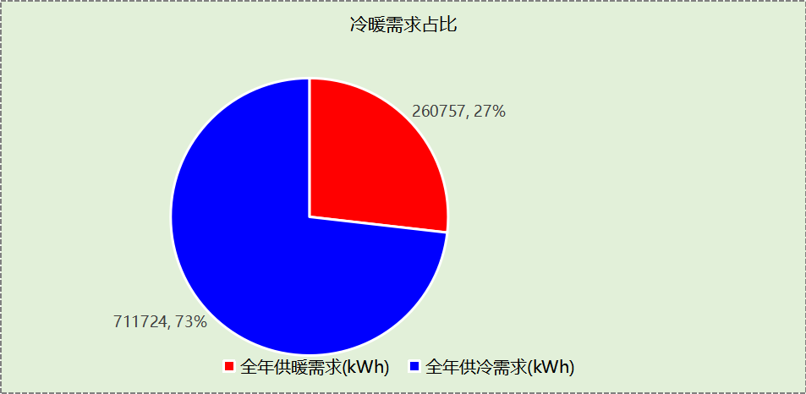

负荷分项统计
分类 | 围护传热 | 室内得热 | 窗日射 | 新风/渗透 | 热回收 | 合计
供暖(kWh/㎡) | -16.32 | 9.02 | 1.02 | -8.51 | 0.00 | -14.80
供冷(kWh/㎡) | 8.55 | 16.58 | 2.24 | 13.62 | -0.59 | 40.41
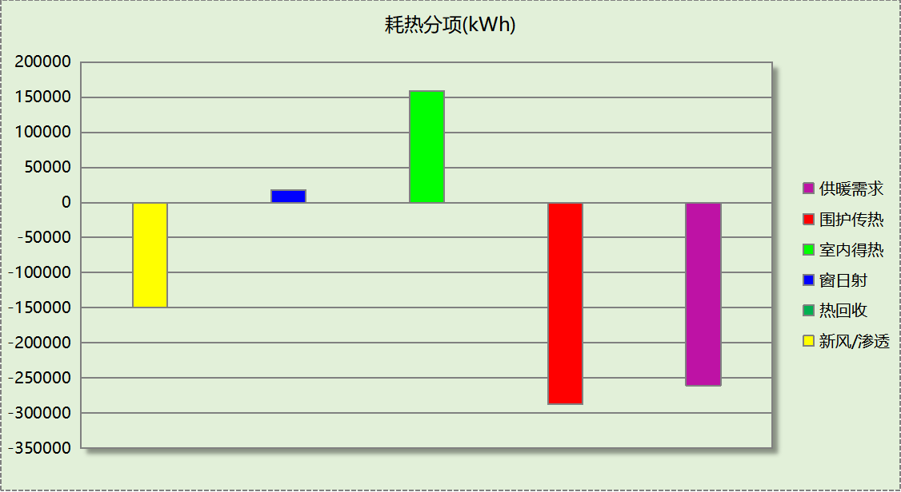
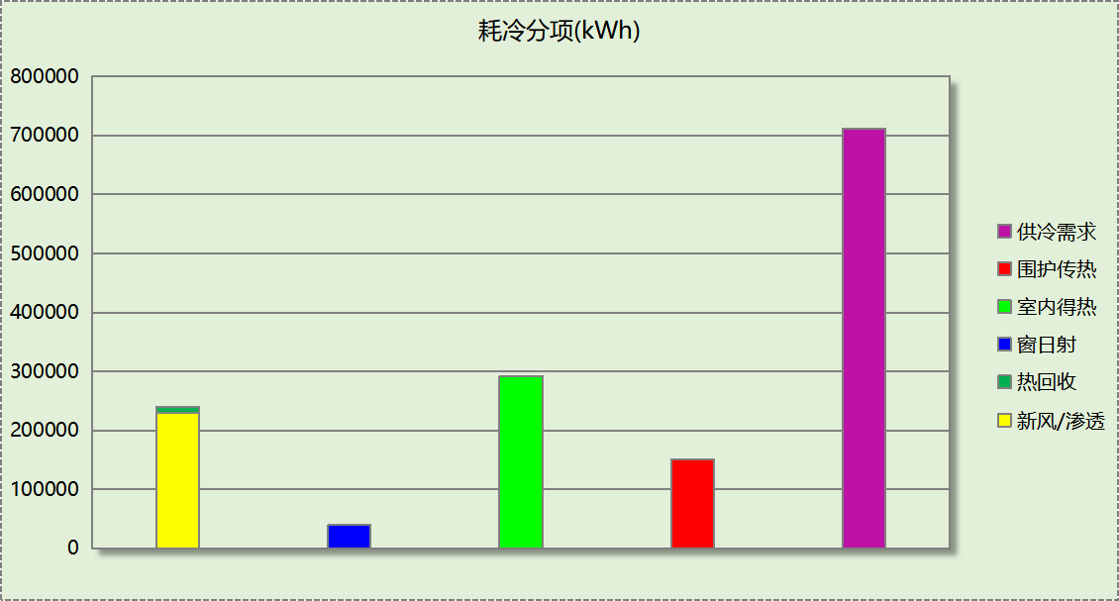

逐月负荷表
月份 | 供暖(kWh) | 供冷(kWh) | 热负荷  峰值(kW) | 热负荷  峰值时刻 | 冷负荷  峰值(kW) | 冷负荷  峰值时刻
1月 | 90699 | 0 | 1076.890 | 1月2日8时 | 0.000 | --
2月 | 69647 | 0 | 1068.654 | 2月4日8时 | 0.000 | --
3月 | 27322 | 136 | 566.705 | 3月4日8时 | 28.764 | 3月21日16时
4月 | 15998 | 4778 | 288.013 | 4月1日8时 | 359.781 | 4月30日16时
5月 | 3680 | 64839 | 62.371 | 5月2日8时 | 531.836 | 5月16日16时
6月 | 393 | 102691 | 5.397 | 6月3日8时 | 847.581 | 6月20日10时
7月 | 10 | 217022 | 1.464 | 7月1日8时 | 1232.610 | 7月15日8时
8月 | 0 | 184486 | 0.000 | -- | 1172.674 | 8月12日16时
9月 | 0 | 111583 | 0.000 | -- | 787.663 | 9月6日14时
10月 | 235 | 21087 | 22.732 | 10月21日8时 | 339.730 | 10月11日16时
11月 | 5656 | 5102 | 169.306 | 11月19日8时 | 245.642 | 11月12日15时
12月 | 47118 | 0 | 697.686 | 12月9日8时 | 0.000 | --
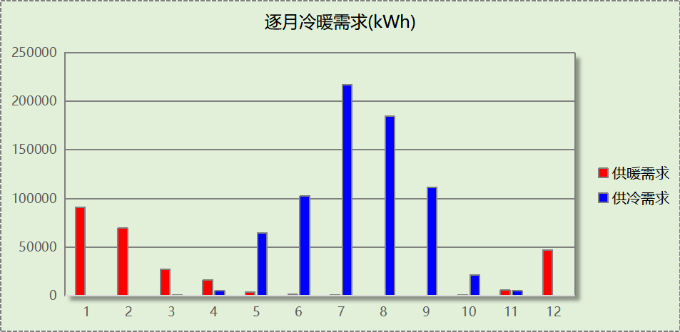
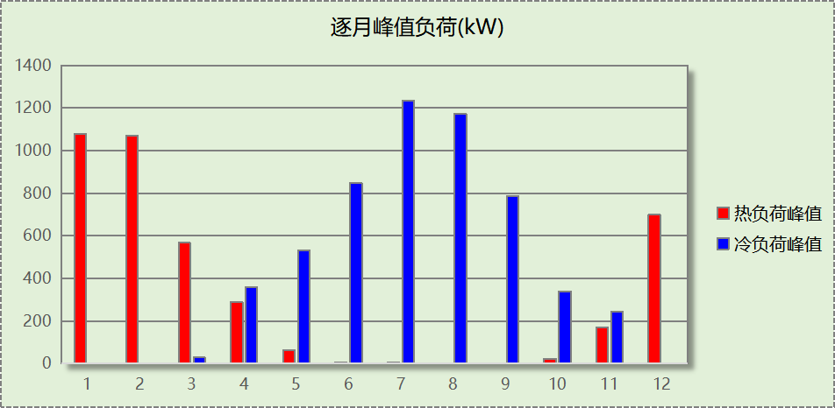

附录
工作日/节假日人员逐时在室率(%)

房间类型 | 1 | 2 | 3 | 4 | 5 | 6 | 7 | 8 | 9 | 10 | 11 | 12 | 13 | 14 | 15 | 16 | 17 | 18 | 19 | 20 | 21 | 22 | 23 | 24
休息室 | 0 | 0 | 0 | 0 | 0 | 0 | 10 | 50 | 95 | 95 | 95 | 80 | 80 | 95 | 95 | 95 | 95 | 30 | 30 | 0 | 0 | 0 | 0 | 0
休息室 | 0 | 0 | 0 | 0 | 0 | 0 | 0 | 0 | 0 | 0 | 0 | 0 | 0 | 0 | 0 | 0 | 0 | 0 | 0 | 0 | 0 | 0 | 0 | 0
会议室 | 0 | 0 | 0 | 0 | 0 | 0 | 10 | 50 | 95 | 95 | 95 | 80 | 80 | 95 | 95 | 95 | 95 | 30 | 30 | 0 | 0 | 0 | 0 | 0
会议室 | 0 | 0 | 0 | 0 | 0 | 0 | 0 | 0 | 0 | 0 | 0 | 0 | 0 | 0 | 0 | 0 | 0 | 0 | 0 | 0 | 0 | 0 | 0 | 0
卫生间 | 0 | 0 | 0 | 0 | 0 | 0 | 10 | 50 | 95 | 95 | 95 | 80 | 80 | 95 | 95 | 95 | 95 | 30 | 30 | 0 | 0 | 0 | 0 | 0
卫生间 | 0 | 0 | 0 | 0 | 0 | 0 | 0 | 0 | 0 | 0 | 0 | 0 | 0 | 0 | 0 | 0 | 0 | 0 | 0 | 0 | 0 | 0 | 0 | 0
大厅 | 0 | 0 | 0 | 0 | 0 | 0 | 10 | 50 | 95 | 95 | 95 | 80 | 80 | 95 | 95 | 95 | 95 | 30 | 30 | 0 | 0 | 0 | 0 | 0
大厅 | 0 | 0 | 0 | 0 | 0 | 0 | 0 | 0 | 0 | 0 | 0 | 0 | 0 | 0 | 0 | 0 | 0 | 0 | 0 | 0 | 0 | 0 | 0 | 0
实验教室 | 0 | 0 | 0 | 0 | 0 | 0 | 10 | 50 | 95 | 95 | 95 | 80 | 80 | 95 | 95 | 95 | 95 | 30 | 30 | 0 | 0 | 0 | 0 | 0
实验教室 | 0 | 0 | 0 | 0 | 0 | 0 | 0 | 0 | 0 | 0 | 0 | 0 | 0 | 0 | 0 | 0 | 0 | 0 | 0 | 0 | 0 | 0 | 0 | 0
开水间 | 0 | 0 | 0 | 0 | 0 | 0 | 10 | 50 | 95 | 95 | 95 | 80 | 80 | 95 | 95 | 95 | 95 | 30 | 30 | 0 | 0 | 0 | 0 | 0
开水间 | 0 | 0 | 0 | 0 | 0 | 0 | 0 | 0 | 0 | 0 | 0 | 0 | 0 | 0 | 0 | 0 | 0 | 0 | 0 | 0 | 0 | 0 | 0 | 0
普通办公室 | 0 | 0 | 0 | 0 | 0 | 0 | 10 | 50 | 95 | 95 | 95 | 80 | 80 | 95 | 95 | 95 | 95 | 30 | 30 | 0 | 0 | 0 | 0 | 0
普通办公室 | 0 | 0 | 0 | 0 | 0 | 0 | 0 | 0 | 0 | 0 | 0 | 0 | 0 | 0 | 0 | 0 | 0 | 0 | 0 | 0 | 0 | 0 | 0 | 0
普通教室 | 0 | 0 | 0 | 0 | 0 | 0 | 10 | 50 | 95 | 95 | 95 | 80 | 80 | 95 | 95 | 95 | 95 | 30 | 30 | 0 | 0 | 0 | 0 | 0
普通教室 | 0 | 0 | 0 | 0 | 0 | 0 | 0 | 0 | 0 | 0 | 0 | 0 | 0 | 0 | 0 | 0 | 0 | 0 | 0 | 0 | 0 | 0 | 0 | 0
更衣室 | 0 | 0 | 0 | 0 | 0 | 0 | 10 | 50 | 95 | 95 | 95 | 80 | 80 | 95 | 95 | 95 | 95 | 30 | 30 | 0 | 0 | 0 | 0 | 0
更衣室 | 0 | 0 | 0 | 0 | 0 | 0 | 0 | 0 | 0 | 0 | 0 | 0 | 0 | 0 | 0 | 0 | 0 | 0 | 0 | 0 | 0 | 0 | 0 | 0
楼梯间 | 0 | 0 | 0 | 0 | 0 | 0 | 10 | 50 | 95 | 95 | 95 | 80 | 80 | 95 | 95 | 95 | 95 | 30 | 30 | 0 | 0 | 0 | 0 | 0
楼梯间 | 0 | 0 | 0 | 0 | 0 | 0 | 0 | 0 | 0 | 0 | 0 | 0 | 0 | 0 | 0 | 0 | 0 | 0 | 0 | 0 | 0 | 0 | 0 | 0
空房间 | 0 | 0 | 0 | 0 | 0 | 0 | 0 | 20 | 50 | 80 | 80 | 80 | 80 | 80 | 80 | 80 | 80 | 80 | 80 | 70 | 50 | 0 | 0 | 0
空房间 | 0 | 0 | 0 | 0 | 0 | 0 | 0 | 0 | 0 | 0 | 0 | 0 | 0 | 0 | 0 | 0 | 0 | 0 | 0 | 0 | 0 | 0 | 0 | 0
设备间 | 0 | 0 | 0 | 0 | 0 | 0 | 0 | 0 | 0 | 0 | 0 | 0 | 0 | 0 | 0 | 0 | 0 | 0 | 0 | 0 | 0 | 0 | 0 | 0
设备间 | 0 | 0 | 0 | 0 | 0 | 0 | 0 | 0 | 0 | 0 | 0 | 0 | 0 | 0 | 0 | 0 | 0 | 0 | 0 | 0 | 0 | 0 | 0 | 0
走廊 | 0 | 0 | 0 | 0 | 0 | 0 | 10 | 50 | 95 | 95 | 95 | 80 | 80 | 95 | 95 | 95 | 95 | 30 | 30 | 0 | 0 | 0 | 0 | 0
走廊 | 0 | 0 | 0 | 0 | 0 | 0 | 0 | 0 | 0 | 0 | 0 | 0 | 0 | 0 | 0 | 0 | 0 | 0 | 0 | 0 | 0 | 0 | 0 | 0
阅览室 | 0 | 0 | 0 | 0 | 0 | 0 | 10 | 50 | 95 | 95 | 95 | 80 | 80 | 95 | 95 | 95 | 95 | 30 | 30 | 0 | 0 | 0 | 0 | 0
阅览室 | 0 | 0 | 0 | 0 | 0 | 0 | 0 | 0 | 0 | 0 | 0 | 0 | 0 | 0 | 0 | 0 | 0 | 0 | 0 | 0 | 0 | 0 | 0 | 0
注：上行：工作日；下行：节假日

工作日/节假日照明开关时间表(%)

房间类型 | 1 | 2 | 3 | 4 | 5 | 6 | 7 | 8 | 9 | 10 | 11 | 12 | 13 | 14 | 15 | 16 | 17 | 18 | 19 | 20 | 21 | 22 | 23 | 24
休息室 | 0 | 0 | 0 | 0 | 0 | 0 | 10 | 50 | 95 | 95 | 95 | 80 | 80 | 95 | 95 | 95 | 95 | 30 | 30 | 0 | 0 | 0 | 0 | 0
休息室 | 0 | 0 | 0 | 0 | 0 | 0 | 0 | 0 | 0 | 0 | 0 | 0 | 0 | 0 | 0 | 0 | 0 | 0 | 0 | 0 | 0 | 0 | 0 | 0
会议室 | 0 | 0 | 0 | 0 | 0 | 0 | 10 | 50 | 95 | 95 | 95 | 80 | 80 | 95 | 95 | 95 | 95 | 30 | 30 | 0 | 0 | 0 | 0 | 0
会议室 | 0 | 0 | 0 | 0 | 0 | 0 | 0 | 0 | 0 | 0 | 0 | 0 | 0 | 0 | 0 | 0 | 0 | 0 | 0 | 0 | 0 | 0 | 0 | 0
卫生间 | 0 | 0 | 0 | 0 | 0 | 0 | 10 | 50 | 95 | 95 | 95 | 80 | 80 | 95 | 95 | 95 | 95 | 30 | 30 | 0 | 0 | 0 | 0 | 0
卫生间 | 0 | 0 | 0 | 0 | 0 | 0 | 0 | 0 | 0 | 0 | 0 | 0 | 0 | 0 | 0 | 0 | 0 | 0 | 0 | 0 | 0 | 0 | 0 | 0
大厅 | 0 | 0 | 0 | 0 | 0 | 0 | 10 | 50 | 95 | 95 | 95 | 80 | 80 | 95 | 95 | 95 | 95 | 30 | 30 | 0 | 0 | 0 | 0 | 0
大厅 | 0 | 0 | 0 | 0 | 0 | 0 | 0 | 0 | 0 | 0 | 0 | 0 | 0 | 0 | 0 | 0 | 0 | 0 | 0 | 0 | 0 | 0 | 0 | 0
实验教室 | 0 | 0 | 0 | 0 | 0 | 0 | 10 | 50 | 95 | 95 | 95 | 80 | 80 | 95 | 95 | 95 | 95 | 30 | 30 | 0 | 0 | 0 | 0 | 0
实验教室 | 0 | 0 | 0 | 0 | 0 | 0 | 0 | 0 | 0 | 0 | 0 | 0 | 0 | 0 | 0 | 0 | 0 | 0 | 0 | 0 | 0 | 0 | 0 | 0
开水间 | 0 | 0 | 0 | 0 | 0 | 0 | 10 | 50 | 95 | 95 | 95 | 80 | 80 | 95 | 95 | 95 | 95 | 30 | 30 | 0 | 0 | 0 | 0 | 0
开水间 | 0 | 0 | 0 | 0 | 0 | 0 | 0 | 0 | 0 | 0 | 0 | 0 | 0 | 0 | 0 | 0 | 0 | 0 | 0 | 0 | 0 | 0 | 0 | 0
普通办公室 | 0 | 0 | 0 | 0 | 0 | 0 | 10 | 50 | 95 | 95 | 95 | 80 | 80 | 95 | 95 | 95 | 95 | 30 | 30 | 0 | 0 | 0 | 0 | 0
普通办公室 | 0 | 0 | 0 | 0 | 0 | 0 | 0 | 0 | 0 | 0 | 0 | 0 | 0 | 0 | 0 | 0 | 0 | 0 | 0 | 0 | 0 | 0 | 0 | 0
普通教室 | 0 | 0 | 0 | 0 | 0 | 0 | 10 | 50 | 95 | 95 | 95 | 80 | 80 | 95 | 95 | 95 | 95 | 30 | 30 | 0 | 0 | 0 | 0 | 0
普通教室 | 0 | 0 | 0 | 0 | 0 | 0 | 0 | 0 | 0 | 0 | 0 | 0 | 0 | 0 | 0 | 0 | 0 | 0 | 0 | 0 | 0 | 0 | 0 | 0
更衣室 | 0 | 0 | 0 | 0 | 0 | 0 | 10 | 50 | 95 | 95 | 95 | 80 | 80 | 95 | 95 | 95 | 95 | 30 | 30 | 0 | 0 | 0 | 0 | 0
更衣室 | 0 | 0 | 0 | 0 | 0 | 0 | 0 | 0 | 0 | 0 | 0 | 0 | 0 | 0 | 0 | 0 | 0 | 0 | 0 | 0 | 0 | 0 | 0 | 0
楼梯间 | 0 | 0 | 0 | 0 | 0 | 0 | 10 | 50 | 95 | 95 | 95 | 80 | 80 | 95 | 95 | 95 | 95 | 30 | 30 | 0 | 0 | 0 | 0 | 0
楼梯间 | 0 | 0 | 0 | 0 | 0 | 0 | 0 | 0 | 0 | 0 | 0 | 0 | 0 | 0 | 0 | 0 | 0 | 0 | 0 | 0 | 0 | 0 | 0 | 0
空房间 | 10 | 10 | 10 | 10 | 10 | 10 | 10 | 50 | 60 | 60 | 60 | 60 | 60 | 60 | 60 | 60 | 80 | 90 | 100 | 100 | 100 | 10 | 10 | 10
空房间 | 0 | 0 | 0 | 0 | 0 | 0 | 0 | 0 | 0 | 0 | 0 | 0 | 0 | 0 | 0 | 0 | 0 | 0 | 0 | 0 | 0 | 0 | 0 | 0
设备间 | 100 | 100 | 100 | 100 | 100 | 100 | 100 | 100 | 100 | 100 | 100 | 100 | 100 | 100 | 100 | 100 | 100 | 100 | 100 | 100 | 100 | 100 | 100 | 100
设备间 | 0 | 0 | 0 | 0 | 0 | 0 | 0 | 0 | 0 | 0 | 0 | 0 | 0 | 0 | 0 | 0 | 0 | 0 | 0 | 0 | 0 | 0 | 0 | 0
走廊 | 0 | 0 | 0 | 0 | 0 | 0 | 10 | 50 | 95 | 95 | 95 | 80 | 80 | 95 | 95 | 95 | 95 | 30 | 30 | 0 | 0 | 0 | 0 | 0
走廊 | 0 | 0 | 0 | 0 | 0 | 0 | 0 | 0 | 0 | 0 | 0 | 0 | 0 | 0 | 0 | 0 | 0 | 0 | 0 | 0 | 0 | 0 | 0 | 0
阅览室 | 0 | 0 | 0 | 0 | 0 | 0 | 10 | 50 | 95 | 95 | 95 | 80 | 80 | 95 | 95 | 95 | 95 | 30 | 30 | 0 | 0 | 0 | 0 | 0
阅览室 | 0 | 0 | 0 | 0 | 0 | 0 | 0 | 0 | 0 | 0 | 0 | 0 | 0 | 0 | 0 | 0 | 0 | 0 | 0 | 0 | 0 | 0 | 0 | 0
注：上行：工作日；下行：节假日

工作日/节假日设备逐时使用率(%)

房间类型 | 1 | 2 | 3 | 4 | 5 | 6 | 7 | 8 | 9 | 10 | 11 | 12 | 13 | 14 | 15 | 16 | 17 | 18 | 19 | 20 | 21 | 22 | 23 | 24
休息室 | 0 | 0 | 0 | 0 | 0 | 0 | 10 | 50 | 95 | 95 | 95 | 50 | 50 | 95 | 95 | 95 | 95 | 30 | 30 | 0 | 0 | 0 | 0 | 0
休息室 | 0 | 0 | 0 | 0 | 0 | 0 | 0 | 0 | 0 | 0 | 0 | 0 | 0 | 0 | 0 | 0 | 0 | 0 | 0 | 0 | 0 | 0 | 0 | 0
会议室 | 0 | 0 | 0 | 0 | 0 | 0 | 10 | 50 | 95 | 95 | 95 | 50 | 50 | 95 | 95 | 95 | 95 | 30 | 30 | 0 | 0 | 0 | 0 | 0
会议室 | 0 | 0 | 0 | 0 | 0 | 0 | 0 | 0 | 0 | 0 | 0 | 0 | 0 | 0 | 0 | 0 | 0 | 0 | 0 | 0 | 0 | 0 | 0 | 0
卫生间 | 0 | 0 | 0 | 0 | 0 | 0 | 10 | 50 | 95 | 95 | 95 | 50 | 50 | 95 | 95 | 95 | 95 | 30 | 30 | 0 | 0 | 0 | 0 | 0
卫生间 | 0 | 0 | 0 | 0 | 0 | 0 | 0 | 0 | 0 | 0 | 0 | 0 | 0 | 0 | 0 | 0 | 0 | 0 | 0 | 0 | 0 | 0 | 0 | 0
大厅 | 0 | 0 | 0 | 0 | 0 | 0 | 10 | 50 | 95 | 95 | 95 | 50 | 50 | 95 | 95 | 95 | 95 | 30 | 30 | 0 | 0 | 0 | 0 | 0
大厅 | 0 | 0 | 0 | 0 | 0 | 0 | 0 | 0 | 0 | 0 | 0 | 0 | 0 | 0 | 0 | 0 | 0 | 0 | 0 | 0 | 0 | 0 | 0 | 0
实验教室 | 0 | 0 | 0 | 0 | 0 | 0 | 10 | 50 | 95 | 95 | 95 | 50 | 50 | 95 | 95 | 95 | 95 | 30 | 30 | 0 | 0 | 0 | 0 | 0
实验教室 | 0 | 0 | 0 | 0 | 0 | 0 | 0 | 0 | 0 | 0 | 0 | 0 | 0 | 0 | 0 | 0 | 0 | 0 | 0 | 0 | 0 | 0 | 0 | 0
开水间 | 0 | 0 | 0 | 0 | 0 | 0 | 10 | 50 | 95 | 95 | 95 | 50 | 50 | 95 | 95 | 95 | 95 | 30 | 30 | 0 | 0 | 0 | 0 | 0
开水间 | 0 | 0 | 0 | 0 | 0 | 0 | 0 | 0 | 0 | 0 | 0 | 0 | 0 | 0 | 0 | 0 | 0 | 0 | 0 | 0 | 0 | 0 | 0 | 0
普通办公室 | 0 | 0 | 0 | 0 | 0 | 0 | 10 | 50 | 95 | 95 | 95 | 50 | 50 | 95 | 95 | 95 | 95 | 30 | 30 | 0 | 0 | 0 | 0 | 0
普通办公室 | 0 | 0 | 0 | 0 | 0 | 0 | 0 | 0 | 0 | 0 | 0 | 0 | 0 | 0 | 0 | 0 | 0 | 0 | 0 | 0 | 0 | 0 | 0 | 0
普通教室 | 0 | 0 | 0 | 0 | 0 | 0 | 10 | 50 | 95 | 95 | 95 | 50 | 50 | 95 | 95 | 95 | 95 | 30 | 30 | 0 | 0 | 0 | 0 | 0
普通教室 | 0 | 0 | 0 | 0 | 0 | 0 | 0 | 0 | 0 | 0 | 0 | 0 | 0 | 0 | 0 | 0 | 0 | 0 | 0 | 0 | 0 | 0 | 0 | 0
更衣室 | 0 | 0 | 0 | 0 | 0 | 0 | 10 | 50 | 95 | 95 | 95 | 50 | 50 | 95 | 95 | 95 | 95 | 30 | 30 | 0 | 0 | 0 | 0 | 0
更衣室 | 0 | 0 | 0 | 0 | 0 | 0 | 0 | 0 | 0 | 0 | 0 | 0 | 0 | 0 | 0 | 0 | 0 | 0 | 0 | 0 | 0 | 0 | 0 | 0
楼梯间 | 0 | 0 | 0 | 0 | 0 | 0 | 10 | 50 | 95 | 95 | 95 | 50 | 50 | 95 | 95 | 95 | 95 | 30 | 30 | 0 | 0 | 0 | 0 | 0
楼梯间 | 0 | 0 | 0 | 0 | 0 | 0 | 0 | 0 | 0 | 0 | 0 | 0 | 0 | 0 | 0 | 0 | 0 | 0 | 0 | 0 | 0 | 0 | 0 | 0
空房间 | 0 | 0 | 0 | 0 | 0 | 0 | 0 | 30 | 50 | 80 | 80 | 80 | 80 | 80 | 80 | 80 | 80 | 80 | 80 | 70 | 50 | 0 | 0 | 0
空房间 | 0 | 0 | 0 | 0 | 0 | 0 | 0 | 0 | 0 | 0 | 0 | 0 | 0 | 0 | 0 | 0 | 0 | 0 | 0 | 0 | 0 | 0 | 0 | 0
设备间 | 100 | 100 | 100 | 100 | 100 | 100 | 100 | 100 | 100 | 100 | 100 | 100 | 100 | 100 | 100 | 100 | 100 | 100 | 100 | 100 | 100 | 100 | 100 | 100
设备间 | 0 | 0 | 0 | 0 | 0 | 0 | 0 | 0 | 0 | 0 | 0 | 0 | 0 | 0 | 0 | 0 | 0 | 0 | 0 | 0 | 0 | 0 | 0 | 0
走廊 | 0 | 0 | 0 | 0 | 0 | 0 | 10 | 50 | 95 | 95 | 95 | 50 | 50 | 95 | 95 | 95 | 95 | 30 | 30 | 0 | 0 | 0 | 0 | 0
走廊 | 0 | 0 | 0 | 0 | 0 | 0 | 0 | 0 | 0 | 0 | 0 | 0 | 0 | 0 | 0 | 0 | 0 | 0 | 0 | 0 | 0 | 0 | 0 | 0
阅览室 | 0 | 0 | 0 | 0 | 0 | 0 | 10 | 50 | 95 | 95 | 95 | 50 | 50 | 95 | 95 | 95 | 95 | 30 | 30 | 0 | 0 | 0 | 0 | 0
阅览室 | 0 | 0 | 0 | 0 | 0 | 0 | 0 | 0 | 0 | 0 | 0 | 0 | 0 | 0 | 0 | 0 | 0 | 0 | 0 | 0 | 0 | 0 | 0 | 0
注：上行：工作日；下行：节假日

工作日/节假日空调系统开关时间表

系统编号 | 1 | 2 | 3 | 4 | 5 | 6 | 7 | 8 | 9 | 10 | 11 | 12 | 13 | 14 | 15 | 16 | 17 | 18 | 19 | 20 | 21 | 22 | 23 | 24
默认 | 0 | 0 | 0 | 0 | 0 | 0 | 0 | 1 | 1 | 1 | 1 | 1 | 1 | 1 | 1 | 1 | 1 | 1 | 0 | 0 | 0 | 0 | 0 | 0
默认 | 0 | 0 | 0 | 0 | 0 | 0 | 0 | 0 | 0 | 0 | 0 | 0 | 0 | 0 | 0 | 0 | 0 | 0 | 0 | 0 | 0 | 0 | 0 | 0
Sys | 0 | 0 | 0 | 0 | 0 | 0 | 0 | 1 | 1 | 1 | 1 | 1 | 1 | 1 | 1 | 1 | 1 | 1 | 0 | 0 | 0 | 0 | 0 | 0
Sys | 0 | 0 | 0 | 0 | 0 | 0 | 0 | 0 | 0 | 0 | 0 | 0 | 0 | 0 | 0 | 0 | 0 | 0 | 0 | 0 | 0 | 0 | 0 | 0
注：上行：工作日；下行：节假日

