**新建项目**

**全年负荷计算书**

|  |  |
| --- | --- |
| 工程名称 | 新建项目 |
| 设计编号 |  |
| 建设单位 |  |
| 设计单位 |  |
| 计 算 人 |  |
| 校 对 人 |  |
| 审 核 人 |  |
| 计算日期 | 2024年12月24日 |



|  |  |
| --- | --- |
| 采用软件 | 暖通负荷BECH2024 |
| 软件版本 | 20240430(SP1) |
| 研发单位 | 北京绿建软件股份有限公司 |
| 正版授权码 | T13732236081 |

**目 录**

1 建筑概况 1

2 气象数据 1

2.1 气象地点 1

2.2 逐日干球温度表 1

2.3 逐月辐照量表 2

2.4 峰值工况 2

3 软件介绍 2

4 围护结构 2

4.1 屋顶构造 2

4.1.1 屋顶构造一 2

4.2 外墙构造 3

4.2.1 填充墙构造一 3

4.3 挑空楼板构造 3

4.3.1 挑空楼板构造一 3

4.4 楼板构造 3

4.4.1 控温房间楼板构造一 3

4.5 周边地面构造 4

4.5.1 地面构造一 4

4.6 非周边地面构造 4

4.6.1 地面构造一 4

4.7 门构造 4

4.8 窗构造 4

5 房间类型 5

5.1 房间参数表 5

5.2 作息时间表 5

6 系统设置 6

6.1 系统划分 6

6.2 运行时间表 6

7 计算结果 6

7.1 模拟周期 6

7.2 全年冷暖需求 6

7.3 负荷分项统计 6

7.4 逐月负荷表 7

8 附录 9

# 建筑概况

|  |  |  |
| --- | --- | --- |
| 地理位置 | 北京-北京 | |
| 气候分区 | 寒冷B区 | |
| 北纬 | 39.80 | |
| 东经 | 116.47 | |
| 建筑名称 | 新建项目 | |
| 建筑类型 | 公共建筑 |  |
| 建筑面积 | 地上 19418.77 ㎡ | 地下 0.00 ㎡ |
| 建筑高度 | 地上 30.00 m | 地下0.00 |
| 建筑层数 | 地上 10 | 地下 0 |
| 北向角度 | 90° | |

# 气象数据

## 气象地点

北京-北京, 《建筑节能气象参数标准》JGJ346-2014

## 逐日干球温度表

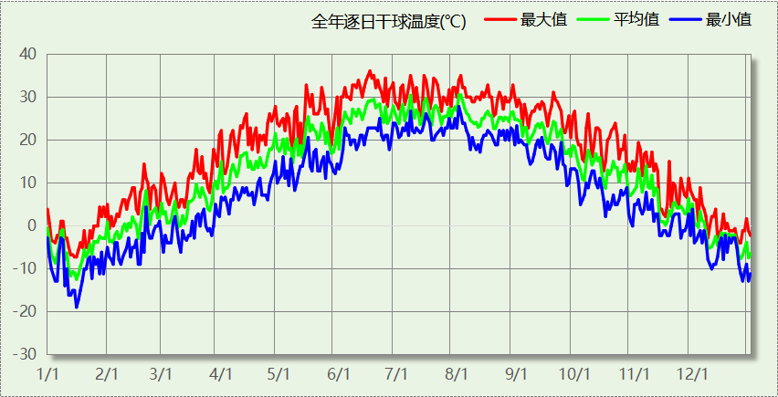

## 逐月辐照量表

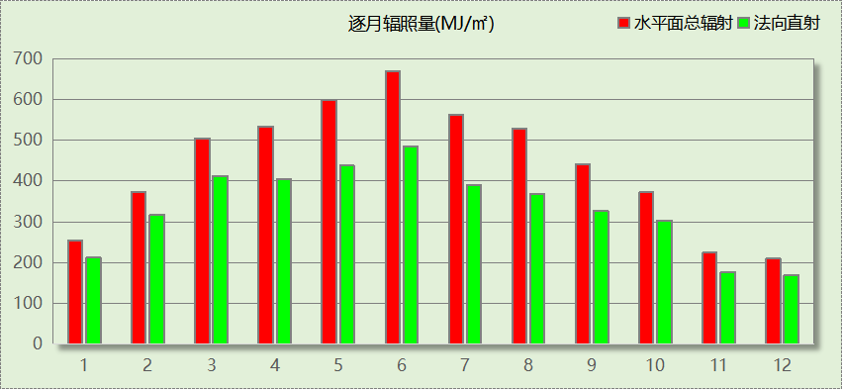

## 峰值工况

|  |  |  |  |  |  |
| --- | --- | --- | --- | --- | --- |
| 气象数据 | 时刻 | 干球温度(℃) | 湿球温度(℃) | 含湿量(g/kg) | 焓值(kj/kg) |
| 最热 | 06月16日15时 | 36.1 | 23.3 | 13.1 | 69.9 |
| 最冷 | 01月15日07时 | -18.9 | -20.0 | 0.3 | -18.2 |

# 软件介绍

本报告采用的软件为绿建暖通负荷BECH2024，该软件紧密结合暖通和节能设计规范、可根据项目实际情况建立建筑热工模型，并可对围护结构材料、房间内扰发热、作息时间表、热回收方式等参数进行设置。

软件包含全国各地典型气象年数据，内置DOE2.1E内核，对于建筑的逐时负荷进行动态模拟，既可以模拟8760小时理想负荷，也可以根据设定好的采暖期/空调期进行逐时模拟。

软件还支持分析全年建筑能耗的来源构成，依据日射得热、新风负荷、围护传热和内扰得热进行归类分项，生成设计建筑全年负荷计算报告书，提供详实的数据和多样的图表，为设计师在设备选型、制定运行策略等方面提供参考和帮助。

# 围护结构

## 屋顶构造

### 屋顶构造一

|  |  |  |  |  |  |  |
| --- | --- | --- | --- | --- | --- | --- |
| 材料名称 （由上到下） | 厚度δ | 导热系数λ | 蓄热系数S | 修正 系数 | 热阻R | 热惰性 指标 |
| (mm) | W/(m.K) | W/(㎡.K) | α | (㎡K)/W | D=R*S |
| 水泥砂浆 | 20 | 0.930 | 11.370 | 1.00 | 0.022 | 0.245 |
| c20细石混凝土(ρ=2300) | 40 | 1.510 | 15.243 | 1.00 | 0.026 | 0.404 |
| 挤塑聚苯板(ρ=25-32) | 90 | 0.030 | 0.320 | 1.10 | 2.727 | 0.960 |
| 轻骨料混凝土(找坡层) | 30 | 0.300 | 5.000 | 1.50 | 0.067 | 0.500 |
| 钢筋混凝土 | 120 | 1.740 | 17.200 | 1.00 | 0.069 | 1.186 |
| 混合砂浆 | 20 | 0.870 | 10.750 | 1.00 | 0.023 | 0.247 |
| 各层之和∑ | 320 | － | － | － | 2.934 | 3.542 |
| 传热系数K=1/(0.15+∑R) | 0.32 | | | | | |

## 外墙构造

### 填充墙构造一

|  |  |  |  |  |  |  |
| --- | --- | --- | --- | --- | --- | --- |
| 材料名称 （由外到内） | 厚度δ | 导热系数λ | 蓄热系数S | 修正 系数 | 热阻R | 热惰性 指标 |
| (mm) | W/(m.K) | W/(㎡.K) | α | (㎡K)/W | D=R*S |
| 水泥砂浆 | 20 | 0.930 | 11.370 | 1.00 | 0.022 | 0.245 |
| 岩棉板(ρ=60-160) | 70 | 0.041 | 0.615 | 1.10 | 1.552 | 1.050 |
| 加气混凝土、泡沫混凝土(ρ=700) | 200 | 0.180 | 3.100 | 1.25 | 0.889 | 3.444 |
| 混合砂浆 | 20 | 0.870 | 10.750 | 1.00 | 0.023 | 0.247 |
| 各层之和∑ | 310 | － | － | － | 2.485 | 4.986 |
| 传热系数K=1/(0.15+∑R) | 0.38 | | | | | |

## 挑空楼板构造

### 挑空楼板构造一

|  |  |  |  |  |  |  |
| --- | --- | --- | --- | --- | --- | --- |
| 材料名称 （由上到下） | 厚度δ | 导热系数λ | 蓄热系数S | 修正 系数 | 热阻R | 热惰性 指标 |
| (mm) | W/(m.K) | W/(㎡.K) | α | (㎡K)/W | D=R*S |
| 水泥砂浆 | 20 | 0.930 | 11.370 | 1.00 | 0.022 | 0.245 |
| 挤塑聚苯板(ρ=25-32) | 70 | 0.030 | 0.320 | 1.10 | 2.121 | 0.747 |
| 钢筋混凝土 | 120 | 1.740 | 17.200 | 1.00 | 0.069 | 1.186 |
| 混合砂浆 | 20 | 0.870 | 10.750 | 1.00 | 0.023 | 0.247 |
| 各层之和∑ | 230 | － | － | － | 2.235 | 2.425 |
| 传热系数K=1/(0.15+∑R) | 0.42 | | | | | |

## 楼板构造

### 控温房间楼板构造一

|  |  |  |  |  |  |  |
| --- | --- | --- | --- | --- | --- | --- |
| 材料名称 | 厚度δ | 导热系数λ | 蓄热系数S | 修正 系数 | 热阻R | 热惰性 指标 |
| (mm) | W/(m.K) | W/(㎡.K) | α | (㎡K)/W | D=R*S |
| 水泥砂浆 | 20 | 0.930 | 11.370 | 1.00 | 0.022 | 0.245 |
| 聚苯乙烯泡沫塑料（灰板） | 15 | 0.033 | 0.280 | 1.20 | 0.379 | 0.127 |
| 钢筋混凝土 | 120 | 1.740 | 17.200 | 1.00 | 0.069 | 1.186 |
| 混合砂浆 | 20 | 0.870 | 10.750 | 1.00 | 0.023 | 0.247 |
| 各层之和∑ | 175 | － | － | － | 0.492 | 1.805 |
| 传热系数K=1/(0.22+∑R) | 1.40 | | | | | |

## 周边地面构造

### 地面构造一

|  |  |  |  |  |  |  |
| --- | --- | --- | --- | --- | --- | --- |
| 材料名称 | 厚度δ | 导热系数λ | 蓄热系数S | 修正 系数 | 热阻R | 热惰性 指标 |
| (mm) | W/(m.K) | W/(㎡.K) | α | (㎡K)/W | D=R*S |
| 水泥砂浆 | 20 | 0.930 | 11.370 | 1.00 | 0.022 | 0.245 |
| 挤塑聚苯板(ρ=25-32) | 20 | 0.030 | 0.320 | 1.10 | 0.606 | 0.213 |
| 钢筋混凝土 | 120 | 1.740 | 17.200 | 1.00 | 0.069 | 1.186 |
| 各层之和∑ | 160 | － | － | － | 0.697 | 1.644 |
| 传热系数K=1/(0.11+∑R) | 0.40 | | | | | |

## 非周边地面构造

### 地面构造一

|  |  |  |  |  |  |  |
| --- | --- | --- | --- | --- | --- | --- |
| 材料名称 | 厚度δ | 导热系数λ | 蓄热系数S | 修正 系数 | 热阻R | 热惰性 指标 |
| (mm) | W/(m.K) | W/(㎡.K) | α | (㎡K)/W | D=R*S |
| 水泥砂浆 | 20 | 0.930 | 11.370 | 1.00 | 0.022 | 0.245 |
| 挤塑聚苯板(ρ=25-32) | 55 | 0.030 | 0.320 | 1.10 | 1.667 | 0.587 |
| 钢筋混凝土 | 120 | 1.740 | 17.200 | 1.00 | 0.069 | 1.186 |
| 各层之和∑ | 195 | － | － | － | 1.757 | 2.017 |
| 传热系数K=1/(0.11+∑R) | 0.20 | | | | | |

## 门构造

|  |  |  |  |
| --- | --- | --- | --- |
| 序号 | 构造名称 | 传热系数 | 备注 |
| 1 | 金属三防门(硅酸铝板保温-普通型) | 1.500 |  |

## 窗构造

|  |  |  |  |  |  |
| --- | --- | --- | --- | --- | --- |
| 序号 | 构造名称 | 传热系数 | 窗遮阳系数 | 可见光透射比 | 备注 |
| 1 | 60系列内平开下悬铝合金窗[5Low-E+16A+5] | 1.900 | 0.425 | 0.620 |  |
| 2 | 60系列内平开下悬铝合金窗[5Low-E+16A+5] | 1.900 | 0.425 | 0.620 |  |

# 房间类型

## 房间参数表

|  |  |  |  |  |  |  |
| --- | --- | --- | --- | --- | --- | --- |
| 房间类型 | 空调温度 ℃ | 供暖温度 ℃ | 新风量 | 人员密度 | 照明功率 密度 | 电器设备 功率 |
| 书库 | 26 | 20 | 30(m^3/h.人) | 8(m^2/人) | 8(W/m^2) | 15(W/m^2) |
| 休息室 | 26 | 18 | 24(m^3/h.人) | 1.39(m^2/人) | 9(W/m^2) | 5(W/m^2) |
| 办公-普通办公室 | 26 | 20 | 30(m^3/h.人) | 8(m^2/人) | 8(W/m^2) | 15(W/m^2) |
| 卫生间 | 28 | 16 | 0(m^3/h.人) | 0(人) | 5(W/m^2) | 5(W/m^2) |
| 多媒体区 | 26 | 20 | 30(m^3/h.人) | 2.5(m^2/人) | 13.5(W/m^2) | 15(W/m^2) |
| 大厅 | 26 | 20 | 30(m^3/h.人) | 20(m^2/人) | 10(W/m^2) | 0(W/m^2) |
| 实验教室 | 26 | 18 | 20(m^3/h.人) | 4(m^2/人) | 8(W/m^2) | 5(W/m^2) |
| 布草间 | 26 | 20 | 30(m^3/h.人) | 10(m^2/人) | 5(W/m^2) | 15(W/m^2) |
| 开架书库 | 26 | 20 | 30(m^3/h.人) | 8(m^2/人) | 8(W/m^2) | 15(W/m^2) |
| 文物修复室 | 26 | 20 | 30(m^3/h.人) | 8(m^2/人) | 8(W/m^2) | 15(W/m^2) |
| 普通办公室 | 26 | 20 | 30(m^3/h.人) | 6(m^2/人) | 8(W/m^2) | 5(W/m^2) |
| 普通办公室 | 26 | 20 | 30(m^3/h.人) | 8(m^2/人) | 8(W/m^2) | 15(W/m^2) |
| 普通教室 | 26 | 18 | 24(m^3/h.人) | 1.39(m^2/人) | 8(W/m^2) | 5(W/m^2) |
| 楼梯间 | － | － | 0(m^3/h.人) | 0(人) | 5(W/m^2) | 5(W/m^2) |
| 楼梯间 | 26 | 20 | 30(m^3/h.人) | 8(m^2/人) | 8(W/m^2) | 15(W/m^2) |
| 楼梯间 | 26 | 20 | 30(m^3/h.人) | 8(m^2/人) | 8(W/m^2) | 15(W/m^2) |
| 楼梯间 | － | － | 0(m^3/h.人) | 0(人) | 3.5(W/m^2) | 15(W/m^2) |
| 空房间 | － | － | 20(m^3/h.人) | 0(人) | 0(W/m^2) | 0(W/m^2) |
| 设备间 | － | － | 0(次/h) | 0(人) | 6(W/m^2) | 15(W/m^2) |
| 设备间 | － | － | 0(次/h) | 0(人) | 6(W/m^2) | 15(W/m^2) |
| 走廊 | 26 | 20 | 30(m^3/h.人) | 8(m^2/人) | 8(W/m^2) | 15(W/m^2) |
| 走廊 | － | － | 0(m^3/h.人) | 0(人) | 5(W/m^2) | 5(W/m^2) |
| 走廊 | 26 | 20 | 30(m^3/h.人) | 8(m^2/人) | 8(W/m^2) | 15(W/m^2) |
| 走廊 | 26 | 18 | 0(m^3/h.人) | 50(m^2/人) | 3.5(W/m^2) | 15(W/m^2) |
| 酒吧、茶座 | 26 | 20 | 30(m^3/h.人) | 4(m^2/人) | 8(W/m^2) | 0(W/m^2) |
| 阅览室 | 26 | 20 | 30(m^3/h.人) | 8(m^2/人) | 8(W/m^2) | 15(W/m^2) |
| 阅览室 | 26 | 20 | 20(m^3/h.人) | 1.9(m^2/人) | 8(W/m^2) | 5(W/m^2) |

## 作息时间表

详见附录

# 系统设置

## 系统划分

|  |  |  |  |  |  |  |
| --- | --- | --- | --- | --- | --- | --- |
| 系统编号 | 热回收 类型 | 启动 条件 | 回收 效率 | 排风 比例 | 面积(m2) | 包含的房间 |
| 默认 | 无 | -- | -- | -- | 17419.23 | 所有房间 |

## 运行时间表

详见附录

# 计算结果

## 模拟周期

全年8760小时模拟

## 全年冷暖需求

|  |  |  |  |  |
| --- | --- | --- | --- | --- |
| 系统名称\负荷 | 供暖需求 (kWh) | 供暖指标 (kWh/㎡·a) | 供冷需求 (kWh) | 供冷指标 (kWh/㎡·a) |
| 建筑总计 | 490102 | 25.24 | 1636427 | 84.27 |

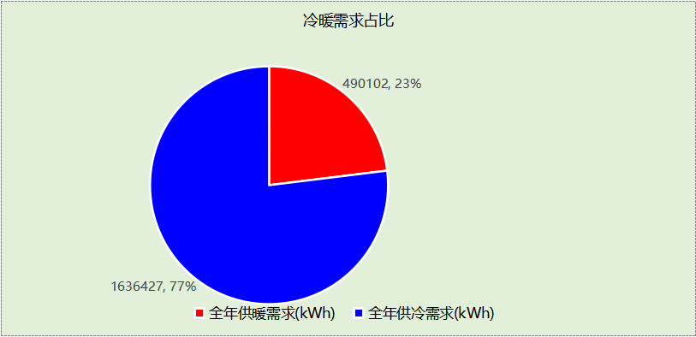

## 负荷分项统计

|  |  |  |  |  |  |  |
| --- | --- | --- | --- | --- | --- | --- |
| 分类 | 围护传热 | 室内得热 | 窗日射 | 新风/渗透 | 热回收 | 合计 |
| 供暖(kWh/㎡) | -8.16 | 15.28 | 3.02 | -35.38 | 0.00 | -25.24 |
| 供冷(kWh/㎡) | 14.34 | 48.47 | 8.29 | 13.18 | 0.00 | 84.27 |

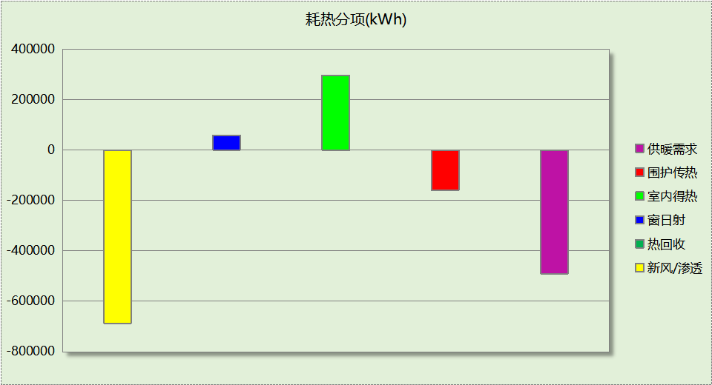

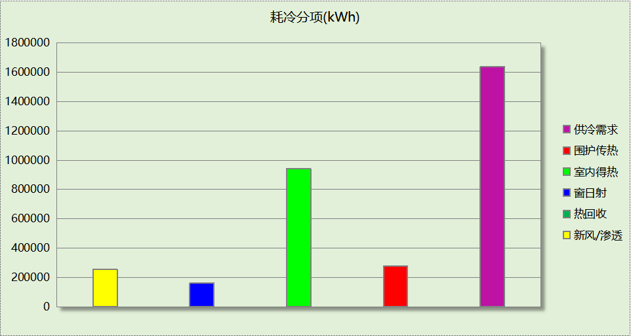

## 逐月负荷表

|  |  |  |  |  |  |  |
| --- | --- | --- | --- | --- | --- | --- |
| 月份 | 供暖(kWh) | 供冷(kWh) | 热负荷 峰值(kW) | 热负荷 峰值时刻 | 冷负荷 峰值(kW) | 冷负荷 峰值时刻 |
| 1月 | 201190 | 0 | 1884.103 | 1月14日8时 | 0.000 | -- |
| 2月 | 64838 | 32 | 1148.476 | 2月4日8时 | 5.180 | 2月21日12时 |
| 3月 | 35279 | 400 | 741.709 | 3月4日8时 | 23.782 | 3月28日15时 |
| 4月 | 2141 | 42983 | 114.754 | 4月1日17时 | 804.974 | 4月26日15时 |
| 5月 | 127 | 147155 | 2.816 | 5月13日7时 | 1394.029 | 5月14日13时 |
| 6月 | 2 | 299016 | 0.625 | 6月3日7时 | 2408.716 | 6月28日15时 |
| 7月 | 0 | 478312 | 0.000 | -- | 2637.286 | 7月29日15时 |
| 8月 | 0 | 416660 | 0.000 | -- | 3243.791 | 8月2日15时 |
| 9月 | 0 | 211228 | 0.000 | -- | 1849.816 | 9月2日15时 |
| 10月 | 78 | 39160 | 33.717 | 10月30日8时 | 715.245 | 10月10日15时 |
| 11月 | 29762 | 1481 | 806.856 | 11月18日8时 | 86.367 | 11月6日14时 |
| 12月 | 156685 | 0 | 1413.527 | 12月30日8时 | 0.000 | -- |

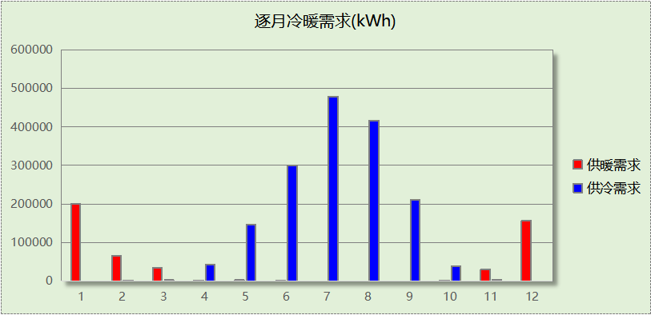

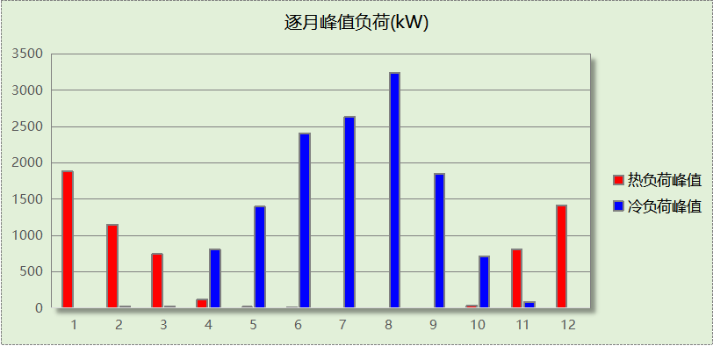

# 附录

**工作日/节假日人员逐时在室率(%)**

|  |  |  |  |  |  |  |  |  |  |  |  |  |  |  |  |  |  |  |  |  |  |  |  |  |
| --- | --- | --- | --- | --- | --- | --- | --- | --- | --- | --- | --- | --- | --- | --- | --- | --- | --- | --- | --- | --- | --- | --- | --- | --- |
| 房间类型 | 1 | 2 | 3 | 4 | 5 | 6 | 7 | 8 | 9 | 10 | 11 | 12 | 13 | 14 | 15 | 16 | 17 | 18 | 19 | 20 | 21 | 22 | 23 | 24 |
| 书库 | 0 | 0 | 0 | 0 | 0 | 0 | 10 | 50 | 100 | 100 | 100 | 30 | 100 | 100 | 100 | 100 | 50 | 20 | 10 | 0 | 0 | 0 | 0 | 0 |
| 0 | 0 | 0 | 0 | 0 | 0 | 0 | 20 | 45 | 0 | 0 | 0 | 0 | 0 | 0 | 0 | 0 | 0 | 0 | 0 | 0 | 0 | 0 | 0 |
| 休息室 | 0 | 0 | 0 | 0 | 0 | 0 | 10 | 50 | 95 | 95 | 95 | 80 | 80 | 95 | 95 | 95 | 95 | 30 | 30 | 0 | 0 | 0 | 0 | 0 |
| 0 | 0 | 0 | 0 | 0 | 0 | 0 | 0 | 0 | 0 | 0 | 0 | 0 | 0 | 0 | 0 | 0 | 0 | 0 | 0 | 0 | 0 | 0 | 0 |
| 办公-普通办公室 | 0 | 0 | 0 | 0 | 0 | 0 | 10 | 50 | 100 | 100 | 100 | 30 | 100 | 100 | 100 | 100 | 50 | 20 | 10 | 0 | 0 | 0 | 0 | 0 |
| 0 | 0 | 0 | 0 | 0 | 0 | 0 | 20 | 45 | 0 | 0 | 0 | 0 | 0 | 0 | 0 | 0 | 0 | 0 | 0 | 0 | 0 | 0 | 0 |
| 卫生间 | 0 | 0 | 0 | 0 | 0 | 0 | 10 | 50 | 95 | 95 | 95 | 80 | 80 | 95 | 95 | 95 | 95 | 30 | 30 | 0 | 0 | 0 | 0 | 0 |
| 0 | 0 | 0 | 0 | 0 | 0 | 0 | 0 | 0 | 0 | 0 | 0 | 0 | 0 | 0 | 0 | 0 | 0 | 0 | 0 | 0 | 0 | 0 | 0 |
| 多媒体区 | 0 | 0 | 0 | 0 | 0 | 0 | 10 | 50 | 100 | 100 | 100 | 30 | 100 | 100 | 100 | 100 | 50 | 20 | 10 | 0 | 0 | 0 | 0 | 0 |
| 0 | 0 | 0 | 0 | 0 | 0 | 0 | 20 | 45 | 0 | 0 | 0 | 0 | 0 | 0 | 0 | 0 | 0 | 0 | 0 | 0 | 0 | 0 | 0 |
| 大厅 | 0 | 0 | 0 | 0 | 0 | 0 | 10 | 50 | 95 | 95 | 95 | 80 | 80 | 95 | 95 | 95 | 95 | 30 | 30 | 0 | 0 | 0 | 0 | 0 |
| 0 | 0 | 0 | 0 | 0 | 0 | 0 | 0 | 0 | 0 | 0 | 0 | 0 | 0 | 0 | 0 | 0 | 0 | 0 | 0 | 0 | 0 | 0 | 0 |
| 实验教室 | 0 | 0 | 0 | 0 | 0 | 0 | 10 | 50 | 95 | 95 | 95 | 80 | 80 | 95 | 95 | 95 | 95 | 30 | 30 | 0 | 0 | 0 | 0 | 0 |
| 0 | 0 | 0 | 0 | 0 | 0 | 0 | 0 | 0 | 0 | 0 | 0 | 0 | 0 | 0 | 0 | 0 | 0 | 0 | 0 | 0 | 0 | 0 | 0 |
| 布草间 | 70 | 70 | 70 | 70 | 70 | 70 | 70 | 70 | 50 | 50 | 50 | 50 | 50 | 50 | 50 | 50 | 50 | 50 | 70 | 70 | 70 | 70 | 70 | 70 |
| 70 | 70 | 70 | 70 | 70 | 70 | 70 | 70 | 50 | 50 | 50 | 50 | 50 | 50 | 50 | 50 | 50 | 50 | 70 | 70 | 70 | 70 | 70 | 70 |
| 开架书库 | 0 | 0 | 0 | 0 | 0 | 0 | 10 | 50 | 100 | 100 | 100 | 30 | 100 | 100 | 100 | 100 | 50 | 20 | 10 | 0 | 0 | 0 | 0 | 0 |
| 0 | 0 | 0 | 0 | 0 | 0 | 0 | 20 | 45 | 0 | 0 | 0 | 0 | 0 | 0 | 0 | 0 | 0 | 0 | 0 | 0 | 0 | 0 | 0 |
| 文物修复室 | 0 | 0 | 0 | 0 | 0 | 0 | 10 | 50 | 100 | 100 | 100 | 30 | 100 | 100 | 100 | 100 | 50 | 20 | 10 | 0 | 0 | 0 | 0 | 0 |
| 0 | 0 | 0 | 0 | 0 | 0 | 0 | 20 | 45 | 0 | 0 | 0 | 0 | 0 | 0 | 0 | 0 | 0 | 0 | 0 | 0 | 0 | 0 | 0 |
| 普通办公室 | 0 | 0 | 0 | 0 | 0 | 0 | 10 | 50 | 95 | 95 | 95 | 80 | 80 | 95 | 95 | 95 | 95 | 30 | 30 | 0 | 0 | 0 | 0 | 0 |
| 0 | 0 | 0 | 0 | 0 | 0 | 0 | 0 | 0 | 0 | 0 | 0 | 0 | 0 | 0 | 0 | 0 | 0 | 0 | 0 | 0 | 0 | 0 | 0 |
| 普通办公室 | 0 | 0 | 0 | 0 | 0 | 0 | 10 | 50 | 100 | 100 | 100 | 30 | 100 | 100 | 100 | 100 | 50 | 20 | 10 | 0 | 0 | 0 | 0 | 0 |
| 0 | 0 | 0 | 0 | 0 | 0 | 0 | 20 | 45 | 0 | 0 | 0 | 0 | 0 | 0 | 0 | 0 | 0 | 0 | 0 | 0 | 0 | 0 | 0 |
| 普通教室 | 0 | 0 | 0 | 0 | 0 | 0 | 10 | 50 | 95 | 95 | 95 | 80 | 80 | 95 | 95 | 95 | 95 | 30 | 30 | 0 | 0 | 0 | 0 | 0 |
| 0 | 0 | 0 | 0 | 0 | 0 | 0 | 0 | 0 | 0 | 0 | 0 | 0 | 0 | 0 | 0 | 0 | 0 | 0 | 0 | 0 | 0 | 0 | 0 |
| 楼梯间 | 0 | 0 | 0 | 0 | 0 | 0 | 10 | 50 | 95 | 95 | 95 | 80 | 80 | 95 | 95 | 95 | 95 | 30 | 30 | 0 | 0 | 0 | 0 | 0 |
| 0 | 0 | 0 | 0 | 0 | 0 | 0 | 0 | 0 | 0 | 0 | 0 | 0 | 0 | 0 | 0 | 0 | 0 | 0 | 0 | 0 | 0 | 0 | 0 |
| 楼梯间 | 0 | 0 | 0 | 0 | 0 | 0 | 10 | 50 | 100 | 100 | 100 | 30 | 100 | 100 | 100 | 100 | 50 | 20 | 10 | 0 | 0 | 0 | 0 | 0 |
| 0 | 0 | 0 | 0 | 0 | 0 | 0 | 20 | 45 | 0 | 0 | 0 | 0 | 0 | 0 | 0 | 0 | 0 | 0 | 0 | 0 | 0 | 0 | 0 |
| 楼梯间 | 0 | 0 | 0 | 0 | 0 | 0 | 10 | 50 | 100 | 100 | 100 | 30 | 100 | 100 | 100 | 100 | 50 | 20 | 10 | 0 | 0 | 0 | 0 | 0 |
| 0 | 0 | 0 | 0 | 0 | 0 | 0 | 20 | 45 | 0 | 0 | 0 | 0 | 0 | 0 | 0 | 0 | 0 | 0 | 0 | 0 | 0 | 0 | 0 |
| 楼梯间 | 0 | 0 | 0 | 0 | 0 | 0 | 0 | 20 | 50 | 80 | 80 | 80 | 80 | 80 | 80 | 80 | 80 | 80 | 80 | 70 | 50 | 0 | 0 | 0 |
| 0 | 0 | 0 | 0 | 0 | 0 | 0 | 0 | 0 | 0 | 0 | 0 | 0 | 0 | 0 | 0 | 0 | 0 | 0 | 0 | 0 | 0 | 0 | 0 |
| 空房间 | 0 | 0 | 0 | 0 | 0 | 0 | 0 | 20 | 50 | 80 | 80 | 80 | 80 | 80 | 80 | 80 | 80 | 80 | 80 | 70 | 50 | 0 | 0 | 0 |
| 0 | 0 | 0 | 0 | 0 | 0 | 0 | 0 | 0 | 0 | 0 | 0 | 0 | 0 | 0 | 0 | 0 | 0 | 0 | 0 | 0 | 0 | 0 | 0 |
| 设备间 | 0 | 0 | 0 | 0 | 0 | 0 | 0 | 0 | 0 | 0 | 0 | 0 | 0 | 0 | 0 | 0 | 0 | 0 | 0 | 0 | 0 | 0 | 0 | 0 |
| 0 | 0 | 0 | 0 | 0 | 0 | 0 | 0 | 0 | 0 | 0 | 0 | 0 | 0 | 0 | 0 | 0 | 0 | 0 | 0 | 0 | 0 | 0 | 0 |
| 设备间 | 0 | 0 | 0 | 0 | 0 | 0 | 0 | 0 | 0 | 0 | 0 | 0 | 0 | 0 | 0 | 0 | 0 | 0 | 0 | 0 | 0 | 0 | 0 | 0 |
| 0 | 0 | 0 | 0 | 0 | 0 | 0 | 0 | 0 | 0 | 0 | 0 | 0 | 0 | 0 | 0 | 0 | 0 | 0 | 0 | 0 | 0 | 0 | 0 |
| 走廊 | 0 | 0 | 0 | 0 | 0 | 0 | 10 | 50 | 100 | 100 | 100 | 30 | 100 | 100 | 100 | 100 | 50 | 20 | 10 | 0 | 0 | 0 | 0 | 0 |
| 0 | 0 | 0 | 0 | 0 | 0 | 0 | 20 | 45 | 0 | 0 | 0 | 0 | 0 | 0 | 0 | 0 | 0 | 0 | 0 | 0 | 0 | 0 | 0 |
| 走廊 | 0 | 0 | 0 | 0 | 0 | 0 | 10 | 50 | 95 | 95 | 95 | 80 | 80 | 95 | 95 | 95 | 95 | 30 | 30 | 0 | 0 | 0 | 0 | 0 |
| 0 | 0 | 0 | 0 | 0 | 0 | 0 | 0 | 0 | 0 | 0 | 0 | 0 | 0 | 0 | 0 | 0 | 0 | 0 | 0 | 0 | 0 | 0 | 0 |
| 走廊 | 0 | 0 | 0 | 0 | 0 | 0 | 10 | 50 | 100 | 100 | 100 | 30 | 100 | 100 | 100 | 100 | 50 | 20 | 10 | 0 | 0 | 0 | 0 | 0 |
| 0 | 0 | 0 | 0 | 0 | 0 | 0 | 20 | 45 | 0 | 0 | 0 | 0 | 0 | 0 | 0 | 0 | 0 | 0 | 0 | 0 | 0 | 0 | 0 |
| 走廊 | 70 | 70 | 70 | 70 | 70 | 70 | 70 | 70 | 50 | 50 | 50 | 50 | 50 | 50 | 50 | 50 | 50 | 50 | 70 | 70 | 70 | 70 | 70 | 70 |
| 70 | 70 | 70 | 70 | 70 | 70 | 70 | 70 | 50 | 50 | 50 | 50 | 50 | 50 | 50 | 50 | 50 | 50 | 70 | 70 | 70 | 70 | 70 | 70 |
| 酒吧、茶座 | 70 | 70 | 70 | 70 | 70 | 70 | 70 | 70 | 50 | 50 | 50 | 50 | 50 | 50 | 50 | 50 | 50 | 50 | 70 | 70 | 70 | 70 | 70 | 70 |
| 70 | 70 | 70 | 70 | 70 | 70 | 70 | 70 | 50 | 50 | 50 | 50 | 50 | 50 | 50 | 50 | 50 | 50 | 70 | 70 | 70 | 70 | 70 | 70 |
| 阅览室 | 0 | 0 | 0 | 0 | 0 | 0 | 10 | 50 | 100 | 100 | 100 | 30 | 100 | 100 | 100 | 100 | 50 | 20 | 10 | 0 | 0 | 0 | 0 | 0 |
| 0 | 0 | 0 | 0 | 0 | 0 | 0 | 20 | 45 | 0 | 0 | 0 | 0 | 0 | 0 | 0 | 0 | 0 | 0 | 0 | 0 | 0 | 0 | 0 |
| 阅览室 | 0 | 0 | 0 | 0 | 0 | 0 | 10 | 50 | 95 | 95 | 95 | 80 | 80 | 95 | 95 | 95 | 95 | 30 | 30 | 0 | 0 | 0 | 0 | 0 |
| 0 | 0 | 0 | 0 | 0 | 0 | 0 | 0 | 0 | 0 | 0 | 0 | 0 | 0 | 0 | 0 | 0 | 0 | 0 | 0 | 0 | 0 | 0 | 0 |

注：上行：工作日；下行：节假日

**工作日/节假日照明开关时间表(%)**

|  |  |  |  |  |  |  |  |  |  |  |  |  |  |  |  |  |  |  |  |  |  |  |  |  |
| --- | --- | --- | --- | --- | --- | --- | --- | --- | --- | --- | --- | --- | --- | --- | --- | --- | --- | --- | --- | --- | --- | --- | --- | --- |
| 房间类型 | 1 | 2 | 3 | 4 | 5 | 6 | 7 | 8 | 9 | 10 | 11 | 12 | 13 | 14 | 15 | 16 | 17 | 18 | 19 | 20 | 21 | 22 | 23 | 24 |
| 书库 | 10 | 10 | 10 | 10 | 10 | 10 | 10 | 36 | 62 | 56 | 54 | 43 | 53 | 55 | 58 | 67 | 40 | 18 | 10 | 10 | 10 | 10 | 10 | 10 |
| 0 | 0 | 0 | 0 | 0 | 0 | 0 | 0 | 0 | 0 | 0 | 0 | 0 | 0 | 0 | 0 | 0 | 0 | 0 | 0 | 0 | 0 | 0 | 0 |
| 休息室 | 0 | 0 | 0 | 0 | 0 | 0 | 10 | 50 | 95 | 95 | 95 | 80 | 80 | 95 | 95 | 95 | 95 | 30 | 30 | 0 | 0 | 0 | 0 | 0 |
| 0 | 0 | 0 | 0 | 0 | 0 | 0 | 0 | 0 | 0 | 0 | 0 | 0 | 0 | 0 | 0 | 0 | 0 | 0 | 0 | 0 | 0 | 0 | 0 |
| 办公-普通办公室 | 10 | 10 | 10 | 10 | 10 | 10 | 10 | 36 | 62 | 56 | 54 | 43 | 53 | 55 | 58 | 67 | 40 | 18 | 10 | 10 | 10 | 10 | 10 | 10 |
| 0 | 0 | 0 | 0 | 0 | 0 | 0 | 0 | 0 | 0 | 0 | 0 | 0 | 0 | 0 | 0 | 0 | 0 | 0 | 0 | 0 | 0 | 0 | 0 |
| 卫生间 | 0 | 0 | 0 | 0 | 0 | 0 | 10 | 50 | 95 | 95 | 95 | 80 | 80 | 95 | 95 | 95 | 95 | 30 | 30 | 0 | 0 | 0 | 0 | 0 |
| 0 | 0 | 0 | 0 | 0 | 0 | 0 | 0 | 0 | 0 | 0 | 0 | 0 | 0 | 0 | 0 | 0 | 0 | 0 | 0 | 0 | 0 | 0 | 0 |
| 多媒体区 | 10 | 10 | 10 | 10 | 10 | 10 | 10 | 36 | 62 | 56 | 54 | 43 | 53 | 55 | 58 | 67 | 40 | 18 | 10 | 10 | 10 | 10 | 10 | 10 |
| 0 | 0 | 0 | 0 | 0 | 0 | 0 | 0 | 0 | 0 | 0 | 0 | 0 | 0 | 0 | 0 | 0 | 0 | 0 | 0 | 0 | 0 | 0 | 0 |
| 大厅 | 0 | 0 | 0 | 0 | 0 | 0 | 10 | 50 | 95 | 95 | 95 | 80 | 80 | 95 | 95 | 95 | 95 | 30 | 30 | 0 | 0 | 0 | 0 | 0 |
| 0 | 0 | 0 | 0 | 0 | 0 | 0 | 0 | 0 | 0 | 0 | 0 | 0 | 0 | 0 | 0 | 0 | 0 | 0 | 0 | 0 | 0 | 0 | 0 |
| 实验教室 | 0 | 0 | 0 | 0 | 0 | 0 | 10 | 50 | 95 | 95 | 95 | 80 | 80 | 95 | 95 | 95 | 95 | 30 | 30 | 0 | 0 | 0 | 0 | 0 |
| 0 | 0 | 0 | 0 | 0 | 0 | 0 | 0 | 0 | 0 | 0 | 0 | 0 | 0 | 0 | 0 | 0 | 0 | 0 | 0 | 0 | 0 | 0 | 0 |
| 布草间 | 10 | 10 | 10 | 10 | 10 | 10 | 30 | 30 | 30 | 30 | 30 | 30 | 30 | 30 | 50 | 50 | 60 | 90 | 90 | 90 | 90 | 80 | 10 | 10 |
| 10 | 10 | 10 | 10 | 10 | 10 | 30 | 30 | 30 | 30 | 30 | 30 | 30 | 30 | 50 | 50 | 60 | 90 | 90 | 90 | 90 | 80 | 10 | 10 |
| 开架书库 | 10 | 10 | 10 | 10 | 10 | 10 | 10 | 36 | 62 | 56 | 54 | 43 | 53 | 55 | 58 | 67 | 40 | 18 | 10 | 10 | 10 | 10 | 10 | 10 |
| 0 | 0 | 0 | 0 | 0 | 0 | 0 | 0 | 0 | 0 | 0 | 0 | 0 | 0 | 0 | 0 | 0 | 0 | 0 | 0 | 0 | 0 | 0 | 0 |
| 文物修复室 | 10 | 10 | 10 | 10 | 10 | 10 | 10 | 36 | 62 | 56 | 54 | 43 | 53 | 55 | 58 | 67 | 40 | 18 | 10 | 10 | 10 | 10 | 10 | 10 |
| 0 | 0 | 0 | 0 | 0 | 0 | 0 | 0 | 0 | 0 | 0 | 0 | 0 | 0 | 0 | 0 | 0 | 0 | 0 | 0 | 0 | 0 | 0 | 0 |
| 普通办公室 | 0 | 0 | 0 | 0 | 0 | 0 | 10 | 50 | 95 | 95 | 95 | 80 | 80 | 95 | 95 | 95 | 95 | 30 | 30 | 0 | 0 | 0 | 0 | 0 |
| 0 | 0 | 0 | 0 | 0 | 0 | 0 | 0 | 0 | 0 | 0 | 0 | 0 | 0 | 0 | 0 | 0 | 0 | 0 | 0 | 0 | 0 | 0 | 0 |
| 普通办公室 | 10 | 10 | 10 | 10 | 10 | 10 | 10 | 36 | 62 | 56 | 54 | 43 | 53 | 55 | 58 | 67 | 40 | 18 | 10 | 10 | 10 | 10 | 10 | 10 |
| 0 | 0 | 0 | 0 | 0 | 0 | 0 | 0 | 0 | 0 | 0 | 0 | 0 | 0 | 0 | 0 | 0 | 0 | 0 | 0 | 0 | 0 | 0 | 0 |
| 普通教室 | 0 | 0 | 0 | 0 | 0 | 0 | 10 | 50 | 95 | 95 | 95 | 80 | 80 | 95 | 95 | 95 | 95 | 30 | 30 | 0 | 0 | 0 | 0 | 0 |
| 0 | 0 | 0 | 0 | 0 | 0 | 0 | 0 | 0 | 0 | 0 | 0 | 0 | 0 | 0 | 0 | 0 | 0 | 0 | 0 | 0 | 0 | 0 | 0 |
| 楼梯间 | 0 | 0 | 0 | 0 | 0 | 0 | 10 | 50 | 95 | 95 | 95 | 80 | 80 | 95 | 95 | 95 | 95 | 30 | 30 | 0 | 0 | 0 | 0 | 0 |
| 0 | 0 | 0 | 0 | 0 | 0 | 0 | 0 | 0 | 0 | 0 | 0 | 0 | 0 | 0 | 0 | 0 | 0 | 0 | 0 | 0 | 0 | 0 | 0 |
| 楼梯间 | 10 | 10 | 10 | 10 | 10 | 10 | 10 | 36 | 62 | 56 | 54 | 43 | 53 | 55 | 58 | 67 | 40 | 18 | 10 | 10 | 10 | 10 | 10 | 10 |
| 0 | 0 | 0 | 0 | 0 | 0 | 0 | 0 | 0 | 0 | 0 | 0 | 0 | 0 | 0 | 0 | 0 | 0 | 0 | 0 | 0 | 0 | 0 | 0 |
| 楼梯间 | 10 | 10 | 10 | 10 | 10 | 10 | 10 | 36 | 62 | 56 | 54 | 43 | 53 | 55 | 58 | 67 | 40 | 18 | 10 | 10 | 10 | 10 | 10 | 10 |
| 0 | 0 | 0 | 0 | 0 | 0 | 0 | 0 | 0 | 0 | 0 | 0 | 0 | 0 | 0 | 0 | 0 | 0 | 0 | 0 | 0 | 0 | 0 | 0 |
| 楼梯间 | 10 | 10 | 10 | 10 | 10 | 10 | 10 | 50 | 60 | 60 | 60 | 60 | 60 | 60 | 60 | 60 | 80 | 90 | 100 | 100 | 100 | 10 | 10 | 10 |
| 0 | 0 | 0 | 0 | 0 | 0 | 0 | 0 | 0 | 0 | 0 | 0 | 0 | 0 | 0 | 0 | 0 | 0 | 0 | 0 | 0 | 0 | 0 | 0 |
| 空房间 | 10 | 10 | 10 | 10 | 10 | 10 | 10 | 50 | 60 | 60 | 60 | 60 | 60 | 60 | 60 | 60 | 80 | 90 | 100 | 100 | 100 | 10 | 10 | 10 |
| 0 | 0 | 0 | 0 | 0 | 0 | 0 | 0 | 0 | 0 | 0 | 0 | 0 | 0 | 0 | 0 | 0 | 0 | 0 | 0 | 0 | 0 | 0 | 0 |
| 设备间 | 100 | 100 | 100 | 100 | 100 | 100 | 100 | 100 | 100 | 100 | 100 | 100 | 100 | 100 | 100 | 100 | 100 | 100 | 100 | 100 | 100 | 100 | 100 | 100 |
| 100 | 100 | 100 | 100 | 100 | 100 | 100 | 100 | 100 | 100 | 100 | 100 | 100 | 100 | 100 | 100 | 100 | 100 | 100 | 100 | 100 | 100 | 100 | 100 |
| 设备间 | 100 | 100 | 100 | 100 | 100 | 100 | 100 | 100 | 100 | 100 | 100 | 100 | 100 | 100 | 100 | 100 | 100 | 100 | 100 | 100 | 100 | 100 | 100 | 100 |
| 0 | 0 | 0 | 0 | 0 | 0 | 0 | 0 | 0 | 0 | 0 | 0 | 0 | 0 | 0 | 0 | 0 | 0 | 0 | 0 | 0 | 0 | 0 | 0 |
| 走廊 | 10 | 10 | 10 | 10 | 10 | 10 | 10 | 36 | 62 | 56 | 54 | 43 | 53 | 55 | 58 | 67 | 40 | 18 | 10 | 10 | 10 | 10 | 10 | 10 |
| 0 | 0 | 0 | 0 | 0 | 0 | 0 | 0 | 0 | 0 | 0 | 0 | 0 | 0 | 0 | 0 | 0 | 0 | 0 | 0 | 0 | 0 | 0 | 0 |
| 走廊 | 0 | 0 | 0 | 0 | 0 | 0 | 10 | 50 | 95 | 95 | 95 | 80 | 80 | 95 | 95 | 95 | 95 | 30 | 30 | 0 | 0 | 0 | 0 | 0 |
| 0 | 0 | 0 | 0 | 0 | 0 | 0 | 0 | 0 | 0 | 0 | 0 | 0 | 0 | 0 | 0 | 0 | 0 | 0 | 0 | 0 | 0 | 0 | 0 |
| 走廊 | 10 | 10 | 10 | 10 | 10 | 10 | 10 | 36 | 62 | 56 | 54 | 43 | 53 | 55 | 58 | 67 | 40 | 18 | 10 | 10 | 10 | 10 | 10 | 10 |
| 0 | 0 | 0 | 0 | 0 | 0 | 0 | 0 | 0 | 0 | 0 | 0 | 0 | 0 | 0 | 0 | 0 | 0 | 0 | 0 | 0 | 0 | 0 | 0 |
| 走廊 | 10 | 10 | 10 | 10 | 10 | 10 | 30 | 30 | 30 | 30 | 30 | 30 | 30 | 30 | 50 | 50 | 60 | 90 | 90 | 90 | 90 | 80 | 10 | 10 |
| 10 | 10 | 10 | 10 | 10 | 10 | 30 | 30 | 30 | 30 | 30 | 30 | 30 | 30 | 50 | 50 | 60 | 90 | 90 | 90 | 90 | 80 | 10 | 10 |
| 酒吧、茶座 | 10 | 10 | 10 | 10 | 10 | 10 | 30 | 30 | 30 | 30 | 30 | 30 | 30 | 30 | 50 | 50 | 60 | 90 | 90 | 90 | 90 | 80 | 10 | 10 |
| 10 | 10 | 10 | 10 | 10 | 10 | 30 | 30 | 30 | 30 | 30 | 30 | 30 | 30 | 50 | 50 | 60 | 90 | 90 | 90 | 90 | 80 | 10 | 10 |
| 阅览室 | 10 | 10 | 10 | 10 | 10 | 10 | 10 | 36 | 62 | 56 | 54 | 43 | 53 | 55 | 58 | 67 | 40 | 18 | 10 | 10 | 10 | 10 | 10 | 10 |
| 0 | 0 | 0 | 0 | 0 | 0 | 0 | 0 | 0 | 0 | 0 | 0 | 0 | 0 | 0 | 0 | 0 | 0 | 0 | 0 | 0 | 0 | 0 | 0 |
| 阅览室 | 0 | 0 | 0 | 0 | 0 | 0 | 10 | 50 | 95 | 95 | 95 | 80 | 80 | 95 | 95 | 95 | 95 | 30 | 30 | 0 | 0 | 0 | 0 | 0 |
| 0 | 0 | 0 | 0 | 0 | 0 | 0 | 0 | 0 | 0 | 0 | 0 | 0 | 0 | 0 | 0 | 0 | 0 | 0 | 0 | 0 | 0 | 0 | 0 |

注：上行：工作日；下行：节假日

**工作日/节假日设备逐时使用率(%)**

|  |  |  |  |  |  |  |  |  |  |  |  |  |  |  |  |  |  |  |  |  |  |  |  |  |
| --- | --- | --- | --- | --- | --- | --- | --- | --- | --- | --- | --- | --- | --- | --- | --- | --- | --- | --- | --- | --- | --- | --- | --- | --- |
| 房间类型 | 1 | 2 | 3 | 4 | 5 | 6 | 7 | 8 | 9 | 10 | 11 | 12 | 13 | 14 | 15 | 16 | 17 | 18 | 19 | 20 | 21 | 22 | 23 | 24 |
| 书库 | 0 | 0 | 0 | 0 | 0 | 0 | 10 | 50 | 100 | 100 | 100 | 100 | 100 | 100 | 100 | 100 | 50 | 20 | 10 | 0 | 0 | 0 | 0 | 0 |
| 0 | 0 | 0 | 0 | 0 | 0 | 0 | 0 | 0 | 0 | 0 | 0 | 0 | 0 | 0 | 0 | 0 | 0 | 0 | 0 | 0 | 0 | 0 | 0 |
| 休息室 | 0 | 0 | 0 | 0 | 0 | 0 | 10 | 50 | 95 | 95 | 95 | 50 | 50 | 95 | 95 | 95 | 95 | 30 | 30 | 0 | 0 | 0 | 0 | 0 |
| 0 | 0 | 0 | 0 | 0 | 0 | 0 | 0 | 0 | 0 | 0 | 0 | 0 | 0 | 0 | 0 | 0 | 0 | 0 | 0 | 0 | 0 | 0 | 0 |
| 办公-普通办公室 | 0 | 0 | 0 | 0 | 0 | 0 | 10 | 50 | 100 | 100 | 100 | 100 | 100 | 100 | 100 | 100 | 50 | 20 | 10 | 0 | 0 | 0 | 0 | 0 |
| 0 | 0 | 0 | 0 | 0 | 0 | 0 | 0 | 0 | 0 | 0 | 0 | 0 | 0 | 0 | 0 | 0 | 0 | 0 | 0 | 0 | 0 | 0 | 0 |
| 卫生间 | 0 | 0 | 0 | 0 | 0 | 0 | 10 | 50 | 95 | 95 | 95 | 50 | 50 | 95 | 95 | 95 | 95 | 30 | 30 | 0 | 0 | 0 | 0 | 0 |
| 0 | 0 | 0 | 0 | 0 | 0 | 0 | 0 | 0 | 0 | 0 | 0 | 0 | 0 | 0 | 0 | 0 | 0 | 0 | 0 | 0 | 0 | 0 | 0 |
| 多媒体区 | 0 | 0 | 0 | 0 | 0 | 0 | 10 | 50 | 100 | 100 | 100 | 100 | 100 | 100 | 100 | 100 | 50 | 20 | 10 | 0 | 0 | 0 | 0 | 0 |
| 0 | 0 | 0 | 0 | 0 | 0 | 0 | 0 | 0 | 0 | 0 | 0 | 0 | 0 | 0 | 0 | 0 | 0 | 0 | 0 | 0 | 0 | 0 | 0 |
| 大厅 | 0 | 0 | 0 | 0 | 0 | 0 | 10 | 50 | 95 | 95 | 95 | 50 | 50 | 95 | 95 | 95 | 95 | 30 | 30 | 0 | 0 | 0 | 0 | 0 |
| 0 | 0 | 0 | 0 | 0 | 0 | 0 | 0 | 0 | 0 | 0 | 0 | 0 | 0 | 0 | 0 | 0 | 0 | 0 | 0 | 0 | 0 | 0 | 0 |
| 实验教室 | 0 | 0 | 0 | 0 | 0 | 0 | 10 | 50 | 95 | 95 | 95 | 50 | 50 | 95 | 95 | 95 | 95 | 30 | 30 | 0 | 0 | 0 | 0 | 0 |
| 0 | 0 | 0 | 0 | 0 | 0 | 0 | 0 | 0 | 0 | 0 | 0 | 0 | 0 | 0 | 0 | 0 | 0 | 0 | 0 | 0 | 0 | 0 | 0 |
| 布草间 | 0 | 0 | 0 | 0 | 0 | 0 | 0 | 0 | 0 | 0 | 0 | 0 | 0 | 0 | 0 | 0 | 0 | 80 | 80 | 80 | 80 | 80 | 0 | 0 |
| 0 | 0 | 0 | 0 | 0 | 0 | 0 | 0 | 0 | 0 | 0 | 0 | 0 | 0 | 0 | 0 | 0 | 80 | 80 | 80 | 80 | 80 | 0 | 0 |
| 开架书库 | 0 | 0 | 0 | 0 | 0 | 0 | 10 | 50 | 100 | 100 | 100 | 100 | 100 | 100 | 100 | 100 | 50 | 20 | 10 | 0 | 0 | 0 | 0 | 0 |
| 0 | 0 | 0 | 0 | 0 | 0 | 0 | 0 | 0 | 0 | 0 | 0 | 0 | 0 | 0 | 0 | 0 | 0 | 0 | 0 | 0 | 0 | 0 | 0 |
| 文物修复室 | 0 | 0 | 0 | 0 | 0 | 0 | 10 | 50 | 100 | 100 | 100 | 100 | 100 | 100 | 100 | 100 | 50 | 20 | 10 | 0 | 0 | 0 | 0 | 0 |
| 0 | 0 | 0 | 0 | 0 | 0 | 0 | 0 | 0 | 0 | 0 | 0 | 0 | 0 | 0 | 0 | 0 | 0 | 0 | 0 | 0 | 0 | 0 | 0 |
| 普通办公室 | 0 | 0 | 0 | 0 | 0 | 0 | 10 | 50 | 95 | 95 | 95 | 50 | 50 | 95 | 95 | 95 | 95 | 30 | 30 | 0 | 0 | 0 | 0 | 0 |
| 0 | 0 | 0 | 0 | 0 | 0 | 0 | 0 | 0 | 0 | 0 | 0 | 0 | 0 | 0 | 0 | 0 | 0 | 0 | 0 | 0 | 0 | 0 | 0 |
| 普通办公室 | 0 | 0 | 0 | 0 | 0 | 0 | 10 | 50 | 100 | 100 | 100 | 100 | 100 | 100 | 100 | 100 | 50 | 20 | 10 | 0 | 0 | 0 | 0 | 0 |
| 0 | 0 | 0 | 0 | 0 | 0 | 0 | 0 | 0 | 0 | 0 | 0 | 0 | 0 | 0 | 0 | 0 | 0 | 0 | 0 | 0 | 0 | 0 | 0 |
| 普通教室 | 0 | 0 | 0 | 0 | 0 | 0 | 10 | 50 | 95 | 95 | 95 | 50 | 50 | 95 | 95 | 95 | 95 | 30 | 30 | 0 | 0 | 0 | 0 | 0 |
| 0 | 0 | 0 | 0 | 0 | 0 | 0 | 0 | 0 | 0 | 0 | 0 | 0 | 0 | 0 | 0 | 0 | 0 | 0 | 0 | 0 | 0 | 0 | 0 |
| 楼梯间 | 0 | 0 | 0 | 0 | 0 | 0 | 10 | 50 | 95 | 95 | 95 | 50 | 50 | 95 | 95 | 95 | 95 | 30 | 30 | 0 | 0 | 0 | 0 | 0 |
| 0 | 0 | 0 | 0 | 0 | 0 | 0 | 0 | 0 | 0 | 0 | 0 | 0 | 0 | 0 | 0 | 0 | 0 | 0 | 0 | 0 | 0 | 0 | 0 |
| 楼梯间 | 0 | 0 | 0 | 0 | 0 | 0 | 10 | 50 | 100 | 100 | 100 | 100 | 100 | 100 | 100 | 100 | 50 | 20 | 10 | 0 | 0 | 0 | 0 | 0 |
| 0 | 0 | 0 | 0 | 0 | 0 | 0 | 0 | 0 | 0 | 0 | 0 | 0 | 0 | 0 | 0 | 0 | 0 | 0 | 0 | 0 | 0 | 0 | 0 |
| 楼梯间 | 0 | 0 | 0 | 0 | 0 | 0 | 10 | 50 | 100 | 100 | 100 | 100 | 100 | 100 | 100 | 100 | 50 | 20 | 10 | 0 | 0 | 0 | 0 | 0 |
| 0 | 0 | 0 | 0 | 0 | 0 | 0 | 0 | 0 | 0 | 0 | 0 | 0 | 0 | 0 | 0 | 0 | 0 | 0 | 0 | 0 | 0 | 0 | 0 |
| 楼梯间 | 0 | 0 | 0 | 0 | 0 | 0 | 0 | 30 | 50 | 80 | 80 | 80 | 80 | 80 | 80 | 80 | 80 | 80 | 80 | 70 | 50 | 0 | 0 | 0 |
| 0 | 0 | 0 | 0 | 0 | 0 | 0 | 0 | 0 | 0 | 0 | 0 | 0 | 0 | 0 | 0 | 0 | 0 | 0 | 0 | 0 | 0 | 0 | 0 |
| 空房间 | 0 | 0 | 0 | 0 | 0 | 0 | 0 | 30 | 50 | 80 | 80 | 80 | 80 | 80 | 80 | 80 | 80 | 80 | 80 | 70 | 50 | 0 | 0 | 0 |
| 0 | 0 | 0 | 0 | 0 | 0 | 0 | 0 | 0 | 0 | 0 | 0 | 0 | 0 | 0 | 0 | 0 | 0 | 0 | 0 | 0 | 0 | 0 | 0 |
| 设备间 | 100 | 100 | 100 | 100 | 100 | 100 | 100 | 100 | 100 | 100 | 100 | 100 | 100 | 100 | 100 | 100 | 100 | 100 | 100 | 100 | 100 | 100 | 100 | 100 |
| 100 | 100 | 100 | 100 | 100 | 100 | 100 | 100 | 100 | 100 | 100 | 100 | 100 | 100 | 100 | 100 | 100 | 100 | 100 | 100 | 100 | 100 | 100 | 100 |
| 设备间 | 100 | 100 | 100 | 100 | 100 | 100 | 100 | 100 | 100 | 100 | 100 | 100 | 100 | 100 | 100 | 100 | 100 | 100 | 100 | 100 | 100 | 100 | 100 | 100 |
| 0 | 0 | 0 | 0 | 0 | 0 | 0 | 0 | 0 | 0 | 0 | 0 | 0 | 0 | 0 | 0 | 0 | 0 | 0 | 0 | 0 | 0 | 0 | 0 |
| 走廊 | 0 | 0 | 0 | 0 | 0 | 0 | 10 | 50 | 100 | 100 | 100 | 100 | 100 | 100 | 100 | 100 | 50 | 20 | 10 | 0 | 0 | 0 | 0 | 0 |
| 0 | 0 | 0 | 0 | 0 | 0 | 0 | 0 | 0 | 0 | 0 | 0 | 0 | 0 | 0 | 0 | 0 | 0 | 0 | 0 | 0 | 0 | 0 | 0 |
| 走廊 | 0 | 0 | 0 | 0 | 0 | 0 | 10 | 50 | 95 | 95 | 95 | 50 | 50 | 95 | 95 | 95 | 95 | 30 | 30 | 0 | 0 | 0 | 0 | 0 |
| 0 | 0 | 0 | 0 | 0 | 0 | 0 | 0 | 0 | 0 | 0 | 0 | 0 | 0 | 0 | 0 | 0 | 0 | 0 | 0 | 0 | 0 | 0 | 0 |
| 走廊 | 0 | 0 | 0 | 0 | 0 | 0 | 10 | 50 | 100 | 100 | 100 | 100 | 100 | 100 | 100 | 100 | 50 | 20 | 10 | 0 | 0 | 0 | 0 | 0 |
| 0 | 0 | 0 | 0 | 0 | 0 | 0 | 0 | 0 | 0 | 0 | 0 | 0 | 0 | 0 | 0 | 0 | 0 | 0 | 0 | 0 | 0 | 0 | 0 |
| 走廊 | 0 | 0 | 0 | 0 | 0 | 0 | 0 | 0 | 0 | 0 | 0 | 0 | 0 | 0 | 0 | 0 | 0 | 80 | 80 | 80 | 80 | 80 | 0 | 0 |
| 0 | 0 | 0 | 0 | 0 | 0 | 0 | 0 | 0 | 0 | 0 | 0 | 0 | 0 | 0 | 0 | 0 | 80 | 80 | 80 | 80 | 80 | 0 | 0 |
| 酒吧、茶座 | 0 | 0 | 0 | 0 | 0 | 0 | 0 | 0 | 0 | 0 | 0 | 0 | 0 | 0 | 0 | 0 | 0 | 80 | 80 | 80 | 80 | 80 | 0 | 0 |
| 0 | 0 | 0 | 0 | 0 | 0 | 0 | 0 | 0 | 0 | 0 | 0 | 0 | 0 | 0 | 0 | 0 | 80 | 80 | 80 | 80 | 80 | 0 | 0 |
| 阅览室 | 0 | 0 | 0 | 0 | 0 | 0 | 10 | 50 | 100 | 100 | 100 | 100 | 100 | 100 | 100 | 100 | 50 | 20 | 10 | 0 | 0 | 0 | 0 | 0 |
| 0 | 0 | 0 | 0 | 0 | 0 | 0 | 0 | 0 | 0 | 0 | 0 | 0 | 0 | 0 | 0 | 0 | 0 | 0 | 0 | 0 | 0 | 0 | 0 |
| 阅览室 | 0 | 0 | 0 | 0 | 0 | 0 | 10 | 50 | 95 | 95 | 95 | 50 | 50 | 95 | 95 | 95 | 95 | 30 | 30 | 0 | 0 | 0 | 0 | 0 |
| 0 | 0 | 0 | 0 | 0 | 0 | 0 | 0 | 0 | 0 | 0 | 0 | 0 | 0 | 0 | 0 | 0 | 0 | 0 | 0 | 0 | 0 | 0 | 0 |

注：上行：工作日；下行：节假日

**工作日/节假日空调系统开关时间表**

|  |  |  |  |  |  |  |  |  |  |  |  |  |  |  |  |  |  |  |  |  |  |  |  |  |
| --- | --- | --- | --- | --- | --- | --- | --- | --- | --- | --- | --- | --- | --- | --- | --- | --- | --- | --- | --- | --- | --- | --- | --- | --- |
| 系统编号 | 1 | 2 | 3 | 4 | 5 | 6 | 7 | 8 | 9 | 10 | 11 | 12 | 13 | 14 | 15 | 16 | 17 | 18 | 19 | 20 | 21 | 22 | 23 | 24 |
| 默认 | 0 | 0 | 0 | 0 | 0 | 0 | 0 | 1 | 1 | 1 | 1 | 1 | 1 | 1 | 1 | 1 | 1 | 1 | 0 | 0 | 0 | 0 | 0 | 0 |
| 0 | 0 | 0 | 0 | 0 | 0 | 0 | 0 | 0 | 0 | 0 | 0 | 0 | 0 | 0 | 0 | 0 | 0 | 0 | 0 | 0 | 0 | 0 | 0 |

注：上行：工作日；下行：节假日