**建筑全能耗报告书**

公共建筑

|  |  |
| --- | --- |
| 工程名称 | 新建项目 |
| 工程地点 | 北京-北京 |
| 设计编号 |  |
| 建设单位 |  |
| 设计单位 |  |
| 设 计 人 |  |
| 审 核 人 |  |
| 审 定 人 |  |
| 设计日期 | 2024年12月24日 |



|  |  |
| --- | --- |
| 采用软件 | 能耗计算BESI2024 |
| 软件版本 | 20240430(SP1) |
| 研发单位 | 北京绿建软件股份有限公司 |
| 正版授权码 | T13732236081 |

**目 录**

1 建筑概况 3

2 计算依据 3

3 软件介绍 3

4 气象数据 4

4.1 气象地点 4

4.2 逐日干球温度表 4

4.3 逐月辐照量表 4

4.4 峰值工况 5

5 围护结构 5

5.1 工程材料 5

5.2 围护结构作法简要说明 6

6 围护结构概况 6

7 房间类型 7

7.1 房间参数表 7

7.2 作息时间表 8

8 暖通空调系统 8

8.1 系统类型 8

8.1.1 系统分区 8

8.1.2 热回收参数 8

8.2 制冷系统 8

8.2.1 默认冷源 8

8.3 供暖系统 9

8.3.1 默认热源 9

8.4 空调风机 9

8.4.1 独立新排风 9

8.4.2 风机盘管 9

9 照明 9

10 插座设备 10

11 光伏发电 11

12 计算结果 11

12.1 负荷分项统计 11

12.2 逐月负荷表 12

12.3 逐月电耗 13

12.4 全年能耗 14

13 附录 16

13.1 工作日/节假日人员逐时在室率(%) 16

13.2 工作日/节假日照明开关时间表(%) 17

13.3 工作日/节假日设备逐时使用率(%) 19

13.4 工作日/节假日空调系统运行时间表(1:开,0:关) 21

13.5 工作日/节假日新风运行时间表(%) 21

# 建筑概况

|  |  |  |
| --- | --- | --- |
| 工程名称 | 新建项目 | |
| 工程地点 | 北京-北京 | |
| 地理位置 | 北纬：39.80° | 东经：116.47° |
| 建筑面积(m2) | 地上19419 地下0 | |
| 建筑层数 | 地上10 地下0 | |
| 建筑高度（m） | 地上30.0 地下0.0 | |
| 建筑体积(m3) | 58256.30 | |
| 建筑外表面积(m2) | 12820.06 | |
| 北向角度 | 90 | |
| 结构类型 |  | |
| 外墙太阳辐射吸收系数 | 0.75 | |
| 屋顶太阳辐射吸收系数 | 0.75 | |
| 控温期 | 供冷期:6.14-8.31,供暖期:11.30-2.28 | |

# 计算依据

1. 《绿色建筑评价标准》(GB/T50378-2019)

2. 《民用建筑绿色性能计算标准》(JGJ/T 449-2018)

3. 《建筑能效标识技术标准》(JGJ/T 288-2012)

4. 《建筑节能与可再生能源利用通用规范》GB55015-2021

5. 《公共建筑节能设计标准》GB50189-2015

6. 《民用建筑热工设计规范》GB50176-2016

7. 《建筑幕墙、门窗通用技术条件》GB/T31433-2015

# 软件介绍

本报告内容由能耗计算BESI2024计算并输出，能耗计算BESI以CAD为平台，内置DOE2内核，可与建筑节能模型无缝对接，精准快速得到动态理想负荷，完美支持从《建筑能效标识技术标准》到《绿色建筑评价标准》要求的节能率，以及建筑全能耗的计算；软件充分考虑工程实际需求，从冷热源、输配水泵到末端风机，覆盖了常见暖通设备的能耗计算；并支持灵活的采暖供冷期、系统划分、运行策略设置等功能以及强大的结果数据分析。

# 气象数据

## 气象地点

北京-北京, 《建筑节能气象参数标准》

## 逐日干球温度表

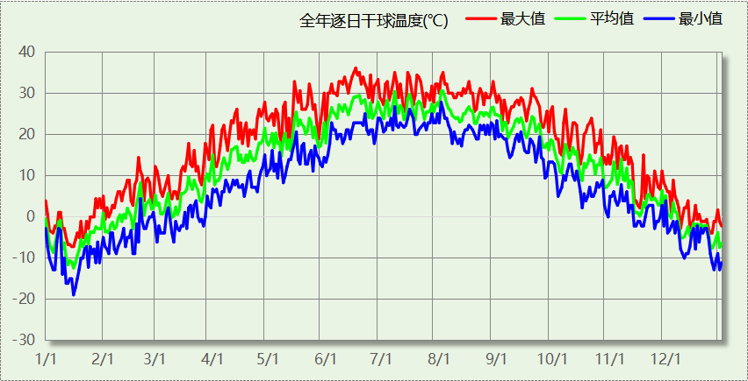

## 逐月辐照量表

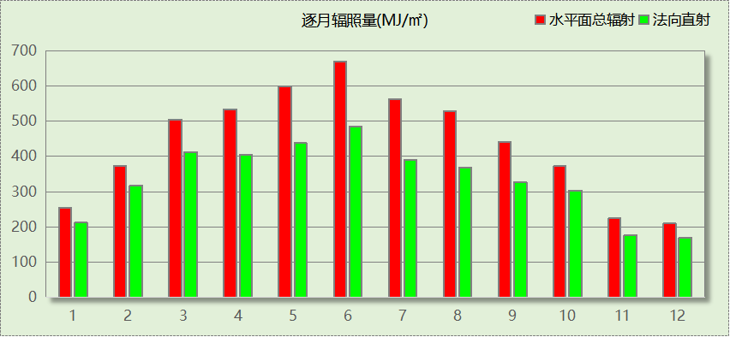

## 峰值工况

|  |  |  |  |  |  |
| --- | --- | --- | --- | --- | --- |
| 气象数据 | 时刻 | 干球温度(℃) | 湿球温度(℃) | 含湿量(g/kg) | 焓值(kj/kg) |
| 最热 | 06月16日15时 | 36.1 | 23.3 | 13.1 | 69.9 |
| 最冷 | 01月15日07时 | -18.9 | -20.0 | 0.3 | -18.2 |

# 围护结构

## 工程材料

|  |  |  |  |  |  |  |
| --- | --- | --- | --- | --- | --- | --- |
| 材料名称 | 导热系数λ | 蓄热系数S | 密度ρ | 比热容Cp | 蒸汽渗透 系数u | 数据来源 |
| W/(m.K) | W/(㎡.K) | kg/m3 | J/(kg.K) | g/(m.h.kPa) |
| 水泥砂浆 | 0.930 | 11.370 | 1800.0 | 1050.0 | 0.0210 | 民用建筑热工设计规范 GB50176-2016 |
| 聚苯乙烯泡沫塑料（灰板） | 0.033 | 0.280 | 20.0 | 1380.0 | 0.0162 | 民用建筑热工设计规范 GB50176-2016 |
| 混合砂浆 | 0.870 | 10.750 | 1700.0 | 1074.4 | 0.0975 | 民用建筑热工设计规范 GB50176-2016 |
| 钢筋混凝土 | 1.740 | 17.200 | 2500.0 | 920.0 | 0.0158 | 民用建筑热工设计规范 GB50176-2016 |
| 挤塑聚苯板(ρ=25-32) | 0.030 | 0.320 | 28.5 | 1647.0 | 0.0162 | 民用建筑热工设计规范 GB50176-2016 |
| 加气混凝土、泡沫混凝土(ρ=700) | 0.180 | 3.100 | 700.0 | 1050.0 | 0.0998 | 民用建筑热工设计规范 GB50176-2016 |
| 混凝土多孔砖(190六孔砖） | 0.750 | 7.490 | 1450.0 | 709.4 | 0.0010 | 民用建筑热工设计规范 GB50176-2016 |
| 岩棉板(ρ=60-160) | 0.041 | 0.615 | 110.0 | 1220.0 | 0.4880 | 民用建筑热工设计规范 GB50176-2016 |
| c20细石混凝土(ρ=2300) | 1.510 | 15.243 | 2300.0 | 920.0 | 0.0173 | 民用建筑热工设计规范 GB50176-2016 |
| 轻骨料混凝土(找坡层) | 0.300 | 5.000 | 1050.0 | 1091.3 | 0.0140 | 民用建筑热工设计规范 GB50176-2016 |

## 围护结构作法简要说明

**1. 屋顶：**屋顶构造一 (K=0.324,D=3.542)：（由上到下）

水泥砂浆 20mm＋c20细石混凝土(ρ=2300) 40mm＋挤塑聚苯板(ρ=25-32) 90mm＋轻骨料混凝土(找坡层) 30mm＋钢筋混凝土 120mm＋混合砂浆 20mm

**2. 外墙（填充墙）：**填充墙构造一 (K=0.379,D=4.986)：（由外到内）

水泥砂浆 20mm＋岩棉板(ρ=60-160) 70mm＋加气混凝土、泡沫混凝土(ρ=700) 200mm＋混合砂浆 20mm

**3. 外墙（剪力墙）：**剪力墙构造一 (K=0.411,D=3.215)：（由外到内）

水泥砂浆 20mm＋挤塑聚苯板(ρ=25-32) 70mm＋钢筋混凝土 200mm＋混合砂浆 20mm

**4. 挑空楼板：**挑空楼板构造一 (K=0.419,D=2.425)：（由上到下）

水泥砂浆 20mm＋挤塑聚苯板(ρ=25-32) 70mm＋钢筋混凝土 120mm＋混合砂浆 20mm

**5. 控温与非控温隔墙：**控温与非控温隔墙构造一 (K=0.867,D=3.936)：

水泥砂浆 20mm＋加气混凝土、泡沫混凝土(ρ=700) 200mm＋混合砂浆 20mm

**6. 控温房间隔墙：**控温房间隔墙构造一 (K=0.867,D=3.936)：

水泥砂浆 20mm＋加气混凝土、泡沫混凝土(ρ=700) 200mm＋混合砂浆 20mm

**7. 外窗：**60系列内平开下悬铝合金窗[5Low-E+16A+5] (K=1.900)：

传热系数1.900W/㎡.K，窗太阳得热系数0.370

**8. 幕墙：**60系列内平开下悬铝合金窗[5Low-E+16A+5] (K=1.900)：

传热系数1.900W/㎡.K，窗太阳得热系数0.370

**9. 周边地面：**地面构造一 (K=1.240,D=1.644)：

水泥砂浆 20mm＋挤塑聚苯板(ρ=25-32) 20mm＋钢筋混凝土 120mm

# 围护结构概况

|  |  |  |  |  |  |
| --- | --- | --- | --- | --- | --- |
|  | | | 设计建筑 | | |
| 屋顶传热系数K  和热情性指标 D | | | 0.32  3.54 | | |
| 外墙传热系数K  和热情性指标 D | | | 0.46  4.88 | | |
| 挑空(或架空)楼板传热系数K  和热惰性指标 D | | | 0.42  2.43 | | |
| 天窗传热系数K  和太阳得热系数 SHGC | | | －  － | | |
| 外窗（包括透明幕墙） | 朝向 | 立面 | 窗墙比 | 传热  系数 | 太阳得热系数 |
| 南向 | 南-默认立面 | 0.41 | 1.90 | 0.37 |
| 北向 | 北-默认立面 | 0.42 | 1.90 | 0.37 |
| 东向 | 东-默认立面 | 0.46 | 1.90 | 0.37 |
| 西向 | 西-默认立面 | 0.19 | 1.90 | 0.37 |

# 房间类型

## 房间参数表

|  |  |  |  |  |  |  |  |
| --- | --- | --- | --- | --- | --- | --- | --- |
| 房间类型 | 空调 温度℃ | 供暖 温度℃ | 新风量 | 渗透风 换气次数 | 人员密度 | 照明功率 密度 | 电器设备 功率 |
| 书库 | 26 | 20 | 30(m3/h.人) | 0(次/h) | 8(㎡/人) | 8(W/㎡) | 15(W/㎡) |
| 休息室 | 26 | 18 | 24(m3/h.人) | 0(次/h) | 1.39(㎡/人) | 8(W/㎡) | 5(W/㎡) |
| 办公-普通办公室 | 26 | 20 | 30(m3/h.人) | 0(次/h) | 8(㎡/人) | 8(W/㎡) | 15(W/㎡) |
| 卫生间 | 28 | 16 | 0(m3/h.人) | 0(次/h) | 0(人) | 5(W/㎡) | 5(W/㎡) |
| 多媒体区 | 26 | 20 | 30(m3/h.人) | 0(次/h) | 2.5(㎡/人) | 13.5(W/㎡) | 15(W/㎡) |
| 大厅 | 26 | 20 | 30(m3/h.人) | 0(次/h) | 20(㎡/人) | 10(W/㎡) | 0(W/㎡) |
| 实验教室 | 26 | 18 | 20(m3/h.人) | 0(次/h) | 4(㎡/人) | 8(W/㎡) | 5(W/㎡) |
| 布草间 | 26 | 20 | 30(m3/h.人) | 0(次/h) | 10(㎡/人) | 5(W/㎡) | 15(W/㎡) |
| 开架书库 | 26 | 20 | 30(m3/h.人) | 0(次/h) | 8(㎡/人) | 8(W/㎡) | 15(W/㎡) |
| 文物修复室 | 26 | 20 | 30(m3/h.人) | 0(次/h) | 8(㎡/人) | 8(W/㎡) | 15(W/㎡) |
| 普通办公室 | 26 | 20 | 30(m3/h.人) | 0(次/h) | 6(㎡/人) | 8(W/㎡) | 5(W/㎡) |
| 普通办公室 | 26 | 20 | 30(m3/h.人) | 0(次/h) | 8(㎡/人) | 8(W/㎡) | 15(W/㎡) |
| 普通教室 | 26 | 18 | 24(m3/h.人) | 0(次/h) | 1.39(㎡/人) | 8(W/㎡) | 5(W/㎡) |
| 楼梯间 | － | － | 0(m3/h.人) | 0(次/h) | 0(人) | 5(W/㎡) | 5(W/㎡) |
| 楼梯间 | 26 | 20 | 30(m3/h.人) | 0(次/h) | 8(㎡/人) | 8(W/㎡) | 15(W/㎡) |
| 楼梯间 | 26 | 20 | 30(m3/h.人) | 0(次/h) | 8(㎡/人) | 8(W/㎡) | 15(W/㎡) |
| 楼梯间 | － | － | 0(m3/h.人) | 0(次/h) | 0(人) | 3.5(W/㎡) | 15(W/㎡) |
| 空房间 | － | － | 0(m3/h.人) | 0(次/h) | 0(人) | 0(W/㎡) | 0(W/㎡) |
| 设备间 | － | － | 0(次/h) | 0(次/h) | 0(人) | 6(W/㎡) | 15(W/㎡) |
| 设备间 | － | － | 0(次/h) | 0(次/h) | 0(人) | 6(W/㎡) | 15(W/㎡) |
| 走廊 | 26 | 20 | 30(m3/h.人) | 0(次/h) | 8(㎡/人) | 8(W/㎡) | 15(W/㎡) |
| 走廊 | － | － | 0(m3/h.人) | 0(次/h) | 0(人) | 5(W/㎡) | 5(W/㎡) |
| 走廊 | 26 | 20 | 30(m3/h.人) | 0(次/h) | 8(㎡/人) | 8(W/㎡) | 15(W/㎡) |
| 走廊 | 26 | 18 | 0(m3/h.人) | 0(次/h) | 50(㎡/人) | 3.5(W/㎡) | 15(W/㎡) |
| 酒吧、茶座 | 26 | 20 | 30(m3/h.人) | 0(次/h) | 4(㎡/人) | 8(W/㎡) | 0(W/㎡) |
| 阅览室 | 26 | 20 | 30(m3/h.人) | 0(次/h) | 8(㎡/人) | 8(W/㎡) | 15(W/㎡) |
| 阅览室 | 26 | 20 | 20(m3/h.人) | 0(次/h) | 1.9(㎡/人) | 8(W/㎡) | 5(W/㎡) |

## 作息时间表

详见附录

# 暖通空调系统

## 系统类型

### 系统分区

|  |  |  |  |  |  |
| --- | --- | --- | --- | --- | --- |
| 系统编号 | 系统类型 | 制冷 SEER | 制热 HSPF | 面积(㎡) | 包含的房间 |
| 默认 | 双管制风机盘管 | － | － | 15013.68 | 所有房间 |

### 热回收参数

|  |  |  |  |  |  |
| --- | --- | --- | --- | --- | --- |
| 系统编号 | 热回收 | 供冷 | | 供暖 | |
| 回收效率 | 启动温(焓)差 | 回收效率 | 启动温(焓)差 |
| 默认 | 无 | － | － | － | － |

## 制冷系统

### 默认冷源

#### 供应的系统

|  |  |
| --- | --- |
| 系统编号 | 默认 |

#### 冷水机组

根据《民用建筑绿色性能计算标准》表5.3.4-2的要求，区域冷源按电动离心/螺杆式冷水机组计算。

软件按电动离心式冷水机组计算。

|  |  |  |  |  |  |  |  |  |
| --- | --- | --- | --- | --- | --- | --- | --- | --- |
| 名称 | 类型 | 额定 耗电量(kW) | 额定 制冷量(kW) | 额定性 能系数 (COP) | 台数 | 全年 供冷量(kWh) | 综合部分 负荷性能系数(IPLV) | 电耗 (kWh) |
| 机组1 | 水冷-离心式冷水机组 | 525.21 | 3256 | 6.20 | 1 | 1101505 | 6.10 | 180575 |

#### 冷却水泵

|  |  |  |  |  |  |  |
| --- | --- | --- | --- | --- | --- | --- |
| 机组名称 | 冷水机组 制冷量(kW) | 机组性能 系数(COP) | 冷凝负荷(kW) | 输送能效比 | 运行时长 (h) | 水泵电耗 (kWh) |
| 机组1 | 3256.31 | 6.20 | 3782 | 0.0214 | 616 | 49850 |

#### 冷冻水泵

|  |  |  |  |  |
| --- | --- | --- | --- | --- |
| 机组名称 | 机组制冷量(kW) | 输送能效比 | 运行时长(h) | 水泵电耗(kWh) |
| 机组1 | 3256.31 | 0.0241 | 616 | 48342 |

#### 冷却塔

|  |  |  |  |  |  |
| --- | --- | --- | --- | --- | --- |
| 类型 | 机组制冷量(kW) | 冷却塔风机单位 电耗制冷量(kW/kW) | 冷却塔风机 功率(kW) | 运行时长(h) | 冷却塔电耗 (kWh) |
| 冷却塔 | 3256.31 | 170 | 19.155 | 616 | 11799 |

## 供暖系统

### 默认热源

#### 供应的系统

|  |  |
| --- | --- |
| 系统编号 | 默认 |

#### 市政热力系统能耗

|  |  |  |  |  |  |  |
| --- | --- | --- | --- | --- | --- | --- |
| 累计 热负荷 (kWh) | 外网热 输送效率 | 耗电 输热比 EHR | 热/电 转换系数 (kWh/kWh) | 热源折合 电耗 (kWh) | 供暖水 泵电耗 (kWh) | 合计 电耗 (kWh) |
| 445075 | 0.92 | 0.00433 | 2.93 | 165089 | 1927 | 167016 |

## 空调风机

### 独立新排风

|  |  |  |  |  |  |
| --- | --- | --- | --- | --- | --- |
| 系统编号 | 新风量 (m3/h) | 单位风量耗功率 W/(m3/h) | 风机功率(W) | 运行时长(h) | 新风电耗(kWh) |
| 默认 | 120766 | 0.24 | 28984 | 1287 | 37302 |
| 合计 | | | | | 37302 |

|  |  |  |  |  |  |  |
| --- | --- | --- | --- | --- | --- | --- |
| 系统编号 | 排风量 (m3/h) | 排风比 | 单位风量耗功率W/(m3/h) | 风机功率(W) | 运行时长(h) | 排风电耗 (kWh) |
| 默认 | 96613 | 0.8 | 0.24 | 23187 | 1287 | 29842 |
| 合计 | | | | | | 29842 |

### 风机盘管

|  |  |  |  |  |
| --- | --- | --- | --- | --- |
| 系统编号 | 总功率(W) | 同时使用系数 | 运行时长(h) | 风机盘管电耗(kWh) |
| 默认 | 400 | 1 | 1287 | 515 |
| 合计 | | | | 515 |

# 照明

|  |  |  |  |  |
| --- | --- | --- | --- | --- |
| 房间类型 | 单位面积电耗 (kWh/㎡) | 房间个数 | 房间合计面积 (㎡) | 合计电耗 (kWh) |
| 书库 | 13.44 | 1 | 9 | 120 |
| 休息室 | 18.90 | 2 | 120 | 2275 |
| 卫生间 | 11.81 | 42 | 628 | 7421 |
| 多媒体区 | 22.68 | 8 | 424 | 9619 |
| 大厅 | 23.63 | 1 | 390 | 9206 |
| 实验教室 | 18.90 | 75 | 4574 | 86449 |
| 布草间 | 16.79 | 4 | 15 | 257 |
| 开架书库 | 13.44 | 1 | 85 | 1147 |
| 文物修复室 | 13.44 | 8 | 842 | 11319 |
| 普通办公室 | 18.90 | 15 | 394 | 7455 |
| 普通教室 | 18.90 | 61 | 3594 | 67926 |
| 楼梯间 | 11.81 | 27 | 527 | 6219 |
| 空房间 | 0.00 | 15 | 21 | 0 |
| 设备间 | 52.56 | 78 | 307 | 16111 |
| 走廊 | 13.44 | 44 | 3277 | 44039 |
| 酒吧、茶座 | 26.86 | 1 | 39 | 1050 |
| 阅览室 | 13.44 | 10 | 3336 | 44834 |
| 总计 | | | | 315447 |

# 插座设备

|  |  |  |  |  |
| --- | --- | --- | --- | --- |
| 房间类型 | 单位面积电耗 (kWh/㎡) | 房间个数 | 房间合计面积 (㎡) | 合计电耗 (kWh) |
| 书库 | 35.25 | 1 | 9 | 314 |
| 休息室 | 11.06 | 2 | 120 | 1332 |
| 卫生间 | 11.06 | 42 | 628 | 6950 |
| 多媒体区 | 35.25 | 8 | 424 | 14950 |
| 大厅 | 0.00 | 1 | 390 | 0 |
| 实验教室 | 11.06 | 75 | 4574 | 50600 |
| 布草间 | 21.90 | 4 | 15 | 335 |
| 开架书库 | 35.25 | 1 | 85 | 3007 |
| 文物修复室 | 35.25 | 8 | 842 | 29687 |
| 普通办公室 | 11.06 | 15 | 394 | 4363 |
| 普通教室 | 11.06 | 61 | 3594 | 39758 |
| 楼梯间 | 11.06 | 27 | 527 | 5825 |
| 空房间 | 0.00 | 15 | 21 | 0 |
| 设备间 | 131.40 | 78 | 307 | 40278 |
| 走廊 | 35.25 | 44 | 3277 | 115504 |
| 酒吧、茶座 | 0.00 | 1 | 39 | 0 |
| 阅览室 | 35.25 | 10 | 3336 | 117588 |
| 总计 | | | | 430493 |

# 光伏发电

日照辐照量(kJ/㎡.天)：16340，年运行天数：365

|  |  |  |  |  |
| --- | --- | --- | --- | --- |
| 光伏板面积 (㎡) | 光电转换 效率(%) | 光伏系统效率 | 光伏电池性能衰减修正系数 | 全年供电 (kWh) |
| 1126 | 25 | 0.75 | 0.85 | 297304 |
| 总计 | | | | 297304 |

# 计算结果

## 负荷分项统计

|  |  |  |  |  |  |  |
| --- | --- | --- | --- | --- | --- | --- |
| 分类 | 围护传热 | 室内得热 | 窗日射 | 新风/渗透 | 热回收 | 合计 |
| 供暖(kWh/㎡) | -9.17 | 11.36 | 2.89 | -28.01 | 0.00 | -22.92 |
| 供冷(kWh/㎡) | 11.83 | 21.03 | 3.83 | 20.03 | 0.00 | 56.72 |

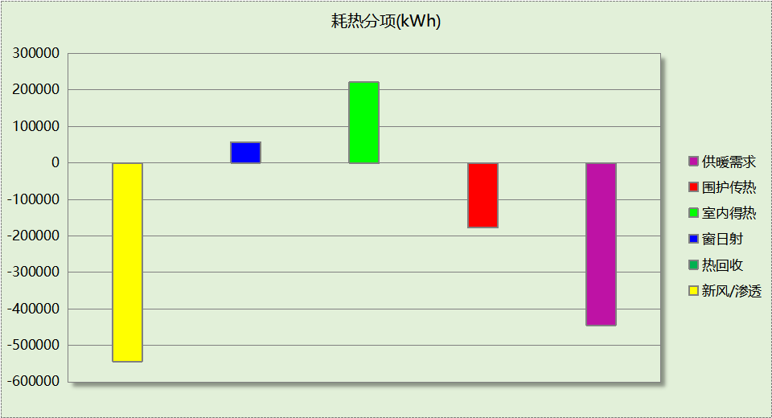

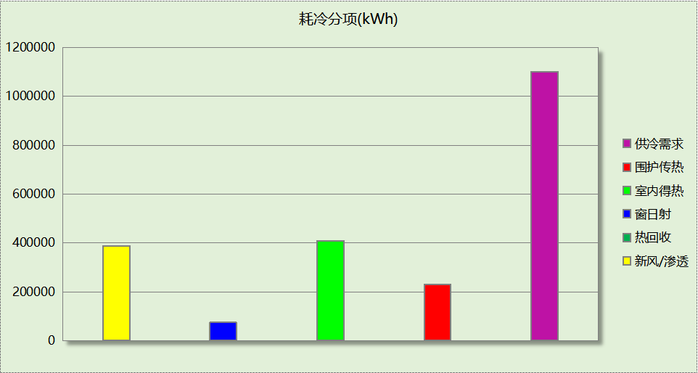

## 逐月负荷表

|  |  |  |  |  |  |  |
| --- | --- | --- | --- | --- | --- | --- |
| 月份 | 供暖(kWh) | 供冷(kWh) | 热负荷 峰值(kW) | 热负荷 峰值时刻 | 冷负荷 峰值(kW) | 冷负荷 峰值时刻 |
| 1月 | 208214 | 0 | 1984.903 | 1月14日9时 | 0.000 | -- |
| 2月 | 67447 | 0 | 1233.343 | 2月4日9时 | 0.000 | -- |
| 3月 | 0 | 0 | 0.000 | -- | 0.000 | -- |
| 4月 | 0 | 0 | 0.000 | -- | 0.000 | -- |
| 5月 | 0 | 0 | 0.000 | -- | 0.000 | -- |
| 6月 | 0 | 193257 | 0.000 | -- | 2430.233 | 6月28日16时 |
| 7月 | 0 | 485768 | 0.000 | -- | 2674.492 | 7月29日16时 |
| 8月 | 0 | 422480 | 0.000 | -- | 3256.313 | 8月2日16时 |
| 9月 | 0 | 0 | 0.000 | -- | 0.000 | -- |
| 10月 | 0 | 0 | 0.000 | -- | 0.000 | -- |
| 11月 | 0 | 0 | 0.000 | -- | 0.000 | -- |
| 12月 | 169414 | 0 | 1510.424 | 12月30日9时 | 0.000 | -- |

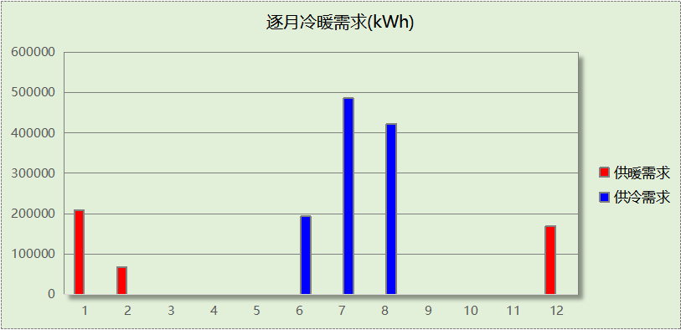

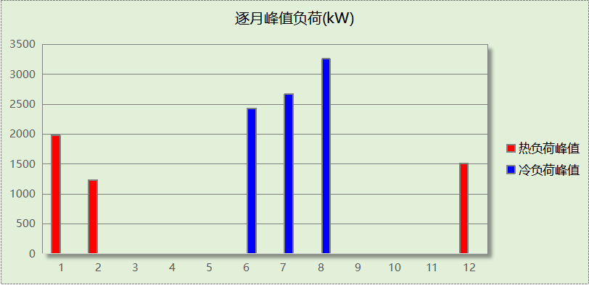

## 逐月电耗

注:供冷供暖为冷热源及输配水泵电耗，热水为扣减太阳能后电耗，所有数据单位kWh/㎡。

|  |  |  |  |  |  |  |  |  |
| --- | --- | --- | --- | --- | --- | --- | --- | --- |
| 月 | 供冷 | 供暖 | 空调风机 | 照明 | 插座设备 | 排风机 | 电梯 | 热水 |
| 1 | 0.00 | 4.02 | 0.66 | 1.43 | 1.94 | 0.00 | 0.00 | 0.00 |
| 2 | 0.00 | 1.30 | 0.51 | 1.11 | 1.53 |
| 3 | 0.00 | 0.00 | 0.00 | 1.37 | 1.86 |
| 4 | 0.00 | 0.00 | 0.00 | 1.36 | 1.86 |
| 5 | 0.00 | 0.00 | 0.00 | 1.43 | 1.94 |
| 6 | 2.74 | 0.00 | 0.33 | 1.24 | 1.70 |
| 7 | 6.43 | 0.00 | 0.68 | 1.49 | 2.02 |
| 8 | 5.79 | 0.00 | 0.66 | 1.43 | 1.94 |
| 9 | 0.00 | 0.00 | 0.00 | 1.30 | 1.78 |
| 10 | 0.00 | 0.00 | 0.00 | 1.30 | 1.78 |
| 11 | 0.00 | 0.00 | 0.00 | 1.36 | 1.86 |
| 12 | 0.00 | 3.27 | 0.66 | 1.43 | 1.94 |
| 合计 | 14.96 | 8.60 | 3.48 | 16.24 | 22.17 | 0.00 | 0.00 | 0.00 |

## 全年能耗

|  |  |  |  |
| --- | --- | --- | --- |
| 能耗分类 | 能耗子类 | 设计建筑  (kWh/㎡) | 备注 |
| 建筑负荷 | 耗冷量 | 56.72 |  |
| 耗热量 | 22.92 |  |
| 冷热合计 | 79.64 |  |
| 热回收 | 供冷 | 0.00 |  |
| 供暖 | 0.00 |  |
| 冷热合计 | 0.00 |  |
| 供冷电耗  (Ec) | 中央冷源 | 9.30 |  |
| 冷却水泵 | 2.57 |  |
| 冷冻水泵 | 2.49 |  |
| 冷却塔 | 0.61 |  |
| 多联机/单元式空调 | 0.00 |  |
| 供冷合计 | 14.96 |  |
| 供暖电耗  (Eh) | 中央热源 | 8.50 |  |
| 供暖水泵 | 0.10 |  |
| 热源侧水泵 | 0.00 |  |
| 多联机/单元式热泵 | 0.00 |  |
| 供暖合计 | 8.60 |  |
| 空调风机电耗  (Ef) | 新排风 | 3.46 |  |
| 风机盘管 | 0.03 |  |
| 全空气系统 | 0.00 |  |
| 风机合计 | 3.48 |  |
| 照明电耗(El) | | 16.24 |  |
| 插座设备电耗(Ej) | | 22.17 |  |
| 其他电耗(Eo) | 电梯 | 0.00 |  |
| 独立排风机 | 0.00 |  |
| 生活热水 | 0.00 | 扣减了太阳能热水 |
| 其他设备 | 0.00 |  |
| 其他合计 | 0.00 |  |
| 可再生发电  (Er) | 光伏发电(Ep) | 15.31 |  |
| 风力发电(Ew) | 0.00 |  |
| 合计 | 15.31 |  |
| 建筑总能耗(E1)：电耗(kWh/㎡) | | 50.15 | E1=Ec+Eh+Ef+El +Ej +Eo-Er |

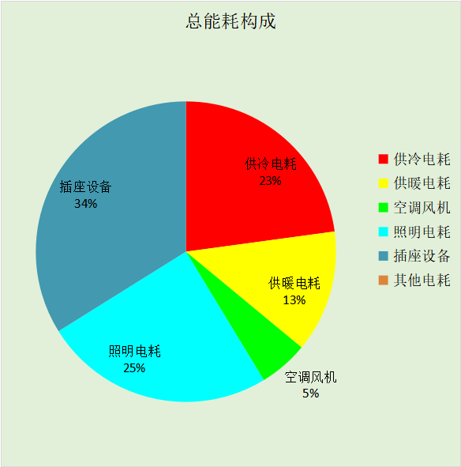

# 附录

## 工作日/节假日人员逐时在室率(%)

|  |  |  |  |  |  |  |  |  |  |  |  |  |  |  |  |  |  |  |  |  |  |  |  |  |
| --- | --- | --- | --- | --- | --- | --- | --- | --- | --- | --- | --- | --- | --- | --- | --- | --- | --- | --- | --- | --- | --- | --- | --- | --- |
| 房间类型 | 1 | 2 | 3 | 4 | 5 | 6 | 7 | 8 | 9 | 10 | 11 | 12 | 13 | 14 | 15 | 16 | 17 | 18 | 19 | 20 | 21 | 22 | 23 | 24 |
| 书库 | 0 | 0 | 0 | 0 | 0 | 0 | 10 | 50 | 100 | 100 | 100 | 30 | 100 | 100 | 100 | 100 | 50 | 20 | 10 | 0 | 0 | 0 | 0 | 0 |
| 0 | 0 | 0 | 0 | 0 | 0 | 0 | 20 | 45 | 0 | 0 | 0 | 0 | 0 | 0 | 0 | 0 | 0 | 0 | 0 | 0 | 0 | 0 | 0 |
| 休息室 | 0 | 0 | 0 | 0 | 0 | 0 | 10 | 50 | 95 | 95 | 95 | 80 | 80 | 95 | 95 | 95 | 95 | 30 | 30 | 0 | 0 | 0 | 0 | 0 |
| 0 | 0 | 0 | 0 | 0 | 0 | 0 | 0 | 0 | 0 | 0 | 0 | 0 | 0 | 0 | 0 | 0 | 0 | 0 | 0 | 0 | 0 | 0 | 0 |
| 办公-普通办公室 | 0 | 0 | 0 | 0 | 0 | 0 | 10 | 50 | 100 | 100 | 100 | 30 | 100 | 100 | 100 | 100 | 50 | 20 | 10 | 0 | 0 | 0 | 0 | 0 |
| 0 | 0 | 0 | 0 | 0 | 0 | 0 | 20 | 45 | 0 | 0 | 0 | 0 | 0 | 0 | 0 | 0 | 0 | 0 | 0 | 0 | 0 | 0 | 0 |
| 卫生间 | 0 | 0 | 0 | 0 | 0 | 0 | 10 | 50 | 95 | 95 | 95 | 80 | 80 | 95 | 95 | 95 | 95 | 30 | 30 | 0 | 0 | 0 | 0 | 0 |
| 0 | 0 | 0 | 0 | 0 | 0 | 0 | 0 | 0 | 0 | 0 | 0 | 0 | 0 | 0 | 0 | 0 | 0 | 0 | 0 | 0 | 0 | 0 | 0 |
| 多媒体区 | 0 | 0 | 0 | 0 | 0 | 0 | 10 | 50 | 100 | 100 | 100 | 30 | 100 | 100 | 100 | 100 | 50 | 20 | 10 | 0 | 0 | 0 | 0 | 0 |
| 0 | 0 | 0 | 0 | 0 | 0 | 0 | 20 | 45 | 0 | 0 | 0 | 0 | 0 | 0 | 0 | 0 | 0 | 0 | 0 | 0 | 0 | 0 | 0 |
| 大厅 | 0 | 0 | 0 | 0 | 0 | 0 | 10 | 50 | 95 | 95 | 95 | 80 | 80 | 95 | 95 | 95 | 95 | 30 | 30 | 0 | 0 | 0 | 0 | 0 |
| 0 | 0 | 0 | 0 | 0 | 0 | 0 | 0 | 0 | 0 | 0 | 0 | 0 | 0 | 0 | 0 | 0 | 0 | 0 | 0 | 0 | 0 | 0 | 0 |
| 实验教室 | 0 | 0 | 0 | 0 | 0 | 0 | 10 | 50 | 95 | 95 | 95 | 80 | 80 | 95 | 95 | 95 | 95 | 30 | 30 | 0 | 0 | 0 | 0 | 0 |
| 0 | 0 | 0 | 0 | 0 | 0 | 0 | 0 | 0 | 0 | 0 | 0 | 0 | 0 | 0 | 0 | 0 | 0 | 0 | 0 | 0 | 0 | 0 | 0 |
| 布草间 | 70 | 70 | 70 | 70 | 70 | 70 | 70 | 70 | 50 | 50 | 50 | 50 | 50 | 50 | 50 | 50 | 50 | 50 | 70 | 70 | 70 | 70 | 70 | 70 |
| 70 | 70 | 70 | 70 | 70 | 70 | 70 | 70 | 50 | 50 | 50 | 50 | 50 | 50 | 50 | 50 | 50 | 50 | 70 | 70 | 70 | 70 | 70 | 70 |
| 开架书库 | 0 | 0 | 0 | 0 | 0 | 0 | 10 | 50 | 100 | 100 | 100 | 30 | 100 | 100 | 100 | 100 | 50 | 20 | 10 | 0 | 0 | 0 | 0 | 0 |
| 0 | 0 | 0 | 0 | 0 | 0 | 0 | 20 | 45 | 0 | 0 | 0 | 0 | 0 | 0 | 0 | 0 | 0 | 0 | 0 | 0 | 0 | 0 | 0 |
| 文物修复室 | 0 | 0 | 0 | 0 | 0 | 0 | 10 | 50 | 100 | 100 | 100 | 30 | 100 | 100 | 100 | 100 | 50 | 20 | 10 | 0 | 0 | 0 | 0 | 0 |
| 0 | 0 | 0 | 0 | 0 | 0 | 0 | 20 | 45 | 0 | 0 | 0 | 0 | 0 | 0 | 0 | 0 | 0 | 0 | 0 | 0 | 0 | 0 | 0 |
| 普通办公室 | 0 | 0 | 0 | 0 | 0 | 0 | 10 | 50 | 95 | 95 | 95 | 80 | 80 | 95 | 95 | 95 | 95 | 30 | 30 | 0 | 0 | 0 | 0 | 0 |
| 0 | 0 | 0 | 0 | 0 | 0 | 0 | 0 | 0 | 0 | 0 | 0 | 0 | 0 | 0 | 0 | 0 | 0 | 0 | 0 | 0 | 0 | 0 | 0 |
| 普通办公室 | 0 | 0 | 0 | 0 | 0 | 0 | 10 | 50 | 100 | 100 | 100 | 30 | 100 | 100 | 100 | 100 | 50 | 20 | 10 | 0 | 0 | 0 | 0 | 0 |
| 0 | 0 | 0 | 0 | 0 | 0 | 0 | 20 | 45 | 0 | 0 | 0 | 0 | 0 | 0 | 0 | 0 | 0 | 0 | 0 | 0 | 0 | 0 | 0 |
| 普通教室 | 0 | 0 | 0 | 0 | 0 | 0 | 10 | 50 | 95 | 95 | 95 | 80 | 80 | 95 | 95 | 95 | 95 | 30 | 30 | 0 | 0 | 0 | 0 | 0 |
| 0 | 0 | 0 | 0 | 0 | 0 | 0 | 0 | 0 | 0 | 0 | 0 | 0 | 0 | 0 | 0 | 0 | 0 | 0 | 0 | 0 | 0 | 0 | 0 |
| 楼梯间 | 0 | 0 | 0 | 0 | 0 | 0 | 10 | 50 | 95 | 95 | 95 | 80 | 80 | 95 | 95 | 95 | 95 | 30 | 30 | 0 | 0 | 0 | 0 | 0 |
| 0 | 0 | 0 | 0 | 0 | 0 | 0 | 0 | 0 | 0 | 0 | 0 | 0 | 0 | 0 | 0 | 0 | 0 | 0 | 0 | 0 | 0 | 0 | 0 |
| 楼梯间 | 0 | 0 | 0 | 0 | 0 | 0 | 10 | 50 | 100 | 100 | 100 | 30 | 100 | 100 | 100 | 100 | 50 | 20 | 10 | 0 | 0 | 0 | 0 | 0 |
| 0 | 0 | 0 | 0 | 0 | 0 | 0 | 20 | 45 | 0 | 0 | 0 | 0 | 0 | 0 | 0 | 0 | 0 | 0 | 0 | 0 | 0 | 0 | 0 |
| 楼梯间 | 0 | 0 | 0 | 0 | 0 | 0 | 10 | 50 | 100 | 100 | 100 | 30 | 100 | 100 | 100 | 100 | 50 | 20 | 10 | 0 | 0 | 0 | 0 | 0 |
| 0 | 0 | 0 | 0 | 0 | 0 | 0 | 20 | 45 | 0 | 0 | 0 | 0 | 0 | 0 | 0 | 0 | 0 | 0 | 0 | 0 | 0 | 0 | 0 |
| 楼梯间 | 0 | 0 | 0 | 0 | 0 | 0 | 0 | 20 | 50 | 80 | 80 | 80 | 80 | 80 | 80 | 80 | 80 | 80 | 80 | 70 | 50 | 0 | 0 | 0 |
| 0 | 0 | 0 | 0 | 0 | 0 | 0 | 0 | 0 | 0 | 0 | 0 | 0 | 0 | 0 | 0 | 0 | 0 | 0 | 0 | 0 | 0 | 0 | 0 |
| 空房间 | 0 | 0 | 0 | 0 | 0 | 0 | 0 | 20 | 50 | 80 | 80 | 80 | 80 | 80 | 80 | 80 | 80 | 80 | 80 | 70 | 50 | 0 | 0 | 0 |
| 0 | 0 | 0 | 0 | 0 | 0 | 0 | 0 | 0 | 0 | 0 | 0 | 0 | 0 | 0 | 0 | 0 | 0 | 0 | 0 | 0 | 0 | 0 | 0 |
| 设备间 | 0 | 0 | 0 | 0 | 0 | 0 | 0 | 0 | 0 | 0 | 0 | 0 | 0 | 0 | 0 | 0 | 0 | 0 | 0 | 0 | 0 | 0 | 0 | 0 |
| 0 | 0 | 0 | 0 | 0 | 0 | 0 | 0 | 0 | 0 | 0 | 0 | 0 | 0 | 0 | 0 | 0 | 0 | 0 | 0 | 0 | 0 | 0 | 0 |
| 设备间 | 0 | 0 | 0 | 0 | 0 | 0 | 0 | 0 | 0 | 0 | 0 | 0 | 0 | 0 | 0 | 0 | 0 | 0 | 0 | 0 | 0 | 0 | 0 | 0 |
| 0 | 0 | 0 | 0 | 0 | 0 | 0 | 0 | 0 | 0 | 0 | 0 | 0 | 0 | 0 | 0 | 0 | 0 | 0 | 0 | 0 | 0 | 0 | 0 |
| 走廊 | 0 | 0 | 0 | 0 | 0 | 0 | 10 | 50 | 100 | 100 | 100 | 30 | 100 | 100 | 100 | 100 | 50 | 20 | 10 | 0 | 0 | 0 | 0 | 0 |
| 0 | 0 | 0 | 0 | 0 | 0 | 0 | 20 | 45 | 0 | 0 | 0 | 0 | 0 | 0 | 0 | 0 | 0 | 0 | 0 | 0 | 0 | 0 | 0 |
| 走廊 | 0 | 0 | 0 | 0 | 0 | 0 | 10 | 50 | 95 | 95 | 95 | 80 | 80 | 95 | 95 | 95 | 95 | 30 | 30 | 0 | 0 | 0 | 0 | 0 |
| 0 | 0 | 0 | 0 | 0 | 0 | 0 | 0 | 0 | 0 | 0 | 0 | 0 | 0 | 0 | 0 | 0 | 0 | 0 | 0 | 0 | 0 | 0 | 0 |
| 走廊 | 0 | 0 | 0 | 0 | 0 | 0 | 10 | 50 | 100 | 100 | 100 | 30 | 100 | 100 | 100 | 100 | 50 | 20 | 10 | 0 | 0 | 0 | 0 | 0 |
| 0 | 0 | 0 | 0 | 0 | 0 | 0 | 20 | 45 | 0 | 0 | 0 | 0 | 0 | 0 | 0 | 0 | 0 | 0 | 0 | 0 | 0 | 0 | 0 |
| 走廊 | 70 | 70 | 70 | 70 | 70 | 70 | 70 | 70 | 50 | 50 | 50 | 50 | 50 | 50 | 50 | 50 | 50 | 50 | 70 | 70 | 70 | 70 | 70 | 70 |
| 70 | 70 | 70 | 70 | 70 | 70 | 70 | 70 | 50 | 50 | 50 | 50 | 50 | 50 | 50 | 50 | 50 | 50 | 70 | 70 | 70 | 70 | 70 | 70 |
| 酒吧、茶座 | 70 | 70 | 70 | 70 | 70 | 70 | 70 | 70 | 50 | 50 | 50 | 50 | 50 | 50 | 50 | 50 | 50 | 50 | 70 | 70 | 70 | 70 | 70 | 70 |
| 70 | 70 | 70 | 70 | 70 | 70 | 70 | 70 | 50 | 50 | 50 | 50 | 50 | 50 | 50 | 50 | 50 | 50 | 70 | 70 | 70 | 70 | 70 | 70 |
| 阅览室 | 0 | 0 | 0 | 0 | 0 | 0 | 10 | 50 | 100 | 100 | 100 | 30 | 100 | 100 | 100 | 100 | 50 | 20 | 10 | 0 | 0 | 0 | 0 | 0 |
| 0 | 0 | 0 | 0 | 0 | 0 | 0 | 20 | 45 | 0 | 0 | 0 | 0 | 0 | 0 | 0 | 0 | 0 | 0 | 0 | 0 | 0 | 0 | 0 |
| 阅览室 | 0 | 0 | 0 | 0 | 0 | 0 | 10 | 50 | 95 | 95 | 95 | 80 | 80 | 95 | 95 | 95 | 95 | 30 | 30 | 0 | 0 | 0 | 0 | 0 |
| 0 | 0 | 0 | 0 | 0 | 0 | 0 | 0 | 0 | 0 | 0 | 0 | 0 | 0 | 0 | 0 | 0 | 0 | 0 | 0 | 0 | 0 | 0 | 0 |

注：上行：工作日；下行：节假日

## 工作日/节假日照明开关时间表(%)

|  |  |  |  |  |  |  |  |  |  |  |  |  |  |  |  |  |  |  |  |  |  |  |  |  |
| --- | --- | --- | --- | --- | --- | --- | --- | --- | --- | --- | --- | --- | --- | --- | --- | --- | --- | --- | --- | --- | --- | --- | --- | --- |
| 房间类型 | 1 | 2 | 3 | 4 | 5 | 6 | 7 | 8 | 9 | 10 | 11 | 12 | 13 | 14 | 15 | 16 | 17 | 18 | 19 | 20 | 21 | 22 | 23 | 24 |
| 书库 | 10 | 10 | 10 | 10 | 10 | 10 | 10 | 36 | 62 | 56 | 54 | 43 | 53 | 55 | 58 | 67 | 40 | 18 | 10 | 10 | 10 | 10 | 10 | 10 |
| 0 | 0 | 0 | 0 | 0 | 0 | 0 | 0 | 0 | 0 | 0 | 0 | 0 | 0 | 0 | 0 | 0 | 0 | 0 | 0 | 0 | 0 | 0 | 0 |
| 休息室 | 0 | 0 | 0 | 0 | 0 | 0 | 10 | 50 | 95 | 95 | 95 | 80 | 80 | 95 | 95 | 95 | 95 | 30 | 30 | 0 | 0 | 0 | 0 | 0 |
| 0 | 0 | 0 | 0 | 0 | 0 | 0 | 0 | 0 | 0 | 0 | 0 | 0 | 0 | 0 | 0 | 0 | 0 | 0 | 0 | 0 | 0 | 0 | 0 |
| 办公-普通办公室 | 10 | 10 | 10 | 10 | 10 | 10 | 10 | 36 | 62 | 56 | 54 | 43 | 53 | 55 | 58 | 67 | 40 | 18 | 10 | 10 | 10 | 10 | 10 | 10 |
| 0 | 0 | 0 | 0 | 0 | 0 | 0 | 0 | 0 | 0 | 0 | 0 | 0 | 0 | 0 | 0 | 0 | 0 | 0 | 0 | 0 | 0 | 0 | 0 |
| 卫生间 | 0 | 0 | 0 | 0 | 0 | 0 | 10 | 50 | 95 | 95 | 95 | 80 | 80 | 95 | 95 | 95 | 95 | 30 | 30 | 0 | 0 | 0 | 0 | 0 |
| 0 | 0 | 0 | 0 | 0 | 0 | 0 | 0 | 0 | 0 | 0 | 0 | 0 | 0 | 0 | 0 | 0 | 0 | 0 | 0 | 0 | 0 | 0 | 0 |
| 多媒体区 | 10 | 10 | 10 | 10 | 10 | 10 | 10 | 36 | 62 | 56 | 54 | 43 | 53 | 55 | 58 | 67 | 40 | 18 | 10 | 10 | 10 | 10 | 10 | 10 |
| 0 | 0 | 0 | 0 | 0 | 0 | 0 | 0 | 0 | 0 | 0 | 0 | 0 | 0 | 0 | 0 | 0 | 0 | 0 | 0 | 0 | 0 | 0 | 0 |
| 大厅 | 0 | 0 | 0 | 0 | 0 | 0 | 10 | 50 | 95 | 95 | 95 | 80 | 80 | 95 | 95 | 95 | 95 | 30 | 30 | 0 | 0 | 0 | 0 | 0 |
| 0 | 0 | 0 | 0 | 0 | 0 | 0 | 0 | 0 | 0 | 0 | 0 | 0 | 0 | 0 | 0 | 0 | 0 | 0 | 0 | 0 | 0 | 0 | 0 |
| 实验教室 | 0 | 0 | 0 | 0 | 0 | 0 | 10 | 50 | 95 | 95 | 95 | 80 | 80 | 95 | 95 | 95 | 95 | 30 | 30 | 0 | 0 | 0 | 0 | 0 |
| 0 | 0 | 0 | 0 | 0 | 0 | 0 | 0 | 0 | 0 | 0 | 0 | 0 | 0 | 0 | 0 | 0 | 0 | 0 | 0 | 0 | 0 | 0 | 0 |
| 布草间 | 10 | 10 | 10 | 10 | 10 | 10 | 30 | 30 | 30 | 30 | 30 | 30 | 30 | 30 | 50 | 50 | 60 | 90 | 90 | 90 | 90 | 80 | 10 | 10 |
| 10 | 10 | 10 | 10 | 10 | 10 | 30 | 30 | 30 | 30 | 30 | 30 | 30 | 30 | 50 | 50 | 60 | 90 | 90 | 90 | 90 | 80 | 10 | 10 |
| 开架书库 | 10 | 10 | 10 | 10 | 10 | 10 | 10 | 36 | 62 | 56 | 54 | 43 | 53 | 55 | 58 | 67 | 40 | 18 | 10 | 10 | 10 | 10 | 10 | 10 |
| 0 | 0 | 0 | 0 | 0 | 0 | 0 | 0 | 0 | 0 | 0 | 0 | 0 | 0 | 0 | 0 | 0 | 0 | 0 | 0 | 0 | 0 | 0 | 0 |
| 文物修复室 | 10 | 10 | 10 | 10 | 10 | 10 | 10 | 36 | 62 | 56 | 54 | 43 | 53 | 55 | 58 | 67 | 40 | 18 | 10 | 10 | 10 | 10 | 10 | 10 |
| 0 | 0 | 0 | 0 | 0 | 0 | 0 | 0 | 0 | 0 | 0 | 0 | 0 | 0 | 0 | 0 | 0 | 0 | 0 | 0 | 0 | 0 | 0 | 0 |
| 普通办公室 | 0 | 0 | 0 | 0 | 0 | 0 | 10 | 50 | 95 | 95 | 95 | 80 | 80 | 95 | 95 | 95 | 95 | 30 | 30 | 0 | 0 | 0 | 0 | 0 |
| 0 | 0 | 0 | 0 | 0 | 0 | 0 | 0 | 0 | 0 | 0 | 0 | 0 | 0 | 0 | 0 | 0 | 0 | 0 | 0 | 0 | 0 | 0 | 0 |
| 普通办公室 | 10 | 10 | 10 | 10 | 10 | 10 | 10 | 36 | 62 | 56 | 54 | 43 | 53 | 55 | 58 | 67 | 40 | 18 | 10 | 10 | 10 | 10 | 10 | 10 |
| 0 | 0 | 0 | 0 | 0 | 0 | 0 | 0 | 0 | 0 | 0 | 0 | 0 | 0 | 0 | 0 | 0 | 0 | 0 | 0 | 0 | 0 | 0 | 0 |
| 普通教室 | 0 | 0 | 0 | 0 | 0 | 0 | 10 | 50 | 95 | 95 | 95 | 80 | 80 | 95 | 95 | 95 | 95 | 30 | 30 | 0 | 0 | 0 | 0 | 0 |
| 0 | 0 | 0 | 0 | 0 | 0 | 0 | 0 | 0 | 0 | 0 | 0 | 0 | 0 | 0 | 0 | 0 | 0 | 0 | 0 | 0 | 0 | 0 | 0 |
| 楼梯间 | 0 | 0 | 0 | 0 | 0 | 0 | 10 | 50 | 95 | 95 | 95 | 80 | 80 | 95 | 95 | 95 | 95 | 30 | 30 | 0 | 0 | 0 | 0 | 0 |
| 0 | 0 | 0 | 0 | 0 | 0 | 0 | 0 | 0 | 0 | 0 | 0 | 0 | 0 | 0 | 0 | 0 | 0 | 0 | 0 | 0 | 0 | 0 | 0 |
| 楼梯间 | 10 | 10 | 10 | 10 | 10 | 10 | 10 | 36 | 62 | 56 | 54 | 43 | 53 | 55 | 58 | 67 | 40 | 18 | 10 | 10 | 10 | 10 | 10 | 10 |
| 0 | 0 | 0 | 0 | 0 | 0 | 0 | 0 | 0 | 0 | 0 | 0 | 0 | 0 | 0 | 0 | 0 | 0 | 0 | 0 | 0 | 0 | 0 | 0 |
| 楼梯间 | 10 | 10 | 10 | 10 | 10 | 10 | 10 | 36 | 62 | 56 | 54 | 43 | 53 | 55 | 58 | 67 | 40 | 18 | 10 | 10 | 10 | 10 | 10 | 10 |
| 0 | 0 | 0 | 0 | 0 | 0 | 0 | 0 | 0 | 0 | 0 | 0 | 0 | 0 | 0 | 0 | 0 | 0 | 0 | 0 | 0 | 0 | 0 | 0 |
| 楼梯间 | 10 | 10 | 10 | 10 | 10 | 10 | 10 | 50 | 60 | 60 | 60 | 60 | 60 | 60 | 60 | 60 | 80 | 90 | 100 | 100 | 100 | 10 | 10 | 10 |
| 0 | 0 | 0 | 0 | 0 | 0 | 0 | 0 | 0 | 0 | 0 | 0 | 0 | 0 | 0 | 0 | 0 | 0 | 0 | 0 | 0 | 0 | 0 | 0 |
| 空房间 | 10 | 10 | 10 | 10 | 10 | 10 | 10 | 50 | 60 | 60 | 60 | 60 | 60 | 60 | 60 | 60 | 80 | 90 | 100 | 100 | 100 | 10 | 10 | 10 |
| 0 | 0 | 0 | 0 | 0 | 0 | 0 | 0 | 0 | 0 | 0 | 0 | 0 | 0 | 0 | 0 | 0 | 0 | 0 | 0 | 0 | 0 | 0 | 0 |
| 设备间 | 100 | 100 | 100 | 100 | 100 | 100 | 100 | 100 | 100 | 100 | 100 | 100 | 100 | 100 | 100 | 100 | 100 | 100 | 100 | 100 | 100 | 100 | 100 | 100 |
| 100 | 100 | 100 | 100 | 100 | 100 | 100 | 100 | 100 | 100 | 100 | 100 | 100 | 100 | 100 | 100 | 100 | 100 | 100 | 100 | 100 | 100 | 100 | 100 |
| 设备间 | 100 | 100 | 100 | 100 | 100 | 100 | 100 | 100 | 100 | 100 | 100 | 100 | 100 | 100 | 100 | 100 | 100 | 100 | 100 | 100 | 100 | 100 | 100 | 100 |
| 0 | 0 | 0 | 0 | 0 | 0 | 0 | 0 | 0 | 0 | 0 | 0 | 0 | 0 | 0 | 0 | 0 | 0 | 0 | 0 | 0 | 0 | 0 | 0 |
| 走廊 | 10 | 10 | 10 | 10 | 10 | 10 | 10 | 36 | 62 | 56 | 54 | 43 | 53 | 55 | 58 | 67 | 40 | 18 | 10 | 10 | 10 | 10 | 10 | 10 |
| 0 | 0 | 0 | 0 | 0 | 0 | 0 | 0 | 0 | 0 | 0 | 0 | 0 | 0 | 0 | 0 | 0 | 0 | 0 | 0 | 0 | 0 | 0 | 0 |
| 走廊 | 0 | 0 | 0 | 0 | 0 | 0 | 10 | 50 | 95 | 95 | 95 | 80 | 80 | 95 | 95 | 95 | 95 | 30 | 30 | 0 | 0 | 0 | 0 | 0 |
| 0 | 0 | 0 | 0 | 0 | 0 | 0 | 0 | 0 | 0 | 0 | 0 | 0 | 0 | 0 | 0 | 0 | 0 | 0 | 0 | 0 | 0 | 0 | 0 |
| 走廊 | 10 | 10 | 10 | 10 | 10 | 10 | 10 | 36 | 62 | 56 | 54 | 43 | 53 | 55 | 58 | 67 | 40 | 18 | 10 | 10 | 10 | 10 | 10 | 10 |
| 0 | 0 | 0 | 0 | 0 | 0 | 0 | 0 | 0 | 0 | 0 | 0 | 0 | 0 | 0 | 0 | 0 | 0 | 0 | 0 | 0 | 0 | 0 | 0 |
| 走廊 | 10 | 10 | 10 | 10 | 10 | 10 | 30 | 30 | 30 | 30 | 30 | 30 | 30 | 30 | 50 | 50 | 60 | 90 | 90 | 90 | 90 | 80 | 10 | 10 |
| 10 | 10 | 10 | 10 | 10 | 10 | 30 | 30 | 30 | 30 | 30 | 30 | 30 | 30 | 50 | 50 | 60 | 90 | 90 | 90 | 90 | 80 | 10 | 10 |
| 酒吧、茶座 | 10 | 10 | 10 | 10 | 10 | 10 | 30 | 30 | 30 | 30 | 30 | 30 | 30 | 30 | 50 | 50 | 60 | 90 | 90 | 90 | 90 | 80 | 10 | 10 |
| 10 | 10 | 10 | 10 | 10 | 10 | 30 | 30 | 30 | 30 | 30 | 30 | 30 | 30 | 50 | 50 | 60 | 90 | 90 | 90 | 90 | 80 | 10 | 10 |
| 阅览室 | 10 | 10 | 10 | 10 | 10 | 10 | 10 | 36 | 62 | 56 | 54 | 43 | 53 | 55 | 58 | 67 | 40 | 18 | 10 | 10 | 10 | 10 | 10 | 10 |
| 0 | 0 | 0 | 0 | 0 | 0 | 0 | 0 | 0 | 0 | 0 | 0 | 0 | 0 | 0 | 0 | 0 | 0 | 0 | 0 | 0 | 0 | 0 | 0 |
| 阅览室 | 0 | 0 | 0 | 0 | 0 | 0 | 10 | 50 | 95 | 95 | 95 | 80 | 80 | 95 | 95 | 95 | 95 | 30 | 30 | 0 | 0 | 0 | 0 | 0 |
| 0 | 0 | 0 | 0 | 0 | 0 | 0 | 0 | 0 | 0 | 0 | 0 | 0 | 0 | 0 | 0 | 0 | 0 | 0 | 0 | 0 | 0 | 0 | 0 |

注：上行：工作日；下行：节假日

## 工作日/节假日设备逐时使用率(%)

|  |  |  |  |  |  |  |  |  |  |  |  |  |  |  |  |  |  |  |  |  |  |  |  |  |
| --- | --- | --- | --- | --- | --- | --- | --- | --- | --- | --- | --- | --- | --- | --- | --- | --- | --- | --- | --- | --- | --- | --- | --- | --- |
| 房间类型 | 1 | 2 | 3 | 4 | 5 | 6 | 7 | 8 | 9 | 10 | 11 | 12 | 13 | 14 | 15 | 16 | 17 | 18 | 19 | 20 | 21 | 22 | 23 | 24 |
| 书库 | 0 | 0 | 0 | 0 | 0 | 0 | 10 | 50 | 100 | 100 | 100 | 100 | 100 | 100 | 100 | 100 | 50 | 20 | 10 | 0 | 0 | 0 | 0 | 0 |
| 0 | 0 | 0 | 0 | 0 | 0 | 0 | 0 | 0 | 0 | 0 | 0 | 0 | 0 | 0 | 0 | 0 | 0 | 0 | 0 | 0 | 0 | 0 | 0 |
| 休息室 | 0 | 0 | 0 | 0 | 0 | 0 | 10 | 50 | 95 | 95 | 95 | 50 | 50 | 95 | 95 | 95 | 95 | 30 | 30 | 0 | 0 | 0 | 0 | 0 |
| 0 | 0 | 0 | 0 | 0 | 0 | 0 | 0 | 0 | 0 | 0 | 0 | 0 | 0 | 0 | 0 | 0 | 0 | 0 | 0 | 0 | 0 | 0 | 0 |
| 办公-普通办公室 | 0 | 0 | 0 | 0 | 0 | 0 | 10 | 50 | 100 | 100 | 100 | 100 | 100 | 100 | 100 | 100 | 50 | 20 | 10 | 0 | 0 | 0 | 0 | 0 |
| 0 | 0 | 0 | 0 | 0 | 0 | 0 | 0 | 0 | 0 | 0 | 0 | 0 | 0 | 0 | 0 | 0 | 0 | 0 | 0 | 0 | 0 | 0 | 0 |
| 卫生间 | 0 | 0 | 0 | 0 | 0 | 0 | 10 | 50 | 95 | 95 | 95 | 50 | 50 | 95 | 95 | 95 | 95 | 30 | 30 | 0 | 0 | 0 | 0 | 0 |
| 0 | 0 | 0 | 0 | 0 | 0 | 0 | 0 | 0 | 0 | 0 | 0 | 0 | 0 | 0 | 0 | 0 | 0 | 0 | 0 | 0 | 0 | 0 | 0 |
| 多媒体区 | 0 | 0 | 0 | 0 | 0 | 0 | 10 | 50 | 100 | 100 | 100 | 100 | 100 | 100 | 100 | 100 | 50 | 20 | 10 | 0 | 0 | 0 | 0 | 0 |
| 0 | 0 | 0 | 0 | 0 | 0 | 0 | 0 | 0 | 0 | 0 | 0 | 0 | 0 | 0 | 0 | 0 | 0 | 0 | 0 | 0 | 0 | 0 | 0 |
| 大厅 | 0 | 0 | 0 | 0 | 0 | 0 | 10 | 50 | 95 | 95 | 95 | 50 | 50 | 95 | 95 | 95 | 95 | 30 | 30 | 0 | 0 | 0 | 0 | 0 |
| 0 | 0 | 0 | 0 | 0 | 0 | 0 | 0 | 0 | 0 | 0 | 0 | 0 | 0 | 0 | 0 | 0 | 0 | 0 | 0 | 0 | 0 | 0 | 0 |
| 实验教室 | 0 | 0 | 0 | 0 | 0 | 0 | 10 | 50 | 95 | 95 | 95 | 50 | 50 | 95 | 95 | 95 | 95 | 30 | 30 | 0 | 0 | 0 | 0 | 0 |
| 0 | 0 | 0 | 0 | 0 | 0 | 0 | 0 | 0 | 0 | 0 | 0 | 0 | 0 | 0 | 0 | 0 | 0 | 0 | 0 | 0 | 0 | 0 | 0 |
| 布草间 | 0 | 0 | 0 | 0 | 0 | 0 | 0 | 0 | 0 | 0 | 0 | 0 | 0 | 0 | 0 | 0 | 0 | 80 | 80 | 80 | 80 | 80 | 0 | 0 |
| 0 | 0 | 0 | 0 | 0 | 0 | 0 | 0 | 0 | 0 | 0 | 0 | 0 | 0 | 0 | 0 | 0 | 80 | 80 | 80 | 80 | 80 | 0 | 0 |
| 开架书库 | 0 | 0 | 0 | 0 | 0 | 0 | 10 | 50 | 100 | 100 | 100 | 100 | 100 | 100 | 100 | 100 | 50 | 20 | 10 | 0 | 0 | 0 | 0 | 0 |
| 0 | 0 | 0 | 0 | 0 | 0 | 0 | 0 | 0 | 0 | 0 | 0 | 0 | 0 | 0 | 0 | 0 | 0 | 0 | 0 | 0 | 0 | 0 | 0 |
| 文物修复室 | 0 | 0 | 0 | 0 | 0 | 0 | 10 | 50 | 100 | 100 | 100 | 100 | 100 | 100 | 100 | 100 | 50 | 20 | 10 | 0 | 0 | 0 | 0 | 0 |
| 0 | 0 | 0 | 0 | 0 | 0 | 0 | 0 | 0 | 0 | 0 | 0 | 0 | 0 | 0 | 0 | 0 | 0 | 0 | 0 | 0 | 0 | 0 | 0 |
| 普通办公室 | 0 | 0 | 0 | 0 | 0 | 0 | 10 | 50 | 95 | 95 | 95 | 50 | 50 | 95 | 95 | 95 | 95 | 30 | 30 | 0 | 0 | 0 | 0 | 0 |
| 0 | 0 | 0 | 0 | 0 | 0 | 0 | 0 | 0 | 0 | 0 | 0 | 0 | 0 | 0 | 0 | 0 | 0 | 0 | 0 | 0 | 0 | 0 | 0 |
| 普通办公室 | 0 | 0 | 0 | 0 | 0 | 0 | 10 | 50 | 100 | 100 | 100 | 100 | 100 | 100 | 100 | 100 | 50 | 20 | 10 | 0 | 0 | 0 | 0 | 0 |
| 0 | 0 | 0 | 0 | 0 | 0 | 0 | 0 | 0 | 0 | 0 | 0 | 0 | 0 | 0 | 0 | 0 | 0 | 0 | 0 | 0 | 0 | 0 | 0 |
| 普通教室 | 0 | 0 | 0 | 0 | 0 | 0 | 10 | 50 | 95 | 95 | 95 | 50 | 50 | 95 | 95 | 95 | 95 | 30 | 30 | 0 | 0 | 0 | 0 | 0 |
| 0 | 0 | 0 | 0 | 0 | 0 | 0 | 0 | 0 | 0 | 0 | 0 | 0 | 0 | 0 | 0 | 0 | 0 | 0 | 0 | 0 | 0 | 0 | 0 |
| 楼梯间 | 0 | 0 | 0 | 0 | 0 | 0 | 10 | 50 | 95 | 95 | 95 | 50 | 50 | 95 | 95 | 95 | 95 | 30 | 30 | 0 | 0 | 0 | 0 | 0 |
| 0 | 0 | 0 | 0 | 0 | 0 | 0 | 0 | 0 | 0 | 0 | 0 | 0 | 0 | 0 | 0 | 0 | 0 | 0 | 0 | 0 | 0 | 0 | 0 |
| 楼梯间 | 0 | 0 | 0 | 0 | 0 | 0 | 10 | 50 | 100 | 100 | 100 | 100 | 100 | 100 | 100 | 100 | 50 | 20 | 10 | 0 | 0 | 0 | 0 | 0 |
| 0 | 0 | 0 | 0 | 0 | 0 | 0 | 0 | 0 | 0 | 0 | 0 | 0 | 0 | 0 | 0 | 0 | 0 | 0 | 0 | 0 | 0 | 0 | 0 |
| 楼梯间 | 0 | 0 | 0 | 0 | 0 | 0 | 10 | 50 | 100 | 100 | 100 | 100 | 100 | 100 | 100 | 100 | 50 | 20 | 10 | 0 | 0 | 0 | 0 | 0 |
| 0 | 0 | 0 | 0 | 0 | 0 | 0 | 0 | 0 | 0 | 0 | 0 | 0 | 0 | 0 | 0 | 0 | 0 | 0 | 0 | 0 | 0 | 0 | 0 |
| 楼梯间 | 0 | 0 | 0 | 0 | 0 | 0 | 0 | 30 | 50 | 80 | 80 | 80 | 80 | 80 | 80 | 80 | 80 | 80 | 80 | 70 | 50 | 0 | 0 | 0 |
| 0 | 0 | 0 | 0 | 0 | 0 | 0 | 0 | 0 | 0 | 0 | 0 | 0 | 0 | 0 | 0 | 0 | 0 | 0 | 0 | 0 | 0 | 0 | 0 |
| 空房间 | 0 | 0 | 0 | 0 | 0 | 0 | 0 | 30 | 50 | 80 | 80 | 80 | 80 | 80 | 80 | 80 | 80 | 80 | 80 | 70 | 50 | 0 | 0 | 0 |
| 0 | 0 | 0 | 0 | 0 | 0 | 0 | 0 | 0 | 0 | 0 | 0 | 0 | 0 | 0 | 0 | 0 | 0 | 0 | 0 | 0 | 0 | 0 | 0 |
| 设备间 | 100 | 100 | 100 | 100 | 100 | 100 | 100 | 100 | 100 | 100 | 100 | 100 | 100 | 100 | 100 | 100 | 100 | 100 | 100 | 100 | 100 | 100 | 100 | 100 |
| 100 | 100 | 100 | 100 | 100 | 100 | 100 | 100 | 100 | 100 | 100 | 100 | 100 | 100 | 100 | 100 | 100 | 100 | 100 | 100 | 100 | 100 | 100 | 100 |
| 设备间 | 100 | 100 | 100 | 100 | 100 | 100 | 100 | 100 | 100 | 100 | 100 | 100 | 100 | 100 | 100 | 100 | 100 | 100 | 100 | 100 | 100 | 100 | 100 | 100 |
| 0 | 0 | 0 | 0 | 0 | 0 | 0 | 0 | 0 | 0 | 0 | 0 | 0 | 0 | 0 | 0 | 0 | 0 | 0 | 0 | 0 | 0 | 0 | 0 |
| 走廊 | 0 | 0 | 0 | 0 | 0 | 0 | 10 | 50 | 100 | 100 | 100 | 100 | 100 | 100 | 100 | 100 | 50 | 20 | 10 | 0 | 0 | 0 | 0 | 0 |
| 0 | 0 | 0 | 0 | 0 | 0 | 0 | 0 | 0 | 0 | 0 | 0 | 0 | 0 | 0 | 0 | 0 | 0 | 0 | 0 | 0 | 0 | 0 | 0 |
| 走廊 | 0 | 0 | 0 | 0 | 0 | 0 | 10 | 50 | 95 | 95 | 95 | 50 | 50 | 95 | 95 | 95 | 95 | 30 | 30 | 0 | 0 | 0 | 0 | 0 |
| 0 | 0 | 0 | 0 | 0 | 0 | 0 | 0 | 0 | 0 | 0 | 0 | 0 | 0 | 0 | 0 | 0 | 0 | 0 | 0 | 0 | 0 | 0 | 0 |
| 走廊 | 0 | 0 | 0 | 0 | 0 | 0 | 10 | 50 | 100 | 100 | 100 | 100 | 100 | 100 | 100 | 100 | 50 | 20 | 10 | 0 | 0 | 0 | 0 | 0 |
| 0 | 0 | 0 | 0 | 0 | 0 | 0 | 0 | 0 | 0 | 0 | 0 | 0 | 0 | 0 | 0 | 0 | 0 | 0 | 0 | 0 | 0 | 0 | 0 |
| 走廊 | 0 | 0 | 0 | 0 | 0 | 0 | 0 | 0 | 0 | 0 | 0 | 0 | 0 | 0 | 0 | 0 | 0 | 80 | 80 | 80 | 80 | 80 | 0 | 0 |
| 0 | 0 | 0 | 0 | 0 | 0 | 0 | 0 | 0 | 0 | 0 | 0 | 0 | 0 | 0 | 0 | 0 | 80 | 80 | 80 | 80 | 80 | 0 | 0 |
| 酒吧、茶座 | 0 | 0 | 0 | 0 | 0 | 0 | 0 | 0 | 0 | 0 | 0 | 0 | 0 | 0 | 0 | 0 | 0 | 80 | 80 | 80 | 80 | 80 | 0 | 0 |
| 0 | 0 | 0 | 0 | 0 | 0 | 0 | 0 | 0 | 0 | 0 | 0 | 0 | 0 | 0 | 0 | 0 | 80 | 80 | 80 | 80 | 80 | 0 | 0 |
| 阅览室 | 0 | 0 | 0 | 0 | 0 | 0 | 10 | 50 | 100 | 100 | 100 | 100 | 100 | 100 | 100 | 100 | 50 | 20 | 10 | 0 | 0 | 0 | 0 | 0 |
| 0 | 0 | 0 | 0 | 0 | 0 | 0 | 0 | 0 | 0 | 0 | 0 | 0 | 0 | 0 | 0 | 0 | 0 | 0 | 0 | 0 | 0 | 0 | 0 |
| 阅览室 | 0 | 0 | 0 | 0 | 0 | 0 | 10 | 50 | 95 | 95 | 95 | 50 | 50 | 95 | 95 | 95 | 95 | 30 | 30 | 0 | 0 | 0 | 0 | 0 |
| 0 | 0 | 0 | 0 | 0 | 0 | 0 | 0 | 0 | 0 | 0 | 0 | 0 | 0 | 0 | 0 | 0 | 0 | 0 | 0 | 0 | 0 | 0 | 0 |

注：上行：工作日；下行：节假日

## 工作日/节假日空调系统运行时间表(1:开,0:关)

采暖期：

|  |  |  |  |  |  |  |  |  |  |  |  |  |  |  |  |  |  |  |  |  |  |  |  |  |
| --- | --- | --- | --- | --- | --- | --- | --- | --- | --- | --- | --- | --- | --- | --- | --- | --- | --- | --- | --- | --- | --- | --- | --- | --- |
| 系统编号 | 1 | 2 | 3 | 4 | 5 | 6 | 7 | 8 | 9 | 10 | 11 | 12 | 13 | 14 | 15 | 16 | 17 | 18 | 19 | 20 | 21 | 22 | 23 | 24 |
| 默认 | 0 | 0 | 0 | 0 | 0 | 0 | 0 | 1 | 1 | 1 | 1 | 1 | 1 | 1 | 1 | 1 | 1 | 1 | 0 | 0 | 0 | 0 | 0 | 0 |
| 0 | 0 | 0 | 0 | 0 | 0 | 0 | 0 | 0 | 0 | 0 | 0 | 0 | 0 | 0 | 0 | 0 | 0 | 0 | 0 | 0 | 0 | 0 | 0 |

供冷期：

|  |  |  |  |  |  |  |  |  |  |  |  |  |  |  |  |  |  |  |  |  |  |  |  |  |
| --- | --- | --- | --- | --- | --- | --- | --- | --- | --- | --- | --- | --- | --- | --- | --- | --- | --- | --- | --- | --- | --- | --- | --- | --- |
| 系统编号 | 1 | 2 | 3 | 4 | 5 | 6 | 7 | 8 | 9 | 10 | 11 | 12 | 13 | 14 | 15 | 16 | 17 | 18 | 19 | 20 | 21 | 22 | 23 | 24 |
| 默认 | 0 | 0 | 0 | 0 | 0 | 0 | 0 | 1 | 1 | 1 | 1 | 1 | 1 | 1 | 1 | 1 | 1 | 1 | 0 | 0 | 0 | 0 | 0 | 0 |
| 0 | 0 | 0 | 0 | 0 | 0 | 0 | 0 | 0 | 0 | 0 | 0 | 0 | 0 | 0 | 0 | 0 | 0 | 0 | 0 | 0 | 0 | 0 | 0 |

注：上行：工作日；下行：节假日

## 工作日/节假日新风运行时间表(%)

采暖期：

|  |  |  |  |  |  |  |  |  |  |  |  |  |  |  |  |  |  |  |  |  |  |  |  |  |
| --- | --- | --- | --- | --- | --- | --- | --- | --- | --- | --- | --- | --- | --- | --- | --- | --- | --- | --- | --- | --- | --- | --- | --- | --- |
| 系统编号 | 1 | 2 | 3 | 4 | 5 | 6 | 7 | 8 | 9 | 10 | 11 | 12 | 13 | 14 | 15 | 16 | 17 | 18 | 19 | 20 | 21 | 22 | 23 | 24 |
| 默认 | 0 | 0 | 0 | 0 | 0 | 0 | 0 | 100 | 100 | 100 | 100 | 100 | 100 | 100 | 100 | 100 | 100 | 100 | 0 | 0 | 0 | 0 | 0 | 0 |
| 0 | 0 | 0 | 0 | 0 | 0 | 0 | 0 | 0 | 0 | 0 | 0 | 0 | 0 | 0 | 0 | 0 | 0 | 0 | 0 | 0 | 0 | 0 | 0 |

供冷期：

|  |  |  |  |  |  |  |  |  |  |  |  |  |  |  |  |  |  |  |  |  |  |  |  |  |
| --- | --- | --- | --- | --- | --- | --- | --- | --- | --- | --- | --- | --- | --- | --- | --- | --- | --- | --- | --- | --- | --- | --- | --- | --- |
| 系统编号 | 1 | 2 | 3 | 4 | 5 | 6 | 7 | 8 | 9 | 10 | 11 | 12 | 13 | 14 | 15 | 16 | 17 | 18 | 19 | 20 | 21 | 22 | 23 | 24 |
| 默认 | 0 | 0 | 0 | 0 | 0 | 0 | 0 | 100 | 100 | 100 | 100 | 100 | 100 | 100 | 100 | 100 | 100 | 100 | 0 | 0 | 0 | 0 | 0 | 0 |
| 0 | 0 | 0 | 0 | 0 | 0 | 0 | 0 | 0 | 0 | 0 | 0 | 0 | 0 | 0 | 0 | 0 | 0 | 0 | 0 | 0 | 0 | 0 | 0 |

注：上行：工作日；下行：节假日