苏州某高校教学楼设计
全年负荷计算书

工程名称 | 苏州某高校教学楼设计
设计编号 | C
建设单位 | A
设计单位 | B
计 算 人
校 对 人
审 核 人
计算日期 | 2024年12月21日

采用软件 | 暖通负荷BECH2024
软件版本 | 20240430(SP1)
研发单位 | 北京绿建软件股份有限公司
正版授权码 | T18918990944
目 录

1 建筑概况 1
2 气象数据 1
2.1 气象地点 1
2.2 逐日干球温度表 1
2.3 逐月辐照量表 2
2.4 峰值工况 2
3 软件介绍 2
4 围护结构 2
4.1 屋顶构造 2
4.1.1 保温平屋面：挤塑聚苯板(XPS)+钢筋混凝土 2
4.2 外墙构造 3
4.2.1 外墙（填充墙）构造一 3
4.3 挑空楼板构造 3
4.3.1 挑空楼板构造：TD3-90钢筋桁架楼承板+岩棉板 3
4.4 楼板构造 3
4.4.1 控温房间楼板构造一：挤塑聚苯板(XPS)+钢筋混凝土 3
4.5 周边地面构造 4
4.5.1 地面构造一 4
4.6 非周边地面构造 4
4.6.1 地面构造一 4
4.7 门构造 4
4.8 窗构造 4
5 房间类型 5
5.1 房间参数表 5
5.2 作息时间表 5
6 系统设置 5
6.1 系统划分 5
6.2 运行时间表 6
7 计算结果 6
7.1 模拟周期 6
7.2 全年冷暖需求 7
7.3 负荷分项统计 7
7.4 逐月负荷表 8
8 附录 10

建筑概况
地理位置 | 江苏-苏州
气候分区 | 夏热冬冷A区
北纬 | 31.32
东经 | 120.62
建筑名称 | 苏州某高校教学楼设计
建筑类型 | 公共建筑
建筑面积 | 地上 10851.33 ㎡ | 地下 0.00 ㎡
建筑高度 | 地上 26.10 m | 地下0.00
建筑层数 | 地上 6 | 地下 0
北向角度 | 82°

气象数据

气象地点
江苏-东山, 《建筑节能气象参数标准》JGJ346-2014

逐日干球温度表
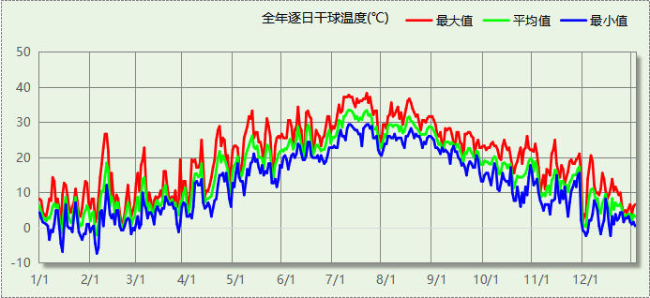

逐月辐照量表
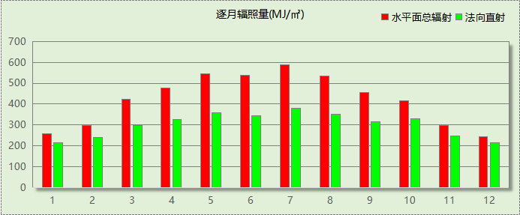

峰值工况
气象数据 | 时刻 | 干球温度(℃) | 湿球温度(℃) | 含湿量(g/kg) | 焓值(kj/kg)
最热 | 07月19日13时 | 38.3 | 26.7 | 18.0 | 84.8
最冷 | 02月04日06时 | -7.2 | -7.2 | 2.0 | -2.3

软件介绍
本报告采用的软件为绿建暖通负荷BECH2024，该软件紧密结合暖通和节能设计规范、可根据项目实际情况建立建筑热工模型，并可对围护结构材料、房间内扰发热、作息时间表、热回收方式等参数进行设置。
软件包含全国各地典型气象年数据，内置DOE2.1E内核，对于建筑的逐时负荷进行动态模拟，既可以模拟8760小时理想负荷，也可以根据设定好的采暖期/空调期进行逐时模拟。
软件还支持分析全年建筑能耗的来源构成，依据日射得热、新风负荷、围护传热和内扰得热进行归类分项，生成设计建筑全年负荷计算报告书，提供详实的数据和多样的图表，为设计师在设备选型、制定运行策略等方面提供参考和帮助。

围护结构

屋顶构造

保温平屋面：挤塑聚苯板(XPS)+钢筋混凝土
材料名称  （由上到下） | 厚度δ | 导热系数λ | 蓄热系数S | 修正  系数 | 热阻R | 热惰性  指标
材料名称  （由上到下） | (mm) | W/(m.K) | W/(㎡.K) | α | (㎡K)/W | D=R*S
细石混凝土 | 40 | 1.740 | 17.200 | 1.00 | 0.023 | 0.395
挤塑聚苯板(XPS) | 120 | 0.030 | 0.540 | 1.25 | 3.200 | 2.160
防水卷材 | 1 | － | － | － | － | －
陶粒混凝土找坡 | 30 | 0.890 | 10.360 | 1.50 | 0.022 | 0.349
钢筋混凝土 | 120 | 1.740 | 17.200 | 1.00 | 0.069 | 1.186
各层之和∑ | 311 | － | － | － | 3.314 | 4.091
传热系数K=1/(0.15+∑R) | 0.29

外墙构造

外墙（填充墙）构造一
材料名称  （由外到内） | 厚度δ | 导热系数λ | 蓄热系数S | 修正  系数 | 热阻R | 热惰性  指标
材料名称  （由外到内） | (mm) | W/(m.K) | W/(㎡.K) | α | (㎡K)/W | D=R*S
花岗岩、玄武岩 | 1 | 3.490 | 25.490 | 1.00 | 0.000 | 0.007
轻钢主龙骨+副龙骨 | 1 | － | － | － | － | －
锚固件固定 | 1 | － | － | － | － | －
高分子防水透气层 | 1 | － | － | － | － | －
岩棉板（夏热冬冷地区） | 30 | 0.040 | 0.700 | 1.20 | 0.625 | 0.525
防水砂浆 | 10 | 0.930 | 11.370 | 1.00 | 0.011 | 0.122
ALC外墙板 | 200 | 0.170 | 2.180 | 1.10 | 1.070 | 2.565
各层之和∑ | 244 | － | － | － | 1.706 | 3.219
传热系数K=1/(0.15+∑R) | 0.54

挑空楼板构造

挑空楼板构造：TD3-90钢筋桁架楼承板+岩棉板
材料名称  （由上到下） | 厚度δ | 导热系数λ | 蓄热系数S | 修正  系数 | 热阻R | 热惰性  指标
材料名称  （由上到下） | (mm) | W/(m.K) | W/(㎡.K) | α | (㎡K)/W | D=R*S
TD3-90钢筋桁架楼承板 | 120 | 1.740 | 17.200 | 1.00 | 0.069 | 1.186
胶粘剂 | 1 | － | － | － | － | －
岩棉板（夏热冬冷地区） | 60 | 0.040 | 0.700 | 1.20 | 1.250 | 1.050
抹面砂浆 | 10 | 0.930 | 11.306 | 1.00 | 0.011 | 0.122
各层之和∑ | 191 | － | － | － | 1.330 | 2.358
传热系数K=1/(0.15+∑R) | 0.68

楼板构造

控温房间楼板构造一：挤塑聚苯板(XPS)+钢筋混凝土
材料名称 | 厚度δ | 导热系数λ | 蓄热系数S | 修正  系数 | 热阻R | 热惰性  指标
材料名称 | (mm) | W/(m.K) | W/(㎡.K) | α | (㎡K)/W | D=R*S
饰面层 | 1 | － | － | － | － | －
细石混凝土（内配筋） | 40 | 1.740 | 17.200 | 1.00 | 0.023 | 0.395
挤塑聚苯板(XPS) | 10 | 0.030 | 0.540 | 1.25 | 0.267 | 0.180
钢筋混凝土 | 120 | 1.740 | 17.200 | 1.00 | 0.069 | 1.186
各层之和∑ | 171 | － | － | － | 0.359 | 1.762
传热系数K=1/(0.22+∑R) | 1.73

周边地面构造

地面构造一
材料名称 | 厚度δ | 导热系数λ | 蓄热系数S | 修正  系数 | 热阻R | 热惰性  指标
材料名称 | (mm) | W/(m.K) | W/(㎡.K) | α | (㎡K)/W | D=R*S
水泥砂浆 | 20 | 0.930 | 11.370 | 1.00 | 0.022 | 0.245
挤塑聚苯板(XPS) | 45 | 0.030 | 0.540 | 1.25 | 1.200 | 0.810
钢筋混凝土 | 120 | 1.740 | 17.200 | 1.00 | 0.069 | 1.186
各层之和∑ | 185 | － | － | － | 1.290 | 2.241
传热系数K=1/(0.11+∑R) | 0.32

非周边地面构造

地面构造一
材料名称 | 厚度δ | 导热系数λ | 蓄热系数S | 修正  系数 | 热阻R | 热惰性  指标
材料名称 | (mm) | W/(m.K) | W/(㎡.K) | α | (㎡K)/W | D=R*S
水泥砂浆 | 20 | 0.930 | 11.370 | 1.00 | 0.022 | 0.245
挤塑聚苯板(XPS) | 45 | 0.030 | 0.540 | 1.25 | 1.200 | 0.810
钢筋混凝土 | 120 | 1.740 | 17.200 | 1.00 | 0.069 | 1.186
各层之和∑ | 185 | － | － | － | 1.290 | 2.241
传热系数K=1/(0.11+∑R) | 0.22

门构造
序号 | 构造名称 | 传热系数 | 备注
1 | 节能门 | 1.400

窗构造
序号 | 构造名称 | 传热系数 | 窗遮阳系数 | 可见光透射比 | 备注
1 | 65系列内平开隔热铝合金窗(6mm双银离线Low-E镀膜玻璃(室外侧)+12Ar+6mm普通透明玻璃+12Ar+6mm普通透明玻璃(室内侧)(暖边)) | 1.600 | 0.260 | 0.350
2 | 65系列内平开隔热铝合金窗(6mm双银离线Low-E镀膜玻璃(室外侧)+12Ar+6mm普通透明玻璃+12Ar+6mm普通透明玻璃(室内侧)(暖边)) | 1.600 | 0.260 | 0.350

房间类型

房间参数表
房间类型 | 空调温度  ℃ | 供暖温度  ℃ | 新风量 | 人员密度 | 照明功率  密度 | 电器设备  功率
休息室 | 26 | 18 | 24(m^3/h.人) | 1.39(m^2/人) | 9(W/m^2) | 5(W/m^2)
会议室 | 26 | 20 | 30(m^3/h.人) | 3.3(m^2/人) | 8(W/m^2) | 5(W/m^2)
健身活动室 | 24 | 19 | 40(m^3/h.人) | 4(m^2/人) | 8(W/m^2) | 5(W/m^2)
卫生间 | 28 | 16 | 0(m^3/h.人) | 0(人) | 5(W/m^2) | 5(W/m^2)
大厅 | 26 | 20 | 30(m^3/h.人) | 20(m^2/人) | 10(W/m^2) | 0(W/m^2)
实验教室 | 26 | 18 | 20(m^3/h.人) | 4(m^2/人) | 8(W/m^2) | 5(W/m^2)
展示区 | 26 | 20 | 30(m^3/h.人) | 2.5(m^2/人) | 8(W/m^2) | 15(W/m^2)
开水间 | 26 | 18 | 24(m^3/h.人) | 1.39(m^2/人) | 9(W/m^2) | 5(W/m^2)
报告厅 | 26 | 18 | 14(m^3/h.人) | 2.5(m^2/人) | 12(W/m^2) | 5(W/m^2)
普通办公室 | 26 | 20 | 30(m^3/h.人) | 6(m^2/人) | 8(W/m^2) | 5(W/m^2)
普通教室 | 26 | 18 | 24(m^3/h.人) | 1.39(m^2/人) | 8(W/m^2) | 5(W/m^2)
楼梯间 | － | － | 0(m^3/h.人) | 0(人) | 5(W/m^2) | 5(W/m^2)
空房间 | － | － | 20(m^3/h.人) | 0(人) | 0(W/m^2) | 0(W/m^2)
设备间 | － | － | 0(次/h) | 0(人) | 6(W/m^2) | 15(W/m^2)
走廊 | － | － | 0(m^3/h.人) | 0(人) | 5(W/m^2) | 5(W/m^2)
餐厅 | 26 | 18 | 25(m^3/h.人) | 2(m^2/人) | 8(W/m^2) | 5(W/m^2)
高档办公室 | 26 | 20 | 30(m^3/h.人) | 8(m^2/人) | 13.5(W/m^2) | 5(W/m^2)

作息时间表
详见附录

系统设置

系统划分
系统编号 | 热回收  类型 | 启动  条件 | 回收  效率 | 排风  比例 | 面积(m2) | 包含的房间
默认 | 无 | -- | -- | -- | 1355.30 | 1164,1144,1140,1127,1126,1125,1124,1120,1110,1109,1108,1102,1098,1086,1075,2141,2130,2129,2128,2121,2113,2112,2111,2103,2099,3142,3134,3133,3132,3122,3116,3115,3114,3105,3104,3100,4045,4044,4043,4042,4040,4039,4038,4037,4036,4035,4034,5019,5018,5016,5014,5013,5012,5011,5010,5009,6156,6155,6143,6138,6137,6136,6123,6119,6118,6117,6107,6106,6101,6093
Sys | 全热回收 | 温差启动  冷:≥5.0(℃)  暖:≥5.0(℃) | 冷:0.50, 暖:0.55 | 0.80 | 8714.22 | 1163,1162,1145,1139,1091,1090,1089,1088,1085,1077,1076,1057,1056,1055,1054,1053,2148,2147,2146,2081,2080,2079,2078,3165,3154,3153,3152,3151,3150,3149,3131,3082,3063,3062,3061,3060,3059,3058,4052,4051,4050,4049,4048,4047,4046,4041,4033,4032,4031,4030,4029,4028,4027,5026,5025,5024,5023,5022,5021,5020,5017,5015,5008,5007,5006,5005,5004,5003,5002,5001,6177,6176,6175,6174,6173,6172,6171,6170,6169,6168,6167,6166,6161,6160,6159,6158,6157,6135,6097,6096,6095,6094,6092,6084,6083,6074,6073,6072,6071,6070,6069,6068,6067,6066,6065,6064

运行时间表
详见附录

计算结果

模拟周期
全年8760小时模拟

全年冷暖需求
系统名称\负荷 | 供暖需求  (kWh) | 供暖指标  (kWh/㎡·a) | 供冷需求  (kWh) | 供冷指标  (kWh/㎡·a)
Sys | 92153 | 10.57 | 1237294 | 141.99
默认系统 | 2399 | 1.77 | 71949 | 53.09
建筑总计 | 94552 | 8.71 | 1309243 | 120.65
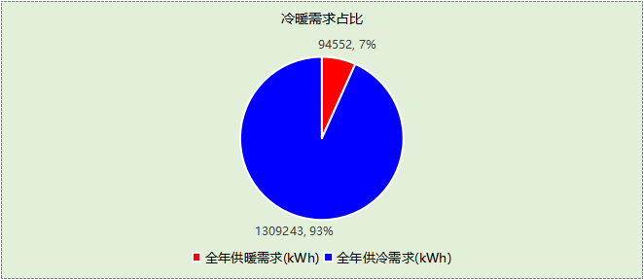

负荷分项统计
分类 | 围护传热 | 室内得热 | 窗日射 | 新风/渗透 | 热回收 | 合计
供暖(kWh/㎡) | -12.77 | 20.03 | 2.00 | -31.21 | 13.24 | -8.71
供冷(kWh/㎡) | 13.22 | 54.24 | 3.37 | 62.37 | -12.55 | 120.65
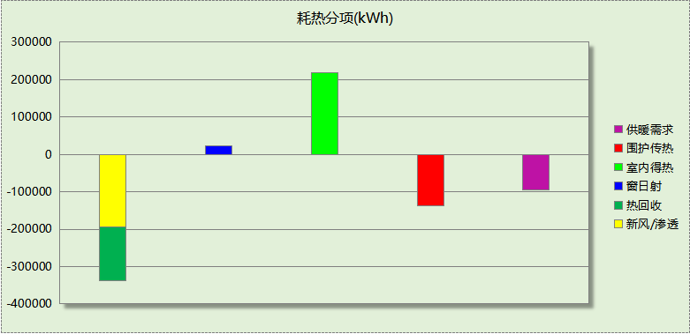
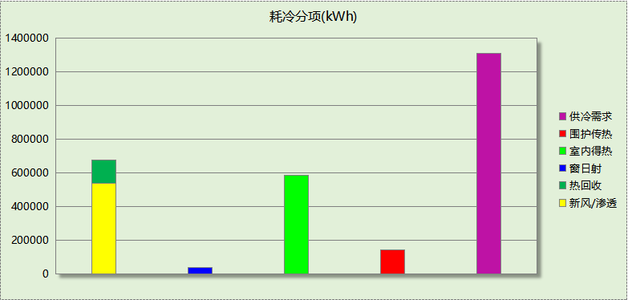

逐月负荷表
月份 | 供暖(kWh) | 供冷(kWh) | 热负荷  峰值(kW) | 热负荷  峰值时刻 | 冷负荷  峰值(kW) | 冷负荷  峰值时刻
1月 | 34177 | 0 | 733.388 | 1月14日8时 | 0.000 | --
2月 | 27848 | 0 | 769.878 | 2月4日8时 | 0.000 | --
3月 | 8988 | 21 | 425.724 | 3月11日8时 | 7.887 | 3月5日16时
4月 | 2880 | 30357 | 234.806 | 4月1日17时 | 759.398 | 4月23日15时
5月 | 0 | 114729 | 0.000 | -- | 1292.877 | 5月13日14时
6月 | 0 | 202231 | 0.000 | -- | 1651.693 | 6月13日8时
7月 | 0 | 367332 | 0.000 | -- | 2098.599 | 7月12日8时
8月 | 0 | 346597 | 0.000 | -- | 2096.232 | 8月15日8时
9月 | 0 | 193575 | 0.000 | -- | 1456.487 | 9月2日13时
10月 | 0 | 49442 | 0.000 | -- | 766.735 | 10月15日14时
11月 | 1286 | 4960 | 204.507 | 11月29日8时 | 474.803 | 11月26日14时
12月 | 19373 | 0 | 519.600 | 12月30日8时 | 0.000 | --
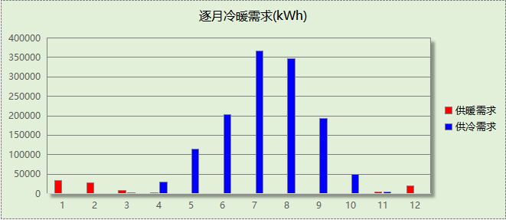
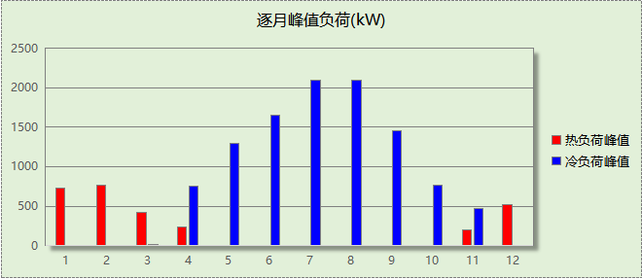

附录
工作日/节假日人员逐时在室率(%)

房间类型 | 1 | 2 | 3 | 4 | 5 | 6 | 7 | 8 | 9 | 10 | 11 | 12 | 13 | 14 | 15 | 16 | 17 | 18 | 19 | 20 | 21 | 22 | 23 | 24
休息室 | 0 | 0 | 0 | 0 | 0 | 0 | 10 | 50 | 95 | 95 | 95 | 80 | 80 | 95 | 95 | 95 | 95 | 30 | 30 | 0 | 0 | 0 | 0 | 0
休息室 | 0 | 0 | 0 | 0 | 0 | 0 | 0 | 0 | 0 | 0 | 0 | 0 | 0 | 0 | 0 | 0 | 0 | 0 | 0 | 0 | 0 | 0 | 0 | 0
会议室 | 0 | 0 | 0 | 0 | 0 | 0 | 10 | 50 | 95 | 95 | 95 | 80 | 80 | 95 | 95 | 95 | 95 | 30 | 30 | 0 | 0 | 0 | 0 | 0
会议室 | 0 | 0 | 0 | 0 | 0 | 0 | 0 | 0 | 0 | 0 | 0 | 0 | 0 | 0 | 0 | 0 | 0 | 0 | 0 | 0 | 0 | 0 | 0 | 0
健身活动室 | 0 | 0 | 0 | 0 | 0 | 0 | 10 | 50 | 95 | 95 | 95 | 80 | 80 | 95 | 95 | 95 | 95 | 30 | 30 | 0 | 0 | 0 | 0 | 0
健身活动室 | 0 | 0 | 0 | 0 | 0 | 0 | 0 | 0 | 0 | 0 | 0 | 0 | 0 | 0 | 0 | 0 | 0 | 0 | 0 | 0 | 0 | 0 | 0 | 0
卫生间 | 0 | 0 | 0 | 0 | 0 | 0 | 10 | 50 | 95 | 95 | 95 | 80 | 80 | 95 | 95 | 95 | 95 | 30 | 30 | 0 | 0 | 0 | 0 | 0
卫生间 | 0 | 0 | 0 | 0 | 0 | 0 | 0 | 0 | 0 | 0 | 0 | 0 | 0 | 0 | 0 | 0 | 0 | 0 | 0 | 0 | 0 | 0 | 0 | 0
大厅 | 0 | 0 | 0 | 0 | 0 | 0 | 10 | 50 | 95 | 95 | 95 | 80 | 80 | 95 | 95 | 95 | 95 | 30 | 30 | 0 | 0 | 0 | 0 | 0
大厅 | 0 | 0 | 0 | 0 | 0 | 0 | 0 | 0 | 0 | 0 | 0 | 0 | 0 | 0 | 0 | 0 | 0 | 0 | 0 | 0 | 0 | 0 | 0 | 0
实验教室 | 0 | 0 | 0 | 0 | 0 | 0 | 10 | 50 | 95 | 95 | 95 | 80 | 80 | 95 | 95 | 95 | 95 | 30 | 30 | 0 | 0 | 0 | 0 | 0
实验教室 | 0 | 0 | 0 | 0 | 0 | 0 | 0 | 0 | 0 | 0 | 0 | 0 | 0 | 0 | 0 | 0 | 0 | 0 | 0 | 0 | 0 | 0 | 0 | 0
展示区 | 0 | 0 | 0 | 0 | 0 | 0 | 10 | 50 | 100 | 100 | 100 | 30 | 100 | 100 | 100 | 100 | 50 | 20 | 10 | 0 | 0 | 0 | 0 | 0
展示区 | 0 | 0 | 0 | 0 | 0 | 0 | 0 | 20 | 45 | 0 | 0 | 0 | 0 | 0 | 0 | 0 | 0 | 0 | 0 | 0 | 0 | 0 | 0 | 0
开水间 | 0 | 0 | 0 | 0 | 0 | 0 | 10 | 50 | 95 | 95 | 95 | 80 | 80 | 95 | 95 | 95 | 95 | 30 | 30 | 0 | 0 | 0 | 0 | 0
开水间 | 0 | 0 | 0 | 0 | 0 | 0 | 0 | 0 | 0 | 0 | 0 | 0 | 0 | 0 | 0 | 0 | 0 | 0 | 0 | 0 | 0 | 0 | 0 | 0
报告厅 | 0 | 0 | 0 | 0 | 0 | 0 | 10 | 50 | 95 | 95 | 95 | 80 | 80 | 95 | 95 | 95 | 95 | 30 | 30 | 0 | 0 | 0 | 0 | 0
报告厅 | 0 | 0 | 0 | 0 | 0 | 0 | 0 | 0 | 0 | 0 | 0 | 0 | 0 | 0 | 0 | 0 | 0 | 0 | 0 | 0 | 0 | 0 | 0 | 0
普通办公室 | 0 | 0 | 0 | 0 | 0 | 0 | 10 | 50 | 95 | 95 | 95 | 80 | 80 | 95 | 95 | 95 | 95 | 30 | 30 | 0 | 0 | 0 | 0 | 0
普通办公室 | 0 | 0 | 0 | 0 | 0 | 0 | 0 | 0 | 0 | 0 | 0 | 0 | 0 | 0 | 0 | 0 | 0 | 0 | 0 | 0 | 0 | 0 | 0 | 0
普通教室 | 0 | 0 | 0 | 0 | 0 | 0 | 10 | 50 | 95 | 95 | 95 | 80 | 80 | 95 | 95 | 95 | 95 | 30 | 30 | 0 | 0 | 0 | 0 | 0
普通教室 | 0 | 0 | 0 | 0 | 0 | 0 | 0 | 0 | 0 | 0 | 0 | 0 | 0 | 0 | 0 | 0 | 0 | 0 | 0 | 0 | 0 | 0 | 0 | 0
楼梯间 | 0 | 0 | 0 | 0 | 0 | 0 | 10 | 50 | 95 | 95 | 95 | 80 | 80 | 95 | 95 | 95 | 95 | 30 | 30 | 0 | 0 | 0 | 0 | 0
楼梯间 | 0 | 0 | 0 | 0 | 0 | 0 | 0 | 0 | 0 | 0 | 0 | 0 | 0 | 0 | 0 | 0 | 0 | 0 | 0 | 0 | 0 | 0 | 0 | 0
空房间 | 0 | 0 | 0 | 0 | 0 | 0 | 0 | 20 | 50 | 80 | 80 | 80 | 80 | 80 | 80 | 80 | 80 | 80 | 80 | 70 | 50 | 0 | 0 | 0
空房间 | 0 | 0 | 0 | 0 | 0 | 0 | 0 | 0 | 0 | 0 | 0 | 0 | 0 | 0 | 0 | 0 | 0 | 0 | 0 | 0 | 0 | 0 | 0 | 0
设备间 | 0 | 0 | 0 | 0 | 0 | 0 | 0 | 0 | 0 | 0 | 0 | 0 | 0 | 0 | 0 | 0 | 0 | 0 | 0 | 0 | 0 | 0 | 0 | 0
设备间 | 0 | 0 | 0 | 0 | 0 | 0 | 0 | 0 | 0 | 0 | 0 | 0 | 0 | 0 | 0 | 0 | 0 | 0 | 0 | 0 | 0 | 0 | 0 | 0
走廊 | 0 | 0 | 0 | 0 | 0 | 0 | 10 | 50 | 95 | 95 | 95 | 80 | 80 | 95 | 95 | 95 | 95 | 30 | 30 | 0 | 0 | 0 | 0 | 0
走廊 | 0 | 0 | 0 | 0 | 0 | 0 | 0 | 0 | 0 | 0 | 0 | 0 | 0 | 0 | 0 | 0 | 0 | 0 | 0 | 0 | 0 | 0 | 0 | 0
餐厅 | 0 | 0 | 0 | 0 | 0 | 0 | 10 | 50 | 95 | 95 | 95 | 80 | 80 | 95 | 95 | 95 | 95 | 30 | 30 | 0 | 0 | 0 | 0 | 0
餐厅 | 0 | 0 | 0 | 0 | 0 | 0 | 0 | 0 | 0 | 0 | 0 | 0 | 0 | 0 | 0 | 0 | 0 | 0 | 0 | 0 | 0 | 0 | 0 | 0
高档办公室 | 0 | 0 | 0 | 0 | 0 | 0 | 10 | 50 | 95 | 95 | 95 | 80 | 80 | 95 | 95 | 95 | 95 | 30 | 30 | 0 | 0 | 0 | 0 | 0
高档办公室 | 0 | 0 | 0 | 0 | 0 | 0 | 0 | 0 | 0 | 0 | 0 | 0 | 0 | 0 | 0 | 0 | 0 | 0 | 0 | 0 | 0 | 0 | 0 | 0
注：上行：工作日；下行：节假日

工作日/节假日照明开关时间表(%)

房间类型 | 1 | 2 | 3 | 4 | 5 | 6 | 7 | 8 | 9 | 10 | 11 | 12 | 13 | 14 | 15 | 16 | 17 | 18 | 19 | 20 | 21 | 22 | 23 | 24
休息室 | 0 | 0 | 0 | 0 | 0 | 0 | 10 | 50 | 95 | 95 | 95 | 80 | 80 | 95 | 95 | 95 | 95 | 30 | 30 | 0 | 0 | 0 | 0 | 0
休息室 | 0 | 0 | 0 | 0 | 0 | 0 | 0 | 0 | 0 | 0 | 0 | 0 | 0 | 0 | 0 | 0 | 0 | 0 | 0 | 0 | 0 | 0 | 0 | 0
会议室 | 0 | 0 | 0 | 0 | 0 | 0 | 10 | 50 | 95 | 95 | 95 | 80 | 80 | 95 | 95 | 95 | 95 | 30 | 30 | 0 | 0 | 0 | 0 | 0
会议室 | 0 | 0 | 0 | 0 | 0 | 0 | 0 | 0 | 0 | 0 | 0 | 0 | 0 | 0 | 0 | 0 | 0 | 0 | 0 | 0 | 0 | 0 | 0 | 0
健身活动室 | 0 | 0 | 0 | 0 | 0 | 0 | 10 | 50 | 95 | 95 | 95 | 80 | 80 | 95 | 95 | 95 | 95 | 30 | 30 | 0 | 0 | 0 | 0 | 0
健身活动室 | 0 | 0 | 0 | 0 | 0 | 0 | 0 | 0 | 0 | 0 | 0 | 0 | 0 | 0 | 0 | 0 | 0 | 0 | 0 | 0 | 0 | 0 | 0 | 0
卫生间 | 0 | 0 | 0 | 0 | 0 | 0 | 10 | 50 | 95 | 95 | 95 | 80 | 80 | 95 | 95 | 95 | 95 | 30 | 30 | 0 | 0 | 0 | 0 | 0
卫生间 | 0 | 0 | 0 | 0 | 0 | 0 | 0 | 0 | 0 | 0 | 0 | 0 | 0 | 0 | 0 | 0 | 0 | 0 | 0 | 0 | 0 | 0 | 0 | 0
大厅 | 0 | 0 | 0 | 0 | 0 | 0 | 10 | 50 | 95 | 95 | 95 | 80 | 80 | 95 | 95 | 95 | 95 | 30 | 30 | 0 | 0 | 0 | 0 | 0
大厅 | 0 | 0 | 0 | 0 | 0 | 0 | 0 | 0 | 0 | 0 | 0 | 0 | 0 | 0 | 0 | 0 | 0 | 0 | 0 | 0 | 0 | 0 | 0 | 0
实验教室 | 0 | 0 | 0 | 0 | 0 | 0 | 10 | 50 | 95 | 95 | 95 | 80 | 80 | 95 | 95 | 95 | 95 | 30 | 30 | 0 | 0 | 0 | 0 | 0
实验教室 | 0 | 0 | 0 | 0 | 0 | 0 | 0 | 0 | 0 | 0 | 0 | 0 | 0 | 0 | 0 | 0 | 0 | 0 | 0 | 0 | 0 | 0 | 0 | 0
展示区 | 10 | 10 | 10 | 10 | 10 | 10 | 10 | 36 | 62 | 56 | 54 | 43 | 53 | 55 | 58 | 67 | 40 | 18 | 10 | 10 | 10 | 10 | 10 | 10
展示区 | 0 | 0 | 0 | 0 | 0 | 0 | 0 | 0 | 0 | 0 | 0 | 0 | 0 | 0 | 0 | 0 | 0 | 0 | 0 | 0 | 0 | 0 | 0 | 0
开水间 | 0 | 0 | 0 | 0 | 0 | 0 | 10 | 50 | 95 | 95 | 95 | 80 | 80 | 95 | 95 | 95 | 95 | 30 | 30 | 0 | 0 | 0 | 0 | 0
开水间 | 0 | 0 | 0 | 0 | 0 | 0 | 0 | 0 | 0 | 0 | 0 | 0 | 0 | 0 | 0 | 0 | 0 | 0 | 0 | 0 | 0 | 0 | 0 | 0
报告厅 | 0 | 0 | 0 | 0 | 0 | 0 | 10 | 50 | 95 | 95 | 95 | 80 | 80 | 95 | 95 | 95 | 95 | 30 | 30 | 0 | 0 | 0 | 0 | 0
报告厅 | 0 | 0 | 0 | 0 | 0 | 0 | 0 | 0 | 0 | 0 | 0 | 0 | 0 | 0 | 0 | 0 | 0 | 0 | 0 | 0 | 0 | 0 | 0 | 0
普通办公室 | 0 | 0 | 0 | 0 | 0 | 0 | 10 | 50 | 95 | 95 | 95 | 80 | 80 | 95 | 95 | 95 | 95 | 30 | 30 | 0 | 0 | 0 | 0 | 0
普通办公室 | 0 | 0 | 0 | 0 | 0 | 0 | 0 | 0 | 0 | 0 | 0 | 0 | 0 | 0 | 0 | 0 | 0 | 0 | 0 | 0 | 0 | 0 | 0 | 0
普通教室 | 0 | 0 | 0 | 0 | 0 | 0 | 10 | 50 | 95 | 95 | 95 | 80 | 80 | 95 | 95 | 95 | 95 | 30 | 30 | 0 | 0 | 0 | 0 | 0
普通教室 | 0 | 0 | 0 | 0 | 0 | 0 | 0 | 0 | 0 | 0 | 0 | 0 | 0 | 0 | 0 | 0 | 0 | 0 | 0 | 0 | 0 | 0 | 0 | 0
楼梯间 | 0 | 0 | 0 | 0 | 0 | 0 | 10 | 50 | 95 | 95 | 95 | 80 | 80 | 95 | 95 | 95 | 95 | 30 | 30 | 0 | 0 | 0 | 0 | 0
楼梯间 | 0 | 0 | 0 | 0 | 0 | 0 | 0 | 0 | 0 | 0 | 0 | 0 | 0 | 0 | 0 | 0 | 0 | 0 | 0 | 0 | 0 | 0 | 0 | 0
空房间 | 10 | 10 | 10 | 10 | 10 | 10 | 10 | 50 | 60 | 60 | 60 | 60 | 60 | 60 | 60 | 60 | 80 | 90 | 100 | 100 | 100 | 10 | 10 | 10
空房间 | 0 | 0 | 0 | 0 | 0 | 0 | 0 | 0 | 0 | 0 | 0 | 0 | 0 | 0 | 0 | 0 | 0 | 0 | 0 | 0 | 0 | 0 | 0 | 0
设备间 | 100 | 100 | 100 | 100 | 100 | 100 | 100 | 100 | 100 | 100 | 100 | 100 | 100 | 100 | 100 | 100 | 100 | 100 | 100 | 100 | 100 | 100 | 100 | 100
设备间 | 0 | 0 | 0 | 0 | 0 | 0 | 0 | 0 | 0 | 0 | 0 | 0 | 0 | 0 | 0 | 0 | 0 | 0 | 0 | 0 | 0 | 0 | 0 | 0
走廊 | 0 | 0 | 0 | 0 | 0 | 0 | 10 | 50 | 95 | 95 | 95 | 80 | 80 | 95 | 95 | 95 | 95 | 30 | 30 | 0 | 0 | 0 | 0 | 0
走廊 | 0 | 0 | 0 | 0 | 0 | 0 | 0 | 0 | 0 | 0 | 0 | 0 | 0 | 0 | 0 | 0 | 0 | 0 | 0 | 0 | 0 | 0 | 0 | 0
餐厅 | 0 | 0 | 0 | 0 | 0 | 0 | 10 | 50 | 95 | 95 | 95 | 80 | 80 | 95 | 95 | 95 | 95 | 30 | 30 | 0 | 0 | 0 | 0 | 0
餐厅 | 0 | 0 | 0 | 0 | 0 | 0 | 0 | 0 | 0 | 0 | 0 | 0 | 0 | 0 | 0 | 0 | 0 | 0 | 0 | 0 | 0 | 0 | 0 | 0
高档办公室 | 0 | 0 | 0 | 0 | 0 | 0 | 10 | 50 | 95 | 95 | 95 | 80 | 80 | 95 | 95 | 95 | 95 | 30 | 30 | 0 | 0 | 0 | 0 | 0
高档办公室 | 0 | 0 | 0 | 0 | 0 | 0 | 0 | 0 | 0 | 0 | 0 | 0 | 0 | 0 | 0 | 0 | 0 | 0 | 0 | 0 | 0 | 0 | 0 | 0
注：上行：工作日；下行：节假日

工作日/节假日设备逐时使用率(%)

房间类型 | 1 | 2 | 3 | 4 | 5 | 6 | 7 | 8 | 9 | 10 | 11 | 12 | 13 | 14 | 15 | 16 | 17 | 18 | 19 | 20 | 21 | 22 | 23 | 24
休息室 | 0 | 0 | 0 | 0 | 0 | 0 | 10 | 50 | 95 | 95 | 95 | 50 | 50 | 95 | 95 | 95 | 95 | 30 | 30 | 0 | 0 | 0 | 0 | 0
休息室 | 0 | 0 | 0 | 0 | 0 | 0 | 0 | 0 | 0 | 0 | 0 | 0 | 0 | 0 | 0 | 0 | 0 | 0 | 0 | 0 | 0 | 0 | 0 | 0
会议室 | 0 | 0 | 0 | 0 | 0 | 0 | 10 | 50 | 95 | 95 | 95 | 50 | 50 | 95 | 95 | 95 | 95 | 30 | 30 | 0 | 0 | 0 | 0 | 0
会议室 | 0 | 0 | 0 | 0 | 0 | 0 | 0 | 0 | 0 | 0 | 0 | 0 | 0 | 0 | 0 | 0 | 0 | 0 | 0 | 0 | 0 | 0 | 0 | 0
健身活动室 | 0 | 0 | 0 | 0 | 0 | 0 | 10 | 50 | 95 | 95 | 95 | 50 | 50 | 95 | 95 | 95 | 95 | 30 | 30 | 0 | 0 | 0 | 0 | 0
健身活动室 | 0 | 0 | 0 | 0 | 0 | 0 | 0 | 0 | 0 | 0 | 0 | 0 | 0 | 0 | 0 | 0 | 0 | 0 | 0 | 0 | 0 | 0 | 0 | 0
卫生间 | 0 | 0 | 0 | 0 | 0 | 0 | 10 | 50 | 95 | 95 | 95 | 50 | 50 | 95 | 95 | 95 | 95 | 30 | 30 | 0 | 0 | 0 | 0 | 0
卫生间 | 0 | 0 | 0 | 0 | 0 | 0 | 0 | 0 | 0 | 0 | 0 | 0 | 0 | 0 | 0 | 0 | 0 | 0 | 0 | 0 | 0 | 0 | 0 | 0
大厅 | 0 | 0 | 0 | 0 | 0 | 0 | 10 | 50 | 95 | 95 | 95 | 50 | 50 | 95 | 95 | 95 | 95 | 30 | 30 | 0 | 0 | 0 | 0 | 0
大厅 | 0 | 0 | 0 | 0 | 0 | 0 | 0 | 0 | 0 | 0 | 0 | 0 | 0 | 0 | 0 | 0 | 0 | 0 | 0 | 0 | 0 | 0 | 0 | 0
实验教室 | 0 | 0 | 0 | 0 | 0 | 0 | 10 | 50 | 95 | 95 | 95 | 50 | 50 | 95 | 95 | 95 | 95 | 30 | 30 | 0 | 0 | 0 | 0 | 0
实验教室 | 0 | 0 | 0 | 0 | 0 | 0 | 0 | 0 | 0 | 0 | 0 | 0 | 0 | 0 | 0 | 0 | 0 | 0 | 0 | 0 | 0 | 0 | 0 | 0
展示区 | 0 | 0 | 0 | 0 | 0 | 0 | 10 | 50 | 100 | 100 | 100 | 100 | 100 | 100 | 100 | 100 | 50 | 20 | 10 | 0 | 0 | 0 | 0 | 0
展示区 | 0 | 0 | 0 | 0 | 0 | 0 | 0 | 0 | 0 | 0 | 0 | 0 | 0 | 0 | 0 | 0 | 0 | 0 | 0 | 0 | 0 | 0 | 0 | 0
开水间 | 0 | 0 | 0 | 0 | 0 | 0 | 10 | 50 | 95 | 95 | 95 | 50 | 50 | 95 | 95 | 95 | 95 | 30 | 30 | 0 | 0 | 0 | 0 | 0
开水间 | 0 | 0 | 0 | 0 | 0 | 0 | 0 | 0 | 0 | 0 | 0 | 0 | 0 | 0 | 0 | 0 | 0 | 0 | 0 | 0 | 0 | 0 | 0 | 0
报告厅 | 0 | 0 | 0 | 0 | 0 | 0 | 10 | 50 | 95 | 95 | 95 | 50 | 50 | 95 | 95 | 95 | 95 | 30 | 30 | 0 | 0 | 0 | 0 | 0
报告厅 | 0 | 0 | 0 | 0 | 0 | 0 | 0 | 0 | 0 | 0 | 0 | 0 | 0 | 0 | 0 | 0 | 0 | 0 | 0 | 0 | 0 | 0 | 0 | 0
普通办公室 | 0 | 0 | 0 | 0 | 0 | 0 | 10 | 50 | 95 | 95 | 95 | 50 | 50 | 95 | 95 | 95 | 95 | 30 | 30 | 0 | 0 | 0 | 0 | 0
普通办公室 | 0 | 0 | 0 | 0 | 0 | 0 | 0 | 0 | 0 | 0 | 0 | 0 | 0 | 0 | 0 | 0 | 0 | 0 | 0 | 0 | 0 | 0 | 0 | 0
普通教室 | 0 | 0 | 0 | 0 | 0 | 0 | 10 | 50 | 95 | 95 | 95 | 50 | 50 | 95 | 95 | 95 | 95 | 30 | 30 | 0 | 0 | 0 | 0 | 0
普通教室 | 0 | 0 | 0 | 0 | 0 | 0 | 0 | 0 | 0 | 0 | 0 | 0 | 0 | 0 | 0 | 0 | 0 | 0 | 0 | 0 | 0 | 0 | 0 | 0
楼梯间 | 0 | 0 | 0 | 0 | 0 | 0 | 10 | 50 | 95 | 95 | 95 | 50 | 50 | 95 | 95 | 95 | 95 | 30 | 30 | 0 | 0 | 0 | 0 | 0
楼梯间 | 0 | 0 | 0 | 0 | 0 | 0 | 0 | 0 | 0 | 0 | 0 | 0 | 0 | 0 | 0 | 0 | 0 | 0 | 0 | 0 | 0 | 0 | 0 | 0
空房间 | 0 | 0 | 0 | 0 | 0 | 0 | 0 | 30 | 50 | 80 | 80 | 80 | 80 | 80 | 80 | 80 | 80 | 80 | 80 | 70 | 50 | 0 | 0 | 0
空房间 | 0 | 0 | 0 | 0 | 0 | 0 | 0 | 0 | 0 | 0 | 0 | 0 | 0 | 0 | 0 | 0 | 0 | 0 | 0 | 0 | 0 | 0 | 0 | 0
设备间 | 100 | 100 | 100 | 100 | 100 | 100 | 100 | 100 | 100 | 100 | 100 | 100 | 100 | 100 | 100 | 100 | 100 | 100 | 100 | 100 | 100 | 100 | 100 | 100
设备间 | 0 | 0 | 0 | 0 | 0 | 0 | 0 | 0 | 0 | 0 | 0 | 0 | 0 | 0 | 0 | 0 | 0 | 0 | 0 | 0 | 0 | 0 | 0 | 0
走廊 | 0 | 0 | 0 | 0 | 0 | 0 | 10 | 50 | 95 | 95 | 95 | 50 | 50 | 95 | 95 | 95 | 95 | 30 | 30 | 0 | 0 | 0 | 0 | 0
走廊 | 0 | 0 | 0 | 0 | 0 | 0 | 0 | 0 | 0 | 0 | 0 | 0 | 0 | 0 | 0 | 0 | 0 | 0 | 0 | 0 | 0 | 0 | 0 | 0
餐厅 | 0 | 0 | 0 | 0 | 0 | 0 | 10 | 50 | 95 | 95 | 95 | 50 | 50 | 95 | 95 | 95 | 95 | 30 | 30 | 0 | 0 | 0 | 0 | 0
餐厅 | 0 | 0 | 0 | 0 | 0 | 0 | 0 | 0 | 0 | 0 | 0 | 0 | 0 | 0 | 0 | 0 | 0 | 0 | 0 | 0 | 0 | 0 | 0 | 0
高档办公室 | 0 | 0 | 0 | 0 | 0 | 0 | 10 | 50 | 95 | 95 | 95 | 50 | 50 | 95 | 95 | 95 | 95 | 30 | 30 | 0 | 0 | 0 | 0 | 0
高档办公室 | 0 | 0 | 0 | 0 | 0 | 0 | 0 | 0 | 0 | 0 | 0 | 0 | 0 | 0 | 0 | 0 | 0 | 0 | 0 | 0 | 0 | 0 | 0 | 0
注：上行：工作日；下行：节假日

工作日/节假日空调系统开关时间表

系统编号 | 1 | 2 | 3 | 4 | 5 | 6 | 7 | 8 | 9 | 10 | 11 | 12 | 13 | 14 | 15 | 16 | 17 | 18 | 19 | 20 | 21 | 22 | 23 | 24
默认 | 0 | 0 | 0 | 0 | 0 | 0 | 0 | 1 | 1 | 1 | 1 | 1 | 1 | 1 | 1 | 1 | 1 | 1 | 0 | 0 | 0 | 0 | 0 | 0
默认 | 0 | 0 | 0 | 0 | 0 | 0 | 0 | 0 | 0 | 0 | 0 | 0 | 0 | 0 | 0 | 0 | 0 | 0 | 0 | 0 | 0 | 0 | 0 | 0
Sys | 0 | 0 | 0 | 0 | 0 | 0 | 0 | 1 | 1 | 1 | 1 | 1 | 1 | 1 | 1 | 1 | 1 | 1 | 0 | 0 | 0 | 0 | 0 | 0
Sys | 0 | 0 | 0 | 0 | 0 | 0 | 0 | 0 | 0 | 0 | 0 | 0 | 0 | 0 | 0 | 0 | 0 | 0 | 0 | 0 | 0 | 0 | 0 | 0
注：上行：工作日；下行：节假日

