**超低能耗**

**建筑能效报告书**

公共建筑

|  |  |
| --- | --- |
| 工程名称 | 浙江美丽乡村学院 |
| 工程地点 | 浙江-衢州 |
| 设计编号 | 001 |
| 建设单位 |  |
| 设计单位 |  |
| 设 计 人 |  |
| 审 核 人 |  |
| 审 定 人 |  |
| 设计日期 | 2024年12月6日 |



|  |  |
| --- | --- |
| 采用软件 | 超低能耗PHES2024 |
| 软件版本 | 20240430(SP1) |
| 研发单位 | 北京绿建软件股份有限公司 |
| 正版授权码 | T15258795825 |

**目 录**

1 建筑概况 4

2 评估依据 4

3 气象数据 4

3.1 气象地点 4

3.2 逐日干球温度表 5

3.3 逐月辐照量表 5

3.4 峰值工况 5

4 围护结构 6

4.1 工程材料 6

4.1.1 普通材料 6

4.1.2 其他材料 7

4.2 屋顶 7

4.2.1 坡屋顶 7

4.3 天窗类型 7

4.4 外墙 8

4.4.1 外墙相关构造 8

4.4.2 外墙线性热桥 8

4.4.3 外墙平均热工特性 11

4.5 外窗热工 12

4.5.1 外窗 12

4.5.2 外遮阳类型 12

4.5.3 总体热工性能 13

4.6 外窗气密性 14

4.7 外门气密性 14

4.8 户门气密性 14

4.9 规定项检查 14

5 围护结构概况 14

6 设计建筑 15

6.1 房间类型 15

6.1.1 房间参数表 15

6.1.2 作息时间表 16

6.2 系统类型 16

6.2.1 系统分区 16

6.2.2 热回收参数 16

6.3 制冷系统 16

6.3.1 默认冷源 16

6.4 照明 17

6.5 生活热水 17

6.5.1 热水需求 17

6.5.2 太阳能集热 17

6.5.3 热水设备 17

6.6 光伏发电 18

6.7 负荷分项统计 18

6.8 逐月负荷表 19

7 基准建筑 20

7.1 房间类型 20

7.1.1 房间参数表 20

7.1.2 作息时间表 21

7.2 系统类型 21

7.3 制冷系统 21

7.3.1 多联机/单元式空调能耗 21

7.4 照明 21

7.5 生活热水 21

7.5.1 热水需求 21

7.5.2 热水设备 22

7.6 负荷分项统计 22

7.7 逐月负荷表 23

8 能效结果 24

8.1 建筑能耗 24

8.2 结论 27

9 附录 28

9.1 工作日/节假日人员逐时在室率(%) 28

9.2 工作日/节假日照明开关时间表(%) 29

9.3 工作日/节假日设备逐时使用率(%) 30

9.4 工作日/节假日空调系统运行时间表(1:开,0:关) 31

9.5 工作日/节假日新风运行时间表(%) 32

# 建筑概况

|  |  |  |
| --- | --- | --- |
| 工程名称 | 浙江美丽乡村学院 | |
| 工程地点 | 浙江-衢州 | |
| 地理位置 | 北纬：29.00° | 东经：118.90° |
| 建筑面积(m2) | 地上1480 地下0 | |
| 建筑层数 | 地上3 地下0 | |
| 建筑高度（m） | 地上14.2 地下0.0 | |
| 建筑体积(m3) | 6549.05 | |
| 建筑外表面积(m2) | 2027.20 | |
| 建筑气密性（换气次数N50） | 0.60 | |
| 建筑类型细化 | 学校建筑 | |
| 北向角度 | 90 | |
| 结构类型 |  | |
| 外墙太阳辐射吸收系数 | 0.75 | |
| 屋顶太阳辐射吸收系数 | 0.75 | |
| 控温期 | 供冷期:7.1-8.31 | |

# 评估依据

1. 《近零能耗建筑技术标准》(GB/T51350-2019)

2. 《公共建筑节能设计标准》(GB50189-2015)

3. 《民用建筑热工设计规范》(GB50176-2016-2016)

4. 《建筑幕墙、门窗通用技术条件》(GB/T31433-2015)

# 气象数据

## 气象地点

浙江-衢州, 《建筑节能气象参数标准》

## 逐日干球温度表

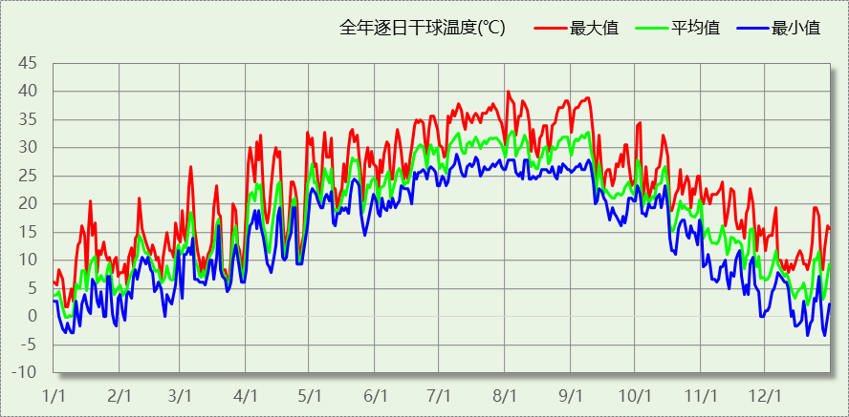

## 逐月辐照量表

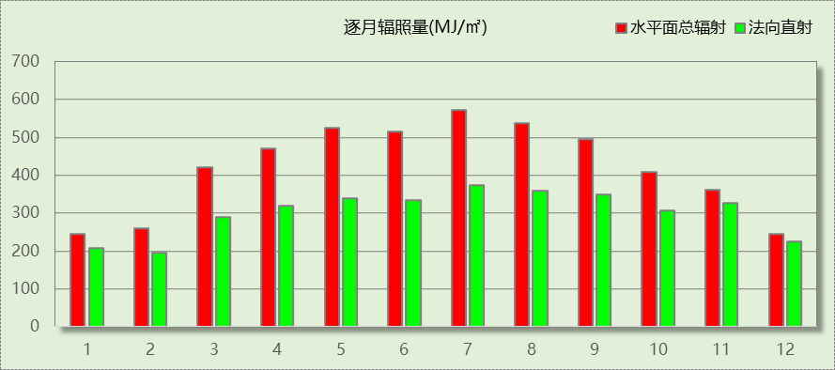

## 峰值工况

|  |  |  |  |  |  |
| --- | --- | --- | --- | --- | --- |
| 气象数据 | 时刻 | 干球温度(℃) | 湿球温度(℃) | 含湿量(g/kg) | 焓值(kj/kg) |
| 最热 | 08月01日14时 | 40.0 | 26.7 | 17.1 | 84.2 |
| 最冷 | 12月20日05时 | -3.3 | -4.4 | 2.2 | 2.1 |

# 围护结构

## 工程材料

### 普通材料

|  |  |  |  |  |  |  |
| --- | --- | --- | --- | --- | --- | --- |
| 材料名称 | 导热系数λ | 蓄热系数S | 密度ρ | 比热容Cp | 蒸汽渗透 系数u | 数据来源 |
| W/(m.K) | W/(㎡.K) | kg/m3 | J/(kg.K) | g/(m.h.kPa) |
| 水泥砂浆 | 0.930 | 11.370 | 1800.0 | 1050.0 | 0.0210 | 民用建筑热工设计规范 GB50176-2016 |
| 石灰砂浆 | 0.810 | 10.070 | 1600.0 | 1050.0 | 0.0443 | 民用建筑热工设计规范 GB50176-2016 |
| 钢筋混凝土 | 1.740 | 17.200 | 2500.0 | 920.0 | 0.0158 | 民用建筑热工设计规范 GB50176-2016 |
| 烧结普通砖砌块 | 0.810 | 10.630 | 1800.0 | 1060.0 | 0.0000 | 浙江居住建筑节能设计标准 DB33/1015-2021 |
| 防水卷材(沥青油毡、油毡纸) | 0.170 | 3.302 | 600.0 | 1470.0 | 0.0014 | 安徽公共建筑节能设计标准 DB34 T753-2007 |
| 纸面石膏板 | 0.330 | 5.280 | 1050.0 | 1100.0 | 0.0000 | 浙江省居住建筑楼板构造(2018浙J76) |
| 钢丝网架聚苯板 | 0.039 | 0.313 | 25.0 | 1380.0 | 0.0162 | 内蒙古公共建筑节能标准 DBJ03-27-2017 |
| 天然花岗岩板材 | 3.490 | 25.569 | 2800.0 | 920.0 | 0.0113 | 民用建筑热工设计规范 GB50176-2016 |
| 聚合物水泥砂浆 | 0.930 | 11.306 | 1800.0 | 1050.0 | 0.0100 | DB23-T120-2001 |
| 挤塑聚苯板（XPS）(屋面楼板) | 0.030 | 0.320 | 35.0 | 1340.0 | 0.0162 | 民用建筑热工设计规范 GB50176-2016 |
| 挤塑聚苯板（XPS）(墙体) | 0.030 | 0.340 | 35.0 | 1510.0 | 0.0162 | 民用建筑热工设计规范 GB50176-2016 |
| 水泥砂浆挂瓦 | 0.930 | 11.306 | 1800.0 | 1050.0 | 0.0080 |  |
| 沥青混凝土 | 1.050 | 16.390 | 2100.0 | 1680.0 | 0.0075 | 安徽省居住建筑节能设计标准 DB34/1466-2019 |
| 铝塑复合板 | 0.450 | 6.886 | 1380.0 | 1050.0 | 0.0000 | 四川省居住建筑节能设计标准 GB51/5027-2019 |

### 其他材料

|  |  |  |  |  |
| --- | --- | --- | --- | --- |
| 材料名称 | 厚度 | 热阻R | 太阳辐射吸收系数 | 备注 |
| mm | (㎡K)/W |
| 胶黏剂 | － | － | － |  |
| 涂料饰面(忽略保温性能) | 0.0 | 0.000 | － |  |

## 屋顶

### 坡屋顶

|  |  |  |  |  |  |  |
| --- | --- | --- | --- | --- | --- | --- |
| 材料名称 （由上到下） | 厚度δ | 导热系数λ | 蓄热系数S | 修正 系数 | 热阻R | 热惰性 指标 |
| (mm) | W/(m.K) | W/(㎡.K) | α | (㎡K)/W | D=R*S |
| 水泥砂浆挂瓦 | 20 | 0.930 | 11.306 | 1.00 | 0.022 | 0.243 |
| 水泥砂浆 | 20 | 0.930 | 11.370 | 1.00 | 0.022 | 0.245 |
| 钢丝网架聚苯板 | 50 | 0.039 | 0.313 | 1.55 | 0.827 | 0.401 |
| 防水卷材(沥青油毡、油毡纸) | 2 | 0.170 | 3.302 | 1.00 | 0.012 | 0.039 |
| 沥青混凝土 | 20 | 1.050 | 16.390 | 1.00 | 0.019 | 0.312 |
| 挤塑聚苯板（XPS）(屋面楼板) | 130 | 0.030 | 0.320 | 1.20 | 3.611 | 1.387 |
| 防水卷材(沥青油毡、油毡纸) | 20 | 0.170 | 3.302 | 1.00 | 0.118 | 0.388 |
| 钢筋混凝土 | 120 | 1.740 | 17.200 | 1.00 | 0.069 | 1.186 |
| 石灰砂浆 | 20 | 0.810 | 10.070 | 1.00 | 0.025 | 0.249 |
| 各层之和∑ | 402 | － | － | － | 4.723 | 4.450 |
| 外表面太阳辐射吸收系数 | 0.75 | | | | | |
| 传热系数K=1/(0.15+∑R) | 0.21 | | | | | |

## 天窗类型

|  |  |  |  |  |  |  |
| --- | --- | --- | --- | --- | --- | --- |
| 序号 | 构造名称 | 构造编号 | 传热系数 | 夏季综合 太阳得热系数 | 冬季综合 太阳得热系数 | 备注 |
| 1 | 65系列平开隔热铝合金窗(5+12Ar+5Low_E)(高透光) | 98 | 2.10 | 0.39 | 0.39 |  |
| 平均 | |  | 2.10 | 0.11 | 0.10 |  |

## 外墙

### 外墙相关构造

#### 砌体墙

|  |  |  |  |  |  |  |
| --- | --- | --- | --- | --- | --- | --- |
| 材料名称 （由外到内） | 厚度δ | 导热系数λ | 蓄热系数S | 修正 系数 | 热阻R | 热惰性 指标 |
| (mm) | W/(m.K) | W/(㎡.K) | α | (㎡K)/W | D=R*S |
| 水泥砂浆 | 20 | 0.930 | 11.370 | 1.00 | 0.022 | 0.245 |
| 挤塑聚苯板（XPS）(墙体) | 80 | 0.030 | 0.340 | 1.10 | 2.424 | 0.907 |
| 水泥砂浆 | 20 | 0.930 | 11.370 | 1.00 | 0.022 | 0.245 |
| 钢筋混凝土 | 200 | 1.740 | 17.200 | 1.00 | 0.115 | 1.977 |
| 石灰砂浆 | 15 | 0.810 | 10.070 | 1.00 | 0.019 | 0.186 |
| 各层之和∑ | 335 | － | － | － | 2.601 | 3.559 |
| 外表面太阳辐射吸收系数 | 0.75 | | | | | |
| 传热系数K=1/(0.15+∑R) | 0.36 | | | | | |
| 考虑线性热桥后K | 0.36 + 92.23/1029.71 = 0.45 | | | | | |

### 外墙线性热桥

|  |  |  |  |  |  |
| --- | --- | --- | --- | --- | --- |
| 朝向 | 热桥部位 | 索引号 | 线传热系数Ψ [W/(m.K)] | 热桥长度L (m) | L*Ψ (W/K) |
| 南 | 外墙－屋顶 | WR-1 | 0.192 | 58.90 | 11.31 |
| 门窗左右口 | WS-1 | 0.083 | 94.80 | 7.87 |
| 门窗上口 | WU-1 | 0.083 | 31.50 | 2.61 |
| 窗下口 | WD-1 | 0.121 | 30.00 | 3.63 |
| 外墙－外墙 | WO-1 | 0.071/2=0.0355 | 45.80 | 1.63 |
| 外墙－楼板 | WF-1 | 0.008 | 53.75 | 0.43 |
| 外墙－内墙 | WI-1 | 0.001 | 24.81 | 0.02 |
| 合计 |  | | | 27.50 |
| 北 | 外墙－屋顶 | WR-1 | 0.192 | 24.15 | 4.64 |
| 门窗左右口 | WS-1 | 0.083 | 140.20 | 11.64 |
| 门窗上口 | WU-1 | 0.083 | 58.90 | 4.89 |
| 窗下口 | WD-1 | 0.121 | 54.60 | 6.61 |
| 外墙－外墙 | WO-1 | 0.071/2=0.0355 | 177.32 | 6.29 |
| 外墙－楼板 | WF-1 | 0.008 | 74.28 | 0.59 |
| 外墙－内墙 | WI-1 | 0.001 | 33.61 | 0.03 |
| 合计 |  | | | 34.69 |
| 东 | 外墙－屋顶 | WR-1 | 0.192 | 23.61 | 4.53 |
| 门窗左右口 | WS-1 | 0.083 | 50.00 | 4.15 |
| 门窗上口 | WU-1 | 0.083 | 14.70 | 1.22 |
| 窗下口 | WD-1 | 0.121 | 11.40 | 1.38 |
| 外墙－外墙 | WO-1 | 0.071/2=0.0355 | 39.69 | 1.41 |
| 外墙－楼板 | WF-1 | 0.008 | 38.60 | 0.31 |
| 外墙－内墙 | WI-1 | 0.001 | 23.25 | 0.02 |
| 合计 |  | | | 13.02 |
| 西 | 外墙－屋顶 | WR-1 | 0.192 | 25.64 | 4.92 |
| 门窗左右口 | WS-1 | 0.083 | 25.20 | 2.09 |
| 门窗上口 | WU-1 | 0.083 | 18.50 | 1.54 |
| 窗下口 | WD-1 | 0.121 | 18.50 | 2.24 |
| 外墙－外墙 | WO-1 | 0.071/2=0.0355 | 162.79 | 5.78 |
| 外墙－楼板 | WF-1 | 0.008 | 50.44 | 0.40 |
| 外墙－内墙 | WI-1 | 0.001 | 43.36 | 0.04 |
| 合计 |  | | | 17.01 |
| 总计 |  | | | | 92.23 |

#### 热桥节点图

|  |  |
| --- | --- |
| 外墙－屋顶：WR-1 | 门窗左右口：WS-1 |
|  |  |

|  |  |
| --- | --- |
| 门窗上口：WU-1 | 窗下口：WD-1 |
|  |  |

|  |  |
| --- | --- |
| 外墙－外墙：WO-1 | 外墙－楼板：WF-1 |
|  |  |

|  |  |
| --- | --- |
| 外墙－内墙：WI-1 |  |
|  |  |

### 外墙平均热工特性

1.　南向

|  |  |  |  |  |  |  |
| --- | --- | --- | --- | --- | --- | --- |
| 构造名称 | 构件 类型 | 面积(㎡) | 面积所占比例 | 传热系数K W / (㎡K) | 热惰性 指标D | 太阳辐射 吸收系数 |
| 砌体墙 | 主墙体 | 315.59 | 1.000 | 0.36 | 3.56 | 0.75 |
| 考虑线性热桥后K | 0.36 + 27.50/315.59 = 0.45 | | | | | |

2.　北向

|  |  |  |  |  |  |  |
| --- | --- | --- | --- | --- | --- | --- |
| 构造名称 | 构件 类型 | 面积(㎡) | 面积所占比例 | 传热系数K W / (㎡K) | 热惰性 指标D | 太阳辐射 吸收系数 |
| 砌体墙 | 主墙体 | 295.55 | 1.000 | 0.36 | 3.56 | 0.75 |
| 考虑线性热桥后K | 0.36 + 34.69/295.55 = 0.48 | | | | | |

3.　东向

|  |  |  |  |  |  |  |
| --- | --- | --- | --- | --- | --- | --- |
| 构造名称 | 构件 类型 | 面积(㎡) | 面积所占比例 | 传热系数K W / (㎡K) | 热惰性 指标D | 太阳辐射 吸收系数 |
| 砌体墙 | 主墙体 | 150.86 | 1.000 | 0.36 | 3.56 | 0.75 |
| 考虑线性热桥后K | 0.36 + 13.02/150.86 = 0.45 | | | | | |

4.　西向

|  |  |  |  |  |  |  |
| --- | --- | --- | --- | --- | --- | --- |
| 构造名称 | 构件 类型 | 面积(㎡) | 面积所占比例 | 传热系数K W / (㎡K) | 热惰性 指标D | 太阳辐射 吸收系数 |
| 砌体墙 | 主墙体 | 267.71 | 1.000 | 0.36 | 3.56 | 0.75 |
| 考虑线性热桥后K | 0.36 + 17.01/267.71 = 0.42 | | | | | |

5.　总体

|  |  |  |  |  |  |  |
| --- | --- | --- | --- | --- | --- | --- |
| 构造名称 | 构件 类型 | 面积(㎡) | 面积所占比例 | 传热系数K W / (㎡K) | 热惰性 指标D | 太阳辐射 吸收系数 |
| 砌体墙 | 主墙体 | 1029.71 | 1.000 | 0.36 | 3.56 | 0.75 |
| 考虑线性热桥后K | 0.36 + 92.23/1029.71 = 0.45 | | | | | |

## 外窗热工

### 外窗

|  |  |  |  |  |  |  |
| --- | --- | --- | --- | --- | --- | --- |
| 序号 | 构造名称 | 构造 编号 | 传热 系数 | 窗遮阳 系数 | 可见光 透射比 | 数据来源 |
| 1 | 铝合金平开窗(5中透Low_E+12A+5)(双银)(34mm隔热条) | 182 | 2.00 | 0.43 | 0.620 | 浙江居住建筑节能设计标准 DB33/1015-2021 |
| 窗编号 | | | | |
| 幕墙 | | | | |
| 2 | 铝合金平开窗(5中透Low_E+12A+5)(双银)(34mm隔热条) | 18 | 2.00 | 0.43 | 0.620 | 浙江居住建筑节能设计标准 DB33/1015-2021 |
| 窗编号 | | | | |
| C1521，C2121，C1213，C1221，C1510，C5911，C1206，C1818，C1419，C1621，C1621a，C1821 | | | | |

### 外遮阳类型

已启用环境遮阳.

#### 平板遮阳

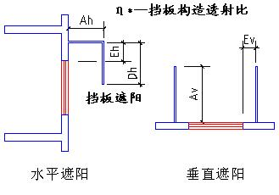

|  |  |  |  |  |  |  |  |
| --- | --- | --- | --- | --- | --- | --- | --- |
| 序号 | 编号 | 水平挑出Ah (m) | 距离上沿Eh (m) | 垂直挑出Av (m) | 距离边沿Ev (m) | 挡板高Dh (m) | 挡板透射η* |
| 1 | 无外遮阳 | 0.100 | 0.000 | 0.100 | 0.000 | 0.000 | 0.000 |

#### 百叶遮阳

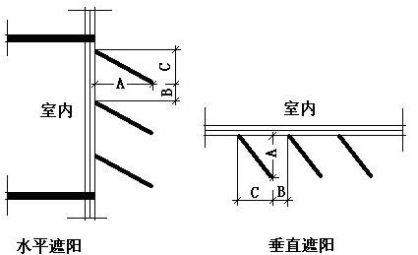

|  |  |  |  |  |
| --- | --- | --- | --- | --- |
| 序号 | 编号 | 挑出 A (m) | 百叶间距 D (m) | 下垂 C (m) |
| 1 | 百叶遮阳0 | 0.080 | 0.150 | 0.100 |

### 总体热工性能

|  |  |  |  |  |  |  |  |
| --- | --- | --- | --- | --- | --- | --- | --- |
| 朝向 | 面积 | 传热系数 | 夏季综合 太阳得热系数 | 冬季综合 太阳得热系数 | 窗墙比 | 标准要求 | 结论 |
| 南向 | 98.28 | 2.00 | 0.24 | 0.24 | 0.24 | K≤2.20, SHGCSum≤0.15, SHGCWin≥0.40 | 不需要 |
| 北向 | 116.38 | 2.00 | 0.30 | 0.32 | 0.28 | K≤2.20, SHGCSum≤0.15, SHGCWin≥0.40 | 不需要 |
| 东向 | 59.80 | 2.00 | 0.23 | 0.29 | 0.27 | K≤2.20, SHGCSum≤0.15, SHGCWin≥0.40 | 不需要 |
| 西向 | 22.09 | 2.00 | 0.21 | 0.21 | 0.08 | K≤2.20, SHGCSum≤0.15, SHGCWin≥0.40 | 不需要 |
| 综合平均 | 296.55 | 2.00 | 0.26 | 0.28 | 0.22 |  |  |
| 标准依据 | 《近零能耗建筑技术标准》(GB/T51350-2019)第6.1.5条 | | | | | | |
| 标准要求 | K和SHGC值可按表6.1.5-2选取 | | | | | | |
| 结论 | 不需要 | | | | | | |

注：本表所统计的外窗包含凸窗。

## 外窗气密性

|  |  |
| --- | --- |
| 最不利气密性等级 | 8级（窗编号：C1206） |
| 外窗气密性措施 |  |
| 标准依据 | 《近零能耗建筑技术标准》第6.1.4条，分级与检测方法《建筑幕墙、门窗通用技术条件》(GB/T31433-2015) |
| 标准要求 | 外窗及外门户门气密性不宜低于《建筑幕墙、门窗通用技术条件》(GB/T31433-2015)的8级 |
| 结论 | 适宜 |

## 外门气密性

|  |  |
| --- | --- |
| 最不利气密性等级 | 7级（窗编号：M1521） |
| 外门气密性措施 |  |
| 标准依据 | 《近零能耗建筑技术标准》第6.1.4条，分级与检测方法《建筑幕墙、门窗通用技术条件》(GB/T31433-2015) |
| 标准要求 | 外窗及外门户门气密性不宜低于《建筑幕墙、门窗通用技术条件》(GB/T31433-2015)的6级 |
| 结论 | 适宜 |

## 户门气密性

|  |  |
| --- | --- |
| 最不利气密性等级 | － |
| 户门气密性措施 |  |
| 标准依据 | 《近零能耗建筑技术标准》第6.1.4条，分级与检测方法《建筑幕墙、门窗通用技术条件》(GB/T31433-2015) |
| 标准要求 | 外窗及外门户门气密性不宜低于《建筑幕墙、门窗通用技术条件》(GB/T31433-2015)的6级 |
| 结论 | － |

## 规定项检查

|  |  |  |
| --- | --- | --- |
| 序号 | 检查项 | 结论 |
| 1 | 屋顶 | 不需要 |
| 2 | 天窗类型 | 不需要 |
| 3 | 外墙 | 不需要 |
| 4 | 外窗热工 | 不需要 |
| 5 | 外窗气密性 | 适宜 |
| 6 | 外门气密性 | 适宜 |
| 7 | 户门气密性 | 适宜 |

# 围护结构概况

|  |  |  |  |  |  |  |  |
| --- | --- | --- | --- | --- | --- | --- | --- |
|  | | 设计建筑 | | | 基准建筑 | | |
| 屋顶传热系数K  和热惰性指标 D | | 0.21  4.45 | | | 0.50  3.35 | | |
| 外墙传热系数K  和热惰性指标 D | | 0.45  3.56 | | | 0.80  3.00 | | |
| 挑空(或架空)楼板传热系数K  和热惰性指标 D | | －  － | | | －  － | | |
| 天窗传热系数K  和太阳得热系数 SHGC | | 2.10  0.11 | | | 2.60  0.30 | | |
| 外窗（包括透明幕墙） | 朝向 | 窗墙比 | 传热  系数 | 太阳得热系数 | 窗墙比 | 传热  系数 | 太阳得热系数 |
| 南向 | 0.24 | 2.00 | 0.23 | 0.24 | 3.00 | 0.44 |
| 北向 | 0.28 | 2.00 | 0.31 | 0.25 | 3.00 | 0.48 |
| 东向 | 0.27 | 2.00 | 0.26 | 0.25 | 3.00 | 0.44 |
| 西向 | 0.08 | 2.00 | 0.21 | 0.08 | 3.50 | －－ |

备注：

1. 传热系数的单位W/(m2.k)，其他参数无量纲.

2. 屋顶和外墙的传热系数K和热情性指标D指平均值.

3. 设计建筑：“—”代表本工程无对应项.

4. 参照建筑：“— —”代表参照建筑不要求，取值同设计建筑.

# 设计建筑

## 房间类型

### 房间参数表

|  |  |  |  |  |  |  |  |
| --- | --- | --- | --- | --- | --- | --- | --- |
| 房间类型 | 空调 温度℃ | 供暖 温度℃ | 新风量 | 渗透风 换气次数 | 人员密度 | 照明功率 密度 | 电器设备 功率 |
| 卫生间 | 26 | 20 | 30(m3/h.人) | 0(次/h) | 10(㎡/人) | 0(W/㎡) | 13(W/㎡) |
| 多媒体教室 | 26 | 20 | 30(m3/h.人) | 0(次/h) | 1.12(㎡/人) | 2(W/㎡) | 5(W/㎡) |
| 普通办公室 | 26 | 20 | 30(m3/h.人) | 0(次/h) | 10(㎡/人) | 0(W/㎡) | 13(W/㎡) |
| 普通教室 | 26 | 20 | 30(m3/h.人) | 0(次/h) | 1.12(㎡/人) | 0(W/㎡) | 5(W/㎡) |
| 楼梯间 | － | － | 20(m3/h.人) | 0(次/h) | 50(㎡/人) | 0(W/㎡) | 0(W/㎡) |
| 空房间 | － | － | 20(m3/h.人) | 0(次/h) | 50(㎡/人) | 0(W/㎡) | 0(W/㎡) |
| 舞蹈教室 | 26 | 20 | 30(m3/h.人) | 0(次/h) | 1.12(㎡/人) | 2(W/㎡) | 5(W/㎡) |
| 设备间 | － | － | 0(m3/h.人) | 0(次/h) | 0(人) | 0(W/㎡) | 0(W/㎡) |
| 走廊 | 26 | 20 | 30(m3/h.人) | 0(次/h) | 20(㎡/人) | 0(W/㎡) | 0(W/㎡) |

### 作息时间表

详见附录

## 系统类型

### 系统分区

|  |  |  |  |  |  |
| --- | --- | --- | --- | --- | --- |
| 系统编号 | 系统类型 | 制冷 SEER | 制热 HSPF | 面积(㎡) | 包含的房间 |
| 默认 | 双管制风机盘管 | － | － | 1059.24 | 所有房间 |

### 热回收参数

|  |  |  |  |  |  |
| --- | --- | --- | --- | --- | --- |
| 系统编号 | 热回收 | 供冷 | | 供暖 | |
| 回收效率 | 启动温(焓)差 | 回收效率 | 启动温(焓)差 |
| 默认 | 全热回收 | 0.75 | 1kJ/kg | 0.75 | 1(kJ/kg) |

## 制冷系统

### 默认冷源

#### 供应的系统

|  |  |
| --- | --- |
| 系统编号 | 默认 |

#### 冷水机组

|  |  |  |  |  |  |
| --- | --- | --- | --- | --- | --- |
| 名称 | 类型 | 额定耗电量 (kW) | 额定制冷量 (kW) | 额定性能系数 (COP) | 台数 |
| 机组1 | 水冷-离心式冷水机组 | 352 | 2000 | 5.68 | 1 |

#### 水泵系统

|  |  |  |  |  |  |  |  |
| --- | --- | --- | --- | --- | --- | --- | --- |
| 类型 | 调节 | 流量 (m3/h) | 扬程 (m) | 设计工作效率(%) | 输入功率 (kW) | 冷却塔耗电比 (kWh/m3) | 台数 |
| 冷冻水泵 | 变频 | 270 | 30 | 80 | 31.7 | － | 1 |

#### 运行工况

|  |  |  |  |  |  |  |
| --- | --- | --- | --- | --- | --- | --- |
| 负载率 (%) | 机组制冷量 (kW) | 机组功率 (kW) | 性能系数 (COP) | 冷却水泵功率 (kW) | 冷冻水泵功率 (kW) | 冷却塔功率 (kW) |
| 20 | 400 | 158.6 | 2.52 | － | 75.1 | 19.2 |
| 40 | 800 | 317.1 | 2.52 | － | 112.7 | 28.8 |
| 60 | 1200 | 475.7 | 2.52 | － | 112.7 | 28.8 |
| 80 | 1600 | 634.3 | 2.52 | － | 112.7 | 63.4 |
| 100 | 2000 | 849.1 | 2.36 | － | 112.7 | 86.4 |

#### 制冷能耗

|  |  |  |  |  |  |  |  |
| --- | --- | --- | --- | --- | --- | --- | --- |
| 负荷区间 (%) | 区间负荷 (kWh) | 运行时长(h) | 制冷机组 (kWh) | 平均性能系数(COP) | 冷却水泵 (kWh) | 冷冻水泵 (kWh) | 冷却塔 (kWh) |
| 0~20 | 14971 | 120 | 5936 | 2.52 | － | 9012 | 2304 |
| 20~40 | 0 | 0 | 0 | 0.00 | － | 0 | 0 |
| 40~60 | 0 | 0 | 0 | 0.00 | － | 0 | 0 |
| 60~80 | 0 | 0 | 0 | 0.00 | － | 0 | 0 |
| 80~100 | 0 | 0 | 0 | 0.00 | － | 0 | 0 |
| >100 | 0 | 0 | 0 | － | － | 0 | 0 |
| 合计 | 14971 | 120 | 5936 |  | － | 9012 | 2304 |

## 照明

|  |  |  |  |  |
| --- | --- | --- | --- | --- |
| 房间类型 | 单位面积电耗 (kWh/㎡) | 房间个数 | 房间合计面积 (㎡) | 合计电耗 (kWh) |
| 卫生间 | 0.00 | 6 | 43 | 0 |
| 多媒体教室 | 3.95 | 1 | 130 | 512 |
| 普通办公室 | 0.00 | 2 | 62 | 0 |
| 普通教室 | 0.00 | 4 | 563 | 0 |
| 楼梯间 | 0.00 | 6 | 136 | 0 |
| 空房间 | 0.00 | 1 | 25 | 0 |
| 舞蹈教室 | 3.95 | 1 | 74 | 293 |
| 设备间 | 0.00 | 1 | 128 | 0 |
| 走廊 | 0.00 | 4 | 264 | 0 |
| 总计 | | | | 805 |

## 生活热水

### 热水需求

|  |  |  |  |  |  |
| --- | --- | --- | --- | --- | --- |
| 分区 | 用水定额 (L/人·d) | 热水温差(℃) | 用水人数 | 年使用天数 | 所需热量 (kWh/a) |
| 办公 | 10 | 45 | 5 | 365 | 939 |
| 总计 | | | | | 939 |

### 太阳能集热

|  |  |  |  |
| --- | --- | --- | --- |
| 年集热量(MJ) | 年均集热效率 | 热量损失率 | 太阳能提供热量(kWh/a) |
| 20376.7 | 0.4 | 0.25 | 1698.06 |

### 热水设备

|  |  |  |  |  |  |
| --- | --- | --- | --- | --- | --- |
| 热水设备 | 供热比例 | 供热量(kWh/a) | 能源 | 效率 | 耗电量(kWh/a) |
| 电加热 | 1 | 0 | 电 | 0.9 | 0 |
| 备注 |  | | | | |

## 光伏发电

|  |  |
| --- | --- |
| 月 | 发电量(kWh) |
| 1 | 5070 |
| 2 | 5090 |
| 3 | 7310 |
| 4 | 8460 |
| 5 | 9410 |
| 6 | 8840 |
| 7 | 11100 |
| 8 | 9990 |
| 9 | 9280 |
| 10 | 7190 |
| 11 | 6030 |
| 12 | 4360 |
| 总计 | 92130 |

## 负荷分项统计

|  |  |  |  |  |  |  |
| --- | --- | --- | --- | --- | --- | --- |
| 分类 | 围护传热 | 室内得热 | 窗日射 | 新风/渗透 | 热回收 | 合计 |
| 供暖(kWh/㎡) | 0.00 | 0.00 | 0.00 | 0.00 | 0.00 | 0.00 |
| 供冷(kWh/㎡) | 1.30 | 1.57 | 0.49 | 16.88 | -10.13 | 10.11 |

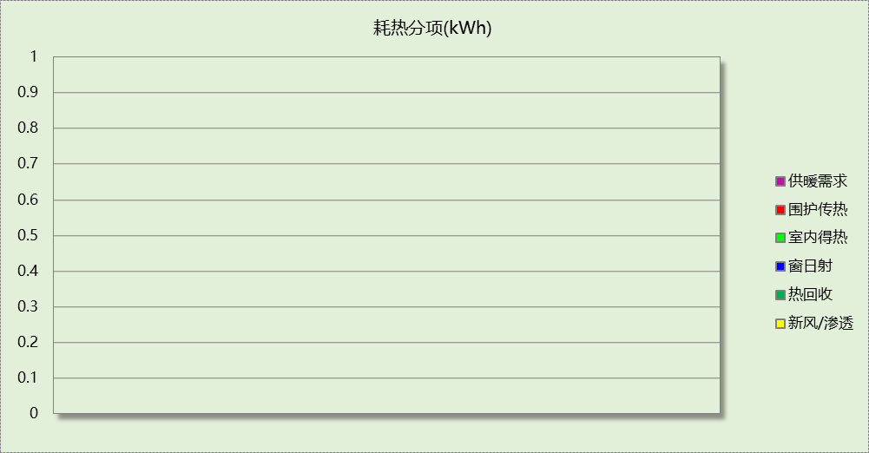

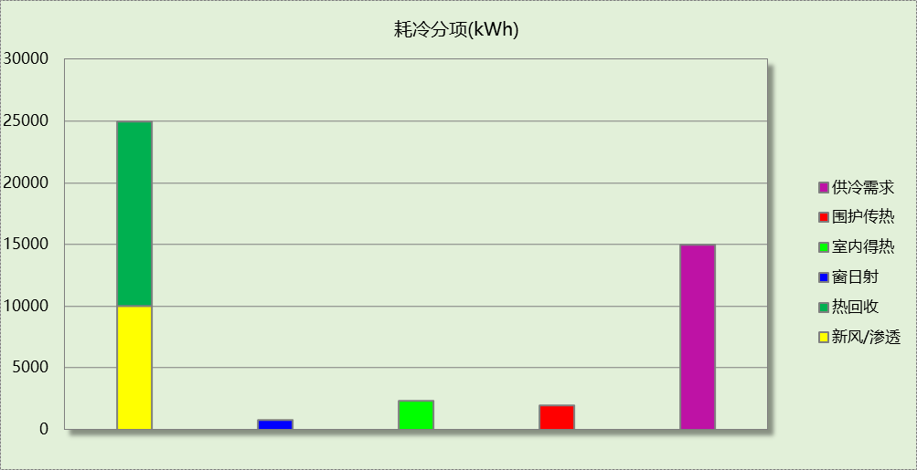

## 逐月负荷表

|  |  |  |  |  |  |  |
| --- | --- | --- | --- | --- | --- | --- |
| 月份 | 供暖(kWh) | 供冷(kWh) | 热负荷 峰值(kW) | 热负荷 峰值时刻 | 冷负荷 峰值(kW) | 冷负荷 峰值时刻 |
| 1月 | 0 | 0 | 0.000 | -- | 0.000 | -- |
| 2月 | 0 | 0 | 0.000 | -- | 0.000 | -- |
| 3月 | 0 | 0 | 0.000 | -- | 0.000 | -- |
| 4月 | 0 | 0 | 0.000 | -- | 0.000 | -- |
| 5月 | 0 | 0 | 0.000 | -- | 0.000 | -- |
| 6月 | 0 | 0 | 0.000 | -- | 0.000 | -- |
| 7月 | 0 | 9371 | 0.000 | -- | 156.186 | 7月8日14时 |
| 8月 | 0 | 5600 | 0.000 | -- | 187.700 | 8月26日8时 |
| 9月 | 0 | 0 | 0.000 | -- | 0.000 | -- |
| 10月 | 0 | 0 | 0.000 | -- | 0.000 | -- |
| 11月 | 0 | 0 | 0.000 | -- | 0.000 | -- |
| 12月 | 0 | 0 | 0.000 | -- | 0.000 | -- |

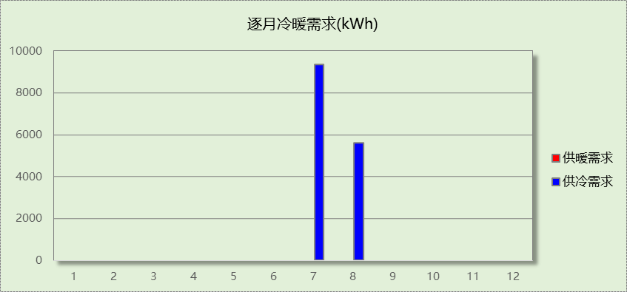

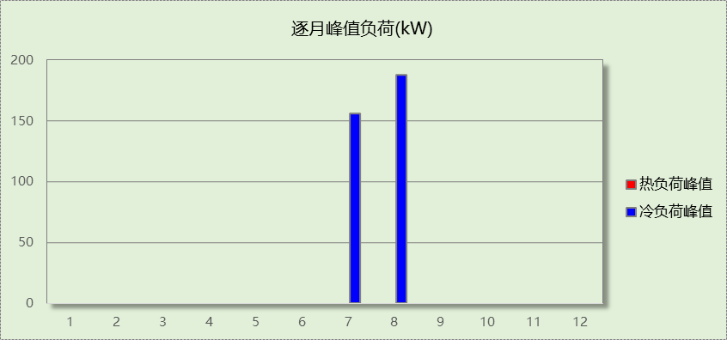

# 基准建筑

## 房间类型

### 房间参数表

|  |  |  |  |  |  |  |  |
| --- | --- | --- | --- | --- | --- | --- | --- |
| 房间类型 | 空调 温度℃ | 供暖 温度℃ | 新风量 | 渗透风 换气次数 | 人员密度 | 照明功率 密度 | 电器设备 功率 |
| 卫生间 | 26 | 20 | 30(m3/h.人) | 0(次/h) | 10(㎡/人) | 8(W/㎡) | 13(W/㎡) |
| 多媒体教室 | 26 | 20 | 30(m3/h.人) | 0(次/h) | 1.12(㎡/人) | 9(W/㎡) | 5(W/㎡) |
| 普通办公室 | 26 | 20 | 30(m3/h.人) | 0(次/h) | 10(㎡/人) | 8(W/㎡) | 13(W/㎡) |
| 普通教室 | 26 | 20 | 30(m3/h.人) | 0(次/h) | 1.12(㎡/人) | 9(W/㎡) | 5(W/㎡) |
| 楼梯间 | － | － | 20(m3/h.人) | 0(次/h) | 50(㎡/人) | 0(W/㎡) | 0(W/㎡) |
| 空房间 | － | － | 20(m3/h.人) | 0(次/h) | 50(㎡/人) | 0(W/㎡) | 0(W/㎡) |
| 舞蹈教室 | 26 | 20 | 30(m3/h.人) | 0(次/h) | 1.12(㎡/人) | 9(W/㎡) | 5(W/㎡) |
| 设备间 | － | － | 0(m3/h.人) | 0(次/h) | 0(人) | 5(W/㎡) | 0(W/㎡) |
| 走廊 | 26 | 20 | 30(m3/h.人) | 0(次/h) | 20(㎡/人) | 10(W/㎡) | 0(W/㎡) |

### 作息时间表

同设计建筑

## 系统类型

|  |  |  |  |  |  |
| --- | --- | --- | --- | --- | --- |
| 系统编号 | 系统类型 | 制冷 SEER | 制热 HSPF | 面积(㎡) | 包含的房间 |
| 默认 | 单元式房间空调器 | 3.50[全年能源消耗效率(APF)] | | 同设计建筑 | 同设计建筑 |

## 制冷系统

### 多联机/单元式空调能耗

|  |  |  |  |
| --- | --- | --- | --- |
| 系统编号 | 制冷SEER | 耗冷量(kWh) | 耗电量(kWh) |
| 默认 | 3.50[全年能源消耗效率(APF)] | 33053 | 9444 |

## 照明

|  |  |  |  |  |
| --- | --- | --- | --- | --- |
| 房间类型 | 单位面积电耗 (kWh/㎡) | 房间个数 | 房间合计面积 (㎡) | 合计电耗 (kWh) |
| 卫生间 | 22.78 | 6 | 43 | 981 |
| 多媒体教室 | 17.78 | 1 | 130 | 2302 |
| 普通办公室 | 22.78 | 2 | 62 | 1401 |
| 普通教室 | 17.78 | 4 | 563 | 10014 |
| 楼梯间 | 0.00 | 6 | 136 | 0 |
| 空房间 | 0.00 | 1 | 25 | 0 |
| 舞蹈教室 | 17.78 | 1 | 74 | 1321 |
| 设备间 | 0.00 | 1 | 128 | 0 |
| 走廊 | 2.85 | 4 | 264 | 751 |
| 总计 | | | | 16770 |

## 生活热水

### 热水需求

|  |  |  |  |  |  |
| --- | --- | --- | --- | --- | --- |
| 分区 | 用水定额 (L/人·d) | 热水温差(℃) | 用水人数 | 年使用天数 | 所需热量 (kWh/a) |
| 办公 | 10 | 45 | 5 | 365 | 939 |
| 总计 | | | | | 939 |

### 热水设备

|  |  |  |  |  |  |
| --- | --- | --- | --- | --- | --- |
| 热水设备 | 供热比例 | 供热量(kWh/a) | 能源 | 效率 | 耗气量(m3/a) |
| 锅炉 | 1 | 939 | 天然气 | 0.9 | 105.913 |
| 备注 |  | | | | |

## 负荷分项统计

|  |  |  |  |  |  |  |
| --- | --- | --- | --- | --- | --- | --- |
| 分类 | 围护传热 | 室内得热 | 窗日射 | 新风/渗透 | 热回收 | 合计 |
| 供暖(kWh/㎡) | 0.00 | 0.00 | 0.00 | 0.00 | 0.00 | 0.00 |
| 供冷(kWh/㎡) | 2.37 | 2.12 | 0.73 | 17.12 | 0.00 | 22.33 |



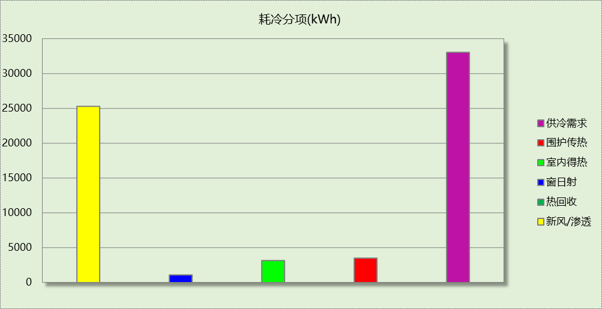

## 逐月负荷表

|  |  |  |  |  |  |  |
| --- | --- | --- | --- | --- | --- | --- |
| 月份 | 供暖(kWh) | 供冷(kWh) | 热负荷 峰值(kW) | 热负荷 峰值时刻 | 冷负荷 峰值(kW) | 冷负荷 峰值时刻 |
| 1月 | 0 | 0 | 0.000 | -- | 0.000 | -- |
| 2月 | 0 | 0 | 0.000 | -- | 0.000 | -- |
| 3月 | 0 | 0 | 0.000 | -- | 0.000 | -- |
| 4月 | 0 | 0 | 0.000 | -- | 0.000 | -- |
| 5月 | 0 | 0 | 0.000 | -- | 0.000 | -- |
| 6月 | 0 | 0 | 0.000 | -- | 0.000 | -- |
| 7月 | 0 | 21611 | 0.000 | -- | 355.028 | 7月8日14时 |
| 8月 | 0 | 11442 | 0.000 | -- | 342.397 | 8月30日14时 |
| 9月 | 0 | 0 | 0.000 | -- | 0.000 | -- |
| 10月 | 0 | 0 | 0.000 | -- | 0.000 | -- |
| 11月 | 0 | 0 | 0.000 | -- | 0.000 | -- |
| 12月 | 0 | 0 | 0.000 | -- | 0.000 | -- |

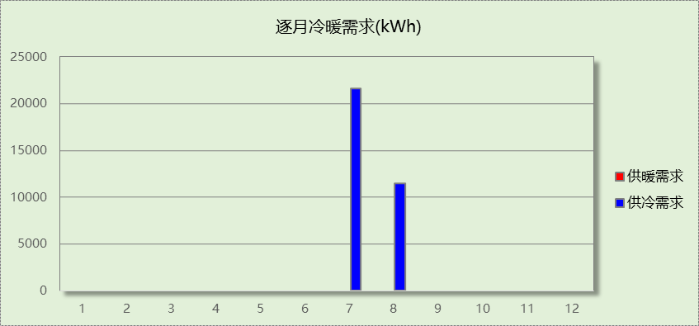

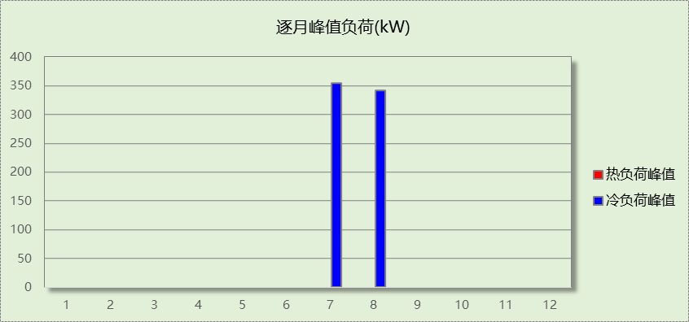

# 能效结果

## 建筑能耗

|  |  |  |  |  |
| --- | --- | --- | --- | --- |
| **设计建筑** | | | | |
| 用能分类 | | | 能耗值 | 一次能源(kWh/㎡) |
| 电力(kWh/㎡) | 供  冷 | 中央冷源 | 4.01 | 10.43 |
| 冷却水泵 | 0.00 | 0.00 |
| 冷冻水泵 | 6.09 | 15.83 |
| 冷却塔 | 1.56 | 4.06 |
| 多联机/单元式空调 | 0.00 | 0.00 |
| 供  暖 | 中央热源 | 0.00 | 0.00 |
| 供暖水泵 | 0.00 | 0.00 |
| 多联机/单元式热泵 | 0.00 | 0.00 |
| 热源侧水泵 | 0.00 | 0.00 |
| 照明 | | 0.54 | 1.40 |
| 生活热水 | | 0.00 | 0.00 |
| 电梯 | | 0.00 | 0.00 |
| 标准煤(kgce/㎡) | 供暖锅炉 | | 0.00 | 0.00 |
| 天然气(m³/㎡) | 供暖锅炉 | | 0.00 | 0.00 |
| 生活热水 | | 0.00 | 0.00 |
| 市政热力(kWh/㎡) | 市政热力 | | 0.00 | 0.00 |
| 可再生发电  (kWh/㎡) | 光伏发电 | | 62.24 | 161.82 |
| 风力发电 | | 0.00 | 0.00 |
| 建筑本体能耗(一次能源) (kWh/㎡) | | | 31.71 | |
| 建筑综合能耗(一次能源) (kWh/㎡) | | | 0.00 | |

|  |  |  |  |  |
| --- | --- | --- | --- | --- |
| **基准建筑** | | | | |
| 用能分类 | | | 能耗值 | 一次能源(kWh/㎡) |
| 电力(kWh/㎡) | 供  冷 | 中央冷源 | 0.00 | 0.00 |
| 冷却水泵 | 0.00 | 0.00 |
| 冷冻水泵 | 0.00 | 0.00 |
| 冷却塔 | 0.00 | 0.00 |
| 多联机/单元式空调 | 6.38 | 16.59 |
| 供  暖 | 中央热源 | 0.00 | 0.00 |
| 供暖水泵 | 0.00 | 0.00 |
| 多联机/单元式热泵 | 0.00 | 0.00 |
| 照明 | | 11.33 | 29.46 |
| 生活热水 | | 0.00 | 0.00 |
| 电梯 | | 0.00 | 0.00 |
| 标准煤(kgce/㎡) | 供暖锅炉 | | 0.00 | 0.00 |
| 天然气(m³/㎡) | 供暖锅炉 | | 0.00 | 0.00 |
| 生活热水 | | 0.07 | 0.69 |
| 市政热力(kWh/㎡) | 市政热力 | | 0.00 | 0.00 |
| 建筑本体能耗(一次能源) (kWh/㎡) | | | 46.75 | |
| 建筑综合能耗(一次能源) (kWh/㎡) | | | 46.75 | |

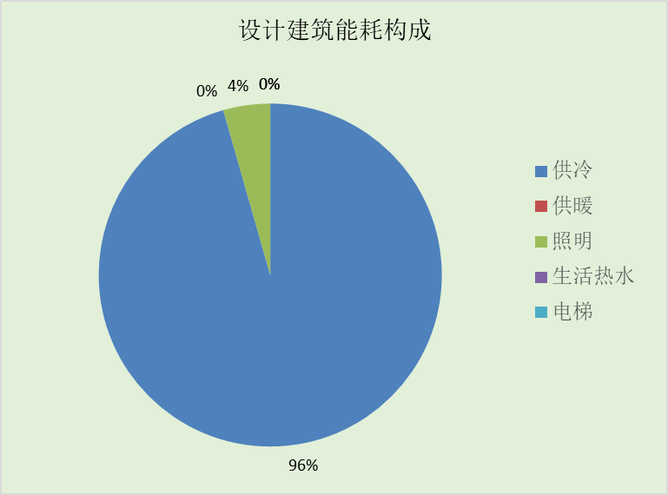

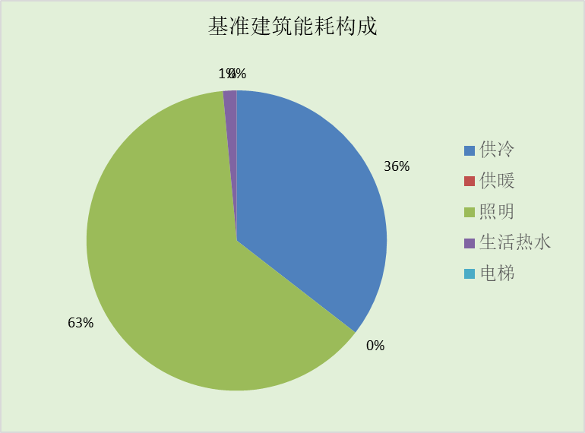

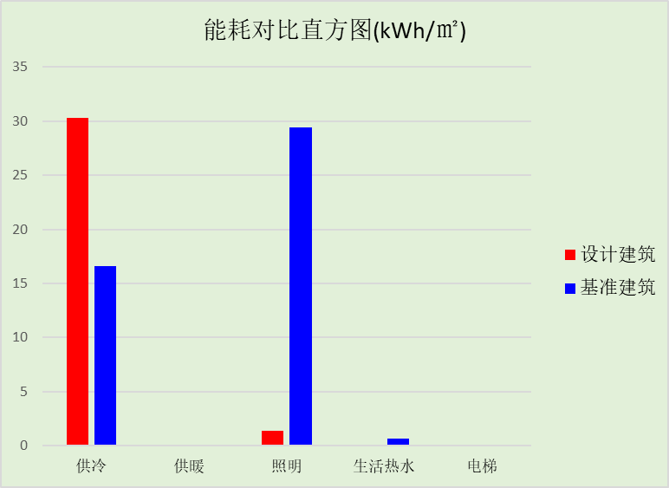

## 结论

|  |  |  |
| --- | --- | --- |
|  | 设计建筑 | 基准建筑 |
| 建筑本体能耗(一次能源) (kWh/㎡) | 31.71 | 46.75 |
| 建筑综合能耗(一次能源) (kWh/㎡) | 0.00 | 46.75 |
|  | 值 | 限值 |
| 建筑本体能耗节能率(%) | 32.16 | 20.00 |
| 建筑综合能耗节能率(%) | 100.00 | 50.00 |
| 标准依据 | 《近零能耗建筑技术标准》(GB/T51350-2019)表5.0.4 | |
| 标准要求 | 建筑综合节能率应≥50%; 建筑本体节能率应符合表5.0.4的要求 | |
| 结论 | 满足 | |

# 附录

暑假:7.15~8.25; 寒假：1.15~3.1

## 工作日/节假日人员逐时在室率(%)

|  |  |  |  |  |  |  |  |  |  |  |  |  |  |  |  |  |  |  |  |  |  |  |  |  |
| --- | --- | --- | --- | --- | --- | --- | --- | --- | --- | --- | --- | --- | --- | --- | --- | --- | --- | --- | --- | --- | --- | --- | --- | --- |
| 房间类型 | 1 | 2 | 3 | 4 | 5 | 6 | 7 | 8 | 9 | 10 | 11 | 12 | 13 | 14 | 15 | 16 | 17 | 18 | 19 | 20 | 21 | 22 | 23 | 24 |
| 卫生间 | 0 | 0 | 0 | 0 | 0 | 0 | 0 | 33 | 33 | 33 | 33 | 33 | 33 | 33 | 33 | 33 | 33 | 33 | 0 | 0 | 0 | 0 | 0 | 0 |
| 0 | 0 | 0 | 0 | 0 | 0 | 0 | 0 | 0 | 0 | 0 | 0 | 0 | 0 | 0 | 0 | 0 | 0 | 0 | 0 | 0 | 0 | 0 | 0 |
| 0 | 0 | 0 | 0 | 0 | 0 | 0 | 0 | 0 | 0 | 0 | 0 | 0 | 0 | 0 | 0 | 0 | 0 | 0 | 0 | 0 | 0 | 0 | 0 |
| 0 | 0 | 0 | 0 | 0 | 0 | 0 | 0 | 0 | 0 | 0 | 0 | 0 | 0 | 0 | 0 | 0 | 0 | 0 | 0 | 0 | 0 | 0 | 0 |
| 多媒体教室 | 0 | 0 | 0 | 0 | 0 | 0 | 0 | 27 | 27 | 27 | 27 | 27 | 27 | 27 | 27 | 27 | 27 | 27 | 0 | 0 | 0 | 0 | 0 | 0 |
| 0 | 0 | 0 | 0 | 0 | 0 | 0 | 0 | 0 | 0 | 0 | 0 | 0 | 0 | 0 | 0 | 0 | 0 | 0 | 0 | 0 | 0 | 0 | 0 |
| 0 | 0 | 0 | 0 | 0 | 0 | 0 | 0 | 0 | 0 | 0 | 0 | 0 | 0 | 0 | 0 | 0 | 0 | 0 | 0 | 0 | 0 | 0 | 0 |
| 0 | 0 | 0 | 0 | 0 | 0 | 0 | 0 | 0 | 0 | 0 | 0 | 0 | 0 | 0 | 0 | 0 | 0 | 0 | 0 | 0 | 0 | 0 | 0 |
| 普通办公室 | 0 | 0 | 0 | 0 | 0 | 0 | 0 | 33 | 33 | 33 | 33 | 33 | 33 | 33 | 33 | 33 | 33 | 33 | 0 | 0 | 0 | 0 | 0 | 0 |
| 0 | 0 | 0 | 0 | 0 | 0 | 0 | 0 | 0 | 0 | 0 | 0 | 0 | 0 | 0 | 0 | 0 | 0 | 0 | 0 | 0 | 0 | 0 | 0 |
| 0 | 0 | 0 | 0 | 0 | 0 | 0 | 0 | 0 | 0 | 0 | 0 | 0 | 0 | 0 | 0 | 0 | 0 | 0 | 0 | 0 | 0 | 0 | 0 |
| 0 | 0 | 0 | 0 | 0 | 0 | 0 | 0 | 0 | 0 | 0 | 0 | 0 | 0 | 0 | 0 | 0 | 0 | 0 | 0 | 0 | 0 | 0 | 0 |
| 普通教室 | 0 | 0 | 0 | 0 | 0 | 0 | 0 | 27 | 27 | 27 | 27 | 27 | 27 | 27 | 27 | 27 | 27 | 27 | 0 | 0 | 0 | 0 | 0 | 0 |
| 0 | 0 | 0 | 0 | 0 | 0 | 0 | 0 | 0 | 0 | 0 | 0 | 0 | 0 | 0 | 0 | 0 | 0 | 0 | 0 | 0 | 0 | 0 | 0 |
| 0 | 0 | 0 | 0 | 0 | 0 | 0 | 0 | 0 | 0 | 0 | 0 | 0 | 0 | 0 | 0 | 0 | 0 | 0 | 0 | 0 | 0 | 0 | 0 |
| 0 | 0 | 0 | 0 | 0 | 0 | 0 | 0 | 0 | 0 | 0 | 0 | 0 | 0 | 0 | 0 | 0 | 0 | 0 | 0 | 0 | 0 | 0 | 0 |
| 楼梯间 | 0 | 0 | 0 | 0 | 0 | 0 | 0 | 20 | 50 | 80 | 80 | 80 | 80 | 80 | 80 | 80 | 80 | 80 | 80 | 70 | 50 | 0 | 0 | 0 |
| 0 | 0 | 0 | 0 | 0 | 0 | 0 | 0 | 0 | 0 | 0 | 0 | 0 | 0 | 0 | 0 | 0 | 0 | 0 | 0 | 0 | 0 | 0 | 0 |
| 0 | 0 | 0 | 0 | 0 | 0 | 0 | 0 | 0 | 0 | 0 | 0 | 0 | 0 | 0 | 0 | 0 | 0 | 0 | 0 | 0 | 0 | 0 | 0 |
| 0 | 0 | 0 | 0 | 0 | 0 | 0 | 0 | 0 | 0 | 0 | 0 | 0 | 0 | 0 | 0 | 0 | 0 | 0 | 0 | 0 | 0 | 0 | 0 |
| 空房间 | 0 | 0 | 0 | 0 | 0 | 0 | 0 | 20 | 50 | 80 | 80 | 80 | 80 | 80 | 80 | 80 | 80 | 80 | 80 | 70 | 50 | 0 | 0 | 0 |
| 0 | 0 | 0 | 0 | 0 | 0 | 0 | 0 | 0 | 0 | 0 | 0 | 0 | 0 | 0 | 0 | 0 | 0 | 0 | 0 | 0 | 0 | 0 | 0 |
| 0 | 0 | 0 | 0 | 0 | 0 | 0 | 0 | 0 | 0 | 0 | 0 | 0 | 0 | 0 | 0 | 0 | 0 | 0 | 0 | 0 | 0 | 0 | 0 |
| 0 | 0 | 0 | 0 | 0 | 0 | 0 | 0 | 0 | 0 | 0 | 0 | 0 | 0 | 0 | 0 | 0 | 0 | 0 | 0 | 0 | 0 | 0 | 0 |
| 舞蹈教室 | 0 | 0 | 0 | 0 | 0 | 0 | 0 | 27 | 27 | 27 | 27 | 27 | 27 | 27 | 27 | 27 | 27 | 27 | 0 | 0 | 0 | 0 | 0 | 0 |
| 0 | 0 | 0 | 0 | 0 | 0 | 0 | 0 | 0 | 0 | 0 | 0 | 0 | 0 | 0 | 0 | 0 | 0 | 0 | 0 | 0 | 0 | 0 | 0 |
| 0 | 0 | 0 | 0 | 0 | 0 | 0 | 0 | 0 | 0 | 0 | 0 | 0 | 0 | 0 | 0 | 0 | 0 | 0 | 0 | 0 | 0 | 0 | 0 |
| 0 | 0 | 0 | 0 | 0 | 0 | 0 | 0 | 0 | 0 | 0 | 0 | 0 | 0 | 0 | 0 | 0 | 0 | 0 | 0 | 0 | 0 | 0 | 0 |
| 设备间 | 0 | 0 | 0 | 0 | 0 | 0 | 0 | 0 | 0 | 0 | 0 | 0 | 0 | 0 | 0 | 0 | 0 | 0 | 0 | 0 | 0 | 0 | 0 | 0 |
| 0 | 0 | 0 | 0 | 0 | 0 | 0 | 0 | 0 | 0 | 0 | 0 | 0 | 0 | 0 | 0 | 0 | 0 | 0 | 0 | 0 | 0 | 0 | 0 |
| 0 | 0 | 0 | 0 | 0 | 0 | 0 | 0 | 0 | 0 | 0 | 0 | 0 | 0 | 0 | 0 | 0 | 0 | 0 | 0 | 0 | 0 | 0 | 0 |
| 0 | 0 | 0 | 0 | 0 | 0 | 0 | 0 | 0 | 0 | 0 | 0 | 0 | 0 | 0 | 0 | 0 | 0 | 0 | 0 | 0 | 0 | 0 | 0 |
| 走廊 | 0 | 0 | 0 | 0 | 0 | 0 | 0 | 55 | 55 | 55 | 55 | 55 | 55 | 55 | 55 | 55 | 55 | 55 | 0 | 0 | 0 | 0 | 0 | 0 |
| 0 | 0 | 0 | 0 | 0 | 0 | 0 | 0 | 0 | 0 | 0 | 0 | 0 | 0 | 0 | 0 | 0 | 0 | 0 | 0 | 0 | 0 | 0 | 0 |
| 0 | 0 | 0 | 0 | 0 | 0 | 0 | 0 | 0 | 0 | 0 | 0 | 0 | 0 | 0 | 0 | 0 | 0 | 0 | 0 | 0 | 0 | 0 | 0 |
| 0 | 0 | 0 | 0 | 0 | 0 | 0 | 0 | 0 | 0 | 0 | 0 | 0 | 0 | 0 | 0 | 0 | 0 | 0 | 0 | 0 | 0 | 0 | 0 |

注：第一行：工作日；第二行：节假日；第三行：寒假；第四行：暑假

## 工作日/节假日照明开关时间表(%)

|  |  |  |  |  |  |  |  |  |  |  |  |  |  |  |  |  |  |  |  |  |  |  |  |  |
| --- | --- | --- | --- | --- | --- | --- | --- | --- | --- | --- | --- | --- | --- | --- | --- | --- | --- | --- | --- | --- | --- | --- | --- | --- |
| 房间类型 | 1 | 2 | 3 | 4 | 5 | 6 | 7 | 8 | 9 | 10 | 11 | 12 | 13 | 14 | 15 | 16 | 17 | 18 | 19 | 20 | 21 | 22 | 23 | 24 |
| 卫生间 | 0 | 0 | 0 | 0 | 0 | 0 | 100 | 100 | 100 | 100 | 100 | 100 | 100 | 100 | 100 | 100 | 100 | 100 | 100 | 0 | 0 | 0 | 0 | 0 |
| 0 | 0 | 0 | 0 | 0 | 0 | 0 | 0 | 0 | 0 | 0 | 0 | 0 | 0 | 0 | 0 | 0 | 0 | 0 | 0 | 0 | 0 | 0 | 0 |
| 0 | 0 | 0 | 0 | 0 | 0 | 0 | 0 | 0 | 0 | 0 | 0 | 0 | 0 | 0 | 0 | 0 | 0 | 0 | 0 | 0 | 0 | 0 | 0 |
| 0 | 0 | 0 | 0 | 0 | 0 | 0 | 0 | 0 | 0 | 0 | 0 | 0 | 0 | 0 | 0 | 0 | 0 | 0 | 0 | 0 | 0 | 0 | 0 |
| 多媒体教室 | 0 | 0 | 0 | 0 | 0 | 0 | 0 | 82 | 82 | 82 | 82 | 82 | 82 | 82 | 82 | 82 | 82 | 82 | 0 | 0 | 0 | 0 | 0 | 0 |
| 0 | 0 | 0 | 0 | 0 | 0 | 0 | 0 | 0 | 0 | 0 | 0 | 0 | 0 | 0 | 0 | 0 | 0 | 0 | 0 | 0 | 0 | 0 | 0 |
| 0 | 0 | 0 | 0 | 0 | 0 | 0 | 0 | 0 | 0 | 0 | 0 | 0 | 0 | 0 | 0 | 0 | 0 | 0 | 0 | 0 | 0 | 0 | 0 |
| 0 | 0 | 0 | 0 | 0 | 0 | 0 | 0 | 0 | 0 | 0 | 0 | 0 | 0 | 0 | 0 | 0 | 0 | 0 | 0 | 0 | 0 | 0 | 0 |
| 普通办公室 | 0 | 0 | 0 | 0 | 0 | 0 | 100 | 100 | 100 | 100 | 100 | 100 | 100 | 100 | 100 | 100 | 100 | 100 | 100 | 0 | 0 | 0 | 0 | 0 |
| 0 | 0 | 0 | 0 | 0 | 0 | 0 | 0 | 0 | 0 | 0 | 0 | 0 | 0 | 0 | 0 | 0 | 0 | 0 | 0 | 0 | 0 | 0 | 0 |
| 0 | 0 | 0 | 0 | 0 | 0 | 0 | 0 | 0 | 0 | 0 | 0 | 0 | 0 | 0 | 0 | 0 | 0 | 0 | 0 | 0 | 0 | 0 | 0 |
| 0 | 0 | 0 | 0 | 0 | 0 | 0 | 0 | 0 | 0 | 0 | 0 | 0 | 0 | 0 | 0 | 0 | 0 | 0 | 0 | 0 | 0 | 0 | 0 |
| 普通教室 | 0 | 0 | 0 | 0 | 0 | 0 | 0 | 82 | 82 | 82 | 82 | 82 | 82 | 82 | 82 | 82 | 82 | 82 | 0 | 0 | 0 | 0 | 0 | 0 |
| 0 | 0 | 0 | 0 | 0 | 0 | 0 | 0 | 0 | 0 | 0 | 0 | 0 | 0 | 0 | 0 | 0 | 0 | 0 | 0 | 0 | 0 | 0 | 0 |
| 0 | 0 | 0 | 0 | 0 | 0 | 0 | 0 | 0 | 0 | 0 | 0 | 0 | 0 | 0 | 0 | 0 | 0 | 0 | 0 | 0 | 0 | 0 | 0 |
| 0 | 0 | 0 | 0 | 0 | 0 | 0 | 0 | 0 | 0 | 0 | 0 | 0 | 0 | 0 | 0 | 0 | 0 | 0 | 0 | 0 | 0 | 0 | 0 |
| 楼梯间 | 10 | 10 | 10 | 10 | 10 | 10 | 10 | 50 | 60 | 60 | 60 | 60 | 60 | 60 | 60 | 60 | 80 | 90 | 100 | 100 | 100 | 10 | 10 | 10 |
| 0 | 0 | 0 | 0 | 0 | 0 | 0 | 0 | 0 | 0 | 0 | 0 | 0 | 0 | 0 | 0 | 0 | 0 | 0 | 0 | 0 | 0 | 0 | 0 |
| 0 | 0 | 0 | 0 | 0 | 0 | 0 | 0 | 0 | 0 | 0 | 0 | 0 | 0 | 0 | 0 | 0 | 0 | 0 | 0 | 0 | 0 | 0 | 0 |
| 0 | 0 | 0 | 0 | 0 | 0 | 0 | 0 | 0 | 0 | 0 | 0 | 0 | 0 | 0 | 0 | 0 | 0 | 0 | 0 | 0 | 0 | 0 | 0 |
| 空房间 | 10 | 10 | 10 | 10 | 10 | 10 | 10 | 50 | 60 | 60 | 60 | 60 | 60 | 60 | 60 | 60 | 80 | 90 | 100 | 100 | 100 | 10 | 10 | 10 |
| 0 | 0 | 0 | 0 | 0 | 0 | 0 | 0 | 0 | 0 | 0 | 0 | 0 | 0 | 0 | 0 | 0 | 0 | 0 | 0 | 0 | 0 | 0 | 0 |
| 0 | 0 | 0 | 0 | 0 | 0 | 0 | 0 | 0 | 0 | 0 | 0 | 0 | 0 | 0 | 0 | 0 | 0 | 0 | 0 | 0 | 0 | 0 | 0 |
| 0 | 0 | 0 | 0 | 0 | 0 | 0 | 0 | 0 | 0 | 0 | 0 | 0 | 0 | 0 | 0 | 0 | 0 | 0 | 0 | 0 | 0 | 0 | 0 |
| 舞蹈教室 | 0 | 0 | 0 | 0 | 0 | 0 | 0 | 82 | 82 | 82 | 82 | 82 | 82 | 82 | 82 | 82 | 82 | 82 | 0 | 0 | 0 | 0 | 0 | 0 |
| 0 | 0 | 0 | 0 | 0 | 0 | 0 | 0 | 0 | 0 | 0 | 0 | 0 | 0 | 0 | 0 | 0 | 0 | 0 | 0 | 0 | 0 | 0 | 0 |
| 0 | 0 | 0 | 0 | 0 | 0 | 0 | 0 | 0 | 0 | 0 | 0 | 0 | 0 | 0 | 0 | 0 | 0 | 0 | 0 | 0 | 0 | 0 | 0 |
| 0 | 0 | 0 | 0 | 0 | 0 | 0 | 0 | 0 | 0 | 0 | 0 | 0 | 0 | 0 | 0 | 0 | 0 | 0 | 0 | 0 | 0 | 0 | 0 |
| 设备间 | 0 | 0 | 0 | 0 | 0 | 0 | 0 | 0 | 0 | 0 | 0 | 0 | 0 | 0 | 0 | 0 | 0 | 0 | 0 | 0 | 0 | 0 | 0 | 0 |
| 0 | 0 | 0 | 0 | 0 | 0 | 0 | 0 | 0 | 0 | 0 | 0 | 0 | 0 | 0 | 0 | 0 | 0 | 0 | 0 | 0 | 0 | 0 | 0 |
| 0 | 0 | 0 | 0 | 0 | 0 | 0 | 0 | 0 | 0 | 0 | 0 | 0 | 0 | 0 | 0 | 0 | 0 | 0 | 0 | 0 | 0 | 0 | 0 |
| 0 | 0 | 0 | 0 | 0 | 0 | 0 | 0 | 0 | 0 | 0 | 0 | 0 | 0 | 0 | 0 | 0 | 0 | 0 | 0 | 0 | 0 | 0 | 0 |
| 走廊 | 0 | 0 | 0 | 0 | 0 | 0 | 10 | 10 | 10 | 10 | 10 | 10 | 10 | 10 | 10 | 10 | 10 | 10 | 10 | 0 | 0 | 0 | 0 | 0 |
| 0 | 0 | 0 | 0 | 0 | 0 | 0 | 0 | 0 | 0 | 0 | 0 | 0 | 0 | 0 | 0 | 0 | 0 | 0 | 0 | 0 | 0 | 0 | 0 |
| 0 | 0 | 0 | 0 | 0 | 0 | 0 | 0 | 0 | 0 | 0 | 0 | 0 | 0 | 0 | 0 | 0 | 0 | 0 | 0 | 0 | 0 | 0 | 0 |
| 0 | 0 | 0 | 0 | 0 | 0 | 0 | 0 | 0 | 0 | 0 | 0 | 0 | 0 | 0 | 0 | 0 | 0 | 0 | 0 | 0 | 0 | 0 | 0 |

注：第一行：工作日；第二行：节假日；第三行：寒假；第四行：暑假

## 工作日/节假日设备逐时使用率(%)

|  |  |  |  |  |  |  |  |  |  |  |  |  |  |  |  |  |  |  |  |  |  |  |  |  |
| --- | --- | --- | --- | --- | --- | --- | --- | --- | --- | --- | --- | --- | --- | --- | --- | --- | --- | --- | --- | --- | --- | --- | --- | --- |
| 房间类型 | 1 | 2 | 3 | 4 | 5 | 6 | 7 | 8 | 9 | 10 | 11 | 12 | 13 | 14 | 15 | 16 | 17 | 18 | 19 | 20 | 21 | 22 | 23 | 24 |
| 卫生间 | 0 | 0 | 0 | 0 | 0 | 0 | 0 | 33 | 33 | 33 | 33 | 33 | 33 | 33 | 33 | 33 | 33 | 33 | 0 | 0 | 0 | 0 | 0 | 0 |
| 0 | 0 | 0 | 0 | 0 | 0 | 0 | 0 | 0 | 0 | 0 | 0 | 0 | 0 | 0 | 0 | 0 | 0 | 0 | 0 | 0 | 0 | 0 | 0 |
| 0 | 0 | 0 | 0 | 0 | 0 | 0 | 0 | 0 | 0 | 0 | 0 | 0 | 0 | 0 | 0 | 0 | 0 | 0 | 0 | 0 | 0 | 0 | 0 |
| 0 | 0 | 0 | 0 | 0 | 0 | 0 | 0 | 0 | 0 | 0 | 0 | 0 | 0 | 0 | 0 | 0 | 0 | 0 | 0 | 0 | 0 | 0 | 0 |
| 多媒体教室 | 0 | 0 | 0 | 0 | 0 | 0 | 0 | 15 | 15 | 15 | 15 | 15 | 15 | 15 | 15 | 15 | 15 | 15 | 0 | 0 | 0 | 0 | 0 | 0 |
| 0 | 0 | 0 | 0 | 0 | 0 | 0 | 0 | 0 | 0 | 0 | 0 | 0 | 0 | 0 | 0 | 0 | 0 | 0 | 0 | 0 | 0 | 0 | 0 |
| 0 | 0 | 0 | 0 | 0 | 0 | 0 | 0 | 0 | 0 | 0 | 0 | 0 | 0 | 0 | 0 | 0 | 0 | 0 | 0 | 0 | 0 | 0 | 0 |
| 0 | 0 | 0 | 0 | 0 | 0 | 0 | 0 | 0 | 0 | 0 | 0 | 0 | 0 | 0 | 0 | 0 | 0 | 0 | 0 | 0 | 0 | 0 | 0 |
| 普通办公室 | 0 | 0 | 0 | 0 | 0 | 0 | 0 | 33 | 33 | 33 | 33 | 33 | 33 | 33 | 33 | 33 | 33 | 33 | 0 | 0 | 0 | 0 | 0 | 0 |
| 0 | 0 | 0 | 0 | 0 | 0 | 0 | 0 | 0 | 0 | 0 | 0 | 0 | 0 | 0 | 0 | 0 | 0 | 0 | 0 | 0 | 0 | 0 | 0 |
| 0 | 0 | 0 | 0 | 0 | 0 | 0 | 0 | 0 | 0 | 0 | 0 | 0 | 0 | 0 | 0 | 0 | 0 | 0 | 0 | 0 | 0 | 0 | 0 |
| 0 | 0 | 0 | 0 | 0 | 0 | 0 | 0 | 0 | 0 | 0 | 0 | 0 | 0 | 0 | 0 | 0 | 0 | 0 | 0 | 0 | 0 | 0 | 0 |
| 普通教室 | 0 | 0 | 0 | 0 | 0 | 0 | 0 | 15 | 15 | 15 | 15 | 15 | 15 | 15 | 15 | 15 | 15 | 15 | 0 | 0 | 0 | 0 | 0 | 0 |
| 0 | 0 | 0 | 0 | 0 | 0 | 0 | 0 | 0 | 0 | 0 | 0 | 0 | 0 | 0 | 0 | 0 | 0 | 0 | 0 | 0 | 0 | 0 | 0 |
| 0 | 0 | 0 | 0 | 0 | 0 | 0 | 0 | 0 | 0 | 0 | 0 | 0 | 0 | 0 | 0 | 0 | 0 | 0 | 0 | 0 | 0 | 0 | 0 |
| 0 | 0 | 0 | 0 | 0 | 0 | 0 | 0 | 0 | 0 | 0 | 0 | 0 | 0 | 0 | 0 | 0 | 0 | 0 | 0 | 0 | 0 | 0 | 0 |
| 楼梯间 | 0 | 0 | 0 | 0 | 0 | 0 | 0 | 30 | 50 | 80 | 80 | 80 | 80 | 80 | 80 | 80 | 80 | 80 | 80 | 70 | 50 | 0 | 0 | 0 |
| 0 | 0 | 0 | 0 | 0 | 0 | 0 | 0 | 0 | 0 | 0 | 0 | 0 | 0 | 0 | 0 | 0 | 0 | 0 | 0 | 0 | 0 | 0 | 0 |
| 0 | 0 | 0 | 0 | 0 | 0 | 0 | 0 | 0 | 0 | 0 | 0 | 0 | 0 | 0 | 0 | 0 | 0 | 0 | 0 | 0 | 0 | 0 | 0 |
| 0 | 0 | 0 | 0 | 0 | 0 | 0 | 0 | 0 | 0 | 0 | 0 | 0 | 0 | 0 | 0 | 0 | 0 | 0 | 0 | 0 | 0 | 0 | 0 |
| 空房间 | 0 | 0 | 0 | 0 | 0 | 0 | 0 | 30 | 50 | 80 | 80 | 80 | 80 | 80 | 80 | 80 | 80 | 80 | 80 | 70 | 50 | 0 | 0 | 0 |
| 0 | 0 | 0 | 0 | 0 | 0 | 0 | 0 | 0 | 0 | 0 | 0 | 0 | 0 | 0 | 0 | 0 | 0 | 0 | 0 | 0 | 0 | 0 | 0 |
| 0 | 0 | 0 | 0 | 0 | 0 | 0 | 0 | 0 | 0 | 0 | 0 | 0 | 0 | 0 | 0 | 0 | 0 | 0 | 0 | 0 | 0 | 0 | 0 |
| 0 | 0 | 0 | 0 | 0 | 0 | 0 | 0 | 0 | 0 | 0 | 0 | 0 | 0 | 0 | 0 | 0 | 0 | 0 | 0 | 0 | 0 | 0 | 0 |
| 舞蹈教室 | 0 | 0 | 0 | 0 | 0 | 0 | 0 | 15 | 15 | 15 | 15 | 15 | 15 | 15 | 15 | 15 | 15 | 15 | 0 | 0 | 0 | 0 | 0 | 0 |
| 0 | 0 | 0 | 0 | 0 | 0 | 0 | 0 | 0 | 0 | 0 | 0 | 0 | 0 | 0 | 0 | 0 | 0 | 0 | 0 | 0 | 0 | 0 | 0 |
| 0 | 0 | 0 | 0 | 0 | 0 | 0 | 0 | 0 | 0 | 0 | 0 | 0 | 0 | 0 | 0 | 0 | 0 | 0 | 0 | 0 | 0 | 0 | 0 |
| 0 | 0 | 0 | 0 | 0 | 0 | 0 | 0 | 0 | 0 | 0 | 0 | 0 | 0 | 0 | 0 | 0 | 0 | 0 | 0 | 0 | 0 | 0 | 0 |
| 设备间 | 0 | 0 | 0 | 0 | 0 | 0 | 0 | 0 | 0 | 0 | 0 | 0 | 0 | 0 | 0 | 0 | 0 | 0 | 0 | 0 | 0 | 0 | 0 | 0 |
| 0 | 0 | 0 | 0 | 0 | 0 | 0 | 0 | 0 | 0 | 0 | 0 | 0 | 0 | 0 | 0 | 0 | 0 | 0 | 0 | 0 | 0 | 0 | 0 |
| 0 | 0 | 0 | 0 | 0 | 0 | 0 | 0 | 0 | 0 | 0 | 0 | 0 | 0 | 0 | 0 | 0 | 0 | 0 | 0 | 0 | 0 | 0 | 0 |
| 0 | 0 | 0 | 0 | 0 | 0 | 0 | 0 | 0 | 0 | 0 | 0 | 0 | 0 | 0 | 0 | 0 | 0 | 0 | 0 | 0 | 0 | 0 | 0 |
| 走廊 | 0 | 0 | 0 | 0 | 0 | 0 | 0 | 0 | 0 | 0 | 0 | 0 | 0 | 0 | 0 | 0 | 0 | 0 | 0 | 0 | 0 | 0 | 0 | 0 |
| 0 | 0 | 0 | 0 | 0 | 0 | 0 | 0 | 0 | 0 | 0 | 0 | 0 | 0 | 0 | 0 | 0 | 0 | 0 | 0 | 0 | 0 | 0 | 0 |
| 0 | 0 | 0 | 0 | 0 | 0 | 0 | 0 | 0 | 0 | 0 | 0 | 0 | 0 | 0 | 0 | 0 | 0 | 0 | 0 | 0 | 0 | 0 | 0 |
| 0 | 0 | 0 | 0 | 0 | 0 | 0 | 0 | 0 | 0 | 0 | 0 | 0 | 0 | 0 | 0 | 0 | 0 | 0 | 0 | 0 | 0 | 0 | 0 |

注：第一行：工作日；第二行：节假日；第三行：寒假；第四行：暑假

## 工作日/节假日空调系统运行时间表(1:开,0:关)

采暖期：

|  |  |  |  |  |  |  |  |  |  |  |  |  |  |  |  |  |  |  |  |  |  |  |  |  |
| --- | --- | --- | --- | --- | --- | --- | --- | --- | --- | --- | --- | --- | --- | --- | --- | --- | --- | --- | --- | --- | --- | --- | --- | --- |
| 系统编号 | 1 | 2 | 3 | 4 | 5 | 6 | 7 | 8 | 9 | 10 | 11 | 12 | 13 | 14 | 15 | 16 | 17 | 18 | 19 | 20 | 21 | 22 | 23 | 24 |
| 默认 | 0 | 0 | 0 | 0 | 0 | 0 | 0 | 0 | 0 | 0 | 0 | 0 | 0 | 0 | 0 | 0 | 0 | 0 | 0 | 0 | 0 | 0 | 0 | 0 |
| 0 | 0 | 0 | 0 | 0 | 0 | 0 | 0 | 0 | 0 | 0 | 0 | 0 | 0 | 0 | 0 | 0 | 0 | 0 | 0 | 0 | 0 | 0 | 0 |
| 0 | 0 | 0 | 0 | 0 | 0 | 0 | 0 | 0 | 0 | 0 | 0 | 0 | 0 | 0 | 0 | 0 | 0 | 0 | 0 | 0 | 0 | 0 | 0 |
| 0 | 0 | 0 | 0 | 0 | 0 | 0 | 0 | 0 | 0 | 0 | 0 | 0 | 0 | 0 | 0 | 0 | 0 | 0 | 0 | 0 | 0 | 0 | 0 |

供冷期：

|  |  |  |  |  |  |  |  |  |  |  |  |  |  |  |  |  |  |  |  |  |  |  |  |  |
| --- | --- | --- | --- | --- | --- | --- | --- | --- | --- | --- | --- | --- | --- | --- | --- | --- | --- | --- | --- | --- | --- | --- | --- | --- |
| 系统编号 | 1 | 2 | 3 | 4 | 5 | 6 | 7 | 8 | 9 | 10 | 11 | 12 | 13 | 14 | 15 | 16 | 17 | 18 | 19 | 20 | 21 | 22 | 23 | 24 |
| 默认 | 0 | 0 | 0 | 0 | 0 | 0 | 0 | 1 | 1 | 1 | 1 | 0 | 0 | 1 | 1 | 1 | 1 | 0 | 0 | 0 | 0 | 0 | 0 | 0 |
| 0 | 0 | 0 | 0 | 0 | 0 | 0 | 0 | 0 | 0 | 0 | 0 | 0 | 0 | 0 | 0 | 0 | 0 | 0 | 0 | 0 | 0 | 0 | 0 |
| 0 | 0 | 0 | 0 | 0 | 0 | 0 | 0 | 0 | 0 | 0 | 0 | 0 | 0 | 0 | 0 | 0 | 0 | 0 | 0 | 0 | 0 | 0 | 0 |
| 0 | 0 | 0 | 0 | 0 | 0 | 0 | 0 | 0 | 0 | 0 | 0 | 0 | 0 | 0 | 0 | 0 | 0 | 0 | 0 | 0 | 0 | 0 | 0 |

注：第一行：工作日；第二行：节假日；第三行：寒假；第四行：暑假

## 工作日/节假日新风运行时间表(%)

采暖期：

|  |  |  |  |  |  |  |  |  |  |  |  |  |  |  |  |  |  |  |  |  |  |  |  |  |
| --- | --- | --- | --- | --- | --- | --- | --- | --- | --- | --- | --- | --- | --- | --- | --- | --- | --- | --- | --- | --- | --- | --- | --- | --- |
| 系统编号 | 1 | 2 | 3 | 4 | 5 | 6 | 7 | 8 | 9 | 10 | 11 | 12 | 13 | 14 | 15 | 16 | 17 | 18 | 19 | 20 | 21 | 22 | 23 | 24 |
| 默认 | 0 | 0 | 0 | 0 | 0 | 0 | 0 | 0 | 0 | 0 | 0 | 0 | 0 | 0 | 0 | 0 | 0 | 0 | 0 | 0 | 0 | 0 | 0 | 0 |
| 0 | 0 | 0 | 0 | 0 | 0 | 0 | 0 | 0 | 0 | 0 | 0 | 0 | 0 | 0 | 0 | 0 | 0 | 0 | 0 | 0 | 0 | 0 | 0 |
| 0 | 0 | 0 | 0 | 0 | 0 | 0 | 0 | 0 | 0 | 0 | 0 | 0 | 0 | 0 | 0 | 0 | 0 | 0 | 0 | 0 | 0 | 0 | 0 |
| 0 | 0 | 0 | 0 | 0 | 0 | 0 | 0 | 0 | 0 | 0 | 0 | 0 | 0 | 0 | 0 | 0 | 0 | 0 | 0 | 0 | 0 | 0 | 0 |

供冷期：

|  |  |  |  |  |  |  |  |  |  |  |  |  |  |  |  |  |  |  |  |  |  |  |  |  |
| --- | --- | --- | --- | --- | --- | --- | --- | --- | --- | --- | --- | --- | --- | --- | --- | --- | --- | --- | --- | --- | --- | --- | --- | --- |
| 系统编号 | 1 | 2 | 3 | 4 | 5 | 6 | 7 | 8 | 9 | 10 | 11 | 12 | 13 | 14 | 15 | 16 | 17 | 18 | 19 | 20 | 21 | 22 | 23 | 24 |
| 默认 | 0 | 0 | 0 | 0 | 0 | 0 | 0 | 100 | 100 | 100 | 100 | 0 | 0 | 100 | 100 | 100 | 100 | 0 | 0 | 0 | 0 | 0 | 0 | 0 |
| 0 | 0 | 0 | 0 | 0 | 0 | 0 | 0 | 0 | 0 | 0 | 0 | 0 | 0 | 0 | 0 | 0 | 0 | 0 | 0 | 0 | 0 | 0 | 0 |
| 0 | 0 | 0 | 0 | 0 | 0 | 0 | 0 | 0 | 0 | 0 | 0 | 0 | 0 | 0 | 0 | 0 | 0 | 0 | 0 | 0 | 0 | 0 | 0 |
| 0 | 0 | 0 | 0 | 0 | 0 | 0 | 0 | 0 | 0 | 0 | 0 | 0 | 0 | 0 | 0 | 0 | 0 | 0 | 0 | 0 | 0 | 0 | 0 |

注：第一行：工作日；第二行：节假日；第三行：寒假；第四行：暑假