南昌某幼儿园
全年负荷计算书

工程名称 | 南昌某幼儿园
设计编号
建设单位
设计单位
计 算 人
校 对 人
审 核 人
计算日期 | 2024年12月11日

采用软件 | 暖通负荷BECH2024
软件版本 | 20240430(SP1)
研发单位 | 北京绿建软件股份有限公司
正版授权码 | T18270851291
目 录

1 建筑概况 1
2 气象数据 1
2.1 气象地点 1
2.2 逐日干球温度表 1
2.3 逐月辐照量表 2
2.4 峰值工况 2
3 软件介绍 2
4 围护结构 2
4.1 屋顶构造 2
4.1.1 屋顶构造一 2
4.2 外墙构造 3
4.2.1 外墙构造一 3
4.3 楼板构造 3
4.3.1 控温房间楼板构造一 3
4.4 非周边地面构造 3
4.4.1 非周边地面构造一 3
4.5 门构造 4
4.6 窗构造 4
5 房间类型 4
5.1 房间参数表 4
5.2 作息时间表 5
6 系统设置 5
6.1 系统划分 5
6.2 运行时间表 5
7 计算结果 5
7.1 模拟周期 5
7.2 全年冷暖需求 5
7.3 负荷分项统计 6
7.4 逐月负荷表 6
8 附录 8

建筑概况
地理位置 | 江西-南昌
气候分区 | 夏热冬冷A区
北纬 | 28.68
东经 | 115.86
建筑名称 | 南昌某幼儿园
建筑类型 | 公共建筑
建筑面积 | 地上 2593.79 ㎡ | 地下 0.00 ㎡
建筑高度 | 地上 11.70 m | 地下0.00
建筑层数 | 地上 3 | 地下 0
北向角度 | 90°

气象数据

气象地点
江西-南昌, 《建筑节能气象参数标准》JGJ346-2014

逐日干球温度表
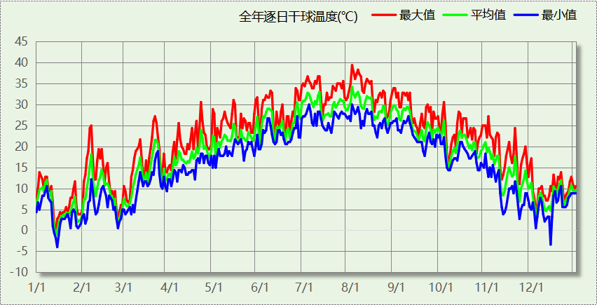

逐月辐照量表
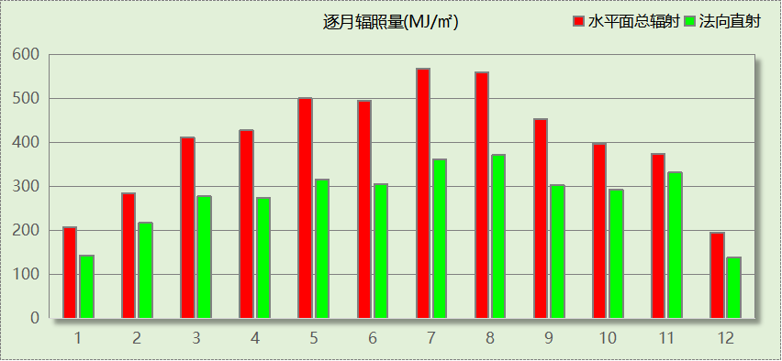

峰值工况
气象数据 | 时刻 | 干球温度(℃) | 湿球温度(℃) | 含湿量(g/kg) | 焓值(kj/kg)
最热 | 08月01日15时 | 39.4 | 27.8 | 19.3 | 89.3
最冷 | 01月14日08时 | -3.9 | -3.9 | 2.7 | 2.8

软件介绍
本报告采用的软件为绿建暖通负荷BECH2024，该软件紧密结合暖通和节能设计规范、可根据项目实际情况建立建筑热工模型，并可对围护结构材料、房间内扰发热、作息时间表、热回收方式等参数进行设置。
软件包含全国各地典型气象年数据，内置DOE2.1E内核，对于建筑的逐时负荷进行动态模拟，既可以模拟8760小时理想负荷，也可以根据设定好的采暖期/空调期进行逐时模拟。
软件还支持分析全年建筑能耗的来源构成，依据日射得热、新风负荷、围护传热和内扰得热进行归类分项，生成设计建筑全年负荷计算报告书，提供详实的数据和多样的图表，为设计师在设备选型、制定运行策略等方面提供参考和帮助。

围护结构

屋顶构造

屋顶构造一
材料名称  （由上到下） | 厚度δ | 导热系数λ | 蓄热系数S | 修正  系数 | 热阻R | 热惰性  指标
材料名称  （由上到下） | (mm) | W/(m.K) | W/(㎡.K) | α | (㎡K)/W | D=R*S
改性粉煤灰保温砂浆 | 25 | 0.035 | 1.070 | 1.00 | 0.714 | 0.764
沥青油毡、油毡纸 | 10 | 0.170 | 3.302 | 1.00 | 0.059 | 0.194
膨胀矿渣珠混凝土(ρ=2000) | 30 | 0.770 | 10.369 | 1.00 | 0.039 | 0.404
挤塑聚苯板（1） | 90 | 0.033 | 0.347 | 1.00 | 2.727 | 0.946
加气混凝土、泡沫混凝土(ρ=300) | 120 | 0.100 | 1.514 | 1.00 | 1.200 | 1.817
各层之和∑ | 275 | － | － | － | 4.739 | 4.126
传热系数K=1/(0.15+∑R) | 0.21

外墙构造

外墙构造一
材料名称  （由外到内） | 厚度δ | 导热系数λ | 蓄热系数S | 修正  系数 | 热阻R | 热惰性  指标
材料名称  （由外到内） | (mm) | W/(m.K) | W/(㎡.K) | α | (㎡K)/W | D=R*S
改性粉煤灰保温砂浆 | 5 | 0.035 | 1.070 | 1.00 | 0.143 | 0.153
岩棉板(ρ=60-160) | 10 | 0.041 | 0.615 | 1.00 | 0.244 | 0.150
蒸压砂加气混凝土砌块b06 | 150 | 0.160 | 3.280 | 1.25 | 0.750 | 3.075
加气混凝土、泡沫混凝土(ρ=300) | 100 | 0.100 | 1.514 | 1.00 | 1.000 | 1.514
水泥砂浆 | 20 | 0.930 | 11.370 | 1.00 | 0.022 | 0.245
各层之和∑ | 285 | － | － | － | 2.158 | 5.136
传热系数K=1/(0.15+∑R) | 0.43

楼板构造

控温房间楼板构造一
材料名称 | 厚度δ | 导热系数λ | 蓄热系数S | 修正  系数 | 热阻R | 热惰性  指标
材料名称 | (mm) | W/(m.K) | W/(㎡.K) | α | (㎡K)/W | D=R*S
水泥砂浆（1） | 15 | 0.930 | 11.306 | 1.00 | 0.016 | 0.182
砂加气砌块（B05级） | 200 | 0.194 | 3.335 | 1.00 | 1.031 | 3.438
水泥砂浆（1） | 15 | 0.930 | 11.306 | 1.00 | 0.016 | 0.182
各层之和∑ | 230 | － | － | － | 1.063 | 3.803
传热系数K=1/(0.22+∑R) | 0.78
修正后K, D | K = 0.82, D = 3.28
修正原因

非周边地面构造

非周边地面构造一
材料名称 | 厚度δ | 导热系数λ | 蓄热系数S | 修正  系数 | 热阻R | 热惰性  指标
材料名称 | (mm) | W/(m.K) | W/(㎡.K) | α | (㎡K)/W | D=R*S
水泥砂浆 | 20 | 0.930 | 11.370 | 1.00 | 0.022 | 0.245
加气混凝土、泡沫混凝土(ρ=300) | 120 | 0.100 | 1.514 | 1.00 | 1.200 | 1.817
各层之和∑ | 140 | － | － | － | 1.222 | 2.061
传热系数K=1/(0.11+∑R) | 0.22

门构造
序号 | 构造名称 | 传热系数 | 备注
1 | 保温门（多功能门） | 1.972

窗构造
序号 | 构造名称 | 传热系数 | 窗遮阳系数 | 可见光透射比 | 备注
1 | Low-E中空玻璃窗高 | 2.400 | 0.251 | 0.710

房间类型

房间参数表
房间类型 | 空调温度  ℃ | 供暖温度  ℃ | 新风量 | 人员密度 | 照明功率  密度 | 电器设备  功率
主食库 | － | － | 0(m^3/h.人) | 0(m^2/人) | 10(W/m^2) | 0(W/m^2)
会议室 | 26 | 22 | 30(m^3/h.人) | 6(人) | 8(W/m^2) | 5(W/m^2)
储藏间 | － | － | 0(m^3/h.人) | 0(m^2/人) | 9(W/m^2) | 5(W/m^2)
冷库 | 0 | 0 | 0(m^3/h.人) | 0(m^2/人) | 10(W/m^2) | 0(W/m^2)
副食库 | － | － | 0(m^3/h.人) | 0(m^2/人) | 10(W/m^2) | 5(W/m^2)
卫生间 | 26 | 22 | 0(m^3/h.人) | 6(人) | 5(W/m^2) | 5(W/m^2)
厨房 | 27 | 22 | 0(次/h) | 4(人) | 8(W/m^2) | 5(W/m^2)
开水间 | 26 | 18 | 0(m^3/h.人) | 2(人) | 9(W/m^2) | 5(W/m^2)
教具制作室 | － | － | 30(m^3/h.人) | 4(人) | 9(W/m^2) | 5(W/m^2)
普通办公室 | 26 | 22 | 30(m^3/h.人) | 6(人) | 8(W/m^2) | 5(W/m^2)
普通教室 | 26 | 22 | 30(m^3/h.人) | 30(人) | 8(W/m^2) | 5(W/m^2)
更衣室 | 26 | 20 | 30(m^3/h.人) | 2(人) | 5(W/m^2) | 5(W/m^2)
洗消间 | － | － | 0(m^3/h.人) | 1(人) | 10(W/m^2) | 5(W/m^2)
消毒室 | － | － | 0(m^3/h.人) | 0(m^2/人) | 9(W/m^2) | 5(W/m^2)
空房间 | － | － | 20(m^3/h.人) | 0(人) | 0(W/m^2) | 0(W/m^2)
设备间 | － | － | 0(次/h) | 0(人) | 6(W/m^2) | 15(W/m^2)
走廊 | － | － | 0(m^3/h.人) | 0(人) | 5(W/m^2) | 5(W/m^2)
配电间 | － | － | 0(m^3/h.人) | 0(m^2/人) | 10(W/m^2) | 5(W/m^2)
阅览室 | 26 | 22 | 30(m^3/h.人) | 30(人) | 8(W/m^2) | 5(W/m^2)

作息时间表
详见附录

系统设置

系统划分
系统编号 | 热回收  类型 | 启动  条件 | 回收  效率 | 排风  比例 | 面积(m2) | 包含的房间
默认 | 无 | -- | -- | -- | 2203.06 | 所有房间

运行时间表
详见附录

计算结果

模拟周期
供冷季(6.14-9.30) 供暖季(11.30-2.28)

全年冷暖需求
系统名称\负荷 | 供暖需求  (kWh) | 供暖指标  (kWh/㎡·a) | 供冷需求  (kWh) | 供冷指标  (kWh/㎡·a)
建筑总计 | 36049 | 13.90 | 179373 | 69.15
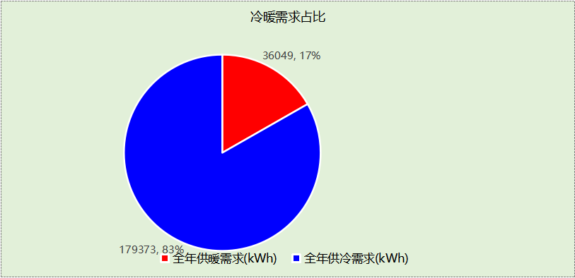

负荷分项统计
分类 | 围护传热 | 室内得热 | 窗日射 | 新风/渗透 | 热回收 | 合计
供暖(kWh/㎡) | -5.57 | 8.48 | 0.96 | -17.77 | 0.00 | -13.90
供冷(kWh/㎡) | 12.23 | 19.25 | 1.79 | 35.88 | 0.00 | 69.15
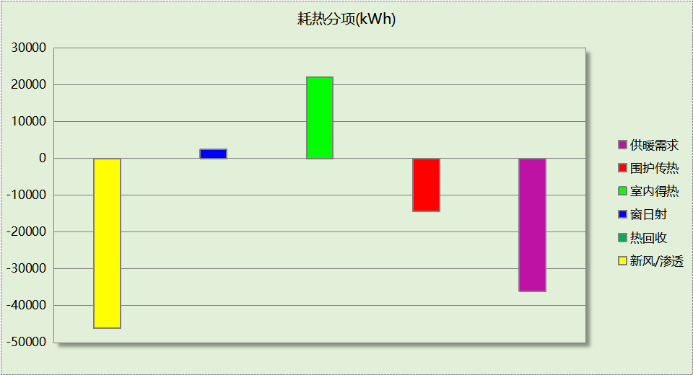
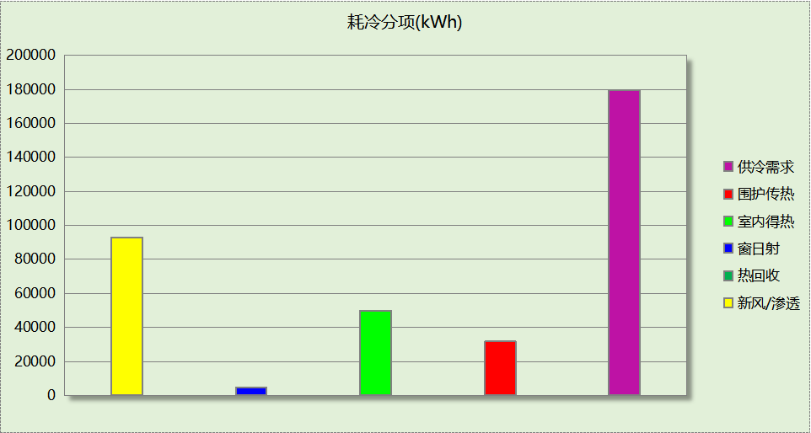

逐月负荷表
月份 | 供暖(kWh) | 供冷(kWh) | 热负荷  峰值(kW) | 热负荷  峰值时刻 | 冷负荷  峰值(kW) | 冷负荷  峰值时刻
1月 | 18179 | 0 | 175.252 | 1月14日7时 | 0.000 | --
2月 | 7567 | 0 | 131.560 | 2月25日7时 | 0.000 | --
3月 | 0 | 0 | 0.000 | -- | 0.000 | --
4月 | 0 | 0 | 0.000 | -- | 0.000 | --
5月 | 0 | 0 | 0.000 | -- | 0.000 | --
6月 | 0 | 26526 | 0.000 | -- | 447.301 | 6月14日7时
7月 | 0 | 62245 | 0.000 | -- | 269.554 | 7月2日8时
8月 | 0 | 55774 | 0.000 | -- | 285.164 | 8月5日10时
9月 | 0 | 34827 | 0.000 | -- | 226.262 | 9月9日14时
10月 | 0 | 0 | 0.000 | -- | 0.000 | --
11月 | 0 | 0 | 0.000 | -- | 0.000 | --
12月 | 10303 | 0 | 115.232 | 12月9日7时 | 0.000 | --
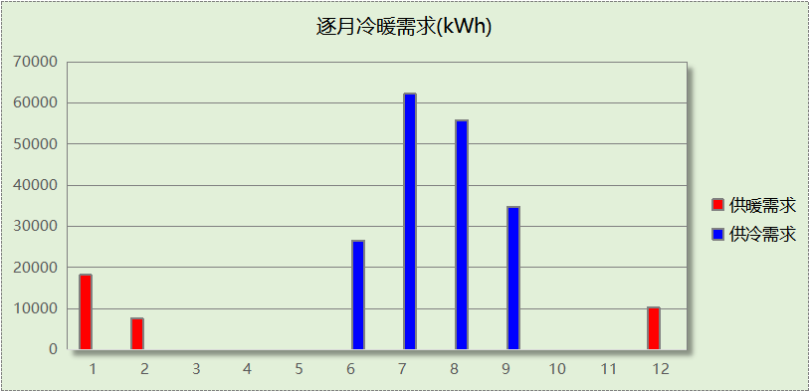
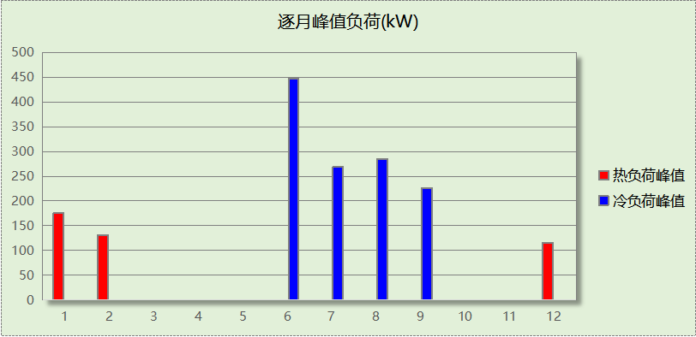

附录
工作日/节假日人员逐时在室率(%)

房间类型 | 1 | 2 | 3 | 4 | 5 | 6 | 7 | 8 | 9 | 10 | 11 | 12 | 13 | 14 | 15 | 16 | 17 | 18 | 19 | 20 | 21 | 22 | 23 | 24
主食库 | 0 | 0 | 0 | 0 | 0 | 0 | 10 | 50 | 95 | 95 | 95 | 80 | 80 | 95 | 95 | 95 | 95 | 30 | 30 | 0 | 0 | 0 | 0 | 0
主食库 | 0 | 0 | 0 | 0 | 0 | 0 | 0 | 0 | 0 | 0 | 0 | 0 | 0 | 0 | 0 | 0 | 0 | 0 | 0 | 0 | 0 | 0 | 0 | 0
会议室 | 0 | 0 | 0 | 0 | 0 | 0 | 10 | 50 | 95 | 95 | 95 | 80 | 80 | 95 | 95 | 95 | 95 | 30 | 30 | 0 | 0 | 0 | 0 | 0
会议室 | 0 | 0 | 0 | 0 | 0 | 0 | 0 | 0 | 0 | 0 | 0 | 0 | 0 | 0 | 0 | 0 | 0 | 0 | 0 | 0 | 0 | 0 | 0 | 0
储藏间 | 0 | 0 | 0 | 0 | 0 | 0 | 10 | 50 | 95 | 95 | 95 | 80 | 80 | 95 | 95 | 95 | 95 | 30 | 30 | 0 | 0 | 0 | 0 | 0
储藏间 | 0 | 0 | 0 | 0 | 0 | 0 | 0 | 0 | 0 | 0 | 0 | 0 | 0 | 0 | 0 | 0 | 0 | 0 | 0 | 0 | 0 | 0 | 0 | 0
冷库 | 0 | 0 | 0 | 0 | 0 | 0 | 10 | 50 | 95 | 95 | 95 | 80 | 80 | 95 | 95 | 95 | 95 | 30 | 30 | 0 | 0 | 0 | 0 | 0
冷库 | 0 | 0 | 0 | 0 | 0 | 0 | 0 | 0 | 0 | 0 | 0 | 0 | 0 | 0 | 0 | 0 | 0 | 0 | 0 | 0 | 0 | 0 | 0 | 0
副食库 | 0 | 0 | 0 | 0 | 0 | 0 | 10 | 50 | 95 | 95 | 95 | 80 | 80 | 95 | 95 | 95 | 95 | 30 | 30 | 0 | 0 | 0 | 0 | 0
副食库 | 0 | 0 | 0 | 0 | 0 | 0 | 0 | 0 | 0 | 0 | 0 | 0 | 0 | 0 | 0 | 0 | 0 | 0 | 0 | 0 | 0 | 0 | 0 | 0
卫生间 | 0 | 0 | 0 | 0 | 0 | 0 | 10 | 50 | 95 | 95 | 95 | 80 | 80 | 95 | 95 | 95 | 95 | 30 | 30 | 0 | 0 | 0 | 0 | 0
卫生间 | 0 | 0 | 0 | 0 | 0 | 0 | 0 | 0 | 0 | 0 | 0 | 0 | 0 | 0 | 0 | 0 | 0 | 0 | 0 | 0 | 0 | 0 | 0 | 0
厨房 | 0 | 0 | 0 | 0 | 0 | 0 | 10 | 50 | 95 | 95 | 95 | 80 | 80 | 95 | 95 | 95 | 95 | 30 | 30 | 0 | 0 | 0 | 0 | 0
厨房 | 0 | 0 | 0 | 0 | 0 | 0 | 0 | 0 | 0 | 0 | 0 | 0 | 0 | 0 | 0 | 0 | 0 | 0 | 0 | 0 | 0 | 0 | 0 | 0
开水间 | 0 | 0 | 0 | 0 | 0 | 0 | 10 | 50 | 95 | 95 | 95 | 80 | 80 | 95 | 95 | 95 | 95 | 30 | 30 | 0 | 0 | 0 | 0 | 0
开水间 | 0 | 0 | 0 | 0 | 0 | 0 | 0 | 0 | 0 | 0 | 0 | 0 | 0 | 0 | 0 | 0 | 0 | 0 | 0 | 0 | 0 | 0 | 0 | 0
教具制作室 | 0 | 0 | 0 | 0 | 0 | 0 | 10 | 50 | 95 | 95 | 95 | 80 | 80 | 95 | 95 | 95 | 95 | 30 | 30 | 0 | 0 | 0 | 0 | 0
教具制作室 | 0 | 0 | 0 | 0 | 0 | 0 | 0 | 0 | 0 | 0 | 0 | 0 | 0 | 0 | 0 | 0 | 0 | 0 | 0 | 0 | 0 | 0 | 0 | 0
普通办公室 | 0 | 0 | 0 | 0 | 0 | 0 | 10 | 50 | 95 | 95 | 95 | 80 | 80 | 95 | 95 | 95 | 95 | 30 | 30 | 0 | 0 | 0 | 0 | 0
普通办公室 | 0 | 0 | 0 | 0 | 0 | 0 | 0 | 0 | 0 | 0 | 0 | 0 | 0 | 0 | 0 | 0 | 0 | 0 | 0 | 0 | 0 | 0 | 0 | 0
普通教室 | 0 | 0 | 0 | 0 | 0 | 0 | 10 | 50 | 95 | 95 | 95 | 80 | 80 | 95 | 95 | 95 | 95 | 30 | 30 | 0 | 0 | 0 | 0 | 0
普通教室 | 0 | 0 | 0 | 0 | 0 | 0 | 0 | 0 | 0 | 0 | 0 | 0 | 0 | 0 | 0 | 0 | 0 | 0 | 0 | 0 | 0 | 0 | 0 | 0
更衣室 | 0 | 0 | 0 | 0 | 0 | 0 | 10 | 50 | 95 | 95 | 95 | 80 | 80 | 95 | 95 | 95 | 95 | 30 | 30 | 0 | 0 | 0 | 0 | 0
更衣室 | 0 | 0 | 0 | 0 | 0 | 0 | 0 | 0 | 0 | 0 | 0 | 0 | 0 | 0 | 0 | 0 | 0 | 0 | 0 | 0 | 0 | 0 | 0 | 0
洗消间 | 0 | 0 | 0 | 0 | 0 | 0 | 10 | 50 | 95 | 95 | 95 | 80 | 80 | 95 | 95 | 95 | 95 | 30 | 30 | 0 | 0 | 0 | 0 | 0
洗消间 | 0 | 0 | 0 | 0 | 0 | 0 | 0 | 0 | 0 | 0 | 0 | 0 | 0 | 0 | 0 | 0 | 0 | 0 | 0 | 0 | 0 | 0 | 0 | 0
消毒室 | 0 | 0 | 0 | 0 | 0 | 0 | 10 | 50 | 95 | 95 | 95 | 80 | 80 | 95 | 95 | 95 | 95 | 30 | 30 | 0 | 0 | 0 | 0 | 0
消毒室 | 0 | 0 | 0 | 0 | 0 | 0 | 0 | 0 | 0 | 0 | 0 | 0 | 0 | 0 | 0 | 0 | 0 | 0 | 0 | 0 | 0 | 0 | 0 | 0
空房间 | 0 | 0 | 0 | 0 | 0 | 0 | 0 | 20 | 50 | 80 | 80 | 80 | 80 | 80 | 80 | 80 | 80 | 80 | 80 | 70 | 50 | 0 | 0 | 0
空房间 | 0 | 0 | 0 | 0 | 0 | 0 | 0 | 0 | 0 | 0 | 0 | 0 | 0 | 0 | 0 | 0 | 0 | 0 | 0 | 0 | 0 | 0 | 0 | 0
设备间 | 0 | 0 | 0 | 0 | 0 | 0 | 0 | 0 | 0 | 0 | 0 | 0 | 0 | 0 | 0 | 0 | 0 | 0 | 0 | 0 | 0 | 0 | 0 | 0
设备间 | 0 | 0 | 0 | 0 | 0 | 0 | 0 | 0 | 0 | 0 | 0 | 0 | 0 | 0 | 0 | 0 | 0 | 0 | 0 | 0 | 0 | 0 | 0 | 0
走廊 | 0 | 0 | 0 | 0 | 0 | 0 | 10 | 50 | 95 | 95 | 95 | 80 | 80 | 95 | 95 | 95 | 95 | 30 | 30 | 0 | 0 | 0 | 0 | 0
走廊 | 0 | 0 | 0 | 0 | 0 | 0 | 0 | 0 | 0 | 0 | 0 | 0 | 0 | 0 | 0 | 0 | 0 | 0 | 0 | 0 | 0 | 0 | 0 | 0
配电间 | 0 | 0 | 0 | 0 | 0 | 0 | 10 | 50 | 95 | 95 | 95 | 80 | 80 | 95 | 95 | 95 | 95 | 30 | 30 | 0 | 0 | 0 | 0 | 0
配电间 | 0 | 0 | 0 | 0 | 0 | 0 | 0 | 0 | 0 | 0 | 0 | 0 | 0 | 0 | 0 | 0 | 0 | 0 | 0 | 0 | 0 | 0 | 0 | 0
阅览室 | 0 | 0 | 0 | 0 | 0 | 0 | 10 | 50 | 95 | 95 | 95 | 80 | 80 | 95 | 95 | 95 | 95 | 30 | 30 | 0 | 0 | 0 | 0 | 0
阅览室 | 0 | 0 | 0 | 0 | 0 | 0 | 0 | 0 | 0 | 0 | 0 | 0 | 0 | 0 | 0 | 0 | 0 | 0 | 0 | 0 | 0 | 0 | 0 | 0
注：上行：工作日；下行：节假日

工作日/节假日照明开关时间表(%)

房间类型 | 1 | 2 | 3 | 4 | 5 | 6 | 7 | 8 | 9 | 10 | 11 | 12 | 13 | 14 | 15 | 16 | 17 | 18 | 19 | 20 | 21 | 22 | 23 | 24
主食库 | 0 | 0 | 0 | 0 | 0 | 0 | 10 | 50 | 95 | 95 | 95 | 80 | 80 | 95 | 95 | 95 | 95 | 30 | 30 | 0 | 0 | 0 | 0 | 0
主食库 | 0 | 0 | 0 | 0 | 0 | 0 | 0 | 0 | 0 | 0 | 0 | 0 | 0 | 0 | 0 | 0 | 0 | 0 | 0 | 0 | 0 | 0 | 0 | 0
会议室 | 0 | 0 | 0 | 0 | 0 | 0 | 10 | 50 | 95 | 95 | 95 | 80 | 80 | 95 | 95 | 95 | 95 | 30 | 30 | 0 | 0 | 0 | 0 | 0
会议室 | 0 | 0 | 0 | 0 | 0 | 0 | 0 | 0 | 0 | 0 | 0 | 0 | 0 | 0 | 0 | 0 | 0 | 0 | 0 | 0 | 0 | 0 | 0 | 0
储藏间 | 0 | 0 | 0 | 0 | 0 | 0 | 10 | 50 | 95 | 95 | 95 | 80 | 80 | 95 | 95 | 95 | 95 | 30 | 30 | 0 | 0 | 0 | 0 | 0
储藏间 | 0 | 0 | 0 | 0 | 0 | 0 | 0 | 0 | 0 | 0 | 0 | 0 | 0 | 0 | 0 | 0 | 0 | 0 | 0 | 0 | 0 | 0 | 0 | 0
冷库 | 0 | 0 | 0 | 0 | 0 | 0 | 10 | 50 | 95 | 95 | 95 | 80 | 80 | 95 | 95 | 95 | 95 | 30 | 30 | 0 | 0 | 0 | 0 | 0
冷库 | 0 | 0 | 0 | 0 | 0 | 0 | 0 | 0 | 0 | 0 | 0 | 0 | 0 | 0 | 0 | 0 | 0 | 0 | 0 | 0 | 0 | 0 | 0 | 0
副食库 | 0 | 0 | 0 | 0 | 0 | 0 | 10 | 50 | 95 | 95 | 95 | 80 | 80 | 95 | 95 | 95 | 95 | 30 | 30 | 0 | 0 | 0 | 0 | 0
副食库 | 0 | 0 | 0 | 0 | 0 | 0 | 0 | 0 | 0 | 0 | 0 | 0 | 0 | 0 | 0 | 0 | 0 | 0 | 0 | 0 | 0 | 0 | 0 | 0
卫生间 | 0 | 0 | 0 | 0 | 0 | 0 | 10 | 50 | 95 | 95 | 95 | 80 | 80 | 95 | 95 | 95 | 95 | 30 | 30 | 0 | 0 | 0 | 0 | 0
卫生间 | 0 | 0 | 0 | 0 | 0 | 0 | 0 | 0 | 0 | 0 | 0 | 0 | 0 | 0 | 0 | 0 | 0 | 0 | 0 | 0 | 0 | 0 | 0 | 0
厨房 | 0 | 0 | 0 | 0 | 0 | 0 | 10 | 50 | 95 | 95 | 95 | 80 | 80 | 95 | 95 | 95 | 95 | 30 | 30 | 0 | 0 | 0 | 0 | 0
厨房 | 0 | 0 | 0 | 0 | 0 | 0 | 0 | 0 | 0 | 0 | 0 | 0 | 0 | 0 | 0 | 0 | 0 | 0 | 0 | 0 | 0 | 0 | 0 | 0
开水间 | 0 | 0 | 0 | 0 | 0 | 0 | 10 | 50 | 95 | 95 | 95 | 80 | 80 | 95 | 95 | 95 | 95 | 30 | 30 | 0 | 0 | 0 | 0 | 0
开水间 | 0 | 0 | 0 | 0 | 0 | 0 | 0 | 0 | 0 | 0 | 0 | 0 | 0 | 0 | 0 | 0 | 0 | 0 | 0 | 0 | 0 | 0 | 0 | 0
教具制作室 | 0 | 0 | 0 | 0 | 0 | 0 | 10 | 50 | 95 | 95 | 95 | 80 | 80 | 95 | 95 | 95 | 95 | 30 | 30 | 0 | 0 | 0 | 0 | 0
教具制作室 | 0 | 0 | 0 | 0 | 0 | 0 | 0 | 0 | 0 | 0 | 0 | 0 | 0 | 0 | 0 | 0 | 0 | 0 | 0 | 0 | 0 | 0 | 0 | 0
普通办公室 | 0 | 0 | 0 | 0 | 0 | 0 | 10 | 50 | 95 | 95 | 95 | 80 | 80 | 95 | 95 | 95 | 95 | 30 | 30 | 0 | 0 | 0 | 0 | 0
普通办公室 | 0 | 0 | 0 | 0 | 0 | 0 | 0 | 0 | 0 | 0 | 0 | 0 | 0 | 0 | 0 | 0 | 0 | 0 | 0 | 0 | 0 | 0 | 0 | 0
普通教室 | 0 | 0 | 0 | 0 | 0 | 0 | 10 | 50 | 95 | 95 | 95 | 80 | 80 | 95 | 95 | 95 | 95 | 30 | 30 | 0 | 0 | 0 | 0 | 0
普通教室 | 0 | 0 | 0 | 0 | 0 | 0 | 0 | 0 | 0 | 0 | 0 | 0 | 0 | 0 | 0 | 0 | 0 | 0 | 0 | 0 | 0 | 0 | 0 | 0
更衣室 | 0 | 0 | 0 | 0 | 0 | 0 | 10 | 50 | 95 | 95 | 95 | 80 | 80 | 95 | 95 | 95 | 95 | 30 | 30 | 0 | 0 | 0 | 0 | 0
更衣室 | 0 | 0 | 0 | 0 | 0 | 0 | 0 | 0 | 0 | 0 | 0 | 0 | 0 | 0 | 0 | 0 | 0 | 0 | 0 | 0 | 0 | 0 | 0 | 0
洗消间 | 0 | 0 | 0 | 0 | 0 | 0 | 10 | 50 | 95 | 95 | 95 | 80 | 80 | 95 | 95 | 95 | 95 | 30 | 30 | 0 | 0 | 0 | 0 | 0
洗消间 | 0 | 0 | 0 | 0 | 0 | 0 | 0 | 0 | 0 | 0 | 0 | 0 | 0 | 0 | 0 | 0 | 0 | 0 | 0 | 0 | 0 | 0 | 0 | 0
消毒室 | 0 | 0 | 0 | 0 | 0 | 0 | 10 | 50 | 95 | 95 | 95 | 80 | 80 | 95 | 95 | 95 | 95 | 30 | 30 | 0 | 0 | 0 | 0 | 0
消毒室 | 0 | 0 | 0 | 0 | 0 | 0 | 0 | 0 | 0 | 0 | 0 | 0 | 0 | 0 | 0 | 0 | 0 | 0 | 0 | 0 | 0 | 0 | 0 | 0
空房间 | 10 | 10 | 10 | 10 | 10 | 10 | 10 | 50 | 60 | 60 | 60 | 60 | 60 | 60 | 60 | 60 | 80 | 90 | 100 | 100 | 100 | 10 | 10 | 10
空房间 | 0 | 0 | 0 | 0 | 0 | 0 | 0 | 0 | 0 | 0 | 0 | 0 | 0 | 0 | 0 | 0 | 0 | 0 | 0 | 0 | 0 | 0 | 0 | 0
设备间 | 100 | 100 | 100 | 100 | 100 | 100 | 100 | 100 | 100 | 100 | 100 | 100 | 100 | 100 | 100 | 100 | 100 | 100 | 100 | 100 | 100 | 100 | 100 | 100
设备间 | 0 | 0 | 0 | 0 | 0 | 0 | 0 | 0 | 0 | 0 | 0 | 0 | 0 | 0 | 0 | 0 | 0 | 0 | 0 | 0 | 0 | 0 | 0 | 0
走廊 | 0 | 0 | 0 | 0 | 0 | 0 | 10 | 50 | 95 | 95 | 95 | 80 | 80 | 95 | 95 | 95 | 95 | 30 | 30 | 0 | 0 | 0 | 0 | 0
走廊 | 0 | 0 | 0 | 0 | 0 | 0 | 0 | 0 | 0 | 0 | 0 | 0 | 0 | 0 | 0 | 0 | 0 | 0 | 0 | 0 | 0 | 0 | 0 | 0
配电间 | 0 | 0 | 0 | 0 | 0 | 0 | 10 | 50 | 95 | 95 | 95 | 80 | 80 | 95 | 95 | 95 | 95 | 30 | 30 | 0 | 0 | 0 | 0 | 0
配电间 | 0 | 0 | 0 | 0 | 0 | 0 | 0 | 0 | 0 | 0 | 0 | 0 | 0 | 0 | 0 | 0 | 0 | 0 | 0 | 0 | 0 | 0 | 0 | 0
阅览室 | 0 | 0 | 0 | 0 | 0 | 0 | 10 | 50 | 95 | 95 | 95 | 80 | 80 | 95 | 95 | 95 | 95 | 30 | 30 | 0 | 0 | 0 | 0 | 0
阅览室 | 0 | 0 | 0 | 0 | 0 | 0 | 0 | 0 | 0 | 0 | 0 | 0 | 0 | 0 | 0 | 0 | 0 | 0 | 0 | 0 | 0 | 0 | 0 | 0
注：上行：工作日；下行：节假日

工作日/节假日设备逐时使用率(%)

房间类型 | 1 | 2 | 3 | 4 | 5 | 6 | 7 | 8 | 9 | 10 | 11 | 12 | 13 | 14 | 15 | 16 | 17 | 18 | 19 | 20 | 21 | 22 | 23 | 24
主食库 | 0 | 0 | 0 | 0 | 0 | 0 | 10 | 50 | 95 | 95 | 95 | 50 | 50 | 95 | 95 | 95 | 95 | 30 | 30 | 0 | 0 | 0 | 0 | 0
主食库 | 0 | 0 | 0 | 0 | 0 | 0 | 0 | 0 | 0 | 0 | 0 | 0 | 0 | 0 | 0 | 0 | 0 | 0 | 0 | 0 | 0 | 0 | 0 | 0
会议室 | 0 | 0 | 0 | 0 | 0 | 0 | 10 | 50 | 95 | 95 | 95 | 50 | 50 | 95 | 95 | 95 | 95 | 30 | 30 | 0 | 0 | 0 | 0 | 0
会议室 | 0 | 0 | 0 | 0 | 0 | 0 | 0 | 0 | 0 | 0 | 0 | 0 | 0 | 0 | 0 | 0 | 0 | 0 | 0 | 0 | 0 | 0 | 0 | 0
储藏间 | 0 | 0 | 0 | 0 | 0 | 0 | 10 | 50 | 95 | 95 | 95 | 50 | 50 | 95 | 95 | 95 | 95 | 30 | 30 | 0 | 0 | 0 | 0 | 0
储藏间 | 0 | 0 | 0 | 0 | 0 | 0 | 0 | 0 | 0 | 0 | 0 | 0 | 0 | 0 | 0 | 0 | 0 | 0 | 0 | 0 | 0 | 0 | 0 | 0
冷库 | 0 | 0 | 0 | 0 | 0 | 0 | 10 | 50 | 95 | 95 | 95 | 50 | 50 | 95 | 95 | 95 | 95 | 30 | 30 | 0 | 0 | 0 | 0 | 0
冷库 | 0 | 0 | 0 | 0 | 0 | 0 | 0 | 0 | 0 | 0 | 0 | 0 | 0 | 0 | 0 | 0 | 0 | 0 | 0 | 0 | 0 | 0 | 0 | 0
副食库 | 0 | 0 | 0 | 0 | 0 | 0 | 10 | 50 | 95 | 95 | 95 | 50 | 50 | 95 | 95 | 95 | 95 | 30 | 30 | 0 | 0 | 0 | 0 | 0
副食库 | 0 | 0 | 0 | 0 | 0 | 0 | 0 | 0 | 0 | 0 | 0 | 0 | 0 | 0 | 0 | 0 | 0 | 0 | 0 | 0 | 0 | 0 | 0 | 0
卫生间 | 0 | 0 | 0 | 0 | 0 | 0 | 10 | 50 | 95 | 95 | 95 | 50 | 50 | 95 | 95 | 95 | 95 | 30 | 30 | 0 | 0 | 0 | 0 | 0
卫生间 | 0 | 0 | 0 | 0 | 0 | 0 | 0 | 0 | 0 | 0 | 0 | 0 | 0 | 0 | 0 | 0 | 0 | 0 | 0 | 0 | 0 | 0 | 0 | 0
厨房 | 0 | 0 | 0 | 0 | 0 | 0 | 10 | 50 | 95 | 95 | 95 | 50 | 50 | 95 | 95 | 95 | 95 | 30 | 30 | 0 | 0 | 0 | 0 | 0
厨房 | 0 | 0 | 0 | 0 | 0 | 0 | 0 | 0 | 0 | 0 | 0 | 0 | 0 | 0 | 0 | 0 | 0 | 0 | 0 | 0 | 0 | 0 | 0 | 0
开水间 | 0 | 0 | 0 | 0 | 0 | 0 | 10 | 50 | 95 | 95 | 95 | 50 | 50 | 95 | 95 | 95 | 95 | 30 | 30 | 0 | 0 | 0 | 0 | 0
开水间 | 0 | 0 | 0 | 0 | 0 | 0 | 0 | 0 | 0 | 0 | 0 | 0 | 0 | 0 | 0 | 0 | 0 | 0 | 0 | 0 | 0 | 0 | 0 | 0
教具制作室 | 0 | 0 | 0 | 0 | 0 | 0 | 10 | 50 | 95 | 95 | 95 | 50 | 50 | 95 | 95 | 95 | 95 | 30 | 30 | 0 | 0 | 0 | 0 | 0
教具制作室 | 0 | 0 | 0 | 0 | 0 | 0 | 0 | 0 | 0 | 0 | 0 | 0 | 0 | 0 | 0 | 0 | 0 | 0 | 0 | 0 | 0 | 0 | 0 | 0
普通办公室 | 0 | 0 | 0 | 0 | 0 | 0 | 10 | 50 | 95 | 95 | 95 | 50 | 50 | 95 | 95 | 95 | 95 | 30 | 30 | 0 | 0 | 0 | 0 | 0
普通办公室 | 0 | 0 | 0 | 0 | 0 | 0 | 0 | 0 | 0 | 0 | 0 | 0 | 0 | 0 | 0 | 0 | 0 | 0 | 0 | 0 | 0 | 0 | 0 | 0
普通教室 | 0 | 0 | 0 | 0 | 0 | 0 | 10 | 50 | 95 | 95 | 95 | 50 | 50 | 95 | 95 | 95 | 95 | 30 | 30 | 0 | 0 | 0 | 0 | 0
普通教室 | 0 | 0 | 0 | 0 | 0 | 0 | 0 | 0 | 0 | 0 | 0 | 0 | 0 | 0 | 0 | 0 | 0 | 0 | 0 | 0 | 0 | 0 | 0 | 0
更衣室 | 0 | 0 | 0 | 0 | 0 | 0 | 10 | 50 | 95 | 95 | 95 | 50 | 50 | 95 | 95 | 95 | 95 | 30 | 30 | 0 | 0 | 0 | 0 | 0
更衣室 | 0 | 0 | 0 | 0 | 0 | 0 | 0 | 0 | 0 | 0 | 0 | 0 | 0 | 0 | 0 | 0 | 0 | 0 | 0 | 0 | 0 | 0 | 0 | 0
洗消间 | 0 | 0 | 0 | 0 | 0 | 0 | 10 | 50 | 95 | 95 | 95 | 50 | 50 | 95 | 95 | 95 | 95 | 30 | 30 | 0 | 0 | 0 | 0 | 0
洗消间 | 0 | 0 | 0 | 0 | 0 | 0 | 0 | 0 | 0 | 0 | 0 | 0 | 0 | 0 | 0 | 0 | 0 | 0 | 0 | 0 | 0 | 0 | 0 | 0
消毒室 | 0 | 0 | 0 | 0 | 0 | 0 | 10 | 50 | 95 | 95 | 95 | 50 | 50 | 95 | 95 | 95 | 95 | 30 | 30 | 0 | 0 | 0 | 0 | 0
消毒室 | 0 | 0 | 0 | 0 | 0 | 0 | 0 | 0 | 0 | 0 | 0 | 0 | 0 | 0 | 0 | 0 | 0 | 0 | 0 | 0 | 0 | 0 | 0 | 0
空房间 | 0 | 0 | 0 | 0 | 0 | 0 | 0 | 30 | 50 | 80 | 80 | 80 | 80 | 80 | 80 | 80 | 80 | 80 | 80 | 70 | 50 | 0 | 0 | 0
空房间 | 0 | 0 | 0 | 0 | 0 | 0 | 0 | 0 | 0 | 0 | 0 | 0 | 0 | 0 | 0 | 0 | 0 | 0 | 0 | 0 | 0 | 0 | 0 | 0
设备间 | 100 | 100 | 100 | 100 | 100 | 100 | 100 | 100 | 100 | 100 | 100 | 100 | 100 | 100 | 100 | 100 | 100 | 100 | 100 | 100 | 100 | 100 | 100 | 100
设备间 | 0 | 0 | 0 | 0 | 0 | 0 | 0 | 0 | 0 | 0 | 0 | 0 | 0 | 0 | 0 | 0 | 0 | 0 | 0 | 0 | 0 | 0 | 0 | 0
走廊 | 0 | 0 | 0 | 0 | 0 | 0 | 10 | 50 | 95 | 95 | 95 | 50 | 50 | 95 | 95 | 95 | 95 | 30 | 30 | 0 | 0 | 0 | 0 | 0
走廊 | 0 | 0 | 0 | 0 | 0 | 0 | 0 | 0 | 0 | 0 | 0 | 0 | 0 | 0 | 0 | 0 | 0 | 0 | 0 | 0 | 0 | 0 | 0 | 0
配电间 | 0 | 0 | 0 | 0 | 0 | 0 | 10 | 50 | 95 | 95 | 95 | 50 | 50 | 95 | 95 | 95 | 95 | 30 | 30 | 0 | 0 | 0 | 0 | 0
配电间 | 0 | 0 | 0 | 0 | 0 | 0 | 0 | 0 | 0 | 0 | 0 | 0 | 0 | 0 | 0 | 0 | 0 | 0 | 0 | 0 | 0 | 0 | 0 | 0
阅览室 | 0 | 0 | 0 | 0 | 0 | 0 | 10 | 50 | 95 | 95 | 95 | 50 | 50 | 95 | 95 | 95 | 95 | 30 | 30 | 0 | 0 | 0 | 0 | 0
阅览室 | 0 | 0 | 0 | 0 | 0 | 0 | 0 | 0 | 0 | 0 | 0 | 0 | 0 | 0 | 0 | 0 | 0 | 0 | 0 | 0 | 0 | 0 | 0 | 0
注：上行：工作日；下行：节假日

工作日/节假日空调系统开关时间表
采暖期：
系统编号 | 1 | 2 | 3 | 4 | 5 | 6 | 7 | 8 | 9 | 10 | 11 | 12 | 13 | 14 | 15 | 16 | 17 | 18 | 19 | 20 | 21 | 22 | 23 | 24
默认 | 0 | 0 | 0 | 0 | 0 | 0 | 1 | 1 | 1 | 1 | 1 | 1 | 1 | 1 | 1 | 1 | 1 | 1 | 1 | 0 | 0 | 0 | 0 | 0
默认 | 0 | 0 | 0 | 0 | 0 | 0 | 0 | 0 | 0 | 0 | 0 | 0 | 0 | 0 | 0 | 0 | 0 | 0 | 0 | 0 | 0 | 0 | 0 | 0
供冷期：

系统编号 | 1 | 2 | 3 | 4 | 5 | 6 | 7 | 8 | 9 | 10 | 11 | 12 | 13 | 14 | 15 | 16 | 17 | 18 | 19 | 20 | 21 | 22 | 23 | 24
默认 | 0 | 0 | 0 | 0 | 0 | 0 | 1 | 1 | 1 | 1 | 1 | 1 | 1 | 1 | 1 | 1 | 1 | 1 | 1 | 0 | 0 | 0 | 0 | 0
默认 | 0 | 0 | 0 | 0 | 0 | 0 | 0 | 0 | 0 | 0 | 0 | 0 | 0 | 0 | 0 | 0 | 0 | 0 | 0 | 0 | 0 | 0 | 0 | 0
注：上行：工作日；下行：节假日

