**新建项目**

**全年负荷计算书**

|  |  |
| --- | --- |
| 工程名称 | 新建项目 |
| 设计编号 |  |
| 建设单位 |  |
| 设计单位 |  |
| 计 算 人 |  |
| 校 对 人 |  |
| 审 核 人 |  |
| 计算日期 | 2024年12月27日 |



|  |  |
| --- | --- |
| 采用软件 | 暖通负荷BECH2024 |
| 软件版本 | 20240430(SP1) |
| 研发单位 | 北京绿建软件股份有限公司 |
| 正版授权码 | T13967867356 |

**目 录**

1 建筑概况 1

2 气象数据 1

2.1 气象地点 1

2.2 逐日干球温度表 1

2.3 逐月辐照量表 2

2.4 峰值工况 2

3 软件介绍 2

4 围护结构 2

4.1 屋顶构造 2

4.1.1 屋顶构造一 2

4.2 外墙构造 3

4.2.1 外墙构造一 3

4.2.2 外墙（填充墙）构造一 3

4.3 挑空楼板构造 3

4.3.1 挑空楼板构造一 3

4.4 楼板构造 4

4.4.1 楼板构造一 4

4.5 周边地面构造 4

4.5.1 周边地面构造一 4

4.6 非周边地面构造 4

4.6.1 地面构造一 4

4.7 门构造 4

4.8 窗构造 5

5 房间类型 5

5.1 房间参数表 5

5.2 作息时间表 5

6 系统设置 6

6.1 系统划分 6

6.2 运行时间表 6

7 计算结果 6

7.1 模拟周期 6

7.2 全年冷暖需求 7

7.3 负荷分项统计 7

7.4 逐月负荷表 8

8 附录 10

# 建筑概况

|  |  |  |
| --- | --- | --- |
| 地理位置 | 福建-龙岩 | |
| 气候分区 | 夏热冬暖A区 | |
| 北纬 | 25.06 | |
| 东经 | 117.01 | |
| 建筑名称 | 新建项目 | |
| 建筑类型 | 公共建筑 |  |
| 建筑面积 | 地上 5276.58 ㎡ | 地下 0.00 ㎡ |
| 建筑高度 | 地上 14.70 m | 地下0.00 |
| 建筑层数 | 地上 4 | 地下 0 |
| 北向角度 | 90° | |

# 气象数据

## 气象地点

福建-龙岩, 《建筑节能气象参数标准》JGJ346-2014

## 逐日干球温度表

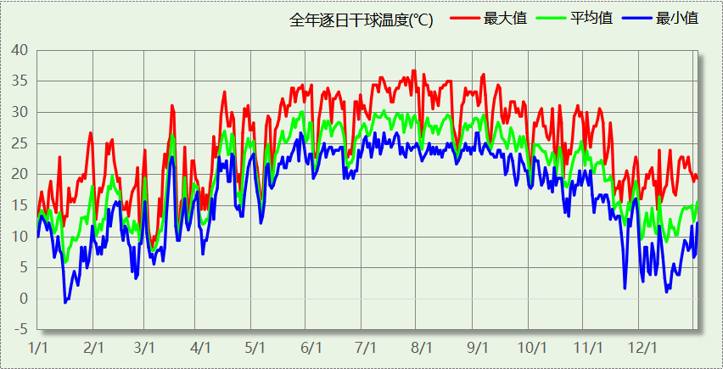

## 逐月辐照量表

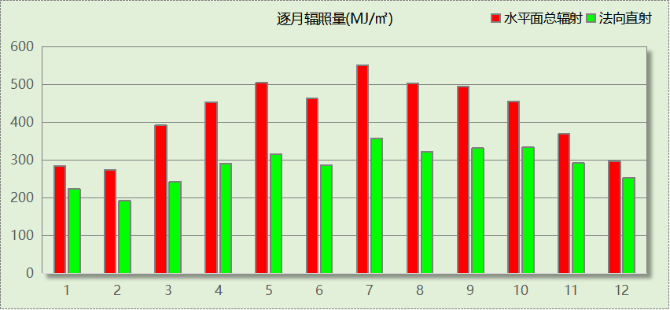

## 峰值工况

|  |  |  |  |  |  |
| --- | --- | --- | --- | --- | --- |
| 气象数据 | 时刻 | 干球温度(℃) | 湿球温度(℃) | 含湿量(g/kg) | 焓值(kj/kg) |
| 最热 | 07月26日14时 | 36.7 | 23.9 | 14.6 | 74.3 |
| 最冷 | 01月15日06时 | -0.6 | -2.2 | 2.5 | 5.7 |

# 软件介绍

本报告采用的软件为绿建暖通负荷BECH2024，该软件紧密结合暖通和节能设计规范、可根据项目实际情况建立建筑热工模型，并可对围护结构材料、房间内扰发热、作息时间表、热回收方式等参数进行设置。

软件包含全国各地典型气象年数据，内置DOE2.1E内核，对于建筑的逐时负荷进行动态模拟，既可以模拟8760小时理想负荷，也可以根据设定好的采暖期/空调期进行逐时模拟。

软件还支持分析全年建筑能耗的来源构成，依据日射得热、新风负荷、围护传热和内扰得热进行归类分项，生成设计建筑全年负荷计算报告书，提供详实的数据和多样的图表，为设计师在设备选型、制定运行策略等方面提供参考和帮助。

# 围护结构

## 屋顶构造

### 屋顶构造一

|  |  |  |  |  |  |  |
| --- | --- | --- | --- | --- | --- | --- |
| 材料名称 （由上到下） | 厚度δ | 导热系数λ | 蓄热系数S | 修正 系数 | 热阻R | 热惰性 指标 |
| (mm) | W/(m.K) | W/(㎡.K) | α | (㎡K)/W | D=R*S |
| 钢筋混凝土屋面板 | 40 | 1.740 | 17.200 | 1.00 | 0.023 | 0.395 |
| 1:3水泥砂浆找平层 | 20 | 0.930 | 11.370 | 1.00 | 0.022 | 0.245 |
| C20细石混凝土（1） | 20 | 1.740 | 17.200 | 1.00 | 0.011 | 0.198 |
| EPS板 | 80 | 0.037 | 0.371 | 1.00 | 2.162 | 0.802 |
| XPS板 | 120 | 0.030 | 0.340 | 1.00 | 4.000 | 1.360 |
| 低标号砂浆隔离层 | 20 | 0.930 | 11.370 | 1.00 | 0.022 | 0.245 |
| 各层之和∑ | 300 | － | － | － | 6.240 | 3.244 |
| 传热系数K=1/(0.15+∑R) | 0.16 | | | | | |

## 外墙构造

### 外墙构造一

|  |  |  |  |  |  |  |
| --- | --- | --- | --- | --- | --- | --- |
| 材料名称 （由外到内） | 厚度δ | 导热系数λ | 蓄热系数S | 修正 系数 | 热阻R | 热惰性 指标 |
| (mm) | W/(m.K) | W/(㎡.K) | α | (㎡K)/W | D=R*S |
| C20细石混凝土（1） | 20 | 1.740 | 17.200 | 1.00 | 0.011 | 0.198 |
| XPS板 | 20 | 0.030 | 0.340 | 1.20 | 0.556 | 0.227 |
| C20细石混凝土（1） | 20 | 1.740 | 17.200 | 1.00 | 0.011 | 0.198 |
| 1:3水泥砂浆找平层 | 200 | 0.930 | 11.370 | 1.00 | 0.215 | 2.445 |
| 钢筋混凝土屋面板 | 20 | 1.740 | 17.200 | 1.00 | 0.011 | 0.198 |
| 各层之和∑ | 280 | － | － | － | 0.805 | 3.265 |
| 传热系数K=1/(0.15+∑R) | 1.05 | | | | | |

### 外墙（填充墙）构造一

|  |  |  |  |  |  |  |
| --- | --- | --- | --- | --- | --- | --- |
| 材料名称 （由外到内） | 厚度δ | 导热系数λ | 蓄热系数S | 修正 系数 | 热阻R | 热惰性 指标 |
| (mm) | W/(m.K) | W/(㎡.K) | α | (㎡K)/W | D=R*S |
| C20细石混凝土（1） | 20 | 1.740 | 17.200 | 1.00 | 0.011 | 0.198 |
| XPS板 | 20 | 0.030 | 0.340 | 1.20 | 0.556 | 0.227 |
| C20细石混凝土（1） | 20 | 1.740 | 17.200 | 1.00 | 0.011 | 0.198 |
| 1:3水泥砂浆找平层 | 200 | 0.930 | 11.370 | 1.00 | 0.215 | 2.445 |
| 低标号砂浆隔离层 | 20 | 0.930 | 11.370 | 1.00 | 0.022 | 0.245 |
| 各层之和∑ | 280 | － | － | － | 0.815 | 3.312 |
| 传热系数K=1/(0.15+∑R) | 1.04 | | | | | |

## 挑空楼板构造

### 挑空楼板构造一

|  |  |  |  |  |  |  |
| --- | --- | --- | --- | --- | --- | --- |
| 材料名称 （由上到下） | 厚度δ | 导热系数λ | 蓄热系数S | 修正 系数 | 热阻R | 热惰性 指标 |
| (mm) | W/(m.K) | W/(㎡.K) | α | (㎡K)/W | D=R*S |
| C20细石混凝土（1） | 20 | 1.740 | 17.200 | 1.00 | 0.011 | 0.198 |
| 1:3水泥砂浆找平层 | 120 | 0.930 | 11.370 | 1.00 | 0.129 | 1.467 |
| C20细石混凝土（1） | 20 | 1.740 | 17.200 | 1.00 | 0.011 | 0.198 |
| XPS板 | 20 | 0.030 | 0.340 | 1.20 | 0.556 | 0.227 |
| C20细石混凝土（1） | 20 | 1.740 | 17.200 | 1.00 | 0.011 | 0.198 |
| 各层之和∑ | 200 | － | － | － | 0.719 | 2.287 |
| 传热系数K=1/(0.15+∑R) | 1.15 | | | | | |

## 楼板构造

### 楼板构造一

|  |  |  |  |  |  |  |
| --- | --- | --- | --- | --- | --- | --- |
| 材料名称 | 厚度δ | 导热系数λ | 蓄热系数S | 修正 系数 | 热阻R | 热惰性 指标 |
| (mm) | W/(m.K) | W/(㎡.K) | α | (㎡K)/W | D=R*S |
| C20细石混凝土（1） | 20 | 1.740 | 17.200 | 1.00 | 0.011 | 0.198 |
| 1:3水泥砂浆找平层 | 120 | 0.930 | 11.370 | 1.00 | 0.129 | 1.467 |
| 低标号砂浆隔离层 | 20 | 0.930 | 11.370 | 1.00 | 0.022 | 0.245 |
| 各层之和∑ | 160 | － | － | － | 0.162 | 1.909 |
| 传热系数K=1/(0.22+∑R) | 2.62 | | | | | |

## 周边地面构造

### 周边地面构造一

|  |  |  |  |  |  |  |
| --- | --- | --- | --- | --- | --- | --- |
| 材料名称 | 厚度δ | 导热系数λ | 蓄热系数S | 修正 系数 | 热阻R | 热惰性 指标 |
| (mm) | W/(m.K) | W/(㎡.K) | α | (㎡K)/W | D=R*S |
| C20细石混凝土（1） | 20 | 1.740 | 17.200 | 1.00 | 0.011 | 0.198 |
| 1:3水泥砂浆找平层 | 120 | 0.930 | 11.370 | 1.00 | 0.129 | 1.467 |
| 各层之和∑ | 140 | － | － | － | 0.141 | 1.665 |
| 传热系数K=1/(0.11+∑R) | 0.52 | | | | | |

## 非周边地面构造

### 地面构造一

|  |  |  |  |  |  |  |
| --- | --- | --- | --- | --- | --- | --- |
| 材料名称 | 厚度δ | 导热系数λ | 蓄热系数S | 修正 系数 | 热阻R | 热惰性 指标 |
| (mm) | W/(m.K) | W/(㎡.K) | α | (㎡K)/W | D=R*S |
| C20细石混凝土（1） | 20 | 1.740 | 17.200 | 1.00 | 0.011 | 0.198 |
| 1:3水泥砂浆找平层 | 120 | 0.930 | 11.370 | 1.00 | 0.129 | 1.467 |
| 各层之和∑ | 140 | － | － | － | 0.141 | 1.665 |
| 传热系数K=1/(0.11+∑R) | 0.30 | | | | | |

## 门构造

|  |  |  |  |
| --- | --- | --- | --- |
| 序号 | 构造名称 | 传热系数 | 备注 |
| 1 | 保温门（多功能门） | 1.972 |  |
| 2 | 普通保温措施玻璃门（断桥铝合金框） | 2.200 |  |

## 窗构造

|  |  |  |  |  |  |
| --- | --- | --- | --- | --- | --- |
| 序号 | 构造名称 | 传热系数 | 窗遮阳系数 | 可见光透射比 | 备注 |
| 1 | 断热铝合金窗--5高透光双银Low-E玻璃+9Ar+5透明玻璃+9Ar+5透明玻璃 | 2.100 | 0.287 | 0.520 |  |
| 2 | 断热铝合金--6高透光双银Low-E玻璃+9Ar+6透明玻璃+9Ar+6透明玻璃 | 1.420 | 0.391 | 0.520 |  |

# 房间类型

## 房间参数表

|  |  |  |  |  |  |  |
| --- | --- | --- | --- | --- | --- | --- |
| 房间类型 | 空调温度 ℃ | 供暖温度 ℃ | 新风量 | 人员密度 | 照明功率 密度 | 电器设备 功率 |
| 3星客房 | 25 | 22 | 30(m^3/h.人) | 15(m^2/人) | 7(W/m^2) | 20(W/m^2) |
| 一般商店 | 26 | 20 | 19(m^3/h.人) | 4(m^2/人) | 9(W/m^2) | 13(W/m^2) |
| 会议室 | 26 | 18 | 14(m^3/h.人) | 2.5(m^2/人) | 8(W/m^2) | 15(W/m^2) |
| 健身房 | 24 | 19 | 40(m^3/h.人) | 4(m^2/人) | 8(W/m^2) | 15(W/m^2) |
| 卫生间 | － | － | 0(m^3/h.人) | 0(人) | 5(W/m^2) | 13(W/m^2) |
| 厨房 | 27 | 18 | 28(次/h) | 5(m^2/人) | 8(W/m^2) | 13(W/m^2) |
| 后勤区 | 26 | 20 | 20(m^3/h.人) | 10(m^2/人) | 8(W/m^2) | 13(W/m^2) |
| 大厅 | 28 | 18 | 20(m^3/h.人) | 50(m^2/人) | 8(W/m^2) | 15(W/m^2) |
| 展览馆 | 26 | 20 | 30(m^3/h.人) | 8(m^2/人) | 9(W/m^2) | 15(W/m^2) |
| 布草间 | － | － | 30(m^3/h.人) | 10(m^2/人) | 5(W/m^2) | 15(W/m^2) |
| 普通办公室 | 26 | 20 | 30(m^3/h.人) | 8(m^2/人) | 8(W/m^2) | 15(W/m^2) |
| 空房间 | － | － | 20(m^3/h.人) | 0(人) | 0(W/m^2) | 0(W/m^2) |
| 空房间 | － | － | 20(m^3/h.人) | 0(人) | 0(W/m^2) | 0(W/m^2) |
| 餐厅 | 26 | 20 | 30(m^3/h.人) | 2.5(m^2/人) | 8(W/m^2) | 15(W/m^2) |

## 作息时间表

详见附录

# 系统设置

## 系统划分

|  |  |  |  |  |  |  |
| --- | --- | --- | --- | --- | --- | --- |
| 系统编号 | 热回收 类型 | 启动 条件 | 回收 效率 | 排风 比例 | 面积(m2) | 包含的房间 |
| 默认 | 无 | -- | -- | -- | 930.69 | 1012,1011,1010,1009,1008,1007,1006,1005,1004,1003,1002,1014,1024,1018,1017,1016,1031,1028,1022,1021,1020,1019,1015,2005,2004,2003,2002,2009,2008,2007,2006,2030,2020,2019,2018,2023,2017,2016,2015,3009,3008,3007,3006,3005,3004,3003,3002,3024,3018,3016,3015,3033,3021,3020,3019,4035,4032,4040,4031,4027,4029,4036,4039,4015,4041,4030,4034,4028,4016,4037,4038,4033 |
| Sys1 | 无 | -- | -- | -- | 2773.07 | 1013,1001,1029,1023,1030,1027,1026,1025,2001,2010,2011,2014,2025,2024,2022,2021,3010,3023,3022,3011,3001,3026,3025,4002,4001,4004,4003 |
| Sys3 | 无 | -- | -- | -- | 1182.38 | 2029,2028,2027,2026,2013,2012,3032,3031,3030,3029,3028,3027,3017,3014,3013,3012,4023,4025,4024,4021,4022,4026,4017,4018,4020,4019,4014,4009,4007,4008,4006,4005,4013,4011,4012,4010 |

## 运行时间表

详见附录

# 计算结果

## 模拟周期

供冷季(6.14-8.31) 供暖季(11.30-2.28)

## 全年冷暖需求

|  |  |  |  |  |
| --- | --- | --- | --- | --- |
| 系统名称\负荷 | 供暖需求 (kWh) | 供暖指标 (kWh/㎡·a) | 供冷需求 (kWh) | 供冷指标 (kWh/㎡·a) |
| Sys1 | 1760 | 0.63 | 210414 | 75.88 |
| Sys3 | 0 | 0.00 | 89201 | 75.44 |
| 默认系统 | 1449 | 1.56 | 136320 | 146.47 |
| 建筑总计 | 3209 | 0.61 | 435935 | 82.62 |

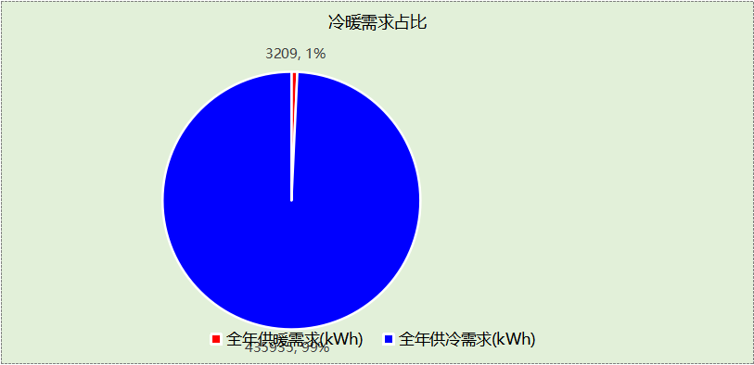

## 负荷分项统计

|  |  |  |  |  |  |  |
| --- | --- | --- | --- | --- | --- | --- |
| 分类 | 围护传热 | 室内得热 | 窗日射 | 新风/渗透 | 热回收 | 合计 |
| 供暖(kWh/㎡) | -0.18 | 0.05 | 0.00 | -0.48 | 0.00 | -0.61 |
| 供冷(kWh/㎡) | 13.80 | 28.76 | 0.01 | 40.05 | 0.00 | 82.62 |

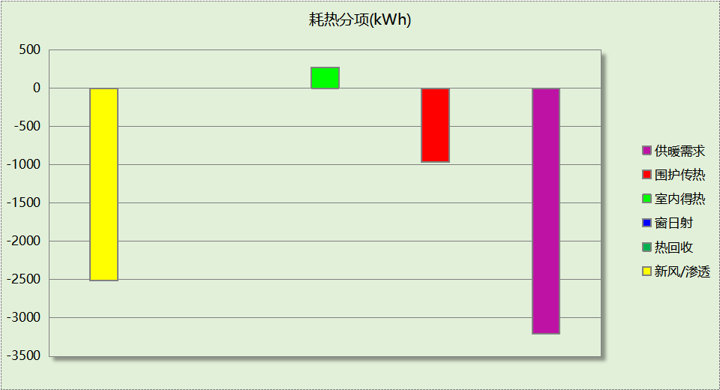

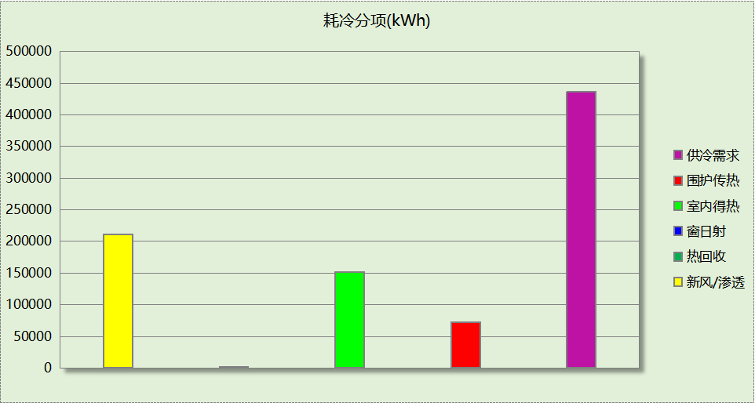

## 逐月负荷表

|  |  |  |  |  |  |  |
| --- | --- | --- | --- | --- | --- | --- |
| 月份 | 供暖(kWh) | 供冷(kWh) | 热负荷 峰值(kW) | 热负荷 峰值时刻 | 冷负荷 峰值(kW) | 冷负荷 峰值时刻 |
| 1月 | 1518 | 0 | 39.664 | 1月21日7时 | 0.000 | -- |
| 2月 | 1279 | 0 | 34.165 | 2月4日7时 | 0.000 | -- |
| 3月 | 0 | 0 | 0.000 | -- | 0.000 | -- |
| 4月 | 0 | 0 | 0.000 | -- | 0.000 | -- |
| 5月 | 0 | 0 | 0.000 | -- | 0.000 | -- |
| 6月 | 0 | 59764 | 0.000 | -- | 533.624 | 6月14日8时 |
| 7月 | 0 | 187888 | 0.000 | -- | 555.153 | 7月10日10时 |
| 8月 | 0 | 188284 | 0.000 | -- | 564.270 | 8月5日13时 |
| 9月 | 0 | 0 | 0.000 | -- | 0.000 | -- |
| 10月 | 0 | 0 | 0.000 | -- | 0.000 | -- |
| 11月 | 0 | 0 | 0.000 | -- | 0.000 | -- |
| 12月 | 412 | 0 | 24.100 | 12月16日7时 | 0.000 | -- |

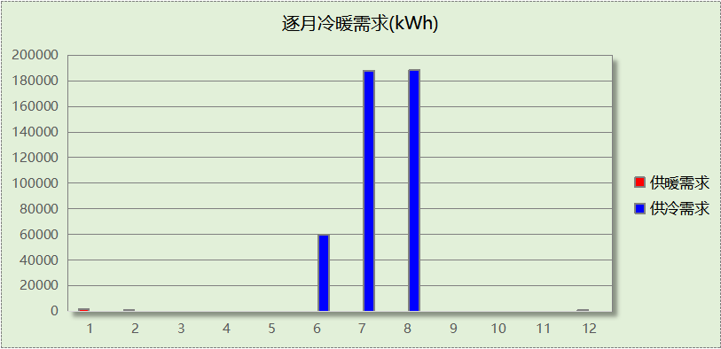

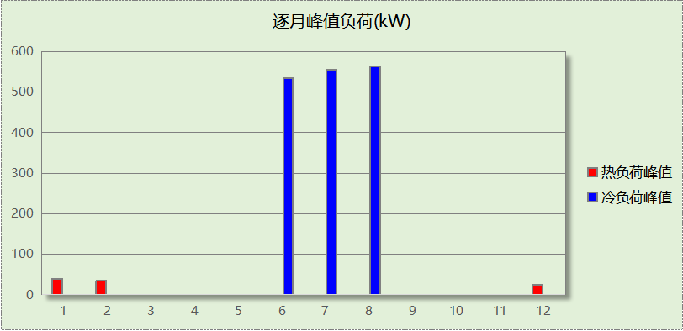

# 附录

**工作日/节假日人员逐时在室率(%)**

|  |  |  |  |  |  |  |  |  |  |  |  |  |  |  |  |  |  |  |  |  |  |  |  |  |
| --- | --- | --- | --- | --- | --- | --- | --- | --- | --- | --- | --- | --- | --- | --- | --- | --- | --- | --- | --- | --- | --- | --- | --- | --- |
| 房间类型 | 1 | 2 | 3 | 4 | 5 | 6 | 7 | 8 | 9 | 10 | 11 | 12 | 13 | 14 | 15 | 16 | 17 | 18 | 19 | 20 | 21 | 22 | 23 | 24 |
| 3星客房 | 70 | 70 | 70 | 70 | 70 | 70 | 70 | 70 | 50 | 50 | 50 | 50 | 50 | 50 | 50 | 50 | 50 | 50 | 70 | 70 | 70 | 70 | 70 | 70 |
| 70 | 70 | 70 | 70 | 70 | 70 | 70 | 70 | 50 | 50 | 50 | 50 | 50 | 50 | 50 | 50 | 50 | 50 | 70 | 70 | 70 | 70 | 70 | 70 |
| 一般商店 | 0 | 0 | 0 | 0 | 0 | 0 | 0 | 20 | 50 | 80 | 80 | 80 | 80 | 80 | 80 | 80 | 80 | 80 | 80 | 70 | 50 | 0 | 0 | 0 |
| 0 | 0 | 0 | 0 | 0 | 0 | 0 | 20 | 50 | 80 | 80 | 80 | 80 | 80 | 80 | 80 | 80 | 80 | 80 | 70 | 50 | 0 | 0 | 0 |
| 会议室 | 0 | 0 | 0 | 0 | 0 | 0 | 10 | 50 | 100 | 100 | 100 | 30 | 100 | 100 | 100 | 100 | 50 | 20 | 10 | 0 | 0 | 0 | 0 | 0 |
| 0 | 0 | 0 | 0 | 0 | 0 | 0 | 20 | 45 | 0 | 0 | 0 | 0 | 0 | 0 | 0 | 0 | 0 | 0 | 0 | 0 | 0 | 0 | 0 |
| 健身房 | 70 | 70 | 70 | 70 | 70 | 70 | 70 | 70 | 50 | 50 | 50 | 50 | 50 | 50 | 50 | 50 | 50 | 50 | 70 | 70 | 70 | 70 | 70 | 70 |
| 70 | 70 | 70 | 70 | 70 | 70 | 70 | 70 | 50 | 50 | 50 | 50 | 50 | 50 | 50 | 50 | 50 | 50 | 70 | 70 | 70 | 70 | 70 | 70 |
| 卫生间 | 0 | 0 | 0 | 0 | 0 | 0 | 0 | 20 | 50 | 80 | 80 | 80 | 80 | 80 | 80 | 80 | 80 | 80 | 80 | 70 | 50 | 0 | 0 | 0 |
| 0 | 0 | 0 | 0 | 0 | 0 | 0 | 20 | 50 | 80 | 80 | 80 | 80 | 80 | 80 | 80 | 80 | 80 | 80 | 70 | 50 | 0 | 0 | 0 |
| 厨房 | 0 | 0 | 0 | 0 | 0 | 0 | 0 | 20 | 50 | 80 | 80 | 80 | 80 | 80 | 80 | 80 | 80 | 80 | 80 | 70 | 50 | 0 | 0 | 0 |
| 0 | 0 | 0 | 0 | 0 | 0 | 0 | 20 | 50 | 80 | 80 | 80 | 80 | 80 | 80 | 80 | 80 | 80 | 80 | 70 | 50 | 0 | 0 | 0 |
| 后勤区 | 0 | 0 | 0 | 0 | 0 | 0 | 0 | 20 | 50 | 80 | 80 | 80 | 80 | 80 | 80 | 80 | 80 | 80 | 80 | 70 | 50 | 0 | 0 | 0 |
| 0 | 0 | 0 | 0 | 0 | 0 | 0 | 20 | 50 | 80 | 80 | 80 | 80 | 80 | 80 | 80 | 80 | 80 | 80 | 70 | 50 | 0 | 0 | 0 |
| 大厅 | 70 | 70 | 70 | 70 | 70 | 70 | 70 | 70 | 50 | 50 | 50 | 50 | 50 | 50 | 50 | 50 | 50 | 50 | 70 | 70 | 70 | 70 | 70 | 70 |
| 70 | 70 | 70 | 70 | 70 | 70 | 70 | 70 | 50 | 50 | 50 | 50 | 50 | 50 | 50 | 50 | 50 | 50 | 70 | 70 | 70 | 70 | 70 | 70 |
| 展览馆 | 0 | 0 | 0 | 0 | 0 | 0 | 10 | 50 | 100 | 100 | 100 | 30 | 100 | 100 | 100 | 100 | 50 | 20 | 10 | 0 | 0 | 0 | 0 | 0 |
| 0 | 0 | 0 | 0 | 0 | 0 | 0 | 20 | 45 | 0 | 0 | 0 | 0 | 0 | 0 | 0 | 0 | 0 | 0 | 0 | 0 | 0 | 0 | 0 |
| 布草间 | 70 | 70 | 70 | 70 | 70 | 70 | 70 | 70 | 50 | 50 | 50 | 50 | 50 | 50 | 50 | 50 | 50 | 50 | 70 | 70 | 70 | 70 | 70 | 70 |
| 70 | 70 | 70 | 70 | 70 | 70 | 70 | 70 | 50 | 50 | 50 | 50 | 50 | 50 | 50 | 50 | 50 | 50 | 70 | 70 | 70 | 70 | 70 | 70 |
| 普通办公室 | 70 | 70 | 70 | 70 | 70 | 70 | 70 | 70 | 50 | 50 | 50 | 50 | 50 | 50 | 50 | 50 | 50 | 50 | 70 | 70 | 70 | 70 | 70 | 70 |
| 70 | 70 | 70 | 70 | 70 | 70 | 70 | 70 | 50 | 50 | 50 | 50 | 50 | 50 | 50 | 50 | 50 | 50 | 70 | 70 | 70 | 70 | 70 | 70 |
| 空房间 | 0 | 0 | 0 | 0 | 0 | 0 | 0 | 20 | 50 | 80 | 80 | 80 | 80 | 80 | 80 | 80 | 80 | 80 | 80 | 70 | 50 | 0 | 0 | 0 |
| 0 | 0 | 0 | 0 | 0 | 0 | 0 | 20 | 50 | 80 | 80 | 80 | 80 | 80 | 80 | 80 | 80 | 80 | 80 | 70 | 50 | 0 | 0 | 0 |
| 空房间 | 0 | 0 | 0 | 0 | 0 | 0 | 0 | 20 | 50 | 80 | 80 | 80 | 80 | 80 | 80 | 80 | 80 | 80 | 80 | 70 | 50 | 0 | 0 | 0 |
| 0 | 0 | 0 | 0 | 0 | 0 | 0 | 20 | 50 | 80 | 80 | 80 | 80 | 80 | 80 | 80 | 80 | 80 | 80 | 70 | 50 | 0 | 0 | 0 |
| 餐厅 | 70 | 70 | 70 | 70 | 70 | 70 | 70 | 70 | 50 | 50 | 50 | 50 | 50 | 50 | 50 | 50 | 50 | 50 | 70 | 70 | 70 | 70 | 70 | 70 |
| 70 | 70 | 70 | 70 | 70 | 70 | 70 | 70 | 50 | 50 | 50 | 50 | 50 | 50 | 50 | 50 | 50 | 50 | 70 | 70 | 70 | 70 | 70 | 70 |

注：上行：工作日；下行：节假日

**工作日/节假日照明开关时间表(%)**

|  |  |  |  |  |  |  |  |  |  |  |  |  |  |  |  |  |  |  |  |  |  |  |  |  |
| --- | --- | --- | --- | --- | --- | --- | --- | --- | --- | --- | --- | --- | --- | --- | --- | --- | --- | --- | --- | --- | --- | --- | --- | --- |
| 房间类型 | 1 | 2 | 3 | 4 | 5 | 6 | 7 | 8 | 9 | 10 | 11 | 12 | 13 | 14 | 15 | 16 | 17 | 18 | 19 | 20 | 21 | 22 | 23 | 24 |
| 3星客房 | 10 | 10 | 10 | 10 | 10 | 10 | 30 | 30 | 30 | 30 | 30 | 30 | 30 | 30 | 50 | 50 | 60 | 90 | 90 | 90 | 90 | 80 | 10 | 10 |
| 10 | 10 | 10 | 10 | 10 | 10 | 30 | 30 | 30 | 30 | 30 | 30 | 30 | 30 | 50 | 50 | 60 | 90 | 90 | 90 | 90 | 80 | 10 | 10 |
| 一般商店 | 10 | 10 | 10 | 10 | 10 | 10 | 10 | 50 | 60 | 60 | 60 | 60 | 60 | 60 | 60 | 60 | 80 | 90 | 100 | 100 | 100 | 10 | 10 | 10 |
| 10 | 10 | 10 | 10 | 10 | 10 | 10 | 50 | 60 | 60 | 60 | 60 | 60 | 60 | 60 | 60 | 80 | 90 | 100 | 100 | 100 | 10 | 10 | 10 |
| 会议室 | 10 | 10 | 10 | 10 | 10 | 10 | 10 | 36 | 62 | 56 | 54 | 43 | 53 | 55 | 58 | 67 | 40 | 18 | 10 | 10 | 10 | 10 | 10 | 10 |
| 0 | 0 | 0 | 0 | 0 | 0 | 0 | 0 | 0 | 0 | 0 | 0 | 0 | 0 | 0 | 0 | 0 | 0 | 0 | 0 | 0 | 0 | 0 | 0 |
| 健身房 | 10 | 10 | 10 | 10 | 10 | 10 | 30 | 30 | 30 | 30 | 30 | 30 | 30 | 30 | 50 | 50 | 60 | 90 | 90 | 90 | 90 | 80 | 10 | 10 |
| 10 | 10 | 10 | 10 | 10 | 10 | 30 | 30 | 30 | 30 | 30 | 30 | 30 | 30 | 50 | 50 | 60 | 90 | 90 | 90 | 90 | 80 | 10 | 10 |
| 卫生间 | 10 | 10 | 10 | 10 | 10 | 10 | 10 | 50 | 60 | 60 | 60 | 60 | 60 | 60 | 60 | 60 | 80 | 90 | 100 | 100 | 100 | 10 | 10 | 10 |
| 10 | 10 | 10 | 10 | 10 | 10 | 10 | 50 | 60 | 60 | 60 | 60 | 60 | 60 | 60 | 60 | 80 | 90 | 100 | 100 | 100 | 10 | 10 | 10 |
| 厨房 | 10 | 10 | 10 | 10 | 10 | 10 | 10 | 50 | 60 | 60 | 60 | 60 | 60 | 60 | 60 | 60 | 80 | 90 | 100 | 100 | 100 | 10 | 10 | 10 |
| 10 | 10 | 10 | 10 | 10 | 10 | 10 | 50 | 60 | 60 | 60 | 60 | 60 | 60 | 60 | 60 | 80 | 90 | 100 | 100 | 100 | 10 | 10 | 10 |
| 后勤区 | 10 | 10 | 10 | 10 | 10 | 10 | 10 | 50 | 60 | 60 | 60 | 60 | 60 | 60 | 60 | 60 | 80 | 90 | 100 | 100 | 100 | 10 | 10 | 10 |
| 10 | 10 | 10 | 10 | 10 | 10 | 10 | 50 | 60 | 60 | 60 | 60 | 60 | 60 | 60 | 60 | 80 | 90 | 100 | 100 | 100 | 10 | 10 | 10 |
| 大厅 | 10 | 10 | 10 | 10 | 10 | 10 | 30 | 30 | 30 | 30 | 30 | 30 | 30 | 30 | 50 | 50 | 60 | 90 | 90 | 90 | 90 | 80 | 10 | 10 |
| 10 | 10 | 10 | 10 | 10 | 10 | 30 | 30 | 30 | 30 | 30 | 30 | 30 | 30 | 50 | 50 | 60 | 90 | 90 | 90 | 90 | 80 | 10 | 10 |
| 展览馆 | 10 | 10 | 10 | 10 | 10 | 10 | 10 | 36 | 62 | 56 | 54 | 43 | 53 | 55 | 58 | 67 | 40 | 18 | 10 | 10 | 10 | 10 | 10 | 10 |
| 0 | 0 | 0 | 0 | 0 | 0 | 0 | 0 | 0 | 0 | 0 | 0 | 0 | 0 | 0 | 0 | 0 | 0 | 0 | 0 | 0 | 0 | 0 | 0 |
| 布草间 | 10 | 10 | 10 | 10 | 10 | 10 | 30 | 30 | 30 | 30 | 30 | 30 | 30 | 30 | 50 | 50 | 60 | 90 | 90 | 90 | 90 | 80 | 10 | 10 |
| 10 | 10 | 10 | 10 | 10 | 10 | 30 | 30 | 30 | 30 | 30 | 30 | 30 | 30 | 50 | 50 | 60 | 90 | 90 | 90 | 90 | 80 | 10 | 10 |
| 普通办公室 | 10 | 10 | 10 | 10 | 10 | 10 | 30 | 30 | 30 | 30 | 30 | 30 | 30 | 30 | 50 | 50 | 60 | 90 | 90 | 90 | 90 | 80 | 10 | 10 |
| 10 | 10 | 10 | 10 | 10 | 10 | 30 | 30 | 30 | 30 | 30 | 30 | 30 | 30 | 50 | 50 | 60 | 90 | 90 | 90 | 90 | 80 | 10 | 10 |
| 空房间 | 10 | 10 | 10 | 10 | 10 | 10 | 10 | 50 | 60 | 60 | 60 | 60 | 60 | 60 | 60 | 60 | 80 | 90 | 100 | 100 | 100 | 10 | 10 | 10 |
| 10 | 10 | 10 | 10 | 10 | 10 | 10 | 50 | 60 | 60 | 60 | 60 | 60 | 60 | 60 | 60 | 80 | 90 | 100 | 100 | 100 | 10 | 10 | 10 |
| 空房间 | 10 | 10 | 10 | 10 | 10 | 10 | 10 | 50 | 60 | 60 | 60 | 60 | 60 | 60 | 60 | 60 | 80 | 90 | 100 | 100 | 100 | 10 | 10 | 10 |
| 10 | 10 | 10 | 10 | 10 | 10 | 10 | 50 | 60 | 60 | 60 | 60 | 60 | 60 | 60 | 60 | 80 | 90 | 100 | 100 | 100 | 10 | 10 | 10 |
| 餐厅 | 10 | 10 | 10 | 10 | 10 | 10 | 30 | 30 | 30 | 30 | 30 | 30 | 30 | 30 | 50 | 50 | 60 | 90 | 90 | 90 | 90 | 80 | 10 | 10 |
| 10 | 10 | 10 | 10 | 10 | 10 | 30 | 30 | 30 | 30 | 30 | 30 | 30 | 30 | 50 | 50 | 60 | 90 | 90 | 90 | 90 | 80 | 10 | 10 |

注：上行：工作日；下行：节假日

**工作日/节假日设备逐时使用率(%)**

|  |  |  |  |  |  |  |  |  |  |  |  |  |  |  |  |  |  |  |  |  |  |  |  |  |
| --- | --- | --- | --- | --- | --- | --- | --- | --- | --- | --- | --- | --- | --- | --- | --- | --- | --- | --- | --- | --- | --- | --- | --- | --- |
| 房间类型 | 1 | 2 | 3 | 4 | 5 | 6 | 7 | 8 | 9 | 10 | 11 | 12 | 13 | 14 | 15 | 16 | 17 | 18 | 19 | 20 | 21 | 22 | 23 | 24 |
| 3星客房 | 0 | 0 | 0 | 0 | 0 | 0 | 0 | 0 | 0 | 0 | 0 | 0 | 0 | 0 | 0 | 0 | 0 | 80 | 80 | 80 | 80 | 80 | 0 | 0 |
| 0 | 0 | 0 | 0 | 0 | 0 | 0 | 0 | 0 | 0 | 0 | 0 | 0 | 0 | 0 | 0 | 0 | 80 | 80 | 80 | 80 | 80 | 0 | 0 |
| 一般商店 | 0 | 0 | 0 | 0 | 0 | 0 | 0 | 30 | 50 | 80 | 80 | 80 | 80 | 80 | 80 | 80 | 80 | 80 | 80 | 70 | 50 | 0 | 0 | 0 |
| 0 | 0 | 0 | 0 | 0 | 0 | 0 | 30 | 50 | 80 | 80 | 80 | 80 | 80 | 80 | 80 | 80 | 80 | 80 | 70 | 50 | 0 | 0 | 0 |
| 会议室 | 0 | 0 | 0 | 0 | 0 | 0 | 10 | 50 | 100 | 100 | 100 | 100 | 100 | 100 | 100 | 100 | 50 | 20 | 10 | 0 | 0 | 0 | 0 | 0 |
| 0 | 0 | 0 | 0 | 0 | 0 | 0 | 0 | 0 | 0 | 0 | 0 | 0 | 0 | 0 | 0 | 0 | 0 | 0 | 0 | 0 | 0 | 0 | 0 |
| 健身房 | 0 | 0 | 0 | 0 | 0 | 0 | 0 | 0 | 0 | 0 | 0 | 0 | 0 | 0 | 0 | 0 | 0 | 80 | 80 | 80 | 80 | 80 | 0 | 0 |
| 0 | 0 | 0 | 0 | 0 | 0 | 0 | 0 | 0 | 0 | 0 | 0 | 0 | 0 | 0 | 0 | 0 | 80 | 80 | 80 | 80 | 80 | 0 | 0 |
| 卫生间 | 0 | 0 | 0 | 0 | 0 | 0 | 0 | 30 | 50 | 80 | 80 | 80 | 80 | 80 | 80 | 80 | 80 | 80 | 80 | 70 | 50 | 0 | 0 | 0 |
| 0 | 0 | 0 | 0 | 0 | 0 | 0 | 30 | 50 | 80 | 80 | 80 | 80 | 80 | 80 | 80 | 80 | 80 | 80 | 70 | 50 | 0 | 0 | 0 |
| 厨房 | 0 | 0 | 0 | 0 | 0 | 0 | 0 | 30 | 50 | 80 | 80 | 80 | 80 | 80 | 80 | 80 | 80 | 80 | 80 | 70 | 50 | 0 | 0 | 0 |
| 0 | 0 | 0 | 0 | 0 | 0 | 0 | 30 | 50 | 80 | 80 | 80 | 80 | 80 | 80 | 80 | 80 | 80 | 80 | 70 | 50 | 0 | 0 | 0 |
| 后勤区 | 0 | 0 | 0 | 0 | 0 | 0 | 0 | 30 | 50 | 80 | 80 | 80 | 80 | 80 | 80 | 80 | 80 | 80 | 80 | 70 | 50 | 0 | 0 | 0 |
| 0 | 0 | 0 | 0 | 0 | 0 | 0 | 30 | 50 | 80 | 80 | 80 | 80 | 80 | 80 | 80 | 80 | 80 | 80 | 70 | 50 | 0 | 0 | 0 |
| 大厅 | 0 | 0 | 0 | 0 | 0 | 0 | 0 | 0 | 0 | 0 | 0 | 0 | 0 | 0 | 0 | 0 | 0 | 80 | 80 | 80 | 80 | 80 | 0 | 0 |
| 0 | 0 | 0 | 0 | 0 | 0 | 0 | 0 | 0 | 0 | 0 | 0 | 0 | 0 | 0 | 0 | 0 | 80 | 80 | 80 | 80 | 80 | 0 | 0 |
| 展览馆 | 0 | 0 | 0 | 0 | 0 | 0 | 10 | 50 | 100 | 100 | 100 | 100 | 100 | 100 | 100 | 100 | 50 | 20 | 10 | 0 | 0 | 0 | 0 | 0 |
| 0 | 0 | 0 | 0 | 0 | 0 | 0 | 0 | 0 | 0 | 0 | 0 | 0 | 0 | 0 | 0 | 0 | 0 | 0 | 0 | 0 | 0 | 0 | 0 |
| 布草间 | 0 | 0 | 0 | 0 | 0 | 0 | 0 | 0 | 0 | 0 | 0 | 0 | 0 | 0 | 0 | 0 | 0 | 80 | 80 | 80 | 80 | 80 | 0 | 0 |
| 0 | 0 | 0 | 0 | 0 | 0 | 0 | 0 | 0 | 0 | 0 | 0 | 0 | 0 | 0 | 0 | 0 | 80 | 80 | 80 | 80 | 80 | 0 | 0 |
| 普通办公室 | 0 | 0 | 0 | 0 | 0 | 0 | 0 | 0 | 0 | 0 | 0 | 0 | 0 | 0 | 0 | 0 | 0 | 80 | 80 | 80 | 80 | 80 | 0 | 0 |
| 0 | 0 | 0 | 0 | 0 | 0 | 0 | 0 | 0 | 0 | 0 | 0 | 0 | 0 | 0 | 0 | 0 | 80 | 80 | 80 | 80 | 80 | 0 | 0 |
| 空房间 | 0 | 0 | 0 | 0 | 0 | 0 | 0 | 30 | 50 | 80 | 80 | 80 | 80 | 80 | 80 | 80 | 80 | 80 | 80 | 70 | 50 | 0 | 0 | 0 |
| 0 | 0 | 0 | 0 | 0 | 0 | 0 | 30 | 50 | 80 | 80 | 80 | 80 | 80 | 80 | 80 | 80 | 80 | 80 | 70 | 50 | 0 | 0 | 0 |
| 空房间 | 0 | 0 | 0 | 0 | 0 | 0 | 0 | 30 | 50 | 80 | 80 | 80 | 80 | 80 | 80 | 80 | 80 | 80 | 80 | 70 | 50 | 0 | 0 | 0 |
| 0 | 0 | 0 | 0 | 0 | 0 | 0 | 30 | 50 | 80 | 80 | 80 | 80 | 80 | 80 | 80 | 80 | 80 | 80 | 70 | 50 | 0 | 0 | 0 |
| 餐厅 | 0 | 0 | 0 | 0 | 0 | 0 | 0 | 0 | 0 | 0 | 0 | 0 | 0 | 0 | 0 | 0 | 0 | 80 | 80 | 80 | 80 | 80 | 0 | 0 |
| 0 | 0 | 0 | 0 | 0 | 0 | 0 | 0 | 0 | 0 | 0 | 0 | 0 | 0 | 0 | 0 | 0 | 80 | 80 | 80 | 80 | 80 | 0 | 0 |

注：上行：工作日；下行：节假日

**工作日/节假日空调系统开关时间表**

采暖期：

|  |  |  |  |  |  |  |  |  |  |  |  |  |  |  |  |  |  |  |  |  |  |  |  |  |
| --- | --- | --- | --- | --- | --- | --- | --- | --- | --- | --- | --- | --- | --- | --- | --- | --- | --- | --- | --- | --- | --- | --- | --- | --- |
| 系统编号 | 1 | 2 | 3 | 4 | 5 | 6 | 7 | 8 | 9 | 10 | 11 | 12 | 13 | 14 | 15 | 16 | 17 | 18 | 19 | 20 | 21 | 22 | 23 | 24 |
| 默认 | 0 | 0 | 0 | 0 | 0 | 0 | 0 | 1 | 1 | 1 | 1 | 1 | 1 | 1 | 1 | 1 | 1 | 1 | 1 | 1 | 1 | 0 | 0 | 0 |
| 0 | 0 | 0 | 0 | 0 | 0 | 0 | 1 | 1 | 1 | 1 | 1 | 1 | 1 | 1 | 1 | 1 | 1 | 1 | 1 | 1 | 0 | 0 | 0 |
| Sys1 | 0 | 0 | 0 | 0 | 0 | 0 | 0 | 1 | 1 | 1 | 1 | 1 | 1 | 1 | 1 | 1 | 1 | 1 | 1 | 1 | 1 | 0 | 0 | 0 |
| 0 | 0 | 0 | 0 | 0 | 0 | 0 | 1 | 1 | 1 | 1 | 1 | 1 | 1 | 1 | 1 | 1 | 1 | 1 | 1 | 1 | 0 | 0 | 0 |
| Sys3 | 0 | 0 | 0 | 0 | 0 | 0 | 0 | 1 | 1 | 1 | 1 | 1 | 1 | 1 | 1 | 1 | 1 | 1 | 1 | 1 | 1 | 0 | 0 | 0 |
| 0 | 0 | 0 | 0 | 0 | 0 | 0 | 1 | 1 | 1 | 1 | 1 | 1 | 1 | 1 | 1 | 1 | 1 | 1 | 1 | 1 | 0 | 0 | 0 |

供冷期：

|  |  |  |  |  |  |  |  |  |  |  |  |  |  |  |  |  |  |  |  |  |  |  |  |  |
| --- | --- | --- | --- | --- | --- | --- | --- | --- | --- | --- | --- | --- | --- | --- | --- | --- | --- | --- | --- | --- | --- | --- | --- | --- |
| 系统编号 | 1 | 2 | 3 | 4 | 5 | 6 | 7 | 8 | 9 | 10 | 11 | 12 | 13 | 14 | 15 | 16 | 17 | 18 | 19 | 20 | 21 | 22 | 23 | 24 |
| 默认 | 0 | 0 | 0 | 0 | 0 | 0 | 0 | 1 | 1 | 1 | 1 | 1 | 1 | 1 | 1 | 1 | 1 | 1 | 1 | 1 | 1 | 0 | 0 | 0 |
| 0 | 0 | 0 | 0 | 0 | 0 | 0 | 1 | 1 | 1 | 1 | 1 | 1 | 1 | 1 | 1 | 1 | 1 | 1 | 1 | 1 | 0 | 0 | 0 |
| Sys1 | 0 | 0 | 0 | 0 | 0 | 0 | 0 | 1 | 1 | 1 | 1 | 1 | 1 | 1 | 1 | 1 | 1 | 1 | 1 | 1 | 1 | 0 | 0 | 0 |
| 0 | 0 | 0 | 0 | 0 | 0 | 0 | 1 | 1 | 1 | 1 | 1 | 1 | 1 | 1 | 1 | 1 | 1 | 1 | 1 | 1 | 0 | 0 | 0 |
| Sys3 | 0 | 0 | 0 | 0 | 0 | 0 | 0 | 1 | 1 | 1 | 1 | 1 | 1 | 1 | 1 | 1 | 1 | 1 | 1 | 1 | 1 | 0 | 0 | 0 |
| 0 | 0 | 0 | 0 | 0 | 0 | 0 | 1 | 1 | 1 | 1 | 1 | 1 | 1 | 1 | 1 | 1 | 1 | 1 | 1 | 1 | 0 | 0 | 0 |

注：上行：工作日；下行：节假日