**综合能耗节能率计算书**

公共建筑

|  |  |
| --- | --- |
| 工程名称 | 图书馆改造（十三组） |
| 工程地点 | 河南-郑州 |
| 设计编号 |  |
| 建设单位 |  |
| 设计单位 |  |
| 设 计 人 |  |
| 审 核 人 |  |
| 审 定 人 |  |
| 设计日期 | 2025年3月14日 |



|  |  |
| --- | --- |
| 采用软件 | 能耗计算BESI2024 |
| 软件版本 | 20240430(SP1) |
| 研发单位 | 北京绿建软件股份有限公司 |
| 正版授权码 | T13032273082 |

**目 录**

1 建筑概况 5

2 计算依据 5

3 计算要求 5

3.1 计算目标 5

3.2 计算方法 6

4 软件介绍 6

5 气象数据 6

5.1 气象地点 6

5.2 逐日干球温度表 7

5.3 逐月辐照量表 7

5.4 峰值工况 7

6 建筑大样 8

7 围护结构 11

7.1 工程材料 11

7.2 围护结构作法简要说明 12

7.3 体形系数 12

7.3.1 体形系数 12

7.3.2 楼层信息表 12

7.4 窗墙比 13

7.4.1 窗墙比 13

7.4.2 外窗表 13

7.5 天窗 14

7.5.1 天窗屋顶比 14

7.5.2 天窗类型 14

7.6 屋顶 14

7.6.1 屋顶构造一 14

7.7 外墙 14

7.7.1 外墙构造一 14

7.7.2 外墙主断面传热系数的修正系数ψ 15

7.8 挑空楼板 15

7.8.1 挑空楼板构造一 15

7.9 地下车库与供暖房间之间的楼板 15

7.10 采暖与非采暖隔墙 15

7.11 外窗热工 15

7.11.1 外窗 15

7.11.2 外遮阳类型 16

7.11.3 平均传热系数 16

7.11.4 综合太阳得热系数 17

7.11.5 总体热工性能 19

7.12 周边地面 19

7.12.1 周边地面构造一 19

7.13 采暖地下室外墙 19

7.14 变形缝 20

7.15 可开启窗扇 20

8 围护结构概况 20

9 设计建筑 20

9.1 房间类型 20

9.1.1 房间参数表 20

9.1.2 作息时间表 21

9.2 系统类型 21

9.2.1 系统分区 21

9.2.2 热回收参数 21

9.3 制冷系统 22

9.3.1 默认冷源 22

9.3.2 多联机/单元式空调能耗 22

9.4 供暖系统 23

9.4.1 默认热源 23

9.5 空调风机 23

9.5.1 独立新排风 23

9.5.2 风机盘管 23

9.6 负荷分项统计 23

9.7 逐月负荷表 24

9.8 逐月电耗 25

10 参照建筑 26

10.1 房间类型 26

10.1.1 房间参数表 26

10.1.2 作息时间表 26

10.2 系统类型 26

10.3 制冷系统 27

10.3.1 默认冷源 27

10.3.2 多联机/单元式空调能耗 27

10.4 供暖系统 28

10.4.1 默认热源 28

10.5 空调风机 28

10.5.1 独立新排风 28

10.5.2 风机盘管 28

10.6 负荷分项统计 28

10.7 逐月负荷表 29

10.8 逐月电耗 30

11 计算结果 31

12 绿色建筑性能评估得分 31

13 附录 35

13.1 工作日/节假日人员逐时在室率(%) 35

13.2 工作日/节假日照明开关时间表(%) 37

13.3 工作日/节假日设备逐时使用率(%) 39

13.4 工作日/节假日空调系统运行时间表(1:开,0:关) 41

13.5 工作日/节假日新风运行时间表(%) 41

# 建筑概况

|  |  |  |
| --- | --- | --- |
| 工程名称 | 图书馆改造（十三组） | |
| 工程地点 | 河南-郑州 | |
| 地理位置 | 北纬：35.00° | 东经：113.65° |
| 建筑面积(m2) | 地上5963 地下0 | |
| 建筑层数 | 地上4 地下0 | |
| 建筑高度（m） | 地上16.0 地下0.0 | |
| 建筑体积(m3) | 23339.92 | |
| 建筑外表面积(m2) | 6928.16 | |
| 北向角度 | 90 | |
| 结构类型 |  | |
| 外墙太阳辐射吸收系数 | 0.50 | |
| 屋顶太阳辐射吸收系数 | 0.50 | |
| 控温期 | 供冷期:7.15-8.25,供暖期:11.15-1.15 | |

# 计算依据

1. 《绿色建筑评价标准》(GB/T50378-2019)

2. 《民用建筑绿色性能计算标准》(JGJ/T 449-2018)

3. 《建筑能效标识技术标准》(JGJ/T 288-2012)

4. 《建筑节能与可再生能源利用通用规范》GB55015-2021

5. 《公共建筑节能设计标准》GB50189-2015

6. 《民用建筑热工设计规范》GB50176-2016

7. 《建筑幕墙、门窗通用技术条件》GB/T31433-2015

# 计算要求

## 计算目标

《绿色建筑评价标准》(GB/T50378-2019) 第7.2.8条：采取措施降低建筑能耗，评价总分值10分。建筑能耗相比国家现行有关建筑节能标准降低10%，得5分；降低20%，得10分。

《绿色建筑评价标准》(GB/T50378-2019) 第9.2.1条：采取措施进一步降低建筑供暖空调系统的能耗，评价总分值30分。建筑供暖空调系统能耗相比国家现行有关建筑节能标准降低40%，得10分；每再降低10%，再得5分；最高得30分。

## 计算方法

建立参照建筑，参照建筑的热工参数、采暖空调照明形式及设备满足现行国家节能标准要求。

根据现行行业标准《民用建筑绿色性能计算标准》JGJ/T449的相关规定，分别计算设计建筑及参照建筑的供暖空调和照明系统能耗，计算其节能率并进行得分判定。

即：建筑综合节能率 （7.2.8条）＝ （参照建筑全年采暖空调照明耗电量 － 设计建筑全年采暖空调照明耗电量） / 参照建筑全年采暖空调照明耗电量 × 100%

建筑采暖空调节能率 （9.2.1条）＝ （参照建筑全年采暖空调耗电量 － 设计建筑全年采暖空调耗电量） / 参照建筑全年采暖空调耗电量 × 100%

# 软件介绍

本报告内容由能耗计算BESI2024计算并输出，能耗计算BESI以CAD为平台，内置DOE2内核，可与建筑节能模型无缝对接，精准快速得到动态理想负荷，完美支持从《建筑能效标识技术标准》到《绿色建筑评价标准》要求的节能率，以及建筑全能耗的计算；软件充分考虑工程实际需求，从冷热源、输配水泵到末端风机，覆盖了常见暖通设备的能耗计算；并支持灵活的采暖供冷期、系统划分、运行策略设置等功能以及强大的结果数据分析。

# 气象数据

## 气象地点

河南-郑州, 《建筑节能气象参数标准》JGJ346-2014

## 逐日干球温度表

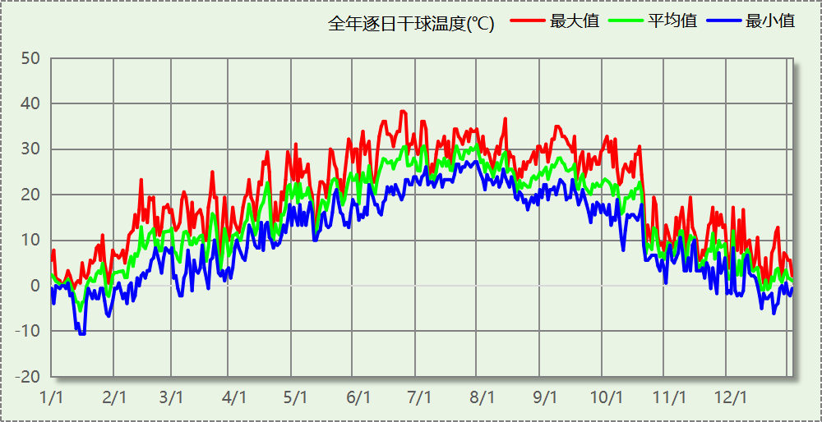

## 逐月辐照量表

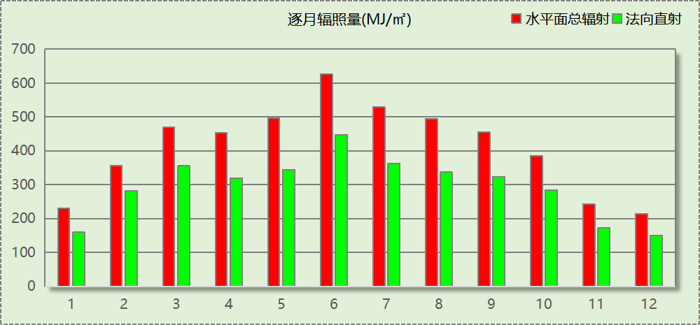

## 峰值工况

|  |  |  |  |  |  |
| --- | --- | --- | --- | --- | --- |
| 气象数据 | 时刻 | 干球温度(℃) | 湿球温度(℃) | 含湿量(g/kg) | 焓值(kj/kg) |
| 最热 | 06月21日15时 | 38.3 | 21.1 | 8.9 | 61.4 |
| 最冷 | 01月14日07时 | -10.6 | -10.6 | 1.4 | -7.1 |

# 建筑大样



西南轴侧图



东南轴侧图



西北轴侧图



东北轴侧图

# 围护结构

## 工程材料

|  |  |  |  |  |  |  |
| --- | --- | --- | --- | --- | --- | --- |
| 材料名称 | 导热系数λ | 蓄热系数S | 密度ρ | 比热容Cp | 蒸汽渗透 系数u | 数据来源 |
| W/(m.K) | W/(㎡.K) | kg/m3 | J/(kg.K) | g/(m.h.kPa) |
| C20细石混凝土(ρ=2300) | 1.510 | 15.243 | 2300.0 | 920.0 | 0.0158 | 安徽公共建筑节能设计标准 DB34 T753-2007 |
| 抹面砂浆（敷设耐碱玻纤网格布一层） | 0.760 | 9.440 | 1500.0 | 1074.9 | 0.0000 |  |
| 1:3水泥砂浆找平层 | 0.930 | 11.370 | 1800.0 | 1061.9 | 0.0000 | 闽2023-J-06 |
| 难燃型挤塑聚苯板（1） | 0.030 | 0.540 | 31.0 | 4311.6 | 0.0000 | 湖南省公/居建节能设计标准常用材料-2022 |
| 加气混凝土、泡沫混凝土(ρ=700) | 0.180 | 3.100 | 700.0 | 1050.0 | 0.0998 |  |
| 混凝土多孔砖(190六孔砖） | 0.750 | 7.490 | 1450.0 | 709.4 | 0.0000 |  |
| 沥青混凝土 | 1.050 | 16.390 | 2100.0 | 1680.0 | 0.0075 | 民用建筑热工设计规范 GB50176-2016 |
| 水泥砂浆找平层 | 0.930 | 11.306 | 1800.0 | 1050.0 | 0.0430 |  |
| 专用抹面砂浆 | 0.930 | 11.306 | 1800.0 | 1050.0 | 0.0140 |  |

## 围护结构作法简要说明

**1. 屋顶：**屋顶构造一 (K=0.337,D=10.564)：（由上到下）

沥青混凝土 20mm＋水泥砂浆找平层 20mm＋C20细石混凝土(ρ=2300) 20mm＋加气混凝土、泡沫混凝土(ρ=700) 470.6mm＋水泥砂浆找平层 120mm＋专用抹面砂浆 20mm

**2. 外墙：**外墙构造一 (K=0.400,D=26.674)：（由外到内）

C20细石混凝土(ρ=2300) 20mm＋水泥砂浆找平层 372.1mm＋C20细石混凝土(ρ=2300) 20mm＋水泥砂浆找平层 200mm＋专用抹面砂浆 1588.8mm

**3. 挑空楼板：**挑空楼板构造一 (K=0.499,D=21.113)：（由上到下）

C20细石混凝土(ρ=2300) 20mm＋水泥砂浆找平层 1666.9mm＋C20细石混凝土(ρ=2300) 20mm＋水泥砂浆找平层 20mm＋C20细石混凝土(ρ=2300) 20mm

**4. 幕墙：**65系列内平开隔热铝合金窗(5+12Ar+5Low-E) (K=2.200)：

传热系数2.200W/㎡.K，窗太阳得热系数0.370

**5. 外窗：**12A钢铝单框双玻窗（平均） (K=1.925)：

传热系数1.925W/㎡.K，窗太阳得热系数0.405

**6. 周边地面：**周边地面构造一 (K=0.971,D=2.373)：

C20细石混凝土(ρ=2300) 20mm＋1:3水泥砂浆找平层 120mm＋加气混凝土、泡沫混凝土(ρ=700) 20mm＋难燃型挤塑聚苯板（1） 20mm

## 体形系数

### 体形系数

|  |  |
| --- | --- |
| 外表面积 | 6928.16 |
| 建筑体积 | 23339.92 |
| 体形系数 | 0.30 |

### 楼层信息表

|  |  |  |  |  |
| --- | --- | --- | --- | --- |
| 楼层 | 层高(m) | 建筑面积(㎡) | 外表面积(㎡) | 计算体积(m3) |
| 1 | 3.500 | 2910.48 | 1584.52 | 10186.67 |
| 2 | 3.500 | 1603.40 | 2126.05 | 7338.11 |
| 3 | 3.500 | 618.30 | 1829.22 | 2907.57 |
| 4 | 3.500 | 830.73 | 563.35 | 2907.57 |
| 5 | 2.000 | 0.00 | 825.03 | 0.00 |
| 合计 | 16.00 | 5962.91 | 6928.16 | 23339.92 |

## 窗墙比

### 窗墙比

|  |  |  |  |  |
| --- | --- | --- | --- | --- |
| 朝向 | 立面 | 窗面积(㎡) | 墙面积(㎡) | 窗墙比 |
| 南向 | 南-默认立面 | 552.01 | 1323.46 | 0.42 |
| 北向 | 北-默认立面 | 659.61 | 1306.31 | 0.50 |
| 东向 | 东-默认立面 | 204.73 | 620.20 | 0.33 |
| 西向 | 西-默认立面 | 277.49 | 728.29 | 0.38 |

### 外窗表

|  |  |  |  |  |  |  |  |  |
| --- | --- | --- | --- | --- | --- | --- | --- | --- |
| 朝向 | 立面 | 编号 | 尺寸 | 楼层 | 数量 | 单个面积 （㎡） | 合计面积 （㎡） | 总面积 （㎡） |
| 南向 | 南-默认立面 |  | 1.80×1.50 | 1 | 2 | 2.70 | 5.40 | 552.01 |
|  | 1.80×1.50 | 2~4 | 3 | 2.70 | 8.10 |
| BLMQ |  | 1~4 |  |  | 157.83 |
| BLMQ |  | 1~2 |  |  | 60.09 |
| C1815 | 1.80×1.50 | 1~4 | 66 | 2.70 | 178.20 |
| C1820 | 1.80×2.00 | 1~2 | 34 | 3.60 | 122.40 |
| C2020 | 2.00×2.00 | 1 | 5 | 4.00 | 20.00 |
| 北向 | 北-默认立面 | (玻璃幕墙) |  | 1 |  |  | 29.23 | 659.61 |
|  | 1.80×1.50 | 2~4 | 7 | 2.70 | 18.90 |
| BLMQ |  | 1~4 |  |  | 437.23 |
| C1515 | 1.50×1.50 | 1 | 1 | 2.25 | 2.25 |
| C1815 | 1.80×1.50 | 1~4 | 40 | 2.70 | 108.00 |
| C1820 | 1.80×2.00 | 3 | 10 | 3.60 | 36.00 |
| C2020 | 2.00×2.00 | 1 | 7 | 4.00 | 28.00 |
| 东向 | 东-默认立面 |  | 1.80×1.50 | 2~4 | 12 | 2.70 | 32.40 | 204.73 |
| BLMQ |  | 2~4 |  |  | 56.33 |
| C1815 | 1.80×1.50 | 1~4 | 33 | 2.70 | 89.10 |
| C1820 | 1.80×2.00 | 3 | 4 | 3.60 | 14.40 |
| C2020 | 2.00×2.00 | 1 | 2 | 4.00 | 8.00 |
| C3015 | 3.00×1.50 | 1 | 1 | 4.50 | 4.50 |
| 西向 | 西-默认立面 |  | 1.80×1.50 | 1 | 2 | 2.70 | 5.40 | 277.49 |
|  | 1.80×1.50 | 2~4 | 12 | 2.70 | 32.40 |
| BLMQ |  | 1~4 |  |  | 100.90 |
| BLMQ |  | 1~2 |  |  | 82.19 |
| C1815 | 1.80×1.50 | 1~4 | 14 | 2.70 | 37.80 |
| C1820 | 1.80×2.00 | 2 | 3 | 3.60 | 10.80 |
| C2020 | 2.00×2.00 | 1 | 2 | 4.00 | 8.00 |

## 天窗

### 天窗屋顶比

本工程无此项内容

### 天窗类型

本工程无此项内容

## 屋顶

### 屋顶构造一

|  |  |  |  |  |  |  |
| --- | --- | --- | --- | --- | --- | --- |
| 材料名称 （由上到下） | 厚度δ | 导热系数λ | 蓄热系数S | 修正 系数 | 热阻R | 热惰性 指标 |
| (mm) | W/(m.K) | W/(㎡.K) | α | (㎡K)/W | D=R*S |
| 沥青混凝土 | 20 | 1.050 | 16.390 | 1.00 | 0.019 | 0.312 |
| 水泥砂浆找平层 | 20 | 0.930 | 11.306 | 1.00 | 0.022 | 0.243 |
| C20细石混凝土(ρ=2300) | 20 | 1.510 | 15.243 | 1.00 | 0.013 | 0.202 |
| 加气混凝土、泡沫混凝土(ρ=700) | 470.6 | 0.180 | 3.100 | 1.00 | 2.614 | 8.105 |
| 水泥砂浆找平层 | 120 | 0.930 | 11.306 | 1.00 | 0.129 | 1.459 |
| 专用抹面砂浆 | 20 | 0.930 | 11.306 | 1.00 | 0.022 | 0.243 |
| 各层之和∑ | 670.6 | － | － | － | 2.819 | 10.564 |
| 外表面太阳辐射吸收系数 | 0.50[默认] | | | | | |
| 传热系数K=1/(0.15+∑R) | 0.34 | | | | | |

## 外墙

### 外墙构造一

|  |  |  |  |  |  |  |
| --- | --- | --- | --- | --- | --- | --- |
| 材料名称 （由外到内） | 厚度δ | 导热系数λ | 蓄热系数S | 修正 系数 | 热阻R | 热惰性 指标 |
| (mm) | W/(m.K) | W/(㎡.K) | α | (㎡K)/W | D=R*S |
| C20细石混凝土(ρ=2300) | 20 | 1.510 | 15.243 | 1.00 | 0.013 | 0.202 |
| 水泥砂浆找平层 | 372.1 | 0.930 | 11.306 | 1.00 | 0.400 | 4.524 |
| C20细石混凝土(ρ=2300) | 20 | 1.510 | 15.243 | 1.00 | 0.013 | 0.202 |
| 水泥砂浆找平层 | 200 | 0.930 | 11.306 | 1.00 | 0.215 | 2.431 |
| 专用抹面砂浆 | 1588.8 | 0.930 | 11.306 | 1.00 | 1.708 | 19.315 |
| 各层之和∑ | 2200.9 | － | － | － | 2.350 | 26.674 |
| 外表面太阳辐射吸收系数 | 0.50[默认] | | | | | |
| 传热系数K=1/(0.15+∑R) | 0.40 | | | | | |

### 外墙主断面传热系数的修正系数ψ

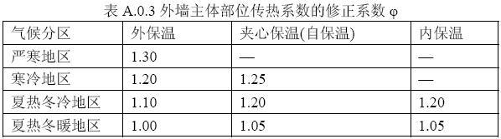

## 挑空楼板

### 挑空楼板构造一

|  |  |  |  |  |  |  |
| --- | --- | --- | --- | --- | --- | --- |
| 材料名称 （由上到下） | 厚度δ | 导热系数λ | 蓄热系数S | 修正 系数 | 热阻R | 热惰性 指标 |
| (mm) | W/(m.K) | W/(㎡.K) | α | (㎡K)/W | D=R*S |
| C20细石混凝土(ρ=2300) | 20 | 1.510 | 15.243 | 1.00 | 0.013 | 0.202 |
| 水泥砂浆找平层 | 1666.9 | 0.930 | 11.306 | 1.00 | 1.792 | 20.264 |
| C20细石混凝土(ρ=2300) | 20 | 1.510 | 15.243 | 1.00 | 0.013 | 0.202 |
| 水泥砂浆找平层 | 20 | 0.930 | 11.306 | 1.00 | 0.022 | 0.243 |
| C20细石混凝土(ρ=2300) | 20 | 1.510 | 15.243 | 1.00 | 0.013 | 0.202 |
| 各层之和∑ | 1746.9 | － | － | － | 1.854 | 21.113 |
| 传热系数K=1/(0.15+∑R) | 0.50 | | | | | |

## 地下车库与供暖房间之间的楼板

本工程无此项内容

## 采暖与非采暖隔墙

本工程无此项内容

## 外窗热工

### 外窗

|  |  |  |  |  |  |  |
| --- | --- | --- | --- | --- | --- | --- |
| 序号 | 构造名称 | 构造 编号 | 传热 系数 | 窗太阳 得热系数 | 可见光 透射比 | 数据来源 |
| 1 | 12A钢铝单框双玻窗（平均） | 18 | 1.93 | 0.40 | 0.720 |  |
| 窗编号 | | | | |
| ，C1815，C1820，C2020，C3015，C1515 | | | | |
| 2 | 65系列内平开隔热铝合金窗(5+12Ar+5Low-E) | 65 | 2.20 | 0.37 | 0.620 | 近零能耗建筑技术标准 GBT51350-2019 |
| 窗编号 | | | | |
| BLMQ，幕墙 | | | | |

### 外遮阳类型

#### 自定义遮阳

|  |  |  |  |  |  |
| --- | --- | --- | --- | --- | --- |
| 序号 | 编号 | 夏季遮阳系数 | 冬季遮阳系数 | 平均遮阳系数 | 备注 |
| 1 | 活动遮阳0 | 0.200 | 1.000 | 0.600 |  |

### 平均传热系数

1. 南向：

南-默认立面

|  |  |  |  |  |  |  |  |
| --- | --- | --- | --- | --- | --- | --- | --- |
| 序号 | 门窗 编号 | 楼层 | 数量 | 单个面积（㎡） | 总面积（㎡） | 构造 编号 | 传热系数 |
| 1 |  | 1 | 2 | 2.700 | 5.400 | 18 | 1.925 |
| 2 |  | 2~4 | 3 | 2.700 | 8.100 | 18 | 1.925 |
| 3 | BLMQ | 1~4 |  |  | 157.825 | 65 | 2.200 |
| 4 | BLMQ | 1~2 |  |  | 60.088 | 65 | 2.200 |
| 5 | C1815 | 1~4 | 66 | 2.700 | 178.200 | 18 | 1.925 |
| 6 | C1820 | 1~2 | 34 | 3.600 | 122.400 | 18 | 1.925 |
| 7 | C2020 | 1 | 5 | 4.000 | 20.000 | 18 | 1.925 |
| 立面总面积(㎡) | | | 552.013 | 立面平均传热系数 | | | 2.034 |

2. 北向：

北-默认立面

|  |  |  |  |  |  |  |  |
| --- | --- | --- | --- | --- | --- | --- | --- |
| 序号 | 门窗 编号 | 楼层 | 数量 | 单个面积（㎡） | 总面积（㎡） | 构造 编号 | 传热系数 |
| 1 | (玻璃幕墙) | 1 |  |  | 29.225 | 65 | 2.200 |
| 2 |  | 2~4 | 7 | 2.700 | 18.900 | 18 | 1.925 |
| 3 | BLMQ | 1~4 |  |  | 437.232 | 65 | 2.200 |
| 4 | C1515 | 1 | 1 | 2.250 | 2.250 | 18 | 1.925 |
| 5 | C1815 | 1~4 | 40 | 2.700 | 108.000 | 18 | 1.925 |
| 6 | C1820 | 3 | 10 | 3.600 | 36.000 | 18 | 1.925 |
| 7 | C2020 | 1 | 7 | 4.000 | 28.000 | 18 | 1.925 |
| 立面总面积(㎡) | | | 659.607 | 立面平均传热系数 | | | 2.119 |

3. 东向：

东-默认立面

|  |  |  |  |  |  |  |  |
| --- | --- | --- | --- | --- | --- | --- | --- |
| 序号 | 门窗 编号 | 楼层 | 数量 | 单个面积（㎡） | 总面积（㎡） | 构造 编号 | 传热系数 |
| 1 |  | 2~4 | 12 | 2.700 | 32.400 | 18 | 1.925 |
| 2 | BLMQ | 2~4 |  |  | 56.325 | 65 | 2.200 |
| 3 | C1815 | 1~4 | 33 | 2.700 | 89.100 | 18 | 1.925 |
| 4 | C1820 | 3 | 4 | 3.600 | 14.400 | 18 | 1.925 |
| 5 | C2020 | 1 | 2 | 4.000 | 8.000 | 18 | 1.925 |
| 6 | C3015 | 1 | 1 | 4.500 | 4.500 | 18 | 1.925 |
| 立面总面积(㎡) | | | 204.725 | 立面平均传热系数 | | | 2.001 |

4. 西向：

西-默认立面

|  |  |  |  |  |  |  |  |
| --- | --- | --- | --- | --- | --- | --- | --- |
| 序号 | 门窗 编号 | 楼层 | 数量 | 单个面积（㎡） | 总面积（㎡） | 构造 编号 | 传热系数 |
| 1 |  | 1 | 2 | 2.700 | 5.400 | 18 | 1.925 |
| 2 |  | 2~4 | 12 | 2.700 | 32.400 | 18 | 1.925 |
| 3 | BLMQ | 1~4 |  |  | 100.898 | 65 | 2.200 |
| 4 | BLMQ | 1~2 |  |  | 82.188 | 65 | 2.200 |
| 5 | C1815 | 1~4 | 14 | 2.700 | 37.800 | 18 | 1.925 |
| 6 | C1820 | 2 | 3 | 3.600 | 10.800 | 18 | 1.925 |
| 7 | C2020 | 1 | 2 | 4.000 | 8.000 | 18 | 1.925 |
| 立面总面积(㎡) | | | 277.486 | 立面平均传热系数 | | | 2.106 |

### 综合太阳得热系数

1. 南向：

南-默认立面

|  |  |  |  |  |  |  |  |  |  |  |
| --- | --- | --- | --- | --- | --- | --- | --- | --- | --- | --- |
| 序号 | 门窗 编号 | 楼层 | 数量 | 单个面积（㎡） | 总面积（㎡） | 构造 编号 | 窗太阳 得热系数 | 外遮阳 编号 | 外遮阳 系数 | 综合太阳 得热系数 |
| 1 |  | 1 | 2 | 2.700 | 5.400 | 18 | 0.405 | 活动遮阳0 | 0.600 | 0.243 |
| 2 |  | 2~4 | 3 | 2.700 | 8.100 | 18 | 0.405 |  | 1.000 | 0.405 |
| 3 | BLMQ | 1~4 |  |  | 157.825 | 65 | 0.370 |  | 1.000 | 0.370 |
| 4 | BLMQ | 1~2 |  |  | 60.088 | 65 | 0.370 | 活动遮阳0 | 0.600 | 0.222 |
| 5 | C1815 | 1~4 | 66 | 2.700 | 178.200 | 18 | 0.405 | 活动遮阳0 | 0.600 | 0.243 |
| 6 | C1820 | 1~2 | 34 | 3.600 | 122.400 | 18 | 0.405 | 活动遮阳0 | 0.600 | 0.243 |
| 7 | C2020 | 1 | 5 | 4.000 | 20.000 | 18 | 0.405 | 活动遮阳0 | 0.600 | 0.243 |
| 立面总面积(㎡) | | | | | 552.013 | 综合太阳得热系数 | | | | 0.279 |

2. 北向：

北-默认立面

|  |  |  |  |  |  |  |  |  |  |  |
| --- | --- | --- | --- | --- | --- | --- | --- | --- | --- | --- |
| 序号 | 门窗 编号 | 楼层 | 数量 | 单个面积（㎡） | 总面积（㎡） | 构造 编号 | 窗太阳 得热系数 | 外遮阳 编号 | 外遮阳 系数 | 综合太阳 得热系数 |
| 1 | (玻璃幕墙) | 1 |  |  | 29.225 | 65 | 0.370 |  | 1.000 | 0.370 |
| 2 |  | 2~4 | 7 | 2.700 | 18.900 | 18 | 0.405 |  | 1.000 | 0.405 |
| 3 | BLMQ | 1~4 |  |  | 437.232 | 65 | 0.370 |  | 1.000 | 0.370 |
| 4 | C1515 | 1 | 1 | 2.250 | 2.250 | 18 | 0.405 |  | 1.000 | 0.405 |
| 5 | C1815 | 1~4 | 40 | 2.700 | 108.000 | 18 | 0.405 |  | 1.000 | 0.405 |
| 6 | C1820 | 3 | 10 | 3.600 | 36.000 | 18 | 0.405 |  | 1.000 | 0.405 |
| 7 | C2020 | 1 | 7 | 4.000 | 28.000 | 18 | 0.405 |  | 1.000 | 0.405 |
| 立面总面积(㎡) | | | | | 659.607 | 综合太阳得热系数 | | | | 0.380 |

3. 东向：

东-默认立面

|  |  |  |  |  |  |  |  |  |  |  |
| --- | --- | --- | --- | --- | --- | --- | --- | --- | --- | --- |
| 序号 | 门窗 编号 | 楼层 | 数量 | 单个面积（㎡） | 总面积（㎡） | 构造 编号 | 窗太阳 得热系数 | 外遮阳 编号 | 外遮阳 系数 | 综合太阳 得热系数 |
| 1 |  | 2~4 | 12 | 2.700 | 32.400 | 18 | 0.405 |  | 1.000 | 0.405 |
| 2 | BLMQ | 2~4 |  |  | 56.325 | 65 | 0.370 |  | 1.000 | 0.370 |
| 3 | C1815 | 1~4 | 33 | 2.700 | 89.100 | 18 | 0.405 | 活动遮阳0 | 0.600 | 0.243 |
| 4 | C1820 | 3 | 4 | 3.600 | 14.400 | 18 | 0.405 | 活动遮阳0 | 0.600 | 0.243 |
| 5 | C2020 | 1 | 2 | 4.000 | 8.000 | 18 | 0.405 |  | 1.000 | 0.405 |
| 6 | C3015 | 1 | 1 | 4.500 | 4.500 | 18 | 0.405 | 活动遮阳0 | 0.600 | 0.243 |
| 立面总面积(㎡) | | | | | 204.725 | 综合太阳得热系数 | | | | 0.310 |

4. 西向：

西-默认立面

|  |  |  |  |  |  |  |  |  |  |  |
| --- | --- | --- | --- | --- | --- | --- | --- | --- | --- | --- |
| 序号 | 门窗 编号 | 楼层 | 数量 | 单个面积（㎡） | 总面积（㎡） | 构造 编号 | 窗太阳 得热系数 | 外遮阳 编号 | 外遮阳 系数 | 综合太阳 得热系数 |
| 1 |  | 1 | 2 | 2.700 | 5.400 | 18 | 0.405 | 活动遮阳0 | 0.600 | 0.243 |
| 2 |  | 2~4 | 12 | 2.700 | 32.400 | 18 | 0.405 |  | 1.000 | 0.405 |
| 3 | BLMQ | 1~4 |  |  | 100.898 | 65 | 0.370 |  | 1.000 | 0.370 |
| 4 | BLMQ | 1~2 |  |  | 82.188 | 65 | 0.370 | 活动遮阳0 | 0.600 | 0.222 |
| 5 | C1815 | 1~4 | 14 | 2.700 | 37.800 | 18 | 0.405 | 活动遮阳0 | 0.600 | 0.243 |
| 6 | C1820 | 2 | 3 | 3.600 | 10.800 | 18 | 0.405 | 活动遮阳0 | 0.600 | 0.243 |
| 7 | C2020 | 1 | 2 | 4.000 | 8.000 | 18 | 0.405 |  | 1.000 | 0.405 |
| 立面总面积(㎡) | | | | | 277.486 | 综合太阳得热系数 | | | | 0.306 |

### 总体热工性能

|  |  |  |  |  |  |
| --- | --- | --- | --- | --- | --- |
| 朝向 | 立面 | 面积 | 传热系数 | 综合太阳得热系数 | 窗墙比 |
| 南向 | 南-默认立面 | 552.01 | 2.03 | 0.28 | 0.42 |
| 北向 | 北-默认立面 | 659.61 | 2.12 | 0.38 | 0.50 |
| 东向 | 东-默认立面 | 204.73 | 2.00 | 0.31 | 0.33 |
| 西向 | 西-默认立面 | 277.49 | 2.11 | 0.31 | 0.38 |
| 综合平均 |  | 1693.83 | 2.07 | 0.33 | 0.43 |

注：本表所统计的外窗包含凸窗。

## 周边地面

### 周边地面构造一

|  |  |  |  |  |  |  |
| --- | --- | --- | --- | --- | --- | --- |
| 材料名称 | 厚度δ | 导热系数λ | 蓄热系数S | 修正 系数 | 热阻R | 热惰性 指标 |
| (mm) | W/(m.K) | W/(㎡.K) | α | (㎡K)/W | D=R*S |
| C20细石混凝土(ρ=2300) | 20 | 1.510 | 15.243 | 1.00 | 0.013 | 0.202 |
| 1:3水泥砂浆找平层 | 120 | 0.930 | 11.370 | 1.00 | 0.129 | 1.467 |
| 加气混凝土、泡沫混凝土(ρ=700) | 20 | 0.180 | 3.100 | 1.00 | 0.111 | 0.344 |
| 难燃型挤塑聚苯板（1） | 20 | 0.030 | 0.540 | 1.00 | 0.667 | 0.360 |
| 各层之和∑ | 180 | － | － | － | 0.920 | 2.373 |
| 保温材料层R | 0.78 | | | | | |

备注：用灰色显示的材料是非保温材料。

## 采暖地下室外墙

本工程无此项内容

## 变形缝

本工程无此项内容

## 可开启窗扇

# 围护结构概况

|  |  |  |  |  |  |  |  |  |
| --- | --- | --- | --- | --- | --- | --- | --- | --- |
|  | | | 设计建筑 | | | 参照建筑 | | |
| 屋顶传热系数K  和热惰性指标 D | | | 0.34  10.56 | | | 0.40  9.11 | | |
| 外墙传热系数K  和热惰性指标 D | | | 0.40  26.67 | | | 0.50  4.01 | | |
| 挑空(或架空)楼板传热系数K  和热惰性指标 D | | | 0.50  21.11 | | | 0.50  3.43 | | |
| 天窗传热系数K  和太阳得热系数 SHGC | | | －  － | | | －  － | | |
| 外窗（包括透明幕墙） | 朝向 | 立面 | 窗墙比 | 传热  系数 | 太阳得热系数 | 窗墙比 | 传热  系数 | 太阳得热系数 |
| 南向 | 南-默认立面 | 0.42 | 2.03 | 0.28 | 0.42 | 1.90 | 0.40 |
| 北向 | 北-默认立面 | 0.50 | 2.12 | 0.38 | 0.50 | 1.90 | －－ |
| 东向 | 东-默认立面 | 0.33 | 2.00 | 0.31 | 0.33 | 2.00 | 0.40 |
| 西向 | 西-默认立面 | 0.38 | 2.11 | 0.31 | 0.38 | 2.00 | 0.40 |

备注：

1. 传热系数的单位W/(m2.k)，其他参数无量纲.

2. 屋顶和外墙的传热系数K和热情性指标D指平均值.

3. 设计建筑：“—”代表本工程无对应项.

4. 参照建筑：“— —”代表参照建筑不要求，取值同设计建筑.

# 设计建筑

## 房间类型

### 房间参数表

|  |  |  |  |  |  |  |  |
| --- | --- | --- | --- | --- | --- | --- | --- |
| 房间类型 | 空调 温度℃ | 供暖 温度℃ | 新风量 | 渗透风 换气次数 | 人员密度 | 照明功率 密度 | 电器设备 功率 |
| 一般商店 | 26 | 20 | 19(m3/h.人) | 0(次/h) | 4(㎡/人) | 9(W/㎡) | 13(W/㎡) |
| 书库 | 26 | 20 | 30(m3/h.人) | 0(次/h) | 8(㎡/人) | 8(W/㎡) | 15(W/㎡) |
| 休息室 | 26 | 20 | 30(m3/h.人) | 0(次/h) | 3.3(㎡/人) | 5(W/㎡) | 0(W/㎡) |
| 会议室 | 26 | 18 | 14(m3/h.人) | 0(次/h) | 2.5(㎡/人) | 8(W/㎡) | 15(W/㎡) |
| 办公-普通办公室 | 26 | 20 | 30(m3/h.人) | 0(次/h) | 8(㎡/人) | 8(W/㎡) | 15(W/㎡) |
| 卫生间 | 26 | 20 | 30(m3/h.人) | 0(次/h) | 8(㎡/人) | 8(W/㎡) | 15(W/㎡) |
| 大厅 | 26 | 18 | 20(m3/h.人) | 0(次/h) | 30(㎡/人) | 10(W/㎡) | 15(W/㎡) |
| 展示区 | 26 | 20 | 30(m3/h.人) | 0(次/h) | 2.5(㎡/人) | 8(W/㎡) | 15(W/㎡) |
| 开架书库 | 26 | 20 | 30(m3/h.人) | 0(次/h) | 8(㎡/人) | 8(W/㎡) | 15(W/㎡) |
| 普通办公室 | 26 | 20 | 30(m3/h.人) | 0(次/h) | 8(㎡/人) | 8(W/㎡) | 15(W/㎡) |
| 楼梯间 | 26 | 20 | 30(m3/h.人) | 0(次/h) | 8(㎡/人) | 8(W/㎡) | 15(W/㎡) |
| 目录室 | 26 | 20 | 30(m3/h.人) | 0(次/h) | 8(㎡/人) | 8(W/㎡) | 15(W/㎡) |
| 走廊 | 26 | 20 | 30(m3/h.人) | 0(次/h) | 8(㎡/人) | 8(W/㎡) | 15(W/㎡) |
| 酒吧、茶座 | 26 | 18 | 30(m3/h.人) | 0(次/h) | 2(㎡/人) | 8(W/㎡) | 0(W/㎡) |
| 阅览室 | 26 | 20 | 30(m3/h.人) | 0(次/h) | 8(㎡/人) | 8(W/㎡) | 15(W/㎡) |

### 作息时间表

详见附录

## 系统类型

### 系统分区

|  |  |  |  |  |  |
| --- | --- | --- | --- | --- | --- |
| 系统编号 | 系统类型 | 制冷 SEER | 制热 HSPF | 面积(㎡) | 包含的房间 |
| 默认 | 双管制风机盘管 | － | － | 2347.69 | 1004(1),1003(1),2008(2),2007(2),2003(2),3002(3),4001(4) |
| Sys | 地暖/辐射板采暖/散热器采暖+多联机供冷 | 4.00 | － | 3093.54 | 1045(1),1043(1),1044(1),1001(1),1042(1),1041(1),1039(1),1037(1),1033(1),1030(1),1029(1),1026(1),1019(1),1018(1),1017(1),1016(1),1015(1),1014(1),1013(1),1011(1),1010(1),2001(2),2044(2),2043(2),2040(2),2038(2),2034(2),2032(2),2031(2),2027(2),3009(3),3008(3),3004(3),4007(4),4006(4),4003(4) |

### 热回收参数

|  |  |  |  |  |  |
| --- | --- | --- | --- | --- | --- |
| 系统编号 | 热回收 | 供冷 | | 供暖 | |
| 回收效率 | 启动温(焓)差 | 回收效率 | 启动温(焓)差 |
| 默认 | 全热回收 | 0.00 | 5℃ | 0.00 | 5(℃) |
| Sys | 全热回收 | 0.50 | 5℃ | 0.55 | 5(℃) |

## 制冷系统

### 默认冷源

#### 供应的系统

|  |  |
| --- | --- |
| 系统编号 | 默认 |

#### 冷水机组

|  |  |  |  |  |  |
| --- | --- | --- | --- | --- | --- |
| 名称 | 类型 | 额定耗电量 (kW) | 额定制冷量 (kW) | 额定性能系数 (COP) | 台数 |
| 机组1 | 水冷-螺杆式冷水机组 | 100 | 500 | 5.00 | 1 |

#### 水泵系统

|  |  |  |  |  |  |  |  |
| --- | --- | --- | --- | --- | --- | --- | --- |
| 类型 | 调节 | 流量 (m3/h) | 扬程 (m) | 设计工作效率(%) | 输入功率 (kW) | 冷却塔耗电比 (kWh/m3) | 台数 |
| 冷却水泵 | 单速 | 320 | 25 | 80 | 31.3 | 0.03 | 1 |
| 冷冻水泵 | 单速 | 320 | 30 | 80 | 37.6 | － | 1 |

#### 运行工况

|  |  |  |  |  |  |  |
| --- | --- | --- | --- | --- | --- | --- |
| 负载率 (%) | 机组制冷量 (kW) | 机组功率 (kW) | 性能系数 (COP) | 冷却水泵功率 (kW) | 冷冻水泵功率 (kW) | 冷却塔功率 (kW) |
| 20 | 100 | 25 | 4.00 | 31.3 | 37.6 | 10 |
| 40 | 200 | 48 | 4.17 | 31.3 | 37.6 | 10 |
| 60 | 300 | 68 | 4.41 | 31.3 | 37.6 | 10 |
| 80 | 400 | 80 | 5.00 | 31.3 | 37.6 | 10 |
| 100 | 500 | 100 | 5.00 | 31.3 | 37.6 | 10 |

#### 制冷能耗

|  |  |  |  |  |  |  |  |
| --- | --- | --- | --- | --- | --- | --- | --- |
| 负荷区间 (%) | 区间负荷 (kWh) | 运行时长(h) | 制冷机组 (kWh) | 平均性能系数(COP) | 冷却水泵 (kWh) | 冷冻水泵 (kWh) | 冷却塔 (kWh) |
| 0~20 | 0 | 0 | 0 | 0.00 | 0 | 0 | 0 |
| 20~40 | 0 | 0 | 0 | 0.00 | 0 | 0 | 0 |
| 40~60 | 0 | 0 | 0 | 0.00 | 0 | 0 | 0 |
| 60~80 | 0 | 0 | 0 | 0.00 | 0 | 0 | 0 |
| 80~100 | 0 | 0 | 0 | 0.00 | 0 | 0 | 0 |
| >100 | 0 | 0 | 0 | － | 0 | 0 | 0 |
| 合计 | 0 | 0 | 0 |  | 0 | 0 | 0 |

### 多联机/单元式空调能耗

|  |  |  |  |
| --- | --- | --- | --- |
| 系统编号 | 制冷SEER | 耗冷量(kWh) | 耗电量(kWh) |
| Sys | 4.00 | 38174 | 9544 |

## 供暖系统

### 默认热源

#### 供应的系统

|  |  |
| --- | --- |
| 系统编号 | 默认, Sys |

#### 市政热力系统能耗

|  |  |  |  |  |  |  |
| --- | --- | --- | --- | --- | --- | --- |
| 累计 热负荷 (kWh) | 外网热 输送效率 | 耗电 输热比 EHR | 热/电 转换系数 (kWh/kWh) | 热源折合 电耗 (kWh) | 供暖水 泵电耗 (kWh) | 合计 电耗 (kWh) |
| 69270 | 0.92 | 0.00433 | 2.93 | 25694 | 300 | 25994 |

## 空调风机

### 独立新排风

|  |  |  |  |  |  |
| --- | --- | --- | --- | --- | --- |
| 系统编号 | 新风量 (m3/h) | 单位风量耗功率 W/(m3/h) | 风机功率(W) | 运行时长(h) | 新风电耗(kWh) |
| 默认 | 15191 | 0.24 | 3646 | 1080 | 3141 |
| Sys | 24587 | 0.24 | 5901 | 1528 | 6256 |
| 合计 | | | | | 9397 |

|  |  |  |  |  |  |  |
| --- | --- | --- | --- | --- | --- | --- |
| 系统编号 | 排风量 (m3/h) | 排风比 | 单位风量耗功率W/(m3/h) | 风机功率(W) | 运行时长(h) | 排风电耗 (kWh) |
| 默认 | 15191 | 1 | 0.24 | 3646 | 1080 | 3141 |
| 合计 | | | | | | 3141 |

### 风机盘管

|  |  |  |  |  |
| --- | --- | --- | --- | --- |
| 系统编号 | 总功率(W) | 同时使用系数 | 运行时长(h) | 风机盘管电耗(kWh) |
| 默认 | 400 | 1 | 562 | 225 |
| 合计 | | | | 225 |

## 负荷分项统计

|  |  |  |  |  |  |  |
| --- | --- | --- | --- | --- | --- | --- |
| 分类 | 围护传热 | 室内得热 | 窗日射 | 新风/渗透 | 热回收 | 合计 |
| 供暖(kWh/㎡) | -9.46 | 8.25 | 2.74 | -20.38 | 7.23 | -11.62 |
| 供冷(kWh/㎡) | 1.98 | 1.65 | 0.03 | 3.69 | -0.95 | 6.40 |

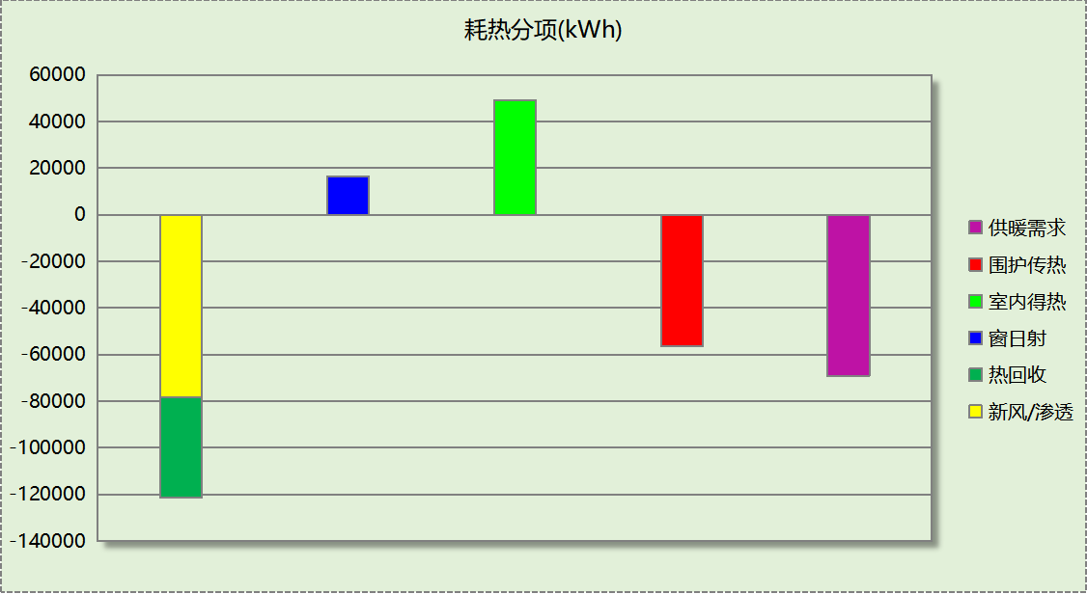

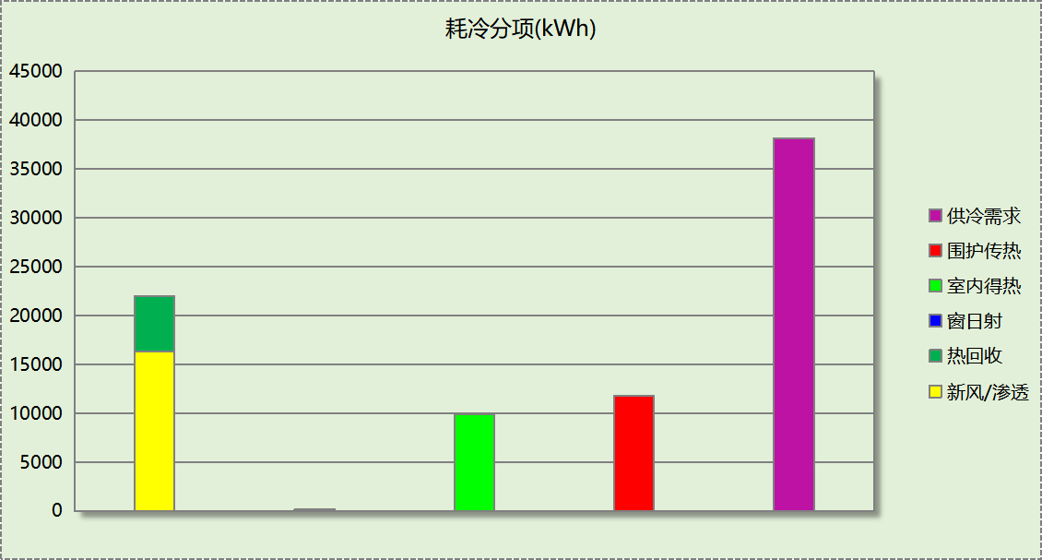

## 逐月负荷表

|  |  |  |  |  |  |  |
| --- | --- | --- | --- | --- | --- | --- |
| 月份 | 供暖(kWh) | 供冷(kWh) | 热负荷 峰值(kW) | 热负荷 峰值时刻 | 冷负荷 峰值(kW) | 冷负荷 峰值时刻 |
| 1月 | 26381 | 0 | 686.125 | 1月2日8时 | 0.000 | -- |
| 2月 | 0 | 0 | 0.000 | -- | 0.000 | -- |
| 3月 | 0 | 0 | 0.000 | -- | 0.000 | -- |
| 4月 | 0 | 0 | 0.000 | -- | 0.000 | -- |
| 5月 | 0 | 0 | 0.000 | -- | 0.000 | -- |
| 6月 | 0 | 0 | 0.000 | -- | 0.000 | -- |
| 7月 | 0 | 19388 | 0.000 | -- | 131.141 | 7月26日11时 |
| 8月 | 0 | 18786 | 0.000 | -- | 125.383 | 8月11日10时 |
| 9月 | 0 | 0 | 0.000 | -- | 0.000 | -- |
| 10月 | 0 | 0 | 0.000 | -- | 0.000 | -- |
| 11月 | 9234 | 0 | 510.948 | 11月15日8时 | 0.000 | -- |
| 12月 | 33655 | 0 | 469.136 | 12月16日8时 | 0.000 | -- |

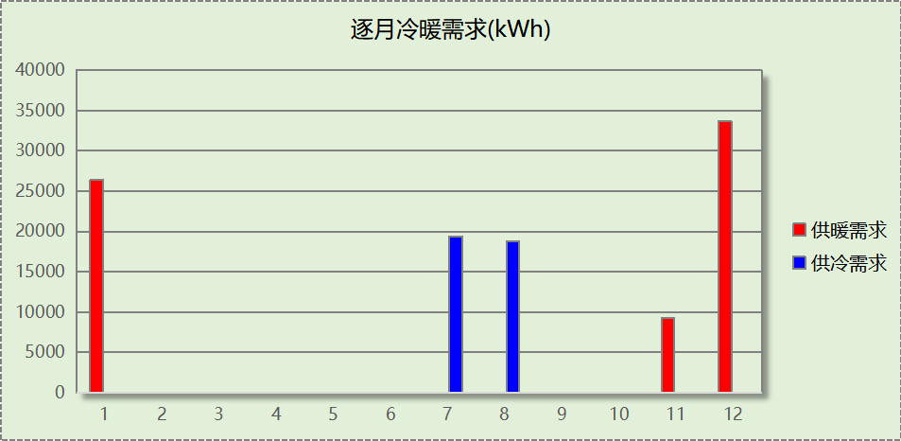

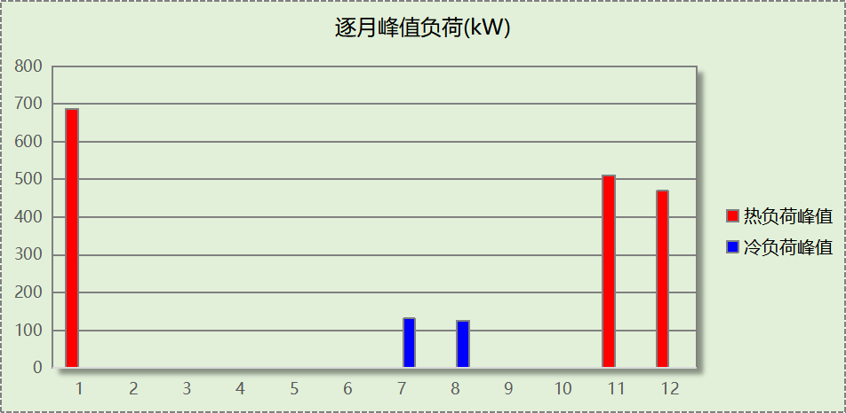

## 逐月电耗

注:供冷供暖为冷热源及输配水泵电耗，热水为扣减太阳能后电耗，所有数据单位kWh/㎡。

|  |  |  |  |  |  |  |  |  |
| --- | --- | --- | --- | --- | --- | --- | --- | --- |
| 月 | 供冷 | 供暖 | 空调风机 | 照明 | 插座设备 | 排风机 | 电梯 | 热水 |
| 1 | 0.00 | 1.66 | 0.28 | － | － | － | － | － |
| 2 | 0.00 | 0.00 | 0.00 | － | － |
| 3 | 0.00 | 0.00 | 0.00 | － | － |
| 4 | 0.00 | 0.00 | 0.00 | － | － |
| 5 | 0.00 | 0.00 | 0.00 | － | － |
| 6 | 0.00 | 0.00 | 0.00 | － | － |
| 7 | 0.81 | 0.00 | 0.37 | － | － |
| 8 | 0.79 | 0.00 | 0.50 | － | － |
| 9 | 0.00 | 0.00 | 0.00 | － | － |
| 10 | 0.00 | 0.00 | 0.00 | － | － |
| 11 | 0.00 | 0.58 | 0.33 | － | － |
| 12 | 0.00 | 2.12 | 0.66 | － | － |
| 合计 | 1.60 | 4.36 | 2.14 | － | － | － | － | － |

# 参照建筑

## 房间类型

### 房间参数表

|  |  |  |  |  |  |  |  |
| --- | --- | --- | --- | --- | --- | --- | --- |
| 房间类型 | 空调 温度℃ | 供暖 温度℃ | 新风量 | 渗透风 换气次数 | 人员密度 | 照明功率 密度 | 电器设备 功率 |
| 一般商店 | 26 | 20 | 19(m3/h.人) | 0(次/h) | 4(㎡/人) | 10(W/㎡) | 13(W/㎡) |
| 书库 | 26 | 20 | 30(m3/h.人) | 0(次/h) | 8(㎡/人) | 9(W/㎡) | 15(W/㎡) |
| 休息室 | 26 | 20 | 30(m3/h.人) | 0(次/h) | 3.3(㎡/人) | 5(W/㎡) | 0(W/㎡) |
| 会议室 | 26 | 18 | 14(m3/h.人) | 0(次/h) | 2.5(㎡/人) | 9(W/㎡) | 15(W/㎡) |
| 办公-普通办公室 | 26 | 20 | 30(m3/h.人) | 0(次/h) | 8(㎡/人) | 9(W/㎡) | 15(W/㎡) |
| 卫生间 | 26 | 20 | 30(m3/h.人) | 0(次/h) | 8(㎡/人) | 9(W/㎡) | 15(W/㎡) |
| 大厅 | 26 | 18 | 20(m3/h.人) | 0(次/h) | 30(㎡/人) | 11(W/㎡) | 15(W/㎡) |
| 展示区 | 26 | 20 | 30(m3/h.人) | 0(次/h) | 2.5(㎡/人) | 9(W/㎡) | 15(W/㎡) |
| 开架书库 | 26 | 20 | 30(m3/h.人) | 0(次/h) | 8(㎡/人) | 9(W/㎡) | 15(W/㎡) |
| 普通办公室 | 26 | 20 | 30(m3/h.人) | 0(次/h) | 8(㎡/人) | 9(W/㎡) | 15(W/㎡) |
| 楼梯间 | 26 | 20 | 30(m3/h.人) | 0(次/h) | 8(㎡/人) | 9(W/㎡) | 15(W/㎡) |
| 目录室 | 26 | 20 | 30(m3/h.人) | 0(次/h) | 8(㎡/人) | 9(W/㎡) | 15(W/㎡) |
| 走廊 | 26 | 20 | 30(m3/h.人) | 0(次/h) | 8(㎡/人) | 9(W/㎡) | 15(W/㎡) |
| 酒吧、茶座 | 26 | 18 | 30(m3/h.人) | 0(次/h) | 2(㎡/人) | 8(W/㎡) | 0(W/㎡) |
| 阅览室 | 26 | 20 | 30(m3/h.人) | 0(次/h) | 8(㎡/人) | 9(W/㎡) | 15(W/㎡) |

### 作息时间表

同设计建筑

## 系统类型

|  |  |  |  |  |  |
| --- | --- | --- | --- | --- | --- |
| 系统编号 | 系统类型 | 制冷 SEER | 制热 HSPF | 面积(㎡) | 包含的房间 |
| 默认 | 双管制风机盘管 | － | － | 同设计建筑 | 同设计建筑 |
| Sys | 地暖/辐射板采暖/散热器采暖+多联机供冷 | 2.70 | － | 同设计建筑 | 同设计建筑 |

## 制冷系统

### 默认冷源

#### 供应的系统

|  |  |
| --- | --- |
| 系统编号 | 默认 |

#### 冷水机组

|  |  |  |  |  |  |  |  |  |
| --- | --- | --- | --- | --- | --- | --- | --- | --- |
| 名称 | 类型 | 额定 耗电量(kW) | 额定 制冷量(kW) | 额定性 能系数 (COP) | 台数 | 全年 供冷量(kWh) | 综合部分 负荷性能系数(IPLV) | 电耗 (kWh) |
| 机组1 | 水冷-螺杆式冷水机组 | 42 | 223 | 5.30 | 1 | 0 | 5.45 | 0 |
| 合计 | | | | | | | | 0 |

#### 冷却水泵

|  |  |  |  |  |  |  |
| --- | --- | --- | --- | --- | --- | --- |
| 机组名称 | 冷水机组 制冷量(kW) | 机组性能 系数(COP) | 冷凝负荷(kW) | 输送能效比 | 运行时长 (h) | 水泵电耗 (kWh) |
| 机组1 | 223 | 5.30 | 265 | 0.0214 | 0 | 0 |
| 合计 | 223 |  | 265 |  |  | 0 |

#### 冷冻水泵

|  |  |  |  |  |
| --- | --- | --- | --- | --- |
| 机组名称 | 机组制冷量(kW) | 输送能效比 | 运行时长(h) | 水泵电耗(kWh) |
| 机组1 | 223 | 0.0241 | 0 | 0 |
| 合计 | 223 |  |  | 0 |

#### 冷却塔

|  |  |  |  |  |  |
| --- | --- | --- | --- | --- | --- |
| 类型 | 机组制冷量(kW) | 冷却塔风机单位 电耗制冷量(kW/kW) | 冷却塔风机 功率(kW) | 运行时长(h) | 冷却塔电耗 (kWh) |
| 冷却塔 | 223 | 170 | 1.31 | 0 | 0 |

### 多联机/单元式空调能耗

|  |  |  |  |
| --- | --- | --- | --- |
| 系统编号 | 制冷SEER | 耗冷量(kWh) | 耗电量(kWh) |
| Sys | 2.70 | 53013 | 19634 |

## 供暖系统

### 默认热源

#### 供应的系统

|  |  |
| --- | --- |
| 系统编号 | 默认, Sys |

#### 市政热力系统能耗

|  |  |  |  |  |  |  |
| --- | --- | --- | --- | --- | --- | --- |
| 累计 热负荷 (kWh) | 外网热 输送效率 | 耗电 输热比 EHR | 热/电 转换系数 (kWh/kWh) | 热源折合 电耗 (kWh) | 供暖水 泵电耗 (kWh) | 合计 电耗 (kWh) |
| 113710 | 0.92 | 0.00433 | 2.93 | 42178 | 492 | 42670 |

## 空调风机

### 独立新排风

|  |  |  |  |  |  |
| --- | --- | --- | --- | --- | --- |
| 系统编号 | 新风量 (m3/h) | 单位风量耗功率 W/(m3/h) | 风机功率(W) | 运行时长(h) | 新风电耗(kWh) |
| 默认 | 15191 | 0.24 | 3646 | 1080 | 3938 |
| Sys | 24587 | 0.24 | 5901 | 1528 | 9017 |
| 合计 | | | | | 12954 |

|  |  |  |  |  |  |  |
| --- | --- | --- | --- | --- | --- | --- |
| 系统编号 | 排风量 (m3/h) | 排风比 | 单位风量耗功率W/(m3/h) | 风机功率(W) | 运行时长(h) | 排风电耗 (kWh) |
| 默认 | 15191 | 1 | 0.24 | 3646 | 1080 | 3938 |
| 合计 | | | | | | 3938 |

### 风机盘管

|  |  |  |  |  |
| --- | --- | --- | --- | --- |
| 系统编号 | 总功率(W) | 同时使用系数 | 运行时长(h) | 风机盘管电耗(kWh) |
| 默认 | 400 | 1 | 563 | 225 |
| 合计 | | | | 225 |

## 负荷分项统计

|  |  |  |  |  |  |  |
| --- | --- | --- | --- | --- | --- | --- |
| 分类 | 围护传热 | 室内得热 | 窗日射 | 新风/渗透 | 热回收 | 合计 |
| 供暖(kWh/㎡) | -10.08 | 8.57 | 2.84 | -20.40 | 0.00 | -19.07 |
| 供冷(kWh/㎡) | 2.85 | 1.93 | 0.19 | 3.92 | 0.00 | 8.89 |

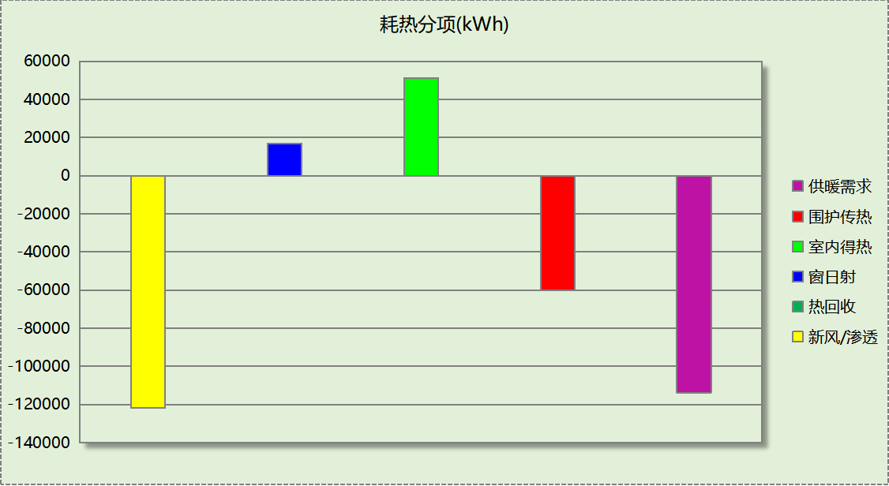

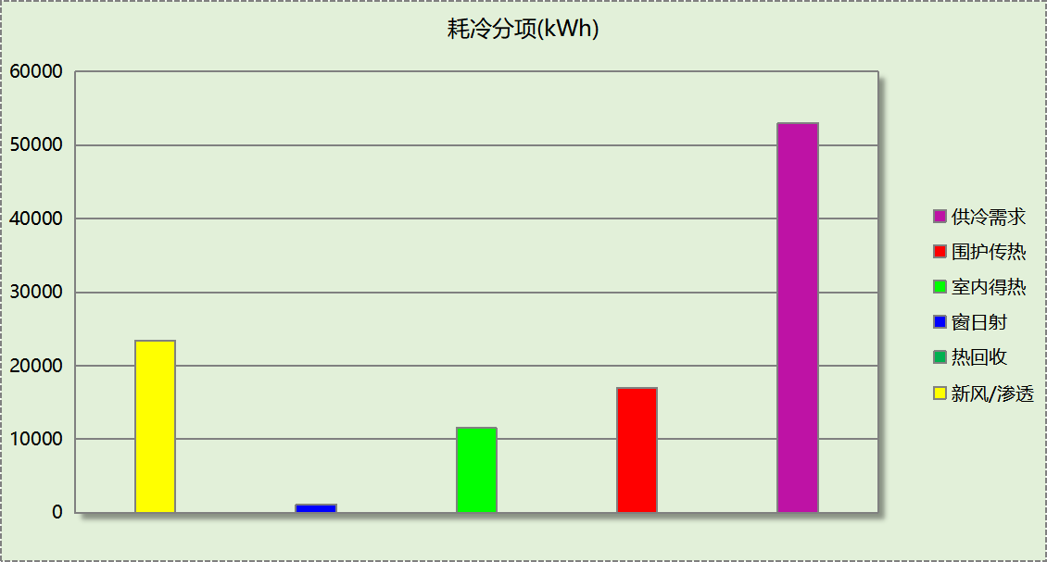

## 逐月负荷表

|  |  |  |  |  |  |  |
| --- | --- | --- | --- | --- | --- | --- |
| 月份 | 供暖(kWh) | 供冷(kWh) | 热负荷 峰值(kW) | 热负荷 峰值时刻 | 冷负荷 峰值(kW) | 冷负荷 峰值时刻 |
| 1月 | 41057 | 0 | 811.345 | 1月14日8时 | 0.000 | -- |
| 2月 | 0 | 0 | 0.000 | -- | 0.000 | -- |
| 3月 | 0 | 0 | 0.000 | -- | 0.000 | -- |
| 4月 | 0 | 0 | 0.000 | -- | 0.000 | -- |
| 5月 | 0 | 0 | 0.000 | -- | 0.000 | -- |
| 6月 | 0 | 0 | 0.000 | -- | 0.000 | -- |
| 7月 | 0 | 26169 | 0.000 | -- | 167.659 | 7月18日10时 |
| 8月 | 0 | 26844 | 0.000 | -- | 160.310 | 8月11日17时 |
| 9月 | 0 | 0 | 0.000 | -- | 0.000 | -- |
| 10月 | 0 | 0 | 0.000 | -- | 0.000 | -- |
| 11月 | 15570 | 0 | 576.551 | 11月15日8时 | 0.000 | -- |
| 12月 | 57083 | 0 | 566.123 | 12月23日8时 | 0.000 | -- |

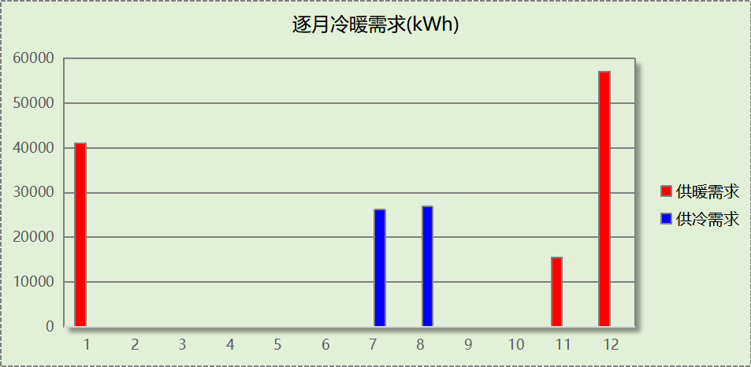

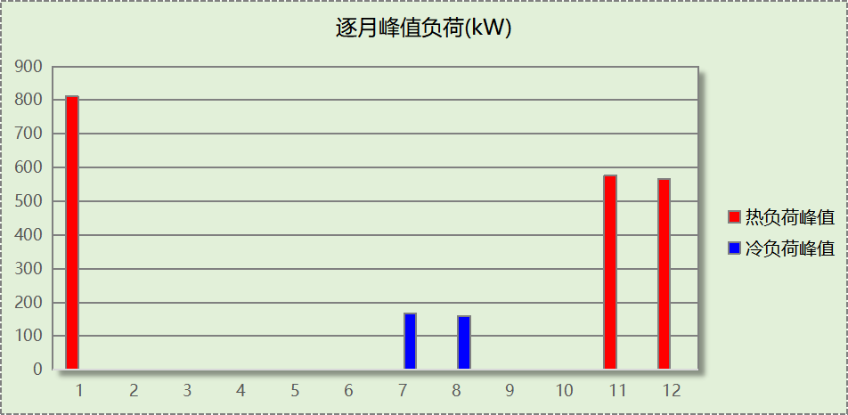

## 逐月电耗

注:供冷供暖为冷热源及输配水泵电耗，热水为扣减太阳能后电耗，所有数据单位kWh/㎡。

|  |  |  |  |  |  |  |  |  |
| --- | --- | --- | --- | --- | --- | --- | --- | --- |
| 月 | 供冷 | 供暖 | 空调风机 | 照明 | 插座设备 | 排风机 | 电梯 | 热水 |
| 1 | 0.00 | 2.58 | 0.01 | － | － | － | － | － |
| 2 | 0.00 | 0.00 | 0.00 | － | － |
| 3 | 0.00 | 0.00 | 0.00 | － | － |
| 4 | 0.00 | 0.00 | 0.00 | － | － |
| 5 | 0.00 | 0.00 | 0.00 | － | － |
| 6 | 0.00 | 0.00 | 0.00 | － | － |
| 7 | 1.63 | 0.00 | 0.00 | － | － |
| 8 | 1.67 | 0.00 | 0.00 | － | － |
| 9 | 0.00 | 0.00 | 0.00 | － | － |
| 10 | 0.00 | 0.00 | 0.00 | － | － |
| 11 | 0.00 | 0.98 | 0.01 | － | － |
| 12 | 0.00 | 3.59 | 0.02 | － | － |
| 合计 | 3.29 | 7.16 | 0.04 | － | － | － | － | － |

# 计算结果

|  |  |  |  |  |
| --- | --- | --- | --- | --- |
| 能耗分类 | 能耗子类 | 设计建筑  (kWh/㎡) | 参照建筑  (kWh/㎡) | 节能率  （%） |
| 建筑负荷 | 耗冷量 | 6.40 | 8.89 | 27.99% |
| 耗热量 | 11.62 | 19.07 | 39.08% |
| 冷热合计 | 18.02 | 27.96 | 35.56% |
| 热回收负荷 | 供冷 | 0.95 | － |  |
| 供暖 | 7.23 | － |  |
| 冷热合计 | 8.18 | － |  |
| 供冷电耗 | 中央冷源 | 0.00 | 0.00 | 51.39% |
| 冷却水泵 | 0.00 | 0.00 |
| 冷冻水泵 | 0.00 | 0.00 |
| 冷却塔 | 0.00 | 0.00 |
| 多联机/单元式空调 | 1.60 | 3.29 |
| 供冷合计 | 1.60 | 3.29 |
| 供暖电耗 | 中央热源 | 4.31 | 7.07 | 39.08% |
| 热源侧水泵 | 0.00 | － |
| 供暖水泵 | 0.05 | 0.08 |
| 多联机/单元式热泵 | 0.00 | 0.00 |
| 供暖合计 | 4.36 | 7.16 |
| 空调风机电耗 | 独立新排风 | 2.10 | 2.83 | 25.44% |
| 风机盘管 | 0.04 | 0.04 |
| 全空气系统 | 0.00 | 0.00 |
| 风机合计 | 2.14 | 2.87 |
| 采暖空调电耗 | | 8.10 | 13.32 | 39.19% |

# 绿色建筑性能评估得分

|  |  |  |  |
| --- | --- | --- | --- |
| 标准条文 | 得分评价 | 节能率 | 得分 |
| 9.2.1 采取措施进一步降低建筑供暖空调系统的能耗 | 评价总分值为30 分。建筑供暖空调系统能耗相比国家现行有关建筑节能标准降低40%, 得10 分；每再降低10%, 再得5 分，最高得30 分。 | 39.19% | 0 |
| 标准依据 | 《绿色建筑评价标准》GB-T 50378-2019 | | |

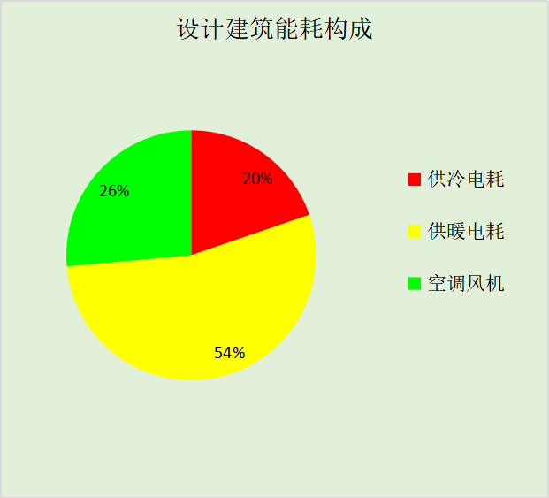

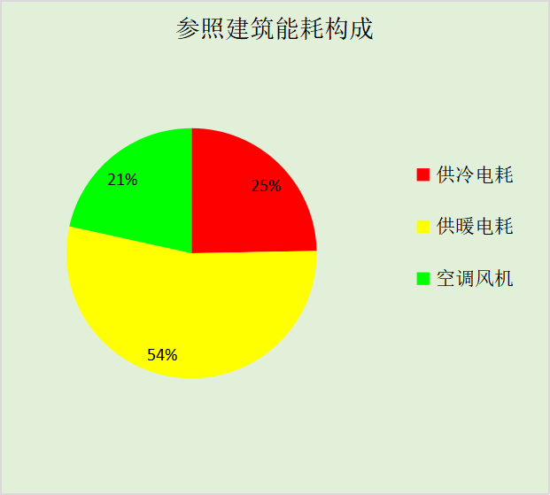

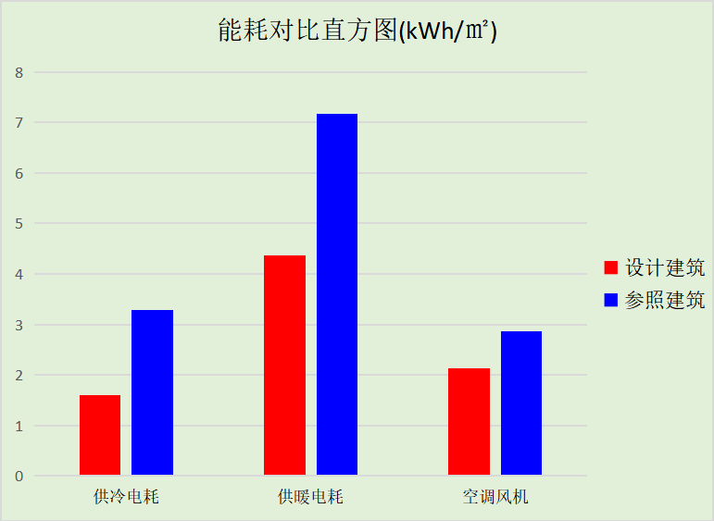

# 附录

暑假:7.15~8.25; 寒假：1.15~3.1

## 工作日/节假日人员逐时在室率(%)

|  |  |  |  |  |  |  |  |  |  |  |  |  |  |  |  |  |  |  |  |  |  |  |  |  |
| --- | --- | --- | --- | --- | --- | --- | --- | --- | --- | --- | --- | --- | --- | --- | --- | --- | --- | --- | --- | --- | --- | --- | --- | --- |
| 房间类型 | 1 | 2 | 3 | 4 | 5 | 6 | 7 | 8 | 9 | 10 | 11 | 12 | 13 | 14 | 15 | 16 | 17 | 18 | 19 | 20 | 21 | 22 | 23 | 24 |
| 一般商店 | 0 | 0 | 0 | 0 | 0 | 0 | 0 | 20 | 50 | 80 | 80 | 80 | 80 | 80 | 80 | 80 | 80 | 80 | 80 | 70 | 50 | 0 | 0 | 0 |
| 0 | 0 | 0 | 0 | 0 | 0 | 0 | 20 | 50 | 80 | 80 | 80 | 80 | 80 | 80 | 80 | 80 | 80 | 80 | 70 | 50 | 0 | 0 | 0 |
| 0 | 0 | 0 | 0 | 0 | 0 | 0 | 20 | 50 | 80 | 80 | 80 | 80 | 80 | 80 | 80 | 80 | 80 | 80 | 70 | 50 | 0 | 0 | 0 |
| 0 | 0 | 0 | 0 | 0 | 0 | 0 | 20 | 50 | 80 | 80 | 80 | 80 | 80 | 80 | 80 | 80 | 80 | 80 | 70 | 50 | 0 | 0 | 0 |
| 书库 | 0 | 0 | 0 | 0 | 0 | 0 | 10 | 50 | 100 | 100 | 100 | 30 | 100 | 100 | 100 | 100 | 50 | 20 | 10 | 0 | 0 | 0 | 0 | 0 |
| 0 | 0 | 0 | 0 | 0 | 0 | 0 | 20 | 45 | 0 | 0 | 0 | 0 | 0 | 0 | 0 | 0 | 0 | 0 | 0 | 0 | 0 | 0 | 0 |
| 0 | 0 | 0 | 0 | 0 | 0 | 0 | 20 | 45 | 0 | 0 | 0 | 0 | 0 | 0 | 0 | 0 | 0 | 0 | 0 | 0 | 0 | 0 | 0 |
| 0 | 0 | 0 | 0 | 0 | 0 | 0 | 20 | 45 | 0 | 0 | 0 | 0 | 0 | 0 | 0 | 0 | 0 | 0 | 0 | 0 | 0 | 0 | 0 |
| 休息室 | 0 | 0 | 0 | 0 | 0 | 0 | 10 | 50 | 100 | 100 | 100 | 30 | 100 | 100 | 100 | 100 | 50 | 20 | 10 | 0 | 0 | 0 | 0 | 0 |
| 0 | 0 | 0 | 0 | 0 | 0 | 0 | 20 | 45 | 0 | 0 | 0 | 0 | 0 | 0 | 0 | 0 | 0 | 0 | 0 | 0 | 0 | 0 | 0 |
| 0 | 0 | 0 | 0 | 0 | 0 | 0 | 20 | 45 | 0 | 0 | 0 | 0 | 0 | 0 | 0 | 0 | 0 | 0 | 0 | 0 | 0 | 0 | 0 |
| 0 | 0 | 0 | 0 | 0 | 0 | 0 | 20 | 45 | 0 | 0 | 0 | 0 | 0 | 0 | 0 | 0 | 0 | 0 | 0 | 0 | 0 | 0 | 0 |
| 会议室 | 0 | 0 | 0 | 0 | 0 | 0 | 10 | 50 | 100 | 100 | 100 | 30 | 100 | 100 | 100 | 100 | 50 | 20 | 10 | 0 | 0 | 0 | 0 | 0 |
| 0 | 0 | 0 | 0 | 0 | 0 | 0 | 20 | 45 | 0 | 0 | 0 | 0 | 0 | 0 | 0 | 0 | 0 | 0 | 0 | 0 | 0 | 0 | 0 |
| 0 | 0 | 0 | 0 | 0 | 0 | 0 | 20 | 45 | 0 | 0 | 0 | 0 | 0 | 0 | 0 | 0 | 0 | 0 | 0 | 0 | 0 | 0 | 0 |
| 0 | 0 | 0 | 0 | 0 | 0 | 0 | 20 | 45 | 0 | 0 | 0 | 0 | 0 | 0 | 0 | 0 | 0 | 0 | 0 | 0 | 0 | 0 | 0 |
| 办公-普通办公室 | 0 | 0 | 0 | 0 | 0 | 0 | 10 | 50 | 100 | 100 | 100 | 30 | 100 | 100 | 100 | 100 | 50 | 20 | 10 | 0 | 0 | 0 | 0 | 0 |
| 0 | 0 | 0 | 0 | 0 | 0 | 0 | 20 | 45 | 0 | 0 | 0 | 0 | 0 | 0 | 0 | 0 | 0 | 0 | 0 | 0 | 0 | 0 | 0 |
| 0 | 0 | 0 | 0 | 0 | 0 | 0 | 20 | 45 | 0 | 0 | 0 | 0 | 0 | 0 | 0 | 0 | 0 | 0 | 0 | 0 | 0 | 0 | 0 |
| 0 | 0 | 0 | 0 | 0 | 0 | 0 | 20 | 45 | 0 | 0 | 0 | 0 | 0 | 0 | 0 | 0 | 0 | 0 | 0 | 0 | 0 | 0 | 0 |
| 卫生间 | 0 | 0 | 0 | 0 | 0 | 0 | 10 | 50 | 100 | 100 | 100 | 30 | 100 | 100 | 100 | 100 | 50 | 20 | 10 | 0 | 0 | 0 | 0 | 0 |
| 0 | 0 | 0 | 0 | 0 | 0 | 0 | 20 | 45 | 0 | 0 | 0 | 0 | 0 | 0 | 0 | 0 | 0 | 0 | 0 | 0 | 0 | 0 | 0 |
| 0 | 0 | 0 | 0 | 0 | 0 | 0 | 20 | 45 | 0 | 0 | 0 | 0 | 0 | 0 | 0 | 0 | 0 | 0 | 0 | 0 | 0 | 0 | 0 |
| 0 | 0 | 0 | 0 | 0 | 0 | 0 | 20 | 45 | 0 | 0 | 0 | 0 | 0 | 0 | 0 | 0 | 0 | 0 | 0 | 0 | 0 | 0 | 0 |
| 大厅 | 0 | 0 | 0 | 0 | 0 | 0 | 10 | 50 | 100 | 100 | 100 | 30 | 100 | 100 | 100 | 100 | 50 | 20 | 10 | 0 | 0 | 0 | 0 | 0 |
| 0 | 0 | 0 | 0 | 0 | 0 | 0 | 20 | 45 | 0 | 0 | 0 | 0 | 0 | 0 | 0 | 0 | 0 | 0 | 0 | 0 | 0 | 0 | 0 |
| 0 | 0 | 0 | 0 | 0 | 0 | 0 | 20 | 45 | 0 | 0 | 0 | 0 | 0 | 0 | 0 | 0 | 0 | 0 | 0 | 0 | 0 | 0 | 0 |
| 0 | 0 | 0 | 0 | 0 | 0 | 0 | 20 | 45 | 0 | 0 | 0 | 0 | 0 | 0 | 0 | 0 | 0 | 0 | 0 | 0 | 0 | 0 | 0 |
| 展示区 | 0 | 0 | 0 | 0 | 0 | 0 | 10 | 50 | 100 | 100 | 100 | 30 | 100 | 100 | 100 | 100 | 50 | 20 | 10 | 0 | 0 | 0 | 0 | 0 |
| 0 | 0 | 0 | 0 | 0 | 0 | 0 | 20 | 45 | 0 | 0 | 0 | 0 | 0 | 0 | 0 | 0 | 0 | 0 | 0 | 0 | 0 | 0 | 0 |
| 0 | 0 | 0 | 0 | 0 | 0 | 0 | 20 | 45 | 0 | 0 | 0 | 0 | 0 | 0 | 0 | 0 | 0 | 0 | 0 | 0 | 0 | 0 | 0 |
| 0 | 0 | 0 | 0 | 0 | 0 | 0 | 20 | 45 | 0 | 0 | 0 | 0 | 0 | 0 | 0 | 0 | 0 | 0 | 0 | 0 | 0 | 0 | 0 |
| 开架书库 | 0 | 0 | 0 | 0 | 0 | 0 | 10 | 50 | 100 | 100 | 100 | 30 | 100 | 100 | 100 | 100 | 50 | 20 | 10 | 0 | 0 | 0 | 0 | 0 |
| 0 | 0 | 0 | 0 | 0 | 0 | 0 | 20 | 45 | 0 | 0 | 0 | 0 | 0 | 0 | 0 | 0 | 0 | 0 | 0 | 0 | 0 | 0 | 0 |
| 0 | 0 | 0 | 0 | 0 | 0 | 0 | 20 | 45 | 0 | 0 | 0 | 0 | 0 | 0 | 0 | 0 | 0 | 0 | 0 | 0 | 0 | 0 | 0 |
| 0 | 0 | 0 | 0 | 0 | 0 | 0 | 20 | 45 | 0 | 0 | 0 | 0 | 0 | 0 | 0 | 0 | 0 | 0 | 0 | 0 | 0 | 0 | 0 |
| 普通办公室 | 0 | 0 | 0 | 0 | 0 | 0 | 10 | 50 | 100 | 100 | 100 | 30 | 100 | 100 | 100 | 100 | 50 | 20 | 10 | 0 | 0 | 0 | 0 | 0 |
| 0 | 0 | 0 | 0 | 0 | 0 | 0 | 20 | 45 | 0 | 0 | 0 | 0 | 0 | 0 | 0 | 0 | 0 | 0 | 0 | 0 | 0 | 0 | 0 |
| 0 | 0 | 0 | 0 | 0 | 0 | 0 | 20 | 45 | 0 | 0 | 0 | 0 | 0 | 0 | 0 | 0 | 0 | 0 | 0 | 0 | 0 | 0 | 0 |
| 0 | 0 | 0 | 0 | 0 | 0 | 0 | 20 | 45 | 0 | 0 | 0 | 0 | 0 | 0 | 0 | 0 | 0 | 0 | 0 | 0 | 0 | 0 | 0 |
| 楼梯间 | 0 | 0 | 0 | 0 | 0 | 0 | 10 | 50 | 100 | 100 | 100 | 30 | 100 | 100 | 100 | 100 | 50 | 20 | 10 | 0 | 0 | 0 | 0 | 0 |
| 0 | 0 | 0 | 0 | 0 | 0 | 0 | 20 | 45 | 0 | 0 | 0 | 0 | 0 | 0 | 0 | 0 | 0 | 0 | 0 | 0 | 0 | 0 | 0 |
| 0 | 0 | 0 | 0 | 0 | 0 | 0 | 20 | 45 | 0 | 0 | 0 | 0 | 0 | 0 | 0 | 0 | 0 | 0 | 0 | 0 | 0 | 0 | 0 |
| 0 | 0 | 0 | 0 | 0 | 0 | 0 | 20 | 45 | 0 | 0 | 0 | 0 | 0 | 0 | 0 | 0 | 0 | 0 | 0 | 0 | 0 | 0 | 0 |
| 目录室 | 0 | 0 | 0 | 0 | 0 | 0 | 10 | 50 | 100 | 100 | 100 | 30 | 100 | 100 | 100 | 100 | 50 | 20 | 10 | 0 | 0 | 0 | 0 | 0 |
| 0 | 0 | 0 | 0 | 0 | 0 | 0 | 20 | 45 | 0 | 0 | 0 | 0 | 0 | 0 | 0 | 0 | 0 | 0 | 0 | 0 | 0 | 0 | 0 |
| 0 | 0 | 0 | 0 | 0 | 0 | 0 | 20 | 45 | 0 | 0 | 0 | 0 | 0 | 0 | 0 | 0 | 0 | 0 | 0 | 0 | 0 | 0 | 0 |
| 0 | 0 | 0 | 0 | 0 | 0 | 0 | 20 | 45 | 0 | 0 | 0 | 0 | 0 | 0 | 0 | 0 | 0 | 0 | 0 | 0 | 0 | 0 | 0 |
| 走廊 | 0 | 0 | 0 | 0 | 0 | 0 | 10 | 50 | 100 | 100 | 100 | 30 | 100 | 100 | 100 | 100 | 50 | 20 | 10 | 0 | 0 | 0 | 0 | 0 |
| 0 | 0 | 0 | 0 | 0 | 0 | 0 | 20 | 45 | 0 | 0 | 0 | 0 | 0 | 0 | 0 | 0 | 0 | 0 | 0 | 0 | 0 | 0 | 0 |
| 0 | 0 | 0 | 0 | 0 | 0 | 0 | 20 | 45 | 0 | 0 | 0 | 0 | 0 | 0 | 0 | 0 | 0 | 0 | 0 | 0 | 0 | 0 | 0 |
| 0 | 0 | 0 | 0 | 0 | 0 | 0 | 20 | 45 | 0 | 0 | 0 | 0 | 0 | 0 | 0 | 0 | 0 | 0 | 0 | 0 | 0 | 0 | 0 |
| 酒吧、茶座 | 0 | 0 | 0 | 0 | 0 | 0 | 0 | 20 | 50 | 80 | 80 | 80 | 80 | 80 | 80 | 80 | 80 | 80 | 80 | 70 | 50 | 0 | 0 | 0 |
| 0 | 0 | 0 | 0 | 0 | 0 | 0 | 20 | 50 | 80 | 80 | 80 | 80 | 80 | 80 | 80 | 80 | 80 | 80 | 70 | 50 | 0 | 0 | 0 |
| 0 | 0 | 0 | 0 | 0 | 0 | 0 | 20 | 50 | 80 | 80 | 80 | 80 | 80 | 80 | 80 | 80 | 80 | 80 | 70 | 50 | 0 | 0 | 0 |
| 0 | 0 | 0 | 0 | 0 | 0 | 0 | 20 | 50 | 80 | 80 | 80 | 80 | 80 | 80 | 80 | 80 | 80 | 80 | 70 | 50 | 0 | 0 | 0 |
| 阅览室 | 0 | 0 | 0 | 0 | 0 | 0 | 10 | 50 | 100 | 100 | 100 | 30 | 100 | 100 | 100 | 100 | 50 | 20 | 10 | 0 | 0 | 0 | 0 | 0 |
| 0 | 0 | 0 | 0 | 0 | 0 | 0 | 20 | 45 | 0 | 0 | 0 | 0 | 0 | 0 | 0 | 0 | 0 | 0 | 0 | 0 | 0 | 0 | 0 |
| 0 | 0 | 0 | 0 | 0 | 0 | 0 | 20 | 45 | 0 | 0 | 0 | 0 | 0 | 0 | 0 | 0 | 0 | 0 | 0 | 0 | 0 | 0 | 0 |
| 0 | 0 | 0 | 0 | 0 | 0 | 0 | 20 | 45 | 0 | 0 | 0 | 0 | 0 | 0 | 0 | 0 | 0 | 0 | 0 | 0 | 0 | 0 | 0 |

注：第一行：工作日；第二行：节假日；第三行：寒假；第四行：暑假

## 工作日/节假日照明开关时间表(%)

|  |  |  |  |  |  |  |  |  |  |  |  |  |  |  |  |  |  |  |  |  |  |  |  |  |
| --- | --- | --- | --- | --- | --- | --- | --- | --- | --- | --- | --- | --- | --- | --- | --- | --- | --- | --- | --- | --- | --- | --- | --- | --- |
| 房间类型 | 1 | 2 | 3 | 4 | 5 | 6 | 7 | 8 | 9 | 10 | 11 | 12 | 13 | 14 | 15 | 16 | 17 | 18 | 19 | 20 | 21 | 22 | 23 | 24 |
| 一般商店 | 10 | 10 | 10 | 10 | 10 | 10 | 10 | 50 | 60 | 60 | 60 | 60 | 60 | 60 | 60 | 60 | 80 | 90 | 100 | 100 | 100 | 10 | 10 | 10 |
| 10 | 10 | 10 | 10 | 10 | 10 | 10 | 50 | 60 | 60 | 60 | 60 | 60 | 60 | 60 | 60 | 80 | 90 | 100 | 100 | 100 | 10 | 10 | 10 |
| 10 | 10 | 10 | 10 | 10 | 10 | 10 | 50 | 60 | 60 | 60 | 60 | 60 | 60 | 60 | 60 | 80 | 90 | 100 | 100 | 100 | 10 | 10 | 10 |
| 10 | 10 | 10 | 10 | 10 | 10 | 10 | 50 | 60 | 60 | 60 | 60 | 60 | 60 | 60 | 60 | 80 | 90 | 100 | 100 | 100 | 10 | 10 | 10 |
| 书库 | 10 | 10 | 10 | 10 | 10 | 10 | 10 | 36 | 62 | 56 | 54 | 43 | 53 | 55 | 58 | 67 | 40 | 18 | 10 | 10 | 10 | 10 | 10 | 10 |
| 0 | 0 | 0 | 0 | 0 | 0 | 0 | 0 | 0 | 0 | 0 | 0 | 0 | 0 | 0 | 0 | 0 | 0 | 0 | 0 | 0 | 0 | 0 | 0 |
| 0 | 0 | 0 | 0 | 0 | 0 | 0 | 0 | 0 | 0 | 0 | 0 | 0 | 0 | 0 | 0 | 0 | 0 | 0 | 0 | 0 | 0 | 0 | 0 |
| 0 | 0 | 0 | 0 | 0 | 0 | 0 | 0 | 0 | 0 | 0 | 0 | 0 | 0 | 0 | 0 | 0 | 0 | 0 | 0 | 0 | 0 | 0 | 0 |
| 休息室 | 10 | 10 | 10 | 10 | 10 | 10 | 10 | 36 | 62 | 56 | 54 | 43 | 53 | 55 | 58 | 67 | 40 | 18 | 10 | 10 | 10 | 10 | 10 | 10 |
| 0 | 0 | 0 | 0 | 0 | 0 | 0 | 0 | 0 | 0 | 0 | 0 | 0 | 0 | 0 | 0 | 0 | 0 | 0 | 0 | 0 | 0 | 0 | 0 |
| 0 | 0 | 0 | 0 | 0 | 0 | 0 | 0 | 0 | 0 | 0 | 0 | 0 | 0 | 0 | 0 | 0 | 0 | 0 | 0 | 0 | 0 | 0 | 0 |
| 0 | 0 | 0 | 0 | 0 | 0 | 0 | 0 | 0 | 0 | 0 | 0 | 0 | 0 | 0 | 0 | 0 | 0 | 0 | 0 | 0 | 0 | 0 | 0 |
| 会议室 | 10 | 10 | 10 | 10 | 10 | 10 | 10 | 36 | 62 | 56 | 54 | 43 | 53 | 55 | 58 | 67 | 40 | 18 | 10 | 10 | 10 | 10 | 10 | 10 |
| 0 | 0 | 0 | 0 | 0 | 0 | 0 | 0 | 0 | 0 | 0 | 0 | 0 | 0 | 0 | 0 | 0 | 0 | 0 | 0 | 0 | 0 | 0 | 0 |
| 0 | 0 | 0 | 0 | 0 | 0 | 0 | 0 | 0 | 0 | 0 | 0 | 0 | 0 | 0 | 0 | 0 | 0 | 0 | 0 | 0 | 0 | 0 | 0 |
| 0 | 0 | 0 | 0 | 0 | 0 | 0 | 0 | 0 | 0 | 0 | 0 | 0 | 0 | 0 | 0 | 0 | 0 | 0 | 0 | 0 | 0 | 0 | 0 |
| 办公-普通办公室 | 10 | 10 | 10 | 10 | 10 | 10 | 10 | 36 | 62 | 56 | 54 | 43 | 53 | 55 | 58 | 67 | 40 | 18 | 10 | 10 | 10 | 10 | 10 | 10 |
| 0 | 0 | 0 | 0 | 0 | 0 | 0 | 0 | 0 | 0 | 0 | 0 | 0 | 0 | 0 | 0 | 0 | 0 | 0 | 0 | 0 | 0 | 0 | 0 |
| 0 | 0 | 0 | 0 | 0 | 0 | 0 | 0 | 0 | 0 | 0 | 0 | 0 | 0 | 0 | 0 | 0 | 0 | 0 | 0 | 0 | 0 | 0 | 0 |
| 0 | 0 | 0 | 0 | 0 | 0 | 0 | 0 | 0 | 0 | 0 | 0 | 0 | 0 | 0 | 0 | 0 | 0 | 0 | 0 | 0 | 0 | 0 | 0 |
| 卫生间 | 10 | 10 | 10 | 10 | 10 | 10 | 10 | 36 | 62 | 56 | 54 | 43 | 53 | 55 | 58 | 67 | 40 | 18 | 10 | 10 | 10 | 10 | 10 | 10 |
| 0 | 0 | 0 | 0 | 0 | 0 | 0 | 0 | 0 | 0 | 0 | 0 | 0 | 0 | 0 | 0 | 0 | 0 | 0 | 0 | 0 | 0 | 0 | 0 |
| 0 | 0 | 0 | 0 | 0 | 0 | 0 | 0 | 0 | 0 | 0 | 0 | 0 | 0 | 0 | 0 | 0 | 0 | 0 | 0 | 0 | 0 | 0 | 0 |
| 0 | 0 | 0 | 0 | 0 | 0 | 0 | 0 | 0 | 0 | 0 | 0 | 0 | 0 | 0 | 0 | 0 | 0 | 0 | 0 | 0 | 0 | 0 | 0 |
| 大厅 | 10 | 10 | 10 | 10 | 10 | 10 | 10 | 36 | 62 | 56 | 54 | 43 | 53 | 55 | 58 | 67 | 40 | 18 | 10 | 10 | 10 | 10 | 10 | 10 |
| 0 | 0 | 0 | 0 | 0 | 0 | 0 | 0 | 0 | 0 | 0 | 0 | 0 | 0 | 0 | 0 | 0 | 0 | 0 | 0 | 0 | 0 | 0 | 0 |
| 0 | 0 | 0 | 0 | 0 | 0 | 0 | 0 | 0 | 0 | 0 | 0 | 0 | 0 | 0 | 0 | 0 | 0 | 0 | 0 | 0 | 0 | 0 | 0 |
| 0 | 0 | 0 | 0 | 0 | 0 | 0 | 0 | 0 | 0 | 0 | 0 | 0 | 0 | 0 | 0 | 0 | 0 | 0 | 0 | 0 | 0 | 0 | 0 |
| 展示区 | 10 | 10 | 10 | 10 | 10 | 10 | 10 | 36 | 62 | 56 | 54 | 43 | 53 | 55 | 58 | 67 | 40 | 18 | 10 | 10 | 10 | 10 | 10 | 10 |
| 0 | 0 | 0 | 0 | 0 | 0 | 0 | 0 | 0 | 0 | 0 | 0 | 0 | 0 | 0 | 0 | 0 | 0 | 0 | 0 | 0 | 0 | 0 | 0 |
| 0 | 0 | 0 | 0 | 0 | 0 | 0 | 0 | 0 | 0 | 0 | 0 | 0 | 0 | 0 | 0 | 0 | 0 | 0 | 0 | 0 | 0 | 0 | 0 |
| 0 | 0 | 0 | 0 | 0 | 0 | 0 | 0 | 0 | 0 | 0 | 0 | 0 | 0 | 0 | 0 | 0 | 0 | 0 | 0 | 0 | 0 | 0 | 0 |
| 开架书库 | 10 | 10 | 10 | 10 | 10 | 10 | 10 | 36 | 62 | 56 | 54 | 43 | 53 | 55 | 58 | 67 | 40 | 18 | 10 | 10 | 10 | 10 | 10 | 10 |
| 0 | 0 | 0 | 0 | 0 | 0 | 0 | 0 | 0 | 0 | 0 | 0 | 0 | 0 | 0 | 0 | 0 | 0 | 0 | 0 | 0 | 0 | 0 | 0 |
| 0 | 0 | 0 | 0 | 0 | 0 | 0 | 0 | 0 | 0 | 0 | 0 | 0 | 0 | 0 | 0 | 0 | 0 | 0 | 0 | 0 | 0 | 0 | 0 |
| 0 | 0 | 0 | 0 | 0 | 0 | 0 | 0 | 0 | 0 | 0 | 0 | 0 | 0 | 0 | 0 | 0 | 0 | 0 | 0 | 0 | 0 | 0 | 0 |
| 普通办公室 | 10 | 10 | 10 | 10 | 10 | 10 | 10 | 36 | 62 | 56 | 54 | 43 | 53 | 55 | 58 | 67 | 40 | 18 | 10 | 10 | 10 | 10 | 10 | 10 |
| 0 | 0 | 0 | 0 | 0 | 0 | 0 | 0 | 0 | 0 | 0 | 0 | 0 | 0 | 0 | 0 | 0 | 0 | 0 | 0 | 0 | 0 | 0 | 0 |
| 0 | 0 | 0 | 0 | 0 | 0 | 0 | 0 | 0 | 0 | 0 | 0 | 0 | 0 | 0 | 0 | 0 | 0 | 0 | 0 | 0 | 0 | 0 | 0 |
| 0 | 0 | 0 | 0 | 0 | 0 | 0 | 0 | 0 | 0 | 0 | 0 | 0 | 0 | 0 | 0 | 0 | 0 | 0 | 0 | 0 | 0 | 0 | 0 |
| 楼梯间 | 10 | 10 | 10 | 10 | 10 | 10 | 10 | 36 | 62 | 56 | 54 | 43 | 53 | 55 | 58 | 67 | 40 | 18 | 10 | 10 | 10 | 10 | 10 | 10 |
| 0 | 0 | 0 | 0 | 0 | 0 | 0 | 0 | 0 | 0 | 0 | 0 | 0 | 0 | 0 | 0 | 0 | 0 | 0 | 0 | 0 | 0 | 0 | 0 |
| 0 | 0 | 0 | 0 | 0 | 0 | 0 | 0 | 0 | 0 | 0 | 0 | 0 | 0 | 0 | 0 | 0 | 0 | 0 | 0 | 0 | 0 | 0 | 0 |
| 0 | 0 | 0 | 0 | 0 | 0 | 0 | 0 | 0 | 0 | 0 | 0 | 0 | 0 | 0 | 0 | 0 | 0 | 0 | 0 | 0 | 0 | 0 | 0 |
| 目录室 | 10 | 10 | 10 | 10 | 10 | 10 | 10 | 36 | 62 | 56 | 54 | 43 | 53 | 55 | 58 | 67 | 40 | 18 | 10 | 10 | 10 | 10 | 10 | 10 |
| 0 | 0 | 0 | 0 | 0 | 0 | 0 | 0 | 0 | 0 | 0 | 0 | 0 | 0 | 0 | 0 | 0 | 0 | 0 | 0 | 0 | 0 | 0 | 0 |
| 0 | 0 | 0 | 0 | 0 | 0 | 0 | 0 | 0 | 0 | 0 | 0 | 0 | 0 | 0 | 0 | 0 | 0 | 0 | 0 | 0 | 0 | 0 | 0 |
| 0 | 0 | 0 | 0 | 0 | 0 | 0 | 0 | 0 | 0 | 0 | 0 | 0 | 0 | 0 | 0 | 0 | 0 | 0 | 0 | 0 | 0 | 0 | 0 |
| 走廊 | 10 | 10 | 10 | 10 | 10 | 10 | 10 | 36 | 62 | 56 | 54 | 43 | 53 | 55 | 58 | 67 | 40 | 18 | 10 | 10 | 10 | 10 | 10 | 10 |
| 0 | 0 | 0 | 0 | 0 | 0 | 0 | 0 | 0 | 0 | 0 | 0 | 0 | 0 | 0 | 0 | 0 | 0 | 0 | 0 | 0 | 0 | 0 | 0 |
| 0 | 0 | 0 | 0 | 0 | 0 | 0 | 0 | 0 | 0 | 0 | 0 | 0 | 0 | 0 | 0 | 0 | 0 | 0 | 0 | 0 | 0 | 0 | 0 |
| 0 | 0 | 0 | 0 | 0 | 0 | 0 | 0 | 0 | 0 | 0 | 0 | 0 | 0 | 0 | 0 | 0 | 0 | 0 | 0 | 0 | 0 | 0 | 0 |
| 酒吧、茶座 | 10 | 10 | 10 | 10 | 10 | 10 | 10 | 50 | 60 | 60 | 60 | 60 | 60 | 60 | 60 | 60 | 80 | 90 | 100 | 100 | 100 | 10 | 10 | 10 |
| 10 | 10 | 10 | 10 | 10 | 10 | 10 | 50 | 60 | 60 | 60 | 60 | 60 | 60 | 60 | 60 | 80 | 90 | 100 | 100 | 100 | 10 | 10 | 10 |
| 10 | 10 | 10 | 10 | 10 | 10 | 10 | 50 | 60 | 60 | 60 | 60 | 60 | 60 | 60 | 60 | 80 | 90 | 100 | 100 | 100 | 10 | 10 | 10 |
| 10 | 10 | 10 | 10 | 10 | 10 | 10 | 50 | 60 | 60 | 60 | 60 | 60 | 60 | 60 | 60 | 80 | 90 | 100 | 100 | 100 | 10 | 10 | 10 |
| 阅览室 | 10 | 10 | 10 | 10 | 10 | 10 | 10 | 36 | 62 | 56 | 54 | 43 | 53 | 55 | 58 | 67 | 40 | 18 | 10 | 10 | 10 | 10 | 10 | 10 |
| 0 | 0 | 0 | 0 | 0 | 0 | 0 | 0 | 0 | 0 | 0 | 0 | 0 | 0 | 0 | 0 | 0 | 0 | 0 | 0 | 0 | 0 | 0 | 0 |
| 0 | 0 | 0 | 0 | 0 | 0 | 0 | 0 | 0 | 0 | 0 | 0 | 0 | 0 | 0 | 0 | 0 | 0 | 0 | 0 | 0 | 0 | 0 | 0 |
| 0 | 0 | 0 | 0 | 0 | 0 | 0 | 0 | 0 | 0 | 0 | 0 | 0 | 0 | 0 | 0 | 0 | 0 | 0 | 0 | 0 | 0 | 0 | 0 |

注：第一行：工作日；第二行：节假日；第三行：寒假；第四行：暑假

## 工作日/节假日设备逐时使用率(%)

|  |  |  |  |  |  |  |  |  |  |  |  |  |  |  |  |  |  |  |  |  |  |  |  |  |
| --- | --- | --- | --- | --- | --- | --- | --- | --- | --- | --- | --- | --- | --- | --- | --- | --- | --- | --- | --- | --- | --- | --- | --- | --- |
| 房间类型 | 1 | 2 | 3 | 4 | 5 | 6 | 7 | 8 | 9 | 10 | 11 | 12 | 13 | 14 | 15 | 16 | 17 | 18 | 19 | 20 | 21 | 22 | 23 | 24 |
| 一般商店 | 0 | 0 | 0 | 0 | 0 | 0 | 0 | 30 | 50 | 80 | 80 | 80 | 80 | 80 | 80 | 80 | 80 | 80 | 80 | 70 | 50 | 0 | 0 | 0 |
| 0 | 0 | 0 | 0 | 0 | 0 | 0 | 30 | 50 | 80 | 80 | 80 | 80 | 80 | 80 | 80 | 80 | 80 | 80 | 70 | 50 | 0 | 0 | 0 |
| 0 | 0 | 0 | 0 | 0 | 0 | 0 | 30 | 50 | 80 | 80 | 80 | 80 | 80 | 80 | 80 | 80 | 80 | 80 | 70 | 50 | 0 | 0 | 0 |
| 0 | 0 | 0 | 0 | 0 | 0 | 0 | 30 | 50 | 80 | 80 | 80 | 80 | 80 | 80 | 80 | 80 | 80 | 80 | 70 | 50 | 0 | 0 | 0 |
| 书库 | 0 | 0 | 0 | 0 | 0 | 0 | 10 | 50 | 100 | 100 | 100 | 100 | 100 | 100 | 100 | 100 | 50 | 20 | 10 | 0 | 0 | 0 | 0 | 0 |
| 0 | 0 | 0 | 0 | 0 | 0 | 0 | 0 | 0 | 0 | 0 | 0 | 0 | 0 | 0 | 0 | 0 | 0 | 0 | 0 | 0 | 0 | 0 | 0 |
| 0 | 0 | 0 | 0 | 0 | 0 | 0 | 0 | 0 | 0 | 0 | 0 | 0 | 0 | 0 | 0 | 0 | 0 | 0 | 0 | 0 | 0 | 0 | 0 |
| 0 | 0 | 0 | 0 | 0 | 0 | 0 | 0 | 0 | 0 | 0 | 0 | 0 | 0 | 0 | 0 | 0 | 0 | 0 | 0 | 0 | 0 | 0 | 0 |
| 休息室 | 0 | 0 | 0 | 0 | 0 | 0 | 10 | 50 | 100 | 100 | 100 | 100 | 100 | 100 | 100 | 100 | 50 | 20 | 10 | 0 | 0 | 0 | 0 | 0 |
| 0 | 0 | 0 | 0 | 0 | 0 | 0 | 0 | 0 | 0 | 0 | 0 | 0 | 0 | 0 | 0 | 0 | 0 | 0 | 0 | 0 | 0 | 0 | 0 |
| 0 | 0 | 0 | 0 | 0 | 0 | 0 | 0 | 0 | 0 | 0 | 0 | 0 | 0 | 0 | 0 | 0 | 0 | 0 | 0 | 0 | 0 | 0 | 0 |
| 0 | 0 | 0 | 0 | 0 | 0 | 0 | 0 | 0 | 0 | 0 | 0 | 0 | 0 | 0 | 0 | 0 | 0 | 0 | 0 | 0 | 0 | 0 | 0 |
| 会议室 | 0 | 0 | 0 | 0 | 0 | 0 | 10 | 50 | 100 | 100 | 100 | 100 | 100 | 100 | 100 | 100 | 50 | 20 | 10 | 0 | 0 | 0 | 0 | 0 |
| 0 | 0 | 0 | 0 | 0 | 0 | 0 | 0 | 0 | 0 | 0 | 0 | 0 | 0 | 0 | 0 | 0 | 0 | 0 | 0 | 0 | 0 | 0 | 0 |
| 0 | 0 | 0 | 0 | 0 | 0 | 0 | 0 | 0 | 0 | 0 | 0 | 0 | 0 | 0 | 0 | 0 | 0 | 0 | 0 | 0 | 0 | 0 | 0 |
| 0 | 0 | 0 | 0 | 0 | 0 | 0 | 0 | 0 | 0 | 0 | 0 | 0 | 0 | 0 | 0 | 0 | 0 | 0 | 0 | 0 | 0 | 0 | 0 |
| 办公-普通办公室 | 0 | 0 | 0 | 0 | 0 | 0 | 10 | 50 | 100 | 100 | 100 | 100 | 100 | 100 | 100 | 100 | 50 | 20 | 10 | 0 | 0 | 0 | 0 | 0 |
| 0 | 0 | 0 | 0 | 0 | 0 | 0 | 0 | 0 | 0 | 0 | 0 | 0 | 0 | 0 | 0 | 0 | 0 | 0 | 0 | 0 | 0 | 0 | 0 |
| 0 | 0 | 0 | 0 | 0 | 0 | 0 | 0 | 0 | 0 | 0 | 0 | 0 | 0 | 0 | 0 | 0 | 0 | 0 | 0 | 0 | 0 | 0 | 0 |
| 0 | 0 | 0 | 0 | 0 | 0 | 0 | 0 | 0 | 0 | 0 | 0 | 0 | 0 | 0 | 0 | 0 | 0 | 0 | 0 | 0 | 0 | 0 | 0 |
| 卫生间 | 0 | 0 | 0 | 0 | 0 | 0 | 10 | 50 | 100 | 100 | 100 | 100 | 100 | 100 | 100 | 100 | 50 | 20 | 10 | 0 | 0 | 0 | 0 | 0 |
| 0 | 0 | 0 | 0 | 0 | 0 | 0 | 0 | 0 | 0 | 0 | 0 | 0 | 0 | 0 | 0 | 0 | 0 | 0 | 0 | 0 | 0 | 0 | 0 |
| 0 | 0 | 0 | 0 | 0 | 0 | 0 | 0 | 0 | 0 | 0 | 0 | 0 | 0 | 0 | 0 | 0 | 0 | 0 | 0 | 0 | 0 | 0 | 0 |
| 0 | 0 | 0 | 0 | 0 | 0 | 0 | 0 | 0 | 0 | 0 | 0 | 0 | 0 | 0 | 0 | 0 | 0 | 0 | 0 | 0 | 0 | 0 | 0 |
| 大厅 | 0 | 0 | 0 | 0 | 0 | 0 | 10 | 50 | 100 | 100 | 100 | 100 | 100 | 100 | 100 | 100 | 50 | 20 | 10 | 0 | 0 | 0 | 0 | 0 |
| 0 | 0 | 0 | 0 | 0 | 0 | 0 | 0 | 0 | 0 | 0 | 0 | 0 | 0 | 0 | 0 | 0 | 0 | 0 | 0 | 0 | 0 | 0 | 0 |
| 0 | 0 | 0 | 0 | 0 | 0 | 0 | 0 | 0 | 0 | 0 | 0 | 0 | 0 | 0 | 0 | 0 | 0 | 0 | 0 | 0 | 0 | 0 | 0 |
| 0 | 0 | 0 | 0 | 0 | 0 | 0 | 0 | 0 | 0 | 0 | 0 | 0 | 0 | 0 | 0 | 0 | 0 | 0 | 0 | 0 | 0 | 0 | 0 |
| 展示区 | 0 | 0 | 0 | 0 | 0 | 0 | 10 | 50 | 100 | 100 | 100 | 100 | 100 | 100 | 100 | 100 | 50 | 20 | 10 | 0 | 0 | 0 | 0 | 0 |
| 0 | 0 | 0 | 0 | 0 | 0 | 0 | 0 | 0 | 0 | 0 | 0 | 0 | 0 | 0 | 0 | 0 | 0 | 0 | 0 | 0 | 0 | 0 | 0 |
| 0 | 0 | 0 | 0 | 0 | 0 | 0 | 0 | 0 | 0 | 0 | 0 | 0 | 0 | 0 | 0 | 0 | 0 | 0 | 0 | 0 | 0 | 0 | 0 |
| 0 | 0 | 0 | 0 | 0 | 0 | 0 | 0 | 0 | 0 | 0 | 0 | 0 | 0 | 0 | 0 | 0 | 0 | 0 | 0 | 0 | 0 | 0 | 0 |
| 开架书库 | 0 | 0 | 0 | 0 | 0 | 0 | 10 | 50 | 100 | 100 | 100 | 100 | 100 | 100 | 100 | 100 | 50 | 20 | 10 | 0 | 0 | 0 | 0 | 0 |
| 0 | 0 | 0 | 0 | 0 | 0 | 0 | 0 | 0 | 0 | 0 | 0 | 0 | 0 | 0 | 0 | 0 | 0 | 0 | 0 | 0 | 0 | 0 | 0 |
| 0 | 0 | 0 | 0 | 0 | 0 | 0 | 0 | 0 | 0 | 0 | 0 | 0 | 0 | 0 | 0 | 0 | 0 | 0 | 0 | 0 | 0 | 0 | 0 |
| 0 | 0 | 0 | 0 | 0 | 0 | 0 | 0 | 0 | 0 | 0 | 0 | 0 | 0 | 0 | 0 | 0 | 0 | 0 | 0 | 0 | 0 | 0 | 0 |
| 普通办公室 | 0 | 0 | 0 | 0 | 0 | 0 | 10 | 50 | 100 | 100 | 100 | 100 | 100 | 100 | 100 | 100 | 50 | 20 | 10 | 0 | 0 | 0 | 0 | 0 |
| 0 | 0 | 0 | 0 | 0 | 0 | 0 | 0 | 0 | 0 | 0 | 0 | 0 | 0 | 0 | 0 | 0 | 0 | 0 | 0 | 0 | 0 | 0 | 0 |
| 0 | 0 | 0 | 0 | 0 | 0 | 0 | 0 | 0 | 0 | 0 | 0 | 0 | 0 | 0 | 0 | 0 | 0 | 0 | 0 | 0 | 0 | 0 | 0 |
| 0 | 0 | 0 | 0 | 0 | 0 | 0 | 0 | 0 | 0 | 0 | 0 | 0 | 0 | 0 | 0 | 0 | 0 | 0 | 0 | 0 | 0 | 0 | 0 |
| 楼梯间 | 0 | 0 | 0 | 0 | 0 | 0 | 10 | 50 | 100 | 100 | 100 | 100 | 100 | 100 | 100 | 100 | 50 | 20 | 10 | 0 | 0 | 0 | 0 | 0 |
| 0 | 0 | 0 | 0 | 0 | 0 | 0 | 0 | 0 | 0 | 0 | 0 | 0 | 0 | 0 | 0 | 0 | 0 | 0 | 0 | 0 | 0 | 0 | 0 |
| 0 | 0 | 0 | 0 | 0 | 0 | 0 | 0 | 0 | 0 | 0 | 0 | 0 | 0 | 0 | 0 | 0 | 0 | 0 | 0 | 0 | 0 | 0 | 0 |
| 0 | 0 | 0 | 0 | 0 | 0 | 0 | 0 | 0 | 0 | 0 | 0 | 0 | 0 | 0 | 0 | 0 | 0 | 0 | 0 | 0 | 0 | 0 | 0 |
| 目录室 | 0 | 0 | 0 | 0 | 0 | 0 | 10 | 50 | 100 | 100 | 100 | 100 | 100 | 100 | 100 | 100 | 50 | 20 | 10 | 0 | 0 | 0 | 0 | 0 |
| 0 | 0 | 0 | 0 | 0 | 0 | 0 | 0 | 0 | 0 | 0 | 0 | 0 | 0 | 0 | 0 | 0 | 0 | 0 | 0 | 0 | 0 | 0 | 0 |
| 0 | 0 | 0 | 0 | 0 | 0 | 0 | 0 | 0 | 0 | 0 | 0 | 0 | 0 | 0 | 0 | 0 | 0 | 0 | 0 | 0 | 0 | 0 | 0 |
| 0 | 0 | 0 | 0 | 0 | 0 | 0 | 0 | 0 | 0 | 0 | 0 | 0 | 0 | 0 | 0 | 0 | 0 | 0 | 0 | 0 | 0 | 0 | 0 |
| 走廊 | 0 | 0 | 0 | 0 | 0 | 0 | 10 | 50 | 100 | 100 | 100 | 100 | 100 | 100 | 100 | 100 | 50 | 20 | 10 | 0 | 0 | 0 | 0 | 0 |
| 0 | 0 | 0 | 0 | 0 | 0 | 0 | 0 | 0 | 0 | 0 | 0 | 0 | 0 | 0 | 0 | 0 | 0 | 0 | 0 | 0 | 0 | 0 | 0 |
| 0 | 0 | 0 | 0 | 0 | 0 | 0 | 0 | 0 | 0 | 0 | 0 | 0 | 0 | 0 | 0 | 0 | 0 | 0 | 0 | 0 | 0 | 0 | 0 |
| 0 | 0 | 0 | 0 | 0 | 0 | 0 | 0 | 0 | 0 | 0 | 0 | 0 | 0 | 0 | 0 | 0 | 0 | 0 | 0 | 0 | 0 | 0 | 0 |
| 酒吧、茶座 | 0 | 0 | 0 | 0 | 0 | 0 | 0 | 30 | 50 | 80 | 80 | 80 | 80 | 80 | 80 | 80 | 80 | 80 | 80 | 70 | 50 | 0 | 0 | 0 |
| 0 | 0 | 0 | 0 | 0 | 0 | 0 | 30 | 50 | 80 | 80 | 80 | 80 | 80 | 80 | 80 | 80 | 80 | 80 | 70 | 50 | 0 | 0 | 0 |
| 0 | 0 | 0 | 0 | 0 | 0 | 0 | 30 | 50 | 80 | 80 | 80 | 80 | 80 | 80 | 80 | 80 | 80 | 80 | 70 | 50 | 0 | 0 | 0 |
| 0 | 0 | 0 | 0 | 0 | 0 | 0 | 30 | 50 | 80 | 80 | 80 | 80 | 80 | 80 | 80 | 80 | 80 | 80 | 70 | 50 | 0 | 0 | 0 |
| 阅览室 | 0 | 0 | 0 | 0 | 0 | 0 | 10 | 50 | 100 | 100 | 100 | 100 | 100 | 100 | 100 | 100 | 50 | 20 | 10 | 0 | 0 | 0 | 0 | 0 |
| 0 | 0 | 0 | 0 | 0 | 0 | 0 | 0 | 0 | 0 | 0 | 0 | 0 | 0 | 0 | 0 | 0 | 0 | 0 | 0 | 0 | 0 | 0 | 0 |
| 0 | 0 | 0 | 0 | 0 | 0 | 0 | 0 | 0 | 0 | 0 | 0 | 0 | 0 | 0 | 0 | 0 | 0 | 0 | 0 | 0 | 0 | 0 | 0 |
| 0 | 0 | 0 | 0 | 0 | 0 | 0 | 0 | 0 | 0 | 0 | 0 | 0 | 0 | 0 | 0 | 0 | 0 | 0 | 0 | 0 | 0 | 0 | 0 |

注：第一行：工作日；第二行：节假日；第三行：寒假；第四行：暑假

## 工作日/节假日空调系统运行时间表(1:开,0:关)

采暖期：

|  |  |  |  |  |  |  |  |  |  |  |  |  |  |  |  |  |  |  |  |  |  |  |  |  |
| --- | --- | --- | --- | --- | --- | --- | --- | --- | --- | --- | --- | --- | --- | --- | --- | --- | --- | --- | --- | --- | --- | --- | --- | --- |
| 系统编号 | 1 | 2 | 3 | 4 | 5 | 6 | 7 | 8 | 9 | 10 | 11 | 12 | 13 | 14 | 15 | 16 | 17 | 18 | 19 | 20 | 21 | 22 | 23 | 24 |
| 默认 | 1 | 1 | 1 | 1 | 1 | 1 | 1 | 1 | 1 | 1 | 1 | 1 | 1 | 1 | 1 | 1 | 1 | 1 | 1 | 1 | 1 | 1 | 1 | 1 |
| 0 | 0 | 0 | 0 | 0 | 0 | 0 | 0 | 0 | 0 | 0 | 0 | 0 | 0 | 0 | 0 | 0 | 0 | 0 | 0 | 0 | 0 | 0 | 0 |
| 0 | 0 | 0 | 0 | 0 | 0 | 0 | 0 | 0 | 0 | 0 | 0 | 0 | 0 | 0 | 0 | 0 | 0 | 0 | 0 | 0 | 0 | 0 | 0 |
| 0 | 0 | 0 | 0 | 0 | 0 | 0 | 0 | 0 | 0 | 0 | 0 | 0 | 0 | 0 | 0 | 0 | 0 | 0 | 0 | 0 | 0 | 0 | 0 |
| Sys | 0 | 0 | 0 | 0 | 0 | 0 | 0 | 1 | 1 | 1 | 1 | 1 | 1 | 1 | 1 | 1 | 1 | 1 | 1 | 1 | 1 | 0 | 0 | 0 |
| 0 | 0 | 0 | 0 | 0 | 0 | 0 | 1 | 1 | 1 | 1 | 1 | 1 | 1 | 1 | 1 | 1 | 1 | 1 | 1 | 1 | 0 | 0 | 0 |
| 0 | 0 | 0 | 0 | 0 | 0 | 0 | 1 | 1 | 1 | 1 | 1 | 1 | 1 | 1 | 1 | 1 | 1 | 1 | 1 | 1 | 0 | 0 | 0 |
| 0 | 0 | 0 | 0 | 0 | 0 | 0 | 1 | 1 | 1 | 1 | 1 | 1 | 1 | 1 | 1 | 1 | 1 | 1 | 1 | 1 | 0 | 0 | 0 |

供冷期：

|  |  |  |  |  |  |  |  |  |  |  |  |  |  |  |  |  |  |  |  |  |  |  |  |  |
| --- | --- | --- | --- | --- | --- | --- | --- | --- | --- | --- | --- | --- | --- | --- | --- | --- | --- | --- | --- | --- | --- | --- | --- | --- |
| 系统编号 | 1 | 2 | 3 | 4 | 5 | 6 | 7 | 8 | 9 | 10 | 11 | 12 | 13 | 14 | 15 | 16 | 17 | 18 | 19 | 20 | 21 | 22 | 23 | 24 |
| 默认 | 1 | 1 | 1 | 1 | 1 | 1 | 1 | 1 | 1 | 1 | 1 | 1 | 1 | 1 | 1 | 1 | 1 | 1 | 1 | 1 | 1 | 1 | 1 | 1 |
| 0 | 0 | 0 | 0 | 0 | 0 | 0 | 0 | 0 | 0 | 0 | 0 | 0 | 0 | 0 | 0 | 0 | 0 | 0 | 0 | 0 | 0 | 0 | 0 |
| 0 | 0 | 0 | 0 | 0 | 0 | 0 | 0 | 0 | 0 | 0 | 0 | 0 | 0 | 0 | 0 | 0 | 0 | 0 | 0 | 0 | 0 | 0 | 0 |
| 0 | 0 | 0 | 0 | 0 | 0 | 0 | 0 | 0 | 0 | 0 | 0 | 0 | 0 | 0 | 0 | 0 | 0 | 0 | 0 | 0 | 0 | 0 | 0 |
| Sys | 0 | 0 | 0 | 0 | 0 | 0 | 0 | 1 | 1 | 1 | 1 | 1 | 1 | 1 | 1 | 1 | 1 | 1 | 1 | 1 | 1 | 0 | 0 | 0 |
| 0 | 0 | 0 | 0 | 0 | 0 | 0 | 1 | 1 | 1 | 1 | 1 | 1 | 1 | 1 | 1 | 1 | 1 | 1 | 1 | 1 | 0 | 0 | 0 |
| 0 | 0 | 0 | 0 | 0 | 0 | 0 | 1 | 1 | 1 | 1 | 1 | 1 | 1 | 1 | 1 | 1 | 1 | 1 | 1 | 1 | 0 | 0 | 0 |
| 0 | 0 | 0 | 0 | 0 | 0 | 0 | 1 | 1 | 1 | 1 | 1 | 1 | 1 | 1 | 1 | 1 | 1 | 1 | 1 | 1 | 0 | 0 | 0 |

注：第一行：工作日；第二行：节假日；第三行：寒假；第四行：暑假

## 工作日/节假日新风运行时间表(%)

|  |  |  |  |  |  |  |  |  |  |  |  |  |  |  |  |  |  |  |  |  |  |  |  |  |
| --- | --- | --- | --- | --- | --- | --- | --- | --- | --- | --- | --- | --- | --- | --- | --- | --- | --- | --- | --- | --- | --- | --- | --- | --- |
| 房间类型 | 1 | 2 | 3 | 4 | 5 | 6 | 7 | 8 | 9 | 10 | 11 | 12 | 13 | 14 | 15 | 16 | 17 | 18 | 19 | 20 | 21 | 22 | 23 | 24 |
| 一般商店 | 0 | 0 | 0 | 0 | 0 | 0 | 0 | 100 | 100 | 100 | 100 | 100 | 100 | 100 | 100 | 100 | 100 | 100 | 100 | 100 | 100 | 0 | 0 | 0 |
| 0 | 0 | 0 | 0 | 0 | 0 | 0 | 100 | 100 | 100 | 100 | 100 | 100 | 100 | 100 | 100 | 100 | 100 | 100 | 100 | 100 | 0 | 0 | 0 |
| 0 | 0 | 0 | 0 | 0 | 0 | 0 | 100 | 100 | 100 | 100 | 100 | 100 | 100 | 100 | 100 | 100 | 100 | 100 | 100 | 100 | 0 | 0 | 0 |
| 0 | 0 | 0 | 0 | 0 | 0 | 0 | 100 | 100 | 100 | 100 | 100 | 100 | 100 | 100 | 100 | 100 | 100 | 100 | 100 | 100 | 0 | 0 | 0 |
| 书库 | 0 | 0 | 0 | 0 | 0 | 0 | 100 | 100 | 100 | 100 | 100 | 100 | 100 | 100 | 100 | 100 | 100 | 100 | 0 | 0 | 0 | 0 | 0 | 0 |
| 0 | 0 | 0 | 0 | 0 | 0 | 0 | 0 | 0 | 0 | 0 | 0 | 0 | 0 | 0 | 0 | 0 | 0 | 0 | 0 | 0 | 0 | 0 | 0 |
| 0 | 0 | 0 | 0 | 0 | 0 | 0 | 0 | 0 | 0 | 0 | 0 | 0 | 0 | 0 | 0 | 0 | 0 | 0 | 0 | 0 | 0 | 0 | 0 |
| 0 | 0 | 0 | 0 | 0 | 0 | 0 | 0 | 0 | 0 | 0 | 0 | 0 | 0 | 0 | 0 | 0 | 0 | 0 | 0 | 0 | 0 | 0 | 0 |
| 休息室 | 0 | 0 | 0 | 0 | 0 | 0 | 0 | 100 | 100 | 100 | 100 | 100 | 100 | 100 | 100 | 100 | 100 | 100 | 100 | 100 | 100 | 0 | 0 | 0 |
| 0 | 0 | 0 | 0 | 0 | 0 | 0 | 0 | 0 | 0 | 0 | 0 | 0 | 0 | 0 | 0 | 0 | 0 | 0 | 0 | 0 | 0 | 0 | 0 |
| 0 | 0 | 0 | 0 | 0 | 0 | 0 | 0 | 0 | 0 | 0 | 0 | 0 | 0 | 0 | 0 | 0 | 0 | 0 | 0 | 0 | 0 | 0 | 0 |
| 0 | 0 | 0 | 0 | 0 | 0 | 0 | 0 | 0 | 0 | 0 | 0 | 0 | 0 | 0 | 0 | 0 | 0 | 0 | 0 | 0 | 0 | 0 | 0 |
| 会议室 | 0 | 0 | 0 | 0 | 0 | 0 | 100 | 100 | 100 | 100 | 100 | 100 | 100 | 100 | 100 | 100 | 100 | 100 | 0 | 0 | 0 | 0 | 0 | 0 |
| 0 | 0 | 0 | 0 | 0 | 0 | 0 | 0 | 0 | 0 | 0 | 0 | 0 | 0 | 0 | 0 | 0 | 0 | 0 | 0 | 0 | 0 | 0 | 0 |
| 0 | 0 | 0 | 0 | 0 | 0 | 0 | 0 | 0 | 0 | 0 | 0 | 0 | 0 | 0 | 0 | 0 | 0 | 0 | 0 | 0 | 0 | 0 | 0 |
| 0 | 0 | 0 | 0 | 0 | 0 | 0 | 0 | 0 | 0 | 0 | 0 | 0 | 0 | 0 | 0 | 0 | 0 | 0 | 0 | 0 | 0 | 0 | 0 |
| 办公-普通办公室 | 0 | 0 | 0 | 0 | 0 | 0 | 100 | 100 | 100 | 100 | 100 | 100 | 100 | 100 | 100 | 100 | 100 | 100 | 0 | 0 | 0 | 0 | 0 | 0 |
| 0 | 0 | 0 | 0 | 0 | 0 | 0 | 0 | 0 | 0 | 0 | 0 | 0 | 0 | 0 | 0 | 0 | 0 | 0 | 0 | 0 | 0 | 0 | 0 |
| 0 | 0 | 0 | 0 | 0 | 0 | 0 | 0 | 0 | 0 | 0 | 0 | 0 | 0 | 0 | 0 | 0 | 0 | 0 | 0 | 0 | 0 | 0 | 0 |
| 0 | 0 | 0 | 0 | 0 | 0 | 0 | 0 | 0 | 0 | 0 | 0 | 0 | 0 | 0 | 0 | 0 | 0 | 0 | 0 | 0 | 0 | 0 | 0 |
| 卫生间 | 0 | 0 | 0 | 0 | 0 | 0 | 100 | 100 | 100 | 100 | 100 | 100 | 100 | 100 | 100 | 100 | 100 | 100 | 0 | 0 | 0 | 0 | 0 | 0 |
| 0 | 0 | 0 | 0 | 0 | 0 | 0 | 0 | 0 | 0 | 0 | 0 | 0 | 0 | 0 | 0 | 0 | 0 | 0 | 0 | 0 | 0 | 0 | 0 |
| 0 | 0 | 0 | 0 | 0 | 0 | 0 | 0 | 0 | 0 | 0 | 0 | 0 | 0 | 0 | 0 | 0 | 0 | 0 | 0 | 0 | 0 | 0 | 0 |
| 0 | 0 | 0 | 0 | 0 | 0 | 0 | 0 | 0 | 0 | 0 | 0 | 0 | 0 | 0 | 0 | 0 | 0 | 0 | 0 | 0 | 0 | 0 | 0 |
| 大厅 | 0 | 0 | 0 | 0 | 0 | 0 | 100 | 100 | 100 | 100 | 100 | 100 | 100 | 100 | 100 | 100 | 100 | 100 | 0 | 0 | 0 | 0 | 0 | 0 |
| 0 | 0 | 0 | 0 | 0 | 0 | 0 | 0 | 0 | 0 | 0 | 0 | 0 | 0 | 0 | 0 | 0 | 0 | 0 | 0 | 0 | 0 | 0 | 0 |
| 0 | 0 | 0 | 0 | 0 | 0 | 0 | 0 | 0 | 0 | 0 | 0 | 0 | 0 | 0 | 0 | 0 | 0 | 0 | 0 | 0 | 0 | 0 | 0 |
| 0 | 0 | 0 | 0 | 0 | 0 | 0 | 0 | 0 | 0 | 0 | 0 | 0 | 0 | 0 | 0 | 0 | 0 | 0 | 0 | 0 | 0 | 0 | 0 |
| 展示区 | 0 | 0 | 0 | 0 | 0 | 0 | 100 | 100 | 100 | 100 | 100 | 100 | 100 | 100 | 100 | 100 | 100 | 100 | 0 | 0 | 0 | 0 | 0 | 0 |
| 0 | 0 | 0 | 0 | 0 | 0 | 0 | 0 | 0 | 0 | 0 | 0 | 0 | 0 | 0 | 0 | 0 | 0 | 0 | 0 | 0 | 0 | 0 | 0 |
| 0 | 0 | 0 | 0 | 0 | 0 | 0 | 0 | 0 | 0 | 0 | 0 | 0 | 0 | 0 | 0 | 0 | 0 | 0 | 0 | 0 | 0 | 0 | 0 |
| 0 | 0 | 0 | 0 | 0 | 0 | 0 | 0 | 0 | 0 | 0 | 0 | 0 | 0 | 0 | 0 | 0 | 0 | 0 | 0 | 0 | 0 | 0 | 0 |
| 开架书库 | 0 | 0 | 0 | 0 | 0 | 0 | 100 | 100 | 100 | 100 | 100 | 100 | 100 | 100 | 100 | 100 | 100 | 100 | 0 | 0 | 0 | 0 | 0 | 0 |
| 0 | 0 | 0 | 0 | 0 | 0 | 0 | 0 | 0 | 0 | 0 | 0 | 0 | 0 | 0 | 0 | 0 | 0 | 0 | 0 | 0 | 0 | 0 | 0 |
| 0 | 0 | 0 | 0 | 0 | 0 | 0 | 0 | 0 | 0 | 0 | 0 | 0 | 0 | 0 | 0 | 0 | 0 | 0 | 0 | 0 | 0 | 0 | 0 |
| 0 | 0 | 0 | 0 | 0 | 0 | 0 | 0 | 0 | 0 | 0 | 0 | 0 | 0 | 0 | 0 | 0 | 0 | 0 | 0 | 0 | 0 | 0 | 0 |
| 普通办公室 | 0 | 0 | 0 | 0 | 0 | 0 | 100 | 100 | 100 | 100 | 100 | 100 | 100 | 100 | 100 | 100 | 100 | 100 | 0 | 0 | 0 | 0 | 0 | 0 |
| 0 | 0 | 0 | 0 | 0 | 0 | 0 | 0 | 0 | 0 | 0 | 0 | 0 | 0 | 0 | 0 | 0 | 0 | 0 | 0 | 0 | 0 | 0 | 0 |
| 0 | 0 | 0 | 0 | 0 | 0 | 0 | 0 | 0 | 0 | 0 | 0 | 0 | 0 | 0 | 0 | 0 | 0 | 0 | 0 | 0 | 0 | 0 | 0 |
| 0 | 0 | 0 | 0 | 0 | 0 | 0 | 0 | 0 | 0 | 0 | 0 | 0 | 0 | 0 | 0 | 0 | 0 | 0 | 0 | 0 | 0 | 0 | 0 |
| 楼梯间 | 0 | 0 | 0 | 0 | 0 | 0 | 100 | 100 | 100 | 100 | 100 | 100 | 100 | 100 | 100 | 100 | 100 | 100 | 0 | 0 | 0 | 0 | 0 | 0 |
| 0 | 0 | 0 | 0 | 0 | 0 | 0 | 0 | 0 | 0 | 0 | 0 | 0 | 0 | 0 | 0 | 0 | 0 | 0 | 0 | 0 | 0 | 0 | 0 |
| 0 | 0 | 0 | 0 | 0 | 0 | 0 | 0 | 0 | 0 | 0 | 0 | 0 | 0 | 0 | 0 | 0 | 0 | 0 | 0 | 0 | 0 | 0 | 0 |
| 0 | 0 | 0 | 0 | 0 | 0 | 0 | 0 | 0 | 0 | 0 | 0 | 0 | 0 | 0 | 0 | 0 | 0 | 0 | 0 | 0 | 0 | 0 | 0 |
| 目录室 | 0 | 0 | 0 | 0 | 0 | 0 | 100 | 100 | 100 | 100 | 100 | 100 | 100 | 100 | 100 | 100 | 100 | 100 | 0 | 0 | 0 | 0 | 0 | 0 |
| 0 | 0 | 0 | 0 | 0 | 0 | 0 | 0 | 0 | 0 | 0 | 0 | 0 | 0 | 0 | 0 | 0 | 0 | 0 | 0 | 0 | 0 | 0 | 0 |
| 0 | 0 | 0 | 0 | 0 | 0 | 0 | 0 | 0 | 0 | 0 | 0 | 0 | 0 | 0 | 0 | 0 | 0 | 0 | 0 | 0 | 0 | 0 | 0 |
| 0 | 0 | 0 | 0 | 0 | 0 | 0 | 0 | 0 | 0 | 0 | 0 | 0 | 0 | 0 | 0 | 0 | 0 | 0 | 0 | 0 | 0 | 0 | 0 |
| 走廊 | 0 | 0 | 0 | 0 | 0 | 0 | 100 | 100 | 100 | 100 | 100 | 100 | 100 | 100 | 100 | 100 | 100 | 100 | 0 | 0 | 0 | 0 | 0 | 0 |
| 0 | 0 | 0 | 0 | 0 | 0 | 0 | 0 | 0 | 0 | 0 | 0 | 0 | 0 | 0 | 0 | 0 | 0 | 0 | 0 | 0 | 0 | 0 | 0 |
| 0 | 0 | 0 | 0 | 0 | 0 | 0 | 0 | 0 | 0 | 0 | 0 | 0 | 0 | 0 | 0 | 0 | 0 | 0 | 0 | 0 | 0 | 0 | 0 |
| 0 | 0 | 0 | 0 | 0 | 0 | 0 | 0 | 0 | 0 | 0 | 0 | 0 | 0 | 0 | 0 | 0 | 0 | 0 | 0 | 0 | 0 | 0 | 0 |
| 酒吧、茶座 | 0 | 0 | 0 | 0 | 0 | 0 | 0 | 100 | 100 | 100 | 100 | 100 | 100 | 100 | 100 | 100 | 100 | 100 | 100 | 100 | 100 | 0 | 0 | 0 |
| 0 | 0 | 0 | 0 | 0 | 0 | 0 | 100 | 100 | 100 | 100 | 100 | 100 | 100 | 100 | 100 | 100 | 100 | 100 | 100 | 100 | 0 | 0 | 0 |
| 0 | 0 | 0 | 0 | 0 | 0 | 0 | 100 | 100 | 100 | 100 | 100 | 100 | 100 | 100 | 100 | 100 | 100 | 100 | 100 | 100 | 0 | 0 | 0 |
| 0 | 0 | 0 | 0 | 0 | 0 | 0 | 100 | 100 | 100 | 100 | 100 | 100 | 100 | 100 | 100 | 100 | 100 | 100 | 100 | 100 | 0 | 0 | 0 |
| 阅览室 | 0 | 0 | 0 | 0 | 0 | 0 | 100 | 100 | 100 | 100 | 100 | 100 | 100 | 100 | 100 | 100 | 100 | 100 | 0 | 0 | 0 | 0 | 0 | 0 |
| 0 | 0 | 0 | 0 | 0 | 0 | 0 | 0 | 0 | 0 | 0 | 0 | 0 | 0 | 0 | 0 | 0 | 0 | 0 | 0 | 0 | 0 | 0 | 0 |
| 0 | 0 | 0 | 0 | 0 | 0 | 0 | 0 | 0 | 0 | 0 | 0 | 0 | 0 | 0 | 0 | 0 | 0 | 0 | 0 | 0 | 0 | 0 | 0 |
| 0 | 0 | 0 | 0 | 0 | 0 | 0 | 0 | 0 | 0 | 0 | 0 | 0 | 0 | 0 | 0 | 0 | 0 | 0 | 0 | 0 | 0 | 0 | 0 |

注：第一行：工作日；第二行：节假日；第三行：寒假；第四行：暑假