**高校活动中心**

**全年负荷计算书**

|  |  |
| --- | --- |
| 工程名称 | 高校活动中心 |
| 设计编号 |  |
| 建设单位 |  |
| 设计单位 |  |
| 计 算 人 |  |
| 校 对 人 |  |
| 审 核 人 |  |
| 计算日期 | 2024年12月20日 |



|  |  |
| --- | --- |
| 采用软件 | 暖通负荷BECH2024 |
| 软件版本 | 20240430(SP1) |
| 研发单位 | 北京绿建软件股份有限公司 |
| 正版授权码 | T13516328578 |

**目 录**

1 建筑概况 1

2 气象数据 1

2.1 气象地点 1

2.2 逐日干球温度表 1

2.3 逐月辐照量表 2

2.4 峰值工况 2

3 软件介绍 2

4 围护结构 2

4.1 屋顶构造 2

4.1.1 屋顶构造一 2

4.2 外墙构造 3

4.2.1 填充墙构造一 3

4.3 挑空楼板构造 3

4.3.1 挑空楼板构造一 3

4.4 楼板构造 3

4.4.1 控温房间楼板构造一 3

4.5 周边地面构造 4

4.5.1 地面构造一 4

4.6 非周边地面构造 4

4.6.1 地面构造一 4

4.7 门构造 4

4.8 窗构造 4

5 房间类型 5

5.1 房间参数表 5

5.2 作息时间表 5

6 系统设置 5

6.1 系统划分 5

6.2 运行时间表 5

7 计算结果 5

7.1 模拟周期 5

7.2 全年冷暖需求 6

7.3 负荷分项统计 6

7.4 逐月负荷表 7

8 附录 9

# 建筑概况

|  |  |  |
| --- | --- | --- |
| 地理位置 | 湖北-武汉 | |
| 气候分区 | 夏热冬冷A区 | |
| 北纬 | 30.58 | |
| 东经 | 114.24 | |
| 建筑名称 | 高校活动中心 | |
| 建筑类型 | 公共建筑 |  |
| 建筑面积 | 地上 2125.20 ㎡ | 地下 0.00 ㎡ |
| 建筑高度 | 地上 12.00 m | 地下0.00 |
| 建筑层数 | 地上 3 | 地下 0 |
| 北向角度 | 90° | |

# 气象数据

## 气象地点

湖北-武汉, 《建筑节能气象参数标准》JGJ346-2014

## 逐日干球温度表

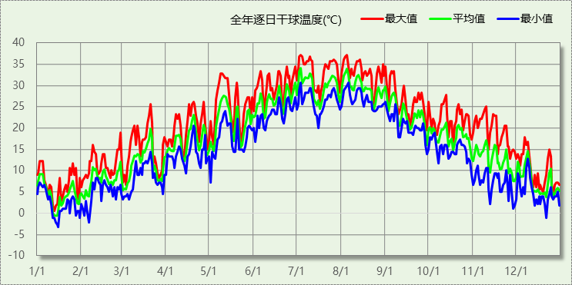

## 逐月辐照量表

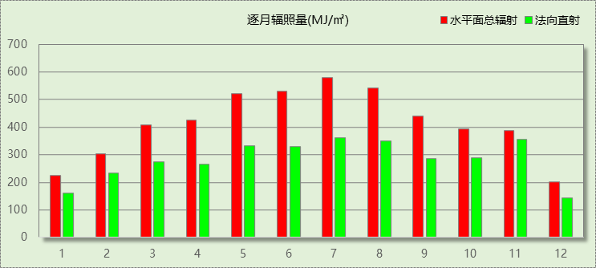

## 峰值工况

|  |  |  |  |  |  |
| --- | --- | --- | --- | --- | --- |
| 气象数据 | 时刻 | 干球温度(℃) | 湿球温度(℃) | 含湿量(g/kg) | 焓值(kj/kg) |
| 最热 | 07月03日14时 | 37.2 | 27.8 | 20.5 | 90.1 |
| 最冷 | 01月15日02时 | -3.3 | -3.3 | 2.8 | 3.6 |

# 软件介绍

本报告采用的软件为绿建暖通负荷BECH2024，该软件紧密结合暖通和节能设计规范、可根据项目实际情况建立建筑热工模型，并可对围护结构材料、房间内扰发热、作息时间表、热回收方式等参数进行设置。

软件包含全国各地典型气象年数据，内置DOE2.1E内核，对于建筑的逐时负荷进行动态模拟，既可以模拟8760小时理想负荷，也可以根据设定好的采暖期/空调期进行逐时模拟。

软件还支持分析全年建筑能耗的来源构成，依据日射得热、新风负荷、围护传热和内扰得热进行归类分项，生成设计建筑全年负荷计算报告书，提供详实的数据和多样的图表，为设计师在设备选型、制定运行策略等方面提供参考和帮助。

# 围护结构

## 屋顶构造

### 屋顶构造一

|  |  |  |  |  |  |  |
| --- | --- | --- | --- | --- | --- | --- |
| 材料名称 （由上到下） | 厚度δ | 导热系数λ | 蓄热系数S | 修正 系数 | 热阻R | 热惰性 指标 |
| (mm) | W/(m.K) | W/(㎡.K) | α | (㎡K)/W | D=R*S |
| 水泥砂浆 | 20 | 0.930 | 11.370 | 1.00 | 0.022 | 0.245 |
| c20细石混凝土(ρ=2300) | 30 | 1.510 | 15.243 | 1.00 | 0.020 | 0.303 |
| 绝热用挤塑聚苯乙烯泡沫塑料板（xps板） | 70 | 0.030 | 0.290 | 1.05 | 2.222 | 0.677 |
| c5泡沫混凝土找坡隔热层 | 30 | 0.310 | 4.330 | 1.00 | 0.097 | 0.419 |
| 钢筋混凝土 | 120 | 1.740 | 17.200 | 1.00 | 0.069 | 1.186 |
| 各层之和∑ | 270 | － | － | － | 2.429 | 2.829 |
| 传热系数K=1/(0.15+∑R) | 0.39 | | | | | |

## 外墙构造

### 填充墙构造一

|  |  |  |  |  |  |  |
| --- | --- | --- | --- | --- | --- | --- |
| 材料名称 （由外到内） | 厚度δ | 导热系数λ | 蓄热系数S | 修正 系数 | 热阻R | 热惰性 指标 |
| (mm) | W/(m.K) | W/(㎡.K) | α | (㎡K)/W | D=R*S |
| 水泥砂浆 | 20 | 0.930 | 11.370 | 1.00 | 0.022 | 0.245 |
| 专用保温砌筑砂浆砌加气混凝土砌块墙（水平灰缝与竖向灰缝厚度均≤10）b06级 | 200 | 0.190 | 3.010 | 1.00 | 1.053 | 3.168 |
| 泡沫玻璃板ⅰ型 | 30 | 0.050 | 0.650 | 1.05 | 0.571 | 0.390 |
| 水泥砂浆 | 20 | 0.930 | 11.370 | 1.00 | 0.022 | 0.245 |
| 各层之和∑ | 270 | － | － | － | 1.667 | 4.047 |
| 传热系数K=1/(0.15+∑R) | 0.55 | | | | | |

## 挑空楼板构造

### 挑空楼板构造一

|  |  |  |  |  |  |  |
| --- | --- | --- | --- | --- | --- | --- |
| 材料名称 （由上到下） | 厚度δ | 导热系数λ | 蓄热系数S | 修正 系数 | 热阻R | 热惰性 指标 |
| (mm) | W/(m.K) | W/(㎡.K) | α | (㎡K)/W | D=R*S |
| 水泥砂浆 | 20 | 0.930 | 11.370 | 1.00 | 0.022 | 0.245 |
| 泡沫玻璃板ⅰ型 | 30 | 0.050 | 0.650 | 1.05 | 0.571 | 0.390 |
| 钢筋混凝土 | 200 | 1.740 | 17.200 | 1.00 | 0.115 | 1.977 |
| 水泥砂浆 | 20 | 0.930 | 11.370 | 1.00 | 0.022 | 0.245 |
| 各层之和∑ | 270 | － | － | － | 0.729 | 2.856 |
| 传热系数K=1/(0.15+∑R) | 1.14 | | | | | |

## 楼板构造

### 控温房间楼板构造一

|  |  |  |  |  |  |  |
| --- | --- | --- | --- | --- | --- | --- |
| 材料名称 | 厚度δ | 导热系数λ | 蓄热系数S | 修正 系数 | 热阻R | 热惰性 指标 |
| (mm) | W/(m.K) | W/(㎡.K) | α | (㎡K)/W | D=R*S |
| 水泥砂浆 | 20 | 0.930 | 11.370 | 1.00 | 0.022 | 0.245 |
| 岩棉板(ρ=60-160) | 20 | 0.041 | 0.615 | 1.00 | 0.488 | 0.300 |
| 钢筋混凝土 | 120 | 1.740 | 17.200 | 1.00 | 0.069 | 1.186 |
| 石灰砂浆 | 20 | 0.810 | 10.070 | 1.00 | 0.025 | 0.249 |
| 各层之和∑ | 180 | － | － | － | 0.603 | 1.979 |
| 传热系数K=1/(0.22+∑R) | 1.22 | | | | | |

## 周边地面构造

### 地面构造一

|  |  |  |  |  |  |  |
| --- | --- | --- | --- | --- | --- | --- |
| 材料名称 | 厚度δ | 导热系数λ | 蓄热系数S | 修正 系数 | 热阻R | 热惰性 指标 |
| (mm) | W/(m.K) | W/(㎡.K) | α | (㎡K)/W | D=R*S |
| 水泥砂浆 | 20 | 0.930 | 11.370 | 1.00 | 0.022 | 0.245 |
| 绝热用挤塑聚苯乙烯泡沫塑料板（xps板） | 25 | 0.030 | 0.290 | 1.00 | 0.833 | 0.242 |
| 钢筋混凝土 | 120 | 1.740 | 17.200 | 1.00 | 0.069 | 1.186 |
| 各层之和∑ | 165 | － | － | － | 0.924 | 1.672 |
| 传热系数K=1/(0.11+∑R) | 0.36 | | | | | |

## 非周边地面构造

### 地面构造一

|  |  |  |  |  |  |  |
| --- | --- | --- | --- | --- | --- | --- |
| 材料名称 | 厚度δ | 导热系数λ | 蓄热系数S | 修正 系数 | 热阻R | 热惰性 指标 |
| (mm) | W/(m.K) | W/(㎡.K) | α | (㎡K)/W | D=R*S |
| 水泥砂浆 | 20 | 0.930 | 11.370 | 1.00 | 0.022 | 0.245 |
| 绝热用挤塑聚苯乙烯泡沫塑料板（xps板） | 25 | 0.030 | 0.290 | 1.00 | 0.833 | 0.242 |
| 钢筋混凝土 | 120 | 1.740 | 17.200 | 1.00 | 0.069 | 1.186 |
| 各层之和∑ | 165 | － | － | － | 0.924 | 1.672 |
| 传热系数K=1/(0.11+∑R) | 0.24 | | | | | |

## 门构造

|  |  |  |  |
| --- | --- | --- | --- |
| 序号 | 构造名称 | 传热系数 | 备注 |
| 1 | 金属三防门(硅酸铝板保温-普通型) | 1.500 |  |

## 窗构造

|  |  |  |  |  |  |
| --- | --- | --- | --- | --- | --- |
| 序号 | 构造名称 | 传热系数 | 窗遮阳系数 | 可见光透射比 | 备注 |
| 1 | 70系列平开（遮阳型6Low-E双银+12A+6 暖边）（隔热条宽29mm） | 2.000 | 0.285 | 0.550 | 湖北建筑节能门窗工程技术标准DB42T1770-2021 附录C |

# 房间类型

## 房间参数表

|  |  |  |  |  |  |  |
| --- | --- | --- | --- | --- | --- | --- |
| 房间类型 | 空调温度 ℃ | 供暖温度 ℃ | 新风量 | 人员密度 | 照明功率 密度 | 电器设备 功率 |
| 休息室 | 26 | 18 | 24(m^3/h.人) | 1.39(m^2/人) | 9(W/m^2) | 5(W/m^2) |
| 多媒体教室 | 26 | 18 | 20(m^3/h.人) | 4(m^2/人) | 8(W/m^2) | 5(W/m^2) |
| 大厅 | 26 | 20 | 30(m^3/h.人) | 20(m^2/人) | 10(W/m^2) | 0(W/m^2) |
| 实验教室 | 26 | 18 | 20(m^3/h.人) | 4(m^2/人) | 8(W/m^2) | 5(W/m^2) |
| 报告厅 | 26 | 18 | 14(m^3/h.人) | 2.5(m^2/人) | 12(W/m^2) | 5(W/m^2) |
| 普通办公室 | 26 | 20 | 30(m^3/h.人) | 6(m^2/人) | 8(W/m^2) | 5(W/m^2) |
| 普通教室 | 26 | 18 | 24(m^3/h.人) | 1.39(m^2/人) | 8(W/m^2) | 5(W/m^2) |
| 走廊 | － | － | 0(m^3/h.人) | 0(人) | 5(W/m^2) | 5(W/m^2) |
| 餐厅 | 26 | 18 | 25(m^3/h.人) | 2(m^2/人) | 8(W/m^2) | 5(W/m^2) |

## 作息时间表

详见附录

# 系统设置

## 系统划分

|  |  |  |  |  |  |  |
| --- | --- | --- | --- | --- | --- | --- |
| 系统编号 | 热回收 类型 | 启动 条件 | 回收 效率 | 排风 比例 | 面积(m2) | 包含的房间 |
| Sys | 全热回收 | 温差启动 冷:≥5.0(℃) 暖:≥5.0(℃) | 冷:0.20, 暖:0.00 | 1.00 | 1958.58 | 所有房间 |

## 运行时间表

详见附录

# 计算结果

## 模拟周期

全年8760小时模拟

## 全年冷暖需求

|  |  |  |  |  |
| --- | --- | --- | --- | --- |
| 系统名称\负荷 | 供暖需求 (kWh) | 供暖指标 (kWh/㎡·a) | 供冷需求 (kWh) | 供冷指标 (kWh/㎡·a) |
| 建筑总计 | 77036 | 36.25 | 250164 | 117.71 |

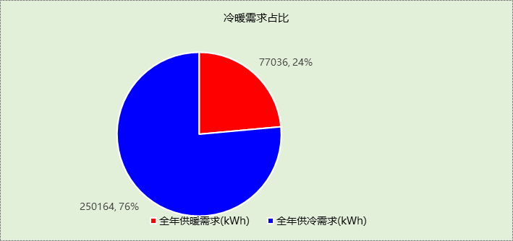

## 负荷分项统计

|  |  |  |  |  |  |  |
| --- | --- | --- | --- | --- | --- | --- |
| 分类 | 围护传热 | 室内得热 | 窗日射 | 新风/渗透 | 热回收 | 合计 |
| 供暖(kWh/㎡) | -30.76 | 22.97 | 2.15 | -30.61 | 0.00 | -36.25 |
| 供冷(kWh/㎡) | 12.91 | 46.86 | 3.59 | 60.34 | -5.99 | 117.71 |

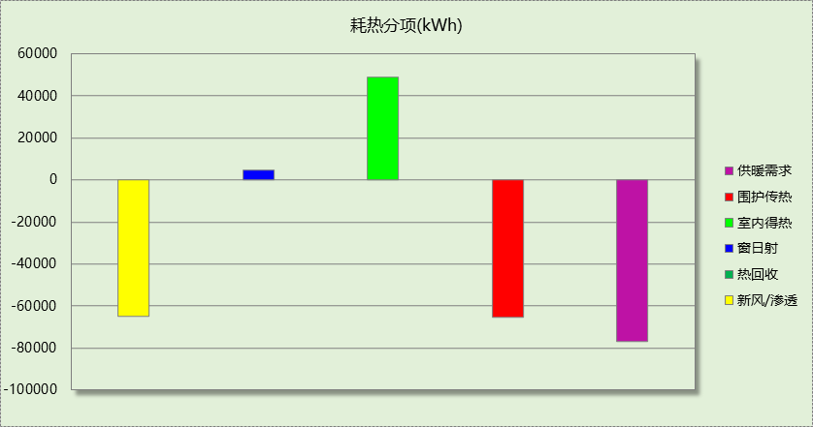

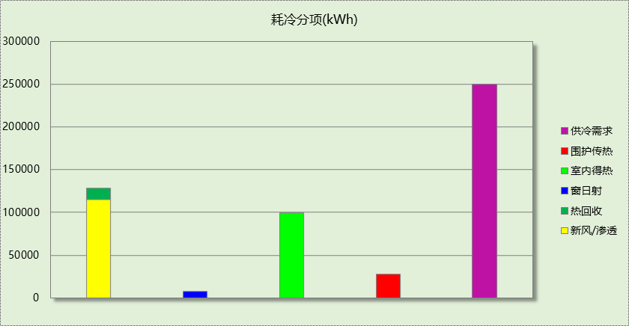

## 逐月负荷表

|  |  |  |  |  |  |  |
| --- | --- | --- | --- | --- | --- | --- |
| 月份 | 供暖(kWh) | 供冷(kWh) | 热负荷 峰值(kW) | 热负荷 峰值时刻 | 冷负荷 峰值(kW) | 冷负荷 峰值时刻 |
| 1月 | 32785 | 0 | 270.338 | 1月14日8时 | 0.000 | -- |
| 2月 | 14211 | 0 | 221.329 | 2月4日8时 | 0.000 | -- |
| 3月 | 7508 | 167 | 171.565 | 3月4日8时 | 47.391 | 3月20日16时 |
| 4月 | 556 | 3123 | 26.439 | 4月1日8时 | 170.958 | 4月19日16时 |
| 5月 | 37 | 21458 | 4.351 | 5月3日8时 | 259.941 | 5月13日14时 |
| 6月 | 0 | 47141 | 0.000 | -- | 344.661 | 6月24日8时 |
| 7月 | 0 | 74515 | 0.000 | -- | 373.423 | 7月26日8时 |
| 8月 | 0 | 68028 | 0.000 | -- | 440.798 | 8月12日8时 |
| 9月 | 0 | 32218 | 0.000 | -- | 303.176 | 9月13日10时 |
| 10月 | 27 | 3511 | 19.249 | 10月31日8时 | 112.692 | 10月23日16时 |
| 11月 | 2486 | 2 | 114.482 | 11月28日8时 | 1.061 | 11月8日15时 |
| 12月 | 19424 | 0 | 181.356 | 12月23日8时 | 0.000 | -- |

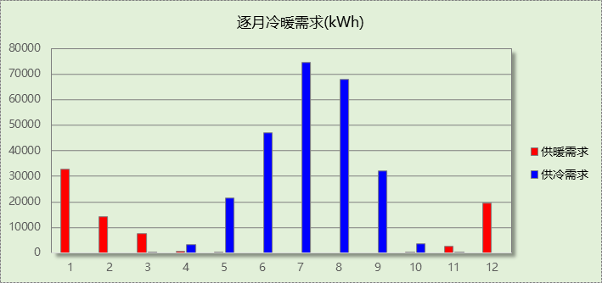

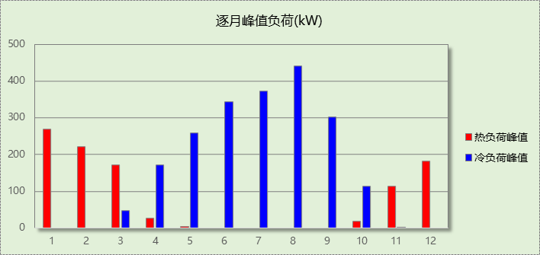

# 附录

**工作日/节假日人员逐时在室率(%)**

|  |  |  |  |  |  |  |  |  |  |  |  |  |  |  |  |  |  |  |  |  |  |  |  |  |
| --- | --- | --- | --- | --- | --- | --- | --- | --- | --- | --- | --- | --- | --- | --- | --- | --- | --- | --- | --- | --- | --- | --- | --- | --- |
| 房间类型 | 1 | 2 | 3 | 4 | 5 | 6 | 7 | 8 | 9 | 10 | 11 | 12 | 13 | 14 | 15 | 16 | 17 | 18 | 19 | 20 | 21 | 22 | 23 | 24 |
| 休息室 | 0 | 0 | 0 | 0 | 0 | 0 | 10 | 50 | 95 | 95 | 95 | 80 | 80 | 95 | 95 | 95 | 95 | 30 | 30 | 0 | 0 | 0 | 0 | 0 |
| 0 | 0 | 0 | 0 | 0 | 0 | 0 | 0 | 0 | 0 | 0 | 0 | 0 | 0 | 0 | 0 | 0 | 0 | 0 | 0 | 0 | 0 | 0 | 0 |
| 多媒体教室 | 0 | 0 | 0 | 0 | 0 | 0 | 10 | 50 | 95 | 95 | 95 | 80 | 80 | 95 | 95 | 95 | 95 | 30 | 30 | 0 | 0 | 0 | 0 | 0 |
| 0 | 0 | 0 | 0 | 0 | 0 | 0 | 0 | 0 | 0 | 0 | 0 | 0 | 0 | 0 | 0 | 0 | 0 | 0 | 0 | 0 | 0 | 0 | 0 |
| 大厅 | 0 | 0 | 0 | 0 | 0 | 0 | 10 | 50 | 95 | 95 | 95 | 80 | 80 | 95 | 95 | 95 | 95 | 30 | 30 | 0 | 0 | 0 | 0 | 0 |
| 0 | 0 | 0 | 0 | 0 | 0 | 0 | 0 | 0 | 0 | 0 | 0 | 0 | 0 | 0 | 0 | 0 | 0 | 0 | 0 | 0 | 0 | 0 | 0 |
| 实验教室 | 0 | 0 | 0 | 0 | 0 | 0 | 10 | 50 | 95 | 95 | 95 | 80 | 80 | 95 | 95 | 95 | 95 | 30 | 30 | 0 | 0 | 0 | 0 | 0 |
| 0 | 0 | 0 | 0 | 0 | 0 | 0 | 0 | 0 | 0 | 0 | 0 | 0 | 0 | 0 | 0 | 0 | 0 | 0 | 0 | 0 | 0 | 0 | 0 |
| 报告厅 | 0 | 0 | 0 | 0 | 0 | 0 | 10 | 50 | 95 | 95 | 95 | 80 | 80 | 95 | 95 | 95 | 95 | 30 | 30 | 0 | 0 | 0 | 0 | 0 |
| 0 | 0 | 0 | 0 | 0 | 0 | 0 | 0 | 0 | 0 | 0 | 0 | 0 | 0 | 0 | 0 | 0 | 0 | 0 | 0 | 0 | 0 | 0 | 0 |
| 普通办公室 | 0 | 0 | 0 | 0 | 0 | 0 | 10 | 50 | 95 | 95 | 95 | 80 | 80 | 95 | 95 | 95 | 95 | 30 | 30 | 0 | 0 | 0 | 0 | 0 |
| 0 | 0 | 0 | 0 | 0 | 0 | 0 | 0 | 0 | 0 | 0 | 0 | 0 | 0 | 0 | 0 | 0 | 0 | 0 | 0 | 0 | 0 | 0 | 0 |
| 普通教室 | 0 | 0 | 0 | 0 | 0 | 0 | 10 | 50 | 95 | 95 | 95 | 80 | 80 | 95 | 95 | 95 | 95 | 30 | 30 | 0 | 0 | 0 | 0 | 0 |
| 0 | 0 | 0 | 0 | 0 | 0 | 0 | 0 | 0 | 0 | 0 | 0 | 0 | 0 | 0 | 0 | 0 | 0 | 0 | 0 | 0 | 0 | 0 | 0 |
| 走廊 | 0 | 0 | 0 | 0 | 0 | 0 | 10 | 50 | 95 | 95 | 95 | 80 | 80 | 95 | 95 | 95 | 95 | 30 | 30 | 0 | 0 | 0 | 0 | 0 |
| 0 | 0 | 0 | 0 | 0 | 0 | 0 | 0 | 0 | 0 | 0 | 0 | 0 | 0 | 0 | 0 | 0 | 0 | 0 | 0 | 0 | 0 | 0 | 0 |
| 餐厅 | 0 | 0 | 0 | 0 | 0 | 0 | 10 | 50 | 95 | 95 | 95 | 80 | 80 | 95 | 95 | 95 | 95 | 30 | 30 | 0 | 0 | 0 | 0 | 0 |
| 0 | 0 | 0 | 0 | 0 | 0 | 0 | 0 | 0 | 0 | 0 | 0 | 0 | 0 | 0 | 0 | 0 | 0 | 0 | 0 | 0 | 0 | 0 | 0 |

注：上行：工作日；下行：节假日

**工作日/节假日照明开关时间表(%)**

|  |  |  |  |  |  |  |  |  |  |  |  |  |  |  |  |  |  |  |  |  |  |  |  |  |
| --- | --- | --- | --- | --- | --- | --- | --- | --- | --- | --- | --- | --- | --- | --- | --- | --- | --- | --- | --- | --- | --- | --- | --- | --- |
| 房间类型 | 1 | 2 | 3 | 4 | 5 | 6 | 7 | 8 | 9 | 10 | 11 | 12 | 13 | 14 | 15 | 16 | 17 | 18 | 19 | 20 | 21 | 22 | 23 | 24 |
| 休息室 | 0 | 0 | 0 | 0 | 0 | 0 | 10 | 50 | 95 | 95 | 95 | 80 | 80 | 95 | 95 | 95 | 95 | 30 | 30 | 0 | 0 | 0 | 0 | 0 |
| 0 | 0 | 0 | 0 | 0 | 0 | 0 | 0 | 0 | 0 | 0 | 0 | 0 | 0 | 0 | 0 | 0 | 0 | 0 | 0 | 0 | 0 | 0 | 0 |
| 多媒体教室 | 0 | 0 | 0 | 0 | 0 | 0 | 10 | 50 | 95 | 95 | 95 | 80 | 80 | 95 | 95 | 95 | 95 | 30 | 30 | 0 | 0 | 0 | 0 | 0 |
| 0 | 0 | 0 | 0 | 0 | 0 | 0 | 0 | 0 | 0 | 0 | 0 | 0 | 0 | 0 | 0 | 0 | 0 | 0 | 0 | 0 | 0 | 0 | 0 |
| 大厅 | 0 | 0 | 0 | 0 | 0 | 0 | 10 | 50 | 95 | 95 | 95 | 80 | 80 | 95 | 95 | 95 | 95 | 30 | 30 | 0 | 0 | 0 | 0 | 0 |
| 0 | 0 | 0 | 0 | 0 | 0 | 0 | 0 | 0 | 0 | 0 | 0 | 0 | 0 | 0 | 0 | 0 | 0 | 0 | 0 | 0 | 0 | 0 | 0 |
| 实验教室 | 0 | 0 | 0 | 0 | 0 | 0 | 10 | 50 | 95 | 95 | 95 | 80 | 80 | 95 | 95 | 95 | 95 | 30 | 30 | 0 | 0 | 0 | 0 | 0 |
| 0 | 0 | 0 | 0 | 0 | 0 | 0 | 0 | 0 | 0 | 0 | 0 | 0 | 0 | 0 | 0 | 0 | 0 | 0 | 0 | 0 | 0 | 0 | 0 |
| 报告厅 | 0 | 0 | 0 | 0 | 0 | 0 | 10 | 50 | 95 | 95 | 95 | 80 | 80 | 95 | 95 | 95 | 95 | 30 | 30 | 0 | 0 | 0 | 0 | 0 |
| 0 | 0 | 0 | 0 | 0 | 0 | 0 | 0 | 0 | 0 | 0 | 0 | 0 | 0 | 0 | 0 | 0 | 0 | 0 | 0 | 0 | 0 | 0 | 0 |
| 普通办公室 | 0 | 0 | 0 | 0 | 0 | 0 | 10 | 50 | 95 | 95 | 95 | 80 | 80 | 95 | 95 | 95 | 95 | 30 | 30 | 0 | 0 | 0 | 0 | 0 |
| 0 | 0 | 0 | 0 | 0 | 0 | 0 | 0 | 0 | 0 | 0 | 0 | 0 | 0 | 0 | 0 | 0 | 0 | 0 | 0 | 0 | 0 | 0 | 0 |
| 普通教室 | 0 | 0 | 0 | 0 | 0 | 0 | 10 | 50 | 95 | 95 | 95 | 80 | 80 | 95 | 95 | 95 | 95 | 30 | 30 | 0 | 0 | 0 | 0 | 0 |
| 0 | 0 | 0 | 0 | 0 | 0 | 0 | 0 | 0 | 0 | 0 | 0 | 0 | 0 | 0 | 0 | 0 | 0 | 0 | 0 | 0 | 0 | 0 | 0 |
| 走廊 | 0 | 0 | 0 | 0 | 0 | 0 | 10 | 50 | 95 | 95 | 95 | 80 | 80 | 95 | 95 | 95 | 95 | 30 | 30 | 0 | 0 | 0 | 0 | 0 |
| 0 | 0 | 0 | 0 | 0 | 0 | 0 | 0 | 0 | 0 | 0 | 0 | 0 | 0 | 0 | 0 | 0 | 0 | 0 | 0 | 0 | 0 | 0 | 0 |
| 餐厅 | 0 | 0 | 0 | 0 | 0 | 0 | 10 | 50 | 95 | 95 | 95 | 80 | 80 | 95 | 95 | 95 | 95 | 30 | 30 | 0 | 0 | 0 | 0 | 0 |
| 0 | 0 | 0 | 0 | 0 | 0 | 0 | 0 | 0 | 0 | 0 | 0 | 0 | 0 | 0 | 0 | 0 | 0 | 0 | 0 | 0 | 0 | 0 | 0 |

注：上行：工作日；下行：节假日

**工作日/节假日设备逐时使用率(%)**

|  |  |  |  |  |  |  |  |  |  |  |  |  |  |  |  |  |  |  |  |  |  |  |  |  |
| --- | --- | --- | --- | --- | --- | --- | --- | --- | --- | --- | --- | --- | --- | --- | --- | --- | --- | --- | --- | --- | --- | --- | --- | --- |
| 房间类型 | 1 | 2 | 3 | 4 | 5 | 6 | 7 | 8 | 9 | 10 | 11 | 12 | 13 | 14 | 15 | 16 | 17 | 18 | 19 | 20 | 21 | 22 | 23 | 24 |
| 休息室 | 0 | 0 | 0 | 0 | 0 | 0 | 10 | 50 | 95 | 95 | 95 | 50 | 50 | 95 | 95 | 95 | 95 | 30 | 30 | 0 | 0 | 0 | 0 | 0 |
| 0 | 0 | 0 | 0 | 0 | 0 | 0 | 0 | 0 | 0 | 0 | 0 | 0 | 0 | 0 | 0 | 0 | 0 | 0 | 0 | 0 | 0 | 0 | 0 |
| 多媒体教室 | 0 | 0 | 0 | 0 | 0 | 0 | 10 | 50 | 95 | 95 | 95 | 50 | 50 | 95 | 95 | 95 | 95 | 30 | 30 | 0 | 0 | 0 | 0 | 0 |
| 0 | 0 | 0 | 0 | 0 | 0 | 0 | 0 | 0 | 0 | 0 | 0 | 0 | 0 | 0 | 0 | 0 | 0 | 0 | 0 | 0 | 0 | 0 | 0 |
| 大厅 | 0 | 0 | 0 | 0 | 0 | 0 | 10 | 50 | 95 | 95 | 95 | 50 | 50 | 95 | 95 | 95 | 95 | 30 | 30 | 0 | 0 | 0 | 0 | 0 |
| 0 | 0 | 0 | 0 | 0 | 0 | 0 | 0 | 0 | 0 | 0 | 0 | 0 | 0 | 0 | 0 | 0 | 0 | 0 | 0 | 0 | 0 | 0 | 0 |
| 实验教室 | 0 | 0 | 0 | 0 | 0 | 0 | 10 | 50 | 95 | 95 | 95 | 50 | 50 | 95 | 95 | 95 | 95 | 30 | 30 | 0 | 0 | 0 | 0 | 0 |
| 0 | 0 | 0 | 0 | 0 | 0 | 0 | 0 | 0 | 0 | 0 | 0 | 0 | 0 | 0 | 0 | 0 | 0 | 0 | 0 | 0 | 0 | 0 | 0 |
| 报告厅 | 0 | 0 | 0 | 0 | 0 | 0 | 10 | 50 | 95 | 95 | 95 | 50 | 50 | 95 | 95 | 95 | 95 | 30 | 30 | 0 | 0 | 0 | 0 | 0 |
| 0 | 0 | 0 | 0 | 0 | 0 | 0 | 0 | 0 | 0 | 0 | 0 | 0 | 0 | 0 | 0 | 0 | 0 | 0 | 0 | 0 | 0 | 0 | 0 |
| 普通办公室 | 0 | 0 | 0 | 0 | 0 | 0 | 10 | 50 | 95 | 95 | 95 | 50 | 50 | 95 | 95 | 95 | 95 | 30 | 30 | 0 | 0 | 0 | 0 | 0 |
| 0 | 0 | 0 | 0 | 0 | 0 | 0 | 0 | 0 | 0 | 0 | 0 | 0 | 0 | 0 | 0 | 0 | 0 | 0 | 0 | 0 | 0 | 0 | 0 |
| 普通教室 | 0 | 0 | 0 | 0 | 0 | 0 | 10 | 50 | 95 | 95 | 95 | 50 | 50 | 95 | 95 | 95 | 95 | 30 | 30 | 0 | 0 | 0 | 0 | 0 |
| 0 | 0 | 0 | 0 | 0 | 0 | 0 | 0 | 0 | 0 | 0 | 0 | 0 | 0 | 0 | 0 | 0 | 0 | 0 | 0 | 0 | 0 | 0 | 0 |
| 走廊 | 0 | 0 | 0 | 0 | 0 | 0 | 10 | 50 | 95 | 95 | 95 | 50 | 50 | 95 | 95 | 95 | 95 | 30 | 30 | 0 | 0 | 0 | 0 | 0 |
| 0 | 0 | 0 | 0 | 0 | 0 | 0 | 0 | 0 | 0 | 0 | 0 | 0 | 0 | 0 | 0 | 0 | 0 | 0 | 0 | 0 | 0 | 0 | 0 |
| 餐厅 | 0 | 0 | 0 | 0 | 0 | 0 | 10 | 50 | 95 | 95 | 95 | 50 | 50 | 95 | 95 | 95 | 95 | 30 | 30 | 0 | 0 | 0 | 0 | 0 |
| 0 | 0 | 0 | 0 | 0 | 0 | 0 | 0 | 0 | 0 | 0 | 0 | 0 | 0 | 0 | 0 | 0 | 0 | 0 | 0 | 0 | 0 | 0 | 0 |

注：上行：工作日；下行：节假日

**工作日/节假日空调系统开关时间表**

|  |  |  |  |  |  |  |  |  |  |  |  |  |  |  |  |  |  |  |  |  |  |  |  |  |
| --- | --- | --- | --- | --- | --- | --- | --- | --- | --- | --- | --- | --- | --- | --- | --- | --- | --- | --- | --- | --- | --- | --- | --- | --- |
| 系统编号 | 1 | 2 | 3 | 4 | 5 | 6 | 7 | 8 | 9 | 10 | 11 | 12 | 13 | 14 | 15 | 16 | 17 | 18 | 19 | 20 | 21 | 22 | 23 | 24 |
| Sys | 1 | 1 | 1 | 1 | 1 | 1 | 1 | 1 | 1 | 1 | 1 | 1 | 1 | 1 | 1 | 1 | 1 | 1 | 1 | 1 | 1 | 1 | 1 | 1 |
| 0 | 1 | 0 | 0 | 1 | 0 | 0 | 1 | 0 | 0 | 0 | 1 | 0 | 0 | 0 | 0 | 1 | 0 | 0 | 0 | 0 | 1 | 0 | 0 |

注：上行：工作日；下行：节假日