**教学楼**

**全年负荷计算书**

|  |  |
| --- | --- |
| 工程名称 | 教学楼 |
| 设计编号 |  |
| 建设单位 |  |
| 设计单位 |  |
| 计 算 人 |  |
| 校 对 人 |  |
| 审 核 人 |  |
| 计算日期 | 2024年12月27日 |



|  |  |
| --- | --- |
| 采用软件 | 暖通负荷BECH2024 |
| 软件版本 | 20240430(SP1) |
| 研发单位 | 北京绿建软件股份有限公司 |
| 正版授权码 | T13955158202 |

**目 录**

1 建筑概况 1

2 气象数据 1

2.1 气象地点 1

2.2 逐日干球温度表 1

2.3 逐月辐照量表 2

2.4 峰值工况 2

3 软件介绍 2

4 围护结构 2

4.1 屋顶构造 2

4.1.1 屋顶构造一（上人倒置式屋面） 2

4.2 外墙构造 3

4.2.1 外墙（填充墙）构造一 3

4.3 挑空楼板构造 3

4.3.1 挑空楼板构造一 3

4.4 楼板构造 4

4.4.1 控温房间楼板构造一 4

4.5 门构造 4

4.6 窗构造 4

5 房间类型 4

5.1 房间参数表 4

5.2 作息时间表 5

6 系统设置 5

6.1 系统划分 5

6.2 运行时间表 5

7 计算结果 5

7.1 模拟周期 5

7.2 全年冷暖需求 5

7.3 负荷分项统计 6

7.4 逐月负荷表 7

8 附录 9

# 建筑概况

|  |  |  |
| --- | --- | --- |
| 地理位置 | 湖南-株洲 | |
| 气候分区 | 夏热冬冷A区 | |
| 北纬 | 28.00 | |
| 东经 | 113.16 | |
| 建筑名称 | 教学楼 | |
| 建筑类型 | 公共建筑 |  |
| 建筑面积 | 地上 20320.07 ㎡ | 地下 0.00 ㎡ |
| 建筑高度 | 地上 23.40 m | 地下0.00 |
| 建筑层数 | 地上 6 | 地下 0 |
| 北向角度 | 90° | |

# 气象数据

## 气象地点

湖南-郴州, 《建筑节能气象参数标准》JGJ346-2014

## 逐日干球温度表

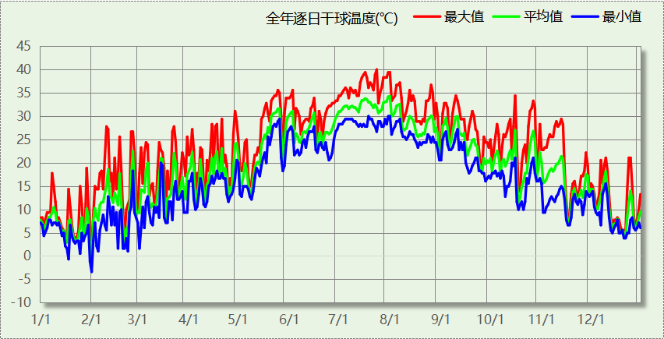

## 逐月辐照量表

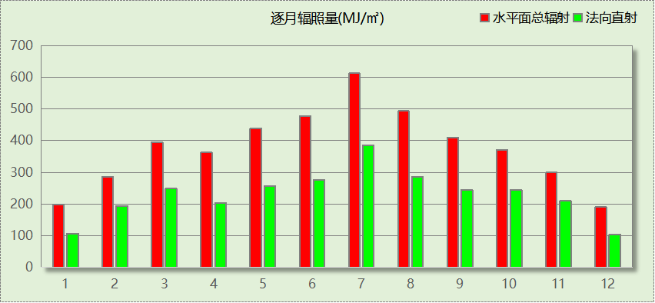

## 峰值工况

|  |  |  |  |  |  |
| --- | --- | --- | --- | --- | --- |
| 气象数据 | 时刻 | 干球温度(℃) | 湿球温度(℃) | 含湿量(g/kg) | 焓值(kj/kg) |
| 最热 | 07月23日16时 | 40.0 | 26.1 | 16.2 | 81.9 |
| 最冷 | 01月31日12时 | -3.3 | -3.3 | 2.7 | 3.4 |

# 软件介绍

本报告采用的软件为绿建暖通负荷BECH2024，该软件紧密结合暖通和节能设计规范、可根据项目实际情况建立建筑热工模型，并可对围护结构材料、房间内扰发热、作息时间表、热回收方式等参数进行设置。

软件包含全国各地典型气象年数据，内置DOE2.1E内核，对于建筑的逐时负荷进行动态模拟，既可以模拟8760小时理想负荷，也可以根据设定好的采暖期/空调期进行逐时模拟。

软件还支持分析全年建筑能耗的来源构成，依据日射得热、新风负荷、围护传热和内扰得热进行归类分项，生成设计建筑全年负荷计算报告书，提供详实的数据和多样的图表，为设计师在设备选型、制定运行策略等方面提供参考和帮助。

# 围护结构

## 屋顶构造

### 屋顶构造一（上人倒置式屋面）

|  |  |  |  |  |  |  |
| --- | --- | --- | --- | --- | --- | --- |
| 材料名称 （由上到下） | 厚度δ | 导热系数λ | 蓄热系数S | 修正 系数 | 热阻R | 热惰性 指标 |
| (mm) | W/(m.K) | W/(㎡.K) | α | (㎡K)/W | D=R*S |
| C20细石混凝土保护层，内配Φ4@100双向钢筋网片 | 50 | 1.510 | 15.360 | 1.00 | 0.033 | 0.509 |
| 干铺聚酯无纺布一层 | － | － | － | － | 0.000 | － |
| 难燃型挤塑聚苯板 | 85 | 0.030 | 0.540 | 1.25 | 2.267 | 1.530 |
| SBS改性沥青防水卷材 | 3 | 0.230 | 9.370 | 1.20 | 0.011 | 0.122 |
| 非固化橡胶沥青防水涂料 | 2 | 0.230 | 9.370 | 1.20 | 0.007 | 0.081 |
| 1：2.5水泥砂浆 | 20 | 0.930 | 11.370 | 1.00 | 0.022 | 0.245 |
| 粉煤灰陶粒混凝土 | 30 | 0.950 | 11.400 | 1.00 | 0.032 | 0.360 |
| 钢筋混凝土 | 120 | 1.740 | 17.200 | 1.00 | 0.069 | 1.186 |
| 石灰水泥砂浆 | 10 | 0.870 | 10.750 | 1.00 | 0.011 | 0.124 |
| 各层之和∑ | 320 | － | － | － | 2.451 | 4.157 |
| 传热系数K=1/(0.15+∑R) | 0.38 | | | | | |

## 外墙构造

### 外墙（填充墙）构造一

|  |  |  |  |  |  |  |
| --- | --- | --- | --- | --- | --- | --- |
| 材料名称 （由外到内） | 厚度δ | 导热系数λ | 蓄热系数S | 修正 系数 | 热阻R | 热惰性 指标 |
| (mm) | W/(m.K) | W/(㎡.K) | α | (㎡K)/W | D=R*S |
| 岩棉保温装饰复合一体板 | 45 | 0.045 | 0.750 | 1.20 | 0.833 | 0.750 |
| 聚氨酯防水涂料 | 1.5 | 0.150 | 6.070 | 1.00 | 0.010 | 0.061 |
| 聚合物水泥防水砂浆 | 6 | 0.930 | 11.370 | 1.00 | 0.006 | 0.073 |
| 改性玻化微珠轻质砂浆 （保温隔热型）（1） | 20 | 0.070 | 1.500 | 1.00 | 0.286 | 0.429 |
| 重砂浆砌筑烧结页岩多孔砖/空心砖墙 | 200 | 0.580 | 7.920 | 1.00 | 0.345 | 2.731 |
| 改性玻化微珠轻质砂浆 （保温隔热型）（1） | 20 | 0.070 | 1.500 | 1.00 | 0.286 | 0.429 |
| 各层之和∑ | 292.5 | － | － | － | 1.766 | 4.472 |
| 传热系数K=1/(0.15+∑R) | 0.52 | | | | | |

## 挑空楼板构造

### 挑空楼板构造一

|  |  |  |  |  |  |  |
| --- | --- | --- | --- | --- | --- | --- |
| 材料名称 （由上到下） | 厚度δ | 导热系数λ | 蓄热系数S | 修正 系数 | 热阻R | 热惰性 指标 |
| (mm) | W/(m.K) | W/(㎡.K) | α | (㎡K)/W | D=R*S |
| 改性玻化微珠轻质砂浆 （保温隔热型）（1） | 20 | 0.070 | 1.500 | 1.00 | 0.286 | 0.429 |
| 钢筋混凝土 | 120 | 1.740 | 17.200 | 1.00 | 0.069 | 1.186 |
| 改性玻化微珠轻质砂浆 （保温隔热型）（1） | 20 | 0.070 | 1.500 | 1.00 | 0.286 | 0.429 |
| 岩棉保温装饰复合一体板 | 30 | 0.045 | 0.750 | 1.20 | 0.556 | 0.500 |
| 各层之和∑ | 190 | － | － | － | 1.196 | 2.543 |
| 传热系数K=1/(0.15+∑R) | 0.74 | | | | | |

## 楼板构造

### 控温房间楼板构造一

|  |  |  |  |  |  |  |
| --- | --- | --- | --- | --- | --- | --- |
| 材料名称 | 厚度δ | 导热系数λ | 蓄热系数S | 修正 系数 | 热阻R | 热惰性 指标 |
| (mm) | W/(m.K) | W/(㎡.K) | α | (㎡K)/W | D=R*S |
| 钢筋混凝土 | 130 | 1.740 | 17.200 | 1.00 | 0.075 | 1.285 |
| 改性玻化微珠轻质砂浆 （保温隔热型）（1） | 20 | 0.070 | 1.500 | 1.00 | 0.286 | 0.429 |
| 各层之和∑ | 150 | － | － | － | 0.360 | 1.714 |
| 传热系数K=1/(0.22+∑R) | 1.72 | | | | | |

## 门构造

|  |  |  |  |
| --- | --- | --- | --- |
| 序号 | 构造名称 | 传热系数 | 备注 |
| 1 | 保温门（多功能门） | 2.500 |  |

## 窗构造

|  |  |  |  |  |  |
| --- | --- | --- | --- | --- | --- |
| 序号 | 构造名称 | 传热系数 | 窗遮阳系数 | 可见光透射比 | 备注 |
| 1 | 断桥铝合金型材14.8mm 6 高透光双银 Low-E+12A+6 透明 | 2.500 | 0.414 | 0.680 | 湖南省居住建筑节能设计标准DBJ43/T025-2022 |
| 2 | 隔热金属型材 6中透光Low-E+12空气+6透明 | 2.600 | 0.460 | 0.620 |  |

# 房间类型

## 房间参数表

|  |  |  |  |  |  |  |
| --- | --- | --- | --- | --- | --- | --- |
| 房间类型 | 空调温度 ℃ | 供暖温度 ℃ | 新风量 | 人员密度 | 照明功率 密度 | 电器设备 功率 |
| 休息室 | 26 | 18 | 24(m^3/h.人) | 1.39(m^2/人) | 9(W/m^2) | 5(W/m^2) |
| 会议室 | 26 | 20 | 30(m^3/h.人) | 3.3(m^2/人) | 8(W/m^2) | 5(W/m^2) |
| 卫生间 | 28 | 16 | 0(m^3/h.人) | 0(人) | 5(W/m^2) | 5(W/m^2) |
| 多媒体教室 | 26 | 18 | 20(m^3/h.人) | 4(m^2/人) | 8(W/m^2) | 5(W/m^2) |
| 实验教室 | 26 | 18 | 20(m^3/h.人) | 4(m^2/人) | 8(W/m^2) | 5(W/m^2) |
| 普通办公室 | 26 | 20 | 30(m^3/h.人) | 6(m^2/人) | 8(W/m^2) | 5(W/m^2) |
| 普通教室 | 26 | 18 | 24(m^3/h.人) | 1.39(m^2/人) | 8(W/m^2) | 5(W/m^2) |
| 楼梯间 | － | － | 0(m^3/h.人) | 0(人) | 5(W/m^2) | 5(W/m^2) |
| 设备间 | － | － | 0(次/h) | 0(人) | 6(W/m^2) | 15(W/m^2) |
| 走廊 | － | － | 0(m^3/h.人) | 0(人) | 5(W/m^2) | 5(W/m^2) |

## 作息时间表

详见附录

# 系统设置

## 系统划分

|  |  |  |  |  |  |  |
| --- | --- | --- | --- | --- | --- | --- |
| 系统编号 | 热回收 类型 | 启动 条件 | 回收 效率 | 排风 比例 | 面积(m2) | 包含的房间 |
| 默认 | 全热回收 | 温差启动 冷:≥5.0(℃) 暖:≥5.0(℃) | 冷:0.50, 暖:0.55 | 1.00 | 11525.33 | 所有房间 |

## 运行时间表

详见附录

# 计算结果

## 模拟周期

全年8760小时模拟

## 全年冷暖需求

|  |  |  |  |  |
| --- | --- | --- | --- | --- |
| 系统名称\负荷 | 供暖需求 (kWh) | 供暖指标 (kWh/㎡·a) | 供冷需求 (kWh) | 供冷指标 (kWh/㎡·a) |
| 建筑总计 | 13019 | 0.64 | 1822478 | 89.69 |

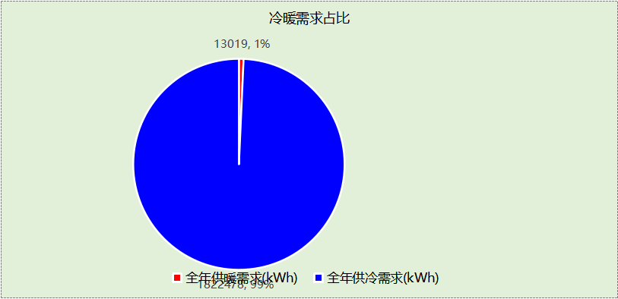

## 负荷分项统计

|  |  |  |  |  |  |  |
| --- | --- | --- | --- | --- | --- | --- |
| 分类 | 围护传热 | 室内得热 | 窗日射 | 新风/渗透 | 热回收 | 合计 |
| 供暖(kWh/㎡) | -2.47 | 5.52 | 0.61 | -8.18 | 3.87 | -0.64 |
| 供冷(kWh/㎡) | 10.19 | 42.84 | 4.97 | 41.94 | -10.25 | 89.69 |

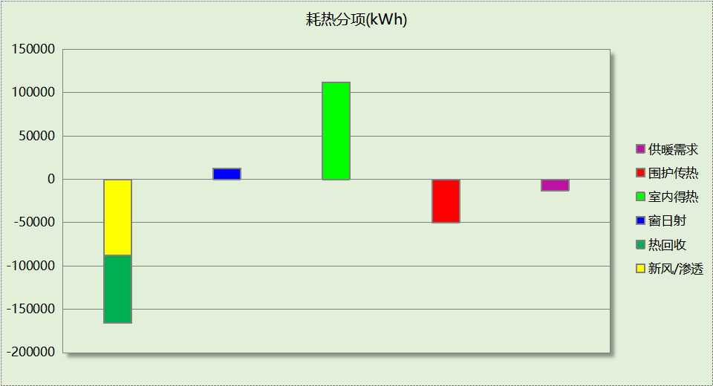

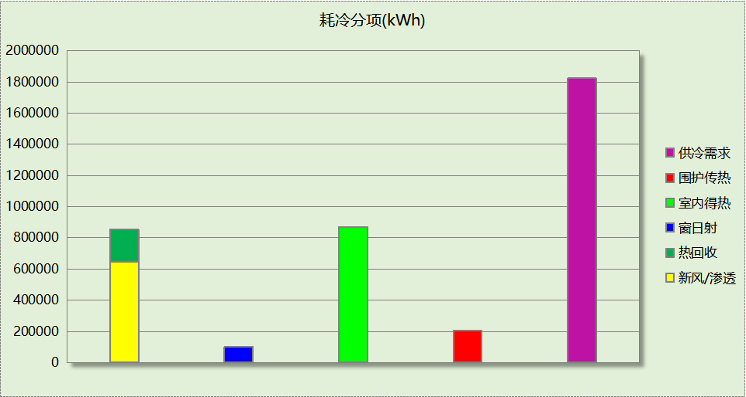

## 逐月负荷表

|  |  |  |  |  |  |  |
| --- | --- | --- | --- | --- | --- | --- |
| 月份 | 供暖(kWh) | 供冷(kWh) | 热负荷 峰值(kW) | 热负荷 峰值时刻 | 冷负荷 峰值(kW) | 冷负荷 峰值时刻 |
| 1月 | 9793 | 0 | 417.974 | 1月2日8时 | 0.000 | -- |
| 2月 | 961 | 2697 | 275.709 | 2月4日8时 | 451.659 | 2月25日16时 |
| 3月 | 6 | 32683 | 1.673 | 3月11日8时 | 958.332 | 3月22日16时 |
| 4月 | 0 | 95754 | 0.000 | -- | 1253.086 | 4月30日16时 |
| 5月 | 0 | 207944 | 0.000 | -- | 1816.496 | 5月28日16时 |
| 6月 | 0 | 300917 | 0.000 | -- | 2057.333 | 6月18日13时 |
| 7月 | 0 | 360984 | 0.000 | -- | 2262.582 | 7月22日8时 |
| 8月 | 0 | 379223 | 0.000 | -- | 2177.384 | 8月12日8时 |
| 9月 | 0 | 249459 | 0.000 | -- | 2065.131 | 9月4日8时 |
| 10月 | 0 | 136182 | 0.000 | -- | 1437.095 | 10月15日10时 |
| 11月 | 16 | 54861 | 3.848 | 11月25日17时 | 934.702 | 11月12日16时 |
| 12月 | 2243 | 1773 | 283.982 | 12月23日8时 | 330.166 | 12月9日16时 |

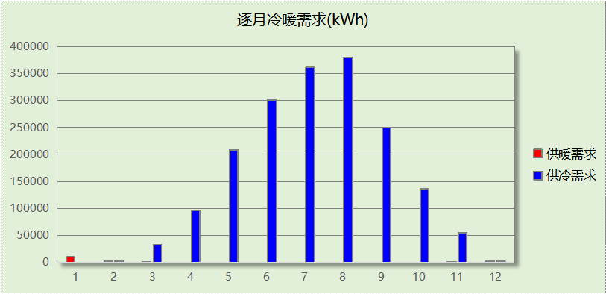

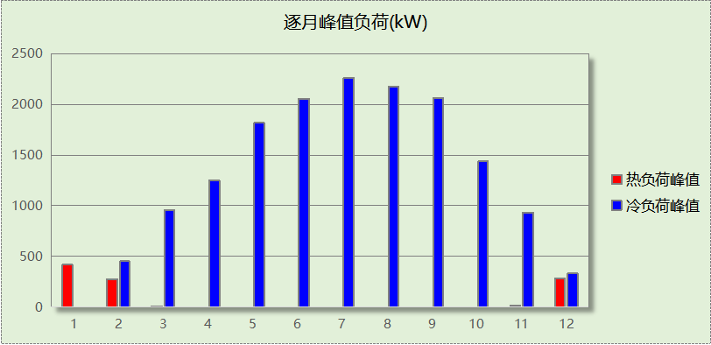

# 附录

**工作日/节假日人员逐时在室率(%)**

|  |  |  |  |  |  |  |  |  |  |  |  |  |  |  |  |  |  |  |  |  |  |  |  |  |
| --- | --- | --- | --- | --- | --- | --- | --- | --- | --- | --- | --- | --- | --- | --- | --- | --- | --- | --- | --- | --- | --- | --- | --- | --- |
| 房间类型 | 1 | 2 | 3 | 4 | 5 | 6 | 7 | 8 | 9 | 10 | 11 | 12 | 13 | 14 | 15 | 16 | 17 | 18 | 19 | 20 | 21 | 22 | 23 | 24 |
| 休息室 | 0 | 0 | 0 | 0 | 0 | 0 | 10 | 50 | 95 | 95 | 95 | 80 | 80 | 95 | 95 | 95 | 95 | 30 | 30 | 0 | 0 | 0 | 0 | 0 |
| 0 | 0 | 0 | 0 | 0 | 0 | 0 | 0 | 0 | 0 | 0 | 0 | 0 | 0 | 0 | 0 | 0 | 0 | 0 | 0 | 0 | 0 | 0 | 0 |
| 会议室 | 0 | 0 | 0 | 0 | 0 | 0 | 10 | 50 | 95 | 95 | 95 | 80 | 80 | 95 | 95 | 95 | 95 | 30 | 30 | 0 | 0 | 0 | 0 | 0 |
| 0 | 0 | 0 | 0 | 0 | 0 | 0 | 0 | 0 | 0 | 0 | 0 | 0 | 0 | 0 | 0 | 0 | 0 | 0 | 0 | 0 | 0 | 0 | 0 |
| 卫生间 | 0 | 0 | 0 | 0 | 0 | 0 | 10 | 50 | 95 | 95 | 95 | 80 | 80 | 95 | 95 | 95 | 95 | 30 | 30 | 0 | 0 | 0 | 0 | 0 |
| 0 | 0 | 0 | 0 | 0 | 0 | 0 | 0 | 0 | 0 | 0 | 0 | 0 | 0 | 0 | 0 | 0 | 0 | 0 | 0 | 0 | 0 | 0 | 0 |
| 多媒体教室 | 0 | 0 | 0 | 0 | 0 | 0 | 10 | 50 | 95 | 95 | 95 | 80 | 80 | 95 | 95 | 95 | 95 | 30 | 30 | 0 | 0 | 0 | 0 | 0 |
| 0 | 0 | 0 | 0 | 0 | 0 | 0 | 0 | 0 | 0 | 0 | 0 | 0 | 0 | 0 | 0 | 0 | 0 | 0 | 0 | 0 | 0 | 0 | 0 |
| 实验教室 | 0 | 0 | 0 | 0 | 0 | 0 | 10 | 50 | 95 | 95 | 95 | 80 | 80 | 95 | 95 | 95 | 95 | 30 | 30 | 0 | 0 | 0 | 0 | 0 |
| 0 | 0 | 0 | 0 | 0 | 0 | 0 | 0 | 0 | 0 | 0 | 0 | 0 | 0 | 0 | 0 | 0 | 0 | 0 | 0 | 0 | 0 | 0 | 0 |
| 普通办公室 | 0 | 0 | 0 | 0 | 0 | 0 | 10 | 50 | 95 | 95 | 95 | 80 | 80 | 95 | 95 | 95 | 95 | 30 | 30 | 0 | 0 | 0 | 0 | 0 |
| 0 | 0 | 0 | 0 | 0 | 0 | 0 | 0 | 0 | 0 | 0 | 0 | 0 | 0 | 0 | 0 | 0 | 0 | 0 | 0 | 0 | 0 | 0 | 0 |
| 普通教室 | 0 | 0 | 0 | 0 | 0 | 0 | 10 | 50 | 95 | 95 | 95 | 80 | 80 | 95 | 95 | 95 | 95 | 30 | 30 | 0 | 0 | 0 | 0 | 0 |
| 0 | 0 | 0 | 0 | 0 | 0 | 0 | 0 | 0 | 0 | 0 | 0 | 0 | 0 | 0 | 0 | 0 | 0 | 0 | 0 | 0 | 0 | 0 | 0 |
| 楼梯间 | 0 | 0 | 0 | 0 | 0 | 0 | 10 | 50 | 95 | 95 | 95 | 80 | 80 | 95 | 95 | 95 | 95 | 30 | 30 | 0 | 0 | 0 | 0 | 0 |
| 0 | 0 | 0 | 0 | 0 | 0 | 0 | 0 | 0 | 0 | 0 | 0 | 0 | 0 | 0 | 0 | 0 | 0 | 0 | 0 | 0 | 0 | 0 | 0 |
| 设备间 | 0 | 0 | 0 | 0 | 0 | 0 | 0 | 0 | 0 | 0 | 0 | 0 | 0 | 0 | 0 | 0 | 0 | 0 | 0 | 0 | 0 | 0 | 0 | 0 |
| 0 | 0 | 0 | 0 | 0 | 0 | 0 | 0 | 0 | 0 | 0 | 0 | 0 | 0 | 0 | 0 | 0 | 0 | 0 | 0 | 0 | 0 | 0 | 0 |
| 走廊 | 0 | 0 | 0 | 0 | 0 | 0 | 10 | 50 | 95 | 95 | 95 | 80 | 80 | 95 | 95 | 95 | 95 | 30 | 30 | 0 | 0 | 0 | 0 | 0 |
| 0 | 0 | 0 | 0 | 0 | 0 | 0 | 0 | 0 | 0 | 0 | 0 | 0 | 0 | 0 | 0 | 0 | 0 | 0 | 0 | 0 | 0 | 0 | 0 |

注：上行：工作日；下行：节假日

**工作日/节假日照明开关时间表(%)**

|  |  |  |  |  |  |  |  |  |  |  |  |  |  |  |  |  |  |  |  |  |  |  |  |  |
| --- | --- | --- | --- | --- | --- | --- | --- | --- | --- | --- | --- | --- | --- | --- | --- | --- | --- | --- | --- | --- | --- | --- | --- | --- |
| 房间类型 | 1 | 2 | 3 | 4 | 5 | 6 | 7 | 8 | 9 | 10 | 11 | 12 | 13 | 14 | 15 | 16 | 17 | 18 | 19 | 20 | 21 | 22 | 23 | 24 |
| 休息室 | 0 | 0 | 0 | 0 | 0 | 0 | 10 | 50 | 95 | 95 | 95 | 80 | 80 | 95 | 95 | 95 | 95 | 30 | 30 | 0 | 0 | 0 | 0 | 0 |
| 0 | 0 | 0 | 0 | 0 | 0 | 0 | 0 | 0 | 0 | 0 | 0 | 0 | 0 | 0 | 0 | 0 | 0 | 0 | 0 | 0 | 0 | 0 | 0 |
| 会议室 | 0 | 0 | 0 | 0 | 0 | 0 | 10 | 50 | 95 | 95 | 95 | 80 | 80 | 95 | 95 | 95 | 95 | 30 | 30 | 0 | 0 | 0 | 0 | 0 |
| 0 | 0 | 0 | 0 | 0 | 0 | 0 | 0 | 0 | 0 | 0 | 0 | 0 | 0 | 0 | 0 | 0 | 0 | 0 | 0 | 0 | 0 | 0 | 0 |
| 卫生间 | 0 | 0 | 0 | 0 | 0 | 0 | 10 | 50 | 95 | 95 | 95 | 80 | 80 | 95 | 95 | 95 | 95 | 30 | 30 | 0 | 0 | 0 | 0 | 0 |
| 0 | 0 | 0 | 0 | 0 | 0 | 0 | 0 | 0 | 0 | 0 | 0 | 0 | 0 | 0 | 0 | 0 | 0 | 0 | 0 | 0 | 0 | 0 | 0 |
| 多媒体教室 | 0 | 0 | 0 | 0 | 0 | 0 | 10 | 50 | 95 | 95 | 95 | 80 | 80 | 95 | 95 | 95 | 95 | 30 | 30 | 0 | 0 | 0 | 0 | 0 |
| 0 | 0 | 0 | 0 | 0 | 0 | 0 | 0 | 0 | 0 | 0 | 0 | 0 | 0 | 0 | 0 | 0 | 0 | 0 | 0 | 0 | 0 | 0 | 0 |
| 实验教室 | 0 | 0 | 0 | 0 | 0 | 0 | 10 | 50 | 95 | 95 | 95 | 80 | 80 | 95 | 95 | 95 | 95 | 30 | 30 | 0 | 0 | 0 | 0 | 0 |
| 0 | 0 | 0 | 0 | 0 | 0 | 0 | 0 | 0 | 0 | 0 | 0 | 0 | 0 | 0 | 0 | 0 | 0 | 0 | 0 | 0 | 0 | 0 | 0 |
| 普通办公室 | 0 | 0 | 0 | 0 | 0 | 0 | 10 | 50 | 95 | 95 | 95 | 80 | 80 | 95 | 95 | 95 | 95 | 30 | 30 | 0 | 0 | 0 | 0 | 0 |
| 0 | 0 | 0 | 0 | 0 | 0 | 0 | 0 | 0 | 0 | 0 | 0 | 0 | 0 | 0 | 0 | 0 | 0 | 0 | 0 | 0 | 0 | 0 | 0 |
| 普通教室 | 0 | 0 | 0 | 0 | 0 | 0 | 10 | 50 | 95 | 95 | 95 | 80 | 80 | 95 | 95 | 95 | 95 | 30 | 30 | 0 | 0 | 0 | 0 | 0 |
| 0 | 0 | 0 | 0 | 0 | 0 | 0 | 0 | 0 | 0 | 0 | 0 | 0 | 0 | 0 | 0 | 0 | 0 | 0 | 0 | 0 | 0 | 0 | 0 |
| 楼梯间 | 0 | 0 | 0 | 0 | 0 | 0 | 10 | 50 | 95 | 95 | 95 | 80 | 80 | 95 | 95 | 95 | 95 | 30 | 30 | 0 | 0 | 0 | 0 | 0 |
| 0 | 0 | 0 | 0 | 0 | 0 | 0 | 0 | 0 | 0 | 0 | 0 | 0 | 0 | 0 | 0 | 0 | 0 | 0 | 0 | 0 | 0 | 0 | 0 |
| 设备间 | 100 | 100 | 100 | 100 | 100 | 100 | 100 | 100 | 100 | 100 | 100 | 100 | 100 | 100 | 100 | 100 | 100 | 100 | 100 | 100 | 100 | 100 | 100 | 100 |
| 0 | 0 | 0 | 0 | 0 | 0 | 0 | 0 | 0 | 0 | 0 | 0 | 0 | 0 | 0 | 0 | 0 | 0 | 0 | 0 | 0 | 0 | 0 | 0 |
| 走廊 | 0 | 0 | 0 | 0 | 0 | 0 | 10 | 50 | 95 | 95 | 95 | 80 | 80 | 95 | 95 | 95 | 95 | 30 | 30 | 0 | 0 | 0 | 0 | 0 |
| 0 | 0 | 0 | 0 | 0 | 0 | 0 | 0 | 0 | 0 | 0 | 0 | 0 | 0 | 0 | 0 | 0 | 0 | 0 | 0 | 0 | 0 | 0 | 0 |

注：上行：工作日；下行：节假日

**工作日/节假日设备逐时使用率(%)**

|  |  |  |  |  |  |  |  |  |  |  |  |  |  |  |  |  |  |  |  |  |  |  |  |  |
| --- | --- | --- | --- | --- | --- | --- | --- | --- | --- | --- | --- | --- | --- | --- | --- | --- | --- | --- | --- | --- | --- | --- | --- | --- |
| 房间类型 | 1 | 2 | 3 | 4 | 5 | 6 | 7 | 8 | 9 | 10 | 11 | 12 | 13 | 14 | 15 | 16 | 17 | 18 | 19 | 20 | 21 | 22 | 23 | 24 |
| 休息室 | 0 | 0 | 0 | 0 | 0 | 0 | 10 | 50 | 95 | 95 | 95 | 50 | 50 | 95 | 95 | 95 | 95 | 30 | 30 | 0 | 0 | 0 | 0 | 0 |
| 0 | 0 | 0 | 0 | 0 | 0 | 0 | 0 | 0 | 0 | 0 | 0 | 0 | 0 | 0 | 0 | 0 | 0 | 0 | 0 | 0 | 0 | 0 | 0 |
| 会议室 | 0 | 0 | 0 | 0 | 0 | 0 | 10 | 50 | 95 | 95 | 95 | 50 | 50 | 95 | 95 | 95 | 95 | 30 | 30 | 0 | 0 | 0 | 0 | 0 |
| 0 | 0 | 0 | 0 | 0 | 0 | 0 | 0 | 0 | 0 | 0 | 0 | 0 | 0 | 0 | 0 | 0 | 0 | 0 | 0 | 0 | 0 | 0 | 0 |
| 卫生间 | 0 | 0 | 0 | 0 | 0 | 0 | 10 | 50 | 95 | 95 | 95 | 50 | 50 | 95 | 95 | 95 | 95 | 30 | 30 | 0 | 0 | 0 | 0 | 0 |
| 0 | 0 | 0 | 0 | 0 | 0 | 0 | 0 | 0 | 0 | 0 | 0 | 0 | 0 | 0 | 0 | 0 | 0 | 0 | 0 | 0 | 0 | 0 | 0 |
| 多媒体教室 | 0 | 0 | 0 | 0 | 0 | 0 | 10 | 50 | 95 | 95 | 95 | 50 | 50 | 95 | 95 | 95 | 95 | 30 | 30 | 0 | 0 | 0 | 0 | 0 |
| 0 | 0 | 0 | 0 | 0 | 0 | 0 | 0 | 0 | 0 | 0 | 0 | 0 | 0 | 0 | 0 | 0 | 0 | 0 | 0 | 0 | 0 | 0 | 0 |
| 实验教室 | 0 | 0 | 0 | 0 | 0 | 0 | 10 | 50 | 95 | 95 | 95 | 50 | 50 | 95 | 95 | 95 | 95 | 30 | 30 | 0 | 0 | 0 | 0 | 0 |
| 0 | 0 | 0 | 0 | 0 | 0 | 0 | 0 | 0 | 0 | 0 | 0 | 0 | 0 | 0 | 0 | 0 | 0 | 0 | 0 | 0 | 0 | 0 | 0 |
| 普通办公室 | 0 | 0 | 0 | 0 | 0 | 0 | 10 | 50 | 95 | 95 | 95 | 50 | 50 | 95 | 95 | 95 | 95 | 30 | 30 | 0 | 0 | 0 | 0 | 0 |
| 0 | 0 | 0 | 0 | 0 | 0 | 0 | 0 | 0 | 0 | 0 | 0 | 0 | 0 | 0 | 0 | 0 | 0 | 0 | 0 | 0 | 0 | 0 | 0 |
| 普通教室 | 0 | 0 | 0 | 0 | 0 | 0 | 10 | 50 | 95 | 95 | 95 | 50 | 50 | 95 | 95 | 95 | 95 | 30 | 30 | 0 | 0 | 0 | 0 | 0 |
| 0 | 0 | 0 | 0 | 0 | 0 | 0 | 0 | 0 | 0 | 0 | 0 | 0 | 0 | 0 | 0 | 0 | 0 | 0 | 0 | 0 | 0 | 0 | 0 |
| 楼梯间 | 0 | 0 | 0 | 0 | 0 | 0 | 10 | 50 | 95 | 95 | 95 | 50 | 50 | 95 | 95 | 95 | 95 | 30 | 30 | 0 | 0 | 0 | 0 | 0 |
| 0 | 0 | 0 | 0 | 0 | 0 | 0 | 0 | 0 | 0 | 0 | 0 | 0 | 0 | 0 | 0 | 0 | 0 | 0 | 0 | 0 | 0 | 0 | 0 |
| 设备间 | 100 | 100 | 100 | 100 | 100 | 100 | 100 | 100 | 100 | 100 | 100 | 100 | 100 | 100 | 100 | 100 | 100 | 100 | 100 | 100 | 100 | 100 | 100 | 100 |
| 0 | 0 | 0 | 0 | 0 | 0 | 0 | 0 | 0 | 0 | 0 | 0 | 0 | 0 | 0 | 0 | 0 | 0 | 0 | 0 | 0 | 0 | 0 | 0 |
| 走廊 | 0 | 0 | 0 | 0 | 0 | 0 | 10 | 50 | 95 | 95 | 95 | 50 | 50 | 95 | 95 | 95 | 95 | 30 | 30 | 0 | 0 | 0 | 0 | 0 |
| 0 | 0 | 0 | 0 | 0 | 0 | 0 | 0 | 0 | 0 | 0 | 0 | 0 | 0 | 0 | 0 | 0 | 0 | 0 | 0 | 0 | 0 | 0 | 0 |

注：上行：工作日；下行：节假日

**工作日/节假日空调系统开关时间表**

|  |  |  |  |  |  |  |  |  |  |  |  |  |  |  |  |  |  |  |  |  |  |  |  |  |
| --- | --- | --- | --- | --- | --- | --- | --- | --- | --- | --- | --- | --- | --- | --- | --- | --- | --- | --- | --- | --- | --- | --- | --- | --- |
| 系统编号 | 1 | 2 | 3 | 4 | 5 | 6 | 7 | 8 | 9 | 10 | 11 | 12 | 13 | 14 | 15 | 16 | 17 | 18 | 19 | 20 | 21 | 22 | 23 | 24 |
| 默认 | 0 | 0 | 0 | 0 | 0 | 0 | 0 | 1 | 1 | 1 | 1 | 1 | 1 | 1 | 1 | 1 | 1 | 1 | 0 | 0 | 0 | 0 | 0 | 0 |
| 0 | 0 | 0 | 0 | 0 | 0 | 0 | 0 | 0 | 0 | 0 | 0 | 0 | 0 | 0 | 0 | 0 | 0 | 0 | 0 | 0 | 0 | 0 | 0 |

注：上行：工作日；下行：节假日