**云栖绿廊**

**全年负荷计算书**

|  |  |
| --- | --- |
| 工程名称 | 云栖绿廊 |
| 设计编号 |  |
| 建设单位 |  |
| 设计单位 |  |
| 计 算 人 |  |
| 校 对 人 |  |
| 审 核 人 |  |
| 计算日期 | 2025年3月13日 |



|  |  |
| --- | --- |
| 采用软件 | 暖通负荷BECH2024 |
| 软件版本 | 20240430(SP1) |
| 研发单位 | 北京绿建软件股份有限公司 |
| 正版授权码 | T19132052027 |

**目 录**

1 建筑概况 1

2 气象数据 1

2.1 气象地点 1

2.2 逐日干球温度表 1

2.3 逐月辐照量表 2

2.4 峰值工况 2

3 软件介绍 2

4 围护结构 2

4.1 屋顶构造 2

4.1.1 屋顶构造一 2

4.2 外墙构造 3

4.2.1 外墙构造一 3

4.3 楼板构造 3

4.3.1 楼板构造一 3

4.4 周边地面构造 3

4.4.1 周边地面构造一 3

4.5 非周边地面构造 4

4.5.1 非周边地面构造一 4

4.6 门构造 4

4.7 窗构造 4

5 房间类型 4

5.1 房间参数表 4

5.2 作息时间表 5

6 系统设置 5

6.1 系统划分 5

6.2 运行时间表 5

7 计算结果 5

7.1 模拟周期 5

7.2 全年冷暖需求 5

7.3 负荷分项统计 6

7.4 逐月负荷表 7

8 附录 9

# 建筑概况

|  |  |  |
| --- | --- | --- |
| 地理位置 | 重庆-重庆 | |
| 气候分区 | 夏热冬冷A区 | |
| 北纬 | 29.58 | |
| 东经 | 106.47 | |
| 建筑名称 | 云栖绿廊 | |
| 建筑类型 | 公共建筑 |  |
| 建筑面积 | 地上 3291.46 ㎡ | 地下 0.00 ㎡ |
| 建筑高度 | 地上 7.00 m | 地下0.00 |
| 建筑层数 | 地上 2 | 地下 0 |
| 北向角度 | 90° | |

# 气象数据

## 气象地点

重庆-重庆, 《建筑节能气象参数标准》JGJ346-2014

## 逐日干球温度表

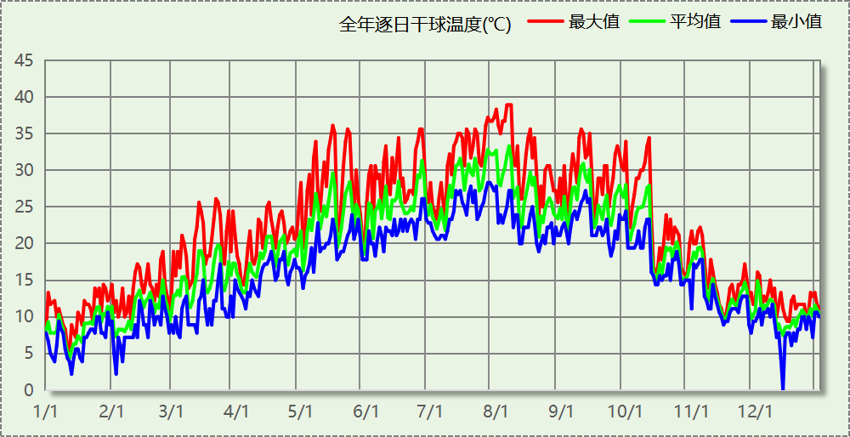

## 逐月辐照量表

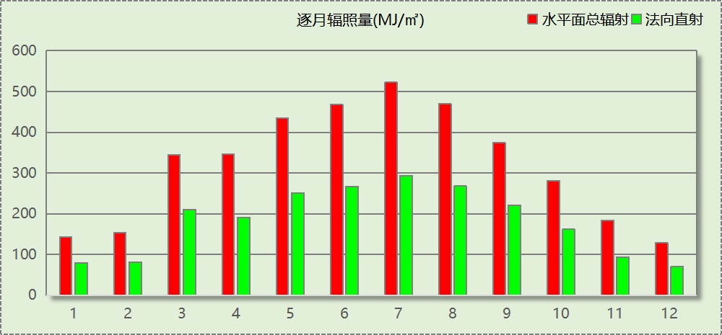

## 峰值工况

|  |  |  |  |  |  |
| --- | --- | --- | --- | --- | --- |
| 气象数据 | 时刻 | 干球温度(℃) | 湿球温度(℃) | 含湿量(g/kg) | 焓值(kj/kg) |
| 最热 | 08月05日17时 | 38.9 | 25.6 | 16.3 | 81.0 |
| 最冷 | 12月13日05时 | 0.0 | 0.0 | 3.7 | 9.3 |

# 软件介绍

本报告采用的软件为绿建暖通负荷BECH2024，该软件紧密结合暖通和节能设计规范、可根据项目实际情况建立建筑热工模型，并可对围护结构材料、房间内扰发热、作息时间表、热回收方式等参数进行设置。

软件包含全国各地典型气象年数据，内置DOE2.1E内核，对于建筑的逐时负荷进行动态模拟，既可以模拟8760小时理想负荷，也可以根据设定好的采暖期/空调期进行逐时模拟。

软件还支持分析全年建筑能耗的来源构成，依据日射得热、新风负荷、围护传热和内扰得热进行归类分项，生成设计建筑全年负荷计算报告书，提供详实的数据和多样的图表，为设计师在设备选型、制定运行策略等方面提供参考和帮助。

# 围护结构

## 屋顶构造

### 屋顶构造一

|  |  |  |  |  |  |  |
| --- | --- | --- | --- | --- | --- | --- |
| 材料名称 （由上到下） | 厚度δ | 导热系数λ | 蓄热系数S | 修正 系数 | 热阻R | 热惰性 指标 |
| (mm) | W/(m.K) | W/(㎡.K) | α | (㎡K)/W | D=R*S |
| 蒸压加气混凝土(ρ=500) | 40 | 0.140 | 2.310 | 1.00 | 0.286 | 0.660 |
| 挤塑聚苯乙烯泡沫塑料（带表皮） | 20 | 0.030 | 0.340 | 1.00 | 0.667 | 0.227 |
| 无机轻集料保温砂浆（ρ≤350） | 20 | 0.070 | 1.260 | 1.00 | 0.286 | 0.360 |
| 蒸压加气混凝土(ρ=500) | 80 | 0.140 | 2.310 | 1.00 | 0.571 | 1.320 |
| 加气混凝土、泡沫混凝土(ρ=500) | 120 | 0.120 | 2.200 | 1.00 | 1.000 | 2.200 |
| 无机轻集料保温砂浆（ρ≤350） | 20 | 0.070 | 1.260 | 1.00 | 0.286 | 0.360 |
| 各层之和∑ | 300 | － | － | － | 3.095 | 5.127 |
| 传热系数K=1/(0.15+∑R) | 0.31 | | | | | |

## 外墙构造

### 外墙构造一

|  |  |  |  |  |  |  |
| --- | --- | --- | --- | --- | --- | --- |
| 材料名称 （由外到内） | 厚度δ | 导热系数λ | 蓄热系数S | 修正 系数 | 热阻R | 热惰性 指标 |
| (mm) | W/(m.K) | W/(㎡.K) | α | (㎡K)/W | D=R*S |
| 无机轻集料保温砂浆（ρ≤350） | 20 | 0.070 | 1.260 | 1.00 | 0.286 | 0.360 |
| 挤塑聚苯乙烯泡沫塑料（带表皮） | 20 | 0.030 | 0.340 | 1.20 | 0.556 | 0.227 |
| 无机保温砂浆(ρ≤330) | 20 | 0.070 | 1.260 | 1.00 | 0.286 | 0.360 |
| 钢筋混凝土（1） | 200 | 1.740 | 17.200 | 1.00 | 0.115 | 1.977 |
| 无机轻集料保温砂浆（ρ≤350） | 20 | 0.070 | 1.260 | 1.00 | 0.286 | 0.360 |
| 各层之和∑ | 280 | － | － | － | 1.528 | 3.284 |
| 传热系数K=1/(0.15+∑R) | 0.60 | | | | | |

## 楼板构造

### 楼板构造一

|  |  |  |  |  |  |  |
| --- | --- | --- | --- | --- | --- | --- |
| 材料名称 | 厚度δ | 导热系数λ | 蓄热系数S | 修正 系数 | 热阻R | 热惰性 指标 |
| (mm) | W/(m.K) | W/(㎡.K) | α | (㎡K)/W | D=R*S |
| 无机保温砂浆(ρ≤330) | 20 | 0.070 | 1.260 | 1.00 | 0.286 | 0.360 |
| 钢筋混凝土（1） | 120 | 1.740 | 17.200 | 1.00 | 0.069 | 1.186 |
| 无机轻集料保温砂浆（ρ≤350） | 20 | 0.070 | 1.260 | 1.00 | 0.286 | 0.360 |
| 各层之和∑ | 160 | － | － | － | 0.640 | 1.906 |
| 传热系数K=1/(0.22+∑R) | 1.16 | | | | | |

## 周边地面构造

### 周边地面构造一

|  |  |  |  |  |  |  |
| --- | --- | --- | --- | --- | --- | --- |
| 材料名称 | 厚度δ | 导热系数λ | 蓄热系数S | 修正 系数 | 热阻R | 热惰性 指标 |
| (mm) | W/(m.K) | W/(㎡.K) | α | (㎡K)/W | D=R*S |
| 无机保温砂浆(ρ≤330) | 20 | 0.070 | 1.260 | 1.00 | 0.286 | 0.360 |
| 加气混凝土、泡沫混凝土(ρ=500) | 120 | 0.120 | 2.200 | 1.00 | 1.000 | 2.200 |
| 各层之和∑ | 140 | － | － | － | 1.286 | 2.560 |
| 传热系数K=1/(0.11+∑R) | 0.31 | | | | | |

## 非周边地面构造

### 非周边地面构造一

|  |  |  |  |  |  |  |
| --- | --- | --- | --- | --- | --- | --- |
| 材料名称 | 厚度δ | 导热系数λ | 蓄热系数S | 修正 系数 | 热阻R | 热惰性 指标 |
| (mm) | W/(m.K) | W/(㎡.K) | α | (㎡K)/W | D=R*S |
| 无机保温砂浆(ρ≤330) | 20 | 0.070 | 1.260 | 1.00 | 0.286 | 0.360 |
| 加气混凝土、泡沫混凝土(ρ=500) | 120 | 0.120 | 2.200 | 1.00 | 1.000 | 2.200 |
| 各层之和∑ | 140 | － | － | － | 1.286 | 2.560 |
| 传热系数K=1/(0.11+∑R) | 0.22 | | | | | |

## 门构造

|  |  |  |  |
| --- | --- | --- | --- |
| 序号 | 构造名称 | 传热系数 | 备注 |
| 1 | 保温门（多功能门） | 1.972 |  |

## 窗构造

|  |  |  |  |  |  |
| --- | --- | --- | --- | --- | --- |
| 序号 | 构造名称 | 传热系数 | 窗遮阳系数 | 可见光透射比 | 备注 |
| 1 | 65系列以下 {6高透光三银Low-E+12A +6透明} | 2.000 | 0.264 | 0.640 |  |
| 2 | 65系列以下 {6高透光三银Low-E+12A +6透明} | 2.000 | 0.264 | 0.640 |  |
| 3 | 65系列及以上{6高透光三银Low-E+12A +6透明+12A+6透明} | 1.400 | 0.230 | 0.560 |  |

# 房间类型

## 房间参数表

|  |  |  |  |  |  |  |
| --- | --- | --- | --- | --- | --- | --- |
| 房间类型 | 空调温度 ℃ | 供暖温度 ℃ | 新风量 | 人员密度 | 照明功率 密度 | 电器设备 功率 |
| 一般商店 | 26 | 20 | 19(m^3/h.人) | 4(m^2/人) | 9(W/m^2) | 13(W/m^2) |
| 会议室 | 26 | 20 | 30(m^3/h.人) | 8(m^2/人) | 9(W/m^2) | 15(W/m^2) |
| 办公室 | 26 | 20 | 30(m^3/h.人) | 8(m^2/人) | 9(W/m^2) | 15(W/m^2) |
| 办公室 | 25 | 20 | 30(m^3/h.人) | 4(m^2/人) | 8(W/m^2) | 10(W/m^2) |
| 卫生间 | 26 | 18 | 30(m^3/h.人) | 20(m^2/人) | 3(W/m^2) | 10(W/m^2) |
| 卫生间 | 26 | 20 | 30(m^3/h.人) | 8(m^2/人) | 9(W/m^2) | 15(W/m^2) |
| 后勤区 | 26 | 20 | 20(m^3/h.人) | 10(m^2/人) | 8(W/m^2) | 13(W/m^2) |
| 大厅 | 26 | 20 | 30(m^3/h.人) | 8(m^2/人) | 9(W/m^2) | 15(W/m^2) |
| 影音设备室 | 23 | 20 | 0(m^3/h.人) | 0(人) | 3.5(W/m^2) | 10(W/m^2) |
| 控制室 | 25 | 20 | 0(m^3/h.人) | 0(人) | 3.5(W/m^2) | 10(W/m^2) |
| 普通办公室 | 26 | 20 | 30(m^3/h.人) | 8(m^2/人) | 8(W/m^2) | 15(W/m^2) |
| 普通办公室 | 26 | 20 | 30(m^3/h.人) | 6(m^2/人) | 8(W/m^2) | 5(W/m^2) |
| 楼梯间 | 26 | 20 | 30(m^3/h.人) | 8(m^2/人) | 9(W/m^2) | 15(W/m^2) |
| 空房间 | － | － | 20(m^3/h.人) | 0(人) | 0(W/m^2) | 0(W/m^2) |
| 观众厅 | 25 | 20 | 35(m^3/h.人) | 0.75(m^2/人) | 20(W/m^2) | 10(W/m^2) |
| 设备间 | － | － | 0(次/h) | 0(人) | 6(W/m^2) | 15(W/m^2) |

## 作息时间表

详见附录

# 系统设置

## 系统划分

|  |  |  |  |  |  |  |
| --- | --- | --- | --- | --- | --- | --- |
| 系统编号 | 热回收 类型 | 启动 条件 | 回收 效率 | 排风 比例 | 面积(m2) | 包含的房间 |
| 默认 | 无 | -- | -- | -- | 3153.53 | 所有房间 |

## 运行时间表

详见附录

# 计算结果

## 模拟周期

全年8760小时模拟

## 全年冷暖需求

|  |  |  |  |  |
| --- | --- | --- | --- | --- |
| 系统名称\负荷 | 供暖需求 (kWh) | 供暖指标 (kWh/㎡·a) | 供冷需求 (kWh) | 供冷指标 (kWh/㎡·a) |
| 建筑总计 | 15281 | 4.64 | 394422 | 119.83 |

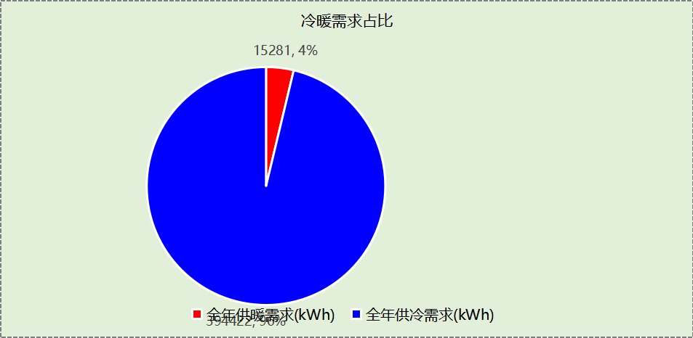

## 负荷分项统计

|  |  |  |  |  |  |  |
| --- | --- | --- | --- | --- | --- | --- |
| 分类 | 围护传热 | 室内得热 | 窗日射 | 新风/渗透 | 热回收 | 合计 |
| 供暖(kWh/㎡) | -4.25 | 8.56 | 0.70 | -9.65 | 0.00 | -4.64 |
| 供冷(kWh/㎡) | 17.22 | 50.88 | 5.06 | 46.67 | 0.00 | 119.83 |

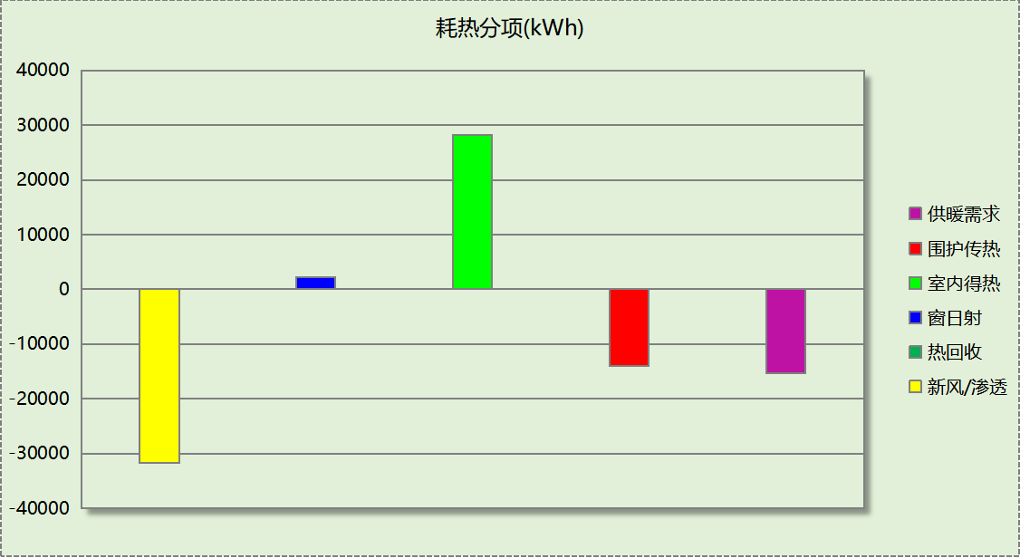

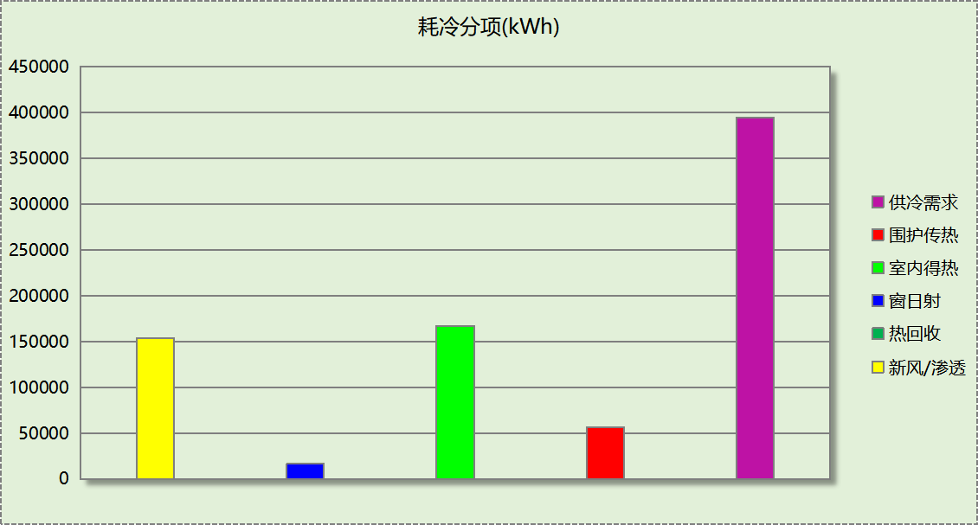

## 逐月负荷表

|  |  |  |  |  |  |  |
| --- | --- | --- | --- | --- | --- | --- |
| 月份 | 供暖(kWh) | 供冷(kWh) | 热负荷 峰值(kW) | 热负荷 峰值时刻 | 冷负荷 峰值(kW) | 冷负荷 峰值时刻 |
| 1月 | 8784 | 168 | 136.031 | 1月2日7时 | 17.705 | 1月2日9时 |
| 2月 | 3062 | 469 | 97.447 | 2月4日7时 | 26.061 | 2月14日9时 |
| 3月 | 124 | 7108 | 31.476 | 3月1日7时 | 175.576 | 3月22日15时 |
| 4月 | 0 | 15811 | 0.291 | 4月5日7时 | 187.650 | 4月16日15时 |
| 5月 | 0 | 46982 | 0.000 | -- | 325.923 | 5月27日13时 |
| 6月 | 0 | 55446 | 0.000 | -- | 420.327 | 6月27日13时 |
| 7月 | 0 | 87008 | 0.000 | -- | 479.366 | 7月15日10时 |
| 8月 | 0 | 79000 | 0.000 | -- | 507.354 | 8月7日13时 |
| 9月 | 0 | 63929 | 0.000 | -- | 439.276 | 9月9日12时 |
| 10月 | 0 | 32706 | 0.000 | -- | 328.527 | 10月11日12时 |
| 11月 | 237 | 5505 | 14.071 | 11月18日7时 | 176.552 | 11月4日15时 |
| 12月 | 3073 | 291 | 78.845 | 12月16日7时 | 32.716 | 12月2日9时 |

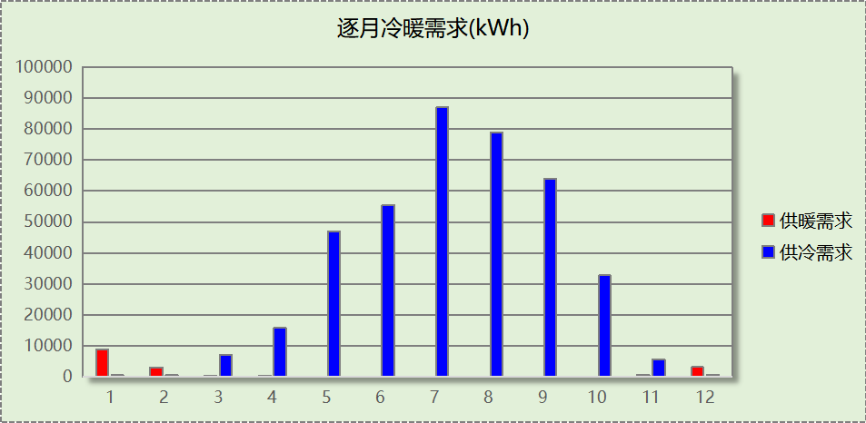

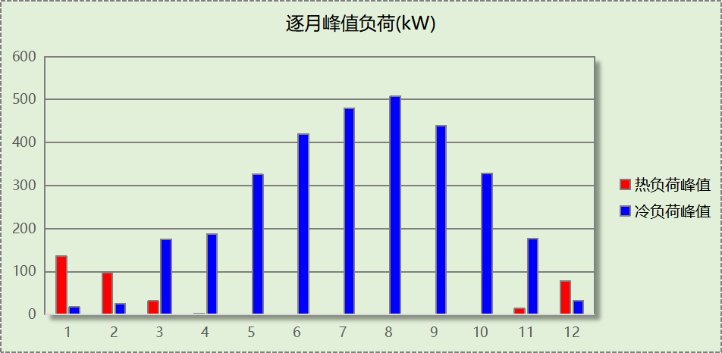

# 附录

**工作日/节假日人员逐时在室率(%)**

|  |  |  |  |  |  |  |  |  |  |  |  |  |  |  |  |  |  |  |  |  |  |  |  |  |
| --- | --- | --- | --- | --- | --- | --- | --- | --- | --- | --- | --- | --- | --- | --- | --- | --- | --- | --- | --- | --- | --- | --- | --- | --- |
| 房间类型 | 1 | 2 | 3 | 4 | 5 | 6 | 7 | 8 | 9 | 10 | 11 | 12 | 13 | 14 | 15 | 16 | 17 | 18 | 19 | 20 | 21 | 22 | 23 | 24 |
| 一般商店 | 0 | 0 | 0 | 0 | 0 | 0 | 0 | 20 | 50 | 80 | 80 | 80 | 80 | 80 | 80 | 80 | 80 | 80 | 80 | 70 | 50 | 0 | 0 | 0 |
| 0 | 0 | 0 | 0 | 0 | 0 | 0 | 20 | 50 | 80 | 80 | 80 | 80 | 80 | 80 | 80 | 80 | 80 | 80 | 70 | 50 | 0 | 0 | 0 |
| 会议室 | 0 | 0 | 0 | 0 | 0 | 0 | 10 | 50 | 100 | 100 | 100 | 30 | 100 | 100 | 100 | 100 | 50 | 20 | 10 | 0 | 0 | 0 | 0 | 0 |
| 0 | 0 | 0 | 0 | 0 | 0 | 0 | 20 | 45 | 0 | 0 | 0 | 0 | 0 | 0 | 0 | 0 | 0 | 0 | 0 | 0 | 0 | 0 | 0 |
| 办公室 | 0 | 0 | 0 | 0 | 0 | 0 | 10 | 50 | 100 | 100 | 100 | 30 | 100 | 100 | 100 | 100 | 50 | 20 | 10 | 0 | 0 | 0 | 0 | 0 |
| 0 | 0 | 0 | 0 | 0 | 0 | 0 | 20 | 45 | 0 | 0 | 0 | 0 | 0 | 0 | 0 | 0 | 0 | 0 | 0 | 0 | 0 | 0 | 0 |
| 办公室 | 0 | 0 | 0 | 0 | 0 | 0 | 0 | 0 | 10 | 90 | 90 | 90 | 90 | 90 | 90 | 90 | 90 | 90 | 90 | 90 | 90 | 90 | 10 | 0 |
| 0 | 0 | 0 | 0 | 0 | 0 | 0 | 0 | 10 | 90 | 90 | 90 | 90 | 90 | 90 | 90 | 90 | 90 | 90 | 90 | 90 | 90 | 10 | 0 |
| 卫生间 | 0 | 0 | 0 | 0 | 0 | 0 | 0 | 0 | 10 | 90 | 90 | 90 | 90 | 90 | 90 | 90 | 90 | 90 | 90 | 90 | 90 | 90 | 10 | 0 |
| 0 | 0 | 0 | 0 | 0 | 0 | 0 | 0 | 10 | 90 | 90 | 90 | 90 | 90 | 90 | 90 | 90 | 90 | 90 | 90 | 90 | 90 | 10 | 0 |
| 卫生间 | 0 | 0 | 0 | 0 | 0 | 0 | 10 | 50 | 100 | 100 | 100 | 30 | 100 | 100 | 100 | 100 | 50 | 20 | 10 | 0 | 0 | 0 | 0 | 0 |
| 0 | 0 | 0 | 0 | 0 | 0 | 0 | 20 | 45 | 0 | 0 | 0 | 0 | 0 | 0 | 0 | 0 | 0 | 0 | 0 | 0 | 0 | 0 | 0 |
| 后勤区 | 0 | 0 | 0 | 0 | 0 | 0 | 0 | 20 | 50 | 80 | 80 | 80 | 80 | 80 | 80 | 80 | 80 | 80 | 80 | 70 | 50 | 0 | 0 | 0 |
| 0 | 0 | 0 | 0 | 0 | 0 | 0 | 20 | 50 | 80 | 80 | 80 | 80 | 80 | 80 | 80 | 80 | 80 | 80 | 70 | 50 | 0 | 0 | 0 |
| 大厅 | 0 | 0 | 0 | 0 | 0 | 0 | 10 | 50 | 100 | 100 | 100 | 30 | 100 | 100 | 100 | 100 | 50 | 20 | 10 | 0 | 0 | 0 | 0 | 0 |
| 0 | 0 | 0 | 0 | 0 | 0 | 0 | 20 | 45 | 0 | 0 | 0 | 0 | 0 | 0 | 0 | 0 | 0 | 0 | 0 | 0 | 0 | 0 | 0 |
| 影音设备室 | 0 | 0 | 0 | 0 | 0 | 0 | 0 | 0 | 10 | 90 | 90 | 90 | 90 | 90 | 90 | 90 | 90 | 90 | 90 | 90 | 90 | 90 | 10 | 0 |
| 0 | 0 | 0 | 0 | 0 | 0 | 0 | 0 | 10 | 90 | 90 | 90 | 90 | 90 | 90 | 90 | 90 | 90 | 90 | 90 | 90 | 90 | 10 | 0 |
| 控制室 | 0 | 0 | 0 | 0 | 0 | 0 | 0 | 0 | 10 | 90 | 90 | 90 | 90 | 90 | 90 | 90 | 90 | 90 | 90 | 90 | 90 | 90 | 10 | 0 |
| 0 | 0 | 0 | 0 | 0 | 0 | 0 | 0 | 10 | 90 | 90 | 90 | 90 | 90 | 90 | 90 | 90 | 90 | 90 | 90 | 90 | 90 | 10 | 0 |
| 普通办公室 | 0 | 0 | 0 | 0 | 0 | 0 | 10 | 50 | 100 | 100 | 100 | 30 | 100 | 100 | 100 | 100 | 50 | 20 | 10 | 0 | 0 | 0 | 0 | 0 |
| 0 | 0 | 0 | 0 | 0 | 0 | 0 | 20 | 45 | 0 | 0 | 0 | 0 | 0 | 0 | 0 | 0 | 0 | 0 | 0 | 0 | 0 | 0 | 0 |
| 普通办公室 | 0 | 0 | 0 | 0 | 0 | 0 | 10 | 50 | 95 | 95 | 95 | 80 | 80 | 95 | 95 | 95 | 95 | 30 | 30 | 0 | 0 | 0 | 0 | 0 |
| 0 | 0 | 0 | 0 | 0 | 0 | 0 | 0 | 0 | 0 | 0 | 0 | 0 | 0 | 0 | 0 | 0 | 0 | 0 | 0 | 0 | 0 | 0 | 0 |
| 楼梯间 | 0 | 0 | 0 | 0 | 0 | 0 | 10 | 50 | 100 | 100 | 100 | 30 | 100 | 100 | 100 | 100 | 50 | 20 | 10 | 0 | 0 | 0 | 0 | 0 |
| 0 | 0 | 0 | 0 | 0 | 0 | 0 | 20 | 45 | 0 | 0 | 0 | 0 | 0 | 0 | 0 | 0 | 0 | 0 | 0 | 0 | 0 | 0 | 0 |
| 空房间 | 0 | 0 | 0 | 0 | 0 | 0 | 0 | 20 | 50 | 80 | 80 | 80 | 80 | 80 | 80 | 80 | 80 | 80 | 80 | 70 | 50 | 0 | 0 | 0 |
| 0 | 0 | 0 | 0 | 0 | 0 | 0 | 20 | 50 | 80 | 80 | 80 | 80 | 80 | 80 | 80 | 80 | 80 | 80 | 70 | 50 | 0 | 0 | 0 |
| 观众厅 | 0 | 0 | 0 | 0 | 0 | 0 | 0 | 0 | 10 | 90 | 90 | 90 | 90 | 90 | 90 | 90 | 90 | 90 | 90 | 90 | 90 | 90 | 10 | 0 |
| 0 | 0 | 0 | 0 | 0 | 0 | 0 | 0 | 10 | 90 | 90 | 90 | 90 | 90 | 90 | 90 | 90 | 90 | 90 | 90 | 90 | 90 | 10 | 0 |
| 设备间 | 0 | 0 | 0 | 0 | 0 | 0 | 0 | 0 | 0 | 0 | 0 | 0 | 0 | 0 | 0 | 0 | 0 | 0 | 0 | 0 | 0 | 0 | 0 | 0 |
| 0 | 0 | 0 | 0 | 0 | 0 | 0 | 0 | 0 | 0 | 0 | 0 | 0 | 0 | 0 | 0 | 0 | 0 | 0 | 0 | 0 | 0 | 0 | 0 |

注：上行：工作日；下行：节假日

**工作日/节假日照明开关时间表(%)**

|  |  |  |  |  |  |  |  |  |  |  |  |  |  |  |  |  |  |  |  |  |  |  |  |  |
| --- | --- | --- | --- | --- | --- | --- | --- | --- | --- | --- | --- | --- | --- | --- | --- | --- | --- | --- | --- | --- | --- | --- | --- | --- |
| 房间类型 | 1 | 2 | 3 | 4 | 5 | 6 | 7 | 8 | 9 | 10 | 11 | 12 | 13 | 14 | 15 | 16 | 17 | 18 | 19 | 20 | 21 | 22 | 23 | 24 |
| 一般商店 | 10 | 10 | 10 | 10 | 10 | 10 | 10 | 50 | 60 | 60 | 60 | 60 | 60 | 60 | 60 | 60 | 80 | 90 | 100 | 100 | 100 | 10 | 10 | 10 |
| 10 | 10 | 10 | 10 | 10 | 10 | 10 | 50 | 60 | 60 | 60 | 60 | 60 | 60 | 60 | 60 | 80 | 90 | 100 | 100 | 100 | 10 | 10 | 10 |
| 会议室 | 10 | 10 | 10 | 10 | 10 | 10 | 10 | 36 | 62 | 56 | 54 | 43 | 53 | 55 | 58 | 67 | 40 | 18 | 10 | 10 | 10 | 10 | 10 | 10 |
| 0 | 0 | 0 | 0 | 0 | 0 | 0 | 0 | 0 | 0 | 0 | 0 | 0 | 0 | 0 | 0 | 0 | 0 | 0 | 0 | 0 | 0 | 0 | 0 |
| 办公室 | 10 | 10 | 10 | 10 | 10 | 10 | 10 | 36 | 62 | 56 | 54 | 43 | 53 | 55 | 58 | 67 | 40 | 18 | 10 | 10 | 10 | 10 | 10 | 10 |
| 0 | 0 | 0 | 0 | 0 | 0 | 0 | 0 | 0 | 0 | 0 | 0 | 0 | 0 | 0 | 0 | 0 | 0 | 0 | 0 | 0 | 0 | 0 | 0 |
| 办公室 | 10 | 10 | 10 | 10 | 10 | 10 | 10 | 10 | 20 | 90 | 90 | 90 | 90 | 90 | 90 | 90 | 90 | 90 | 90 | 90 | 90 | 90 | 20 | 10 |
| 10 | 10 | 10 | 10 | 10 | 10 | 10 | 10 | 20 | 90 | 90 | 90 | 90 | 90 | 90 | 90 | 90 | 90 | 90 | 90 | 90 | 90 | 20 | 10 |
| 卫生间 | 10 | 10 | 10 | 10 | 10 | 10 | 10 | 10 | 20 | 90 | 90 | 90 | 90 | 90 | 90 | 90 | 90 | 90 | 90 | 90 | 90 | 90 | 20 | 10 |
| 10 | 10 | 10 | 10 | 10 | 10 | 10 | 10 | 20 | 90 | 90 | 90 | 90 | 90 | 90 | 90 | 90 | 90 | 90 | 90 | 90 | 90 | 20 | 10 |
| 卫生间 | 10 | 10 | 10 | 10 | 10 | 10 | 10 | 36 | 62 | 56 | 54 | 43 | 53 | 55 | 58 | 67 | 40 | 18 | 10 | 10 | 10 | 10 | 10 | 10 |
| 0 | 0 | 0 | 0 | 0 | 0 | 0 | 0 | 0 | 0 | 0 | 0 | 0 | 0 | 0 | 0 | 0 | 0 | 0 | 0 | 0 | 0 | 0 | 0 |
| 后勤区 | 10 | 10 | 10 | 10 | 10 | 10 | 10 | 50 | 60 | 60 | 60 | 60 | 60 | 60 | 60 | 60 | 80 | 90 | 100 | 100 | 100 | 10 | 10 | 10 |
| 10 | 10 | 10 | 10 | 10 | 10 | 10 | 50 | 60 | 60 | 60 | 60 | 60 | 60 | 60 | 60 | 80 | 90 | 100 | 100 | 100 | 10 | 10 | 10 |
| 大厅 | 10 | 10 | 10 | 10 | 10 | 10 | 10 | 36 | 62 | 56 | 54 | 43 | 53 | 55 | 58 | 67 | 40 | 18 | 10 | 10 | 10 | 10 | 10 | 10 |
| 0 | 0 | 0 | 0 | 0 | 0 | 0 | 0 | 0 | 0 | 0 | 0 | 0 | 0 | 0 | 0 | 0 | 0 | 0 | 0 | 0 | 0 | 0 | 0 |
| 影音设备室 | 10 | 10 | 10 | 10 | 10 | 10 | 10 | 10 | 20 | 90 | 90 | 90 | 90 | 90 | 90 | 90 | 90 | 90 | 90 | 90 | 90 | 90 | 20 | 10 |
| 10 | 10 | 10 | 10 | 10 | 10 | 10 | 10 | 20 | 90 | 90 | 90 | 90 | 90 | 90 | 90 | 90 | 90 | 90 | 90 | 90 | 90 | 20 | 10 |
| 控制室 | 10 | 10 | 10 | 10 | 10 | 10 | 10 | 10 | 20 | 90 | 90 | 90 | 90 | 90 | 90 | 90 | 90 | 90 | 90 | 90 | 90 | 90 | 20 | 10 |
| 10 | 10 | 10 | 10 | 10 | 10 | 10 | 10 | 20 | 90 | 90 | 90 | 90 | 90 | 90 | 90 | 90 | 90 | 90 | 90 | 90 | 90 | 20 | 10 |
| 普通办公室 | 10 | 10 | 10 | 10 | 10 | 10 | 10 | 36 | 62 | 56 | 54 | 43 | 53 | 55 | 58 | 67 | 40 | 18 | 10 | 10 | 10 | 10 | 10 | 10 |
| 0 | 0 | 0 | 0 | 0 | 0 | 0 | 0 | 0 | 0 | 0 | 0 | 0 | 0 | 0 | 0 | 0 | 0 | 0 | 0 | 0 | 0 | 0 | 0 |
| 普通办公室 | 0 | 0 | 0 | 0 | 0 | 0 | 10 | 50 | 95 | 95 | 95 | 80 | 80 | 95 | 95 | 95 | 95 | 30 | 30 | 0 | 0 | 0 | 0 | 0 |
| 0 | 0 | 0 | 0 | 0 | 0 | 0 | 0 | 0 | 0 | 0 | 0 | 0 | 0 | 0 | 0 | 0 | 0 | 0 | 0 | 0 | 0 | 0 | 0 |
| 楼梯间 | 10 | 10 | 10 | 10 | 10 | 10 | 10 | 36 | 62 | 56 | 54 | 43 | 53 | 55 | 58 | 67 | 40 | 18 | 10 | 10 | 10 | 10 | 10 | 10 |
| 0 | 0 | 0 | 0 | 0 | 0 | 0 | 0 | 0 | 0 | 0 | 0 | 0 | 0 | 0 | 0 | 0 | 0 | 0 | 0 | 0 | 0 | 0 | 0 |
| 空房间 | 10 | 10 | 10 | 10 | 10 | 10 | 10 | 50 | 60 | 60 | 60 | 60 | 60 | 60 | 60 | 60 | 80 | 90 | 100 | 100 | 100 | 10 | 10 | 10 |
| 10 | 10 | 10 | 10 | 10 | 10 | 10 | 50 | 60 | 60 | 60 | 60 | 60 | 60 | 60 | 60 | 80 | 90 | 100 | 100 | 100 | 10 | 10 | 10 |
| 观众厅 | 10 | 10 | 10 | 10 | 10 | 10 | 10 | 10 | 20 | 90 | 90 | 90 | 90 | 90 | 90 | 90 | 90 | 90 | 90 | 90 | 90 | 90 | 20 | 10 |
| 10 | 10 | 10 | 10 | 10 | 10 | 10 | 10 | 20 | 90 | 90 | 90 | 90 | 90 | 90 | 90 | 90 | 90 | 90 | 90 | 90 | 90 | 20 | 10 |
| 设备间 | 100 | 100 | 100 | 100 | 100 | 100 | 100 | 100 | 100 | 100 | 100 | 100 | 100 | 100 | 100 | 100 | 100 | 100 | 100 | 100 | 100 | 100 | 100 | 100 |
| 100 | 100 | 100 | 100 | 100 | 100 | 100 | 100 | 100 | 100 | 100 | 100 | 100 | 100 | 100 | 100 | 100 | 100 | 100 | 100 | 100 | 100 | 100 | 100 |

注：上行：工作日；下行：节假日

**工作日/节假日设备逐时使用率(%)**

|  |  |  |  |  |  |  |  |  |  |  |  |  |  |  |  |  |  |  |  |  |  |  |  |  |
| --- | --- | --- | --- | --- | --- | --- | --- | --- | --- | --- | --- | --- | --- | --- | --- | --- | --- | --- | --- | --- | --- | --- | --- | --- |
| 房间类型 | 1 | 2 | 3 | 4 | 5 | 6 | 7 | 8 | 9 | 10 | 11 | 12 | 13 | 14 | 15 | 16 | 17 | 18 | 19 | 20 | 21 | 22 | 23 | 24 |
| 一般商店 | 0 | 0 | 0 | 0 | 0 | 0 | 0 | 30 | 50 | 80 | 80 | 80 | 80 | 80 | 80 | 80 | 80 | 80 | 80 | 70 | 50 | 0 | 0 | 0 |
| 0 | 0 | 0 | 0 | 0 | 0 | 0 | 30 | 50 | 80 | 80 | 80 | 80 | 80 | 80 | 80 | 80 | 80 | 80 | 70 | 50 | 0 | 0 | 0 |
| 会议室 | 0 | 0 | 0 | 0 | 0 | 0 | 10 | 50 | 100 | 100 | 100 | 100 | 100 | 100 | 100 | 100 | 50 | 20 | 10 | 0 | 0 | 0 | 0 | 0 |
| 0 | 0 | 0 | 0 | 0 | 0 | 0 | 0 | 0 | 0 | 0 | 0 | 0 | 0 | 0 | 0 | 0 | 0 | 0 | 0 | 0 | 0 | 0 | 0 |
| 办公室 | 0 | 0 | 0 | 0 | 0 | 0 | 10 | 50 | 100 | 100 | 100 | 100 | 100 | 100 | 100 | 100 | 50 | 20 | 10 | 0 | 0 | 0 | 0 | 0 |
| 0 | 0 | 0 | 0 | 0 | 0 | 0 | 0 | 0 | 0 | 0 | 0 | 0 | 0 | 0 | 0 | 0 | 0 | 0 | 0 | 0 | 0 | 0 | 0 |
| 办公室 | 0 | 0 | 0 | 0 | 0 | 0 | 0 | 0 | 10 | 85 | 85 | 85 | 85 | 85 | 85 | 85 | 85 | 85 | 85 | 85 | 85 | 85 | 10 | 0 |
| 0 | 0 | 0 | 0 | 0 | 0 | 0 | 0 | 10 | 85 | 85 | 85 | 85 | 85 | 85 | 85 | 85 | 85 | 85 | 85 | 85 | 85 | 10 | 0 |
| 卫生间 | 0 | 0 | 0 | 0 | 0 | 0 | 0 | 0 | 10 | 85 | 85 | 85 | 85 | 85 | 85 | 85 | 85 | 85 | 85 | 85 | 85 | 85 | 10 | 0 |
| 0 | 0 | 0 | 0 | 0 | 0 | 0 | 0 | 10 | 85 | 85 | 85 | 85 | 85 | 85 | 85 | 85 | 85 | 85 | 85 | 85 | 85 | 10 | 0 |
| 卫生间 | 0 | 0 | 0 | 0 | 0 | 0 | 10 | 50 | 100 | 100 | 100 | 100 | 100 | 100 | 100 | 100 | 50 | 20 | 10 | 0 | 0 | 0 | 0 | 0 |
| 0 | 0 | 0 | 0 | 0 | 0 | 0 | 0 | 0 | 0 | 0 | 0 | 0 | 0 | 0 | 0 | 0 | 0 | 0 | 0 | 0 | 0 | 0 | 0 |
| 后勤区 | 0 | 0 | 0 | 0 | 0 | 0 | 0 | 30 | 50 | 80 | 80 | 80 | 80 | 80 | 80 | 80 | 80 | 80 | 80 | 70 | 50 | 0 | 0 | 0 |
| 0 | 0 | 0 | 0 | 0 | 0 | 0 | 30 | 50 | 80 | 80 | 80 | 80 | 80 | 80 | 80 | 80 | 80 | 80 | 70 | 50 | 0 | 0 | 0 |
| 大厅 | 0 | 0 | 0 | 0 | 0 | 0 | 10 | 50 | 100 | 100 | 100 | 100 | 100 | 100 | 100 | 100 | 50 | 20 | 10 | 0 | 0 | 0 | 0 | 0 |
| 0 | 0 | 0 | 0 | 0 | 0 | 0 | 0 | 0 | 0 | 0 | 0 | 0 | 0 | 0 | 0 | 0 | 0 | 0 | 0 | 0 | 0 | 0 | 0 |
| 影音设备室 | 0 | 0 | 0 | 0 | 0 | 0 | 0 | 0 | 10 | 85 | 85 | 85 | 85 | 85 | 85 | 85 | 85 | 85 | 85 | 85 | 85 | 85 | 10 | 0 |
| 0 | 0 | 0 | 0 | 0 | 0 | 0 | 0 | 10 | 85 | 85 | 85 | 85 | 85 | 85 | 85 | 85 | 85 | 85 | 85 | 85 | 85 | 10 | 0 |
| 控制室 | 0 | 0 | 0 | 0 | 0 | 0 | 0 | 0 | 10 | 85 | 85 | 85 | 85 | 85 | 85 | 85 | 85 | 85 | 85 | 85 | 85 | 85 | 10 | 0 |
| 0 | 0 | 0 | 0 | 0 | 0 | 0 | 0 | 10 | 85 | 85 | 85 | 85 | 85 | 85 | 85 | 85 | 85 | 85 | 85 | 85 | 85 | 10 | 0 |
| 普通办公室 | 0 | 0 | 0 | 0 | 0 | 0 | 10 | 50 | 100 | 100 | 100 | 100 | 100 | 100 | 100 | 100 | 50 | 20 | 10 | 0 | 0 | 0 | 0 | 0 |
| 0 | 0 | 0 | 0 | 0 | 0 | 0 | 0 | 0 | 0 | 0 | 0 | 0 | 0 | 0 | 0 | 0 | 0 | 0 | 0 | 0 | 0 | 0 | 0 |
| 普通办公室 | 0 | 0 | 0 | 0 | 0 | 0 | 10 | 50 | 95 | 95 | 95 | 50 | 50 | 95 | 95 | 95 | 95 | 30 | 30 | 0 | 0 | 0 | 0 | 0 |
| 0 | 0 | 0 | 0 | 0 | 0 | 0 | 0 | 0 | 0 | 0 | 0 | 0 | 0 | 0 | 0 | 0 | 0 | 0 | 0 | 0 | 0 | 0 | 0 |
| 楼梯间 | 0 | 0 | 0 | 0 | 0 | 0 | 10 | 50 | 100 | 100 | 100 | 100 | 100 | 100 | 100 | 100 | 50 | 20 | 10 | 0 | 0 | 0 | 0 | 0 |
| 0 | 0 | 0 | 0 | 0 | 0 | 0 | 0 | 0 | 0 | 0 | 0 | 0 | 0 | 0 | 0 | 0 | 0 | 0 | 0 | 0 | 0 | 0 | 0 |
| 空房间 | 0 | 0 | 0 | 0 | 0 | 0 | 0 | 30 | 50 | 80 | 80 | 80 | 80 | 80 | 80 | 80 | 80 | 80 | 80 | 70 | 50 | 0 | 0 | 0 |
| 0 | 0 | 0 | 0 | 0 | 0 | 0 | 30 | 50 | 80 | 80 | 80 | 80 | 80 | 80 | 80 | 80 | 80 | 80 | 70 | 50 | 0 | 0 | 0 |
| 观众厅 | 0 | 0 | 0 | 0 | 0 | 0 | 0 | 0 | 10 | 85 | 85 | 85 | 85 | 85 | 85 | 85 | 85 | 85 | 85 | 85 | 85 | 85 | 10 | 0 |
| 0 | 0 | 0 | 0 | 0 | 0 | 0 | 0 | 10 | 85 | 85 | 85 | 85 | 85 | 85 | 85 | 85 | 85 | 85 | 85 | 85 | 85 | 10 | 0 |
| 设备间 | 100 | 100 | 100 | 100 | 100 | 100 | 100 | 100 | 100 | 100 | 100 | 100 | 100 | 100 | 100 | 100 | 100 | 100 | 100 | 100 | 100 | 100 | 100 | 100 |
| 100 | 100 | 100 | 100 | 100 | 100 | 100 | 100 | 100 | 100 | 100 | 100 | 100 | 100 | 100 | 100 | 100 | 100 | 100 | 100 | 100 | 100 | 100 | 100 |

注：上行：工作日；下行：节假日

**工作日/节假日空调系统开关时间表**

|  |  |  |  |  |  |  |  |  |  |  |  |  |  |  |  |  |  |  |  |  |  |  |  |  |
| --- | --- | --- | --- | --- | --- | --- | --- | --- | --- | --- | --- | --- | --- | --- | --- | --- | --- | --- | --- | --- | --- | --- | --- | --- |
| 系统编号 | 1 | 2 | 3 | 4 | 5 | 6 | 7 | 8 | 9 | 10 | 11 | 12 | 13 | 14 | 15 | 16 | 17 | 18 | 19 | 20 | 21 | 22 | 23 | 24 |
| 默认 | 0 | 0 | 0 | 0 | 0 | 0 | 1 | 1 | 1 | 1 | 1 | 1 | 1 | 1 | 1 | 1 | 1 | 1 | 0 | 0 | 0 | 0 | 0 | 0 |
| 0 | 0 | 0 | 0 | 0 | 0 | 0 | 0 | 0 | 0 | 0 | 0 | 0 | 0 | 0 | 0 | 0 | 0 | 0 | 0 | 0 | 0 | 0 | 0 |

注：上行：工作日；下行：节假日