**新建项目**

**全年负荷计算书**

|  |  |
| --- | --- |
| 工程名称 | 新建项目 |
| 设计编号 |  |
| 建设单位 |  |
| 设计单位 |  |
| 计 算 人 |  |
| 校 对 人 |  |
| 审 核 人 |  |
| 计算日期 | 2024年12月29日 |



|  |  |
| --- | --- |
| 采用软件 | 暖通负荷BECH2024 |
| 软件版本 | 20240430(SP1) |
| 研发单位 | 北京绿建软件股份有限公司 |
| 正版授权码 | T19138125867 |

**目 录**

1 建筑概况 1

2 气象数据 1

2.1 气象地点 1

2.2 逐日干球温度表 1

2.3 逐月辐照量表 2

2.4 峰值工况 2

3 软件介绍 2

4 围护结构 2

4.1 屋顶构造 2

4.1.1 屋顶构造一 2

4.2 外墙构造 3

4.2.1 填充墙构造一 3

4.3 挑空楼板构造 3

4.3.1 挑空楼板构造一 3

4.4 楼板构造 3

4.4.1 控温房间楼板构造一 3

4.5 周边地面构造 4

4.5.1 周边地面构造一 4

4.6 非周边地面构造 4

4.6.1 非周边地面构造一 4

4.7 门构造 4

4.8 窗构造 4

5 房间类型 5

5.1 房间参数表 5

5.2 作息时间表 5

6 系统设置 5

6.1 系统划分 5

6.2 运行时间表 5

7 计算结果 5

7.1 模拟周期 5

7.2 全年冷暖需求 6

7.3 负荷分项统计 6

7.4 逐月负荷表 7

8 附录 9

# 建筑概况

|  |  |  |
| --- | --- | --- |
| 地理位置 | 河南-郑州 | |
| 气候分区 | 寒冷B区 | |
| 北纬 | 35.00 | |
| 东经 | 113.65 | |
| 建筑名称 | 新建项目 | |
| 建筑类型 | 公共建筑 |  |
| 建筑面积 | 地上 8326.25 ㎡ | 地下 0.00 ㎡ |
| 建筑高度 | 地上 16.20 m | 地下0.00 |
| 建筑层数 | 地上 3 | 地下 0 |
| 北向角度 | 90° | |

# 气象数据

## 气象地点

河南-郑州, 《建筑节能气象参数标准》JGJ346-2014

## 逐日干球温度表

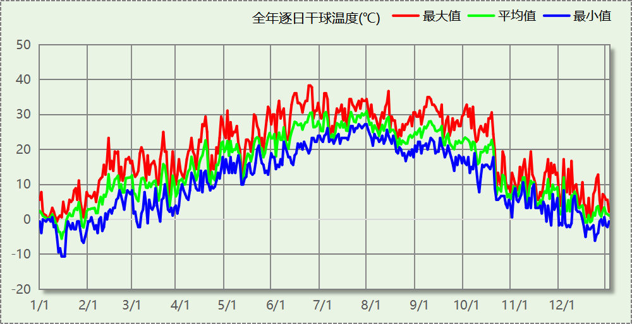

## 逐月辐照量表

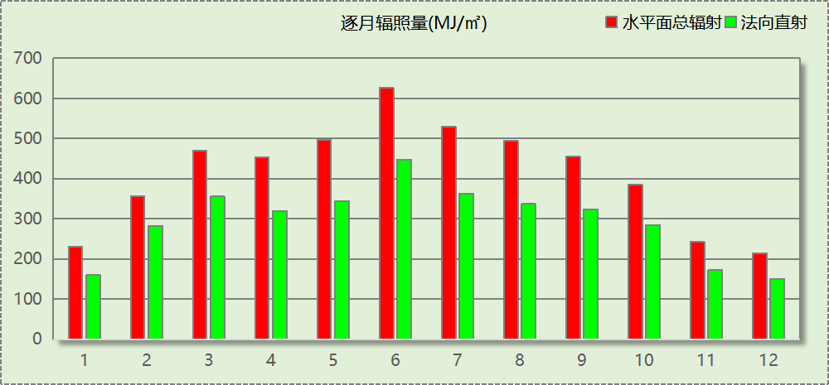

## 峰值工况

|  |  |  |  |  |  |
| --- | --- | --- | --- | --- | --- |
| 气象数据 | 时刻 | 干球温度(℃) | 湿球温度(℃) | 含湿量(g/kg) | 焓值(kj/kg) |
| 最热 | 06月21日15时 | 38.3 | 21.1 | 8.9 | 61.4 |
| 最冷 | 01月14日07时 | -10.6 | -10.6 | 1.4 | -7.1 |

# 软件介绍

本报告采用的软件为绿建暖通负荷BECH2024，该软件紧密结合暖通和节能设计规范、可根据项目实际情况建立建筑热工模型，并可对围护结构材料、房间内扰发热、作息时间表、热回收方式等参数进行设置。

软件包含全国各地典型气象年数据，内置DOE2.1E内核，对于建筑的逐时负荷进行动态模拟，既可以模拟8760小时理想负荷，也可以根据设定好的采暖期/空调期进行逐时模拟。

软件还支持分析全年建筑能耗的来源构成，依据日射得热、新风负荷、围护传热和内扰得热进行归类分项，生成设计建筑全年负荷计算报告书，提供详实的数据和多样的图表，为设计师在设备选型、制定运行策略等方面提供参考和帮助。

# 围护结构

## 屋顶构造

### 屋顶构造一

|  |  |  |  |  |  |  |
| --- | --- | --- | --- | --- | --- | --- |
| 材料名称 （由上到下） | 厚度δ | 导热系数λ | 蓄热系数S | 修正 系数 | 热阻R | 热惰性 指标 |
| (mm) | W/(m.K) | W/(㎡.K) | α | (㎡K)/W | D=R*S |
| 水泥砂浆 | 20 | 0.930 | 11.370 | 1.00 | 0.022 | 0.245 |
| c20细石混凝土(ρ=2300) | 40 | 1.510 | 15.243 | 1.00 | 0.026 | 0.404 |
| 挤塑聚苯板(ρ=25-32) | 90 | 0.030 | 0.320 | 1.00 | 3.000 | 0.960 |
| 岩棉板(ρ=60-160) | 20 | 0.041 | 0.615 | 1.00 | 0.488 | 0.300 |
| 轻骨料混凝土(找坡层) | 30 | 0.300 | 5.000 | 1.50 | 0.067 | 0.500 |
| 钢筋混凝土 | 120 | 1.740 | 17.200 | 1.00 | 0.069 | 1.186 |
| 混合砂浆 | 20 | 0.870 | 10.750 | 1.00 | 0.023 | 0.247 |
| 各层之和∑ | 340 | － | － | － | 3.694 | 3.842 |
| 传热系数K=1/(0.15+∑R) | 0.26 | | | | | |

## 外墙构造

### 填充墙构造一

|  |  |  |  |  |  |  |
| --- | --- | --- | --- | --- | --- | --- |
| 材料名称 （由外到内） | 厚度δ | 导热系数λ | 蓄热系数S | 修正 系数 | 热阻R | 热惰性 指标 |
| (mm) | W/(m.K) | W/(㎡.K) | α | (㎡K)/W | D=R*S |
| 水泥砂浆 | 20 | 0.930 | 11.370 | 1.00 | 0.022 | 0.245 |
| 挤塑聚苯板(ρ=25-32) | 100 | 0.030 | 0.320 | 1.00 | 3.333 | 1.067 |
| 加气混凝土、泡沫混凝土(ρ=700) | 200 | 0.180 | 3.100 | 1.25 | 0.889 | 3.444 |
| 混合砂浆 | 20 | 0.870 | 10.750 | 1.00 | 0.023 | 0.247 |
| 各层之和∑ | 340 | － | － | － | 4.267 | 5.003 |
| 传热系数K=1/(0.15+∑R) | 0.23 | | | | | |

## 挑空楼板构造

### 挑空楼板构造一

|  |  |  |  |  |  |  |
| --- | --- | --- | --- | --- | --- | --- |
| 材料名称 （由上到下） | 厚度δ | 导热系数λ | 蓄热系数S | 修正 系数 | 热阻R | 热惰性 指标 |
| (mm) | W/(m.K) | W/(㎡.K) | α | (㎡K)/W | D=R*S |
| 水泥砂浆 | 20 | 0.930 | 11.370 | 1.00 | 0.022 | 0.245 |
| 挤塑聚苯板(ρ=25-32) | 70 | 0.030 | 0.320 | 1.10 | 2.121 | 0.747 |
| 钢筋混凝土 | 120 | 1.740 | 17.200 | 1.00 | 0.069 | 1.186 |
| 混合砂浆 | 20 | 0.870 | 10.750 | 1.00 | 0.023 | 0.247 |
| 各层之和∑ | 230 | － | － | － | 2.235 | 2.425 |
| 传热系数K=1/(0.15+∑R) | 0.42 | | | | | |

## 楼板构造

### 控温房间楼板构造一

|  |  |  |  |  |  |  |
| --- | --- | --- | --- | --- | --- | --- |
| 材料名称 | 厚度δ | 导热系数λ | 蓄热系数S | 修正 系数 | 热阻R | 热惰性 指标 |
| (mm) | W/(m.K) | W/(㎡.K) | α | (㎡K)/W | D=R*S |
| 水泥砂浆 | 20 | 0.930 | 11.370 | 1.00 | 0.022 | 0.245 |
| 挤塑聚苯板(ρ=25-32) | 80 | 0.030 | 0.320 | 1.00 | 2.667 | 0.853 |
| 钢筋混凝土 | 120 | 1.740 | 17.200 | 1.00 | 0.069 | 1.186 |
| 混合砂浆 | 20 | 0.870 | 10.750 | 1.00 | 0.023 | 0.247 |
| 各层之和∑ | 240 | － | － | － | 2.780 | 2.531 |
| 传热系数K=1/(0.22+∑R) | 0.33 | | | | | |

## 周边地面构造

### 周边地面构造一

|  |  |  |  |  |  |  |
| --- | --- | --- | --- | --- | --- | --- |
| 材料名称 | 厚度δ | 导热系数λ | 蓄热系数S | 修正 系数 | 热阻R | 热惰性 指标 |
| (mm) | W/(m.K) | W/(㎡.K) | α | (㎡K)/W | D=R*S |
| 水泥砂浆 | 20 | 0.930 | 11.370 | 1.00 | 0.022 | 0.245 |
| 挤塑聚苯板(ρ=25-32) | 20 | 0.030 | 0.320 | 1.10 | 0.606 | 0.213 |
| 钢筋混凝土 | 100 | 1.740 | 17.200 | 1.00 | 0.057 | 0.989 |
| 各层之和∑ | 140 | － | － | － | 0.685 | 1.446 |
| 传热系数K=1/(0.11+∑R) | 0.40 | | | | | |

## 非周边地面构造

### 非周边地面构造一

|  |  |  |  |  |  |  |
| --- | --- | --- | --- | --- | --- | --- |
| 材料名称 | 厚度δ | 导热系数λ | 蓄热系数S | 修正 系数 | 热阻R | 热惰性 指标 |
| (mm) | W/(m.K) | W/(㎡.K) | α | (㎡K)/W | D=R*S |
| 水泥砂浆 | 20 | 0.930 | 11.370 | 1.00 | 0.022 | 0.245 |
| 钢筋混凝土 | 120 | 1.740 | 17.200 | 1.00 | 0.069 | 1.186 |
| 各层之和∑ | 140 | － | － | － | 0.090 | 1.431 |
| 传热系数K=1/(0.11+∑R) | 0.30 | | | | | |

## 门构造

|  |  |  |  |
| --- | --- | --- | --- |
| 序号 | 构造名称 | 传热系数 | 备注 |
| 1 | 金属三防门(挤塑型聚苯乙烯泡沫板) | 1.100 |  |

## 窗构造

|  |  |  |  |  |  |
| --- | --- | --- | --- | --- | --- |
| 序号 | 构造名称 | 传热系数 | 窗遮阳系数 | 可见光透射比 | 备注 |
| 1 | 断桥铝框(框洞比0.2)--5mm+12A+5mm(白玻中空) | 3.000 | 0.711 | 0.740 |  |
| 2 | 断桥铝框(框洞比0.2)--5mm+6A+5mm(白玻中空) | 3.400 | 0.711 | 0.740 |  |

# 房间类型

## 房间参数表

|  |  |  |  |  |  |  |
| --- | --- | --- | --- | --- | --- | --- |
| 房间类型 | 空调温度 ℃ | 供暖温度 ℃ | 新风量 | 人员密度 | 照明功率 密度 | 电器设备 功率 |
| 一般商店 | 26 | 20 | 19(m^3/h.人) | 4(m^2/人) | 9(W/m^2) | 13(W/m^2) |
| 会议室 | 26 | 20 | 30(m^3/h.人) | 8(m^2/人) | 9(W/m^2) | 15(W/m^2) |
| 办公-普通办公室 | 26 | 20 | 30(m^3/h.人) | 8(m^2/人) | 8(W/m^2) | 15(W/m^2) |
| 办公室 | 26 | 20 | 30(m^3/h.人) | 8(m^2/人) | 9(W/m^2) | 15(W/m^2) |
| 大厅 | 26 | 20 | 30(m^3/h.人) | 8(m^2/人) | 9(W/m^2) | 15(W/m^2) |
| 展览馆 | 26 | 20 | 30(m^3/h.人) | 8(m^2/人) | 9(W/m^2) | 15(W/m^2) |
| 库房 | 26 | 20 | 30(m^3/h.人) | 8(m^2/人) | 9(W/m^2) | 15(W/m^2) |
| 快餐店 | 26 | 20 | 30(m^3/h.人) | 2(m^2/人) | 5(W/m^2) | 0(W/m^2) |
| 楼梯间 | 26 | 20 | 30(m^3/h.人) | 8(m^2/人) | 9(W/m^2) | 15(W/m^2) |
| 空房间 | － | － | 20(m^3/h.人) | 0(人) | 0(W/m^2) | 0(W/m^2) |
| 走廊 | 26 | 20 | 30(m^3/h.人) | 8(m^2/人) | 9(W/m^2) | 15(W/m^2) |
| 餐厅 | 26 | 18 | 30(m^3/h.人) | 1(m^2/人) | 8(W/m^2) | 13(W/m^2) |

## 作息时间表

详见附录

# 系统设置

## 系统划分

|  |  |  |  |  |  |  |
| --- | --- | --- | --- | --- | --- | --- |
| 系统编号 | 热回收 类型 | 启动 条件 | 回收 效率 | 排风 比例 | 面积(m2) | 包含的房间 |
| 默认 | 全热回收 | 温差启动 冷:≥5.0(℃) 暖:≥5.0(℃) | 冷:0.50, 暖:0.55 | 0.80 | 7716.38 | 所有房间 |

## 运行时间表

详见附录

# 计算结果

## 模拟周期

全年8760小时模拟

## 全年冷暖需求

|  |  |  |  |  |
| --- | --- | --- | --- | --- |
| 系统名称\负荷 | 供暖需求 (kWh) | 供暖指标 (kWh/㎡·a) | 供冷需求 (kWh) | 供冷指标 (kWh/㎡·a) |
| 建筑总计 | 154716 | 18.58 | 539265 | 64.77 |

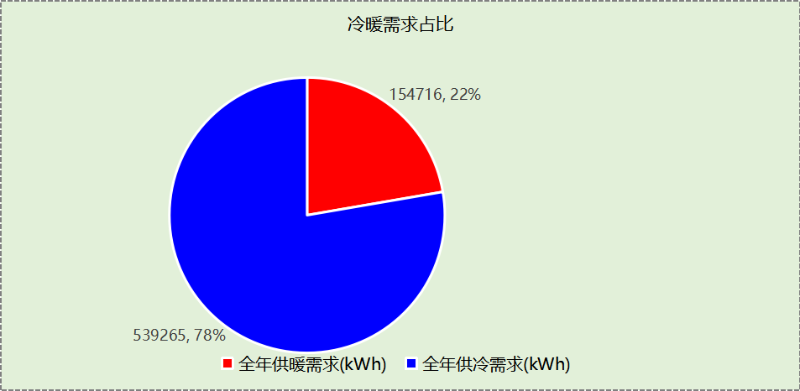

## 负荷分项统计

|  |  |  |  |  |  |  |
| --- | --- | --- | --- | --- | --- | --- |
| 分类 | 围护传热 | 室内得热 | 窗日射 | 新风/渗透 | 热回收 | 合计 |
| 供暖(kWh/㎡) | -26.53 | 24.05 | 0.28 | -28.44 | 12.06 | -18.58 |
| 供冷(kWh/㎡) | 4.25 | 36.26 | 1.38 | 26.72 | -3.84 | 64.77 |

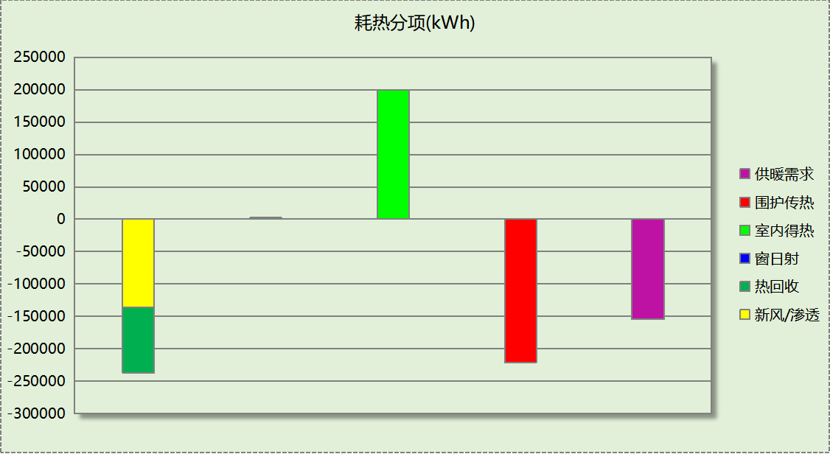

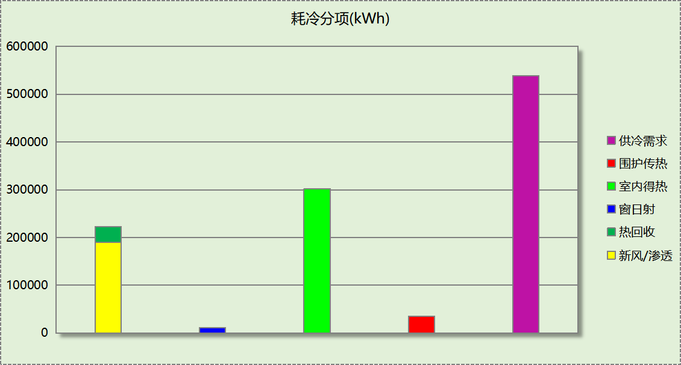

## 逐月负荷表

|  |  |  |  |  |  |  |
| --- | --- | --- | --- | --- | --- | --- |
| 月份 | 供暖(kWh) | 供冷(kWh) | 热负荷 峰值(kW) | 热负荷 峰值时刻 | 冷负荷 峰值(kW) | 冷负荷 峰值时刻 |
| 1月 | 64256 | 76 | 892.163 | 1月2日8时 | 3.075 | 1月30日13时 |
| 2月 | 19525 | 651 | 549.174 | 2月4日8时 | 7.330 | 2月14日13时 |
| 3月 | 13515 | 703 | 407.090 | 3月4日8时 | 13.401 | 3月20日16时 |
| 4月 | 4858 | 9171 | 216.770 | 4月1日8时 | 279.203 | 4月17日10时 |
| 5月 | 164 | 37981 | 15.650 | 5月13日8时 | 431.819 | 5月20日15时 |
| 6月 | 0 | 85582 | 0.000 | -- | 637.788 | 6月24日8时 |
| 7月 | 0 | 161505 | 0.000 | -- | 904.747 | 7月18日8时 |
| 8月 | 0 | 129046 | 0.000 | -- | 751.400 | 8月2日14时 |
| 9月 | 0 | 93848 | 0.000 | -- | 673.088 | 9月13日15时 |
| 10月 | 2259 | 20314 | 225.588 | 10月28日8时 | 391.927 | 10月17日15时 |
| 11月 | 11353 | 283 | 400.610 | 11月18日8时 | 5.520 | 11月25日13时 |
| 12月 | 38786 | 104 | 590.329 | 12月16日8时 | 3.545 | 12月4日13时 |

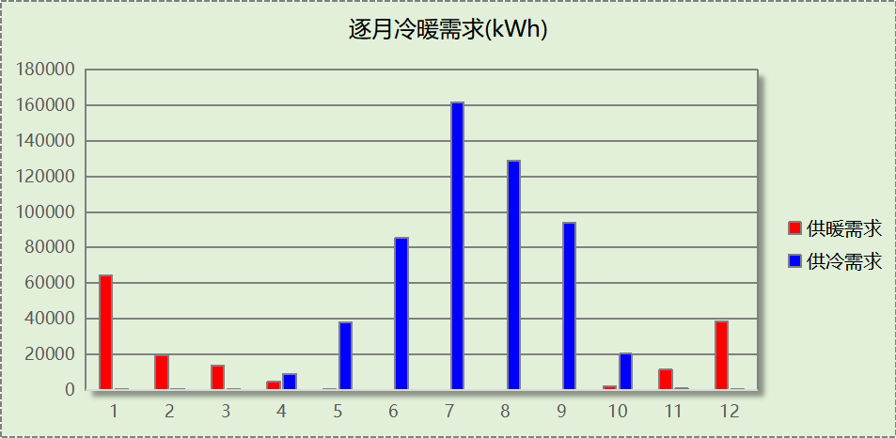

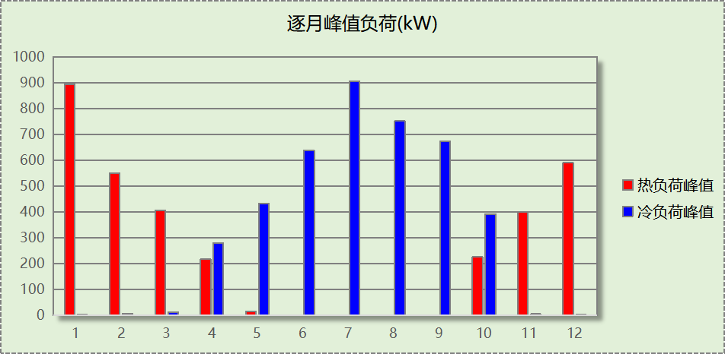

# 附录

**工作日/节假日人员逐时在室率(%)**

|  |  |  |  |  |  |  |  |  |  |  |  |  |  |  |  |  |  |  |  |  |  |  |  |  |
| --- | --- | --- | --- | --- | --- | --- | --- | --- | --- | --- | --- | --- | --- | --- | --- | --- | --- | --- | --- | --- | --- | --- | --- | --- |
| 房间类型 | 1 | 2 | 3 | 4 | 5 | 6 | 7 | 8 | 9 | 10 | 11 | 12 | 13 | 14 | 15 | 16 | 17 | 18 | 19 | 20 | 21 | 22 | 23 | 24 |
| 一般商店 | 0 | 0 | 0 | 0 | 0 | 0 | 0 | 20 | 50 | 80 | 80 | 80 | 80 | 80 | 80 | 80 | 80 | 80 | 80 | 70 | 50 | 0 | 0 | 0 |
| 0 | 0 | 0 | 0 | 0 | 0 | 0 | 20 | 50 | 80 | 80 | 80 | 80 | 80 | 80 | 80 | 80 | 80 | 80 | 70 | 50 | 0 | 0 | 0 |
| 会议室 | 0 | 0 | 0 | 0 | 0 | 0 | 10 | 50 | 100 | 100 | 100 | 30 | 100 | 100 | 100 | 100 | 50 | 20 | 10 | 0 | 0 | 0 | 0 | 0 |
| 0 | 0 | 0 | 0 | 0 | 0 | 0 | 20 | 45 | 0 | 0 | 0 | 0 | 0 | 0 | 0 | 0 | 0 | 0 | 0 | 0 | 0 | 0 | 0 |
| 办公-普通办公室 | 0 | 0 | 0 | 0 | 0 | 0 | 10 | 50 | 100 | 100 | 100 | 30 | 100 | 100 | 100 | 100 | 50 | 20 | 10 | 0 | 0 | 0 | 0 | 0 |
| 0 | 0 | 0 | 0 | 0 | 0 | 0 | 20 | 45 | 0 | 0 | 0 | 0 | 0 | 0 | 0 | 0 | 0 | 0 | 0 | 0 | 0 | 0 | 0 |
| 办公室 | 0 | 0 | 0 | 0 | 0 | 0 | 10 | 50 | 100 | 100 | 100 | 30 | 100 | 100 | 100 | 100 | 50 | 20 | 10 | 0 | 0 | 0 | 0 | 0 |
| 0 | 0 | 0 | 0 | 0 | 0 | 0 | 20 | 45 | 0 | 0 | 0 | 0 | 0 | 0 | 0 | 0 | 0 | 0 | 0 | 0 | 0 | 0 | 0 |
| 大厅 | 0 | 0 | 0 | 0 | 0 | 0 | 10 | 50 | 100 | 100 | 100 | 30 | 100 | 100 | 100 | 100 | 50 | 20 | 10 | 0 | 0 | 0 | 0 | 0 |
| 0 | 0 | 0 | 0 | 0 | 0 | 0 | 20 | 45 | 0 | 0 | 0 | 0 | 0 | 0 | 0 | 0 | 0 | 0 | 0 | 0 | 0 | 0 | 0 |
| 展览馆 | 0 | 0 | 0 | 0 | 0 | 0 | 10 | 50 | 100 | 100 | 100 | 30 | 100 | 100 | 100 | 100 | 50 | 20 | 10 | 0 | 0 | 0 | 0 | 0 |
| 0 | 0 | 0 | 0 | 0 | 0 | 0 | 20 | 45 | 0 | 0 | 0 | 0 | 0 | 0 | 0 | 0 | 0 | 0 | 0 | 0 | 0 | 0 | 0 |
| 库房 | 0 | 0 | 0 | 0 | 0 | 0 | 10 | 50 | 100 | 100 | 100 | 30 | 100 | 100 | 100 | 100 | 50 | 20 | 10 | 0 | 0 | 0 | 0 | 0 |
| 0 | 0 | 0 | 0 | 0 | 0 | 0 | 20 | 45 | 0 | 0 | 0 | 0 | 0 | 0 | 0 | 0 | 0 | 0 | 0 | 0 | 0 | 0 | 0 |
| 快餐店 | 70 | 70 | 70 | 70 | 70 | 70 | 70 | 70 | 50 | 50 | 50 | 50 | 50 | 50 | 50 | 50 | 50 | 50 | 70 | 70 | 70 | 70 | 70 | 70 |
| 70 | 70 | 70 | 70 | 70 | 70 | 70 | 70 | 50 | 50 | 50 | 50 | 50 | 50 | 50 | 50 | 50 | 50 | 70 | 70 | 70 | 70 | 70 | 70 |
| 楼梯间 | 0 | 0 | 0 | 0 | 0 | 0 | 10 | 50 | 100 | 100 | 100 | 30 | 100 | 100 | 100 | 100 | 50 | 20 | 10 | 0 | 0 | 0 | 0 | 0 |
| 0 | 0 | 0 | 0 | 0 | 0 | 0 | 20 | 45 | 0 | 0 | 0 | 0 | 0 | 0 | 0 | 0 | 0 | 0 | 0 | 0 | 0 | 0 | 0 |
| 空房间 | 0 | 0 | 0 | 0 | 0 | 0 | 0 | 20 | 50 | 80 | 80 | 80 | 80 | 80 | 80 | 80 | 80 | 80 | 80 | 70 | 50 | 0 | 0 | 0 |
| 0 | 0 | 0 | 0 | 0 | 0 | 0 | 20 | 50 | 80 | 80 | 80 | 80 | 80 | 80 | 80 | 80 | 80 | 80 | 70 | 50 | 0 | 0 | 0 |
| 走廊 | 0 | 0 | 0 | 0 | 0 | 0 | 10 | 50 | 100 | 100 | 100 | 30 | 100 | 100 | 100 | 100 | 50 | 20 | 10 | 0 | 0 | 0 | 0 | 0 |
| 0 | 0 | 0 | 0 | 0 | 0 | 0 | 20 | 45 | 0 | 0 | 0 | 0 | 0 | 0 | 0 | 0 | 0 | 0 | 0 | 0 | 0 | 0 | 0 |
| 餐厅 | 0 | 0 | 0 | 0 | 0 | 0 | 0 | 20 | 50 | 80 | 80 | 80 | 80 | 80 | 80 | 80 | 80 | 80 | 80 | 70 | 50 | 0 | 0 | 0 |
| 0 | 0 | 0 | 0 | 0 | 0 | 0 | 20 | 50 | 80 | 80 | 80 | 80 | 80 | 80 | 80 | 80 | 80 | 80 | 70 | 50 | 0 | 0 | 0 |

注：上行：工作日；下行：节假日

**工作日/节假日照明开关时间表(%)**

|  |  |  |  |  |  |  |  |  |  |  |  |  |  |  |  |  |  |  |  |  |  |  |  |  |
| --- | --- | --- | --- | --- | --- | --- | --- | --- | --- | --- | --- | --- | --- | --- | --- | --- | --- | --- | --- | --- | --- | --- | --- | --- |
| 房间类型 | 1 | 2 | 3 | 4 | 5 | 6 | 7 | 8 | 9 | 10 | 11 | 12 | 13 | 14 | 15 | 16 | 17 | 18 | 19 | 20 | 21 | 22 | 23 | 24 |
| 一般商店 | 10 | 10 | 10 | 10 | 10 | 10 | 10 | 50 | 60 | 60 | 60 | 60 | 60 | 60 | 60 | 60 | 80 | 90 | 100 | 100 | 100 | 10 | 10 | 10 |
| 10 | 10 | 10 | 10 | 10 | 10 | 10 | 50 | 60 | 60 | 60 | 60 | 60 | 60 | 60 | 60 | 80 | 90 | 100 | 100 | 100 | 10 | 10 | 10 |
| 会议室 | 10 | 10 | 10 | 10 | 10 | 10 | 10 | 36 | 62 | 56 | 54 | 43 | 53 | 55 | 58 | 67 | 40 | 18 | 10 | 10 | 10 | 10 | 10 | 10 |
| 0 | 0 | 0 | 0 | 0 | 0 | 0 | 0 | 0 | 0 | 0 | 0 | 0 | 0 | 0 | 0 | 0 | 0 | 0 | 0 | 0 | 0 | 0 | 0 |
| 办公-普通办公室 | 10 | 10 | 10 | 10 | 10 | 10 | 10 | 36 | 62 | 56 | 54 | 43 | 53 | 55 | 58 | 67 | 40 | 18 | 10 | 10 | 10 | 10 | 10 | 10 |
| 0 | 0 | 0 | 0 | 0 | 0 | 0 | 0 | 0 | 0 | 0 | 0 | 0 | 0 | 0 | 0 | 0 | 0 | 0 | 0 | 0 | 0 | 0 | 0 |
| 办公室 | 10 | 10 | 10 | 10 | 10 | 10 | 10 | 36 | 62 | 56 | 54 | 43 | 53 | 55 | 58 | 67 | 40 | 18 | 10 | 10 | 10 | 10 | 10 | 10 |
| 0 | 0 | 0 | 0 | 0 | 0 | 0 | 0 | 0 | 0 | 0 | 0 | 0 | 0 | 0 | 0 | 0 | 0 | 0 | 0 | 0 | 0 | 0 | 0 |
| 大厅 | 10 | 10 | 10 | 10 | 10 | 10 | 10 | 36 | 62 | 56 | 54 | 43 | 53 | 55 | 58 | 67 | 40 | 18 | 10 | 10 | 10 | 10 | 10 | 10 |
| 0 | 0 | 0 | 0 | 0 | 0 | 0 | 0 | 0 | 0 | 0 | 0 | 0 | 0 | 0 | 0 | 0 | 0 | 0 | 0 | 0 | 0 | 0 | 0 |
| 展览馆 | 10 | 10 | 10 | 10 | 10 | 10 | 10 | 36 | 62 | 56 | 54 | 43 | 53 | 55 | 58 | 67 | 40 | 18 | 10 | 10 | 10 | 10 | 10 | 10 |
| 0 | 0 | 0 | 0 | 0 | 0 | 0 | 0 | 0 | 0 | 0 | 0 | 0 | 0 | 0 | 0 | 0 | 0 | 0 | 0 | 0 | 0 | 0 | 0 |
| 库房 | 10 | 10 | 10 | 10 | 10 | 10 | 10 | 36 | 62 | 56 | 54 | 43 | 53 | 55 | 58 | 67 | 40 | 18 | 10 | 10 | 10 | 10 | 10 | 10 |
| 0 | 0 | 0 | 0 | 0 | 0 | 0 | 0 | 0 | 0 | 0 | 0 | 0 | 0 | 0 | 0 | 0 | 0 | 0 | 0 | 0 | 0 | 0 | 0 |
| 快餐店 | 10 | 10 | 10 | 10 | 10 | 10 | 30 | 30 | 30 | 30 | 30 | 30 | 30 | 30 | 50 | 50 | 60 | 90 | 90 | 90 | 90 | 80 | 10 | 10 |
| 10 | 10 | 10 | 10 | 10 | 10 | 30 | 30 | 30 | 30 | 30 | 30 | 30 | 30 | 50 | 50 | 60 | 90 | 90 | 90 | 90 | 80 | 10 | 10 |
| 楼梯间 | 10 | 10 | 10 | 10 | 10 | 10 | 10 | 36 | 62 | 56 | 54 | 43 | 53 | 55 | 58 | 67 | 40 | 18 | 10 | 10 | 10 | 10 | 10 | 10 |
| 0 | 0 | 0 | 0 | 0 | 0 | 0 | 0 | 0 | 0 | 0 | 0 | 0 | 0 | 0 | 0 | 0 | 0 | 0 | 0 | 0 | 0 | 0 | 0 |
| 空房间 | 10 | 10 | 10 | 10 | 10 | 10 | 10 | 50 | 60 | 60 | 60 | 60 | 60 | 60 | 60 | 60 | 80 | 90 | 100 | 100 | 100 | 10 | 10 | 10 |
| 10 | 10 | 10 | 10 | 10 | 10 | 10 | 50 | 60 | 60 | 60 | 60 | 60 | 60 | 60 | 60 | 80 | 90 | 100 | 100 | 100 | 10 | 10 | 10 |
| 走廊 | 10 | 10 | 10 | 10 | 10 | 10 | 10 | 36 | 62 | 56 | 54 | 43 | 53 | 55 | 58 | 67 | 40 | 18 | 10 | 10 | 10 | 10 | 10 | 10 |
| 0 | 0 | 0 | 0 | 0 | 0 | 0 | 0 | 0 | 0 | 0 | 0 | 0 | 0 | 0 | 0 | 0 | 0 | 0 | 0 | 0 | 0 | 0 | 0 |
| 餐厅 | 10 | 10 | 10 | 10 | 10 | 10 | 10 | 50 | 60 | 60 | 60 | 60 | 60 | 60 | 60 | 60 | 80 | 90 | 100 | 100 | 100 | 10 | 10 | 10 |
| 10 | 10 | 10 | 10 | 10 | 10 | 10 | 50 | 60 | 60 | 60 | 60 | 60 | 60 | 60 | 60 | 80 | 90 | 100 | 100 | 100 | 10 | 10 | 10 |

注：上行：工作日；下行：节假日

**工作日/节假日设备逐时使用率(%)**

|  |  |  |  |  |  |  |  |  |  |  |  |  |  |  |  |  |  |  |  |  |  |  |  |  |
| --- | --- | --- | --- | --- | --- | --- | --- | --- | --- | --- | --- | --- | --- | --- | --- | --- | --- | --- | --- | --- | --- | --- | --- | --- |
| 房间类型 | 1 | 2 | 3 | 4 | 5 | 6 | 7 | 8 | 9 | 10 | 11 | 12 | 13 | 14 | 15 | 16 | 17 | 18 | 19 | 20 | 21 | 22 | 23 | 24 |
| 一般商店 | 0 | 0 | 0 | 0 | 0 | 0 | 0 | 30 | 50 | 80 | 80 | 80 | 80 | 80 | 80 | 80 | 80 | 80 | 80 | 70 | 50 | 0 | 0 | 0 |
| 0 | 0 | 0 | 0 | 0 | 0 | 0 | 30 | 50 | 80 | 80 | 80 | 80 | 80 | 80 | 80 | 80 | 80 | 80 | 70 | 50 | 0 | 0 | 0 |
| 会议室 | 0 | 0 | 0 | 0 | 0 | 0 | 10 | 50 | 100 | 100 | 100 | 100 | 100 | 100 | 100 | 100 | 50 | 20 | 10 | 0 | 0 | 0 | 0 | 0 |
| 0 | 0 | 0 | 0 | 0 | 0 | 0 | 0 | 0 | 0 | 0 | 0 | 0 | 0 | 0 | 0 | 0 | 0 | 0 | 0 | 0 | 0 | 0 | 0 |
| 办公-普通办公室 | 0 | 0 | 0 | 0 | 0 | 0 | 10 | 50 | 100 | 100 | 100 | 100 | 100 | 100 | 100 | 100 | 50 | 20 | 10 | 0 | 0 | 0 | 0 | 0 |
| 0 | 0 | 0 | 0 | 0 | 0 | 0 | 0 | 0 | 0 | 0 | 0 | 0 | 0 | 0 | 0 | 0 | 0 | 0 | 0 | 0 | 0 | 0 | 0 |
| 办公室 | 0 | 0 | 0 | 0 | 0 | 0 | 10 | 50 | 100 | 100 | 100 | 100 | 100 | 100 | 100 | 100 | 50 | 20 | 10 | 0 | 0 | 0 | 0 | 0 |
| 0 | 0 | 0 | 0 | 0 | 0 | 0 | 0 | 0 | 0 | 0 | 0 | 0 | 0 | 0 | 0 | 0 | 0 | 0 | 0 | 0 | 0 | 0 | 0 |
| 大厅 | 0 | 0 | 0 | 0 | 0 | 0 | 10 | 50 | 100 | 100 | 100 | 100 | 100 | 100 | 100 | 100 | 50 | 20 | 10 | 0 | 0 | 0 | 0 | 0 |
| 0 | 0 | 0 | 0 | 0 | 0 | 0 | 0 | 0 | 0 | 0 | 0 | 0 | 0 | 0 | 0 | 0 | 0 | 0 | 0 | 0 | 0 | 0 | 0 |
| 展览馆 | 0 | 0 | 0 | 0 | 0 | 0 | 10 | 50 | 100 | 100 | 100 | 100 | 100 | 100 | 100 | 100 | 50 | 20 | 10 | 0 | 0 | 0 | 0 | 0 |
| 0 | 0 | 0 | 0 | 0 | 0 | 0 | 0 | 0 | 0 | 0 | 0 | 0 | 0 | 0 | 0 | 0 | 0 | 0 | 0 | 0 | 0 | 0 | 0 |
| 库房 | 0 | 0 | 0 | 0 | 0 | 0 | 10 | 50 | 100 | 100 | 100 | 100 | 100 | 100 | 100 | 100 | 50 | 20 | 10 | 0 | 0 | 0 | 0 | 0 |
| 0 | 0 | 0 | 0 | 0 | 0 | 0 | 0 | 0 | 0 | 0 | 0 | 0 | 0 | 0 | 0 | 0 | 0 | 0 | 0 | 0 | 0 | 0 | 0 |
| 快餐店 | 0 | 0 | 0 | 0 | 0 | 0 | 0 | 0 | 0 | 0 | 0 | 0 | 0 | 0 | 0 | 0 | 0 | 80 | 80 | 80 | 80 | 80 | 0 | 0 |
| 0 | 0 | 0 | 0 | 0 | 0 | 0 | 0 | 0 | 0 | 0 | 0 | 0 | 0 | 0 | 0 | 0 | 80 | 80 | 80 | 80 | 80 | 0 | 0 |
| 楼梯间 | 0 | 0 | 0 | 0 | 0 | 0 | 10 | 50 | 100 | 100 | 100 | 100 | 100 | 100 | 100 | 100 | 50 | 20 | 10 | 0 | 0 | 0 | 0 | 0 |
| 0 | 0 | 0 | 0 | 0 | 0 | 0 | 0 | 0 | 0 | 0 | 0 | 0 | 0 | 0 | 0 | 0 | 0 | 0 | 0 | 0 | 0 | 0 | 0 |
| 空房间 | 0 | 0 | 0 | 0 | 0 | 0 | 0 | 30 | 50 | 80 | 80 | 80 | 80 | 80 | 80 | 80 | 80 | 80 | 80 | 70 | 50 | 0 | 0 | 0 |
| 0 | 0 | 0 | 0 | 0 | 0 | 0 | 30 | 50 | 80 | 80 | 80 | 80 | 80 | 80 | 80 | 80 | 80 | 80 | 70 | 50 | 0 | 0 | 0 |
| 走廊 | 0 | 0 | 0 | 0 | 0 | 0 | 10 | 50 | 100 | 100 | 100 | 100 | 100 | 100 | 100 | 100 | 50 | 20 | 10 | 0 | 0 | 0 | 0 | 0 |
| 0 | 0 | 0 | 0 | 0 | 0 | 0 | 0 | 0 | 0 | 0 | 0 | 0 | 0 | 0 | 0 | 0 | 0 | 0 | 0 | 0 | 0 | 0 | 0 |
| 餐厅 | 0 | 0 | 0 | 0 | 0 | 0 | 0 | 30 | 50 | 80 | 80 | 80 | 80 | 80 | 80 | 80 | 80 | 80 | 80 | 70 | 50 | 0 | 0 | 0 |
| 0 | 0 | 0 | 0 | 0 | 0 | 0 | 30 | 50 | 80 | 80 | 80 | 80 | 80 | 80 | 80 | 80 | 80 | 80 | 70 | 50 | 0 | 0 | 0 |

注：上行：工作日；下行：节假日

**工作日/节假日空调系统开关时间表**

|  |  |  |  |  |  |  |  |  |  |  |  |  |  |  |  |  |  |  |  |  |  |  |  |  |
| --- | --- | --- | --- | --- | --- | --- | --- | --- | --- | --- | --- | --- | --- | --- | --- | --- | --- | --- | --- | --- | --- | --- | --- | --- |
| 系统编号 | 1 | 2 | 3 | 4 | 5 | 6 | 7 | 8 | 9 | 10 | 11 | 12 | 13 | 14 | 15 | 16 | 17 | 18 | 19 | 20 | 21 | 22 | 23 | 24 |
| 默认 | 0 | 0 | 0 | 0 | 0 | 0 | 0 | 0 | 1 | 1 | 1 | 1 | 1 | 1 | 1 | 1 | 1 | 1 | 1 | 1 | 1 | 0 | 0 | 0 |
| 0 | 0 | 0 | 0 | 0 | 0 | 0 | 0 | 1 | 1 | 1 | 1 | 1 | 1 | 1 | 1 | 1 | 1 | 1 | 1 | 1 | 0 | 0 | 0 |

注：上行：工作日；下行：节假日