**建筑全能耗报告书**

公共建筑

|  |  |
| --- | --- |
| 工程名称 | 新建项目 |
| 工程地点 | 河南-郑州 |
| 设计编号 |  |
| 建设单位 |  |
| 设计单位 |  |
| 设 计 人 |  |
| 审 核 人 |  |
| 审 定 人 |  |
| 设计日期 | 2024年12月28日 |



|  |  |
| --- | --- |
| 采用软件 | 建筑碳排放CEEB2024 |
| 软件版本 | 20240430(SP1) |
| 研发单位 | 北京绿建软件股份有限公司 |
| 正版授权码 | T16603871880 |

**目 录**

1 建筑概况 3

2 计算依据 3

3 软件介绍 3

4 气象数据 4

4.1 逐日干球温度表 4

4.2 逐月辐照量表 4

4.3 峰值工况 4

5 围护结构 5

5.1 工程材料 5

5.2 围护结构作法简要说明 5

6 围护结构概况 6

7 房间类型 7

7.1 房间参数表 7

7.2 作息时间表 7

8 暖通空调系统 7

8.1 系统类型 7

8.1.1 系统分区 7

8.1.2 热回收参数 7

8.2 制冷系统 8

8.2.1 默认冷源 8

8.3 供暖系统 9

8.3.1 默认热源 9

8.4 空调风机 9

8.4.1 独立新排风 9

8.4.2 风机盘管 10

9 照明 10

10 光伏发电 10

11 计算结果 11

11.1 负荷分项统计 11

11.2 逐月负荷表 11

11.3 逐月电耗 12

11.4 全年能耗 13

12 附录 15

12.1 工作日/节假日人员逐时在室率(%) 15

12.2 工作日/节假日照明开关时间表(%) 16

12.3 工作日/节假日设备逐时使用率(%) 17

12.4 工作日/节假日空调系统运行时间表(1:开,0:关) 18

12.5 工作日/节假日新风运行时间表(%) 18

# 建筑概况

|  |  |  |
| --- | --- | --- |
| 工程名称 | 新建项目 | |
| 工程地点 | 河南-郑州 | |
| 地理位置 | 北纬：35.00° | 东经：113.65° |
| 建筑面积(m2) | 地上4043 地下634 | |
| 建筑层数 | 地上3 地下1 | |
| 建筑高度（m） | 地上13.8 地下3.6 | |
| 建筑体积(m3) | 17120.34 | |
| 建筑外表面积(m2) | 5436.36 | |
| 北向角度 | 90 | |
| 结构类型 | 框架结构 | |
| 外墙太阳辐射吸收系数 | 0.70 | |
| 屋顶太阳辐射吸收系数 | 0.52 | |
| 控温期 | 供冷期:5.15-9.15,供暖期:11.15-3.15 | |

# 计算依据

1. 《建筑节能与可再生能源利用通用规范》GB55010-2021

2. 《民用建筑绿色性能计算标准》JGJ/T 449-2018

# 软件介绍

本报告内容由建筑碳排放CEEB2024计算并输出，CEEB以CAD为平台，内置DOE2内核，可与建筑节能模型无缝对接，精准快速得到动态理想负荷，软件充分考虑工程实际需求，从冷热源、输配水泵到末端风机，覆盖了常见暖通设备的能耗计算；并支持照明、生活热水、电梯动力、插座设备等能耗计算，最终得到包含详细数据的建筑运行能耗报告。

# 气象数据

## 逐日干球温度表

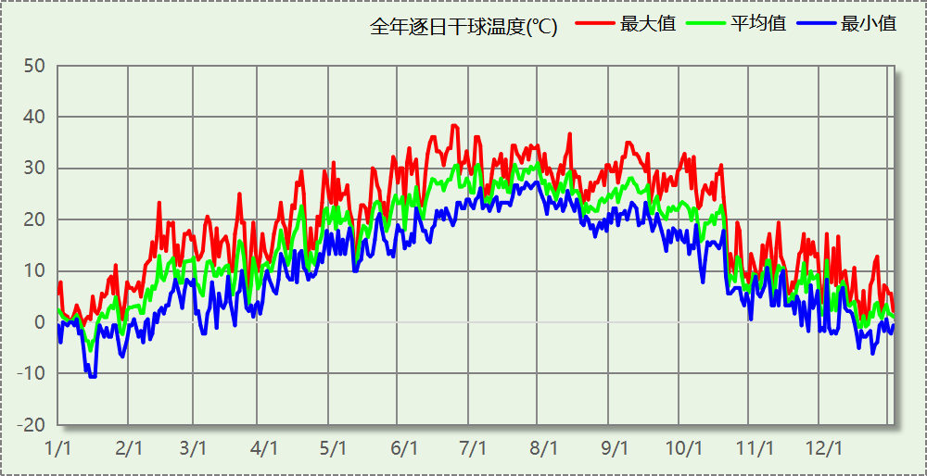

## 逐月辐照量表

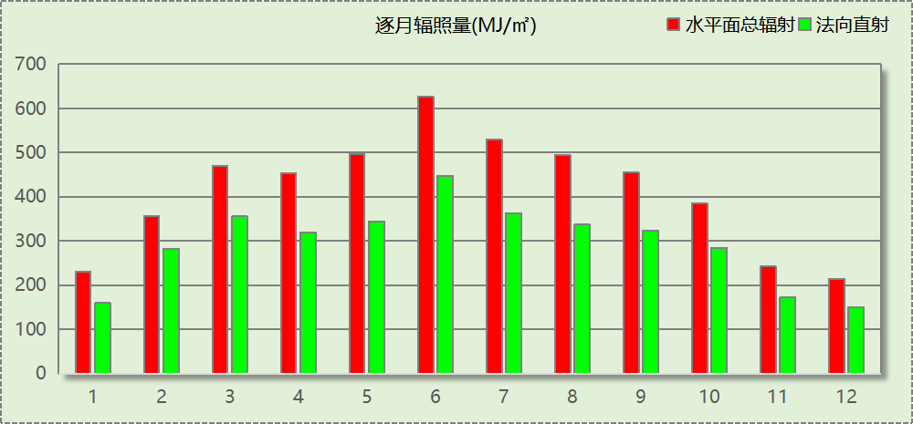

## 峰值工况

|  |  |  |  |  |  |
| --- | --- | --- | --- | --- | --- |
| 气象数据 | 时刻 | 干球温度(℃) | 湿球温度(℃) | 含湿量(g/kg) | 焓值(kj/kg) |
| 最热 | 06月21日15时 | 38.3 | 21.1 | 8.9 | 61.4 |
| 最冷 | 01月14日07时 | -10.6 | -10.6 | 1.4 | -7.1 |

# 围护结构

## 工程材料

|  |  |  |  |  |  |  |
| --- | --- | --- | --- | --- | --- | --- |
| 材料名称 | 导热系数λ | 蓄热系数S | 密度ρ | 比热容Cp | 蒸汽渗透 系数u | 数据来源 |
| W/(m.K) | W/(㎡.K) | kg/m3 | J/(kg.K) | g/(m.h.kPa) |
| 水泥砂浆 | 0.930 | 11.370 | 1800.0 | 1050.0 | 0.0210 | 民用建筑热工设计规范 GB50176-2016 |
| 混合砂浆 | 0.870 | 10.750 | 1700.0 | 1074.4 | 0.0975 | 民用建筑热工设计规范 GB50176-2016 |
| 钢筋混凝土 | 1.740 | 17.200 | 2500.0 | 920.0 | 0.0158 | 民用建筑热工设计规范 GB50176-2016 |
| 挤塑聚苯板(ρ=25-32) | 0.030 | 0.320 | 28.5 | 1647.0 | 0.0162 | 民用建筑热工设计规范 GB50176-2016 |
| 加气混凝土、泡沫混凝土(ρ=700) | 0.180 | 3.100 | 700.0 | 1050.0 | 0.0998 | 民用建筑热工设计规范 GB50176-2016 |
| 混凝土多孔砖(190六孔砖） | 0.750 | 7.490 | 1450.0 | 709.4 | 0.0010 | 民用建筑热工设计规范 GB50176-2016 |
| c20细石混凝土(ρ=2300) | 1.510 | 15.243 | 2300.0 | 920.0 | 0.0173 | 民用建筑热工设计规范 GB50176-2016 |
| 轻骨料混凝土(找坡层) | 0.300 | 5.000 | 1050.0 | 1091.3 | 0.0140 | 民用建筑热工设计规范 GB50176-2016 |
| 石墨聚苯板（seps） | 0.033 | 0.208 | 18.0 | 1001.6 | 0.0162 | 山东居住建筑节能设计标准 DB37-5026-2022 |

## 围护结构作法简要说明

**1. 屋顶：**屋顶构造一 (K=0.172,D=4.502)：（由上到下）

水泥砂浆 20mm＋c20细石混凝土(ρ=2300) 40mm＋挤塑聚苯板(ρ=25-32) 180mm＋轻骨料混凝土(找坡层) 30mm＋钢筋混凝土 120mm＋混合砂浆 20mm

**2. 外墙：**填充墙构造一 (K=0.153,D=5.071)：（由外到内）

水泥砂浆 20mm＋石墨聚苯板（seps） 180mm＋加气混凝土、泡沫混凝土(ρ=700) 200mm＋混合砂浆 20mm

**3. 挑空楼板：**挑空楼板构造一 (K=0.175,D=3.598)：（由上到下）

水泥砂浆 20mm＋挤塑聚苯板(ρ=25-32) 180mm＋钢筋混凝土 120mm＋混合砂浆 20mm

**4. 采暖与非采暖隔墙：**控温与非控温隔墙构造一 (K=0.902,D=3.764)：

水泥砂浆 20mm＋加气混凝土、泡沫混凝土(ρ=700) 190mm＋混合砂浆 20mm

**5. 外窗：**断桥铝100系列平开门(6单银Low-E新型膜+15Ar+5+15Ar+6单银 Low-E新型膜暖边)框洞比0.45 (K=0.900)：

传热系数0.900W/㎡.K，窗太阳得热系数0.320

**6. 幕墙：**断桥铝100系列平开门(6单银Low-E新型膜+15Ar+5+15Ar+6单银 Low-E新型膜暖边)框洞比0.45 (K=0.900)：

传热系数0.900W/㎡.K，窗太阳得热系数0.320

**7. 天窗：**断桥铝100系列平开门(6单银Low-E新型膜+15Ar+5+15Ar+6单银 Low-E新型膜暖边)框洞比0.45 (K=0.900)：

传热系数0.900W/㎡.K，窗太阳得热系数0.320

**8. 周边地面：**周边地面构造一 (K=1.258,D=1.446)：

水泥砂浆 20mm＋挤塑聚苯板(ρ=25-32) 20mm＋钢筋混凝土 100mm

# 围护结构概况

|  |  |  |  |  |  |
| --- | --- | --- | --- | --- | --- |
|  | | | 设计建筑 | | |
| 体形系数S | | | 0.32 | | |
| 屋顶传热系数K  和热惰性指标 D | | | 0.17  4.50 | | |
| 外墙传热系数K  和热惰性指标 D | | | 0.24  5.07 | | |
| 挑空(或架空)楼板传热系数K  和热惰性指标 D | | | 0.18  3.60 | | |
| 天窗传热系数K  和太阳得热系数 SHGC | | | 0.90  0.32 | | |
| 外窗（包括透明幕墙） | 朝向 | 立面 | 窗墙比 | 传热  系数 | 太阳得热系数 |
| 南向 | 南-默认立面 | 0.38 | 0.90 | 0.32 |
| 北向 | 北-默认立面 | 0.30 | 0.90 | 0.31 |
| 东向 | 东-默认立面 | 0.25 | 0.90 | 0.25 |
| 西向 | 西-默认立面 | 0.22 | 0.90 | 0.26 |

# 房间类型

## 房间参数表

|  |  |  |  |  |  |  |  |
| --- | --- | --- | --- | --- | --- | --- | --- |
| 房间类型 | 空调 温度℃ | 供暖 温度℃ | 新风量 | 渗透风 换气次数 | 人员密度 | 照明功率 密度 | 电器设备 功率 |
| 会议室 | 26 | 20 | 30(m3/h.人) | 0(次/h) | 3.33(㎡/人) | 8(W/㎡) | 5(W/㎡) |
| 健身房 | 26 | 20 | 30(m3/h.人) | 0(次/h) | 10(㎡/人) | 8(W/㎡) | 13(W/㎡) |
| 办公-普通办公室 | 26 | 20 | 30(m3/h.人) | 0(次/h) | 10(㎡/人) | 8(W/㎡) | 13(W/㎡) |
| 卫生间 | 26 | 20 | 30(m3/h.人) | 0(次/h) | 10(㎡/人) | 8(W/㎡) | 13(W/㎡) |
| 厨房 | 26 | 20 | 30(m3/h.人) | 0(次/h) | 10(㎡/人) | 8(W/㎡) | 13(W/㎡) |
| 多功能厅 | 26 | 20 | 30(m3/h.人) | 0(次/h) | 10(㎡/人) | 12(W/㎡) | 5(W/㎡) |
| 大厅 | 26 | 20 | 30(m3/h.人) | 0(次/h) | 20(㎡/人) | 5(W/㎡) | 0(W/㎡) |
| 普通办公室 | 26 | 20 | 30(m3/h.人) | 0(次/h) | 10(㎡/人) | 8(W/㎡) | 13(W/㎡) |
| 档案室 | 26 | 20 | 30(m3/h.人) | 0(次/h) | 10(㎡/人) | 8(W/㎡) | 13(W/㎡) |
| 楼梯间 | － | － | 20(m3/h.人) | 0(次/h) | 50(㎡/人) | 0(W/㎡) | 0(W/㎡) |
| 浴室 | － | － | 20(m3/h.人) | 0(次/h) | 50(㎡/人) | 0(W/㎡) | 0(W/㎡) |
| 空房间 | － | － | 20(m3/h.人) | 0(次/h) | 50(㎡/人) | 0(W/㎡) | 0(W/㎡) |
| 设备间 | － | － | 0(m3/h.人) | 0(次/h) | 0(人) | 5(W/㎡) | 0(W/㎡) |
| 走廊 | 26 | 20 | 30(m3/h.人) | 0(次/h) | 20(㎡/人) | 5(W/㎡) | 0(W/㎡) |
| 阅览室 | 26 | 20 | 30(m3/h.人) | 0(次/h) | 10(㎡/人) | 8(W/㎡) | 13(W/㎡) |
| 餐厅 | 26 | 20 | 30(m3/h.人) | 0(次/h) | 10(㎡/人) | 8(W/㎡) | 13(W/㎡) |

## 作息时间表

详见附录

# 暖通空调系统

## 系统类型

### 系统分区

|  |  |  |  |  |  |
| --- | --- | --- | --- | --- | --- |
| 系统编号 | 系统类型 | 制冷 SEER | 制热 HSPF | 面积(㎡) | 包含的房间 |
| 默认 | 地暖/辐射板采暖/散热器采暖+风机盘管供冷 | － | － | 3216.13 | 所有房间 |

### 热回收参数

|  |  |  |  |  |  |
| --- | --- | --- | --- | --- | --- |
| 系统编号 | 热回收 | 供冷 | | 供暖 | |
| 回收效率 | 启动温(焓)差 | 回收效率 | 启动温(焓)差 |
| 默认 | 全热回收 | 0.60 | 5kJ/kg | 0.60 | 5(kJ/kg) |

## 制冷系统

### 默认冷源

#### 供应的系统

|  |  |
| --- | --- |
| 系统编号 | 默认 |

#### 冷水机组

|  |  |  |  |  |  |
| --- | --- | --- | --- | --- | --- |
| 名称 | 类型 | 额定耗电量 (kW) | 额定制冷量 (kW) | 额定性能系数 (COP) | 台数 |
| 机组1 | 空气源热泵 | 13 | 67 | 5.00 | 2 |

#### 水泵系统

|  |  |  |  |  |  |  |  |
| --- | --- | --- | --- | --- | --- | --- | --- |
| 类型 | 调节 | 流量 (m3/h) | 扬程 (m) | 设计工作效率(%) | 输入功率 (kW) | 冷却塔耗电比 (kWh/m3) | 台数 |
| 冷冻水泵 | 单速 | 25 | 30 | 80 | 2.9 | － | 1 |

#### 运行工况

|  |  |  |  |  |  |  |
| --- | --- | --- | --- | --- | --- | --- |
| 负载率 (%) | 机组制冷量 (kW) | 机组功率 (kW) | 性能系数 (COP) | 冷却水泵功率 (kW) | 冷冻水泵功率 (kW) | 冷却塔功率 (kW) |
| 20 | 26.8 | 3.5 | 7.66 | － | 2.9 | 0 |
| 40 | 53.6 | 7.4 | 7.24 | － | 2.9 | 0 |
| 60 | 80.4 | 12.5 | 6.43 | － | 5.9 | 0 |
| 80 | 107.2 | 16.6 | 6.46 | － | 5.9 | 0 |
| 100 | 134 | 23.7 | 5.65 | － | 5.9 | 0 |

#### 制冷能耗

|  |  |  |  |  |  |  |  |
| --- | --- | --- | --- | --- | --- | --- | --- |
| 负荷区间 (%) | 区间负荷 (kWh) | 运行时长(h) | 制冷机组 (kWh) | 平均性能系数(COP) | 冷却水泵 (kWh) | 冷冻水泵 (kWh) | 冷却塔 (kWh) |
| 0~20 | 163 | 27 | 21 | 7.66 | － | 78 | 0 |
| 20~40 | 1621 | 43 | 217 | 7.48 | － | 125 | 0 |
| 40~60 | 5280 | 76 | 787 | 6.71 | － | 448 | 0 |
| 60~80 | 14839 | 156 | 2302 | 6.45 | － | 920 | 0 |
| 80~100 | 50595 | 420 | 8382 | 6.04 | － | 2478 | 0 |
| >100 | 36441 | 235 | 5570 | － | － | 1387 | 0 |
| 合计 | 108937 | 957 | 17278 |  | － | 5436 | 0 |

## 供暖系统

### 默认热源

#### 供应的系统

|  |  |
| --- | --- |
| 系统编号 | 默认 |

#### 热泵系统

##### 热泵机组

|  |  |  |  |  |  |
| --- | --- | --- | --- | --- | --- |
| 名称 | 类型 | 额定耗电量(kW) | 额定制热量(kW) | 额定性能系数 COP | 台数 |
| 热泵机组 | 空气源热泵 | 16 | 65 | 4.00 | 2 |

##### 热水循环泵

|  |  |  |  |  |  |
| --- | --- | --- | --- | --- | --- |
| 类型 | 流量(m3/h) | 扬程(m) | 设计工作效率(%) | 输入功率(kW) | 台数 |
| 单速 | 25 | 30 | 80 | 2.9 | 1 |

##### 运行工况

|  |  |  |  |  |
| --- | --- | --- | --- | --- |
| 负载率(%) | 机组制热量(kW) | 机组功率(kW) | 性能系数(COP) | 供暖水泵功率(kW) |
| 20 | 26 | 8.7 | 2.99 | 2.9 |
| 40 | 52 | 19.2 | 2.71 | 5.9 |
| 60 | 78 | 32.8 | 2.38 | 8.8 |
| 80 | 104 | 43.7 | 2.38 | 11.7 |
| 100 | 130 | 64.1 | 2.03 | 11.7 |

##### 制热能耗

|  |  |  |  |  |  |
| --- | --- | --- | --- | --- | --- |
| 负荷区间 (%) | 区间负荷 (kWh) | 运行时长 (h) | 平均性能系数 (COP) | 热泵机组 (kWh) | 供暖水泵 (kWh) |
| 0~20 | 5058 | 632 | 2.99 | 1692 | 1833 |
| 20~40 | 4273 | 119 | 2.86 | 1492 | 702 |
| 40~60 | 1942 | 31 | 2.56 | 758 | 273 |
| 60~80 | 606 | 7 | 2.38 | 255 | 82 |
| 80~100 | 336 | 3 | 2.26 | 149 | 35 |
| >100 | 275 | 2 | － | 128 | 23 |
| 合计 | 12490 | 794 |  | 4474 | 2948 |

## 空调风机

### 独立新排风

|  |  |  |  |  |  |
| --- | --- | --- | --- | --- | --- |
| 系统编号 | 新风量 (m3/h) | 单位风量耗功率 W/(m3/h) | 风机功率(W) | 运行时长(h) | 新风电耗(kWh) |
| 默认 | 9782 | 0.24 | 2348 | 1870 | 4390 |
| 合计 | | | | | 4390 |

|  |  |  |  |  |  |  |
| --- | --- | --- | --- | --- | --- | --- |
| 系统编号 | 排风量 (m3/h) | 排风比 | 单位风量耗功率W/(m3/h) | 风机功率(W) | 运行时长(h) | 排风电耗 (kWh) |
| 默认 | 7825 | 0.8 | 0.24 | 1878 | 1870 | 3512 |
| 合计 | | | | | | 3512 |

### 风机盘管

|  |  |  |  |  |
| --- | --- | --- | --- | --- |
| 系统编号 | 总功率(W) | 同时使用系数 | 运行时长(h) | 风机盘管电耗(kWh) |
| 默认 | 400 | 1 | 957 | 383 |
| 合计 | | | | 383 |

# 照明

|  |  |  |  |  |
| --- | --- | --- | --- | --- |
| 房间类型 | 单位面积电耗 (kWh/㎡) | 房间个数 | 房间合计面积 (㎡) | 合计电耗 (kWh) |
| 会议室 | 18.04 | 1 | 103 | 1857 |
| 健身房 | 24.00 | 1 | 80 | 1919 |
| 卫生间 | 24.00 | 6 | 197 | 4720 |
| 厨房 | 24.00 | 4 | 99 | 2375 |
| 多功能厅 | 22.21 | 1 | 133 | 2947 |
| 大厅 | 15.00 | 2 | 184 | 2760 |
| 普通办公室 | 24.00 | 27 | 1552 | 37253 |
| 档案室 | 24.00 | 1 | 64 | 1536 |
| 楼梯间 | 0.00 | 11 | 235 | 0 |
| 浴室 | 0.00 | 1 | 82 | 0 |
| 空房间 | 0.00 | 6 | 321 | 0 |
| 设备间 | 0.00 | 6 | 327 | 0 |
| 走廊 | 15.00 | 6 | 772 | 11585 |
| 阅览室 | 24.00 | 1 | 54 | 1287 |
| 餐厅 | 24.00 | 1 | 172 | 4122 |
| 总计 | | | | 72363 |

# 光伏发电

日照辐照量(kJ/㎡.天)：14558，年运行天数：365

|  |  |  |  |  |
| --- | --- | --- | --- | --- |
| 光伏板面积 (㎡) | 光电转换 效率(%) | 光伏系统效率 | 光伏电池性能衰减修正系数 | 全年供电 (kWh) |
| 500 | 15 | 0.75 | 0.85 | 70572 |
| 总计 | | | | 70572 |

# 计算结果

## 负荷分项统计

|  |  |  |  |  |  |  |
| --- | --- | --- | --- | --- | --- | --- |
| 分类 | 围护传热 | 室内得热 | 窗日射 | 新风/渗透 | 热回收 | 合计 |
| 供暖(kWh/㎡) | -4.45 | 4.42 | 1.13 | -7.19 | 3.42 | -2.67 |
| 供冷(kWh/㎡) | 4.68 | 8.59 | 4.87 | 10.00 | -4.85 | 23.29 |

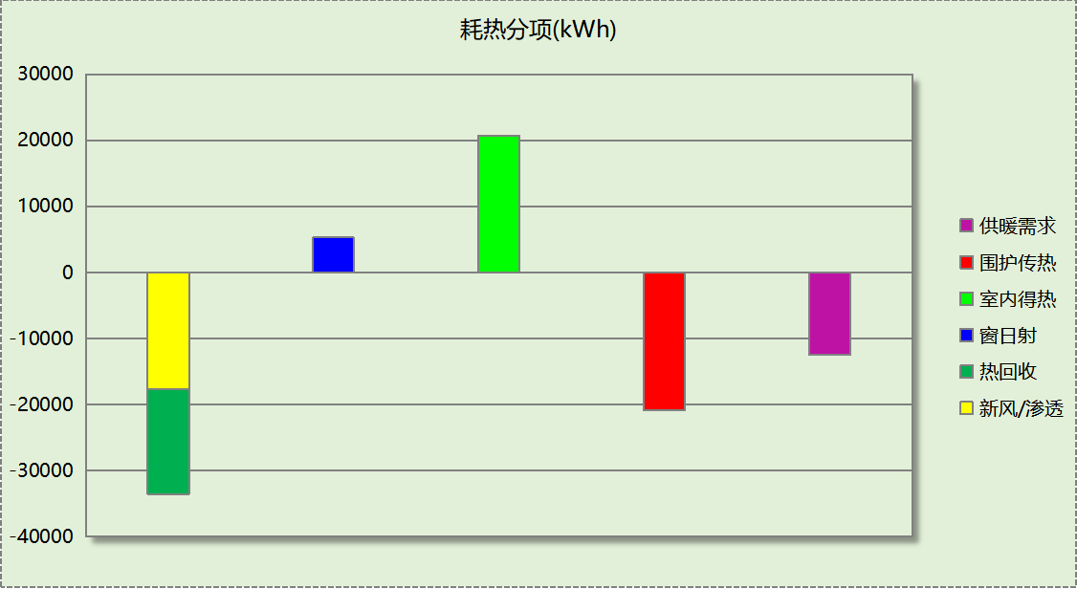

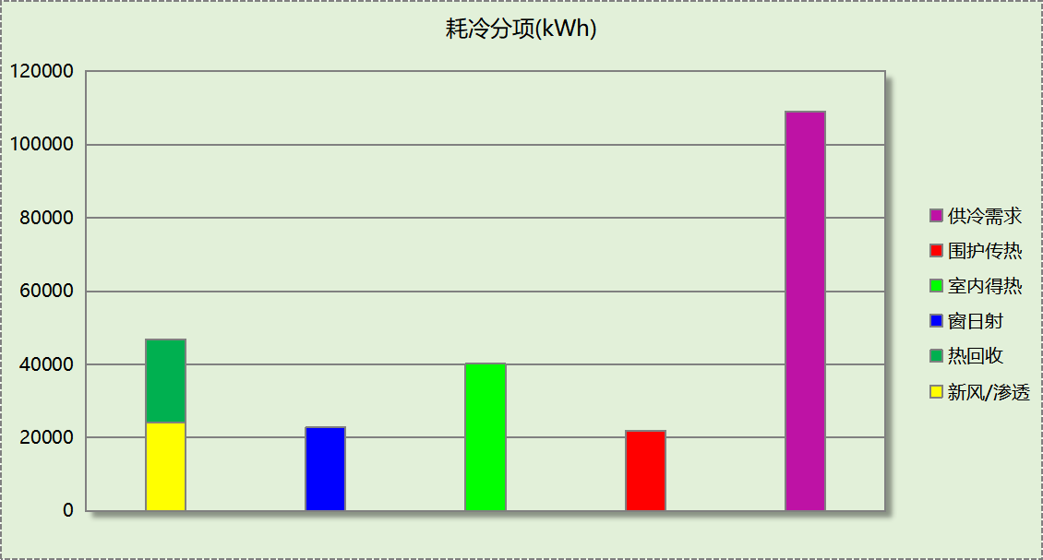

## 逐月负荷表

|  |  |  |  |  |  |  |
| --- | --- | --- | --- | --- | --- | --- |
| 月份 | 供暖(kWh) | 供冷(kWh) | 热负荷 峰值(kW) | 热负荷 峰值时刻 | 冷负荷 峰值(kW) | 冷负荷 峰值时刻 |
| 1月 | 7599 | 0 | 143.862 | 1月14日8时 | 0.000 | -- |
| 2月 | 1620 | 0 | 70.855 | 2月4日8时 | 0.000 | -- |
| 3月 | 194 | 0 | 20.427 | 3月4日8时 | 0.000 | -- |
| 4月 | 0 | 0 | 0.000 | -- | 0.000 | -- |
| 5月 | 0 | 7074 | 0.000 | -- | 113.660 | 5月27日8时 |
| 6月 | 0 | 22781 | 0.000 | -- | 241.340 | 6月24日8时 |
| 7月 | 0 | 35872 | 0.000 | -- | 252.960 | 7月29日8时 |
| 8月 | 0 | 28779 | 0.000 | -- | 233.671 | 8月12日8时 |
| 9月 | 0 | 14432 | 0.000 | -- | 223.585 | 9月9日8时 |
| 10月 | 0 | 0 | 0.000 | -- | 0.000 | -- |
| 11月 | 467 | 0 | 56.093 | 11月15日8时 | 0.000 | -- |
| 12月 | 2610 | 0 | 64.644 | 12月16日8时 | 0.000 | -- |

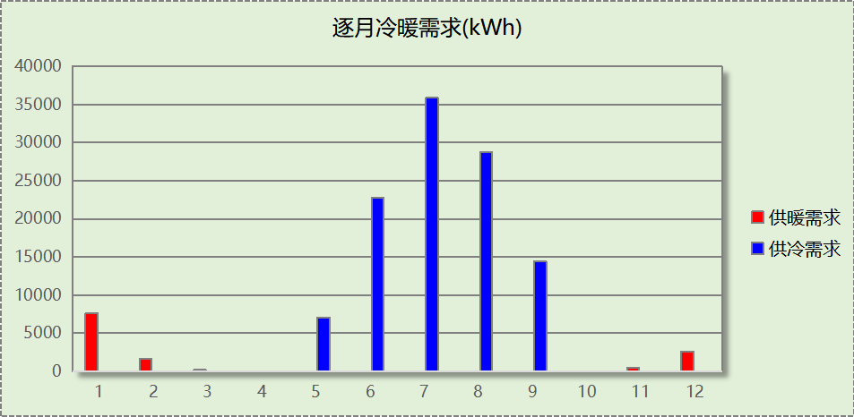

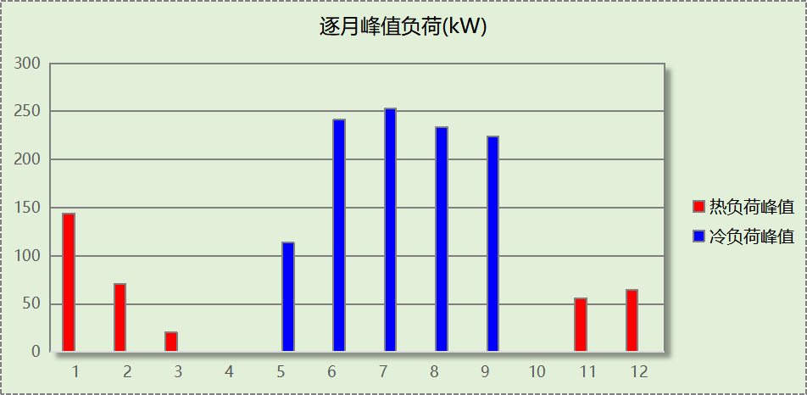

## 逐月电耗

注:供冷供暖为冷热源及输配水泵电耗，热水为扣减太阳能后电耗，所有数据单位kWh/㎡。

|  |  |  |  |  |  |  |  |  |
| --- | --- | --- | --- | --- | --- | --- | --- | --- |
| 月 | 供冷 | 供暖 | 空调风机 | 照明 | 插座设备 | 排风机 | 电梯 | 热水 |
| 1 | 0.00 | 0.85 | 0.22 | 1.36 | － | 0.00 | 0.00 | 0.00 |
| 2 | 0.00 | 0.23 | 0.17 | 1.06 | － |
| 3 | 0.00 | 0.08 | 0.11 | 1.30 | － |
| 4 | 0.00 | 0.00 | 0.00 | 1.30 | － |
| 5 | 0.36 | 0.00 | 0.14 | 1.36 | － |
| 6 | 1.03 | 0.00 | 0.21 | 1.18 | － |
| 7 | 1.52 | 0.00 | 0.25 | 1.42 | － |
| 8 | 1.30 | 0.00 | 0.24 | 1.36 | － |
| 9 | 0.64 | 0.00 | 0.11 | 1.24 | － |
| 10 | 0.00 | 0.00 | 0.00 | 1.24 | － |
| 11 | 0.00 | 0.08 | 0.11 | 1.30 | － |
| 12 | 0.00 | 0.35 | 0.22 | 1.36 | － |
| 合计 | 4.86 | 1.59 | 1.77 | 15.47 | － | 0.00 | 0.00 | 0.00 |

## 全年能耗

|  |  |  |  |
| --- | --- | --- | --- |
| 能耗分类 | 能耗子类 | 设计建筑  (kWh/㎡) | 备注 |
| 建筑负荷 | 耗冷量 | 23.29 |  |
| 耗热量 | 2.67 |  |
| 冷热合计 | 25.97 |  |
| 热回收 | 供冷 | 4.85 |  |
| 供暖 | 3.42 |  |
| 冷热合计 | 8.27 |  |
| 供冷电耗  (Ec) | 中央冷源 | 3.69 |  |
| 冷却水泵 | 0.00 |  |
| 冷冻水泵 | 1.16 |  |
| 冷却塔 | 0.00 |  |
| 多联机/单元式空调 | 0.00 |  |
| 供冷合计 | 4.86 |  |
| 供暖电耗  (Eh) | 中央热源 | 0.96 |  |
| 供暖水泵 | 0.63 |  |
| 热源侧水泵 | 0.00 |  |
| 多联机/单元式热泵 | 0.00 |  |
| 供暖合计 | 1.59 |  |
| 空调风机电耗  (Ef) | 新排风 | 1.69 |  |
| 风机盘管 | 0.08 |  |
| 全空气系统 | 0.00 |  |
| 风机合计 | 1.77 |  |
| 照明电耗 | | 15.47 |  |
| 插座设备电耗 | | - |  |
| 其他电耗(Eo) | 电梯 | 0.00 |  |
| 独立排风机 | 0.00 |  |
| 生活热水 | 0.00 | 扣减了太阳能热水 |
| 其他设备 | 0.00 |  |
| 合计 | 0.00 |  |
| 可再生能源  (Er) | 光伏发电(Ep) | 15.09 |  |
| 风力发电(Ew) | 0.00 |  |
| 建筑总能耗(E1)：电耗(kWh/㎡) | | 8.60 | E1=Ec+Eh+Ef+Eo-Er |

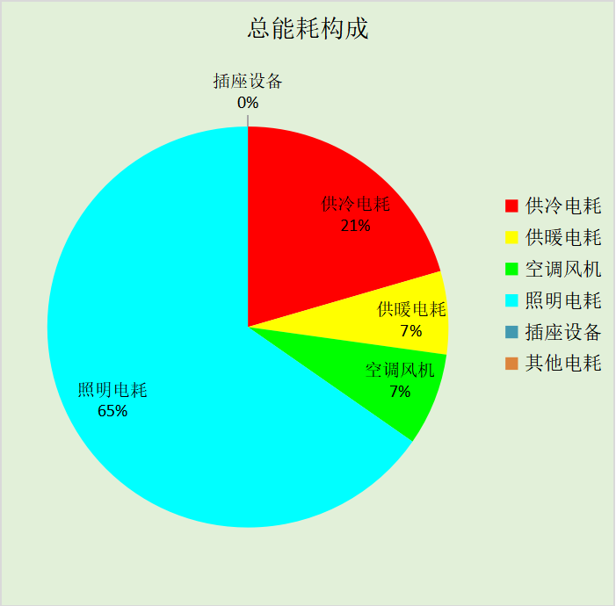

# 附录

## 工作日/节假日人员逐时在室率(%)

|  |  |  |  |  |  |  |  |  |  |  |  |  |  |  |  |  |  |  |  |  |  |  |  |  |
| --- | --- | --- | --- | --- | --- | --- | --- | --- | --- | --- | --- | --- | --- | --- | --- | --- | --- | --- | --- | --- | --- | --- | --- | --- |
| 房间类型 | 1 | 2 | 3 | 4 | 5 | 6 | 7 | 8 | 9 | 10 | 11 | 12 | 13 | 14 | 15 | 16 | 17 | 18 | 19 | 20 | 21 | 22 | 23 | 24 |
| 会议室 | 0 | 0 | 0 | 0 | 0 | 0 | 0 | 17 | 17 | 17 | 17 | 17 | 17 | 17 | 17 | 17 | 17 | 17 | 0 | 0 | 0 | 0 | 0 | 0 |
| 0 | 0 | 0 | 0 | 0 | 0 | 0 | 0 | 0 | 0 | 0 | 0 | 0 | 0 | 0 | 0 | 0 | 0 | 0 | 0 | 0 | 0 | 0 | 0 |
| 健身房 | 0 | 0 | 0 | 0 | 0 | 0 | 0 | 33 | 33 | 33 | 33 | 33 | 33 | 33 | 33 | 33 | 33 | 33 | 0 | 0 | 0 | 0 | 0 | 0 |
| 0 | 0 | 0 | 0 | 0 | 0 | 0 | 0 | 0 | 0 | 0 | 0 | 0 | 0 | 0 | 0 | 0 | 0 | 0 | 0 | 0 | 0 | 0 | 0 |
| 办公-普通办公室 | 0 | 0 | 0 | 0 | 0 | 0 | 0 | 33 | 33 | 33 | 33 | 33 | 33 | 33 | 33 | 33 | 33 | 33 | 0 | 0 | 0 | 0 | 0 | 0 |
| 0 | 0 | 0 | 0 | 0 | 0 | 0 | 0 | 0 | 0 | 0 | 0 | 0 | 0 | 0 | 0 | 0 | 0 | 0 | 0 | 0 | 0 | 0 | 0 |
| 卫生间 | 0 | 0 | 0 | 0 | 0 | 0 | 0 | 33 | 33 | 33 | 33 | 33 | 33 | 33 | 33 | 33 | 33 | 33 | 0 | 0 | 0 | 0 | 0 | 0 |
| 0 | 0 | 0 | 0 | 0 | 0 | 0 | 0 | 0 | 0 | 0 | 0 | 0 | 0 | 0 | 0 | 0 | 0 | 0 | 0 | 0 | 0 | 0 | 0 |
| 厨房 | 0 | 0 | 0 | 0 | 0 | 0 | 0 | 33 | 33 | 33 | 33 | 33 | 33 | 33 | 33 | 33 | 33 | 33 | 0 | 0 | 0 | 0 | 0 | 0 |
| 0 | 0 | 0 | 0 | 0 | 0 | 0 | 0 | 0 | 0 | 0 | 0 | 0 | 0 | 0 | 0 | 0 | 0 | 0 | 0 | 0 | 0 | 0 | 0 |
| 多功能厅 | 0 | 0 | 0 | 0 | 0 | 0 | 0 | 37 | 37 | 37 | 37 | 37 | 37 | 37 | 37 | 37 | 37 | 37 | 37 | 37 | 0 | 0 | 0 | 0 |
| 0 | 0 | 0 | 0 | 0 | 0 | 0 | 37 | 37 | 37 | 37 | 37 | 37 | 37 | 37 | 37 | 37 | 37 | 37 | 37 | 0 | 0 | 0 | 0 |
| 大厅 | 0 | 0 | 0 | 0 | 0 | 0 | 0 | 33 | 33 | 33 | 33 | 33 | 33 | 33 | 33 | 33 | 33 | 33 | 0 | 0 | 0 | 0 | 0 | 0 |
| 0 | 0 | 0 | 0 | 0 | 0 | 0 | 0 | 0 | 0 | 0 | 0 | 0 | 0 | 0 | 0 | 0 | 0 | 0 | 0 | 0 | 0 | 0 | 0 |
| 普通办公室 | 0 | 0 | 0 | 0 | 0 | 0 | 0 | 33 | 33 | 33 | 33 | 33 | 33 | 33 | 33 | 33 | 33 | 33 | 0 | 0 | 0 | 0 | 0 | 0 |
| 0 | 0 | 0 | 0 | 0 | 0 | 0 | 0 | 0 | 0 | 0 | 0 | 0 | 0 | 0 | 0 | 0 | 0 | 0 | 0 | 0 | 0 | 0 | 0 |
| 档案室 | 0 | 0 | 0 | 0 | 0 | 0 | 0 | 33 | 33 | 33 | 33 | 33 | 33 | 33 | 33 | 33 | 33 | 33 | 0 | 0 | 0 | 0 | 0 | 0 |
| 0 | 0 | 0 | 0 | 0 | 0 | 0 | 0 | 0 | 0 | 0 | 0 | 0 | 0 | 0 | 0 | 0 | 0 | 0 | 0 | 0 | 0 | 0 | 0 |
| 楼梯间 | 0 | 0 | 0 | 0 | 0 | 0 | 0 | 20 | 50 | 80 | 80 | 80 | 80 | 80 | 80 | 80 | 80 | 80 | 80 | 70 | 50 | 0 | 0 | 0 |
| 0 | 0 | 0 | 0 | 0 | 0 | 0 | 0 | 0 | 0 | 0 | 0 | 0 | 0 | 0 | 0 | 0 | 0 | 0 | 0 | 0 | 0 | 0 | 0 |
| 浴室 | 0 | 0 | 0 | 0 | 0 | 0 | 0 | 20 | 50 | 80 | 80 | 80 | 80 | 80 | 80 | 80 | 80 | 80 | 80 | 70 | 50 | 0 | 0 | 0 |
| 0 | 0 | 0 | 0 | 0 | 0 | 0 | 20 | 50 | 80 | 80 | 80 | 80 | 80 | 80 | 80 | 80 | 80 | 80 | 70 | 50 | 0 | 0 | 0 |
| 空房间 | 0 | 0 | 0 | 0 | 0 | 0 | 0 | 20 | 50 | 80 | 80 | 80 | 80 | 80 | 80 | 80 | 80 | 80 | 80 | 70 | 50 | 0 | 0 | 0 |
| 0 | 0 | 0 | 0 | 0 | 0 | 0 | 0 | 0 | 0 | 0 | 0 | 0 | 0 | 0 | 0 | 0 | 0 | 0 | 0 | 0 | 0 | 0 | 0 |
| 设备间 | 0 | 0 | 0 | 0 | 0 | 0 | 0 | 0 | 0 | 0 | 0 | 0 | 0 | 0 | 0 | 0 | 0 | 0 | 0 | 0 | 0 | 0 | 0 | 0 |
| 0 | 0 | 0 | 0 | 0 | 0 | 0 | 0 | 0 | 0 | 0 | 0 | 0 | 0 | 0 | 0 | 0 | 0 | 0 | 0 | 0 | 0 | 0 | 0 |
| 走廊 | 0 | 0 | 0 | 0 | 0 | 0 | 0 | 33 | 33 | 33 | 33 | 33 | 33 | 33 | 33 | 33 | 33 | 33 | 0 | 0 | 0 | 0 | 0 | 0 |
| 0 | 0 | 0 | 0 | 0 | 0 | 0 | 0 | 0 | 0 | 0 | 0 | 0 | 0 | 0 | 0 | 0 | 0 | 0 | 0 | 0 | 0 | 0 | 0 |
| 阅览室 | 0 | 0 | 0 | 0 | 0 | 0 | 0 | 33 | 33 | 33 | 33 | 33 | 33 | 33 | 33 | 33 | 33 | 33 | 0 | 0 | 0 | 0 | 0 | 0 |
| 0 | 0 | 0 | 0 | 0 | 0 | 0 | 0 | 0 | 0 | 0 | 0 | 0 | 0 | 0 | 0 | 0 | 0 | 0 | 0 | 0 | 0 | 0 | 0 |
| 餐厅 | 0 | 0 | 0 | 0 | 0 | 0 | 0 | 33 | 33 | 33 | 33 | 33 | 33 | 33 | 33 | 33 | 33 | 33 | 0 | 0 | 0 | 0 | 0 | 0 |
| 0 | 0 | 0 | 0 | 0 | 0 | 0 | 0 | 0 | 0 | 0 | 0 | 0 | 0 | 0 | 0 | 0 | 0 | 0 | 0 | 0 | 0 | 0 | 0 |

注：上行：工作日；下行：节假日

## 工作日/节假日照明开关时间表(%)

|  |  |  |  |  |  |  |  |  |  |  |  |  |  |  |  |  |  |  |  |  |  |  |  |  |
| --- | --- | --- | --- | --- | --- | --- | --- | --- | --- | --- | --- | --- | --- | --- | --- | --- | --- | --- | --- | --- | --- | --- | --- | --- |
| 房间类型 | 1 | 2 | 3 | 4 | 5 | 6 | 7 | 8 | 9 | 10 | 11 | 12 | 13 | 14 | 15 | 16 | 17 | 18 | 19 | 20 | 21 | 22 | 23 | 24 |
| 会议室 | 0 | 0 | 0 | 0 | 0 | 0 | 0 | 82 | 82 | 82 | 82 | 82 | 82 | 82 | 82 | 82 | 82 | 82 | 0 | 0 | 0 | 0 | 0 | 0 |
| 0 | 0 | 0 | 0 | 0 | 0 | 0 | 0 | 0 | 0 | 0 | 0 | 0 | 0 | 0 | 0 | 0 | 0 | 0 | 0 | 0 | 0 | 0 | 0 |
| 健身房 | 0 | 0 | 0 | 0 | 0 | 0 | 0 | 100 | 100 | 100 | 100 | 100 | 100 | 100 | 100 | 100 | 100 | 100 | 100 | 0 | 0 | 0 | 0 | 0 |
| 0 | 0 | 0 | 0 | 0 | 0 | 0 | 0 | 0 | 0 | 0 | 0 | 0 | 0 | 0 | 0 | 0 | 0 | 0 | 0 | 0 | 0 | 0 | 0 |
| 办公-普通办公室 | 0 | 0 | 0 | 0 | 0 | 0 | 0 | 100 | 100 | 100 | 100 | 100 | 100 | 100 | 100 | 100 | 100 | 100 | 100 | 0 | 0 | 0 | 0 | 0 |
| 0 | 0 | 0 | 0 | 0 | 0 | 0 | 0 | 0 | 0 | 0 | 0 | 0 | 0 | 0 | 0 | 0 | 0 | 0 | 0 | 0 | 0 | 0 | 0 |
| 卫生间 | 0 | 0 | 0 | 0 | 0 | 0 | 0 | 100 | 100 | 100 | 100 | 100 | 100 | 100 | 100 | 100 | 100 | 100 | 100 | 0 | 0 | 0 | 0 | 0 |
| 0 | 0 | 0 | 0 | 0 | 0 | 0 | 0 | 0 | 0 | 0 | 0 | 0 | 0 | 0 | 0 | 0 | 0 | 0 | 0 | 0 | 0 | 0 | 0 |
| 厨房 | 0 | 0 | 0 | 0 | 0 | 0 | 0 | 100 | 100 | 100 | 100 | 100 | 100 | 100 | 100 | 100 | 100 | 100 | 100 | 0 | 0 | 0 | 0 | 0 |
| 0 | 0 | 0 | 0 | 0 | 0 | 0 | 0 | 0 | 0 | 0 | 0 | 0 | 0 | 0 | 0 | 0 | 0 | 0 | 0 | 0 | 0 | 0 | 0 |
| 多功能厅 | 0 | 0 | 0 | 0 | 0 | 0 | 0 | 39 | 39 | 39 | 39 | 39 | 39 | 39 | 39 | 39 | 39 | 39 | 39 | 39 | 0 | 0 | 0 | 0 |
| 0 | 0 | 0 | 0 | 0 | 0 | 0 | 39 | 39 | 39 | 39 | 39 | 39 | 39 | 39 | 39 | 39 | 39 | 39 | 39 | 0 | 0 | 0 | 0 |
| 大厅 | 0 | 0 | 0 | 0 | 0 | 0 | 0 | 100 | 100 | 100 | 100 | 100 | 100 | 100 | 100 | 100 | 100 | 100 | 100 | 0 | 0 | 0 | 0 | 0 |
| 0 | 0 | 0 | 0 | 0 | 0 | 0 | 0 | 0 | 0 | 0 | 0 | 0 | 0 | 0 | 0 | 0 | 0 | 0 | 0 | 0 | 0 | 0 | 0 |
| 普通办公室 | 0 | 0 | 0 | 0 | 0 | 0 | 0 | 100 | 100 | 100 | 100 | 100 | 100 | 100 | 100 | 100 | 100 | 100 | 100 | 0 | 0 | 0 | 0 | 0 |
| 0 | 0 | 0 | 0 | 0 | 0 | 0 | 0 | 0 | 0 | 0 | 0 | 0 | 0 | 0 | 0 | 0 | 0 | 0 | 0 | 0 | 0 | 0 | 0 |
| 档案室 | 0 | 0 | 0 | 0 | 0 | 0 | 0 | 100 | 100 | 100 | 100 | 100 | 100 | 100 | 100 | 100 | 100 | 100 | 100 | 0 | 0 | 0 | 0 | 0 |
| 0 | 0 | 0 | 0 | 0 | 0 | 0 | 0 | 0 | 0 | 0 | 0 | 0 | 0 | 0 | 0 | 0 | 0 | 0 | 0 | 0 | 0 | 0 | 0 |
| 楼梯间 | 10 | 10 | 10 | 10 | 10 | 10 | 10 | 50 | 60 | 60 | 60 | 60 | 60 | 60 | 60 | 60 | 80 | 90 | 100 | 100 | 100 | 10 | 10 | 10 |
| 0 | 0 | 0 | 0 | 0 | 0 | 0 | 0 | 0 | 0 | 0 | 0 | 0 | 0 | 0 | 0 | 0 | 0 | 0 | 0 | 0 | 0 | 0 | 0 |
| 浴室 | 10 | 10 | 10 | 10 | 10 | 10 | 10 | 50 | 60 | 60 | 60 | 60 | 60 | 60 | 60 | 60 | 80 | 90 | 100 | 100 | 100 | 10 | 10 | 10 |
| 10 | 10 | 10 | 10 | 10 | 10 | 10 | 50 | 60 | 60 | 60 | 60 | 60 | 60 | 60 | 60 | 80 | 90 | 100 | 100 | 100 | 10 | 10 | 10 |
| 空房间 | 10 | 10 | 10 | 10 | 10 | 10 | 10 | 50 | 60 | 60 | 60 | 60 | 60 | 60 | 60 | 60 | 80 | 90 | 100 | 100 | 100 | 10 | 10 | 10 |
| 0 | 0 | 0 | 0 | 0 | 0 | 0 | 0 | 0 | 0 | 0 | 0 | 0 | 0 | 0 | 0 | 0 | 0 | 0 | 0 | 0 | 0 | 0 | 0 |
| 设备间 | 0 | 0 | 0 | 0 | 0 | 0 | 0 | 0 | 0 | 0 | 0 | 0 | 0 | 0 | 0 | 0 | 0 | 0 | 0 | 0 | 0 | 0 | 0 | 0 |
| 0 | 0 | 0 | 0 | 0 | 0 | 0 | 0 | 0 | 0 | 0 | 0 | 0 | 0 | 0 | 0 | 0 | 0 | 0 | 0 | 0 | 0 | 0 | 0 |
| 走廊 | 0 | 0 | 0 | 0 | 0 | 0 | 0 | 100 | 100 | 100 | 100 | 100 | 100 | 100 | 100 | 100 | 100 | 100 | 100 | 0 | 0 | 0 | 0 | 0 |
| 0 | 0 | 0 | 0 | 0 | 0 | 0 | 0 | 0 | 0 | 0 | 0 | 0 | 0 | 0 | 0 | 0 | 0 | 0 | 0 | 0 | 0 | 0 | 0 |
| 阅览室 | 0 | 0 | 0 | 0 | 0 | 0 | 0 | 100 | 100 | 100 | 100 | 100 | 100 | 100 | 100 | 100 | 100 | 100 | 100 | 0 | 0 | 0 | 0 | 0 |
| 0 | 0 | 0 | 0 | 0 | 0 | 0 | 0 | 0 | 0 | 0 | 0 | 0 | 0 | 0 | 0 | 0 | 0 | 0 | 0 | 0 | 0 | 0 | 0 |
| 餐厅 | 0 | 0 | 0 | 0 | 0 | 0 | 0 | 100 | 100 | 100 | 100 | 100 | 100 | 100 | 100 | 100 | 100 | 100 | 100 | 0 | 0 | 0 | 0 | 0 |
| 0 | 0 | 0 | 0 | 0 | 0 | 0 | 0 | 0 | 0 | 0 | 0 | 0 | 0 | 0 | 0 | 0 | 0 | 0 | 0 | 0 | 0 | 0 | 0 |

注：上行：工作日；下行：节假日

## 工作日/节假日设备逐时使用率(%)

|  |  |  |  |  |  |  |  |  |  |  |  |  |  |  |  |  |  |  |  |  |  |  |  |  |
| --- | --- | --- | --- | --- | --- | --- | --- | --- | --- | --- | --- | --- | --- | --- | --- | --- | --- | --- | --- | --- | --- | --- | --- | --- |
| 房间类型 | 1 | 2 | 3 | 4 | 5 | 6 | 7 | 8 | 9 | 10 | 11 | 12 | 13 | 14 | 15 | 16 | 17 | 18 | 19 | 20 | 21 | 22 | 23 | 24 |
| 会议室 | 0 | 0 | 0 | 0 | 0 | 0 | 0 | 62 | 62 | 62 | 62 | 62 | 62 | 62 | 62 | 62 | 62 | 62 | 0 | 0 | 0 | 0 | 0 | 0 |
| 0 | 0 | 0 | 0 | 0 | 0 | 0 | 0 | 0 | 0 | 0 | 0 | 0 | 0 | 0 | 0 | 0 | 0 | 0 | 0 | 0 | 0 | 0 | 0 |
| 健身房 | 0 | 0 | 0 | 0 | 0 | 0 | 0 | 33 | 33 | 33 | 33 | 33 | 33 | 33 | 33 | 33 | 33 | 33 | 0 | 0 | 0 | 0 | 0 | 0 |
| 0 | 0 | 0 | 0 | 0 | 0 | 0 | 0 | 0 | 0 | 0 | 0 | 0 | 0 | 0 | 0 | 0 | 0 | 0 | 0 | 0 | 0 | 0 | 0 |
| 办公-普通办公室 | 0 | 0 | 0 | 0 | 0 | 0 | 0 | 33 | 33 | 33 | 33 | 33 | 33 | 33 | 33 | 33 | 33 | 33 | 0 | 0 | 0 | 0 | 0 | 0 |
| 0 | 0 | 0 | 0 | 0 | 0 | 0 | 0 | 0 | 0 | 0 | 0 | 0 | 0 | 0 | 0 | 0 | 0 | 0 | 0 | 0 | 0 | 0 | 0 |
| 卫生间 | 0 | 0 | 0 | 0 | 0 | 0 | 0 | 33 | 33 | 33 | 33 | 33 | 33 | 33 | 33 | 33 | 33 | 33 | 0 | 0 | 0 | 0 | 0 | 0 |
| 0 | 0 | 0 | 0 | 0 | 0 | 0 | 0 | 0 | 0 | 0 | 0 | 0 | 0 | 0 | 0 | 0 | 0 | 0 | 0 | 0 | 0 | 0 | 0 |
| 厨房 | 0 | 0 | 0 | 0 | 0 | 0 | 0 | 33 | 33 | 33 | 33 | 33 | 33 | 33 | 33 | 33 | 33 | 33 | 0 | 0 | 0 | 0 | 0 | 0 |
| 0 | 0 | 0 | 0 | 0 | 0 | 0 | 0 | 0 | 0 | 0 | 0 | 0 | 0 | 0 | 0 | 0 | 0 | 0 | 0 | 0 | 0 | 0 | 0 |
| 多功能厅 | 0 | 0 | 0 | 0 | 0 | 0 | 0 | 62 | 62 | 62 | 62 | 62 | 62 | 62 | 62 | 62 | 62 | 62 | 62 | 62 | 0 | 0 | 0 | 0 |
| 0 | 0 | 0 | 0 | 0 | 0 | 0 | 62 | 62 | 62 | 62 | 62 | 62 | 62 | 62 | 62 | 62 | 62 | 62 | 62 | 0 | 0 | 0 | 0 |
| 大厅 | 0 | 0 | 0 | 0 | 0 | 0 | 0 | 0 | 0 | 0 | 0 | 0 | 0 | 0 | 0 | 0 | 0 | 0 | 0 | 0 | 0 | 0 | 0 | 0 |
| 0 | 0 | 0 | 0 | 0 | 0 | 0 | 0 | 0 | 0 | 0 | 0 | 0 | 0 | 0 | 0 | 0 | 0 | 0 | 0 | 0 | 0 | 0 | 0 |
| 普通办公室 | 0 | 0 | 0 | 0 | 0 | 0 | 0 | 33 | 33 | 33 | 33 | 33 | 33 | 33 | 33 | 33 | 33 | 33 | 0 | 0 | 0 | 0 | 0 | 0 |
| 0 | 0 | 0 | 0 | 0 | 0 | 0 | 0 | 0 | 0 | 0 | 0 | 0 | 0 | 0 | 0 | 0 | 0 | 0 | 0 | 0 | 0 | 0 | 0 |
| 档案室 | 0 | 0 | 0 | 0 | 0 | 0 | 0 | 33 | 33 | 33 | 33 | 33 | 33 | 33 | 33 | 33 | 33 | 33 | 0 | 0 | 0 | 0 | 0 | 0 |
| 0 | 0 | 0 | 0 | 0 | 0 | 0 | 0 | 0 | 0 | 0 | 0 | 0 | 0 | 0 | 0 | 0 | 0 | 0 | 0 | 0 | 0 | 0 | 0 |
| 楼梯间 | 0 | 0 | 0 | 0 | 0 | 0 | 0 | 30 | 50 | 80 | 80 | 80 | 80 | 80 | 80 | 80 | 80 | 80 | 80 | 70 | 50 | 0 | 0 | 0 |
| 0 | 0 | 0 | 0 | 0 | 0 | 0 | 0 | 0 | 0 | 0 | 0 | 0 | 0 | 0 | 0 | 0 | 0 | 0 | 0 | 0 | 0 | 0 | 0 |
| 浴室 | 0 | 0 | 0 | 0 | 0 | 0 | 0 | 30 | 50 | 80 | 80 | 80 | 80 | 80 | 80 | 80 | 80 | 80 | 80 | 70 | 50 | 0 | 0 | 0 |
| 0 | 0 | 0 | 0 | 0 | 0 | 0 | 30 | 50 | 80 | 80 | 80 | 80 | 80 | 80 | 80 | 80 | 80 | 80 | 70 | 50 | 0 | 0 | 0 |
| 空房间 | 0 | 0 | 0 | 0 | 0 | 0 | 0 | 30 | 50 | 80 | 80 | 80 | 80 | 80 | 80 | 80 | 80 | 80 | 80 | 70 | 50 | 0 | 0 | 0 |
| 0 | 0 | 0 | 0 | 0 | 0 | 0 | 0 | 0 | 0 | 0 | 0 | 0 | 0 | 0 | 0 | 0 | 0 | 0 | 0 | 0 | 0 | 0 | 0 |
| 设备间 | 0 | 0 | 0 | 0 | 0 | 0 | 0 | 0 | 0 | 0 | 0 | 0 | 0 | 0 | 0 | 0 | 0 | 0 | 0 | 0 | 0 | 0 | 0 | 0 |
| 0 | 0 | 0 | 0 | 0 | 0 | 0 | 0 | 0 | 0 | 0 | 0 | 0 | 0 | 0 | 0 | 0 | 0 | 0 | 0 | 0 | 0 | 0 | 0 |
| 走廊 | 0 | 0 | 0 | 0 | 0 | 0 | 0 | 0 | 0 | 0 | 0 | 0 | 0 | 0 | 0 | 0 | 0 | 0 | 0 | 0 | 0 | 0 | 0 | 0 |
| 0 | 0 | 0 | 0 | 0 | 0 | 0 | 0 | 0 | 0 | 0 | 0 | 0 | 0 | 0 | 0 | 0 | 0 | 0 | 0 | 0 | 0 | 0 | 0 |
| 阅览室 | 0 | 0 | 0 | 0 | 0 | 0 | 0 | 33 | 33 | 33 | 33 | 33 | 33 | 33 | 33 | 33 | 33 | 33 | 0 | 0 | 0 | 0 | 0 | 0 |
| 0 | 0 | 0 | 0 | 0 | 0 | 0 | 0 | 0 | 0 | 0 | 0 | 0 | 0 | 0 | 0 | 0 | 0 | 0 | 0 | 0 | 0 | 0 | 0 |
| 餐厅 | 0 | 0 | 0 | 0 | 0 | 0 | 0 | 33 | 33 | 33 | 33 | 33 | 33 | 33 | 33 | 33 | 33 | 33 | 0 | 0 | 0 | 0 | 0 | 0 |
| 0 | 0 | 0 | 0 | 0 | 0 | 0 | 0 | 0 | 0 | 0 | 0 | 0 | 0 | 0 | 0 | 0 | 0 | 0 | 0 | 0 | 0 | 0 | 0 |

注：上行：工作日；下行：节假日

## 工作日/节假日空调系统运行时间表(1:开,0:关)

采暖期：

|  |  |  |  |  |  |  |  |  |  |  |  |  |  |  |  |  |  |  |  |  |  |  |  |  |
| --- | --- | --- | --- | --- | --- | --- | --- | --- | --- | --- | --- | --- | --- | --- | --- | --- | --- | --- | --- | --- | --- | --- | --- | --- |
| 系统编号 | 1 | 2 | 3 | 4 | 5 | 6 | 7 | 8 | 9 | 10 | 11 | 12 | 13 | 14 | 15 | 16 | 17 | 18 | 19 | 20 | 21 | 22 | 23 | 24 |
| 默认 | 0 | 0 | 0 | 0 | 0 | 0 | 0 | 1 | 1 | 1 | 1 | 1 | 1 | 1 | 1 | 1 | 1 | 1 | 0 | 0 | 0 | 0 | 0 | 0 |
| 0 | 0 | 0 | 0 | 0 | 0 | 0 | 0 | 0 | 0 | 0 | 0 | 0 | 0 | 0 | 0 | 0 | 0 | 0 | 0 | 0 | 0 | 0 | 0 |

供冷期：

|  |  |  |  |  |  |  |  |  |  |  |  |  |  |  |  |  |  |  |  |  |  |  |  |  |
| --- | --- | --- | --- | --- | --- | --- | --- | --- | --- | --- | --- | --- | --- | --- | --- | --- | --- | --- | --- | --- | --- | --- | --- | --- |
| 系统编号 | 1 | 2 | 3 | 4 | 5 | 6 | 7 | 8 | 9 | 10 | 11 | 12 | 13 | 14 | 15 | 16 | 17 | 18 | 19 | 20 | 21 | 22 | 23 | 24 |
| 默认 | 0 | 0 | 0 | 0 | 0 | 0 | 0 | 1 | 1 | 1 | 1 | 1 | 1 | 1 | 1 | 1 | 1 | 1 | 0 | 0 | 0 | 0 | 0 | 0 |
| 0 | 0 | 0 | 0 | 0 | 0 | 0 | 0 | 0 | 0 | 0 | 0 | 0 | 0 | 0 | 0 | 0 | 0 | 0 | 0 | 0 | 0 | 0 | 0 |

注：上行：工作日；下行：节假日

## 工作日/节假日新风运行时间表(%)

采暖期：

|  |  |  |  |  |  |  |  |  |  |  |  |  |  |  |  |  |  |  |  |  |  |  |  |  |
| --- | --- | --- | --- | --- | --- | --- | --- | --- | --- | --- | --- | --- | --- | --- | --- | --- | --- | --- | --- | --- | --- | --- | --- | --- |
| 系统编号 | 1 | 2 | 3 | 4 | 5 | 6 | 7 | 8 | 9 | 10 | 11 | 12 | 13 | 14 | 15 | 16 | 17 | 18 | 19 | 20 | 21 | 22 | 23 | 24 |
| 默认 | 0 | 0 | 0 | 0 | 0 | 0 | 0 | 100 | 100 | 100 | 100 | 100 | 100 | 100 | 100 | 100 | 100 | 100 | 0 | 0 | 0 | 0 | 0 | 0 |
| 0 | 0 | 0 | 0 | 0 | 0 | 0 | 0 | 0 | 0 | 0 | 0 | 0 | 0 | 0 | 0 | 0 | 0 | 0 | 0 | 0 | 0 | 0 | 0 |

供冷期：

|  |  |  |  |  |  |  |  |  |  |  |  |  |  |  |  |  |  |  |  |  |  |  |  |  |
| --- | --- | --- | --- | --- | --- | --- | --- | --- | --- | --- | --- | --- | --- | --- | --- | --- | --- | --- | --- | --- | --- | --- | --- | --- |
| 系统编号 | 1 | 2 | 3 | 4 | 5 | 6 | 7 | 8 | 9 | 10 | 11 | 12 | 13 | 14 | 15 | 16 | 17 | 18 | 19 | 20 | 21 | 22 | 23 | 24 |
| 默认 | 0 | 0 | 0 | 0 | 0 | 0 | 0 | 100 | 100 | 100 | 100 | 100 | 100 | 100 | 100 | 100 | 100 | 100 | 0 | 0 | 0 | 0 | 0 | 0 |
| 0 | 0 | 0 | 0 | 0 | 0 | 0 | 0 | 0 | 0 | 0 | 0 | 0 | 0 | 0 | 0 | 0 | 0 | 0 | 0 | 0 | 0 | 0 | 0 |

注：上行：工作日；下行：节假日